**Synthesis of a Precursor to Sacubitril Using Enabling Technologies**

**Shing-Hing Lau,§*a* Samuel L. Bourne,§*a* Benjamin Martin,*b* Berthold Schenkel,*b* Gerhard Penn,b and Steven V. Ley*\*a***

*a* Whiffen Laboratory, Chemistry Department, University of Cambridge, Lensfield Road, CB2 1EW, Cambridge, UK.

*b* Novartis Pharma AG, Postfach, 4002 Basel, Switzerland.

*svl1000@cam.ac.uk

Electronic Supplementary Information

TABLE OF CONTENTS

1. General information **S2**
2. Preparation of a precursor to the sacubitril **S3**
3. 1H and 13C NMR spectra **S9**
4. HPLC data **S16**
5. References **S18**

**1. GENERAL INFORMATION**

Unless stated otherwise, reagents were obtained from commercial sources and used without purification. New compounds have been fully characterized. NMR characterization was performed on reported ones.  1H-NMR spectra were recorded on Bruker Avance DPX-400 or DPX-600 (600 MHz), with the residual solvent peak as the internal reference (CDCl3 = 7.26 ppm). 1H resonances are reported to the nearest 0.01 ppm. 13C-NMR spectra were recorded on the same spectrometer with proton decoupling, with the solvent peak as the internal reference (CDCl3 = 77.00 ppm). All 13C resonances are reported to the nearest 0.01 ppm. DEPT 135, COSY, HMQC, and HMBC experiments were used to aid structural determination and spectral assignment. The multiplicity of 1H signals are indicated as: s =singlet, d = doublet, dd = doublet of doublets, ddd = doublet of doublets of doublets, t = triplet, q = quadruplet, sext = sextet, m = multiplet, br = broad, or combinations of thereof. Coupling constants (*J*) are quoted in Hz and reported to the nearest 0.1 Hz. Where appropriate, measures of the same coupling constant are averaged. Unless stated otherwise, reagents were obtained from commercial sources and used without purification. The removal of solvent under reduced pressure was carried out on a standard rotary evaporator. High resolution mass spectrometry (HRMS) was performed using a Waters Micromass LCT Premier™ spectrometer using time of flight with positive ESI, or a Bruker BioApex 47e FTICR spectrometer using (positive or negative) ESI or EI at 70 eV to within a tolerance of 5 ppm of the theoretically calculated value. Infrared spectra were recorded on a Perkin-Elmer Spectrum RX One FT-IR ATR (Attenuated Total Reflectance) spectrometer. The samples were prepared as thin films deposited on the ATR, unless otherwise specified. Only structurally important absorptions are quoted. Absorption maxima (νmax) are reported in wavenumbers (cm-1). Optical rotations were measured on a Perkin-Elmer Polarimeter 343 at 589 nm (Na D-line) with a path length of 10 cm path length. Concentration (c) are quoted in g per 100 mL and specific rotations, [α]D24 are reported in units of 10-1cm2g-1 at 24 oC. Melting points were using an OptiMelt automated melting point system available from Standford Research Systems. High pressure liquid chromatography (HPLC) was run on an Agilent Technologies 1100 Series HPLC with wavelength monitoring at 210 and 254 nm, using a Daicel Chiralpak AD-H column (250 mm x 4.6 mm I.D.; pore size: 50 μm). The flow experiments were performed on Uniqsis FlowSyn module1 or a Vapourtec R2+R4 module.2 Back pressure regulator is indicated as BPR. All gas-flow reactions were performed with a tube-in-tube reactor as described to introduce gases into a continuous flow stream. For the design of the tube-in-tube reactor see previous publications.3 Omnifit® columns4 were used for the containment of polymer-supported reagent or other solid reagents.

2. Preparation of a precursor to the sacubitril

Flow synthesis of 4-phenylstyrene 11



4-Iodobiphenyl **10** (420 mg, 1.5 mmol), Cy2NMe (0.39 mL, 1.8 mmol), Pd(OAc)2 (3 mg, 1 mol%) and *t*Bu3PH.BF4 (9 mg, 2 mol%) were dissolved in PhMe/MeOH (5 mL, 9:1). The reaction mixture was injected into a Uniqsis Flowsyn reactor *via* a 5 mL PEEK injection loop. The reaction plug was pumped at 1.0 mL min−1 (using PhMe/MeOH (9:1) as stock solvent) through a tube-in-tube gas reactor pressurized with ethylene (15 bar) followed by a 20 mL PTFE reaction coil at 120 °C. The exiting reaction stream passed through an Omnifit column containing a mixture of QP-TU and QP-SA followed by a 200 psi BPR. The output was directed into a pre-weighed flask and flushed with argon. The solvent was removed *in vacuo* to provide 268 mg (99%) of the title compound **11** as a white crystalline solid.

**1H NMR** (400 MHz, CDCl3) δ 7.64 (d, *J* = 7.2 Hz, 2H), 7.61 (d, *J* = 8.3 Hz, 2H), 7.52 (d, *J* = 8.3 Hz, 2H), 7.48 (t, *J* = 7.4 Hz, 2H), 7.38 (t, *J* = 7.4 Hz, 1H), 6.78 (dd, *J* = 17.6, 11.0 Hz, 1H), 5.83 (d, *J* = 17.6 Hz, 1H), 5.31 (d, *J* = 11.0 Hz, 1H).

**13C NMR** (100 MHz, CDCl3) δ 140.7, 140.6, 136.6, 136.4, 128.7, 128.7, 127.3, 127.2, 127.2, 126.9, 126.9, 126.6, 126.6, 114.0.

Flow synthesis of (4-Biphenylyl)acetaldehyde 7



4-Phenylstyrene **11** (72 mg, 0.4 mmol) was dissolved in PhMe/*t*BuOH (1:6, 2 mL) and loaded into injection loop A (2 mL). (MeCN)2PdCl2 (5 mg, 5 mol%), CuCl2 (3 mg, 5 mol%) and H2O (0.01 mL, 0.56 mmol) were dissolved in PhMe/*t*BuOH (1:6, 2 mL) and loaded into injection loop B (2 mL). Both reagents were then pumped using a Uniqsis Flowsyn reactor *via* the 2 mL PEEK injection loops A and B at a combined flow rate of 0.5 mL min−1 (using PhMe/*t*BuOH (1:6) as stock solvent). The combined reagent stream was the passed through a tube-in-tube reactor pressurized with dry O2 (8 bar) followed by a 30 mL stainless steel reaction coil at 60 °C. The output stream then passed through an Omnifit column containing QP-TU and a 150 psi BPR, directed into a round-bottom flask. The flask was purged throughout the reaction with a stream of argon. The solvent was removed under vacuum and the crude reside purified by silica gel column chromatography to yield 63 mg (80%) of the title compound **7** as a white crystalline solid.

**1H NMR** (400 MHz, CDCl3) δ = 9.81 (1 H, t, *J* = 2.5 Hz), 7.63 (4 H, d, *J* = 7.8 Hz), 7.48 (2 H, t, *J* = 7.4 Hz), 7.39 (1H, t, 7.4 Hz), 7.32 (2H, d, *J* = 7.8 Hz), 3.75 (2H, s).

**13C NMR** (101 MHz, CDCl3­) δ 191.4, 140.6, 140.4, 130.9, 130.1, 128.9, 127.7, 127.4, 127.1, 50.0.

Flow synthesis of [2-(4-Biphenylyl)ethylidene]((*S*)-*tert*-butylsulfinyl)amine 12



(4-Biphenyl)acetaldehyde 7 (392 mg, 2mmol) was dissolved in PhMe/*t*BuOH (1:9, 2 mL) and loaded into injection loop A (2 mL). (*S*)-*tert*-Butylsulfinamide 8 (266 mg, 2.2 mmol) and PPTS (25 mg, 5 mol%) were dissolved in *i*PrOH (2 mL) and loaded into injection loop B (2 mL). The reagents are pumped using a Uniqsis Flowsyn reactor *via* the 2 mL PEEK injection loops A and B. The two sample loops were switched inline into streams of PhMe/*t*BuOH each flowing at 0.15 mL min−1 and mixed in T-piece. The output of the T-piece was directed to an Omnifit column containing MgSO­4 (6 g) held at 70 °C, followed by a column containing a mixture of QP-SA and QP-BZA, followed by a 40 psi BPR. The output stream was collected in a 25 mL round bottom flask and the solvent was removed *in vacuo* to afford 595 mg (99%) of analytical pure title compound 12 as an orange solid.

**1H NMR** (400 MHz, CDCl3) δ 8.17 (1 H, t, *J* = 5.2 Hz), 7.58 (4 H, dd , *J* = 7.4, 7.8 Hz), 7.44 (2 H, t, *J* = 7.4 Hz), 7.35 (1 H, t, *J* = 7.3 Hz), 7.31 (2 H, d, *J* = 8.0 Hz), 3.88 (2 H, m), 1.21 (9 H, s).

**13C NMR** (101 MHz, CDCl3­) δ 167.3, 140.7, 140.1, 133.8, 129.6, 128.8, 127.6, 127.3, 127.0, 56.9, 42.3, 22.4.

**m.p.** 48.1–50.0 °C

**[α]D24**+195.8 (*c* 1.0, CHCl3)

**ν*max***(film)/cm−1 1620 (C=N sulfinimine), 1487 (C=C aromatic), 1364 (S=O sulfinimine), 1081, 1078

**HRMS** (EI, m/z [M+H]+) Calcd for C18H22NOS 300.1422; found 300.1417.

**HPLC** 97 % *ee* (Daicel Chiralpak AD-H column; 90:10 hexanes/isopropanol; flow rate = 0.9 mL min-1; 25 oC; λ = 254 nm; run time = 35 min; t*R* (*S*) = 14.6 min, t*R* (*R*) = 8.9 min).

Flow synthesis of (4*R*)-5-(4-biphenylyl)-4-[(*S*)-*tert*-butylsulfinylamino]-2-methylenepentanoic acid ethyl ester 13



Activation of zinc dust procedure5: Zinc dust6 is activated by stirring with dilute HCl, then washing with distilled water, ethanol and diethyl ether, followed by rigorous drying.

[2-(4-Biphenylyl)ethylidene]((*S*)-*tert*-butylsulfinyl)amine 12 (595 mg, 2 mmol) was dissolved in *i*PrOH (2 mL) and loaded into injection loop A (2 mL). 2-(Bromomethyl)propenoic acid ethyl ester 8 (460 mg, 2.4 mmol) and LiCl (339 mg, 8 mmol) dissolved in *i*PrOH (2 mL) and loaded into injection loop B (2 mL). The reagents are pumped using a Uniqsis Flowsyn reactor *via* the 2 mL PEEK injection loops A and B. The two sample loops were switched inline into streams of *i*PrOH each flowing at 0.1 mL min−1. The two sample loops were switched inline into streams of *i*PrOH each flowing at 0.15 mL min−1 and mixed in T-piece. The output stream of the T-piece was directed to an Ominfit column (3 mm i.d. x 100 mm) containing activated zinc dust (1.35 g) followed by a 10 mL PFA reactor coil. The output was then pumped through an Omnifit column containing QP-SA and QP-TU, followed by a 40 psi BPR. The exiting stream containing the reaction mixture was directed into a 25 mL round bottom flask and the solvent was removed under vacuum. Purification of the crude residue by silica gel column chromatography provided 579 mg (70%) of the title compound 13 as a colourless oil.

**1H NMR** (600 MHz, CDCl3) δ 7.60 (2 H, d, *J* = 8.4 Hz), 7.57 (2 H, d, *J* = 8.2 Hz), 7.45 (2 H, t, *J* = 7.5 Hz), 7.35 (3 H, m), 6.26 (1 H, s), 5.60 (1 H, s), 4.19 (2 H, q, *J* = 7.1 Hz), 3.80 (1 H, m), 3.35 (1 H, d, *J* = 8.3 Hz), 3.14 (1 H, dd , *J* = 13.7, 5.1 Hz), 3.02 (1 H, dd, *J* = 13.7, 7.1 Hz), 2.57 (1 H, dd, *J* = 14.1, 4.3 Hz), 2.44 (1 H, dd, *J* = 14.1, 9.5 Hz), 1.28 (3 H, t, *J* = 7.1 Hz), 1.16 (9 H, s)

**13C NMR** (101 MHz, CDCl3­) δ 167.0, 140.8, 139.5, 137.7, 136.1, 130.4, 128.7, 127.7, 127.1, 127.0, 127.0, 61.0, 57.0, 56.2, 42.6, 38.0, 22.6, 14.2

**νmax** (film)/cm−1 3234, 2958, 1713 (C=O ester), 1628 (C=C alkene), 1487, 1182, 1143, 1053

***m/z*** (EI, m/z [M+H]+) calcd for C24H32NO3S 414.2103, found 414.2097

**HPLC** 98:2 d.r. (Daicel Chiralpak AD-H column; 90:10 hexanes/isopropanol; flow rate = 0.9 mL min-1; 25 oC; λ = 254 nm; run time = 35 min; t*R* (4R,S*S*) = 12.4 min, t*R* (4S,S*S*) = 17.0 min).

Scheme 1 Carbethoxyallylation of **13**



**Table 1. Carbethoxyallylation Optimizations - Batch**

|  |  |  |  |  |  |
| --- | --- | --- | --- | --- | --- |
| entry*a* | metal | solvent | additive*b* | yield %*c* | d.r.*d* |
| 1 | Zn | DMF | LiCl | 75 | 99:1 |
| 2*e* | Zn | DMF | LiCl | 78 | 99:1 |
| 3*e* | Zn | *i*PrOH | LiCl | 82 | 99:1 |
| 4*e,f* | Zn | *i*PrOH | LiCl | 68 | 99:1 |
| *Flow*5*g* | Zn | DMF | LiCl | 40 | 99:1 |
| *Flow*6 | Zn | DMF | LiCl | 61 | 99:1 |
| *Flow*7*h* | Zn | DMF | LiCl | 65 | 99:1 |
| *Flow*8*h* | Zn | *i*PrOH | LiCl | 70 | 99:1 |

*a*Imine (1.7 mmol), **7** (2.0 mmol) 0.5 M, 20 °C, 2 h. *b*LiCl (4 eq.) is used. *c*Isolated yield of diastereomerically pure material after column chromatography. *d*d.r. determined by 1H NMR analysis of crude mixtures. *e*K2CO3 (0.5 eq.) is added. *f*Performed on 30 g scale. *g*Run without the 10 mL reaction coil after the zinc column. *h*LiCl (8 eq.) is used.

Batch synthesis of (4*R*)-5-(4-biphenylyl)-4-[(*S*)-*tert*-butylsulfinylamino]-2-methylenepentanoic acid 6



To a stirred solution of (4*R*)-5-(4-biphenylyl)-4-[(*S*)-tert-butylsulfinylamino]-2-methylenepentanoic acid ethyl ester 13 (28 g, 68 mmol) in THF (500 mL) at 0 °C was added a solution of lithium hydroxide (9 g) in H2O (300 mL). The reaction mixture was allowed to warm to room temperature and stirred for 6 h. The reaction was quenched by addition of phosphoric acid (85% v/v) until pH 3-4 was obtained. Et2O (500 mL) was added and the aqueous layer removed. The remaining organic layer was washed with brine (100 mL), dried with MgSO4 and the solvent removed under vacuum. The residue was dissolved in the minimum amount of CH2Cl2 followed by slow addition of hexane to precipitate 25.2 g (98%) of titled compound 6 as a white amorphous solid.

1H NMR (400 MHz, CDCl3) δ 7.58 (d, *J* = 7.4 Hz, 2H), 7.54 (d, *J* = 8.1 Hz, 2H), 7.43 (t, *J* = 7.4 Hz, 2H), 7.33 (t, *J* = 7.1 Hz, 1H), 7.33 (d, *J* = 8.1 Hz, 2H), 6.34 (s, 1H), 5.66 (s, 1H), 3.85 (m, 1H), 3.65 (d, *J* = 7.8 Hz, 1H), 3.10 (dd, *J* = 13.8, 5.6 Hz, 1H), 3.03 (dd, *J* = 13.8, 6.9 Hz, 1H), 2.51 (m, 2H), 1.16 (s, 9H).

13C NMR (100 MHz, CDCl3) δ 170.4, 140.8, 139.5, 137.7, 136.2, 130.3, 128.8, 127.2, 127.0, 57.1, 56.6, 55.5, 42.5, 37.5, 22.7, 22.2.

IR (neat, υmax cm−1) 2925 (C-H alkyl), 1694 (C=O acid), 1626 (C=C alkene), 1487 (C=C aromatic), 1185 (C-O ester), 1007 (S=O sulfinyl).

mp 59.6 °C

HRMS (ESI+, m/z [M+H]+) Calcd for C22H27NO3S 386.1790; found 386.1780.

**HPLC** 95:5 d.r. (Daicel Chiralpak AD-H column; 90:10 hexanes/isopropanol; 25 oC; flow rate = 0.9 mL min-1; λ = 254 nm; run time = 30 min; t*R* (4R,S*S*) = 16.9 min, t*R* (4S,S*S*) = 8.9, 21.3 min).

Flow synthesis of (2*R*, 4*S*)-5-(4-biphenylyl)-4-[(*S*)-*tert*-butylsulfinylamino]-2-methylpentanoic acid 14

(4*R*)-5-(4-Biphenylyl)-4-[(*S*)-tert-butylsulfinylamino]-2-methylenepentanoic acid **6** (2.0 g, 5.2 mmol), (−)-2,3-Bis[(2*R*,5*R*)-2,5-dimethylphospholano] maleicanhydride(1,5-cyclooctadiene)rhodium(I) tetrafluoroborate (324 mg, 519 μmol) and *N,N*-diisopropylethylamine (0.06 mL, 4.67 mmol) were dissolved in EtOH (69 mL). The reaction mixture was injected into a Vapourtec R2+/R4, flowing at 0.2 mL min−1 through a tube-in-tube gas reactor pressurized with H2 (20 bar) followed by two 10 mL stainless steel reaction coils at room temperature. The output reaction stream passed through another tube-in-tube gas reactor pressurized with H2 (20 bar) by two 10 mL stainless steel reaction coils at room temperature. The output was directed through a 40 psi BPR and a variable BPR into a pre-weighed flask and flushed with argon. The reaction mixture was filtered through celite and the solvent removed *in vacuo* to provide 1.99 g (99%) of the title compound **14** as a yellow solid.

**1H NMR** (600 MHz, CDCl3) δ 7.58 (2 H, d, *J* = 7.4 Hz), 7.54 (2 H, d, *J* = 8.0 Hz), 7.42 (2 H, t, *J* = 7.6 Hz), 7.33 (1 H, t, *J* = 8.2 Hz), 7.32 (2 H, d, *J* = 8.2 Hz), 3.68 – 3.75 (1 H, m), 3.37 (1 H, d, *J* = 9.0 Hz), 3.10 (1 H, dd, *J* = 13.7, 4.6 Hz), 3.04 (1 H, dd, *J* = 13.7, 6.9 Hz), 2.72 (1 H, m), 1.91 (1 H, ddd, *J* = 14.0, 10.4, 3.5 Hz), 1.51 (1 H, ddd, *J* = 14.0, 10.4, 3.5 Hz), 1.23 (3 H, d, *J* = 6.8 Hz), 1.21 (9 H, s), 1.20 (3 H, d, *J* = 7.1 Hz)

**13C NMR** (151 MHz, CDCl3­) δ 180.9, 140.8, 139.4, 135.8, 135.8, 130.6, 128.7, 127.2, 127.1, 127.0, 56.4, 55.8, 42.4, 39.0, 36.2, 22.7, 17.9.

**m.p.** 120.1 °C

**[α]D20**(*c* 1.0, CHCl3) −15.8

***m/z*** (EI) (Found: [M+H]+ 388.1958, requires [M+H]+ 388.1946, [M+Na]+ 410.1763, requires [M+Na]+ 410.1766)

**HPLC** 97:3 d.r. (Daicel Chiralpak AD-H column; 90:10 hexanes/isopropanol; 25 oC; flow rate = 0.9 mL min-1; λ = 210 nm; run time = 45 min; t*R* (2R,4S) = 16.1 min, t*R* (2R,4R) = 23.6 min).

Scheme 2 Enantioselective Hydrogenation of 14



Table 1 Optimisation of the asymmetric hydrogenation of acrylic acid 7 in flow

|  |  |  |  |  |
| --- | --- | --- | --- | --- |
| Entrya | Concentration (M) | Conversion (%)b | Isolated yield (%) | drc |
| *Plug* 1 | 0.1 | 100 | 99 | 93:7 |
| *Plug* 2 | 0.2 | 99 | 99 | 93:7 |
| *Plug* 3 | 0.3 | 85 | 82 | 93:7 |
| *Continuous* 5d | 0.2 | 83 | 83 | 93:7 |
| *Continuous* 4d | 0.075 | 100 | 99 | 93:7 |

**a All reactions performed on a 0.1 mmol scale with a residence time of 200 min. b Determined by analysis of the crude reaction product with 1H-NMR spectroscopy. c Determined by HPLC. d Reaction performed on a 5.2 mmol scale.**

**Figure 1. X-ray Crystal Structure of 14**

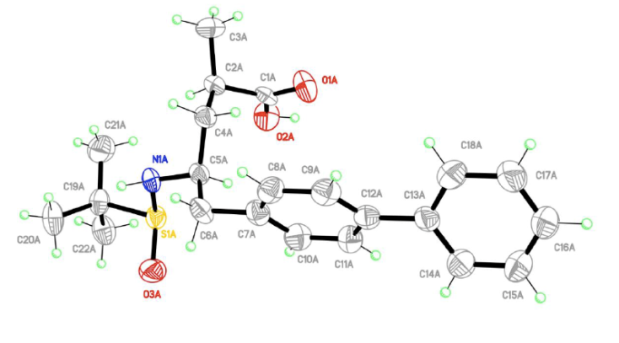

CCDC: 1427794

Summary of Data CCDC 1427794

Compound Name: Formula: 2(C22 H29 N1 O3 S1),C4 H10 O1,(C1)n

Unit Cell Parameters: a 6.5483(2) b 14.2646(5) c 25.3389(9) P21

Batch Synthesis of (2*R*, 4*S*)-5-(4-biphenylyl)-4-amino-2-methylpentanoic acid ethyl ester hydrochloride 3



To a stirred solution of (2*R*, 4*S*)-5-(4-Biphenylyl)-2-methyl-4-(*tert*-butylsulfinylamino)valeric acid **14** (50.0 mg, 134 μmol) in absolute ethanol (0.4 mL) at 0 °C was added thionyl chloride (20 μL, 268 μmol). The reaction mixture was stirred at room temperature for 3 h. The solvent was removed to yield 46.0 mg (99%) of titled compound **3** as a white solid.

**1H NMR** (600 MHz, DMSO-*d*6) δ 8.17 (br. s, 3H), 7.66 (dd, *J* = 8.0, 7.4 Hz, 4H), 7.47 (t, *J* = 7.7 Hz, 2H), 7.36 (2 H, t, *J* = 7.4 Hz, H15, 2H), 7.36 (1 H, d, *J* = 8.0 Hz, H15), 3.99 (q, *J* = 7.1 Hz, H18), 3.42 – 3.36 (m, H4, 1H), 3.04 (dd, *J* = 13.8, 5.5 Hz, 1H), 2.81 (dd, *J* = 13.8, 8.1 Hz, 1H), 2.77 – 2.70 (m, 1H), 1.86 (ddd, *J* = 14.3, 9.1, 5.0 Hz, 1H), 1.59 (ddd, *J* = 13.8, 8.1, 5.4 Hz, 1H), 1.10 (t, *J* = 7.1 Hz, 3H), 1.07 (d, *J* = 7.1 Hz, 3H).

**13C NMR** (151 MHz, CDCl3­) δ 174.7, 139.7, 138.7, 135.5, 130.0, 129.0, 127.4, 126.8, 126.5, 60.1, 50.4, 38.1, 35.5, 35.0, 17.5, 13.9.

**HRMS** (ESI+, m/z [M+H]+) Calcd for C20H26NO2 312.1964; found 312.1967;

**HPLC**. 97:3 d.r. (Daicel Chiralpak AD-H column; isocratic n-hexane/ethanol/methanol/trimethylamine 80/10/10/0.2; 40 oC; flow rate = 0.8 mL min-1; λ = 254 nm; run time = 23 mins; t*R* (2R, 4S) 97.07%; t*R* (2S,4R) 0.21%; t*R* (2S, 4S) 2.32%; t*R* (2R,4R) 0.40%)

**3. 1H- AND 13C-NMR SPECTRA**

**4-Phenylstyrene 11**

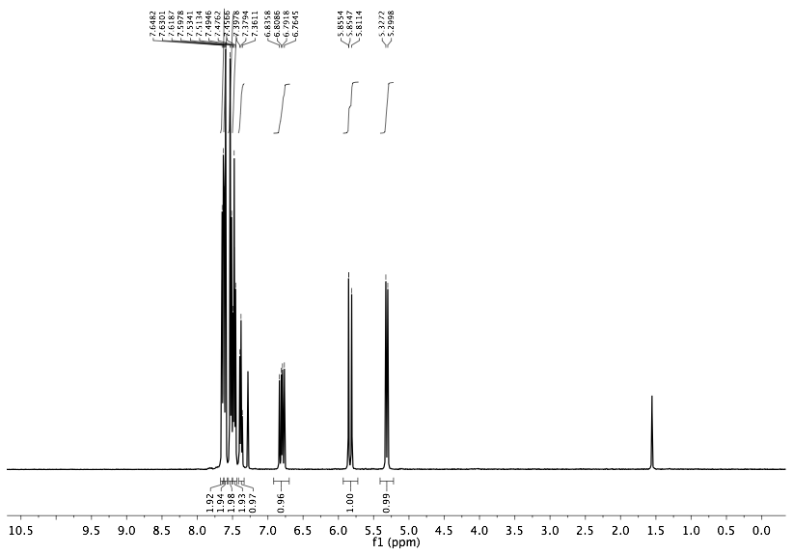

**1H NMR**

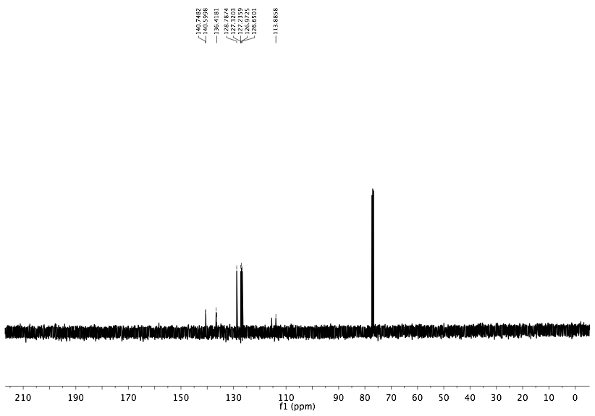

**13C NMR**

**(4-Biphenylyl)acetaldehyde 7**

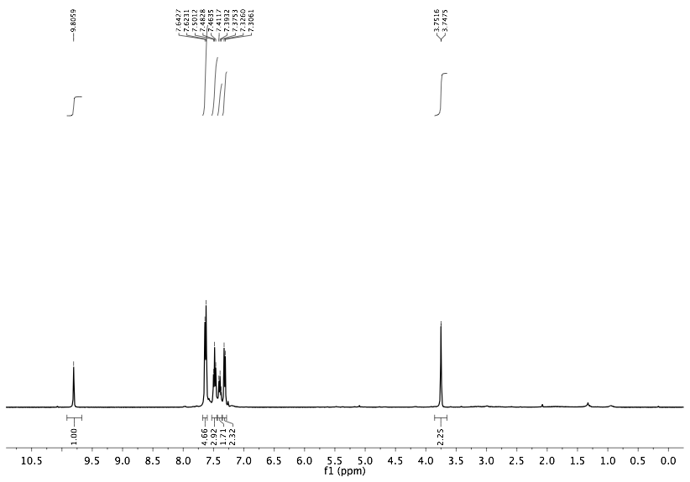

**1H-NMR**

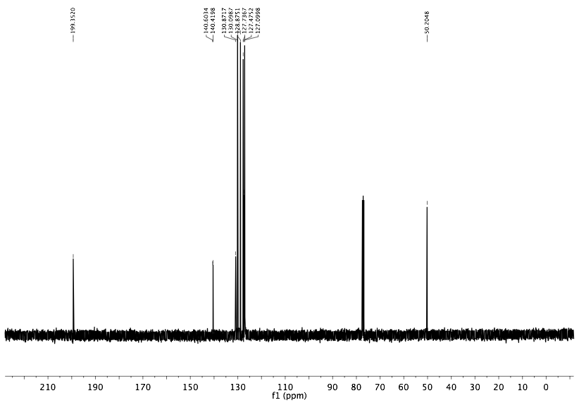

**13C-NMR**

**[2-(4-Biphenylyl)ethylidene]((*S*)-*tert*-butylsulfinyl)amine** **12  
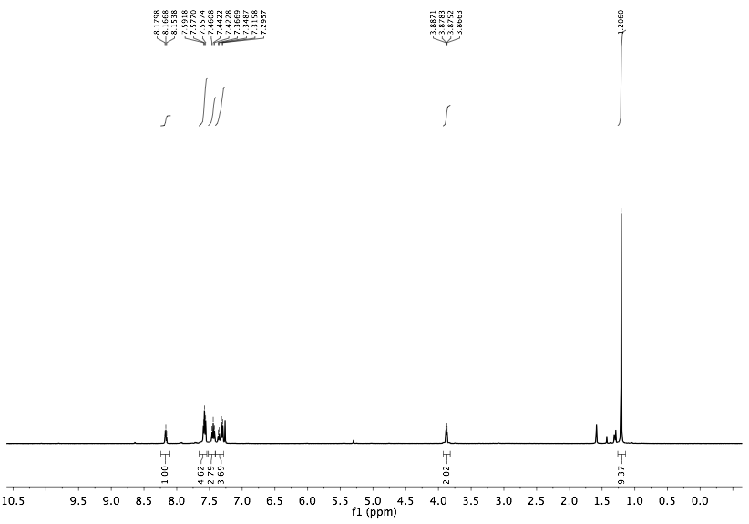**

**1H-NMR**

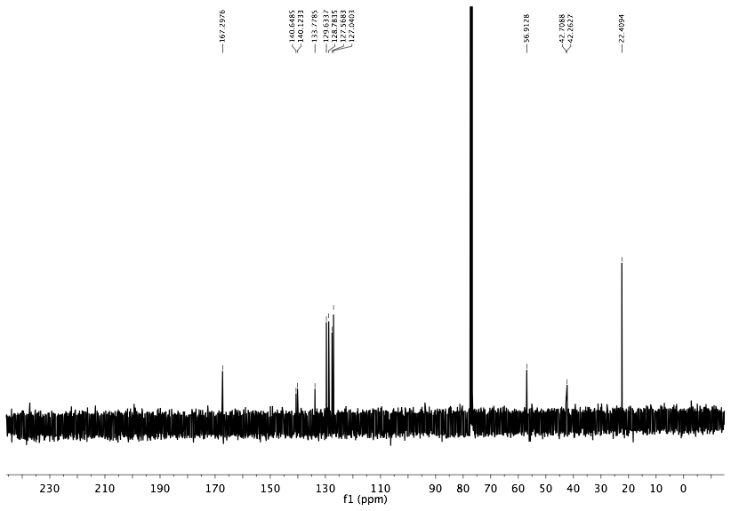**13C-NMR**

**Ethyl 2-[(2*R*)-3-(4-biphenylyl)-2-(*tert*-butylsulfinylamino)propyl]acrylate 13**

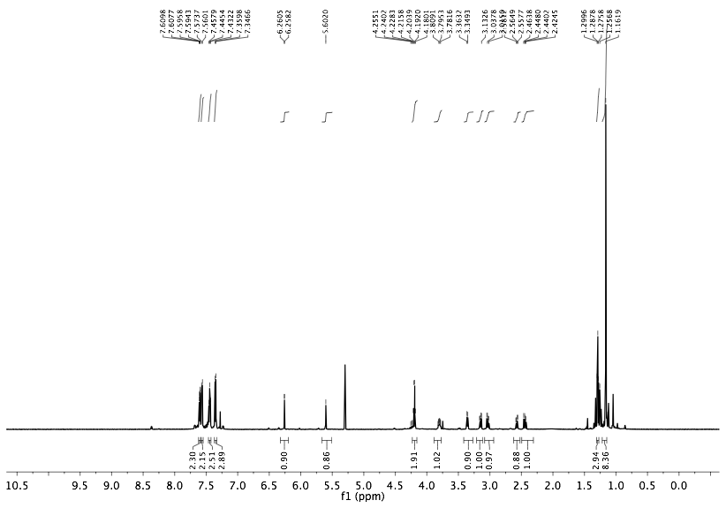

**1H-NMR**

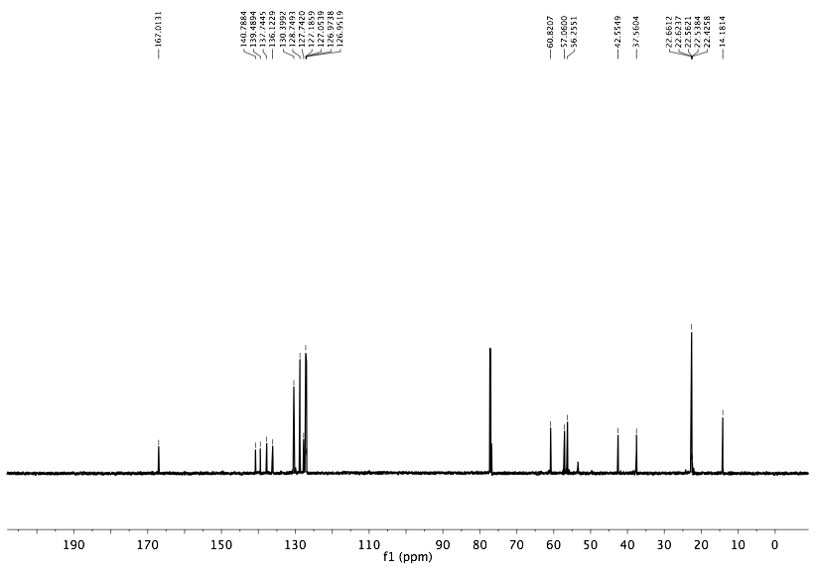

**13C-NMR**

**(4*R*)-5-(4-Biphenylyl)-4-[(*S*)-*tert*-butylsulfinylamino]-2-methylenepentanoic acid 6**

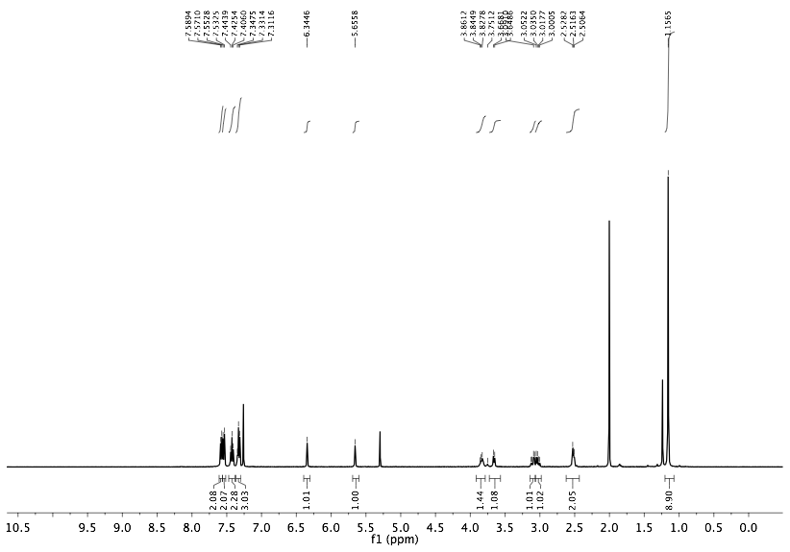

**1H-NMR**

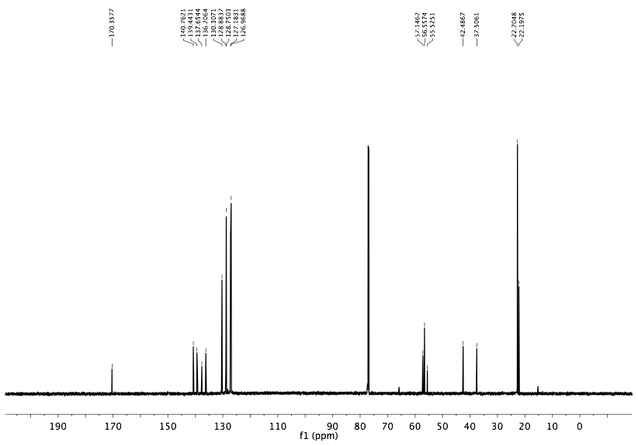

**13C-NMR**

**(2*R*,4*S*)-5-(4-Biphenylyl)-2-methyl-4-(*tert*-butylsulfinylamino)valeric acid 14**

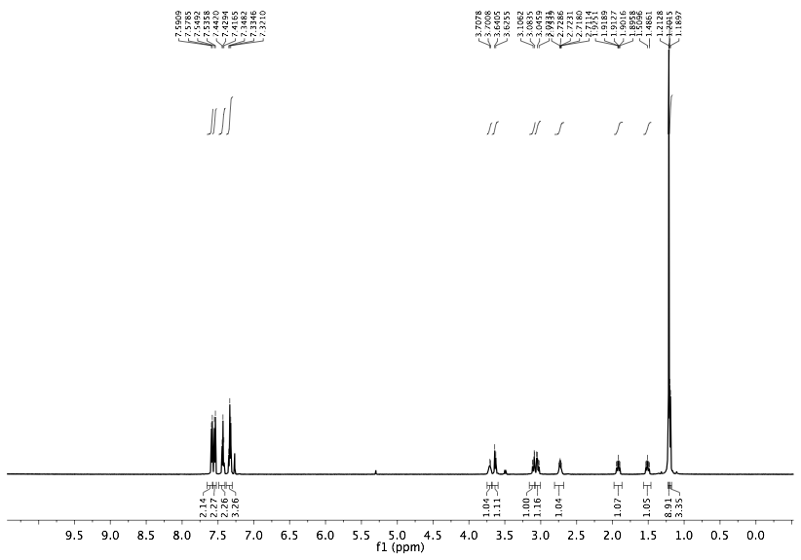

**1H-NMR**

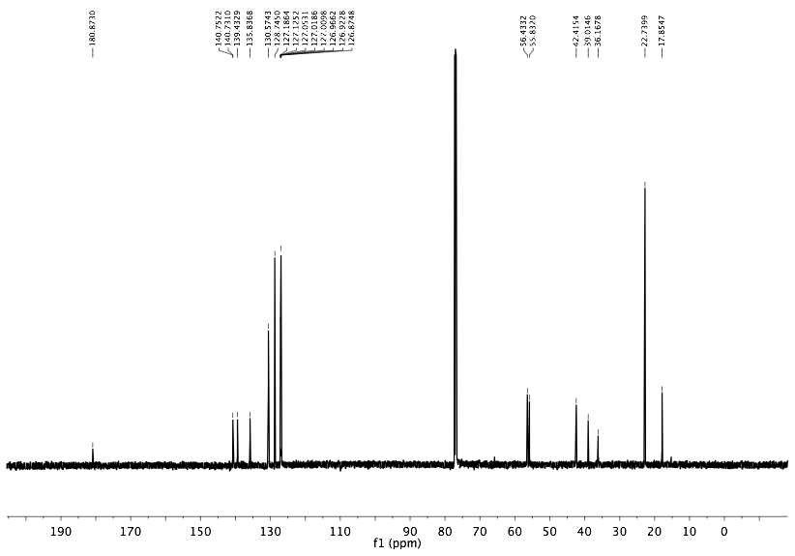

**13C-NMR**

**Ethyl (2*R*,4*S*)-5-(4-biphenylyl)-4-amino-2-methylpentanoate hydrochloride 3**

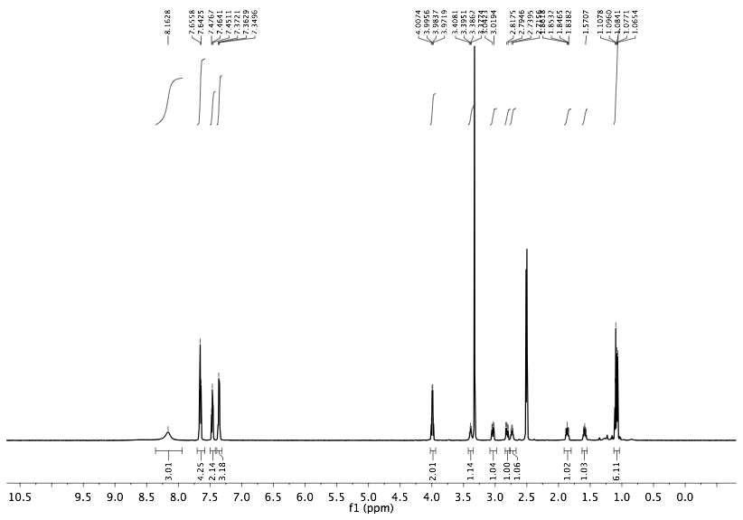

**1H-NMR**

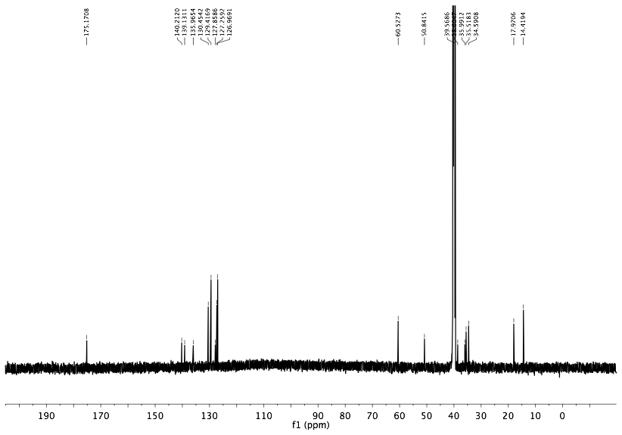

**13C-NMR**

**4. HPLC DATA**

**[2-(4-Biphenylyl)ethylidene]((*S*)-*tert*-butylsulfinyl)amine 12**

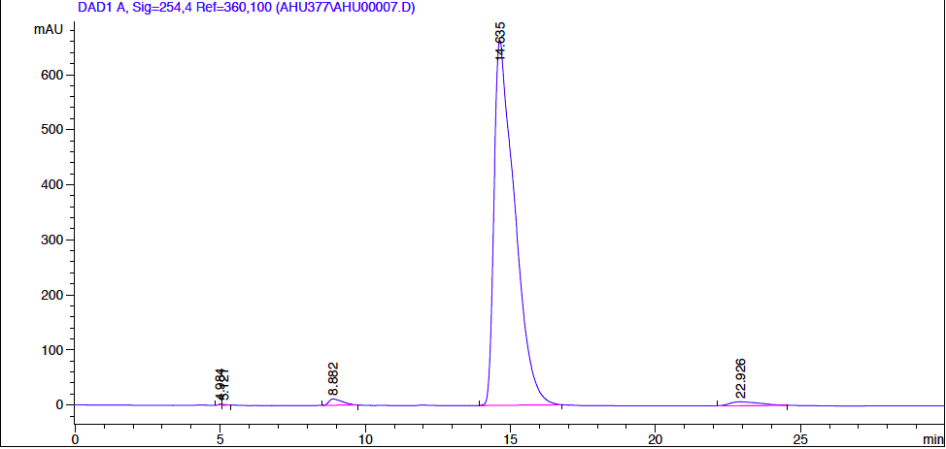

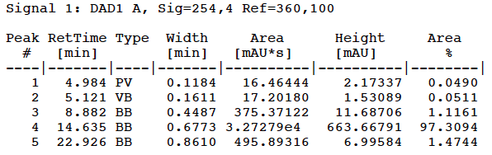

**Ethyl 2-[(2*R*)-3-(4-biphenylyl)-2-(*tert*-butylsulfinylamino)propyl]acrylate 13**

****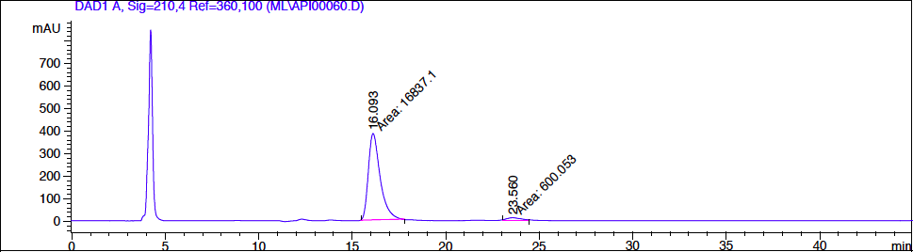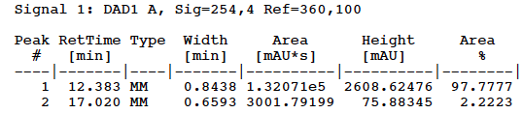

**(4*R*)-5-(4-Biphenylyl)-4-[(*S*)-*tert*-butylsulfinylamino]-2-methylenepentanoic acid 6**

****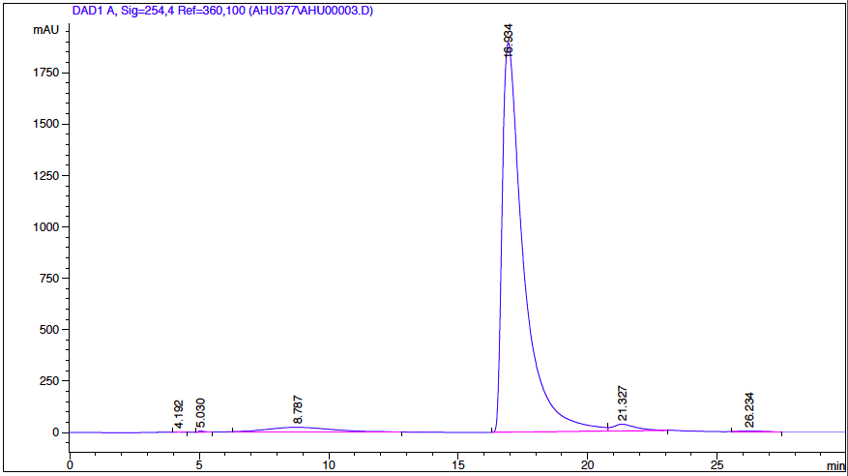

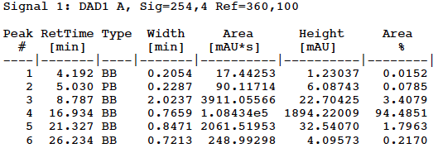

**2*R*,4*S*)-5-(4-Biphenylyl)-2-methyl-4-(*tert*-butylsulfinylamino)valeric acid 14**

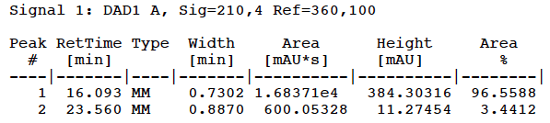

**Ethyl (2*R*,4*S*)-5-(4-biphenylyl)-4-amino-2-methylpentanoate hydrochloride 3**

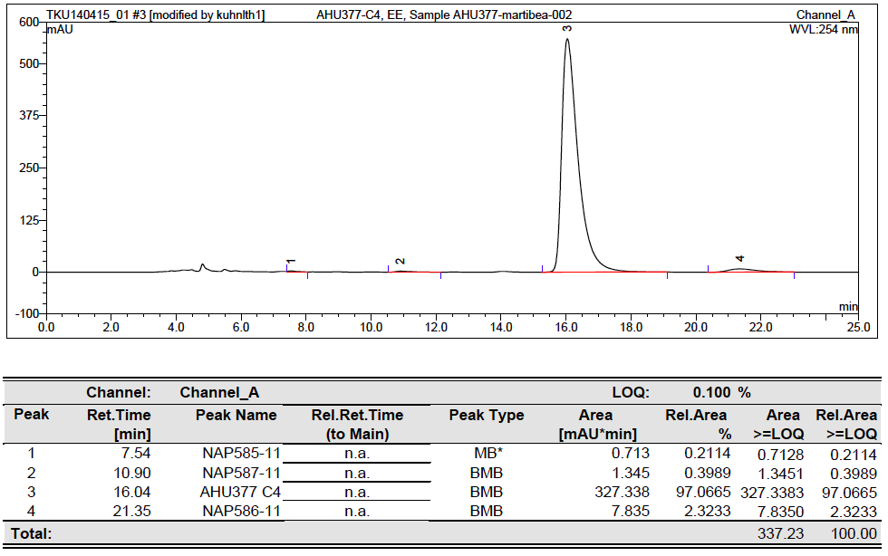

**5. REFERENCES**

**1.** http://www.uniqsis.com/

**2.** www.vapourtec.co.uk/

**3.** Polyzos, A.; O’Brien, M.; Petersen, T. P.; Baxendale, I. R. and Ley, S. V. *Angew. Chem.* **2011**, *123*, 1222-1225; *Angew. Chem. Int. Ed.* **2011**, *50*, 1190-1193

**4.** http://kinesis.co.uk/omnifit-chromatography-columns/

**5.** Simth, C. R. *Synlett* 2009, **9**, 1522-1523.

**6.** Zinc dust was purchased from Acros Organics (Lot# A017161501)