Online Supplementary Material
Khandaker et. al. Childhood Infection, IQ and Risk of Non-Affective Psychosis in Adulthood: a Swedish population-based longitudinal cohort and co-relative study

eMethods
General Population Registers and Study Sample

eFigure 1: Sample Selection for the Analyses of Childhood Infection, IQ and Non-Affective Psychosis

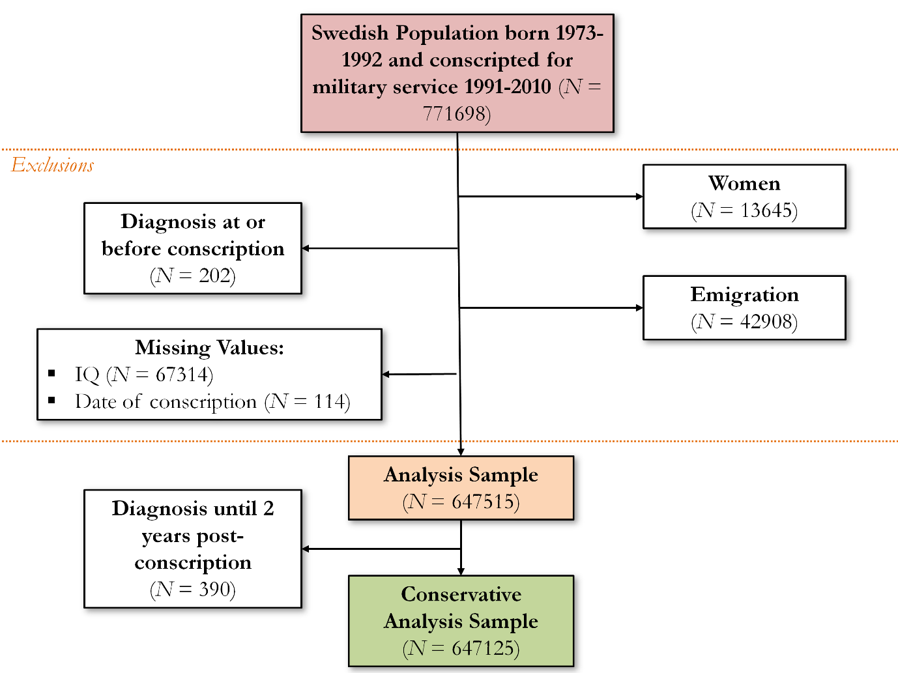

eFigure 2: Unadjusted Hazard Ratios for Non-affective Psychoses for Childhood Infection (sample divided into one-year age bands for age at infection)

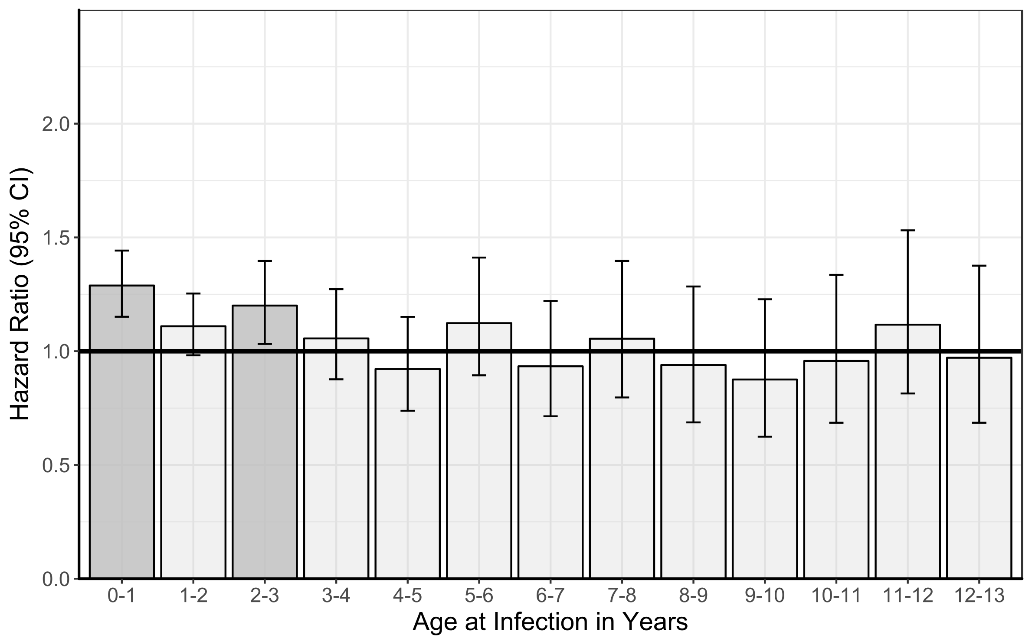
Note: Dark grey bars indicate statistically significant association. The results correspond to unadjusted HR and 95% CI from Cox regression analysis presented in eTable 5.

eFigure 3: Mean IQ (95% CI) at Conscription for Participants Exposed to Infection in Childhood Grouped by Age at Infection

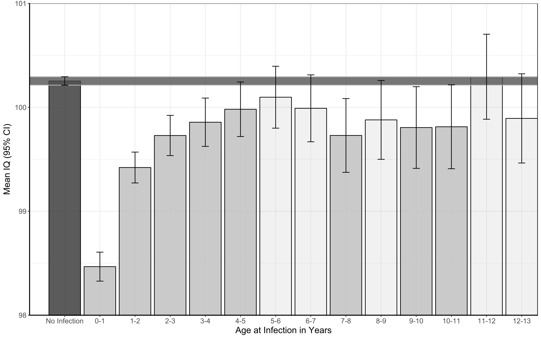

Note: The black bar indicates mean IQ for the unexposed group (i.e., no infection at any age). The grey bars indicate mean IQ for participants exposed to infection grouped by age at infection. Dark grey bars indicate a statistically significant difference in mean IQ for exposure to infection in that particular age compared with unexposed group.

Assessment of Childhood Infection

eTable 1: ICD Codes for Hospitalised Cases of Childhood Infection

Type of Infection | ICD Version¹ | Diagnostic Codes for Hospitalised Cases of Childhood Infection
Any infection | ICD-8 | 006.00-007.99, 009.00-009.98, 084.00-087.99, 099.96-099.99, 110.00-130.10, 130.99-131.99, 136.09, 320.88-320.99, 360.00, 380.02-381.99, 384.00-384.08, 420.00-420.09, 421.98, 422.97-422.99, 462.01, 462.09, 463.09, 466.99, 483.99-486.09, 503.00-503.09, 540.00-540.02, 540.04-540.99, 572,99, 686.00-686.98, 761,40, 763.10, 763.98, 778,60 + ICD-8 codes in ‘Bacterial infection’ and ‘Viral infection’.
 | ICD-9 | 006-007X, 008W, 009-D, 084-086X, 099E-X, 110-136X, 321A, 321W, 370E-F, X, 372A-D, 380B, C, 381A, 382X, 420- 422X, 462-463, 466-B, 473-X, 483, 485-486, 490, 491B, 540A, X, 572A, 647C, E, W, X, 680A, 711G-X, 727A, 770A, 771C, E-W + ICD-9 codes in ‘Bacterial infection’ and ‘Viral infection’.
 | ICD-10 | A06-07.9, A08.5, A09, A59-59.9, A63, A63.8-64, B35-49, B50 -89, B99, G02.1-02.8, G04, G04.9, G05.2, H10.0, H10.3-10.9, H16.2-16.3, H16.9, H32, H60, H60.3, H65.0-65.1, H66.9, I30.0-30.9, I33.0-33.9, I40.0, J02*, J02.8-02.9*, J03*, J03.8-03.9*, J16, J16.8, J18-18.9, J20, J20.8-21, J21.8-21.9, J22, J32-32.9*, J35.0, J37-37.1*, J40-42, K35, K35.9, K75.0, L30.3, M46.5, M65.1, M71.1, O98.3, O98.6-98.9, P23.8-23.9, P37.1-39.9, Z22.4, Z22.8-22.9 + ICD-10 codes in ‘Bacterial infection’ and ‘Viral infection’.
Bacterial | ICD-8 | 000.01-005.99, 008.00-008.30, 010.99-018.98, 020.00-039.98, 073.99, 076.99, 079.30, 080.99-083.99, 088.99-104.98, 320.00-320.80, 322.00-322.03, 361.00-361.09, 362.02, 366.00, 369.00, 380.00-380.01, 382.00-383.99, 390.97-392.99, 421.00, 461.00-461.09, 462.02, 463.01, 481,99-482.98, 501.99, 508.00-508.02, 510.01-510.09, 511.10, 513.99, 522.50, 527.30, 528.00, 528.30, 540.03, 562.00-562.19, 566.00-566.01, 567.00-567.02, 569.00, 577.01, 590.00-590.99, 595.00-595.02, 597.00, 599.02, 611.00, 611.01, 612.01-614.99, 616.00-616.03, 620.00-620.99, 622.00-622.19, 629.40, 630.00-630.09, 635.00-636.09, 645.90-645.91, 670.00-670.09, 678.02, 680.00-682.99, 684.00-684.09, 710.00-710.09, 720.00-720.29, 732.99, 761,00, 763.00, 998.50, 999.30
 | ICD-9 | 001-005X, 008A-F, 010-041X, 073, 076, 078D, J, 790H, 080-083X, 087-099D, 100-104, 245A, 254B, 320-X, 324-X, 360A, 373B, 375D, 376A, 382A-E, 383A-X, 390-392X, 421A, 461-X, 475, 481-482X, 510-X, 511B, 513-B, 522E, H, 526E, 527D, 528A, D, 540B, 562-B, 566, 567-C, 569F, 575A, 590-X, 597A, 595-D, X, 597W, 599A, 611A, 614-F, W-X, 615A, X, 616-X, 634A, 635A, 636A, 637A, 638A, 639A, 646F, G, 647A, B, D, 658E, 659D, 670, 675-B, W-X, 681-686X, 711A, E, 728A, 729E, 730-D, X, 771D, 996G, 998F, 999D
 | ICD-10 | A00-05.9, A15-17.9, A20-28.9, A30 -58, A65 -79.9, B95-96.8, E06.0, E32.1, G00-00.9, G01, G04.2, G05.0, G06-06.2*, G07, H00.0, H01.0, H04.3, H05.0, H44.0, H60.0-60.1, H66.0-66.4, H70.0-70.9, I00-02.9, J01-01.9*, J02.0, J03.0, J13-15.9, J16.0, J20.0-20.2, J34.0, J36*, J39.0-39.1, J85.1-85.3, J86-86.9*, K04.6-04.7, K05.2, K11.3, K12.2, K14.0, K35.1, K57-57.9, K61-61.4, K63.0, K65.0*, K81.0, K85, L00 -08.9, M00-00.9, M46.3*, M60.0*, M86-86.9*, N10-12*, N13.6*, N15.1, N15.9, N30-30.3*, N30.8-30.9*, N34-34.1*, N39.0*, , N61, N70-76.8*, N98.0, O07.0, O07.5, O08.0, O23-23.9, O41.1, O75.3, O85-86.8*, O91-91.1, O98.0-98.2, P23.1-23.6, P36, P37.0, T80.2, T81.4, T82.6-82.7, T83.5-83.6, T84.5-84.7, T85.7, T88.0, Z22.0-22.3
Viral | ICD-8 | 008.80-008.98, 040.00-043.99, 045.00-065.99, 067.00-072.09, 074.00-075.09, 078.00-079.20, 079.40-079.99, 099.92, 460.99, 464.01-480,99, 508.03, 761.20, 761.30
 | ICD-9 | 008H-M, 045-066, 070-072X, 074-075, 077-078H, 078W-079X, 279K, 321B-H, 323A, 323C-D, 460, 464-465X, 480-X, 487-W, 647F, G, 711F, 771A, B, 790W
 | ICD-10 | A08-08.4, A60-60.9, A63.0, A80-89, A90-99, B00-06.0, B06.8-09, B15-19.9, B20-24, B25-34, B97-97.8, G02.0, G05.1, J00, J04-06.9*, J10-11.8, J12-12.9, J20.3-20.7, J21.0, O35.3, O98.4-98.5, P23.0, P35, Z21, Z22.5-22.6
CNS | ICD-8 | 013.00-013.99, 027.01, 036.00, 090.40, 094.00-094.98, 320.00-320.80, 322.00-322.03, 392.99, 040.00-043.99, 045.00-046.99, 052.00, 054.04, 062.00-065.99, 071.99, 072.01, 075.02, 079.20, 474.99, 084.00, 320.88-320.99
 | ICD-9 | 013-X, 036A, B, 090E, 094-X, 320-X, 324-X, 392-X, 045-049X, 054D, 052B, 053A, 055A, 056A, 071, 072B, C, 321B-H, 323A, 323C, D, 006F, 321A, 321W
 | ICD-10 | A02.2 (if G01), A17-17.9, A20.3, A22.8, A32.1, A39.0, A39.8 (if G05), A50.4 (if G05.0 or G01), A51.4 (if G01), A52.1 (if G05.0, G01 or F02.8), A54.8 (if G07 or G01), A69.2 (if G01), G00-00.9, G01, G04.2, G05.0, G06-06.2, G07, I02-02.9, A80-89, B00.3-00.4, B01.0-01.1, B02.0-02.1, B05.0-05.1, B06.0, B26.1-26.2, G02.0, G05.1, B58.2, A06.6, B37.5, B38.4, B43.1, B45.1, B46.1, B50.0, B57.4, B60.2, B69.0, B83.2, G02.1-02.8, G04, G04.9, G05.2
Respiratory | ICD-8 | 010-012, 020.10, 461.00-461.09, 462.02, 463.01, 481,99-482.98, 501.99, 508.00-508.02, 510.01-510.09, 511.10, 513.99, 460.99, 464.01-464.09, 465.99, 470.99-473.99, 480,99, 508.03, 462.01, 462.09, 463.09, 466.99, 483.99-486.09, 502.00-503.09, 519.92, 490.99-491.09
 | ICD-9 | 010-012W, 031A, 033-034B, 052A, 055B, 112E, 122B, 460-466, 475, 481-482X, 510-X, 511B, 513-B, 480-X, 487-W, 462, 463, 466-B, 473-X, 483, 485, 486, 490, 491B
 | ICD-10 | A15-16, A20.2, A21.2, A22.1, A31.0, A37, A38, A48.1, B00.2, B01.2, B05.2, B27, B37.1, B39-42, B44, B45.0, B46.0, B58.3, B59, J01-01.9, J02.0, J03.0, J13-15.9, J16.0, J20.0-20.2, J34.0, J36, J39.0-39.1, J85.1-85.3, J86-86.9, J00, J04-06.9, J10-11.8, J12-12.9, J20.3-20.7, J21.0, , J02, J02.8-02.9, J03, J03.8-03.9, J16, J16.8, J18-18.9, J20, J20.8-21, J21.8-21.9, J22, J32-32.9, J35.0, J37-37.1, J40-42
Skin | ICD-8 | 017.01-017.09, 110-111, 050-057, 680.00-680.90, 681.00-682.99, 684.00-684.09, 686.00-686.98
 | ICD-9 | 017A, 031B, 050-057, 074D, 091D, 110-111, 112D, 681-682X, 683, 684, 685-686X, 680A
 | ICD-10 | A18.4, A20.0, A22.0, A26.0, A31.1, A32, A36.3, B00-09, B35-36, B37.2, B43.0, B43.2, B45.2, B46.3, B55.1, L00, L01-01.1, L02-02.9, L03-03.9, L04-08.9, L70.0, L30.3
Genitourinary | ICD-8 | 090-099, 016, 054.02, 590.00-590.99, 595.00-595.02, 597.00, 599.02, 601.00, 604.00, 604.01, 607.30, 611.00, 611.01, 612.01-614.99, 616.00-616.03, 620.00-620.99, 622.00-622.19, 629.40
 | ICD-9 | 016, 054B, 112B, C, 090-099, 131A, 590-X, 597A, 595-D, X, 597W, 599A, 601-D, 603B, 604A, 604X, 607B, C, 608A, E, 611A, 614-F, W-X, 615A, X, 616-X
 | ICD-10 | A18.0-18.1, A50-64, A70-74, B37.3-37.4, N10-12, N13.6, N15.1, N15.9, N30-30.3, N30.8-30.9, N34-34.1, N39.0, N41-41.3, N43.1, N45.0-45.9, N48.1-48.2, N49-49.9, N61, N70-76.8, N98.0
Gastrointestinal | ICD-8 | 000-009, 014, 039.92, 127.99, 522.50, 527.30, 528.00, 528.30, 562.00-562.19, 566.00-566.01, 567.00-567.02, 569.00, 577.01, 540.00-540.99, 572,99
 | ICD-9 | 001-009, 123, 123, 127, 129, 014, 522E, H, 526E, 527D, 528A, D, 540B, 562-B, 566, 567-C, 569F, 575A, 540A, X, 572A
 | ICD-10 | 001-009, 123, 123, 127, 129, 014, 522E, H, 526E, 527D, 528A, D, 540B, 562-B, 566, 567-C, 569F, 575A, 540A, X, 572A

¹ In Sweden ICD-8 was used from 1969 to 1986, ICD-9 from 1987 to 1996, and ICD-10 from 1997 to date. All diagnoses of post-infection or sequel are excluded.
* The additional codes, B95-97.8, denotes the infecting organism. Bacteria= B95-96.8, Virus= B97-97.8.

eResults
Baseline Characteristics

eTable 2: Baseline Characteristics of Sample

Characteristics | Childhood Infection at 0-13 Years
 | Exposed | Unexposed | χ²- Statistic | P-value
Sample, No. (%) | 153460 (23.70) | 494055 (76.30) | - | -
Winter Birth, No. (%) | 80166 (52.24) | 262241 (53.08) | 33.15 | <0.001
Household Crowding, No. (%) |  |  | 1026.10 | <0.001
Not overcrowded | 84833 (55.28) | 295520 (59.82)
Overcrowded | 3183 (2.07) | 10275 (2.08)
Unknown | 65444 (42.65) | 188260 (38.11)
Parental Socioeconomic Status, No. (%) |  |  | 1256.00 | <0.001
Worker | 28139 (18.33) | 95065 (19.24)
White Collar | 46909 (30.57) | 166122 (33.62)
Business owner | 8720 (5.68) | 33005 (6.68)
Unknown | 69692 (45.41) | 199863 (40.45)
Migrant Parents, No. (%) | 22951 (14.96) | 64915 (13.14) | 329.26 | <0.001
Parental History of Non-Affective Psychosis, No. (%) | 3076 (2.00) | 9027 (1.83) | 19.97 | <0.001

Association between Childhood Infection and NAP: Results for Schizophrenia and Other Non-Affective Psychosis Presented Separately

eTable 3: Association between Childhood Infection and Risk of Schizophrenia in Adulthood based on a Sample of 644925 Swedish Men Excluding Cases with Other Non-Affective Psychosis

Age At Infection | Exposed to Infection, No. (%) | Unadjusted Analysis |  | Adjusted Analysis¹
 |  | Hazard Ratio (95% CI) | P-value | Hazard Ratio (95% CI) | P-value
All (0-13 years) | 152775 (23.69) | 1.16 (1.03-1.30) | 0.014 | 1.13 (1.00-1.27) | 0.049
0-1 years | 48906 (7.58) | 1.27 (1.06-1.53) | 0.011 | 1.22 (1.01-1.47) | 0.038
2-4 years | 83629 (12.97) | 1.00 (0.86-1.17) | 0.983 | 0.98 (0.83-1.14) | 0.757
5-9 years | 34118 (5.29) | 1.06 (0.86-1.32) | 0.577 | 1.05 (0.84-1.30) | 0.680
10-13 years | 14914 (2.31) | 1.05 (0.76-1.45) | 0.752 | 1.05 (0.76-1.45) | 0.765
¹ Regression models have been adjusted for household crowding, winter birth, parental socioeconomic status, migration status, and parental history of non-affective psychoses.

eTable 4: Association between Childhood Infection and Risk of Other Non-Affective Psychosis in Adulthood based on a Sample of 646060 Swedish Men excluding Cases with Schizophrenia

Age At Infection | Exposed to Infection, No. (%) | Unadjusted Analysis |  | Adjusted Analysis¹
 |  | Hazard Ratio (95% CI) | P-value | Hazard Ratio (95% CI) | P-value
All (0-13 years) | 153088 (23.70) | 1.24 (1.14-1.35) | <0.001 | 1.17 (1.08-1.28) | <0.001
0-1 years | 49004 (7.58) | 1.30 (1.13-1.50) | <0.001 | 1.17 (1.02-1.35) | 0.028
2-4 years | 83833 (12.98) | 1.24 (1.11-1.38) | <0.001 | 1.19 (1.07-1.33) | 0.002
5-9 years | 34179 (5.29) | 0.98 (0.83-1.15) | 0.769 | 0.99 (0.83-1.17) | 0.874
10-13 years | 14941 (2.31) | 0.98 (0.77-1.26) | 0.878 | 1.00 (0.78-1.28) | 0.986
¹ Regression models have been adjusted for household crowding, winter birth, parental socioeconomic status, migration status, and parental history of non-affective psychoses.

Association between Infection and NAP: Sensitivity Analyses by Age at Infection

eTable 5: Association between Childhood Infection and Risk of Non-Affective Psychoses in Adulthood based on a Sample of 647515 Swedish Men
Age At Infection | Exposed to Infection, No. (%) | Unadjusted Analysis |  | Adjusted Analysis¹
 |  | Hazard Ratio (95% CI) | P-value | Hazard Ratio (95% CI) | P-value
All (0-13 years) | 153460 (23.70) | 1.21 (1.13-1.30) | <0.001 | 1.16 (1.08-1.24) | <0.001
0-1 years | 49127 (7.59) | 1.29 (1.15-1.44) | <0.001 | 1.17 (1.06-1.33) | 0.003
1-2 years | 43491 (6.72) | 1.12 (0.98-1.25) | 0.095 | 1.06 (0.94-1.20) | 0.326
2-3 years | 24727 (3.82) | 1.20 (1.03-1.40) | 0.018 | 1.18 (1.01-1.37) | 0.034
3-4 years | 16831 (2.60) | 1.06 (0.88-1.27) | 0.566 | 1.05 (0.87-1.26) | 0.630
4-5 years | 13072 (2.02) | 0.92 (0.74-1.15) | 0.472 | 0.92 (0.74-1.15) | 0.484
5-6 years | 10049 (1.55) | 1.12 (0.89-1.41) | 0.318 | 1.13 (0.90-1.42) | 0.285
6-7 years | 8534 (1.32) | 0.93 (0.71-1.22) | 0.616 | 0.93 (0.71-1.22) | 0.614
7-8 years | 6979 (1.08) | 1.05 (0.80-1.40) | 0.709 | 1.06 (0.80-1.40) | 0.684
8-9 years | 6086 (0.94) | 0.94 (0.69-1.28) | 0.695 | 0.93 (0.68-1.28) | 0.667
9-10 years | 5659 (0.87) | 0.88 (0.62-1.23) | 0.442 | 0.87 (0.62-1.23) | 0.435
10-11 years | 5349 (0.83) | 0.96 (0.69-1.34) | 0.796 | 0.95 (0.68-1.33) | 0.777
11-12 years | 5209 (0.80) | 1.12 (0.81-1.53) | 0.494 | 1.14 (0.83-1.56) | 0.413
12-13 years | 4721 (0.73) | 0.97 (0.69-1.38) | 0.870 | 0.99 (0.70-1.40) | 0.936
¹ Regression models have been adjusted for household crowding, winter birth, parental socioeconomic status, migration status, and parental history of non-affective psychoses.
Association between Infection and IQ: Sensitivity Analyses by Age at Infection

eTable 6: Association between Childhood Infection and IQ at Age 18 Years based on a Sample of 647515 Swedish Men
Age at Infection | Exposed to Infection |  | Unexposed to Infection |  | Unadjusted Analysis |  | Adjusted Analysis¹
 | Sample | Mean IQ (SD) | Sample | Mean IQ (SD) | Mean Difference (95% CI) | P-Value | Mean Difference (95% CI) | P-Value
All (0-13 years) | 153460 | 99.18 (15.02) | 494055 | 100.26 (14.98) | -1.08 (-1.16, -0.99) | <0.001 | -0.98 (-1.07, -0.90) | <0.001
0-1 years | 49127 | 98.20 (15.10) | 494055 | 100.26 (14.98) | -1.79 (-1.93, -1.65) | <0.001 | -1.58 (-1.71, -1.44) | <0.001
1-2 years | 43491 | 98.91 (15.04) | 494055 | 100.26 (14.98) | -0.83 (-0.98, -0.68) | <0.001 | -0.78 (-0.93, -0.64) | <0.001
2-3 years | 24727 | 99.14 (15.09) | 494055 | 100.26 (14.98) | -0.53 (-0.72, -0.33) | <0.001 | -0.52 (-0.71, -0.33) | <0.001
3-4 years | 16831 | 99.25 (15.11) | 494055 | 100.26 (14.98) | -0.40 (-0.63, -0.16) | <0.001 | -0.36 (-0.59, -0.14) | 0.002
4-5 years | 13072 | 99.38 (14.96) | 494055 | 100.26 (14.98) | -0.27 (-0.53, -0.01) | 0.042 | -0.27 (-0.52, -0.01) | 0.043
5-6 years | 10049 | 99.53 (15.12) | 494055 | 100.26 (14.98) | -0.16 (-0.45, 0.14) | 0.303 | -0.12 (-0.41, 0.17) | 0.422
6-7 years | 8534 | 99.46 (15.05) | 494055 | 100.26 (14.98) | -0.26 (-0.59, 0.06) | 0.109 | -0.13 (-0.44, 0.19) | 0.434
7-8 years | 6979 | 99.24 (15.11) | 494055 | 100.26 (14.98) | -0.52 (-0.88, -0.17) | 0.004 | -0.40 (-0.74, -0.05) | 0.025
8-9 years | 6086 | 99.43 (14.96) | 494055 | 100.26 (14.98) | -0.37 (-0.75, 0.00) | 0.053 | -0.26 (-0.63, 0.11) | 0.162
9-10 years | 5659 | 99.38 (14.97) | 494055 | 100.26 (14.98) | -0.45 (-0.84, -0.06) | 0.025 | -0.36 (-0.74, 0.03) | 0.068
10-11 years | 5349 | 99.42 (14.82) | 494055 | 100.26 (14.98) | -0.44 (-0.84, -0.04) | 0.032 | -0.32 (-0.71, 0.08) | 0.117
11-12 years | 5209 | 99.92 (15.07) | 494055 | 100.26 (14.98) | 0.04 (-0.37, 0.45) | 0.845 | 0.10 (-0.30, 0.50) | 0.632
12-13 years | 4721 | 99.55 (14.83) | 494055 | 100.26 (14.98) | -0.36 (-0.79, 0.07) | 0.100 | -0.24 (-0.66, 0.18) | 0.259
¹ Regression models have been adjusted for household crowding, winter birth, parental socioeconomic status, migration status, and parental history of non-affective psychoses.
Association between Infection and NAP: Results for CNS and Non-CNS Infections Separately

Table 7: Association between Childhood CNS and Non-CNS Infections and Risk of Non-Affective Psychoses in Adulthood

Type of Infection | Sample Size¹ | Exposed to Infection, No. (%) | Unadjusted Analysis |  | Adjusted Analysis²
 |  |  | Hazard Ratio (95% CI) | P-value | Hazard Ratio (95% CI) | P-value
All NAP
All | 647515 | 153460 (23.70) | 1.21 (1.13-1.30) | <0.001 | 1.16 (1.08-1.24) | <0.001
CNS | 498718 | 4663 (0.93) | 1.04 (0.74-1.48) | 0.811 | 1.04 (0.74-1.48) | 0.817
Non-CNS | 644554 | 150499 (23.35) | 1.22 (1.14-1.31) | <0.001 | 1.16 (1.08-1.25) | <0.001
Schizophrenia
All | 644925 | 152775 (23.69) | 1.16 (1.03-1.30) | 0.014 | 1.13 (1.00-1.27) | 0.049
CNS | 496792 | 4642 (0.93) | 1.00 (0.55-1.81) | 1.00 | 0.98 (0.54-1.78) | 0.949
Non-CNS | 641972 | 149822 (23.34) | 1.16 (1.03-1.30) | 0.017 | 1.12 (1.00-1.27) | 0.056
Other NAP
All | 646060 | 153088 (23.70) | 1.24 (1.14-1.35) | <0.001 | 1.17 (1.08-1.28) | <0.001
CNS | 497624 | 4652 (0.93) | 1.07 (0.69-1.16) | 0.765 | 1.08 (0.70-1.66) | 0.737
Non-CNS | 643108 | 150136 (23.35) | 1.25 (1.15-1.37) | <0.001 | 1.19 (1.09-1.30) | <0.001

¹ The sample for analysis of CNS infection excludes participants with non-CNS infection and vice versa; the sample for analysis of schizophrenia excludes participants with other NAP and vice versa.
² Regression models have been adjusted for household crowding, winter birth, parental socioeconomic status, migration status, and parental history of non-affective psychoses.

Association between Infection and IQ: Results for CNS and Non-CNS Infections Separately

Table 8: Association between CNS and Non-CNS Infection in Childhood and IQ at Age 18

Type of Infection | Exposed to Infection |  | Unexposed to Infection |  | Unadjusted Analysis |  | Adjusted Analysis¹
 | Sample | Mean IQ (SD) | Sample | Mean IQ (SD) | Mean Difference (95% CI) | P-Value | Mean Difference (95% CI) | P-Value
All | 153460 | 99.18 (15.02) | 494055 | 100.26 (14.98) | -1.08 (-1.16, -0.99) | <0.001 | -0.98 (-1.07, -0.90) | <0.001
CNS | 4663 | 99.35 (14.68) | 494055 | 100.26 (14.98) | -0.91 (-1.34, -0.47) | <0.001 | -0.86 (-1.28, -0.44) | <0.001
Non-CNS | 150499 | 99.17 (15.03) | 494055 | 100.26 (14.98) | -1.09 (-1.17, -1.00) | <0.001 | -0.99 (-1.07, -0.90) | <0.001

¹ Regression models have been adjusted for household crowding, winter birth, parental socioeconomic status, migration status, and parental history of non-affective psychoses.

Association between IQ and NAP: Results for Schizophrenia and Other Non-Affective Psychosis Presented Separately

eTable 9: Hazard Ratio (95% CI) for Schizophrenia and Other Non-Affective Psychosis for Each 1-point Increase in Total IQ Score at Conscription

Outcome | Sample Size | No. of Cases (%) | Unadjusted Analysis |  | Adjusted Analysis After Excluding Prodromal Cases¹
 |  |  | Hazard Ratio (95% CI) | P-value | Hazard Ratio (95% CI) | P-value
All NAP | 647515 | 4045 (0.62) | 0.975 (0.973-0.977) | <0.001 | 0.976 (0.974-0.978) | <0.001
Schizophrenia | 644925 | 1455 (0.22) | 0.976 (0.974-0.978) | <0.001 | 0.976 (0.972-0.980) | <0.001
Other NAP | 646060 | 2590 (0.40) | 0.975 (0.973-0.978) | <0.001 | 0.975 (0.973-0.978) | <0.001
¹ Regression models have been adjusted for household crowding, winter birth, parental socioeconomic status, migration status, and parental history of non-affective psychoses and excluded 390 individuals who were diagnosed with NAP within 2 years of conscription.

Co-relative Analyses of Childhood Infection and NAP: Sensitivity Analyses (discordance for infection is defined as lack of exposure to infection at any age)

eTable 10: Co-Relative Control Analyses of Childhood Infection and Adult Non-Affective Psychoses based on a Sample of 647515 Swedish Men

Groups | Sample | Hazard Ratio (95% CI)
 |  | Age at Infection 0-13 Years (All) | Age at Infection 0-4 Years (“Sensitive Period”) | Age at Infection 5-13 Years
General Population | 647515 | 1.21 (1.13-1.30) | 1.24 (1.15-1.34) | 1.04 (0.92-1.16)
Cousins¹ | 304486 | 1.08 (0.97-1.20) | 1.07 (0.94-0.21) | 1.00 (0.83-1.21)²
Half Siblings¹ | 21336 | 1.03 (0.72-1.48) | 0.98 (0.67-1.44) | 1.25 (0.58-2.67)
Full Siblings¹ | 80288 | 1.23 (1.00-1.54) | 1.32 (1.02-1.71) | 1.00 (0.68-1.46)

¹ Co-relative analyses were based on cousin, half-sibling and full-sibling pairs who were discordant for infection (i.e., for each relative pair, one member was exposed to infection and the other was not exposed to infection at any age).
² The proportionality assumption for Cox regression was violated for this model, so this particular hazard ratio needs to interpreted with care.

Interaction between Infection and IQ

eTable 11: Interaction Analyses of Infection and IQ for the Outcome of Non-Affective Psychoses (N=647515)
Predictor | Estimates for Non-Affective Psychosis
 | Β (SE) | OR (95% CI) | P-value
Intercept | -5.163 (0.019) | - | <0.001
Childhood infection | 0.065 (0.040) | 1.067 (0.987, 1.153) | 0.102
IQ† | 0.025 (0.001) | 1.025 (1.023, 1.028) | <0.001
Multiplicative Interaction‡ | 0.006 (0.002) | 1.006 (1.001, 1.011) | 0.020
RERI | 0.008 (0.002) | - | 0.001

† IQ has been centred (i.e. Mean=0 and SD=15), and reversed (i.e. OR=effect for each one-point decrease) to allow interpretation of the infection main effects as well as the interaction.
‡ The OR for multiplicative interaction represents risk of non-affective psychoses for every 1-point decrease in IQ for those exposed to infection in addition to the main effects of IQ and infection on psychosis risk.

Mediating Effect of IQ on the Infection-Non Affective Psychosis Relationship

eTable 12: Mediating Effect of IQ on the Infection-Non Affective Psychosis Relationship (N=647515)

Effect of Childhood Infection | Estimates for Non-Affective Psychosis,  β (SE) | P-value
Direct Effect | 0.106 (0.035) | 0.002
Indirect Effect via IQ | 0.028 (0.002) | <0.001
Total Effect | 0.134 (0.035) | <0.001

