Supplementary Information
Control of Geminate Recombination by the Material Composition and Processing Conditions in Novel Polymer:Non-Fullerene Acceptor Photovoltaic Devices
- Jiangbin Zhang,^{1, 2}* Qinying Gu,^{1,3} Thu Trang Do,⁴ Kira Rundel, ³ Prashant Sonar, ⁴ Richard H. Friend, ² Christopher R. McNeill, ³ and Artem A. Bakulin¹*
- Department of Chemistry, Imperial College London, London SW7 2AZ, United Kingdom
- Cavendish Laboratory, University of Cambridge, JJ Thomson Avenue, Cambridge CB3 0HE, United Kingdom
- Department of Materials Science and Engineering, Monash University, Wellington Road, Clayton, Victoria, 3800, Australia
- School of Chemistry, Physics and Mechanical Engineering, Queensland University of Technology, 4001 Brisbane, Australia
*a.bakulin@imperial.ac.uk
*jz400@cam.ac.uk

Device Fabrication. The glass slides with indium tin oxide (ITO) were subsequently cleaned using detergent and deionized water, acetone and isopropanol for 10 min each. A 0.1M zinc oxide (ZnO) solution was prepared by dissolving zinc acetate dihydrate (220 mg) in 10 ml 2-methoxyethanol, with ethanolamine (61 mg) as a stabilizer. The solution was then stirred at 60°C for 12 hours under ambient conditions. The 0.4% poly(ethylenimine) ethoxylated (PEIE) precursor was prepared by dissolving 40 mg PEIE in 10 ml of 2-methoxyethanol. Both solutions were filtered before use. A ZnO film was first spin coated on top of the ITO glass substrate at a speed of 4000 RPM, followed by film annealing on the hot plate in ambient conditions at 200˚C for 30 min. A PEIE film was then deposited by spin coating at 5000 RPM. After baking the PEIE film at 120 ˚C for 20 min, the substrates were transferred to a glovebox under nitrogen atmosphere for deposition of active layers, MoO_{x} and Ag. The deposition and post-annealing of the BHJ layers were the same as that in the film described in the main text. Samples were then loaded into a vacuum deposition chamber to evaporate a 12 nm molybdenum oxide (MoO_{x}) and 100 nm silver cathode on top of the active layer subsequently. A mask was used during vacuum evaporation to generate eight individual pixels in each substrate with the active device area of 4.5 mm². Finally, these devices were fitted with edge clips, encapsulated by epoxy and glass, and placed inside the glovebox overnight, enabling the epoxy to be dried before further testing or characterization.

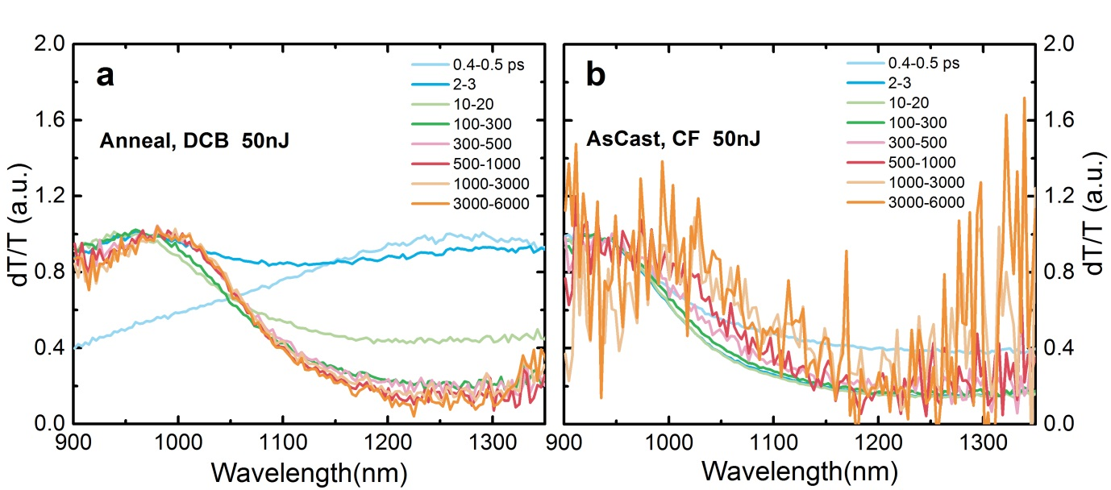
Figure S1. Normalized pump-probe spectra of P3HT:DPP-ANQ-DPP films with different processing conditions. (a) Annealed with DCB (b) As cast with CF.

Table S1. Solar Cell Performance of DPP-FN-DPP and DPP-ANQ-DPP based Blends in DCB.
Blend | Thickness  (nm) | V_{OC}  (V) | J_{SC}  (mA cm⁻²) | FF  (%) | PCE  (%) | EQE J_{SC} ª  (mA.cm⁻²) | Max EQE  (%)
P3HT:DPP-FN-DPP As Cast | 39 ± 2 | 0.98 | 1.96 | 30.4 | 0.58 | 1.82 | 12.0
P3HT:DPP-FN-DPP Anneal | 39 ± 2 | 0.97 | 3.20 | 37.2 | 1.20 | 3.00 | 22.8
P3HT:DPP-ANQ-DPP As Cast | 75 ± 7 | 0.85 | 1.32 | 41.1 | 0.46 | 1.25 | 7.3
P3HT:DPP-ANQ-DPP Anneal | 75 ± 7 | 0.85 | 2.00 | 38.7 | 0.70 | 2.20 | 13.7
ªEQE J_{SC} is the current density calculated according to the EQE profile.

Table S2. Solar Cell Performance of DPP-FN-DPP and DPP-ANQ-DPP based Blends in CF.
Blend | Thickness  (nm) | V_{OC}  (V) | J_{SC}  (mA cm⁻²) | FF  (%) | PCE  (%) | EQE J_{SC} ª  (mA.cm⁻²) | Max EQE  (%)
P3HT:DPP-FN-DPP As Cast | / | 0.93 | 0.72 | 30.61 | 0.21 | 0.94 | 8.24
P3HT:DPP-FN-DPP Anneal | / | 0.98 | 1.02 | 30.94 | 0.35 | 1.90 | 12.15
P3HT:DPP-ANQ-DPP As Cast | / | 0.85 | 0.79 | 24.17 | 0.16 | 1.05 | 8.40
P3HT:DPP-ANQ-DPP Anneal | / | 0.85 | 1.37 | 27.23 | 0.32 | 1.37 | 9.89

Table S3. Summary of Pump-Push Responses of the Studied Material Blends with Different Processing Conditions.
Sample | Acceptor | Processing | Solvent | PCE (%) | J/nA | ∆J/J (10⁻³)
1 | DPP-FN-DPP | Anneal | DCB | 1.2 | 84 | <0.025
2 | DPP-ANQ-DPP | Anneal | DCB | 0.7 | 75 | 0.06
3 | DPP-FN-DPP | As Cast | DCB | 0.58 | 70 | 0.6
4 | DPP-ANQ-DPP | As Cast | DCB | 0.46 | 45 | 0.3
5 | DPP-FN-DPP | Anneal | CF | 0.35 | 9 | 2.2
6 | DPP-ANQ-DPP | Anneal | CF | 0.32 | 20 | 5.4
7 | DPP-FN-DPP | As Cast | CF | 0.21 | 20 | 7.2
8 | DPP-ANQ-DPP | As Cast | CF | 0.16 | 0.5 | 373

Table S4. Sensitivity Comparison of ∆J/J in Devices with Different Processing Conditions.
Variant | Value 1 | Value 2 | Value 3 | Value 4
Annealing  As Cast | $\left(\frac{1}{3}\right)\frac{0.6}{0.025}$=24 | $\left(\frac{2}{4}\right)\frac{0.3}{0.06}$=5 | $\left(\frac{5}{7}\right)\frac{7.2}{2.2}$=3.27 | $\left(\frac{6}{8}\right)\frac{373}{5.4}$=69
FN  ANQ | $\left(\frac{1}{2}\right)\frac{0.06}{0.025}$=2.4 | $\left(\frac{3}{4}\right)\frac{0.3}{0.6}$=0.5 | $\left(\frac{5}{6}\right)\frac{5.4}{2.2}$=2.45 | $\left(\frac{7}{8}\right)\frac{373}{7.2}$=51.8
DCB  CF | $\left(\frac{1}{5}\right)\frac{2.2}{0.025}$=88 | $\left(\frac{2}{6}\right)\frac{5.4}{0.06}$=90 | $\left(\frac{3}{7}\right)\frac{7.2}{0.6}$=12 | $\left(\frac{4}{8}\right)\frac{373}{0.3}$=1243

