Supporting information:

Additional Spectra
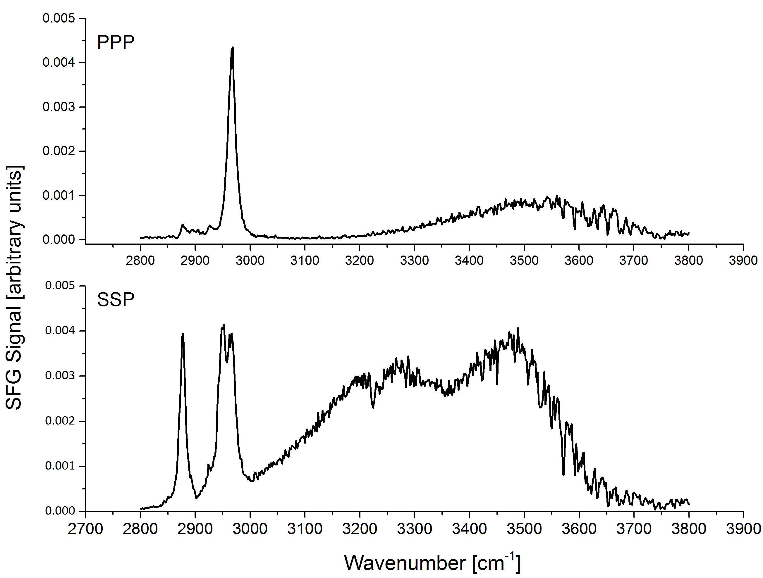

Figure S1 – SFG spectra of un-deuterated surfactin in H₂O (10 x CMC) in the C-H and O-H region.

Figure S2 - SFG spectra in the PPP polarisation of the C-H region of un-deuterated surfactin under different pH conditions in D₂O (10 x CMC).

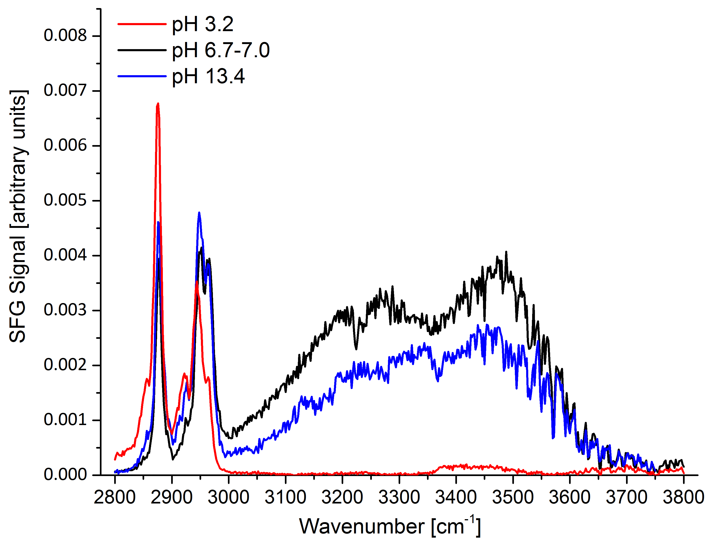
Figure S3 - SFG spectra in the SSP polarisation of the C-H and O-H region of un-deuterated surfactin under different pH conditions in H₂O (10 x CMC). The difference in water structure is due to the charge neutralisation of surfactin at low pH. Charged surfactants induce ordering in the water molecules, giving rise to the strong O-H resonances observed in the alkali and neutral spectra. These strong O-H resonances distort the peaks in the C-H region; hence we have largely relied on solutions in D₂O to consider the effect of pH on surfactin structure. The alkali water spectrum appears weaker than the neutral water spectrum. This might arise due to ion pairing with the Na⁺ ions with the surfactin, reducing the surface charge, and therefore the ordering and SFG response of the water. We also note that the water bands observed are complex – out of phase resonances may also reduce the apparent intensity.

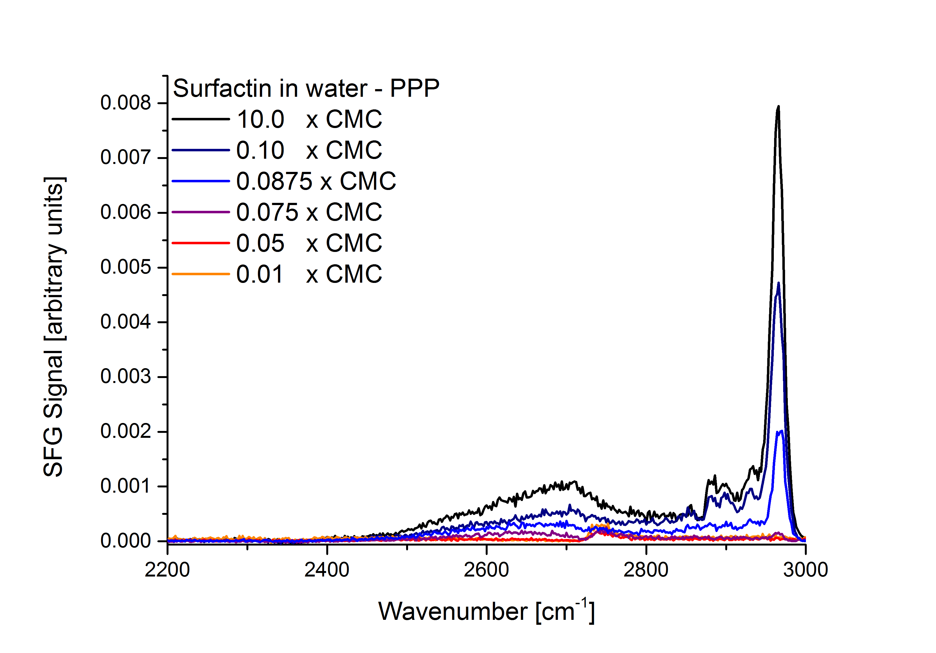
Figure S4 - Spectra of the O-D and C-H regions of un-deuterated surfactin in the PPP polarisation at different concentrations on D₂O. Since the ratios of the peaks are unchanging at different concentrations, and the ratios between concentrations are nearly identical for the SSP and PPP polarisations, we can obtain a rough estimate of the surface coverage at different bulk concentrations using the peak areas. Peak areas in SFG are proportional to the square of the number of molecules at the surface. Using the peak areas of the 0.1, and 0.0875 CMC solutions give a relative surface density of 76.52% and 46.51% with respect to the 10 CMC solution. The literature value for the molecular area of surfactin above the CMC at pH 7.5 is 147 Å, giving 190 Å and 312 Å for the 0.1 and 0.0875 CMC solutions, respectively.

Fitting Parameters
Fitting was done using “Origin Pro 9.1 64bit”, employing a least squares Levenberg-Marquardt algorithm to fit the resonances to Voigt line profiles. Peak Areas, Centres, Max Height, and the Full Width at Half Maximum are given in the table below. Where PPP spectra are included in the figures, the corresponding data has been given in the right column.
Figure and Spectral Region | SSP |  |  |  |  | PPP
 | Peak Index | Area Fit | Center Max | Max Height | FWHM | Peak Index | Area Fit | Center Max | Max Height | FWHM
Figure 1
2000-3000 | 1 | 0.13752 | 2852 | 0.002680 | 36.67 | 1 | 0.20414 | 2963.787 | 0.00817 | 15.99482
 | 2 | 0.16455 | 2875 | 0.009630 | 13.29 | 2 | 0.0158 | 2930.056 | 6.88E-04 | 14.71051
 | 3 | 0.0316 | 2922 | 0.001340 | 20.78 | 3 | 0.03093 | 2898.656 | 6.62E-04 | 29.72842
 | 4 | 0.05479 | 2944 | 0.002780 | 14.95 | 4 | 0.01253 | 2879.914 | 5.87E-04 | 13.58774
 | 5 | 0.04852 | 2966 | 0.001550 | 21.48 | 5 | 0.42509 | 2683.338 | 0.00107 | 252.1259
 | 6 | 0.02319 | 2764 | 0.000426 | 34.69
 | 7 | 0.0111 | 2814 | 0.000397 | 26.28
1500 -1800 | 1 | 0.01971 | 1669 | 0.000821 | 18.06
 | 2 | 0.0745 | 1741 | 0.002090 | 29.11
Figure 2
 | 1 | 0.00706 | 2065 | 0.000412 | 10.89 | 1 | 0.00823 | 2223.295 | 6.04E-04 | 8.67884
 | 2 | 0.0035 | 2039 | 0.000057 | 39.38 | 2 | 0.00813 | 2211.297 | 2.12E-04 | 24.47648
2000-2300 | 3 | 0.00576 | 2136 | 0.000155 | 23.64
 | 4 | 0.00143 | 2224 | 0.000128 | 7.11
 | 5 | 0.00372 | 2213 | 0.000086 | 27.49
Figure 3
pH 3.2 | 1 | 0.01342 | 2713 | 0.000120 | 105.13
 | 2 | 0.0462 | 2874 | 0.002550 | 14.56
 | 3 | 0.00769 | 2918 | 0.000396 | 15.57
 | 4 | 0.01578 | 2945 | 0.000792 | 15.85
 | 5 | 0.01113 | 2966 | 0.000470 | 17.63
 | 6 | 0.03463 | 2852 | 0.000556 | 39.67
pH 6.7 - 7.0 | 1 | 0.01342 | 2713 | 0.000120 | 105.13
 | 2 | 0.0462 | 2874 | 0.002550 | 14.56
 | 3 | 0.00769 | 2918 | 0.000396 | 15.57
 | 4 | 0.01578 | 2945 | 0.000792 | 15.85
 | 5 | 0.01113 | 2966 | 0.000470 | 17.63
 | 6 | 0.03463 | 2852 | 0.000556 | 39.67
pH 13.4 | 1 | 0.1646 | 2874 | 0.008630 | 14.14
 | 2 | 0.12378 | 2849 | 0.002020 | 38.95
 | 3 | 0.01901 | 2921 | 0.000832 | 21.47
 | 4 | 0.06474 | 2947 | 0.002820 | 18.04
 | 5 | 0.0268 | 2967 | 0.001590 | 12.87
Figure 4
 | 1 | 0.06812 | 2380 | 0.000905 | 70.10 | 1 | 0.20414 | 2963.787 | 0.00817 | 15.99482
10.0 CMC | 2 | -0.02584 | 2338 | -0.001250 | 18.61 | 2 | 0.0158 | 2930.056 | 6.88E-04 | 14.71051
 | 3 | -0.05872 | 2365 | -0.002380 | 23.20 | 3 | 0.03093 | 2898.656 | 6.62E-04 | 29.72842
 | 4 | 1.03198 | 2507 | 0.003210 | 270.10 | 4 | 0.01253 | 2879.914 | 5.87E-04 | 13.58774
 | 5 | 0.13752 | 2852 | 0.002680 | 36.67 | 5 | 0.42509 | 2683.338 | 0.00107 | 252.1259
 | 6 | 0.16455 | 2875 | 0.009630 | 13.29
 | 7 | 0.0316 | 2922 | 0.001340 | 20.78
 | 8 | 0.05479 | 2944 | 0.002780 | 14.95
 | 9 | 0.04852 | 2966 | 0.001550 | 21.48
 | 10 | 0.00549 | 2721 | 0.000273 | 16.73
 | 11 | 0.02319 | 2764 | 0.000426 | 34.69
 | 12 | 0.0111 | 2814 | 0.000397 | 26.28
0.1 0 CMC | 1 | 0.10559 | 2380 | 0.000933 | 106.32 | 1 | 0.12019 | 2964.399 | 0.00478 | 17.34516
 | 2 | -0.01431 | 2335 | -0.000630 | 19.26 | 2 | 0.01708 | 2929.775 | 6.03E-04 | 18.11231
 | 3 | -0.04939 | 2362 | -0.001340 | 29.56 | 3 | 0.01566 | 2900.044 | 5.70E-04 | 19.35835
 | 4 | 0.48702 | 2507 | 0.001460 | 215.98 | 4 | 0.00845 | 2881.349 | 5.02E-04 | 10.75234
 | 5 | 0.06686 | 2852 | 0.001290 | 37.08 | 5 | 0.0178 | 2852.571 | 2.92E-04 | 38.77294
 | 6 | 0.09586 | 2875 | 0.005410 | 12.61 | 6 | 0.2002 | 2686.726 | 5.33E-04 | 240.2015
 | 7 | 0.01498 | 2922 | 0.000686 | 20.51
 | 8 | 0.03037 | 2944 | 0.001450 | 17.22
 | 9 | 0.02118 | 2966 | 0.000699 | 22.89
 | 10 | 0.00466 | 2717 | 0.000100 | 29.60
 | 11 | 0.01329 | 2760 | 0.000199 | 49.13
0.0875 CMC | 1 | 0.05874 | 2380 | 0.000557 | 98.75 | 1 | 0.10819 | 2666.369 | 3.15E-04 | 234.2255
 | 2 | -0.01014 | 2335 | -0.000319 | 22.31 | 2 | 0.00814 | 2932 | 2.73E-04 | 20.14787
 | 3 | -0.03408 | 2362 | -0.000771 | 34.17 | 3 | 0.00601 | 2904.322 | 1.84E-04 | 21.8346
 | 4 | 0.30366 | 2507 | 0.001040 | 196.64 | 4 | 0.00386 | 2882 | 1.52E-04 | 16.20539
 | 5 | 0.03765 | 2852 | 0.000646 | 37.12 | 5 | 0.0091 | 2858 | 1.84E-04 | 32.13597
 | 6 | 0.03596 | 2875 | 0.002060 | 14.19 | 6 | 0.0437 | 2966.063 | 0.00207 | 16.51763
 | 7 | 0.00812 | 2922 | 0.000378 | 20.16
 | 8 | 0.01125 | 2946 | 0.000628 | 16.44
 | 9 | 0.01429 | 2968 | 0.000451 | 22.92
 | 10 | 0.00497 | 2717 | 0.000075 | 48.36
 | 11 | 0.00805 | 2760 | 0.000121 | 49.13
Figure S1
2800-3800 | 1 | 0.05925 | 2877 | 0.003720 | 10.69 | 1 | 0.0014 | 2924.222 | 1.20E-04 | 10.88581
 | 2 | 1.00E-03 | 2860 | 0.000058 | 11.48 | 2 | 0.00575 | 2900.014 | 1.46E-04 | 24.99969
 | 3 | 0.00266 | 2930 | 0.000154 | 11.48 | 3 | 0.00385 | 2878.399 | 2.64E-04 | 10.23315
 | 4 | 0.09734 | 2952 | 0.003560 | 18.12 | 4 | 0.09876 | 2966.611 | 0.00421 | 16.47662
 | 5 | 0.04514 | 2968 | 0.002620 | 11.48 | 5 | 0.30116 | 3507.254 | 8.23E-04 | 308.9462
 | 6 | 1.26114 | 3236 | 0.003060 | 263.69
 | 7 | 0.84434 | 3473 | 0.003250 | 170.67
Figure S2
pH 3.2 | 1 | 0.00829 | 2887 | 0.000143 | 36.98
 | 2 | 0.00374 | 2914 | 0.000063 | 39.90
 | 3 | 0.00502 | 2936 | 0.000170 | 27.11
 | 4 | 0.04661 | 2964 | 0.002300 | 17.50
pH 6.7 - 7.0 | 1 | 0.20414 | 2964 | 0.008170 | 15.99
 | 2 | 0.0158 | 2930 | 0.000688 | 14.71
 | 3 | 0.03093 | 2899 | 0.000662 | 29.73
 | 4 | 0.01253 | 2880 | 0.000587 | 13.59
 | 5 | 0.42509 | 2683 | 0.001070 | 252.13
ph 13.4 | 1 | 0.0052 | 2891 | 0.000156 | 24.56
 | 2 | 0.0033 | 2933 | 0.000152 | 13.81
 | 3 | 0.04849 | 2967 | 0.002010 | 17.49
 | 4 | 0.03946 | 3511 | 0.000144 | 257.31
 | 5 | 0.00129 | 2916 | 0.000035 | 27.41
Figure S3
pH 3.2 | 1 | 0.04946 | 2852 | 0.000925 | 34.03
 | 2 | 0.13402 | 2875 | 0.006640 | 12.86
 | 3 | 0.03209 | 2920 | 0.001220 | 16.70
 | 4 | 0.09698 | 2945 | 0.003270 | 18.87
 | 5 | 0.01611 | 2964 | 0.001120 | 9.17
 | 6 | 0.02741 | 3434 | 0.000149 | 117.11
pH 6.7 - 7.0 | 1 | 0.05925 | 2877 | 0.003720 | 10.69
 | 2 | 1.00E-03 | 2860 | 0.000058 | 11.48
 | 3 | 0.00266 | 2930 | 0.000154 | 11.48
 | 4 | 0.09734 | 2952 | 0.003560 | 18.12
 | 5 | 0.04514 | 2968 | 0.002620 | 11.48
 | 6 | 1.26114 | 3236 | 0.003060 | 263.69
 | 7 | 0.84434 | 3473 | 0.003250 | 170.67
pH 13.4 | 1 | 1230.168 | -78551 | 0.000011 | #########
 | 2 | 0.10321 | 2878 | 0.004410 | 14.89
 | 3 | 0.02517 | 2924 | 0.000823 | 25.28
 | 4 | 0.11843 | 2950 | 0.004330 | 20.09
 | 5 | 0.04329 | 2967 | 0.002510 | 13.38
 | 6 | 0.50854 | 3236 | 0.001680 | 268.32
 | 7 | 0.60329 | 3470 | 0.002170 | 238.54
Figure S4
10.0 CMC | 1 | 0.20414 | 2964 | 0.008170 | 15.99
 | 2 | 0.0158 | 2930 | 0.000688 | 14.71
 | 3 | 0.03093 | 2899 | 0.000662 | 29.73
 | 4 | 0.01253 | 2880 | 0.000587 | 13.59
 | 5 | 0.42509 | 2683 | 0.001070 | 252.13
0.10 CMC | 1 | 0.12019 | 2964 | 0.004780 | 17.35
 | 2 | 0.01708 | 2930 | 0.000603 | 18.11
 | 3 | 0.01566 | 2900 | 0.000570 | 19.36
 | 4 | 0.00845 | 2881 | 0.000502 | 10.75
 | 5 | 0.0178 | 2853 | 0.000292 | 38.77
 | 6 | 0.2002 | 2687 | 0.000533 | 240.20
0.0875 CMC | 1 | 0.10819 | 2666 | 0.000315 | 234.23
 | 2 | 0.00814 | 2932 | 0.000273 | 20.15
 | 3 | 0.00601 | 2904 | 0.000184 | 21.83
 | 4 | 0.00386 | 2882 | 0.000152 | 16.21
 | 5 | 0.0091 | 2858 | 0.000184 | 32.14
 | 6 | 0.0437 | 2966 | 0.002070 | 16.52

Preparation and Analysis of partially deuterated Surfactin

Production of partially deuterated surfactin was carried out following the protocol described by Shen et al.¹ Bacillus subtilis BBK006, kindly provided by Dr Peter Martin (University of Manchester), was inoculated into LB medium and incubated at 30 °C for 16 hours. A 1% subculture was inoculated into 20 mL of M9 minimal medium (glucose, 0.2 % w/v; Na₂HPO₄.2H₂O, 34 mM; KH₂PO₄, 22 mM; NaCl, 8.6 mM; NH₄Cl, 9.4 mM; MgSO₄, 1 mM; CaCl₂, 0.3 mM; biotin, 1 μg/L; thiamin, 1 μg/L; EDTA, 0.13 mM; FeCl₃, 31 μM; ZnCl₂, 6.2 μM; CuCl₂, 0.76 μM; CoCl₂, 0.42 μM; H₃BO₃, 1.6 μM; MnCl₂, 0.08 μM) and the culture was incubated at 30 °C for 48 hours with shaking at 250 rpm. This seed culture was used to inoculate (10 %) 2 x 100 mL of M9 minimal medium containing 0.04% (w/v) deuterated D/L-leucine (D₁₀), in 500 mL unbaffled shake flasks. The culture was incubated at 30 °C for 48 hours with shaking at 250 rpm. Cells were removed by centrifugation and the supernatant subjected to sterile filtration then acidified to pH 2 with 1M HCl, whereupon a fine precipitate was formed. The precipitate was extracted using CH₂Cl₂, and after drying over MgSO₄, the solvent was removed in vacuo. Further purification was achieved following the protocol described by Cooper et al.² The extract was dissolved in H₂O by neutralizing to pH 7 using 1M NaOH. The resulting solution was filtered, and surfactin was then precipitated by acidifying to pH 2. The white solid (16 mg) was collected by centrifugation, the aqueous layer removed and residual water removed by lyophilization.

High resolution mass spectroscopy was carried out using positive ion electrospray ionization on a Waters Xevo G2-S QTOF (Figure S5). Labelled surfactins A, B and C were identified, with masses indicating that the labile deuterium atoms located at the alpha-carbon of the leucine residues had been replaced by protons during the course of the fermentation, such that 9 deuterium atoms were incorporated per leucine residue. All species observed featured incorporation of deuterium at all four leucine residues. In addition, surfactins A and C featuring D₉ labelling of the fatty acid side-chain were observed, presumably via the conversion of leucine-D₁₀ into isovaleryl-CoA and its subsequent use as a starter unit for fatty acid biosynthesis.
Surfactin A-D₃₆, m/z = 1044.8840 [M+H]⁺, (calc. for C₅₁H₅₄D₃₆ N₇O₁₃ 1044.8821);
Surfactin A-D₄₅, m/z = 1053.9423 [M+H]⁺, (calc. for C₅₁H₄₅D₄₅ N₇O₁₃ 1053.9377);
Surfactin B-D₃₆ , m/z = 1058.9019 [M+H]⁺, (calc. for C₅₂H₅₆D₃₆ N₇O₁₃ 1058.8978);
Surfactin C-D₃₆, m/z = 1072.9153 [M+H]⁺, (calc. for C₅₃H₅₈D₃₆ N₇O₁₃ 1072.913);
Surfactin C-D₄₅, m/z = 1081.9728 [M+H]⁺, (calc. for C₅₃H₄₈D₄₅ N₇O₁₃ 1081.969).

NMR data were recorded using a Bruker 400 MHz Avance III HD Spectrometer (Figure S6).
δ_{H} (500 MHz, DMSO-D6) 8.41 (1H, d, 7.1 Hz), 8.13, (1H, d, 7.1 Hz), 8.03 (1H, br s), 7.98 (1H, br s), 7.83 (1H, d, 4.6 Hz), 7.59 (1H, d, 8.0 Hz), 5.07 (1H, q, 6.13 Hz), 4.55 (1H, dd, 8.0, 4.7 Hz), 4.34 (1H, d, 8.5 Hz), 4.15 (2H, m), 4.05 (2H, m), 2.74 (1H, dd, 16.8, 4.3 Hz), 2.59 (1H, dd, 16.8, 9.3 Hz), 2.32 (1H, dd, 14.0, 7.9 Hz), 2.24 (2H, t, 8.0 Hz), 2.00 (1H, m), 1.92 (1H, m), 1.81 (1H, m), 1.56-1.49 (3H, br m), 1.29-1.17 (14 H, br m), 0.88-0.78 (9H, m).

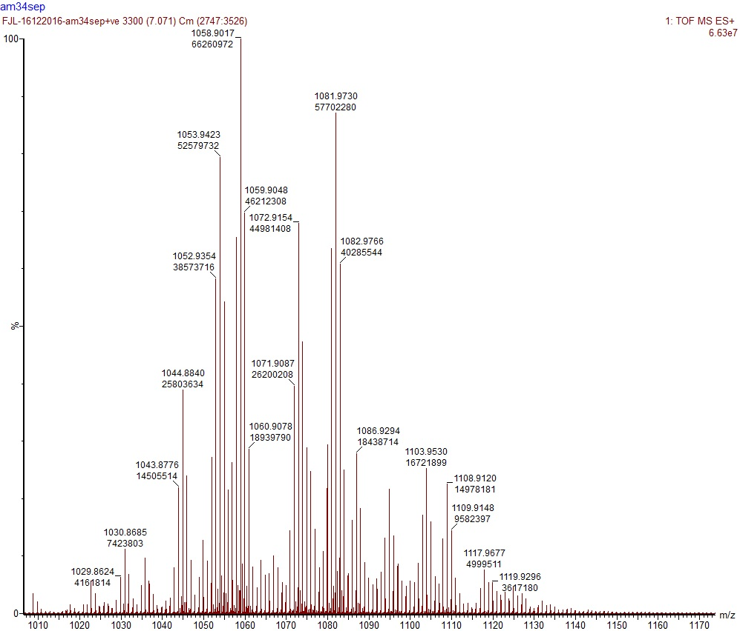
Figure S5 - High resolution mass spectrometric (positive mode) analysis of deuterium labelled surfactin mixtures obtained by fermentation of Bacillus subtilis BBK006 in M9 minimal medium containing 0.04% (w/v) D/L-leucine (D₁₀).

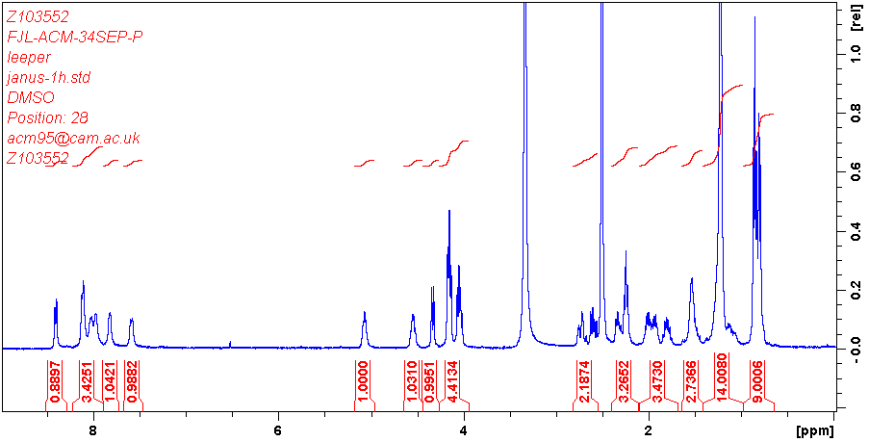
Figure S6 - ¹H NMR (DMSO-D6) of deuterium labelled surfactin mixtures obtained by fermentation of Bacillus subtilis BBK006 in M9 minimal medium containing 0.04% (w/v) D/L-leucine (D₁₀).

Supporting Information References:
- Aggregation of the Naturally Occurring Lipopeptide, Surfactin, at Interfaces and in Solution: An Unusual Type of Surfactant? H.-H. Shen, R. K. Thomas, C.-Y. Chen, R. C. Darton, S. C. Baker, J. Penfold, Langmuir, 2009, 25, 4211-4218

- Enhanced Production of Surfactin from Bacillus subtilis by Continuous Product Removal and Metal Cation Additions, D. G. Cooper, C. R. MacDonald, S. J. B. Duff, N. Kosaric, Appl. Envir. Microbiol., 1981, 42, (3), 408-412

