ONLINE-ONLY TEXT Supplementary Methods Regarding Immunohistochemistry and Analysis

eTABLES

eTable 1. Epithelial Ovarian Cancer Study Sites
eTable 2. Clinical Characteristics of 5,577 Epithelial Ovarian Cancer Patients and Associations with Overall Survival
eTable 3. Distribution of CD8⁺ Tumor Infiltrating Lymphocytes by Histopathological Groups, N (row %)
eTable 4. Multivariate-Adjusted Association of CD8⁺ Tumor Infiltrating Lymphocytes and Overall Survival among HGSOC Cases with Information on Residual Disease (N=2,173)
eTable 5. Association of CD8⁺ Tumor Infiltrating Lymphocytes and Overall Survival by Histopathological Groups, and among HGSOC Cases by Disease Stage (N=3,128) and by Age at Diagnosis (N=3,196)
eTable 6. Association of CD8⁺ Tumor Infiltrating Lymphocytes and Progression-Free Survival among Cases with the Five Most Common Invasive Epithelial Ovarian Cancer Histotypes (N=2,681)
eTable 7. Multivariate-Adjusted Association of CD8⁺ Tumor Infiltrating Lymphocytes and Overall Survival among HGSOC Cases by Extent of Residual Disease (N=2,173), by Pathogenic Mutation Status (N=1,043), and by First Line Chemotherapy (N=501)
eTable 8. Association of CD8⁺ Tumor Infiltrating Lymphocytes and Overall Survival among HGSOC Cases Rescored for Numeric Levels (N=1,449)
eTable 9. Association of CD8⁺ Tumor Infiltrating Lymphocytes and Overall Survival among HGSOC Cases Rescored for Numeric Levels (N=1,449) Using a Range of Dichotomizations
eFIGURES
eFigure Legends
eFigure 1. Kaplan-Meier Curve Showing Survival of Endometrioid Ovarian Carcinomas Reclassified as High-Grade Serous Ovarian Carcinomas (HGSOC) Based on WT1 and p53.
eFigure 2. Evaluation of CD8⁺ Tumor-Infiltrating Lymphocytes (TIL)
eFigure 3. Distribution of CD8⁺ Tumor-Infiltrating Lymphocytes (TIL) among the Five Most Common Invasive Ovarian Cancer Histotypes, and among High-Grade Serous Ovarian Carcinomas (HGSOC) by Extent of Residual Disease and by Pathogenic Mutation Status
eFigure 4. Kaplan-Meier Overall Survival Plots by CD8⁺ Tumor-Infiltrating Lymphocyte (TIL) Levels for Clear Cell and Low-Grade Serous Ovarian Carcinoma
eFigure 5. Assessment of the Functional Form of Numeric CD8⁺ Tumor-Infiltrating Lymphocyte (TIL) Levels in a Subset of 1,449 Women with HGSOC

Online-Only Text
Immunohistochemistry
Staining at the Mayo Clinic (84% of patients) used the Leica Bond RX stainer (Leica, Buffalo, IL). Dewaxing using Bond Dewax (Leica, Buffalo, IL) and antigens retrieved for 10 minutes using Epitope Retrieval 2 (Leica, Buffalo, IL). The primary antibody (Clone 144B, Dako, Carpinteria, CA) was diluted in Bond Antibody Diluent (Leica, Buffalo, IL) at 1:200 and slides incubated for 15 minutes at room temperature. The detection system was Polymer Refine Detection System (Leica, Buffalo, IL) with visualization using DAB. Slides were counterstained using Schmidt hematoxylin. For two studies (SEA, MAY1), we used previously stained slides, given marker robustness and good visual agreement on re-stained cases. SEA retrieval used citrate-based unmasking solution and a Dako Autostainer at the University of Cambridge, while MAY1 used EDTA (Chem Lab) and monoclonal CD8 antibody (Dako; M7103) diluted at 1:100 followed by EnVision™⁺ Dual Link detection system (Dako K4061) at the Mayo Clinic.
Analysis
Intra-tumoral heterogeneity of CD8 values across the multiple cores measured within an individual was examined using intraclass correlation coefficients (ICCs). Specifically, we used the ICC(3,1) method of Shrout and Fleiss (Psychol Bull. 1979;86(2):420-428), assuming a fixed core effect and accounting for the fact that each core was read by the same two pathologists. Overall survival was defined as time from diagnosis to death from any cause, right-censoring at 10 years and accounting for left truncation due to any delayed patient enrollment. For primary associations, we also examined associations using unordered, three degree-of-freedom tests. Progression-free survival analyses considered time from diagnosis to disease progression as provided by each study (eTable 1). Proportional hazards assumptions were formally tested (and not violated), all tests were two-sided and based on a nominal p=0.05 level of significance uncorrected for multiple testing, and all analyses used SAS and R software. Conservatively considering 20 primary tests of hypothesis regarding associations of CD8⁺ TILs with overall survival (five major invasive histotypes, five subsets of HGSOCs, and 10 other histopathological groupings), one could alternatively utilize p=0.0025 as a statistical significance threshold.

eTable 1.

Study | Name |  |  | Ref- erence | Location |  | Years |  | Ascertainment of Patients and Clinical Data |  | Pathology Data and Review |  | N (%) |  |  | High-grade serous N (%)
VAN | Vancouver Ovarian Cancer Study |  |  | (1, 2) | Canada |  | 1984-2000 |  | Ovarian Cancer Registry serving British Columbia and the Cheryl Brown Outcomes Unit |  | Central review of pathology reports and histological slides by University of British Columbia pathologists |  | 1,007 (18%) |  |  | 591 (18%)
AOV | Alberta Ovarian Tumor Types Study |  |  | (3) | Canada |  | 1978-2010 |  | Population-based Alberta Cancer Registry; annual updates are performed for vital statistics |  | Pathology reports and histological slides review by the study pathologist |  | 579 (10%) |  |  | 77 (2%)
SEA | Study of Epidemiology and Risk Factors in Cancer Heredity |  |  | (4) | UK |  | 1998-2008 |  | Eastern Region Cancer Intelligence Unit, West Midlands Cancer Intelligence Unit, and multiple cancer networks |  | Pathology reports and histological slides reviewed by study pathologist |  | 476 (9%) |  |  | 231 (7%)
MAY1 | Mayo Clinic Ovarian Cancer Study |  |  | (5) | US |  | 2000-2009 |  | Mayo Clinic medical records and death certificates |  | Pathology reports and histologic slides reviewed by Mayo Clinic gynecologic pathologists |  | 432 (8%) |  |  | 323 (10%)
NOT | Nottingham Study |  |  | (6) | UK |  | 1991-2011 |  | Hospital records and Trent cancer registry |  | Pathology reports reviewed by gynecologic pathologist |  | 406 (7%) |  |  | 247 (8%)
MAY2 | Mayo Clinic Ovarian Cancer Study |  |  | (5) | US |  | 2009-2013 |  | Mayo Clinic medical records and death certificates |  | Pathology reports and histologic slides reviewed by Mayo Clinic gynecologic pathologists |  | 308 (5%) |  |  | 244 (8%)
STA | Genetic Epidemiology of Ovarian Cancer Study |  |  | (7) | US |  | 1997-2001 |  | Greater Bay Area Cancer Registry |  | Pathology reports and histological slides reviewed by study pathologist |  | 343 (6%) |  |  | 168 (5%)
LAX | Women's Cancer Research Program - Cedars-Sinai Medical Center |  |  | (8) | US |  | 1989-2009 |  | Women's Cancer Program Biorepository |  | Pathology reports and histological slides reviewed by the Department of Pathology and Laboratory Medicine at Cedars-Sinai Medical Center |  | 246 (4%) |  |  | 242 (8%)
BAV | Bavarian Ovarian Cancer Study |  |  | (9) | Germany |  | 2002-2006 |  | Gynecologic Oncology Center at the Comprehensive Cancer Center Erlangen- Nuremberg |  | Centralized review of pathology reports and histological slides for all patients by study pathologists |  | 210 (4%) |  |  | 132 (4 %)
WMH | Westmead Hospital, Gynaecological Oncology Biobank (GynBiobank) |  |  | (10) | Australia |  | 1992-2014 |  | The Crown Princess Mary Cancer Centre and affiliated hospitals |  | Pathology reports and diagnostic slides reviewed by panel of gynecologic pathologists |  | 200 (4%) |  |  | 134 (4%)
TUE | Tuebingen University Hospital |  |  | - | Germany |  | 1999-2008 |  | Department of Obstetrics and Gynaecology, Eberhard Karls Universitats Tübingen, Tübingen Germany |  | Pathology reports and histologic slides reviewed by gynecologic pathologist |  | 188 (3%) |  |  | 147 (5%)
TVA | Ovarian Cancer in Alberta |  |  | (11) | Canada |  | 2005-2011 |  | Alberta Cancer Registry and affiliated hospitals |  | Pathology reports and histological slides reviewed by study pathologist (MK) |  | 154 (3%) |  |  | 84 (3%)
POC | Polish Ovarian Cancer Study |  |  | (12) | Poland |  | 2000-2003 |  | Hospital records and cancer registries serving Warsaw and Lodz |  | Histological slides reviewed by study pathologist |  | 130 (2%) |  |  | 81 (3%)
HAW | Hawaii Ovarian Cancer Study |  |  | (13, 14) | US |  | 1993-2008 |  | Hawaii Tumor Registry and medical records |  | Pathology reports and histological slides reviewed by study pathologist |  | 126 (2%) |  |  | 60 (2%)
CNI | CNIO Ovarian Cancer Study |  |  | (15) | Spain |  | 2006-2013 |  | Hospitals in Madrid in Medical Oncology Divisions |  | Pathology information was obtained from medical charts of the patients used in the Medical Oncology Units |  | 118 (2%) |  |  | 54 (2%)
BRZ |  | Ribeirao Preto Ovarian Cancer Study | - |  |  | Brazil |  | 1987-2010 |  | University Hospital of Ribeirao Preto School of Medicine (HCRP), case series with prospective follow up |  | Pathology reports and histologic slides reviewed by HCRP gynecologic pathologists |  | 110 (2%) | 57 (2%)
UKO |  | United Kingdom Ovarian Cancer Population study | (16) |  |  | UK |  | 2006-2010 |  | Ten major Gynecologic Oncology NHS centers in England, Wales and Northern Ireland; cancer registries; NHS Information Centre for Health and Social Care (England and Wales) and Central Services Agency (Northern Ireland) |  | Central review of pathology reports by gynecologic oncologist |  | 109 (2%) | 59 (2%)
CAL |  | Calgary Serous Carcinoma Study | (17) |  |  | Canada |  | 2003-2007 |  | Hospital based retrospective observational study |  | Histological review of all slides by study pathologist supported by centralized biomarker analysis |  | 103 (2%) | 75 (2%)
AOC |  | Australian Ovarian Cancer Study | (18) |  |  | Australia |  | 2002-2006 |  | Treatment centers throughout Australia; cancer registries serving Queensland, South and West Australia; regular follow- up by medical record review |  | Pathology reports and diagnostic slides reviewed by panel of gynecologic pathologists |  | 94 (2%) | 90 (3%)
GER |  | Germany Ovarian Cancer Study | (19) |  |  | Germany |  | 1993-1996 |  | 26 hospitals in the study regions |  | Pathology reports were requested from the respective pathology institutes. Tissue samples were provided by the tissue bank of the National Center for Tumor Diseases (NCT, Heidelberg, Germany) in accordance with the regulations of the tissue bank and the approval of the ethics committee of Heidelberg University and by other pathology institutes. Histological slides were reviewed by gynecologic pathologist at the University of Heidelberg |  | 84 (1%) | 41 (1%)
MAL |  | Malignant Ovarian Cancer Study | (20, 21) |  |  | Denmark |  | 1994-1999 |  | Gynecological departments in Copenhagen, Frederiksberg and 7 surrounding counties |  | Review of pathology reports for all patients and histological slides for 30% by gynecologic pathologist |  | 57 (1%) | 7 (<1%)
SOC |  | Southampton Ovarian Cancer Study | (22) |  |  | UK |  | 1993-1998 |  | Hospitals in the Wessex region of southern England |  | Original pathology report |  | 55 (1%) | 26 (1%)
HOP |  | Hormones and Ovarian Cancer PrEdiction | (23) |  |  | US |  | 2003-2009 |  | Hospital registries and active surveillance of medical practices in Western PA, Northeastern OH, and Western NY |  | Medical chart review for all cases |  | 42 (1%) | 26 (1%)
 |  |  |  |  |  |  |  |  |  |  |  |  |  | 5,577 | 3,196
- Prentice LM, Klausen C, Kalloger S, Kobel M, McKinney S, Santos JL, et al. Kisspeptin and GPR54 immunoreactivity in a cohort of 518 patients defines favourable prognosis and clear cell subtype in ovarian carcinoma. BMC Med. 2007;5:33.
- Kobel M, Reuss A, Bois A, Kommoss S, Kommoss F, Gao D, et al. The biological and clinical value of p53 expression in pelvic high-grade serous carcinomas. J Pathol. 2010;222:191-8.
- Köbel M, Madore J, Ramus SJ, Clarke BA, Pharoah PDP, Deen S, et al. Evidence for a time-dependent association between FOLR1 expression and survival from ovarian carcinoma: Implications for clinical testing. An Ovarian Tumor Tissue Analysis consortium study. Br J Cancer. 2014;111:2297-307.
- Song H, Ramus SJ, Quaye L, Dicioccio RA, Tyrer J, Lomas E, et al. Common variants in mismatch repair genes and risk of invasive ovarian cancer. Carcinogenesis. 2006;27:2235-42.
- Goode EL, Chenevix-Trench G, Hartmann LC, Fridley BL, Kalli KR, Vierkant RA, et al. Assessment of hepatocyte growth factor in ovarian cancer mortality. Cancer Epidemiol Biomarkers Prev. 2011;20:1638-48.
- Williams E, Martin S, Moss R, Durrant L, Deen S. Co-expression of VEGF and CA9 in ovarian high-grade serous carcinoma and relationship to survival. Virchows Arch. 2012;461:33-9.
- McGuire V, Felberg A, Mills M, Ostrow KL, DiCioccio R, John EM, et al. Relation of contraceptive and reproductive history to ovarian cancer risk in carriers and noncarriers of BRCA1 gene mutations. Am J Epidemiol. 2004;160:613-8.
- Ramus SJ, Antoniou AC, Kuchenbaecker KB, Soucy P, Beesley J, Chen X, et al. Ovarian cancer susceptibility alleles and risk of ovarian cancer in BRCA1 and BRCA2 mutation carriers. Hum Mutat. 2012;33:690-702.
- Hein A, Thiel FC, Bayer CM, Fasching PA, Haberle L, Lux MP, et al. Hormone replacement therapy and prognosis in ovarian cancer patients. Eur J Cancer Prev. 2013;22:52-8.
- Emmanuel C, Chiew YE, George J, Etemadmoghadam D, Anglesio MS, Sharma R, et al. Genomic classification of serous ovarian cancer with adjacent borderline differentiates RAS pathway and TP53-mutant tumors and identifies NRAS as an oncogenic driver. Clin Cancer Res. 2014;20:6618-30.
- Cook LS, Leung AC, Swenerton K, Gallagher RP, Magliocco A, Steed H, et al. Adult lifetime alcohol consumption and invasive epithelial ovarian cancer risk in a population-based case-control study. Gynecol Oncol. 2015.
- Garcia-Closas M, Brinton LA, Lissowska J, Richesson D, Sherman ME, Szeszenia-Dabrowska N, et al. Ovarian cancer risk and common variation in the sex hormone-binding globulin gene: a population-based case-control study. BMC cancer. 2007;7:60.
- Goodman MT, Lurie G, Thompson PJ, McDuffie KE, Carney ME. Association of two common single-nucleotide polymorphisms in the CYP19A1 locus and ovarian cancer risk. Endocr Relat Cancer. 2008;15:1055-60.
- Lurie G, Wilkens LR, Thompson PJ, McDuffie KE, Carney ME, Terada KY, et al. Genetic polymorphisms in the Paraoxonase 1 gene and risk of ovarian epithelial carcinoma. Cancer Epidemiol Biomarkers Prev. 2008;17:2070-7.
- Kamieniak MM, Rico D, Milne RL, Munoz-Repeto I, Ibanez K, Grillo MA, et al. Deletion at 6q24.2-26 predicts longer survival of high-grade serous epithelial ovarian cancer patients. Mol Oncol. 2015;9:422-36.
- Balogun N, Gentry-Maharaj A, Wozniak EL, Lim A, Ryan A, Ramus SJ, et al. Recruitment of newly diagnosed ovarian cancer patients proved challenging in a multicentre biobanking study. J Clin Epidemiol. 2011;64:525-30.
- Bromley AB, Altman AD, Chu P, Nation JG, Nelson GS, Ghatage P, et al. Architectural patterns of ovarian/pelvic high-grade serous carcinoma. Int J Gynecol Pathol. 2012;31:397- 404.
- Merritt MA, Green AC, Nagle CM, Webb PM. Talcum powder, chronic pelvic inflammation and NSAIDs in relation to risk of epithelial ovarian cancer. Int J Cancer. 2008;122:170-6.
- Peterlongo P, Chang-Claude J, Moysich KB, Rudolph A, Schmutzler RK, Simard J, et al. Candidate genetic modifiers for breast and ovarian cancer risk in BRCA1 and BRCA2 mutation carriers. Cancer Epidemiol Biomarkers Prev. 2015;24:308-16.
- Glud E, Kjaer SK, Thomsen BL, Hogdall C, Christensen L, Hogdall E, et al. Hormone therapy and the impact of estrogen intake on the risk of ovarian cancer. Arch Intern Med. 2004;164:2253-9.
- Soegaard M, Jensen A, Hogdall E, Christensen L, Hogdall C, Blaakaer J, et al. Different risk factor profiles for mucinous and nonmucinous ovarian cancer: results from the Danish MALOVA study. Cancer Epidemiol Biomarkers Prev. 2007;16:1160-6.
- Baxter SW, Choong DY, Eccles DM, Campbell IG. Transforming growth factor beta receptor 1 polyalanine polymorphism and exon 5 mutation analysis in breast and ovarian cancer. Cancer epidemiology, biomarkers & prevention : a publication of the American Association for Cancer Research, cosponsored by the American Society of Preventive Oncology. 2002;11:211-4.
- Lo-Ciganic WH, Zgibor JC, Bunker CH, Moysich KB, Edwards RP, Ness RB. Aspirin, nonaspirin nonsteroidal anti-inflammatory drugs, or acetaminophen and risk of ovarian cancer. Epidemiology. 2012;23:311-9.

eTable 2.

 | Mean, median (range) | Site-Adjusted HR (95% CI)
Age at diagnosis, years | 58.4, 58.2 (16-95) | 1.027 (1.024-1.030)
Time to study entry, months | 4.4, 0 (0-118.7) | NA
Time to last follow-up, months | 57.4, 48.9 (0.1-120.0) | NA
 | N (%) | Age- and Site-Adjusted HR (95% CI)
Vital status at last follow-up
Living | 2,555 (46%) | NA
Deceased | 3,022 (54%)
Tumor behavior
Borderline (atypical proliferative) | 185 (3%) | ref.
Invasive | 5,392 (97%) | 5.97 (3.69-9.64)
Histology
High-grade serous | 3,196 (57%) | 2.17 (1.98-2.37)
Endometrioid | 729 (13%) | 0.39 (0.33-0.45)
Clear cell | 648 (12%) | 0.78 (0.68-0.89)
Mucinous | 343 (6%) | 0.70 (0.58-0.84)
Low-grade serous | 162 (3%) | 0.98 (0.78-1.23)
Mucinous borderline | 122 (2%) | 0.20 (0.11-0.35)
Serous borderline | 51 (<1%) | 0.17 (0.07-0.42)
Mixed histology | 120 (2%) | 0.82 (0.62-1.08)
Undifferentiated/poorly differentiated epithelial | 71 (1%) | not estimated
Unknown, but known to be epithelial | 69 (1%) | not estimated
Other specified epithelial | 45 (1%) | not estimated
Endometrioid borderline | 10 (<1%) | not estimated
Serous, unknown-grade | 9 (<1%) | not estimated
Clear cell borderline | 1 (<1%) | not estimated
Other specified epithelial borderline | 1 (<1%) | not estimated
Stage
FIGO I, II | 2,240 (42%) | ref.
FIGO III, IV | 3,139 (58%) | 4.11 (3.74-4.52)
Unknown | 198
Grade
Low | 668 (14%) | ref.
High | 4,270 (86%) | 2.35 (2.03-2.74)
Not Applicable/Unknown | 639
Race
White | 2,628 (79%) | ref.
Presumed white | 362 (11%) | 0.78 (0.54-1.13)
Asian | 177 (5%) | 0.89 (0.67-1.20)
Black | 30 (1%) | 1.49 (0.95-2.34)
Other | 115 (3%) | 1.05 (0.77-1.44)
Unknown | 2,265
Ethnicity
Not Hispanic | 3,264 (99%) | ref.
Hispanic | 47 (1%) | 1.66 (1.00-2.75)
Unknown | 2,266
HR, hazard ratio, CI, confidence interval; FIGO, International Federation of Gynecologic Oncologists; ; for histology, analyses compare histologic category of interest to all others combined; NA, not applicable; age at diagnosis HR estimated per year change in risk based on log-linear association adjusted for only study site; ref., referent group.
eTable 3

 | Extent of CD8⁺ Tumor Infiltrating Lymphocytes (TIL)
 | Negative Low Moderate High | Total
All invasive | 1,367 (25%) 977 (18%) 2,065 (38%) 983 (18%) | 5,392
Serous | 593 (18%) 590 (18%) 1,461 (43%) 723 (21%) | 3,367
High-grade serous (HGSOC) | 546 (17%) 546 (17%) 1,394 (44%) 710 (22%) | 3,196
Low-grade serous (HGSOC) | 43 (27%) 44 (27%) 63 (39%) 12 (7%) | 162
Endometrioid (ENOC) | 206 (28%) 130 (18%) 283 (39%) 110 (15%) | 729
Grade 1 endometrioid | 84 (25%) 47 (14%) 158 (47%) 46 (14%) | 335
Grade 2/3 endometrioid | 109 (31%) 71 (20%) 114 (32%) 58 (16%) | 352
Clear cell (CCOC) | 309 (48%) 141 (22%) 118 (18%) 80 (12%) | 648
Mucinous (MOC) | 168 (49%) 77 (22%) 85 (25%) 13 (4%) | 343
All borderline | 44 (24%) 48 (26%) 79 (43%) 14 (8%) | 185
Serous borderline | 8 (16%) 8 (16%) 31 (61%) 4 (8%) | 51
Mucinous borderline | 36 (30%) 39 (32%) 39 (32%) 8 (7%) | 122
Serous borderline or invasive | 601 (18%) 598 (17%) 1,492 (44%) 727 (21%) | 3,418
Mucinous borderline or invasive | 204 (44%) 116 (25%) 124 (27%) 21 (5%) | 465
Low-grade serous or serous borderline | 51 (24%) 52 (24%) 94 (44%) 16 (8%) | 213
Total | 1,411 (25%) 1,025 (18%) 2,144 (38%) 997 (18%) | 5,557
Levels based on counts of CD8⁺ TIL per high-powered field: negative, none; low, 1-2; moderate, 3-19; high, 20+; numbers do not sum to total due to inclusion in sub-groups indicated by indentation as well as inclusion of patients with tumors of unknown grade, histotype, or tumor behavior where appropriate.

eTable 4.

 |  |  |  | Adjusted for age, study, and stage |  |  | Adjusted for age, study, stage, and residual disease
CD8⁺ TILs | N | Person-Years | % events | HR (95% CI) | P value trend | P value 3 d.f. | HR (95% CI) | P value trend | P value 3 d.f.
Negative | 379 | 1,216.48 | 75.7% | ref. | 1.9 x 10⁻¹¹ | 4.5 x 10⁻¹⁰ | ref. | 5.2 x 10⁻¹¹ | 1.9 x 10⁻⁹
Low | 375 | 1,269.84 | 72.8% | 0.92 (0.78-1.08) |  |  | 0.91 (0.77-1.07)
Moderate | 926 | 3,617.14 | 68.9% | 0.78 (0.67-0.89) |  |  | 0.76 (0.66-0.88)
High | 493 | 2,126.94 | 57.2% | 0.58 (0.49-0.69) |  |  | 0.59 (0.50-0.70)
Covariates were study, age (continuous), stage (I/II, III/IV, unknown), residual disease (macroscopic, not macroscopic). Levels based on counts of CD8⁺ TIL per high-powered field: negative, none; low, 1-2; moderate, 3-19; high, 20+; HR, hazard ratio, CI, confidence interval; P value trend, from a one degree-of-freedom trend test; P value 3 d.f., from an unordered three degree-of-freedom test.

eTable 5.

 | CD8+ TILs | N | Person- years | % Events | HR (95% CI) | P value trend | P value 3 d.f.
Histological group
Grade 1 endometrioid | Negative | 84 | 531.29 | 23.8% | ref | 0.12 | 0.33
 | Low | 47 | 259.83 | 29.8% | 0.98 (0.47-2.07)
 | Moderate | 158 | 1,046.10 | 14.6% | 0.58 (0.31-1.11)
 | High | 46 | 304.93 | 10.9% | 0.71 (0.24-2.06)
Grade 2/3 endometrioid | Negative | 109 | 544.02 | 40.4% | ref | 0.033 | 0.038
 | Low | 71 | 345.33 | 40.8% | 0.73 (0.44-1.21)
 | Moderate | 114 | 732.59 | 22.8% | 0.46 (0.27-0.78)
 | High | 58 | 331.94 | 31.0% | 0.71 (0.39-1.30)
Serous invasive | Negative | 593 | 1,920.42 | 74.4% | ref | 8.7 x 10⁻¹⁵ | 7.8 x 10⁻¹⁴
 | Low | 590 | 2,093.29 | 71.9% | 0.89 (0.78-1.01)
 | Moderate | 1,461 | 5,556.74 | 68.0% | 0.80 (0.71-0.90)
 | High | 723 | 3,161.67 | 56.2% | 0.59 (0.51-0.67)
All borderline | Negative | 44 | 313.25 | 6.8% | ref | 0.95 | 0.30
 | Low | 48 | 364.00 | 16.7% | 2.19 (0.57-8.47)
 | Moderate | 79 | 598.50 | 5.1% | 0.80 (0.17-3.74)
 | High | 14 | 72.85 | 14.3% | 2.61 (0.37-18.4)
All invasive | Negative | 1,367 | 5,789.03 | 55.4% | ref | 3.8 x 10-¹⁵ | 1.7 x 10⁻¹³
 | Low | 977 | 3,992.97 | 59.0% | 0.90 (0.81-1.00)
 | Moderate | 2,065 | 8,959.56 | 57.2% | 0.79 (0.72-0.87)
 | High | 983 | 4,560.65 | 49.8% | 0.64 (0.57-0.72)
Serous borderline or invasive | Negative | 601 | 1,968.40 | 73.4% | ref | 3.6 x 10⁻¹⁴ | 3.8 x 10⁻¹³
 | Low | 598 | 2,134.78 | 71.4% | 0.89 (0.78-1.02)
 | Moderate | 1,492 | 5,766.96 | 66.8% | 0.80 (0.72-0.90)
 | High | 727 | 3,177.38 | 55.8% | 0.59 (0.52-0.68)
Mucinous borderline or invasive | Negative | 204 | 1,016.03 | 37.7% | ref | 0.034 | 0.074
 | Low | 116 | 689.15 | 25.0% | 0.88 (0.56-1.38)
 | Moderate | 124 | 784.01 | 20.2% | 0.54 (0.34-0.86)
 | High | 21 | 109.96 | 23.8% | 1.07 (0.41-2.83)
Low-grade serous or serous borderline | Negative | 51 | 246.04 | 41.2% | ref | 0.67 | 0.94
 | Low | 52 | 226.38 | 61.5% | 1.07 (0.58-1.98)
 | Moderate | 94 | 482.34 | 34.0% | 0.95 (0.52-1.74)
 | High | 16 | 65.25 | 31.3% | 0.80 (0.29-2.24)
Serous borderline | Negative | 8 | 47.98 | 0 | ref | 0.71 | 1.00
 | Low | 8 | 41.49 | 37.5% | not estimated
 | Moderate | 31 | 210.21 | 6.5% | not estimated
 | High | 4 | 15.72 | 0 | not estimated
Mucinous borderline | Negative | 36 | 265.27 | 8.3% | ref | 0.33 | 0.15
 | Low | 39 | 313.88 | 12.8% | 2.50 (0.43-14.6)
 | Moderate | 39 | 313.40 | 5.1% | 0.98 (0.13-7.05)
 | High | 8 | 37.61 | 25.0% | 8.71 (1.02-74.3)
HGSOC: Disease stage
FIGO I, II | Negative | 96 | 407.94 | 53.1% | ref | 2.7 x 10⁻⁵ | 1.0 x 10⁻⁴
 | Low | 85 | 434.98 | 42.4% | 0.58 (0.37-0.91)
 | Moderate | 240 | 1,274.35 | 41.7% | 0.63 (0.45-0.89)
 | High | 169 | 1,014.44 | 29.6% | 0.39 (0.26-0.58)
FIGO III, IV | Negative | 434 | 1,269.69 | 80.9% | ref | 6.0 x 10⁻¹² | 3.6 x 10⁻¹¹
 | Low | 452 | 1,455.48 | 78.1% | 0.90 (0.78-1.05)
 | Moderate | 1,000 | 3,884.42 | 75.2% | 0.82 (0.72-0.93)
 | High | 528 | 2,069.18 | 64.0% | 0.59 (0.51-0.69)
HGSOC: Age at diagnosis
60 years and younger | Negative | 236 | 837.39 | 68.6% | ref | 8.5 x 10⁻¹⁰ | 9.6 x 10⁻⁹
 | Low | 246 | 967.47 | 68.3% | 0.87 (0.70-1.09)
 | Moderate | 731 | 3,014.03 | 64.3% | 0.77 (0.64-0.92)
 | High | 365 | 1,734.18 | 50.4% | 0.52 (0.42-0.65)
61 years and older | Negative | 310 | 872.36 | 81.9% | ref | 2.1 x 10⁻¹¹ | 5.5 x 10⁻¹⁰
 | Low | 300 | 940.93 | 75.7% | 0.85 (0.71-1.02)
 | Moderate | 663 | 2,250.79 | 74.2% | 0.75 (0.64-0.87)
 | High | 345 | 1,376.69 | 62.9% | 0.54 (0.45-0.65)

Histological group analyses adjusted for study, age, and stage; disease stage analyses adjusted for study and age (continuous); age at diagnosis analyses adjusted for study and stage (I/II, III/IV, unknown); Levels based on counts of CD8⁺ TIL per high-powered field: negative, none; low, 1-2; moderate, 3-19; high, 20+; HR, hazard ratio, CI, confidence interval; P value trend, from a one degree-of-freedom trend test; P value 3 d.f., from an unordered three degree-of-freedom test;

eTable 6.

Histotype | CD8⁺ TILs | N | Person-Years | % Events | HR (95% CI) | P value trend | P value 3 d.f.
High-grade serous | Negative | 295 | 933.39 | 76.6% | ref | 2.4 x 10⁻¹⁰ | 1.2 x 10⁻⁹
 | Low | 317 | 1,028.42 | 76.7% | 0.94 (0.78-1.13)
 | Moderate | 790 | 2,933.31 | 70.9% | 0.81 (0.69-0.95)
 | High | 363 | 1466.46 | 55.4% | 0.55 (0.45-0.67)
Endometrioid | Negative | 101 | 509.22 | 34.7% | ref | 0.035 | 0.71
 | Low | 46 | 193.90 | 41.3% | 0.97 (0.53-1.78)
 | Moderate | 152 | 951.68 | 16.5% | 0.50 (0.28-0.87)
 | High | 60 | 363.28 | 21.7% | 0.65 (0.33-1.29)
Clear cell | Negative | 136 | 620.16 | 53.7% | ref | 0.060 | 0.16
 | Low | 84 | 359.86 | 46.4% | 1.00 (0.65-1.53)
 | Moderate | 53 | 278.20 | 47.2% | 0.61 (0.38-0.98)
 | High | 43 | 203.19 | 41.9% | 0.75 (0.44-1.28)
Mucinous | Negative | 77 | 312.86 | 49.4% | ref | 0.022 | 0.065
 | Low | 41 | 188.21 | 29.3% | 0.57 (0.27-1.19)
 | Moderate | 42 | 236.12 | 28.6% | 0.40 (0.20-0.80)
 | High | 11 | 62.42 | 27.3% | 0.74 (0.21-2.64)
Low-grade serous | Negative | 23 | 88.95 | 47.8% | ref | 0.31 | 0.56
 | Low | 21 | 94.12 | 71.4% | 0.51 (0.20-1.35)
 | Moderate | 22 | 81.17 | 59.1% | 0.53 (0.18-1.58)
 | High | 4 | 10.48 | 25.0% | 0.63 (0.07-5.42)

Adjusted for study, age (continuous); and stage (I/II, III/IV, unknown); levels based on counts of CD8⁺ TIL per high-powered field: negative, none; low, 1-2; moderate, 3-19; high, 20+; HR, hazard ratio; CI, confidence interval; P value trend, from a one degree-of-freedom trend test; P value 3 d.f., from an unordered three degree-of-freedom test.

eTable 7.
 | CD8⁺ TILs | N | Person-Years | % events | HR (95% CI) | P value trend | P value 3 d.f.
Extent of Residual Disease
Macroscopic disease | Negative | 230 | 624.99 | 83.5% | ref | 5.3 x 10⁻⁶ | 4.6 x 10⁻⁵
 | Low | 230 | 657.66 | 82.6% | 0.97 (0.79-1.19)
 | Moderate | 540 | 1,724.83 | 82.0% | 0.84 (0.70-0.99)
 | High | 252 | 926.34 | 75.0% | 0.64 (0.52-0.79)
No macroscopic disease | Negative | 149 | 591.50 | 63.8% | ref | 1.2 x 10⁻⁶ | 3.0 x 10⁻⁵
 | Low | 145 | 612.18 | 57.2% | 0.81 (0.60-1.09)
 | Moderate | 386 | 1,892.31 | 50.5% | 0.64 (0.50-0.81)
 | High | 241 | 1,200.59 | 38.6% | 0.51 (0.38-0.69)
Pathogenic Mutation Status
Tested negative | Negative | 134 | 410.23 | 79.1% | ref | 5.1 x 10⁻⁷ | 1.8 x 10⁻⁶
 | Low | 147 | 516.97 | 76.2% | 0.87 (0.66-1.14)
 | Moderate | 409 | 1,446.57 | 71.9% | 0.79 (0.63-0.99)
 | High | 154 | 745.21 | 53.9% | 0.46 (0.34-0.62)
Pathogenic BRCA1 mutation | Negative | 10 | 36.73 | 80.0% | ref | 0.0025 | 0.027
 | Low | 18 | 70.98 | 66.7% | 0.57 (0.21-1.54)
 | Moderate | 66 | 329.51 | 66.7% | 0.46 (0.21-1.01)
 | High | 39 | 218.78 | 43.6% | 0.27 (0.11-0.66)
Pathogenic BRCA2 mutation | Negative | 10 | 64.30 | 30.0% | ref | 0.62 | 0.82
 | Low | 12 | 55.21 | 41.7% | 2.23 (0.38-13.1)
 | Moderate | 34 | 173.16 | 47.1% | 2.01 (0.43-9.50)
 | High | 10 | 36.46 | 50.0% | 1.74 (0.25-12.0)
First Line Chemotherapy Treatment
Standard treatment | Negative | 74 | 291.9 | 68.9% | ref | 3.3 x 10⁻⁴ | 1.2 x 10⁻⁴
 | Low | 93 | 344.6 | 79.6% | 1.25 (0.86-1.80)
 | Moderate | 230 | 975.5 | 68.7% | 0.93 (0.67-1.29)
 | High | 104 | 493.5 | 44.3% | 0.52 (0.34-0.78)
HGSOC, high-grade serous ovarian cancer; adjusted for study, age (continuous), and stage (I/II, III/IV, unknown); mutation status reflects results of germline testing; standard treatment includes 295 patients receiving ≥ four cycles of intra-venous carboplatin AUC 5 or 6 and paclitaxel 135 mg/m² or 175 mg/m² every three weeks and 206 patients receiving ≥ four cycles of intra-venous carboplatin and paclitaxel every three weeks with dose presumed to be carboplatin AUC 5 or 6 and paclitaxel 135 mg/m² or 175 mg/m²; TIL levels based on counts of CD8⁺ TIL per high-powered field: negative, none; low, 1-2; moderate, 3-19; high, 20+; HR, hazard ratio, CI, confidence interval; P value trend, from a one degree-of-freedom trend test; P value 3 d.f., from an unordered three degree-of-freedom test.

eTable 8.

 |  |  |  | Adjusted for study site, age, stage |  | Adjusted for study site, age, stage, residual disease, treatment
CD8⁺ TILs | N | Person-Years | % events | HR (95% CI) | P value trend | HR (95% CI) | P value trend
Original Scoring Method
Negative | 335 | 1,164.53 | 74.3% | ref. | 4.6 x 10⁻⁶ | ref. | 2.2 x 10⁻⁵
Low (1-2) | 233 | 817.41 | 72.1% | 0.86 (0.70-1.06) |  | 0.86 (0.70-1.06)
Moderate (3-19) | 533 | 1,948.29 | 66.2% | 0.80 (0.68-0.96) |  | 0.80 (0.67-0.95)
High (20+) | 348 | 1,454.04 | 58.1% | 0.63 (0.52-0.77) |  | 0.66 (0.54-0.80)
Zhang et al. Scoring Method
Negative | 335 | 1,164.53 | 74.3% | ref. | 1.1 x 10⁻⁶ | ref. | 1.1 x 10⁻⁵
Low (1-5) | 405 | 1,438.21 | 71.9% | 0.87 (0.73-1.04) |  | 0.86 (0.72-1.03)
Moderate (6-19) | 361 | 1,327.49 | 63.7% | 0.76 (0.63-0.92) |  | 0.77 (0.64-0.94)
High (20+) | 348 | 1,454.04 | 58.1% | 0.63 (0.52-0.77) |  | 0.66 (0.54-0.80)
HGSOC, high-grade serous ovarian cancer; age (continuous), stage (I/II, III/IV, unknown), residual disease (macroscopic, not microscopic), and treatment (known to be standard, presumed to be standard, unknown); levels based on counts of CD8⁺ TIL per high-powered field; Original scoring method: negative, none; low, 1-2; moderate, 3-19; high, 20+; Zhang et al scoring method: negative, none; low, 1-5; moderate, 6-19; high, 20+; HR, hazard ratio, CI, confidence interval; P value trend, from a one degree-of-freedom trend test; Zhang et al N Engl J Med 2003;348(3):203-213.

eTable 9.

Level 1 |  |  |  | Level 2
CD8⁺ TIL Count | N | Person-Years | % events | CD8⁺ TIL Count | N | Person-Years | % events | HR (95% CI) | P value
0 | 333 | 1,164.53 | 74.3% | 1+ | 1,114 | 4,219.74 | 64.9% | 0.81 (0.70-0.93) | 9.7 x 10⁻⁴
0-2 | 568 | 1,981.94 | 73.4% | 3+ | 881 | 3,402.33 | 63.0% | 0.83 (0.73-0.94) | 1.1 x 10⁻³
0-3 | 647 | 2,253.45 | 73.3% | 4+ | 802 | 3,130.82 | 62.1% | 0.81 (0.71-0.92) | 3.3 x 10⁻⁴
0-4 | 694 | 2,422.35 | 73.3% | 5+ | 755 | 2,961.92 | 61.3% | 0.81 (0.71-0.92) | 3.3 x 10⁻⁴
0-5 | 740 | 2,602.74 | 73.0% | 6+ | 709 | 2,781.52 | 60.9% | 0.80 (0.70-0.91) | 1.5 x 10⁻⁴
0-6 | 791 | 2,767.99 | 72.6% | 7+ | 658 | 2,616.28 | 60.5% | 0.78 (0.68-0.88) | 3.4 x 10⁻⁵
0-7 | 823 | 2,888.09 | 72.4% | 8+ | 626 | 2,496.18 | 60.1% | 0.77 (0.67-0.87) | 1.7 x 10⁻⁵
0-8 | 857 | 3,009.94 | 72.2% | 9+ | 592 | 2,374.33 | 59.6% | 0.78 (0.68-0.89) | 4.1 x 10⁻⁵
0-9 | 890 | 3,125.45 | 71.9% | 10+ | 559 | 2,258.82 | 59.4% | 0.77 (0.67-0.88) | 3.0 x 10⁻⁵
0-10 | 924 | 3,249.81 | 71.8% | 11+ | 525 | 2,134.46 | 58.9% | 0.77 (0.67-0.88) | 4.4 x 10⁻⁵
0-11 | 938 | 3,289.91 | 71.7% | 12+ | 511 | 2,094.36 | 58.5% | 0.76 (0.66-0.87) | 1.7 x 10⁻⁵
0-12 | 954 | 3,345.73 | 71.6% | 13+ | 495 | 2,038.54 | 58.4% | 0.76 (0.66-0.87) | 2.0 x 10⁻⁵
0-13 | 978 | 3,421.95 | 71.3% | 14+ | 471 | 1,962.32 | 58.4% | 0.75 (0.65-0.86) | 1.5 x 10⁻⁵
0-14 | 997 | 3,510.54 | 71.1% | 15+ | 452 | 1,873.72 | 58.2% | 0.76 (0.66-0.88) | 5.9 x 10⁻⁵
0-15 | 1,024 | 3,625.18 | 70.5% | 16+ | 425 | 1,759.09 | 58.8% | 0.77 (0.66-0.89) | 9.0 x 10⁻⁵
0-16 | 1,042 | 3,701.65 | 70.3% | 17+ | 407 | 1,682.62 | 58.7% | 0.78 (0.67-0.90) | 1.8 x 10⁻⁴
0-17 | 1,063 | 3,782.51 | 70.3% | 18+ | 386 | 1,601.76 | 58.3% | 0.76 (0.66-0.89) | 9.4 x 10⁻⁵
0-18 | 1,083 | 3,852.41 | 70.2% | 19+ | 366 | 1,531.85 | 57.9% | 0.75 (0.64-0.88) | 6.4 x 10⁻⁵
0-19 | 1,101 | 3,930.23 | 69.9% | 20+ | 348 | 1,454.04 | 58.0% | 0.76 (0.65-0.89) | 1.5 x 10⁻⁴

HGSOC, high-grade serous ovarian cancer; dichotomized levels (Level 1 and Level 2) based on counts of CD8⁺ TIL per high-powered field; counts of 1 and 2 CD8⁺ TILs were not separately recorded, nor were counts of 20 or more CD8⁺ TILs; covariates were study, age (continuous) and stage (I/II, III/IV, unknown); HR, hazard ratio, CI, confidence interval; bold indicates the most statistically significant value.

eFIGURE LEGENDS

eFigure 1.
As some high-grade serous ovarian carcinomas (HGSOC) may be mistakenly classified as endometrioid ovarian carcinomas during initial pathologic review, we utilized WT1 and p53 immunohistochemical staining information available from 17 studies. Eighty-two endometrioid cases that were positive for WT1 and showed abnormal p53 staining were re-classified as HGSOC. Compared to endometrioid cases that weren’t reclassified (solid line), overall survival of cases reclassified as HGSOC was poorer and was consistent with HGSOC.

eFigure 2.
First row showing two negative cases with CD8⁺ TILs abutting tumor cells but not being strictly within the tumor cell compartment. Second row showing low positive cases with one or two CD8⁺ TILs indicated by black arrows. Third row showing moderate positive cases with 3-19 CD8⁺ TILs indicated by black arrows. Fourth row showing high positive cases with at least 20 CD8⁺ TILs.

eFigure 3.
Negative, no CD8⁺ TILs; low, 1-2 CD8⁺ TILs; moderate, 3-19 CD8⁺ TILs; high, 20+ CD8⁺ TILs per high-powered field. Numbers of patients are shown within percentages.

eFigure 4.
Negative, no CD8⁺ TILs; low, 1-2 CD8⁺ TILs; moderate, 3-19 CD8⁺ TILs; high, 20+ CD8⁺ TILs per high-powered field. The numbers just above the x-axis represent the number of women at risk in two year time intervals. Number at risk on date of diagnosis may be smaller than number at risk later due to left truncation of follow-up resulting from delayed study enrollment.

eFigure 5.
HGSOC, high-grade serous ovarian cancer; hazard ratios (solid red line) and 95% confidence bands (dotted red lines) estimated using penalized B-splines in a Cox proportional hazards regression analysis adjusting for age at diagnosis and tumor stage. Solid black line is hazard ratio modeling CD8⁺ TIL levels as a one degree-of-freedom linear term in an age- and tumor-stage adjusted Cox regression model.
eFigure 1.

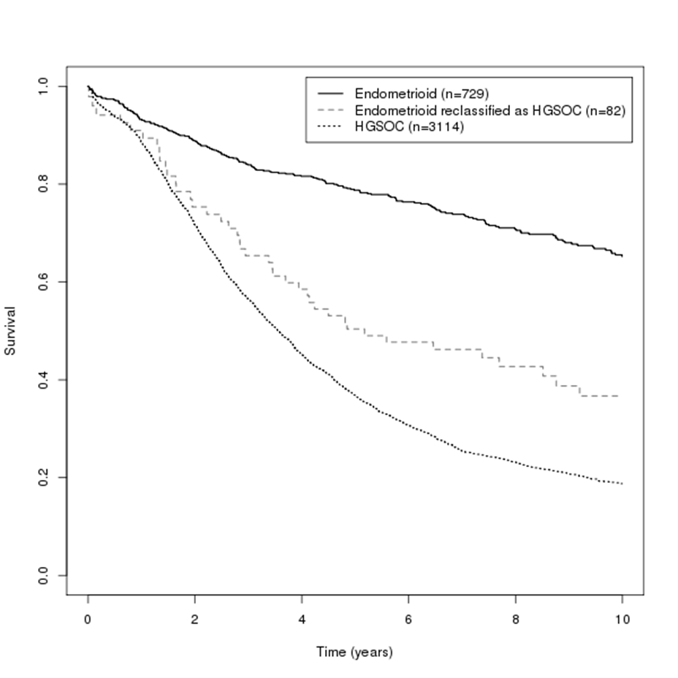

eFigure 2.

eFigure 3.

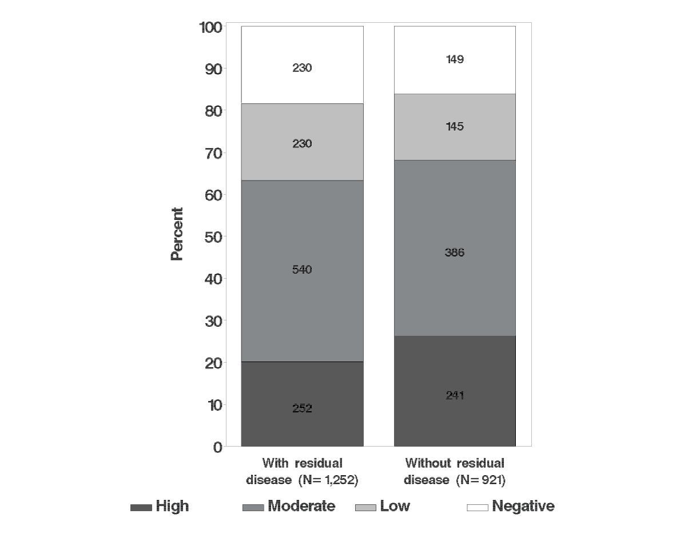
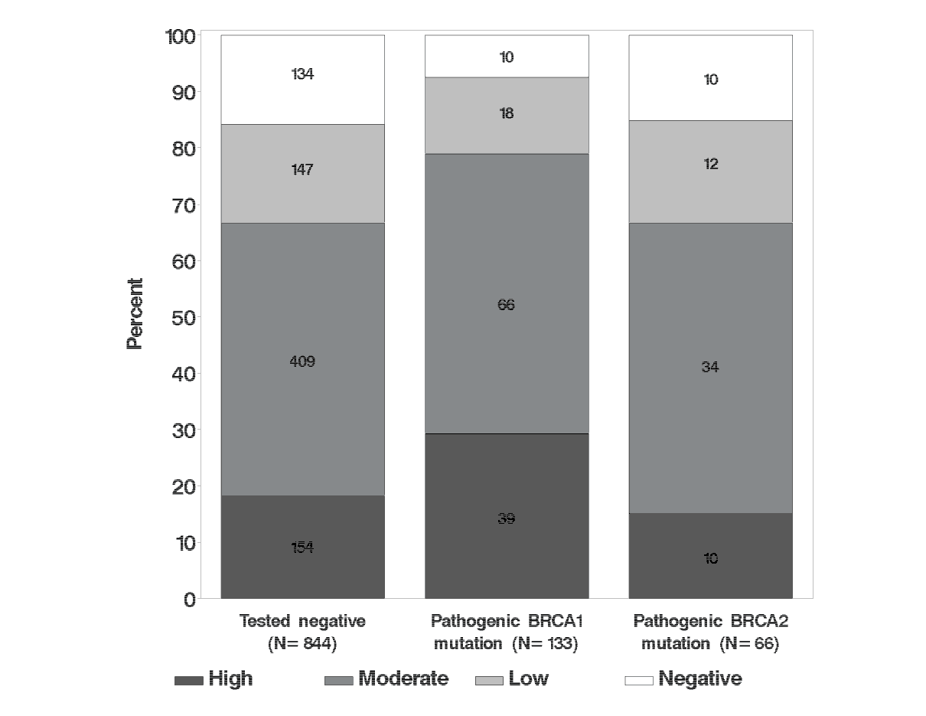
eFigure 4.
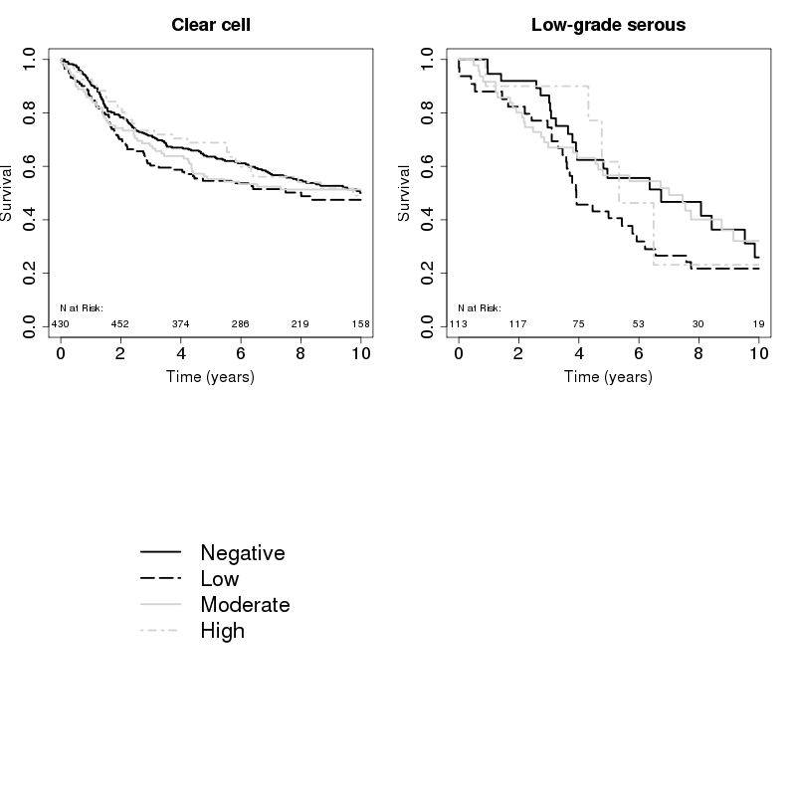

eFigure 5.

