Figur 2. Distribution of number of physical symptoms (erectile dysfunction, urinary incontinence, weak stream, and nocturia)
within the different groups

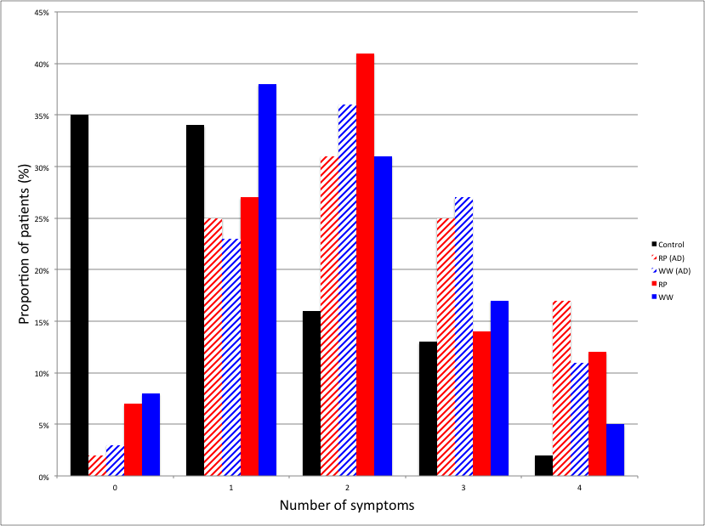
Analysis was made by intention to treat. Erectile dysfunction defined as an inability to get an erection spontaneously or elicited. Urinary incontinence was defined as leakage once a day or more. Weak stream was defined as a weak stream on more than half of occasions of urination. Nocturia was defined as urination on more than two occasions at night.
RP = radical prostatectomy, WW= watchful waiting, AD = androgen deprivation therapy, Control= population control group.

