Do ICP - derived parameters differ in Vegetative State from other outcome groups?
Czosnyka M ¹, Donnelly J¹, L. Calviello¹ , Smielewski P¹, Menon DK², Pickard JD³,
1- Brain Physics Lab, Division of Neurosurgery, Cambridge University Hospital,UK
2-Department of Anesthesiology, Cambridge University Hospital, UK
3- NIHR Brain Injury Healthcare Technology Co-Operative, Cambridge, UK

ABSTRACT
Objective: In nearly 1000 TBI patients monitored in the years 1992-2014, we identified only 18 Vegetative State (VS) cases. Our database provided access to continuous computer-recorded signals which we used to compare primary monitored signals, ICP-derived indices and demographic data between VS patients, patients who survived but who were not VS (S), and patients who died (D).
Method: Mean values of ICP, ABP, and cerebral perfusion pressure (CPP) from the whole monitoring periods were compared between the different outcome groups. Secondary indices included Pressure Reactivity index (PRx), the magnitude of slow ICP vasogenic waves, the pulse amplitude of the 1st harmonic component of the ICP waveform, and heart rate (HR).
Results: Mean blood pressure was lowest in the VS group – significantly in comparison to those who died (p=0.02) and almost significantly (p=0.1) in comparison to the patients who survived. Mean ICP in VS patients was lower than those who died (VS: 13 +/- 5 mm Hg, D: 22 +/- 14 mm Hg; p <0.001), but not significantly different from those who survived p>0.05). The magnitude of slow vasogenic ICP waves was the same in VS patients and those who died, but significantly lower than in those who survived (S: 1.04+/-0.57 mm Hg; .VS: 0.74+/-0.45; p=0.01).
Conclusion: Patients who progress to the vegetative state differ from non-VS survivors in displaying decreased power of slow vasogenic waves, and from those who die by not experiencing as high a burden of intracranial hypertension.

Introduction: Brain monitoring following traumatic brain injury nowadays includes multiple modalities. Intracranial pressure (ICP) is one of the essential signals. Along with arterial blood pressure (ABP), it permits the calculation of cerebral perfusion pressure (CPP), which in turn is necessary for conducting CPP-oriented management [1]. However, high ICP is associated with increased mortality [2]. Therefore, contemporary management protocols combine the lower threshold of CPP (CPP is usually above 60 to 70 mm Hg) and the upper thresholds for ICP (20 to 25 mm Hg). The individualization of thresholds for CPP and ICP has been proposed recently [3,4], however these proposals still await confirmation using prospective randomized multicenter trials.
Monitoring of ICP cannot by itself improve outcome after TBI [5], unless it is associated with an efficient protocol targeting the prevention of its elevation [6]. As ICP can be affected by multiple mechanisms (arterial blood inflow, venous outflow, CSF circulation, volumetric brain/lesion changes), the information included in pressure waveforms is very complex and can be processed and presented in a multitude of ways [7]. Simple time-averaging is a crude method, but still quite efficient.
Vegetative State (VS) is fortunately uncommon after traumatic brain injury (TBI). In nearly 1000 TBI patients monitored in the years 1992-2014, we identified only 18 such cases. Our long-established database provided access to continuous computer-recorded brain monitoring modalities (from 1992-2003: one-minute averages; from 2003-2014: high-resolution arterial blood pressure (ABP) and ICP signals) which we used to compare primary monitored signals, ICP-derived indices and demographic data between VS patients, patients who survived but who were not VS (S) and patients who died (D) .

Material and Method:
All patients were sedated, intubated, and mechanically ventilated. A CPP/ICP-oriented protocol for TBI management was used, which targeted maintenance of CPP above 65 mmHg and ICP below 25 mmHg [8]. Anonymized digital recordings were deposited in a computer database. The baseline neurological status of each patient was determined using the Glasgow Coma Score (GCS) collected on scene, before intubation. The clinical outcome was assessed at 6 months using the Glasgow Outcome Scale (GOS). All data were recorded as a part of standard clinical care. Data were averaged for the whole time of stay in the Neuro-Critical Care Unit (NCCU) of Addenbrooke’s Hospital in Cambridge, UK. All patients were monitored according to NCCU management protocol, under approval of both the Ethical and the NCCU Users’ Committees.
MAP was monitored invasively through the radial or femoral artery using a standard pressure monitoring kit (Baxter Healthcare Corp, CardioVascular Group, Irvine, CA, USA). MAP was zeroed at the right atrial level. ICP was monitored using an intraparenchymal probe (Codman ICP MicroSensor, Codman & Shurtleff Inc., Raynham, MA, USA) inserted into the frontal cortex. Mean values of ICP, ABP, and cerebral perfusion pressure (CPP) were compared between the different outcome groups (Numbers of patients in each group: VS -18, D - 222 and S – 712). Secondary indices included Pressure Reactivity index (PRx), the cerebrospinal compensatory reserve index (RAP – the 5-minute correlation coefficient between 10-second averages of pulse amplitude of ICP and mean ICP), the magnitude of slow ICP vasogenic waves (the square root of the ICP power spectrum within frequency limits 0.005 and 0.05 Hz), the pulse amplitude of the 1st harmonic component of ICP pulse waveforms, and heart rate (HR). Bedside computers running ICM (until 2003) and ICM+ (from 2003 onward) software were used. Non-parametric comparison tests were used.

Results
Mean blood pressure was lowest in the VS group – significantly in comparison to those who died (p=0.02) and almost significantly (p=0.1) in comparison to the patients who survived. Typical trends of ICP and CPP in the VS, S and D groups are presented in Figure 1. The distributions of mean ICP and Slow vasogenic waves in different outcome groups are given in Figure 2. Mean ICP in VS patients was lower than those who died (VS: 13 +/- 5 mm Hg, D: 22 +/- 14 mm Hg; p <0.001), but not significantly different from those who survived but were not VS (VS: 13 +/- 5 mm Hg, S: 14.7+/- 5.3 mm Hg; p>0.05). Remarkably, the magnitude of slow vasogenic ICP waves was the same in VS patients and those who died, but significantly lower than in those who survived (S: 1.04+/-0.57 mm Hg; .VS: 0.74+/-0.45; p=0.01). There was a trend (p=0.1) for better cerebrovascular reactivity in VS patients than in those who died. CPP, cerebrospinal compensatory reserve, heart rate and pulse amplitude of ICP were not significantly different between the groups.

Discussion
With the exception of brain imaging studies [9] and electrophysiological investigations [10], there is little known about the physiology of VS. Links between specific profiles of brain monitoring in acute periods and outcome are very rarely discussed.
Patients who progress to the vegetative state differ from non-VS survivors in displaying decreased power of slow vasogenic waves, and from those who died by not experiencing as high a burden of intracranial hypertension. There was a trend in patients with VS to have better cerebral autoregulation than in patients who died. Due to the low number of VS patients, the standard error of PRx was too high in the VS group to classify this difference as significant.
These data reinforce the view that ICP has a critical role in driving survival in TBI, but that the quality of survival is more strongly associated with autoregulatory indices and dynamics of the ICP signal, which discriminate between survivors who do and do not recover consciousness.
Raised dynamics of the ICP signal may be also estimated using entropy measures. Recently, low entropy (complexity) of ICP was reported to be associated with increased mortality after TBI [11). The complexity of ICP in patients with VS should be analyzed- and this will be done in the future when we have a larger number of cases with raw data recordings.

References
- Rosner MJ, Rosner SD, Johnson AH. Cerebral perfusion pressure: management protocol and clinical results. J Neurosurg. 1995 Dec;83(6):949-62.
- Miller JD, Becker DP, Ward JD, Sullivan HG, Adams WE, Rosner MJ. Significance of intracranial hypertension in severe head injury. J Neurosurg. 1977 Oct;47(4):503-16.
- Aries MJ, Czosnyka M, Budohoski KP, Steiner LA, Lavinio A, Kolias AG, Hutchinson PJ, Brady KM, Menon DK, Pickard JD, Smielewski P. Continuous determination of optimal cerebral perfusion pressure in traumatic brain injury. Crit Care Med. 2012 Aug;40(8):2456-63
- Lazaridis C, DeSantis SM, Smielewski P, Menon DK, Hutchinson P, Pickard JD, Czosnyka M. Patient-specific thresholds of intracranial pressure in severe traumatic brain injury. J Neurosurg. 2014 Apr;120(4):893-900
- Chesnut RM, Temkin N, Carney N, Dikmen S, Rondina C, Videtta W, Petroni G, Lujan S, Pridgeon J, Barber J, Machamer J, Chaddock K, Celix JM, Cherner M, Hendrix T; Global Neurotrauma Research Group trial of intracranial-pressure monitoring in traumatic brain injury. N Engl J Med. 2012 Dec 27;367(26):2471-81.
- Hutchinson PJ, Kolias AG, Timofeev IS, Corteen EA, Czosnyka M, Timothy J, Anderson I, Bulters DO, Belli A, Eynon CA, Wadley J, Mendelow AD, Mitchell PM, Wilson MH, Critchley G, Sahuquillo J, Unterberg A, Servadei F, Teasdale GM, Pickard JD, Menon DK, Murray GD, Kirkpatrick PJ; RESCUEicp Trial Collaborators. Trial of Decompressive Craniectomy for Traumatic Intracranial Hypertension. N Engl J Med. 2016 Sep 22;375(12):1119-30
- Miller JD, Dearden NM, Piper IR, Chan KH. Control of intracranial pressure in patients with severe head injury.J Neurotrauma. 1992 Mar;9 Suppl 1:S317-26
- Patel HC, Menon DK, Tebbs S, Hawker R, Hutchinson PJ, Kirkpatrick PJ. Specialist neurocritical care and outcome from head injury. Intensive Care Med 2002 May;28(5):547-53.
- Owen AM, Coleman MR, Menon DK, Johnsrude IS, Rodd JM, Davis MH, Taylor K, Pickard JD. Residual auditory function in persistent vegetative state: a combined PET and fMRI study. Neuropsychol Rehabil. 2005 Jul-Sep;15(3-4):290-306.

- Owen AM. Using functional magnetic resonance imaging and electroencephalography to detect consciousness after severe brain injury. Handb Clin Neurol. 2015;127:277-93.

- Lu CW, Czosnyka M, Shieh JS, Smielewska A, Pickard JD, Smielewski P. Complexity of intracranial pressure correlates with outcome after traumatic brain injury. Brain. 2012 Aug;135(Pt 8):2399-408

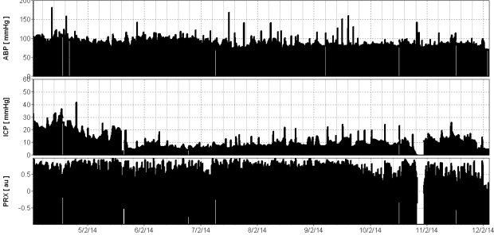

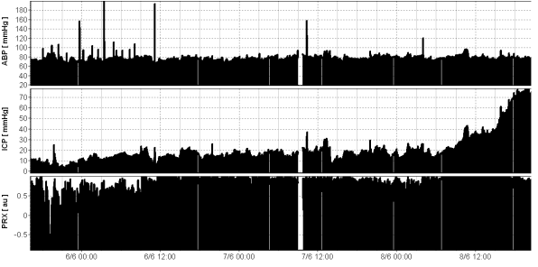

Figure 1: A few days of monitoring of ICP, ABP, and pressure reactivity (PRx) in a patient with VS (upper) outcome and in a patient who died (lower). Most of the time, ICP was below 20 mm Hg in both patients (although the patient who died had a final refractory increase in ICP to 70 mmHg). In both cases, pressure reactivity was mostly impaired. X axis- time in format: date hours: minutes

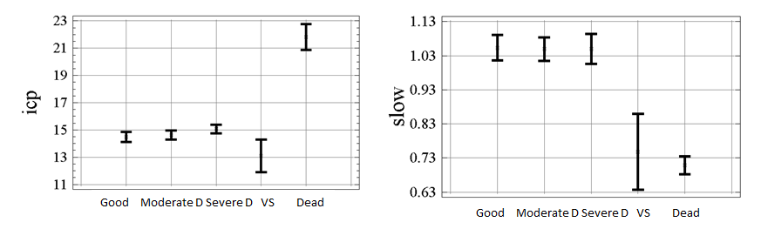
Figure 2: Distribution of ICP (in mm Hg-left panel) and averaged magnitude of ICP slow waves (in mm Hg- right panel) in different outcome groups. Mean ICP in VS patients was significantly lower than in patients who died, while VS and dead patients had lower magnitudes of slow waves than patients who survived after TBI. Mean values and 95% confidence limits for mean values.

