Supporting Information
Titration Calculations
The equations used to calculate the surface binding constants are given in Eq. S1-S3, with n_{s} being the titrated site density per unit area, C_{t} the concentration of the titrating solution of either 100 mM sodium hydroxide or hydrochloric acid, S being the solids concentration of the suspension, and A being the specific area of the solid. […] and [$≡$…] respectively denotes the concentration of a particular species in solution and on surface.
$K_{a}=\frac{{[≡FeOH}_{n}^{n-1}][H^{+}]}{[{≡FeOH}_{n+1}^{n}]}$ (S1)
$pH=pK_{a}+log\frac{[{≡FeOH}_{n}^{n-1}]}{[{≡FeOH}_{n+1}^{n}]}$ (S2)
$n_{s}=\frac{VC_{t}}{SA}$ (S3)
Abrasive Residue Surface Coverage Analysis
The coverage values are determined by analysing the luminosity histogram of the image using ImageJ, developed by the National Institutes of Health. The surface coverage of abrasive is analysed using Eq. S4. %A_{garnet} is the garnet surface coverage, and %A_{LL} is the percentile area of least luminosity, i.e. the region in black.
${\%A}_{garnet}=100\%-{\%A}_{LL}$ (S4)

a)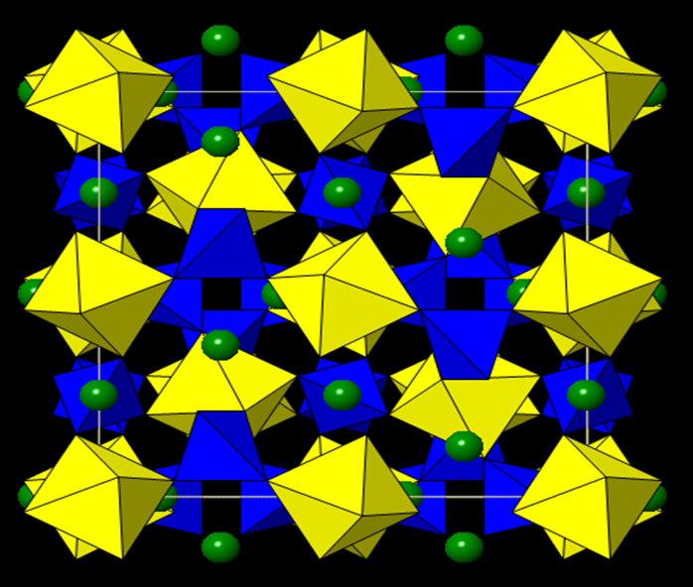
b)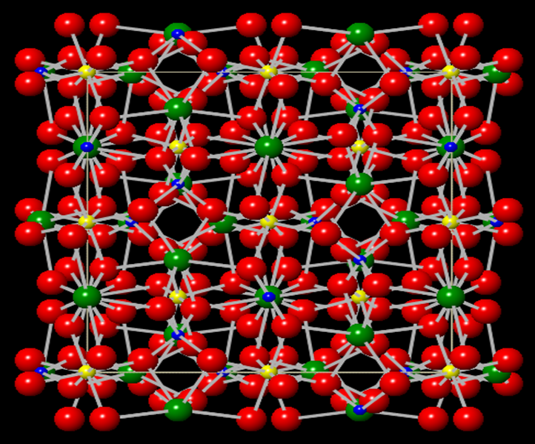
Figure SI1. The crystal structure of almandine garnet with a) a polyhedral representation and b) a ball-and-stick representation. Green: iron, yellow: aluminium, blue: silicon, red: oxygen. The yellow octahedrons are {AlO₆} units and blue tetrahedrons are {SiO₄} units. Iron atoms are in large dodecahedral ‘voids’ inside the aluminosilicate framework. Structures are drawn using CrystalViewer/CrystalMaker®, CrystalMaker Software Ltd., Oxford.

a)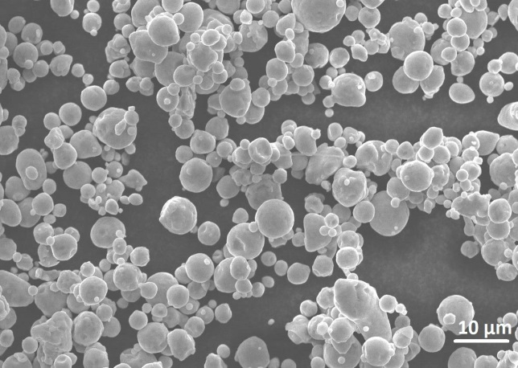b)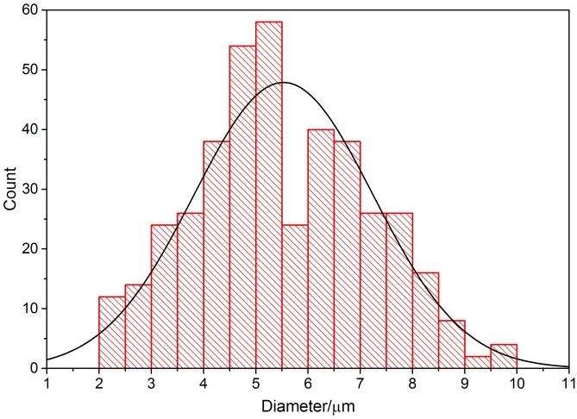
Element | Atomic Percentage/%
Fe | 78.0 ± 5.7
O | 20.3 ± 5.9
Mn | 0.9 ± 0.1
Si | 0.4 ± 0.1
C | 0.4 ± 0.1
c)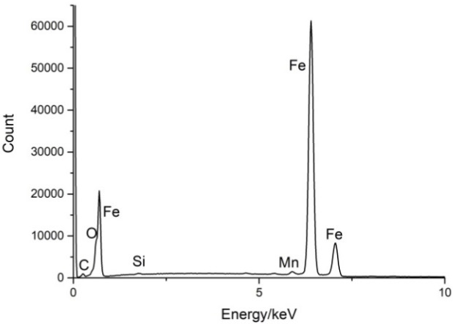d)
Figure SI2. a) Electron micrograph of S355 steel powder, with b) the sizing of the S355 powder through analysis of electron micrographs. The curve included is a Gaussian fit. c) Example EDX spectra of S355 powder, with d) the evaluated atomic percentage analysis.

a)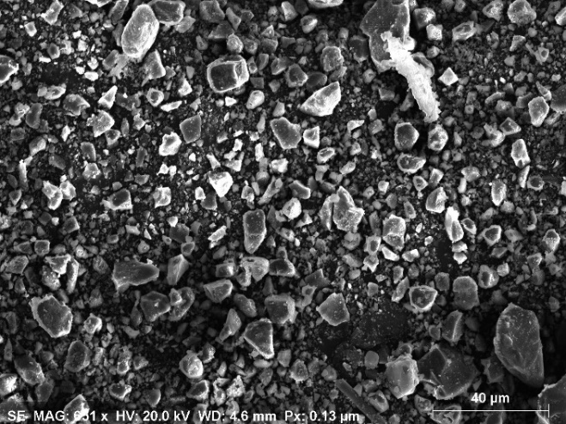b)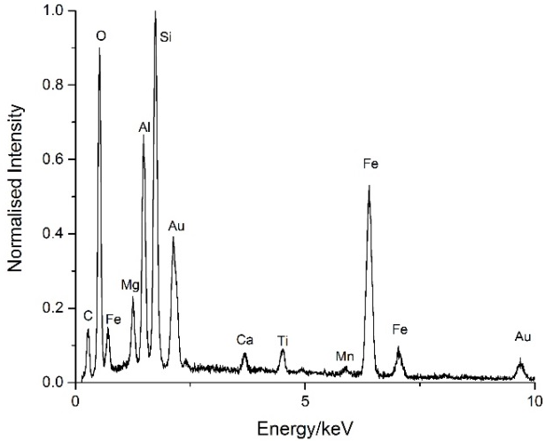
c) 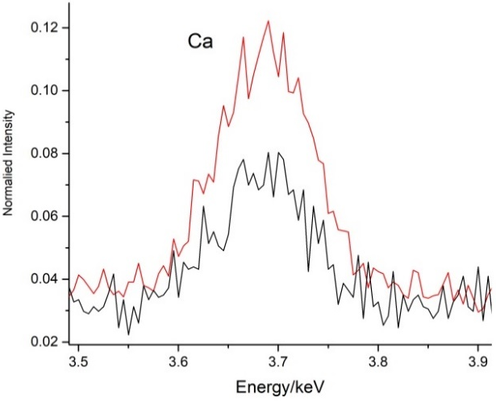d)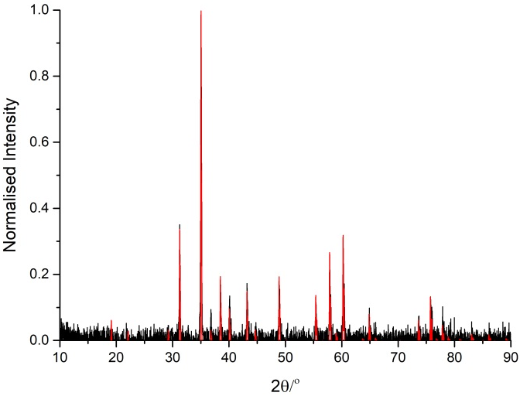
Figure SI3. a) Electron micrograph of gold-plated acid-washed garnet powder, supported on carbon tape. b) EDS spectra of the acid-washed garnet, sputtered with gold to improve conductivity. Identified elements are labels on the spectra. c) EDX image of the milled almandine garnet powder, before (red) and after (black) 10%/wt nitric acid washing and subsequent water rinsing. Intensities are normalised to allow for comparison between the two spectra. d) Powder X-ray Diffraction pattern of the acid-washed garnet powder (black), directly matching with database almandine garnet spectrum (red).

a)
b)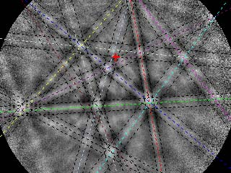
Figure SI4.a) Typical iron 2p XPS peak for a polished steel sample, peak fits on the Fe 2p_{3/2}. B) Typical crystallographic Kikuchi line diffraction pattern of backscattered electrons, from magnetite surface crystal.
a)
b)
Figure SI5. a) Calcium and b) aluminium levels in consecutive washings of 30 g of garnet. AW: 30 mL 10%/wt nitric acid wash, WW: 30 mL ultrapure water wash.

Figure SI6. Example surface charge plot from an acid-base titration of acid-treated almandine garnet abrasive in a 50 g L⁻¹ suspension, in different concentrations of sodium nitrate, a non-specifically adsorbing electrolyte. Black: 10 mM NaNO₃, Blue: 100 mM NaNO₃
Figure SI7. The surface coverage of calcium on the garnet-blasted S355 steel surface, determined by EDX elemental mapping, as a function of blasting time.
Figure SI8. TOF-SIMS elemental analysis of S355 steel samples, abrasive blasted for different durations at 40 psi pressure. Iron (purple), calcium (green), aluminium (blue) and silicon (magenta) signals are shown. The crossover points between the iron and calcium signals are highlighted.

