DOI: 10.1002/ ((please add manuscript number))
Article type: Progress Report

Hierarchy Design in Metal Oxides as Anodes for Advanced Lithium-ion Batteries

Jun Jin†, Liang Wu†, Shaozhuan Huang†, Min Yan†, Hongen Wang, Lihua Chen, Tawfique Hasan, Yu Li* and Bao-Lian Su

Dr. J. Jin, Dr. L. Wu, Dr. S. Z. Huang, Dr. M. Yan, Dr. H. E. Wang, Prof. L. H. Chen, Prof. Y. Li, Prof. B. L. Su
State Key Laboratory of Advanced Technology for Materials Synthesis and Processing, Wuhan University of Technology, 122 Luoshi Road, 430070, Wuhan, Hubei, China; Email: yu.li@whut.edu.cn

Dr. J. Jin
Energy Research Institute, Nanyang Technological University, 639798, Singapore, Singapore

Dr. S. Z. Huang
Institute for Integrative Nanoscience, Leibniz Institute for Solid State and Materials Research, IFW Dresden, Helmholtzstraße 20, Germany

Prof. T. Hasan
Cambridge Graphene Centre, University of Cambridge, 9 JJ Thomson Avenue, Cambridge CB3 0FA, United Kingdom

Prof. B. L. Su
Laboratory of Inorganic Materials Chemistry (CMI), University of Namur, 61 rue de Bruxelles, B-5000 Namur, Belgium

Prof. B. L. Su
Clare Hall, University of Cambridge, Herschel Road, Cambridge CB3 9AL, United Kingdom

† These authors contributed equally to this work.

Keywords: Hierarchy; micro/nanostructured metal oxides; reaction kinetics; reaction mechanisms; lithium ion batteries
Abstract
Hierarchical structures are widely found in both animals and plants to ensure their functions working with high efficiency. This explains why hierarchical metal oxides (HMOs) micro/nanostructures have recently received great attention as anode materials for high performance lithium ion batteries (LIBs). Indeed, hierarchy in such micro/nanostructured HMOs offers high specific surface area, stable structure, short path length and improved packing density to enhance the reaction kinetics and Li⁺/e⁻ transport kinetics, resulting in highly enhanced rate capability and cycling stability. In this report, we focus on hierarchy design from structural, morphological, porous and component levels to summary the HMOs micro/nanostructures as anodes for LIBs. The advantages of HMOs micro/nanostructures based on three reaction mechanisms (intercalation/de-intercalation, conversion and alloying/de-alloying), important challenges that need to be faced and future perspectives on designing advanced electrode materials for next-generation high-performance LIBs are highlighted.

1. Introduction
Rechargeable lithium ion batteries (LIBs) have attracted much attention as a power source for portable electronic devices and electric vehicles due to their high energy and power density, long cycle life and non-toxicity. However, commonly used graphite-based anode materials in LIBs suffer from low theoretical specific capacity (~370 mAh g⁻¹), low safety and poor rate capability, limiting their further utilization. Metal oxides, because of their high reversible capacity, high energy density and improved safety over conventional graphite-based materials, have been considered as promising electrode materials for high-performance LIBs. However, the exploitation of metal oxides as anode materials still encounters difficulties due to their intrinsic poor electrical conductivity, low Li⁺/e⁻ transport kinetics and pronounced volume expansion/contraction. Therefore, it is quite important to find out the sources of these problems and resolve them.
Generally, the Li⁺ diffusion time (T_{eq}) in metal oxides electrodes primarily depends on the diffusion path length and diffusion efficiency according to the relation: 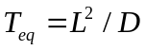, where L is the size or dimension of electrode materials while D represents the ease of Li⁺ movement.. This indicates that reducing L and/or enhancing D can improve the Li⁺ diffusion. Thus far, decreasing the size of the metal oxides anode materials to micro-/nano-size has become the first choice to improve their electrochemical performances. Many metal oxides nanostructures, including nanoparticles, nanotubes, and nanosheets, have been designed to enhance the Li⁺/e⁻ transport kinetics as well as buffer the volume expansion/contraction during the discharge/charge process. However, the low-dimensional nanostructures tend to aggregate during the reaction process, resulting in poor cycle life and low capacities at high rate. Rationally assembling low-dimensional metal oxides nanostructures can avoid their aggregation and largely improve their electrochemical performance. This suggests that it is critical to finely design the metal oxides micro/nanostructures for high performance LIBs.
In the context of designing metal oxides, mother nature has provided us variously optimized zero-, one-, two-, and three-dimensional (0D, 1D, 2D and 3D) elaborated hirarchical architectures. For instance, diatoms, butterfly, wood, leaf, animal bones and skeletons, have already shown exceptional properties due to their functional adaption of the superstructure at various levels of hierarchy in the natural systems. With the idea of “learning from nature”, one can not only mimic the functions of the natural materials with hierarchical structures, but also endow the desirable and even new properties for a large series of applications, such as catalysis, separation, solar cells and lithium ion batteries. Recently, our group developed a microporous ZnO constructed Murray Material with macro-meso-microporosity following one optimum natural system of derived general Murray’s Law. This novel ZnO Murray Material exhibited highly enhanced mass exchange and transfer in electrochemical reactions and demonstrates greatly improved capacity and stability.^{[31]} Indeed, engineering HMOs micro/nanostructures from low-dimensional nanostructures with distinct components can combine the advantages of both microstructures and nanostructures, resulting in good monodispersity, high packing density, high surface area, good stability and excellent rate performance for LIBs. Therefore, fine design of electrode materials with hierarchy in structural, morphological, porous and component levels is quite crucial for their practical applicability in LIBs.
As there already have many excellent reviews on the synthesis process in detail recently, in this report, we only highlight the advantages of hierarchy design in HMOs micro/nanostructures as anodes for LIBs. We first discuss the characteristics of hierarchy design from different levels, such as structures, morphologies, porosities and components for LIBs. Through the typical examples, we then present the recent developments of HMOs according to their reaction mechanisms: (1) intercalation/de-intercalation reaction occurring in some HMOs (e.g. TiO₂, MoO₂ and Nb₂O₅) with a 2D layer/3D network structure that can reversibly intercalate Li into the lattice without destroying the crystal structure; (2) conversion reaction usually involving Li in the formation and decomposition of Li₂O accompanied with the reduction/oxidation of metal nanoparticles in many HMOs (e.g. MnO_{x}, CoO_{x}, FeO_{x} and NiO_{x}); (3) alloying/de-alloying reaction occurring at low potentials (≤ 1V vs Li⁺/Li) in certain HMOs (e.g. SnO₂, SiO_{x} and ZnO) and their composites decorated by elements such as Si and Sn. We finally conclude via presenting the current and near-term challenges and the perspectives of hierarchy design in metal oxides based anode materials for the next generation LIBs. Note that although we have tried to summarize the important and pertinent results, due to the vast amount of available literature, it is impossible to mention all the available references herein.
2. The characteristics of hierarchy in micro/nanostructured HMOs anodes
As mentioned above, the HMOs micro/nanostructure electrode materials, assembled by 0D, 1D, 2D building blocks from the nano to macroscopic scale, bring unprecedented advantages and open a promising avenue to boost the electrochemical performance for LIBs. From the literatures, we note that the characteristics of hierarchy in HMOs mainly lie in structural, morphological, porous and component levels. In fact, all reported micro/nanostructured HMOs combine with two or three even four of these characteristics. For instance, the nanoparticles constructed highly monodisperse unique walnut-shaped porous MnO₂/carbon nanospheres (P-MO/C-NSs) exhibited highly enhanced oxidization reaction kinetics, leading to the deep oxidation of Mn²⁺ to Mn³⁺ during the cycling process owing to the hierarchy in morphological, porous and component levels.
Compared to nanoparticles and 1D nanostructures, 2D nanosheets exhibit superior electrochemical and faster charge transfer kinetics due to the reduced pathway for Li⁺/e⁻ transport. In particular, 2D nanosheets provide high specific surface area facilitating Li⁺ insertion with pseudo-capacitive Li⁺ storage capability at the surface. In addition, yolk-shell structure with a distinctive core-void-shell configuration, can improve the volumetric specific capacity, energy density and structural stability, thus enhance the electrochemical performance of anode material. Hence, the combination of 2D nanosheets and porous yolk-shell structure in one hierarchical architechture can provide a stable, porous framework and a short charge diffusion pathway. For instance, the hierarchical nanosheet-constructed yolk-shell TiO₂ (NYTiO₂) porous microspheres demonstrated a high reversible capacity of 225 mAh g⁻¹ after 100 cycles at 1 C (1C = 167 mA g⁻¹). The yolk-shell morphology provided a large void space between the outer nanosheet-based porous shell and the inner nanocrystal-based mesoporous core to ensure the easy penetration of electrolyte, to facilitate charge transfer across the electrode/electrolyte interface and more importantly to buffer the volume change during the Li⁺ insertion/extraction process (Figure 1a), leading to the highly enhanced reaction kinetics and stable cyclability.
Porous materials with well-interconnected pores and nanosized walls also typically provide reduced diffusion length L and boost the charge-transfer rate. Therefore, three-dimensional ordered macroporous (3DOM) electrode due to the interconnected porous structure, the high specific surface area and the easy electrolyte pemeation, is an ideal candidate for highly enhanced Li⁺ storage capacity and rate capability. For instance, the introduction of inner-particle mesopores within this 3DOM structure facilitated the charge diffusion. As a consequence, the resulted 3DOM TiO₂ with inner-particle mesopores (3DOMM TiO₂) exhibited a very high Li diffusion coefficient D of 1.75 × 10⁻¹⁴ cm² s^{-0.5}, almost five times that of 3DOM TiO₂ (3.78 × 10⁻¹⁵ cm² s^{-0.5}). This confirms that the straight inner-particle mesopores facilitate the lithium insertion/extraction kinetics via the synergy of hierarchy in porosity (Figure 1b). The 3D bicontinuous hierarchically porous Mn₂O₃ single crystals (BHP-Mn₂O₃-SCs) is another typical sample with hierarchy in structure and porosity, which can not only shorten the charge diffusion pathway but also accommodate the volume change during the lithium insertion/extraction process (Figure 1c), leading to high capacity and long cycle life. Particularly, we followed the Murray’s law to incorporate macro-meso-micropores in one solid body, via a bottom-up approach on the basis of a completely new layer-by-layer evaporation driven self-assembly process using well defined and monosized microporous ZnO nanoparticles as the building blocks (Figure 1d). Such unprecedented bio-inspired vascularized material whose pore sizes regularly decrease across multiple scales and finally terminate in size-invariant units like leaf veins providing hierarchical branches and precise diameter-ratios for connecting multiscale pores from macro to micro levels and enable highly enhanced mass exchange and transfer in electrochemical reactions.^{[31]}
Integrating different component nanostructures in one material is also a typical characteristic of hierarchy. For instance, hierarchically porous c-Si/SnO₂ NW composite via growing crystalline Si nanowire (NW) on ultra-long SnO₂ nanowire (Figure 1e) achieved a high capacity and cycling stability due to its good contact with electrolyte. Furthermore, combining different crystalline phases of the same material in one structure can bring unexpected electrochemical performance. This has been successfully demonstrated by a hierarchically structured mesoporous TiO₂ anatase/rutile hybrid nanowire bundle (HM-TiO₂-NB) with amorphous phase at the nanowire surface (Figure 1f), which provided more active sites in nanocrystalline anatase/rutile for Li⁺ insertion and facilitated Li⁺/e⁻ transport, leading to highly improved capacity and stability.
As seen from the above examples, all the micro/nanostructured HMOs assembled from low-dimensional nanostructures can combine the benefits of hierarchy at different levels, resulting in high electrochemical performance for LIBs.
3. Recent developments in hierarchy design in HMO anodes
3.1 HMO anodes based on intercalation/de-intercalation reaction
Metal oxides for LIBs based on intercalation reaction include titanium dioxide (TiO₂) based materials, monoclinic MoO₂, orthorhombic Nb₂O₅, VO_{x} etc. These intercalated hosts (possessing conductive 1D paths or 2D planes) are favorable for Li⁺ insertion/extraction with excellent structural stability and low volume expansion during the cycling process. Among the family of intercalated materials, hierarchically structured TiO₂, mainly including anatase, rutile and TiO₂-B have been intensively studied as promising anode materials for LIBs due to their structural/electrochemical stability, low cost, environmental friendliness and excellent rate capability. Particularly, the formation of solid electrolyte interfacial (SEI) layers can be avoided when the voltage window is conducted at 1.0-3.0 V.
Generally, the theoretical capacity of anatase TiO₂ is 335 mA h g⁻¹ with the complete reduction of Ti⁴⁺ to Ti³⁺. However, the elastic interaction force between intercalated Li⁺ and the formation of weak Ti–Ti interactions makes Li⁺ randomly distribute over half of the available interstitial octahedral sites. This makes the maximum reversible insertion level limited to an insertion coefficient of 0.5Li per formula unit of TiO₂, corresponding to the two equilibrium phases of the Li-poor Li_{0.05}TiO₂ and the Li-rich Li_{0.5}TiO₂. The associated reversible capacity is then 168 mA h g⁻¹.
The Li⁺ insertion process for anatase TiO₂ can be divided into three stages. The first stage is the potential dropping from the open circuit value of ~2.9 V to a value of ~1.8 V, often attributed to a pseudocapacitive-like surface effect or to the formation of a solid solution of TiO₂. The second stage is the horizontal plateau region, representing the process of Li⁺ insertion into the vacant sites of TiO₂ crystal structure. The last stage is the gradual voltage decay after the plateau region, reflecting the insertion process of Li⁺ into the surface layer of TiO₂. However, the intrinsic poor electron transport and Li⁺ diffusion limit the Li⁺ insertion/extraction kinetics. Therefore, unique hierarchical micro/nanostructures assembled from low-dimensional nanostructures are considered as promising candidates for high performance LIBs anodes due to the highly enhanced reaction kinetics.
Our group fabricated hierarchical nanorods chains-constructed anatase TiO₂ hollow microspheres (HNC-TiO₂-HMSs) as anode material for LIBs (Figure 2a). After being discharged at 1 C for 100 cycles with the voltage of 1.0-3.0 V, a reversible capacity of 216 mAh g⁻¹ was achieved. The in-situ XRD and post-mortem HRTEM revealed more information on the Li⁺ insertion/extraction and phase transformation (Figure 2b-c). In the discharge process, the intensity of the Bragg peaks related to anatase at 25.3° and 37.8° corresponding to the (101) and (004) planes, gradually decreased. Meanwhile, some novel diffraction peaks at 23.9°, 24.5° and 39.6° appeared (Figure 2b). After the lithium insertion, numerous ~5 nm Li₂Ti₂O₄ were randomly distributed on the surface of the nanorods (Figure 2c). This is because the continuous Li⁺ insertion in Li_{x}TiO₂ (Equation (1)) leaded to the atomic rearrangement to finally form Li₂Ti₂O₄ (Equation (2)) crystalline domains on the nanorods surface.
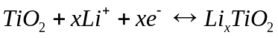 (0≤ x ≤1) (1)
(2)
In general, rutile TiO₂ is less efficient for lithium storage compared with its anatase counterpart because of its compact crystal structure. However, a large amount of Li can be inserted into nanosized rutile TiO₂. In addition, the amorphous TiO₂ phase has also demonstrated a significant pseudo-capacitance behavior. Thus, a hierarchically porous crystalline TiO₂ nanostructure, combined with amorphous/rutile/anatase components should be a promising anode with high lithium storage and cycling stability. As a proof-of-concept, the hierarchically mesoporous TiO₂ nanowire bundles (HM-TiO₂-NB) with amorphous/rutile/anatase phases were designed and synthesized through a template method at a low temperature under acidic and wet condition (Figure 1g). Indeed, the HM-TiO₂-NB with hierarchy from structural, morphological, porous and component levels exhibited a capacity of 174 mAh g⁻¹ at 1C and an excellent rate performance with a capacity of 96 mAh g⁻¹ at 50C in the voltage of 1.0-3.0 V. Again, a large number of Li₂Ti₂O₄ crystallites were observed on the surface of TiO₂ nanowires at the discharged state (Figure 2d). The special structure and the formed Li₂Ti₂O₄ crystallites could contribute to such a self-improving phenomenon of the Li⁺ insertion capability.
Compared to other polymorphs of TiO₂, TiO₂-B has attracted much attention due to high Li storage capacity (340 mA g⁻¹). For instance, Hu et al. fabricated hierarchical tubes (HTs) constructed from randomly oriented TiO₂-B nanosheets with a shell thickness of 50 nm through an efficient Cu nanowire templated solvothermal method (Figure 2e). The nanosheets constructed porous shells enlarged the electrolyte–electrode interface, the thin nanosheets shortened the diffusion length for Li⁺ ions and the interior cavities efficiently accommodated the volume variation during the cycling processes (Figure 2f), resulting in a high reversible capacity of 160 mAh g⁻¹ after 400 cycles at 5C (1C =335 mA g⁻¹) in the voltage range of 1.0−3.0 V (Figure 2g). Our group also designed hierarchically nanotube-constructed porous TiO₂-B spheres, demonstating highly reversible lithium storage capacity of 270 mA h g⁻¹ at 1 C (340 mA g⁻¹), excellent rate capability of 221 mA h g⁻¹ at 10 C, and long cycle life with over 70% capacity retention after 1000 cycles at 10 C in the voltage of 1.0-3.0 V.^{[58]} Interestingly, some discrete cubic LiTiO₂ nanodots were formed on the outer surfaces of TiO₂-B nanotubes, which might account for the slight capacity loss upon prolonged electrochemical cycling. In particular, Wu et al. synthesized hierarchical anatase/TiO₂-B microspheres constructed by TiO₂-B nano-domains embedded in ultrathin anatase nanosheets, forming a large number of interfaces between the anatase and TiO₂-B nanodomains. The mixed phases of anatase and TiO₂-B had a combined process of dominated diffusion-limited reaction and minor faradic pseudocapacitance characteristic. The synthesized anatase/TiO₂-B microspheres demonstrated high capacities and rate capability of 180 and 110 mAh g⁻¹ after 1000 cycles at current density of 3.4 and 8.5 A g⁻¹ between 0.8−3.0 V, respectively.
Combing with carbon materials is also very helpful to improve the diffusion capability of Li⁺/e⁻ in TiO₂. For instance, Jiang et al. combined the anatase/TiO₂-B with conductive carbon and reduced graphene oxide (rGO), to form a hierarchically porous carbon-coated mixed-phase TiO₂ nanosheet/rGO composite (TiO₂@C/rGO) through a one-pot solvothermal process. This TiO₂@C/rGO from different hierarchy levels exhibited an excellent capacity of 158.6 mAh g⁻¹ after 500 cycles at 800 mA g⁻¹ with a voltage window of 0.01–3.0 V, due to the unique 3D hierarchical, porous structure and conducting carbon. The interesting phenomenon was that the capacities always increased during the cycling process at different current densities. However, the authors failed to present an explanation on this. Most possibly, this capacity increase was resulted from the lithiation behavior of this composite at the voltage window of 0.01–3.0 V. During this voltage, the lithiation behavior of TiO₂ involves both the intercalation reaction (1.0-3.0 V) and the conversion reaction (0.01-1.0V). The conversion reaction is a continuous process and is relative to the structure, surface and crystallinity of TiO₂. In addition, below the voltage of 1.0 V, the generation of SEI layers can increase the capacity and stability of the anode.
Monoclinic MoO₂ is another promising anode material. It has high theoretical specific capacity (838 mAh g⁻¹), low electrical resistivity, high thermal and chemical stability, low cost and high density. In general, bulk MoO₂ suffers from the low capacity retention and poor cycle stability due to the intrinsically slow kinetics and huge volume expansion during the Li⁺ insertion/extraction. Designing hierarchical micro/nanostructures of MoO₂ can overcome these drawbacks by improving the insertion/extraction kinetics. For instance, Tang et al. prepared hierarchical peony flower-like MoO₂ microspheres via a simple, template-free solvothermal method. The hierarchical MoO₂ microspheres with structural, morphological and porous characteristics of hierarchy presented a high reversible specific capacity of 757 mAh g⁻¹ after 100 cycles at 200 mA g⁻¹, good cycling performance and high capacity retention and good rate performance in the voltage range of 0.01-3.0V. Again, during the discharge/charge process, the reactions of the MoO₂ electrode can be attributed to intercalation reaction and conversion reaction as follows: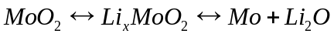. Thus, the hierarchical MoO₂ microspheres partially lost its crystallinity and transformed into an amorphous-like structure during the cycling. This improved the Li diffusion kinetics and more Li could be reversibly intercalated/de-intercalated. In addition, the interfacial and structural defects in the hierarchical structures may lead to better charge transfer kinetics and Li⁺/e⁻ diffusion kinetics, and allow the insertion of extra Li ions to improve the specific capacity. As an evidence, uniform hierarchical MoO₂/C spheres were fabricated through calcination of a MoO₃/resin precursor, which was produced via a simple hydrothermal method. The synthesized hierarchical MoO₂/C-600 exhibited a reversible capacity of 596 mAh g⁻¹ after 400 cycles at 0.5 A g⁻¹ because the MoO₂ nanoparticles decreased the diffusion distance of Li⁺/e⁻, and carbon layers increased the conductivity. Still, conversion reaction appeared during the cycling process in the voltage window of 0.01-3.0V.
Monoclinic Nb₂O₅ is also considered a promising intercalated material because of its atomic structure beneficial for lithium ions intercalation. The lithium intercalation reaction can be written as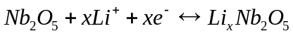. Its largest lithium ion insertion number is 2.5. For instance, Zhang et al. prepared hierarchical 3D monoclinic Nb₂O₅ nanowire superstructure through a facile hydrothermal method and a subsequent thermal transformation of Nb₃O₇(OH) into Nb₂O₅. This Nb₂O₅ superstructure presented an initial discharge capacity of 225 mAh g⁻¹ corresponding x = 2.2 for Li_{x}Nb₂O₅ and a high capacity of 177 mAh g⁻¹ after 150 cycles at 100 mA g⁻¹ in the voltage range of 1.0-3.0 V. Guo et al. synthesized hierarchical flower-like Nb₂O₅ microspheres constructed by distorted, 30 nm thick nanoflakes via a facile hydrothermal approach. The microspheres with hierarchy in structure, morphology and porosity demonstrated a high capacity of 217.5 mAh g⁻¹ after 200 cycles at 50 mA g⁻¹ in the voltage range of 0.01–3.00 V. Again, at this voltage window, it needs to mention that the converstion reaction appeared leading to the formation of the SEI layers and further lithium consumption via interfacial reactions due to the charge separation at the metal/ Li₂O phase boundary. In its initial cycle, no obvious platform is observed, indicating the pseudocapacitance-like behavior from the Faradaic contributions of side reaction with the electrolyte and/or the reversible formation of polymer-/gel-like film.
To clearly show the advantages of the anode materials with hierarchy in various levels, Table 1 summarizes the detailed morphologies, structures, synthesis methods and LIB performance of the selected micro/nanostructured HMOs based on intercalation/de-intercalation reaction.
3.2 HMO anodes based on conversion reaction
The mechanism of conversion reaction is different from that of intercalation/de-intercalation and involves the formation and decomposition of Li₂O, along with the reduction and oxidation of metals. Such conversion reactions can be represented as: 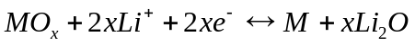, where MO_{x} is typically transition metal oxides such as MnO_{x}, FeO_{x}, CoO_{x} and NiO_{x}. These metal oxides are of great interest as potential high performance anode materials because of their ultrahigh theoretical specific capacity, low operating voltage, reduced toxicity and low cost. Although Li₂O is electrochemically inert, its nanostructured form can promote the decomposition and enhance the kinetics of conversion reaction. Therefore, hierarchical structures from structural, morphological, porous and components levels provide a large volume fraction of interfaces between Li₂O and nanosized metals to enhance the reversibility of transition metal oxides, resulting in high electrochemical reversibility.
Typically, manganese oxides (MnO_{x}) based on conversion reaction are promising anodes because of their high theoretical capacities (MnO₂: 1232 mAh g⁻¹, Mn₂O₃: 1018 mAh g⁻¹, Mn₃O₄: 937 mAh g⁻¹, MnO: 755 mAh g⁻¹), relative low conversion potential, small voltage hysteresis, abundance and environmental friendliness. However, the low electrical conductivity and large volume change during the reaction process lead to the poor rate performance and cycle life. In this context, hierarchical MnO_{x} micro/nanostructures can not only enhance the kinetics of conversion reaction via decreasing the Li⁺/e⁻ diffusion length, enhancing electrical conductivity and improving the contact between electrolyte and electrode, but also effectively prevent self-aggregation and accommodate volume variation during the charge/discharge process, resulting in the highly improved electrochemical activity and rate capability. For instance, our group synthesized a new lamellar manganese alkoxide (Mn-DEG) through a solution-phase reaction. After the in-situ carbonization of Mn-DEG precursor under nitrogen, the formed hierarchical mesoporous urchin-like Mn₃O₄/carbon microspheres (HM-MO/C-MS, MO-N) were composed of many radially orientated nanorods (Figure 3a). Comparing to MO-A (nanopartical constructed) from the calcination of Mn-DEG in air, the unique MO-N structure presented higher reversible capacity, better stability and excellent rate capability (Figure 3b).
Xia et al. fabricated monodisperse hollow porous MnO/C microspheres with a green and facile microalgae biotemplating method to embed the MnO nanoparticles into porous carbon matrix. The formed hollow porous MnO/C microspheres exhibited a high reversible specific capacity of 700 mAh g⁻¹ at 100 mA g⁻¹ between 0.05 and 3 V (Figure 3c), and enhanced rate performance of 230 mAh g⁻¹ at 3 A g⁻¹.^{[81]} The hierarchy in hollow interior and the shell porosity favorably accommodated the volume change during the electrochemical reactions and facilitated the accessibility of MnO hosts to Li⁺ and eletrolyte. In addition, the porous carbon matrix effectively enhanced the electrical conductivity and ensured the structural integrity of MnO/C microspheres.
Wang et al. synthesized the hydrogenated TiO₂ branches coated Mn₃O₄ nanorods (Mn₃O₄@H-TiO₂).^{[85]} Its specific capacity could reach to 615 mAh g⁻¹ after 100 cycles in the range of 0.01−3 V at a current density of 500 mA g⁻¹ (Figure 3d). The excellent cycling stability and rate capability of Mn₃O₄@H-TiO₂ were associated with hirarchy in various levels: their unique ultrathin branched structure shortening the lithium diffusion pathway and benefiting the release of the strain/stress, rational inter-surface design between electrode and electrolyte accommodating volume change and bad cycling stability, and successful formation of oxygen vacancies promoting the electrical conductivity and lowering charge-transfer resistance.
Our group desinged the walnut-shaped porous MnO₂/carbon nanospheres (P-MO/C-NSs) with hierarchy on morphological, porous and component (Figure 3e), which demonstrated an extraordinarily high capacity of 1192 mAh g⁻¹ at a current density of 1000 mA g⁻¹ after a long period of cycling, very close to the theoretical reversible capacity of MnO₂ (1232 mAh g⁻¹) owing to the enhanced oxidization reaction kinetics with deep oxidation of Mn²⁺ to Mn³⁺ during the cycling process.^{[36]}
Introducing hierarchical micro/nanostructures in porous single crystals (SCs) can further enhance their overall electrochemical performance due to more available active sites for Li⁺ intercalation and the shortened charge diffusion pathway. This is evidenced by the 3D bicontinuous hierarchically porous Mn₂O₃ single crystals (BHP-Mn₂O₃-SCs) with uniform parallelepiped geometry (Figure 3f). The obtained ~700 nm BHP-Mn₂O₃-SCs showed a high reversible capacity of 845 mAh g⁻¹ at 100 mA g⁻¹ after 50 cycles, high coulombic efficiency (>95%), and good rate capability of 410 mAh g⁻¹ at 1 A g⁻¹ in the voltage of 0.01-3.0 V (Figure 3g).
As another typical transition metal oxide anode material, CoO_{x} has been extensively studied because of its easy fabrication and high theoretical specific capacity (CoO: 716 mAh g⁻¹, Co₃O₄: 890 mA h g⁻¹). This anode material also suffers from large volume change. To address this, Cao et al. fabricated hierarchical CoO nanowire clusters (NWCs) composed of ultra-small nanoparticles (~10 nm) directly grown on copper current collector as an anode of binder-free LIBs (Figure 4a).^{[90]} At a rate of 1 C (1C = 716 mA g⁻¹) with the voltge window of 0.01-3.0V, a capacity of 1248.8 mA h g⁻¹ was remained after 50 cycles, larger than the theoretical one. As a comparison, the conventional electrode prepared by nonself-supported hierarchical CoO NWCs (broken CoO NWCs) by scraped off the Cu substrate exhibited a sharply decreasing trend in capacity, and only 440 mA h g⁻¹ was retained after 50 cycles under the same conditions (Figure 4b). The special hirarchy in structual and morphological levels of the CoO NWCs electrode could highly improve the reaction kinetics to ensure Co²⁺ easily oxidized to Co³⁺. This definitely resulted in superior performance.^{[90]}
Beyond improving the electrochemical performances using hierarchical electrode materials with nanostructured building blocks, hierarchical electrode materials with mesocrystal structures also significantly enhance the electrochemical performances of lithium-ion batteries. For instance, Cao et al. synthesized a 3D hierarchical Co₃O₄ flower-like architecture with a mesocrystal nanostructure through a surfactant-free hydrothermal method (Figure 4c).^{[92]} The hierarchical architecture accommodated the volume change and mitigated mechanical stress during the lithiation–delithiation processes, and the mesocrystal structure provided extra lithium-ion storage and Li⁺/e⁻ transport paths. The synergetic effect of hierarchy in structural, morphological and porous levels led to a highly reversible capacity of 920 mA·h·g⁻¹ after 800 cycles at 1.12 C (1 C = 890 mA·h·g⁻¹), improved rate performance and cycling stability (Figure 4d). Zhang et al. synthesized hierarchically structured Co₃O₄@carbon porous fibers by thermal treatment of the electrospinned ZIF-67 NPs.^{[93]} The graphited carbon around Co and formed micropores from ZIF-67 were helpful to improve the reversible capacity and cycle performance, showing a high reversible capacity of about 650 and 580 mAh g⁻¹ at 5 and 10 A g⁻¹, respectively.
Fe₂O₃ is also promising anode material due to its high theoretical specific capacity of 1006 mAh g⁻¹. To overcome the drawbacks of low conductivity and drastic volume change, Cao et al. fabricated hierarchically porous α-Fe₂O₃ nanosheet-based 3D structures on copper foil, exhibiting a high reversible capacity of 877 mAh g⁻¹ at 2.01 A g⁻¹ after 1000 cycles, and excellent rate capability of 433 mAh g⁻¹ at 20.1 A g⁻¹ in the voltage range 0.01-3.0 V (Figure 4e). This in-situ grown binder-free electrode had more exposed active sites and a stronger adhesion to the substrate, leading to a better LIB performance compared to the scraped nanosheet electrode. This confirms that the integrity of the electrode form different levels in hierarchy is very important for long cycle life and good rate capability. Ma et al. synthesized highly uniform hierarchical Fe₃O₄ hollow spheres composed of ultrathin porous nanosheets via a facile solvothermal method to get Fe–glycerate hollow spheres combined with subsequent calcination (Figure 4f).^{[52]} The hierarchical Fe₃O₄ hollow spheres exhibited stable cycling performance with a high reversible capacity of 1046 mAh g⁻¹ over 100 discharge/charge cycles at a current density of 500 mA g⁻¹ in the voltage range of 0.01–3.0 V (Figure 4g). Even at a high current density of 3 A g⁻¹, these hierarchical Fe₃O₄ hollow spheres delivered a stable capacity of about 700 mAh g⁻¹ without notable fading over 200 cycles due to the synergy of hierarchy in different levels.^{[52]}
Based on the strategy of introducing a 3D conductive network into the electrode to form a binder-free electrode, our group constructed a binder-free 3D macro-mesoporous electrode architecture via self-assembly of 3 nm NiO nanodots on a macroporous nickel foam (NF) for high performance supercapacitor-like lithium battery. The self-assembly of nanodots formed a mesoporous structure on NF. The NiO/NF electrode demonstrated a reversible capacity of 710 mAh g⁻¹ after 1000 cycles at a current density of 1 A g⁻¹ in the voltage of 0.01-3.0 V (Figure 4h). In addition, no pulverization of the 3nm NiO/NF electrode material was observed (Figure 4e inset). In particular, such electrode architecture showed supercapacitor-like high rate capability with a very high capacity of 518 mAh g⁻¹ at an ultrahigh current density of 50 A g⁻¹ between 0.01 V and 3.0 V.
Shen et al. fabricated the mesoporous NiCo₂O₄ nanowire arrays on carbon textiles substrates with robust adhesion by a simple surfactant-assisted hydrothermal method combined with a short post annealing treatment (Figure 4i).^{[95]} The mesoporous NiCo₂O₄/carbon textiles exhibited a reversible capacity of ~1012 mA h g⁻¹ at a current density of 0.5 A g⁻¹, and retained at 854 mA h g⁻¹ after 100 cycles (Figure 4j), much higher than the NiCo₂O₄ microshperes without carbon textiles. On the one hand, the mesoporous NiCo₂O₄/carbon textiles had numerous highly crystalline nanoparticles, leaving a large number of mesopores to accomodate the volume change during the cycling process. On the other hand, the electrode architectures allowed each NiCo₂O₄ nanowire to contact well with the electrolyte for Li⁺ diffusion and the carbon fiber substrate enhanced the electrical conductivity. The synergestic hierarchy resulting in the highly improved electrochemical reaction kinetic could explain the highly enhanced electrochemical properties.
The HMOs with different levels of hierarchy can not only effectively improve the overall electrochemical performance of MnO_{x}, FeO_{x}, CoO_{x}, NiO_{x} discussed here, but also can be expanded to other potential anode materials, such as CuO, NiCo₂O₄, and NiFe₂O₄. Table 1 compares the electrochemical performances of the selected HMOs based on conversion reaction as anodes for LIBs. From these typical samples, one can see that it is indeed very important to rationally design HMOs combined with structural, morphological, porous and component levels for high performance LIBs.
3.3 HMO anodes based on alloying/de-alloying reaction
During the discharge process at low potentials (≤ 1 V) in some metal oxides like SnO₂ (or SnO, ZnO), the oxides are first reduced by Li to their respective metals and then followed by Li alloy reaction. For instance, the typical alloying/de-alloying reaction of SnO₂ can be presented as:
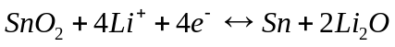 (3)
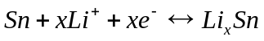 (0≤x≤4.4) (4)
The alloying reaction has made these metal oxides promising anode materials because of their high theoretical specific capacities. For example, SnO₂ has a theoretical capacity of 780 mAh g⁻¹ while this is 978 mAh g⁻¹ for ZnO. However, the Li storage capability of these metal oxides is largely restricted by their huge volume expansion (~240%) upon cycling, leading to the pulverization of these anodes. In particular, the first conversion reaction is generally irreversible because of the limited conversion reaction kinetics. From the reaction point of view, the design of HMOs nanostructures can enhance the kinetics of the first conversion to largely improve the reversible capacity and the initial coulombic efficiency. For instance, Li et al. fabricated a carbon/SnO₂ composite (C-SnO₂) with hierarchically photonic structure using butterfly wing as template (Figure 5a). This hierarchical C-SnO₂ composite showed superior discharge capacity of 572 mAh g⁻¹ after 100 cycles at 50 mA g⁻¹ within the voltage range of 0-2.0 V owing to the synergy of hierarchy in structural, porous and component levels ensuring the enhanced reaction kinetics.
The carbon shell outside the nanoplate can also enhance structural stability and electrical conductivity. Chen et al. reported a unique, branched CNT@SnO₂ nanorods@carbon hierarchical heterostructure by growing SnO₂ mesocrystalline nanorods on multi-walled carbon nanotubes (CNTs) and a subsequent carbon coating on the SnO₂ nanorod surface (Figure 5b). The synthesized heterostructure combing with hierarchy from porous and component levels exhibited a high capacity of 984 mAh g⁻¹ at 720 mA g⁻¹ in the voltage range of 0.05-2.5 V (Figure 5c). This was further verified by constructing hierarchical tubular structures with a shell-thickness of 100 nm via carbon-coating ultrathin (5 nm) SnO₂ nanoplates (SnO₂@C-HTs) through a simple hydrothermal method (Figure 5d). The obtained SnO₂@C-HTs demonstrated a high discharge capacity of 700 mAh g⁻¹ after 50 cycles at 200 mA g⁻¹ over a voltage window of 0.05−1.5V due to the increase electrical conductivity (Figure 5e).
The ability to accommodate large volume changes derived from alloying reaction can also be achieved by elaborately designing hollow building blocks. For instance, three-dimensionally ordered macroporous (3-DOM) SnO_{x}-C microspheres assembled from hollow SnO₂ nanoplates were synthesized by spray pyrolysis.^{[103]} The ultrafine nanosheets contained empty voids that allowed excellent Li⁺ storage performance, even at high current densities. The discharge capacity was 404 mA·h·g⁻¹ at a current density of 5 A·g⁻¹ for the 600th cycle. Such high performane was resulted from the synergetic effect of hierarchy from structural, morphological and porous levels with the largely improved reaction kinetics and sufficient void space to buffer the volume expansion.
Inspired by the high theoretical specific capacity (4200 mAh g⁻¹), Si is often introduced to these metal oxides with considerable reaction plateaus. For example, Song et al. prepared a hierarchically structured c-Si/SnO₂, where the SnO₂ nanowires acted as the conductive and stable architecture to achieve a high mass-loading of c-Si NWs for high Li⁺ storage (Figure 5f). This c-Si/SnO₂ NW with different levels in hierarchy exhibited a high initial charging capacity of ~3400 mAh g⁻¹ and a charging capacity of ~1200 mAh g⁻¹ after 100 cycles at 340 mA g⁻¹ in the voltage range of 0.01-1.5V owing to the one dimensional nanorods constructed hierarchical structure with different components (Figure 5g).
It has been reported that forming amorphous layer on silicon (a-SiO₂) via partially oxidizing or coating another oxide layer can significantly improve the cyclability compared to the pristine silicon.^{[106-108]} There are two possible mechanisms proposed with the final products of either Li₂O, Si and irreversible Li₄SiO₄, or reversible Li₂Si₂O₅ and Si when lithium reacts with a-SiO₂ domains.^{[109]} The generated irreversible lithium salts remain as mechanical framework, while the reversible lithium salts contribute to the reversible capacity. In particular, it is found that low oxygen content in SiO₂ can increase the reversible capacity. However, this diminishes the stability.^{[108]} To address this shortage, Zhang et al. designed component hierarchical SiO_{x}/SiO_{y} bilayer nanocomposite with the silicon-rich (SiO_{y}) and oxygen-rich (SiO_{x}) layers (Figure 5h) by simply controlling the oxygen contents.^{[110]} When used as anodes for LIBs, it exhibited a reversible capacity of about 1300 mAh·g⁻¹ over 100 cycles at a current rate of 100 mA·g⁻¹ from 0.01-1.5 V, as well as a good rate capability (Figure 5i). This still confirms that the synergestic various levels of hierarchy in HMOs is beneficial for the highly improved electrochemical performance.
In spite of the large volume change during the charge/discharge process, ZnO is still regarded as a promising anode material due to its high theoretical capacity, low-cost and facile preparation. Through the reasonable hierarchy design in ZnO anode material, it is possible to highly enhance the performance for LIBs. This is verified in our recent result on design novel ZnO Murray material, which is a typical conbination of microporous nanoparticles with macro-mesoporous structure, demonstrating a high reversible capacity of 1660 mAh g⁻¹ after 50 cycles at 0.05 Ag⁻¹, far beyond the its theoretial capacity of 978 mAh g⁻¹ (Figure 6). In particular, the novel ZnO Murray material delivered a reversible capacity of 870 mAh g⁻¹ at the extreme high-current density of 20 A g⁻¹, a 40-fold rate increase compared to that of microporous ZnO nanoparticles.^{[31]}
Some other hierarchical micro/nanostructured anode materials based on the Li alloying/de-alloying reaction, such as GeO₂, Cd₂GeO₄, Zn₂GeO₄, ZnFe₂O₄^{[114]}, etc., have also recently been designed for enhanced electrochemical performance of LIBs. This indicates that hierarchical micro/nanostructures based on alloying/de-alloying reaction are arousing an increasing level of attention among the research community. Table 1 also lists the details of the selected HMOs from alloying/de-alloying reaction.
4 Conclusion and outlook
We have highlighted the recent progresses of hierarchy design in HMOs micro/nanostructures as anode materials for LIBs. Through examples focused on TiO₂, MoO₂, Nb₂O₅, MnO_{x}, CoO_{x}, FeO_{x}, NiO_{x}, SnO₂, SiO_{x} and ZnO, the benefits of engineering hierarchical metal oxides micro/nanostructures with different levels of hierarchy for their electrochemical performances are discussed via three important reaction mechanisms (intercalation/de-intercalation, conversion reaction and alloying/de-alloying). Indeed, exploitation of hierarchy in micro/nanostructures mitigates several shortcomings of metal oxides, such as low Li⁺/e⁻ conductivity, large volume expansion (mainly for MoO₂, MnO_{x}, CoO_{x}, FeO_{x}, NiO_{x} and SnO₂), relatively low capacity (mainly for TiO₂ and Nb₂O₅), possible surface side reaction and low volume energy density.
Despite significant progress on the development of hierarchy design in metal oxides as anode materials, some critical challenges still remain for their synthesis and practical LIBs application. First, the synthesis of hierarchical micro/nanostructures is still in randomness and/or accidental. This means that the hierarchy design is not “real design” according to the conceived idea. A universal strategy to guide the design and synthesis of such hierarchy from structural, morphological, porous and component levels still needs to be developed in the near future. Indeed, natural structures have already presented us such inspiration. The strategy based on the idea of “learn from nature” should guide us to define the expected hierarchically micro/nanostructures at all levels. For instance, integrating the inner-particle mesoporosity in an optimized 3D interconnected macro-mesoporous TiO₂ structure via the mediation of biomolecular self-assembly of the lipids and proteins from rape pollen coats and P123 demonstrated high rate and long cycle performances for lithium storage.^{[115]} In particular, following the newly developed general Murray’s Law to guide the design of novel HMOs should also be a promising strategy.^{[31]} The bio-inspired Murray materials can boost the performance of rechargeable LIBs. However, our modern civilizations are yet to benefit from a broad of similar synthetic materials due to the difficulties in mimicking and applying nature’s hierarchical networks. On the basis of the Murray’s Law for the design of hierarchical micro/nanostructures in all levels and understanding of the mechanism for enhanced electrochemical properties, it is highly expected that such hierarchical metal oxides micro/nanostructures based on the Murray’s Law can effectively work like natural structures. In addition, the designed novel Murray materials may not only provide a way to reduce the battery weight but also be helpful to develop all-solid-state LIBs.
Second, the reaction mechanism and exact structural transformation of metal oxides anodes are not yet well understood. For example, an interesting self-improving phenomenon has always been observed in most metal oxides anode materials. Therefore, it is important to develop more advanced high-resolution in-situ (and ex-situ) characterization techniques, such as Synchrotron, XRD, TEM, NMR, Raman and EIS, combined with advanced molecular dynamics simulations to investigate and model the phase transitions of the anode material during the discharge/charge process.^{[116]} This can, in turn, push the selection and design of HMOs anode materials.
Third, improving the rate performance of HMOs is still challenging. This is of critical importance for practical applications of metal oxides for LIBs in electric vehicles. Further, finding an effective way to improve the cycling stabilities and first cycle columbic efficiencies of these metal oxides are also very urgent. Although not discussed here, decreasing the thickness of SEI or avoiding SEI formation is still challenging for many metal oxides. To address the above points, one should mainly focus on the electrochemical reaction itself. Although there are three typical mechanisms for metal oxides anode materials, the basic reaction is still a redox reaction. The essence of redox reaction is electrons or charges transport. From this key point, increasing the electron or charge transportation via enhancing the reaction kinetics should significantly improve the anode electrochemical performance. Due to the quick reversible reaction at the electrode, the thickness of SEI is expected to decrease. This is also helpful for the improvement of the first cycle columbic efficiency. Thus, hybridizing metal oxides micro/nanostructures with conductive additives (such as CNTs, graphene, Ag and Ni) can enhance the electrical conductivity and structural stability, resulting in the high rate performance and long cycle life as already evidenced in the literature.

Acknowledgements
Y. Li acknowledges Hubei Provincial Department of Education for the “Chutian Scholar” program. B. L. Su acknowledges the Chinese Central Government for an “Expert of the State” position in the Program of the “Thousand Talents” and a Clare Hall Life Membership at the Clare Hall and the financial support of the Department of Chemistry, University of Cambridge. T. Hasan acknowledges support from the Royal Academy of Engineering (Graphlex). This work is financially supported the National Key R&D Program of China (2016YFA0202602), National Natural Science Foundation of China (U1663225, 51502225), Program for Changjiang Scholars and Innovative Research Team in University (IRT_15R52) and the Fundamental Research Funds for the Central Universities (WUT: 2017III001).
Received: ((will be filled in by the editorial staff))
Revised: ((will be filled in by the editorial staff))
Published online: ((will be filled in by the editorial staff))

References

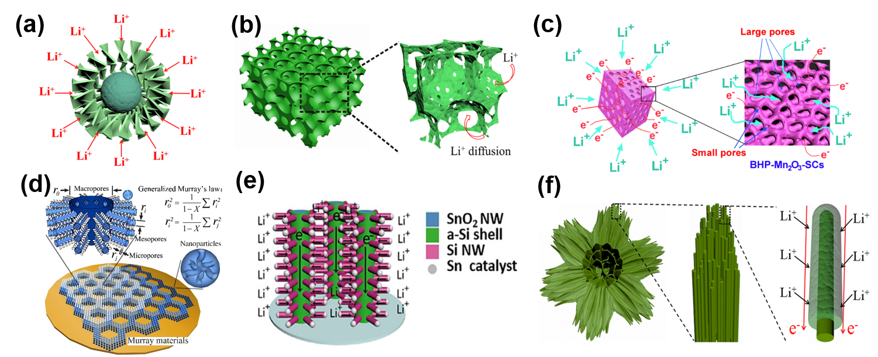
Figure 1. Schematic Li⁺ insertion diagrams of representative HMOs micro/nanostructures: (a) hierarchical nanosheet-constructed yolk-shell TiO₂ porous microspheres (Reproduced with permission, Copyright 2015, Royal Society Chemistry), (b) 3DOM TiO₂ with inner-particle mesopores (Reproduced with permission, Copyright 2014, Royal Society Chemistry), (c) 3D bicontinuous hierarchically porous Mn₂O₃ single crystals (Reproduced with permission, Copyright 2015, Macmillan Publishers Limited), (d) bio-inspired macro-meso-microporous ZnO Murray material (Reproduced with permission, Copyright 2017, Macmillan Publishers Limited), (e) hierarchical nano-branched c-Si/SnO₂ nanowires (Reproduced with permission. Copyright 2016, Elsevier Ltd.), (f) hierarchcial phases junctioned mesoporous TiO₂ nanowire bundles (Reproduced with permission. Copyright 2015, Wiley-VCH).

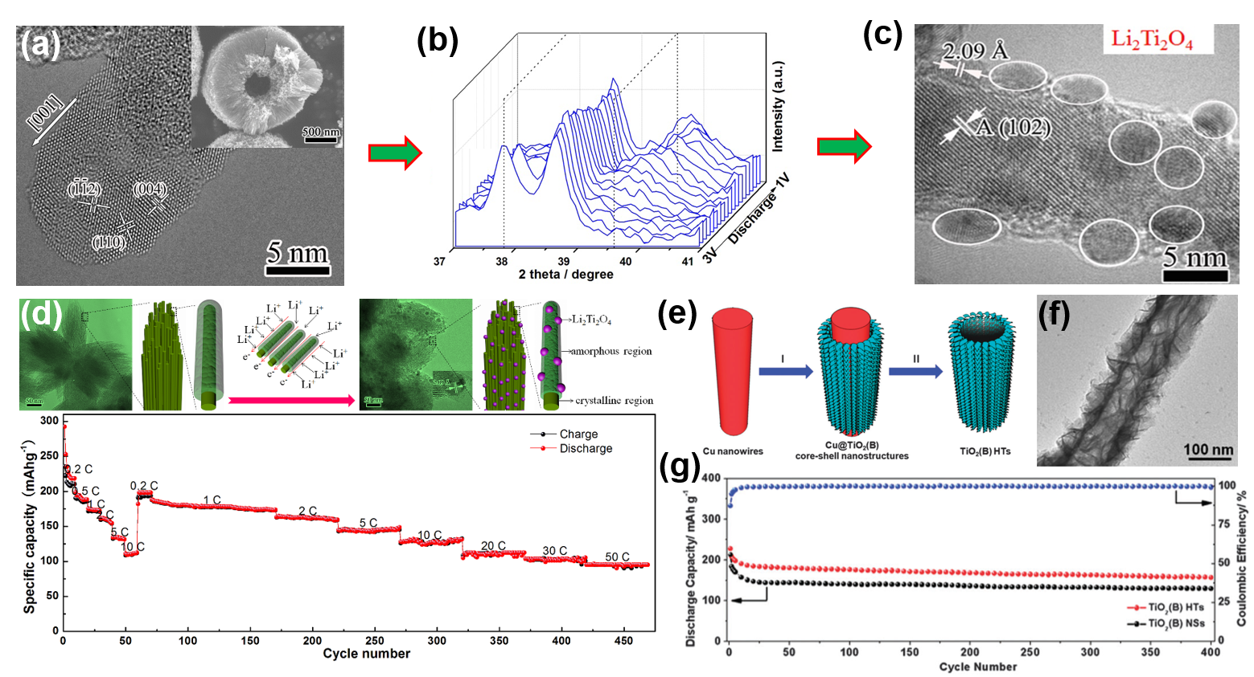
Figure 2. (a) SEM image, HRTEM image and (b) in-situ XRD discharge progress from 3.0-1.0 V and of the HNC-TiO₂-HMSs, (c) HRTEM image of HNC-TiO₂-HMSs after 100 cycles at 1C (Reproduced with permission, Copyright 2015, Elsevier Ltd.); (d) the schematic mechanism of the Li⁺ insertion into the nanorods to form the new Li₂Ti₂O₄ crystalline domains and the rate performance of HM-TiO₂-NB (Reproduced with permission. Copyright 2015, Wiley-VCH), (e) Schematic illustration, (f) TEM image and (g) cycling performance of TiO₂(B) HTs (Reproduced with permission, Copyright 2015, Royal Society Chemistry).

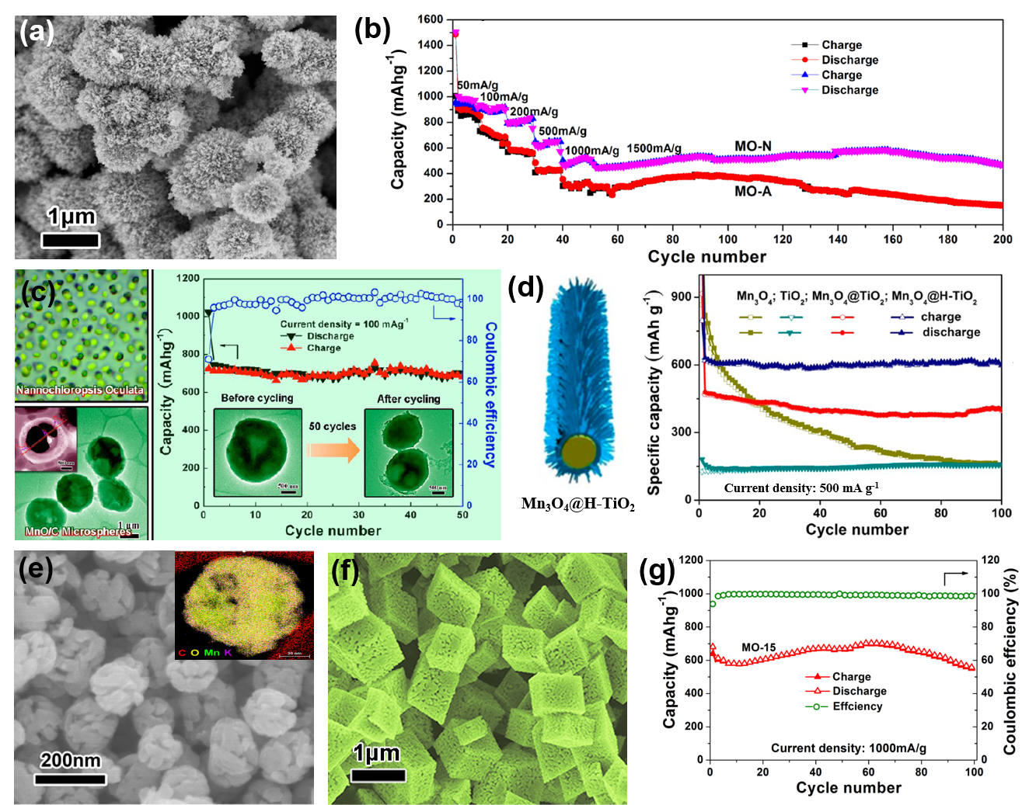
Figure 3. (a) SEM image and (b) cycling performance of the HM-Mn/C-MS (MO-A and MO-N) (Reproduced with permission, Copyright 2015, Elsevier Ltd.), (c) TEM images and cycling performance of the hollow porous MnO/C microspheres (Reproduced with permission, Copyright 2013, American Chemical Society), (d) cycling performance of Mn₃O₄@H-TiO₂ (Reproduced with permission, Copyright 2015, American Chemical Society), (e) SEM image of P-MO/C-NSs (Reproduced with permission, Copyright 2016, Royal Society Chemistry), (f) SEM image and (g) cycling performance of BHP-Mn₂O₃-SCs (MO-15) (Reproduced with permission, Copyright 2015, Macmillan Publishers Limited).

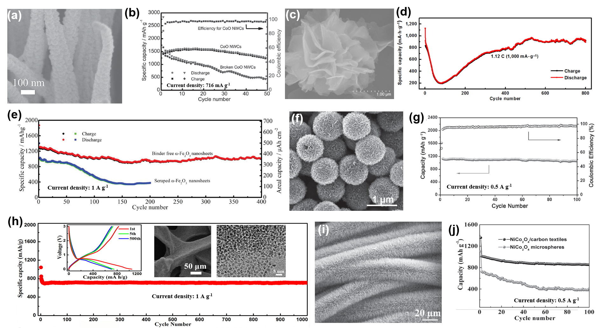
Figure 4. (a) SEM image and (b) cycling performance of CoO nanowire nanowire clusters (Reproduced with permission. Copyright 2015, Wiley-VCH), (c) SEM image and (d) cycling performance of 3D hierarchical Co₃O₄ flower-like architectures with a mesocrystal nanostructure (Reproduced with permission,^{[92]} Copyright 2017, Tsinghua University Press and Springer-Verlag GmbH Germany), (e) cycling performance of hierarchically porous α-Fe₂O₃ nanosheet-based 3D structures on copper foil (Reproduced with permission. Copyright 2015, Wiley-VCH), (f) SEM image and (g) the cycling performance of hierarchical Fe₃O₄ hollow spheres (Reproduced with permission, Copyright 2015, Wiley-VCH), (h) SEM image，TEM image and cycling performance of the 3 nm NiO/NF (Reproduced with permission, Copyright 2015, Elsevier Ltd.), (i) SEM image and (j) cycling performance of NiCo₂O₄/carbon textiles (Reproduced with permission.^{[95]} Copyright 2014, Wiley-VCH).

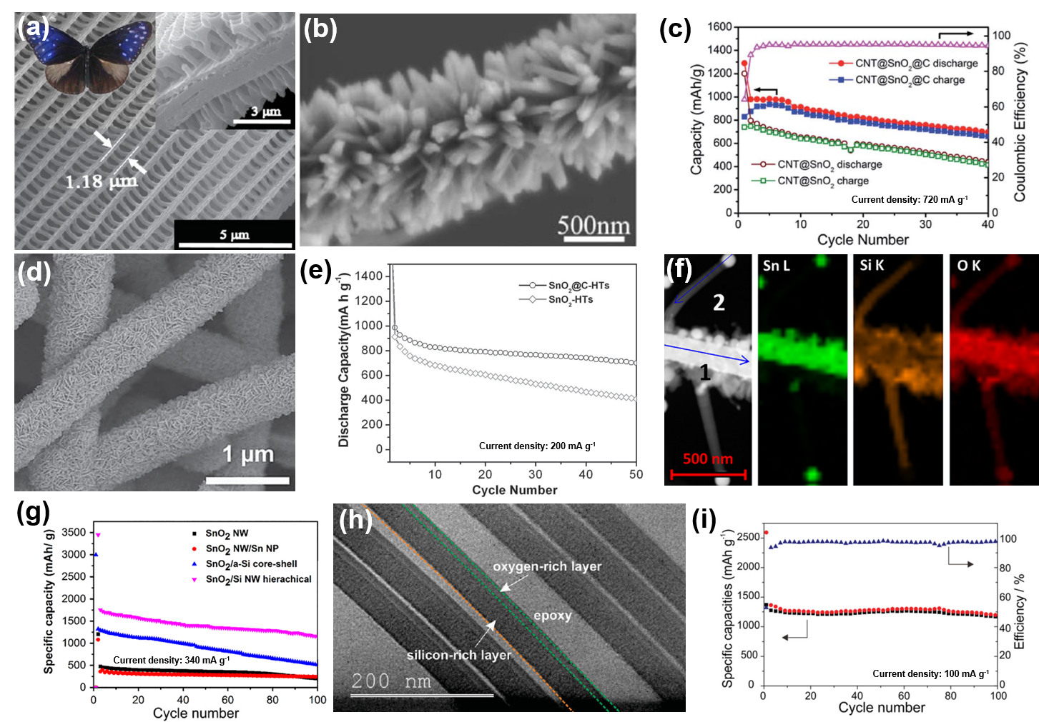
Figure 5. (a) SEM and cross-section image (right inset) of EM-C-SnO₂ and optical image of the butterfly wings (left inset) (Reproduced with permission, Copyright 2015, American Chemical Society), (b) SEM image and (c) cycling performance of branched CNT@SnO₂@C hierarchical heterostructure (Reproduced with permission, Copyright 2014, Royal Society Chemistry), (d) SEM image and (e) cycling performance of SnO₂@C-HTs (Reproduced with permission,^{[102]} Copyright 2013, Wiley-VCH), (f) STEM image (left) and the elemental mapping images of Si, Sn and O, and (g) cycling perfomrance of the Si/SnO₂ hierarchical complex (Reproduced with permission, Copyright 2016, Elsevier Ltd.), (h) TEM image from the cross section of the component hierarchical SiOx/SiOy bilayer nanocomposite and (i) its cycling performance (Reproduced with permission,^{[110]} Copyright 2014, Wiley-VCH).

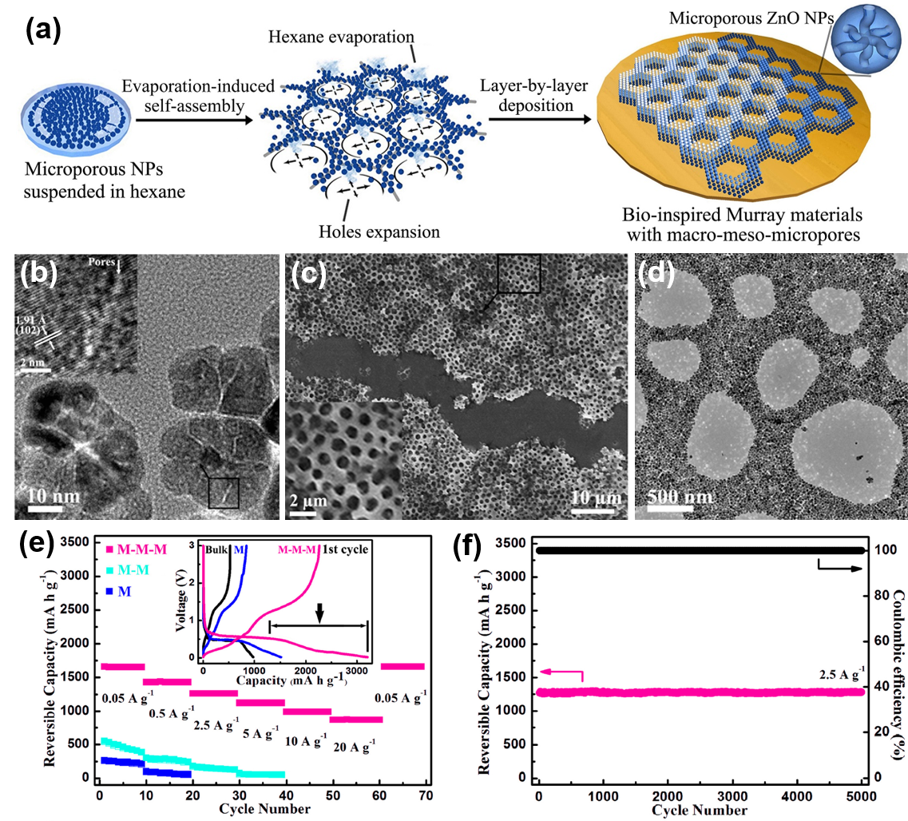
Figure 6. (a) Fabrication process of the macro-meso-microporous Murray materials via layer-by-layer evaporation-driven self-assembly of microporous ZnO NPs, (b) HRTEM image of microporous ZnO NPs, (c) SEM image, (d) TEM image, (e) rate performance and (f) cycling performance of the fabricated ZnO Murray material (Reproduced with permission, Copyright 2017, Macmillan Publishers Limited).
Table 1. Summary of the representative micro/nanostructured HMOs for LIBs
Hierarchically structured materials | Methods | LIBs performance | Voltage (V) | Ref.
Hierarchically porous anatase/rutile TiO₂ nanowire bundles | Sol-gel templating method | 174 mAh g⁻¹ after 100 cycles at 167 mAh g⁻¹, 96 mA h g⁻¹ after 50 cycles at 8.35 A g⁻¹ | 1.0-3.0
Hierarchical nanosheet-constructed anatase TiO₂ yolk-shell porous microsphere | Solvothermal alcoholysis | 225 mAh g⁻¹ after 100 cycles at 167 mA g⁻¹ | 1.0-3.0
3DOM anatase TiO₂ with inner-particle mesopores | Hard-template method | 202 mAh g⁻¹ at 167 mA g⁻¹, 106 mA h g⁻¹ after 200 cycles at 668 mA g⁻¹ | 1.0-3.0
Hierarchical nanotube-constructed TiO₂-B porous spheres | Alkaline hydrothermal, multi-step topotactic | 270 mAh g⁻¹ at 340 mA g⁻¹, 211 mAh g⁻¹ after 200 cycles at 3.4 A g⁻¹ | 1.0-3.0
Hierarchical nanosheet- constructed TiO₂-B tubular structure | Template-engaged synthesis | 160 mAh g⁻¹ after 400 cycles at 1.675 A g⁻¹ | 1.0-3.0
Nanosheet-constructed antase/TiO₂-B microspheres | Multi-step topotactic | 180 mAh g⁻¹ after 1000 cycles at 3.4 A g⁻¹ | 1.0-3.0
Carbon-coated anatase/TiO₂-B/C/rGO nanosheets/rGO | One-pot solvothermal process | 158.6 mAh g⁻¹ after 500 cycles at 800 mA g⁻¹ | 1.0-3.0
3D interconnected hierarchically anatase TiO₂ macro-mesoporous network | biotemplate and soft template | 127 mAh g⁻¹ after 1000 cycles at 1.67 A g⁻¹ | 1.0-3.0
Peony-like MoO₂ microspheres | Template-free solvothermal | 757 mAh g⁻¹ after 100 cycles at 200 mA g⁻¹ | 0.01-3.0
Uniform MoO/C hierarchical spheres | Hydrothermal method | 596 mAh g⁻¹ after 400 cycles at 0.5 A g⁻¹ | 0.01-3.0
Nanowire Nb₂O₅ superstructure | Hydrothermal method | 177 mAh g⁻¹ after 150 cycles at 100 mA g⁻¹ | 0.01-3.0
Flower-like Nb₂O₅ microspheres constructed by nanoflakes | Hydrothermal method | 217.5 mAh g⁻¹ after 200 cycles at 50 mA g⁻¹ | 0.01-3.0
Hollow MnO_{x} nanospheres assembled by nanosheets | Carbon nanospheres template | 637, 820 and 1050 mAh g⁻¹ after 150 cycles at 500 mA g⁻¹ | 0.01-3.0
Hierarchical mesoporous urchin-like Mn₃O₄/C microspheres | In situ carbonization of lamellar manganese alkoxide | 915 mAh g⁻¹ after 50 cycles at 100 mA g⁻¹ | 0.01-3.0
Unique walnut-shaped porous MnO₂/C nanoshperes | In situ carbonization of amorphous MnO₂ nanospheres | 1176 mAh g⁻¹ after 50 cycles at 100 mA g⁻¹ | 0.01-3.0
Bicontinuous hierarchically porous Mn₂O₃ single crystals | Thermal decomposition of MnCO₃ single crystal | 845 mAh g⁻¹ after 50 cycles at 100 mA g⁻¹ | 0.01-3.0
Hierarchical Co₃O₄ flower-like microspheres | Hydrothermal method | 715 mAh g⁻¹ after 1000 cycles at 1 A g⁻¹ | 0.01-3.0
Porous Fe₂O₃ nanosheets on copper foil | Liquid-phase synthesis | 877 mAh g⁻¹ after 1000 cycles at 2.01 A g⁻¹ | 0.01-3.0
NiO nanodots on macroporous nickel foam | High temperature solution-phase reaction | 710 mAh g⁻¹ after 1000 cycles at 1 A g⁻¹ | 0.01-3.0
SnO₂/C tubular structured nanoplates | Hydrothermal method | 700 mAh g⁻¹ after 50 cycles at 200 mA g⁻¹ | 0.05-1.5
Branched CNT@ SnO₂@C heterostructures | CNTs template and carbon coating | 984 mAh g⁻¹ at 720 mA g⁻¹ | 0.05-2.5
Hierarchical SnO₂/C photonic structure | Butterfly wings-template | 572 mAh g⁻¹ after 100 cycles at 50 mA g⁻¹ | 0-2.0
Crystalline SnO₂/Si trunks | Plasma enhanced chemical vapor deposition | 1200 mAh g⁻¹ after 100 cycles at 340 mA g⁻¹ | 0.01-1.5
Multilayered ZnO/CoO bipyramid nanoframes with sheet branches | Solvothermal method | 518 mAh g⁻¹ after 800 cycles at 2 A g⁻¹ | 0.01-3.0
Author Photographs


Jun Jin received his Bachelor degree in Material Chemistry in 2010 and his Ph. D. Degree in 2015 under the supervision of Prof. Dr. Bao-Lian Su and Prof. Dr. Yu Li from Wuhan University of Technology. He is currently a Postdoctoral Research Fellow at Nanyang Technological University, Singapore. His research interests focus on designing novel nanomaterials for energy conversion and storage.


Liang Wu received his Bachelor degree in Material Science and Engineering in 2009 and Master degree in Material Engineering in 2014 from the Wuhan University of Technology. He is currently pursuing his Ph. D. degree under the supervision of Prof. Dr. Bao-Lian Su and Prof. Dr. Yu Li at the State Key Laboratory of Advanced Technology for Materials Synthesis and Processing in Wuhan University of Technology. His current research interests are mainly focused on protein-directed hierarchical materials for electrochemical energy conversion and storage.


Shao-Zhuan Huang received his Bachelor degree in Material Chemistry in 2010 and his Ph. D. degree in 2015 under the supervision of Prof. Dr. Bao-Lian Su and Prof. Dr. Yu Li from Wuhan University of Technology. He is currently a Postdoctoral Research Fellow at Leibniz Institute for Solid State and Materials Research Dresden, Germany. His current research interests are mainly focused on designing novel materials for electrochemical energy conversion and storage.


Min Yan received her Ph.D. degree under the supervision of Prof. Dr. Bao-Lian Su and Prof. Dr. Yu Li in the Laboratory of living materials from the Wuhan University of Technology. She started her postdoctoral research at Institute of Chemistry, Chinese Academy of Science under the supervision of Prof. Lijun Wan from the fall of 2017. Her current research interests are mainly focused on advanced nanocomposite materials for electrochemical energy conversion and storage.


Hongen Wang received his Bachelor’s Degree at Central South University in 2007 and Ph. D degree at City University of Hong Kong in 2012. He is now an Associate Professor in the Laboratory of Living Materials from the Wuhan University of Technology in 2012 and Postdoctoral Research Assistant in Physics and Materials Science at the City University of Hong Kong. His interests are mainly focused on the synthesis and applications of functional materials in the field of energy conversion and storage.


Lihua Chen awarded his Ph.D degrees, one in inorganic chemistry from Jilin University, China (2009), and another in inorganic materials chemistry from University of Namur, FUNDP, Belgium (2011). In 2011-2012, he held a project-researcher position at the University of Namur with Professor Bao-Lian Su working on hierarchically porous zeolites. He is currently a full professor working in the State Key Laboratory of Advanced Technology for Materials Synthesis and Processing from the Wuhan University of Technology, China. His research is aimed at new porous materials with designed hierarchically porosity towards catalysis.


Tawfique Hasan gained his PhD from the University of Cambridge in 2009. He is currently a Reader in Nanomaterials Engineering at the Cambridge Graphene Centre, Cambridge University Engineering Department and a Title A Fellow in Engineering in Churchill College, Cambridge. He also holds a concurrent Professorship at Nanjing University. Dr Hasan’s current research focuses on formulation of functional inks of 0, 1- and 2-dimensional nanomaterials and their hybrids for a wide range of printable and flexible device applications including ultrafast lasers, photonic, (opto)electronic, sensing and energy devices.


Yu Li received his Bachelor degree from Xi’an Jiaotong University in 1999 and received his Mater degree from Liaoning Shihua University in 2002. He obtained his Ph.D. from Zhejiang University in 2005. He worked in EMAT at the University of Antwerp with Prof. G. Van Tendeloo in 2005 and then in CMI at the University of Namur with Prof. Bao-Lian Su in 2006. Currently, he is a “Chutian” Professor at Wuhan University of Technology. His research interests include nanomaterials and hierarchically porous materials design, synthesis and their applications in the fundamental aspects of energy and environment.

Prof. Bao-Lian Su created the Laboratory of Inorganic Materials Chemistry (CMI) at the University of Namur, Belgium in 1995. He is currently Full Professor of Chemistry, Member of the Royal Academy of Belgium, Fellow of the Royal Society of Chemistry, UK and Life Member of Clare Hall College, University of Cambridge. He is also Changjiang Professor at Wuhan University of Technology and an ‘‘Expert of the State’’ in the frame of ‘‘Thousands Talents’’ program, China. His current research fields include the synthesis, the property study and the molecular engineering of organized, hierarchically porous and bio-inspired materials, living materials and leaf-like materials and the immobilization of bio-organisms for artificial photosynthesis, (photo)Catalysis, Energy Conversion and Storage, Biotechnology, Cell therapy and Biomedical applications.
Hierarchical metal oxides (HMOs) micro/nanostructures combine the characteristics of hierarchy in structural, morphological, porous and component levels are highlighted in this report. Owing to the hierarchy presenting good monodispersity, high packing density, high surface area and short path length, the HMOs show good stability and excellent rate performance for LIBs via largely enhancing the reaction kinetics and Li⁺/e⁻ transport kinetics.

Keyword
Lithium-ion battery

Authors
Jun Jin†, Liang Wu†, Shaozhuan Huang†, Min Yan†, Hongen Wang, Lihua Chen, Tawfique Hasan, Yu Li* and Bao-Lian Su*

Title
Hierarchy Design in Metal Oxides as Anodes for Advanced Lithium-ion Batteries

TOC figure


