H₂ production from partial oxidation of CH₄ by Fe₂O₃-supported Ni-based catalysts in a plasma-assisted packed bed reactor
Yaoyao Zheng^{*1}, Rob Grant², Wenting Hu³, Ewa Marek¹ and Stuart A. Scott¹
¹Department of Engineering, University of Cambridge, Trumpington Street, Cambridge, CB2 1PZ, United Kingdom.
²Gas Recovery & Recycle Ltd, Aztec House, Perrywood Business Park, Salfords, Surrey, RH1 5DZ, United Kingdom
³School of Engineering, Newcastle University, Newcastle upon Tyne, NE1 7RU, United Kingdom
*Corresponding Author: yz450@cam.ac.uk

Abstract

H₂-rich gas production from CH₄ at mild temperature (673 K), was achieved in a single step without introducing a separate oxygen stream. This was conducted in a plasma-assisted packed bed reactor in the presence of Ni-based catalysts doped on an active support, i.e. Fe₂O₃. Among the tested materials, NiO/Fe₂O₃ was found to be very promising and its excellent catalytic properties seemed to be induced by the presence of Fe₂O₃, which suppressed the formation of deposited carbon, and thus maintained the catalytic effect of metallic Ni (formed during NiO reduction by the CH₄/Ar plasma). This work demonstrates the potential of plasma-assisted chemical looping partial oxidation for H₂ production.
Keywords: plasma, chemical looping, H₂ production, catalyst

Introduction

Steam reforming of natural gas is used industrially for H₂-rich gas production. The reforming reaction is endothermic and carried out at temperatures above 1073 K [1]. To improve the yield of H₂, water-gas shift (WGS) is usually employed and operated at much lower temperatures (~ 673 K) due to the equilibrium constraints. Overall, the process is endothermic and external heating is needed. The fact that multiple stages are adopted in CH₄-steam reforming makes it more appropriate for large scale processing and applications not requiring high purity H₂.
Chemical looping H₂ production, which employs solid oxygen carriers cycled between two interconnected reactors, has been actively studied due to its potential of achieving high yield and purity of H₂ [2–4]. This technique usually requires high temperatures (~ 1073 K). For small- and medium-scale H₂ production, suitable techniques also include water splitting (e.g. electrolysis) and plasma (particularly non-thermal) -assisted reforming processes [5]. Electrolysis is widely used but its significant electricity demand, high cost of catalysts, and the need to pretreat water, are issues [6]. In processes assisted by non-thermal plasma, H₂ is produced at lower temperatures than would otherwise be possible [7–9]. CO₂ or steam reforming of methane for H₂ production in dielectric barrier discharge (DBD) reactors is one of the most attractive approaches [7]. To achieve a high yield of H₂, the process often includes catalysts and Ni-based catalysts are commonly used due to their low cost and high catalytic activity. This, however, also implies short lifetime, as Ni-catalysts suffer from carbon deposition, and deactivation [10].
Here, a DBD reactor is used to achieve H₂ production from CH₄ at 673 K. In contrast to conventional plasma-assisted systems, an active oxygen carrier, Fe₂O₃, is proposed as the support for Ni-based catalyst. The introduction of Fe₂O₃ aims to provide a source of oxygen to suppress the carbon deposition, so that the activity of Ni could be maintained. The likely advantages of this plasma-assisted chemical looping H₂ production (PCLH) approach are: (i) operating at low temperatures to favour selectivity for H₂ and to reduce any downstream processing; ii) the chemical loop itself allows oxygen to be added to the process without a separate stream of oxygen.

Experimental

Materials
Fe₂O₃-supported Ni-based materials
Two Fe₂O₃-supported catalysts were prepared: NiO/Fe₂O₃ and NiFe₂O₄/Fe₂O₃. Pure Fe₂O₃ was also studied for comparison. Fe₂O₃ particles were prepared from iron oxide powders (Fisher Scientific; 10 $μm$, > 95 wt%) by granulation, using de-ionised (DI) water (1/10th the mass of Fe₂O₃), as a binder. After mixing, the resulting granules were sieved to 600 – 1000 $μm$, then calcined at 1273 K for 6 hours in air. The sintered particles were re-sieved to 600 – 850 $μm$. The Ni-based Fe₂O₃-supported materials were then prepared by dry-impregnation. Nickel nitrate hexahydrate (Sigma-Aldrich, Ni(NO₃)₂$∙$6H₂O, $≥$ 98.5 %), was mixed with the Fe₂O₃ particles, followed by the addition of DI water to just dissolve the nitrate. The resulting mixture was stirred at 313 K for 20 min, followed by drying at 398 K for 12 hours. The dried mixture was then calcined at 823 K for 5 hours to form NiO/Fe₂O₃, or at 1123 K for 5 hours to produce NiFe₂O₄/ Fe₂O₃. In both cases, the molar ratio of Ni to the total metal (i.e. Ni + Fe) was about 1: 10.
Al₂O₃-supported Ni-based materials
As a control, materials were also prepared with Al₂O₃ instead of Fe₂O₃. The preparation of Al₂O₃ started with aluminium oxide pellets (Sigma-Aldrich, $γ$-Al₂O₃, 3 mm). The pellets were crushed to 600 – 850 $μm$, and then calcined at 1273 K for 6 hours in air. The preparation of NiO/Al₂O₃ followed the same protocol (i.e. dry-impregnation) as that for NiO/Fe₂O₃. The prepared NiO/Al₂O₃ was then divided into two equal portions. One portion was used as prepared, i.e. NiO/Al₂O₃. The other portion was reduced at 1073 K in 5 % H₂ (balance N₂, BOC) for 30 min to obtain Ni/Al₂O₃. Similarly, the resulting Al₂O₃-supported Ni-based particles had a sieve size of 600 – 850 $μm$, with a Ni to total metal molar ratio of 1: 10.

Apparatus
The DBD reactor (Fig. 1) was made of a quartz tube (i.d. 25.0 mm, o.d. 28.0 mm), acting as the packed bed reactor as well as the dielectric material between the two electrodes. A co-axial stainless-steel rod (diameter of 12.0 mm) within the quartz tube formed the high voltage electrode. A stainless-steel mesh wrapped around the outer surface of the quartz tube formed the ground electrode, enclosing a height of 20 mm. The gap between the quartz tube and the high voltage rod surface (6.5 mm) was the plasma discharge zone and was packed with the prepared materials (a volume of 7.5 ml). The system was operated at atmospheric pressure and heated externally with its temperature measured by a K-type thermocouple (positioned outside the DBD reactor, the temperature inside the bed was about 5 K higher). AC power (primary) was supplied to the DBD reactor with a voltage of 10.5 $±$ 1.0 kV and frequency 26.0 $±$ 3.0 kHz (PVM500-2500, Information Unlimited). The dissipated plasma power (determined by Q-V Lissajous plot) was controlled at 7.2 $±$ 0.7 W.
The gas stream entered the DBD reactor from the bottom at 0.75 L/min (all the flow rates are expressed at 293 K and 1 atm), low enough to prevent fluidisation. The product gas was sampled at 0.5 L/min. H₂ and O₂ were measured by a thermal conductivity analyser (ABB, Caldos27) and a paramagnetic oxygen analyser (ABB, magnos206), respectively. Carbon-containing gas species were measured by a Fourier transform infrared (FTIR, MKS Instruments - MultiGasTM) analyser. For a typical experiment, the reactor was heated to 673 K in flowing air (BOC, 99.995%), followed by Ar (BOC, 99.998%) to purge the system before the start of the experiment. During an experiment, a stream of CH₄ (BOC, 99.5%) was mixed with Ar to give 8.5 $±$ 0.5 vol% CH₄. After the mixed gas flow stabilised, the plasma was applied. For each experiment, the plasma discharge period was about 5.6 $±$ 0.5 min. After CH₄/Ar plasma discharge, the gas was switched to air to burn off any deposited carbon as well as re-oxidise the bed materials. Plasma discharge was later introduced to assist the process of de-coking and re-oxidation. The reduction-oxidation cycle was repeated three times.

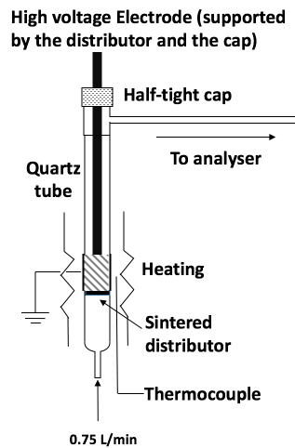
Figure 1 Illustration of the DBD reactor.

Data analysis
The main gaseous products observed were H₂, CO, CO₂, with traces of C₂H₂, and C₂H₄ (< 150 ppm). The averaged conversion of CH₄, $X_{{CH}_{4}}$, is defined as:

$X_{{CH}_{4}}$ = $\frac{\frac{\int_{t_{0}}^{t_{end}}{{(F_{total,0}∙x}_{{CH}_{4,0}}-{ F_{total}∙x}_{{CH}_{4}})dt}}{t_{end}-t_{0}}}{F_{total,0}∙x_{{CH}_{4},0}}$,

where $x_{{CH}_{4},0}$ and $x_{{CH}_{4}}$are CH₄ mole fractions measured at the reactor inlet and outlet, respectively. $F_{total,0}$ and $F_{total}$ are the corresponding total flow rates. The converted CH₄ was averaged for the period with plasma discharge. Assuming that the amount of Ar did not change over time, only CO, CO₂, H₂, C₂H₂, C₂H₄ and Ar were present at the outlet, then the total flow rate at the outlet (dry basis), $F_{total}$, can be obtained from the Ar balance:

$F_{total,0}∙\left(1-x_{{CH}_{4,0}}\right)={ F_{total}∙(1-x}_{{CH}_{4}}-x_{CO}-x_{{CO}_{2}}-x_{C_{2}H_{2}}-x_{C_{2}H_{4}})$.

The averaged selectivities, $S_{a=CO or {CO}_{2} }$for CO or CO₂, and $S_{H_{2}}$ for H₂, are given as:

$S_{a}$ = $\frac{\int_{t_{0}}^{t_{end}}{{F_{total}∙x}_{a}dt}}{\int_{t_{0}}^{t_{end}}{{(F_{total,0}∙x}_{{CH}_{4,0}}-{ F_{total}∙x}_{{CH}_{4}})dt}}$

$S_{H_{2}}$ = $\frac{\int_{t_{0}}^{t_{end}}{{F_{total}∙x}_{H_{2}} dt}}{2\int_{t_{0}}^{t_{end}}{{(F_{total,0}∙x}_{{CH}_{4,0}}-{ F_{total}∙x}_{{CH}_{4}})dt}}$,

where $S_{a}$ is based on C in CH₄, and $S_{H_{2}}$ is based on H in CH₄.
The average yield for each product, $Y_{i}$, was defined as the amount of component i produced for every mole of CH₄ introduced into the DBD reactor:

$Y_{i}=\frac{\frac{\int_{t_{0}}^{t_{end}}{{F_{total}∙x}_{i} dt}}{t_{end}-t_{0}}}{F_{total,0}∙x_{{CH}_{4},0}}$.

The fraction of carbon deposited was estimated from the difference between the carbon input and that detected at the outlet during the reduction period:

$d_{c}=1-\frac{\int_{t_{0}}^{t_{end}}{F_{total}∙(x_{co}+x_{{co}_{2}}+{2x}_{C_{2}H_{4}}+{2x}_{C_{2}H_{2}}) dt}}{\int_{t_{0}}^{t_{end}}{{(F_{total,0}∙x}_{{CH}_{4},0}-{ F_{total}∙x}_{{CH}_{4}})dt}}$.

The carbon and hydrogen balances were also estimated, and defined as the ratio of carbon/hydrogen-containing species measured to the carbon/hydrogen in the converted CH₄ in a complete looping cycle (i.e. CH₄/Ar plasma discharge followed by air plasma discharge stage).

Results

Al₂O₃ and Fe₂O₃
The results of plasma-assisted cracking or/and partial oxidation of CH₄ in undoped Al₂O₃ and Fe₂O₃ beds are presented in Fig. 2. For both materials, CH₄ conversion was only observed when plasma discharge was applied. H₂ was found to be the main product and its generation over the discharge was relatively uniform. CO and CO₂ were observed only at trace levels (< 250 ppm). This suggests that H₂ was primarily generated from CH₄ cracking by the plasma, and the carbon from the converted CH₄ deposited onto the solid phase. This agrees with the fact that the ratio of generated H₂ to converted CH₄ was 1.7 $±$ 0.1 (based on three cycles) for both materials. Taking into account C₂H₂ and C₂H₄ generated during discharge period (at ppm levels), over 80 % hydrogen balance was obtained for both materials (see Table 1). The conversion of CH₄, as well as the generation of H₂, in the Al₂O₃ and Fe₂O₃ beds were similar, suggesting that neither material is a good catalyst for CH₄ cracking. In the air plasma discharge period, trace levels (< 100 ppm) of CO and CO₂ were observed, suggesting the presence of deposited carbon from the cracking process in the bed. However, the deposited carbon could not be removed completely at such low temperatures, even with the assistance of plasma. Further regeneration of the bed was carried out by raising the temperature of the reactor to 823 K for over 30 min until no CO and CO₂ were detected.
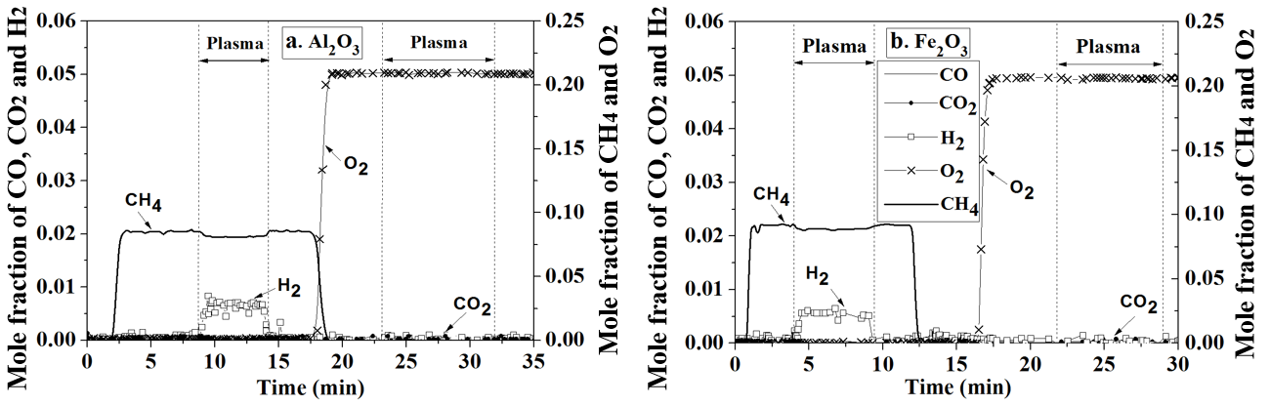
Figure 2 Plasma-assisted cracking/partial oxidation of CH₄ at 673 K with DBD reactor packed with a) Al₂O₃; b) Fe₂O₃.

NiO/Al₂O₃, Ni/Al₂O₃, NiO/Fe₂O₃ and NiFe₂O₄/Fe₂O₃
CH₄ conversion in the NiO/Al₂O₃ bed, shown in Fig. 3a, was similar to those in Al₂O₃ and Fe₂O₃ beds, suggesting that this material also has little effect on CH₄ reforming or partial oxidation. For Ni/Al₂O₃ as seen in Fig. 3b, a significant rise in [H₂] was observed when CH₄ was introduced into the reactor, without plasma. This was mainly due to the catalytic effect of Ni, as reported in e.g. ref [10]. However, the catalytic effect did not last long and the H₂ level dropped and gradually reached a mole fraction of 0.01, whilst no significant production of CO and CO₂ was observed. This suggests that the deactivation of Ni was likely due to carbon deposition. The formation of nickel aluminate (confirmed by post-reaction XRD results shown in Fig. S1) could have also contributed to this deactivation. When plasma discharge was applied from t = 9.5 to t = 15.6 min, higher degrees of CH₄ conversion and H₂ production were achieved. At t = 22.0 min, CH₄ was stopped, leaving the bed purging in Ar. Then, as soon as the gas was switched from Ar to air, a significant CO₂ peak together with a small CO peak was observed and an overall carbon balance of 94% was obtained.

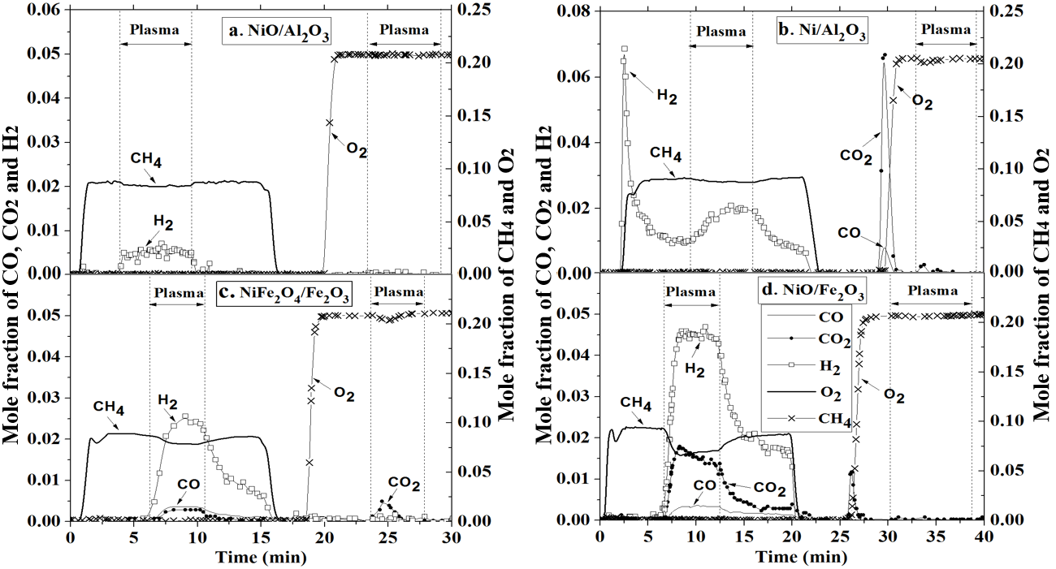
Figure 3 Plasma-assisted cracking/partial oxidation of CH₄ at 673 K with DBD reactor packed with a) NiO/Al₂O₃; b) Ni/Al₂O₃; c) NiFe₂O₄/Fe₂O₃; d) NiO/Fe₂O₃.

When the reactor was loaded with NiFe₂O₄/Fe₂O₃, according to Fig. 3c, no significant conversion of CH₄ was seen without plasma discharge. At t = 6.8 min, when plasma was introduced, much improved generation of H₂ over the whole discharge period was observed; at the same time, there was a clear production of CO and CO₂, indicating that the reduction of the bed material occurred (NiFe₂O₄/Fe₂O₃ was the only source of oxygen in the system). The overall result was a partial oxidation of CH₄ by plasma discharge to a product stream rich in H₂, CO and CO₂. When plasma discharge was stopped, H₂ was still produced from the NiFe₂O₄/Fe₂O₃ bed, though at lower levels. The fact that NiFe₂O₄ was not reactive for H₂ production before plasma discharge but was after, suggests the generation of some additional phase other than NiFe₂O₄ during plasma discharge, with this (probably reduced) phase having a catalytic effect even without plasma. In the air regeneration stage, CO₂ was only observed when plasma was applied. In the NiO/Fe₂O₃ bed, according to Fig. 3d, no conversion of CH₄ was observed until plasma was applied, at which point a significant amount of H₂ was generated. The CO and CO₂ productions were also much higher than those from other beds during plasma discharge. CH₄ conversion reached 32% in this instance. Similar to the case in the NiFe₂O₄/Fe₂O₃ bed, when plasma was switched off, there was still post-plasma H₂ production. Most of the deposited carbon was recovered in air, without the presence of plasma. It should be noted that it was not possible to prepare and investigate Ni/Fe₂O₃ because Ni/Fe₂O₃ is thermodynamically unstable at the studied conditions.
Table 1 Summarised results in different bed materials (errors show the range of three repeats).
Parameters | Al₂O₃ | NiO/Al₂O₃ | Ni/Al₂O₃ | Fe₂O₃ | NiO/Fe₂O₃ | NiFe₂O₄/ Fe₂O₃
$$d_{c}$$ | 0.75 $±$ 0.04 | 0.75 $±$ 0.03 | 0.90 $±$ 0.07 | 0.71 $±$ 0.05 | 0.15 $±$ 0.03 | 0.47$±$ 0.08
C balance | 0.26 $±$ 0.02 | 0.25 $±$ 0.02 | 0.94 $±$ 0.02 | 0.38 $±$ 0.02 | 0.94 $±$ 0.03 | 0.63 $±$ 0.04
H balance | 0.93 $±$ 0.04 | 0.94 $±$ 0.03 | 0.96 $±$ 0.04 | 0.82 $±$ 0.02 | 0.82 $±$ 0.03 | 0.99 $±$ 0.06
$$X_{{CH}_{4}}$$ | 0.05 $±$ 0.01 | 0.05 $±$ 0.01 | 0.10 $±$ 0.02 | 0.04 $±$ 0.01 | 0.39 $±$ 0.07 | 0.19 $±$ 0.04
$$S_{co}$$ | 0.01 $±$ 0.01 | 0.01 $±$ 0.01 | 0.03 $±$ 0.01 | 0.01 $±$ 0.01 | 0.12 $±$ 0.01 | 0.25 $±$ 0.01
$$S_{co_{2}}$$ | 0.03 $±$ 0.01 | 0.06 $±$ 0.01 | 0.02 $±$ 0.01 | 0.08 $±$ 0.01 | 0.71 $±$ 0.02 | 0.27 $±$ 0.02
$$S_{H_{2}}$$ | 0.84 $±$ 0.01 | 0.85 $±$ 0.01 | 0.95 $±$ 0.01 | 0.74 $±$ 0.01 | 0.92 $±$ 0.01 | 0.98 $±$ 0.07
$Y_{co}$×10³ | 0. 3 $±$ 0. 1 | 0.3 $±$ 0.1 | 0.3 $±$ 0.1 | 0.2 $±$ 0.1 | 45.2 $±$ 4.9 | 38.4 $±$ 5.2
$Y_{{co}_{2}}$×10³ | 1.2 $±$ 0.3 | 2.7 $±$ 0.5 | 2.2 $±$ 0.6 | 3.2 $±$ 0.7 | 285.5 $±$ 15.1 | 45.4 $±$ 3.1
$Y_{H_{2}}$×10³ | 64.7 $±$ 1.4 | 81.3 $±$ 1.2 | 180.6 $±$ 11.2 | 58.9 $±$ 1.1 | 621.7 $±$ 32.3 | 319.0 $±$ 40.2

Table 1 presents the summarised results of degree of carbon deposition, conversion of CH₄, selectivity and yield for products, carbon and hydrogen balances. It should be noted that after three cycles, no mechanical deterioration was visually observed for any of the tested materials. Overall, NiO/Fe₂O₃ seems to be the most promising material for H₂ production due to its low degree of carbon deposition, high carbon and hydrogen balances, and high selectivity and yield for H₂. The hydrogen balance in the case of NiO/Fe₂O₃ was slightly lower than those in other Ni-doped materials. This suggests that some H-containing products other than H₂ might have been generated, probably H₂O. NiFe₂O₄/Fe₂O₃ also exhibited very high selectivity towards the production of H₂, although its resistance to coking, carbon balance and the conversion of CH₄ were not as good as those of NiO/Fe₂O₃.

XRD results for NiO/Fe₂O₃ and NiFe₂O₄/Fe₂O₃
To evaluate any possible change in the material structure after the plasma-assisted CH₄ conversion, the bed material samples were collected and X-ray powder diffraction (XRD) performed using an Empyrean PANalytical diffractometer. A typical diffractogram was collected in the range of $2θ$ from $5°$ to $80°$ using Cu $K_{α}$ radiation with a voltage of 40 kV and current of 40 mA. The phases in the samples were identified using the reference patterns from ICSD database (Table S1).

NiO/Fe₂O₃
Figure 4 shows the XRD patterns of NiO/Fe₂O₃ samples: freshly prepared, with CH₄/Ar plasma treatment and after regeneration in air plasma. Major peaks of each phase and an unknown peak ($2θ$ = 26.7) are marked accordingly. For the freshly calcined NiO/Fe₂O₃, only NiO and Fe₂O₃ were detected. This suggests no chemical interaction between NiO and Fe₂O₃ during calcination. After CH₄/Ar plasma treatment, NiO was no longer detected; instead, metallic Ni and magnetite, Fe₃O₄, were detected. For the air regenerated NiO/Fe₂O₃, similar to the fresh sample, NiO and Fe₂O₃ were the only phases detected, suggesting that the NiO phase can remain separate during plasma discharge in air.

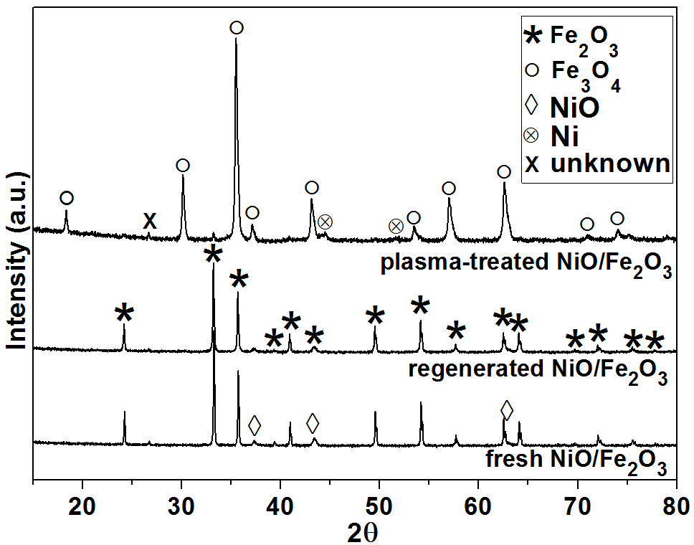
Figure 4 XRD spectra of fresh NiO/Fe₂O₃, CH₄/Ar plasma treated NiO/Fe₂O₃ and air plasma regenerated NiO/Fe₂O₃.

NiFe₂O₄/Fe₂O₃
XRD Results for NiFe₂O₄/Fe₂O₃ samples are presented in Fig. 5. Fe₂O₃ and NiFe₂O₄ phases were observed in the fresh sample. The formation of NiFe₂O₄ indicates the diffusion of NiO into the Fe₂O₃ crystal structure during calcination. In the XRD pattern of the CH₄/Ar plasma treated NiFe₂O₄/Fe₂O₃, there was a decrease in the intensity of the peaks for the NiFe₂O₄ phase; additionally, metallic alloy of Ni-Fe, expresses as (Ni, Fe), was observed. There was no clear evidence of the presence of Fe₃O₄, suggesting that the oxygen in the produced CO and CO₂ in the CH₄/Ar discharge period probably came from the reduction of NiFe₂O₄ to the metallic (Ni, Fe). On regeneration with air, the (Ni, Fe) phase disappeared, but the intensity of NiFe₂O₄ peaks did not return to the higher level as seen in the fresh NiFe₂O₄/Fe₂O₃ sample.

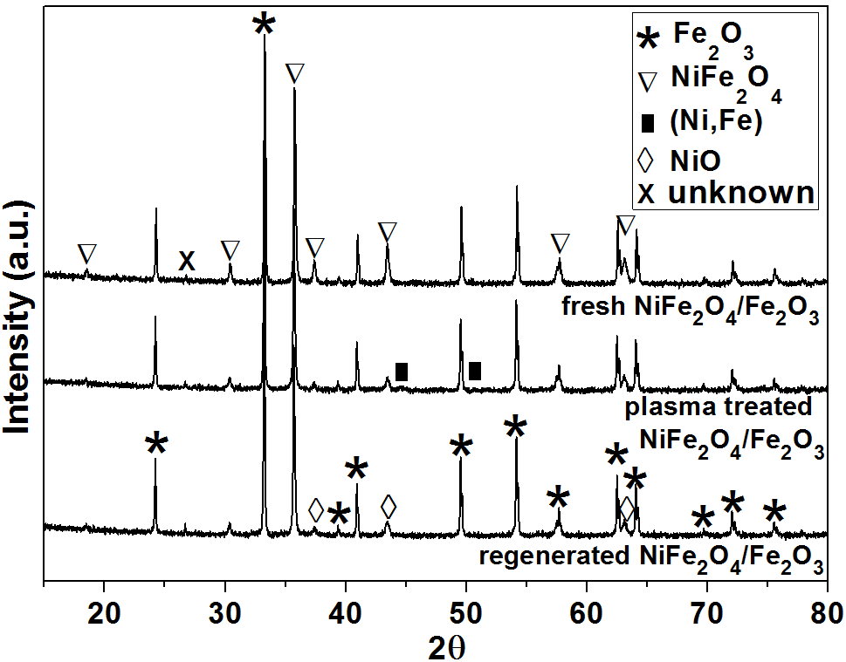
Figure 5 XRD spectra of fresh NiFe₂O₄/Fe₂O₃, CH₄/Ar plasma treated NiFe₂O₄/Fe₂O₃ and air plasma regenerated NiFe₂O₄/Fe₂O₃.

Discussion

Catalytic activity
The results in Figs. 2 and 3 show that NiO (when supported on inert Al₂O₃) and Fe₂O₃ alone did not show good catalytic activity for the conversion of CH₄, even in the presence of the plasma discharge. However, the combination of NiO and Fe₂O₃, which resulted in NiO/Fe₂O₃ or NiFe₂O₄/Fe₂O₃, demonstrated significantly improved performance.

NiO/Fe₂O₃
The results in Fig. 4 imply the formation of Ni when NiO/Fe₂O₃ was subjected to CH₄/Ar plasma discharge. In contrast to the Ni/Al₂O₃ experiment (in Fig. 3b), where the production of H₂ was high at the very beginning of the plasma discharge but decreased quickly, the bed of NiO/Fe₂O₃ was able to produce significant amounts of H₂ over the entire plasma discharge period. The superior performance of NiO/Fe₂O₃ might have resulted from lattice oxygen in NiO/Fe₂O₃, which seems to suppress the coking of the solid bed, so that the catalytic activity of Ni can be maintained. This is supported by the smaller amount of carbon deposited in the NiO/Fe₂O₃ bed. Owing to the presence of Fe₃O₄, it was difficult to determine if NiO was still present in the plasma treated NiO/Fe₂O₃ sample from the XRD (NiO peaks overlap with those from Fe₃O₄). However, calculation of the oxygen balance can provide additional insight on to the phases present. It was found that the amount of oxygen in the produced CO, CO₂ and H₂O (estimated from the hydrogen balance) during CH₄/Ar plasma discharge period accounted for 3.2 wt% $±$ 0.2 wt% of the total mass of NiO/Fe₂O₃. The oxygen capacity from NiO $→$ Ni was 2.0 wt%, whilst that in Fe₂O₃ $→$ Fe₃O₄ was 3.0 wt%. As most of the hematite was reduced (only low intensity of Fe₂O₃ peaks were detected), it is possible that some NiO might have remained after CH₄/Ar plasma discharge.
Interestingly, the NiFe₂O₄ phase was not observed in the XRD pattern of the NiO/Fe₂O₃ (Fig. 4), suggesting little interaction between NiO and Fe₂O₃, either during calcination or plasma treatment. The fact that NiO alone was inactive during plasma discharge, suggests the presence of some available oxygen in the NiO/Fe₂O₃ to suppress coking. One of the three hypothesis might describe these conditions: 1) NiO itself is responsible for the partial oxidation of CH₄ via NiO + CH₄ $→$ CO + CO₂ + H₂ + Ni, and Fe₂O₃ helps the process to continue by transporting oxygen to the Ni sites; 2) metallic Ni is responsible for the generation of H₂ via CH₄ $\underset{→}{Ni}$C + H₂, and the presence of Fe₂O₃ helps to remove the solid carbon from the Ni sites; 3) a combination of 1) and 2). The above results seem to suggest that 2) is more likely to dominate, as the H₂ production rate in the NiO/Fe₂O₃ bed was comparable to that when Ni/Al₂O₃ was just exposed to CH₄. This is further supported by the results from SEM-EDX analysis, which showed that the surface of NiO/Fe₂O₃ particles treated with CH₄/Ar plasma was predominantly covered by Ni (see Fig. S2 and Table S2). Furthermore, the trace amounts of CO and CO₂ produced from NiO/Al₂O₃ subjected to CH₄/Ar plasma discharge were similar to those from bare Al₂O₃ and Fe₂O₃ beds, showing that NiO in the absence of Fe₂O₃ cokes easily, or does not react with CH₄.
It is reasonable to identify the sequence of phase transformation of NiO/Fe₂O₃ in the reducing CH₄ environment by referring to the Ni-O and Fe-O phase diagrams (computed by MTDATA [11], see Figs. S3 and S4). Thermodynamically, at 673 K, the $P_{O_{2}}$ to cause a phase transition from NiO to Ni is lower than that for Fe₂O₃ to Fe₃O₄, but higher than that for Fe₃O₄ to Fe. This means that assuming negligible solubility of NiO into the Fe₂O₃ system, the sequence for reduction would be: Fe₂O₃ + NiO $→$ NiO + Fe₃O₄ $→$ Ni + Fe₃O₄. Therefore, in a reducing environment, it is expected that if Ni was detected, Fe₃O₄ would then also be present. However, at the relatively mild temperatures in this study, reaction kinetics are important and Fe₂O₃ is un-reactive towards CH₄. A high level of H₂ production in NiO/Fe₂O₃ was observed as soon as the plasma discharge was applied. If the catalytic effect for H₂ production was only due to the presence of metallic Ni, then the formation of Ni must have happened as soon as NiO/Fe₂O₃ was subjected to plasma discharge. This contrasts with the pure NiO/Al₂O₃ material, which could also have reduced to Ni locally, but for some reason remained inactive, perhaps because of coking, with carbon immediately deposited on any newly created Ni-metallic site. Additionally, the formation of nickel aluminate after plasma treatment also means that less Ni was available for CH₄ cracking. If Ni formed immediately when plasma was applied in the NiO/Fe₂O₃ bed, the suppression of coking was most likely due to the presence of an oxygen source, i.e. Fe₂O₃. The co-existence of Ni and Fe₂O₃ is thermodynamically unstable, and the system tends to form NiO and Fe₃O₄ at equilibrium. The transfer of oxygen to the Ni sites would then help remove any deposited carbon, or prevent transiently formed absorbed carbon species from forming coke, and thus maintaining the catalytic activity of Ni. This means that a synergistic effect, which here most likely depends on the CH₄, Ni and oxygen from Fe₂O₃ being in intimate contact, exists. For NiO/Fe₂O₃, not only was less coke formed, but also the remaining coke was more easily burned off during the air regeneration stage, compared with other materials e.g. NiO/Al₂O₃ and Fe₂O₃. The superior performance of the NiO/Fe₂O₃ for H₂ production and its easy regeneration demonstrate the possibility of plasma-assisted chemical looping system for H₂ production at mild temperatures. The process requires further studies and careful optimisation. Interestingly, at higher temperatures, as observed in preliminary tests at 773 K, plasma treatment on NiO/Fe₂O₃ resulted in total combustion of CH₄ to H₂O and CO₂.

NiFe₂O₄/Fe₂O₃
As shown in Fig. 4, the observed (Ni, Fe) phase together with the decreased intensity of NiFe₂O₄ peaks in the XRD spectra in the CH₄/Ar plasma treated sample, indicates the phase segregation of NiFe₂O₄ to (Ni,Fe). This seems to be consistent with the study carried out by Raghavan [12]. At 1273 K and low $P_{O_{2}}$ ($P_{O_{2}}$ < 10⁻¹¹ bar), NiFe₂O₄ tends to reach equilibrium with (Ni, Fe)₃O₄ and (Ni, Fe). Extrapolating to the low temperatures used here, it is reasonable to expect that the reduction follows NiFe₂O₄ $→$ (Ni, Fe)₃O₄ + (Ni, Fe). In our study, when the NiFe₂O₄ material was regenerated in air plasma at 673 K (Fig. 5), the (Ni, Fe) peaks disappeared. The most likely route for Ni oxidation is to create NiO. However, the presence of NiO was difficult to confirm, due to significant overlap of the NiO and NiFe₂O₄ peaks in the XRD pattern. For Fe, no evidence of wustite or magnetite phase was observed, and the most likely route would then be Fe $→$ Fe₂O₃. In terms of the catalytic effect in the NiFe₂O₄ bed, it was found that H₂ yield improved slightly in the second and third reduction cycles (Fig. S5). If NiO was indeed created in the regeneration stage, then it could have helped with the production of H₂ in subsequent reductions.

Comparison to water gas shift equilibrium
In NiO/Fe₂O₃, the products from CH₄/Ar plasma discharge were mainly H₂ and CO₂. A high yield of H₂ and CO₂ at such low temperature (673 K) could be linked with WGS (H₂O + CO $→$H₂ + CO₂). Assuming that water was also produced and is responsible for the missing H in the mass balance (as shown in Table 1), then the reaction quotient, $\frac{\left[H_{2}\right][{CO}_{2}]}{\left[H_{2}O\right][CO]}$= 64.6 $±$ 19.1, can be compared with the equilibrium constant of WGS at 673 K, K_{eq} = 12.0 [13]. This suggests that the plasma-assisted process tends to push production of H₂ and CO₂, beyond the thermodynamic equilibrium of WGS. To achieve a K_{eq} close to the reaction quotient obtained here, the conventional WGS would need to operate at a lower temperature (though it should be noted that excess water is usually used to shift the equilibrium). For the WGS to achieve a high conversion to H₂ and maintain favourable kinetics, multiple reaction stages are often employed (e.g. moving from high to low temperatures), and thus complicating the process. For the presented PCLH approach, the fact that such high production of H₂ and CO₂ was achieved within such a small bed (~ 7.5 ml) indicates fast reaction rates. The high value of $\frac{\left[H_{2}\right][{CO}_{2}]}{\left[H_{2}O\right][CO]}$ found here seems to suggest that H₂ and CO₂ might be directly produced from the partial oxidation of CH₄ by the oxygen carrier, without going through some intermediate steps involving WGS. The unusually high ratio is likely to be a result of H₂ and CO₂ not having sufficient time to reach a WGS equilibrium.

4.3 Energy cost for H₂ production
Assuming electricity production from CH₄ combustion with 60% efficiency (see supplementary information Eq. S1), the estimated energy cost for H₂ production from a NiO/Fe₂O₃ bed, is 440 $±$ 20 MJ/kg of produced H₂ (based on HHV of CH₄). This is higher than the cost of conventional steam methane reforming, which is less than 160 MJ/kg [14], but comparable to that of water electrolysis, from 320 to 510 MJ/kg (estimated based on electricity consumption between 50 to 79 kWh/kg [15]). Given that the current experimental set-up can be further optimised, there is scope for further cost reduction.

Conclusions
Ni-based catalysts supported on Al₂O₃ and Fe₂O₃ were investigated for plasma-assisted H₂ production from CH₄. Experiments carried out in a DBD packed bed reactor at 673 K showed that the supporting metal oxide, Fe₂O₃, positively influences the activity of the catalyst. Among the tested materials, NiO/Fe₂O₃ exhibited the highest H₂ yield, whilst carbon deposition and the subsequent catalyst deactivation were significantly lower than those from NiO or Ni supported on alumina.
The catalytic activity for H₂ production in the combined catalyst/oxygen carrier (NiO/Fe₂O₃) was attributed to the generation of metallic Ni, and the suppression of carbon deposition was connected to the presence of the active metal oxide, Fe₂O₃. The hydrogen yield form the plasma-assisted CH₄ reforming and oxidation by the oxygen carrier exceeded that anticipated from the WGS equilibrium.

Acknowledgements
Yaoyao Zheng is grateful for the financial support from the China Scholarship Council and Cambridge Trust.

References
[1] J.R. Rostrup-Nielsen, T. Rostrup-Nielsen, CATTECH 6 (2002) 150–159.
[2] M. Rydén, A. Lyngfelt, Int. J. Hydrogen Energy 31 (2006) 1271–1283.
[3] M. Tang, L. Xu, M. Fan, Appl. Energy 151 (2015) 143–156.
[4] J. Adanez, A. Abad, F. Garcia-Labiano, P. Gayan, L.F. de Diego, Prog. Energy Combust. Sci. 38 (2012) 215–282.
[5] N.Z. Muradov, T.N. Veziroǧlu, Int. J. Hydrogen Energy 30 (2005) 225–237.
[6] J. Genovese, K. Harg, M. Paster, J. Turner, Analysis (2009) 51.
[7] Q. Wang, H. Shi, B. Yan, Y. Jin, Y. Cheng, Int. J. Hydrogen Energy 36 (2011) 8301–8306.
[8] H. Taghvaei, M.M. Shirazi, N. Hooshmand, M.R. Rahimpour, A. Jahanmiri, Appl. Energy 98 (2012) 3–10.
[9] Y.X. Zeng, L. Wang, C.F. Wu, J.Q. Wang, B.X. Shen, X. Tu, Appl. Catal. B Environ. 224 (2018) 469–478.
[10] Y.-G. Chen, J. Ren, Catal. Letters 29 (1994) 39–48.
[11] R.H. Davies, A.T. Dinsdale, J.A. Gisby, J.A.J. Robinson, S.M. Martin, Calphad 26 (2002) 229–71.
[12] V. Raghavan, J. Phase Equilibria Diffus. 31 (2010) 369–371.
[13] C.A. Callaghan, Kinetics and Catalysis of the Water-Gas-Shift Reaction: A Microkinetic and Graph Theoretic Approach, 2006.
[14] P.L. Spath, M.K. Mann, Natl. Renew. Energy Lab. DOE, U.S. (2001) NREL/TP-570-27637.
[15] B. Kruse, S. Grinna, C. Buch, Hydrogen: Status and Possibilities, 2002.

List of supplemental materials
Fig. S1 XRD spectra of CH₄/Ar plasma treated NiO/$γ$-Al₂O₃. Material was only reduced and not regenerated with air after the plasma treatment.
Fig. S2 SEM micrograph combined with EDX analysis of NiO/Fe₂O₃ particle surface after experiment in the DBD reactor. The material was retreated after CH₄/Ar plasma-assisted reduction (no air regeneration). The micrograph was collected with TESCAN MIRA3 FEG-SEM combined with Oxford Instruments Aztec Energy X-maxN 80 EDS system at an accelerating voltage of 15 kV, working distance of 14 mm and 1000x magnification. The quantitative results from the EDX analysis are presented in Table S2.
Fig. S3 Phase diagram of Ni-O system, calculated with MTDATA [11] (SGTE database).
Fig. S4 Phase diagram of Fe-O system with MTDATA [11] (NPL database).
Fig. S5 H₂ concentration measured during three subsequent CH₄/Ar plasma discharge experiments, using NiFe₂O₄/Fe₂O₃ as the bed material.
Table S1 Collection Code of the XRD reference patterns used from ICSD database.
Table S2 Results from the EDX analysis of NiO/Fe₂O₃ particle surface after experiment in the DBD reactor. The material was retreated after CH₄/Ar plasma-assisted reduction (no air regeneration). The analysis was performed with TESCAN MIRA3 FEG-SEM combined with Oxford Instruments Aztec Energy X-maxN 80 EDS system at an accelerating voltage of 15 kV, working distance of 14 mm and 1000x magnification. The SEM micrograph and EDX maps are presented in Fig. S2.
Eq. S1 The energy cost for H₂ production, MJ /kg.

Fig. S1
Fig. S2
Fig. S3
Fig. S4

Fig. S5
Table S1
Component | Fe₂O₃ | Fe₃O₄ | NiO | Ni | NiFe₂O₄ | (Ni, Fe) | NiAl₂O₄
Collection Code from ICSD | 15840 | 30860 | 9866 | 260169 | 40040 | 56386 | 9556

Table S2
Element | Weight in wt% | $σ$ in wt%
C | 6.59 | 0.06
O | 10.84 | 0.03
Fe | 20.28 | 0.05
Ni | 62.2 | 0.07

Eq. S1
The energy cost in this manuscript was defined as:
Energy cost = $\frac{(\frac{W}{B_{{CH}_{4}}∙η}+n_{{CH}_{4}})∙{HHV}_{{CH}_{4}}}{n_{H_{2}}}$,
where W is the applied plasma power, $n_{H_{2}}$ is the amount of H₂ produced over processing time. $B_{{CH}_{4}}$ is the chemical exergy of CH₄, which is ~ 52 MJ/kg. $η$ is the efficiency from thermal to electricity energy and a value of 60% is assumed here. $n_{{CH}_{4}}$ is the converted amount of CH₄, and ${HHV}_{{CH}_{4}}$ is the high heating value of ${CH}_{4}$ (~ 55.5 MJ/kg).

