Supplementary Material
Inclusion criteria:
- RCT of either conventional synthetic (including glucocorticoids) or biologic disease modifying anti-rheumatic drugs (DMARDs) in early inflammatory polyarthritis, or RA
- RCT co-ordinated in the UK or included enrolment of UK-based participants and been completed between 2002 and 2012 (to increase chance of access)
- Phase II or III RCT of three or more months treatment duration
- RCT must include 80% or more of the required individual-level and trial-level information
- Participants aged 16 years and over
- Original informed consent must have permitted the sharing of data
- Sponsors agree to share de-identified/anonymised patient level data
The information requested comprised
- Trial information: inclusion/exclusion criteria and treatment regimes;
- Randomisation details;
- Baseline data: demographics (e.g. age, sex, smoking), clinical (e.g. disease duration, rheumatoid factor (RF) and anti-citrullinated protein antibody (ACPA) status, disease activity measures including erythrocyte sedimentation rate (ESR) and/or C-reactive protein (CRP) , radiographic damage), patient reported outcome measures (PROMs) (e.g. Health Assessment Questionnaire (HAQ) score; Short Form 36 Health Survey (SF-36), Fatigue) and medication history;
- Follow-up data: the timing of follow-up visits, end of study status, reasons for withdrawal, disease outcome information including disease activity variables (28-joint counts, acute-phase reactants, global assessment of disease activity, disease activity scores etc.), radiographic damage, and PROMs, co-medications and treatment received, and treatment departure and adherence.

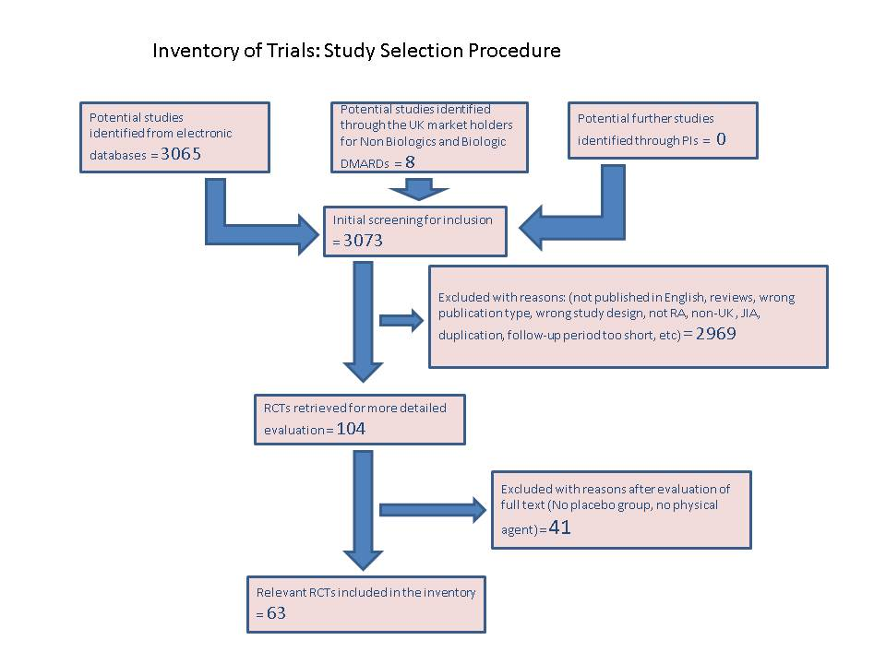
Supplementary Figure 1: Flow diagram summarising the study selection procedure

Supplementary Table 1a: Description of the 19 Randomised Controlled Trials received (Stivea trial excluded from all analyses)
Trial Identifier  (Start year) | Trial design | Planned duration of RCT phase (weeks) | Control arm treatment(s) | Open label extension part? | Failed to respond to at least one csDMARD  as an inclusion criteria | Did some patients have prior MTX use? | Number of patients reported in control arm(s) | Number of patients extracted from control arm(s)
NCT00291928  (2005) | Phase I/II | 48 | Placebo | No | Yes | Yes | 63 | 63
NCT00713544  (2008) | Phase IIb | 12 | Placebo + Background MTX | No | Yes | Yes | 65 | 65
NCT00548834*  (2003) | Phase III multi-centre  (UK site?) | 24 | Placebo | Yes** | Yes | Yes, but discontinued | 109 | 88
NCT00152386*  (2005) | Phase III  multi-centre | 52 | Placebo + BackgroundMTX | Yes** | Yes# | Yes | 199 | 162
ETANERCEPT STUDY 309  (Before 2006) | Phase III  multi-centre | 24 | Sulfasalazine (SSZ) | No | Yes## | Yes, but discontinued | 50 | 50
NCT00195494  (2004) | Phase III  multi-centre | 52 | MTX | No | No | No | 268 | 268
NCT00393471  (2000) | Phase III  multi-centre | 52 | MTX | No | Yes### | Yes, but discontinued | 228 | 231^
STIVEA***  (2002) | Phase III  multi-centre | 52 | Placebo and IM Glucorticoid | No | No | No | 265 | 265
CARDERA  (2000) | Phase III multi-centre factorial trial | 104 | MTX, MTX + Ciclosporin, MTX + Prednisone and Triple Therapy | No | No | No | 467 | 467
NCT00544154*  (2002) | Phase III multi-centre | 24 | Placebo + Background MTX | Yes** | Yes# | Yes | 121 | 98
NCT00611455  (2008) | Phase III multi-centre | 24 | Placebo + Background MTX | Yes** | Yes# | Yes | 131 | 134^
NCT00111423~  (2001) | Phase II | 24 | Placebo + Background MTX | No | Yes# | Yes | 77 | 77
NCT00037700  (2001) | Phase II | 24 | Placebo + Background MTX | No | Yes# | Yes | 68 | 68
NCT00106522****  (2005) | Phase III multi-centre | 24 | Placebo + Background MTX | No | Yes | Yes | 160 | 160
NCT00106535****  (2005) | Phase III multi-centre | 52@ | Placebo + Background MTX | Yes@@ | Yes | Yes | 393 | 392^^
NCT00106548****  (2005) | Phase III multi-centre | 24 | Placebo + Background MTX | No | Yes | Yes | 204 | 204
NCT00109408  (2005) | Phase III multi-centre | 24 | MTX | No | No | Yes, but discontinued | 284 | 284
NCT00106574****  (2005) | Phase III multi-centre | 24 | Placebo + Background DMARD therapy | Yes** | Yes | Yes | 415 | 414^^
NCT00520572  (2007) | Phase IIb | 28 | Placebo + Background MTX or SSZ | No | Yes | Yes | 65 | 65
* Random 80%; ** Encouraged or eligible to enter an open-label extension study if withdrawn or after completion (open-label data not available); *** Study of patients with very early inflammatory polyarthritis (excluded from analyses); # Active disease despite on MTX; ## Active disease despite on SSZ; ### Not MTX; ^ Includes patients who although randomised did not receive test article or randomised in error; **** Rescue therapy offered at 16/8 weeks in all cases of treatment failure (41.25%, 50%, 33.33%, 3.9% and 10.8% resp.) ; @ Only have 24 weeks of data; @@ Second year of open-label therapy and an optional 3-year open-label extension phase; ^^ Patients who actually received the control treatment; ~The Trial identifier corresponds to the extension study to the original trial which does not have an NCT identifier.
Supplementary Table 1b: Description of the 19 Randomised Controlled Trials received (Stivea Trial excluded from all analyses)
Trial Identifier  (Start year) | Trial design | Biological Intervention | Primary Efficacy Outcome  (disease activity-related) | Secondary Efficacy Outcomes  (disease activity-related)
NCT00291928  (2005) | Phase I/II | Ofatumumab | ACR20 and DAS28 over time  (ACR20 at 24 weeks) | EULAR response  (EULAR at 24 weeks)
NCT00713544  (2008) | Phase IIb | AZD5672 | ACR20 at 12 weeks | ACR50/70 at 12 weeks; Change in DAS28 after 12 weeks
NCT00548834  (2003) | Phase III multi-centre  (UK site?) | CDP870 | ACR20 at 24 weeks | ACR50/70 at 24 weeks; ACR component scores; DAS28(ESR) 3
NCT00152386  (2005) | Phase III  multi-centre | CDP870 | ACR20 at 24 weeks | ACR20 at 52 weeks; ACR50/70 at 24 and 52 weeks
ETANERCEPT STUDY 309  (Before 2006) | Phase III  multi-centre | ETANERCEPT | ACR20 at 24 weeks | ACR20/50/70, DAS and its components over time
NCT00195494  (2004) | Phase III  multi-centre | ETANERCEPT | DAS28 remission at 52 weeks; | DAS44 remission, ACR20/50/70
NCT00393471  (2000) | Phase III  multi-centre | ETANERCEPT | ACR response AUC over 24 weeks | ACR20/50/70 and DAS
STIVEA  (2002) | Phase III  multi-centre | None | Need to start DMARDs by 6 months | DAS28(3)
CARDERA  (2000) | Phase III multi-centre factorial trial | None | None | Changes in DAS28
NCT00544154  (2002) | Phase III multi-centre | CDP870 | ACR20 at 24 weeks | ACR50/70 at 24 weeks; ACR component scores
NCT00611455  (2008) | Phase III multi-centre | Ofatumumab | ACR20 at 24 weeks | ACR50/70, EULAR response and DAS28 at 24 weeks
NCT00111423  (2001) | Phase II | Pegsunercept | ACR20 at 24 weeks | Sustained ACR20/50/70 response at 24 weeks, DAS, change from baseline in ACR component scores
NCT00037700  (2001) | Phase II | Anakinra, Pegsunercept | No details available from ClinicalTrials.gov | No details available from ClinicalTrials.gov
NCT00106522  (2005) | Phase III multi-centre | Tocilizumab | ACR20 at 24 weeks | ACR50/70 at 24 weeks; Changes in ACR component scores; DAS28 and EULAR response
NCT00106535  (2005) | Phase III multi-centre | Tocilizumab | ACR20 at 24 weeks | ACR20/50/70; DAS28
NCT00106548  (2005) | Phase III multi-centre | Tocilizumab | None | ACR50/70 at 24 weeks; Change from baseline in DAS28 at 24 weeks; DAS28 remission and EULAR response
NCT00109408  (2005) | Phase III multi-centre | Tocilizumab | ACR20 at 24 weeks | ACR20 at 8 weeks; ACR50/70 at 24 weeks; Change in ACR components; DAS28 and EULAR response
NCT00106574  (2005) | Phase III multi-centre | Tocilizumab | ACR20 at 24 weeks | ACR20 at 8 weeks; ACR50/70 at 24 weeks; Change in ACR components; DAS28; EULAR response and Time to ACR20/50/70 response
NCT00520572  (2007) | Phase IIb | AZD9056 | ACR20 at 24 weeks | ACR50/70; Changes in ACR components; DAS28

Supplementary Table 2: Base logistic regression model for clinical remission at 6 months for MTX-naïve entry subjects

Predictors | log(Odds Ratio) | Standard Error | Odds Ratio | 95% CI | p-value
Intercept* | ---- | ---- | ---- | ---- | ----
Age at Entry, years | -0.0188 | 0.0074 | 0.98 | 0.97-1.00 | 0.0109
Disease Duration, years | -0.0111 | 0.0294 | 0.99 | 0.93-1.05 | 0.7062
Gender  Male v Female | 0.9761 | 0.1914 | 2.65 | 1.82-3.86 | <0.0001
Ethnicity  White v Rest | 1.3524 | 0.4886 | 3.87 | 1.48-10.1 | 0.0056
DAS28-ESR at Baseline | -0.5028 | 0.0825 | 0.60 | 0.51-0.71 | <0.0001
Rheumatoid Factor Positivity  Yes v No | -0.1460 | 0.1990 | 0.86 | 0.59-1.28 | 0.4630
Randomised to MTX at start*  Yes v No | ---- | ---- | ---- | ---- | ----
Randomised to or on csDMARD at start  Yes v No | 0.1594 | 0.2696 | 1.17 | 0.69-1.99 | 0.5543
Randomised to Glucocorticoids at start  Yes v No | 1.3558 | 0.2905 | 3.88 | 2.20-6.86 | <0.0001
On Background Glucocorticoids at start  Yes v No | 0.2638 | 0.4795 | 1.30 | 0.51-3.33 | 0.5823
* Estimates and standard error are not estimable. MTX usage during study has been adjusted for in models. Majority of MTX-naïve subjects at trial entry received MTX during study (93%).

