**The influence of interface geometry, stiffness and crushing on the dynamic response of masonry collapse mechanisms**

Anjali Mehrotra1 and Matthew J. DeJong1

1Department of Engineering, University of Cambridge, United Kingdom

Failure of masonry structures generally occurs via specific collapse mechanisms which have been well-documented. Using rocking dynamics, equations of motion have been derived for a number of different failure mechanisms ranging from the simple overturning of a single block, to more complicated mechanisms. However, most of the equations of motion derived thus far assume that the structures can be modelled as rigid bodies rocking on rigid interfaces with an infinite compressive strength – which is not always the case. In fact, crushing of masonry - commonly observed in larger-scale constructions and vertically-restrained walls – can lead to a reduction in the dynamic capacity of these structures. This paper re-derives the rocking equation of motion to account for the influence of flexible interfaces, characterized by a specific interface stiffness as well as finite compressive strength. The interface now includes a continually shifting rotation point, the location of which depends not only on the material properties of the interface but also on its geometry. Expressions have thus also been derived for interfaces of different geometries, and parametric studies conducted to gauge their influence on dynamic response. The new interface formulations are also implemented within a new analytical modelling tool that provides a novel approach to the dynamic analysis of masonry collapse mechanisms. Finally, this tool is exemplified, along with the importance of the interface formulation, by evaluating the collapse of the Dharahara Tower in Kathmandu, which was almost completely destroyed during the 2015 Gorkha earthquake.

**KEYWORDS**

Interface geometry, interface stiffness, crushing effects, masonry collapse mechanisms, rocking dynamics, analytical modelling tools

# **1. Introduction**

The rocking response of masonry structures under the influence of seismic excitation has been well-documented, and numerous studies have been conducted with the objective of deriving equations of motion for the different possible failure mechanisms which range from the simple overturning of the single block [Housner 1963], to more complicated two and three block mechanisms, which can be used to capture the behaviour of structures such as cracked wall sections, arches and portal frames [Doherty et al. 2002; Mauro et al. 2015; De Lorenzis et al. 2007; Allen & Bielaks 1986; Makris & Vassiliou 2013]. However, deriving these equations can be challenging – especially for structures with irregular or arbitrary geometries such as statues or monumental ruins. To this end, an analytical modelling tool has recently been developed [Mehrotra & DeJong 2017] to derive these equations of motion for more complicated geometries, using as a starting point a 3D CAD drawing (or laser scan) of the structure.

Nevertheless, the equations of motion derived thus far assume that the structure can be modelled as a rigid body rocking on a rigid foundation, which is not necessarily true – especially since real structures have non-rigid interfaces, and typically rest on soil. In fact, experimental tests conducted by ElGawady et al. [2011] using concrete, timber, rubber and steel joints demonstrated that the interface material tends to have a substantial influence on the free rocking response of rigid blocks. In this case, it is thus perhaps more realistic to use a flexible Winkler-type foundation, which models the interface as a set of springs with a stiffness *kn*. While most of the analytical studies previously conducted on these flexible interfaces assume pure elastic behaviour [Psycharis & Jennings 1983; Koh et al. 1986; Shawa et al. 2012; Lipo & de Felice 2016; Lipo & de Felice 2017], recent work by Roh & Reinhorn [2009], Costa et al [Costa 2012; Costa et al. 2013] and Penna & Galasco [2013] assumes a bilinear elastic representation of the compressive behaviour of the interface, and thus also accounts for crushing effects. Nonetheless, in both cases the rocking equation of motion now includes an additional term *af* (*θ*) which accounts for the moment due to the reaction from the elastic/elasto-plastic joint, and is a function of the rotation *θ* of the structure, as illustrated by Equation (1):

 (1)

where  is the angular acceleration, *W* is the weight, *R0*is the distance between the center of the mass and the axis of rotation, *a0* is the slenderness, is the input ground acceleration, *g* is the acceleration due to gravity, and *θ* is the corresponding rotation of the structure. The equation of motion also depends on the moment of inertia *IO’*(*θ*), which in this case is determined relative to a shifting rotation point *O’*, which varies based on the rotation of the structure (Costa 2012). However, Equation (1) does not account for the accelerations induced by this shifting rotation point *O’* - thus in Section 2 of this paper, the rocking equation of motion will be re-derived to include these effects.

Furthermore, the analytical expressions derived for *af* (*θ*) thus far have been limited to bases (interfaces) which assume the form of solid rectangles as for the rocking block, whereas in reality this is not always the case – as demonstrated by structures such as bell towers, columns, domes etc., which tend to have non-rectangular and/or hollow interfaces. For the analytical modelling tool currently under development to be practically useful, it needs to be able to automatically derive equations of motion for these more complicated geometries. Therefore, to incorporate the effects of interface flexibility and crushing into the tool, Section 3 of this paper presents derivations for *af* (*θ*) for different interface geometries, including hollow rectangular bases, solid circular bases and hollow circular bases. The modified equations of motion will then be used to investigate the influence of base geometry, interface flexibility, and crushing on the seismic resilience of a few simple masonry structures. Finally, real-world application of these new equations will be demonstrated using as a case study the Dharahara Tower in Kathmandu, Nepal, which was severely damaged during the Gorkha earthquake in 2015.

# **2. Equation of motion for the flexible interface**

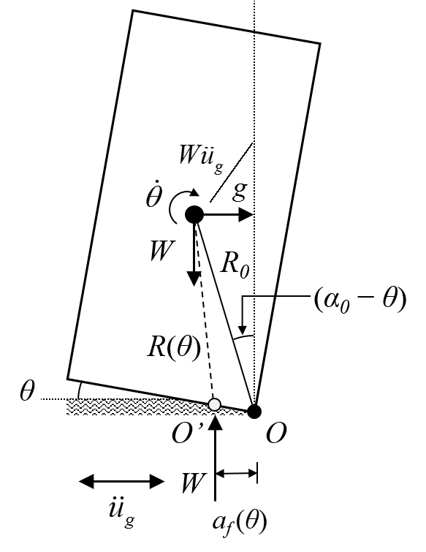

**Figure 1 Geometry of a rigid block rocking on a flexible interface.**

The equation of motion for the rigid block rocking on a flexible foundation (Figure 1) is derived using Lagrange’s principle as shown below:

 (2)

where *θ* is the rotation of the block and  the angular velocity. The term *T*(*θ,*) represents the kinetic energy of the block, *V*(*θ*) the potential energy, *B*(*θ*) the inertial force induced by the ground acceleration, and *M*(*θ*) the moment due to the reaction from the flexible interface. Each of these terms is defined as follows:

 (3)

 (4)

 (5)

 (6)

Note that the kinetic energy *T*(*θ*) depends on *IO’*(*θ*), which is the moment of inertia relative to the shifting rotation point *O’*, and is determined using the following equation:

 (7)

where *Ic* is the moment of inertia of the block about its centroid, and *R*(*θ*) is the distance between the centroid of the block and the shifted rotation point *O’* (as indicated in Figure 1). This distance *R*(*θ*) is obtained from:

 (8)

where *af*(*θ*) is the “inward-shift” of the rotation point *O’* relative to original (rigid) rotation point *O*, as well as the location of the reaction force from the flexible interface.

Thus the modified equation of motion, essentially similar in form to Equation (1), but now including an additional term to account for the accelerations induced by the shifting rotation point *O’*, assumes the following generalized form:

 (9)

# **3. Derivation of *af* (*θ*) for different base geometries**

In this section, expressions will be derived for *af*(*θ*) for different base geometries, which can then be substituted either into the equation of motion as defined in Costa [2012] (Equation 1) or into the modified equation of motion derived in Section 2 (Equation 9). The analytical tool under development allows the user to interactively select the 3D collapse in the CAD environment, and then exports the appropriate equations to MATLAB, where they can be solved for a variety of ground motions.

## **3.1. Solid rectangular base**

Structures which can be modelled as having solid rectangular bases include walls, solid towers, rectangular columns, and statues or sculptures which rest on rectangular bases, as illustrated by Figure 2. Due to the introduction of a flexible interface, the equation of motion now comprises additional terms which depend on *af* (*θ*) in order to account for the position of the reaction force, which in turn depends on the rotation *θ* of the structure and can be calculated based on the relationship between the stiffness of the interface *kn* (=*E*/*e*, where *E* is the Young’s modulus and *e* is the thickness of the interface), curvature *χ* (=*θ*/*e*), strain *ε* (=*χa* where *a* is the width of the interface) and stress *σ* (=*Eε*), as presented in Costa et al. [2013].

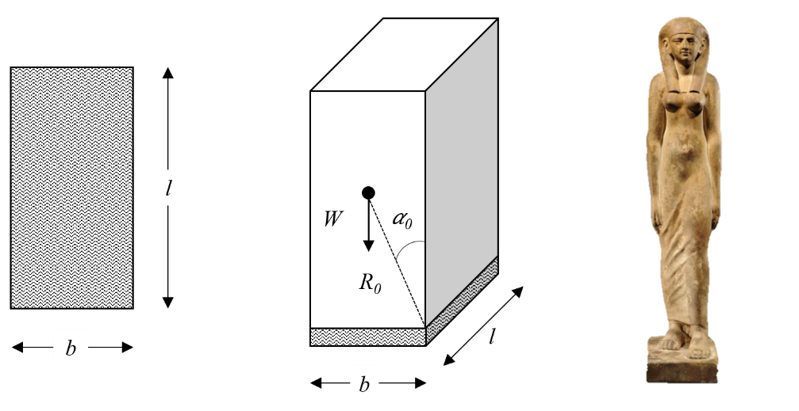

**Figure 2 Solid rectangular base geometry and example real-world application – sculpture of an Egyptian Royal Lady (Royal-Athena Galleries).**

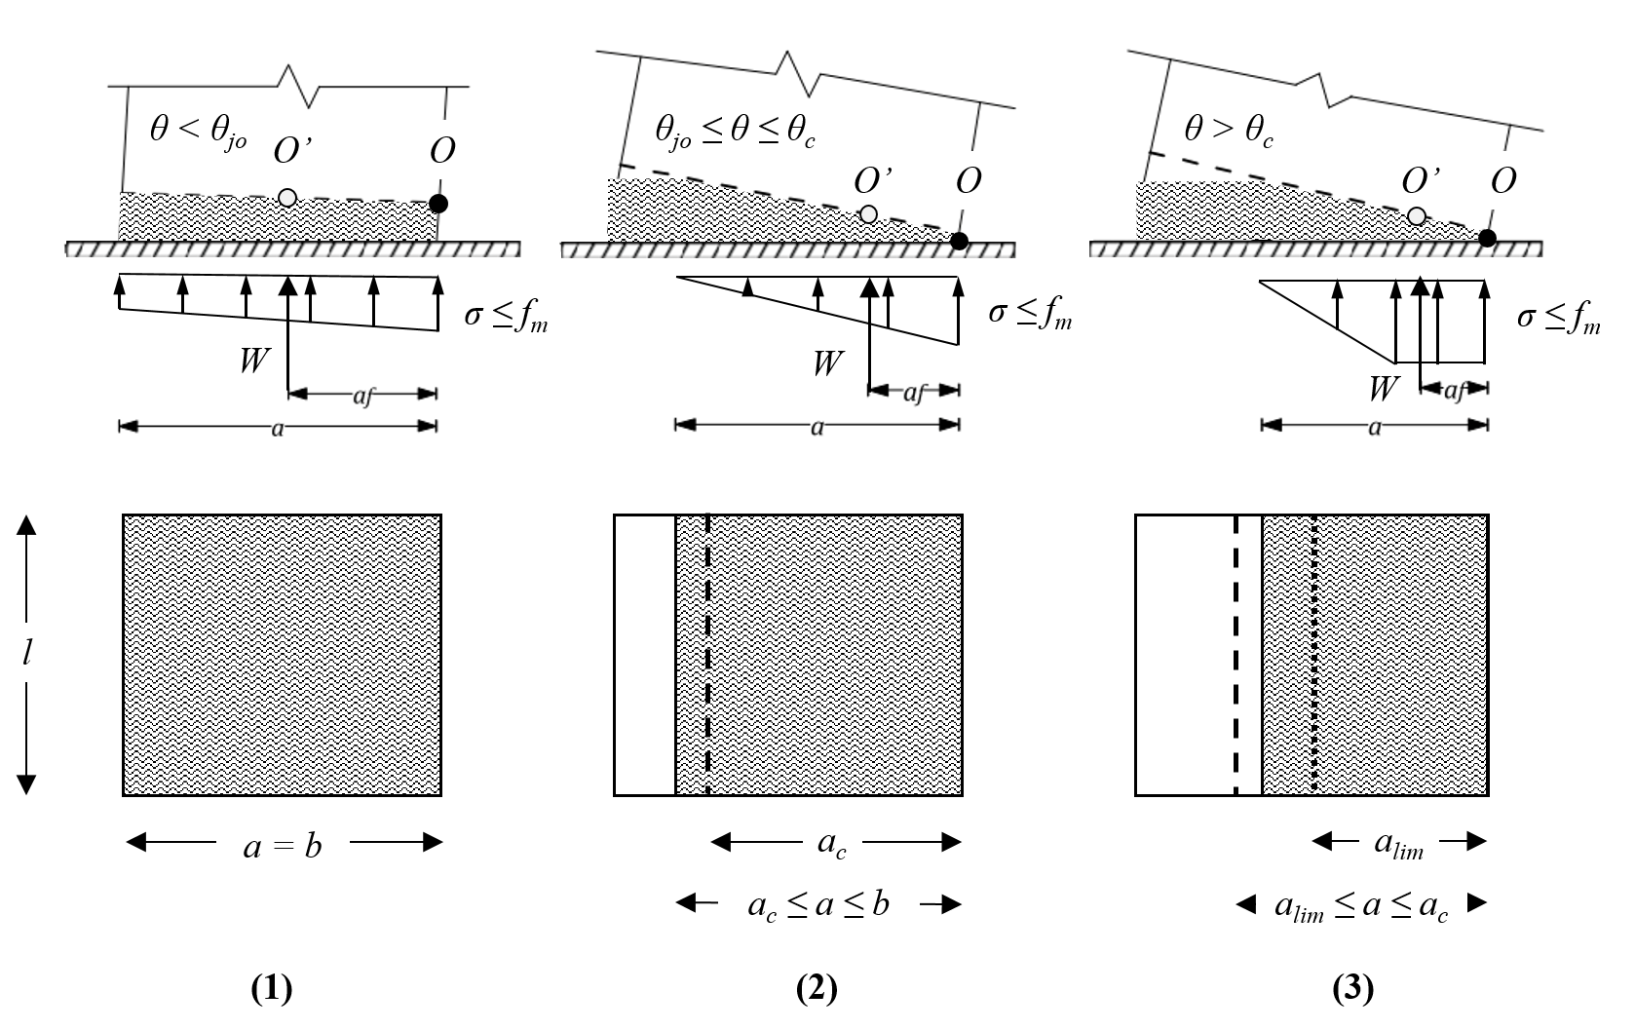

**Figure 3 Interface stress distributions and corresponding rotations (adapted from [Costa et al. 2013]).**

Following Costa’s approach, the position of the reaction force is calculated for three different cases which depend primarily on the stress distribution at the base, which in turn is a function of the rotation of the structure *θ* as illustrated by Figure 3, and includes: (1) full contact, (2) partial contact and (3) partial contact with crushing. Full contact is assumed for cases in which the rotation is less than the joint opening rotation *θjo*, which is determined analytically using the following expression:

 (10)

Where *W* is the weight of the structure, *b* and *l* are the base dimensions as depicted in Figure 2, and *kn* is the normal stiffness of the interface. Upon exceeding *θjo*, the entire cross section is no longer in contact with the base and the stress distribution assumes a triangular form. The contact length *a* decreases with an increase in the rotation *θ*, until the point where the maximum stress *σ* equals the compressive strength *fm*. At this point, the threshold contact length *ac* is reached (indicated by the dashed line in Figure 3), which can be determined analytically using the following equation:

 (11)

The corresponding threshold rotation at which crushing begins, *θc,* can then be obtained by substituting *ac* into the following expression:

 (12)

Upon the exceedance of this threshold rotation, the behaviour of the interface switches from purely elastic to bilinear elasto-plastic, with the contact length continuing to decrease until the limiting length *alim* (depicted by the dotted line in Figure 3) is reached at which point the behaviour is purely plastic across the entire area of joint contact.

Once the various threshold conditions (rotations and contact lengths) have been determined, expressions can then be derived for the position of the reaction force *af* (*θ*) for each of the different cases, as given by Equations (13)-(15). These expressions can then be used to determine *af* (*θ*) for a range of different rotations, which can then be substituted back into either Equation 1 or 9 to generate and solve the modified rocking equation of motion.

  (13)

  (14)

  (15)

Where sgn(*θ*) is the sign function and is equal to 1 for *θ* > 0 and -1 for *θ* < 0. Note that *af* (0) = *b*/2.

## **3.2. Hollow rectangular base**

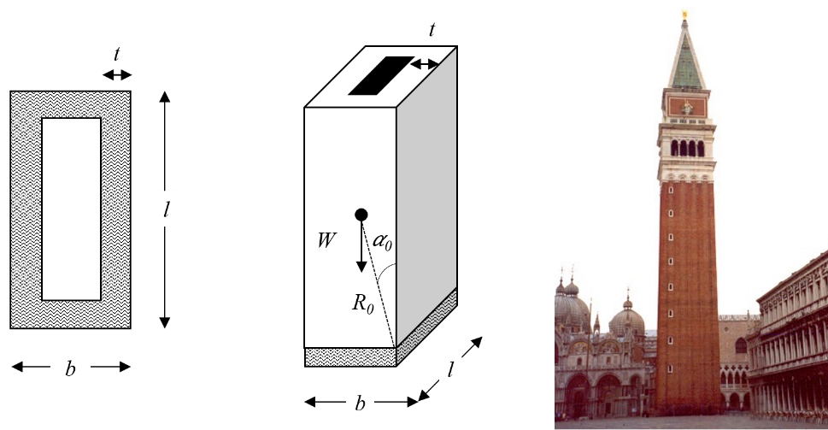

**Figure 4 Hollow rectangular base geometry and example structure - St Mark’s Campanile (Wikimedia Commons).**

While the analytical expressions determined for *af* (*θ*) for solid rectangular bases by Costa et al. [2013] can be used for a broad range of structures, there also exist cases in which they may not always be applicable – one such example being bell towers, which instead have hollow rectangular bases, as illustrated by Figure 4. In the case of such bases, new expressions for *af* (*θ*), as well as the threshold rotations and contact lengths, need to be derived, which take into consideration the reduction in contact area due to the hollow base section. The threshold joint opening rotation *θjo* for such a base is now given by the following expression, where *t* corresponds to the thickness of the base as shown in Figure 4:

 (16)

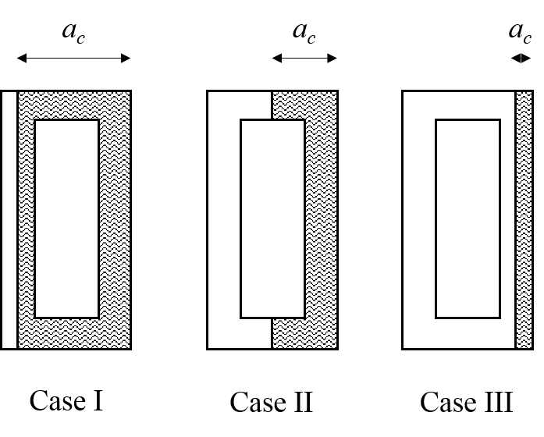

**Figure 5 Different cases considered for threshold contact length ac for the hollow rectangular base.**

Similarly, in order to determine the threshold contact length *ac* at which crushing occurs, i.e. the maximum stress at the base equals the compressive strength *fm*, three possible cases need to be considered, as illustrated by Figure 5. The corresponding analytical expressions for *ac* for each of these different cases are provided by Equations (17)-(19):

Case I:  (17)

Case II:  (18)

Case III:  (19)

Once *ac* has been determined, it can then be substituted into Equation (12) to obtain the resultant threshold rotation for crushing *θc* at which the behaviour of the interface switches from purely elastic to elasto-plastic. Expressions were then derived for *af* (*θ*) for the cases of full contact, partial contact and partial contact with crushing.

For full contact, the position of the reaction force can be determined using the following analytical expression:

  (20)

For partial contact with pure elastic behaviour, three possible cases, analogous to those for *ac*, need to be considered:

Case I:  (21)

Case II:   (22)

Case III: (23)

It is worth noting that the expression for *af* (*θ*) (as well as *ac*) for Case III is the same as that for the solid rectangular base. Similarly for *θc* ≤ |*θ*| (partial contact with crushing), although theoretically the same three cases should be considered, it can be shown that for most reasonable values of compressive strength and density (and correspondingly *W*), the first two cases can be neglected and thus the same equation as is used for the solid rectangular base (Equation (15)) can be applied here as well.

## **3.3. Solid circular base**

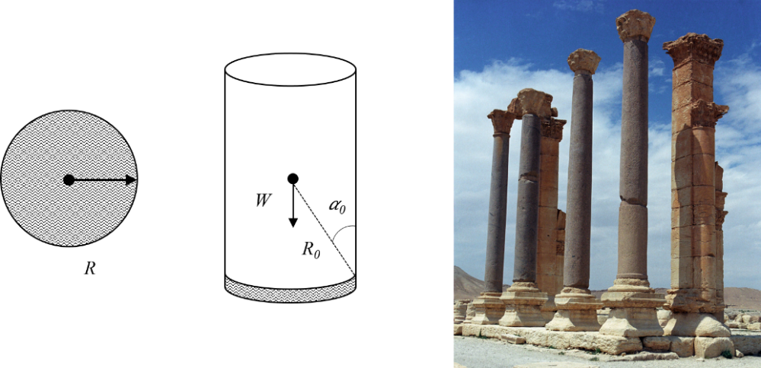

**Figure 6 Solid circular base geometry and example structure – Columns of the Baths of Diocletian (Jerzy Strzelecki CC BY-SA 3.0).**

Expressions were also derived for solid circular bases, as are commonly found in structures such as monumental columns and pedestals, as illustrated by Figure 6. The joint opening rotation *θjo* for such bases (which have a radius *R*) can be determined analytically using the following expression:

 (24)

However, unlike the rectangular base cases and due to the 3D nature of the stress distribution as illustrated by Figure 7, a closed-form analytical solution does not exist for *ac*. Instead, *ac* needs to be determined by numerically solving the following expression, which is obtained by integrating the stress distribution and setting it equal to the weight of the structure *W*:

 where  (25)

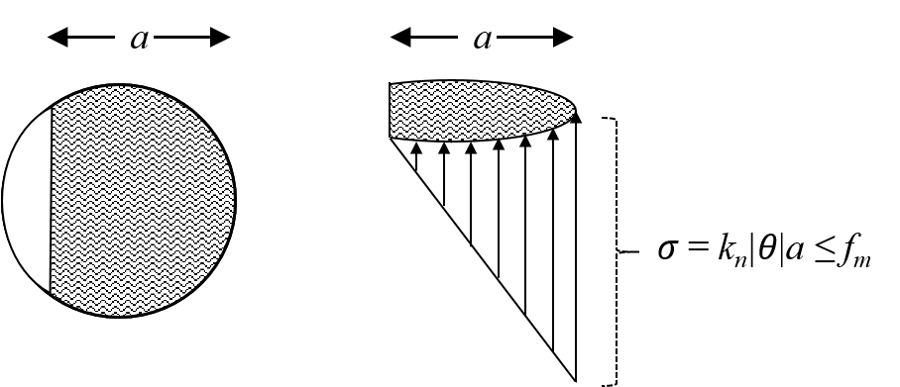

**Figure 7 Stress distribution for θjo ≤ |θ| ≤ θc for the solid circular base/interface.**

Once computed, *ac* can then be substituted into Equation (12) to obtain *θc* for the solid circular base. As in the case of the rectangular base, expressions were then derived for the position of the reaction force *af* (*θ*) for the cases of full contact, partial contact and partial contact with crushing.

In the case of full contact, i.e. for 0 < |*θ*| ≤ *θjo*, the following expression can be used for *af* (*θ*):

 (26)

Note that *af* (0) = *R*. For the case of partial contact with purely elastic behaviour, i.e. *θjo* ≤ |*θ*| ≤ *θc*, the contact length *a* now varies with the rotation *θ*, and thus first needs to be determined by numerically solving the following expression for each value of *θ*:

 where  (27)

The computed value of *a* is then substituted into the following equation to get *af* (*θ*):

 (28)

For cases where the rotation *θ* exceeds the threshold rotation for crushing, i.e. for *θc* ≤ |*θ*|, the derivation of *af* (*θ*) is not as straightforward. In this case, the elastic and plastic portions of the stress distribution (with lengths *a1* and *a2* as depicted in Figure 8 respectively) need to be treated separately. In order to do this, the limiting contact length *alim* at which the interface exhibits pure plastic behaviour first needs to be determined by numerically solving the following equation:

 where  (29)

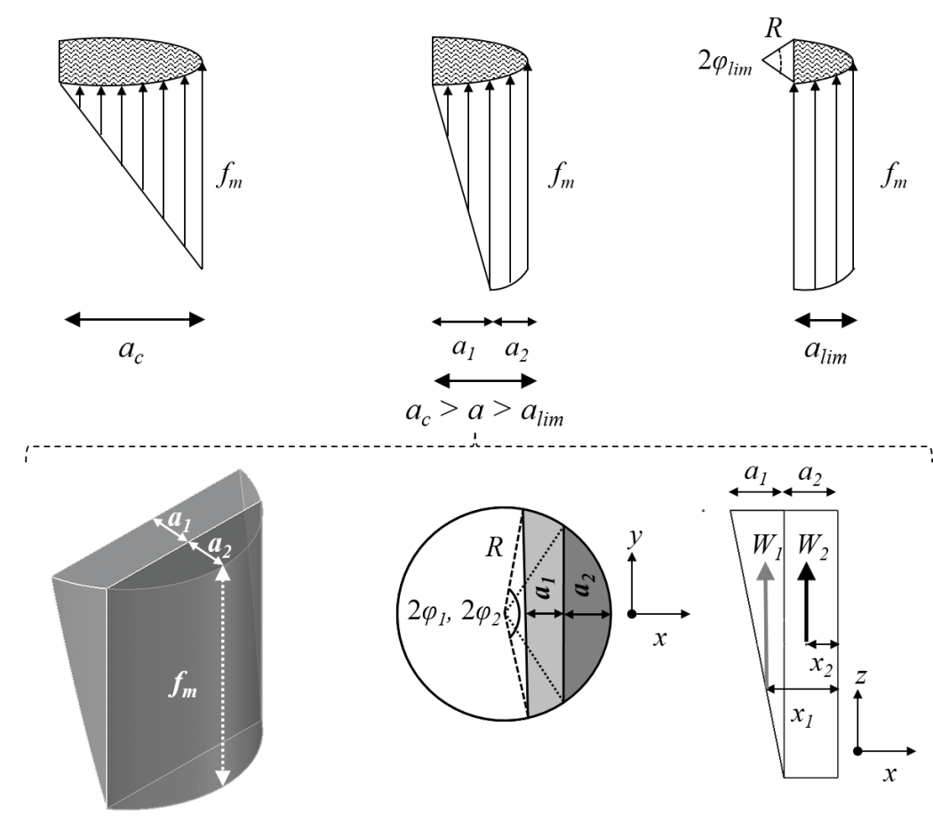

**Figure 8 Stress distribution for θc ≤ |θ| (solid circular base) – elastic portion shown in light grey, plastic in dark grey.**

The length *a2* of the plastic portion of the stress distribution, which depends on the rotation of the structure *θ*, can then be computed using the given expression:

 (30)

Upon calculating *a2*, the reaction force *W2* from the plastic portion of the stress distribution is then calculated as shown below:

 where  (31)

This reaction force *W2* can be assumed to act at a distance of *x2* from the edge of the base:

 (32)

Similarly, the reaction force *W1* from the elastic portion of the stress distribution can be determined by simply subtracting *W2* from the total weight of the structure *W*:

 (33)

Consequently, the length *a1* of the elastic portion of the stress distribution can be obtained by numerically solving the following expression:

 (34)

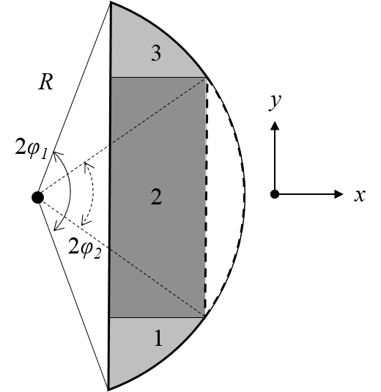

**Figure 9 3 separate sections of stress distribution considered for computation of x1.**

The distance *x1* at which the resultant force *W1* acts is found by determining the x-coordinate of the centroid of the 3D stress distribution (using triple integrals), which is considered as 3 separate sections as illustrated by Figure 9.

  where  (35)

Finally, the resultant point of application of the reaction force *af* (*θ*) for the elasto-plastic case is obtained by taking the weighted average of *x1* and *x2* as shown below:

 (36)

## **3.4. Hollow circular base**

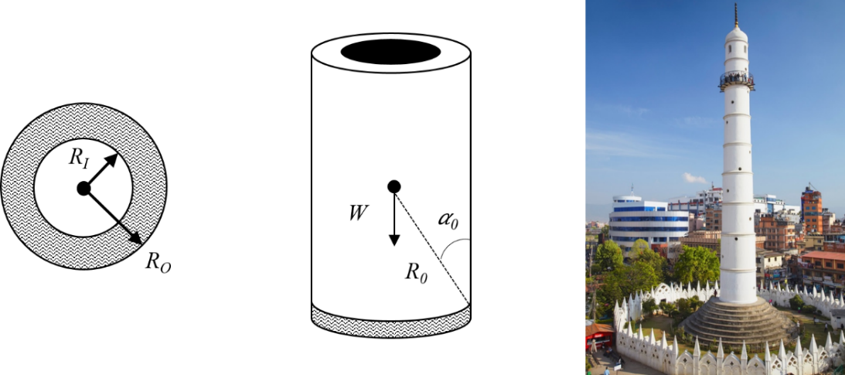

**Figure 10 Hollow circular base geometry and example real-world application – Dharahara Tower (Ian Trower/JAI/Corbis).**

The expressions derived in the previous section for solid circular bases were also modified to account for hollow circular bases, as are commonly found in structures such as minarets, spires and towers as illustrated in Figure 10. The joint opening rotation *θjo* in this case is determined using the following expression:

 (37)

where *RO* and *RI* are the outer and inner radii of the base respectively.

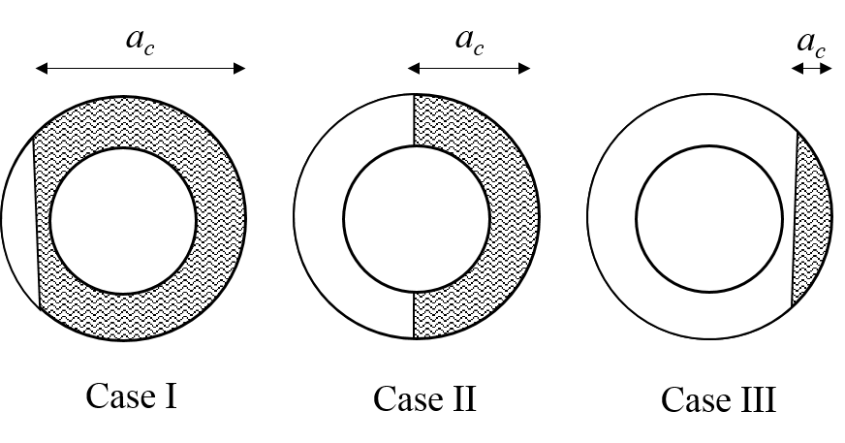

**Figure 11 Different cases considered for threshold contact length ac for the hollow circular base.**

The threshold contact length *ac*, at which the stress at the base is equal to the compressive strength *fm*, is determined by numerically solving the following general expression:

 (38)

Where:

 (39)

However, as in the case of the hollow rectangular base, three possible cases for *ac* need to be considered, as illustrated by Figure 11. Thus, depending on the case, the appropriate value/expression for *φ2* needs to be selected, as shown below:

Case I: 

Case II:  (40)

Case III: 

The computed value of *ac* is then substituted into Equation (12) to obtain the threshold rotation for crushing *θc* for the hollow circular base.

Once the threshold rotations are computed, expressions can then be derived for the position of the reaction force. In the case of full contact, i.e. for 0 < |*θ*| ≤ *θjo*, the following analytical expression can be used for *af* (*θ*):

 (41)

Note that *af* (0) = *RO*. In the case of partial contact with pure elastic behaviour, i.e. *θjo* ≤ |*θ*| ≤ *θc*, the contact length *a* varies with *θ* and is determined by numerically solving the following expression in a manner similar to that for *ac* for each value of *θ*, with *φ1* and *φ2* being defined as in Equations (39) and (40) respectively but in this case replacing *ac* with *a*:

 (42)

The computed value of *a* is then substituted into the following equation to get *af* (*θ*):

 (43)

As was observed for the solid circular base, in the case of partial contact with elasto-plastic behaviour, i.e. *θc* ≤ |*θ*|, the derivation of *af* (*θ*) is more complicated. Once again *alim*, which is the limiting contact lengthat which the interface exhibits pure plastic behaviour, first needs to be determined, and this is done by numerically solving the following equation:

 (44)

Where *φlim,O* and *φlim,I* are defined the same way as *φ1* and *φ2* respectively, but in this case substituting *alim*for *ac*.

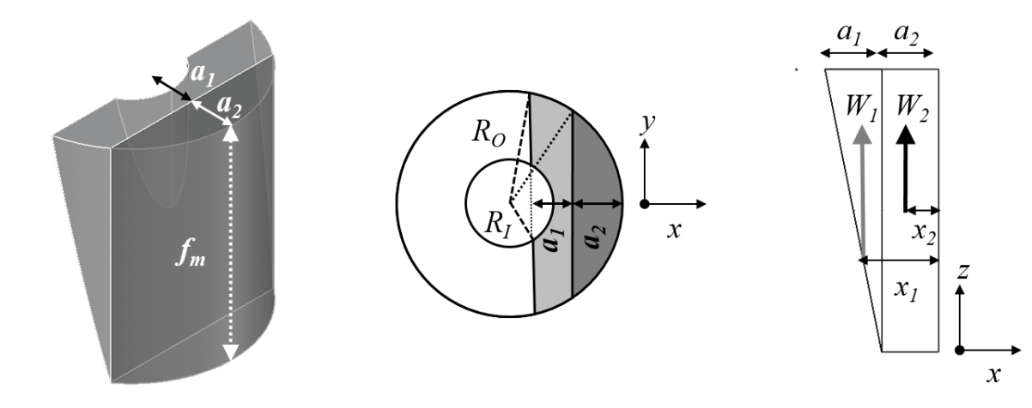

**Figure 12 Stress distribution for θc ≤ |θ| (hollow circular base) – elastic portion shown in light grey, plastic in dark grey.**

The length of the plastic portion of the stress distribution (*a2* in Figure 12) is defined the same way as it was for the solid circular base (Equation (30)) and once computed, it can be used to calculate *W2* using the following expression:

 (45)

Where *φ2,O* and *φ2,I* are defined the same way as *φ1* and *φ2* respectively, but in this case replacing *ac* with *a2*. This reaction from the plastic portion of the stress distribution can be assumed to act at a distance of *x2* from the edge of the base:

 (46)

Similarly *W1*, the reaction from the elastic portion of the stress distribution can be found by subtracting *W2* from the total weight of the structure *W*, as was done in the case of the solid circular base (Equation (33)). The length of the elastic portion of the stress distribution (*a1* in Figure 12) is then found by numerically solving the following expression:

 (47)

Where:

 (48)

And *φ1,I* (z) and *fmI* depend on the magnitude of *a2* and are defined as follows:

  (for *a2* < *RO - RI*) (49)

  (for *a2* ≥ *RO - RI*) (50)

The distance *x1* at which *W1* acts is found by determining the x-coordinate of the centroid of the 3D stress distribution (using triple integrals), but in this case by treating the inner and outer sections separately as shown below:

 

 (51)

With the resultant point of application of the reaction force *af* (*θ*) for this elasto-plastic case being obtained by taking the weighted average of *x1* and *x2* as presented in Equation (36) for the solid circular base.

# **4. Evaluation of the effects of cross-section geometry**

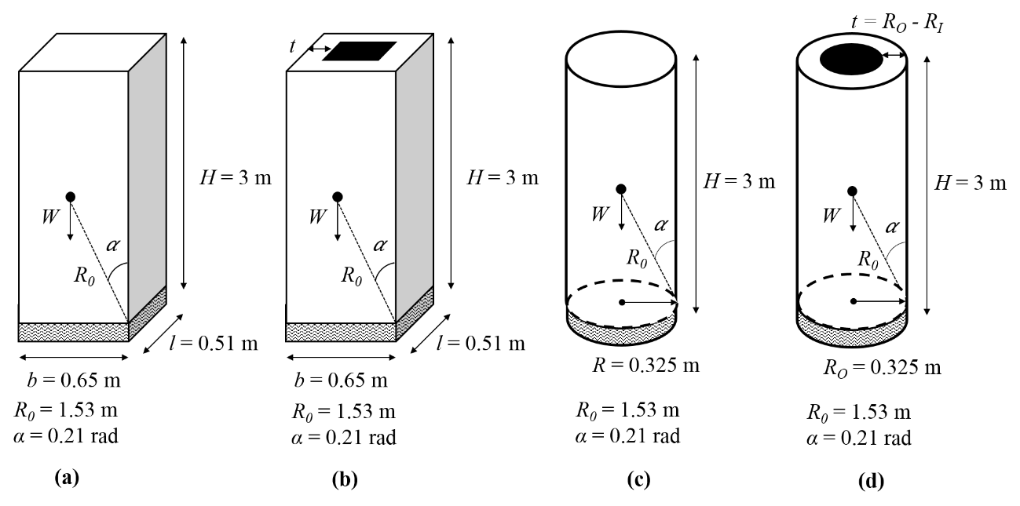

**Figure 13 Structural geometries used for parametric study.**

The expressions derived for *af* (*θ*) for the different base geometries were used to generate moment-rotation curves, making use of the following formula for the restoring moment *MR*:

 (52)

These curves were used to evaluate the influence of the cross-sectional geometry, as well as the material properties (i.e. compressive strength) on the dynamic response of structures, specifically the four structural geometries depicted in Figure 13.

In order to gauge the effect of base geometry on the seismic resistance of the structures, moment-rotation curves (Figure 14a) were first generated for the four different geometries depicted in Figure 13. Note that all four structures have the same size (*R0*) and slenderness (*α*). From Figure 14a it can be observed that for structures of comparable scale and slenderness, the introduction of a flexible interface with a finite compressive strength leads to a greater reduction in the dynamic capacity of structures with circular bases than those with rectangular ones, with the former generally overturning for lower rotations (*MR* = 0). Moreover, structures with hollow bases appear to have a higher seismic resistance than their solid counterparts.

Examining more closely the behaviour of structures with hollow bases, moment-rotation curves were also generated for the hollow rectangular base (Figure 13b) for varying base thicknesses (*t*) as illustrated by Figure 14b. From this plot it was found that the inclusion of an elasto-plastic interface caused less of a reduction in the dynamic capacity of thinner–walled structures.

The effect of varying the compressive strength *fm* of the interface was also investigated, using as a reference case the structure with a solid rectangular base (Figure 13a). Assuming a constant normal stiffness *kn* of 340 MPa/m, moment-rotation curves were generated for different compressive strengths as illustrated by Figure 14c. As expected, decreasing the compressive strength was observed to decrease the dynamic resistance of the structure, with the block experiencing crushing (and ultimately overturning) for lower rotations when the compressive strength is reduced. Moreover, for compressive strengths higher than 1.28 MPa, the behaviour of the interface remained entirely elastic, and no crushing was observed to occur – with the curves for *fm* = 2.56 and 5.12 MPa almost exactly matching the curve generated assuming an infinite compressive strength (*fm* = ∞). Keeping the compressive strength and normal stiffness constant while varying the scale of the structure (Figure 14d) yielded similar results - larger scale structures (scale = 2 and 5) experience crushing more rapidly (and consequently overturning more quickly) than their smaller counterparts (scale = 0.25, 0.50 and 1) - with the latter actually having near-identical moment-rotation curves.

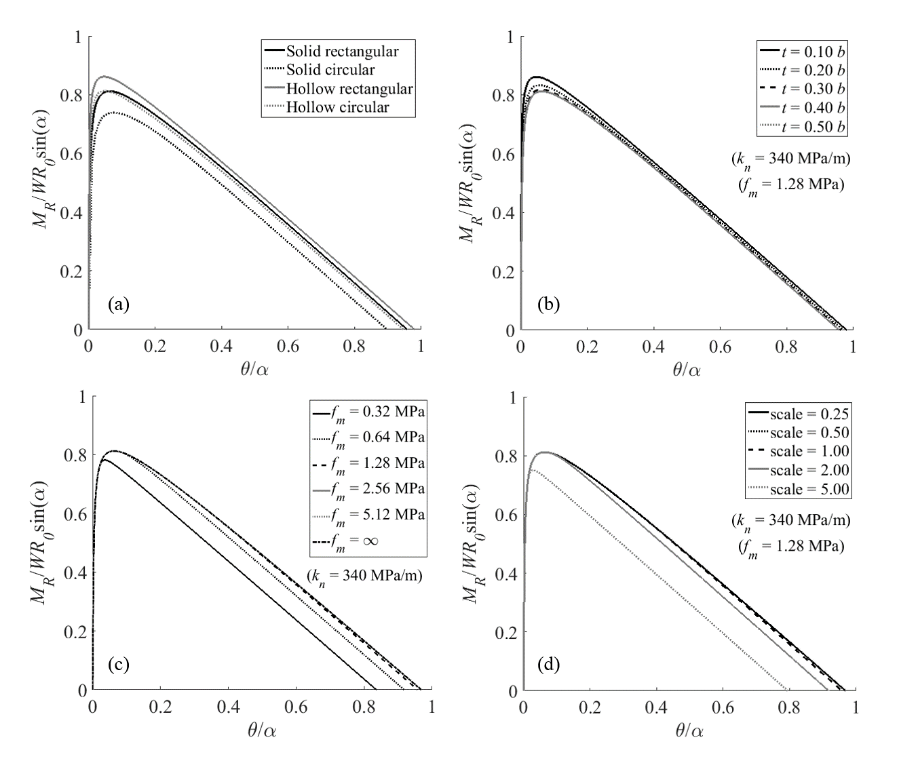

**Figure 14 Moment-rotation curves generated for: (a) varying base geometry; (b) varying thickness (for hollow bases); (c) varying compressive strength and (d) varying scale.**

# **5. Comparison of modified equation of motion with Costa’s solution [Costa 2012]**

In order to gauge the effect of accounting for the movement of the effective rotation point, the free-rocking responses of six blocks of varying slenderness *α*, subjected to an initial rotation *θ0*/*α* = 0.9, were evaluated using Eqn. 1 and Eqn. 9. Following the assumptions of Lipo & de Felice [2016], energy dissipation was modelled using the coefficient of restitution *η* as defined by Housner [1963], which for the simple solid rocking block depends only on *α* and simplifies to:

 (53)

As illustrated in Figure 15, for more slender blocks (*α*  < 0.24 rad), the two solutions compare fairly well, while for the stockier blocks (*α* ≥ 0.24 rad) the two solutions go out of phase in relatively few cycles of the rocking motion, with Costa’s solution (Eqn. 1) generally being less-conservative and damping out earlier.



**Figure 15 Comparison of the free-rocking response (θ0/α = 0.9) of blocks of varying slenderness, as predicted using the modified equation of motion (Eqn. 9) and Costa’s solution (2012, Eqn. 1).**

# **6. Case Study – Dharahara Tower**

To demonstrate real-world applications of the expressions and equations derived in this paper, the Dharahara Tower in Kathmandu, Nepal (Figure 16), which was almost completely destroyed during the 2015 Gorkha earthquake, was chosen as a case-study. The tower was constructed using brick masonry with lime and mud mortar [Bhagat et al. 2017] and the geometry of the structure, including that of its base, is shown in Figure 16. These geometric properties were automatically extracted by the analytical tool, using as a starting point a 3D model of the structure in Rhino.

The material properties adopted for the hollow circular interface are listed in Table 1. To illustrate different possible applications of the model, two different sets of joint stiffnesses and a range of compressive strengths were considered in the analysis. The compressive strengths were chosen based on the range of values provided in the Italian Building Code for brick masonry with lime mortar [DMI 2008], as well as the results of both in-situ and experimental tests conducted on brick masonry structures in Nepal [Parajuli & Kiyono 2015; Parajuli et al. 2011]. Similarly, the first set of joint stiffnesses - varying from flexible (*kn* = 85 MPa/m) to very stiff (*kn* = 13.5 GPa/m), were chosen with the objective of exemplifying how foundation stiffness could be taken into account in the model, and were selected based on similar analyses conducted in [Shawa et al. 2012; Lipo & de Felice 2016; Lipo & de Felice 2017]. The second set of stiffnesses is representative of interfaces within the structure - modelling both the stiffness of a single interface (*kn* = 200, 500, 1500 GPa/m) as well as the deformation associated with of a larger portion of the structure in the vicinity of the interface (*kn* = 2, 5, 15 GPa/m), with the latter having been found to lead to an overall reduction in dynamic capacity [de Felice 2011]. Note that to model the interface stiffness, the values of *kn* were obtained by assuming a Young’s modulus of 1000 x *fm*, and estimating the thickness of a single interface to be 0.01 m and the approximate portion of the structure involved in local deformation near the rotation point to be 1 m.

|  |  |
| --- | --- |
| *RO* (m) | 3.99 |
| *RI*  (m) | 2.12 |
| *W* (kN) | 24003.94 |
| *R0* (m) | 30.44 |
| *𝛼* | 0.125 |

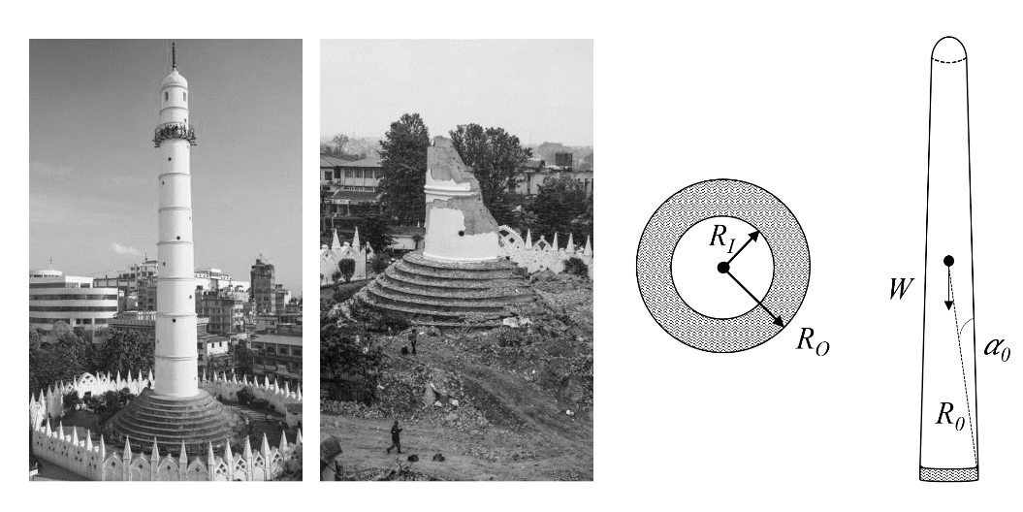

**Figure 16 Dharahara Tower: before and after the 2015 earthquake (left) (Ian Trower/JAI/Corbis, Turjoy Chowdhury/NurPhoto/Corbis) structural geometry (middle) and dimensions (right).**

**Table 1 Material properties considered for interface.**

|  |  |
| --- | --- |
| Joint stiffness (foundation) *kn* (MPa/m) | 85, 170, 340, 680, 1350, 13500 |
| Joint stiffness (interface) *kn* (GPa/m) | 2, 5, 15, 200, 500, 1500 |
| Compressive strength *fm* (MPa) | 2, 5, 15 |

The expressions derived in Section 3 were then used calculate *af* (*θ*) for the specified range of joint stiffnesses and compressive strengths, which in turn were used to generate moment-rotation curves (both with and without crushing) for the structure, as illustrated by Figure 17 and Figure 18. For the purpose of comparison with Housner’s model, the curve for the pure rigid interface (infinite stiffness, infinite compressive strength) is also included in these plots.

Figure 17 shows that for low values of compressive strength (*fm* = 2 MPa), the structure experiences crushing at relatively small rotations for all considered levels of joint stiffness, which leads to an overall reduction of 40% in the dynamic capacity of the structure as compared to the rigid interface model. For higher compressive strengths (*fm* = 15 MPa), the more flexible models (*kn* = 85 MPa/m and 170 MPa/m) remain entirely in the elastic zone (compare with the curves for *fm* = ∞), while the stiffer models still experience crushing, with the threshold rotation for crushing *θc* generally decreasing with an increase in foundation stiffness.

Similarly, in the case of varying interface stiffness, it was observed that including crushing effects resulted in a significant reduction in the dynamic capacity of the structure (Figure 18a vs Figure 18b). In fact, crushing occurred almost instantly for all levels of compressive strength, for both considered stiffness values – thus resulting in nearly-overlapping curves for each value of *fm* (Figure 18b). Furthermore, as rocking of the Dharahara Tower was observed to occur at the masonry-masonry interface during the earthquake, the values derived for *af* (*θ*) for the different interface stiffnesses were then substituted into Equation (9), to be used for the nonlinear time-history analysis of the tower. The input ground motion used in the analysis was the north-south component of the 2015 Gorkha earthquake recorded at the USGS KANTP station, as illustrated by Figure 19. No scaling was applied to the ground motion.

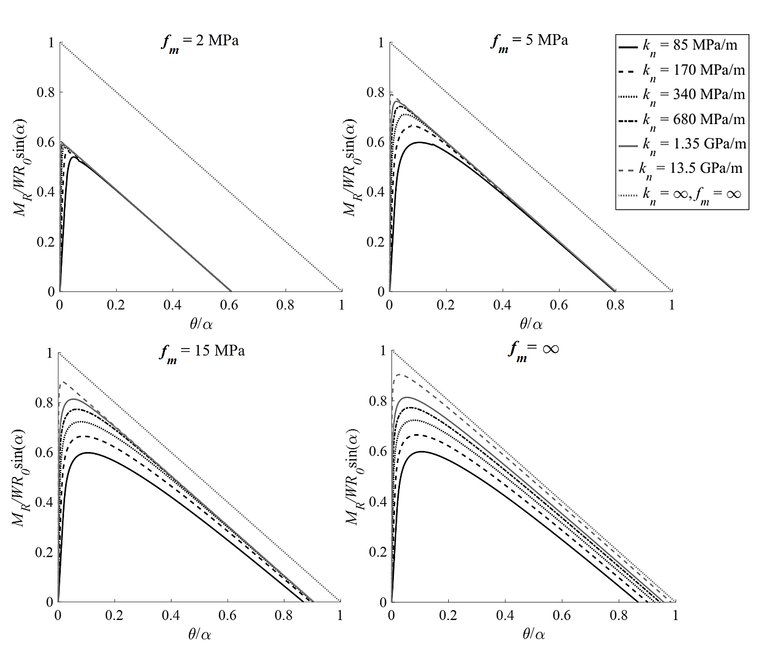

**Figure 17 Moment-rotation curves generated for the Dharahara Tower for different foundation stiffnesses, both with crushing (fm = 2, 5 and 15 MPa) and without crushing (fm = ∞).**

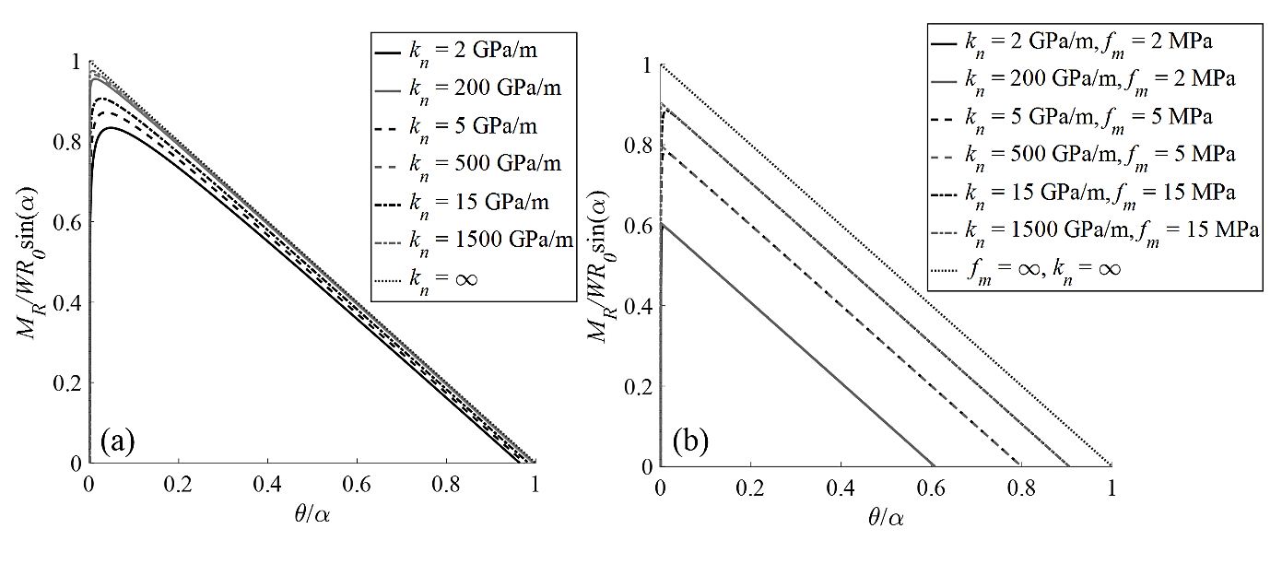

**Figure 18 Moment-rotation curves for the Dharahara Tower for different interface stiffnesses and compressive strengths: (a) without crushing and (b) with crushing.**



**Figure 19 North-south component of the 2015 Gorkha earthquake ground motion as recorded at the USGS KANTP station.**

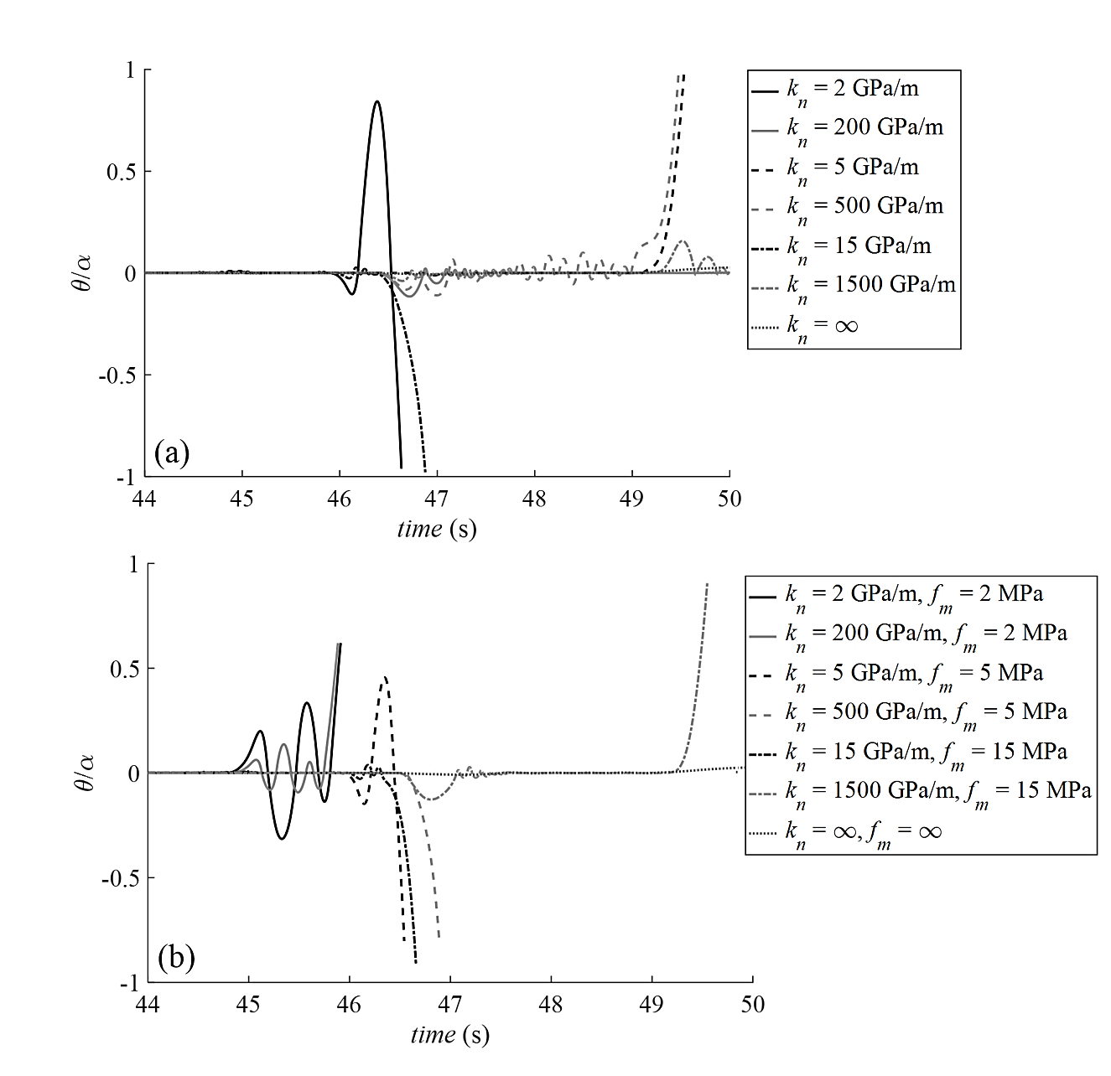

**Figure 20 Time-history responses of the Dharahara Tower for different interface stiffnesses and compressive strengths: (a) without crushing and (b) with crushing.**

The results of the time-history analyses are presented in Figure 20, both for the case without crushing (Figure 20a) and with crushing (Figure 20b). Furthermore, to facilitate comparison with Housner’s model, the time-history response of an interface with infinite stiffness and compressive strength (i.e. a rigid interface) is also presented here. To better compare the relative magnitudes of the rotations predicted by the different interface models, the rotation of the structure *θ* was normalized by the slenderness of the tower *α*. However, as overturning of the structure in this case no longer occurs when *θ/α* exceeds 1 (as is the case for the rigid interface model) – and instead takes place when the restoring moment *MR* = 0, the overturning rotation for each of the models was extracted from Figure 18, and the time-history analyses stopped when this rotation was exceeded.

In the case of the models with infinite compressive strength (no crushing, Figure 20a), overturning of the tower was found to occur for lower levels of the joint stiffness (*kn* ≤ 15 GPa/m), while higher levels of the stiffness was found to cause negligible response (with the exception of *kn* = 500 GPa/m). On the other hand, including crushing effects at the interface results in the tower overturning for all considered levels of interface compressive strength and stiffness, with lower levels of the compressive strength generally resulting in larger rotations and faster overturning of the structure (Figure 20b). For the same values of compressive strength, the more flexible interface models generally overturn faster than their stiffer counterparts – although the difference between collapse times of the two models is generally less than 0.5 seconds, thus indicating that compressive strength more than stiffness tends to control dynamic response. This behaviour compares fairly well what was observed in reality – the Dharahara Tower did in fact overturn and collapse during the earthquake in 2015. Due to the scale of the structure, it is quite possible that some crushing could have occurred at the base, which would have decreased its resistance to overturning. This behaviour failed to be captured by the purely rigid model, which instead predicted very small rotations for the tower (Figure 20). Note that this study has focused on the effects of stiffness and strength at or near the rocking interface; the elastic deformation of the tower itself, being large and slender, was not considered, though it could play a significant role in the response.

# **7. Conclusions**

In this paper, a new equation of motion was derived for rigid bodies rocking on flexible interfaces, taking into account crushing effects. This equation fits within the broader framework of a CAD-interfaced analytical modelling tool currently being developed for the nonlinear dynamic analysis of masonry collapse mechanisms. The modified equation of motion accounts for the inward shift of the rocking rotation point caused by a flexible interface with finite compressive strength, including new derivations for a range of structural geometries.

These new derivations were used in a parametric study to investigate the influence of geometry, interface stiffness and compressive strength on the rocking response. Structures with rectangular bases were generally more resistant to overturning than their circular counterparts, while hollow structures were more resistant to collapse than solid structures. Moreover, for a given structure, increasing the compressive strength (for a fixed stiffness) was found to only increase the seismic resistance to a certain threshold - past which the structure did not experience crushing at all.

The modified equation of motion derived in this paper was also compared to a previous formulation for the solid rectangular block [Costa 2012]. It was found that the two solutions generally compared well, though for stockier structures the shifting rotation point had a non-negligible impact on the dynamic response.

Finally, the real-world application to the Dharahara Tower in Kathmandu highlighted the importance of considering interface stiffness as well as crushing effects. The purely rigid model predicted very small rotations of the tower, while including interface stiffness and crushing effects caused the tower to overturn, as it did in reality.

# **Acknowledgements**

Financial support for this research was provided by the Jawaharlal Nehru Memorial Trust in conjunction with the Cambridge Commonwealth, European & International Trust.

# **References**

Allen RH & Bielaks J. On the dynamic response of rigid body assemblies. Earthquake Engineering & Structural Dynamics1986; 14:861–876.

Bhagat S. et al. Damage to Cultural Heritage Structures and Buildings Due to the 2015 Nepal Gorkha Earthquake. Journal of Earthquake Engineering 2017; pp.1–20.

Costa AA et al. Free rocking response of a regular stone masonry wall with equivalent block approach: experimental and analytical evaluation. Earthquake Engineering & Structural Dynamics 2013; 42(15):2297–2319.

Costa AA. Seismic Assessment of the Out-of-Plane Performance of Traditional Stone Masonry Walls. PhD Thesis, University of Porto, Portugal, 2012.

DMI. Decreto del Ministro delle Infrastrutture 14 gennaio 2008. Approvazione delle nuove norme tecniche per le costruzioni. Gazzetta Ufficiale della Repubblica Italiana n. 29, Supplemento Ordinario n. 30. 2008.

Doherty K. et al. Displacement-based seismic analysis for out-of-plane bending of unreinforced masonry walls. Earthquake Engineering & Structural Dynamics 2002; 31(4):833–850.

ElGawady MA et al. Effects of interface material on the performance of free rocking blocks. Earthquake Engineering & Structural Dynamics 2011; 40:375–392.

de Felice G. Out-of-Plane Seismic Capacity of Masonry Depending on Wall Section Morphology. International Journal of Architectural Heritage 2011; 5(4–5):466–482.

Housner GW. The Behavior of Inverted Pendulum Structures during Earthquakes. Bulletin of the Seismological Society of America 1963; 53(2):403–417.

Koh AS, Spanos PD & Roesset JM. Harmonic rocking of rigid block on flexible foundation. Journal of Engineering Mechanics 1986; 112(11):1165–1180.

Lipo B & de Felice G. Seismic resilience of masonry walls rocking on elastic foundation. Proceedings of the 16th World Conference in Earthquake Engineering (WCEE), Santiago, Chile 2017.

Lipo B & de Felice G. Smooth-rocking oscillator under natural accelerograms. ECCOMAS Congress 2016: 7th European Congress on Computational Methods in Applied Sciences and Engineering, Crete Island, Greece, 2016.

De Lorenzis L, DeJong MJ & Ochsendorf JA. Failure of masonry arches under impulse base motion. Earthquake Engineering & Structural Dynamics 2007; 36(14):2119–2136.

Makris N & Vassiliou MF. Planar rocking response and stability analysis of an array of free-standing columns capped with a freely supported rigid beam. Earthquake Engineering & Structural Dynamics 2013; 42(3):431–449.

Mauro A, de Felice G & DeJong MJ. The relative dynamic resilience of masonry collapse mechanisms. Engineering Structures 2015; 85:182–194.

Mehrotra A & DeJong MJ. A CAD-interfaced dynamics-based tool for analysis of masonry collapse mechanisms. Engineering Structures 2018; 172:833-849.

Parajuli HR, Kiyono J & Taniguchi H. Structural Assessment of the Kathmandu World Heritage Buildings. Proceedings of the 31st Conference on Earthquake Engineering, Japan, 2011.

Parajuli, RR & Kiyono J. Ground Motion Characteristics of the 2015 Gorkha Earthquake, Survey of Damage to Stone Masonry Structures and Structural Field Tests. Frontiers in Built Environment 2015; 1(23):1–12.

Penna A & Galasco A. A Macro-Element Model for the Nonlinear Analysis of Masonry Members Including Second Order Effects. 4th ECCOMAS Thematic Conference on Computational Methods in Structural Dynamics and Earthquake Engineering, Kos Island, Greece, 2013.

Psycharis IN & Jennings PC. Rocking of slender rigid bodies allowed to uplift. Earthquake Engineering & Structural Dynamics 1983; 11:57–76.

Roh H & Reinhorn AM. Analytical modeling of rocking elements. Engineering Structures 2009; 31(5):1179–1189.

Al Shawa O et al. Out-of-plane seismic behaviour of rocking masonry walls. Earthquake Engineering & Structural Dynamics 2012; 41:949–968.