Attaining High Photovoltaic Efficiency and Stability with Multidimensional Perovskite

Felix Utama Kosasih*[a]

[a] F.U. Kosasih  
Department of Materials Science & Metallurgy  
University of Cambridge  
27 Charles Babbage Road  
Cambridge CB3 0FS  
United Kingdom  
E-mail: fuk21@cam.ac.uk

**Abstract:** The power conversion efficiency of organic-inorganic hybrid perovskite solar cells has soared over the past ten years, currently rivalling those of crystalline silicon and other thin film solar cells. Most of the research effort so far has been focused on three-dimensional (3D) perovskite crystals, producing devices with very high efficiency but poor operational and environmental stability. Two-dimensional (2D) Ruddlesden-Popper perovskite has recently shown its potential as a highly stable light absorber, albeit with low efficiency. This work reviews the current progress in attaining both high efficiency and stability in solar cells using 2D perovskite. In particular, the focus is on multidimensional perovskite as a way to combine the best characteristics of 3D and 2D perovskites. Future challenges and potential methods to further boost the performance of multidimensional perovskite solar cells are briefly presented.

|  |
| --- |
|  |
| Felix Utama Kosasih is a PhD researcher in the Department of Materials Science & Metallurgy at the University of Cambridge, where he works under the supervision of Dr. Caterina Ducati in the Electron Microscopy Group. He received his B.Eng.(Hons.) in Materials Science and Engineering from the National University of Singapore in 2017. His research focuses on characterising the properties and stability of perovskite solar cells and modules with analytical transmission electron microscopy. |

1. Introduction

In the past ten years, research on optoelectronic properties of perovskites has experienced a renaissance triggered by the discovery of their photovoltaic potential. Many of perovskites’ exciting electrical properties have been known and investigated for many years, but scientific interest greatly intensified when Kojima et al. discovered halide perovskite’s capacity as light absorbers in 2009 and Lee et al. fabricated the first all-solid-state perovskite solar cell (PSC) in 2012.[1–3] Since then, perovskites have been widely researched for use in a wide array of applications, such as capacitors, field-effect transistors, various sensors and detectors, photoelectrochemical cell sensitisers, memory devices, catalysts, light-emitting diodes, lasers, and solar cells.[4–11]

In photovoltaics, early research on perovskite was mainly conducted on methylammonium lead iodide (MAPbI3). This focus was founded on MAPbI3’s advantageous properties, such as tuneable band gap, high optical absorption, low exciton binding energy, and long carrier diffusion length.[12–15] As a result, MAPbI3 has been extensively studied in various cell architectures, from mesosuperstructured and bulk heterojunction to planar and inverted planar.[16–19] In recent years, there has been a strong momentum towards mixed-cation, mixed-halide perovskite. Substituting MA+ with formamidinium (FA+) or caesium (Cs+) and exchanging I‑ with chloride (Cl-) or bromide (Br-) modulates the perovskite’s band gap and crystal structure.[20,21] This allows broader light absorption and less nonradiative recombination, paving the way towards higher power conversion efficiency (PCE).[22,23] Despite this high efficiency, widespread usage of PSCs is currently blocked by their low operational stability. While silicon solar cells can last for about 25 years, PSCs degrade through various pathways in the scale of weeks or months at best.[24]

While the known parameter spaces for cell architecture and ionic composition have been widely explored, the space for dimensionality has not. MAPbI3 and its related compounds share a three-dimensional perovskite (3DP) crystal structure, in which one larger cation (MA+/FA+/Cs+) is caged inside each corner-sharing lead halide octahedron. As a consequence of this structure, proponents of the mixed-cation, mixed-halide approach have been constrained in their ion choices by the octahedral factor (*μ*) and Goldschmidt’s tolerance factor (*t*). These two criteria govern the ability of certain ion combinations to crystallise in a stable perovskite phase. They are defined as follows, where rA, rB, and rX are the radii of the ions composing ABX3 perovskite.

*μ = rB / rX t = (rA + rX) / √2 (rB + rX)*

Phase-stable and photoactive 3DPs can be obtained at *μ* > 0.422 and 0.8 < *t* < 1.[25,26] This requirement is more difficult to fulfil for halide perovskites compared to oxide perovskites due to halides’ lower charge and larger radii, which is why Cs+ is the only elemental cation of appropriate size and charge. Organic cations are also constrained for the same reason, explaining the dearth of alternatives to MA+ and FA+. If larger organic cations are used (t > 1), 2D perovskites (2DPs, also known as Ruddlesden-Popper perovskites) are formed instead. This minireview aims to evaluate the approaches used to improve the performance and stability of 2DP-based solar cells. In particular, the concept of multidimensional perovskite (MDP) as a method to combine the high PCE of 3DP and good stability of 2DP solar cells is discussed.

2. 2D and Multidimensional Perovskite

In 2DPs, slabs of corner-sharing lead halide octahedra are separated by a layer of large organic cations. The general formula is RmAn-1BnX3n+1, where m is 1 if R is divalent and 2 if R is monovalent and n refers to the number of octahedra layers in each slab. As n is decremented, the proportion of inorganic layer decreases and the optoelectronic properties resemble those of 3DP less and less. A, B, and X have the same meaning as in 3DP while R is the spacer cation bridging the slabs to each other. R is almost always an alkylammonium cation, although it may vary in terms of its carbon chain (aliphatic or aromatic) and number of ammonium group (monoammonium or diammonium). For monoammonium cations, the ammonium end forms a bond with a halide ion in the inorganic layers while the carbon chain form weak van der Waals interaction with its adjacent spacer cation. For diammonium cations, the two ammonium groups must be located at opposite ends of the molecule such that they can bond to two inorganic slabs. As this pair of slabs are now covalently linked by a single molecule instead of van der Waals interaction, 2DPs with diammonium cations form more compact films with fewer pinholes and higher conductivity.[27] This trend is taken one step further with polymeric spacer cations where many ammonium groups branch out of the backbone carbon chain.[28] Explored spacer cations so far include n-butylammonium (BA+), isobutylammonium (iso-BA+), octylammonium (OA+), phenylethylammonium (PEA+), iodoethylammonium (IEA+), cyclohexylmethylammonium (CHMA+), benzylammonium (BeA+), propylphenylammonium (PPA+), cyclopropylammonium (CPA+), ethylenediammonium (EdA2+), butyldiammonium (BdA2+), hexyldiammonium (HdA2+), and octyldiammonium (OdA2+). There have also been studies on more exotic choices such as the polymeric cation polyethylenimine (PEI+), 5-ammonium valeric acid (5-AVA+), 4-(aminomethyl)-benzoic acid (AB+), and 2-thiophenemethylammonium (ThMA+). Each slab can be seen as a slice from a 3D crystal cut in the [100] direction, resulting in a planar layer, or in the [110] direction, producing a corrugated layer (Scheme 1). The spacer cations force these slabs to grow parallel to the substrate while the A cations try to expand them perpendicularly in an attempt to mimic crystal growth in 3D structures. If the n number is low, or equivalently when the ratio of R to A cation is high, steric effect from the spacer cations will be dominant and inorganic layers will be arranged parallel to the substrate. If the opposite is true, then the layers will ‘stand’ vertical on the substrate. Either way, there is a high degree of orientation throughout the grains. 2DPs with n = 1 are sometimes called ‘pure 2D’ while those with 1 < n < ∞ are called ‘quasi-2D’. For simplicity, they shall both be referred to as 2DP unless explicitly specified.

Thus far, PCE values of 2D PSCs are still below those of 3DP and silicon cells. This low efficiency is partially due to significant difference in dielectric constant between the spacer cations (ε ~ 2) and inorganic layers (ε ~ 6) giving rise to strong dielectric confinement. This effect, together with quantum confinement, creates a natural periodic quantum well structure whose barrier height and width are controlled by the R cation while well depth and width are determined by the B and X ions.[1,29] Consequently, 2DPs tend to have much larger band gaps and exciton binding energies relative to 3DPs.[30,31] This means a large portion of the solar spectrum is not absorbed and generated excitons cannot be easily dissociated into free carriers at room temperature as in 3DP, although a pathway for exciton dissociation was recently discovered for quasi-2DP with n > 2.[32] Furthermore, it is unfortunate that many of the same factors which contribute to 2DP’s exceptional stability also cause its poor PCE. Because the inorganic slabs are arranged parallel to the substrate and the bridging organic layers have poor conductivity, it is difficult for photogenerated carriers to reach the charge transport layers. These problems are not exclusive to pure 2DP as they are also present, albeit less severely, in quasi-2DP. There have been numerous attempts to improve the conductivity of 2DP without sacrificing its robustness, for example by using hot-casting synthesis or NH4SCN additive to trigger perpendicular growth of the inorganic slabs.[33,34] Safdari et al. proposed the use of diammonium spacer cations, arguing that they have fewer degrees of freedom and will therefore produce more crystalline materials.[27] Although their pure 2DP cells have very low PCEs, using diammonium cations in high-n quasi-2DP or MDP devices is a potential method to boost PCE.

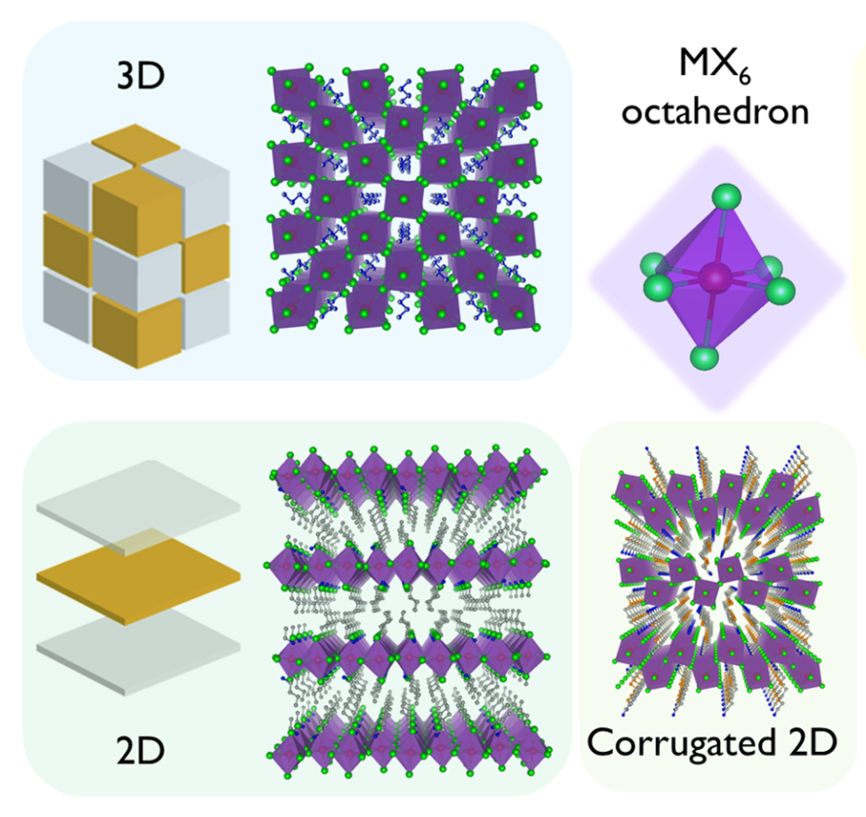

**Scheme 1**. Arrangement of metal halide octahedra (grey cube/layer) and organic cations (brown cube/layer) in 3DP, 2DP, and corrugated 2DP structures. Adapted with permission from ref. [35]. Copyright 2017 American Chemical Society.

Despite its relatively low PCE, 2D PSCs offer remarkable advantages as well. The tendency to self-assemble in a highly oriented fashion naturally creates a dense and smooth film with few or no pinholes and good surface coverage, essential characteristics to maximise current generation and prevent formation of shunt paths. This high-quality film can be achieved with a facile one-step spin-coating process.[28,36–38] The same cannot be said for 3DPs, which normally require two-step spin-coating enhanced with various forms of solvent engineering or additives to achieve a uniform and dense film. The organic layer’s low conductivity, widely considered as 2DP’s primary weakness, has a silver lining as it also dampens J-V curve hysteresis by reducing ion migration.[39] Combined with significantly lower concentration of trap states and small cations compared to 3DP, hysteresis in 2D PSCs can be deeply suppressed.[33,40] The most exceptional feature of 2DP is its environmental stability. From a thermodynamic point of view, 2DPs are fundamentally more stable against decomposition because they have lower (more negative) formation energy due to the spacer cations’ van der Waals interaction.[41] The spacer cations are also more hydrophobic compared to MA+ and FA+due to their longer carbon chain, so they increase overall moisture stability just by replacing some of the smaller organic cations. Thermal stability is simultaneously improved as there are fewer volatile cations like MA+ which sublimate easily. 2DP’s greater resistance to ion migration helps to increase stability by preventing halide segregation in mixed-halide perovskite, iodine migration to anodes, and diffusion of gold atoms.

.

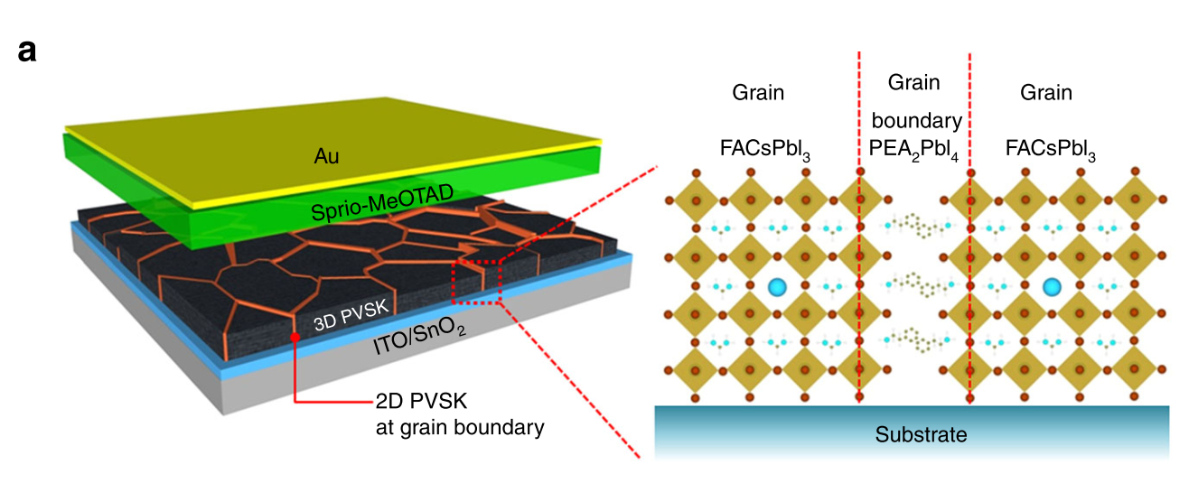

**Scheme 2**. Device schematics of an MDP solar cell with 2D at GB morphology. Reproduced from ref. [42] under a CC-BY 4.0 license ([creativecommons.org/licenses/by/4.0/](http://creativecommons.org/licenses/by/4.0/)).

The need to balance PCE and stability motivates researchers to investigate MDP to combine the best characteristics of 2DP and 3DP. Unfortunately, the term ‘multidimensional’ is not very well-defined. In literature, sometimes quasi-2DP is also referred to as MDP owing to varying values of n in the same film. In this minireview, a more stringent distinction is adopted and the term ‘multidimensional perovskite’ is used only in cases where the 2DP (regardless of n value) and 3DP phases are spatially separated. Under this definition, in practice there are two distinct morphologies of MDP. The first is a spread of small 2DP crystals within a bulk matrix of 3DP, where it is generally found that the 2DP arranges itself along the 3DP grain boundaries to attain the lowest energy and greatest phase stability (2D at GB, Scheme 2).[43] Given this entropy-driven self-arrangement, the 2DP phase must be carefully selected as its band gap is always wider than 3DP’s. Unfavourable straddling gap band alignment at the grain boundaries will further reduce photocurrent as the generated charges are repelled by the 2DP back into the 3DP grains (Scheme 3). On the other hand, the small 2DP grains may enhance overall crystallinity and prevent defect-mediated nonradiative recombination by passivating dangling bonds in the grain boundaries.[40,43] Additionally, in the case of multiphasic 3DP, the presence of 2DP at the grain boundaries can enhance stability of the desired photoactive phase. For example, Li et al. and Lee et al. reported stabilisation of FAPbI3’s α phase through π-π stacking of the spacer cations’ phenyl rings while Zhang et al. stabilized the α phase of CsPbI3 through cross-linking of CsPbI3 crystals with EdA2+ cations.[42–44]

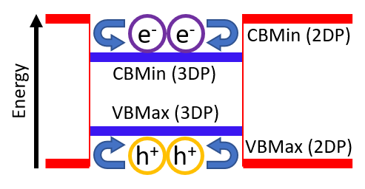

**Scheme 3**. Energy band levels at an interface between 2DP and 3DP phases, showing charge carriers being repelled into the 3DP grain. CBMin is conduction band minima level, while VBMax is valence band maxima level.

The second form is an ultrathin 2DP film capping either the top or bottom surface of 3DP layer (2D/3D), acting as a moisture-proof film thin enough not to significantly hamper charge collection on the perovskite-contact interface. Self-separation of the 2DP phase into its own layer can be achieved by using a precursor with an affinity for the substrate material, choosing organic cations with markedly different solubilities, or using flash annealing-assisted in-situ growth.[45–48] This layer’s thickness can be tuned by varying the concentration of spacer cation precursor or the coating duration.[49] The dense 2DP layer can protect the 3DP bulk from contact-induced degradation, for example diffusion of gold atoms or moisture penetration from hygroscopic PEDOT:PSS and spiro-OMeTAD dopants. Conversely, it can also shield the charge transport layer and contact from mobile ions in the perovskite, such as I- ions. This morphology also bestow other benefits in addition to stability. As the 2DP layer’s conduction and valence band edges are at different energy levels compared to the 3DP phase, the 2DP layer can effectively act as a charge-selective layer provided it is sufficiently thin to avoid severe conductivity impairment as exhibited by Hu et al.[49] The 2DP’s band edges can also be used to achieve faster charge extraction through better energy alignment with charge transport layers and higher open-circuit voltage through larger quasi-Fermi level splitting.[50] Most importantly, the 2DP layer passivates surface defects of the 3DP phase.[51] It is well-known that the surface of 3DPs contains a high concentration of defects in the form of dangling bonds and vacancies created when volatile species sublimated in the annealing step.[52] These defects cause hysteresis, surface recombination, and accelerated moisture-induced degradation.[53] In 2D/3D MDPs, GIWAXS data have shown that the 3DP layer’s surface is reorganised when covered with a thin 2DP layer, resulting in reduced surface recombination.[49] The cationic ammonium ends and the anion counterions in the 2DP layer passivate the dangling bonds, boosting photovoltage and reducing hysteresis. At the same time, care must be taken to ensure that the 2DP layer itself does not cause additional interfacial defects, for example by bromine doping of the 2DP.[54]

3. Operational Stability

In operational conditions, terrestrial solar cells need to be stable under both illumination and heat as they may reach temperatures up to 40oC higher than the ambient temperature. In 3D PSCs, thermal degradation usually occurs through decomposition into its organic and inorganic components. For example, Conings et al. showed decomposition of MAPbI3 into MA, PbI2, HI, and metallic lead by heating it to 85oC in an N2-filled glovebox for 24 hours.[55] Meanwhile, light-induced movement of ions inside the perovskite lattice is also a significant stability issue for 3DP due to its high ionic conductivity and low formation energy of charged defects. Multiple theoretical studies have shown that vacancy-mediated migration of I-, MA+, and FA+ ions in halide perovskites have activation energies comparable to ion conductors, in the range of ~0.1-0.8 eV.[56–58] These ions migrate to and accumulate at the perovskite/charge transport layer interfaces under electric bias, reducing the cell’s electric field, built-in voltage, and charge collection efficiency.[59] Ion migration is an important factor in PSC performance and stability as it contributes to J-V curve hysteresis and irreversible structural damage in ambient air.[60–62] Cells with silver contact are particularly prone to ion migration-induced degradation. Halide ions migrating from the perovskite may react with silver atoms to form silver halide particles, which may become shunt paths.[63,64] Ions from the contact layers can migrate as well, such as gold diffusion into the perovskite layer.[65,66]

As for 2DP, numerous groups have studied the robustness of 2DP films and solar cells against thermal and light-induced degradation through heating or continuous illumination with simulated sunlight. The results from selected works are summarised in Table 1, where entries 1-15 are 2DP samples, 16-18 are 2D at GB MDP samples, and 19-23 are 2D/3D MDP samples. Despite these results’ large variation from one study to another, a common conclusion found in all works is 2DP’s increased stability compared to the 3DP control group. Unfortunately, long-term thermal stability under direct heating is still not well-characterised as most tests were performed for only a short period of time.

The improvement in thermal stability from 3DP to 2DP is mostly due to the spacer cations’ low volatility. As these cations are far heavier than MA+ or FA+, they do not sublimate easily. For example, density functional theory (DFT) simulation has shown that the desorption rate of PEAI from a perovskite structure is six orders of magnitude slower than MAI.[41] However, it should be noted that in many of these studies, thermal stability of the 3DP control was noticeably poorer than for state-of-the-art 3DP devices because the films and devices were synthesised with the same method as the 2DP samples to obtain a fair comparison. As explained in the introduction, simpler synthesis methods are sufficient to create high-quality 2DP films but are very likely to form rough 3DP layers riddled with voids and pinholes. These pinholes become channels through which sublimated MAI or HI can easily escape into the environment. Smooth and dense 3DP films fabricated with optimised processes still exhibit better stability than 2DP at this stage.[67] An important research avenue in the near future would be to optimise the fabrication process and device structure of 2DP and MDP devices to achieve their full thermal stability potential.

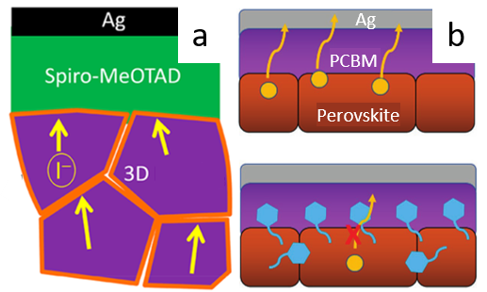

**Scheme 4**. (a) Illustration of 2DP platelets (orange) blocking I- ions (yellow) migrating from the 3DP grains (purple) towards the silver contact in a 2D at GB MDP morphology. Reproduced with permission from ref. [68]. Copyright 2017 American Chemical Society. (b) Illustration of spacer cations (blue) blocking I- ions (yellow) from migrating towards the silver contact in a 2D/3D MDP morphology. Adapted with permission from ref. [69]. Copyright 2017 John Wiley and Sons.

Ion migration in 2DP can be minimised as some of the small organic cations are replaced by bulky spacer cations whose movements are sterically hindered. These spacer cations also have very low ionic conductivity compared to the inorganic octahedral lattice. In addition, it has been shown that vacancies are much more difficult to form in 2DPs compared to 3DPs, thus depriving the mobile ions of their favoured migration path.[70] As a direct consequence of these three reasons, the activation energy of migration for the smaller ions is significantly increased and ion migration is slowed down even in the inorganic octahedra layers. This mechanism is expected to be most beneficial in 2D at GB MDPs, as the migration of mobile ions is fastest at grain boundaries (Scheme 4a).[71] This preference is closely related to thermal stability; upon heating, volatile ions sublimate more easily from surfaces and grain boundaries due to the high defect concentration.[72] This volatilisation then creates vacancies which facilitate ionic motion. As these defects are passivated by the 2DP phase, MDPs are simultaneously more resistant against both thermal decomposition and ion migration. In Chen et al.’s work, for example, putting PEA2PbI4 along the grain boundaries of MAPbI3 reduced the hysteresis and prevented migration of I- ions, thereby accelerating the stabilisation of photocurrent and PCE and preventing formation of AgI. In the same work, DFT calculations also proved that the 2DP phase can act as sinks for I vacancies and thus slow down vacancy-mediated ion migration in the 3DP phase.[68] Similar conclusions were reached by Wang et al., who also observed reduced hysteresis and faster PCE stabilization.[40] As for the 2D/3D MDP morphology, a thin layer of 2DP between 3DP and silver contact effectively becomes a layer of self-encapsulation which prevents silver halide formation Scheme 4b).[69] In short, an MDP morphology with strategic placement of 2DP along the 3DP grain boundaries or between bulk 3DP and charge transport layers is an effective method to stop or reduce ion migration.

|  |  |  |  |
| --- | --- | --- | --- |
| **Table 1.** Summarised operational stability tests results of 2DP and MDP films and solar cells | | | |
|  | Perovskite FormulaRef. | Best Cell PCE (%) | Test Method | Result |
| 1 | BA2MA3Pb4I13[33] | 12.51 | 94 days continuous AM1.5G illumination | Retained ~70% of initial PCE (without encapsulation) |
| 2 | No PCE reduction (encapsulated with glass and epoxy resin) |
| 3 | BA2CsPb2I7[37] | 4.84 | 3 days at 85oC | No change in XRD spectrum |
| 4 | BA2MA3Pb4I13 + 5% Cs[73] | 13.68 | 16 hours at 80oC | Retained 85% of initial PCE |
| 5 | BdAPbI4[27] | 1.08 | Differential scanning calorimetry | Stable until 205oC |
| 6 | HdAPbI4[27] | 0.59 | Stable until 210oC |
| 7 | PEA2GeI4[74] | - | Thermogravimetric analysis | Stable until 250oC |
| 8 | PEA2MA59Pb60I181[41] | 18.4 | 36 hours at 100oC | Retained ~50% of initial PCE |
| 9 | PEI2MA4Pb5I16[28] | 7.63 | 500 hours continuous AM1.5 illumination in short circuit condition | Retained 95% of initial PCE |
| 10 | PEI2MA6Pb7I22[28] | 10.08 | Retained 89% of initial PCE |
| 11 | BA2MA49Pb50Br151[75] | 7.9 | 30 hours continuous AM1.5 illumination in 90oC and 50% relative humidity | Retained 60% of initial PCE |
| 12 | PPA2MA49Pb50Br151[75] | 5.5 |
| 13 | PEA2MA49Pb50Br151[75] | 5.9 | Retained 75% of initial PCE |
| 14 | AB2MA49Pb50I151[76] | 15.6 | 100 hours continuous 1 sun illumination at maximum power point | Retained 90% of initial PCE |
| 15 | BA2MA4Pb5I16[77] | 10.0 | 330 hours continuous illumination in ambient air | Retained 85% of initial PCE |
| 16 | BA0.09(FA0.83Cs0.17)0.91Pb(I0.6Br0.4)3[40] | 17.2 | Continuous full-spectrum simulated sunlight | Retained 80% of initial PCE (42 days without encapsulation) |
| 17 | Retained 80% of initial PCE (162 days encapsulated with polymer foil and glass) |
| 18 | EdAPbI4 / CsPbI3[44] | 10.5 | 7 days at 100oC | No change in film colour and XRD spectrum |
| 19 | (5-AVA)2PbI4 / MAPbI3[45] | 12.9 | >10,000 hours continuous AM1.5G illumination in ambient atmosphere, 55oC | No PCE reduction (sealed with glass cover) |
| 20 | BA2PbI4 / MAPbI3[78] | 19.29 | 100 hours at 95oC | Retained 88% of initial PCE |
| 21 | BA2(MA)n-1PbnI3n+1 / MAPbI3[78] | 18.51 | Retained 96% of initial PCE |
| 22 | PEA2PbI4 / Cs0.05(FA0.83MA0.17)0.95Pb(I0.83Br0.17)3[50] | 18.51 | 100 hours at 60oC, N2 atmosphere | Retained 75% of initial PCE |
| 23 | 100 hours at 85oC, N2 atmosphere | Retained 58% of initial PCE |

As expected, in terms of efficiency MDP devices performed much better than either pure or quasi-2DP devices surveyed in Table 1. Although a direct comparison cannot be made due to variance in component ions and cell architecture, the trend is clear enough for this conclusion to be reached. Remarkably, the most impressive thermal stability was also achieved by an MDP device reported by Grancini et al., whose module exhibited no PCE reduction after more than one year of continuous 1 sun illumination (Figure 1). This impressive achievement shows the huge potential of MDP solar cells to achieve excellent performance and stability at the same time.

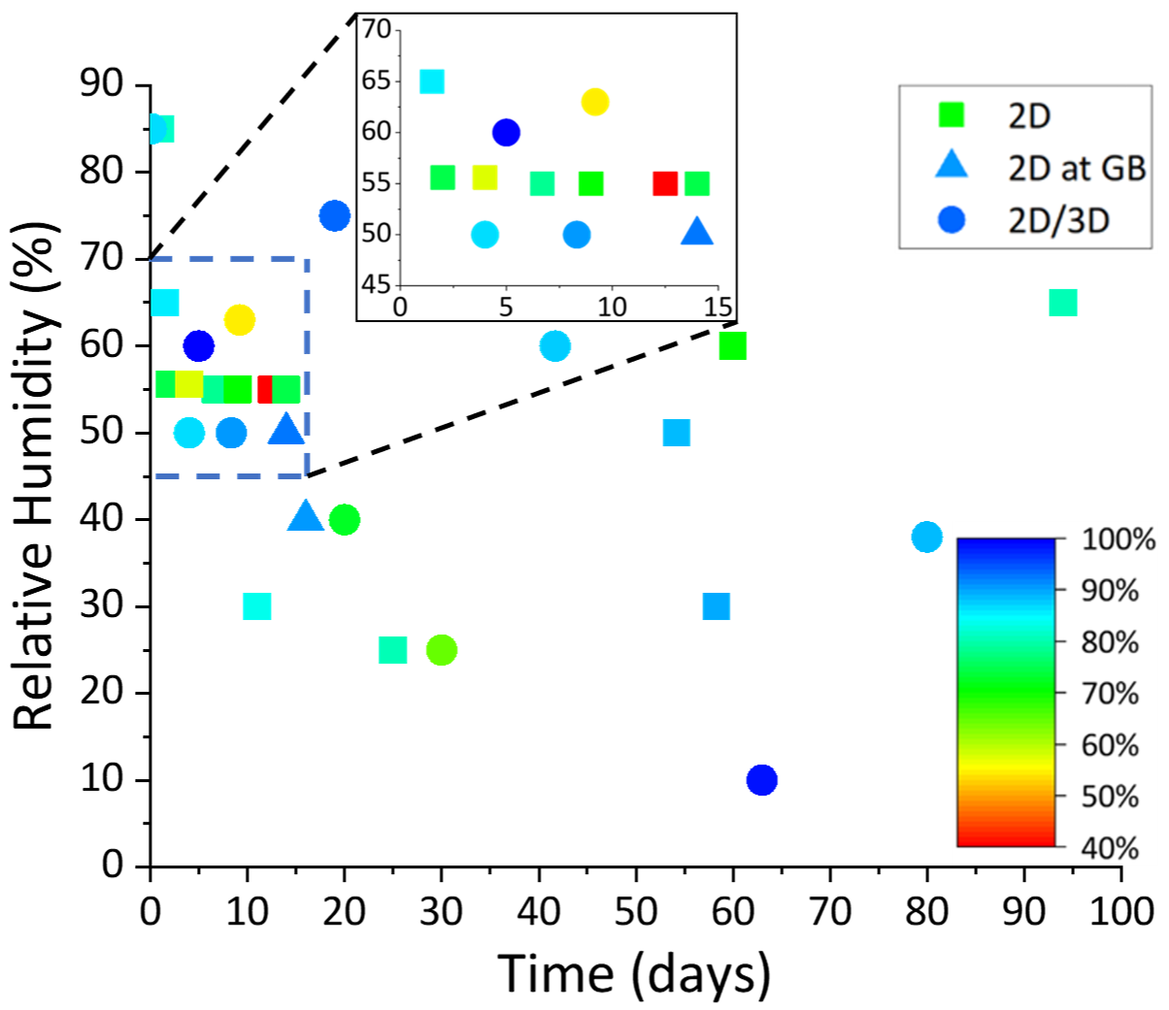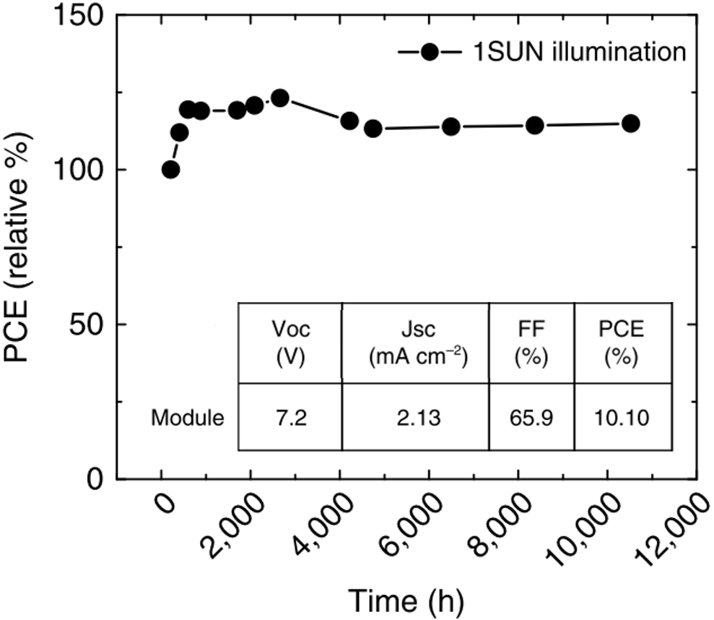

**Figure 1**. PCE evolution of Grancini et al’s module, aged under 1 sun AM 1.5G illumination in short-circuit condition while held at 55oC. PCE increase in the first 500 hours was attributed to field-induced movement, light-induced trap formation, or interfacial charge accumulation. Initial module parameters are detailed in the inset. Adapted from ref. [45] under a CC-BY 4.0 license ([creativecommons.org/licenses/by/4.0/](http://creativecommons.org/licenses/by/4.0/)).

4. Ambient Stability

2DP’s resistance against moisture has been investigated more widely than thermal stability. Figure 2 summarises the results of 32 stability tests of full devices kept in humid environments in room temperature without encapsulation. Numerical data used to construct this plot and reference to the sources can be found in Table 2, where entries 1-17 are 2DP devices, 18-20 are 2D at GB MDP devices, and 21-32 are 2D/3D MDP devices. From Figure 2, most tested devices maintained at least 70% of their original PCE after exposure to humid air. However, most tests lasted for only 2 weeks or less, far shorter than the required operational lifetime. It should also be noted that this summarised dataset is probably affected by publication bias as all data were obtained only from published works and stability tests with disappointing results are less likely to be published.

**Figure 2.** Summarised ambient stability test results of various 2DP and MDP solar cells. Squares are pure 2DP or quasi-2DP devices, triangles are MDP devices with 2D at GB morphology, while circles are MDP devices with 2D/3D morphology. Each symbol’s colour marks the percentage of sustained PCE at the end of that device’s test. The inset shows an enlarged view of the region marked with a dashed box.

To understand the reason for 2DP and MDP’s vastly higher moisture stability compared to 3DP, it is instructive to cover the mechanism for humidity-induced degradation. Yang et al. and Leguy et al. have proposed the formation of hydrated perovskite molecules which will subsequently decompose to MA, HI, MAI, and PbI2 as follows:[79,80]

4MAPbI3 + 4H2O ↔ 4MAPbI3 • H2O

↔ (MA)4PbI6 • 2H2O + 3PbI2 + 2H2O (1)

(MA)4PbI6 • 2H2O → 4MAI + PbI2(s) + 2H2O (2)

(MA)4PbI6 • 2H2O → 4MA(g) + 4HI(g) + PbI2(s) (3)

MDPs slow down this degradation mechanism by preventing the formation of hydrated perovskites, the first step in this sequence of reactions. Water molecules are physically barred from entering the perovskite structure by the low number of pinholes in the 2DP film. This is a direct effect of 2DP’s high degree of orientation easing the formation of dense films with excellent surface coverage. The few water molecules which managed entry will be repelled by the spacer cations’ hydrophobic nature, preventing them from intercalating through the 3DP lattice. Additionally, the simple fact that there are fewer hydrophilic organic cations like MA+ or FA+ means hydrated perovskites are inherently more difficult to form, resulting in slower decomposition (Figure 3). 2DP’s ability to block moisture ingress is crucial for lead halide PSCs as water-soluble lead is a major health and environmental concern for large-scale use of PSCs. While cells can theoretically be encapsulated to avoid contact with moisture, inherently moisture-resistant devices would allow for simpler and cheaper encapsulation material and procedure.

|  |  |  |  |  |  |
| --- | --- | --- | --- | --- | --- |
| **Table 2.** Summarised ambient stability tests results of 2DP and MDP solar cells | | | | | |
|  | Perovskite FormulaRef. | Best Cell PCE (%) | Relative Humidity (%) | Days | PCE Sustained (%) |
| 1 | PEA2MA2Pb3I10[81] | 3.72 | 60 | 60 | 70 |
| 2 | PEA2MA4Pb5I16[38] | 11.01 | 50-60 | 6.7 | 78.5 |
| 3 | 12.5 | 40 |
| 4 | PEA2MA9Pb10I31[41] | 13.89 | 55 | 14 | 87 |
| 5 | PEA2MA39Pb40I121[41] | 18.24 | 77 |
| 6 | PEA2MA59Pb60I181[41] | 18.40 | 74 |
| 7 | BdAPbI4[27] | 1.08 | 55.6 | 2 | 74 |
| 8 | HdAPbI4[27] | 0.59 | 4 | 57 |
| 9 | BA2FA2Pb3I10[82] | 6.88 | 20-30 | 25 | 80 |
| 10 | 50-60 | 9 | >70 |
| 11 | BA2MA3Pb4I13 + 5% Cs[73] | 13.68 | 30 | 58.3 | 89 |
| 12 | 65 | 1.5 | 85 |
| 13 | 85 | 1 | 81 |
| 14 | BA2MA3Pb4I13[33] | 12.51 | 65 | 94 | >80 |
| 15 | BA2MA3Pb4I13[83] | 10.70 | 40-60 | 54.2 | 85 |
| 16 | BA2(MA0.8FA0.2)3Pb4I13[83] | 12.81 | 88 |
| 17 | (ThMA)2MA2Pb3I10 | 15.42 | 20-40 | 11 | 83 |
| 18 | PEA2FA39Pb40I121[43] | 17.7 | 35-45 | 16 | >90 |
| 19 | (MAPbI3)0.98(PEI2PbI4)0.02[84] | 15.2 | ~50 | 14 | 84 |
| 20 | (MAPbI3)0.96(PEI2PbI4)0.04[84] | 12.0 | 92 |
| 21 | PEA2MA4Pb5I16 / MAPbI3[49] | 14.94 | 75 | 19 | 93-94 |
| 22 | PEA2Pb2I4 / MAPbI3[69] | 19.89 | 20-30 | 30 | 64 |
| 23 | PEI2PbI4 / MAPbI3[85] | 16.06 | ~50 | 8.33 | ~90 |
| 24 | (5-AVA)2PbI4 / (FAPbI3)0.88(CsPbBr3)0.12[86] | 16.75 | 75-95 | 0.1 | 86 |
| 25 | ~10 | 63 | 98 |
| 26 | CA2PbI4 / MAPbIxCl3-x[87] | 13.86 | 58-68 | 9.2 | 54 |
| 27 | (CHMA)2MA3Pb4I13 / MAPbI3[46] | 3.78 | >60 | 5 | 100 |
| 28 | (CHMA)2MA4Pb5I16 / MAPbI3[46] | 5.55 |
| 29 | BA2PbI4 / Cs0.05(MA0.17FA0.83)0.95Pb(I0.83Br0.17)3[51] | 15.74 | >50 | 4 | 86 |
| 30 | (5-AVA)2PbI4 ­/ MAPbI3[48] | 18.0 | 40 | 20 | 72 |
| 31 | Br-PEA2PbI4 / Cs0.05(FAxMA1-x)0.95PbIyBr3-y[54] | 20.07 | 38 | 80 | 88 |
| 32 | PEA2PbI4 / Cs0.05(FA0.83MA0.17)0.95Pb(I0.83Br0.17)3[50] | 18.51 | 50-70 | 41.7 | 87.5 |

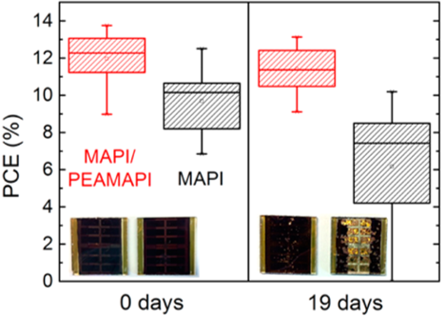

**Figure 3**. PCE distribution of 20 MDP devices with 2D/3D morphology (red) and 20 3DP control devices (black) before and after an ambient stability test. Both cells were aged for 19 days in air at 75% relative humidity and room temperature. The photos are 2D/3D MDP devices (left) and 3DP devices (right) at the start and end of the test. Reproduced with permission from ref. [49]. Copyright 2016 American Chemical Society.

As in the previous section, MDP devices examined in Table 2 exhibit much higher initial PCE compared to the 2DP devices. Notable exceptions are the quasi-2DP cells in entries 5-6, whose n number is so high that they might as well be considered 3DP cells. It remains to be seen whether MDP cells can survive long ambient stability tests with high relative humidity, but existing results are promising.

5. Summary and Outlook

This minireview summarises the attempts to increase efficiency and stability of PSCs by using 2DPs, either on its own or in combination with a 3DP phase as an MDP. It is unfortunate that most of the published works reviewed here do not adhere to a standard set of stability test conditions such as temperature or relative humidity. Further, many also do not publish a measure of stability directly comparable to other works, such as the time taken for devices to lost 20% of their initial efficiency (*t80*). Regardless, 2DPs have been shown to possess greater inherent stability against thermal, moisture, and ion migration-induced degradation compared with 3DPs. However, the former’s PCE is still generally lower due to low conductivity of the organic layer and high exciton binding energy. While many approaches have been proposed to boost the PCE of 2D PSCs, so far MDP seems to be the most powerful approach. By putting just enough amount of 2DP at the right places in or on a bulk layer of 3DP, enhanced stability can be attained while maintaining 3DP’s high efficiency.

There are several potential methods to further increase both the performance and stability of multidimensional PSCs. As the distinctive factor between 2DP and 3DP, the spacer cation is naturally one important parameter to optimise. For example, better thermal and moisture stability can be obtained simply by using a spacer cation with a longer carbon chain or with an aromatic ring[39,88]. Long chains will also reduce conductivity and aggravate charge accumulation, hence an optimum length needs to be found to balance stability and efficiency.[75] Another option to tailor the spacer cation is its charge density distribution, i.e. whether electrons and holes are delocalized (e.g. by conjugation) throughout the whole molecule or concentrated at certain functional groups. It has been shown that localised charges result in higher open-circuit voltage, while delocalised carriers give higher short-circuit current as the molecule’s HOMO and LUMO levels are closer to one another, enabling higher conductivity.[75,76] Again, this is a trade-off situation that must be optimised. Using branched varieties of the spacer cations may help. In an experiment comparing the effect of using BA+ and iso-BA+ as spacer cations, the branched variety exhibited enhanced crystallinity, preferential grain orientation, increased crystal size, and much faster charge transport[89]. Lastly, it is possible to alter the perovskite band gap through the organic spacer by changing the Pb-I-Pb bond angle in the lead halide octahedra.[90] However, the effect of this bond angle on band gap is relatively small. In some cases, satisfactory performance may be obtained by combining two or more of the above approaches. For example, Hu et al. used a spacer cation which is both bifunctional and conjugated to strongly anchor the 2D perovskite on TiO2 nanoparticles and boost conductivity.[76]

For MDP, a crucial parameter is the thickness of the 2DP phase, both for 2DP platelets sitting along 3DP grain boundaries and thin 2DP layer on the top surface of a 3DP perovskite film. So far, no good way has been reported to get a high degree of control over the platelet thickness but tuning the thickness of a 2DP layer is relatively simple. Ideally, we aim to get a layer that is sufficiently thick to be completely impervious to moisture but also thin enough to maintain fast charge collection and minimise parasitic light absorption. Fortunately, there are many factors we can control to obtain this Goldilocks thickness, such as precursor concentration, drying speed, and various deposition method-related parameters. For the 2D/3D configuration specifically, a potential idea to explore is to move even further and apply a thin layer of 0D perovskite quantum dots on top of the 2DP layer. This arrangement has been tried with an all-inorganic CsPbBrI2, in which the graded interface was shown to reduce nonradiative recombination and enable a wider splitting between the electron and hole quasi-Fermi levels.[91]

Finally, 2DP and MDP share two major challenges with 3DP solar cells, namely removing or reducing lead content and expanding lab-scale devices (~0.1 cm2) to large cells (~1 cm2) and modules (~10-100 cm2). As mentioned above, toxic lead is a major concern for commercialisation of lead halide PSCs due to its high solubility in water. Current lead content in a typical lead halide PSC is about 10%, two orders of magnitude higher than the European Union’s Restriction of Hazardous Substances in Electrical and Electronic Equipment directive (RoHS 2).[92,93] Several non-lead 3DP structures have been proposed to tackle this problem, such as dimer perovskite (A3B2X9, B = Sb3+, Bi3+), double perovskite (A2BB’X6, B’ = Cu+, Ag+), or simply replacing lead with tin, germanium, or titanium.[94,95] All these combinations have drawbacks in efficiency, stability, or both, but there has been very little research on the 2D analogues of these non-traditional perovskites. There is a good chance that 2D and multidimensional architectures can improve the properties of those structures just as in the case of MAPbI3 and other conventional photoactive perovskites. At the same time, there is currently increasing interest on developing scalable deposition methods to upscale PSCs into modules. Grancini et al.’s success in printing a module with 47.6 cm2 active area and 11.2% PCE and one-year stability is an excellent starting point for the community to look into making 2DP- or MDP-based modules with blade-coating, slot die-coating, spray coating, and other methods.[45]

Acknowledgements

F.U.K. thanks the Jardine Foundation for a doctoral scholarship.

**Keywords:** energy conversion • multidimensional perovskite • perovskite phases • photovoltaics • stability

[1] D. B. Mitzi, in *Prog. Inorg. Chem.* (Ed.: K.D. Karlin), John Wiley & Sons, **1999**, pp. 1–122.

[2] A. Kojima, K. Teshima, Y. Shirai, T. Miyasaka, *J Am Chem Soc* **2009**, *131*, 6050–6051.

[3] M. M. Lee, J. Teuscher, T. Miyasaka, T. N. Murakami, H. J. Snaith, *Science (80-. ).* **2012**, *338*, 643–647.

[4] M. B. Zakaria, T. Nagata, A. Matsuda, Y. Yasuhara, A. Ogura, M. S. A. Hossain, M. Billah, Y. Yamauchi, T. Chikyow, *ACS Appl. Nano Mater.* **2018**, *3*, acsanm.7b00310.

[5] X. Y. Chin, D. Cortecchia, J. Yin, A. Bruno, C. Soci, *Nat. Commun.* **2015**, *6*, 1–9.

[6] L. Su, Z. X. Zhao, H. Y. Li, J. Yuan, Z. L. Wang, G. Z. Cao, G. Zhu, *ACS Nano* **2015**, *9*, 11310–11316.

[7] A. Guerrero, J. Bisquert, *Curr. Opin. Electrochem.* **2017**, *2*, 144–147.

[8] C. Gu, J. S. Lee, *ACS Nano* **2016**, *10*, 5413–5418.

[9] B. Hua, M. Li, Y. Q. Zhang, Y. F. Sun, J. L. Luo, *Adv. Energy Mater.* **2017**, *7*, 1–8.

[10] Z.-K. Tan, R. S. Moghaddam, M. L. Lai, P. Docampo, R. Higler, F. Deschler, M. Price, A. Sadhanala, L. M. Pazos, D. Credgington, et al., *Nat. Nanotechnol.* **2014**, *9*, 687–692.

[11] G. Xing, N. Mathews, S. S. Lim, N. Yantara, X. Liu, D. Sabba, M. Grätzel, S. Mhaisalkar, T. C. Sum, *Nat. Mater.* **2014**, *13*, 476–480.

[12] J. H. Noh, S. H. Im, J. H. Heo, T. N. Mandal, S. Il Seok, *Nano Lett.* **2013**, *13*, 1764–1769.

[13] S. De Wolf, J. Holovsky, S. J. Moon, P. Löper, B. Niesen, M. Ledinsky, F. J. Haug, J. H. Yum, C. Ballif, *J. Phys. Chem. Lett.* **2014**, *5*, 1035–1039.

[14] K. Galkowski, A. Mitioglu, A. Miyata, P. Plochocka, O. Portugall, G. E. Eperon, J. T.-W. Wang, T. Stergiopoulos, S. D. Stranks, H. J. Snaith, et al., *Energy Environ. Sci.* **2015**, *9*, 962–970.

[15] G. Xing, N. Mathews, S. Sun, S. S. Lim, Y. M. Lam, M. Grätzel, S. Mhaisalkar, T. C. Sum, *Science (80-. ).* **2013**, *342*, 344–7.

[16] Y. Shao, Z. Xiao, C. Bi, Y. Yuan, J. Huang, *Nat. Commun.* **2014**, *5*, 1–7.

[17] L. Etgar, P. Gao, Z. Xue, Q. Peng, A. K. Chandiran, B. Liu, M. K. Nazeeruddin, M. Graetzel, *J. Am. Chem. Soc.* **2012**, *134*, 17396–17399.

[18] J. H. Heo, H. J. Han, D. Kim, T. K. Ahn, S. H. Im, *Energy Environ. Sci.* **2015**, *8*, 1602–1608.

[19] F. T. F. O’Mahony, Y. H. Lee, C. Jellett, S. Dmitrov, D. T. J. Bryant, J. R. Durrant, B. C. O’Regan, M. Graetzel, M. K. Nazeeruddin, S. A. Haque, *J. Mater. Chem. A* **2015**, *3*, 7219–7223.

[20] W. Rehman, D. P. McMeekin, J. B. Patel, R. L. Milot, M. B. Johnston, H. J. Snaith, L. M. Herz, *Energy Environ. Sci.* **2017**, *10*, 361–369.

[21] N. J. Jeon, J. H. Noh, W. S. Yang, Y. C. Kim, S. Ryu, J. Seo, S. Il Seok, *Nature* **2015**, *517*, 476–480.

[22] W. S. Yang, B. Park, E. H. Jung, N. J. Jeon, *Science (80-. ).* **2017**, *356*, 1376–1379.

[23] M. Saliba, T. Matsui, J.-Y. Seo, K. Domanski, J.-P. Correa-Baena, M. K. Nazeeruddin, S. M. Zakeeruddin, W. Tress, A. Abate, A. Hagfeldt, et al., *Energy Environ. Sci.* **2016**, *9*, 1989–1997.

[24] F. U. Kosasih, C. Ducati, *Nano Energy* **2018**, *47*, 243–256.

[25] V. M. Goldschmidt, *Naturwissenschaften* **1926**, *14*, 477–485.

[26] C. Li, X. Lu, W. Ding, L. Feng, Y. Gao, Z. Guo, *Acta Crystallogr. Sect. B Struct. Sci.* **2008**, *64*, 702–707.

[27] M. Safdari, P. H. Svensson, M. T. Hoang, I. Oh, L. Kloo, J. M. Gardner, *J. Mater. Chem. A* **2016**, *4*, 15638–15646.

[28] K. Yao, X. Wang, Y. X. Xu, F. Li, L. Zhou, *Chem. Mater.* **2016**, *28*, 3131–3138.

[29] G. C. Papavassiliou, I. B. Koutselas, *Synth. Met.* **1995**, *71*, 1713–1714.

[30] K. Tanaka, F. Sano, T. Takahashi, T. Kondo, R. Ito, K. Ema, *Solid State Commun.* **2002**, *122*, 249–252.

[31] T. Ishihara, X. Hong, J. Ding, A. V. Nurmikko, *Surf. Sci.* **1992**, *267*, 323–326.

[32] J. C. Blancon, H. Tsai, W. Nie, C. C. Stoumpos, L. Pedesseau, C. Katan, M. Kepenekian, C. M. M. Soe, K. Appavoo, M. Y. Sfeir, et al., *Science (80-. ).* **2017**, *355*, 1288–1292.

[33] H. Tsai, W. Nie, J. C. Blancon, C. C. Stoumpos, R. Asadpour, B. Harutyunyan, A. J. Neukirch, R. Verduzco, J. J. Crochet, S. Tretiak, et al., *Nature* **2016**, *536*, 312–317.

[34] X. Zhang, G. Wu, S. Yang, W. Fu, Z. Zhang, C. Chen, W. Liu, J. Yan, W. Yang, H. Chen, *Small* **2017**, *13*, 1–8.

[35] H. Lin, C. Zhou, Y. Tian, T. Siegrist, B. Ma, *ACS Energy Lett.* **2018**, *3*, 54–62.

[36] I. C. Smith, E. T. Hoke, D. Solis-Ibarra, M. D. McGehee, H. I. Karunadasa, *Angew. Chemie - Int. Ed.* **2014**, *53*, 11232–11235.

[37] J.-F. Liao, H.-S. Rao, B.-X. Chen, D.-B. Kuang, C.-Y. Su, *J. Mater. Chem. A* **2017**, *5*, 2066–2072.

[38] X. Zhang, G. Wu, W. Fu, M. Qin, W. Yang, J. Yan, Z. Zhang, X. Lu, H. Chen, *Adv. Energy Mater.* **2018**, *8*, 1702498.

[39] Y. Lin, Y. Bai, Y. Fang, Q. Wang, Y. Deng, J. Huang, *ACS Energy Lett.* **2017**, *2*, 1571–1572.

[40] Z. Wang, Q. Lin, F. P. Chmiel, N. Sakai, L. M. Herz, H. J. Snaith, *Nat. Energy* **2017**, *6*, 17135.

[41] L. N. Quan, M. Yuan, R. Comin, O. Voznyy, E. M. Beauregard, S. Hoogland, A. Buin, A. R. Kirmani, K. Zhao, A. Amassian, et al., *J. Am. Chem. Soc.* **2016**, *138*, 2649–2655.

[42] J.-W. Lee, Z. Dai, T.-H. Han, C. Choi, S.-Y. Chang, S.-J. Lee, N. De Marco, H. Zhao, P. Sun, Y. Huang, et al., *Nat. Commun.* **2018**, *9*, 3021.

[43] N. Li, Z. Zhu, C. C. Chueh, H. Liu, B. Peng, A. Petrone, X. Li, L. Wang, A. K. Y. Jen, *Adv. Energy Mater.* **2017**, *7*, 1–9.

[44] T. Zhang, M. I. Dar, G. Li, F. Xu, N. Guo, M. Grätzel, Y. Zhao, *Sci. Adv.* **2017**, *3*, e1700841.

[45] G. Grancini, C. Roldán-Carmona, I. Zimmermann, E. Mosconi, X. Lee, D. Martineau, S. Narbey, F. Oswald, F. De Angelis, M. Graetzel, et al., *Nat. Commun.* **2017**, *8*, 15684.

[46] T. M. Koh, J. Huang, I. Neogi, P. P. Boix, S. G. Mhaisalkar, N. Mathews, *ACS Appl. Mater. Interfaces* **2017**, *9*, 28743–28749.

[47] Y. Liao, H. Liu, W. Zhou, D. Yang, Y. Shang, Z. Shi, B. Li, X. Jiang, L. Zhang, L. N. Quan, et al., *J. Am. Chem. Soc.* **2017**, *139*, 6693–6699.

[48] T. Ye, A. Bruno, G. Han, T. M. Koh, J. Li, N. F. Jamaludin, C. Soci, S. G. Mhaisalkar, W. L. Leong, *Adv. Funct. Mater.* **2018**, *28*, 1801654.

[49] Y. Hu, J. Schlipf, M. Wussler, M. L. Petrus, W. Jaegermann, T. Bein, P. Müller-Buschbaum, P. Docampo, *ACS Nano* **2016**, *10*, 5999–6007.

[50] P. Chen, Y. Bai, S. Wang, M. Lyu, J.-H. Yun, L. Wang, *Adv. Funct. Mater.* **2018**, *28*, 1706923.

[51] T. M. Koh, V. Shanmugam, X. Guo, S. S. Lim, O. Filonik, E. M. Herzig, P. Müller-Buschbaum, V. Swamy, S. T. Chien, S. G. Mhaisalkar, et al., *J. Mater. Chem. A* **2018**, *6*, 2122–2128.

[52] G. Han, T. M. Koh, S. S. Lim, T. W. Goh, X. Guo, S. W. Leow, R. Begum, T. C. Sum, N. Mathews, S. Mhaisalkar, *ACS Appl. Mater. Interfaces* **2017**, *9*, 21292–21297.

[53] H. Uratani, K. Yamashita, *J. Phys. Chem. Lett.* **2017**, *8*, 742–746.

[54] Y. Lv, Y. Shi, X. Song, J. Liu, M. Wang, S. Wang, Y. Feng, S. Jin, C. Hao, *ACS Appl. Mater. Interfaces* **2018**, *10*, 31755–31764.

[55] B. Conings, J. Drijkoningen, N. Gauquelin, A. Babayigit, J. D’Haen, L. D’Olieslaeger, A. Ethirajan, J. Verbeeck, J. Manca, E. Mosconi, et al., *Adv. Energy Mater.* **2015**, *5*, 1–8.

[56] C. Eames, J. M. Frost, P. R. F. Barnes, B. C. O’Regan, A. Walsh, M. S. Islam, *Nat. Commun.* **2015**, *6*, 7497.

[57] J. M. Azpiroz, E. Mosconi, J. Bisquert, F. De Angelis, *Energy Environ. Sci.* **2015**, *8*, 2118–2127.

[58] J. Haruyama, K. Sodeyama, L. Han, Y. Tateyama, *J. Am. Chem. Soc.* **2015**, *137*, 10048–10051.

[59] W. Tress, N. Marinova, T. Moehl, S. M. Zakeeruddin, M. K. Nazeeruddin, M. Grätzel, *Energy Environ. Sci.* **2015**, *8*, 995–1004.

[60] S. Van Reenen, M. Kemerink, H. J. Snaith, *J. Phys. Chem. Lett.* **2015**, *6*, 3808–3814.

[61] T. Leijtens, E. T. Hoke, G. Grancini, D. J. Slotcavage, G. E. Eperon, J. M. Ball, M. De Bastiani, A. R. Bowring, N. Martino, K. Wojciechowski, et al., *Adv. Energy Mater.* **2015**, *5*, 1–11.

[62] P. Calado, A. M. Telford, D. Bryant, X. Li, J. Nelson, B. C. O’Regan, P. R. F. Barnes, *Nat. Commun.* **2016**, *7*, 1–10.

[63] Y. Kato, L. K. Ono, M. V. Lee, S. Wang, S. R. Raga, Y. Qi, *Adv. Mater. Interfaces* **2015**, *2*, 2–7.

[64] T. Leijtens, G. E. Eperon, S. Pathak, A. Abate, M. M. Lee, H. J. Snaith, *Nat. Commun.* **2013**, *4*, 1–8.

[65] K. Domanski, J. P. Correa-Baena, N. Mine, M. K. Nazeeruddin, A. Abate, M. Saliba, W. Tress, A. Hagfeldt, M. Grätzel, *ACS Nano* **2016**, *10*, 6306–6314.

[66] S. Cacovich, L. Ciná, F. Matteocci, G. Divitini, P. A. Midgley, A. Di Carlo, C. Ducati, *Nanoscale* **2017**, *9*, 4700–4706.

[67] J. A. Christians, P. Schulz, J. S. Tinkham, T. H. Schloemer, S. P. Harvey, B. J. Tremolet de Villers, A. Sellinger, J. J. Berry, J. M. Luther, *Nat. Energy* **2018**, *3*, 68–74.

[68] J. Chen, D. Lee, N. G. Park, *ACS Appl. Mater. Interfaces* **2017**, *9*, 36338–36349.

[69] Y. Bai, S. Xiao, C. Hu, T. Zhang, X. Meng, H. Lin, Y. Yang, S. Yang, *Adv. Energy Mater.* **2017**, *7*, 1701038.

[70] X. Xiao, J. Dai, Y. Fang, J. Zhao, X. Zheng, S. Tang, P. N. Rudd, X. C. Zeng, J. Huang, *ACS Energy Lett.* **2018**, 684–688.

[71] Y. Yuan, J. Huang, *Acc. Chem. Res.* **2016**, *49*, 286–293.

[72] Q. Wang, B. Chen, Y. Liu, Y. Deng, Y. Bai, Q. Dong, J. Huang, *Energy Environ. Sci.* **2017**, *10*, 516–522.

[73] X. Zhang, X. Ren, B. Liu, R. Munir, X. Zhu, D. Yang, J. Li, Y. Liu, D.-M. Smilgies, R. Li, et al., *Energy Environ. Sci.* **2017**, *10*, 2095–2102.

[74] P. Cheng, T. Wu, J. Zhang, Y. Li, J. Liu, L. Jiang, X. Mao, R. F. Lu, W. Q. Deng, K. Han, *J. Phys. Chem. Lett.* **2017**, *8*, 4402–4406.

[75] B.-E. Cohen, M. Wierzbowska, L. Etgar, *Sustain. Energy Fuels* **2017**, *1*, 1935–1943.

[76] Y. Hu, Z. Zhang, A. Mei, Y. Jiang, X. Hou, Q. Wang, K. Du, Y. Rong, Y. Zhou, G. Xu, et al., *Adv. Mater.* **2018**, *30*, 1705786.

[77] C. M. M. Soe, W. Nie, C. C. Stoumpos, H. Tsai, J.-C. Blancon, F. Liu, J. Even, T. J. Marks, A. D. Mohite, M. G. Kanatzidis, *Adv. Energy Mater.* **2018**, *8*, 1700979.

[78] Y. Lin, Y. Bai, Y. Fang, Z. Chen, S. Yang, X. Zheng, S. Tang, Y. Liu, J. Zhao, J. Huang, *J. Phys. Chem. Lett.* **2018**, *9*, 654–658.

[79] J. Yang, B. D. Siempelkamp, D. Liu, T. L. Kelly, *ACS Nano* **2015**, *9*, 1955–1963.

[80] A. M. A. Leguy, Y. Hu, M. Campoy-Quiles, M. I. Alonso, O. J. Weber, P. Azarhoosh, M. Van Schilfgaarde, M. T. Weller, T. Bein, J. Nelson, et al., *Chem. Mater.* **2015**, *27*, 3397–3407.

[81] X. Gan, O. Wang, K. Liu, X. Du, L. Guo, H. Liu, *Sol. Energy Mater. Sol. Cells* **2017**, *162*, 93–102.

[82] J. Yan, W. Fu, X. Zhang, J. Chen, W. Yang, W. Qiu, G. Wu, F. Liu, P. Heremans, H. Chen, *Mater. Chem. Front.* **2018**, *2*, 121–128.

[83] N. Zhou, Y. Shen, L. Li, S. Tan, N. Liu, G. Zheng, Q. Chen, H. Zhou, *J. Am. Chem. Soc.* **2018**, *140*, 459–465.

[84] K. Yao, X. Wang, F. Li, L. Zhou, *Chem. Commun.* **2015**, *51*, 15430–15433.

[85] K. Yao, X. Wang, Y. Xu, F. Li, *Nano Energy* **2015**, *18*, 165–175.

[86] J. Chen, J.-Y. Seo, N.-G. Park, *Adv. Energy Mater.* **2018**, *8*, 1702714.

[87] C. Ma, C. Leng, Y. Ji, X. Wei, K. Sun, L. Tang, J. Yang, W. Luo, C. Li, Y. Deng, et al., *Nanoscale* **2016**, *8*, 18309–18314.

[88] L. Iagher, L. Etgar, *ACS Energy Lett.* **2018**, *3*, 366–372.

[89] Y. Chen, Y. Sun, J. Peng, W. Zhang, X. Su, K. Zheng, T. Pullerits, Z. Liang, *Adv. Energy Mater.* **2017**, *7*, 1–7.

[90] J. L. K. and, J. D. Martin*, D. B. Mitzi, **2005**, DOI 10.1021/IC050244Q.

[91] J. Zhang, D. Bai, Z. Jin, H. Bian, K. Wang, J. Sun, Q. Wang, S. F. Liu, *Adv. Energy Mater.* **2018**, *8*, 1703246.

[92] M. Saliba, J.-P. Correa-Baena, M. Grätzel, A. Hagfeldt, A. Abate, *Angew. Chemie Int. Ed.* **2018**, *57*, 2554–2569.

[93] European Parliament, Council of the European Union, *Off. J. Eur. Union* **2011**, *54*, 88–110.

[94] F. Giustino, H. J. Snaith, *ACS Energy Lett.* **2016**, *1*, 1233–1240.

[95] M. Chen, M.-G. Ju, A. D. Carl, Y. Zong, R. L. Grimm, J. Gu, X. C. Zeng, Y. Zhou, N. P. Padture, *Joule* **2018**, 1–13.

**Entry for the Table of Contents**

|  |  |  |  |  |
| --- | --- | --- | --- | --- |
| MINIREVIEW | | | | |
| This work reviews the current progress in attaining both high efficiency and stability in solar cells using multidimensional perovskite, combining the best characteristics of 3D and 2D perovskites. Challenges and potential improvements of multidimensional perovskite solar cells are also presented. |  |  |  | Felix Utama Kosasih*  Page No. – Page No.  Attaining High Photovoltaic Efficiency and Stability with Multidimensional Perovskite |
|  |  |