In-Situ Optical Tracking of Electroablation in 2D Transition Metal Dichalcogenides

Anjli Kumar,† Amritanand Sebastian,‡ Saptarshi Das,‡,§ Emilie Ringe^{†,#,φ,Δ,}*
†Department of Chemistry, Rice University, Houston, TX, USA
‡Department of Engineering Science and Mechanics, Pennsylvania State University, University Park, USA
§Materials Research Institute Pennsylvania State University, University Park, PA, USA
#Department of Materials Science and Nanoengineering, Rice University, Houston, TX, USA
^{φ}Department of Materials Science and Metallurgy, University of Cambridge, Cambridge, UK
^{Δ}Department of Earth Sciences, University of Cambridge, Cambridge, UK

KEYWORDS. 2D materials, TMDs, electroablation, MExS, spectroelectrochemistry, reflectance

ABSTRACT
Two-dimensional (2D) transition metal dichalcogenides (TMDs) are a unique class of 2D materials possessing unique optoelectronic properties when exfoliated into mono- and few-layer sheets. Recently, electroablation (EA) has become of interest as a promising synthesis method for single-layer sheets of TMDs. Here, we introduce spectroelectrochemical Micro-Extinction Spectroscopy (SE-MExS) as a high-throughput technique to study electrochemical thinning of TMDs as they occur. This approach enables parallel use of spectroscopy and imaging in order to non-destructively characterize 2D materials in-situ. We unravel optoelectronics of TMDs by observing changes in optical properties during EA. We find that the EA process for MoS₂, WS₂, MoSe₂, and WSe₂ occurs edge-first, generating a high density of edge sites. Our results show that stable monolayers of MoS₂, WS₂, and MoSe₂ can be synthesized from bulk precursors by the EA process, while conversely, no WSe₂ remains post-ablation.

INTRODUCTION
Two-dimensional (2D) materials have attracted increasing interest since the report of the fascinating properties of graphene in 2004.³ In graphene and other atomically thin materials, quantum hall confinement occurs because charge and heat are limited to a 2D space, leading to unique physical and electronic properties including charge density waves and high-temperature superconductivity.^{4–6} Similar to graphene, mechanical exfoliation has been used to extract atomically thin sheets from a variety of van der Waals solids,^{4,7–9} for instance hexagonal boron nitride (h-BN),¹⁰ transmission metal dichalcogenides (TMDs, e.g., MoS₂, WS₂),^{11,12} and other metal chalcogenides (e.g., Bi₂Te₃ and FeSe).^{13,14} Such exfoliation is enabled by the bonding structure of van der Waals solids: covalent bonds strongly connect atoms within layers, while stacks of layers are held together via weaker van der Waals forces.⁴
Atomically TMDs have diverse chemical properties, and, unlike graphene,^{15,16} do not require functionalization in order to be chemically active, allowing the facile use of their confinement-related electronic properties. Furthermore, bulk TMDs have a spectrum of useful properties that remain present when exfoliated into thin sheets; for example they can range from insulators, to semiconductors and semi-metals, to pure metals.¹⁶ TMDs also exhibit various low-temperature phenomena such as superconductivity, charge density waves, and Mott transitions.^{17–19} This unique combination of chemical and physical properties of TMDs results in broad application versatility, fueling the need for large-scale, cost-effective synthesis methods.
In a recent set of studies, Das and co-workers reported EA as a new technique for the synthesis of atomically-thin sheets of TMDs.^{1,20–22} MoS₂, WS₂, and MoSe₂ were observed to undergo a self-limiting electrochemical process where a high positive potential ablates topical layers, leaving behind a stable monolayer. Ex situ atomic force microscopy (AFM), Raman spectroscopy, photoluminescence (PL), and scanning transmission electron microscopy (STEM) studies, in conjunction with optical imaging, revealed the basics of the EA process. However, there remains significant gaps in our understanding of this exciting, scalable EA process, which are difficult to address with such ex situ characterization. The use of in situ techniques has the potential to elucidate the actual process of EA and monolayer formation.
Numerous characterization techniques are available to explore properties of single- and few-layer TMDs. Fluorescence quenching microscopy yields layer thickness^{23–25} but requires surface modification which limits the concurrent use of other techniques to study pure TMD nanosheets. Atomic force microscopy also provides layer thickness^{26–28} and scanning tunneling microscopy, electronic and topographic properties,^{29–33} however they both rely on physical contact between the sample and a cantilever tip that can lead to contamination. Raman spectroscopy informs on composition, thickness, local temperature^{34–36} but uses a laser probe that can ultimately destroy the sample.³⁷ Lastly, transmission electron microscopy unravels composition, single-layer size, interlayer stacking, and crystal structure^{26,28,34,38–41} yet uses a potentially damaging electron probe. Because such sample damage and contamination are non-reversible processes they prevent subsequent analysis of the sample, Butler et al. declared the need for novel high-throughput characterization techniques that nondestructively detect properties of 2D materials; specifically stating that the development of new techniques that use spectroscopy and imaging in parallel will prove useful in exploring the unique properties of atomically-thin materials.⁴
In a recent study, we introduced an optical spatial-scanning hyperspectral approach: Micro-Extinction Spectroscopy (MExS).² MExS is a versatile optical characterization technique in which spectroscopy is done in tandem with optical imaging of “large” regions (100s of microns). The use of low intensity, transmitted white light illumination, as opposed to a focused laser³⁷ or electron beam,^{26,28,34,38–41} enables measurements with no discernible beam damage or probe contamination.
Here, we introduce spectroelectrochemical-MExS (SE-MExS) as a nondestructive, high throughput, in situ characterization technique. We use this technique to probe, in situ, the optical properties of TMDs as they undergo EA. This enables us to elucidate the process of EA for MoS₂, WS₂, MoSe₂, and WSe₂, where tracking changes in energy of excitonic transitions provides information on changes in sample thickness. Further, potential-dependent excitonic energy maps help us explore spatial dependence of the EA process, and we find that ablation occurs “edge-in” for all four materials studied, as summarized in Table 1.

RESULTS AND DISCUSSION
Optical detection of the Electroablation process. We first determined that SE-MExS, a white-light optical scanning-spatial hyperspectral technique,² is an appropriate technique for detecting EA processes. In SE-MExS, a three-electrode electrochemical cell is placed in the MExS optical light path such that the working electrode is the sample, here a TMD on a TiN/Si substrate (Figure 1). This setup is then biased to positive potentials, allowing in situ observation of the oxidative behavior of TMDs. The optical response, tracked in reflectance geometry during oxidation, shows a marked change for all the materials observed, i.e. MoS₂, MoSe₂, WS₂, and WSe₂ (Figure 1c-j). Prior to the potential step, the samples are bright, indicative of the strong reflectance of multilayer samples.⁴² After the potential step, a significant reduction of the reflectance signal is observed.
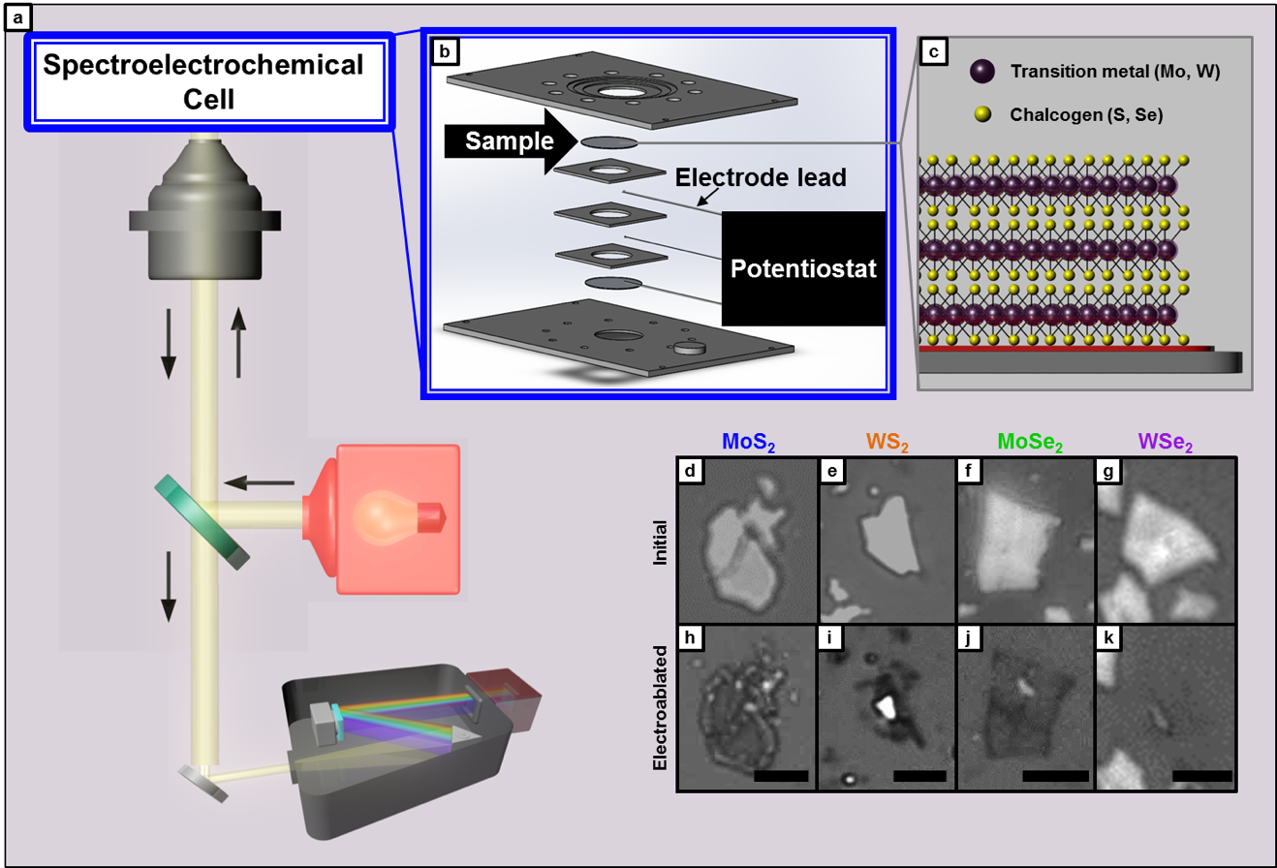
Figure 1. Spectroelectrochemical Micro-Extinction Spectroscopy (SE-MExS) reflectance mode. (a) Reflectance-mode optical setup. Illumination source is an LED lamp. After interaction with the sample, the light is reflected back and passed through the spectrometer and spectral data recorded on the EMCCD. (b) Spectroelectrochemical cell. The sample is placed face down at the top of the electrochemical cell. (c) Schematic of 2D transition metal dichalcogenides. Purple atoms represent the transition metal, yellow atoms represent the chalcogen. (d-f) Optical images before and after electroablation for MoS₂, WS₂, MoSe₂, WSe₂. The initial images (d-g) show that the flakes have high reflectance in contrast to the TiN substrate. The images taken after electroablation for MoS₂, WS₂, MoSe₂ (h-j) show the flakes remain but have much lower reflectance intensity. This is attributed to modification of the flake from multilayer to monolayer. In the case of WSe₂ (k) no flake remains post electroablation. Scalebars: (h-j) 10 μm, (k) 5 μm.

The outline of the sample is still visible after oxidation for MoS₂, WS₂, and MoSe₂. This indicates that the positive potential reduces the sample’s thickness without removing it entirely. In contrast, WSe₂ shows less resistance to the EA process; a large positive potential resulted in its entire removal (Figure 1j). This variation in the extent of EA for different TMDs can be attributed to differences in binding energies (interlayer, basal plane/substrate). The interlayer binding energy (e.g., MoS₂ -0.16 eV), due to weak van der Waals forces, is lower than that of the covalently-bound basal plane/substrate interface (e.g., MoS₂ -1.25 eV).²⁰ For all systems, a sufficiently high positive potential breaks the weak interlayer bonds, i.e. EA occurs (Table 1). These results confirm the suitability of SE-MExS as an in situ characterization tool useful for characterizing the EA process and suggest that MoS₂, WS₂, and MoSe₂ monolayers can withstand highly corrosive environments.
Table 1. Summary of the electroablation process in MoS₂, WS₂, MoSe₂, and WSe₂, and listing of associated Figures.
Composition | MoS₂ | WS₂ | MoSe₂ | WSe₂
Exciton Studied and Energy (nm) | A  670-685 | A  620-650 | B  595-630 | A’  515-565
EA Onset (V) | 0.75 | 0.6 | 1.0 | 1.0
EA Behavior | Edge-in to monolayer | Edge-in to monolayer | Edge-in to monolayer | Edge-in, full ablation
Associated Figures | 1, 2, 3, S2, S3, S6 | 1, S1, S2, S4 | 1, S1, S2, S5 | 1, 4,  S1, S2

Determination of the onset of Electroablation. An advantageous feature of in situ SE-MExS is the ability to acquire spectroscopic data during EA. Thereby, SE-MExS can characterize processes in real time and reveal information beyond that obtained with before and after snapshots (Figure 1c-j). Cyclic voltammetry (CV) experiments were first conducted on each material in order to determine the voltage range where EA occurs (Figure S2). For CV experiments, the potential was swept from 0 to 2 V at 10 mV s⁻¹. The EA occurs only on the forward sweep (0 2 V) and no peak is visible in the reverse sweep (2 0 V). For in situ chronocoulometry (CC) experiments, small potential steps were applied (50 or 100 mV) and the reflectance spectral signature of the material was acquired concurrently; optical images were acquired between applied potential steps (Figures 2 and S1).
The optical image series for MoS₂ shows initial signs of EA at 0.75 V (Figure 2a). The general onset of the EA process occurs at 1.0 V (pH 2); at this potential, there is a decrease in reflectance intensity across the entire sample area. Corresponding spectral data offers confirmation of this observation (Figure 2b). For multilayer MoS₂ the peak for exciton A occurs between 670-685 nm. As layers of material are removed, the energy of exciton A blueshifts.⁴³ Similar analysis of WS₂, MoSe₂, and WSe₂ shows EA onset potentials of 0.6 V for WS₂ and 1.0 V for both MoSe₂ and WSe₂ (optical image series reported in Figure S1, spectral data, Figure 2c-e). The exact EA potentials differ from those previously reported;^{1,21} this is attributed to differences in the electrochemical cell geometry (i.e., electrode surface area, inter-electrode distance). Our results are consistent with previous reports in that the EA onset for MoS₂, WS₂, and MoSe₂ occurs when there are initial signs of oxidation in the corresponding CV curve, while in WSe₂ no EA is seen until the oxidation peak potential (Figure S2).^{1,21} The following sections report on the behavior of each material during EA.
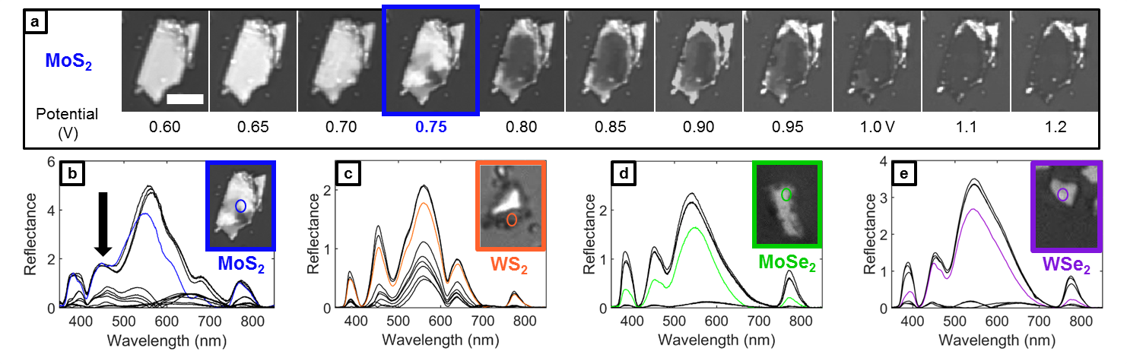
Figure 2. Electroablation onset potential. (a) Optical image series for MoS₂. Each applied potential step was held for 60 seconds. Images acquired between each step. Increments of 50 mV (increments of 100 mV after 1.0 V). The initial onset of electroablation for MoS₂ is qualitatively observed to be 750 mV. Full ablation occurs at 1.0 V. Scalebar: 10 μm. (b-e) Reflectance spectra for MoS₂, WS₂, MoSe₂, WSe₂, respectively. The arrow in (b) shows the optical trend of decreasing reflectance that occurs as a result of applied potential steps. The spectral data supports the qualitative observation of the electroablation onset potentials (corresponding optical image series’ for (c)-(e) are in Figure S1). The onset potential for WS₂ was both qualitatively and quantitatively determined to be 600 mV. For both MoSe₂ and WSe₂ the onset potential was determined to be 1.0 V. (c-e) Inset figure widths: 11 μm, 19 μm, 10 μm, respectively.

Electroablation of MoS₂, WS₂, MoSe₂. The energy of exciton A (650-690 nm)⁴³ provides a way to optically track the EA process in MoS₂ (Figure 3), where exciton A has longer wavelengths for thicker samples.^{42–45} Here, exciton A has a shorter wavelength for thinner regions of the flake (650-660 nm) than for thicker regions (680 nm), as shown in Figure 3h. Enhanced PL signal for regions with lower reflectance intensity confirms that brighter regions of the sample are thicker (Figure S3).⁴⁵
An in situ cyclic voltammetry experiment enabled the detection of the exact onset of EA (Figure 3i-k). A full cycle (0 2 0 V) was carried with a scan rate of 10 mV s⁻¹; exciton A was tracked by the concurrent collection of reflectance. At low potentials (0 to 1.1 V) the peak wavelength of exciton A remained unchanged (675-685 nm). The onset of EA occurred just above 1.0 V; at this point, exciton A’s energy blue shifted by more than 40 nm. Correlating the change in wavelength with position on the sample shows that EA occurs in an “edge-in” manner, confirming results from previous ex situ experiments.²¹ It is, however, interesting to note that the variance in wavelength post-ablation suggests that the sample is not of uniform thickness.
As the potential sweep continues up to 2 V and then back to 0 V, exciton A at each location remains constant, indicating sample stability post-EA. Previous studies have attributed this finding to the relative binding energies; the binding energy between the basal MoS₂ layer and the TiN substrate shows a stronger interaction (-1.25 eV, covalent bond) than that between single sheets of MoS₂ (-0.16 eV, van der Waals forces).²⁰

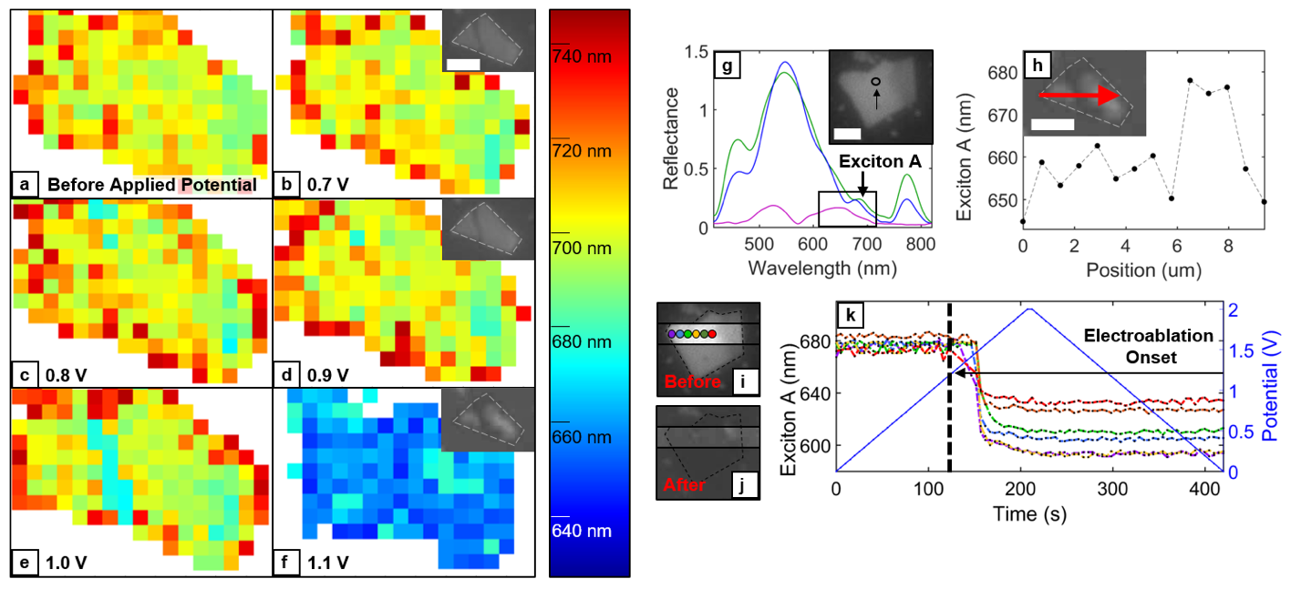
Figure 3. MoS₂ energy map for exciton A and reflectance line scan during electroablation. (a-e) MoS₂ flake prior to electroablation. Applied potentials for (b-e) are 0.7 V, 0.8 V, 0.9 V, and 1.0 V, respectively. Prior to electroablation, the peak wavelength is >700 nm. Inset: optical images of flake at 0.7 and 0.9 V, respectively. (f) MoS₂ flake at the electroablation potential (1.1 V). The peak wavelength is uniformly ~660 nm post-electroablation. Inset: optical image of the flake at 1.1 V. Reflectance intensity decreases for outer regions of the flake first. Scalebar: 5 μm.
MoS₂ (g) Reflectance spectra of the electroablation process for the position shown in the inset. Exciton A region is indicated by an arrow. As the electroablation process occurs, exciton A blueshifts from ~690 to ~650 nm. The reflectance intensity of exciton A post-electroablation is 2/3 of its initial intensity. (h) Line scan for the region indicated by red arrow in the inset (post electroablation). The peak wavelength for exciton A is 650-660 nm in regions of low reflectance intensity and ~680 nm in regions of high reflectance intensity. (i-k) Optical image before (i) and after (j) and spectral data (k) for the cyclic voltammetry experiment. The peak wavelengths for exciton A (left axis) at locations indicated in (c) as a function of potential sweep (right axis). The onset of electroablation occurs just above 1 V. Scalebars: 5 μm.
Energy maps of step-wise EA of MoS₂ are shown in Figure 3. Prior to the onset of EA, exciton A is uniformly 685-695 nm across the entire sample (Figures 3a-d). The onset potential for EA is 1.0 V; a change in the exciton energy is detected at the center of the flake (Figure 3e). Comparing this energy map to the optical map insets in Figures 3d and 3f, it is clear that there are actually two separate flakes meeting at this central location. The drop in the peak wavelength of exciton A to below 680 nm where these two flakes both have edges further suggests “edge-in” EA.²¹ Numerically, we can understand this difference in reactivity by considering surface energies; the surface energy at the edge is 100x the surface energy at the terrace for MoS₂.⁴⁶ Above the EA potential (1.1 V) exciton A is uniformly 655-665 nm indicative of a monolayer (Figure 3f).^{42–45}
In WS_{2,} exciton A appears between 620-650 nm (Figure S4h).⁴⁷ A line scan of a WS₂ sample shows position dependence of the EA process. On the edge of the sample, the energy of this exciton shifts from 640 to 610 as the potential bias increases, while only a slight blue shift occurs in the center of the sample (Figure S4i-k). After EA, exciton A is 20 nm lower at the edge than at the center (Figure S4h). The spatial variance suggests that the layers at the center of the WS₂ sample are strongly bound in comparison to the layers at the edges; WS₂ therefore appears to electroablate “edge-in”.²¹
Potential-dependent energy maps demonstrate the spatial variance of the change in exciton A in further detail, revealing information about the “edge-in” mechanism (Figure S4a-f). At low potential biases (0.4 V, 0.5 V), exciton A is between 640-650 nm (Figure S4a-b); small energy fluctuations are attributed to the effects of varying sample thickness.¹⁶
At the EA potential (0.6 V), exciton A blueshifts to ~620 nm due to quantum confinement effects created by a decrease in layer thickness (Figure S4c).^{16,47} Reflectance studies for WS₂ on quartz showed a similar blue shift in the 630-650 nm range.⁴⁷ Variance in the exact exciton wavelength between our results (WS₂/TiN) and WS₂/quartz are attributed to substrate effects: the local dielectric environment influences exciton energy.⁴⁸ Substrate-sample contrast changes further support that this excitonic shift is correlated to changes in the sample thickness (Figure S4 insets).⁴² While exciton A is uniformly shifted to 620 nm in the outer regions of the sample, in the central region it remains close to its initial energy with a slight blueshift from 655 nm to 645 nm. Reflectance contrast in the optical image inset confirms that the blueshift of exciton A is due to the changing thickness of the sample. This pattern of spatial dependence is similar to that of atmospheric moisture-induced oxidation, and is attributed to the decreased stability of the non-hexagonal bonds existing at grain boundaries.^{49,50}
Increasing the potential past the EA onset (0.7 V, 0.8 V, 0.9 V) causes exciton A to blueshift in the central, multilayer regions (645-650 nm to 635 nm); it does not modify the overall shape of the flake or the energy of exciton A at the edge of the flake (Figure S4 d-f). This remarkable stability of monolayer WS₂ was previously suggested by ex situ measurements conducted by Schulman et al.²¹ Note that the EA potential of WS₂ performed under ambient illumination was reported to be ~1 V,²¹ while the experiments done here, under direct LED illumination show an EA potential of 0.6 V. This 400 mV reduction in EA potential is consistent with the photo-corrosion of WS₂ reported by Sourisseau & Cruege⁵¹. Interestingly, even at higher applied potentials (0.7 V, 0.8 V, 0.9 V), exciton A remains at 635 nm in the center of the flake. This observation is due to passivation of the TiN substrate; oxidation of TiN forms non-conductive TiO₂. All TMD flakes that have large lateral and thickness dimensions exhibit this passivation. In such cases, the central regions of the flake show resistance to EA.^{1,20,21}
MoSe₂ is a visible bandgap semiconductor displaying a thickness-dependent exciton B in mono- to few-layer materials at 595-630 nm (blueshifted for thinner samples⁵²) and no visible exciton at multilayer thicknesses (Figure S5a-c, g,h). The appearance and shift of exciton B enables us to optically track the EA of MoSe₂ (Figure S5). Before EA, exciton B is invisible across the thick sample. At the potential of EA onset (1.0 V), the outmost parts of the sample are sufficiently thin as to feature a measurable peak (600-630 nm), however thicker regions remain at the center with no measurable excitonic transitions (Figure Sa-c). Going radially inwards from the edge of the sample (Figure S5h-i), exciton B energy shifts from just below 600 to 630 nm, then disappears, indicating an increase in thickness toward the sample’s center. Once the monolayer is achieved at the edges, the ablation continues inward as higher potentials are applied (Figure S5j). At the EA potential (1.0 V), exciton B’s energy varies by 50 nm from the center to the edge of the flake; this difference nearly vanishes at 1.1 V and 1.2 V as the flake becomes of increasingly uniform thickness.
Figure 5 shows the spatial distribution of the peak wavelength for exciton B in MoSe₂, which support our findings from the line scan analysis presented in Figure S5. Briefly, at low potential biases (0.9 V, 0.95 V) the peak for exciton B is not present (Figures S5g-h). At the EA potential (1.0 V), high-energy exciton B (595 nm) appears at the sample’s edge (Figure S5i). An intermediate few-layer region is formed between the edge and the center, with variance in exciton B (595-630 nm). No exciton B peak is present in the center of the flake suggesting that the center remains multilayer. Above the EA potential (1.1 V), the exciton B peak blueshifts to ~595 nm for the entire sample, indicating that the layer thickness has gone from few-layer to uniformly monolayer (Figure S5d,j).
These observations reveal an edge-first EA process followed by the creation of a uniform MoSe₂ monolayer, a result consistent with previous ex situ studies conducted by Huang et al. of MoSe₂ EA.¹ This “edge-in” mechanism is attributed to increased surface energy for edge sites (compared to terrace regions) which is likely caused by the heightened reactivity of dangling bonds at the edge of the flake.^{46,53} Our experiments demonstrate that MoSe₂ shows step-wise removal of the superficial layer at the EA potential, which generates more edge sites than present in the multilayer precursor.
Interestingly, when the potential is further raised (1.2 V, 1.3 V), exciton B remains unchanged (595 nm); the stability of exciton B indicates the monolayer is stable at high voltages (Figure S5e-f). Previous EA studies on MoSe₂ postulate that this unique stability is due to differences in rates of corrosion for the bulk and the monolayer (r_{B} = bulk, r_{M} = monolayer).¹ For the MoSe₂ system described here, the r_{B} >> r_{M} can be attributed to the presence of OH⁻ ions at the electrode surface (due to the position potential drift field). At the pH studied, the [OH⁻] concentration was high enough that the OH⁻ ion drift was no longer diffusion limited and the magnitude of OH⁻ ions present at the electrode surface could intercalate the multilayers, but not so high that there was interference with the monolayer-substrate interaction.¹
Electroablation of WSe₂. In WSe₂, we track exciton Aʹ (Figure 4, 515-565 nm) because its energy depends more strongly on the number of layers than that of either exciton A or B.⁵⁴ Optical images show that, unlike for MoS₂, WS₂, and MoSe₂, EA of WSe₂ results in complete removal of the sample with no remnants of a monolayer (Figures 4 and S1c). This finding is in agreement with previous reports of the EA of WSe₂.¹ In order to understand the spatial dependence of EA, line scan data of a small remaining fragment is analyzed in Figure 4h-j. Prior to EA, the wavelength of exciton Aʹ at the edge regions of the sample is slightly lower (7 nm) than at the central regions. This observation indicates that the initial sample has non-uniform thickness. As increasing potential biases are applied, the wavelength of exciton Aʹ blueshifts at the edges, first decreases by 10 nm and then disappears, indicating the entire removal of the sample at that location. Exciton Aʹ in the intermediate regions also blueshifts from 540 to 530 nm, suggesting local ablation from multi- to few-layers. No exciton energy change, i.e. little to no ablation, is observed in the central regions. These results confirm an “edge-in,” complete EA mechanism for WSe₂ with no remnant of a monolayer.¹
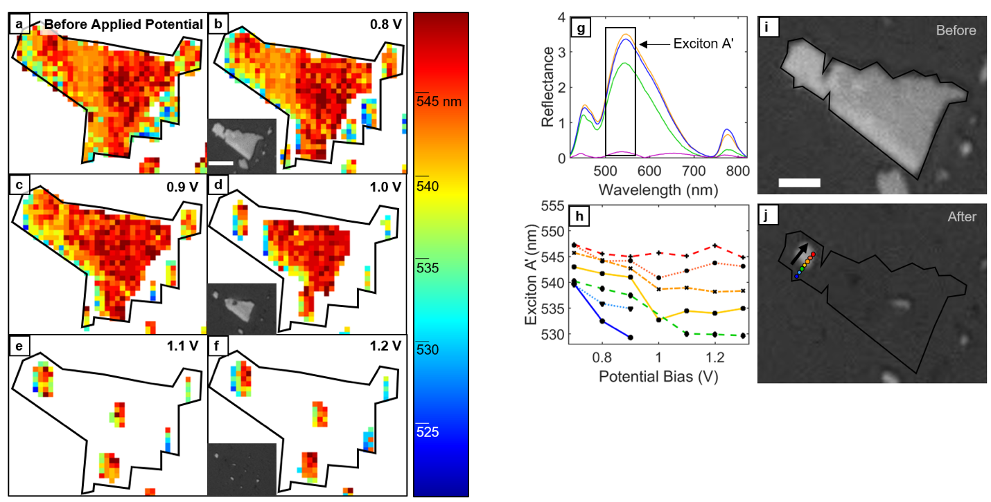
Figure 4. WSe₂ energy map for exciton Aʹ and reflectance line scan during electroablation. (a-c) WSe₂ flake prior to electroablation. This is the same flake shown in Figure 9. Applied potential = 0.8 V and 0.9 V (b and c, respectively). The exciton Aʹ peak is present prior to electroablation and is uniform throughout the flake (540-550 nm). Inset: optical image of flake at 0.8 V. (d) WSe₂ flake at the electroablation potential (1.0 V). The flake edges are ablated first. The exciton Aʹ peak is no longer present at the edges. Inset: the corresponding optical image also shows the flake is ablated at the edges first. (e-f) WSe₂ flake above the electroablation potential. The flake has been ablated entirely, with the exception of a few remnants. Inset: the optical image shows that the flake is no longer present at potentials greater than the electroablation potential. Scalebar: 10 µm. (g) Reflectance spectra for WSe₂ showing Exciton A' peak that is tracked. (h) Optical image of WSe₂ flake before electroablation. (i) Line scan for region shown in (j). The peak wavelength for exciton A' ranges from 540-550 nm prior to electroablation. The bottom two curves show that at the electroablation potential (1.0 V) the exciton A' peak is no longer present at the edge of the flake. The remnant of the flake (top five curves) shows that the peak wavelength decreases to 530-540 nm at the edges and remains unchanged in the center of the remnant. (j) Optical image of WSe₂ flake after electroablation.
Energy maps for WSe₂ are shown in Figure 4a-f. Prior to the onset of EA (0.8 V, 0.9 V), exciton Aʹ (Figure 4a-c) has a constant energy. At the EA potential (1.0 V) exciton Aʹ is no longer detectable at the edges of the flake (Figure 4d). At potentials higher than the EA potential (1.1 V, 1.2 V) the exciton Aʹ peak is undetectable for nearly the entire region, suggesting that the flake is entirely ablated (Figure 4e-f). Optical images confirm that the disappearance of exciton Aʹ corresponds to complete removal of WSe₂ (Figure 4 insets and Figure S1c). Close examination of the energy map at the EA potential (Figure 4d) reveals that the peak wavelength for the bottommost edge has shifted from 545 nm to 535 nm, while the peak wavelength at the center of the flake remains at 545 nm. This further supports the theory of “edge-in” EA for WSe₂.

CONCLUSION
We demonstrated the use of spectroelectrochemical Micro-Extinction Spectroscopy (SE-MExS) for in situ observation of the EA of MoS₂, WS₂, MoSe₂, and WSe₂. By using reflectance-mode SE-MExS, we tracked excitonic transitions that are dependent on layer thickness for two-dimensional TMDs.^{43,47,52,54} The ability to track and monitor the EA process in real-time reveals a venue for the synthesis of 2D TMDs that have a high density of edge sites, a structural feature that is of particular interest for catalytic applications due to the heightened reactivity of edge sites.^{53,55–57} The in situ optical-tracking approach presented in this work introduces a new tool for the synthesis and study of two-dimensional TMDs. We have unraveled the dynamics of the EA process, a promising technique to manufacture thin 2D materials from bulk. We directly visualize the manipulation of the optoelectronic properties during this synthesis process. We show that EA occurs edge-first for MoS₂, WS₂, MoSe₂, and WSe₂. Further we show that EA can be used to generate stable monolayers of MoS₂, WS₂, and MoSe₂, while no monolayer remains for WSe₂ during the EA process.

METHODS
Sample preparation. Sample preparation has been described in detail elsewhere.¹⁹ Briefly, Si wafers with a sputtered TiN coating were used as the sample substrates. TMDs (5-20 μm wide flakes) were mechanically exfoliated from multilayer crystals and deposited onto the TiN/Si substrate.
In situ spectroelectrochemical cell. The electrochemical cell encasing (Figure 1) was machined in acrylic by ProtoLabs specifically for SE-MExS. The outer dimensions of the electrochemical cell were determined by the sample mounting area of the optical stage (6.5 cm x 9.5 cm). The TMD/TiN system served as the working electrode (WE). The counter electrode (CE) was a Pt mesh (Alfa Aesar, 100 mesh woven, 0.0762 mm diameter wire, 99.9% purity). The wire connectors for both the WE and the CE to the potentiostat was Pt wire (Goodfellow, 0.125 mm diameter, 99.95% purity). A Pt quasi-reference electrode (QRE) was employed as the reference electrode. Silicone isolators (Grace Bio-Labs, 13 mm diameter opening, 500 μm depth) were used as spacers in the cell to create a leak-proof seal to contain the electrolyte. Approximately 200-250 μL of 1 M LiCl, pH = 2-3 electrolyte solution was used.
A plain glass coverslip was used as the bottom face of the cell. A silicone spacer (modified to expose the CE and the QRE to the electrolyte solution) was placed on the coverslip securing it in place. Then the CE and QRE, along with their respective wire connectors, were placed over the spacer such that they would be exposed to electrolyte. An unmodified spacer was placed on top of the CE and QRE, followed by electrolyte (200-250 µm). The sample was placed face down, ensuring contact between the WE and the Pt wire connector, and secured shut with screws. For in situ studies, the cell was secured to the stage. The potentiostat leads of a Gamry Reference 600 were attached to their corresponding electrodes.
Reflectance measurements. Reflectance spectra were acquired and analyzed using reflectance-mode SE-MExS (Figure 1, full optics details previously reported⁴¹). Briefly, reflectance-mode SE-MExS experiments were done on a microscope system (Nikon Eclipse Ti) equipped with a piezoelectric stage (Physik Instrumente P-545.3C7), a spectrometer (Princeton Instruments IsoPlane SCT 320, 50 grooves/mm grating), a 1024x1024 pixel array EMCCD camera (Princeton Instruments ProEM-HS: 1024BX3), an imaging camera (QImaging QIClick), a 40x objective (CFI S Plan Fluor ELWD 40X), and an LED lamp (Lumen Dynamics X-Cite 120 LED). All reflectance data reported is differential reflectance, ΔR/R₀ = (R-R₀)/R₀, where R and R₀ are the reflectance of the sample and the substrate, respectively.

ACKNOWLEDGMENT
This research was supported by the Air Force Office of Scientific Research Grant No. AFOSR-YIP FA9550-17-1-0202, the NSF I/UCRC ATOMIC, and a 3M Non-Tenured Faculty award. This research made use of instruments in the Shared Equipment Authority at Rice University. The work of A.S. and S.D. were supported through the Air Force Office of Scientific Research Grant No. AFOSR-YIP FA9550-17-1-0018. The authors thank E. Villarreal for help with photoluminescence measurements.

ASSOCIATED CONTENT
Supporting Information Available. Additional optical image series, cyclic voltammograms, results for WS₂ and MoSe₂, and photoluminescence data (PDF). This material is available free of charge via the Internet at http://pubs.acs.org

AUTHOR INFORMATION

Corresponding Author
er407@cam.ac.uk

Author Contributions
A.K. conducted the electroablation experiments, analyzed the corresponding data and wrote the paper. E.R. designed the research, supported data analysis, and wrote the paper. A.S. and S.D. prepared the samples and contributed to discussions of the experimental design and analysis. All authors contributed to and approved the manuscript.

REFERENCES
1. Huang, Y. T.; Dodda, A.; Schulman, D. S.; Sebastian, A.; Zhang, F.; Buzzell, D.; Terrones, M.; Feng, S.P. Anomalous Corrosion of Bulk Transition Metal Diselenides Leading to Stable Monolayers. ACS Appl. Mater. Interfaces 2017, 9, 39059–39068.
2. Kumar, A.; Villarreal, E.; Zhang, X.; Ringe, E. Micro-Extinction Spectroscopy (MExS): A Versatile Optical Characterization Technique. Adv. Struct. Chem. Imaging 2018, 4, 8 .
3. Novoselov, K.S.; Geim, A.K.; Morozov, S.V.; Jiang, D.A.; Zhang, Y.; Dubonos, S.V.; Grigorieva, I.V.; Firsov, A.A. Electric Field Effect in Atomically Thin Carbon Films. Science 2004, 306, 666–66.
4. Butler, S.Z.; Hollen, S.M.; Cao, L.; Cui, Y.; Gupta, J.A.; Gutiérrez, H.R.; Heinz, T.F.; Hong, S.S.; Huang, J.; Ismach, A.F.; Johnston-Halperin, E. Progress, Challenges, and Opportunities in Two-Dimensional Materials Beyond Graphene. ACS Nano 2013, 7, 2898–2926.
5. Bednorz, J. G. & Müller, K. A. Possible High Tc Superconductivity in the Ba-La-Cu-O System. Condens. Matter 1986, 193, 267–271.
6. Kamihara, Y.; Hiramatsu, H.; Hirano, M.; Kawamura, R.; Yanagi, H.; Kamiya, T.; & Hosono, H.
Iron-Based Layered Superconductor: LaOFeP. J. Am. Chem. Soc. 2016, 128, 10012–10013.
7. Frindt, R. F. Single Crystals of MoS₂ Several Molecular Layers Thick. J. Appl. Phys. 1966, 37, 1928–1929.
8. Frindt, R. F. Superconductivity in Ultrathin NbSe₂ Layers. Phys. Rev. Lett. 1972, 28, 299–301.
9. Bianco, E.; Butler, S.; Jiang, S.; Restrepo, O.D.; Windl, W.; Goldberger, J.E. Stability and Exfoliation of Germanane: A Germanium Graphane Analogue. ACS Nano 2013, 7, 4414–4421
10. Kim, K.K.; Hsu, A.; Jia, X.; Kim, S.M.; Shi, Y.; Hofmann, M.; Nezich, D.; Rodriguez-Nieva, J.F.; Dresselhaus, M.; Palacios, T.; Kong, J. Synthesis of Monolayer Hexagonal Boron Nitride on Cu Foil Using Chemical Vapor Deposition. Nano Lett. 2012, 12, 161–166.
11. Zheng, J.; Zhang, H.; Dong, S.; Liu, Y.; Nai, C.T.; Shin, H.S.; Jeong, H.Y.; Liu, B.; Loh, K.P. High Yield Exfoliation of Two-Dimensional Chalcogenides Using Sodium Naphthalenide. Nat. Commun. 2014, 5, 2995
12. Zeng, Z.; Yin, Z.; Huang, X.; Li, H.; He, Q.; Lu, G.; Boey, F.; Zhang, H. Single-Layer Semiconducting Nanosheets: High-Yield Preparation and Device Fabrication. Angew. Chemie Int. Ed. 2011, 50, 11093–11097.
13. Kong, D.; Dang, W.; Cha, J.J.; Li, H.; Meister, S.; Peng, H.; Liu, Z.; Cui, Y. Few-Layer Nanoplates of Bi₂Se₃and Bi₂Te₃ with Highly Tunable Chemical Potential. Nano Lett. 2010, 10, 2245–2250.
14. Liu, D.; Zhang, W.; Mou, D.; He, J.; Ou, Y.B.; Wang, Q.Y.; Li, Z.; Wang, L.; Zhao, L.; He, S.; Peng, Y. Electronic Origin of High-Temperature Duperconductivity in Single-Layer FeSe Superconductor. Nat. Commun. 2012, 3, 931.
15. Loh, K. P.; Bao, Q.; Eda, G.; Chhowalla, M. Graphene Oxide as a Chemically Tunable Platform for Optical Applications. Nat. Chem. 2010, 2, 1015–1024.
16. Chhowalla, M.; Shin, H.S.; Eda, G.; Li, L.J.; Loh, K.P.; Zhang, H. The Chemistry of Two-Dimensional Layered Transition Metal Dichalcogenide Nanosheets. Nat. Chem. 2013, 5, 263–275.
17. Sipos, B.; Kusmartseva, A.F.; Akrap, A.; Berger, H.; Forró, L.; Tutiš, E. From Mott State to Superconductivity in 1T-TaS₂. Nat. Mater. 2008, 7, 960–965.
18. Kuc, A.; Zibouche, N.; Heine, T. Influence of Quantum Confinement on the Electronic Structure of the Transition Metal Sulfide TS₂. Phys. Rev. B - Condens. Matter Mater. Phys. 2011, 83, 245213.
19. Gordon, R. A., Yang, D., Crozier, E. D., Jiang, D. T. & Frindt, R. F. Structures of Exfoliated Single Layers of WS₂, MoS₂, and MoSe₂ in Aqueous Suspension. Phys. Rev. B - Condens. Matter Mater. Phys. 65, 1254071–1254079 (2002).
20. Das, S.; Bera, M.K.; Tong, S.; Narayanan, B.; Kamath, G.; Mane, A.; Paulikas, A.P.; Antonio, M.R.; Sankaranarayanan, S.K.; Roelofs, A.K. A Self-Limiting Electro-Ablation Technique for the Top-Down Synthesis of Large-Area Monolayer Flakes of 2D Materials. Sci. Rep. 2016, 6, 28195.
21. Schulman, D.S.; May-Rawding, D.; Zhang, F.; Buzzell, D.; Alem, N.; Das, S. Superior Electro-Oxidation and Corrosion Resistance of Monolayer Transition Metal Disulfides. ACS Appl. Mater. Interfaces 2018, 10, 4285–4294.
22. Schulman, D.S.; Sebastian, A.; Buzzell, D.; Huang, Y.T.; Arnold, A.J.; Das, S. Facile Electrochemical Synthesis of 2D Monolayers for High-Performance Thin-Film Transistors. ACS Appl. Mater. Interfaces 2017, 9, 44617–44624.
23. Kim, J.; Cote, L. J.; Kim, F.; Huang, J. Visualizing Graphene Based Sheets by Fluorescence Quenching Microscopy. J. Am. Chem. Soc. 2010, 132, 260–267.
24. Kim, J.; Kim, F.; Huang, J. Seeing Graphene-Based Sheets. Mater. Today 2010, 13, 28–38.
25. Tan, A. T. L.; Kim, J.; Huang, J.-K.; Li, L.-J.; Huang, J. Seeing Two-Dimensional Sheets on Arbitrary Substrates by Fluorescence Quenching Microscopy. Small 2013, 9, 3253-3258.
26. Fukuda, K.; Akatsuka, K.; Ebina, Y.; Ma, R.; Takada, K.; Nakai, I.; Sasaki, T. Exfoliated Nanosheet Crystallite of Cesium Tungstate with 2D Pyrochlore Structure: Synthesis, Characterization, and Photochromic Properties. ACS Nano 2008, 2, 1689–1695.
27. Osada, M.; Takanashi, G.; Li, B.W.; Akatsuka, K.; Ebina, Y.; Ono, K.; Funakubo, H.; Takada, K.; Sasaki, T. Controlled Polarizability of One-Nanometer-Thick Oxide Nanosheets for Tailored, High-κ Nanodielectrics. Adv. Funtional Mater. 2011, 21, 3482-3487.
28. Aksit, M.; Toledo, D. P.; Robinson, R. D. Scalable Nanomanufacturing of Millimetre-Length 2D Na_{x}CoO₂ nanosheets. J. Mater. Chem. 2012, 22, 5936.
29. Helveg, S.; Lauritsen, J.V.; Lægsgaard, E.; Stensgaard, I.; Nørskov, J.K.; Clausen, B.S.; Topsøe, H.; Besenbacher, F. Atomic-Scale Structure of Single-Layer MoS₂ Nanoclusters. Phys. Rev. Lett. 2000, 84, 951–954.
30. Auwärter, W.; Kreutz, T. J.; Greber, T.; Osterwalder, J. XPD and STM Investigation of Hexagonal Boron Nitride on Ni(111). Surf. Sci. 1999, 429, 229–236.
31. Brihuega, I.; Michaelis, C.H.; Zhang, J.; Bose, S.; Sessi, V.; Honolka, J.; Schneider, M.A.; Enders, A.; Kern, K. Electronic Decoupling and Templating of Co Nanocluster Arrays on the Boron Nitride Nanomesh. Surf. Sci. 2008, 602, L95-L99.
32. Besenbacher, F.; Lauritsen, J.V.; Linderoth, T.R.; Lægsgaard, E.; Vang, R.T.; Wendt, S. Atomic-scale surface science phenomena studied by scanning tunneling microscopy. Surf. Sci. 2009, 603, 1315–1327.
33. Natterer, F.D.; Patthey, F.; Brune, H. Ring State for Single Transition Metal Atoms on Boron Nitride on Rh(111). Phys. Rev. Lett. 2012, 109, 166101.
34. Late, D. J.; Liu, B.; Matte, H. S. S. R.; Rao, C. N. R.; Dravid, V. P. Rapid Characterization of Ultrathin Layers of Chalcogenides on SiO₂/Si Substrates. Adv. Funtional Mater. 2012, 22, 1894-1905.
35. Dresselhaus, M. S.; Jorio, A.; Saito, R. Characterizing Graphene, Graphite, and Carbon Nanotubes by Raman Spectroscopy. Annu. Rev. Condens. Matter Phys. 2010, 1, 89–108.
36. Robinson, R. D.; Spanier, J. E.; Zhang, F.; Chan, S. W.; Herman, I. P. Visible Thermal Emission From Sub-Band-Gap Laser Excited Cerium Dioxide Particles. J. Appl. Phys. 2002, 92, 1936–1941.
37. Teweldebrhan, D.; Goyal, V.; Balandin, A. A. Exfoliation and Characterization of Bismuth Telluride Atomic Quintuples and Quasi-Two-Dimensional Crystals. Nano Lett. 2010, 10, 1209–1218.
38. Schliehe, C.; Juarez, B.H.; Pelletier, M.; Jander, S.; Greshnykh, D.; Nagel, M.; Meyer, A.; Foerster, S.; Kornowski, A.; Klinke, C.; Weller, H. Ultrathin PbS Sheets by Two-Dimensional Oriented Attachment. Science 2010, 329, 550–554.
39. Coleman, J.N.; Lotya, M.; O’Neill, A.; Bergin, S.D.; King, P.J.; Khan, U.; Young, K.; Gaucher, A.; De, S.; Smith, R.J.; Shvets, I.V. Two-Dimensional Nanosheets Produced by Liquid Exfoliation of Layered Materials. Science 2011, 331, 568–571.
40. McCombe, B. D. A History of Narrow Gap Semiconductors and Systems: From Graphite to Graphene. AIP Conf. Proc. 2011, 1416, 9–13.
41. Gutiérrez, H.R.; Perea-López, N.; Elías, A.L.; Berkdemir, A.; Wang, B.; Lv, R.; López-Urías, F.; Crespi, V.H.; Terrones, H.; Terrones, M. Extraordinary Room-Temperature Photoluminescence in Triangular WS₂ Monolayers. Nano Lett. 2013, 13, 3447–3454.
42. Mak, K.; Lee, C.; Hone, J.; Shan, J.; Heinz, T. Atomically Thin MoS₂: A New Direct-Gap Semiconductor. Phys. Rev. Lett. 2010, 105, 136805.
43. Castellanos-Gomez, A.; Quereda, J.; van der Meulen, H. P.; Agraït, N.; Rubio-Bollinger, G. Spatially resolved optical absorption spectroscopy of single- and few-layer MoS ₂ by hyperspectral imaging. Nanotechnology 2016, 27, 115705.
44. Wang, Q. H.; Kalantar-Zadeh, K.; Kis, A.; Coleman, J. N.; Strano, M. S. Electronics and optoelectronics of two-dimensional transition metal dichalcogenides. Nat. Nanotechnol. 2012, 7, 699–712.
45. Dhakal, K.P.; Duong, D.L.; Lee, J.; Nam, H.; Kim, M.; Kan, M.; Lee, Y.H.; Kim, J. Confocal absorption spectral imaging of MoS₂ : optical transitions depending on the atomic thickness of intrinsic and chemically doped MoS₂. Nanoscale 2014, 6, 13028–13035.
46. Verble, J. L.; Wietling, T. J.; Reed, P. R. Rigid-Layer Lattice Vibrations and van der Waals Bonding in Hexagonal MoS₂. Solid State Commun. 1972, 11, 941–944.
47. Liu, J.; Lo, T.W.; Sun, J.; Yip, C.T.; Lam, C.H.; Lei, D.Y. A Comprehensive Comparison Study on the Vibrational and Optical Properties of CVD-Grown and Mechanically Exfoliated Few-Layered WS₂. J. Mater. Chem. C 2017, 5, 11239–11245.
48. Lin, Y.; Ling, X.; Yu, L.; Huang, S.; Hsu, A.L.; Lee, Y.H.; Kong, J.; Dresselhaus, M.S.; Palacios, T. Dielectric Screening of Excitons and Trions in Single-Layer MoS₂. Nano Lett. 2014, 14, 5569–5576.
49. Zhang, Y.; Zhang, Y.; Ji, Q.; Ju, J.; Yuan, H.; Shi, J.; Gao, T.; Ma, D.; Liu, M.; Chen, Y.; Song, X., Controlled Growth of High-Quality Monolayer WS₂ Layers on Sapphire and Imaging Its Grain Boundary. ACS Nano 2013, 7, 8963–8971.
50. Rong, Y.; He, K.; Pacios, M.; Robertson, A.W.; Bhaskaran, H.; Warner, J.H. Controlled Preferential Oxidation of Grain Boundaries in Monolayer Tungsten Disulfide for Direct Optical Imaging. ACS Nano 2015, 9, 3695–3703.
51. Sourisseau, C.; Cruege, F. In-situ Raman Investigation of Photo-corrosion Processes at p- and n-type WS₂, Electrodes in Acid Solutions. 1991, 308, 239–253.
52. Zhang, Y.; Chang, T.R.; Zhou, B.; Cui, Y.T.; Yan, H.; Liu, Z.; Schmitt, F.; Lee, J.; Moore, R.; Chen, Y.; Lin, H. Direct Observation of the Transition from Indirect to Direct Bandgap in Atomically Thin Epitaxial MoSe₂. Nat. Nanotechnol. 2014, 9, 111–115.
53. Kong, D.; Wang, H.; Cha, J.J.; Pasta, M.; Koski, K.J.; Yao, J.; Cui, Y. Synthesis of MoS₂ and MoSe₂ Films with Vertically Aligned Layers. Nano Lett. 2013, 13, 1341–1347.
54. Zhao, W.; Ghorannevis, Z.; Chu, L.; Toh, M.; Kloc, C.; Tan, P.H.; Eda, G. Evolution of Electronic Structure in Atomically Thin Sheets of WS₂ and WSe₂. ACS Nano 2013, 7, 791–797.
55. Zhu, Q.; Wegener, S.L.; Xie, C.; Uche, O.; Neurock, M.; Marks, T.J. Sulfur as a Selective ‘Soft’ Oxidant for Catalytic Methane Conversion Probed by Experiment and Theory. Nat. Chem. 2013, 5, 104–109.
56. Prins, R.; De Beer, H. J.; Somorjai, G. A. Structure and Function of the Catalyst and the Promoter in Co-Mo Hydrodesulfurization Catalysts. Catal. Rev. 1989, 31, 1–41.
57. Hinnemann, B.; Moses, P.G.; Bonde, J.; Jørgensen, K.P.; Nielsen, J.H.; Horch, S.; Chorkendorff, I.; Nørskov, J.K. Biomimetic Hydrogen Evolution: MoS₂ Nanoparticles as Catalyst for Hydrogen Evolution. J. Am. Chem. Soc. 2005, 127, 5308–5309.

TOC
