**TITLE PAGE:**

1. **Title: Progression of myocardial fibrosis in hypertrophic cardiomyopathy: Mechanisms and clinical implications.**
2. **Names of Authors:**

Betty Raman MBBS FRACP1, Rina Ariga MBBS MRCP1, Marco Spartera MD1, Sanjay Sivalokanathan MBBS1, Kenneth Chan MBBS MRCP1, Sairia Dass MRCP DPhil1, Steffen E. Petersen MD DPhil MPH FRCP2,3, Matthew J Daniels MRCP PhD1, Jane Francis DCCR DNM1,Robert Smillie BA1, Adam J. Lewandowski DPhil1, Eric O. Ohuma BSc MSc DPhil4, Christopher Rodgers DPhil1, Christopher M. Kramer MD5, Masliza Mahmod MRCP DPhil1, Hugh Watkins MD FRCP1*, Stefan Neubauer MD FRCP1*

* joint senior authors of this work

1. **Institution where the work was performed:**

Oxford Centre for Clinical Magnetic Resonance Research, Division of Cardiovascular Medicine, Radcliffe Department of Medicine, University of Oxford, United Kingdom

1. **Position, institution and location of all authors:**

**Name:** Betty Raman

**Position:** Cardiovascular Research Fellow

**Institution and location:** Oxford Centre for Clinical Magnetic Resonance Research, Division of Cardiovascular Medicine, Radcliffe Department of Medicine, University of Oxford, United Kingdom

**Name:** Rina Ariga

**Position:** Cardiovascular Research Fellow

**Institution and location:** Oxford Centre for Clinical Magnetic Resonance Research, Division of Cardiovascular Medicine, Radcliffe Department of Medicine, University of Oxford, United Kingdom

**Name:** Marco Spartera

**Position:** Cardiovascular Research Fellow

**Institution and location:** Oxford Centre for Clinical Magnetic Resonance Research, Division of Cardiovascular Medicine, Radcliffe Department of Medicine, University of Oxford, United Kingdom

**Name:** Sanjay Sivalokanathan

**Position:** Research Fellow

**Institution and location:** Oxford Centre for Clinical Magnetic Resonance Research, Division of Cardiovascular Medicine, Radcliffe Department of Medicine, University of Oxford, United Kingdom

**Name:** Kenneth Chan

**Position:** Cardiovascular Research Fellow

**Institution and location:** Oxford Centre for Clinical Magnetic Resonance Research, Division of Cardiovascular Medicine, Radcliffe Department of Medicine, University of Oxford, United Kingdom

**Name:** Sairia Dass

**Position:** Internal Medicine Specialist

**Current Location:** [Henry Ford Allegiance Health](https://www.healthcare4ppl.com/hospital/mi/jackson/henry-ford-allegiance-health-230092.html), Michigan, united states

**Institution:** Oxford Centre for Clinical Magnetic Resonance Research, Division of Cardiovascular Medicine, Radcliffe Department of Medicine, University of Oxford, United Kingdom

**Name:** Professor Steffen E. Petersen

**Positions:**

Professor of Cardiovascular Medicine at the William Harvey Research Institute, Queen Mary University of London

Consultant Cardiologist and Clinical Director for Research at Barts Heart Centre, Barts Health NHS Trust

**Institution and location:**

1. William Harvey Research Institute, Queen Mary University of London
2. Barts Heart Centre, Barts Health NHS Trust

**Name:** Matthew J. Daniels

**Position:** Consultant Cardiology

**Institution and location:** Division of Cardiovascular Medicine, Radcliffe Department of Medicine, University of Oxford, United Kingdom

**Name:** Jane Frances

**Position:** Head of Imaging Applications

**Institution and location:** Oxford Centre for Clinical Magnetic Resonance Research, Division of Cardiovascular Medicine, Radcliffe Department of Medicine, University of Oxford, United Kingdom

**Name:** Robert Smillie

**Position:** University of Oxford Medical Student

**Institution and location:** University of Oxford, United Kingdom

**Name:** Adam J. Lewandowski

**Position:** British Heart Foundation intermediate fellow

**Institution and location:** Oxford Centre for Clinical Magnetic Resonance Research, Division of Cardiovascular Medicine, Radcliffe Department of Medicine, University of Oxford, United Kingdom

**Name:** Eric O. Ohuma

**Position:** Senior Medical Statistician

**Institution and location:** (a) Centre for Statistics in Medicine, Botnar Research Centre, Nuffield Department of Orthopaedics, Rheumatology and Musculoskeletal Sciences, University of Oxford, Old Road Campus, Oxford, OX3 7BN, UK

(b) Centre for Tropical Medicine and Global Health, Nuffield Department of Medicine University of Oxford, Old Road Campus, Oxford, OX3 7BN, UK

**Name: Associate** Professor Christopher Rodgers

**Position:** Head of 7T MRI

**Institution and location:** Department of Clinical Neurosciences, Wolfson Brain Imaging Centre, Cambridge, United Kingdom

*The work for this manuscript was undertaken during his time in Oxford

**Name:** Professor Christopher M. Kramer

**Positions:** Professor of Cardiology and Radiology; Director of Cardiovascular Imaging Center

**Institution and location:**

Division of Cardiovascular Medicine and Radiology

University of Virginia

Charlottesville, USA

**Name:** Masliza Mahmod

**Position:** Cardiologist and Head of Clinical Trials Group

**Institution and location:**

Oxford Centre for Clinical Magnetic Resonance Research, Division of Cardiovascular Medicine, Radcliffe Department of Medicine, University of Oxford, United Kingdom

**Name:** Hugh Watkins*

**Position:** Radcliffe Professor of Medicine and Head of Department

**Institution and location:**

Radcliffe Department of Medicine, University of Oxford, United Kingdom

**Name:** Stefan Neubauer*

**Positions:** Professor of Cardiovascular Medicine; Head of Division of Cardiovascular Medicine; Director of Oxford Centre for Clinical Magnetic Resonance Research

**Institution and location:**

Oxford Centre for Clinical Magnetic Resonance Research, Division of Cardiovascular Medicine, Radcliffe Department of Medicine, University of Oxford, United Kingdom

*Joint senior authors

**5) Affiliations:**

1.Oxford Centre for Clinical Magnetic Resonance Research, Division of Cardiovascular Medicine, Radcliffe Department of Medicine, University of Oxford, United Kingdom

2. William Harvey Research Institute, NIHR Barts Biomedical Research Centre, Queen Mary University of London, United Kingdom.

3. Barts Heart Centre, St Bartholomew’s hospital, Barts Health NHS Trust, West Smithfield, London, United Kingdom

4. Centre for Statistics in Medicine, Nuffield Department of Orthopaedics, Rheumatology and Musculoskeletal Sciences, University of Oxford, United Kingdom

5. Cardiology and Radiology, University of Virginia Health System, Charlottesville, Virginia, United States

1. **Address for correspondence:**

Professor Stefan Neubauer MD, FRCP

Division of Cardiovascular Medicine

Oxford Centre for Clinical Magnetic Resonance Research (OCMR)

Radcliffe Department of Medicine

University of Oxford, John Radcliffe Hospital

Headley Way Oxford OX3 9DU, UK

Email: Stefan.neubauer@cardiov.ox.ac.uk

Phone: 0044-1865-226829, Fax 0044-1865-222077

**(7) Funding:** This study was funded by the National Institute of Health Research (NIHR) Oxford Biomedical Research Centre and the British Heart Foundation. BR, MM, MS were funded by National Institute of Health Research Oxford Biomedical Research Centre. RA was funded by a British Heart Foundation Clinical Research Training Fellowship grant (RA: 098436/Z/12/Z). K.C was supported by an NIHR academic clinical fellowship. CTR is supported by a Sir Henry Dale Fellowship jointly funded by the Wellcome Trust and the Royal Society [098436/Z/12/B].SEP acknowledges support from the NIHR Barts Biomedical Research Centre. MJD is supported by the Wellcome Trust (WT098519MA). AJL is supported by the British Heart Foundation (FS/18/3/33292). EOO acknowledges support from Cancer Research UK. SN and HW acknowledge support from the Oxford British Heart Foundation Center of Research Excellence. CMK, SN and HW are supported by U.S. NIH Grant/Contract (U01HL117006-01A1).

**(8) Disclosures:** SEP provides consultancy to Circle Cardiovascular Imaging Inc. (Calgary, Alberta, Canada). CMK provides consultancy to Bayer

# **Abstract (255 words)**

**Background**: Myocardial fibrosis as detected by late gadolinium enhancement (LGE) on cardiac magnetic resonance (CMR) is a powerful prognostic marker in hypertrophic cardiomyopathy (HCM) and may be progressive. The precise mechanisms underlying fibrosis progression are unclear. We sought to assess the extent of LGE progression in HCM and explore potential causal mechanisms and clinical implications.

**Methods and results**: Seventy-two HCM patients had two CMR (CMR1-CMR2) at an interval of 5.7±2.8 years with annual clinical follow up for 6.3±3.6 years from CMR1. A combined endpoint of heart failure progression, cardiac hospitalisation, new onset ventricular tachycardia was assessed. Cine and LGE imaging were performed to assess left ventricular (LV) mass, function, and fibrosis on serial CMR. Stress perfusion imaging and cardiac energetics were undertaken in 38 patients on baseline CMR (CMR1). LGE mass increased from median 4.98g (IQR 0.97–13.48g) to 6.30g (IQR 1.38–17.51g) from CMR1 to CMR2. Substantial LGE progression (ΔLGE≥4.75g) occurred in 26% of patients. LGE increment was significantly higher in those with impaired myocardial perfusion reserve (<MPRI 1.40) and energetics (Phosphocreatine/adenosine triphosphate <1.44) on baseline CMR (p≤0.01 for both). Substantial LGE progression was associated with LV thinning, increased cavity size and reduced systolic function and conferred a five-fold increased risk of subsequent clinical events (Hazard ratio: 5.04, 95% CI 1.85–13.79, p=0.002).

**Conclusion**: Myocardial fibrosis is progressive in some HCM patients. Impaired energetics and perfusion abnormalities are possible mechanistic drivers of the fibrotic process. Fibrosis progression is associated with adverse cardiac remodeling and predicts an increased risk of subsequent clinical events in HCM.

**Key Words**

Hypertrophic cardiomyopathy, fibrosis progression, microvascular dysfunction, clinical outcomes, myocardial energetics, late gadolinium enhancement.

# **Introduction**

Sudden cardiac death and advanced heart failure are recognized complications of hypertrophic cardiomyopathy (HCM) (1). Myocardial fibrosis is an important substrate for both life-threatening arrhythmia and adverse cardiac remodeling (2) in HCM. Histopathological studies confirm a high burden of fibrosis in both young adults (3) who suffered a sudden cardiac death and older patients with end-stage heart failure and HCM (4, 5).

Cardiovascular magnetic resonance (CMR) permits the in-vivo assessment of myocardial fibrosis using late gadolinium enhancement (LGE) imaging (4-6). The presence and extent of LGE are emerging predictors of cardiovascular morbidity and mortality in HCM and not limited to adults (7, 8). Recently, a significant proportion of children and adolescents with HCM were found to have LGE with evidence of progression on serial imaging (9). Longitudinal studies examining the rate of LGE progression at longer intervals are sparse (9-11) with a lack of studies examining the clinical relevance of fibrosis progression. Mechanisms driving fibrosis progression in HCM are also incompletely understood (9).

The myocardium in HCM exhibits characteristic abnormalities in substrate metabolism and vascular remodeling (12, 13). For example, reduced phosphocreatine to adenosine triphosphate concentration ratio (PCr/ATP) on phosphorus magnetic resonance spectroscopy (31P-MRS) is a marker of abnormal energy utilization in HCM and may play a critical role in its pathophysiology (13, 14). Similarly, microvascular dysfunction may trigger fibrosis in HCM, promoting contractile dysfunction (5, 15). Dissecting the pathophysiological factors that cause fibrosis, rather than merely associate, remains a challenge.

Here, we sought to characterize the natural history of myocardial fibrosis in HCM and explore potential underlying mechanisms. We assessed whether the extent of LGE progression can serve as a predictor of clinical events to guide future management.

# **Methods**

**Population**

This is a retrospective analysis of data from an observational study approved by local ethics committee (reference: 07/Q1607/66, 12/LO/1979). All patients with HCM enrolled in this study were recruited from the University of Oxford Inherited Cardiac Conditions Clinic and all were invited to have a repeat CMR as a part of the study.Genetic screening was undertaken for 13 HCM genes and mitochondrial mutations (see supplementary material). Diagnosis of HCM was based on the presence of unexplained left ventricular hypertrophy (LVH) (maximum left ventricular wall thickness or LVWT≥15mm) or the presence of a pathogenic HCM-causing sarcomeric mutation (genotype positive phenotype negative G+P- patients included).

Patients with known coronary artery disease, aortic stenosis, amyloidosis or contraindications to CMR were excluded. A total of 88 patients were included in the study. Of them, 16 were excluded after CMR1. Ten had ICD’s implanted, two had pacemakers, two had reveal devices implanted. One had LGE in a myocardial infarction pattern and one had coronary disease on coronary angiography leaving 72 patients with two CMR scans (CMR1-CMR2) (Figure1).

# **CMR Protocol**

All 72 patients had serial CMR including cine and LGE assessment at 1.5T or 3T (see supplementary material) at an interval of 5.7±2.8 years (Figure1). Sixteen patients had follow up CMR at different field strengths. Thirty-eight patients also had first pass perfusion imaging and myocardial energetics assessment at baseline (CMR1) (Figure1), all 38 had serial CMR at the same field strength (3T). Cine was undertaken using a series of single breath-hold balanced steady-state free precession images for estimation of cardiac volumes and function as previously described (16).

Late gadolinium enhancement (LGE) imaging was acquired in multiple short axis slices to match cine views and long axis planes ~8-10 minutes after intravenous administration of the gadolinium-based contrast agent (GBCA) (total dose 0.15mmol/kg) for all scans (see supplementary material). The inversion time was adjusted for optimal nulling of remote normal myocardium (17). For all CMR scans before 2012, Gadodiamide (Omniscan, Nycomed Amersham, UK) was used as contrast agent. Due to the emerging safety concerns of Gadodiamide (Omniscan), in particular the associated risk of nephrogenic systemic fibrosis, Gadobuterol (Gadovist®, Bayer Inc., Toronto, Ontario, Canada) was used as contrast agent at 1.5 T and Gadoterate meglumine (Dotarem, Guerbet LLC, France) at 3 T for all scans from 2012 (18-20).

Perfusion imaging was undertaken (before LGE imaging) at 3T on CMR1 for thirty-eight patients using a T1-weighted gradient echo sequence with saturation recovery magnetization preparation. Adenosine was used as pharmacological stress at a rate of 140µg/kg/min and up-titrated by haemodynamic response. Three short axis slices (base, mid and apex) were acquired. 0.03mmol/kg of GBCA was injected at 6ml/sec during stress followed by a saline flush 12ml at 6ml/sec and the same dose for rest acquisition. Three patients were excluded (failure of contrast injection (n=2) or intolerance to adenosine (n=1)). The remaining patients were adequately stressed as evidenced by the presence of appropriate hemodynamic response and splenic switch off (16).

31P MRS was performed on baseline CMR (3T) to measure myocardial energetics for thirty-eight patients. Subjects were placed prone with their hearts over the center of the coil as previously described (16). The PCr/ATP ratio from a mid-ventricular septal voxel in a position matching mid ventricular perfusion slice was obtained (see supplementary material).

## **CMR Image analysis**

Commercially available software (Circle Cardiovascular Imaging Inc., Calgary, Canada) was used to analyze left ventricular (LV) volumes, mass, ejection fraction, peak systolic 2-D global longitudinal, circumferential and radial strain as previously reported (21). The assessment of left ventricular indices and LGE mass were undertaken by two observers blinded to the clinical information (MS and SS). Quantitative analysis of LGE was undertaken by setting a signal intensity threshold at five standard deviations (5-SD) above the mean intensity of a reference region of interest placed in a remote area of myocardium with no visual evidence of enhancement (6, 22). A binary visual score (1=progression; 0=no progression) was also provided by an experienced (>5 years) CMR clinician (MM) to assess level of agreement between semiquantitative assessment and observed changes seen by an expert clinician (see supplementary data).

For perfusion analysis, signal intensity curves were generated to measure myocardial perfusion reserve index (MPRI) as previously described (17) .

Post-processing of 31P-MRS data was performed using the OXSA toolbox (see supplementary data).

## **Clinical follow-up**

Clinical follow-up was performed annually for a period of 6.3±3.6 years from CMR1. In cases of a suspected event, all medical records were obtained and reviewed by two observers (BR and MM) blinded to the CMR data.

Major risk factors for sudden cardiac death (SCD) included traditional risk factors (see supplementary material). Additionally, the European Society of Cardiology (ESC) risk calculator was used to estimate 5-year SCD risk for all patients (23).

Given the low event rate in this selected population undergoing serial CMR, we used a composite clinical endpoint of: heart failure progression defined as a progressive increase in NYHA class necessitating optimisation of medical therapy, new onset non-sustained ventricular tachycardia (≥3 heart beats, ≥120bpm) and hospitalization from cardiac cause (arrhythmia or heart failure). A change in NYHA class or medical therapy due to intolerance to medications did not constitute a clinical event in this study.

**Statistical analysis**

Statistical analyses were undertaken using IBM SPSS Statistics 23.0 (IBM Corp., Armonk, NY, USA), STATA/SE 15.0 (Stata Corp, College Station, Texas USA) and GraphPad Prism 7.0 (GraphPad Software, San Diego, California, USA). Normality of data was assessed by visually inspecting the plots. Mean (with standard deviation, SD) and median (with interquartile range, IQR or confidence intervals, CI for median differences) were computed as appropriate. Paired t-test and Mann Witney tests were used for normally distributed and non-Gaussian data respectively. The χ2 and Fisher’s exact tests were used to compare proportions. Given the current lack of a generally accepted cut off for ‘significant’ LGE progression (ΔLGE) , a receiver operator curve was used to estimate the optimal ΔLGE threshold (Youden index) predictive of clinical events which was an increment of 4.75g (see supplementary material, Figure1). Univariate and multivariable binary logistic regression were used to assess predictors of ΔLGE≥4.75g (binary variable) (24). LGE mass at CMR1 was treated as a continuous variable. Kaplan Meier curves were computed to visualize the cumulative patients event rates. A multivariable Cox proportional hazard model was used to analyze independent associations with clinical outcomes. The covariates included were variables known to be potential confounders and were adjusted for in the model. All tests were two-tailed and p-values <0.05 (after Bonferroni correction) were considered significant.

# **Results**

## **Study population**

The final population consisted of 72 patients with paired CMR data. Table 1 lists their background characteristics at baseline CMR (CMR1) and second CMR (CMR2).

Mean age of patients at CMR1 was 45±12 years and 68% were male. At CMR1, the majority (94%) had 1 or no SCD risk factors, and four (6%) had 2 or more SCD risk factors (Table 1). The mean 5 year estimated risk of SCD on ESC risk calculator was low at 2.01±0.86%.

By CMR2, patients were more likely to receive aspirin. The ESC 5-year estimated risk of SCD was also slightly higher (2.31±1.44%, p=0.01) at CMR2 (Table1). Other baseline characteristics did not vary significantly.

## **Influence of field strengths and contrast agents on LGE progression**

In this observational study, 16/72 patients had follow up CMR at different field strengths. Despite this, there was no association between changing field strength and fibrosis progression (β =-0.08, p=0.64). We further assessed if the use of a specific combination of GBCA was associated with LGE progression. On univariate analysis, there was no association between the varying GBCA combinations and LGE progression (β -0.73, p =0.10).

## **Left ventricular volumes, function, mass, and LGE from CMR1-CMR2**

The mean LV end-diastolic volume (LVEDV), ejection fraction (LVEF) and mass at CMR1 were 152±30ml, 67±6% and 146±52g respectively. LVEDV and LVEF did not differ between CMR1-CMR2 (Table1). In contrast, a significant increase in LV mass between scans was detected (146±52g vs 151±52g, p=0.02) (Table1). Modest reductions in both peak LV global circumferential (GCS) and longitudinal (GLS) strain were also seen from CMR1 to CMR2 (GCS -18±3% vs -17±4%, GLS -17±3% vs -16±3%, p<0.05 for both).

LGE was present in 75% of HCM patients at CMR1, increasing to 82% at CMR2 (Table1). LGE mass progressed from a median 4.98g (IQR 0.97–13.48g) on CMR1 to 6.30g (IQR 1.38-17.51g) on CMR2 (Figure2A). As a relative proportion of LV mass, the median increment was 0.74% (95% CI 0.25–1.27%, p<0.0001) from CMR1–CMR2 (Figure2B). LGE increment ≥4.75g was seen in 26% (n=19) of patients.

On univariate analysis, maximum LVWT, LV mass and LGE mass at CMR1 were significant predictors of ΔLGE≥4.75g (Table2). On multivariable analysis, LGE mass at CMR1 remained the only predictor of ΔLGE≥4.75g (Table2).

## **Relationship between left ventricular wall thickness and LGE progression**

Maximum end-diastolic LVWT did not differ significantly between the two CMR scans (19±6mm vs 19±5mm, p=0.79) (Table1). Thirty-two (45%) had stable LVWT on follow up, 24 (33%) had a modest increase (3.0±1.6mm) in LVWT, and 16 (22%) patients had a reduction of LVWT. Seven (10%) had a reduction of >3mm. Interestingly, patients with regression of wall thickness (WT-) had a significantly higher extent of LGE increment (Figure3A,B,C) versus those with stable or increasing LVWT (WT0/+)- median LGE difference of 6.92g (95% CI 2.72–10.40g, p<0.0001) between groups (Figure3C). Two individuals with LVWT regression may have been reclassified to a lower risk group based on the assessment of traditional major SCD risk factors at CMR2 alone. Maximum LVWT at CMR1 correlated moderately with LGE progression (r=0.36, p<0.002). At CMR2, a weaker association was seen between LVWT and LGE progression (r=0.28, p=0.03). With regards to morphological variants, there were no differences in LGE increment between apical (n=6) and non-apical HCM.

**Impact of substantial LGE progression on LV volumes and function**

In the subgroup of patients with ΔLGE≥4.75g (n=19), there was a significant increase in LVEDV from CMR1-CMR2 (CMR1 161±30ml vs CMR2 169±37ml, p=0.04) (Figure3A,B) with reduction in LVEF (CMR1 65±7% vs CMR2 62±7%, p=0.03) and GLS(-16±3% vs -15±3%, p=0.04) (Figure3D,E). There was no difference in LV mass seen despite these changes.

## **Relationship between genotype and LGE progression**

Forty-five (63%) patients had sarcomeric mutations; three (4%) had mitochondrial mutation; three (4%) had a variant of uncertain significance in a sarcomeric gene; no pathogenic mutation was found in 21 (29%) of patients (Supplementary Table1). Nine patients were pre-hypertrophic (max LVWT≤13mm) sarcomeric mutation carriers (G+P-). On univariate analysis, genotype did not predict significant LGE progression.

None of the nine sarcomeric G+P- patients had progression of LGE≥4.75g over a CMR interval of 6±3 years. However, LGE progression did occur in those with (G+P+) sarcomeric HCM (2.79g IQR 1.12–7.39g, p<0.01) versus G+P- patients (0.17g IQR-0.18-1.03g) (Supplementary Figure 2). In patients with LVH (LVWT≥15mm), differences in LGE increments could also be seen between those with and without sarcomeric mutations. Mitochondrial mutation carriers had the highest median LGE increment of 23.16g (IQR 16.84–45.78g) (p<0.01 for all comparisons) followed by sarcomeric mutation 2.79g (IQR 1.12–7.39g) and genotype negative patients 0.52g (IQR -0.38–2.43, p=0.01 for comparison between genotype negative and sarcomeric mutation) (Supplementary Figure2).

## **Impaired energetics and myocardial perfusion reserve are associated with LGE progression**

Myocardial energetics were assessed in 38 patients at CMR1. ΔLGE≥4.75g was seen in 14 patients. An impairment in energetics was defined as less than two standard deviations of previously reported healthy range (1.71±0.35) (16). In those with impaired energetics (PCr/ATP <1.44), there was a significantly higher LGE increment on follow up compared to those with normal energetics (median increment 7.99g IQR 5.01–17.41g vs 1.20g IQR -0.05–25.39, p=0.01) (Figure4A). Additionally, patients with ΔLGE≥4.75g had reduced myocardial energetics at baseline compared to those with less progression (PCr/ATP 1.58±0.34 vs 1.96±0.41, p=0.006) (Figure4C).

Adenosine first-pass perfusion imaging was performed in 35 patients at CMR1. Inducible perfusion abnormalities were seen in 25 patients and ΔLGE≥4.75g was seen in 13 patients. LGE progression commonly involved myocardial segments with inducible perfusion defects at baseline. Seven subjects developed de novo LGE in regions without inducible perfusion defects. Based on a previous study, an MPRI<1.40 was considered suggestive of microvascular dysfunction (25, 26). Patients with impaired MPRI on baseline CMR had a higher LGE increment on interval scans compared with normal MPRI (median 9g IQR 1.47–17.91g vs 0.74g IQR -0.08–2.37g, p<0.01) (Figure4B). In patients with ΔLGE≥4.75g, MPRI was severely impaired on CMR1 compared to those with less progression (1.18±0.23 vs 1.74±0.53, p=0.001) (Figure4D).

## **Progression of fibrosis predicts clinical outcomes**

In the final cohort of 72 patients, eight underwent primary prevention ICD implantation subsequent to CMR2. There were no deaths, aborted cardiac deaths or appropriate ICD shocks. Twenty-four had clinical events as previously defined. New onset ventricular tachycardia was detected in 13 patients. All cases of new onset NSVT were detected on 24 hour ECG monitor prior to the implantation of device.

Progression of heart failure with optimization of therapy occurred in nine patients. Three hospital admissions occurred due to progression of heart failure symptoms and atrial fibrillation.

Amongst those with any LGE at baseline, 41% developed a clinical event during the follow up period (CMR1 to end of study). In contrast, 79% of those with ΔLGE≥4.75g developed a clinical event on follow up. In a univariate cox regression analysis, maximum LVWT on CMR1, initial LGE mass, ΔLGE≥4.75g were significant predictors of clinical outcomes (Table3). On multivariable analysis, ΔLGE≥4.75g remained an independent predictor of outcome despite adjusting for age at outcome, maximum LVWT and LGE mass at CMR1 (HR 5.04, 95% CI 1.85–13.79, p=0.002). HCM patients with ΔLGE≥4.75g had a significantly lower freedom from clinical events compared to others (Figure5A). Similarly, patients with baseline LGE of ≥15% of LV mass had a low freedom from clinical events but to a lesser extent than LGE progression (Figure5B).

**Discussion**

Our study demonstrates that myocardial fibrosis, quantified by LGE, is progressive in a proportion of HCM patients, and clinically relevant LGE progression is characterised by adverse cardiac remodeling. We also provide novel insights into potential mechanisms of LGE progression including the relative contributions of underlying genetic mutations, impaired myocardial energetics and microvascular dysfunction, biological mechanisms believed to promote myocardial fibrosis and hypertrophy in HCM (5, 13, 27). Although there were no deaths in this cohort, significant LGE progression in HCM strongly associated with the risk of escalating heart failure and arrhythmia symptomatology over time. These findings suggest that therapies with energy sparing, vascular protective or anti-fibrotic effects may be beneficial in preventing progression of heart failure and arrhythmic risk in HCM.

## **Progression of myocardial fibrosis in HCM associates with adverse cardiac remodeling**

Late gadolinium enhancement on CMR provides a robust and reproducible tool for the assessment of myocardial fibrosis in HCM (4-6). Previous small proof-of-principle studies examining LGE in HCM report an increase at intervals of 1.5 to 1.9 years (10, 11). However changes in left ventricular function and adverse remodeling in HCM are a gradual process in HCM, likely to be missed on short interval scans (28). We, therefore, examined fibrosis progression over a longer interval. Consistent with others, we report a modest but significant increase in both LGE mass and relative LGE mass (proportion of LV mass). Although, we observed a smaller amount of LGE progression compared to previous work (median LGE increment 6g in (10), we believe this likely reflects the lower baseline risk profile of our patients with the inclusion of G+P- patients in this cohort.

The extent of LGE at a single time point has previously shown to associate with left ventricular dysfunction and incidence of heart failure (29). Interestingly, a recent study by Todiere et al reported an increased burden of heart failure symptoms in those with higher LGE progression rate (10). Here, we show that HCM patients with clinically relevant LGE progression have evidence of adverse ventricular remodeling – including increased LV cavity size, reduced ejection fraction and global longitudinal strain. These findings are unique to this study and possibly reflect the longer intervals between scans in this study. This may also explain the increased event rate in those with substantial LGE progression.

## **Maximum LVWT can regress due to LGE progression**

We did not see a significant increase in maximum wall thickness from CMR1-CMR2. Instead, maximum thickness at CMR1 strongly associated with LGE progression suggesting that those with preexisting hypertrophy tend to develop LGE progression. Importantly, we observed that while in some patients maximum wall thickness increased over time, others had regression associated with a significant rise in LGE burden. Indeed, previous studies have reported a link between LGE mass at a single time point and myocardial thinning on follow up echocardiography (30, 31). However, no study to date has systematically assessed the contribution of LGE progression to myocardial wall thinning. Importantly, in two of our subjects, this phenomenon leads to a reclassification of SCD risk to lower risk based on traditional risk factors at CMR2. Therefore, our data suggests that the assessment of maximum wall thickness without information on LGE burden may potentially underestimate the perceived SCD risk in individuals with HCM. These observations highlight a complex relationship between progression of LGE and degree of left ventricular hypertrophy which may inform clinical protocols for follow-up surveillance.

## **Genotype may influence LGE progression in the hypertrophied ventricle**

We assessed the significance of underlying pathogenic mutations and LGE progression in HCM. Genotype did not associate with LGE progression, possibly due to the inclusion of G+P- patients in our cohort who did not develop hypertrophy or significant LGE progression.

These findings are concordant with a previous study by Ho et al, who showed that phenotype negative carriers lacked LGE despite evidence of increased collagen synthesis, due to a compensatory increase in collagen degradation (32). Interestingly, in those with sarcomeric mutation and overt hypertrophy, this dynamic equilibrium between collagen synthesis and degradation was lost resulting in a significantly higher LGE. Indeed, when we assessed sarcomeric mutation carriers with overt hypertrophy, patients had significantly higher LGE progression compared to those with a pre-hypertrophic phenotype (G+P). Those with sarcomeric HCM were also found to have a higher burden of LGE progression than genotype negative patients. In a cross sectional study by Olivotto et al, similar observations were made about the prevalence of LGE in sarcomeric mutation versus genotype negative HCM (33). This suggests that factors arising either directly from the expression of sarcomeric mutations or due to modifier gene effects (34, 35) possibly promote both hypertrophy and fibrosis in sarcomeric HCM (36).

Interestingly, patients with a metabolically deficient phenocopy of HCM - mitochondrial HCM showed the highest increase in LGE when compared to sarcomeric and genotype negative patients. Previous studies in transgenic mouse models of sarcomeric mutations also suggest that increased ATP utilization and altered calcium-dependent signaling may play a central role in disease progression in HCM (27). Our data provide further evidence that HCM characterized by ‘energy costly’ mutations are at greatest risk for fibrosis progression following the onset of left ventricular hypertrophy. Here, we were unable to examine differences within genetic subgroups and given the limited scale of our study, further validation of our findings in a larger genotyped HCM cohort will most certainly be required.

## **Impaired energetics and microvascular dysfunction underlie LGE progression in HCM**

Impairment in myocardial energetics is important in the development of heart failure (37), but studies examining its long-term sequelae in HCM are lacking. Metabolic therapies that improve energetic deficits have been promising at improving functional capacity in HCM (14), though their role in preventing hypertrophy and fibrosis remains to be elucidated. Here, we found that HCM patients with impaired myocardial energetics at baseline have a higher burden of LGE progression at follow up and conversely in those with substantial LGE progression, myocardial energetics were severely impaired. This suggests that impairment in myocardial energetics may contribute to the risk of fibrosis progression in HCM. Future studies evaluating the effects of metabolic therapies on LGE burden may provide valuable insights into the role of impaired energetics in disease progression.

The non-invasive assessment of microvascular dysfunction can predict adverse cardiac remodeling (5, 15). Several cross-sectional studies report a strong association between microvascular dysfunction and LGE burden (38, 39) but its role in promoting fibrosis is unclear. We observed that HCM patients with impaired myocardial perfusion reserve had more LGE progression. Importantly, in those with substantial LGE progression and adverse remodeling, myocardial perfusion reserve was severely compromised. It, therefore, follows that microvascular dysfunction may promote fibrosis progression which in turn causes adverse cardiac remodeling. The development of de novo regions of fibrosis suggests that factors other than microvascular dysfunction likely contribute to fibrosis progression in HCM including energetic impairment, pro-fibrotic signaling and inflammation (13, 32, 40)

## **Progression of fibrosis predicts composite clinical endpoints**

We assessed if LGE progression could predict clinical events that could potentially alter clinical management. We found that ΔLGE≥4.75g was the strongest predictor of clinical sequelae with an age-adjusted hazard ratio of 5.02 (p=0.02) on multivariable analysis despite adjusting for baseline LGE mass. These findings highlight the importance of longitudinal assessment of LGE as a dynamic pathological process, given its predictive capacity over and above a single measurement of LGE. Although LGE was seen in the majority of individuals at baseline, only 41% of them experienced a clinical event. On the other hand, 79% of those with LGE progression had a clinical event highlighting the common discordance between LGE prevalence and clinical outcome. Our study suggests that assessing the temporal profile of disease activity (LGE progression) rather than just the presence of LGE, a ‘fossil’ of disease activity, may help identify those at risk of clinical deterioration. This is further illustrated by the freedom from clinical event curves which demonstrate that LGE progression was better than LGE extent ≥15% at CMR1 for discriminating those with an evolving disease from others with a stable clinical course.

## **Study limitations.**

This is a single center study limited by relatively small sample size with low SCD risk due to the exclusion of those with ICD after CMR1. Despite our encouraging data, given the lack of hard clinical endpoints in our cohort, the prognostic value of LGE progression for major cardiovascular events requires further investigation – in this context, the recent large international multicenter Hypertrophic Cardiomyopathy Registry study (HCMR; n=2764) could provide an ideal platform for repeat imaging of phenotype progression over time (41).

The LGE technique used in this study detects mostly focal fibrosis. The accuracy of prevalence estimates of LGE progression may also be limited due to the small sample size. In this study, histological validation of LGE progression by endomyocardial biopsy was not feasible. However, previous studies of septal myomectomy and endomyocardial biopsies from HCM patients confirm a strong correlation between the extent of myocardial fibrosis detected on biopsy and LGE on CMR (6, 42).

We acknowledge that the use of different contrast agents at CMR1 and CMR2 and different field strengths for some patients on serial CMR assessments are potential limitations of this study, but there was no evidence that these factors affected the rate of LGE progression*.* The predictive value of LGE progression may be lower than the current estimates from the multivariable analysis due to over-fitting when applying the method prospectively.

Another limitation of this study is the grouping of patients with sarcomeric mutations, which may be an oversimplification, and larger longitudinal studies of LGE imaging in genotyped cohorts will be needed to assess potential differences among individual sarcomeric mutations.

## **Conclusions**

This study has demonstrated that clinically significant progression of myocardial fibrosis occurs in some adults (26%) with HCM over a six-year period. Impairment of myocardial energetics and perfusion reserve may play a pathophysiological role. The detection of fibrosis progression on CMR advances our ability to identify patients at risk of developing adverse left ventricular remodeling, heart failure progression and arrhythmia.

# **Acknowledgements**

We would like to acknowledge Ms. Judith Delos Santos, Ms. Roser Farras-Araya and Ms. Joanne Selwood for their invaluable assistance with patient recruitment.

**References**

1. Elliott PM, Poloniecki J, Dickie S, Sharma S, Monserrat L, Varnava A, et al. Sudden death in hypertrophic cardiomyopathy: identification of high risk patients. J Am Coll Cardiol. 2000;36(7):2212-8.

2. Mavrogeni S, Petrou E, Kolovou G, Theodorakis G, Iliodromitis E. Prediction of ventricular arrhythmias using cardiovascular magnetic resonance. Eur Heart J Cardiovasc Imaging. 2013;14(6):518-25.

3. Shirani J, Pick R, Roberts WC, Maron BJ. Morphology and significance of the left ventricular collagen network in young patients with hypertrophic cardiomyopathy and sudden cardiac death. J Am Coll Cardiol. 2000;35(1):36-44.

4. Moon JC, Sheppard M, Reed E, Lee P, Elliott PM, Pennell DJ. The histological basis of late gadolinium enhancement cardiovascular magnetic resonance in a patient with Anderson-Fabry disease. J Cardiovasc Magn Reson. 2006;8(3):479-82.

5. Galati G, Leone O, Pasquale F, Olivotto I, Biagini E, Grigioni F, et al. Histological and Histometric Characterization of Myocardial Fibrosis in End-Stage Hypertrophic Cardiomyopathy: A Clinical-Pathological Study of 30 Explanted Hearts. Circ Heart Fail. 2016;9(9).

6. Moravsky G, Ofek E, Rakowski H, Butany J, Williams L, Ralph-Edwards A, et al. Myocardial fibrosis in hypertrophic cardiomyopathy: accurate reflection of histopathological findings by CMR. JACC Cardiovascular imaging. 2013;6(5):587-96.

7. O'Hanlon R, Grasso A, Roughton M, Moon JC, Clark S, Wage R, et al. Prognostic significance of myocardial fibrosis in hypertrophic cardiomyopathy. J Am Coll Cardiol. 2010;56(11):867-74.

8. Raymond HC, Barry JM, Iacopo O, Michael JP, Gabriele EA, Tammy H, et al. Prognostic value of quantitative contrast-enhanced cardiovascular magnetic resonance for the evaluation of sudden death risk in patients with hypertrophic cardiomyopathy. Circulation. 2014;130(6):484-95.

9. Axelsson Raja A, Farhad H, Valente AM, Couce JP, Jefferies JL, Bundgaard H, et al. Prevalence and Progression of Late Gadolinium Enhancement in Children and Adolescents with Hypertrophic Cardiomyopathy. Circulation. 2018.

10. Todiere G, Aquaro GD, Piaggi P, Formisano F, Barison A, Masci PG, et al. Progression of myocardial fibrosis assessed with cardiac magnetic resonance in hypertrophic cardiomyopathy. J Am Coll Cardiol. 2012;60(10):922-9.

11. Choi HM, Kim KH, Lee JM, Yoon YE, Lee SP, Park EA, et al. Myocardial fibrosis progression on cardiac magnetic resonance in hypertrophic cardiomyopathy. Heart. 2015;101(11):870-6.

12. Timmer SA, Germans T, Gotte MJ, Russel IK, Dijkmans PA, Lubberink M, et al. Determinants of myocardial energetics and efficiency in symptomatic hypertrophic cardiomyopathy. European journal of nuclear medicine and molecular imaging. 2010;37(4):779-88.

13. Crilley JG, Boehm EA, Blair E, Rajagopalan B, Blamire AM, Styles P, et al. Hypertrophic cardiomyopathy due to sarcomeric gene mutations is characterized by impaired energy metabolism irrespective of the degree of hypertrophy. J Am Coll Cardiol. 2003;41(10):1776-82.

14. Abozguia K, Elliott P, McKenna W, Phan TT, Nallur-Shivu G, Ahmed I, et al. Metabolic modulator perhexiline corrects energy deficiency and improves exercise capacity in symptomatic hypertrophic cardiomyopathy. Circulation. 2010;122(16):1562-9.

15. Olivotto I, Cecchi F, Gistri R, Lorenzoni R, Chiriatti G, Girolami F, et al. Relevance of coronary microvascular flow impairment to long-term remodeling and systolic dysfunction in hypertrophic cardiomyopathy. J Am Coll Cardiol. 2006;47(5):1043-8.

16. Dass S, Cochlin LE, Suttie JJ, Holloway CJ, Rider OJ, Carden L, et al. Exacerbation of cardiac energetic impairment during exercise in hypertrophic cardiomyopathy: a potential mechanism for diastolic dysfunction. European heart journal. 2015;36(24):1547-54.

17. Karamitsos TD, Dass S, Suttie J, Sever E, Birks J, Holloway CJ, et al. Blunted myocardial oxygenation response during vasodilator stress in patients with hypertrophic cardiomyopathy. J Am Coll Cardiol. 2013;61(11):1169-76.

18. Ersoy H, Rybicki FJ. Biochemical safety profiles of gadolinium-based extracellular contrast agents and nephrogenic systemic fibrosis. J Magn Reson Imaging. 2007;26(5):1190-7.

19. Thomsen HS, Morcos SK, Esur. ESUR guidelines on contrast media. Abdom Imaging. 2006;31(2):131-40.

20. Grobner T. Gadolinium--a specific trigger for the development of nephrogenic fibrosing dermopathy and nephrogenic systemic fibrosis? Nephrol Dial Transplant. 2006;21(4):1104-8.

21. Hobbs BD, de Jong K, Lamontagne M, Bosse Y, Shrine N, Artigas MS, et al. Genetic loci associated with chronic obstructive pulmonary disease overlap with loci for lung function and pulmonary fibrosis. Nat Genet. 2017;49(3):426-32.

22. Mikami Y, Kolman L, Joncas SX, Stirrat J, Scholl D, Rajchl M, et al. Accuracy and reproducibility of semi-automated late gadolinium enhancement quantification techniques in patients with hypertrophic cardiomyopathy. J Cardiovasc Magn Reson. 2014;16:85.

23. Nicholls M. The 2014 ESC Guidelines on the Diagnosis and Management of Hypertrophic Cardiomyopathy have been published. European heart journal. 2014;35(41):2849-50.

24. Steyerberg EW, Eijkemans MJ, Harrell FE, Jr., Habbema JD. Prognostic modeling with logistic regression analysis: in search of a sensible strategy in small data sets. Med Decis Making. 2001;21(1):45-56.

25. Liu A, Wijesurendra RS, Liu JM, Forfar JC, Channon KM, Jerosch-Herold M, et al. Diagnosis of Microvascular Angina Using Cardiac Magnetic Resonance. J Am Coll Cardiol. 2018;71(9):969-79.

26. Bakir M, Wei J, Nelson MD, Mehta PK, Haftbaradaran A, Jones E, et al. Cardiac magnetic resonance imaging for myocardial perfusion and diastolic function-reference control values for women. Cardiovasc Diagn Ther. 2016;6(1):78-86.

27. Spindler M, Saupe KW, Christe ME, Sweeney HL, Seidman CE, Seidman JG, et al. Diastolic dysfunction and altered energetics in the alphaMHC403/+ mouse model of familial hypertrophic cardiomyopathy. J Clin Invest. 1998;101(8):1775-83.

28. Melacini P, Basso C, Angelini A, Calore C, Bobbo F, Tokajuk B, et al. Clinicopathological profiles of progressive heart failure in hypertrophic cardiomyopathy. Eur Heart J. 2010;31(17):2111-23.

29. Chan RH, Maron BJ, Olivotto I, Pencina MJ, Assenza GE, Haas T, et al. Prognostic value of quantitative contrast-enhanced cardiovascular magnetic resonance for the evaluation of sudden death risk in patients with hypertrophic cardiomyopathy. Circulation. 2014;130(6):484-95.

30. Moon JC, Mogensen J, Elliott PM, Smith GC, Elkington AG, Prasad SK, et al. Myocardial late gadolinium enhancement cardiovascular magnetic resonance in hypertrophic cardiomyopathy caused by mutations in troponin I. Heart. 2005;91(8):1036-40.

31. Thaman R, Gimeno JR, Reith S, Esteban MT, Limongelli G, Murphy RT, et al. Progressive left ventricular remodeling in patients with hypertrophic cardiomyopathy and severe left ventricular hypertrophy. J Am Coll Cardiol. 2004;44(2):398-405.

32. Ho CY, Lopez B, Coelho-Filho OR, Lakdawala NK, Cirino AL, Jarolim P, et al. Myocardial fibrosis as an early manifestation of hypertrophic cardiomyopathy. The New England journal of medicine. 2010;363(6):552-63.

33. Olivotto I, Girolami F, Sciagra R, Ackerman MJ, Sotgia B, Bos JM, et al. Microvascular function is selectively impaired in patients with hypertrophic cardiomyopathy and sarcomere myofilament gene mutations. J Am Coll Cardiol. 2011;58(8):839-48.

34. Marian AJ, Yu QT, Workman R, Greve G, Roberts R. Angiotensin-Converting Enzyme Polymorphism in Hypertrophic Cardiomyopathy and Sudden Cardiac Death. Lancet. 1993;342(8879):1085-6.

35. Marian AJ. Modifier genes for hypertrophic cardiomyopathy. Curr Opin Cardiol. 2002;17(3):242-52.

36. Teekakirikul P, Eminaga S, Toka O, Alcalai R, Wang L, Wakimoto H, et al. Cardiac fibrosis in mice with hypertrophic cardiomyopathy is mediated by non-myocyte proliferation and requires Tgf-beta. J Clin Invest. 2010;120(10):3520-9.

37. Lygate CA, Schneider JE, Neubauer S. Investigating cardiac energetics in heart failure. Exp Physiol. 2013;98(3):601-5.

38. Petersen SE, Jerosch-Herold M, Hudsmith LE, Robson MD, Francis JM, Doll HA, et al. Evidence for microvascular dysfunction in hypertrophic cardiomyopathy: new insights from multiparametric magnetic resonance imaging. Circulation. 2007;115(18):2418-25.

39. Ismail TF, Hsu LY, Greve AM, Goncalves C, Jabbour A, Gulati A, et al. Coronary microvascular ischemia in hypertrophic cardiomyopathy - a pixel-wise quantitative cardiovascular magnetic resonance perfusion study. J Cardiovasc Magn Reson. 2014;16:49.

40. Kuusisto J, Karja V, Sipola P, Kholova I, Peuhkurinen K, Jaaskelainen P, et al. Low-grade inflammation and the phenotypic expression of myocardial fibrosis in hypertrophic cardiomyopathy. Heart. 2012;98(13):1007-13.

41. Kramer CM, Appelbaum E, Desai MY, Desvigne-Nickens P, DiMarco JP, Friedrich MG, et al. Hypertrophic Cardiomyopathy Registry: The rationale and design of an international, observational study of hypertrophic cardiomyopathy. American heart journal. 2015;170(2):223-30.

42. Konno T, Hayashi K, Fujino N, Nagata Y, Hodatsu A, Masuta E, et al. High sensitivity of late gadolinium enhancement for predicting microscopic myocardial scarring in biopsied specimens in hypertrophic cardiomyopathy. PLoS One. 2014;9(7):e101465.

**Figure and table legends**

**Figure 1. Flowchart of hypertrophic cardiomyopathy (HCM) patients through the study.**

**Figure 2. Comparison of LGE mass (A) and relative LGE mass (B) from CMR1-CMR2 (C) A representative case of fibrosis progression in HCM**

**Figure 3. LGE/fibrosis progression results in a reduction in wall thickness (WT-) (A, B,C), increase in LV end-diastolic volume (A,B) and impairment in myocardial contractility (D,E)**

**Figure 4. LGE mass increases from CMR1-CMR2 in HCM patients with (A) impaired myocardial energetics and (B) perfusion reserve index at baseline CMR. Figure 4. (C) Myocardial energetics and (D) perfusion reserve index are impaired in those with substantial LGE progression.**

**Figure 5 Kaplan Meier curves depict the freedom from clinical events in HCM patients with LGE increment ≥ 4.75g or less (A) and in those with LGE on CMR1 ≥15% of LV mass or less (B)**

**Table legends:**

**Table 1. Baseline characteristics of patients with HCM at CMR1 and CMR2**.

**Table 2. Univariate and multivariable predictors of LGE progression (ΔLGE≥4.75g)**

**Table 3. Univariate and multivariable Cox regression analysis of predictors of clinical outcomes in HCM.**

**Text tables**

**Table 1. Baseline characteristics of patients with HCM at CMR1 and CMR2**.

|  |  |  |  |  |
| --- | --- | --- | --- | --- |
|  | CMR 1 (n=72) | CMR 2 (n=72) | | p-value |
| Age (years) | 45 ±12 | | 51 ±12 | **<0.001** |
| Male, % (n) | 68 (49) | | 68 (49) | 1 .00 |
| Body mass index (kg/m2) | 27±5 | | 27±5 | 0.08 |
| Hypertension % (n) | 10 (7) | | 11 (8) | 1.00 |
| Diabetes % (n) | 3 (2) | | 6 (4) | 0.68 |
| Smoker, % (n) | 7 (5) | | 6 (4) | 1.00 |
| Atrial fibrillation, % (n) | 7 (5) | | 10 (7) | 0.76 |
| SCD risk |  | |  |  |
| Family history of SCD, % (n) | 26 (19) | | 26 (19) | 1.00 |
| Unexplained syncope, % (n) | 4 (3) | | 4 (3) | 1.00 |
| NSVT on Holter monitor, % (n) | 10 (7) | | 24 (17) | **0.04** |
| Abnormal exercise BP response, % (n) | 1 (1) | | 3 (2) | 1.00 |
| Maximum LV wall thickness ≥30 mm, % (n) | 4 (3) | | 4 (3) | 1.00 |
| LV outflow tract gradient, % (n) | 15 (11) | | 15 (11) | 1.00 |
| NYHA Class I,II,III,IV, % (n) | 82,14,4,0 | | 67,25,8,0 | 0.11 |
|  | (59,10,3,0) | | (48,18,6,0) |  |
| ESC risk score | 2.01±0.86 | | 2.31±1.44 | **0.01** |
| SCD risk factors (0/1/2/3 risk factors), %(n) | 61,33,6,0 (44,24,4,0) | | 47,46,6,1 (34,33,4,1) | 0.29 |
| Medications |  | |  |  |
| β-Blockers, % (n) | 50 (36) | | 65 (47) | 0.06 |
| Calcium channel blockers, % (n) | 8 (6) | | 17 (12) | 0.27 |
| Disopyramide, % (n) | 6 (4) | | 15 (11) | 0.09 |
| ACEI/ ARB, % (n) | 14 (10) | | 14 (10) | 1.00 |
| Diuretics, % (n) | 6 (4) | | 7 (5) | 1.00 |
| Aspirin, % (n) | 25 (18) | | 47 (34) | **0.006** |
| Warfarin, % (n) | 6 (4) | | 11 (8) | 0.36 |
| CMR findings |  | |  |  |
| LVEF, % | 67±6 | | 67 ±7 | 0.44 |
| LVEDV (ml) | 152±30 | | 155±32 | 0.12 |
| LVEDV index (ml/m2) | 79±14 | | 79±14 | 0.43 |
| LVESV (ml) | 51±15 | | 51±18 | 0.67 |
| LA diameter (in LVOT/3 ch view) | 37±6 | | 37±7 | 0.37 |
| Stroke volume (ml) | 101±19 | | 104±20 | 0.11 |
| LV Mass (g) | 146±52 | | 151±52 | **0.02** |
| LV Mass index (g/m2) | 75±25 | | 76±27 | 0.15 |
| Max LVWT(mm) | 19±6 | | 19±5 | 0.79 |
| Presence of LGE, % (n) | 75%(54) | | 82%(59) | 0.31 |
| Data are mean±standard deviation. | | | | | |
| LGE late gadolinium enhancement (5-SD); LV Left ventricular; EDV end-diastolic volume; ESV end-systolic volume; EF ejection fraction; LA left atrial; HCM hypertrophic cardiomyopathy; ACEI angiotensin converting enzyme inhibitor; ARB angiotensin receptor blocker; BP blood pressure; NSVT Non sustained ventricular tachycardia; NYHA new York Heart Association; SCD sudden cardiac death, LVOT left ventricular outflow tract; ESC European Society of Cardiology | | | | | |

**Table 2. Univariate and multivariable predictors of LGE progression (ΔLGE≥4.75g)**

|  |  |  |  |  |  |
| --- | --- | --- | --- | --- | --- |
| Univariate analysis | | OR | 95% CI | | p-value |
| Age at CMR1 | | 1.01 | 0.97-1.06 | | 0.70 |
| Max LV wall thickness at CMR1 | | 1.25 | 1.10-1.42 | | **0.001** |
| LV mass at CMR1 | | 1.01 | 1.01-1.03 | | **0.005** |
| LGE mass at CMR1 | | 1.13 | 1.06-1.21 | | **<0.001** |
| LVEF at CMR1 | | 0.94 | 0.86-1.02 | | 0.13 |
| Interval between CMR1-CMR2 (days) | | 1 | 1.00-1.01 | | 0.50 |
| Genotype* | | 1.93 | 0.55-6.73 | | 0.30 |
| Apical vs non apical hypertrophy | | 1.44 | 0.24-8.59 | | 0.68 |
| Baseline SCD risk (0 or ≥1) | | 0.47 | 0.15-1.48 | | 0.19 |
| Multivariable analysis | OR | | 95% CI | p-value | |
| Age at CMR1 | 1.01 | | 0.95-1.07 | 0.76 | |
| Max LVWT at CMR1 | 1.14 | | 0.96-1.34 | 0.14 | |
| LV mass at CMR1 | 0.99 | | 0.99-1.01 | 0.94 | |
| LGE mass at CMR1 | 1.10 | | 1.02-1.19 | **0.02** | |
| CMR cardiac magnetic resonance imaging; LV left ventricular; LVWT left ventricular wall thickness, EF ejection fraction; SCD sudden cardiac death; LGE late gadolinium enhancement; OR odds ratio; CI confidence interval; * sarcomeric and mitochondrial mutations versus genotype negative | | | | | |

**Table 3. Univariate and multivariable Cox regression analysis of predictors of clinical outcomes in HCM.**

|  |  |  |  |  |  |
| --- | --- | --- | --- | --- | --- |
| Univariate Cox | | HR | 95% CI | | p-value |
| Age at outcome | | 0.98 | 0.95-1.01 | | 0.36 |
| Gender | | 0.83 | 0.36-1.91 | | 0.66 |
| Maximum LVWT at CMR1 | | 1.10 | 1.03-1.17 | | **0.007** |
| LV mass at CMR1 | | 1.01 | 0.99-1.01 | | 0.12 |
| LGE mass at CMR1 | | 1.04 | 1.01-1.07 | | **0.002** |
| LGE Progression ≥4.75g | | 5.53 | 2.39-12.78 | | **<0.001** |
| Interval between CMR1-CMR2 (days) | | 1.00 | 0.99-1.00 | | 0.39 |
| LVEF CMR1 | | 1.01 | 0.94-1.08 | | 0.85 |
| Apical vs non apical hypertrophy | | 2.21 | 0.63-7.33 | | 0.22 |
| Genotype* | | 1.94 | 0.66-5.69 | | 0.23 |
| Baseline SCD risk factors | | 0.51 | 0.21 -1.25 | | 0.14 |
| Multivariable Cox | HR | | 95% CI | p-value | |
| Age at outcome | 0.98 | | 0.94-1.01 | 0.19 | |
| Maximum LVWT at CMR1 | 1.07 | | 0.96-1.19 | 0.25 | |
| LGE mass at CMR1 | 0.98 | | 0.94-1.03 | 0.52 | |
| LGE Progression ≥4.75g | 5.04 | | 1.85-13.79 | **0.002** | |
| CMR Cardiac magnetic resonance imaging; LVEF left ventricular ejection fraction; LVWT left ventricular wall thickness, SCD sudden cardiac death; HR hazard ratio; CI confidence interval,* Sarcomeric and mitochondrial mutations versus genotype negative | | | | | |

**Figures**

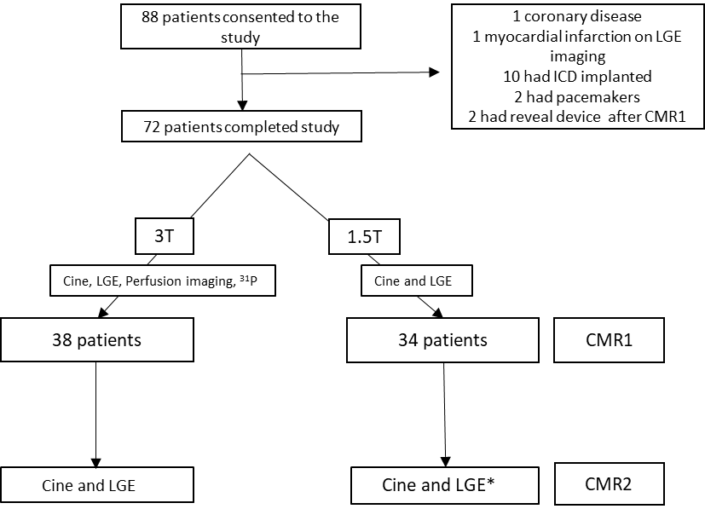

**Figure 1. Flowchart of hypertrophic cardiomyopathy (HCM) patients through the study.** (CMR cardiovascular magnetic resonance imaging, LGE Late gadolinium imaging, 31P Phosphorus-31 Spectroscopy, ICD Implantable cardioverter defibrillator, T Tesla). *CMR2 was at 1.5T or 3T (see supplemental section).

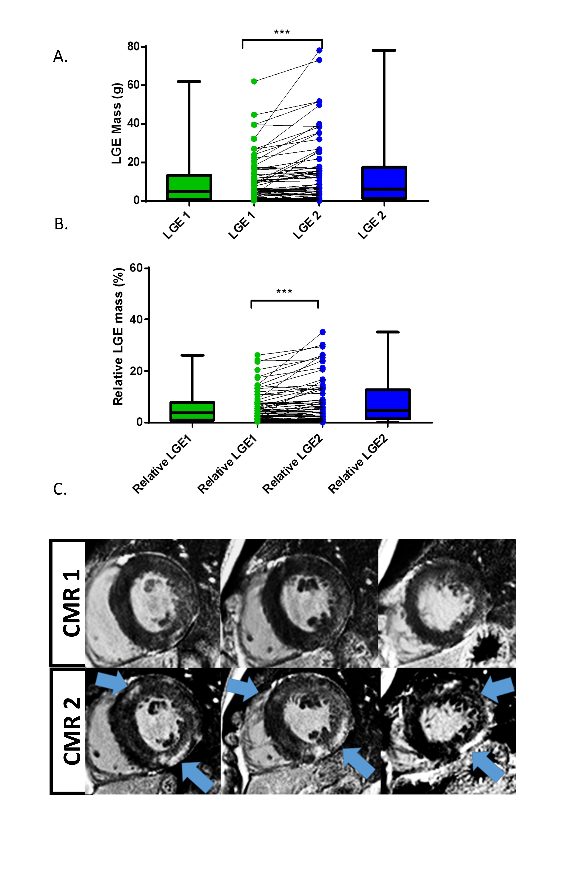

**Figure 2. Comparison of LGE mass (A) and relative LGE mass (B) from CMR1-CMR2** (***p<0.0001, error bars represent SD) **(C) A representative case of fibrosis progression in HCM (Blue arrows indicate new regions of fibrosis).**

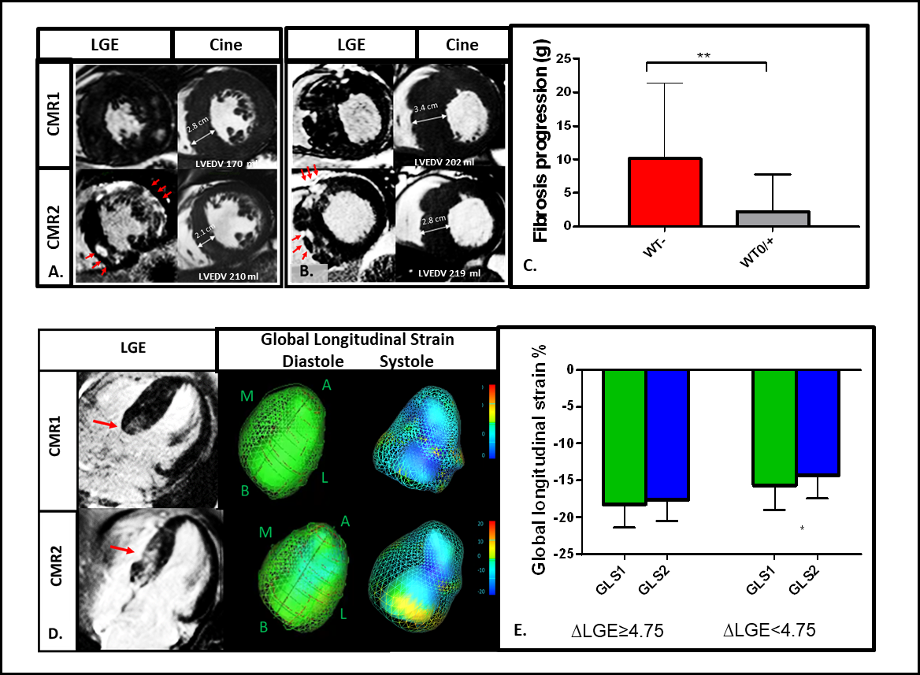

**Figure 3. LGE/fibrosis progression (red arrow indicated LGE progression) results in a reduction in wall thickness (WT-) (A,B,C), increase in LV end-diastolic volume (A,B) and impairment in myocardial contractility (D,E)** (WT0/- stable of increasing wall thickness; GLS global longitudinal strain, **p<0.01, error bars represent standard deviation, *p<0.05).

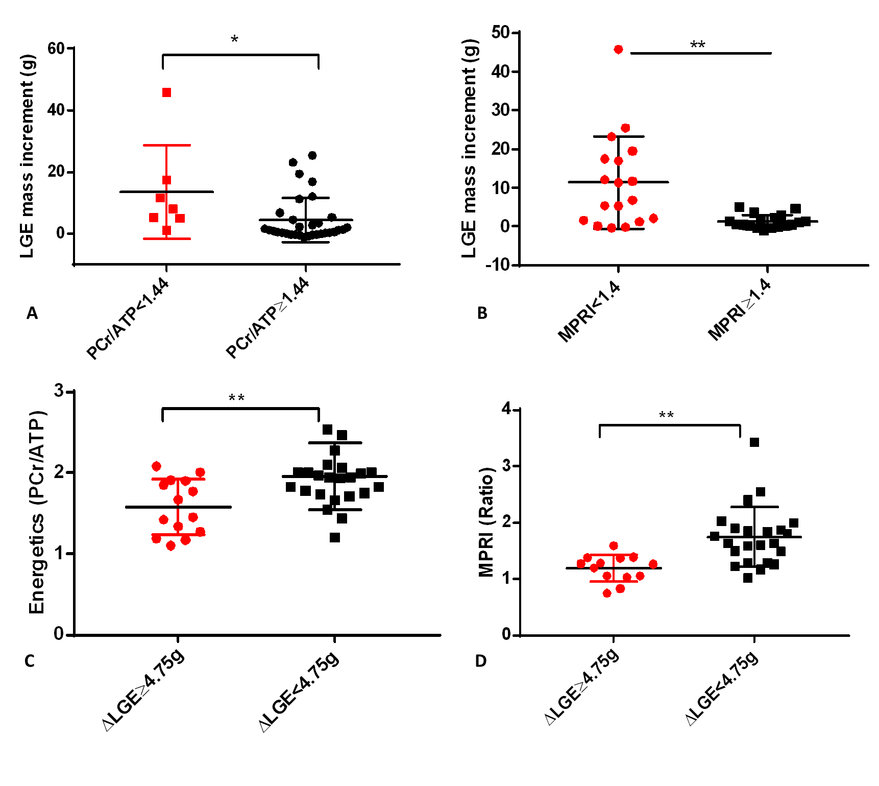

**Figure 4. LGE mass increases from CMR1-CMR2 in HCM patients with (A) impaired myocardial energetics and (B) perfusion reserve index at baseline CMR. Figure 4. (C) Myocardial energetics and (D) perfusion reserve index are impaired in those with substantial LGE progression.**

(MPRI myocardial perfusion reserve index, PCr/ATP Phosphocreatine to adenosine triphosphate ratio, **p<0.01, *p<0.05, ΔLGE≥4.75g LGE progression of ≥4.75g or substantial LGE increment, error bars represent standard deviation).

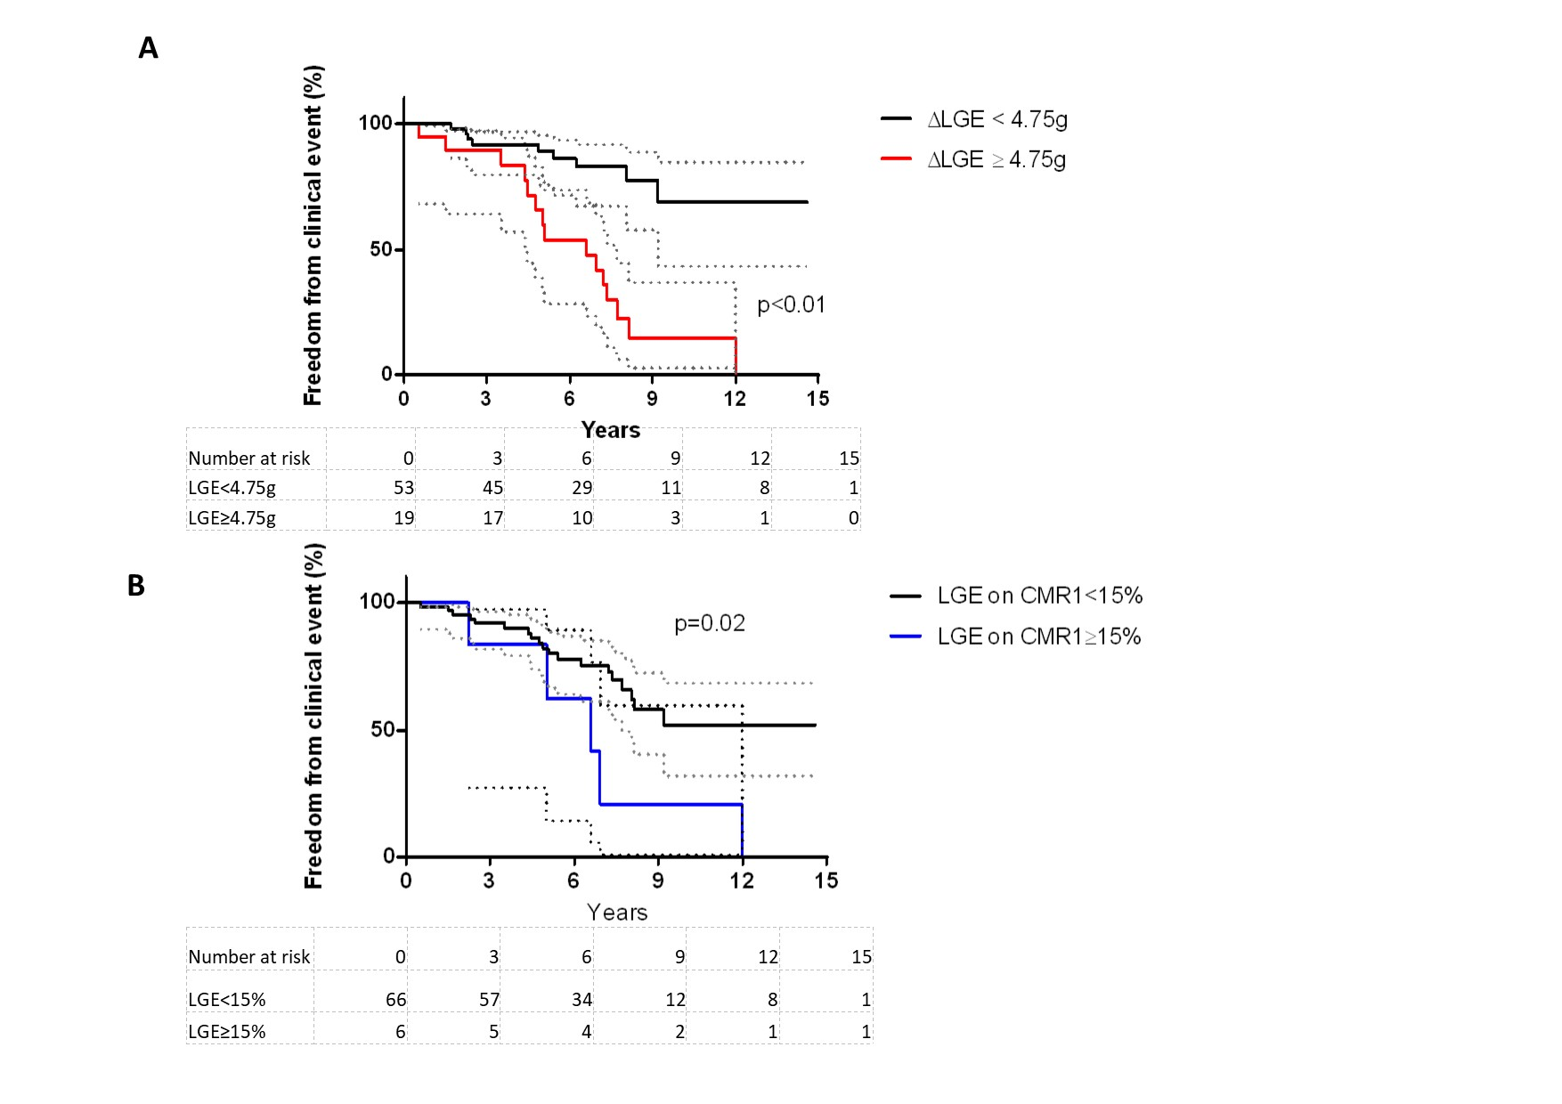

**Figure 5 Kaplan Meier curves depict the freedom from clinical events in HCM patients with LGE increment ≥ 4.75g or less (A) and in those with LGE on CMR1 ≥15% of LV mass or less (B) (**Error bars represent 95 % confidence intervals)

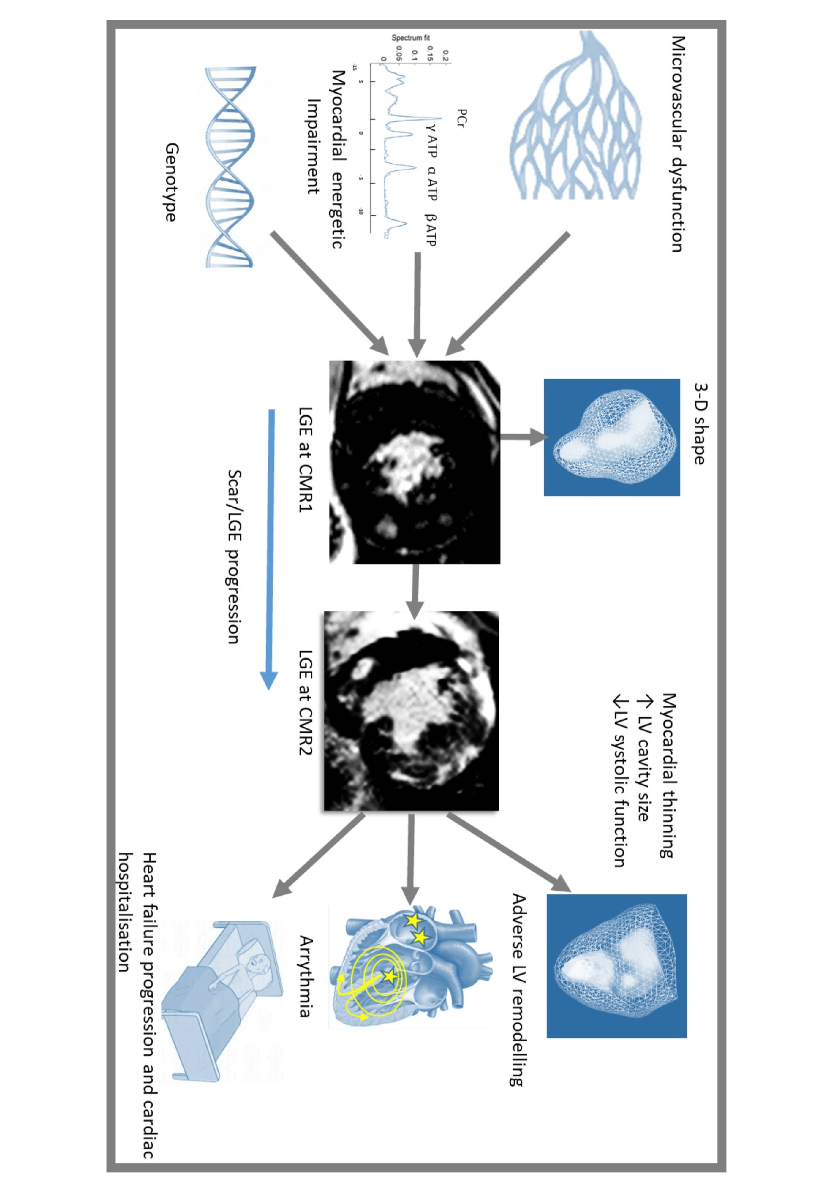

**Take Home Message Figure**

**Scar progression in Hypertrophic Cardiomyopathy is multifactorial and can result in adverse cardiac remodelling, arrhythmia and heart failure progression.**

# **Supplemental material**

**Traditional risk factors for sudden cardiac death**

Traditional risk factors were defined as the presence of : 1) severe LV hypertrophy (maximum LVWT>30 mm); 2) ventricular tachycardia (≥3 consecutive ventricular beats, ≥120 bpm) on 24-hour ambulatory (Holter) ECG monitoring; 3) family history of SCD ( first-degree relative, under 50 years of age); 4) unexplained syncope; 5) abnormal blood pressure response during exercise (under age of 50) (1).

**Genetic screening**

All patients underwent screening for 13 genes associated with HCM (MYBPC3: myosin binding protein C; MYH7: myosin heavy chain; TNNI3: cardiac troponin I; TNNT2: cardiac troponin T; MYL2: regulatory myosin light chain; MYL3: essential myosin light chain; TPM1: alpha tropomyosin; ACTC1: cardiac actin; CSRP3: muscle LIM protein; PRKAG2: AMPK γ2; PLN: phospholamban; GLA: alpha galactosidase; FHL1: four and a half LIM domains 1) including a screen (blood test) for mitochondrial mutations if no sarcomeric mutations were identified.

**Exclusion of coronary disease in final cohort**

Of the 72 patients undergoing serial CMR, coronary angiography was performed in those patients (n=15) with a clinical indication such as symptoms of angina or positive exercise stress test. No significant coronary disease could be detected in any of the fifteen. The remaining patients with negative stress tests had a low cumulative Framingham Risk for coronary disease of <10% with no evidence of myocardial infarction on LGE imaging.

**Methods**

**Cardiac magnetic resonance cine imaging**

Cardiac volumes were acquired using steady state free precession (SSFP) imaging. Scan parameters were typically: voxel size 2.0x2.0x8.0mm, FOV=380x380mm, TR/TE 39.6/1.12ms, flip angle 55°, matrix 192x192, GRAPPA=3, 24 reference lines, segments=15, concatenations=1. Pilot images were initially acquired and used to plan and acquire horizontal long axis (HLA), vertical long axis (VLA), left ventricular outflow tract (LVOT) long axis and short axis stack images. LV short axis epicardial and endocardial borders were manually contoured at end diastole and end systole. LV end systolic (ESV) and end diastolic (EDV) volumes were used to calculate stroke volume (SV) as SV = EDV-ESV. Ejection fraction (EF) and cardiac output (CO) were calculated as EF = SV/EDV and CO=SV x HR, respectively. LV mass was calculated by subtracting the endocardial volume from the epicardial volume, based on prior knowledge of myocardial specific gravity (1.05 g/cm3).

**CMR field strength**

The majority (78%) of paired scans were undertaken at the same field strength. All patients undergoing perfusion and energetics assessment (n=38) had serial CMR at 3 Tesla (T). 18 patients had serial CMR at 1.5T. Sixteen (22%) patients had LGE assessment at different field strengths (1.5T or 3T). All 3 Tesla (3T) scans were undertaken on 3 Tesla (3T), Tim Trio MR System, (Siemens, Erlangen, Germany). All 1.5T scans were undertaken either on Sonata or Avanto Fit, Siemens (Erlangen, Germany).

**Late gadolinium enhancement (LGE) imaging**:

LGE imaging was acquired using a T1-weighted phase-sensitive inversion recovery sequence. Scan parameters were typically: voxel size 2.0 x 1.5 x 8.0 mm, matrix 144x256, field-of view=380x285mm, TR/TE=800.20/3.36ms, flip angle 25o, GRAPPA=2, 24 reference lines, segments=25, phases=1, concatenations=1, measurements=1, bandwidth=130Hz/Px.

**31P magnetic resonance spectroscopy**

A 3-dimensional acquisition-weighted chemical shift imaging technique (3D UTE-CSI) was used with an acquisition matrix of 16 x 8 x 8 over field of view of 240 x 240 x 200 mm3 with 10 averages at the centre of k-space (2). The sequence used the ultrashort echo time (UTE) approach to minimize T2 effects and first-order phase artefacts. The total acquisition time was ~9 min. An optimized radiofrequency pulse centred between the γ- and α-ATP resonance frequencies was used to ensure uniform excitation of all spectral peaks. Five Nuclear Overhauser Effect (NOE) pulses (2.5 ms, 222.2 V separated by 80.5 ms) were used to increase signal to noise. Three 25-mm-thick saturation bands were used to minimise signal contamination in the heart, 2 placed over chest wall muscle and 1 placed over liver. The chemical shift imaging grid was placed with a central voxel in the mid-ventricular septum and rotated to maximize coverage of the septal myocardium.

**CMR Image Post-Processing**

Cine images:

Analysis of left ventricular ejection fraction (LVEF) was performed using the cmr42 software (Circle Cardiovascular Imaging Inc., Calgary, Canada). LV short-axis epicardial and endocardial borders were manually contoured at end-diastole and end-systole, in accordance to the SCMR guidelines on standardized image post-processing of CMR images (3)*.* Papillary muscles were not included in the LV blood pool for LV volume contours. LV end-systolic (LVESV) and end-diastolic (LVEDV) volumes were used to calculate stroke volume (SV) and LVEF [LVEF = SV/EDV]. LV myocardial mass was calculated by subtracting the endocardial volume from the epicardial volume, based on prior knowledge of myocardial specific gravity (1.05 g/cm3). Left atrial diameter was measured in the LV outflow tract (3-chamber) view.

*Myocardial perfusion reserve analysis:*

For analysis of myocardial perfusion, signal intensity (SI) over time curves was generated by tracing endocardial and epicardial contours (cmr42) after correction for displacement during breathing. A region of interest was drawn in the LV blood pool to obtain an arterial input function. Post-adenosine rest and stress myocardial perfusion up slopes were calculated using a five-point linear fit model of SI vs. time and normalized to the LV blood pool upslope. Myocardial perfusion reserve index (MPRI), defined as the ratio of stress to rest normalized myocardial perfusion upslope, was derived for 18 segments and averaged per patient (4).

*31P Spectroscopy analysis:*

The spectrum from a mid-ventricular septal voxel was fitted using a custom implementation of AMARES (the advanced method for accurate, robust, and efficient spectral fitting) in the “OXSA” semi-automated spectroscopy post-processing pipeline (5). Fitting used prior knowledge specifying 11 Lorentzian peaks (α,β,γ-ATP multiplet components, PCr, PDE, and 2x2,3-DPG) and fixed amplitude ratios and scalar couplings for the multiplets. The fitted amplitudes were then corrected for blood contamination by subtracting 30% of the average of the two 2,3-DPG signals from each of the ATP amplitudes. The remaining PCr and ATP signals were corrected for the effects of partial saturation using the flip angle at the centre of the voxel, assuming no motion effects and with literature T1 values.

**Visual assessment and semi-quantitative analysis of LGE**

Visual assessment of LGE progression was also performed to ensure that LGE progression ≥4.75g using a semi quantitative method was detectable by an expert clinician (MM) on blinded analysis. Level of agreement was assessed to be high with Cohens kappa 0.90 (95% CI 0.79-1.00), p<0.01. Inter-observer intra-class correlation coefficient (two-way mixed effect) for (n=15) was excellent at 0.89 (95% CI 0.80-0.95, p<0.01), intra-observer ICC (one-way random effect) was also found to be high 0.97 (95% CI 0.95-0.99, p<0.01).

**LGE increment threshold**

A receiver operator curve analysis was undertaken to estimate a clinically meaningful LGE threshold. We found that substantial LGE increment of 4.75g (ΔLGE≥4.75g) had a good specificity of 92% (95% CI 85%-97%) and reasonable sensitivity of 63% (95% CI 53%-72%) with an AUC of 0.74 (95% CI 0.60-0.88, p=0.001) for discriminating stable patients from those likely to have a clinical event (Supplementary figure 1).

**LVOT Obstruction and LGE progression**

In this study, there were 11 patients with LV outflow tract obstruction at rest or during Valsalva (>30mm Hg), and three demonstrated evidence of substantial LGE progression. There was no significant difference in LGE increment between those with and without LVOT obstruction (p=0.12). Out of those 11 patients, two had clinical events, one had a progression of NYHA class with a restrictive physiology on echocardiogram, the other had new onset ventricular tachycardia and atrial fibrillation. The presence of LVOT obstruction did not significantly associate with LGE progression or clinical events on univariate analysis. However, numbers are small and the present study lacks the power to robustly test such associations.

**Data**

**Table 1. Genotype and patterns of hypertrophy of HCM subjects enrolled in study**

|  |  |
| --- | --- |
| Genotype |  |
| MYH7, %(n) | 26(19) |
| MYBPC3, %(n) | 32(23) |
| ACTC1, %(n) | 1(1) |
| TNNI3, %(n) | 1(1) |
| MYL, %(n) | 1(1) |
| Mitochondrial, %(n) | 4(3) |
| VUS (MYBPC3, MYH7) | 4(3) |
| Gene negative, %(n) | 29(21) |
| Pattern of hypertrophy (6) |  |
| Normal, %(n) | 13(9) |
| Septal, %(n) | 64(46) |
| Reverse septal, %(n) | 3(2) |
| Mid-ventricular, %(n) | 0(0) |
| Apical, %(n) | 9(6) |
| Concentric, %(n) | 12(9) |
| NSVT, non-sustained ventricular tachycardia; SCD, sudden cardiac death; HCM; Hypertrophic cardiomyopathy; MYH7, beta-myosin heavy chain; MYBPC3, myosin-binding protein C, TNN1, Troponin, ACTC1 Alpha cardiac actin; MYL myosin light chain | |

**Table 2. Baseline characteristics of patients with HCM and progression of LGE ≥4.75g**

|  |  |  |  |
| --- | --- | --- | --- |
|  | Progression of fibrosis  (n=19) | | No progression  (n=53) |
| Age (years) | | 46 ± 12 | 45 ± 12 |
| Male%, (n) | | 12(63) | 37(70) |
| Body mass index (kg/m2) | | 29±5 | 27±5 |
| Hypertension, (n) | | 1 | 6 |
| Diabetes, (n) | | 2 | 0 |
| Smoker, (n) | | 1 | 4 |
| Family history of SCD, (n) | | 2 | 17 |
| Unexplained syncope, (n) | | 1 | 2 |
| NSVT on Holter monitor(n) | | 2 | 5 |
| Abnormal exercise BP response, (n) | | 0 | 1 |
| Maximum LV wall thickness ≥30 mm, (n) | | 22±5 | 17±5 |
| Presence of LVOT gradient (n) | | 3 | 8 |
| (0/1/2/3 risk factors), (n) | | 14,4,1,0 | 30,20,3,0 |
| ESC 5-yr estimated SCD risk, % | | 3.0±2.2 | 2.1±0.9 |
| Medications | |  |  |
| β-Blockers, (n) | | 8 | 28 |
| Calcium channel blockers, (n) | | 3 | 3 |
| Disopyramide, (n) | | 3 | 1 |
| ARB/ACEI , (n) | | 3 | 7 |
| Diuretics, (n) | | 2 | 2 |
| Warfarin ,(n) | | 2 | 2 |
| Aspirin, (n) | | 4 | 14 |
| CMR findings | |  |  |
| LVEF, % | | 65±7 | 68±6 |
| LVEDV, ml | | 161±30 | 149±29 |
| LVESV, ml | | 56±17 | 49±14* |
| Stroke volume, ml | | 103±20 | 101±20 |
| LA diameter (LVOT/3ch view) | | 39±7 | 36±5 |
| LV Mass, g | | 178±60 | 135±46* |
| LV Mass/m2 | | 89±30 | 70±21* |
| Max wall thickness, mm | | 23±5 | 17±5* |
| Data are mean ± standard deviation. | | | | |
| LV Left ventricular; LA left atrial; EDV end-diastolic volume; ESV end-systolic volume; EF ejection fraction; HCM hypertrophic cardiomyopathy; LGE, late gadolinium enhancement (5 SD), ACEI angiotensin converting enzyme inhibitor; BP blood pressure; NSVT Non sustained ventricular tachycardia; SCD Sudden cardiac death; LVOT left ventricular outflow tract, *comparison significantly different, p<0.05 | | | | |

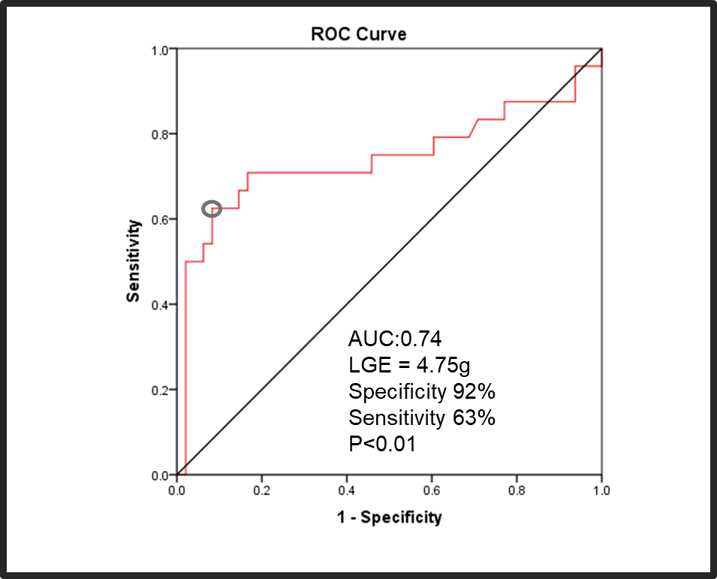

**Supplemental Figure 1 HCM patients who develop clinical events had a higher degree of LGE progression on serial CMR compared to stable patients B. Receiver Operator Curve depicts that an LGE increment threshold of 4.75 g (Youden index) has good specificity of 95% and reasonable sensitivity of 63% to detect clinical events.**



**Supplemental Figure 2. Comparison of LGE increment between those with and without sarcomeric mutations in HCM.**

**References for Supplemental Section**

1. Gersh BJ, Maron BJ, Bonow RO, Dearani JA, Fifer MA, Link MS, et al. 2011 ACCF/AHA guideline for the diagnosis and treatment of hypertrophic cardiomyopathy: executive summary: a report of the American College of Cardiology Foundation/American Heart Association Task Force on Practice Guidelines. J Am Coll Cardiol. 2011;58(25):2703-38.

2. Tyler DJ, Robson MD, Henkelman RM, Young IR, Bydder GM. Magnetic resonance imaging with ultrashort TE (UTE) PULSE sequences: technical considerations. J Magn Reson Imaging. 2007;25(2):279-89.

3. Schulz-Menger J, Bluemke DA, Bremerich J, Flamm SD, Fogel MA, Friedrich MG, et al. Standardized image interpretation and post processing in cardiovascular magnetic resonance: Society for Cardiovascular Magnetic Resonance (SCMR) Board of Trustees Task Force on Standardized Post Processing. Journal of Cardiovascular Magnetic Resonance. 2013;15(1):1-19.

4. Nagel E, Klein C, Paetsch I, Hettwer S, Schnackenburg B, Wegscheider K, et al. Magnetic resonance perfusion measurements for the noninvasive detection of coronary artery disease. Circulation. 2003;108(4):432-7.

5. Purvis LAB, Clarke WT, Biasiolli L, Valkovic L, Robson MD, Rodgers CT. OXSA: An open-source magnetic resonance spectroscopy analysis toolbox in MATLAB. PLoS One. 2017;12(9):e0185356.

6. Noureldin RA, Liu S, Nacif MS, Judge DP, Halushka MK, Abraham TP, et al. The diagnosis of hypertrophic cardiomyopathy by cardiovascular magnetic resonance. J Cardiovasc Magn Reson. 2012;14:17.