TaDa! Analysing cell-type specific chromatin in vivo with Targeted DamID

Jelle van den Ameele*, Robert Krautz* and Andrea H. Brand
The Gurdon Institute and Department of Physiology, Development and Neuroscience, University of Cambridge, Tennis Court Road, Cambridge CB2 1QN, UK.
Corresponding author: Andrea H. Brand, a.brand@gurdon.cam.ac.uk
*These authors contributed equally to this work.
Declarations of interest: none.

Abstract
The emergence of neuronal diversity during development of the nervous system relies on dynamic changes in the epigenetic landscape of neural stem cells and their progeny. Targeted DamID (TaDa) is proving invaluable in identifying the genome-wide binding sites of chromatin-associated proteins in vivo, without fixation, cell isolation, or immunoprecipitation. The simplicity and efficiency of the technique has led to an ever-expanding TaDa toolbox. These tools enable profiling of gene expression and chromatin accessibility, as well as the identification of the genome-wide binding sites of chromatin complexes, transcription factors and RNAs. Here, we review these new developments, with particular emphasis on the use of TaDa in studying neuronal specification.

Introduction
The nervous system is composed of an enormous diversity of cell types that are linked together by an intricate network of connections. When studying genome-wide properties of chromatin in specific neural cell types, many techniques rely on the isolation of cells or nuclei from dissociated brain tissue [1–3]. These isolation steps are invasive and can lead to changes in the epigenome [4–6]. This is certainly the case for the nervous system, where cell-cell communication lies at the heart of its computational abilities. Furthermore, neural development relies on close contact between different cells to control the proliferation of neural stem cells, the orderly migration of young neurons and the directed outgrowth of axons and dendrites.
Targeted DamID (TaDa) can be used to probe the chromatin landscape in specific cells and tissues without the need for fixation, tissue dissociation and disruption of potentially important cell-cell contacts. When combined with next-generation sequencing (NGS), TaDa allows sensitive and specific identification of epigenetic modifications at a genome-wide scale.

Targeted DamID for cell type specific chromatin analysis
DNA adenine methylation identification, or DamID, was developed originally by van Steensel and Henikoff in 2000 [7,8] and has received increasing attention as a simple and robust method for identifying genome wide protein binding sites in vivo. DamID is based on the ability of the E. coli Dam methylase to methylate adenine residues in the sequence GATC [9,10]. By fusing Dam to a chromatin-associated protein, in a conformation which does not interfere with activity of the protein of interest [11], it is possible to methylate genomic DNA at the protein’s native binding sites [12,13]. While DNA adenine methylation has been observed in the genomes of various eukaryotic species (reviewed in [14]), endogenous levels are usually so low (less than 1 in 10⁶ deoxy-adenines [15]) that they are insufficient to interfere with DamID. The absence of background DNA adenine methylation is critical for the high sensitivity and specificity of chromatin profiles acquired with DamID. In highly heterogeneous tissues, DamID methylation in even a small subset of the population can generate reproducible genome-wide chromatin signatures.
DamID has some limitations, including the need for ectopic expression of Dam protein fusions. DamID gives reduced sequence resolution, compared to ChIP-seq, as it depends upon the spacing of GATC-sites within the genome. Recently, MadID was developed to overcome this caveat and increase sequence resolution [16]. MadID makes use of the methylase M.EcoGII, which can methylate N6-adenosine in any sequence context. Expression of moderate to high levels of Dam methylase can also be toxic to cells [17] and for this reason, DamID experiments have often relied on low-level expression from basal, non-induced promoters [12]. Several attempts have been made to regulate levels of Dam-fusion protein expression, for example through insertion of recombination cassettes [18,19], the addition of a protein degradation signal [20], of a hormone-responsive element [21], or of a tamoxifen-inducible intein [22].
Dam methylase toxicity precluded the ability to target expression with cell-type specific promoters in vivo. To overcome this hurdle and achieve cell-type specific, inducible expression of Dam-fusion proteins, we developed Targeted DamID (TaDa) [17] (Figure 1). TaDa enables the identification of genome-wide chromatin binding sites in vivo without cell isolation, fixation or immunoprecipitation. TaDa relies on expression of a bicistronic message lacking an Internal Ribosomal Entry Site (IRES). The first open reading frame (ORF1) encodes a fluorescent protein (i.e., mCherry [17,23]), or a Neomycin resistance gene [24]. This is followed by two stop-codons and a frameshift mutation (5’-UAA-UAA-C-3’) upstream of ORF2, the coding sequence of the Dam fusion protein. ORF1 is translated at high levels while ORF2 is expressed at minimal levels due to infrequent ribosome reinitiation [25] (Figure 1a). As a result, TaDa yields cell- or tissue-specific DNA methylation without toxicity (Figure 1b). TaDa is highly sensitive, robust and reproducible and does not require cell sorting. It has been used successfully to profile small populations of cells in complex tissues, for example, 100 of the 150,000 neurons in intact Drosophila heads [16]. TaDa was first developed for use in Drosophila [17], and has since been widely adopted [26–36]. TaDa has also been modified for inducible expression in mammalian systems (MaTaDa, Mammalian Targeted DamID; [23,24]). As DamID has been successful in yeast [37], plants [38], C. elegans [39] and zebrafish [40], it should be possible to adapt TaDa for use in these systems as well.
A powerful application of TaDa is the ability to profile active transcription by monitoring genome-wide RNA Polymerase II occupancy. Targeted expression of Dam-Pol II has been achieved with the GAL4 system in Drosophila and yields results similar to those generated by ChIP-seq [13]. TaDa has also been used to define changes in the chromatin landscape in the progression from neural stem cells to neurons [28,41] , to map transcription factor binding sites in many different tissues [23,24,26,33–36] and to investigate the role of long-noncoding RNAs in gene regulation [42]. As such, it is making significant contributions in our understanding of the dynamic changes in chromatin states and the regulation of gene expression during nervous system development and in the generation of neuronal diversity. Here we discuss recent innovations that contribute to an ever-growing plug-and-play DamID toolbox for cell-type specific analysis of chromatin (Figure 2).

A TaDa toolbox

TaDa for transcriptional profiling | TaDa was first used to profile RNA polymerase II occupancy in the developing Drosophila optic lobe [17] (Figure 2b) to compare the transcriptional profiles of symmetrically dividing neuroepithelial cells and asymmetrically dividing neuroblasts, two clonally related neural stem cell types. This revealed the signalling pathways that are differentially regulated between these cell types, such as Notch, JAK/STAT, and EGFR. More recently, several hundred quiescent NSCs in the developing Drosophila CNS were transcriptionally profiled with TaDa leading to the discovery of factors regulating stem cell quiescence [27]. Amongst these, the pseudokinase Tribbles was shown to be necessary for entry into quiescence, as well as crucially important for its maintenance. Most notably, Tribbles specifically marked quiescent NSCs arrested in the G₂ phase of the cell cycle, rather than G₀. Thus, TaDa not only paved the way for the identification of factors involved in quiescence, but ultimately revealed a novel type of quiescent stem cell.

TaDa for transcription factors and chromatin complexes | DamID has proven particularly successful in analysing the genome-wide binding patterns of transcription factors (Figure 2b) and chromatin complexes (Figure 2c). While ChIP-seq resolves local binding events with finer resolution, DamID is superior in its simplicity and efficiency [23,43]. This enables DamID experiments to be scaled up to profile many different proteins of interest, as illustrated by the parallel screening of 53 chromatin proteins in tissue culture cells in a single study [44]. Remarkably, despite the great number of possible interactions between these factors, the Drosophila genome is dominated by 5 major protein combinations. These combinations define the chromatin landscape and influence transcriptional activity. Filion and colleagues assigned colours to these chromatin types [44], defining heterochromatic, repressive GREEN chromatin (Su(var)3-9, HP1, Lhr, HP6), repressive, Polycomb-dominated BLUE chromatin (PC, E(z), Pcl, Sce), and the two active, euchromatic states, RED (brm, Su(var)2-10, MED21) and YELLOW (MRG15). This analysis distinguished two distinct euchromatic states, but also uncovered a previously unknown third repressive state spreading across half of the genome, BLACK chromatin (histone H1, D1, aurB, SuUR). The power of TaDa was demonstrated by translating these findings to an in vivo system by profiling specifically proteins that act as proxies for each of these 5 chromatin states (Brm for RED, RNA PolII for YELLOW, HP1a for GREEN, Pc for BLUE and histone H1 for BLACK) [28]. Thus, genome-wide changes in chromatin states could be traced from neural stem cells via ganglion mother cells to neurons during neurogenesis in the Drosophila brain. In this way, conceptually novel chromatin transitions independent of Polycomb were uncovered during neuronal differentiation.

RNA-DamID | Long non-coding RNA (lncRNA)–chromatin interactions are thought to play important roles in development and disease. Whereas lncRNAs encoded by the dosage compensation genes Xist in humans and roX in Drosophila have long been known to play key roles in epigenetic modifications, the function of many lncRNAs remains a mystery. Approaches for easily profiling lncRNA-chromatin associations in vivo had been lacking, in particular for cell-type specific analysis. RNA-DamID was developed as a simple and sensitive technique to detect lncRNA–genome interactions in a cell-type-specific manner in vivo.
RNA-DamID takes advantage of the bipartite, bacteriophage MS2-MCP system: the MS2 coat protein (MCP) tandem dimer is fused to Dam methylase, while the lncRNA of interest is tagged with three MS2 RNA stem–loops [42]. Upon co-expression, MCP recruits Dam to the chromatin-associated lncRNA by binding to its MS2-tag (Figure 2e).
RNA-DamID has been used to perform genome-wide profiling of the roX1 and roX2 lncRNAs in Drosophila leading to the intriguing observation that dosage compensation may vary between cell-types [42]. Long-standing questions regarding the impact of lncRNAs in shaping the chromatin landscape and thereby influencing genome-wide transcriptional activity can now be addressed by leveraging the full potential of the TaDa toolbox: screening simultaneously the genomic sites occupied by lncRNAs, chromatin markers and RNA PolII. In this way the impact and function of lncRNAs can be profiled in unprecendented, genome-wide detail.

Chromatin accessibility TaDa (CATaDa) | Before the introduction of DamID [7,8], Dam itself was used to study chromatin accessibility and nucleosome positioning in yeast and Drosophila [45,46]. These studies led to the observation that Dam can label all GATC-sites within the genome, but does so primarily in regions of low histone density and compaction. More recently, Dam-methylation has been used as a genome-wide proxy for chromatin accessibility in C. Elegans [39]. One of the latest additions to the TaDa toolbox, Chromatin Accessibility Targeted DamID (CATaDa), also exploits this intrinsic preference of the Dam enzyme. By expressing Dam with TaDa in a cell-type specific manner, sites of open chromatin are labelled on a genome-wide scale [41] (Figure 2f). This generates results which are highly comparable to FAIRE-seq and ATAC-seq [41]. As a result, TaDa experiments deliver two for one: in every DamID experiment the Dam-alone control yields valuable information on chromatin accessibility in parallel with the binding profile of the investigated protein.

At the intersection between DamID and TaDa
DamC | The adaptability of the core concept of DamID made it possible to propose a replacement of 3C-derived methods for probing chromatin interactions [47,48]. In order to assess quantitatively chromosome structures in vivo, damC relies on Dam methylation signatures derived by recruiting Dam to experimentally defined binding sites. DamC works without crosslinking, DNA-digestion and religation. Thus, damC can for the first time validate chromosome folding, topologically associated domains (TADs), and CTCF-cohesin-associated loops in their native, nuclear environment.
DamC makes it possible to modify local chromatin looping by introducing novel binding sites for Dam constructs together with CTCF binding sites. Chromosomal interactions in the presence or absence of these newly generated loops can be followed during differentiation. These types of experiments promise to shed light on the significance of chromosomal interactions within TADs and their regulation in tissues throughout development.
Single cell DamID | The nuclear envelope protein, LaminB1, is stably associated with chromatin and results in strong methylation when fused to Dam. In addition, LaminB1-Dam profiles are strikingly anti-correlated with the Dam-only binding pattern, which increases specificity in detecting LaminB1-bound regions. As a result it has been possible to detect LaminB1-Dam methylation in single-cells [49]. This is not yet the case for most other chromatin proteins and transcription factors, which tend to be bound more transiently. Moreover, the binary nature of either methylated or non-methylated GATC motifs limits quantitative analysis.
Split DamID (SpDamID) | The Dam methylase can be separated into two complementary halves that by themselves are inactive; upon reconstitution the protein regains its catalytic activity. This behaviour is exploited in the Split DamID approach, in which the separate Dam-halves are fused to two different proteins that are suspected to physically interact when bound to DNA or chromatin [21]. To enable Dam reconstitution and DNA methylation, the two DNA binding proteins need to bind simultaneously and in close proximity. SpDamID has served to decipher the combinatorial binding of Notch, RBPJ, MAML and p300 during Notch-dependent alteration of chromatin accessibility and transcriptional activation in vitro. Its capacity to decipher the composition of transcriptional complexes in vivo remains to be explored.
Methyl adenine identification (MadID)| MadID relies on the more promiscous methyltransferase, M.EcoGII [16]. This enzyme catalyses N6-adenine methylation irrespective of the surrounding sequence and is thus not limited to methylation of GATC sites [50,51]. MadID overcomes the bias in genome coverage dictated by the genomic distribution of GATC sites.. As proof of principle, MadID revealed binding to telomere sequences devoid of GATC-motifs by proteins of the inner nuclear envelope, such as LaminB1. If the specificity and sensitivity of the antibody for m6A-sites is sufficient, the proposed MadID-workflow could be adapted as a targeted approach.

Conclusion and future perspectives
Since its introduction almost two decades ago [7,8], DamID has inspired technical innovations to enable genome wide profiling of a wide variety of chromatin binding proteins. A notable landmark in this series of innovations was the development of Targeted DamID for cell type analysis in intact organisms [17]. While the powerful genetics in Drosophila has clearly facilitated the use of TaDa, the technology has already been adapted for mammalian systems [23,24]. DamID has inspired new applications such as DamC to quantitatively assess chromosomal interactions [48]. In parallel, computational tools and pipelines are continuously deployed to model and interpret the raw data and intersect with datasets obtained using other techniques [40,48,52,53, our unpublished results]. Together, these are part of an ever-growing plug-and-play toolbox of DamID-related constructs, which may eventually ‘cater for all’. In the wake of single cell-based sequencing approaches, TaDa will prove to be an invaluable tool to validate gene-regulatory networks and probe the chromatin landscape in cell subtypes identified by scRNA-seq [54–56].

Figures

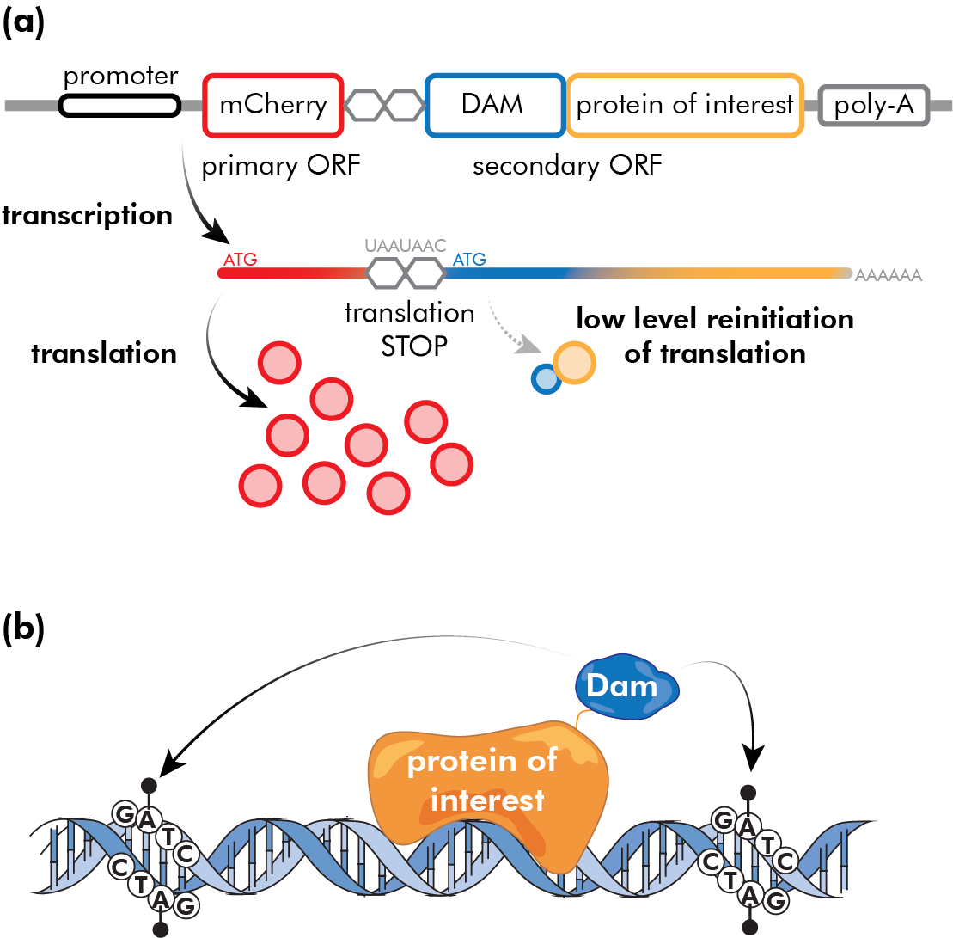
Figure 1. Targeted DamID. (A) Targeted DamID is a genetically encoded tool which allows cell-type specific expression of a protein of interest fused to E.coli Dam methylase. A promoter drives the transcription of a bicistronic mRNA transcript where two coding sequences are separated by two stop codons and a frameshift (UAA-UAA-C). The upstream open reading frame (primary ORF, mCherry in this case) is expressed at high levels when the promoter is active. Translation terminates at the stop codon (UAA), but very infrequently ribosomes reinitiate translation of the secondary ORF (Dam fused to the protein of interest). This results in low-level expression of the Dam fusion protein. (B) This low-level expression is sufficient to generate detectable methylation of GATC motifs near genomic binding sites of the protein of interest.

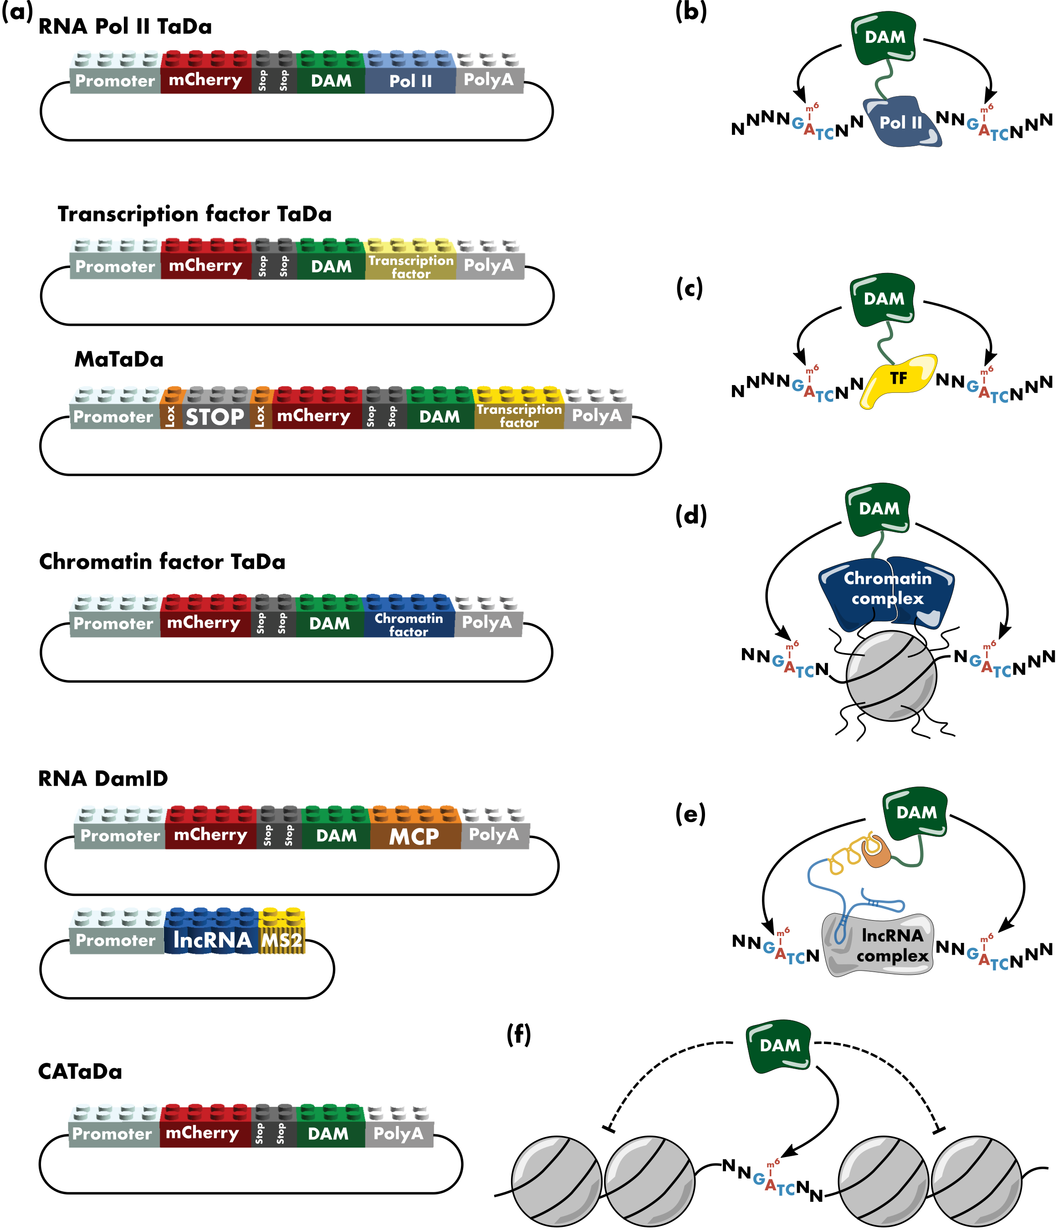Figure 2. A plug-and-play toolbox for Targeted DamID. (A) Many different properties of chromatin can now be identified using TaDa; these innovations contribute to an ever-growing toolbox. (B) Fusion of Dam to RNA Polymerase II allows profiling of gene expression. (C,D) Fusion of Dam to a transcription factor of interest (C), or a subunit of a complex involved in reading or writing chromatin modifications (D), reveals the sites at which these proteins are bound to chromatin. (E) In RNA DamID, Dam is fused to the MCP (MS2 coat protein), which has a very high affinity for MS2 RNA -loops. When these MS2-loops are fused to a specific long noncoding RNA (lncRNA), co-expression of the Dam-MCP fusion protein will report where the lncRNA is associated with the chromatin. (F) CATaDa relies on the intrinsic affinity of Dam for all genomic GATC sites that are not shielded by other proteins, such as nucleosomes (closed chromatin). It therefore reports regions of open chromatin across the genome.

Acknowledgements
We would like to thank the Lego Group for freely providing the LEGO Digital Designer software. This work was funded by Wellcome Trust Senior Investigator Award 103792, and the Royal Society Darwin Trust Research Professorship to AHB. JvdA was supported by Wellcome Trust Postdoctoral Training Fellowship for Clinicians 105839. AHB acknowledges core funding to the Gurdon Institute from the Wellcome Trust (092096) and CRUK (C6946/A14492).

Highlights
- Generation of neuronal diversity is tightly linked to epigenetic modifications
- Targeted DamID (TaDa) allows cell-type specific analysis of chromatin modifications
- An ever-growing toolbox of TaDa-related applications

References
1. Hirabayashi Y, Gotoh Y: Epigenetic control of neural precursor cell fate during development. Nat Rev Neurosci 2010, 11:377–388.
2. Ma DK, Marchetto MC, Guo JU, Ming G-L, Gage FH, Song H: Epigenetic choreographers of neurogenesis in the adult mammalian brain. Nat Neurosci 2010, 13.
3. Yoon KJ, Vissers C, Ming G li, Song H: Epigenetics and epitranscriptomics in temporal patterning of cortical neural progenitor competence. J Cell Biol 2018, 217:1901–1914.
4. Binek A, Rojo D, Godzien J, Rupérez FJ, Nuñez V, Jorge I, Ricote M, Vázquez J, Barbas C: Flow cytometry has a significant impact on the cellular metabolome. J Proteome Res 2018, doi:10.1021/acs.jproteome.8b00472.
5. van den Brink SC, Sage F, Vértesy Á, Spanjaard B, Peterson-Maduro J, Baron CS, Robin C, van Oudenaarden A: Single-cell sequencing reveals dissociation-induced gene expression in tissue subpopulations. Nat Methods 2017, 14:935–936.
6. Potier D, Davie K, Hulselmans G, NavalSanchez M, Haagen L, Huynh-Thu VA, Koldere D, Celik A, Geurts P, Christiaens V, et al.: Mapping Gene Regulatory Networks in Drosophila Eye Development by Large-Scale Transcriptome Perturbations and Motif Inference. Cell Rep 2014, 9:2290–2303.
7. van Steensel B, Henikoff S: Identification of in vivo DNA targets of chromatin proteins using tethered dam methyltransferase. Nat Biotechnol 2000, 18:424–8.
8. Van Steensel B, Delrow J, Henikoff S: Chromatin profiling using targeted DNA adenine methyltransferase. Nat Genet 2001, 27:304–308.
9. Horton JR, Liebert K, Bekes M, Jeltsch A, Cheng X: Structure and Substrate Recognition of the Escherichia coli DNA Adenine Methyltransferase. J Mol Biol 2006, 358:559–570.
10. Brooks JE, Blumenthal RM, Gingeras TR: The isolation and characterization of the Esherichia Coli DNA adenine methylase (dam) gene. Nucleic Acids Res 1983, 11:837–851.
11. Ramialison M, Waardenberg AJ, Schonrock N, Doan T, de Jong D, Bouveret R, Harvey RP: Analysis of steric effects in DamID profiling of transcription factor target genes. Genomics 2017, 109:75–82.
12. Vogel MJ, Peric-Hupkes D, van Steensel B: Detection of in vivo protein - DNA interactions using DamID in mammalian cells. Nat Protoc 2007, 2:1467–1478.
13. Marshall OJ, Southall TD, Cheetham SW, Brand AH: Cell-type-specific profiling of protein-DNA interactions without cell isolation using targeted DamID with next-generation sequencing. Nat Protoc 2016, 11:1586–1598.
14. Parashar NC, Parashar G, Nayyar H, Sandhir R: N6-adenine DNA methylation demystified in eukaryotic genome: From biology to pathology. Biochimie 2018, 144:56–62.
15. Koziol MJ, Bradshaw CR, Allen GE, Costa ASH, Frezza C, Gurdon JB: Identification of methylated deoxyadenosines in vertebrates reveals diversity in DNA modifications. Nat Struct Mol Biol 2015, 23:24–30.
16. Sobecki M, Souaid C, Boulay J, Guerineau V, Noordermeer D, Crabbe L: MadID, a Versatile Approach to Map Protein-DNA Interactions, Highlights Telomere-Nuclear Envelope Contact Sites in Human Cells. Cell Rep 2018, doi:10.1016/j.celrep.2018.11.027.
17. Southall TD, Gold KS, Egger B, Davidson CM, Caygill EE, Marshall OJ, Brand AH: Cell-type-specific profiling of gene expression and chromatin binding without cell isolation: assaying RNA Pol II occupancy in neural stem cells. Dev Cell 2013, 26:101–12.
18. Pindyurin A V.: Genome-Wide Cell Type-Specific Mapping of In Vivo Chromatin Protein Binding Using an FLP-Inducible DamID System in Drosophila. In Methods in molecular biology (Clifton, N.J.). . 2017:99–124.
19. Kozhevnikova EN, Leshchenko AE, Pindyurin A V.: An Inducible DamID System for Profiling Interactions of Nuclear Lamina Protein Component Lamin B1 with Chromosomes in Mouse Cells. Biochem 2018, 83:586–594.
20. Kind J, Pagie L, Vries SS De, Dekker J, Oudenaarden A Van, Kind J, Pagie L, Vries SS De, Nahidiazar L, Dey SS, et al.: Genome-wide Maps of Nuclear Lamina Interactions in Single Human Cells. Cell 2015, doi:10.1016/j.cell.2015.08.040.
21. Hass MR, Liow H, Chen X, Sharma A, Inoue YU, Inoue T, Reeb A, Martens A, Fulbright M, Raju S, et al.: SpDamID: Marking DNA Bound by Protein Complexes Identifies Notch-Dimer Responsive Enhancers. Mol Cell 2015, 59:685–697.
22. Pindyurin A V., Pagie L, Kozhevnikova EN, van Arensbergen J, van Steensel B, Van Arensbergen J, Van Steensel B: Inducible DamID systems for genomic mapping of chromatin proteins in Drosophila. Nucleic Acids Res 2016, 44:5646–5657.
*23. Cheetham SW, Gruhn WH, van den Ameele J, Krautz R, Southall TD, Kobayashi T, Surani MA, Brand AH: Targeted DamID reveals differential binding of mammalian pluripotency factors. Development 2018, doi:10.1242/dev.170209.
*24. Tosti L, Ashmore J, Tan BSN, Carbone B, Mistri TK, Wilson V, Tomlinson SR, Kaji K: Mapping transcription factor occupancy using minimal numbers of cells in vitro and in vivo. Genome Res 2018, 28:592–605.
* These two papers adapt TaDa for use in mammalian systems. They perform extensive comparisons to ChIP-seq and show that these techniques should be considered complementary to one another.

25. Kozak M: Constraints on reinitiation of translation in mammals. Nucleic Acids Res 2001, 29:5226–32.
26. Sen S, Chanchani S, Southall T, Doe CQ: Neuroblast-specific chromatin landscapes allow integration of spatial and temporal cues to generate neuronal diversity in Drosophila. bioRxiv 2018, doi:10.1101/485193.
**27. Otsuki L, Brand AH: Cell cycle heterogeneity directs the timing of neural stem cell activation from quiescence. Science (80- ) 2018, 360:99–102.
** This paper exemplifies the power of TaDa by profiling the transcription of several hundred quiescent neural stem cells within the central nervous system. This enabled the authors to identify a new type of quiescent neural stem cell, arrested in the G₂-stage of the cell cycle.

**28. Marshall OJ, Brand AH: Chromatin state changes during neural development revealed by in vivo cell-type specific profiling. Nat Commun 2017, 8.
** The authors took advantage of TaDa to profile chromatin states in vivo in different cell types of the developing neural lineage.

29. Doupé DP, Marshall OJ, Dayton H, Brand AH, Perrimon N: Drosophila intestinal stem and progenitor cells are major sources and regulators of homeostatic niche signals. Proc Natl Acad Sci 2018, 115:12218–12223.
30. Tamirisa S, Papagiannouli F, Rempel E, Ermakova O, Trost N, Zhou J, Mundorf J, Brunel S, Ruhland N, Boutros M, et al.: Decoding the Regulatory Logic of the Drosophila Male Stem Cell System. Cell Rep 2018, 24:3072–3086.
31. Widmer YF, Bilican A, Bruggmann R, Sprecher SG: Regulators of Long-Term Memory Revealed by Mushroom Body-Specific Gene Expression Profiling in Drosophila melanogaster. Genetics 2018, 209:1167–1181.
32. Spéder P, Brand AH: Systemic and local cues drive neural stem cell niche remodelling during neurogenesis in Drosophila. Elife 2018, 7.
33. Loza‐Coll MA, Southall TD, Sandall SL, Brand AH, Jones DL: Regulation of Drosophila intestinal stem cell maintenance and differentiation by the transcription factor Escargot. EMBO J 2014, 33:2983–2996.
34. Korzelius J, Naumann SK, Loza‐Coll MA, Chan JS, Dutta D, Oberheim J, Gläßer C, Southall TD, Brand AH, Jones DL, et al.: Escargot maintains stemness and suppresses differentiation in Drosophila intestinal stem cells. EMBO J 2014, 33:2967–2982.
35. Vissers JHA, Froldi F, Schröder J, Papenfuss AT, Cheng LY, Harvey KF: The Scalloped and Nerfin-1 Transcription Factors Cooperate to Maintain Neuronal Cell Fate. Cell Rep 2018, 25:1561–1576.e7.
36. Albert EA, Puretskaia OA, Terekhanova N V., Labudina A, Bökel C: Direct control of somatic stem cell proliferation factors by the Drosophila testis stem cell niche. Development 2018, 145:dev156315.
37. Lebrun E, Fourel G, Defossez P-A, Gilson E: A Methyltransferase Targeting Assay Reveals Silencer-Telomere Interactions in Budding Yeast. Mol Cell Biol 2003, 23:1498–1508.
38. Germann S, Juul-Jensen T, Letarnec B, Gaudin V: DamID, a new tool for studying plant chromatin profiling in vivo , and its use to identify putative LHP1 target loci. Plant J 2006, 48:153–163.
39. Sha K, Gu SG, Pantalena-Filho LC, Goh A, Fleenor J, Blanchard D, Krishna C, Fire A: Distributed probing of chromatin structure in vivo reveals pervasive chromatin accessibility for expressed and non-expressed genes during tissue differentiation in C. elegans. BMC Genomics 2010, 11.
40. Gutierrez-Triana JA, Mateo JL, Ibberson D, Ryu S, Wittbrodt J: iDamIDseq and iDEAR: an improved method and computational pipeline to profile chromatin-binding proteins. Development 2016, 143:4272–4278.
**41. Aughey GN, Estacio Gomez A, Thomson J, Yin H, Southall TD: CATaDa reveals global remodelling of chromatin accessibility during stem cell differentiation in vivo. Elife 2018, 7.
** Based on longstanding observations that Dam preferentially methylates open chromatin, the authors turn this to an advantage and show that cell-type specific expression of the Dam methylase generates profiles equivalent to ATAC-seq.

**42. Cheetham SW, Brand AH: RNA-DamID reveals cell-type-specific binding of roX RNAs at chromatin-entry sites. Nat Struct Mol Biol 2017, 25:109–114.
** The authors develop a powerful way to study lncRNA-chromatin interactions.

43. Aughey GN, Southall TD: Dam it’s good! DamID profiling of protein-DNA interactions. Wiley Interdiscip Rev Dev Biol 2016, 5:25–37.
44. Filion GJ, van Bemmel JG, Braunschweig U, Talhout W, Kind J, Ward LD, Brugman W, de Castro IJ, Kerkhoven RM, Bussemaker HJ, et al.: Systematic Protein Location Mapping Reveals Five Principal Chromatin Types in Drosophila Cells. Cell 2010, 143:212–224.
45. Wines DR, Talbert PB, Clark D V., Henikoff S: Introduction of a DNA methyltransferase into Drosophila to probe chromatin structure in vivo. Chromosoma 1996, 104:332–340.
46. Kladde MP, Simpson RT: Positioned nucleosomes inhibit Dam methylation in vivo. Proc Natl Acad Sci U S A 1994, 91:1361–1365.
47. Mitchell AC, Javidfar B, Bicks LK, Neve R, Garbett K, Lander SS, Mirnics K, Morishita H, Wood MA, Jiang Y, et al.: Longitudinal assessment of neuronal 3D genomes in mouse prefrontal cortex. Nat Commun 2016, 7.
**48. Redolfi J, Zhan Y, Valdes C, Kryzhanovska M, Guerreiro IM, Iesmantavicius V, Tiana G, Pollex T, Kind J, Smallwood S, et al.: Modeling of DNA methylation in cis reveals principles of chromatin folding in vivo in the absence of crosslinking and ligation. bioRxiv 2018, doi:10.1101/407031.
** DamC combines the strengths of DamID with advanced modelling of methylation kinetics to solve chromatin architecture in its native context, without the need for cross-linking, digestion and ligation.

49. Kind J, Pagie L, Ortabozkoyun H, Boyle S, De Vries SS, Janssen H, Amendola M, Nolen LD, Bickmore WA, Van Steensel B: Single-cell dynamics of genome-nuclear lamina interactions. Cell 2013, 153:178–192.
50. Fang G, Munera D, Friedman DI, Mandlik A, Chao MC, Banerjee O, Feng Z, Losic B, Mahajan MC, Jabado OJ, et al.: Genome-wide mapping of methylated adenine residues in pathogenic Escherichia coli using single-molecule real-time sequencing. Nat Biotechnol 2012, 30:1232–1239.
51. Murray IA, Morgan RD, Luyten Y, Fomenkov A, Corrêa IR, Dai N, Allaw MB, Zhang X, Cheng X, Roberts RJ: The non-specific adenine DNA methyltransferase M.EcoGII. Nucleic Acids Res 2018, 46:840–848.
52. Marshall OJ, Brand AH: Damidseq-pipeline: An automated pipeline for processing DamID sequencing datasets. Bioinformatics 2015, 31:3371–3373.
53. Li R, Hempel LU, Jiang T: A non-parametric peak calling algorithm for DamID-Seq. PLoS One 2015, 10.
54. Thakore PI, Black JB, Hilton IB, Gersbach CA: Editing the epigenome: technologies for programmable transcription and epigenetic modulation. Nat Methods 2016, 13:127–137.
55. Stricker SH, Köferle A, Beck S: From profiles to function in epigenomics. Nat Rev Genet 2016, 18:51–66.
*56. Albert M, Kalebic N, Florio M, Lakshmanaperumal N, Haffner C, Brandl H, Henry I, Huttner WB: Epigenome profiling and editing of neocortical progenitor cells during development. EMBO J 2017, doi:10.15252/embj.201796764.
* This paper not only characterises histone marks in specific cell types during neurogenesis, but also studies the functional role of a specific mark on one genomic locus through CRISPR-Cas9-based epigenome editing.

