Altitudinal forest-tundra ecotone categorization using texture-based classification
Wenkai Guo ᵃ, W.G. Rees ᵃ
ᵃ Scott Polar Research Institute, Lensfield Rd, Cambridge CB2 1ER, United Kingdom
Email addresses: wg241@cam.ac.uk (Wenkai Guo), wgr2@cam.ac.uk (W.G. Rees).
Corresponding author: Wenkai Guo.
Abstract
This study proposes a new technique involving texture-based image classification to categorize altitudinal FTEs by the degree of fragmentation of the interface. This allows a) universally adaptable altitudinal FTE categorization based on widely available satellite data products and b) assessment of sensitivity of altitudinal FTEs to shift with climate change at different locations based on the spatial distribution of the corresponding categories. The FTE categorization scheme used in this study corresponds partly to the globally occurring primary altitudinal FTE ‘forms.’ Specifically, ‘diffuse’ and ‘abrupt’ FTEs are recognized and separated. Normalized Difference Vegetation Index (NDVI) calculated from Sentinel-2 imagery is used for FTE delineation and categorization. A technique named FOurier-based Textural Ordination (FOTO) is implemented to extract textural information based on NDVI variations in image windows, and supervised classification is used to further separate these windows into FTE categories based on texture. The analysis is conducted on part of the Khibiny Mountains, Kola Peninsula, Russia, and further tested on six other study areas spread across the circumarctic region. The proposed method is able to adapt to different study areas with minimum changes in parameterization, and effectively extract altitudinal FTEs and categorize them into different FTE forms with satisfactory accuracies.
Keywords
Altitudinal forest-tundra ecotone; Sentinel-2; Fourier-based textural ordination (FOTO); Image classification

1. Introduction
The forest-tundra ecotone (FTE), or the Arctic treeline, is the world’s largest vegetation transition zone (Ranson, Montesano and Nelson, 2011), spanning more than 13400 km (Callaghan, Werkman and Crawford, 2002). This transition zone features changes in tree cover and density, tree size and shape, and tree growth and reproduction (Sveinbjörnsson, Hofgaard and Lloyd, 2002). It has long been observed that the FTEs in different regions have different spatial arrangements (Joseph, Anderson and Tatham, 1987; Baker and Weisberg, 1995; Allen and Walsh, 1996). Studies have theorized this phenomenon by pointing out the spatial characteristics of several types of commonly occurring climatic or anthropogenic altitudinal FTEs in the circumarctic landscape (Holtmeier, 2010; Harsch and Bader, 2011). Specifically, four ecotone ‘forms’ have been generalized. The ‘diffuse’ form is characterized by gradually decreasing tree density with increasing altitude or latitude; the ‘abrupt’ form features a continuous canopy with no decline in density up to the FTE; the ‘island’ form is characterized by clumped patches or linear strips of krummholz or trees above the continuous forest limit; the ‘krummholz’ form may share similar spatial patterns with the diffuse or abrupt forms, but it is characterized by the existence of krummholz (Harsch and Bader, 2011). Varying dominance of three primary mechanisms, i.e. growth limitation, seedling mortality and dieback, controls the spatial forms of altitudinal FTEs (Wiegand et al., 2006; Harsch and Bader, 2011).
Through observation, recent studies have confirmed a close link between altitudinal FTE forms and dynamics (Harsch and Bader, 2011). Although disturbances can interfere with the strength of this link in different locations, a general pattern is observed where the diffuse FTEs most frequently respond (advance in position) to growing-season warming, while FTEs of other forms are relatively unresponsive. This link is explained by previous studies as a result of the dependence of altitudinal FTE forms to the relative dominance of primary mechanisms: FTEs with different forms have different dominant primary mechanisms, and differences in the relative dominance of the primary mechanisms causes the FTEs to respond differently to external forcing (Harsch and Bader, 2011; Montesano et al., 2016). Specifically, growth limitation is dominant only at diffuse FTEs, which are therefore more responsive to temperature changes and thus more likely to advance with growing-season warming. On the other hand, abrupt and krummholz FTEs are more strongly limited by constraints that act on tree survival such as low winter temperatures, damage due to wind, and winter desiccation. They are therefore relatively unresponsive to growing-season warming, and more likely to advance only with winter warming which can act specifically to ameliorate the impact of these constraints (Harsch et al., 2009). This difference between different FTE forms could be used to explain the disagreement between studies showing either summer temperatures or winter temperatures as the main control on FTE movements (Masek, 2001; Payette, Fortin and Gamache, 2001; Vlassova, 2002; Crawford, Jeffree and Rees, 2003; Esper and Schweingruber, 2004; Gamache and Payette, 2005; Montesano et al., 2009). Therefore, the sensitivity of altitudinal FTE to shift with climate change can be inferred from the ecotone form, and it is possible to map the gradient of altitudinal FTE sensitivity through the identification of different spatial characteristics of the interface. This can help models to explain and predict vegetation response to climate change in different parts of the circumarctic region (Lloyd, 2005; Harsch et al., 2009).
Various techniques can potentially be applied to distinguish between altitudinal FTE forms. Correlation and cluster analysis of landscape metrics, including patch richness, contagion, contrast, and forest-tundra juxtaposition, etc., have been used to quantify the spatial patterns of alpine FTEs (Allen and Walsh, 1996). Montesano et al. (2016) used primarily spaceborne LiDAR data and high-resolution spaceborne imagery to examine FTE vegetation at the patch scale, investigating primarily the potential of spaceborne estimates of forest height, and hence identifying FTE forms through the examination of the vertical component of forest structure. The objective of this study is to develop a universally applicable FTE categorization method based on the investigation of the horizontal spatial structure of the FTE from widely available image products, using easily adaptable algorithms with minimal input of expert knowledge. Specifically, this study tests the possibility of using Sentinel-2 imagery and global digital elevation model (DEM) datasets to resolve and distinguish between different FTE forms using texture-based classification. The FOurier-based Textural Ordination (FOTO) technique, proposed by Couteron et al. (2006), will be used to extract the texture features of image windows, and supervised classification will then be used to categorize these windows into different ecotone forms. The spatial resolution provided by the Sentinel-2 imagery is unable to resolve individual trees, and thus the island and diffuse forms cannot be distinguished. The Krummholz form is excluded from the analysis since it can either occur in clumped patches which cannot be distinguished from island FTEs, or in dispersed or contiguous bands which is very similar to diffuse FTEs, making it indistinguishable from other forms (Harsch and Bader, 2011). Thus, we argue that the distinction between abrupt and diffuse FTEs (in this study encompassing the commonly recognized ‘diffuse’ and ‘island’ FTE forms) carries sufficient ecological significance and is also the most methodologically feasible approach to the FTE categorization problem.
Two main approaches are commonly used to characterize the spatial texture of landscapes (Haralick, Shanmugan and Dinstein, 1973). The structural approach assumes the existence of distinct vegetation patches and investigates and quantifies their spatial characteristics through the use of various patch metrics such as shape, size and connectivity. This would not be appropriate for the FTE categorization problem because the FTE area exhibits continuously varying degrees of fragmentation, as shown by the different recognized FTE forms, which consists of a range of different sizes of continuous vegetation patches. FTE categorization which relies on the recognition of these patches are thus uneasy and unreliable, both technically and conceptually (Couteron, Barbier and Gautier, 2006; Harsch and Bader, 2011). Instead, this study utilizes the statistical approach which is based purely on the spatial arrangement of digital values on an image of the study area, thus avoiding the need for the recognition of vegetation patches. This study develops the FTE categorization algorithm on one study area, and tests the adaptability of the algorithm on additional altitudinal FTEs around the circumarctic region.

2. Materials and methods
2.1. Study area and data
The algorithm development part of the study focuses on the Khibiny Mountains in the Kola Peninsula, Russia. The Khibiny Mountains cover approximately 2500 km², the highest peaks of which reach between 900-1200m above sea level. Altitudinal ranges where FTEs are expected occur are 300m to 700m above sea level based on visual inspection of the satellite imagery used in this study and previous literature (Mathisen et al., 2013). The dominant tree species include Scots pine (Pinus sylvestris), mountain birch (Betula pubescens subsp. tortuosa) and scattered aspen (Populus tremula), and the shrub layer is dominated by juniper (Juniperus communis) and dwarf birch (Betula nana). The study area has a diverse landscape covering forests, tundra, bare rocks, water bodies, and build-up areas including quarries and road networks (Figure 1). This provides sufficient landscape variety to test the ability of our method in correctly identifying the locations of altitudinal FTEs.
Normalized Difference Vegetation Index (NDVI) calculated from Sentinel-2 imagery is used to isolate vegetation information as input for FTE categorization. The Sentinel-2 platform provides wide-swath, high-resolution imagery with 13 spectral bands at 10m, 20m and 60m spatial resolution (K. Fletcher, 2012), and the calculated NDVI image is at a 10m spatial resolution, the same as both the red and near-infrared bands used in the calculation. Atmospheric correction is performed on the downloaded Level 1C (top-of-atmosphere reflectance) Sentinel data into Level 2A data (at-surface reflectance) using the Sen2cor plugin from the Sentinel-2 Toolbox within the Sentinel Application Platform (SNAP) software developed by European Space Agency (ESA). Four Sentinel-2 scenes, captured on 2017-08-16 and 2017-09-07 and 2017-07-04 (two scenes) were retrieved to provide coverage for the study area, and NDVI is calculated from the mosaic image. Advanced Spaceborne Thermal Emission and Reflection Radiometer (ASTER) Global Digital Elevation Model Version 2 (GDEM v2) at 30m resolution is acquired to retrieve topographic information based on which topographic locations where FTE is unlikely to occur are eliminated. The dataset is resampled to 10m resolution to fit that of the Sentinel-2 imagery.
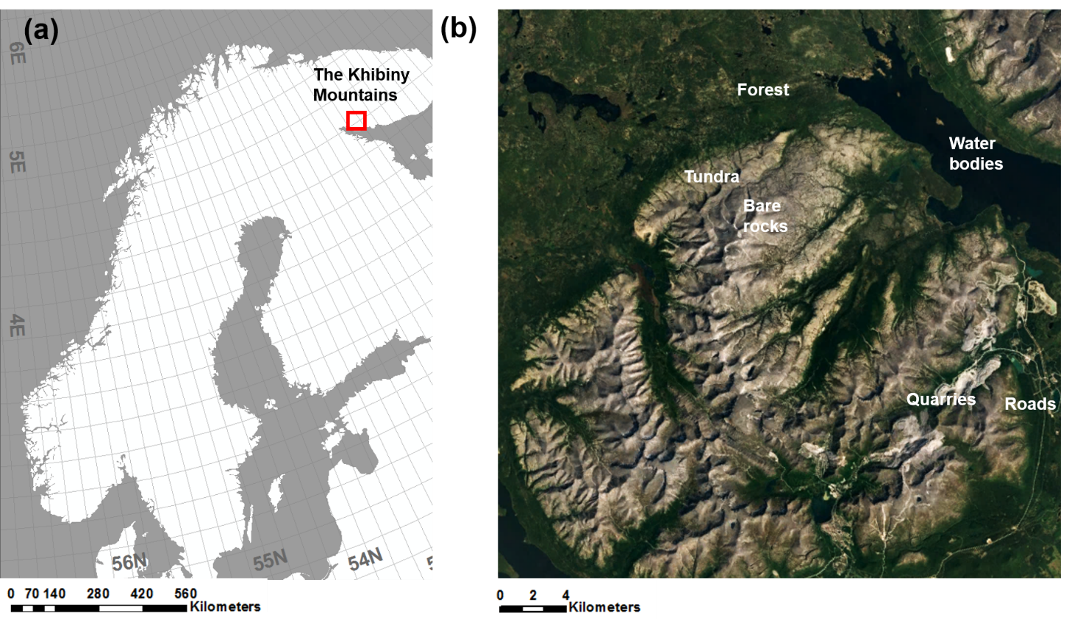
Figure 1 (a) Location of the study area; (b) natural color composite (bands 4, 3 and 2 as RGB) of Sentinel-2 data over the study area.

2.2 Derivation of windows containing FTEs
As texture analysis is based on focal analysis, image windows within which segments of altitudinal FTEs occur are extracted to limit the scope of analysis with a three-step process (Figure 2).
Step 1. In the first step, transition detection is performed on the NDVI image in order to delineate areas where a transition from forest to non-forest occurs. Two-dimensional discrete wavelet transform (DWT) is conducted using Haar wavelets (Haar, 1910) on the NDVI image. The LL (low-low) band of the wavelet domain is used as the basis for transition detection, which contains information of low frequency components of both rows and columns of the window. In this band the contrast between foreground and background information (forest vs. non-forest) is more prominent than in the original image window, which facilitates the transition detection process.
Afterwards, two methods are used separately to extract transition regions. The first method calculates local variance in the LL band using a sliding window approach with a window size of three pixels, and areas with high local variance are extracted as transition regions. Specifically, pixels in the produced variance matrix whose values are larger than the mean value of the original NDVI image are kept as transition region pixels. The second method convolves the NDVI image with a two-dimensional Gabor filter (Jain and Farrokhnia, 1991) to extract the Gabor feature image, which enhances transition regions. The filter is in a set of orientations (0 to 150 degrees in 30 degree intervals) and wavelengths (increasing powers of two starting from $2\sqrt{2}$ pixels up to the hypotenuse length of the image) that is able to localize different subsets of frequency and orientation information (Jain and Farrokhnia, 1990). The Gabor feature matrix produced by the filtering process is then standardized to zero mean and unit variance, and further subjected to principle component analysis (PCA) which summarizes the features into a one-dimensional intensity value for each pixel by extracting the first principle component, which represents most of the variance. Transition regions are extracted by thresholding the intensity image by its standard deviation. Finally, the transition regions extracted by these two methods are intersected to produce the final transition regions. This hybrid approach has been shown to achieve superior performance than each individual one and extracts transition regions more accurately when both the foreground and background are textured, such is the case with the FTEs (Parida and Bhoi, 2017).
Figure 2 The potential FTE window delineation process. Red dashed boxes indicate the three main steps.

Step 2. The second step filters out transition regions identified from Step 1 that do not actually contain an FTE segment. These include transition regions that are detected in topographic positions where altitudinal FTEs are unlikely to occur, and those detected due to the existence of build-up areas and water bodies.
Firstly, we limit the geographic scope of the analysis using topographic information. The topographic position of a pixel is determined through the thresholding of its slope value and the topographic position index, or TPI (Jenness, 2006). The calculation of TPI involves focal analysis of the DEM within a circular neighborhood area around the pixel, as shown in Equation (1) (Weiss, 2001). Valley pixels are identified as those with TPI values less than the inverted standard deviation of the TPI values within their neighborhoods $TPI<=-Stdev({TPI}_{neighborhood})$, and transition regions extracted from the previous step that touches these pixels are excluded from further analysis. A 401-pixel neighborhood is used for the calculation of TPI, which is empirically derived to be able to best distinguish between different topographic positions within the landscape at an appropriate scale.
$TPI=int(DEM-focalmean(DEM)+0.5)$ (1)
Secondly, two spectral indices calculated from Sentinel-2 bands are used to eliminate transition regions detected from water bodies and built-up areas. The Normalized Difference Water Index (NDWI, McFeeters 1996) is calculated for water body exclusion as follows. Pixels with NDWI values larger than 0 are considered as water pixels:
$NDWI=\frac{Green-NIR}{Green+NIR}=\frac{B3-B8}{B3+B8}$ (2)
where B3 and B8 are bands 3 and 8 of the Sentinel-2 image, respectively, both having 10m resolution. The Normalized Difference Built-up Index (NDBI, Zha et al. 2003) is used to extract build-up areas:
$NDBI=\frac{SWIR-NIR}{SWIR+NIR}=\frac{B11-B8}{B11+B8}$ (3)
where B8 and B11 are bands 8 and 11 of the Sentinel-2 image, respectively. Pixels with NDBI values larger than 0 represent Build-up areas. Band 11 has a 20m resolution and thus needs to be resampled to 10m resolution for use in the calculation. Transition regions intersecting with either water bodies or build-up areas extracted by these two indices are excluded. The elimination of transition regions using the above criteria results in the final transition regions.
Step 3. In the last step, NDVI image windows that intersect with the final transition regions are extracted. Furthermore, windows that do not contain any forest pixels are excluded. Transition regions detected in these windows are not FTEs but prominent NDVI transitions within non-forest regions. The NDVI threshold that separates forest from non-forest is variable in different regions and is determined to be 0.55 in our study area based on visual inspection of the natural color composite of Sentinel-2 data. For reference, a map of the Sentinel-2 NDVI image classified using this threshold is shown in Figure 3 along with the natural color composite. Any window whose maximum NDVI value is equal to or less than 0.55 is excluded, resulting in a final selection of windows in which FTEs are categorized. A range of window sizes, in this study from 600m to 1100m in 100m intervals, are empirically derived through visual interpretation of the Sentinel-2 data. They are small enough to only encompass a local segment of forest-to-non-forest transition, and large enough so that transitions of different degrees of fragmentation can be distinguished. The selected windows in these sizes are used as input to the following FOTO and classification processes, and the window size which produces the best classification accuracy will be chosen as the optimal window size.
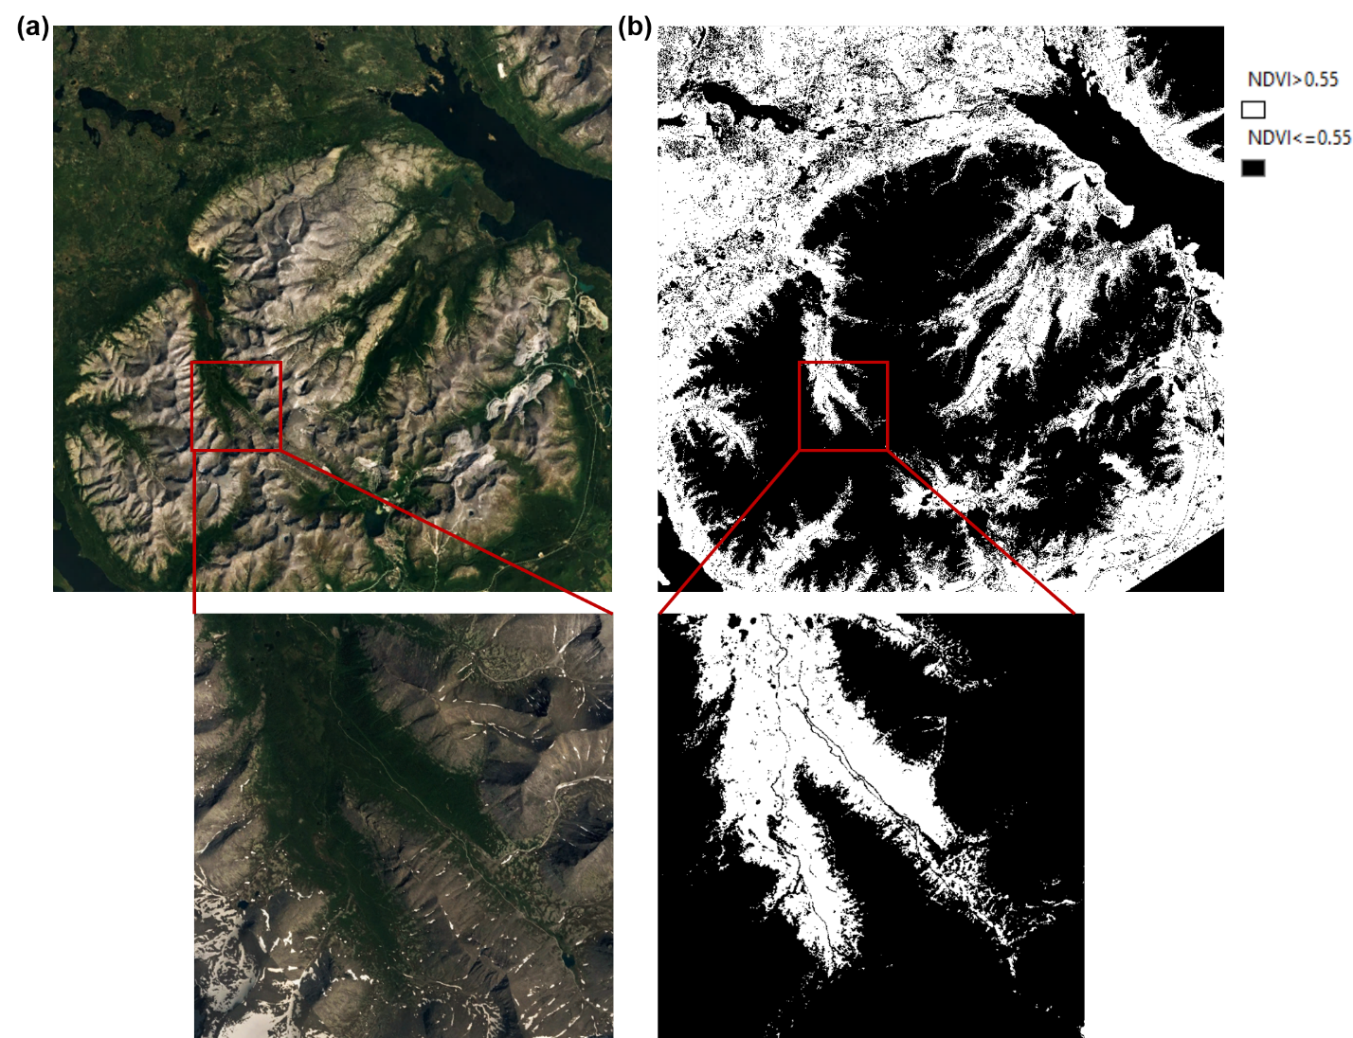
Figure 3 (a) Natural color composite of Sentinel-2 data over the study area; (b) the division of the Sentinel-2 NDVI map based on the 0.55 threshold. A subset is shown where the natural color image and division of NDVI values are compared.
It is worth mentioning that the windows derived using the above method still may include non-FTE windows. Firstly, windows which do not contain an FTE segment but still has detectable, small-scale forest-to-non-forest transitions (compared to the major transition at the FTE interface that dissects a window) may still exist. Typically, these windows are located within the tundra further upper slope from the FTE, and have islands or strips of trees inside and are thus selected by the transition detection process. Secondly, since the calculation of NDBI involves the 20m-resolution Band 11 of the Sentinel-2 image, the effectiveness of the derivation of build-up areas which include road networks is limited. Thin roads, which are also forest-to-non-forest transitions, are recognized and kept by the transition detection process. Therefore, the windows derived using the above three-step process will be referred to as only ‘potential’ FTE windows from here on. The two types of non-FTE windows will be referred to as the ‘upper slope’ windows and ‘road networks’ windows, respectively. However, due to their unique texture features, which will be discussed in the following section, these two types of non-FTE windows can be readily distinguished by the FOTO process and filtered out in the final classification process.

2.3. FOTO
The FOTO process was originally developed to monitor semi-arid vegetation and tropical forests and analyze their stand structure and canopy texture, which can be used to provide estimates for their above-ground biomass and carbon stocks (Couteron, 2002; Couteron et al., 2005; Barbier et al., 2006, 2010; Couteron, Barbier and Gautier, 2006; Proisy et al., 2007; Ploton et al., 2013). It systematically examines textural properties of the input image split into square windows to differentiate their spatial arrangements. In each window, the distribution of the portion of image variance explained by different spatial frequencies is examined through the 2-d spectral analysis process, which represents the scales of the spatial textures. The FOTO process then consolidates this textural information from all image windows to be used in the subsequent classification process to extract windows with different FTE forms.
For each potential FTE window, 2-d spectral analysis is performed to reveal the extent to which data contains periodicities at different spatial frequencies. It operates without prior assumption about the characteristics of the spatial patterns, and is suitable for use in the discovery of both orientation and scales of spatial patterns in remote sensing images (Renshaw and Ford, 1983; Mugglestone and Renshaw, 1998). It is achieved through the calculation of periodograms (Fourier transforms of the spatial autocorrelation function) of image windows which record the relative contribution to the Fourier approximation of the window by different wavelengths, i.e. the relative importance of textural components in different spatial scales (Couteron, Barbier and Gautier, 2006). In this study, the spatial frequency or wavenumber, which is the number of cycles a particular waveform is repeated in the image, is expressed as cycles per kilometer in order to make results from different window sizes comparable. For a certain n by n-pixel window whose size is s, Fourier decomposition is performed on a set of discrete harmonic wavelengths s/1, s/2, s/3, …, s/p, …, s/$p_{max}$, the smallest of which s/$p_{max}$=2s/n corresponds to the Nyquist frequency of n/2. For a particular pair of wavenumbers (p,q) along the two Cartesian directions, the periodogram value is calculated based on the Fourier coefficients $a_{pq}$ and $b_{pq}$, or weights of cosine and sine waveforms, as follows:
$I_{pq}=n^{-2}\left(a_{pq}^{2}+b_{pq}^{2}\right)$ (4)
This is proportional to the image variance accounted for by the waveform (p,q). Since the objective of the analysis is to identify the distribution of scales of spatial patterns in the window, it is convenient to calculate periodogram values in the polar form. This form separates the spatial pattern into its scale, represented by the wavelength or frequency of the pattern, and its direction, which is not important for our analysis. Specifically, the periodogram in its polar form, $I_{rθ}$, represents the portion of the image variance that can be explained by waveforms having spatial frequency $r=\sqrt{p^{2}+q^{2}}$ travelling in direction $θ=\tan^{-1}\left(p/q\right)$. Then, averaging the periodograms on all possible directions $θ$ yields the ‘radial’ spectrum, commonly referred to as the r-spectrum:
$I\left(r\right)={\left(kσ^{2}\right)}^{-1}\sum_{θ}{I_{rθ}}$ (5)
where k represents the number of periodogram values in bin r, and $σ^{2}$ is the image variance (Couteron, Barbier and Gautier, 2006). The r-spectrum of an image subset dominated by coarse textures will skew towards small frequencies, whereas that with mainly fine textures will be more uniform. The actual shape of the r-spectrum curve is further dependent upon the significance of intermediate textural components. A successfully delineated FTE window would have the majority of the variance concentrated in r = 1, i.e. the transition from forest to non-forest having the wavelength of half the window size, and the degree of fragmentation of the interface determines the importance of variances from other smaller wavelengths.
To illustrate the r-spectrum analysis, the r-spectra of image windows (1000m wide) with typical, contrasting landscape types are shown in Figure 4. These include FTE windows (abrupt: Figure 4(a); diffuse: Figure 4(b)) and the above mentioned two types of non-FTE windows (upper slope: Figure 4(c); road networks: Figure 4(c)).
- For the abrupt FTE window, spatial patterns at r = 1 have a distinctively higher r-spectrum value than larger wavenumbers, forming a strongly negatively skewed r-spectrum curve. This indicates that the pattern that dissect the window accounts for the majority of the total window variance, corresponding well with the abruptness of the interface.
- The diffuse FTE window features a flatter curve than that of the abrupt FTE window, but the first wavenumber still accounts for the highest portion of the total variance. This represents the window-scale forest-to-non-forest transition that is the FTE, with the transition being patchier and more gradual, thus showing more of the total variance distributed into patterns at higher spatial frequencies. The r-spectrum spikes at r = 7 and 12 presumably correspond to the major forest patches at these wavenumbers.
- The upper slope window lies within the tundra area next to the FTE (Figure (c1)), and is dominated by transitions smaller in scale than r = 1. Therefore, it has the most even r-spectrum values across all wavenumbers, indicating that spatial patterns of different spatial frequencies constitute the total variance in similar portions.
- The prominent features in the road networks window are the two roads crossing the frame, the combined width of which creates the peak at r = 3 in the r-spectrum curve. Spatial patterns at the rest of the spatial frequencies account for much less of the total variance and thus have low r-spectrum values.
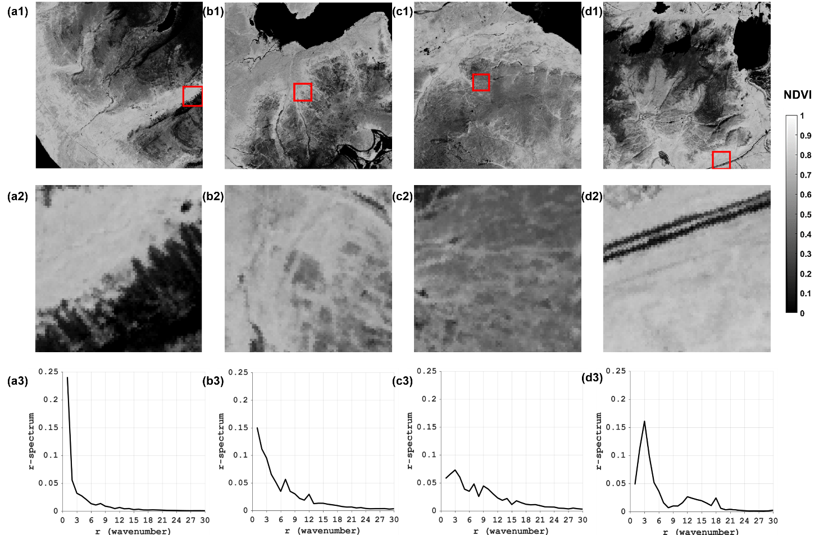
Figure 4 Locations of example windows containing contrasting landscapes (marked by red squares, a1-d1), example windows displayed with NDVI values (a2-d2), and their r-spectra (a3-d3). (a) abrupt FTE; (b) diffuse FTE; (c) upper slope; (d) road networks.
An ‘ordination’ process then repeats 2-d spectral analysis in all potential FTE windows and investigates their r-spectra in a systematic way, which enables the categorization of their spatial textures into different levels of fragmentation. R-spectra of all windows are organized in a table in which their values are stored in pre-specified bins of spatial frequencies (therefore r-spectra as observations and the spatial frequencies as individual variables). The table is then fed into a PCA process that converts the set of r-spectra into principle components (PCs) which are linearly uncorrelated. The values of these PCs at the original wavenumbers, or the PC scores, are then extracted. The positions of these windows on the space formed by the PC score axes suggest their spatial arrangements, and can be used to classify the windows. The FOTO process is performed in MATLAB, except for the PCA analysis which is conducted in SPSS (IBM Corp, 2017). For consistency, for all window sizes only the first 15 wavenumbers are used for PCA (for a window size of 1000m, r = 15 corresponds to textural components with a wavelength of 66.66m). The FOTO process relies only on the determination of the significance of variations in different spatial scales, and is thus capable of detecting transitional interfaces in different directions and different placements within the windows.

2.4. Supervised classification
In the final step, supervised classification is used to categorize all potential FTE windows using their r-spectrum PCA results. 100 windows are randomly selected from all potential FTE windows and their categories manually identified and recorded. ‘True’ FTE windows will be divided into two categories: diffuse and abrupt FTE windows. There is a continuum of ‘abrupt’ to ‘diffuse’ FTE windows with varying degrees of fragmentation, and in this study only those windows that have distinctive, clear-cut forest-to-non-forest boundaries in the sentinel-2 resolution are identified as abrupt FTE windows (such as the one in Figure 4(a2)) to be used to train the classifiers. Other FTE windows are classified generally as ‘diffuse’ FTE windows, which may correspond to the commonly recognized ‘diffuse’ or ‘island’ FTE forms, as stated earlier. The two types of potential FTE windows that do not actually contain an FTE segment will also be identified and eliminated. In summary, the following categorization scheme is used: 1 – abrupt FTE; 2 – diffuse FTE; 3 – upper slope; 4 – road networks. PCA scores of the first seven PC axes are extracted for classification. Also, descriptive statistics of each NDVI window are also calculated, including NDVI average, maximum, median, skewness and ratio of pixels with NDVI values larger than and smaller than the 0.55 threshold. These account for the statistical distinction between windows in different categories which enhances the classifiers’ ability to correctly separate them.
The selection of the optimal classifier incorporates all the above variables of the 100 windows as predictors, and their categories as response. Various supervised classification methods are tested for their performance within MATLAB’s Classification Learner environment (The MathWorks, 2016), which include nearest neighbor, decision trees, discriminant analysis, support vector machines, and various ensemble classifiers. For each window size, all the available classifiers are trained and compared according to their performances. Five-fold cross-validation is chosen for this study to prevent over-fitting, which splits the training data into five separate sets, and for each set trains the classifier using observations outside the set and assesses the performance using data within the set as validation. It repeats this training process for all five sets and calculates the average accuracy reported from the five runs as the final ‘predictive accuracy,’ which is an indicator of the potential classification accuracy achievable by a particular classifier if it was applied to the whole dataset. For each window size, the classifier producing the highest predictive accuracy is chosen to be the optimal classifier, and is used to classify the entire set of observations (potential FTE windows). Another 100 random windows are identified as validation windows based on which the ‘true’ classification accuracy is calculated. Thus, the desirability of each window size is assessed by both the predictive accuracy and true classification accuracy applied to the whole dataset, and the windows size producing the best outcome is chosen as the optimal window size, and is used to classify all the windows into the four categories. Windows classified into the last two categories (upper slope and road networks) are further eliminated, producing a final categorization of diffuse and abrupt FTE windows.

3. Results
3.1. FOTO
The results of the FOTO process for a window size of 1000m are shown in Figure 5 as an example. Scores of the first and second principal components are shown in Figure 5(a), which also shows the wavenumber that corresponds to the peak r-spectrum value (referred to as the ‘peak wavenumber’) for every window. R-spectrum values in most windows reach maximum at r = 1, suggesting the dominance of large-scale variations. This validates the effectiveness of the FTE window derivation process which successfully extracts windows mostly comprised of a transition from forest to non-forest that bisects the window. A rough trend can be observed in which points (windows) with maximum r-spectrum values at lower wavenumbers, i.e. windows dominated by large-scale variations, tend to concentrate towards SW of the axis plane. Towards the opposite (NE) direction, the peak wavenumber generally increases. This suggests an increasing importance of higher-frequency variations, which corresponds to the existence of non-FTE windows. This trend is only a qualitative illustration of the role of PCA in the window ordination process, and these two PCs do not represent full variability in the dataset. Also shown in Figure 5(b) are all the r-spectra of potential FTE windows stacked together illustrating their general forms and distribution, again showing the general dominance of low frequency variation in the windows. Other statistics derived from the PCA including the percentage of variance explained and eigenvalues of the PCs, as well as the relationship between component loadings and spatial frequencies are shown in Figure 5(c) and (d) as a reference.
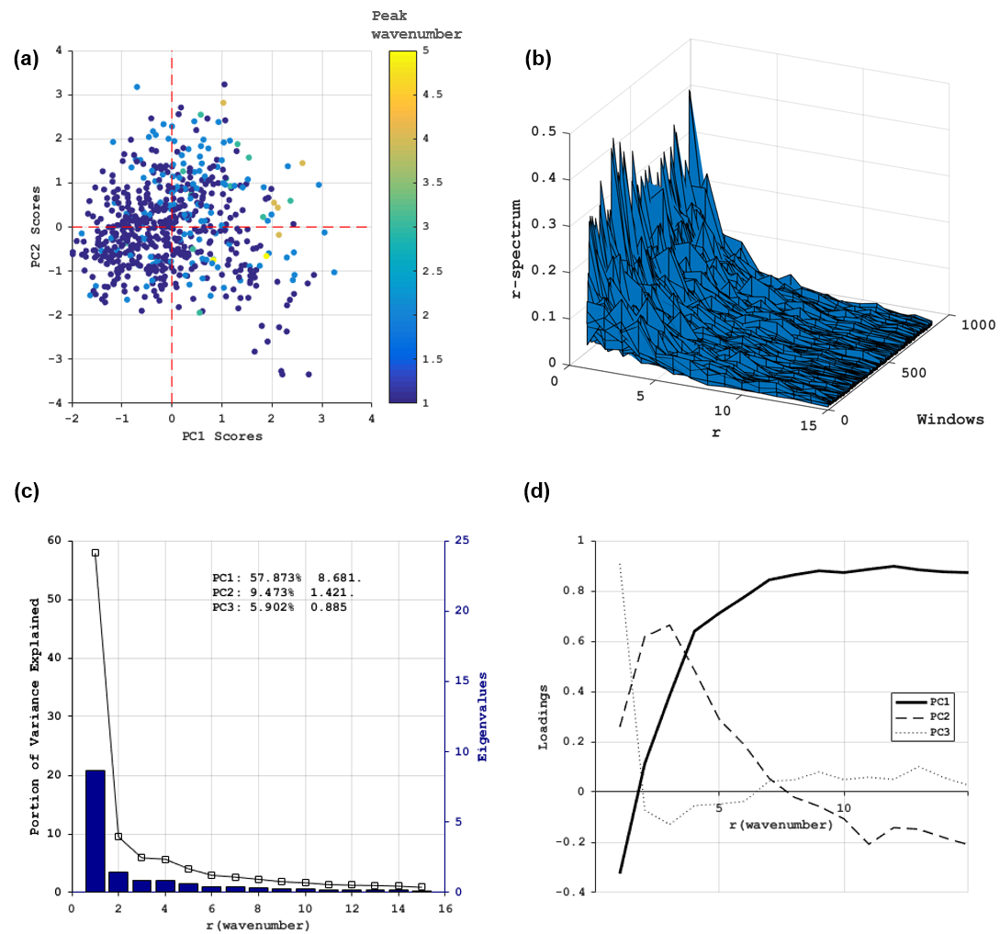
Figure 5 PCA results for window size 1000m. (a) PC1 scores vs PC2 scores color-coded by the wavenumber that contributes to the maximum variance (‘peak wavenumber’). (b) r-spectra for all windows. (c) Portion of variance explained (black line, left axis) and eigenvalues (blue bars, right axis) of the 15 wavenumbers. The two statistics of the first three components are listed in text. (d) Component loadings for the first three components.
The point cloud of PC1 scores vs. PC2 scores shows no distinct discontinuity, suggesting that the spatial configuration of the FTE is in a continuous gradient of fragmentation. In a given angular sector, however, windows located farthest from the axes’ origin (0,0) can be regarded as those that ‘typify’ the class of spatial configuration shown by windows within this particular sector (Couteron, Barbier and Gautier, 2006). On the plane formed by the first and second PC axes, these ‘typical’ sample image windows are extracted and displayed in each angular sector (Figure 6). A qualitative examination of corresponding angular sectors and typical image windows reveals a transition from windows with simple linear features (N) to complex linear networks (NE), majority to full coverage of vegetation patches (E/SE), emerging forest-non-forest transitions (S), clear, diffuse transitions (SW), gradually more abrupt transitions (SW/W/NW), and terrain features resembling linear features (NW/N). This example corresponds well with the above analysis of the peak wavenumbers in the PC1-PC2 plane. True FTE windows dominated by large-scale patterns (smaller peak wavenumbers) concentrate towards SW of the window, while upper slope and road networks windows with mainly smaller-scale variations (larger peak wavenumbers) concentrate towards the NE.
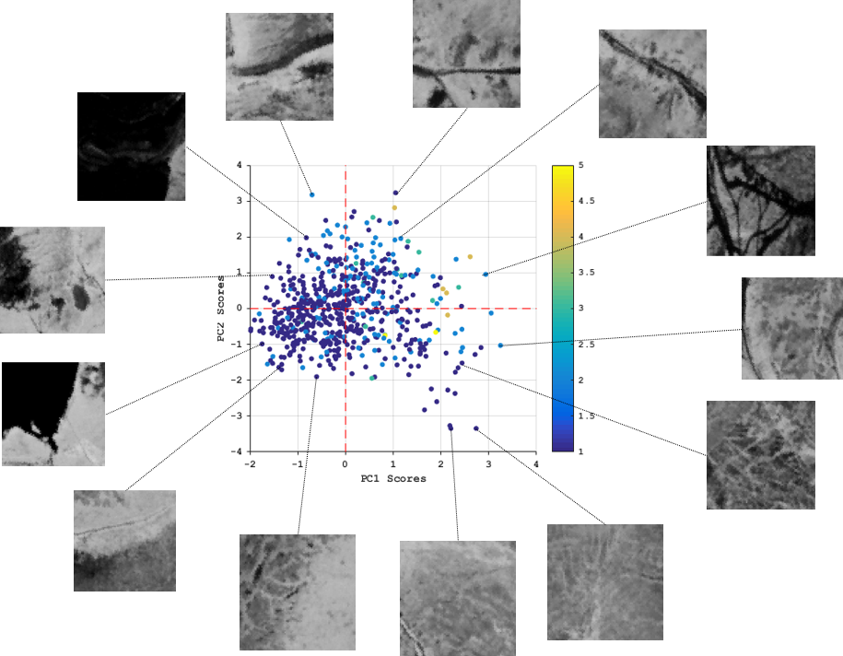
Figure 6 Example PCA result (PC1 vs. PC2) of window periodograms for window size 1000m and typical FTE spatial arrangements for each zone.
Certainly, the two PCs are not sufficient in representing the full textural variability of all the FTE windows (accounting for 67.35% of total variance for a window size of 1000m), but the PC1-PC2 plane does have angular sectors that have traceable correspondence to the distribution of image variance in different frequencies, which then corresponds to windows with different textural arrangements. Although this correspondence is not direct, it does show the capabilities of spectral analysis in capturing textural characteristics of image windows, and the ordination process in systematically consolidating the r-spectrum information from which windows with different spatial arrangements can be classified. With the seven PC axes (accounting for 88.42% of total variance for a window size of 1000m) and additional window descriptive statistics as input, the supervised classification procedure that follows is used to divide the potential FTE windows into the different categories.

3.2. Supervised classification
Table 1 shows the performance of supervised classification methods in classifying the potential FTE windows into the four categories. This is shown for different window sizes, with both highest predictive accuracies produced by the classification trainer and also true classification accuracies produced by the application of the optimal classifiers to the whole dataset.
Table 1 Highest predictive accuracies and true classification accuracies for different window sizes and corresponding optimal classifiers.
Window size (Sentinel-2 pixels / meters) | Highest predictive accuracy | Optimal Classifier | Classification accuracy | Kappa coefficient
60 pixels / 600m | 73.4% | Bagged trees | 80.0% | 0.47
70 pixels / 700m | 75.2% | Bagged trees | 82% | 0.52
80 pixels / 800m | 78.2% | Bagged trees | 87.0% | 0.65
90 pixels / 900m | 69.8% | Bagged trees | 77.0% | 0.39
100 pixels / 1000m | 70.8% | Bagged trees | 79.0% | 0.44
110 pixels / 1100m | 67.8% | Subspace discriminant | 62% | 0.01

The highest predictive accuracy is achieved when 800m-sized windows are used, reaching 78.2%. At the same window size, the maximum true classification accuracy also reaches maximum at 87%, with a kappa coefficient of 0.65. Bagged Trees (Breiman, 1996) is the optimal classifier for this window size and also the majority of the window sizes. It achieves higher performance through bootstrap aggregation, which generates multiple bootstrap replicas of the training dataset and yields an ensemble response by taking a plurality vote from predictions made by decision trees grown from these replicas. This approach has been shown to result in substantial gains in accuracy compared to single trees and is also more robust to perturbations in the learning dataset (Breiman, 1996). Thus, a window size of 800m is chosen for the final classification process using the trained Bagged trees classifier, the result of which is shown in Figure 7(a). The final classification map of FTE into the diffuse and abrupt windows is shown in Figure 7(b) whereby the two non-FTE categories are removed. The final classification result shows that the majority of altitudinal FTE in our study area is diffuse FTE, with the abrupt type scattered across the landscape, mostly within inner portions of the mountain range (Figure 7(b)).
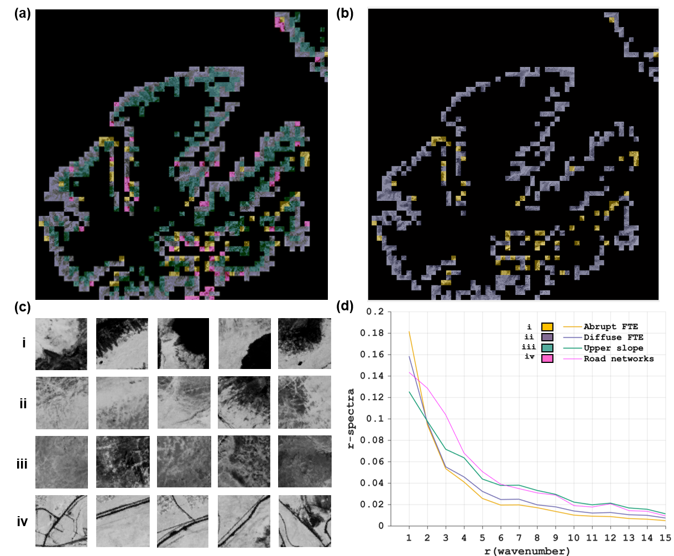
Figure 7 (a) Classification result; (b) the diffuse and abrupt FTEs; (c) typical windows of each class; (d) mean r-spectra for all windows classified as each class.
Figure 7(c) illustrations typical windows classified into each category, and Figure 7(d) shows the mean r-spectra for all windows in each category. Image windows from the four categories vary considerably in their mean r-spectra. Similar to the pattern observed in the example windows in Figure 4, the mean r-spectra of the two FTE classes (yellow and purple) have higher values at r = 1 than non-FTE classes, indicating larger portions of window variance explained by the window-scale transition from non-forest to forest. The mean r-spectra curves of FTE windows are below those of non-FTE windows at higher wavenumbers (r > 2), suggesting a lower contribution from small-scale patterns. Compared to diffuse FTEs, the mean r-spectra curve of abrupt FTEs shows a higher value at r = 1 and drops below at larger wavenumbers. This suggests a greater contribution from the transition that dissects the window and smaller contribution from smaller-scale transitions, corresponding well with the abruptness of the interface. The upper slope class (cyan) has the most even distribution among different frequencies, suggesting the most significant contribution from small scale variations in the windows, as expected. Comparatively, the road networks (magenta) class has larger r-spectrum values in the smallest wavenumber which are however smaller than the FTE classes, and has the highest r-spectra values from wavenumber 2 to 7 among all classes. This correctly represents the scale of the dominant spatial patterns in these windows, which are linear features and their combination as networks, accompanied occasionally by vegetation patches.

3.3. Application to additional study areas
The above FTE categorization method developed in the Khibiny Mountains region is used on altitudinal FTEs in more study areas to test its applicability. This study splits the circumarctic region into seven sub-regions following the scheme of Montesano et al. (2009). Longitudinal limits of each region are: Eastern Canada (ECA): 55°W–80°W; Central/Western Canada (CWCA): 80°W–130°W; Alaska (ALA): 130°W–170°W; Eastern Eurasia (EEU): 180°E–110°E; Central Eurasia (CEU): 110°E–60°E; Western Eurasia (WEU): 60°E–40°E; Scandinavia (SCA): 40°E–4°E. The Khibiny Mountains study area is in the SCA sub-region, and six additional study areas of similar sizes (approx. 50km by 50km) are chosen to test our FTE categorization method, one in each of the other six sub-regions. To streamline the data retrieval process and enhance the adaptability of our method, we explore the feasibility of vegetation and elevation data retrieval from the Google Earth Engine platform, hereafter referred to as GEE (Gorelick et al., 2017). The platform’s comprehensive remote sensing data storage and cloud-based geospatial analysis tools enable rapid data retrieval and pre-processing.
Cloud-free, growing season (1 June to 1 October) Sentinel-2 scenes intersecting with the study areas are mosaicked and downloaded, which are in Level 1C and are processed locally using the Sen2cor plugin from the Sentinel-2 Toolbox into Level 2A at-surface reflectance data. Multiple global DEM products are available in GEE including the Shuttle Radar Topography Mission (SRTM) Digital Elevation Data V3 (approx. 30m resolution), the ALOS Global DSM (approx. 30m resolution), and the ArcticDEM Mosaic (5m resolution). For each additional study area, the three DEM datasets are examined and the one that provides the most complete coverage and best spatial resolution is used as the elevation dataset. Preference is given to ALSO DSM over the SRTM DEM with other circumstances being equal due to generally higher accuracies of the ALSO DSM (Santillan and Makinano-Santillan, 2016). DEM data is also processed into slope rasters within GEE and downloaded, and subsequent TPI calculation is performed locally in MATLAB. Several TPI datasets are available in GEE including the ALOS multi-scale TPI (mTPI) and the SRTM mTPI, but are not used in this study due to their insufficient spatial resolution (270m).
For the developed method to be applied to the additional study areas, the NDVI threshold between forest and non-forest needs to be adjusted for these regions. This is completed with visual inspection of the Sentinel-2 imagery of the study areas, and are recorded in Table 2. Data retrieved from GEE is subjected to the FOTO and supervised classification processes locally with a window size of 800m, which is the derived optimal window size for FTE categorization at Sentinel-2 resolution. The FTE categorization results are displayed in Figure 8 where abrupt and diffuse FTEs are successfully recognized with respect to visual interpretation with accuracies recorded in Table 2, confirming the applicability of our method. In these additional study areas, visual assessment of the comparative placement of diffuse and abrupt FTE windows reveals no consistent, apparent spatial patterns.
Table 2 Parameterization and FTE classification results for the six additional study areas. Those for the Khibiny Mountains study area are listed as a reference.
 | SCA (Khibiny Mountains) | WEU | CEU | EEU | ALA | CWCA | ECA
Year of Sentinel-2 data | 2017 | 2017 | 2016 | 2017 | 2015 | 2017 | 2017
DEM product | ASTER GDEM v2 | ALOS DSM | ALOS DSM | ALOS DSM | ALOS DSM | ALOS DSM | ALOS DSM
NDVI threshold | 0.55 | 0.48 | 0.41 | 0.46 | 0.53 | 0.52 | 0.48
Highest predictive accuracy | 78.2% | 80.0% | 74.0% | 84.0% | 76.0% | 70.0% | 77.0%
Optimal Classifier | Bagged Trees | Quadratic Discriminant | Ensemble – Bagged Trees | Medium Gaussian SVM | Ensemble – Subspace Discriminant | Quadratic Discriminant | Ensemble – Subspace Discriminant
Classification accuracy | 87% | 83% | 80% | 85% | 79% | 76% | 82%
Kappa coefficient | 0.650 | 0.547 | 0.467 | 0.663 | 0.528 | 0.460 | 0.520

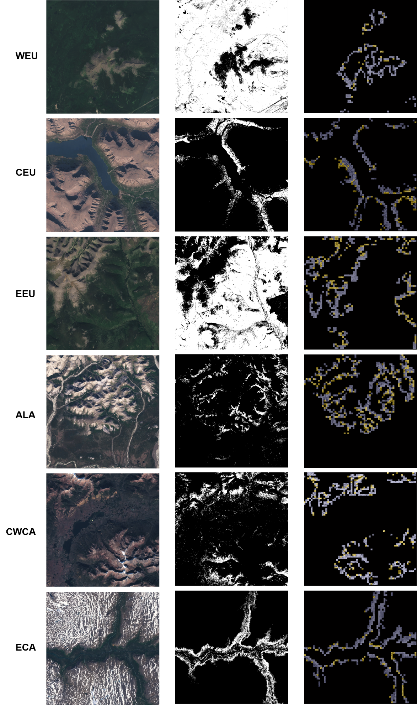
Figure 8 Sentinel-2 natural color composite (left panel), division of the Sentinel-2 NDVI map based on threshold determined for each study area (middle panel), and FTE categorization result, i.e. abrupt (yellow) and diffuse (purple) FTEs (right panel) for the six additional study areas.

4. Discussion
This study utilizes spectral analysis by two-dimensional Fourier transform which models the data as the weighted sum of cosine and sine waveforms of different directions and frequencies, thus characterizing the relative importance of textural components in different wavelengths (Couteron, Barbier and Gautier, 2006). This directly relates to the distinction between different FTE forms having different degrees of fragmentation. Although focused on the categorization of altitudinal FTEs in part of the Khibiny Mountain region, this study aims at deriving an FTE categorization method that is easily transferable to be used in other regions. Measures are taken to ensure the adaptability of our method. This study uses widely available global imagery and DEM products, and data retrieval and pre-processing can be further streamlined through the GEE platform. The only human input is the identification of training and validation datasets, and the NDVI thresholds to separate forest from non-forest which is used as an extra limitation of the scope of analysis and is a non-essential part for the FOTO-classification process. The FOTO method is also a robust approach in distinguishing between interface configurations in that it recognizes different degrees of FTE fragmentation regardless of the direction of the FTE, only considering the contribution of spatial patterns in different wavelengths to the total image variance.
Spatial scale, both in terms of the spatial resolution of the data used and the extent of the study area and image windows relative to the FTE, is key in this study in two ways. Firstly, it is crucial in the conceptual differentiation between different FTE forms, since the abruptness and diffuseness of the FTE are relative concepts dependent on the scale of observation. An FTE can seem abrupt judging from imagery in one spatial resolution but become diffuse when observed from a higher resolution, and further look like islands of individual canopies if further zoomed in. This study separates diffuse and abrupt FTEs based on the degree of fragmentation at the FTE interface using a windowing approach on Sentinel-2 imagery, with window sizes ranging from 600m to 1100m. At this spatial extent and resolution, individual trees cannot be resolved, and the abruptness of the interface is evaluated based on the sizes of vegetation patches formed by a minimum of 10m by 10m Sentinel-2 pixels. Secondly, scale is important as a parameter in the experiment workflow. In segmenting the image into windows of interest for FOTO, it is crucial to determine an appropriate window size in which the FTE segment can be reliably categorized into the correct form. The highest resolvable frequency of spatial pattern in a window (the Nyquist frequency) is half the window length (pixels), and variability belonging to higher frequencies is forced into lower frequencies and thus confounding them (Renshaw and Ford, 1983). Therefore, the window should be large enough to include all patterns of interest, and small enough so that small-scale variations can be properly recognized by the spectral analysis, thus the selected window sizes.

4.1. Future work
As discussed above, universal adaptability is an emphasis in the development of our FTE categorization method. Therefore, the use of the method can be expanded in several ways in future studies. Firstly, our method can be applied to studies of altitudinal FTEs where image products with a higher resolution than the Sentinel data are available, e.g. very-high resolution satellite and UAV imagery, etc. The FTE classes in this study do not correspond directly to the currently conventional terminology of the FTE ‘forms,’ but methodologically achievable and ecologically meaningful, nevertheless. In cases where individual trees are resolvable, it is potentially feasible to distinguish between island and diffuse FTEs, or even extending the categorization of FTE forms to four to six FTE categories depending on the diversity of cover types, relative area of classes, local heterogeneity and mixture of classes, as proposed by previous studies (Joseph, Anderson and Tatham, 1987; Baker and Weisberg, 1995; Allen and Walsh, 1996). In this case DEMs with equivalent spatial resolution will also be required for the delineation of potential FTE locations.
Secondly, the data availability and computing powers of the GEE platform can enable efficient application of our FTE categorization method to altitudinal FTEs in the circumarctic region. Also, based on altitudinal FTEs categorized using our method, further experiments can be conducted to examine the detailed statistical relationship between the categorization of the FTE and its historical movement records, thus evaluating the correspondence between FTE spatial configuration and sensitivity to climate change. The data collection process can be further expedited with future availability of Sentinel 2A products in GEE whereby the normalized difference indices used in this study can be directly calculated on the platform and downloaded as GeoTIFF files. With future improvements on the spatial resolution and coverage of global DEM products, cloud computation of the TPI to constrain the FTE analysis will also be feasible. Improvements on the spatial resolution of ready-made global TPI dataset can also be helpful in this regard. Moreover, since the DEM only serves to eliminate topographic positions where altitudinal FTEs are unlikely to occur, most of our FTE categorization method relies on the examination of imagery data. Therefore, larger-scale, latitudinal FTEs can also be examined using our method, in which case the DEM will not be needed. For the examination of latitudinal FTEs at such spatial scales, global satellite vegetation products at coarser resolution than the Sentinel-2 data can potentially be utilized, e.g. the Vegetation Continuous Fields (VCF) dataset at both Moderate Resolution Imaging Spectroradiometer (MODIS) and Landsat resolution (250m and 30m, respectively).
Finally, the conventional FTE categorization scheme is worth further investigation. The structural approach to the FTE categorization problem is unreliable due to several reasons. First, the delineation of vegetation patches required for FTE categorization is sensitive to the radiometric differences in image scenes in different study areas. Our approach, however, only examines the relative importance of spatial patterns in different spatial frequencies in constituting the image, and is thus tolerant of discrepancies in radiometric values and free from the need to derive variable thresholds for patch derivation. Second, the existence of continuously varying sizes of vegetation patches in FTEs limits the viability of the structural approach. Although it is helpful to clarify general patterns of the relationship between FTE spatial configuration and dynamics by introducing the ‘form’ concept, the discrete division of the FTE is contradictory to the continuous range of degrees of vegetation fragmentation in the interface. A categorical representation of the spatial patterns risks losing significant between-class variabilities and hence true heterogeneity. Therefore, the ‘form’ concept is a constructive but incomplete step towards the goal of mapping FTE sensitivity.
The paradigm shift in landscape ecology from the classic patch mosaic model to the landscape structure gradient model offers a useful hint to this problem (McGarigal and Cushman, 2005). Instead of following the current categorization of the FTE, it can be helpful to place its spatial structures into a continuum of various degrees of fragmentation, which can potentially be related to also a continuous spectrum of FTE response to climate change. Inevitably, dissolving the full range of spatial characteristics of the FTE into a single ‘fragmentation’ metric leads to loss of information, as only the comparative prominence of different scales of spatial patterns is preserved. Also, the correspondence between the interface fragmentation of FTEs and their shift in position remains to be validated through rigorous experiment and validation, e.g. examination of these two variables in altitudinal FTEs where historical records of interface movements are available. Nevertheless, the observed relationship between altitudinal FTE forms and dynamics suggests that there are traceable linkages between FTE sensitivity to climate change and its spatial configuration, of which the degree of fragmentation is the most prominent and relevant feature, as it accounts for the primary difference in physical appearance between different FTE forms. Identifying the underlying reasons for differences in the positions of the different FTE forms would be a valuable future development of this work.
Therefore, the ability to map the FTE interface along a continuous spatial structural gradient can potentially provide a useful visualization of FTE sensitivity to climate change, if the correspondence between the two variables can be validated. The map can also serve as a baseline for further studies into the detailed correlation between other FTE processes and spatial structure. Our method examines the relative importance of patterns in different spatial scales, and is thus directly applicable in this context. The shift to a continuous scheme of FTE spatial configuration, for example a fragmentation index, also opens up possibilities of utilizing a wide range of new analytical tools including surface metrology, fractal analysis, spectral and wavelet analysis, and other gradient-based techniques (McGarigal & Cushman 2005).

5. Conclusions
Accurate characterization of the spatial configuration of the FTEs has great ecological significance and is crucial for the identification of the spatial pattern of FTE sensitivity to shift with climate change. Aimed at understanding the spatial distribution of FTE forms, this study proposes a systematic categorization method of the altitudinal FTE using satellite imagery. This study firstly delineates transitions from forest to non-forest in the study area, and then performs spectral analysis of image windows intersecting with these transitions, examining the extent to which the spatial characteristics of the window can be explained by the relative importance of changes in harmonic spatial frequencies. Systematic window ordination is then performed, and finally supervised classification is conducted from which windows with different spatial configurations are separated and FTE categories recognized. Although focused on the Khibiny Mountain region, the FTE categorization method is universally adaptable, requiring minimal expert knowledge input and change of parameters. This allows our method to be used to examine altitudinal FTEs in different parts of the circumarctic region, and also potentially large-scale latitudinal FTEs. The adaptability of the developed method is validated by its successful application in other study areas around the circumarctic region. In all study areas, altitudinal FTEs are categorized into abrupt and diffuse types with satisfactory accuracies, which corresponds to different levels of FTE sensitivity to climatic forcing. This provides an opportunity to understanding the ecological heterogeneity and complexity of the ecotone, and offers a baseline for the assessment of the relative importance of different influencing factors in FTEs. The mapping of different FTE forms through the application of our method in a wider spatial and temporal range can potentially provide indication to the spatial distribution of in FTE sensitivity to climate change, thus helping future modelling efforts by providing information on the interactions between vegetation dynamics and climatic forcing.

Acknowledgement
W.G. acknowledges financial support by the Cambridge Trust, Trinity and Fitzwilliam colleges, University of Cambridge and the Chinese Scholarship Council. W.G. expresses his immense gratitude towards the handling editor and the anonymous reviewers for their time and attention which helped the authors achieve a clear and relevant presentation of the research materials.

References
Allen, T. R. and Walsh, S. J. (1996) ‘Spatial and compositional pattern of alpine treeline, Glacier National Park, Montana’, Photogrammetric Engineering and Remote Sensing, 62(11), pp. 1261–1268. Available at: http://www.asprs.org/a/publications/pers/96journal/november/1996_nov_1261-1268.pdf.
Baker, W. L. and Weisberg, P. J. (1995) ‘Landscape Analysis of the Forest-Tundra Ecotone in Rocky Mountain National Park, Colorado’, The Professional Geographer. Blackwell Publishing Ltd, 47(4), pp. 361–375. doi: 10.1111/j.0033-0124.1995.00361.x.
Barbier, N. et al. (2006) ‘Self-organized vegetation patterning as a fingerprint of climate and human impact on semi-arid ecosystems’, Journal of Ecology, 94(3), pp. 537–547. doi: 10.1111/j.1365-2745.2006.01126.x.
Barbier, N. et al. (2010) ‘The variation of apparent crown size and canopy heterogeneity across lowland Amazonian forests’, Global Ecology and Biogeography, 19(1), pp. 72–84. doi: 10.1111/j.1466-8238.2009.00493.x.
Breiman, L. (1996) ‘Bagging predictors’, Machine Learning, 24(2), pp. 123–140. doi: 10.1007/BF00058655.
Callaghan, T. V, Werkman, B. R. and Crawford, R. M. M. (2002) ‘The Tundra-Taiga Interface and Its Dynamics: Concepts and Applications’, Ambio Special Report, (12), pp. 6–14. doi: 10.2307/25094570.
Couteron, P. (2002) ‘Quantifying change in patterned semi-arid vegetation by Fourier analysis of digitized aerial photographs’, International Journal of Remote Sensing, 23(17), pp. 3407–3425. doi: 10.1080/01431160110107699.
Couteron, P. et al. (2005) ‘Predicting tropical forest stand structure parameters from Fourier transform of very high-resolution remotely sensed canopy images’, Journal of Applied Ecology, 42(6), pp. 1121–1128. doi: 10.1111/j.1365-2664.2005.01097.x.
Couteron, P., Barbier, N. and Gautier, D. (2006) ‘Textural ordination based on fourier spectral decomposition: A method to analyze and compare landscape patterns’, Landscape Ecology, 21(4), pp. 555–567. doi: 10.1007/s10980-005-2166-6.
Crawford, R. M. M., Jeffree, C. E. and Rees, W. G. (2003) ‘Paludification and Forest Retreat in Northern Oceanic Environments’, Annals of Botany, 91(2), pp. 213–226. doi: 10.1093/aob/mcf185.
Esper, J. and Schweingruber, F. H. (2004) ‘Large-scale treeline changes recorded in Siberia’, Geophysical Research Letters, 31(6), p. L06202. doi: 10.1029/2003GL019178.
Gamache, I. and Payette, S. (2005) ‘Latitudinal response of subarctic tree lines to recent climate change in eastern Canada’, Journal of Biogeography, 32, pp. 849–862. doi: 10.1111/j.1365-2699.2004.01182.x.
Gorelick, N. et al. (2017) ‘Google Earth Engine: Planetary-scale geospatial analysis for everyone’, Remote Sensing of Environment. The Author(s), 202, pp. 18–27. doi: 10.1016/j.rse.2017.06.031.
Haar, A. (1910) ‘Zur theorie der orthogonalen funktionensysteme’, Mathematische Annalen. Springer, 69(3), pp. 331–371.
Haralick, R., Shanmugan, K. and Dinstein, I. (1973) ‘Textural features for image classification’, IEEE Transactions on Systems, Man and Cybernetics, pp. 610–621. doi: 10.1109/TSMC.1973.4309314.
Harsch, M. A. et al. (2009) ‘Are treelines advancing? A global meta-analysis of treeline response to climate warming’, Ecology Letters, 12(10), pp. 1040–1049. doi: 10.1111/j.1461-0248.2009.01355.x.
Harsch, M. A. and Bader, M. Y. (2011) ‘Treeline form - a potential key to understanding treeline dynamics’, Global Ecology and Biogeography, 20(4), pp. 582–596. doi: 10.1111/j.1466-8238.2010.00622.x.
Holtmeier, K. (2010) ‘Altitudinal and polar treelines in the northern hemisphere Causes and response to climate change’, Polarforschung, 79(September 2009), pp. 139–153.
IBM Corp (2017) ‘IBM SPSS Statistics for Windows’. Armonk, NY: IBM Corp.
Jain, a K. and Farrokhnia, F. (1990) ‘Unsupervised texture segmentation using Gabor filters’, Systems, Man and Cybernetics, 1990. Conference Proceedings., IEEE International Conference on , 000, pp. 14–19. doi: 10.1109/ICSMC.1990.142050.
Jain, A. K. and Farrokhnia, F. (1991) ‘Unsupervised texture segmentation using Gabor filters’, Pattern recognition. Elsevier, 24(12), pp. 1167–1186.
Jenness, J. (2006) Topographic Position Index (TPI) v. 1.2.
Joseph, F., Anderson, R. E. and Tatham, R. L. (1987) Multivariate data analysis with readings. Macmillan Publishing Company.
K. Fletcher (2012) Sentinel-2: ESA’s Optical High-Resolution Mission for GMES Operational Services. Available at: https://sentinel.esa.int/web/sentinel/home.
Lloyd, A. H. (2005) ‘Ecological histories from Alaskan tree lines provide insight into future change’, Ecology, 86(7), pp. 1687–1695. doi: 10.1890/03-0786.
Masek, J. (2001) ‘Stability of boreal forest stands during recent climate change: evidence from Landsat satellite imagery’, Journal of biogeography, 28(8), pp. 967–976. doi: 10.1046/j.1365-2699.2001.00612.x.
Mathisen, I. E. et al. (2013) ‘Fifty years of tree line change in the Khibiny Mountains, Russia: advantages of combined remote sensing and dendroecological approaches’, Applied Vegetation Science, 17(1), pp. 6–16. doi: 10.1111/avsc.12038.
McFeeters, S. K. (1996) ‘The use of the Normalized Difference Water Index (NDWI) in the delineation of open water features’, International Journal of Remote Sensing, 17(7), pp. 1425–1432. doi: 10.1080/01431169608948714.
McGarigal, K. and Cushman, S. A. (2005) ‘The gradient concept of landscape structure’, Issues and perspectives in landscape ecology, (Wiens 1989), pp. 112–119. doi: 10.1017/CBO9780511614415.013.
Montesano, P. M. et al. (2009) ‘MODIS tree cover validation for the circumpolar taiga–tundra transition zone’, Remote Sensing of Environment, 113(10), pp. 2130–2141. doi: 10.1016/j.rse.2009.05.021.
Montesano, P. M. et al. (2016) ‘Spaceborne potential for examining taiga-tundra ecotone form and vulnerability’, Biogeosciences Discussions, (January), pp. 1–36. doi: 10.5194/bg-2015-575.
Mugglestone, M. A. and Renshaw, E. (1998) ‘Detection of geological lineations on aerial photographs using two-dimensional spectral analysis’, Computers and Geosciences, 24(8), pp. 771–784. doi: 10.1016/S0098-3004(98)00065-X.
Parida, P. and Bhoi, N. (2017) ‘Wavelet based transition region extraction for image segmentation’, Future Computing and Informatics Journal. Elsevier Ltd, 2(2), pp. 65–78. doi: 10.1016/j.fcij.2017.10.005.
Payette, S., Fortin, M.-J. and Gamache, I. (2001) ‘The Subarctic Forest–Tundra: The Structure of a Biome in a Changing Climate’, BioScience. Oxford University Press, 51(9), pp. 709–718.
Ploton, P. et al. (2013) ‘Canopy Texture Analysis for Large-Scale Assessments of Tropical Forest Stand Structure and Biomass’, in Lowman, M., Devy, S., and Ganesh, T. (eds) Treetops at Risk: Challenges of Global Canopy Ecology and Conservation. New York, NY: Springer New York, pp. 237–245. doi: 10.1007/978-1-4614-7161-5_24.
Proisy, C. et al. (2007) ‘Monitoring canopy grain of tropical forest using Fourier-based textural ordination (FOTO) of very high resolution images’, International Geoscience and Remote Sensing Symposium (IGARSS), (December 2016), pp. 4324–4326. doi: 10.1109/IGARSS.2007.4423808.
Ranson, K. J., Montesano, P. M. and Nelson, R. (2011) ‘Object-based mapping of the circumpolar taiga–tundra ecotone with MODIS tree cover’, Remote Sensing of Environment. Elsevier B.V., 115(12), pp. 3670–3680. doi: 10.1016/j.rse.2011.09.006.
Renshaw, E. and Ford, E. D. (1983) ‘The Interpretation of Process from Pattern Using Two-Dimensional Spectral Analysis : Methods and Problems of Interpretation’, Journal of the Royal Statistical Society. Series C (Applied Statistics), 32(1), pp. 51–63.
Santillan, J. R. and Makinano-Santillan, M. (2016) ‘Vertical accuracy assessment of 30-M resolution ALOS, ASTER, and SRTM global DEMS over Northeastern Mindanao, Philippines’, International Archives of the Photogrammetry, Remote Sensing and Spatial Information Sciences - ISPRS Archives, 41(July), pp. 149–156. doi: 10.5194/isprsarchives-XLI-B4-149-2016.
Sveinbjörnsson, B., Hofgaard, A. and Lloyd, A. (2002) ‘Natural causes of the tundra-taiga boundary.’, Ambio Special Report, (12), pp. 23–29. doi: 10.2307/25094572.
The MathWorks, I. (2016) ‘Classification Learner’. Natick, Massachusetts, United States.
Vlassova, T. K. (2002) ‘Human impacts on the tundra-taiga zone dynamics: the case of the Russian lesotundra’, Ambio Special Report, (12), pp. 30–36. Available at: http://www.ncbi.nlm.nih.gov/entrez/query.fcgi?cmd=Retrieve&db=PubMed&dopt=Citation&list_uids=12374057.
Weiss, a (2001) ‘Topographic position and landforms analysis’, Poster presentation, ESRI User Conference, San Diego, CA, 64, pp. 227–245. doi: http://www.jennessent.com/downloads/TPI-poster-TNC_18x22.pdf.
Wiegand, T. et al. (2006) ‘Abrupt population changes in treeline ecotones along smooth gradients’, Journal of Ecology, 94(4), pp. 880–892. doi: 10.1111/j.1365-2745.2006.01135.x.
Zha, Y., Gao, J. and Ni, S. (2003) ‘Use of normalized difference built-up index in automatically mapping urban areas from TM imagery’, International Journal of Remote Sensing, 24(3), pp. 583–594. doi: 10.1080/01431160304987.

List of Figure Captions
Figure 1 (a) Location of the study area; (b) natural color composite (bands 4, 3 and 2 as RGB) of Sentinel-2 data over the study area.

Figure 2 The potential FTE window delineation process. Red dashed boxes indicate the three main steps.

Figure 3 (a) Natural color composite of Sentinel-2 data over the study area; (b) the division of the Sentinel-2 NDVI map based on the 0.55 threshold. A subset is shown where the natural color image and division of NDVI values are compared.

Figure 4 Locations of example windows containing contrasting landscapes (marked by red squares, a1-d1), example windows displayed with NDVI values (a2-d2), and their r-spectra (a3-d3). (a) abrupt FTE; (b) diffuse FTE; (c) upper slope; (d) road networks.

Figure 5 PCA results for window size 1000m. (a) PC1 scores vs PC2 scores color-coded by the wavenumber that contributes to the maximum variance (‘peak wavenumber’). (b) r-spectra for all windows. (c) Portion of variance explained (black line, left axis) and eigenvalues (blue bars, right axis) of the 15 wavenumbers. The two statistics of the first three components are listed in text. (d) Component loadings for the first three components.

Figure 6 Example PCA result (PC1 vs. PC2) of window periodograms for window size 1000m and typical FTE spatial arrangements for each zone.

Figure 7 (a) Classification result; (b) and the diffuse and abrupt FTEs; (c) typical windows of each class; (d) mean r-spectra for all windows classified as each class.

Figure 8 Sentinel-2 natural color composite (left panel), division of the Sentinel-2 NDVI map based on threshold determined for each study area (middle panel), and FTE categorization result, i.e. abrupt (yellow) and diffuse (purple) FTEs (right panel) for the six additional study areas.

