**DIFFUSE TIBIOFEMORAL CARTILAGE CHANGE PRIOR TO THE DEVELOPMENT OF ACCELERATED KNEE OSTEOARTHRITIS: DATA FROM THE OSTEOARTHRITIS INITIATIVE**

**Matthew S. Harkey, PhD; Julie E. Davis, BS; Bing Lu, MD, DrPH; Lori Lyn Price, MAS, MLA; Charles B. Eaton, MD, MS; Grace H. Lo, MD, MSc; Mary F. Barbe, PhD; Robert Ward, MD; Ming Zhang, PhD; Shao-Hsien Liu, PhD, Kate L. Lapane, PhD; James W. MacKay, MRCP, FRCR; Timothy E. McAlindon, MD, MPH; Jeffrey B. Driban, PhD**

**Purpose:** At least 1 in 7adults who develop accelerated knee osteoarthritis (AKOA) receive a knee replacement at a median of 2.3 years from the first signs of radiographic progression. Hence, adults with AKOA present with a shortened window for intervention. Developing prognostic tools to detect who is at risk for incident AKOA is a critical step towards identifying optimal targets for disease prevention. Traditional compartmental articular cartilage assessments that provide a mean estimate of cartilage change throughout an entire region may fail to accurately describe longitudinal cartilage alterations since this approach combines cartilage locations that may experience either an increase or decrease in cartilage thickness. Therefore, we compared the spatial distribution of tibiofemoral cartilage change between adults who will develop AKOA versus typical knee osteoarthritis (KOA) prior to the development of radiographic KOA.

**Methods:** We conducted a longitudinal case-control analysis of 129 adults from the Osteoarthritis Initiative who had at least one radiographically normal knee at baseline (Kellgren-Lawrence [KL] grade < 1). Participants were classified based on rapidity of radiographic progression during the first 48 months: AKOA=KL progression to >3 within 12 months (n=44), typical KOA=any other KL increase (n=40), and No KOA=no change in KL grade (n=45). Using a semi-automated program, we assessed the percent change in tibiofemoral cartilage on a 3-dimensional dual-echo steady-state magnetic resonance sequence at 36 informative locations (Figure 1). The key timeframe was two to one year prior to the radiographic onset of AKOA or typical KOA. We operationally defined meaningful longitudinal cartilage change as a location experiencing: 1) > the 95th percentile change (i.e. largest cartilage thickening), or 2) < the 5th percentile change (i.e. largest cartilage thinning) in each respective location of the no KOA group. Operationally, an individual had diffuse cartilage change if at least half of the 4 tibiofemoral regions (i.e. medial/lateral tibia/femur) had a meaningful longitudinal change (i.e. increase, decrease) in multiple informative locations. We performed a binary logistic regression to determine if diffuse tibiofemoral cartilage change (predictor) was associated with group (AKOA or typical KOA). We qualitatively described the spatial patterns of tibiofemoral regions experiencing diffuse cartilage change in the AKOA and typical KOA groups. To compare spatial distribution of cartilage change, we determined the percentage of adults with AKOA and typical KOA presenting with any meaningful cartilage change (thickening or thinning), as well as separately for thickening and thinning, at each of the 36 informative locations and qualitatively described the differences in the spatial distribution of cartilage change between groups.

**Results:** Table 1 highlights the group demographics. There was a non-significant trend that adults with diffuse tibiofemoral cartilage change were 2.2 times more likely to develop AKOA when compared to adults who develop typical KOA (OR [95% CI] = 2.2 [0.90,5.14]). A greater percentage of adults with AKOA (13.6%; 6/44 total) presented with involvement in the entire medial tibiofemoral compartment (i.e. both femur and tibia) when compared to the adults with typical KOA (2.5%; 1/40 total; Figure 2). Cartilage damage change simultaneously occurring in the medial femur and lateral tibia represented the most common pattern of cartilage change in the AKOA group (27.3%; 12/44) and this pattern was less prevalent in the typical KOA group (12.5%; 5/40; Figure 2). The AKOA group had more locations (9/36) with >20% of adults experiencing any meaningful cartilage change compared to typical KOA (4/36) (Figure 3). When comparing the spatial distribution of meaningful cartilage change, the commonly affected informative locations (i.e. >10% of adults, Figure 2) infrequently overlapped between AKOA and typical KOA: overlapping thickening = 50% (i.e. 4/8), thinning = 35% (i.e. 5/14).

**Conclusions:** We found preliminary evidence that adults who develop AKOA may present with more diffuse and spatially heterogeneous pre-radiographic tibiofemoral cartilage change when compared to adults who develop typical KOA. These data suggest that AKOA may be a subset of KOA with different instigating structural events compared to typical KOA.

Table 1. Demographics at Two Years prior to the Index Visit

|  |  |  |  |
| --- | --- | --- | --- |
| Variable | **Accelerated Knee OA** *n=44* | **Typical Knee OA** *n=40* | **No Knee OA** *n=45* |
|
| **Age (years),** mean (SD) | 64.4 (8.7) | 57.6 (8.4) | 56.6 (7.5) |
| **BMI (kg/m2),** mean (SD) | 29.6 (4.9) | 28.9 (5.0) | 27.2 (5.2) |
| **WOMAC Pain,** mean(SD) | 1.4 (2.5) | 2.1 (3.0) | 1.8 (2.6) |
| **KL Grade 0**, n(%) | 12 (27%) | 23 (58%) | 30 (67%) |
| **Female**, n(%) | 29 (65%) | 27 (68%) | 29 (64%) |

OA = osteoarthritis, WOMAC = Western Ontario and McMaster’s Osteoarthritis Index; KL Grade 0 = Frequency of Kellgren-Lawrence Grade 0 (i.e. could only be 0 or 1)

Figure 1. Spatial Distribution of the 36 Informative Tibiofemoral Cartilage Locations. Three-dimensional representation of the informative locations on the femur (A) and tibia (B), as well as the two-dimensional (C) representative of these locations derived from the magnetic resonance images.

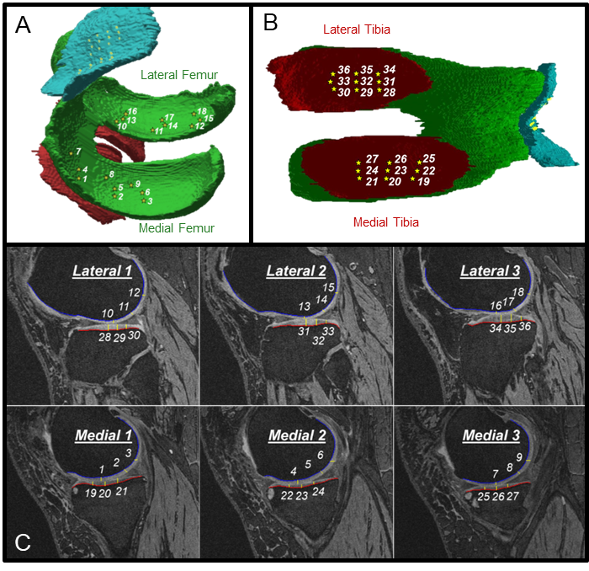

Figure 2. Different Patterns of Tibiofemoral Regions Experiencing Diffuse Cartilage Change Between Accelerated and Typical Knee OA Groups. Outlines the patterns of tibiofemoral compartment involvement and their frequency in adults with accelerated and typical knee OA with diffuse cartilage damage change. Shaded region indicates a region is experiencing multiple locations with cartilage change. M=medial, L=lateral, F=femur, T=tibia.



Figure 3. Heat Map Indicating the Percentage of Adults with Absolute Cartilage Change, Thickening, or Thinning at Each Tibiofemoral Informative Location. The number in each square corresponds to the informative location defined in Figure 1. Within each tibiofemoral compartment, top to bottom corresponds to anterior (A) to posterior (P) and left to right corresponds to medial (M) to lateral (L). Percentage of adults within each group demonstrating change: Green<10%; Yellow 10-20%; Red>20%.

