The impact of oxygen on the electronic structure of mixed-cation halide perovskites
Alexandra Szemjonov^{ǂ}, Krzysztof Galkowski§,¶, Miguel Anaya§, Zahra Andaji-Garmaroudi§, Tomi K. Baikie§, Sebastian Mackowski¶, Iain Baikie^{X}, Samuel D. Stranks§, M. Saiful Islam^{ǂ*}
^{ǂ}Department of Chemistry, University of Bath, BA2 7AY, UK
§Cavendish Laboratory, University of Cambridge, CB3 0EH, UK
¶Institute of Physics, Faculty of Physics, Astronomy and Informatics, Nicolaus Copernicus University, 87-100 Toruń, Poland
^{X}KP Technology Ltd, 12 A Burn Street, Wick KW1 5EH, Caithness, UK

Abstract: Alloyed triple A-cation perovskites containing a mixture of Cs, methylammonium (MA) and formamidinium (FA) cations are attracting intense attention because of their high photovoltaic performance and relative stability. However, there is limited fundamental understanding of their vacancy defect behaviour and influence of molecular oxygen on their electronic and stability properties. In this combined computational-experimental study, we investigate the (FA,MA,Cs)Pb(I,Br)₃ model system with its simulated atomistic structure presented for the first time and supported by X-ray diffraction data. We examine how iodide vacancies and O₂ molecules influence the local geometry and electronic structure. Our calculations, supported by Kelvin Probe contact potential difference and photoluminescence measurements, show that introduction of O₂ leads to a p-doped triple-cation perovskite, and passivates iodide vacancies resulting in enhanced luminescence efficiency. These results have important implications for the performance and stability of mixed-cation perovskites in optoelectronic devices.

Hybrid organic-inorganic halide perovskites have generated tremendous excitement in the field of photovoltaics and are starting to be considered as industrially deployable solar cell absorbers.^{1–7} Recently, the combination of Cs⁺, methylammonium (MA⁺) and formamidinium (FA⁺) at the A-site has proven to be particularly successful,^{8–11} giving improved thermal¹², moisture¹³ and photo-stability^{8,14} with respect to MAPbI₃. Furthermore, these mixed systems have higher crystalline quality,¹⁵ longer charge carrier lifetimes and diffusion lengths,¹² resulting in decreased charge recombination¹² and improved photocurrent over their MAPbI₃ counterparts.¹⁶ Mixed-cation perovskites have also been successfully incorporated into perovskite-silicon tandem devices with a photon-to-electron conversion efficiency of more than 26%.¹⁷
In order to exploit the full potential of perovskites, parasitic non-radiative charge carrier losses must be eliminated. Previous studies have suggested that there are sufficiently deep trap states in perovskites that still limit the sample photoluminescence quantum efficiency (PLQE) under carrier densities typical for an operating device.^{18–20} It was proposed that the effect of light and oxygen adsorption can significantly reduce the density of these trap states in MAPbI_{3.}^{20,21,22} Hence, oxygen and iodide vacancies are intrinsically important for the performance and stability of perovskite devices, so it is crucial to understand the effect they have on their properties.²³ However, the influence of iodide vacancies and oxygen have not been fully addressed for triple-cation perovskites, even though several of the highest performing, perovskite solar cells are based on these materials.^{24–26}
In this work, we examine the structural and electronic properties of triple-cation halide compositions using a combination of X-ray diffraction (XRD), density functional theory (DFT), Kelvin Probe contact potential difference (CPD) and photoluminescence (PL) techniques. We simulate the energetics of iodide vacancies and their occupation by O₂ species. Our computed band structures, impurity charge transition levels, CPD and photoluminescence measurements demonstrate that the introduction of O₂ molecules into vacancies leads to a p-doped perovskite material with enhanced luminescence. The work paves the way to a better understanding of the electronic properties of these alloyed perovskite systems.
First, in Figure 1 we show the XRD pattern of a solution-processed film of FA_{0.79}MA_{0.15}Cs_{0.06}Pb(I_{0.85}Br_{0.15})₃ (see Supporting Information (SI) for methods). This material has a lattice parameter of 6.22 Å assuming a cubic structure, which is slightly smaller than the values of 6.32-6.36 Å measured for α-FAPbI_{3,}^{27–29} as expected with the smaller Cs and MA cations at the A-site. In order to gain insight into these structural properties using a computationally feasible structure, we simulate a FA_{0.85}MA_{0.11}Cs_{0.04}PbI₃ model system. Our calculations indicate that the average energy differences between a range of A-site configurations shown in the SI (Figure S1, Table S1) were found to be negligible (of the order of a few meV), suggesting no long-range ordering in the pristine bulk structure. All subsequent calculations were performed on the lowest energy configuration shown in Figure 1b, with the Crystallographic Information File (CIF) available in the SI.
(a)
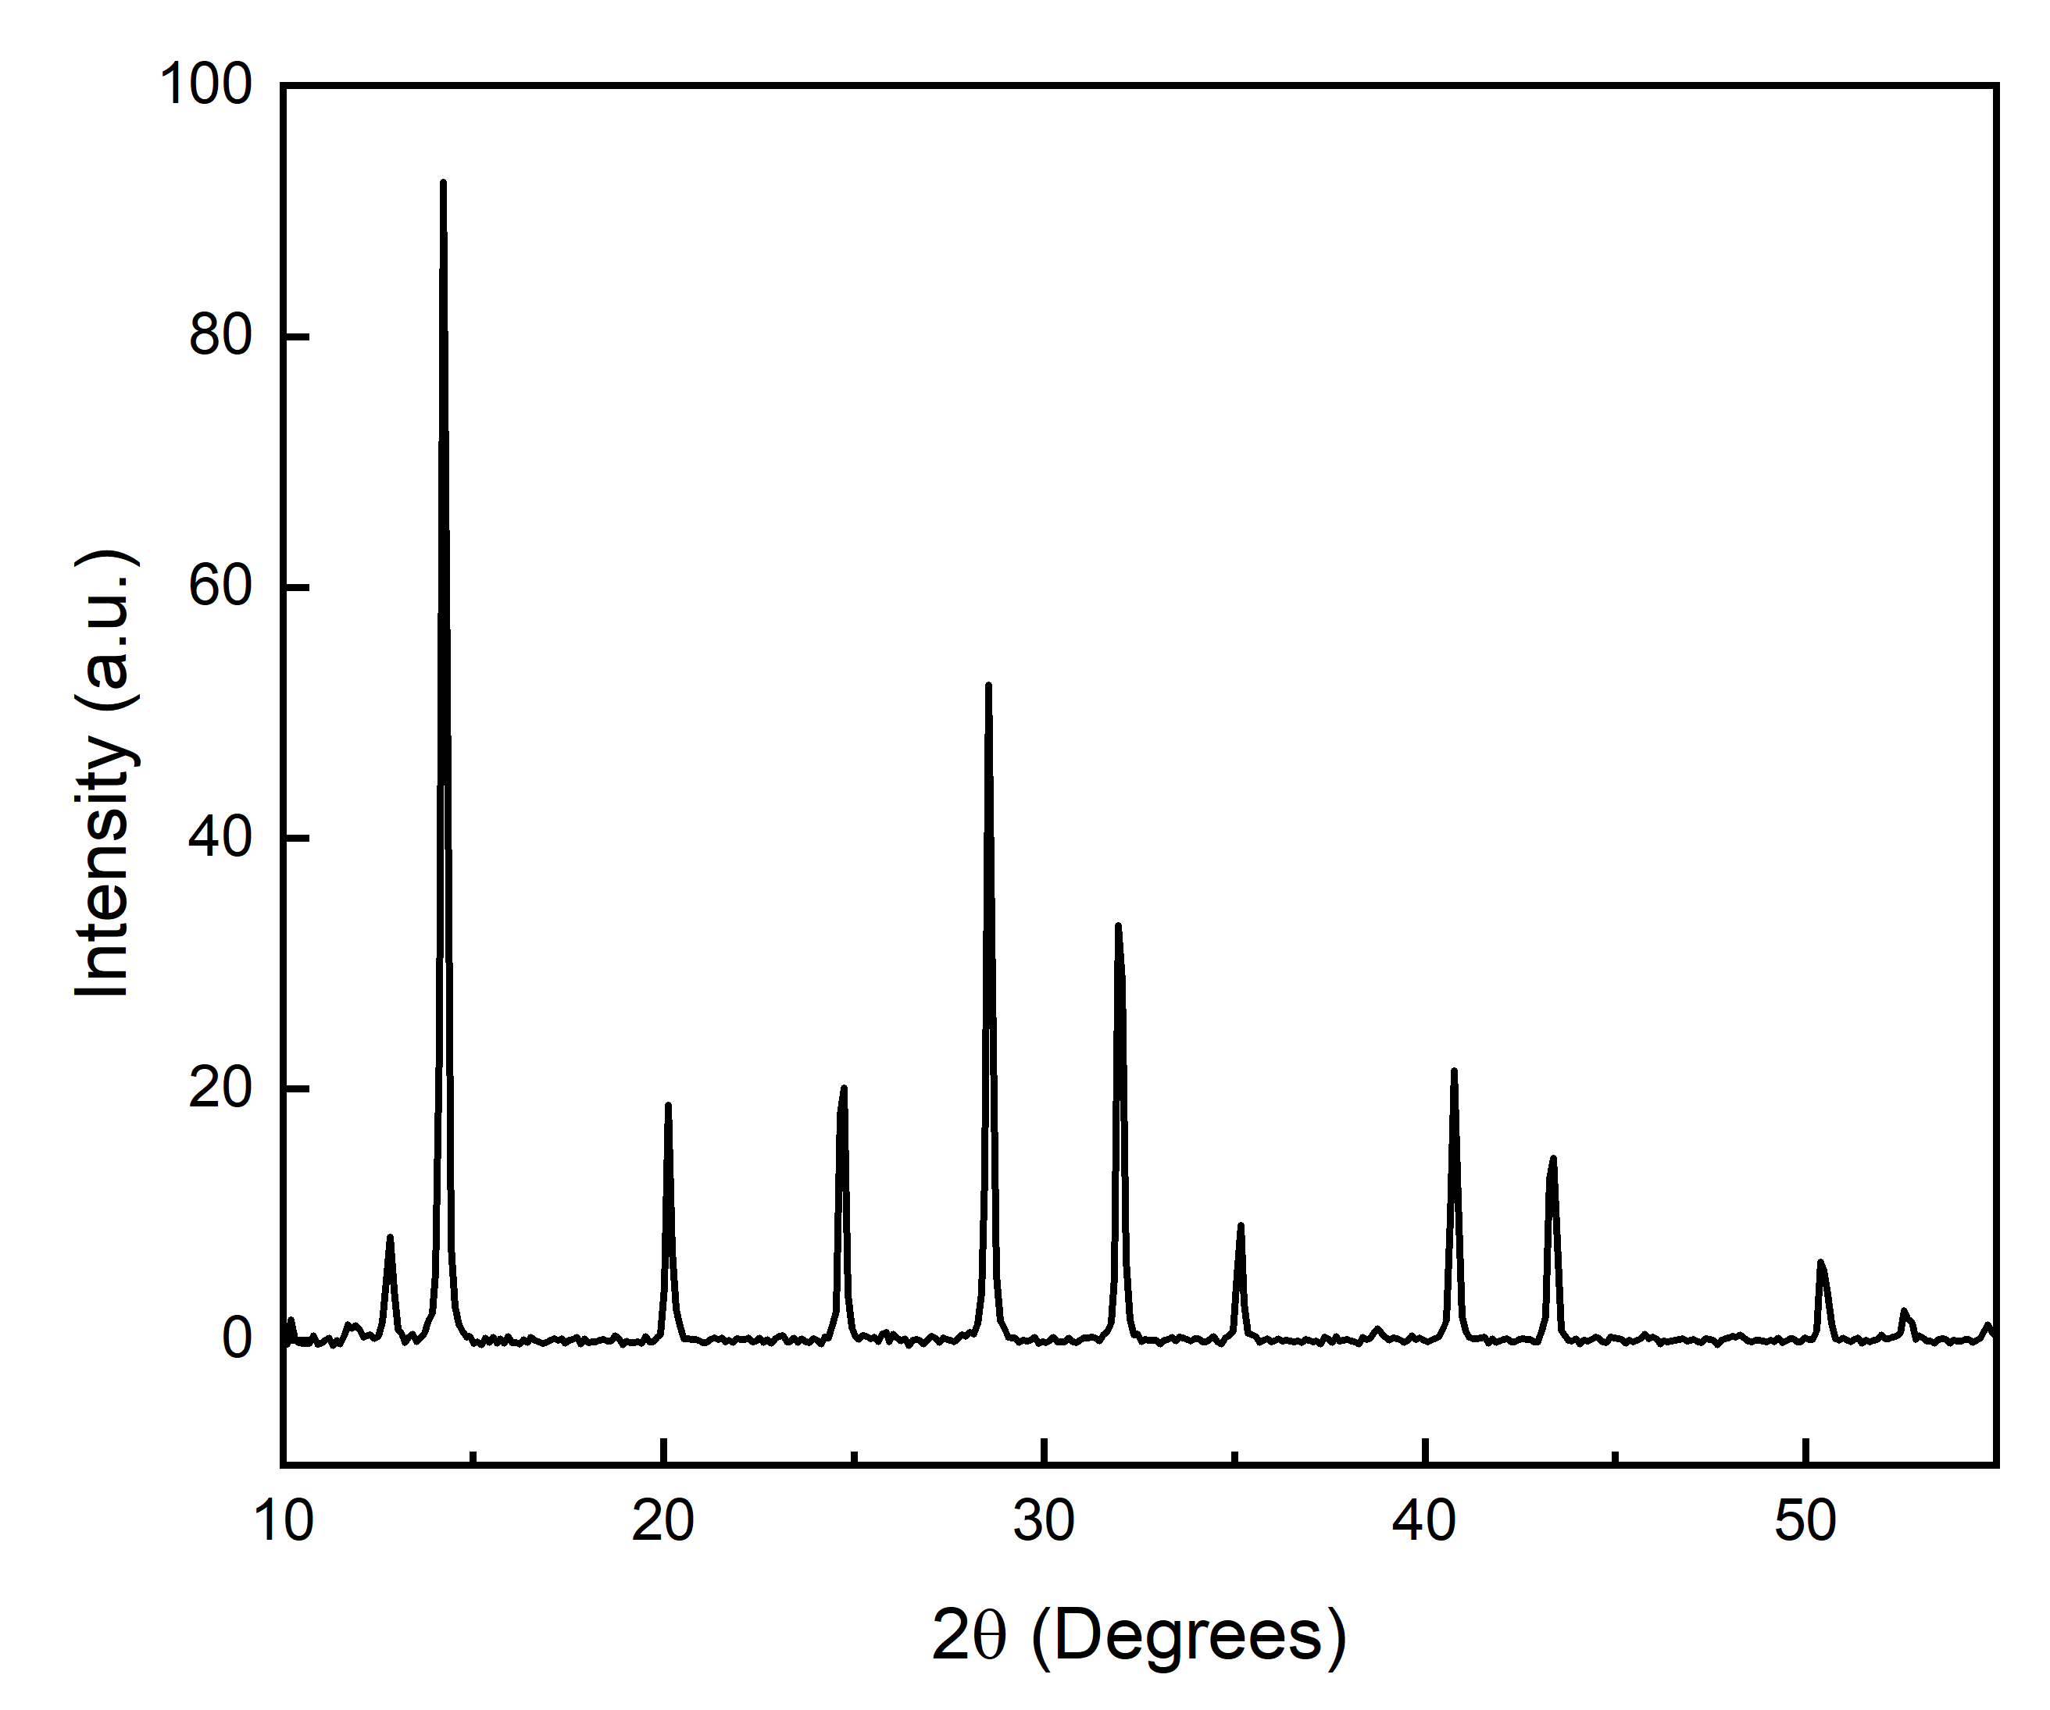
(b)
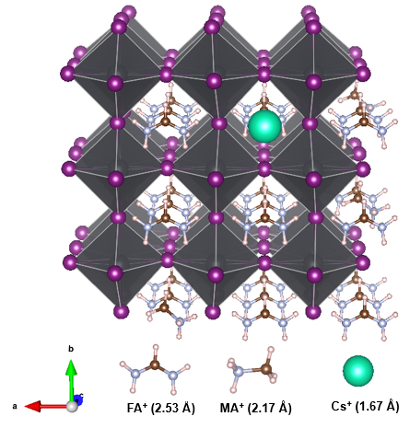
Figure 1. Structural properties. a). X-ray diffraction pattern of a FA_{0.79}MA_{0.15}Cs_{0.06}Pb(I_{0.85}Br_{0.15})₃ perovskite thin film. b) atomistic structure of the model FA_{0.85}MA_{0.11}Cs_{0.04}PbI₃ system showing PbI₆ corner-sharing octahedra with MA⁺, FA⁺ and Cs⁺ at A-sites. (The ionic radii of the A-site cations are indicated in brackets.)
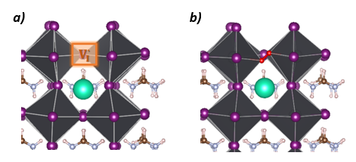
Figure 2. Local structure of FA_{0.85}MA_{0.11}Cs_{0.04}PbI₃ a) around the iodide vacancy site; b) iodide vacancy occupied with an O₂ molecule.
The optimized structure of the triple cation system is found to have an average cubic lattice parameter of 6.38 Å, thus providing a reasonable match to the experimental value and confirming the pseudo-cubic nature of the system. As expected, partial replacement of FA in the parent FAPbI₃ by the smaller MA reduces the lattice parameter.^{30,31,32,33} The incorporation of the even smaller Cs⁺ further reduces the lattice parameter,³⁴ and these trends are reproduced by previous computational work.³⁵
We now consider vacancies and oxygen in these triple-cation structures. From our ab initio modelling, we first found that the energetic differences between the structures containing iodide vacancies were negligible (of the order of 10 meV/perovskite unit), which suggests that the vacancies are distributed randomly in the triple cation system. The insertion of O₂ into a vacancy is shown in Figure 2. In the lowest energy configuration, the O₂ species is inclined with respect to the Pb-I-Pb axis, in which both of the oxygen atoms bonds to an adjacent Pb atom. We stress that calculations on the energetics at various lattice and vacancy sites in the MAPbI₃ structure⁴⁶ have found that the iodide vacancy is the most favourable for O₂ and superoxide species.
To investigate the impurity charge states of the iodide vacancy and the O₂ species occupying this vacancy, we adopted the method of Freysoldt et al³⁶ (as detailed in Section A of the SI). Our results suggest that the creation of an iodide vacancy introduces shallow donor-like electronic states into the bandgap of the triple-cation perovskite. When this vacancy is filled with O₂, the ε(+/0) and ε(0/-) charge transition levels for such incorporation shift to just above the valence band maximum (VBM) shown in Figure S3. We can thus conclude that the occupation of an iodide vacancy by an O₂ molecule results in acceptor-like states in the band gap. This is in agreement with the p-doping effect induced by the adsorption of O₂ on MAPbI₃ surfaces^{37,38}; moreover, we demonstrate here that this effect also occurs in triple-cation systems.
In accordance with these results, the band structures (Fig 3) indicate that, with respect to the pristine structure, an iodide vacancy introduces donor-like states near the bottom of the conduction band. The band structure in Figure 3c shows that an iodide vacancy occupied by O₂ creates electronic states of a different nature: acceptor-like states are now found near the top of the valence band in accord with previous work¹⁹ on MAPbI₃.
To gain further insights into the nature of the iodide vacancy, we plot the charge density at the trap state in Figure 4a, which corresponds to the conduction band minimum (CBM); this figure shows that the charge density is delocalized over the structure.³⁹ We also find that the Pb p-orbitals that dominate the CBM point towards each other in the vicinity of the vacancy. Previous work on halide perovskites such as MAPbI₃ with large Pb-Pb distances have revealed shallow halide vacancies.^{21,40,41} We can thus conclude that the FA_{0.85}MA_{0.11}Cs_{0.04}PbI₃ system also has shallow iodide vacancy states. However, when the vacancy is occupied by an O₂ molecule, the charge density becomes more localized, as shown in Figure 4b, and is consistent with the deeper character of the dopant states.³⁹
From analysis of the local structure in FA_{0.85}MA_{0.11}Cs_{0.04}PbI₃ (Figure 4b), the O-O distance of the O₂ species in the iodide vacancy is 1.31 Å. Interestingly, this value is close to the typical bond distance of a superoxide anion (O₂⁻) at around 1.28 Å.⁴² In addition, the O-O bond order is 1.59, in accord with the typical superoxide bond order (1.50).⁴³ These results therefore strongly suggest the superoxide-like character of the oxygen species in iodide vacancy sites of the triple-cation perovskite, demonstrating their electron scavenging behavior as found for oxygen in MAPbI₃.^{19,21,44,45} Such an oxide species is similar in size to the iodide ion, and effectively replaces the vacant site, thus restoring the full octahedral coordination around Pb.⁴⁶
To support these calculations, we investigate the impact of oxygen on the electronic properties (Fermi Level E_{F} and relative luminescence yields) of thin films of the experimental model perovskite FA_{0.79}MA_{0.15}Cs_{0.06}Pb(I_{0.85}Br_{0.15})₃. Due to the sensitive nature of these films, we first condition the films in dry nitrogen, which contain trace components of O₂ that can occupy vacancies (see Figure S5 for similar results in ambient air). We use CPD measurements in the dark to show that the surface Fermi level stabilizes at around -5 eV with respect to vacuum level (Fig. 5a), concomitant with reasonable photoluminescence intensities (Fig. 5b). Thus, these trace-O₂-exposed films reveal a deep position of the Fermi level with respect to typical VBM values (~ -5.4 eV⁴⁷), and p-type character, consistent with our calculations for acceptor-like character of the iodide-vacancy/oxygen complex states.
We subsequently apply high vacuum (HV, <10⁻⁶ mbar) in-situ to remove O₂ molecules from the film. As the pressure decreases the E_{F} increases in magnitude, shifting towards the CBM, and stabilizing in high vacuum at around -4.7 eV, which is ~0.3 eV above the oxygen-trace level (see inset Fig. 5a). This gradual change is attributed to the pressure-dependent O₂ desorption from the perovskite lattice.

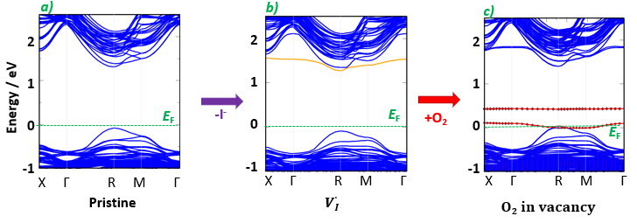
Figure 3. Band structures a) pristine FA_{0.85}MA_{0.11}Cs_{0.04}PbI₃, b) with an iodide vacancy, c) with an O₂ species occupying the iodide vacancy. Adding an O₂ species to the system makes it spin-polarised. Corresponding density of states are in SI Figure S4. Iodide vacancy states are indicated in orange, while O₂ species-related states of the spin-polarised system are indicated in red (both spin up and spin down states). The energy levels were referenced to the Fermi level (marked by a green dashed line).

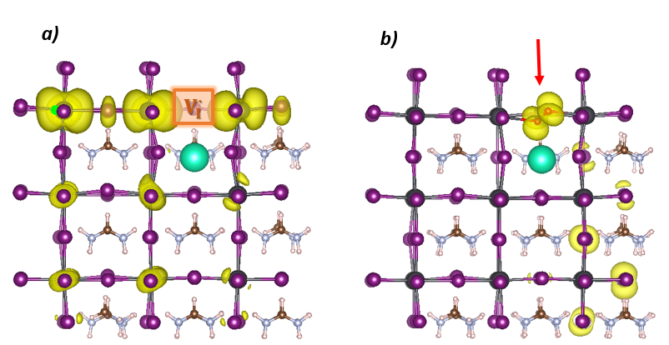
Figure 4. Band-decomposed charge density of FA_{0.85}MA_{0.11}Cs_{0.04}PbI₃ a) iodide vacancy (orange box); b) O₂ molecule occupying the iodide vacancy (indicated with a red arrow). Isosurface level at 0.0008 a. u.
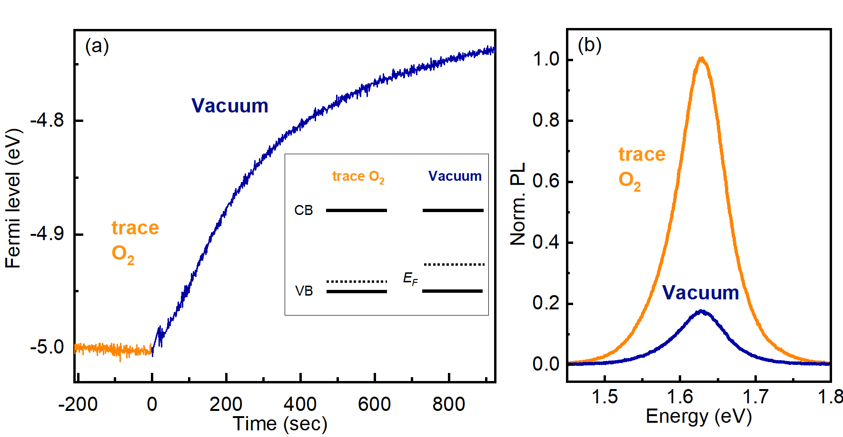
Figure 5. (a) Fermi level measurements of FA_{0.79}MA_{0.15}Cs_{0.06}Pb(I_{0.85}Br_{0.15})₃ thin films ascertained from KP measurements over time in darkness: in trace levels of oxygen (orange, N2) and while in vacuo (blue) to reach vacuum conditions (≤10⁻⁶ mbar). Pump starts at t = 0. (b) PL measurements taken under trace oxygen conditions and under high vacuum (10⁻⁶ mbar). Samples were excited with a 532-nm laser at an excitation density of 100 mW/cm².
We therefore conclude that the neat film in the absence of O₂ is close to intrinsic, but becomes significantly p-doped in the presence of O₂. Furthermore, the PL intensity of the film under UHV conditions decreases by a factor of five when compared to the initial value at the presence of O₂ (Fig. (5b)), which is consistent with O₂ passivating vacancies that can act as non-radiative recombination centers; we note that the increased doping may also contribute to the increased luminescence yields.⁴⁸ These experimental findings qualitatively confirm our computational results on the dual role of O₂ species filling the halide vacancies, as both efficient defect neutralizers and strong p-type dopants.
Our calculations indicate that the trap densities are not shallow (>100 meV from the band edges), and hence suggest that trapped carriers cannot easily de-trap from these states back to the bands. It is difficult to definitively assign these traps to be electron or hole traps, and future work will be critical to elucidate this. It may be possible to saturate such traps at medium to high carrier densities, but for many films this is beyond typical charge carrier densities found in solar cells and photodetectors. Hence, these traps are relevant potential loss pathways for optoelectronic devices. We note that a detailed discussion of the quantitative impact of O₂ on the Fermi level would require further consideration of electric fields across the whole device stack. This would include accounting for O₂ concentration gradients through the sample thickness²³ and E_{F} of the substrate, which are beyond the scope of this work, and warrants future investigation.
In conclusion, we present a combined computational-experimental investigation of the effects that O₂ has on a state-of-the-art triple A-cation iodide perovskites. Three main points emerge. First, the atomistic structure and CIF file of the model FA_{0.85}MA_{0.11}Cs_{0.04}PbI₃ perovskite from ab initio simulations are presented for the first time, and supported by XRD data. Second, O₂ molecules can occupy iodide vacancies resulting in acceptor-like electronic states and suggests a p-doped material. Finally, Kelvin Probe contact potential difference and photoluminescence measurements reveal that even trace amounts of O₂ makes the triple-cation perovskite a well-passivated p-doped material. Such passivation will have important implications for enhancing optoelectronic device performance, while the ability to sensitively p-dope the sample with oxygen molecules opens up new device applications including transistor-based sensors. This work also provides a critical building block to examine effects occurring in devices under operation such as carrier trapping and photo-induced ion migration.

ASSOCIATED CONTENT
Supporting Information.
This material is available free of charge via the Internet at http://pubs.acs.org.
Computational details; structure and energetics of A-cation substitution, iodide vacancy sites, density of states, energetics of an O₂ molecule occupying the vacancy.
Cif file of the FA_{0.85}MA_{0.11}Cs_{0.04}PbI₃ structure.
AUTHOR INFORMATION
Corresponding Author
*E-mail: m.s.islam@bath.ac.uk (M.S.I).
ORCID
M. Saiful Islam: 0000-0003-3882-0285
Alexandra Szemjonov: 0000-0001-9493-9956
Miguel Anaya: 0000-0003-2925-6360
Samuel D. Stranks: 0000-0002-8303-7292
Krzysztof Galkowski: 0000-0002-9275-1519

NOTES
The authors declare no competing financial interest.

ACKNOWLEDGMENTS
This work was supported by the EPSRC Programme Grant ‘Energy Materials: Computational Solutions’ (EP/K016288/1) and the HPC Materials Chemistry Consortium for Archer computational time (EP/L000202/1). Dr A. Aziz, Dr N. Zibouche and Dr D. Ghosh are thanked for useful discussions. Z.A.-G. acknowledges funding from a Winton Studentship, and ICON Studentship from the Lloyd’s Register Foundation. S.D.S acknowledges the Royal Society and Tata Group (UF150033). K.G. acknowledges the Polish Ministry of Science and Higher Education within the Mobilnosc Plus program (Grant No. 1603/MOB/V/2017/0). M.A. acknowledges funding from the European Union’s Horizon 2020 research and innovation programme under the Marie Skłodowska-Curie grant agreement No 841386.
REFERENCES
(1) Wang, Q.; Phung, N.; Di Girolamo, D.; Vivo, P.; Abate, A. Enhancement in Lifespan of Halide Perovskite Solar Cells. Energy Environ. Sci. 2019, 12, 865–886.
(2) Leijtens, T.; Bush, K. A.; Prasanna, R.; McGehee, M. D. Opportunities and Challenges for Tandem Solar Cells Using Metal Halide Perovskite Semiconductors. Nature Energy. 2018, 3, 828.
(3) Correa-Baena, J.-P.; Abate, A.; Saliba, M.; Tress, W.; Jacobsson, T. J.; Grätzel, M.; Hagfeldt, A. The Rapid Evolution of Highly Efficient Perovskite Solar Cells. Energy Environ. Sci. 2017, 10, 710–727.
(4) Egger, D. A.; Bera, A.; Cahen, D.; Hodes, G.; Kirchartz, T.; Kronik, L.; Lovrincic, R.; Rappe, A. M.; Reichman, D. R.; Yaffe, O. What Remains Unexplained about the Properties of Halide Perovskites ? Adv. Mater. 2018, 30, 1800691.
(5) Green, M. A.; Ho-baillie, A. Perovskite Solar Cells : The Birth of a New Era in Photovoltaics. ACS Energy Lett. 2017, 2, 822–830.
(6) Correa-Baena, J.-P.; Saliba, M.; Buonassisi, T.; Grätzel, M.; Abate, A.; Tress, W.; Hagfeldt, A. Promises and Challenges of Perovskite Solar Cells. Science. 2017, 358, 739–744.
(7) Zhao, Z.; Gu, F.; Rao, H.; Ye, S.; Liu, Z.; Bian, Z.; Huang, C. Metal Halide Perovskite Materials for Solar Cells with Long-Term Stability. Adv. Energy Mater. 2019, 9, 1802671.
(8) Saliba, M.; Matsui, T.; Seo, J.-Y.; Domanski, K.; Correa-Baena, J.-P.; Nazeeruddin, M. K.; Zakeeruddin, S. M.; Tress, W.; Abate, A.; Hagfeldt, A. Cesium-Containing Triple Cation Perovskite Solar Cells: Improved Stability, Reproducibility and High Efficiency. Energy Environ. Sci. 2016, 9, 1989–1997.
(9) Abdi-Jalebi, M.; Andaji-Garmaroudi, Z.; Cacovich, S.; Stavrakas, C.; Philippe, B.; Richter, J. M.; Alsari, M.; Booker, E.; Hutter, E. M.; Pearson, A. J.; et al. Maximizing and Stabilizing Luminescence from Halide Perovskites with Potassium Passivation. Nature 2018, 555, 497–501.
(10) Sun, Y.; Peng, J.; Chen, Y.; Yao, Y.; Liang, Z. Triple-Cation Mixed-Halide Perovskites: Towards Efficient, Annealing-Free and Air-Stable Solar Cells Enabled by Pb(SCN) 2 Additive. Sci. Rep. 2017, 7, 1–7.
(11) Singh, T.; Miyasaka, T. Stabilizing the Efficiency Beyond 20% with a Mixed Cation Perovskite Solar Cell Fabricated in Ambient Air under Controlled Humidity. Adv. Energy Mater. 2018, 8, 1–9.
(12) Liu, S.; Huang, W.; Liao, P.; Pootrakulchote, N.; Li, H.; Lu, J.; LI, J.; Huang, F.; Shai, X.; Zhao, X.; et al. 17% Efficient Printable Mesoscopic PIN Metal Oxides Framework Perovskite Solar Cells Using Cesium-Containing Triple Cation-Perovskite. J. Mater. Chem. A 2017, 5, 22952–22958.
(13) Zhang, R.; Liu, D.; Wang, Y.; Zhang, T.; Gu, X.; Zhang, P.; Wu, J.; Chen, Z. D.; Zhao, Y.; Li, S. Theoretical Lifetime Extraction and Experimental Demonstration of Stable Cesium-Containing Tri-Cation Perovskite Solar Cells with High Efficiency. Electrochim. Acta 2018, 265, 98–106.
(14) McMeekin, D. P.; Sadoughi, G.; Rehman, W.; Eperon, G. E.; Saliba, M.; Horantner, M. T.; Haghighirad, A.; Sakai, N.; Korte, L.; Rech, B.; et al. A Mixed-Cation Lead Mixed-Halide Perovskite Absorber for Tandem Solar Cells. Science. 2016, 351, 151–155.
(15) Matsui, T.; Seo, J. Y.; Saliba, M.; Zakeeruddin, S. M.; Grätzel, M. Room-Temperature Formation of Highly Crystalline Multication Perovskites for Efficient, Low-Cost Solar Cells. Adv. Mater. 2017, 29, 2–6.
(16) Salado, M.; Kokal, R. K.; Calio, L.; Kazim, S.; Deepa, M.; Ahmad, S. Identifying the Charge Generation Dynamics in Cs ⁺ -Based Triple Cation Mixed Perovskite Solar Cells. Phys. Chem. Chem. Phys. 2017, 19, 22905–22914.
(17) Duong, T.; Wu, Y.; Shen, H.; Peng, J.; Fu, X.; Jacobs, D.; Wang, E.-C.; Kho, T. C.; Fong, K. C.; Stocks, M.; et al. Rubidium Multication Perovskite with Optimized Bandgap for Perovskite-Silicon Tandem with over 26% Efficiency. Adv. Energy Mater. 2017, 7, 1700228.
(18) Mosconi, E.; Meggiolaro, D.; Snaith, H. J.; Stranks, S. D.; De Angelis, F. Light-Induced Annihilation of Frenkel Defects in Organo-Lead Halide Perovskites. Energy Environ. Sci. 2016, 9, 3180–3187.
(19) Brenes, R.; Eames, C.; Bulovi, V.; Islam, S.; Stranks, S. D. The Impact of Atmosphere on the Local Luminescence Properties of Metal Halide Perovskite Grains. Adv. Mater. 2018, 1706208.
(20) Tian, Y.; Peter, M.; Unger, E.; Abdellah, M.; Zheng, K.; Pullerits, T.; Yartsev, A.; Sundstrom, V.; Scheblykin, I. G. Mechanistic Insights into Perovskite Photoluminescence Enhancement : Light Curing with Oxygen Can Boost Yield Thousandfold. Phys. Chem. Chem. Phys. 2015, 17, 24978--24987.
(21) Brenes, R.; Guo, D.; Osherov, A.; Noel, N. K.; Eames, C.; Hutter, E. M.; Pathak, S. K.; Niroui, F.; Friend, R. H.; Islam, M. S.; et al. Metal Halide Perovskite Polycrystalline Films Exhibiting Properties of Single Crystals. Joule 2017, 1, 155–167.
(22) Galisteo-Lopez, J. F.; Anaya, M.; Calvo, M. E.; Miguez, H. Environmental Effects on the Photophysics of Organic − Inorganic Halide Perovskites. J. Phys. Chem. Lett. 2015, 6, 2200−2205.
(23) Senocrate, A.; Acarturk, T.; Kim, G. Y.; Merkle, R.; Starke, U.; Gratzel, M.; Maier, J. Interaction of Oxygen with Halide Perovskites. J. Mater. Chem. A 2018, 6, 10847–10855.
(24) McMeekin, D. P.; Sadoughi, G.; Rehman, W.; Eperon, G. E.; Saliba, M.; Hörantner, M. T.; Haghighirad, A.; Sakai, N.; Korte, L.; Rech, B.; et al. A Mixed-Cation Lead Mixed-Halide Perovskite Absorber for Tandem Solar Cells. Sci. 2016, 351 (6269), 151–155.
(25) Bu, T.; Liu, X.; Zhou, Y.; Yi, J.; Huang, X.; Luo, L.; Xiao, J.; Ku, Z.; Peng, Y.; Huang, F.; et al. Novel Quadruple-Cation Absorber for Universal Hysteresis Elimination for High Efficiency and Stable Perovskite Solar Cells. Energy Environ. Sci. 2017, 10, 2509–2515.
(26) Grätzel, M. The Rise of Highly Efficient and Stable Perovskite Solar Cells. Acc. Chem. Res. 2017, 50, 487–491.
(27) Zhumekenov, A. A.; Saidaminov, M. I.; Haque, M. A.; Alarousu, E.; Sarmah, S. P.; Murali, B.; Dursun, I.; Miao, X. H.; Abdelhady, A. L.; Wu, T.; et al. Formamidinium Lead Halide Perovskite Crystals with Unprecedented Long Carrier Dynamics and Diffusion Length. ACS Energy Lett. 2016, 1, 32–37.
(28) Weller, M. T.; Weber, O. J.; Frost, J. M.; Walsh, A. Cubic Perovskite Structure of Black Formamidinium Lead Iodide, α-[HC(NH2)2 ]PbI3 , at 298 K. J. Phys. Chem. Lett. 2015, 6, 3209–3212.
(29) Weber, O. J.; Ghosh, D.; Gaines, S.; Henry, P. F.; Walker, A. B.; Islam, M. S.; Weller, M. T. Phase Behavior and Polymorphism of Formamidinium Lead Iodide. Chem. Mater. 2018, 30, 3768–3778.
(30) Eperon, G. E.; Stranks, S. D.; Menelaou, C.; Johnston, M. B.; Herz, L. M.; Snaith, H. J. Formamidinium Lead Trihalide: A Broadly Tunable Perovskite for Efficient Planar Heterojunction Solar Cells. Energy Environ. Sci. 2014, 7, 982.
(31) Slimi, B.; Mollar, M.; Assaker, I. Ben; Kriaa, I.; Chtourou, R.; Marí, B. Perovskite FA1-XMAxPbI3for Solar Cells: Films Formation and Properties. Energy Procedia 2016, 102, 87–95.
(32) Hu, Y.; Aygüler, M. F.; Petrus, M. L.; Bein, T.; Docampo, P. Impact of Rubidium and Cesium Cations on the Moisture Stability of Multiple-Cation Mixed-Halide Perovskites. ACS Energy Lett. 2017, 2, 2212–2218.
(33) Gheshlaghi, N.; Pisheh, H. S.; Karim, M. R.; Ünlü, H. Interface Strain Effects on ZnSe/ (CdSe) Based Type i and ZnSe/CdS Type II Core/Shell Quantum Dots. Energy Procedia 2016, 102, 152–163.
(34) Ramakrishna, V. Mixed Cation Inks for Perovskite Solar Cells, Delft University of Technology, 2017.
(35) Ghosh, D.; Walsh Atkins, P.; Islam, M. S.; Walker, A. B.; Eames, C. Good Vibrations: Locking of Octahedral Tilting in Mixed-Cation Iodide Perovskites for Solar Cells. ACS Energy Lett. 2017, 2, 2424–2429.
(36) Freysoldt, C.; Grabowski, B.; Hickel, T.; Neugebauer, J.; Kresse, G.; Janotti, A.; Van De Walle, C. G. First-Principles Calculations for Point Defects in Solids. Rev. Mod. Phys. 2014, 86, 253–305.
(37) Emara, J.; Schnier, T.; Pourdavoud, N.; Riedl, T.; Meerholz, K.; Olthof, S. Impact of Film Stoichiometry on the Ionization Energy and Electronic Structure of CH 3 NH 3 PbI 3 Perovskites. Adv. Mater. 2016, 28, 553–559.
(38) Ma, X.; Li, Z. The Effect of Oxygen Molecule Adsorption on Lead Iodide Perovskite Surface by First-Principles Calculation. Appl. Surf. Sci. 2018, 428, 140–147.
(39) Alkauskas, A.; McCluskey, M. D.; Van De Walle, C. G. Tutorial: Defects in Semiconductors - Combining Experiment and Theory. J. Appl. Phys. 2016, 119, 181101.
(40) Shi, H.; Du, M. H. Shallow Halogen Vacancies in Halide Optoelectronic Materials. Phys. Rev. B - Condens. Matter Mater. Phys. 2014, 90, 1–6.
(41) Giorgi, G.; Yamashita, K. Zero-Dimensional Hybrid Organic-Inorganic Halide Perovskite Modeling: Insights from First Principles. J. Phys. Chem. Lett. 2016, 7, 888–899.
(42) Abrahams, S. C.; Kalnajs, J. The Crystal Structure of α-Potassium Superoxide. Acta Crystallogr. 1955, 8, 503–506.
(43) Hayyan, M.; Hashim, M. A.; Alnashef, I. M. Superoxide Ion: Generation and Chemical Implications. Chem. Rev. 2016, 116, 3029–3085.
(44) Anaya, M.; Galisteo-Lopez, J. F.; Calvo, M. E.; Espinos, J. P.; Miguez, H. Origin of Light-Induced Photophysical Effects in Organic Metal Halide Perovskites in the Presence of Oxygen. J. Phys. Chem. Lett. 2018, 9, 3891–3896.
(45) Aristidou, N.; Sanchez-molina, I.; Chotchuangchutchaval, T.; Brown, M.; Martinez, L.; Rath, T.; Haque, S. A. The Role of Oxygen in the Degradation of Methylammonium Lead Trihalide Perovskite Photoactive Layers. Angew. Chemie 2015, 127, 8326–8330.
(46) Aristidou, N.; Eames, C.; Sanchez-Molina, I.; Bu, X.; Kosco, J.; Islam, M. S.; Haque, S. A. Fast Oxygen Diffusion and Iodide Defects Mediate Oxygen-Induced Degradation of Perovskite Solar Cells. Nat. Commun. 2017, 8, 15218.
(47) Jung, E. H.; Jeon, N. J.; Park, E. Y.; Moon, C. S.; Shin, T. J.; Yang, T.-Y.; Noh, J. H.; Seo, J. Efficient, Stable and Scalable Perovskite Solar Cells Using Poly(3-Hexylthiophene). Nature 2019, 567, 511–516.

(48) Bowman A.R. et al., Microsecond Carrier Lifetimes, Controlled p-Doping, and Enhanced Air Stability in Low-Bandgap Metal Halide Perovskites, ACS Energy Lett., 2019, 4, 2301-2307.

TABLE OF CONTENTS (TOC) GRAPHIC



