Structural Biology of Multicomponent Assemblies in DNA Double-Strand-Break Repair through Non-Homologous End Joining

Amanda K. Chaplin and Tom L. Blundell

Department of Biochemistry, University of Cambridge, CB2 1GA, Cambridge, United Kingdom.

Abstract
The mechanisms mediating the repair of DNA damage in human cells have been the focus of a multitude of studies since the middle of the previous century, and many of the proteins implicated in these processes have been identified as being part of large macromolecular assemblies. This review gives an overview of the current knowledge of protein structures specifically involved in the repair of DNA double strand breaks through Non-Homologous End Joining, with a focus on recent structures obtained via cryo-electron microscopy and prospects for how this rapidly evolving method will impact our understanding of DNA repair.

Introduction
The macromolecular assemblies involved in DNA repair have been the focus of myriad studies over the past four decades. Structural models of many of these assemblies have been obtained primarily via X-ray crystallography and have been summarised in a variety of recent review articles [1-4]. The ever-increasing advancement of cryo-EM of the resolution revolution during the past few years, including sample preparation techniques, a new generation of electron detectors and image-processing software, has enabled the scientific community to make impressive progress in obtaining larger, and more complex protein structural models.

DNA damage in humans is repaired through a broad range of pathways involving numerous different proteins. Here we focus on proteins involved in the repair of DNA double-strand breaks (DSBs), the most severe and dangerous form of DNA damage. It is estimated that in dividing mammalian cells an average of ten DSBs occur per day per cell, arising from a multitude of factors including ionizing radiation, reactive oxygen species and DNA replication errors [3,5]. To protect the genome from deleterious effects, the DSBs are repaired by one of two major pathways: Homologous Recombination (HR) or Non-Homologous End Joining (NHEJ). Whilst HR requires a sister chromatid to be used as a template and is restricted to the S and G2 phases of the cell cycle, NHEJ can repair the DNA without the need for a template and can occur at any stage of the cell cycle, although this mechanism is dominant in G1 and G2 phases [6,7]. Here we focus on developments over the past two years in structural biology of NHEJ, specifically highlighting some recent cryo-EM structures with a discussion on how the development of cryo-EM methodology is advancing the field of DNA repair.

The general mechanism of NHEJ
The repair of DNA damage by NHEJ takes approximately 30 minutes, compared to a longer timescale of several hours for HR. The temporal efficiency of NHEJ is in part credited to the ability of the proteins involved to assemble rapidly on the broken ends of the damaged DNA [8]. Although rapid, the overall mechanism of NHEJ is a complex multicomponent process comprising three general stages. First, the Ku70/80 heterodimer recognizes the DSB and binds to the DNA ends with high affinity and acts as a central ‘hub’ for further NHEJ proteins to bind [9**,10]. The DNA-dependent protein kinase catalytic subunit (DNA-PKcs) is subsequently recruited due to its high affinity for Ku-DNA and together they form the DNA-PK holoenzyme complex [11,12]. Following autophosphorylation, the DNA-PK holoenzyme acts as a stage for the assembly and activation of further NHEJ components [13-17*]. The second step of the process involves DNA-end processing by factors such as Artemis, which performs endonuclease activity [18]. Finally, XRCC4 and XLF (Cernunnos or XRCC4-like factor) interact with each other and form sliding filament structures [19-23*]. These filaments interact with DNA-PK bridging the broken DNA ends, facilitating ligation by DNA ligase IV (LigIV) [24,25].

While these canonical NHEJ proteins are sufficient to repair some DSBs, most breaks require further proteins including DNA polymerases and nucleases. Furthermore, additional proteins including the Paralog of XRCC4 and XLF (PAXX) a more recently identified NHEJ factor [26] and several adaptor or modulators of NHEJ such as aprataxin and PNKP-like factor (APLF) and Cell Cycle Regulator of NHEJ (CYREN, also known as modulator of retrovirus infection, MRI) have also been shown to play a role in NHEJ by bridging several proteins [27*,28*].

X-ray crystallography of DNA-PKcs
DNA-PKcs is a serine/threonine protein kinase consisting of 4128 amino acids (460 kDa), the first reported structure of which was obtained by X-ray crystallography at a resolution of 6.6 Å. While the general topology of the protein could be observed, tracing of the entire chain was incomplete due to the modest resolution, and as a result the flexible N-terminal region of the protein could not be modelled [14]. In 2017, subsequent crystallographic studies using selenomethionine labelling in HeLa cells enabled a structure of DNA-PKcs in complex with the C-terminal region of Ku80 (residues 539-732) to be solved to 4.3 Å resolution with almost complete tracing of the polypeptide chain (Figure 1A) [17*]. This structure revealed that DNA-PKcs folds into three main structural units, the N-terminal region (1-892), the circular-cradle (893-2801) and the C-terminal head comprising the FAT and kinase domains (2802-4128) (Figure 1A, B) [14,17*]. The structure also revealed three α-helices, most likely corresponding to binding sites A and B for Ku80 C-terminus (Figure 1A). Helix three of binding site A is located close to the ‘PQR’ autophosphorylation cluster, which is also within the proposed BRCA1-binding region (Figure 1A, inset) [29]. This suggests possible competition between Ku80 and BRCA1 for binding to DNA-PKcs, with this site having a potential role in deciding whether DNA is repaired via NHEJ or HR. Although the role of Ku80 in DNA repair is well established, further investigations need be carried out to decipher the exact role of BRCA1 in NHEJ.
In the 4.3 Å structure of DNA-PKcs the crystallographic asymmetric unit contains two independent molecules (chains A and B), displaying small but clearly defined differences in conformation (Figure 1C). In chain B the N-terminal arm (residues 1-382) is moved slightly “upwards”, towards the head unit along with an opening of the kinase active site relative to chain A (Figure 1C). It is possible that these conformational differences are a result of the local contacts imposed by crystal packing; however, they demonstrate concerted changes in conformation between the N-terminus of the protein, and the kinase domain, hinting at a mechanism of allosteric regulation of kinase activity through binding of other components at the N-terminus or circular-cradle [17*].

The Ku Interactome
In addition to DNA-PKcs, the structure of the core ring of the Ku70/80 heterodimer has also been solved by X-ray crystallography. In 2001 structures with and without DNA bound were reported to resolutions of 2.7 and 2.5 Å, respectively [10]. More recently structures of Ku70/80 have been solved with peptides (see below) (Figure 2A). These structures all revealed that the Ku70 and Ku80 subunits share a highly similar fold and the hetero dimer they form adopts a dyad-symmetrical structure with a ring that encircles the duplex DNA (Figure 2A) [10]. The N-terminal of both Ku70 and Ku80 share similarity with the von Willebrand factors A (vWA) domain, a domain that facilitates protein interactions [10,30].

The ability of Ku70/80 to interact with DNA-PKcs to form the DNA-PK holoenzyme has been well established. However, it has also been proposed that the Ku heterodimer acts as a ‘hub’ able to interact with a number of additional NHEJ proteins. These include the recently identified PAXX protein [26], filaments of XLF-XRCC4 [23*] (both of which will be discussed further later), adaptor proteins such as APLF [31] and CYREN [27*,28*], and the Werner syndrome ATP-dependent helicase (WRN) [32]. All of these proteins contain a short peptide module (10-15 amino acids), denoted as a Ku binding motif (KBM), present at different locations within the polypeptide chain (Figure 2B). KBMs were originally identified in the accessory protein APLF denoted as A-KBM, where the short motif is present in the middle of the protein and has been shown to interact with the vWA of Ku80 (Figure 2B) [33,34]. XLF, a protein important in ligation, also contains a KBM, in this case located at the far C-terminus of the protein and denoted X-KBM [33,35]. CYREN, a newly identified adaptor protein that has also been shown to interact with Ku80, contains an A-KBM-like domain at its N-terminus and an XLF-like motif at the extreme C-terminus denoted as XLM (Figure 2B) [28*]. Interestingly, two KBMs have been identified at the C-terminus of WRN, one being an A-KBM-like motif and the other X-KBM-like motif that act cooperatively to bind to Ku [32]. A further type of KBM has been identified at the C-terminus of PAXX named P-KBM and is instead proposed to interact with Ku70 (Figure 2B) [26,36]. Thus, the Ku interactome defines an array of proteins containing KBMs that may compete or act synergistically through molecular mechanisms that are still unknown and certainly require further investigation.
Recently, crystal structures of Ku70/80-DNA have been solved in complex with the A-KBM motif of APLF and the X-KBM motif of XLF (Figure 2A) [9**]. These two KBMs bind to different locations on the vWA domain of Ku80. While the A-KBM of APLF interacts with a highly conserved site of Ku80, the X-KBM of XLF binds to a remote site that causes the Ku80 to open, creating a large groove between the vWA domain and the rest of the Ku heterodimer (Figure 2A). This opening creates a new conformational change, previously unseen in the X-ray structures and therefore represents the ‘open’ conformation of Ku70/80 instead of the ‘closed’ conformation previously observed (Figure 2A, bottom) [9**].
To date, no cryo-EM structures of Ku70/80 in isolation have been reported. Cryo-EM confers several advantages to crystallography including smaller sample volumes and concentrations, the ability to analyse conformational states more easily and the use of heterogenous samples. Solving the cryo-EM structure of Ku70/80 could therefore be utilised to measure the fraction of Ku present in the ‘open’ and the ‘closed’ conformation and could enable us to decipher whether the equilibrium of such changes upon different KBM motifs binding and is important for the mechanism of NHEJ.

Structural advancement of the DNA-PK architecture
The DNA-PK holoenzyme is a 650 kDa heterotetramer composed of DNA-PKcs, Ku70, Ku80 and DNA at a 1:1:1:1 stoichiometry. This large assembly has proved to be unsuitable for structure determination by X-ray crystallography, despite extensive efforts by our own group and others. However, the rapid development of cryo-EM has made it now possible to obtain the structure of the entire DNA-PK complex. The first such cryo-EM structures reported were of apo DNA-PKcs to 4.4 Å resolution and a native DNA-PK complex purified directly from HeLa cells to 5.8 Å resolution, although no clear density for Ku70/80 could be identified in the latter structure [37**]. However, a second cryo-EM study of DNA-PK holoenzyme, reconstituted from purified individual proteins reported the structure of the DNA-PK holoenzyme to 6.6 Å resolution, with density apparent for Ku70/80 (Figure 3, PDB entry 5Y3R) [38**]. While full length Ku70 and Ku80 proteins were used for the reconstitution of the complex, density for the C-terminus of Ku70 (residues 535-609) and the C-terminus of Ku80 (residues 542-732) was not observed in the final deposited structure. The overall conformation of Ku70/80 within the DNA-PK complex appears similar to that of X-ray structure of Ku70/80-DNA previously solved (PDB entry 1JEY, Figure 3A, C). More specifically the two Ku80 structures are essentially identical, whereas the Ku70 molecules reveal subtle conformational changes, such that Ku70 is rotated away from DNA-PKcs when binding to form the complex (Figure 3A, C). Interestingly, the DNA bound by DNA-PK displays a 30º kink at the interface between Ku70/80 and DNA-PKcs (Figure 3B). As this conformation is resolved within the cryo-EM structure it suggests that DNA binding in this kinked trajectory is rigid, though it remains to be established whether this distortion is important for the DNA repair mechanism. The movement of the DNA into the DNA-PKcs ring is restricted by a helix of Ku80 (corresponding to site B in the crystal structure) (Figure 3D). It is thought that this blockage prevents premature processing of the DNA ends.
A direct structural comparison can be made between the cryo-EM structures of DNA-PKcs from the apo-form (PDB entry 5W1R) and from the DNA-PK complex (PDB entry 5Y3R). Concerted conformational changes occur within the N-terminal and ring structures when Ku70/80-DNA are bound in the DNA-PK complex, with the most dramatic movements observed in the N-terminal region (Figure 3E) [37**,38**], where helices 1-8 move inwards and upwards close to the circular cradle and head unit (Figure 3E). Moreover, when Ku70/80 binds to DNA-PKcs the structure of DNA-PKcs becomes more compact, contributing to activation of the kinase through similar but much more extensive changes than observed when comparing the two molecules in the X-ray structure of DNA-PKcs (see above, Figure 3C) [17*].

The ligation framework of XLF-XRCC4 filaments and DNA Ligase IV
The proteins, XLF, XRCC4 and PAXX, are members of a structurally homologous superfamily and all have the ability to form oligomers [22,39-41]. Several groups have shown that XRCC4 and XLF are able to form dynamic heterodimeric filaments [19-23*]. Optical tweezer experiments combined with fluorescent microscopy, have shown that these filaments form helices that are able to bridge two independent DNA molecules and resemble sleeves containing a positively charged tunnel able to slide along the DNA bringing the two ends together [20,23*]. These filaments interact with DNA-PK through the C-terminus of XLF (X-KBM), also present in PAXX (P-KBM), by binding directly to the vWA domain of Ku80 (see above) [35]. The internal pore of these proposed filaments is large enough to contain DNA, Ku, DNA-PKcs or an entire nucleosome [25]. Interestingly, a recent study using single-molecule fluorescence imaging in Xenopus laevis egg extract was able to define a system that efficiently joins DNA ends, by exploiting the ability of XLF to form a single dimer prior to the ligation complex. This indicates that it may be possible for XLF to facilitate the synaptic complex without the need of the XLF-XRCC4 filament and thus may not be necessary in vivo [42*]. Recent single-molecule experiments have shown filaments formed by XLF-XRCC4-LigIV and PAXX maintain synapsis and increase DNA repair stability, highlighting their importance in NHEJ [43**].
In the final step of NHEJ, ligation occurs via LigIV in a complex through its BRCT C-terminal domain with a XRCC4 homodimer [44-46]. XRCC4 promotes ligation by stabilising the interaction with DNA, protecting the DNA from degradation and stimulating adenylation of LigIV [39,47-49]. LigIV is an ATP-dependent DNA-ligase that uses a catalytic lysine to attack ATP. The adenylated protein is then able to transfer AMP to the 5’-phosphate of the DSB, followed by the 3’-hydroxyl ends attacking the adenylated 5’-phosphate forming a phosphodiester bond and eliminating AMP. A recent paper has described two distinct states of LigIV, an open lysyl-AMP intermediate and a closed DNA-adenylate form [50*]. This study provides structural and biochemical information on transitions occurring during the catalytic cycle of LigIV establishing a beginning for future studies on these ligases [50*].

Challenges and future directions
This review demonstrates how X-ray crystallography, in combination with the advances in cryo-EM, has enabled the structures of many NHEJ proteins to be resolved. A timeline of some of the key structures can be seen in Figure 4 illustrating the steep increase in the number of structures being determined through both X-ray crystallography and cryo-EM within the past few years. It also shows how cryo-EM is able to solve large multi-component assemblies compared to X-ray crystallography. Although significant progress has been made in recent years (especially in the field of cryo-EM), obtaining higher resolution structures of these proteins and their corresponding higher order assemblies will further enhance our structural understanding of NHEJ. As structures of larger assemblies involved in NHEJ become available, specific molecular interactions mediating complex formation can be proposed. Subsequently it will be possible to design mutagenesis experiments to validate these interactions, and to gain a better understanding of the mechanisms involved in this intricate, multi-step pathway. Although the static structures generated by both X-ray crystallography and cryo-EM contribute to a detailed, fundamental understanding of how these proteins function, a much larger challenge is to decipher the temporal and spatial arrangement of the multitude of protein and DNA components during this process. The recent study using single-molecule experiments has paved the way for using this technique to complement traditional structural biology methods, and help to understand the dynamic and transient nature of this process [43**]. This study defines the rules of NHEJ protein assembly and provides kinetic insights into the protein machinery [43**].
In conclusion, the combination of structural and mechanistic techniques will eventually allow us to create a detailed 3D reconstruction of the whole NHEJ process over space and time.

Acknowledgements
We thank the Wellcome Trust for a Programme Grant (O93167/Z/10/Z; 2011–2016) and Investigator Award (200814/Z/16/Z; 2016 -) for support of this research on the progression of understanding NHEJ through structural biology and biochemical techniques. We would also like to thank Ales Hnizda, Shikang Liang and Antonia Kefala-Stavridi for their support and contribution to this research area.

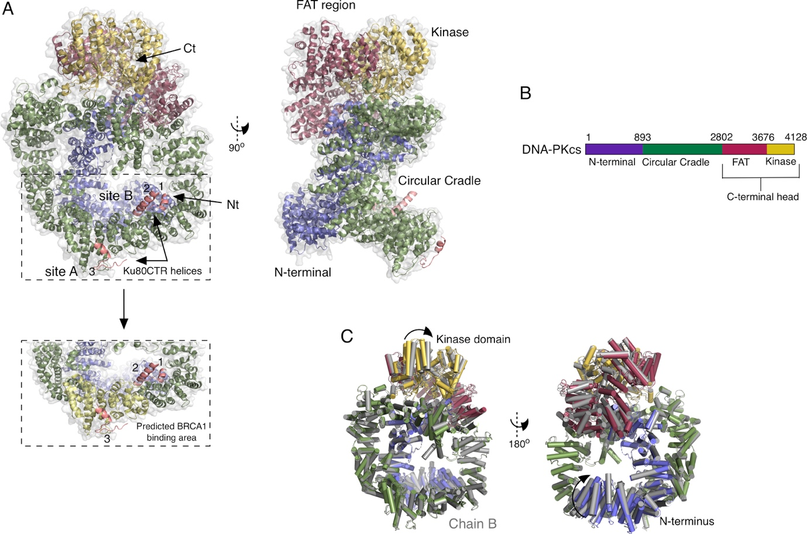
Figure 1: X-ray crystal structures of DNA-PKcs. A) DNA-PKcs X-ray crystal structure (PDB entry 5LUQ) [17*] with helices coloured to illustrate separate domains of the protein shown by sequence according to B. The N-terminal region is coloured in slate blue, the circular cradle in green, the FAT region in red maroon and the kinase domain in yellow. The three helices from Ku80CTR are numbered and coloured in salmon. Inset, displays the proposed BRCA1 binding area in yellow. B) The domain organisation and colour scheme for illustration in the figure. DNA-PKcs is coloured as described above. C) Two chains (A and B) in the crystal structure (5LUQ) of DNA-PKcs superposed. Chain A is shown in colours described above and chain B in grey. Small conformational changes are shown in the N-terminus and kinase domain by arrow representation.

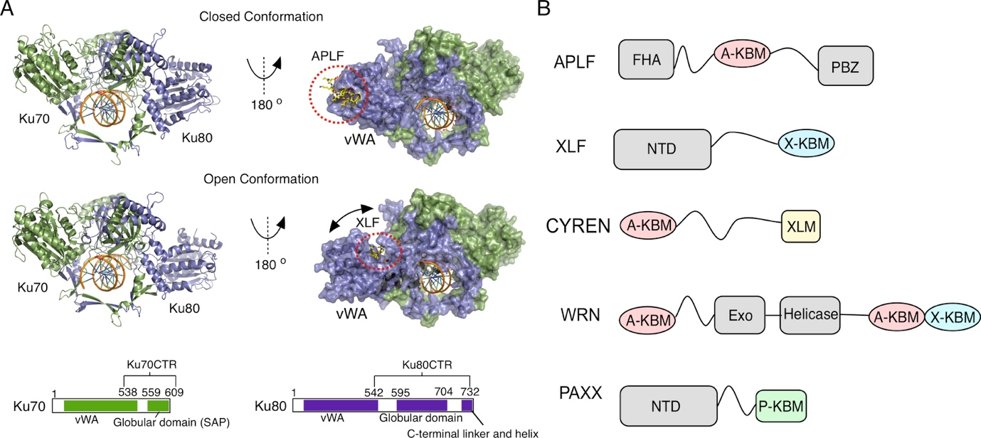
Figure 2: Ku binding motifs and Ku70/80 structures with an A-KBM and a X-KBM peptide. A) Crystal structure of Ku-DNA with Ku70 in green and Ku80 in purple. The top structure shows Ku70/80-DNA with A-KBM peptide from APLF bound to the vWA domain of Ku80 (PDB entry 6ERF). The bottom structure shows Ku70/80-DNA with a X-KBM peptide from XLF (PDB entry 6ERG). The X-KBM peptide binds to an internal site of the vWA domain of Ku80 and causes an opening of the structure indicated by the arrow [9**]. The sequences are shown below with Ku70 in green and Ku80 in purple with white regions representing structures for the areas undetermined. B) Locations of the A-KBM (maroon), X-KBM (blue), XLM (yellow) and P-KBM (green) motifs present in APLF, XLF, CYREN, WRN and PAXX.

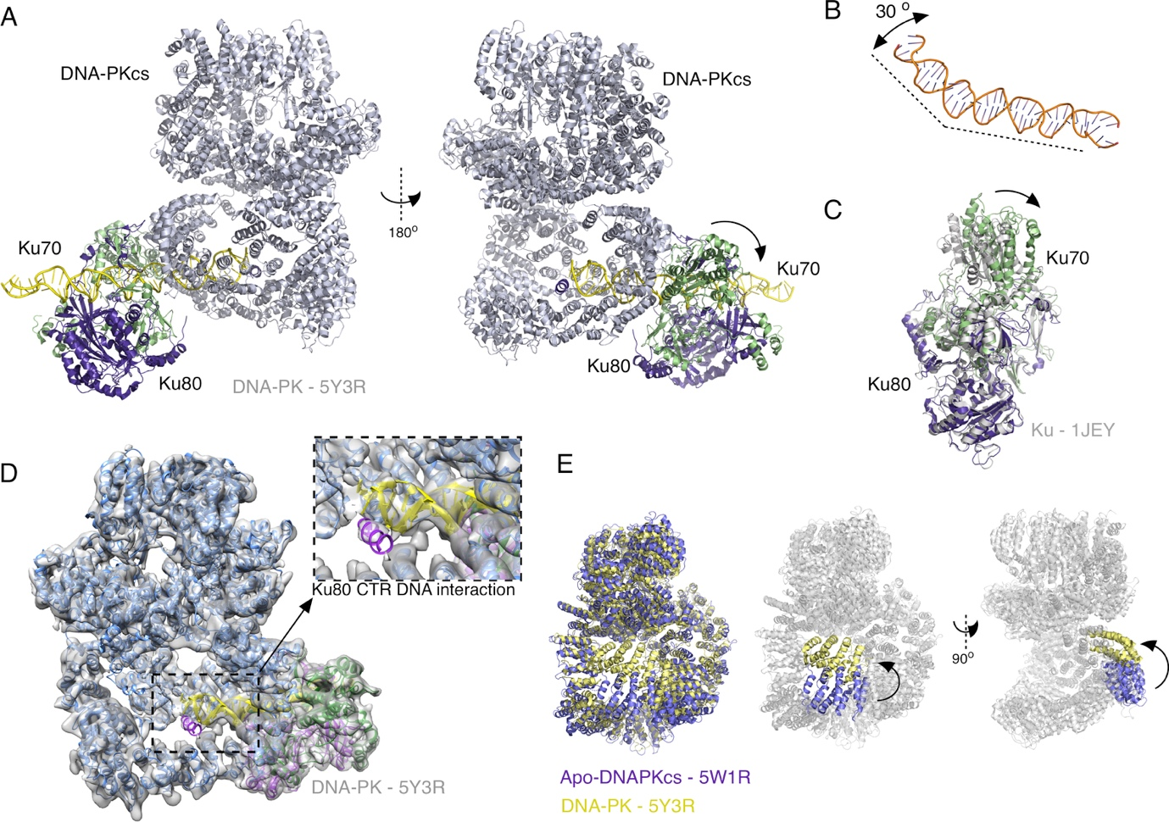
Figure 3: Structure of the DNA-PK holoenzyme. A) The structure of DNA-PK solved using single-particle cryo-EM (PDB entry 5Y3R) [38**]. DNA-PKcs is shown in light blue, Ku70 GREEN, Ku80 purple and DNA in yellow. An arrow indicates movement of Ku70 upon binding to DNA-PKcs. B) DNA from DNA-PK displaying a 30º kink. C) Ku70/80 from the DNA-PK structure (5Y3R), shown in green and purple for Ku70 and 80, respectively, illustrating the movement of Ku70 when compared to the Ku70/80 x-ray crystal structure (PDB entry 1JEY) shown in grey. D) Cryo-EM map of DNA-PK with DNA-PKcs in blue, DNA in purple and the helices of Ku80CTR in orange. Inset, shows an enlarged view of the Ku80CTR interacting with the end of the DNA. E) Structures of cryo-EM apo-DNA-PKcs (purple, PDB entry 5W1R) [37**,38**] and DNA-PKcs from the DNA-PK structure (Yellow, PDB entry 5Y3R, Ku70/80 and DNA removed from image). Structures show the movement of helices 1-8 of the N-terminus.

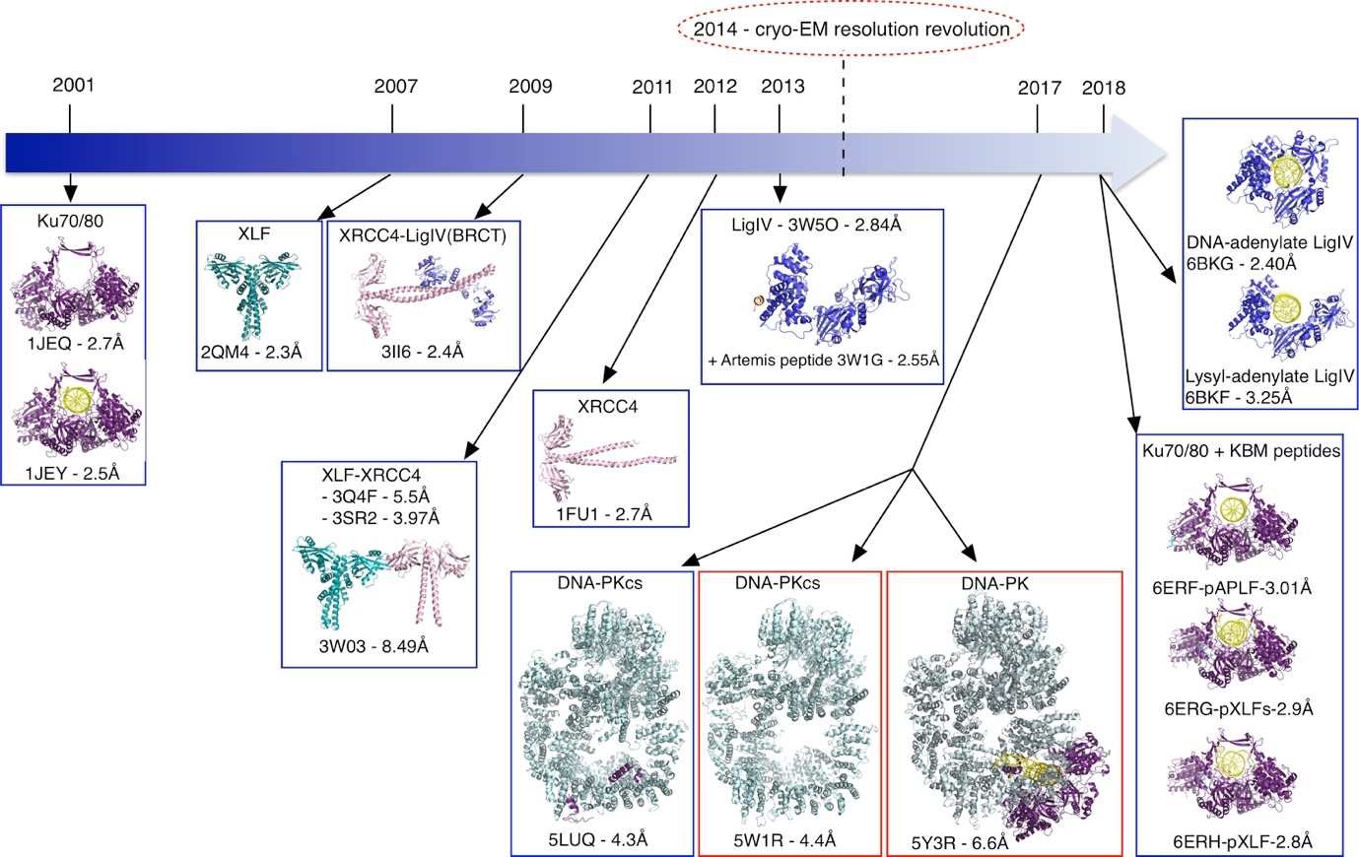
Figure 4: Timeline showing some of the key structures of NHEJ. X-ray crystal structures are illustrated with a blue box and cryo-EM with a red box. PDB codes and resolution are shown below the structures. Ku70/80 is in purple, DNA in yellow, DNA-PKcs in light blue, XLF in teal, XRCC4 in light pink, Ligase IV in blue, Artemis in orange and KBM peptides as blue sticks.

References
Papers of particular interest, published within the period of review, have been highlighted as:
* of special interest
** of outstanding interest

1. Hnizda A, Blundell TL: Multicomponent assemblies in DNA-double-strand break repair by NHEJ. Curr Opin Struct Biol 2019, 55:154-160.
2. Wu Q, Liang S, Ochi T, Chirgadze DY, Huiskonen JT, Blundell TL: Understanding the structure and role of DNA-PK in NHEJ: How X-ray diffraction and cryo-EM contribute in complementary ways. Prog Biophys Mol Biol 2019, 10.1016/j.pbiomolbio.2019.03.007.
3. Chang HHY, Pannunzio NR, Adachi N, Lieber MR: Non-homologous DNA end joining and alternative pathways to double-strand break repair. Nat Rev Mol Cell Biol 2017, 18:495-506.
4. Pannunzio NR, Watanabe G, Lieber MR: Nonhomologous DNA end-joining for repair of DNA double-strand breaks. J Biol Chem 2018, 293:10512-10523.
5. Martin GM, Smith AC, Ketterer DJ, Ogburn CE, Disteche CM: Increased chromosomal aberrations in first metaphases of cells isolated from the kidneys of aged mice. Isr J Med Sci 1985, 21:296-301.
6. Her J, Bunting SF: How cells ensure correct repair of DNA double-strand breaks. J Biol Chem 2018, 293:10502-10511.
7. Karanam K, Kafri R, Loewer A, Lahav G: Quantitative live cell imaging reveals a gradual shift between DNA repair mechanisms and a maximal use of HR in mid S phase. Mol Cell 2012, 47:320-329.
8. Mao Z, Bozzella M, Seluanov A, Gorbunova V: Comparison of nonhomologous end joining and homologous recombination in human cells. DNA Repair (Amst) 2008, 7:1765-1771.
**9. Nemoz C, Ropars V, Frit P, Gontier A, Drevet P, Yu J, Guerois R, Pitois A, Comte A, Delteil C, et al.: XLF and APLF bind Ku80 at two remote sites to ensure DNA repair by non-homologous end joining. Nat Struct Mol Biol 2018, 25:971-980.

This paper shows the X-ray crystal structures of Ku70/80 bound to APLF and XLF KBM peptides, showing for the first time, the opening and closing conformations of Ku.

10. Walker JR, Corpina RA, Goldberg J: Structure of the Ku heterodimer bound to DNA and its implications for double-strand break repair. Nature 2001, 412:607-614.
11. Meek K, Dang V, Lees-Miller SP: DNA-PK: the means to justify the ends? Adv Immunol 2008, 99:33-58.
12. Smith GC, Jackson SP: The DNA-dependent protein kinase. Genes Dev 1999, 13:916-934.
13. Carter T, Vancurova I, Sun I, Lou W, DeLeon S: A DNA-activated protein kinase from HeLa cell nuclei. Mol Cell Biol 1990, 10:6460-6471.
14. Sibanda BL, Chirgadze DY, Blundell TL: Crystal structure of DNA-PKcs reveals a large open-ring cradle comprised of HEAT repeats. Nature 2010, 463:118-121.
15. Hammel M, Yu Y, Mahaney BL, Cai B, Ye R, Phipps BM, Rambo RP, Hura GL, Pelikan M, So S, et al.: Ku and DNA-dependent protein kinase dynamic conformations and assembly regulate DNA binding and the initial non-homologous end joining complex. J Biol Chem 2010, 285:1414-1423.
16. Jiang W, Crowe JL, Liu X, Nakajima S, Wang Y, Li C, Lee BJ, Dubois RL, Liu C, Yu X, et al.: Differential phosphorylation of DNA-PKcs regulates the interplay between end-processing and end-ligation during nonhomologous end-joining. Mol Cell 2015, 58:172-185.
*17. Sibanda BL, Chirgadze DY, Ascher DB, Blundell TL: DNA-PKcs structure suggests an allosteric mechanism modulating DNA double-strand break repair. Science 2017, 355:520-524.

This study reports the X-ray crystal structure of DNA-PKcs to 4.3 Å resolution.

18. Ma Y, Pannicke U, Schwarz K, Lieber MR: Hairpin opening and overhang processing by an Artemis/DNA-dependent protein kinase complex in nonhomologous end joining and V(D)J recombination. Cell 2002, 108:781-794.
19. Ropars V, Drevet P, Legrand P, Baconnais S, Amram J, Faure G, Marquez JA, Pietrement O, Guerois R, Callebaut I, et al.: Structural characterization of filaments formed by human Xrcc4-Cernunnos/XLF complex involved in nonhomologous DNA end-joining. Proc Natl Acad Sci U S A 2011, 108:12663-12668.
20. Hammel M, Rey M, Yu Y, Mani RS, Classen S, Liu M, Pique ME, Fang S, Mahaney BL, Weinfeld M, et al.: XRCC4 protein interactions with XRCC4-like factor (XLF) create an extended grooved scaffold for DNA ligation and double strand break repair. J Biol Chem 2011, 286:32638-32650.
21. Wu Q, Ochi T, Matak-Vinkovic D, Robinson CV, Chirgadze DY, Blundell TL: Non-homologous end-joining partners in a helical dance: structural studies of XLF-XRCC4 interactions. Biochem Soc Trans 2011, 39:1387-1392, suppl 1382 p following 1392.
22. Andres SN, Vergnes A, Ristic D, Wyman C, Modesti M, Junop M: A human XRCC4-XLF complex bridges DNA. Nucleic Acids Res 2012, 40:1868-1878.
*23. Brouwer I, Sitters G, Candelli A, Heerema SJ, Heller I, de Melo AJ, Zhang H, Normanno D, Modesti M, Peterman EJ, et al.: Sliding sleeves of XRCC4-XLF bridge DNA and connect fragments of broken DNA. Nature 2016, 535:566-569.
This paper shows how XLF and XRCC4 interact and form dynamic filaments resembling sleeves that slide along DNA.
24. Ahnesorg P, Smith P, Jackson SP: XLF interacts with the XRCC4-DNA ligase IV complex to promote DNA nonhomologous end-joining. Cell 2006, 124:301-313.
25. Mahaney BL, Hammel M, Meek K, Tainer JA, Lees-Miller SP: XRCC4 and XLF form long helical protein filaments suitable for DNA end protection and alignment to facilitate DNA double strand break repair. Biochem Cell Biol 2013, 91:31-41.
26. Ochi T, Blackford AN, Coates J, Jhujh S, Mehmood S, Tamura N, Travers J, Wu Q, Draviam VM, Robinson CV, et al.: DNA repair. PAXX, a paralog of XRCC4 and XLF, interacts with Ku to promote DNA double-strand break repair. Science 2015, 347:185-188.
*27. Hung PJ, Johnson B, Chen BR, Byrum AK, Bredemeyer AL, Yewdell WT, Johnson TE, Lee BJ, Deivasigamani S, Hindi I, et al.: MRI Is a DNA Damage Response Adaptor during Classical Non-homologous End Joining. Mol Cell 2018, 71:332-342 e338.
This work describes how MRI is a newly identified intrinsically disordered NHEJ adaptor protein, able to interact and bridge several NHEJ proteins.
*28. Arnoult N, Correia A, Ma J, Merlo A, Garcia-Gomez S, Maric M, Tognetti M, Benner CW, Boulton SJ, Saghatelian A, et al.: Regulation of DNA repair pathway choice in S and G2 phases by the NHEJ inhibitor CYREN. Nature 2017, 549:548-552.

This study introduces MRI as a NHEJ inhibitor protein that acts through interaction with Ku70/80.

29. Davis AJ, Chi L, So S, Lee KJ, Mori E, Fattah K, Yang J, Chen DJ: BRCA1 modulates the autophosphorylation status of DNA-PKcs in S phase of the cell cycle. Nucleic Acids Res 2014, 42:11487-11501.
30. Fell VL, Schild-Poulter C: Ku regulates signaling to DNA damage response pathways through the Ku70 von Willebrand A domain. Mol Cell Biol 2012, 32:76-87.
31. Hammel M, Yu Y, Radhakrishnan SK, Chokshi C, Tsai MS, Matsumoto Y, Kuzdovich M, Remesh SG, Fang S, Tomkinson AE, et al.: An Intrinsically Disordered APLF Links Ku, DNA-PKcs, and XRCC4-DNA Ligase IV in an Extended Flexible Non-homologous End Joining Complex. J Biol Chem 2016, 291:26987-27006.
32. Grundy GJ, Rulten SL, Arribas-Bosacoma R, Davidson K, Kozik Z, Oliver AW, Pearl LH, Caldecott KW: The Ku-binding motif is a conserved module for recruitment and stimulation of non-homologous end-joining proteins. Nat Commun 2016, 7:11242.
33. Grundy GJ, Rulten SL, Zeng Z, Arribas-Bosacoma R, Iles N, Manley K, Oliver A, Caldecott KW: APLF promotes the assembly and activity of non-homologous end joining protein complexes. EMBO J 2013, 32:112-125.
34. Shirodkar P, Fenton AL, Meng L, Koch CA: Identification and functional characterization of a Ku-binding motif in aprataxin polynucleotide kinase/phosphatase-like factor (APLF). J Biol Chem 2013, 288:19604-19613.
35. Yano K, Morotomi-Yano K, Lee KJ, Chen DJ: Functional significance of the interaction with Ku in DNA double-strand break recognition of XLF. FEBS Lett 2011, 585:841-846.
36. Tadi SK, Tellier-Lebegue C, Nemoz C, Drevet P, Audebert S, Roy S, Meek K, Charbonnier JB, Modesti M: PAXX Is an Accessory c-NHEJ Factor that Associates with Ku70 and Has Overlapping Functions with XLF. Cell Rep 2016, 17:541-555.
**37. Sharif H, Li Y, Dong Y, Dong L, Wang WL, Mao Y, Wu H: Cryo-EM structure of the DNA-PK holoenzyme. Proc Natl Acad Sci U S A 2017, 114:7367-7372.

This paper describes the cryo-EM structure of DNA-PKcs and the DNA-PK structure although no clear density for Ku70/80 could be observed.

**38. Yin X, Liu M, Tian Y, Wang J, Xu Y: Cryo-EM structure of human DNA-PK holoenzyme. Cell Res 2017, 27:1341-1350.

This is the first study to describe the DNA-PK holoenzyme showing density for Ku70/80, DNA and DNA-PKcs, clearly locating key interaction sites.

39. Sibanda BL, Critchlow SE, Begun J, Pei XY, Jackson SP, Blundell TL, Pellegrini L: Crystal structure of an Xrcc4-DNA ligase IV complex. Nat Struct Biol 2001, 8:1015-1019.
40. Li Y, Chirgadze DY, Bolanos-Garcia VM, Sibanda BL, Davies OR, Ahnesorg P, Jackson SP, Blundell TL: Crystal structure of human XLF/Cernunnos reveals unexpected differences from XRCC4 with implications for NHEJ. EMBO J 2008, 27:290-300.
41. Andres SN, Modesti M, Tsai CJ, Chu G, Junop MS: Crystal structure of human XLF: a twist in nonhomologous DNA end-joining. Mol Cell 2007, 28:1093-1101.
*42. Graham TGW, Carney SM, Walter JC, Loparo JJ: A single XLF dimer bridges DNA ends during nonhomologous end joining. Nat Struct Mol Biol 2018, 25:877-884.

This study uses single-molecule fluorescence imaging to show that an XLF dimer can bind to the DNA ends without the need for the XLF-XRCC4 filament.

**43. Wang JL, Duboc C, Wu Q, Ochi T, Liang S, Tsutakawa SE, Lees-Miller SP, Nadal M, Tainer JA, Blundell TL, et al.: Dissection of DNA double-strand-break repair using novel single-molecule forceps. Nat Struct Mol Biol 2018, 25:482-487.

Single-molecule experiments were used to understand the role of the main NHEJ proteins in efficient DSB synapsis.

44. Bryans M, Valenzano MC, Stamato TD: Absence of DNA ligase IV protein in XR-1 cells: evidence for stabilization by XRCC4. Mutat Res 1999, 433:53-58.
45. Grawunder U, Zimmer D, Lieber MR: DNA ligase IV binds to XRCC4 via a motif located between rather than within its BRCT domains. Curr Biol 1998, 8:873-876.
46. Wu PY, Frit P, Meesala S, Dauvillier S, Modesti M, Andres SN, Huang Y, Sekiguchi J, Calsou P, Salles B, et al.: Structural and functional interaction between the human DNA repair proteins DNA ligase IV and XRCC4. Mol Cell Biol 2009, 29:3163-3172.
47. Modesti M, Hesse JE, Gellert M: DNA binding of Xrcc4 protein is associated with V(D)J recombination but not with stimulation of DNA ligase IV activity. EMBO J 1999, 18:2008-2018.
48. Foster RE, Nnakwe C, Woo L, Frank KM: Monoubiquitination of the nonhomologous end joining protein XRCC4. Biochem Biophys Res Commun 2006, 341:175-183.
49. Modesti M, Junop MS, Ghirlando R, van de Rakt M, Gellert M, Yang W, Kanaar R: Tetramerization and DNA ligase IV interaction of the DNA double-strand break repair protein XRCC4 are mutually exclusive. J Mol Biol 2003, 334:215-228.
*50. Kaminski AM, Tumbale PP, Schellenberg MJ, Williams RS, Williams JG, Kunkel TA, Pedersen LC, Bebenek K: Structures of DNA-bound human ligase IV catalytic core reveal insights into substrate binding and catalysis. Nat Commun 2018, 9:2642.
This study presents X-ray crystal structures of the DNA-LigIV catalytic core showing movements during the catalytic cycle.

