Supplementary Information

Experimental section

Polymer film deposition: NN1 and NN2 were deposited from a 10 mg/mL 1,2,4-trichlorobenzene solution. In order to grow non-aligned polymer films, 100 µL of the polymer solution was spin-coated onto glass substrates. This was followed by annealing of the films at 200 °C for 30 min and subsequently quench-cooling on a metal surface at room temperature. For the fabrication of aligned polymer films, we used a solution shearing technique with a PTFE rod working as the coating blade. We introduced 10 µL of the polymer solution and moved a temperature-controlled glass substrate (140 °C) at a fixed speed of 146 μm/s underneath a PTFE coating blade. In order to obtain precise control of the alignment procedure, it was ensured that solvent evaporation is restricted to the edges of the blade where the solution meniscus is exposed. All the film deposition and annealing processes were conducted inside a controlled nitrogen glovebox environment.

FET fabrication: For the alignment device fabrication, photolithographically defined gold electrodes (channel length L = 20 μm, channel width W = 1 mm, 15 nm thick) with a chromium adhesion layer (3 nm thick) were evaporated onto glass substrates. The glass substrates used are low alkali 1737F Corning glasses with a thickness of 0.7mm. This was followed by introducing the semiconducting layer as per the specified procedure. After depositing and annealing the polymer film, a 360 nm thick PMMA layer was spin-coated on top of the polymer film from n-butyl acetate solution and annealed at 90 °C for 20 min. 20 nm thick gate electrodes (aluminum) were finally evaporated on top through a gate shadow mask. Transfer and output characteristics of FETs were measured using an Agilent 4155B Semiconductor Parameter Analyzer. All the fabrication and room temperature measurement processes described herein were conducted in a nitrogen-filled glove box with well-controlled ppm levels of water and oxygen.
The temperature-dependent characterization of the same devices was measured in a Desert Cryogenics low temperature probe station operating under a vacuum < 5 × 10⁻⁶ mbar. The temperature of the device measured is precisely controlled by a liquid nitrogen cold finger combined with a heating circuit.

Photothermal Deflection Spectroscopy (PDS): Samples were prepared identically as the ones used for the transistor measurement, but spectrosil (IR Quartz Window from UQG Optics) were used as substrate instead. The samples were then kept in a sealed quartz cuvette filled with an inert liquid (Fluorinert FC-72 from 3M Corporation), which works as the deflection medium with a significant temperature-dependent refractive index. In a PDS measurement a thermal gradient near the surface of a sample is created by the absorption of a monochromatic light beam shone perpendicularly on the polymer film, while a continuous wave (CW) laser beam with fixed wavelength (670 nm) passes through the sample surface in a parallel orientation. The laser beam is then deflected by the refractive index gradient associated with the temperature rise in front of the surface that is created when monochromatic light is absorbed in the sample. The detailed procedure for PDS is provided in the methods section of reference^{[1]} .

Electrospray deposition (ESD): Solutions for ESD were prepared by dissolving the NN1 polymer in toluene at an estimated concentration of ~0.08 g/L and adding methanol at a 4:1 ratio in volume. These NN1 solutions were electrosprayed (Molecularspray Ltd.) onto atomically clean and flat Au(111) and Ag(111) with a total deposition charge of 8–10 pA.h. Au(111) and Ag(111) on mica films (Georg Albert PVD) were used as substrates and cleaned prior to ESD by repeated cycles of Ar⁺ sputtering (1 keV ion energy, ion current density of ~3 μA/cm², time 10 min) and annealing (temperature 500 °C, time 10 min). Details of the experimental procedure have been described previously in reference^{[2]}. The solubility issue related with ESD process might come from the synergetic effect of lower solubility of non-chlorinated solvents(toluene and methanol) used and room temperature processing, which leads to lower solubility compared with spin-coated or bar-coated samples, which use high-temperature, chlorinated solvents(140 ℃ 1,2,4-TCB, more specifically).

STM measurements: STM measurements were conducted using a variable temperature STM (SPECS Aarhus 150) under ultrahigh vacuum (~3×10⁻¹⁰ mbar). Images were acquired at −143 °C in constant-current feedback mode, with typical sample bias (V_{bias}) between −2 V and −1.5 V and tunneling currents of 30–50 pA. The Gwyddion software^{[3]} was used to analyze the images.

AFM measurement: AFM measurements were performed within a Bruker’s Dimension Icon AFM instrument in non-contact mode using a silicon tip on nitride lever, backside coated with reflective aluminum (ScanAsyst-Air, Bruker Company) driven at 70 kHz with a force constant of 0.4 N/m. The same type of substrates is used for AFM characterization and OFETs fabrication.

Grazing incidence wide angle X-ray scattering (GIWAXS): 2D GIWAXS measurements were performed by using the synchrotron source at the Pohang Accelerator Laboratory (PAL) in Korea. 2D GIWAXS patterns were recorded with a 2D CCD detector (Rayonix SX165) and the X-ray irradiation time was 1 ~ 10 s depending on the saturation level of the detector. Diffraction angles were calibrated with pre-calibrated source. Scherrer’s equation below was used to calculate coherence length $τ$ of each stacking.

$τ=\frac{0.9 ×1.23}{\sin^{-1}{(\frac{ΔFWHM×1.23}{4π})}} × \cos{\sin^{-1}{(\frac{q×1.23}{4π})}}$
Here the scattering vector q is measured in Å⁻¹.

Figure S1 Evaluation of the 2D persistence length of NN1 polymers deposited by ESD on Ag(111). (a) Example of STM image used for the analysis with line segments drawn over individual polymer strands. The image was acquired with tunneling parameters V_{bias} = −2 V and I = 50 pA. (b) $<R_{2}^{2}(s)>$ function evaluated from a total of 1076 polymers identified in 7 STM images. The error bar was calculated using the standard error. The red line is a least squares fitting of equation (S2), with $l_{p}^{2D}$= 19 nm.

The 2-dimensional persistence length, l_{p}^{2D}, was determined by analyzing a large statistics of polymers in several STM images (one of which is shown in Figure S1a). The STM images were imported in the Inkscape vectorial drawing software and segments were traced by hand over each individual polymer strand. Only molecules that were clearly identified to start and end within the same STM image were selected. A sequence of consecutive straight segments was associated with each polymer, with the transition from one straight segment to the following being located at the position of the sharp kinks in the polymer backbones (see for example Figure S1a). The coordinates of the resulting segments were imported into a custom-developed Python extension which was used to further subdivide each polymer line in 1 nm long segments and to evaluate the function
$R_{2}^{2}(s)={\left|r\left(0\right)-r\left(s\right)\right|}^{2}$ | (S1)
at each node of the 1 nm long segments. In equation (S1), $s$ is the length along the polymer, which is evaluated only at the discrete positions corresponding to the nodes of the 1 nm long segments ($s=0$ identifies the starting point of the polymer); $r(s)$ is a 2D vector defined by the coordinates of the node corresponding to the length $s$.
The average of $R_{2}^{2}(s)$ on a sufficiently large statistics of polymers is expected to fit the equation
$$<R_{2}^{2}(s)> =4l_{p}^{2D}\left[s-2l_{p}^{2D}\left(1-e^{-\frac{s}{2l_{p}^{2D}}}\right)\right]$$ | (S2)
where $l_{p}^{2D}$ is the 2D persistence length^{[4][5]}.

Figure S2: Schematic of the shearing setup used for the alignment of the polymers.

Figure S3 Crystalline size analysis of aligned NN2 film (a) line-cut regions selection (b) line-cut height topology to illustrate the crystal width.
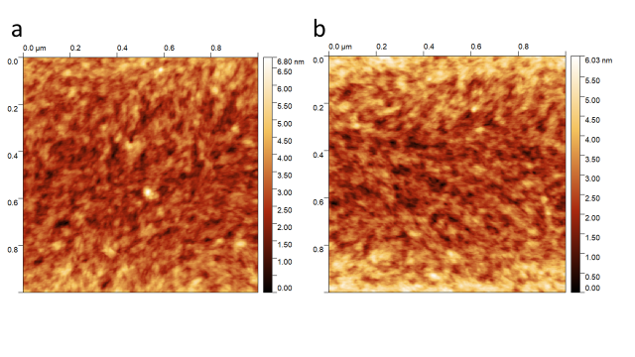Figure S4 AFM images of (a) a solution-sheared and (b) a spin-coated NN1 polymer film.

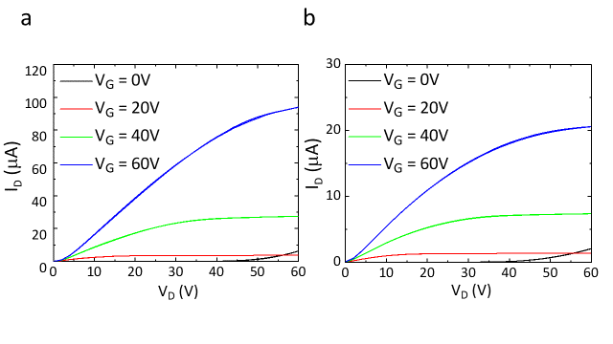
Figure S5 Room temperature output curves measured on a top gate bottom contact field-effect transistor (L = 20 µm, W = 1mm) for charge transport directions (a) parallel and (b) perpendicular to the NN2 polymer chain alignment direction.

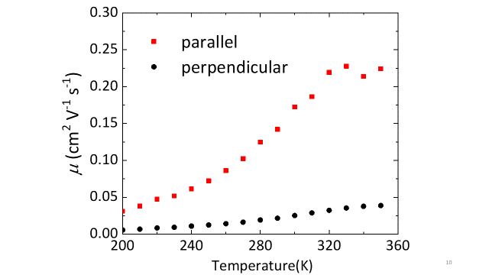
Figure S6 Temperature-dependent saturation mobility for charge transport parallel (red squares) and perpendicular (black round) to the NN2 polymer chain alignment direction.

Figure S7 Temperature-dependent saturation transfer curves (a) and mobilities (b) for the charge transport direction parallel to the NN2 polymer chain alignment direction in the 300-350 K temperature range.

Figure S8 Room temperature transfer and leakage current curves measured on a top gate bottom contact field-effect transistor (L = 20 µm, W = 1mm) for charge transport directions (a) parallel and (b) perpendicular to the NN2 polymer chain alignment direction.

Table S1 GIWAXS spacing parameters for spin-coated and sheared NN2 samples

Crystallographic parameters |  | Parallel | Perpendicular | Spin-Coated
Lamella stacking  (Out-of-plane) | q (Å⁻¹) | 0.25 | 0.25 | 0.23
 | d-spacing (Å) | 25.4 | 25.4 | 27.1
 | Δ_{FWHM} (Å⁻¹) | 0.050 | 0.040 | 0.084
 | Coherence length (Å) | 224.2 | 288.7 | 134.4
Lamella stacking  (In-plane) | q(Å⁻¹) | 0.24 | 0.24 | 0.24
 | d-spacing (Å) | 26.6 | 26.6 | 26.0
 | Δ_{FWHM} (Å⁻¹) | 0.040 | 0.057 | 0.035
 | Coherence length (Å) | 281.1 | 200.1 | 326.9
π – π stacking  (Out-of-plane) | q (Å⁻¹) | N/A | N/A | 1.65
 | d-spacing (Å) | N/A | N/A | 3.8
 | Δ_{FWHM} (Å⁻¹) | N/A | N/A | 0.17
 | Coherence length (Å) | N/A | N/A | 66.2
π – π stacking  (In-plane) | q(Å⁻¹) | 1.63 | 1.59 | 1.54
 | d-spacing (Å) | 3.9 | 3.9 | 4.1
 | Δ_{FWHM} (Å⁻¹) | 0.17 | 0.073 | 0.15
 | Coherence length (Å) | 67.5 | 156.0 | 78.1
N/A denotes not available

References

[1] K. Goedel, R. H. Friend, A. Sadhanala, T. H. Thomas, B. Nair, B. Yang, P. Docampo, N. Giesbrecht, W. Huang, S. P. Senanayak, H. Sirringhaus, C. R. McNeill, X. Moya, E. Gann, S. Guha, Sci. Adv. 2017, 3, e1601935.
[2] D. A. Warr, L. M. A. Perdigão, H. Pinfold, J. Blohm, D. Stringer, A. Leventis, H. Bronstein, A. Troisi, G. Costantini, Sci. Adv. 2018, 4, eaas9543.
[3] D. Nečas, P. Klapetek, Open Phys. 2012, 10, DOI 10.2478/s11534-011-0096-2.
[4] C. Rivetti, M. Guthold, C. Bustamante, J. Mol. Biol. 1996, 264, 919.
[5] P. C. Hiemenz, T. P. Lodge, CRC Press, 2007.

