Effective design of managed realignment schemes can reduce coastal flood risks
Joshua Kiesel*ª, Mark Schuerch^{b}, Elizabeth K. Christie^{c}, Iris Möller^{d}, Tom Spencer^{c}, Athanasios T. Vafeidisª

ª Department of Geography, Christian Albrechts Universität zu Kiel, 24118, Germany
^{b} Lincoln Centre for Water and Planetary Health, School of Geography, University of Lincoln, Brayford Pool Campus, Lincoln, LN6 7TS
^{c} Cambridge Coastal Research Unit, Department of Geography, University of Cambridge, CB2 3EN, UK
^{d} Department of Geography, Trinity College Dublin, Museum Building, Dublin 2, Ireland
* Corresponding author

E-mail addresses:
kiesel@geographie.uni-kiel.de (J. Kiesel), mschuerch@lincoln.ac.uk (M. Schuerch), ekc28@cam.ac.uk (E. K. Christie), moelleri@tcd.ie (I. Möller), ts111@cam.ac.uk (T. Spencer), vafeidis@geographie.uni-kiel.de (A. Vafeidis)

Declarations of interest: none

Abstract
Managed realignment (MR) constitutes a form of nature-based adaptation to coastal hazards, including sea level rise and storm surges. The implementation of MR aims at the (re)creation of intertidal habitats, such as saltmarshes, for mitigating flood and erosion risks and for creating more natural shorelines. However, some evidence suggests that the desired coastal protection function of MR schemes (in terms of high water level (HWL) attenuation) may be limited and it was hypothesized that this was due to the configuration of the remaining seawalls, which we refer to as scheme design. The effects of scheme design on within-site HWL attenuation are analysed for six scheme designs that differ in terms of breach characteristics and water storage capacity. The scenarios are established by manipulating the digital elevation model of the site topography to vary the configuration of the old defence line and the breaches.
Our results show that changes in scheme design, particularly storage area and number and width of breaches, had significant effects on the site´s HWL attenuation capacity. Decreasing the tidal prism by changing the number and size of breaches, with the site area kept constant, leads to increased modelled HWL attenuation rates. However, average HWL attenuation rates of > 10 cm km⁻¹ are only achieved when site size increases. The mean high water depth of each scenario, calculated by dividing tidal prism by MR area, explains most of the variation in average HWL attenuation between all scenarios. Attention to potential within-site hydrodynamics at the design stage will aid the construction of more effective MR schemes with respect to coastal protection in the future.

Keywords: coastal wetland, high water level attenuation, coastal restoration, managed realignment, de-embankment, coastal protection

- Introduction
Managed realignment (MR) constitutes a form of nature-based adaptation for low lying coasts, aiming at the restoration or creation of intertidal habitats, such as saltmarshes, for the long-term management of flood and erosion risks. Saltmarshes can attenuate high water levels (HWL) (Smolders et al., 2015; Stark et al., 2016; Stark et al., 2015; Temmerman et al., 2013), waves (Möller et al., 2014; Möller and Spencer, 2002; Rupprecht et al., 2017; Spencer et al., 2015) and provide flood water storage, thus contributing to mitigating coastal flooding. Furthermore, through the provision of intertidal habitats, saltmarshes provide additional services such as recreation, nutrient cycling, carbon storage, preservation of high water quality and biodiversity (Burden et al., 2013; Esteves, 2014; Luisetti et al., 2011; Spencer and Harvey, 2012).
Despite these multiple benefits, the assessment to what extent MR schemes provide their desired functions is difficult, as data on long-term individual project performance are scarce and of limited geographic coverage. In combination with societal and political resistance (Cooper and McKenna, 2008; Ledoux et al., 2005), the limited evaluation of MR may explain why the wider implementation is still hindered by funding constraints, availability of suitable land and uncertainties related to natural coastal evolution (Esteves and Williams, 2017). Nevertheless, MR schemes have been increasingly implemented in several countries, with large scale examples in Belgium (Sigma Plan, 2011), the USA (Day et al., 2007; EPA, 2013), Germany (Schernewski et al., 2018a; Schernewski et al., 2018b) and the UK (Cross, 2017; Esteves and Thomas, 2014; Turner et al., 2007). In December 2015, a total of 140 European sites were established (Esteves and Williams, 2017). In the UK, for example, the Online Managed Realignment Guide listed 51 MR projects in 2013 (Esteves and Thomas, 2014) which increased to 74 MR sites by 2019 (ABPmer, 2019). This growing interest needs to be accompanied by more comprehensive and longer-term monitoring, which could help to evaluate the sustainability and performance of MR and thus inform better MR design.
So far, there have been various types of MR scheme designs. These can be grouped into four classes, namely: (1) the complete removal of flood defences; (2) single breach schemes; (3) schemes with more than two breaches; and (4) regulated tidal exchange. The latter is excluded from the analysis presented in this paper, as the primary aim of regulated tidal exchange in Europe constitutes habitat creation (Esteves and Williams, 2017). The remaining three approaches have been characterised by various objectives, such as the creation of more natural shorelines, the promotion of biodiversity and, particularly in the UK, the enhancement of flood protection (including the reduction of flood protection costs and flood storage provision) (ABPmer, 2019; Esteves, 2013; Ledoux et al., 2005).
Across all different scheme designs, studies have shown that restored saltmarshes within MR schemes are different from their natural counterparts. These studies have identified differences in vegetation properties (Garbutt and Wolters, 2008; Mazik et al., 2010; Mossman et al., 2012), biogeochemical cycling (Burden et al., 2013), topographic complexity (Lawrence et al., 2018) and HWL attenuation (Kiesel et al., 2019). Burden et al., (2013) and Garbutt and Wolters (2008) suggested that the difference between natural and restored saltmarshes may be a function of time, as it may take up to 100 years for a restored marsh to reach equivalence. The discrepancies between natural and restored saltmarshes reveal that substantial knowledge gaps still exist when it comes to recreating both the habitat and its ecosystem functioning.
These knowledge gaps may originate from the complex nature of coastal evolution and its interaction with the original scheme design. Erosion and sedimentation give rise to changes in site morphology (e.g. breach evolution: Friess et al., 2014; Vandenbruwaene et al., 2015), which in turn provides new environmental conditions to the process regime. Such interrelationships are further complicated by changing baselines, such as longer-term changes in external forcing from modified storm climates, coastal sediment availability and, in the future, accelerated sea level rise (van Goor et al., 2003). This significantly complicates the numerical modelling of the MR site’s morphodynamic evolution before and after breaching (Friess et al., 2014; Symonds et al., 2008).
Esteves (2014) argued that it is important to assess whether the selected breach design allows for the complete tidal drainage of a MR site of a particular size, especially during high water events. Similarly, Stark et al. (2016) found that storage area limitations for floodwater might cause water blockage against dikes, which in turn may result in HWL amplification. This may explain why the close coupling between inundation depth and HWL attenuation within saltmarshes (Stark et al., 2015) may be altered within MR sites (Kiesel et al., 2019). In order to establish effective design guidelines for MR sites at the open coast, and to foster a stronger public support and confidence for this management practice, detailed knowledge on the effects of scheme design (size and breach design) on within-site HWL attenuation needs to be obtained.
For example, the size of MR and its specific breach design determines the volume of water between mean low and mean high water (Friess et al., 2014), which drives site internal inundation depths. The latter has been shown to be correlated with HWL attenuation (Stark et al., 2016; Stark et al., 2015). It is therefore crucial to revive the debate on whether to perform bank removal or breach restoration, which arguably still constitutes “one of the unresolved problems facing the UK intertidal restoration program” (Pethick, 2002 434).
This problem has been illustrated in the MR site of Freiston Shore, where HWL amplifications were observed during a field survey (Kiesel et al., 2019). Thus, the coastal protection function for which Freiston was designed is not fully realised. In this study, we present the results of a 2-D hydrodynamic model, calibrated and validated against field measurements of the highest spring tides of the year between August and October 2017, taken within, and seaward of, the Freiston Shore MR site (Kiesel et al., 2019). We investigate six potential adaptations to Freiston Shore (termed hereafter as scheme design scenarios) in order to explore the potential of improving the HWL attenuation of the MR site. We structure the scenarios in three groups; 1) two scenarios with three breaches and varying MR areas, 2) three single breach scenarios of different width and 3) one bank removal scenario. We furthermore discuss the implications of potential morphodynamic adjustments within each of these adaptations, by providing an analysis of bed shear stress for each scenario. Bed shear stress constitutes a useful parameter for this purpose, as it provides insights into depositional and erosional dynamics of intertidal areas (Callaghan et al., 2010; Li et al., 2019; Widdows et al., 2008).

- Material and Methods
2.1 Study Area
The Freiston Shore MR site is located on the shores of The Wash embayment in Lincolnshire, eastern UK (Fig. 1).
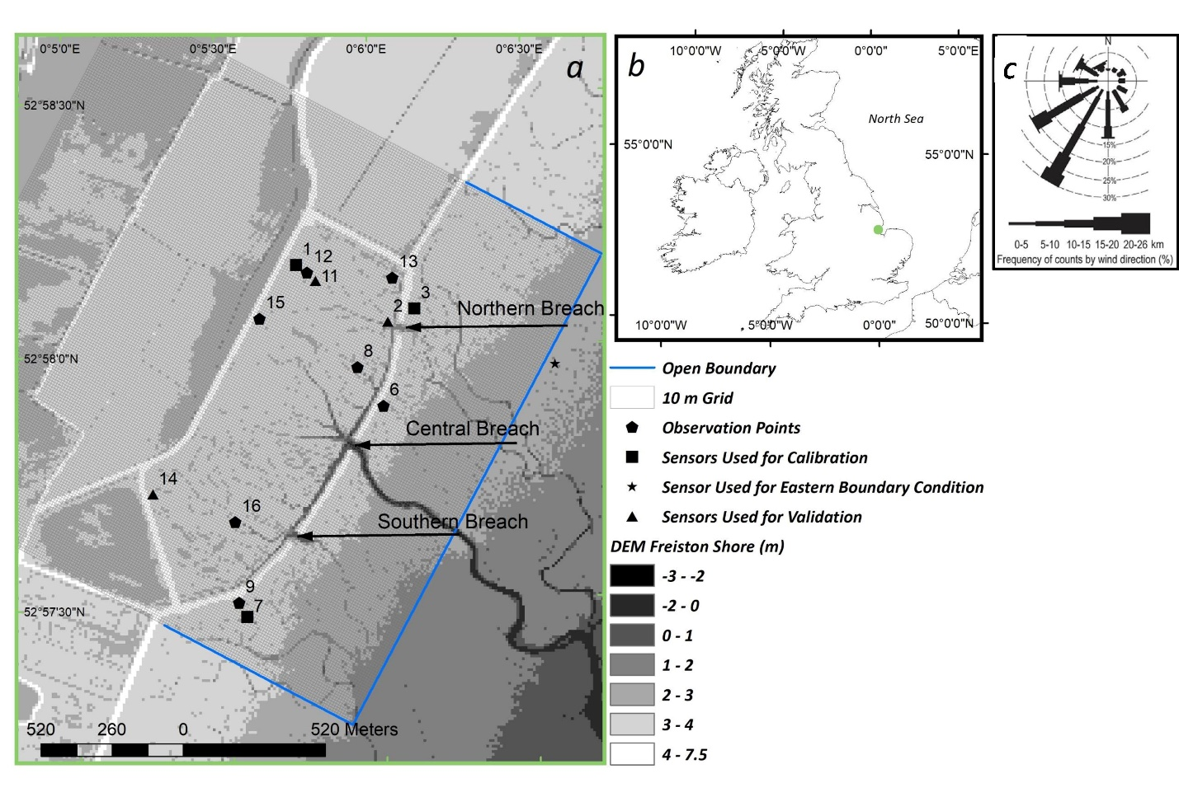
Figure 1: Location of the Freiston Shore MR site (green dot) in eastern England, UK (b). Panel a) shows the model domain and observation points used for model calibration, validation and for the assessment of HWL attenuation rates. The underlying 10 x 10 m digital elevation model was derived from a 2016 Light Detection and Ranging (LiDAR) survey and was provided by the UK Environment Agency. Panel c was taken from Kiesel et al. (2019) and shows the wind conditions during the measurement period at Holbeach weather station, 18 km to the south of the study site. UK Met Office provided the wind data.
The Wash comprises an area of about 600 km² (ca. 25 km long from southwest to northeast, approximately 18 km wide from northwest to southeast at its seaward margin, and about 27 km wide towards its southern margin) with an average depth of < 10 m and maximum depths between 40 – 50 m. The coastline of The Wash has a total length of 110 km, which is fringed by intertidal environments including saltmarshes, mud- and sandflats (Brew and Williams, 2002). Southwesterly winds are dominant in The Wash, which was also the case during the measurement period (Fig. 1c). The Wash has a semi-diurnal, macro tidal regime. Mean neap and spring tidal range is 3.5 m and 6.5 m respectively, with flood-dominated tidal asymmetry at the coastal margins (Friess et al., 2012; Ke et al., 1996; Pye, 1995). Between May 1999 and May 2000, wave rider buoy measurements at the entrance to the Wash recorded maximum wave heights of 2.81 m and mean significant wave heights of 0.61 m. These conditions make The Wash a relatively low-energy embayment, which acts as a sink of marine sediments (Spencer et al., 2012), while fluvial sediment inputs are minimal (Ke et al., 1996). Sediment transport is consequently dominated by tidal currents, although waves have significantly shaped the morphology of The Wash´s margins (Pye, 1995).
Hill and Randerson (1987) stated that 10 % of the UK´s saltmarsh area was located in The Wash at the time of their investigation, comprising a total of 4,199 ha. In the 1990´s, 75 % of The Wash´s coastline was fronted by saltmarsh (Pye, 1995). The shallow intertidal flats of The Wash have been subject to extensive land reclamations since the medieval period up until the 1980s (Doody, 1987). Between 1970 and 1980 alone, 800 ha of natural saltmarsh area was reclaimed for agricultural use (Baily and Pearson, 2007). The latest seawall in this sequence was created at Freiston Shore in 1982 (Symonds and Collins, 2005; Symonds and Collins, 2007a; Symonds and Collins, 2007b), resulting in the retreat of the seaward edge of the fronting natural saltmarsh at rates of 15 m a⁻¹ (Brew and Williams, 2002). Because of the reduced buffer zone, which left the seawall at high risk of breaching, the 1996 regional Shoreline Management Plan recommended realignment of this part of The Wash (Friess et al., 2008). This was finally realized in August 2002 by setting the coastal defence back to an earlier position, allowing for the restoration of formerly reclaimed saltmarshes over an area of 66 ha.
Besides the reinforcement of the landward seawall (0.4 – 0.5 km inland), the realignment was undertaken by excavating three breaches (each of ca. 50 m width) in the seaward embankment. These breaches connected 1,200 m of artificially created tidal creeks within the site with those of the adjacent natural marsh in front of the site (Friess et al., 2014; Symonds and Collins, 2005; Symonds and Collins, 2007a). It was anticipated that the Freiston Shore MR site would fully inundate 150 times per year, which would allow for the development of mid to upper marsh communities, located above mean high water level (Nottage and Robertson, 2005).
Monitoring of the MR was organized by the UK Government´s Department for Environment, Food and Rural Affairs (DEFRA), the Environment Agency (EA) and the UK´s Natural Environmental Research Council´s Centre for Ecology and Hydrology (NERC CEH) and included the Cambridge Coastal Research Unit (University of Cambridge) and Birkbeck, University of London. The monitoring involved an assessment on vegetation development, accretion rates and invertebrates (Brown et al., 2007; Friess et al., 2012). The results confirmed the suitability of the site for rapid vegetation development; by 2007, the mean total halophytic vegetation cover within the MR was estimated at 89 %. In late summer 2017, the most abundant species present were Salicornia europaea, Suaeda maritima, Puccinellia maritima, Atriplex portulacoides and Aster tripolium (Kiesel et al., 2019).
The established vegetation and the additional shallow water area provided by the restored saltmarsh were expected to provide “within-marsh attenuation” of waves and water levels (Smolders et al., 2015), allowing the landward seawall to be of a lower design specification and thus, cheaper to build and maintain (Dixon et al., 1998; Pethick, 2002).
In 2005, elevations at 41 surface elevation table locations within the MR varied between 2.76 m and 3.26 m ODN (Ordnance Datum Newlyn, where 0.0 m ODN approximates to mean sea level). In the first five years after breaching (2002 – 2007) most monitoring sites built up between 6 – 73 mm sediment, while some sites nearest to the central breach showed an exceptionally high total sedimentation of up to 215 mm (Brown et al., 2007). The latter sedimentation rates were most likely a result of high localized sediment input from breach and channel enlargement (Friess et al., 2014; Symonds and Collins, 2007a) and the comparatively low surfaces as a result of the 1982 embanking (Spencer et al., 2012). After MR implementation, average internal elevations used to be lower (generally <0.3 m) compared to the adjacent natural marsh (Friess et al., 2012). Sediment accretion inside the scheme has presumably sustained beyond the scope of the monitoring report, as in 2016 the mean elevation inside the MR (3.04 ± 0.42 m ODN) was higher compared to the external natural marsh (2.88 ± 0.5 m ODN) (Kiesel et al., 2019).

2.2 Model Setup
Flow of water over the model domain was simulated using the Delft3D-FLOW (version 4.00.02) model (Delft Hydraulics, 2003). Delft3D-FLOW allows for the computation of flow and sediment transport over a multi-dimensional (2D (depth averaged) and 3D) finite, rectilinear or curvilinear difference grid (Delft Hydraulics, 2003; Temmerman et al., 2012). A 2D depth averaged computation was used to solve the unsteady shallow-water equations.
Two-dimensional (depth-averaged) tide-induced flow was simulated on a Cartesian grid using the horizontal momentum equations, the continuity equation and 2D turbulence, which was modelled based on a constant horizontal eddy viscosity coefficient (1 m² s⁻¹). The modelled period extended over the highest spring tides of the year 2017, from the 20th of September to the 16th of October, applied at a time-step of six seconds. The model domain covered an area of 1.97 km width and 1.95 km length, extending from the pioneer zone of the natural saltmarsh in front of the MR over the MR itself in landward direction, up to the neighbouring agricultural fields (Fig. 1).
A 2 x 2 m LiDAR (Light Detection and Ranging) based DEM from 2016 (provided by the UK Environment Agency) was used to implement the bathymetry and topography of the Freiston Shore coastal zone. This dataset was resampled to a 10 m x 10 m and 5 m x 5 m resolution grid (the latter only for calibration purposes; see section 2.3) in order to reduce computational costs. A bilinear resampling technique was applied in both cases, which uses the average of the four nearest cells weighted by distance to define the new value of a cell. The bathymetry in the model domain is consequently not reflecting the highest surface levels, but includes sub grid scale features such as smaller tidal creeks, which are important for the undisturbed flow in the study site.
Key surface covers were differentiated for the application of bottom roughness coefficients. A supervised image classification (from Kiesel et al., 2019; overall accuracy of 93 %) was used to distinguish between four different surface cover classes (saltmarsh, water, mud and pasture). This classification was based on vertical aerial photography of 20 x 20 cm resolution, which was taken on 6 May 2016 during low tide for the UK Environment Agency. The results of the classification were validated by comparing twelve classified pixels to ground reference measurements (Kiesel et al., 2019).
The model was forced with hourly meteorological data on wind speed and direction measured at Holbeach weather station, 18 km south of the study site (Kiesel et al. 2019). It was assumed that the wind pattern was homogeneously distributed over the comparatively small model domain.
The hydrodynamic forcing of the eastern open boundary was defined in 10-minute intervals, using water levels measured in 2017 in the direct vicinity (Fig. 1, Kiesel et al. 2019). The two neighbouring open boundaries, situated perpendicular to the eastern boundary, were not forced, but allowed to exchange water with the water body outside the model domain.

2.3 Model Calibration and Validation
The model was calibrated with tidal water depths measured at three locations (Loc 1, Loc 3, Loc 7) within and outside the Freiston Shore MR site (Fig. 1). In order to test the model performance, we compared between modelled and measured water depth. The deviation between both was assessed by calculating root mean square errors (RMSE), mean errors (ME) and mean absolute errors (MAE) for the entire inundated period, as well as RMSEs (RMSE_{HWL}) and MAEs (MAE_{HWL}) of HWLs.
During calibration, the model was analysed for variations in the following model setups and parameters: mesh size (10 m vs 5 m), 2D, 3D (the latter exhibiting both five and two layers), Manning´s n roughness coefficients for saltmarsh surfaces (0.035 – 0.09), wind (including 2 sets of wind drag coefficients and one model run without wind included), reflection parameter alpha (250 – 1000), boundary conditions (only eastern boundary forced vs. all three boundaries forced) and time step (0.01 – 0.1 minutes). Best results were obtained by retaining Delft3D-FLOW’s default wind drag coefficients), a grid size of 10 x 10 m, a reflection parameter (alpha) of 500, 2D model grid, forcing only the eastern open boundary and by applying a time step of six seconds.
The influence of wind on the modelled water levels is calculated in Delft3D-FLOW through the relationship between drag force and wind speed described by three break point drag and wind speed conditions. The influence of these coefficients was calibrated by running the model with a) no wind drag, b) default Delft3D-FLOW wind drag coefficients (breakpoint A coefficient = 0.00063 at windspeed 0 m s⁻¹; B coefficient = 0.00723 and C = 0.00723, both at windspeeds of 100 m s⁻¹), and c) varying drag coefficients and breakpoint windspeeds for breakpoints A (0.0015 at 0 m s⁻¹) and B (0.005 at 40 m s⁻¹) (Bastidas et al., 2016; Delft Hydraulics, 2003).
The effects of a range of values for Manning´s n coefficient for saltmarshes (0.035, 0.06, 0.07, 0.08 and 0.09) on modelled water depths were tested against the field measurements. All coefficients (besides 0.09 and 0.06) were taken from the literature (Lawrence et al., 2004; Stark et al., 2016; Stark et al., 2017; Temmerman et al., 2012; Wamsley et al., 2010). Generally, the Freiston Shore model was not sensitive towards varying values of Manning´s n coefficient. The range of mean MAE_{HWL} for the calibration points varied between 0.047 m (MAE_{HWL} Loc 1 = 0.03, Loc 3 = 0.03 and Loc 7 = 0.08) for a Manning´s n value of 0.06 and 0.08 (MAE_{HWL} Loc 1 = 0.03, Loc 3 = 0.03 and Loc 7 = 0.08) and 0.057 m for a Manning’s n coefficient of 0.09 (MAE_{HWL} Loc 1 = 0.07, Loc 3 = 0.03 and Loc 7 = 0.07). Consequently, the Manning´s n values of 0.06 and 0.08 gave the best fit to the observation data. A Manning´s n coefficient of 0.08 was selected for our model runs as this value has has been used widely in similar studies for saltmarsh areas and proven to be suitable for approximating the roughness of saltmarsh surfaces (Loder et al., 2009; Stark et al., 2016; Temmerman et al., 2012). To account for the bottom roughness of other surface cover classes present in the model domain, Manning’s n coefficients for additional types of surface covers were assigned as follows: tidal flat (0.03), open water (0.02) and pasture (0.06). These values have been shown to be suitable for representing the drag forces of rough surfaces in a range of hydrodynamic model applications (Garzon and Ferreira, 2016; Hossain et al; Lawrence et al., 2004; Liu et al., 2013; Smolders et al., 2015; Stark et al., 2016; Temmerman et al., 2012; Wamsley et al., 2010; Wamsley et al., 2009).
Validation was performed by comparing modelled and measured water depths at three additional locations (Loc 2, Loc 11 and Loc 14) (Fig. 1, Tab. 1). Model validation (based on MAE_{HWL}) confirmed that water depths were well represented by the model across the site. The model outputs showed a phase shift of typically 10 minutes, and a maximum of 20 minutes; a constant correction of 10 minutes was therefore applied.

Table 1: Results of model validation at three locations. Error measurements represent the difference between modelled and measured water depths.
 | RMSE (m) | ME (m) | MAE (m) | RMSE_{HWL} (m) | MAE_{HWL} (m) | Mean MAE_{HWL} (m)
loc 2 | 0.060 | -0.030 | 0.050 | 0.060 | 0.040 | 0.030
loc 11 | 0.050 | 0.0200 | 0.030 | 0.030 | 0.030
loc 14 | 0.060 | 0.030 | 0.030 | 0.020 | 0.020

We used bed shear stress as an indicator for expected morphological adjustments, which are triggered by changes in scheme design and used the Status Quo to assess the validity of this approach. We looked at the difference between two LiDAR derived digital elevation models of Freiston Shore from the years 2002 (the year of the original breach) and 2016, in order to assess areas within Freiston, which have accreted or were eroded in the respective period. This figure shows that, in accordance with the spatial distribution of bed shear stress, morphological change has mostly focussed around the breaches, within, and next to, the artificial tidal creeks (supplementary material, Fig. S1).

2.4 Scheme Design Scenarios
In order to investigate whether changing the design of the Freiston Shore MR site would affect HWL attenuations, the scheme design was artificially changed by manipulating both the dike topography and the breach bathymetry in the model grid.
For this analysis a baseline scenario (status quo) was modelled, which represents the original implemented scheme. Additionally, six MR site modifications were applied, based on the most commonly used MR designs for the purpose of coastal protection in the UK: entire bank removal (Scenario 1), single breach design (Scenario 2) and schemes with more than two breaches (Scenario 3) (Fig. 2). The scenario site design characteristics are displayed in Table 2. Multiple variations in width of the central breach in the single breach designs (Scenarios 2.1, 2.2, 2.3) were tested, ranging from 30 m to 99 m. The latter breach width was implemented to account for any potential breach widening consequent upon changes in site hydrodynamics (Friess et al., 2014; Symonds and Collins, 2007a). Additionally, two variations in MR area for schemes with two or more breaches were tested (Scenario 3.1 and 3.2) to study the influence of site size on HWL attenuation (Tab. 2). For these scenarios, the storage area of the Freiston Shore MR site was increased by 118 % and 73 % for Scenario 3.1 and 3.2, respectively (Tab. 2, Fig. 2).
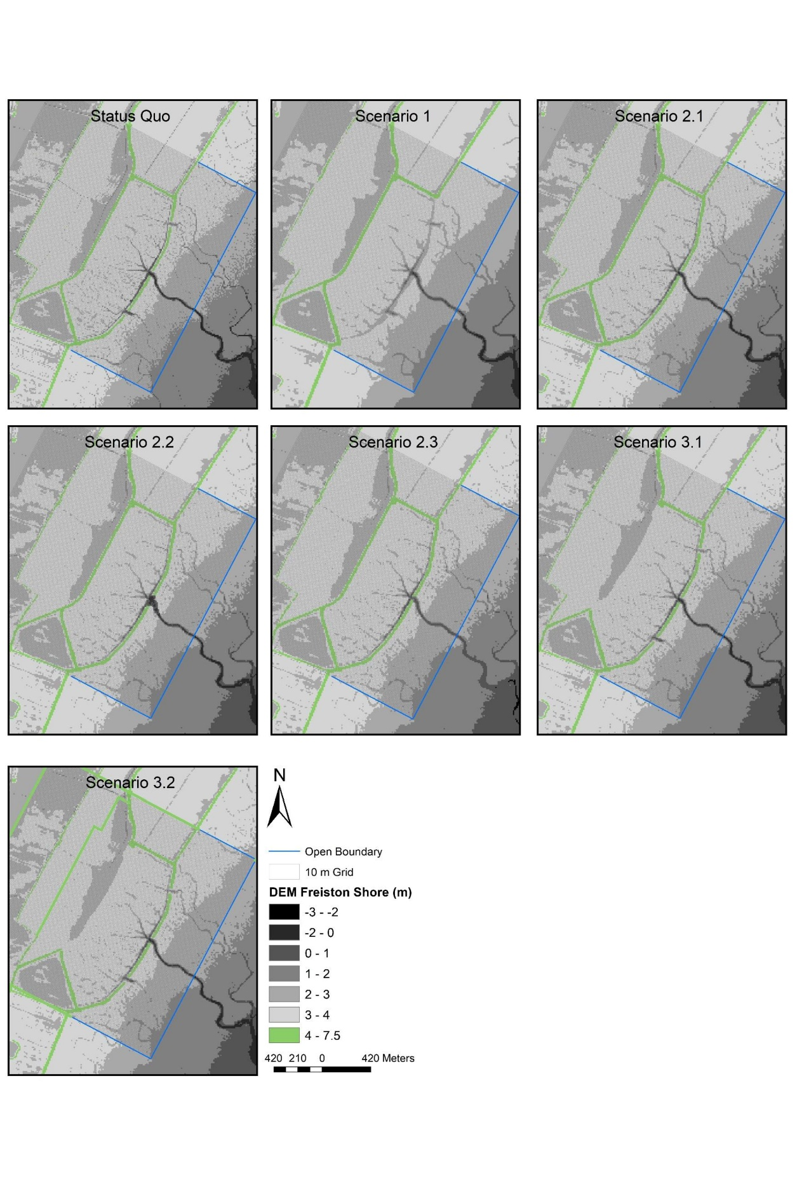
Figure 2: Scheme design scenarios at the Freiston Shore MR site. The Status Quo constitutes the baseline scenario to which other models were compared. Scenario 1 represents a scheme design where the entire seawall has been removed. Scenario 2.1 depicts an alternative option with only one breach, while Scenario 2.2 constitutes a single breach scenario with an enlarged centre breach, accounting for expected morphologic adjustments, resulting from the closed northern- and southernmost breaches. In Scenario 2.3, the centre breach is decreased in size, in order to test the effects of a decreased tidal prism. In Scenario 3.1, the MR is significantly increased in size by removing the landward seawall to the back of the site. Scenario 3.2 is similar to Scenario 3.1, but characterised by a slightly smaller area. See Table 2 for further details.

Table 2: Number of breaches, total breach width and area for every MR scheme design scenario including the Status Quo.
 | Status Quo | Scenario 1 | Scenario 2.1 | Scenario 2.2 | Scenario 2.3 | Scenario 3.1 | Scenario 3.2
number of breaches | 3 | 1 | 1 | 1 | 1 | 3 | 3
total breach width (m) | 127 | 1475 | 45 | 99 | 30 | 127 | 127
MR area (m²) | 650067 | 650067 | 650067 | 650067 | 650067 | 1416350 | 1124400

2.5 Calculation of HWL Attenuation Rates, Tidal Prism and Bed Shear Stress
HWL attenuation rates (cm km⁻¹) were calculated from the vertical difference in water level (elevation based on bathymetry (see Tab. 3) + water depth) between two observation points (termed hereafter as transect) and the measured horizontal distance (m) between the two sensors. The following transects were assessed: Loc 13 – 1, Loc 3 – 1, Loc 2 – 1, Loc 11 – 1, Loc 8 – 15, Loc 6 – 15, Loc 16 – 14, and Loc 9 – 14 (Fig. 1). In order to assess the coastal protection function of the Freiston Shore MR site and the tested scenarios, we calculated HWL attenuation over transects, which range from seaward of the breached seawall to the reinforced landward seawall (Loc 3 – 1, Loc 6 – 15 and Loc 9 – 14). We additionally measured five transects from inside the MR to the landward seawall (Loc 13 – 1, Loc 2 – 1, Loc 11 – 1, Loc 8 – 15 and Loc 16 – 14). Positive rates refer to HWL attenuation, while negative values correspond to an amplification of HWLs along the respective transect (Kiesel et al., 2019).
The tidal prism (m³) for each scenario was assessed by calculating the volume of water between average high and low water level within the MR during the measurement period. We used mean low water level and not just the marsh´s surface elevation to calculate the tidal prism, because tidal creeks and depressions inside the MR always retained some water, even during low tide.
Bed shear stress was extracted from the model results for each cell and each time step. Afterwards, we averaged bed shear stress for every grid cell by exclusively taking periods of inundation into account.

Table 3: Name, location and elevation of observation points used to calculate HWL attenuation rates. Elevation was extracted from the model bathymetry and the coordinates are given in British National Grid coordinate system.
Sensor # | Latitude | Longitude | Elevation based on Model Bathymetry (m ODN)
Loc 1 | 540728 | 343438 | 3.48
Loc 2 | 541059 | 343229 | 3.23
Loc 3 | 541154 | 343281 | 3.4
Loc 6 | 541044 | 342920 | 3.39
Loc 7 | 540544 | 342144 | 3.13
Loc 8 | 540949 | 343061 | 3.24
Loc 9 | 540518 | 342202 | 3.54
Loc 11 | 540799 | 343378 | 3.29
Loc 12 | 540768 | 343405 | 3.32
Loc 13 | 541076 | 343390 | 3.1
Loc 14 | 540205 | 342594 | 3.32
Loc 15 | 540590 | 343239 | 3.32
Loc 16 | 540503 | 342494 | 3.04

2.6 Statistical Analyses
Since the data was neither normally distributed (Shapiro Wilk p-value < 0.0005) nor homoscedastic (Bartlett p-value < 0.0005), the non-parametric One-Way Wilcoxon rank sum test and a Mann Whitney U test were used for statistical analysis. The latter was used to test the hypothesis (H₀) that HWL attenuation rates of every scenario were not significantly different from the status quo. The One-Way Wilcoxon rank sum test was used to investigate the hypothesis (H₀) that HWL attenuation rates were not significantly different from zero.

3 Results
3.1 The Effects of MR Scheme Design on HWL Attenuation
To determine the overall effect of the MR on mean HWL attenuation rates for every scenario, we first averaged attenuation rates over all measured transects and all high water events. Hereafter, positive rates refer to the attenuation of HWLs, while negative values show that HWLs were amplified.

 | Status Quo | Scenario 1 | Scenario 2.1 | Scenario 2.2 | Scenario 2.3 | Scenario 3.1 | Scenario 3.2
Mean attenuation (cm km⁻¹) | -1 | -1 | 4 | 2 | 6 | 16 | 11
Standard Deviation (cm km⁻¹) | 3 | 1 | 7 | 5 | 8 | 11 | 12
One-Way Wilcoxon rank sum test (p-values) | 0.002 | < 0.0005 | < 0.0005 | < 0.0005 | < 0.0005 | < 0.0005 | < 0.0005
Mann Whitney U test (p-values) | / | 0.5 | < 0.0005 | < 0.0005 | < 0.0005 | < 0.0005 | < 0.0005
Tidal prism (m³) | 296891 | 307435 | 263762 | 270122 | 256034 | 498752 | 420997
Area (m²) | 650067 | 650067 | 650067 | 650067 | 650067 | 1416350 | 1124400

Our results reveal statistically significant effects of the Freiston Shore MR scheme design on HWL attenuation rates. HWL attenuation rates in all scenarios were significantly different from zero and, besides Scenario 1, all scenarios were statistically significantly different from the status quo (Fig. 3, Tab. 4).
Table 4: Mean HWL attenuation rates, tidal prism and area for every scheme scenario including Status Quo. Standard deviations as well as p-values for the respective statistical tests are shown.

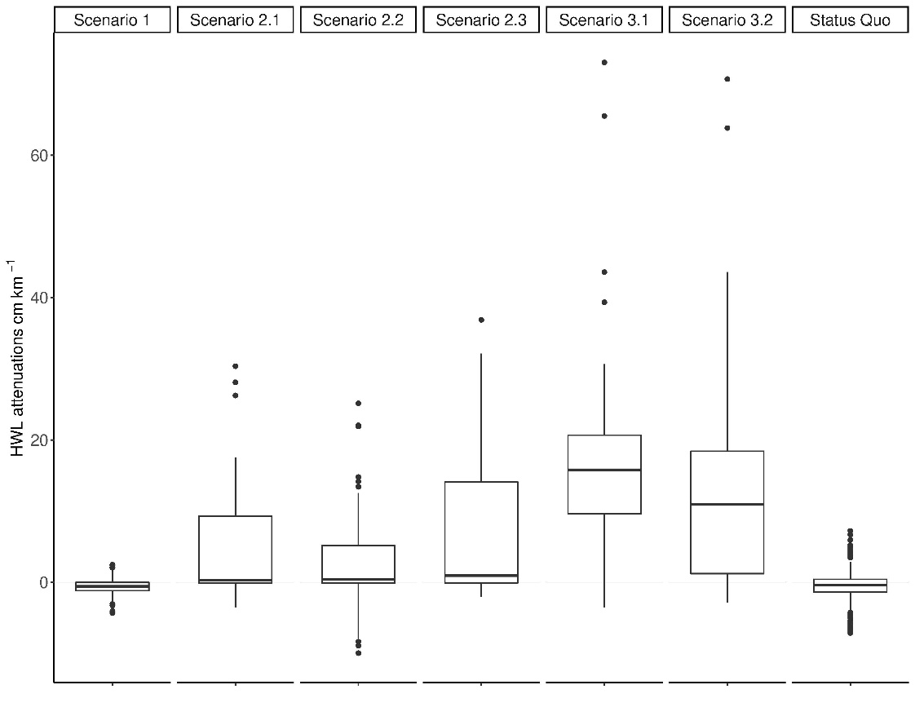
While the status quo and Scenario 1 produced average attenuation rates of -1cm km⁻¹, indicating amplification of HWLs, all other scenarios produced average HWL attenuation, even though their minimum values reveal occasional amplification of HWLs (Fig. 3). HWL attenuation rates were highest for those scenarios where the three breaches remained intact and the MR area was substantially increased (Scenarios 3.1 and 3.2). Scenario 3.1 exhibited the highest attenuation rates, with attenuation rates of up to 73 cm km⁻¹.
Figure 3: HWL attenuation rates for all tested scheme design scenarios. Every boxplot represents the variation of HWL attenuation rates over all transects and all high water events of the respective scenario. The bottom and top ends of the box refer to the 25th and 75th percentile and the centreline constitutes the median. Both whiskers are calculated as the upper and lower boundary of the box + 1.5 * the interquartile range. Data points, which did not fall within this range, are plotted as outliers.

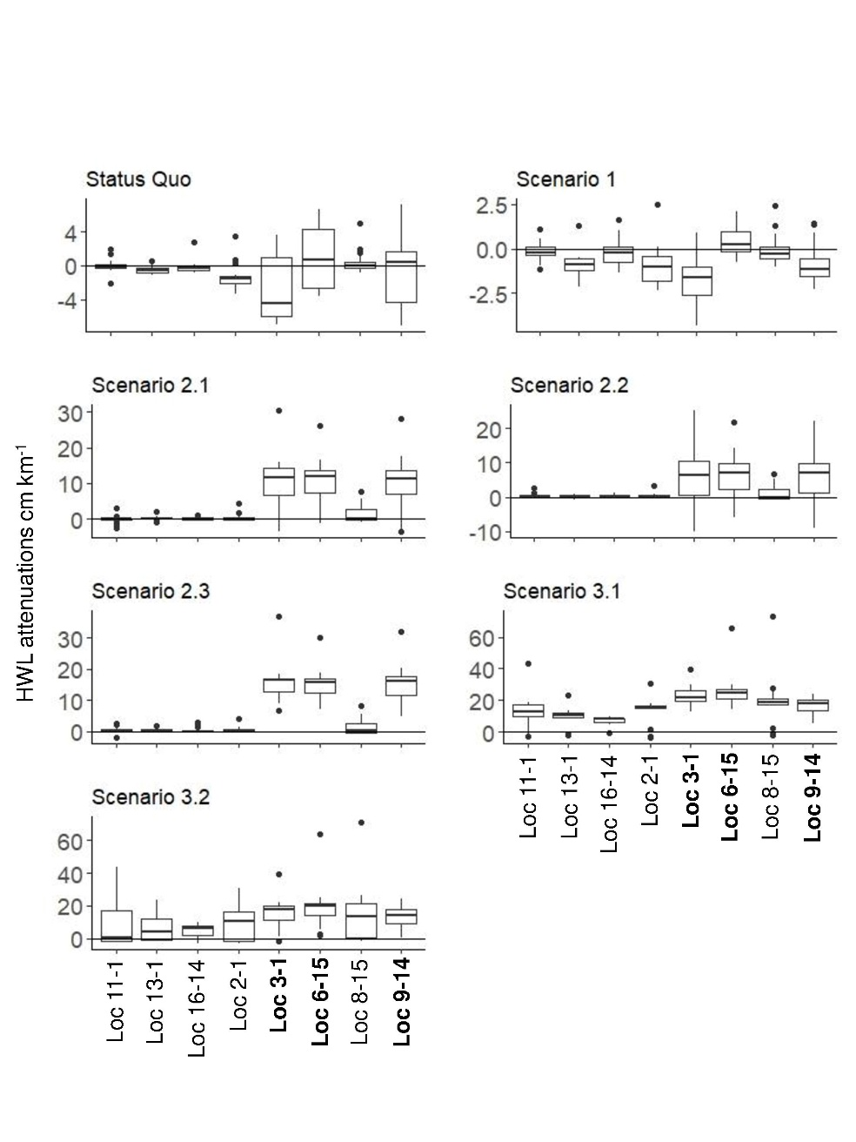
HWL attenuation rates between individual transects shows no distinct spatial trends and great variability across the MR in Scenario 1 and the status quo (Fig. 4). However, spatial patterns can be observed for Scenarios 2 and 3. In Scenarios 2.1, 2.2 and 2.3 we found above average attenuation rates for transects Loc 3 – 1, Loc 6 – 15 and Loc 9 – 14. In contrast to the other transects, these were measured starting from in front of the old and breached dike. This trend is also evident in Scenarios 3.1 and 3.2, but less distinct. In Scenario 3.1, lowest (yet still higher compared to all other scenarios) attenuation rates were assessed for transect Loc 16 – 14.
Figure 4: HWL attenuation rates for every transect of each scenario. Every boxplot represents the variation of HWL attenuation rates over all high water events of the respective scenario. Note that the y-axes vary in scale in order to enhance the readability. Transect written in bold letters on the x-axes indicate those ranging from outside the breached seawall to the new, landward seawall. The bottom and top ends of the box refer to the 25th and 75th percentile and the centreline constitutes the median. Both whiskers are calculated as the upper and lower boundary of the box + 1.5 * the interquartile range. Data points, which did not fall within this range, are plotted as outliers.

3.2 Correlation of HWL Attenuation with Mean High Water Depth (MHWD)
All scenarios, as well as the status quo, differ in terms of tidal prism (Tab. 4). The latter is determined by the respective area of the MR, as well as the breach design. Both determine the mean high water depth (MHWD) within the site, which is described by
$MHWD= tp/A$,
where tp refers to the site´s tidal prism (m³) and A to MR area (m²).. Our results indicate the dependency of HWL attenuation rates on MHWD, as a significantly negative correlation (p-value of polynomial model < 0.0005) was found across all scenarios (Fig. 5).
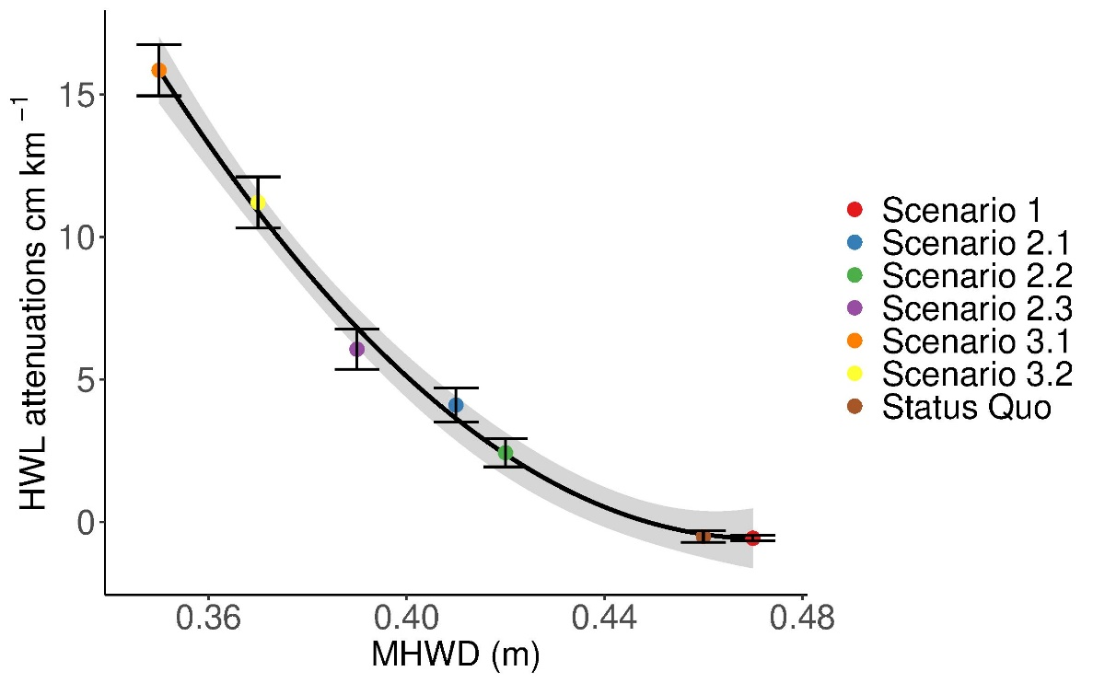
Figure 5: The correlation between mean HWL attenuation of each scenario and MHWD. The error bars show the standard error of the mean and the shaded area around the polynomial model indicates the 95 % confidence interval. Formula: y = 5.5 – 14 x + 4.3x²; R² = 0.996; adjusted R² = 0.994; p < 0.0005.

Similarly, we found significant correlations (described by polynomial functions) between average HWL attenuation and mean high water depth of each individual high water event within each scenario (Fig. 6). The threshold, which divides between attenuation and amplification, is very different between scenarios. While for the status quo the threshold is approximately 0.4 m of mean high water depth, it increases by more than two-fold for scenarios 2.1, 2.2 and 3.2. For scenarios 2.3 and 3.1., the threshold water depth was not reached during the measurement period.
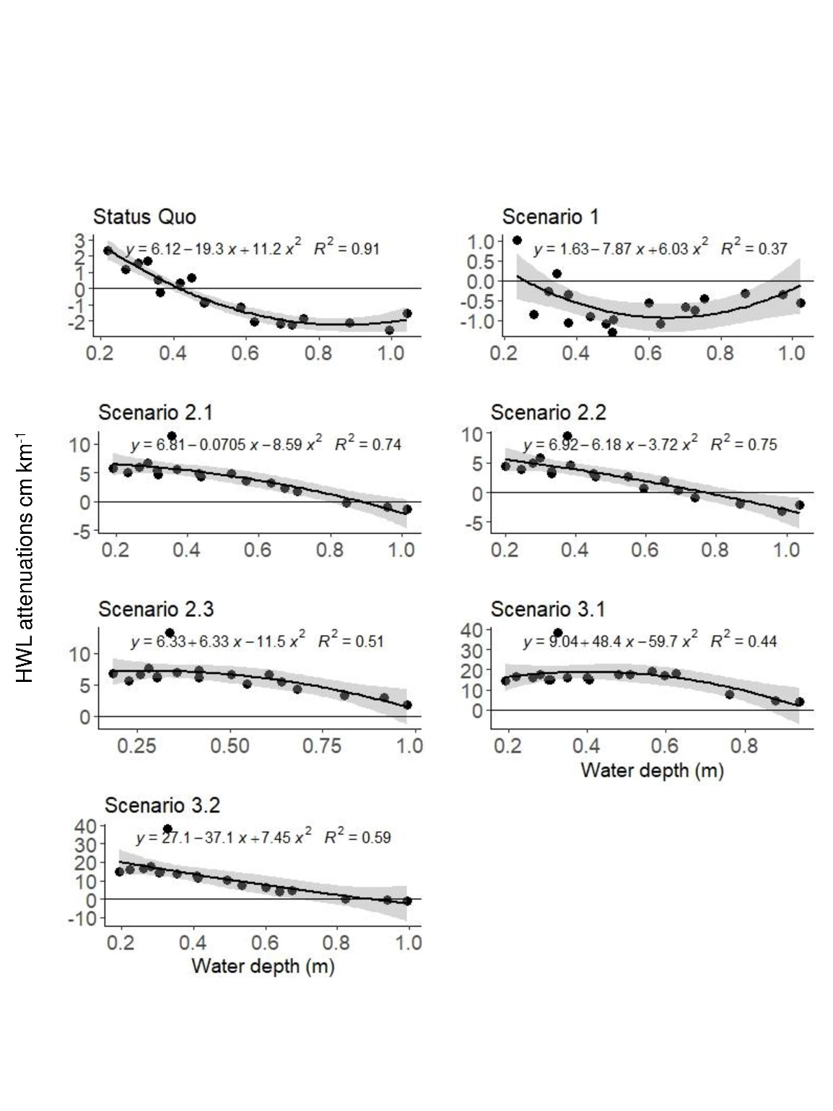
Figure 6: Correlation between average HWL attenuation and mean high water depth. HWL attenuation has been averaged for every individual high water event during the simulated period by using all available transects. Mean high water depth has been calculated for every high water event and over all observation points within each MR scenario. The shaded area around the polynomial model represents the 95 % confidence interval.

3.3 Bed Shear Stress
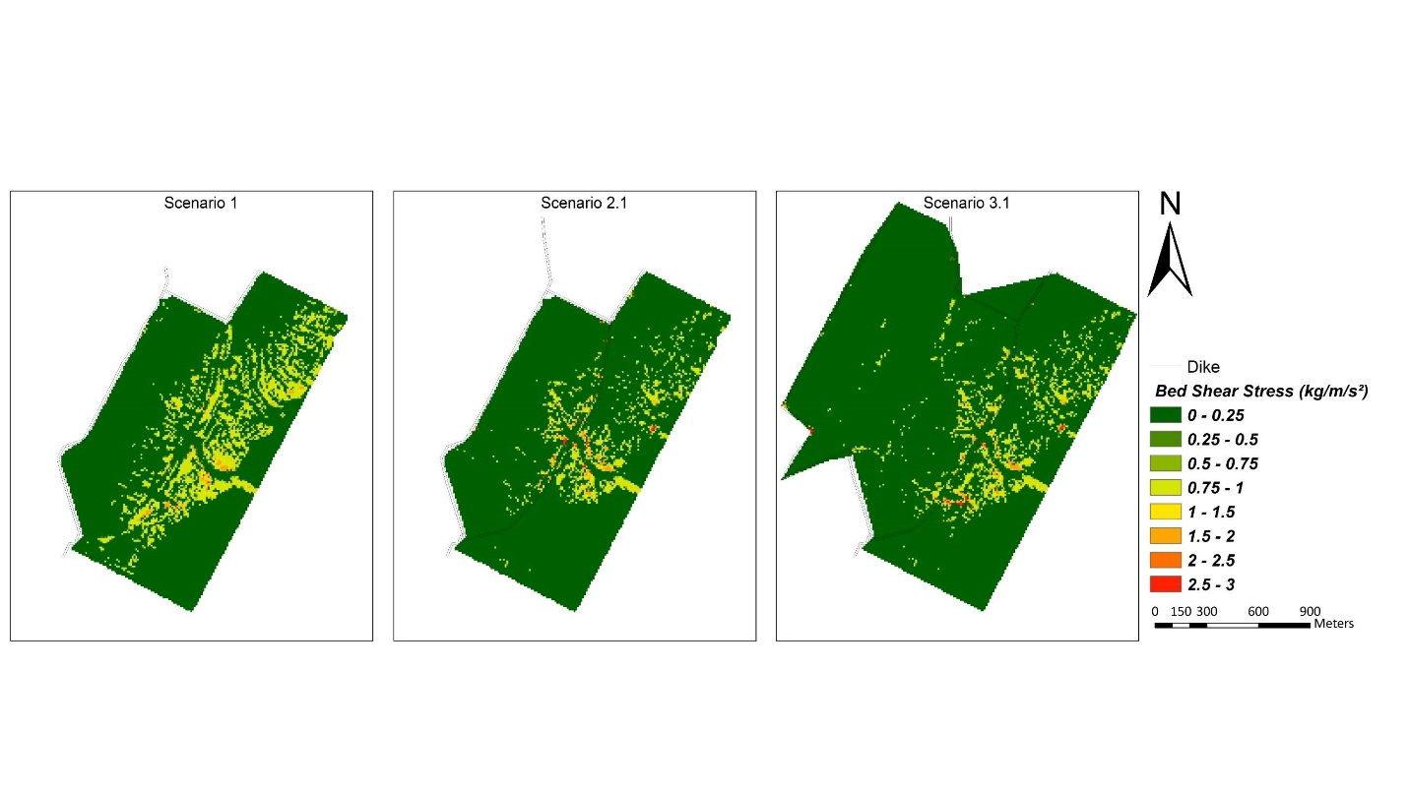
Our results show that areas of comparatively high bed shear stress are in all scenario families mostly limited to the seaward edges of the MR site. Bed shear stress is generally highest around the breaches, which is why it is extensively spread along the removed seawall in Scenario 1 (Fig. 7).
Figure 7: Bed shear stress within the three scenario families. Bed shear stress was averaged over the study period, excluding times when the site was not flooded.
In Scenario 2.1, the highest values of bed shear stress are concentrated around the central breach, whereas areas to the back of the site, including the north-eastern and south-western parts, are characterised by comparatively low bed shear stress. In Scenario 3.1, high values of bed shear stress also concentrate around the three breaches, but in comparison to Scenarios 1 and 2.1, they are more scattered towards the northwest of the site, where the landward seawall has been removed.

- Discussion
4.1 Implications for MR Scheme Design
Storage area and breach design of the Freiston Shore MR site have had a significant effect on the site´s HWL attenuation capacity. Furthermore, HWL attenuation can indeed be controlled by means of breach design. For example, when the storage area of the Freiston Shore MR site was kept constant (as in Scenario 1, 2, 2.2, 2.3 and the status quo), modelled HWL attenuation rates increased with decreasing tidal prism. In these scenarios, the tidal prism was controlled by changing the number and the widths of the breaches. However, our results show that effective coastal protection in terms of higher HWL attenuation rates (i.e. > 10 cm km⁻¹) can only be obtained if the MR area is of sufficient size. The maximum modelled HWL attenuation rates were observed for Scenarios 3.1 and 3.2 (up to 73 cm km⁻¹), which contained the largest storage areas and consequently exhibited the largest tidal prisms. Stark et al. (2015) measured comparable maximum HWL attenuation rates (up to 70 cm km⁻¹) over short transects in the extensive natural Saeftinghe marsh in the Western Scheldt estuary (Netherlands). We note, however, that a larger MR surface area provides also more space for wind waves to develop within the scheme, which may affect the development of vegetation, sedimentation patterns and ultimately, hydrodynamics (Nottage and Robertson, 2005).

Scenario 3.1 and 3.2 produced the highest attenuation rates because of their association with the lowest MHWD. This relationship helped explain most of the variation in mean HWL attenuations across scenarios, which was also observed for each scenario individually (Fig. 5, 6). However, previous studies have shown that also MR site orientation, meteorological conditions, vegetation characteristics and local tidal regime are important drivers of HWL attenuation (Kiesel et al., 2019; Paquier et al., 2017; Resio and Westerink, 2008; Sheng et al., 2012; Stark et al., 2015; Wamsley et al., 2010; Wamsley et al., 2009). This hinders the extrapolation of HWL attenuation rates, measured at a given study site for a specific range of high water events and meteorological conditions, to other MR sites. The diverse driving forces of HWL attenuation help explaining why flood level reduction is highly variable between wetlands, specific wetland locations as well as individual high water events (Temmerman et al., 2012). This variability may be reflected in weaker correlations of HWL attenuation and the mean high water depth of each high water event within the scenarios (Fig. 6), when compared to the overall trend (Fig. 5).

We hypothesize that the close coupling between MHWD and HWL attenuation suggested by this study may vary depending on whether MR sites or natural marshes are considered. For example, this study suggests that scheme scenarios with MHWDs of > 0.4 m (Status Quo and Scenario 1) may already result in overall HWL amplification. This finding raises two major issues: i) problematically, HWL attenuation is particularly important when inundation depths are well above 0.4 m, for example during storm surge conditions; and ii) Stark et al. (2015), analysing field data, showed that for the extensive (natural) Saeftinghe marsh along the Western Scheldt estuary (Netherlands), HWL attenuation rates peaked during inundation depths ranging between 0.5 and 1 m. The latter provides reference that MR schemes (15 years of age) may not be as effective as natural marshes when it comes to the magnitude of HWL attenuation.
Consequently, future MR design needs to account for the altered correlation between MHWD and HWL attenuation within MR schemes and for the strong internal dynamics in attenuation rates. The former may enable the optimization of MR scheme designs for the purpose of “within-wetland” (Smolders et al., 2015) attenuation and thus, coastal protection. By measuring water depth as a function of MR area and local tidal prism, the usage of MHWD may help estimate the HWL attenuation potential of existing MR sites. This could enable the identification of sites with low or even negative HWL attenuation potential. For such sites, it could be possible to retro-fit an improved scheme design, by managing the site’s tidal prism and / or the number, and width/s, of seawall breaches.
Breach design can be essential for coastal protection. Across most scenarios (all but Scenario 1), median and/or maximum HWL attenuation rates were highest for transects, which were measured from in front of the breached seawall (Fig. 4). For sites with a bank removal design, the approach to retro-fit an improved scheme design may, however, come too late.
At Freiston Shore, breach width and depth was, in the early stages of site evolution, dependent on the local tidal prism. This explains why after site implementation, breach channels increased in width by up to 950 % within only 2.5 month and shows that if breaches are designed with a cross sectional area insufficient to accommodate the tidal exchange, they are very likely to erode (Friess et al., 2014; Townend et al., 2016; Vandenbruwaene et al., 2015). This means that the breach design is restricted by local environmental circumstances.
However, adverse effects could be prevented for sites, where the tidal prism is managed via regulated tidal exchange (21 of 74 UK MR sites) (ABPmer, 2019). In the UK, for example, regulated tidal exchange is usually not implemented for the purpose of coastal protection but they may yet prove to be the most efficient in terms of HWL attenuation. However, regulated tidal exchange may only offer a degree of control as the effects of meteorological conditions acting on an enclosed body of water could still lead to adverse internal hydrodynamics and HWL amplification (Kiesel et al., 2019).
Our findings emphasise the importance of breach design and regulated tidal exchange for MR implementation. In contrast to bank removal (Scenario 1), breach design enables, even if only to a limited extent, the regulation of the tidal prism and consequently, inundation depths, which in turn determines the degree to which HWLs are attenuated within the MR site. Furthermore, the remaining structure maintains a certain degree of protection for the restored saltmarsh within the MR, increasing HWL attenuation rates (Fig. 4) and reducing the erosional effects of storm waves and tidal currents and enhancing rapid sedimentation. This may also be true for sites managed through regulated tidal exchange, as defences are maintained and flow into the restoration site is controlled via culverts and sluices (Cox et al., 2006; Esteves, 2014).

4.2 Considerations on the Effects of Site Topography on Modelled HWL Attenuations
In this paper, we evaluate the model results of each scenario based on the original topography of the Freiston Shore MR site in 2016 (represented by a LiDAR derived digital elevation model from 2016). We acknowledge that the morphology within each of the scheme design scenarios would develop differently compared to the status quo, as tidal prism and related hydrodynamics determine within-site sedimentation (Dale et al., 2017). This is indicated by the spatial distribution of bed shear stress within the three scenario families. Changes in marsh topography might be particularly expected for tidal channel geometry, as the latter is a function of the tidal prism (Friess et al., 2014). Marsh topography in terms of surface elevation and presence of tidal creeks affect HWL attenuation (Loder et al., 2009; Stark et al., 2016; Temmerman et al., 2012), which is why we expect HWL attenuation rates to change over time in each of the scenarios.
Stark et al. (2016) suggest that saltmarshes dominated by highly channelized flow provide less attenuation compared to marshes, which are dominated by sheet flow. This consideration suggests that the morphological evolution of MR sites could be critical to the coastal protection function in the long-term. It is therefore reasonable to assume that HWL attenuation rates presented for scenarios 3.1 and 3.2 are overestimated, as the newly created saltmarsh area to the back of the site would develop tidal creeks in order to drain and those creeks near the breaches would further expand in order to accommodate the increased tidal prism (Fig. 7). Unlike Scenarios 3.1 and 3.2, we assume that HWL attenuation rates are underestimated for scenario family 2. In Scenario 2.1, bed shear stress is low (compared to the Status Quo; Figure S1, Fig. 7) in the north-eastern and south-western parts. We would therefore assume the tidal creeks in these areas to fill up with sediments over time, resulting in increased sheet flow and ultimately, increased HWL attenuation rates for transects Loc 11 – 1, Loc 13 – 1, Loc 16 – 14, Loc 2 – 1, Loc 8 – 15. On the other hand, we found HWL attenuations to be exceptionally high for transects Loc 3 – 1, Loc 6 – 15 and Loc 9 – 14 (reaching from in front of the breached dike to the landward dike). Due to exceptionally high loads of bed shear stress within and next to the breaches of all scenarios (and particularly in the remaining central breach for scenario family 2), these transects will be most affected by expected changes in channel morphology such as channel deepening and erosion and are thus likely to be overestimated as well.

4.3 Model Reproduces Water Depths But Not Variability in HWL Attenuations
The model is well suited for the reproduction of measured water depths above the reference plane (bathymetry) at several locations (Tab. 1). In addition, mean HWL attenuation for the status-quo was found to be in the same order of magnitude between the model results (-1 cm km⁻¹) and the field survey (-3 cm km⁻¹) (Kiesel et al., 2019).
However, the exceptional variability of HWL attenuation rates measured inside the MR during the original field survey (SD: 40 cm km-1) could not be reproduced by the model application (SD: 3 cm km-1). The reasons for this discrepancy may involve the following four aspects: 1) the transects over which HWL attenuations were measured differed between the original field survey and this modelling study. 2) Uniform Manning n coefficients were used for all vegetated surfaces, even though vegetation types assessed in the field revealed considerable variations and 3), due to the use of averaged bathymetry and elevation data (10 x 10 m), the model exhibited reduced topographic complexity. Furthermore, the reduced variability within the model may be ascribed to 4) differences in elevation measurements at the pressure sensor locations.
Accuracy of elevation measurements in the field (Leica Viva GS08 GNSS satellite survey (RTK)) are associated with an accuracy of up to 50 mm, but typically below 20 mm (Kiesel et al., 2019). The bathymetry for the model presented in this study was derived from a 2 x 2 m LiDAR digital terrain model measured in 2016 (provided by the UK Environment Agency) and provided a vertical accuracy of ± 20 cm. In fact, this study found a systematic elevation difference between the 10 x 10 m model bathymetry and the RTK measurements of, on average, 0.47 m (Kiesel et al., 2019). Model bathymetry elevations were consistently higher than the RTK measurements. It is known that due to the dense and low vegetation within saltmarshes, LiDAR systems can fail to distinguish centimetre-scale variations between the vegetation canopy (digital surface model) and the bare ground (digital terrain model) (Hopkinson et al., 2004; Schmid et al., 2011). Schmid et al. (2011) ascribed this problem to the poor penetration of the laser pulse through the marsh vegetation, which may result in digital terrain models to be less accurate and significantly varying between different surface types. This effect may be amplified by the high spatial heterogeneity of vegetation and topographic features (Fernandez-Nunez et al., 2017).
This deviation can have a large effects on the calculation of HWL attenuation rates, particularly over shorter marsh transects (Kiesel et al., 2019). The identified differences in elevation measurements underline the difficulties that marsh vegetation and small scale topographic variations pose on the derivation of elevation and bathymetry data. The identified differences in elevation measurements highlight the importance of high-resolution input data for the application of hydrodynamic models in coastal protection studies. This may even be valid for areas with comparatively good data coverage, such as Freiston Shore.

5. Conclusion
MR schemes are generally designed based on well-established relationships between scheme design (e.g. surface area, breach dimensions/number and tidal prism) and hydrodynamic processes. The dependency of HWL attenuation on MR scheme design in this study has shown that these relationships do not necessarily predict HWL attenuation rates several years after breaching, particularly if site morphology and associated hydrodynamics change over time. We therefore stress the need for continued monitoring efforts in MR schemes.
We show that HWL attenuation is strongly dependent on within-site MHWD. The latter is not only a function of the well-established relationship between water depth, surface roughness and HWL attenuation but also incorporates the parameters of tidal prism and MR site area. Thus, once the available area for a MR site is known, the width(s) of the seawall breach(es) can be designed in order to accommodate a tidal prism, which result in the lowest possible MHWDs that allow for the attenuation of HWLs.
We suggest that breach design and regulated tidal exchange should be the preferred design options for MR sites that are implemented for the purpose of coastal protection. The reason is that both enable controlling the tidal prism (and consequently inundation depths) and because the breached seawall may additionally enhance HWL attenuation rates.
We also show that our hydrodynamic model application may not be able to capture the within-site dynamics of HWL attenuation. It is important to account for these dynamics, particularly when the protection standard of new seawalls at the landward margins of MR sites need to be determined. For now, the prediction of the effects of meteorological conditions and extreme events on the relationship between MHWD and HWL attenuation is not fully understood. There is an urgent need for further field investigations of water level dynamics within MR sites, particularly under high water level, storm surge conditions.

Acknowledgements
The work presented in this paper is based on field data obtained during JK´s research stay at the Department of Geography´s Visiting Scholar programme of the University of Cambridge. JK particularly thanks B. Evans (Cambridge Coastal Research Unit) for technical and field assistance. Furthermore, JK thanks Pushpa Dissanayake for his helpful introduction to the Delft3D modelling environment and the Integrated School of Ocean Science as part of the Future Ocean Excellence Cluster (University of Kiel) for funding the original field campaign.
The authors thank the UK Environment Agency, for the supply of vertical aerial photography, LiDAR data and for their fast and helpful responses to our requests regarding the data. Furthermore, the authors would like to thank Deltares Delft Hydraulics for providing the Delft3D-FLOW model. This is a contribution towards UKRI NERC BLUECoast project (NE/N015878/1).

References
ABPmer, 2019. The Online Managed Realignment Guide. https://www.omreg.net/. Accessed 22 February 2019.
Baily, B., Pearson, A.W., 2007. Change detection mapping and analysis of salt marsh areas of central southern England from Hurst Castle Spit to Pagham Harbour. Journal of Coastal Research 236, 1549–1564. 10.2112/05-0597.1.
Bastidas, L.A., Knighton, J., Kline, S.W., 2016. Parameter sensitivity and uncertainty analysis for a storm surge and wave model. Nat. Hazards Earth Syst. Sci. 16 (10), 2195–2210. 10.5194/nhess-16-2195-2016.
Brew, D., Williams, A., 2002. Shoreline movement and shoreline management in The Wash, eastern England. Littoral conference 2002, the changing coast, Porto, Portugal, 313–320.
Brown, S.L., Pinder, A., Scott, L., Bass, J., Rispin, E., Brown, S., Garbutt, A., Thomson, A., Spencer, T., Möller, I., Brooks, S.M., 2007. Wash banks flood defence scheme Freiston environment monitoring 2002 - 2006. FD 1911/TR. Joint DEFRA/EA Flood and Coastal Erosion Risk Management R&D Programme.
Burden, A., Garbutt, R.A., Evans, C.D., Jones, D.L., Cooper, D.M., 2013. Carbon sequestration and biogeochemical cycling in a saltmarsh subject to coastal managed realignment. Estuarine, Coastal and Shelf Science 120, 12–20. 10.1016/j.ecss.2013.01.014.
Callaghan, D.P., Bouma, T.J., Klaassen, P., van der Wal, D., Stive, M., Herman, P., 2010. Hydrodynamic forcing on salt-marsh development: Distinguishing the relative importance of waves and tidal flows. Estuarine, Coastal and Shelf Science 89 (1), 73–88. 10.1016/j.ecss.2010.05.013.
Cooper, J., McKenna, J., 2008. Working with Natural Processes: The Challenge for Coastal Protection Strategies. Geogr. J. 174 (4), 315–331.
Cox, T., Maris, T., Vleeschauwer, P. de, Mulder, T. de, Soetaert, K., Meire, P., 2006. Flood control areas as an opportunity to restore estuarine habitat. Ecological Engineering 28 (1), 55–63. 10.1016/j.ecoleng.2006.04.001.
Cross, M., 2017. Wallasea Island Wild Coast Project, UK: Circular economy in the built environment. Proceedings of the Institution of Civil Engineers - Waste and Resource Management 170 (1), 3–14. 10.1680/jwarm.16.00006.
Dale, J., Burgess, H.M., Cundy, A.B., 2017. Sedimentation rhythms and hydrodynamics in two engineered environments in an open coast managed realignment site. Marine Geology 383, 120–131. 10.1016/j.margeo.2016.12.001.
Day, J.W., Boesch, D.F., Clairain, E.J., Kemp, G.P., Laska, S.B., Mitsch, W.J., Orth, K., Mashriqui, H., Reed, D.J., Shabman, L., Simenstad, C.A., Streever, B.J., Twilley, R.R., Watson, C.C., Wells, J.T., Whigham, D.F., 2007. Restoration of the Mississippi Delta: lessons from Hurricanes Katrina and Rita. Science (New York, N.Y.) 315 (5819), 1679–1684. 10.1126/science.1137030.
Delft Hydraulics, 2003. User Manual Delft3D-FLOW. WL. Delft Hydraulics, Delft, The Netherlands.
Dixon, A.M., Leggett, D., Weight, R.C., 1998. Habitat Creation Opportunities for Landward Coastal Re-alignment: Essex Case Studies. Water Environ. 12 (2), 107–112.
Doody, J.P., 1987. Background to the conference, in: The Wash and its Environment. Nature Conservancy Council, Peterborough, UK.
EPA, 2013. San Francisco Bay Delta Watershed. United States Environmental Protection agency. http://www2.epa.gov/sfbay-delta. Accessed 8 November 2011.
Esteves, L.S., 2013. Is managed realignment a sustainable long-term coastal management approach? Journal of Coastal Research 65, 933–938. 10.2112/SI65-158.1.
Esteves, L.S., 2014. Managed realignment: A viable long-term coastal management strategy? Springer, New York.
Esteves, L.S., Thomas, K., 2014. Managed realignment in practice in the UK: results from two independent surveys. In: Green, A.N., Cooper, J. (Eds.) proceedings 13th International Coastal Symposium, Durban, South Africa, pp. 407–413.
Esteves, L.S., Williams, J.J., 2017. Managed realignment in Europe: a synthesis of methods, achievements and challanges. In: Bilkovic, D.M., Mitchell, M.M., Toft, J.D., La Peyre, M.K. (Eds.) Living Shorelines: The Science and Management of Nature-based Coastal Protection. CRC Press/Taylor & Francis Group, pp. 157–180.
Fernandez-Nunez, M., Burningham, H., Ojeda Zujar, J., 2017. Improving accuracy of LiDAR-derived digital terrain models for saltmarsh management. J Coast Conserv 21 (1), 209–222. 10.1007/s11852-016-0492-2.
Friess, D., Möller, I., Spencer, T., 2008. Managed realignment and the re-establishment of saltmarsh habitat, Freiston Shore, Lincolnshire, United Kingdom, in: The Role of Environmental Management and Eco-Engineering in Disaster Risk Reduction and Climate Change Adaptation, pp. 65–78.
Friess, D.A., Möller, I., Spencer, T., Smith, G.M., Thomson, A.G., Hill, R.A., 2014. Coastal saltmarsh managed realignment drives rapid breach inlet and external creek evolution, Freiston Shore (UK). Geomorphology 208, 22–33. 10.1016/j.geomorph.2013.11.010.
Friess, D.A., Spencer, T., Smith, G.M., Möller, I., Brooks, S.M., Thomson, A.G., 2012. Remote sensing of geomorphological and ecological change in response to saltmarsh managed realignment, The Wash, UK. International Journal of Applied Earth Observation and Geoinformation 18, 57–68. 10.1016/j.jag.2012.01.016.
Garbutt, A., Wolters, M., 2008. The natural regeneration of salt marsh on formerly reclaimed land. Applied Vegetation Science 11 (3), 335–344. 10.3170/2008-7-18451.
Garzon, J., Ferreira, C., 2016. Storm Surge Modeling in Large Estuaries: Sensitivity Analyses to Parameters and Physical Processes in the Chesapeake Bay. JMSE 4 (3), 45. 10.3390/jmse4030045.
Hill, M., Randerson, P., 1987. Saltmarsh vegetation communities of The Wash and their recent development, in: The Wash and its Environment. Nature Conservancy Council, Peterborough, UK.
Hopkinson, C., Lim, K., Chasmer, L.E., Treitz, P., Creed, I.F., Gynan, C., 2004. Wetland grass to plantation forest - estimating vegetation height from the standard deviation of lidar frequency distributions. Int Arch Photogramm Remote Sens Spat Inf Sci 36 (8/W2), 288–294.
Hossain, A., Yafei Jia, Xiabo Chao. Estimation of Manning's roughness coefficient distribution for hydrodynamic model using remotely sensed land cover features, in: 2009 17th International Conference on Geoinformatics, Fairfax, VA, pp. 1–4.
Ke, X., Evans, G., Collins, M.B., 1996. Hydrodynamics and sediment dynamics of The Wash embayment, eastern England. Sedimentology 43, 157–174.
Kiesel, J., Schuerch, M., Möller, I., Spencer, T., Vafeidis, A., 2019. Attenuation of high water levels over retored saltmarshes can be limited.: Insights from Freiston Shore, Lincolnshire, UK. Ecological Engineering 136, 89–100.
Lawrence, D., Allen, J., Havelock, G.M., 2004. Salt Marsh Morphodynamics: an Investigation of Tidal Flows and Marsh Channel Equilibrium. Journal of Coastal Research 20 (1), 301–316.
Lawrence, P.J., Smith, G.R., Sullivan, M.J., Mossman, H.L., 2018. Restored saltmarshes lack the topographic diversity found in natural habitat. Ecological Engineering 115, 58–66. 10.1016/j.ecoleng.2018.02.007.
Ledoux, L., Cornell, S., O’Riordan, T., Harvey, R., Banyard, L., 2005. Towards sustainable flood and coastal management: Identifying drivers of, and obstacles to, managed realignment. Land Use Policy 22 (2), 129–144. 10.1016/j.landusepol.2004.03.001.
Li, X., Leonardi, N., Plater, A.J., 2019. Wave-driven sediment resuspension and salt marsh frontal erosion alter the export of sediments from macro-tidal estuaries. Geomorphology 325, 17–28. 10.1016/j.geomorph.2018.10.004.
Liu, H., Zhang, K., Li, Y., Xie, L., 2013. Numerical study of the sensitivity of mangroves in reducing storm surge and flooding to hurricane characteristics in southern Florida. Continental Shelf Research 64, 51–65. 10.1016/j.csr.2013.05.015.
Loder, N.M., Irish, J.L., Cialone, M.A., Wamsley, T.V., 2009. Sensitivity of hurricane surge to morphological parameters of coastal wetlands. Estuarine, Coastal and Shelf Science 84 (4), 625–636. 10.1016/j.ecss.2009.07.036.
Luisetti, T., Turner, R.K., Bateman, I.J., Morse-Jones, S., Adams, C., Fonseca, L., 2011. Coastal and marine ecosystem services valuation for policy and management: Managed realignment case studies in England. Ocean & Coastal Management 54 (3), 212–224. 10.1016/j.ocecoaman.2010.11.003.
Mazik, K., Musk, W., Dawes, O., Solyanko, K., Brown, S., Mander, L., Elliott, M., 2010. Managed realignment as compensation for the loss of intertidal mudflat: A short term solution to a long term problem? Estuarine, Coastal and Shelf Science 90 (1), 11–20. 10.1016/j.ecss.2010.07.009.
Möller, I., Kudella, M., Rupprecht, F., Spencer, T., Paul, M., van Wesenbeeck, B.K., Wolters, G., Jensen, K., Bouma, T.J., Miranda-Lange, M., Schimmels, S., 2014. Wave attenuation over coastal salt marshes under storm surge conditions. Nature Geosci 7 (10), 727–731. 10.1038/ngeo2251.
Möller, I., Spencer, T., 2002. Wave dissipation over macro-tidal saltmarshes: Effects of marsh edge typology and vegetation change. Journal of Coastal Research (SI36), 506–521.
Mossman, H.L., Davy, A.J., Grant, A., Elphick, C., 2012. Does managed coastal realignment create saltmarshes with ‘equivalent biological characteristics’ to natural reference sites? J Appl Ecol 49 (6), 1446–1456. 10.1111/j.1365-2664.2012.02198.x.
Nottage, A., Robertson, P., 2005. The saltmarsh creation handbook: A project manager's guide to the creation of saltmarsh and intertidal mudflat / by Albert Nottage and Peter Robertson. Royal Society for the Protection of Birds, Sandy.
Paquier, A.-E., Haddad, J., Lawler, S., Ferreira, C.M., 2017. Quantification of the Attenuation of Storm Surge Components by a Coastal Wetland of the US Mid Atlantic. Estuaries and Coasts 40 (4), 930–946. 10.1007/s12237-016-0190-1.
Pethick, J., 2002. Estuarine and Tidal Wetland Restoration in the United Kingdom: Policy Versus Practice. Restoration Ecology 10 (3), 431–437.
Pye, K., 1995. Controls on Long-term Saltmarsh Accretion and Erosion in the Wash, Eastern England. Journal of Coastal Research 11 (2), 337–356.
Resio, D.T., Westerink, J.J., 2008. Modeling the physics of storm surges. Physics Today 61 (9), 33–38. 10.1063/1.2982120.
Rupprecht, F., Möller, I., Paul, M., Kudella, M., Spencer, T., van Wesenbeeck, B.K., Wolters, G., Jensen, K., Bouma, T.J., Miranda-Lange, M., Schimmels, S., 2017. Vegetation-wave interactions in salt marshes under storm surge conditions. Ecological Engineering, 100, 301-315. 10.1016/j.ecoleng.2016.12.030.
Schernewski, G., Bartel, C., Kobarg, N., Karnauskaite, D., 2018a. Retrospective assessment of a managed coastal realignment and lagoon restoration measure: The Geltinger Birk, Germany. J Coast Conserv 22 (1), 157–167. 10.1007/s11852-017-0496-6.
Schernewski, G., Schumacher, J., Weisner, E., Donges, L., 2018b. A combined coastal protection, realignment and wetland restoration scheme in the southern Baltic: Planning process, public information and participation. J Coast Conserv 22 (3), 533–547. 10.1007/s11852-017-0542-4.
Schmid, K.A., Hadley, B.C., Wijekoon, N., 2011. Vertical Accuracy and Use of Topographic LIDAR Data in Coastal Marshes. Journal of Coastal Research 275, 116–132. 10.2112/JCOASTRES-D-10-00188.1.
Sheng, Y.P., Lapetina, A., Ma, G., 2012. The reduction of storm surge by vegetation canopies: Three‐dimensional simulations. Geophys. Res. Lett. 39 (20). 10.1029/2012GL053577.
Sigma Plan, 2011. https://www.sigmaplan.be/en/. Accessed 8 November 2019.
Smolders, S., Plancke, Y., Ides, S., Meire, P., Temmerman, S., 2015. Role of intertidal wetlands for tidal and storm tide attenuation along a confined estuary: A model study. Nat. Hazards Earth Syst. Sci. 15 (7), 1659–1675. 10.5194/nhess-15-1659-2015.
Spencer, K.L., Harvey, G.L., 2012. Understanding system disturbance and ecosystem services in restored saltmarshes: Integrating physical and biogeochemical processes. Estuarine, Coastal and Shelf Science 106, 23–32. 10.1016/j.ecss.2012.04.020.
Spencer, T., Brooks, S.M., Evans, B.R., Tempest, J.A., Möller, I., 2015. Southern North Sea storm surge event of 5 December 2013: Water levels, waves and coastal impacts. Earth-Science Reviews 146, 120–145. 10.1016/j.earscirev.2015.04.002.
Spencer, T., Friess, D.A., Möller, I., Brown, S.L., Garbutt, R.A., French, J.R., 2012. Surface elevation change in natural and re-created intertidal habitats, eastern England, UK, with particular reference to Freiston Shore. Wetlands Ecol Manage 20 (1), 9–33. 10.1007/s11273-011-9238-y.
Stark, J., Plancke, Y., Ides, S., Meire, P., Temmerman, S., 2016. Coastal flood protection by a combined nature-based and engineering approach: Modeling the effects of marsh geometry and surrounding dikes. Estuarine, Coastal and Shelf Science 175, 34–45. 10.1016/j.ecss.2016.03.027.
Stark, J., Smolders, S., Meire, P., Temmerman, S., 2017. Impact of intertidal area characteristics on estuarine tidal hydrodynamics: A modelling study for the Scheldt Estuary. Estuarine, Coastal and Shelf Science 198, 138–155. 10.1016/j.ecss.2017.09.004.
Stark, J., van Oyen, T., Meire, P., Temmerman, S., 2015. Observations of tidal and storm surge attenuation in a large tidal marsh. Limnol. Oceanogr. 60 (4), 1371–1381. 10.1002/lno.10104.
Symonds, A.M., Collins, M.B., 2005. Sediment dynamics associated with managed realignment; Freiston Shore, The Wash, UK, in: Proceedings of the 29th International Conference, National Civil Engineering Laboratory, Lisbon, Portugal. 19 – 24 September 2004, pp. 3173–3185.
Symonds, A.M., Collins, M.B., 2007a. The development of artificially created breaches in an embankment as part of a managed realignment, Freiston Shore, UK. Journal of Coastal Research (SI 50), 130–134.
Symonds, A.M., Collins, M.B., 2007b. The establishment and degeneration of a temporary creek system in response to managed coastal realignment: The Wash, UK. Earth Surf. Process. Landforms 32 (12), 1783–1796. 10.1002/esp.1495.
Symonds, A.M., Scott, C.R., Collins, M.B., 2008. Assessing the physical impacts of managed realignment in an estuarine and coastal environment, in: Proceedings of the 31st International Conference, Hamburg, Germany. 31 August – 5 September 2008, pp. 4508–4520.
Temmerman, S., Meire, P., Bouma, T.J., Herman, P.M.J., Ysebaert, T., Vriend, H.J. de, 2013. Ecosystem-based coastal defence in the face of global change. Nature 504 (7478), 79–83. 10.1038/nature12859.
Temmerman, S., Vries, M.B. de, Bouma, T.J., 2012. Coastal marsh die-off and reduced attenuation of coastal floods: A model analysis. Global and Planetary Change 92-93, 267–274. 10.1016/j.gloplacha.2012.06.001.
Townend, I., Wang, Z.B., Stive, M., Zhou, Z., 2016. Development and extension of an aggregated scale model: Part 1 – Background to ASMITA. China Ocean Eng. (China Ocean Engineering) 30 (4), 483–504. 10.1007/s13344-016-0030-x.
Turner, R.K., Burgess, D., Hadley, D., Coombes, E., Jackson, N., 2007. A cost–benefit appraisal of coastal managed realignment policy. Global Environmental Change 17 (3-4), 397–407. 10.1016/j.gloenvcha.2007.05.006.
van Goor, M.A., Zitman, T.J., Wang, Z.B., Stive, M., 2003. Impact of sea-level rise on the morphological equilibrium state of tidal inlets. Marine Geology 202 (3-4), 211–227. 10.1016/S0025-3227(03)00262-7.
Vandenbruwaene, W., Schwarz, C., Bouma, T.J., Meire, P., Temmerman, S., 2015. Landscape-scale flow patterns over a vegetated tidal marsh and an unvegetated tidal flat: Implications for the landform properties of the intertidal floodplain. Geomorphology 231, 40–52. 10.1016/j.geomorph.2014.11.020.
Wamsley, T.V., Cialone, M.A., Smith, J.M., Atkinson, J.H., Rosati, J.D., 2010. The potential of wetlands in reducing storm surge. Ocean Engineering 37 (1), 59–68. 10.1016/j.oceaneng.2009.07.018.
Wamsley, T.V., Cialone, M.A., Smith, J.M., Ebersole, B.A., Grzegorzewski, A.S., 2009. Influence of landscape restoration and degradation on storm surge and waves in southern Louisiana. Nat Hazards 51 (1), 207–224. 10.1007/s11069-009-9378-z.
Widdows, J., Pope, N.D., Brinsley, M.D., 2008. Effect of Spartina anglica stems on near-bed hydrodynamics, sediment erodability and morphological changes on an intertidal mudflat. Mar. Ecol. Prog. Ser. 362, 45–57. 10.3354/meps07448.

