# The Basolateral amygdala 🡪 Nucleus Accumbens core circuit is necessary for the acquisition of cue-controlled cocaine seeking.

# Authors:

Mickaël Puaud1,*, Alejandro Higuera-Matas2,*, Paul Brunault3, Barry J. Everitt1 and David Belin1

1: Department of Psychology, University of Cambridge, UK.

2: Department of Psychobiology, School of Psychology. UNED. Madrid, Spain.

3: CHRU de Tours -  Équipe de Liaison et de Soins en Addictologie & Clinique Psychiatrique Universitaire/ INSERM U1253 iBrain: Imaging & Brain, Tours, France.

*: these authors contributed equally to this work.

# Supporting Online material

# Supplemental methods

## Animals

Experimentally naïve male Sprague Dawley rats (n=59, Charles River, Kent, UK) weighing approximately 300g upon arrival were housed under a 12-hour reverse light/dark cycle (lights off at 07:00 am) in polycarbonate cages (41 cm x 25 cm x 21 cm, L/W/H) initially in pairs. Following surgery rats were singly housed, in order to prevent the conspecific from interacting with, and damaging the port of the catheter and to match the housing conditions to those used in previous experiments using second order schedules of cocaine reinforcement (1-10) and maintain a consistent approach across experiments over time.

Experiments were carried out during the dark phase, 6-7 days per week.

## Procedures

Briefly, after habituation to the animal facility rats underwent stereotaxic surgeries and following recovery they were singly housed. They were then implanted with an indwelling catheter in their right jugular vein (11) and, following recovery, were fed daily with 15-20g of standard chow per day prior to being trained to self-administer cocaine. Water was freely available in the home cage.

## Viral vectors

On arrival, all viral vectors were aliquoted and stored at -80°C until subsequent use. All viruses were freshly diluted in sterile PBS at a final concentration of 1x109vp/uL.

## Stereotaxic surgery and viral infusions

Viral infusions (design illustrated **Figure 1B**), were performed at least 29 days before the first chemogenetic manipulation thereby enabling the expression of the transgenes, which was assessed immediately after the last challenge.

Rats were randomly assigned to one of the three experimental groups described above and were anaesthetised with isoflurane (O2: 2L/min; 5% for induction and 2-3% for maintenance and analgesia (Metacam, 1mg/kg, sc., Boehringer Ingelheim) prior to being placed in a stereotaxic frame (KOPF instruments, Tujunga, CA, USA).

The CAV2-Cre virus was infused bilaterally (109vp/µl, 1µl/side) into the NAcC at the following stereotaxic coordinates (Paxinos and Watson 2009) AP: +1.2, ML: ±1.8, -7.1 DV (from skull) (5). The AAV8-hSyn-DIO-hM4D(Gi)-mCherry and AAV8-hSyn-DIO-mCherry viruses were infused bilaterally (1ul/side) into the BLA at the following stereotaxic coordinates AP: -2.5, ML: ±4.9, DV (from dura): -7.2 DV (from dura) (1). The AAV8-CaMKIIa-hM4D(Gi)-mCherry and AAV5-CaMKII-GFP viruses were infused bilaterally (0.85ul/side) into the anterior insular cortex at the following stereotaxic coordinates AP: +1.3, ML ±5.35, -7.1 DV (from skull) (12).

All infusions were performed with 10ul Hamilton syringes placed in a Harvard infusion pump and connected with a polyethylene tubing to 24 gauge injectors (Coopers needle works Ltd) at a rate of 0.15 μl/min. Injectors were left in place for 7min following completion of the infusion to allow for diffusion away from the injector tip.

## Intrajugular catheterization surgery

The implantation of an indwelling catheter into the right jugular vein was performed under isoflurane anaesthesia (O2: 2L/min; 5% for induction and 2-3% for maintenance and analgesia (Metacam, 1mg/kg, sc., Boehringer Ingelheim). Following the surgery, rats received daily oral treatment with the analgesic for three days and an antibiotic (Baytril, 10mg/kg, Bayer) for a week. Catheters were flushed with 0.1 ml of heparinized saline (50 U/ml, Wockhardt®) in sterile 0.9% NaCl every other day after surgery and then before and after each daily self-administration session.

## Self-administration

Experiments were conducted in 24 standard operant chambers (Med Associates Inc., St. Albans, VT, USA) controlled by MedPC software (Med Associates Inc., Ltd). Each (29.5 × 32.5 ×23.5 cm) chamber was housed in ventilated, sound-attenuating cubicles. Sidewalls were aluminium; the ceiling, front and back walls were clear polycarbonate. Two retractable levers (4cm wide) were situated 8cm above the grid floor and 12cm apart; a white cue light (2.5W, 24V) was situated above the levers and a white house light (2.5W, 24V), situated on the wall opposite the levers. Implanted catheters were connected to a 10mL syringe driven by an infusion pump (Semat Technical, Herts, UK) via Tygon tubing itself protected within a spring leash attached to a swivel connected to a balanced metal arm secured outside of the chamber.

Rats were trained to self-administer cocaine (0.25 mg/100µl/5.7s/infusion) under continuous reinforcement over 7 daily 2-hour sessions. Under this schedule, each active lever press resulted in drug infusion initiated concurrently with a 20s time out that included onset of a 20s illumination of cue light positioned above the active lever (conditioned stimulus; CS), offset of the house light and retraction of both levers. Inactive lever pressing was recorded but had no scheduled consequence. Active (AL) and inactive (IL) lever assignment was counterbalanced between subjects, and a maximum of 30 infusions was available for this stage.

Then, the daily schedule of reinforcement was changed to fixed intervals, increasing across daily training sessions from 1 min (fixed interval 1 min, FI1) to FI2, FI4, FI8, FI10 and eventually FI15 min (5). Under these schedules of reinforcement, responding on the active lever (AL) after each interval has elapsed results in an infusion of cocaine and initiates concurrently the presentation of the CS, retraction of the levers and a 20s time out, similar to the conditions described under continuous reinforcement. From the first FI15 session onwards cocaine infusions were limited to five per 2-hour session, as previously described (1, 5). Thus, under a FI15 min schedule of reinforcement, each day instrumental responding is maintained over the 15 min interval, in the absence of the drug, but in anticipation of the eventual, contingently-delivered i.v. infusion of cocaine (13, 14).

## Tissue collection

Ninety minutes following a 15min drug-free seeking session under CNO vs Veh treatment rats were deeply anaesthetised with pentobarbital (Euthatal, Merial, 750mg/Kg) and perfused with 0.01M phosphate-buffered saline (PBS), followed by 4% neutral-buffered formaldehyde (NBF). Brains were collected and post-fixed for at least 24h at 4°C in 4% NBF. Brains were then cryo-protected in a 30% sucrose solution (prepared in PBS 0.01M). After quick freezing on dry-ice, brains were processed into 35µm coronal sections using a cryostat (Leica Microsystems). Sections were kept free floating in a cryoprotectant solution (30% sucrose, 30% ethylene glycol, 0.547% Na2HPO4, 0.159% NaH2PO4, 0.9% NaCl, 1% polyvinyl pyrolidone, in distilled water) and stored at -20°C until immunohistochemistry.

## Immunohistochemistry

Brain sections were washed three times 10min in 0.01 M PBS at room temperature. Sections were then blocked for 2 h in 5% bovine serum albumin (BSA, Sigma-Aldrich, A7906) in 0.01 M PBS and 0.3% Triton X-100 (Sigma-Aldrich, T8787) prior to being incubated with a primary antibody (rabbit anti-mCherry; 1:1000; abcam, ab167453) in a 2% BSA and 0.1% Triton X-100 overnight (18h) at 4°C. Sections were then washed three times for 10min each in 0.01 M PBS and incubated in secondary antibody (goat Alexa Anti-Rabbit 488, 1:1,000; ThermoFisher Scientific, #A-11008) for 2 h at room temperature. Sections were again washed three times 10min with 0.01 M PBS and mounted onto glass slides (Fisherbrand Superfrost Microscope Slides) and allowed to dry overnight (protected from light). Slides were then covered with a coverslip and fluoroshield mounting medium (abcam, ab104135). Slides were stored at 4°C prior to image acquisition. Images were acquired with a Zeiss Axio Imager M2 equipped with an AxioCam MRm camera (Oberkochen, Germany). Images were taken using Visiopharm® software (Medicon Valley, Denmark), at magnification 5x and tiled to create the whole slices images or at magnification 10x for the regions of interest.

## Statistics

### Power statistics and determination of group sizes:

The sample sizes were identified a priori by statistical power analysis (G*Power software, Heinrich Heine Universitat, Dusseldorf, Germany) with a RM-ANOVA design including 3 groups (between-subject factor), 6 measurements (within-subject factor) and predicted effect size of 2.8 [drawing from previously published data with performance under FI at 65±12 and SOR at 150±40], 1-ß = 0.8 and  = 0.05. A range from 6 to 12 rats per group is predicted to yield highly reproducible outcomes with 1-ß>0.8 and 0.01<<0.05 

### Detailed statistical analyses:

Analyses were performed on 41 rats as 10 rats were excluded following histological assessment of the spread of the expression of the reporters and 8 rats were lost from the study because of catheter failures.

Because of between-session variability in performance across groups, data pertaining to the acquisition of cue-controlled cocaine seeking were analysed using 2-Way ANOVAs with 3-day blocks (each the average of the number of lever presses performed during the first 15 min drug free interval across 3 sessions) as within-subject factors and group (i. empty control vs hM4D(Gi)-Veh, ii. empty control, hM4D(Gi)-Veh and hM4DGi-CNO, iii. pooled control groups vs hM4DGi-CNO, or any of the control groups vs hM4DGi-CNO) as between-subject factors.

These comparisons were made across five or six 3-day blocks, with either the second FI15 block (during which rats received either vehicle or CNO treatment) and the subsequent four SOR blocks; or the baseline FI15 min block with that of the different treatments followed by the four SOR blocks.

Planned comparisons were carried out to account for the functional and experimental similarity between the two control groups, namely hM4D(Gi)-Veh and Empty-CNO groups, which were both expected to show a potentiation of responding on introduction of contingent CS presentations. This approach is similar to that widely used when pooling control groups after first demonstrating that they do not differ from each other (15-17) (as is the case here), while ensuring the statistical design mirrors that of the experiment. Nevertheless, alongside planned comparisons, systematic comparison to the pooled control groups and further post-hoc analyses were carried-out wherever necessary.

## Supplemental results

### Supplemental results related to Figure 2 and figure S2

The group x block interaction observed when comparing the three groups (e.g. hM4D(Gi)-Veh, hM4D(Gi)-CNO, Empty-CNO) was attributable to the hM4D(Gi)-CNO group responding to the contingent introduction of the CS differently from each of the two control groups, which did not differ from each other, as revealed by the systematic comparison of each pair illustrated in the **Table S1** below:

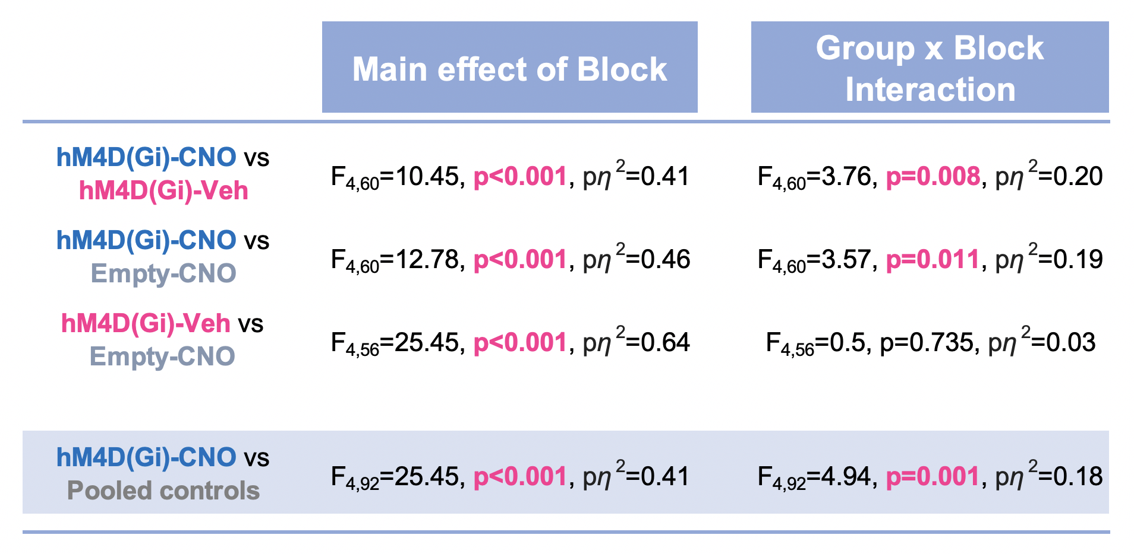

***Table S1: The differential increase in drug seeking upon introduction of the contingent presentation of the cocaine-paired cue observed between the three groups was attributable to the hM4D(Gi)-CNO group: insights from systematic comparisons (RM-ANOVAs) of the Log transformed data between each pair of groups.***

Follow-up post-hoc within-subject comparisons (Table S2) confirmed that the hM4D(Gi)-CNO group was the only one in which seeking responses never differed from that seen under pre-treatment FI15 baseline conditions irrespective of the statistical design, the main effects of which are reported in **Table S1**.

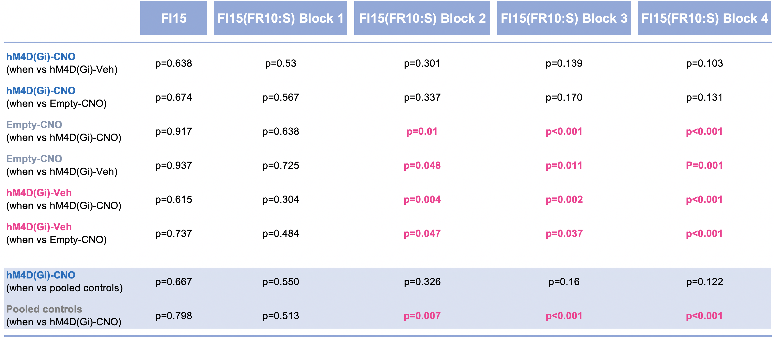

***Table S2: Post-hoc within-subject comparisons of the instrumental seeking responses performed under treatment by each group under each FI15 or SOR block to pre-treatment baseline performance under FI15.***

Consequently, hM4D(Gi)-CNO rats differed from the empty control from the second SOR block onwards and from hM4D(Gi)-Veh and the pooled control groups on the last or last two blocks of SOR, respectively, as illustrated in **Table S3** below.

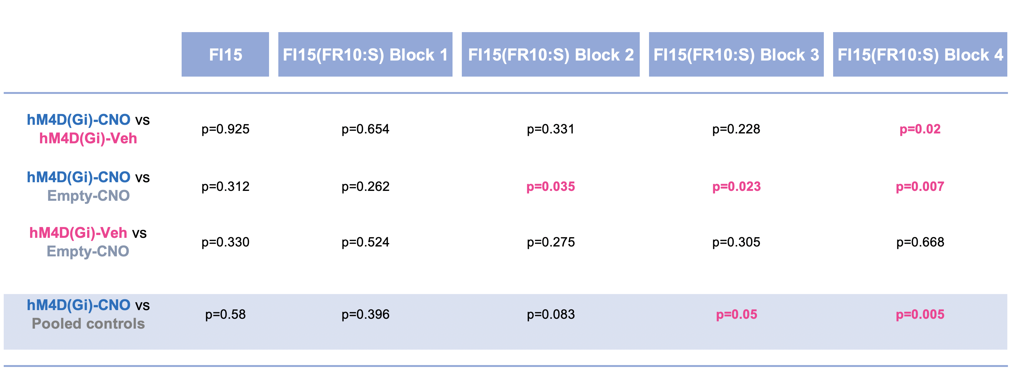

# *Table S3: Post-hoc between-subject comparisons of the instrumental seeking responses performed under treatment by each group under each FI15 or SOR*

# Supporting figures

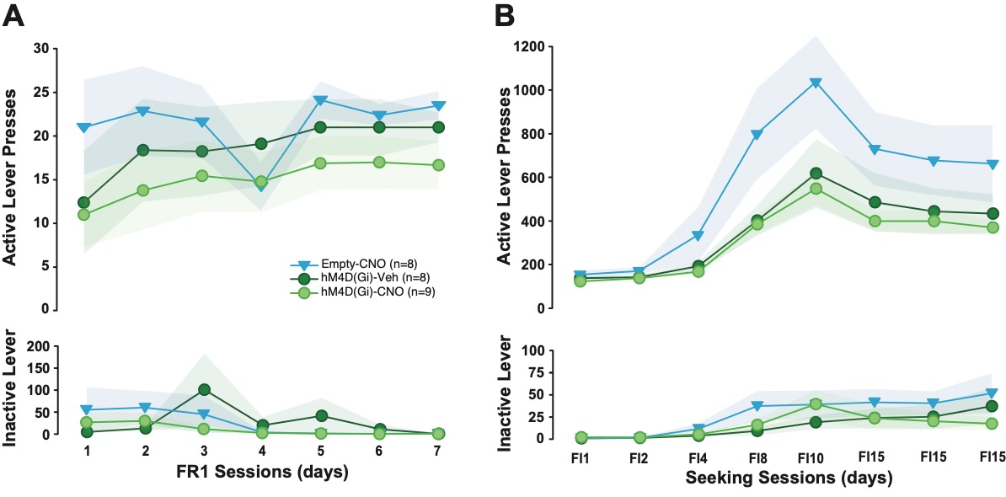

## Figure S1: The cre-mediated expression of an hM4Di inhibitory DREADD or an empty mCherry reporter control virus in the BLA🡪NacC neurons had no influence on the acquisition of cocaine self-administration or that of cocaine seeking.

Rats with the empty virus and that received CNO treatment after acquisition are represented by blue triangles, rats with the hM4D(Gi) expression are represented by green circles (CNO treated after acquisition: light green, vehicle treated after acquisition: dark green). **A)** Active lever presses increased for 7 days of fixed ratio 1 (FR1) for cocaine but no differences between groups were observed. **B)** Active lever presses increased over the 8 days of increasing fixed interval (FI) but no differences between groups were observed.

# 

## Figure S2: Chemogenetic inhibition of NAcC-projecting BLA neurons specifically prevents the potentiation of cocaine seeking behaviour by drug paired cues as compared to the two control groups merged together.

**A)** The introduction of the cocaine-paired cue presented contingent on responding resulted in a differential increase in cocaine seeking over time between the control (eg pooled Empty-CNO and hM4D(Gi)-Veh) and hM4D(Gi)-CNO groups during the first 15min drug-free period of daily sessions [main effect of block: F5,115=9.14, p<0.001, p*η*2=0.28 and group x block interaction: F5,115=2.74, p=0.022, p*η*2=0.11]. While the control groups progressively increased their seeking responses eventually to differ from their baseline performance under FI15 [**: post-hoc analysis vs FI15, p<0.01], the hM4D(Gi)-CNO rats did not show the potentiation of responding by the conditioned reinforcing properties of the CS and maintained levels of responding similar to those made under FI15 [post-hoc analysis, all ps>0.122] that eventually were significantly lower than those of the control groups [#: post-hoc analysis vs control, p<0.05] (see table S1, S2 and S3 for more details).

**B)** The prevention of acquisition of cue- controlled cocaine seeking by chemogenetic inhibition of the NAcC-projecting neurons was reversible [main effect of block: F2,46=49.63, p=10-7, p*η*2=0.68 and group x block interaction: F2,46=5.94, p=0.0054, p*η*2=0.20]. Thus, rats of the hM4D(Gi)-CNO group that received Veh at reversal increased their cocaine seeking responses, which were previously not different from those made under FI15 and lower than those of the control group prior to treatment reversal [#: p<0.05]. They eventually showed a level of responding that was similar to that of the control group [p=0.153], and statistically different from that prior to treatment reversal and FI15 [*: post-hoc analysis vs FI15, p=000017; ¥: vs pre-reversal: p=0.00017]. The treatment reversal had no effect on the level of seeking responses shown by the control group [post-hoc analysis vs pre-reversal, p=0.066], which remained significantly higher than under FI15 [*: post-hoc analysis vs FI15, ps<0.001]

**C)** When expressed as a potentiation ratio from the FI15 pre-treatment block (FI15-Veh), thereby controlling for the potential difference in instrumental performance between them, the two control groups showed a potentiation of responding over the SOR blocks, that overlapped [main effect block: F5,70=11.96, p<0.001, p*η*2=0.46 and group x block interaction: F5,70=0.31, p=0.908, p*η*2=0.02], further justifying their pooling.

**D)** As previously described, when considering the potentiation of responding from baseline [main effect of block: F5,115=9.14, p<0.001, p*η*2=0.28 and group x block interaction: F5,115=2.74, p=0.022, p*η*2=0.11], while the control groups eventually reached a level of cocaine seeking under SOR that was ~340% higher than under FI15 by the last SOR block [*: post-hoc analysis vs FI15 baseline: ps<0.01], the hM4D(Gi)-CNO group was insensitive to the conditioned reinforcing properties of the CS so that the level of responding never differed from baseline [all ps>0.103] and remained lower than the control groups [#: post-hoc analysis vs pooled control group, p<0.026]. A similar difference was observed when the hM4D(Gi)-CNO group was compared only to the hM4D(Gi)-Veh control group: main block x group interaction: F5,75=3.93, p=0.003, p*η*2=0.21, post-hoc analysis between groups: p=0.001].

Empty-CNO, hM4D(Gi)-Veh, hM4D(Gi)-CNO and pooled control groups are represented in blue triangles, dark green, light green circles and grey circles, respectively.

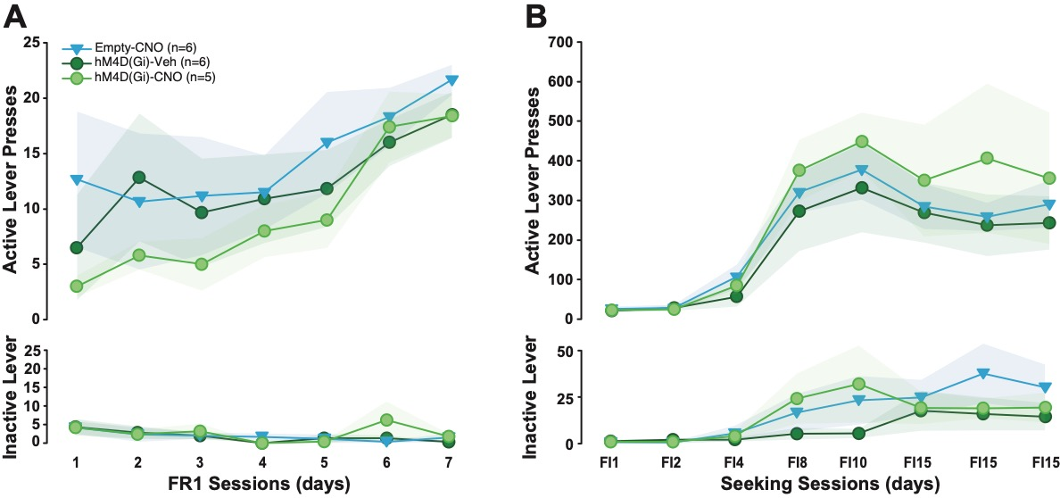

## Figure S3: The expression of an hM4Di inhibitory DREADD or an empty GFP reporter control virus in the anterior insula (AI) had no influence on the acquisition of cocaine self-administration or that of cocaine seeking.

Rats with the empty virus and that received CNO treatment after acquisition are represented by blue triangles, rats with the hM4D(Gi) expression are represented by green circles (CNO treated after acquisition: light green, vehicle treated after acquisition: dark green). **A)** Active lever presses increased for 7 days of fixed ratio 1 (FR1) for cocaine but no differences between groups were observed. **B)** Active lever presses increased over the 8 days of increasing fixed interval (FI) but no differences between groups were observed.

# Supplementary references

1. Murray JE, Belin-Rauscent A, Simon M, Giuliano C, Benoit-Marand M, Everitt BJ, et al. (2015): Basolateral and central amygdala differentially recruit and maintain dorsolateral striatum-dependent cocaine-seeking habits. *Nat Commun*. 6:10088.

2. Murray JE, Dilleen R, Pelloux Y, Economidou D, Dalley JW, Belin D, et al. (2014): Increased impulsivity retards the transition to dorsolateral striatal dopamine control of cocaine seeking. *Biol Psychiatry*. 76:15-22.

3. Murray JE, Everitt BJ, Belin D (2012): N-Acetylcysteine reduces early- and late-stage cocaine seeking without affecting cocaine taking in rats. *Addict Biol*. 17:437-440.

4. Murray JE, Belin D, Everitt BJ (2012): Double dissociation of the dorsomedial and dorsolateral striatal control over the acquisition and performance of cocaine seeking. *Neuropsychopharmacology*. 37:2456-2466.

5. Belin D, Everitt BJ (2008): Cocaine seeking habits depend upon dopamine-dependent serial connectivity linking the ventral with the dorsal striatum. *Neuron*. 57:432-441.

6. Di Ciano P, Everitt BJ (2004): Direct interactions between the basolateral amygdala and nucleus accumbens core underlie cocaine-seeking behavior by rats. *J Neurosci*. 24:7167-7173.

7. Di Ciano P, Everitt BJ (2003): The GABA(B) receptor agonist baclofen attenuates cocaine- and heroin-seeking behavior by rats. *Neuropsychopharmacology*. 28:510-518.

8. Ito R, Dalley JW, Robbins TW, Everitt BJ (2002): Dopamine release in the dorsal striatum during cocaine-seeking behavior under the control of a drug-associated cue. *J Neurosci*. 22:6247-6253.

9. Fattore L, Di Ciano P, Everitt B (2002): Effect of nucleus accumbens core lesions on mantenance of cue-controlled cocaine-seeking and -taking behavior. *Soc Neurosci Abstract*.

10. Vanderschuren LJ, Di Ciano P, Everitt BJ (2005): Involvement of the dorsal striatum in cue-controlled cocaine seeking. *J Neurosci*. 25:8665-8670.

11. Belin-Rauscent A, Lacoste J, Hermine O, Moussy A, Everitt BJ, Belin D (2018): Decrease of cocaine, but not heroin, self-administration and relapse by the tyrosine kinase inhibitor masitinib in male Sprague Dawley rats. *Psychopharmacology (Berl)*. 235:1545-1556.

12. Parkes SL, Ravassard PM, Cerpa JC, Wolff M, Ferreira G, Coutureau E (2018): Insular and Ventrolateral Orbitofrontal Cortices Differentially Contribute to Goal-Directed Behavior in Rodents. *Cereb Cortex*. 28:2313-2325.

13. Everitt BJ, Giuliano C, Belin D (2018): Addictive behaviour in experimental animals: prospects for translation. *Philos Trans R Soc Lond B Biol Sci*. 373.

14. Belin-Rauscent A, Fouyssac M, Bonci A, Belin D (2016): How Preclinical Models Evolved to Resemble the Diagnostic Criteria of Drug Addiction. *Biol Psychiatry*. 79:39-46.

15. Vrontou S, Wong AM, Rau KK, Koerber HR, Anderson DJ (2013): Genetic identification of C fibres that detect massage-like stroking of hairy skin in vivo. *Nature*. 493:669-673.

16. Parnaudeau S, Taylor K, Bolkan SS, Ward RD, Balsam PD, Kellendonk C (2015): Mediodorsal thalamus hypofunction impairs flexible goal-directed behavior. *Biol Psychiatry*. 77:445-453.

17. Nakamura Y, Nakamura Y, Pelosi A, Djemai B, Debacker C, Herve D, et al. (2020): fMRI detects bilateral brain network activation following unilateral chemogenetic activation of direct striatal projection neurons. *Neuroimage*. 220:117079.