Title: Hot droughts compromise interannual survival across all group sizes in a cooperatively breeding bird

Running title: Hot droughts compromise interannual survival
Amanda R. Bourne*¹, Susan J. Cunningham¹, Claire N. Spottiswoode^{1,2}, Amanda R. Ridley^{1,3}
¹ FitzPatrick Institute of African Ornithology, DST-NRF Centre of Excellence, University of Cape Town, Private Bag X3, Rondebosch 7701, South Africa
² Department of Zoology, University of Cambridge, Downing Street, Cambridge CB2 3EJ, UK
³ Centre for Evolutionary Biology, School of Biological Sciences, University of Western Australia, Crawley 6009, Australia
Author contacts: ARB (abourne.uct@gmail.com), SJC (susie.j.c@gmail.com), CNS (cns26@cam.ac.uk), ARR (amanda.ridley@uwa.edu.au)
*Corresponding author: Amanda Ruth Bourne; 0027 (83) 440 2081; abourne.uct@gmail.com
FitzPatrick Institute of African Ornithology, Room 2.18, John Day Zoology Building, University Avenue, University of Cape Town, 7701, South Africa
Keywords: Sociality, unpredictable environments, cooperative breeding, climate change, southern pied babbler, hot drought, group size
Type of article: Letter
Word counts: Abstract (150); Main text (4,988); Text boxes (1)
Number of references: 97
Number of display items: Figures (4), Tables (1)

Statement of authorship
ARR, SJC, ARB, and CNS conceived the study and secured funding. ARR started habituation of the study animals and collection of life history data in 2003 and has maintained it ever since; this was central to making the study possible. ARB undertook all fieldwork from 2016 onwards. ARB and ARR analysed the data. ARB drafted the manuscript. All authors contributed substantially to revisions, and gave final approval for publication.
Data accessibility statement
The data underlying all analyses presented here will be archived at the University of Cape Town’s open-access institutional data respository, ZivaHub (a figshare platform), where it will be publicly available.

Abstract
Climate change is affecting animal populations around the world and one relatively unexplored aspect of species vulnerability is whether and to what extent responses to environmental stressors might be mitigated by variation in group size in social species. We used a 15-year dataset for a cooperatively-breeding bird, the southern pied babbler Turdoides bicolor, to determine the impact of temperature, rainfall, and group size on body mass change and interannual survival in both juveniles and adults. Hot and dry conditions were associated with reduced juvenile growth, mass loss in adults, and compromised survival between years in both juveniles (86% reduction in interannual survival) and adults (60% reduction in interannual survival). Individuals across all group sizes experienced similar effects of climatic conditions. Larger group sizes may not buffer individual group members against the impacts of hot and dry conditions, which are expected to increase in frequency and severity in future.

Introduction
Anthropogenic climate change is affecting population dynamics across taxa (du Plessis et al. 2012; Allen et al. 2015; Rey et al. 2017; Spooner et al. 2018). Understanding life history responses to current environmental conditions is increasingly important for predicting vulnerability to future climate change (Camacho et al. 2018; Conradie et al. 2019). Species living in arid and semi-arid environments are useful models for studying such responses, because these environments are characterised by extremes in temperature and rainfall (McKechnie et al. 2012), and are experiencing rapid increases in temperature and interannual rainfall variability as a result of anthropogenic climate change (Feng & Fu 2013; Mayaud et al. 2017). Several recent studies present evidence that increasing temperatures and decreasing rainfall measurably affect behaviour, body condition, growth, and survival in arid-zone birds (McKechnie & Wolf 2010; Cunningham et al. 2013; Sunday et al. 2014; Iknayan & Beissinger 2018). While droughts are a natural feature of arid and semi-arid ecosystems (MacKellar et al. 2014; Tokura et al. 2018), an increase in the frequency of ‘hot droughts’ – when above-average temperatures and below-average rainfall co-occur (Overpeck 2013) – is likely due to climate change (New et al. 2006; Kruger & Sekele 2013), with the potential to compromise population persistence in many wildlife species (Walther et al. 2002; Sinervo et al. 2010; Cruz-McDonnell & Wolf 2016; Paniw et al. 2019).
Life-history traits with the potential to mitigate the impacts of high temperatures and drought are of significant interest. Global comparative studies show that the distribution of cooperatively-breeding (Rubenstein & Lovette 2007; Jetz & Rubenstein 2011; Lukas & Clutton-Brock 2017; Shen et al. 2017) and group-living (Griesser et al. 2017) birds and mammals is associated with harsh and highly variable environments, suggesting that the presence of helpers buffers against environmental uncertainty (Jetz & Rubenstein 2011; Russell 2016; Cornwallis et al. 2017), at least up to an optimal number (Markham et al. 2015; Ridley 2016). It has been hypothesised that cooperative breeding either evolved in such enviroments (Rubenstein & Lovette 2007; Lukas & Clutton-Brock 2017), enabled species to colonise such environments (Cornwallis et al. 2017), or prevented extinction under increasingly harsh conditions (Russell 2016; Griesser et al. 2017). One prominent explanation for the occurrence of cooperative breeding in birds is that it represents a ‘bet-hedging’ strategy (Rubenstein 2011): breeding individuals share the costs of reproduction with helpers, enabling them to breed successfully even when conditions are poor (Rubenstein & Lovette 2007). Cooperation may therefore moderate impacts of climate change via task-partitioning (Clutton-Brock et al. 2004; Ridley & Raihani 2008), improved access to resources (Golabek et al. 2012; Ebensperger et al. 2016), or load-lightening (reductions in individual workload in response to the presence of helpers; Crick 1992; Hatchwell 1999; Meade et al. 2010; Mumme et al. 2015; Langmore et al. 2016).
A small number of recent studies empirically test the reproductive benefits of cooperation across varying environmental conditions (Langmore et al. 2016; Guindre‑Parker & Rubenstein 2018; van de Ven et al. 2020), and one further considers adult survival (Guindre‑Parker & Rubenstein 2020). These empirical tests primarily consider reproduction and survival in response to variation in rainfall. Temperature is rarely included despite the fact that thermoregulatory benefits of group living have been demonstrated (Paquet et al. 2016). Behavioural thermoregulation (investing time and energy in self-maintenance, including seeking shade or increasing rest) provides a potential mechanism through which load-lightening may buffer group members against the costs of climate variation. Individuals in larger groups may be able to allocate more time to self-maintenance and therefore suffer fewer consequences of trade-offs between self-maintenance and other essential activities during adverse weather. This may allow higher reproductive success under challenging environmental conditions, along with better mass maintenance and improved survival probabilities.
Long-term monitoring of a population of Turdoides bicolor (southern pied babblers, hereafter ‘pied babblers’) provides an opportunity to empirically test the impact of environmental conditions on body mass change (∆M_{b}) and survival between groups of different sizes in a cooperatively breeding species (Ridley 2016). Larger mass is likely to be beneficial in pied babblers because heavier individuals disperse more successfully into breeding positions (Ridley et al. 2008). Mass loss occurs when pied babblers are under stress, e.g. when provisioning young (Wiley & Ridley 2016), defending contested territories (Humphries 2013), being evicted from their groups (Ridley et al. 2008), or experiencing high temperatures (du Plessis et al. 2012). High temperature extremes have increased in frequency and severity at the study site over the last two decades (van de Ven 2017) and rainfall is extremely variable from year to year (MacKellar et al. 2014). In pied babblers, high temperatures and/or drought increase the risk of local extinction (Wiley 2017), reduce offspring provisioning rates (resulting in smaller nestlings; Wiley & Ridley 2016), limit foraging efficiency (du Plessis et al. 2012), lower daily energy expenditure (Bourne et al. 2019), and decrease investment in territorial defence (Golabek et al. 2012).
Here, we examine how within-season ∆M_{b} and interannual survival in pied babblers varies with temperature, rainfall, and group size. We expected negative effects of high temperatures, and positive effects of high rainfall and larger group sizes, on 1) ∆M_{b} in juveniles and in breeding adults, 2) survival of juvenile birds from nutritional independence at 90 days of age to recruitment into the adult population at one year of age, and 3) survival of breeding adults from one breeding season to the next. Analyses do not include subordinate adults because subordinate adults (both sexes) often disperse (Ridley et al. 2008; Raihani et al. 2010) and dispersal is easily confounded with mortality (Layton-Matthews, Ozgul, & Griesser, 2018). We further predicted that larger group sizes would buffer against climatic effects due to load-lightening allowing individuals to invest more in self-directed behaviours during periods of harsh weather. Specifically, we predicted that individuals in larger groups would experience disproportionately fewer negative effects of high temperatures and drought on both ∆M_{b} and survival.

Materials and methods

Study site and system
Pied babblers are medium-sized (60–90 g), cooperatively-breeding passerines endemic to the Kalahari Desert in southern Africa (Hockey et al. 2005). Fieldwork was undertaken at the 33 km² Kuruman River Reserve (KRR; 26°58’S, 21°49’E). Mean summer daily maximum temperature in the region averages 34.7 ± 9.7°C, and mean annual precipitation averages 186.2 ± 87.5mm (1995–2015, mean ± SD; van de Ven, McKechnie & Cunningham 2019). Rainfall has been declining and high temperature extremes increasing in both frequency and severity over the last 20 years (Kruger & Sekele 2013; van Wilgen et al. 2016; van de Ven 2017).
Pied babbler group sizes range between 3–15 adults (Ridley 2016). Groups consist of a single breeding pair, one or more subordinate adult helpers, and immature offspring (Nelson-Flower et al. 2011). All adult group members cooperate, participating in territorial defence, sentinel behaviour, and caring for young (Ridley 2016). Pied babblers are considered nutritionally independent (receiving < 1 feed per hour; referred to as ‘juveniles’) by 90 days of age (Ridley & Raihani 2007), and are defined as sexually mature adults one year after hatching (Ridley 2016).
Birds in the study population are habituated to observation at distances of 1–5 m (Ridley & Raihani 2007). Group composition and life history checks are conducted weekly with habituated groups throughout each summer breeding season (September to March). Groups are territorial and can be reliably located by visits to each territory. Birds in the study population are marked with a unique combination of metal and colour rings for individual identification.

Data collection
Data were collected for each breeding season between September 2005 and 2019. Pied babblers are sexually monomorphic (Ridley 2016; Bourne et al. 2018) and molecular sexing was used to determine sex of individuals (following Fridolfsson & Ellegren, 1999). Blood samples for sexing were collected by brachial venipuncture.

Body mass measurements
Nestlings were weighed to 0.1 g on a top-pan scale 11 days post-hatching (Mass₁₁). Body mass data were collected from 90 (± 15) day-old birds (Mass₉₀; n = 323 mass measurements from 124 individuals) by enticing individuals to stand on a top-pan balance in exchange for a small food reward (Ridley 2016). Most measurements (74%) were collected within 7 days of the 90 day mark. Mean mass was calcultated where multiple measurements per individual were available (52% of juveniles). The sampling period is justified because pied babblers are approximately fully-grown by 90 days of age (Raihani & Ridley 2007; Thompson et al. 2013; Ridley 2016). This was confirmed by data from 16 individuals from whom we collected ≥ 5 mass measurements between 75 and 105 days of age [1 (6%) maintained mass over the period, 7 (44%) lost mass, and 8 (50%) gained mass, with an average change in mass between earliest and latest measurement of ~1 g].
Body mass data were collected from adult breeding birds from the beginning (September or October, Mass_{Oct}) and end (February or March, Mass_{Mar}) of each breeding season in the same way as for juveniles. Variation in exact sampling periods for each mass measure reflect annual variation in the timing of the breeding season. We chose the difference between Mass_{Oct} and Mass_{Mar} as a biologically relevant measure because this time period encompasses a) the hottest months at the study site (December, average T_{max} = 35.71°C; and January, average T_{max} = 35.69°C), b) the wettest months at the study site (72% of annual rain falls December-February), and c) the core breeding season (85% of breeding occurs October-February). We collected multiple Mass_{Oct} and Mass_{Mar} measurements for 63% and 52% of the birds respectively, and used the average of all mass measurements per individual where available.
Body mass measurements from juveniles and adults were collected at dawn, representing pre-foraging body mass. Body mass change (∆M_{b}) was calculated in grams as follows: ∆M_{b} between 11 days and 90 days of age for juveniles (∆M_{b.Juv}) = Mass₉₀ - Mass₁₁; and ∆M_{b} from the start to the end of the breeding season for breeding adults (∆M_{b.Adults}) = Mass_{Mar} - Mass_{Oct}.

Life history data

(i) Juvenile birds
All nests initiated in the study population during each breeding season were monitored to determine hatching dates. Each brood was checked daily from 14 days post-hatching onwards, to determine the date on which nestlings fledged. Natal group size (G.Size_{Brood}; the number of adults present in each individual’s natal group between hatching and fledging; constant during the chick rearing period for all but five of 147 nests), average group size for the period between fledging and independence (G.Size_{90;} variations in group size due to older juveniles reaching 1 year of age, or dispersal of subordinate adults, were observed in 58 of 147 breeding attempts), and brood size (number of nestlings in the brood 11 days post-hatch) were recorded for each brood. Presence/absence of fledglings was noted during weekly visits within each breeding season and presence/absence of juvenile pied babblers was recorded at one year (±15 days) post hatching. Presence/absence in the population at one year of age represents a ‘disappearance rate’ likely to be driven primarily by mortality. Dispersal typically occurs after individuals have reached sexual maturity and the mean age at first dispersal is 565 days (Nelson-Flower et al. 2018). Individuals that dispersed before one year of age (n = 1) were excluded from the analysis.

(ii) Adult breeding birds
Dominant individuals can be identified unambiguously through incubation behaviour (Ridley 2016) and distinctive duets (Wiley & Ridley 2018). Presence/absence of dominant individuals was recorded at the beginning of each breeding season during an annual census, at which point we could determine whether breeding adults had survived over the most recent winter putting them in the position to breed again. For breeding adults, territory and pair fidelity is high between years and voluntary dispersal is unusual (Raihani et al. 2010; Wiley & Ridley 2018). Overwinter disappearance is therefore likely to be driven primarily by mortality. Data for individuals who were dominant for only part of a breeding season due to death (n = 47) or dispersal (n = 9) were excluded from analyses of interannual survival. We calculated average group size during each breeding season (G.Size_{BrSeas}; variations in group size were observed in 62 of 177 group-seasons).

Temperature and rainfall
Daily maximum temperature (°C) and rainfall (mm) data were collected from an on-site weather station (Vantage Pro2, Davis Instruments, Hayward, USA; see van de Ven, McKechnie, & Cunningham, 2019). Missing data from 2009, 2010, and 2011 were sourced from a nearby South Africa Weather Services (SAWS) weather station (Van Zylsrus, 28 km), which recorded significantly repeatable temperature measurements and moderately repeatable rainfall measurements adequately detected wet vs. dry periods in comparison with the on-site weather station (Bourne et al. 2020).
For analyses relating to juveniles, daily maximum temperatures were averaged for the offspring developmental periods between hatching and fledging (mean T_{maxBrood}) and between fledging and independence (mean T_{max90}). Rainfall was summed for the 60 days prior to initiation of incubation at the nest from which each individual fledged (Rain₆₀; to allow for delays between rainfall and invertebrate emergence and therefore improved food availability; Cumming & Bernard, 1997; Ridley & Child, 2009) and for the period between fledging and independence (Rain₉₀) because higher rainfall during the fledgling period is associated with improved food availability and reduced hunger in pied babbler fledglings (Thompson 2013). For analyses relating to adults, daily maximum temperatures were averaged, and rainfall was summed, over the whole breeding season (Sept – Mar, Mean T_{maxBrSeas}; Rain_{BrSeas}). Long term rainfall data for the region was used to determine the presence or absence of a meteorological drought within a breeding season (Drought_{BrSeas}). These data were obtained from a SAWS weather station at Twee Rivieren (~120 km from the study site; available until 2013). Following Mayaud et al (2017), meteorological drought was defined as ≤ 75% of average precipitation between September and March (≤ 137.75 mm), using long term data for the 30-year period 1984–2013 to determine average precipitation in the region.
Box 1: Glossary of terms
Brood size  G.Size_{Brood}  G.Size₉₀  G.Size_{BrSeas}  Mass₁₁ | Number of nestlings per brood  Number of adults in the natal group at initiation of incubation  Average number of adults in the natal group between fledge and nutritional independence at 90 days of age  Average number of adults in the natal group over the breeding season  Nestling body mass (0.1 g) collected 11 days after hatching
Mass₉₀ | (Average) body mass data (0.1 g) collected from 90 (± 15) day-old birds
∆M_{b.Juv} | Change in juvenile body mass (g), calculated as Mass₉₀ - Mass₁₁
Mass_{Oct} | (Average) body mass data (0.1 g) collected from adults at the beginning of the breeding season (September and October)
Mass_{Mar} | (Average) body data (0.1 g) collected from adults at the end of the breeding season (February and March)
∆M_{b.Adults} | Change in adult body mass (g), calculated as Mass_{Mar} - Mass_{Oct}
Mean T_{maxBrood} | Average daily maximum temperatures between hatching and fledging
Mean T_{max90} | Average daily maximum temperatures between fledging and nutritional independence at 90 days of age
Mean T_{maxBrSeas} | Average daily maximum temperatures between the start (September) and the end (March) of the breeding season
Rain₆₀ | Total rainfall in the 60 days prior to initiation of incubation at the nest from which each individual fledged
Rain₉₀ | Total rainfall between fledging and nutritional independence at 90 days of age
Rain_{BrSeas} | Total rainfall between the start (September) and the end (March) of the breeding season
Drought_{BrSeas} | Occurrence of a meteorological drought (rainfall < 135.75 mm) within the breeding season
Caption: The grey boxes below show the breeding seasons within which data were collected. All the climate-related predictor variables were collected during Breeding Season_{(t)} and used in models testing variation in body mass change within the same Breeding Season_{(t)} and interannual survival into the following Breeding Season_{(t+1)}.

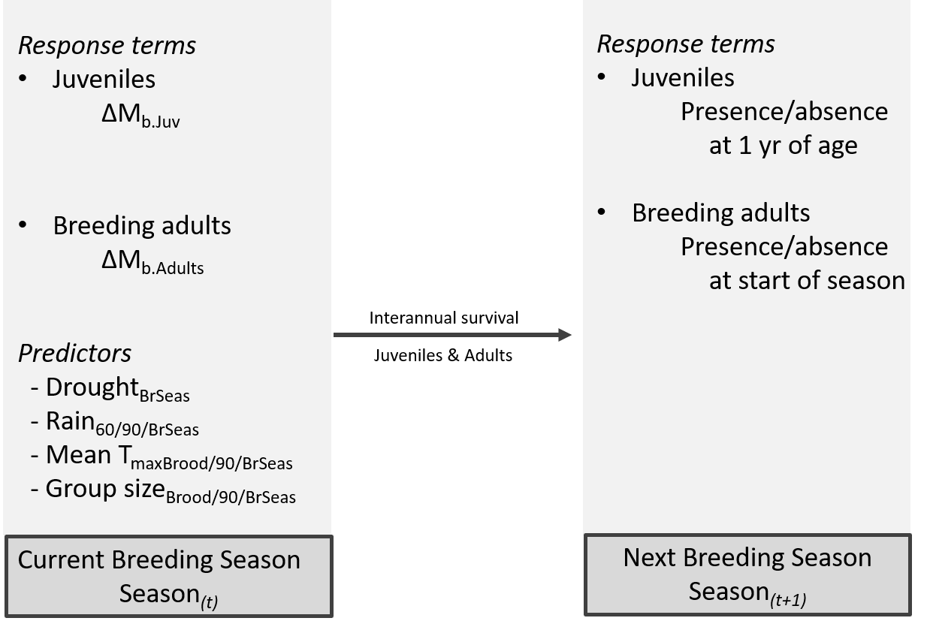

Statistical analyses
Statistical analyses were conducted in R v 3.4.1 (R Core Team 2017). Mixed effects models, using the package lme4 (Bates et al. 2015), were used for all analyses, see Box 1. Model selection with Akaike’s information criterion corrected for small sample size (AICc) was used to explore a series of models to determine which parameters best explained patterns of variation in the data (Symonds & Moussalli 2011; Harrison et al. 2018). Where multiple models were within 5 AICc of the top model, top model sets were averaged using the package MuMin (Barton 2015) and we present parameter estimates for interpretation after model averaging (Burnham & Anderson 2002; Grueber et al. 2011). All continuous explanatory variables were scaled by centering and standardising by the mean (Schielzeth 2010; Harrison et al. 2018). All explanatory variables were tested for correlation with one another (all VIF < 2 for pairs of continuous predictors, Fox & Monette 1992). Rainfall measures were always highly correlated with drought (F_{1,247-350} > 37.611, p < 0.001), and therefore rainfall and drought were not included in the same additive models (Harrison et al. 2018). Linear model fits were checked using normal Q-Q plots and histograms of residuals. Binomial model fits were checked for overdispersion in the RVAideMemoire package (Herve 2019) and for zero-inflation in the DHARMa package (Hartig 2020). Model terms with confidence intervals not intersecting zero were considered to explain significant patterns in the data (Grueber, Nakagawa, Laws, & Jamieson, 2011). Sample sizes reflect datasets after removing records containing missing values. Unless otherwise indicated, summary statistics are presented as mean ± one standard deviation.
Significant effects of an interactions between group size and climate on ∆M_{b} and survival would be consistent with a buffering effect of group size. We conducted sensitivity power analyses to identify the minimum determinable effect of two-way interactions given our sample sizes (Cohen 1988; Greenland et al. 2016). Assuming a fourfold increase in required sample size to adequately detect interactions in mixed-effects linear regression models (Leon & Heo 2009), we confirmed sufficient sample size to detect 1) small to moderate main effects in all analyses (Cohen’s f² ≤ 0.12 in all cases), 2) moderate to very large effects of two-way interactions in ∆M_{b} analyses (f² = 0.28 for fledglings, f² = 0.54 for adults), and 3) small to moderate effects of two-way interactions in interannual survival analyses (f² ≤ 0.14 for juveniles, f² = 0.09 for breeding adults).
Where interannual survival probabilities for juveniles and breeding adults were influenced by interactions, we used the package lsmeans (Lenth 2016) to predict survival probabilities based on different values of the interacting factors.
Body mass change: To determine which variables explained ∆M_{b.Juv} and ∆M_{b.Adults}, we used maximum likelihood linear mixed-effects models (LMMs). For ∆M_{b.Juv} (n = 124), we considered the influence of G.Size₉₀, Drought_{BrSeas}, Rain₆₀, Rain₉₀, mean T_{max90}, sex, brood size, and the interactions among climate variables and group size. Brood identity nested within group identity were included as random terms to account for repeated measures. For ∆M_{b.Adults} (n = 82 measurements from 53 different individuals), we considered the influence of G.Size_{BrSeas}, Drought_{BrSeas}, Rain_{BrSeas}, mean T_{maxBrSeas}, age (in days since hatching), sex, and the interactions among climate variables and group size. Individual identity nested within group identity were included as random terms.
Survival: Non-monitoring periods over winter prevented detailed time-step survival analyses, such as Cox proportional hazards models (Cox 1972; Austin 2017; Guindre‑Parker & Rubenstein 2020), for both juveniles and adults. Therefore, to determine which variables explained interannual survival of known individuals in the study population, we used generalised linear mixed-effects models (GLMMs) with a binomial distribution (survival to next breeding season = yes/no) and a logit link function.
Juveniles: For juvenile birds, interannual survival was measured as survival from nutritional independence to one year of age (± 15 days; recorded in the following breeding season – see Box 1). The factors that influence pied babbler survival probabilities are not constant across time during early development (Bourne et al. in press; Ridley 2016), and conditions experienced in the nest can carry over to influence survival probabilities later (Harrison et al. 2011; Auer & Martin 2017; Moore & Martin 2019). We therefore conducted separate analyses specifically considering climate and social factors experienced in the nest and after fledging. For survival to one year, we considered the influence of (a) G.Size_{Brood}, Rain₆₀, Drought_{BrSeas}, mean T_{maxBrood}, sex, Mass₁₁, brood size, and the two way interactions amongst all group size and climate variables (i.e conditions between hatching and fledging; n = 247 individuals); and (b) G.Size₉₀, Rain₉₀, Drought_{BrSeas}, mean T_{max90}, sex, Mass₁₁, brood size, and the two way interactions among all group size and climate variables (i.e. conditions between fledging and nutritional independence; n = 229 individuals). Brood identity nested within natal group identity were included as random terms in both analyses.
Breeding adults: For breeding adults, interannual survival was measured from the end of a breeding season in which they attempted to breed to the beginning of the subsequent breeding season (see Box 1). For interannual survival (n = 352 records from 136 different adults), we considered the influence of G.Size_{BrSeas}, Drought_{BrSeas}, Rain_{BrSeas}, Mean T_{maxBrSeas}, age, sex, and the two way interactions among all group size and climate variables. Individual identity nested within group identity were included as random terms.
We tested for the influence of ∆M_{b} on interannual survival probabilities for both age classes separately, using univariate binomial GLMMs with a logit link function, due to much smaller sample sizes for body mass than for presence/absence data.
Results
Annual average summer maximum temperature at the study site from 2005–2019 was 34.2 ± 0.9 °C (range: 32.4–36.5 °C), summer rainfall averaged 185.4 ± 86.2 mm (range: 64.4–352.1 mm), and droughts occurred in 5 of 14 breeding seasons studied (Fig. 1A). Group size varied between groups and breeding seasons, averaging 4.2 ± 1.4 adults per group across all breeding seasons (range: 2–9 adults; Fig. 1B), but did not differ significantly between drought and not-drought years (F_{1,164} = 0.754, p = 0.387). Between 2005 and 2019, the largest group averaged 5.4 ± 2.3 adult group members (range across 11 breeding seasons: 2.3–9), while the smallest group averaged 3.3 ± 0.9 members (range across 12 breeding seasons: 2–5).

Change in body mass
Fledglings that survived to 90 days were heavier as nestlings (mean Mass₁₁ = 40.0 ± 5.5 g, n = 270) than those that did not survive (37.4 ± 7.3 g, n = 295; LMM with brood identity as the random term: Est = 2.403 ± 0.526, t = 4.566, 95% CI 1.371 to 3.437). Individuals gained significantly more mass between fledging and independence during wetter periods, and when they were raised in larger broods (Table 1A, Fig. 2A, Fig. 2B). We found little evidence that ∆M_{b.Juv} varied significantly with sex, group size or temperature between fledging and independence, nor did we find evidence of significant interactions among climate and group size variables (Table S1).
High temperatures and low rainfall during the breeding season were associated with body mass loss between the start and the end of the breeding season in breeding adults (Table 1B; Fig. 2C, Fig. 2D). We found little evidence that ∆M_{b.Adults} varied significantly with sex or group size, nor did we find evidence of significant interactions among climate and group size variables (Table S2). Age was not associated with variation in ∆M_{b.Adults} in a subset of 36 individuals of known age (Table S3) and we therefore excluded age from the models analysing our full dataset presented here.

Survival: juveniles
Of 596 nestlings of known Mass₁₁, 254 (42.6%) survived to nutritional independence. Of these, 173 (68.1%) were present in the study population one year post-hatching. Natal group size ranged from 2–9 adults (mean = 4.4 ± 1.5). The likelihood of a juvenile surviving to one year of age increased as Rain₆₀ increased (Table 1C, Fig. 3A). However, juveniles that experienced high mean T_{maxBrood} were less likely to survive to one year of age (Table 1C, Fig. 3B; see Table S4 for full model selection output).
Juveniles were also less likely to survive to one year of age when they were exposed to high mean T_{max90} and Drought_{BrSeas}. The effect of Drought_{BrSeas} on juvenile survival to one year of age was influenced by temperature: mean probability of survival was high (0.90 ± 0.05) when juvenile birds experienced both Drought_{BrSeas} and relatively cool mean T_{max90}, whereas mean probability of survival was very low (0.12 ± 0.08) when juvenile birds experienced both Drought_{BrSeas} and high mean T_{max90} (Table 1D, Fig. 3C). This represents a more than seven-fold decrease in survival when individuals experienced both drought and high temperatures as dependent fledglings, compared to when drought occurred but temperatures were mild. We found little evidence that survival to one year of age varied significantly with Mass₁₁, sex, brood size, or group size in either analysis. Survival to one year of age was also not significantly influenced by interactions between group size and environmental conditions (see Tables S4–S5 for full model selection output). Survival to one year of age was not associated with ∆M_{b.Juv} (GLMM: Est = 0.041 ± 0.037, z = 1.106, 95% CI: -0.039 to 0.081).
Survival: breeding adults
In 264 out of 352 records of interannual survival (75%; from 136 different individuals), breeding adults were still present at the start of the next breeding season. Breeding adults were less likely to be present at the start of the next breeding season when they had experienced Drought_{BrSeas} (Table 1E). The effect of Drought_{BrSeas} on the survival of breeding adults was influenced by temperature: mean probability of survival was high (0.81 ± 0.06) when individuals had experienced Drought_{BrSeas} alongside relatively cool mean T_{maxBrSeas}. However, mean probability of survival was low (0.32 ± 0.09; Table 1E, Fig. 4) when individuals experienced both drought conditions alongside high mean T_{maxBrSeas}, representing a more than 50% decrease in survival of breeding adults from one year to the next compared to when drought occurred but temperatures were mild. We found little evidence that interannual survival of breeding adults varied significantly with sex or group size, nor did we find evidence of significant interactions among climate and group size variables (see Table S6 for full model selection output). Age was not associated with variation in survival in a subset of 58 individuals of known age (Table S7) and we therefore excluded age from the models analysing our full dataset presented here. The probability of breeding adults surviving to the start of the next breeding season was not associated with ∆M_{b.Adults} (GLMM, Est = 0.031 ± 0.071, z = 0.436, 95% CI: -0.111 to 0.171).

Discussion
We investigated the potential for group size to buffer against the impacts of climatic factors on ∆M_{b} and interannual survival in a cooperatively breeding bird. We found that measures of ∆M_{b} and survival for individuals in larger groups were not affected differently by high temperatures and drought compared to those in smaller groups. Environmental conditions significantly affected ∆M_{b} and interannual survival in both juveniles and breeding adults across all group sizes, a finding that contributes to a rapidly growing body of literature (Overpeck 2013; Allen et al. 2015; Cruz-McDonnell & Wolf 2016) demonstrating that high temperatures and prolonged periods of low rainfall negatively impact on survival in a range of species.
Exposure to high temperatures and low rainfall was strongly associated with reduced growth in juvenile pied babblers and body mass loss in breeding adults. Body mass performs well as an index of condition (Labocha & Hayes 2012), particularly when change within individuals is measured over time, and poor body condition has been linked to reduced survival in both adult birds (e.g. Gardner et al. 2018) and nestlings (e.g. Todd et al. 2003; Schwagmeyer & Mock 2008). In our study population, in a simple univariate assessment, the within-individual ∆M_{b} we recorded did not appear to be significantly associated with interannual survival in either juvenile or breeding adult pied babblers, at least over our measurement windows, suggesting that reduced survival is not a consequence of body mass loss/reduced growth.
In pied babblers, exposure to chronic, sublethal effects of high temperatures and low rainfall within the same breeding season are associated with increased risk of overwinter mortality. Hot and dry conditions experienced by juvenile pied babblers between fledging and independence were associated with lower probability of survival to one year of age. Lower survival probabilities result in reduced recruitment into the adult population. Hot and dry conditions were also associated with strongly reduced likelihood of interannual survival in breeding adults. Together these processes likely contribute to the overall trend for population decline in below-average rainfall years in this species (Wiley 2017). Negative effects of adverse climate conditions on the interannual survival of breeding adults are particularly concerning because interannual survival rates of breeding adults (compared to non-breeding adult helpers) have the greatest impact on population growth rates in this species (Wiley 2017), and hence the probability of population persistence through time (Layton-Matthews et al. 2018).
Droughts are currently a regular, natural feature of the local climate (Tokura et al. 2018). Temperatures in the region have increased in recent decades (van Wilgen et al. 2016) and will continue to do so (IPCC 2013), and therefore an increase in the frequency of hot droughts can be expected. If this occurs, pied babbler populations are likely to decline as altered drought regimes reduce opportunities for population recovery following hot drought events. Consecutive years characterised by exceptionally hot and dry conditions could lead to failed recruitment and population crashes, as has been observed in Athene cunicularia burrowing owls (Cruz-McDonnell & Wolf 2016) and is predicted for pied babblers (Wiley 2017; Conradie et al. 2019).
Group size did not buffer the impacts of hot, dry weather on individual body mass change or survival in juveniles or breeding adults, since birds across all group sizes were similarly affected. This is consistent with the findings of concurrent studies on cooperatively-breeding mammals (van de Ven et al. 2019a) and birds (Bourne et al. in press; Guindre‑Parker & Rubenstein 2020). Adverse effects of climatic conditions on ∆M_{b} and survival are likely to be driven primarily by physiological tolerance limits (Smit et al. 2018) and resource constraints (Nowakowski et al. 2018) acting on individuals, irrespective of the number of individuals present in their social group. Benefits of group living and cooperation, including load-lightening and the production of more surviving young by larger groups, have been observed in pied babblers previously (Ridley 2016; Wiley & Ridley 2016; Bourne et al. 2020). Yet we show here that larger group sizes did not moderate the influence of high temperatures and drought on body mass change or survival. While it is possible that the benefits of larger group sizes and the presence of helpers may have previously helped to mitigate the effects of adverse environmental conditions (Jetz & Rubenstein 2011; Russell 2016; Cornwallis et al. 2017), it appears that any such advantage is no longer detectible given current extreme conditions and a rapidly changing climate. Buffering effects of group size may be detectable in reproductive outputs rather than measures of mass change and survival. However, we have recently demonstrated that this is not the case in pied babblers, using a wholly independent dataset from the same population as this study (Bourne et al. in press).
The Intergovernmental Panel on Climate Change predicts that the incidence of hot and dry extremes will continue to become more frequent over most land masses (IPCC 2013). In arid and semi-arid regions already affected by both decreased precipitation and increased warming, interannual survival and recruitment in resident avian species (such as this population of pied babblers) may be insufficient to allow for population recovery between hot droughts. Taken together with our finding that larger group sizes did not buffer pied babblers against adverse climatic conditions, our data raise concerns for the long-term persistence of arid-zone species in the face of changing climatic conditions. The adaptive benefits of cooperative life history strategies in highly variable environments are unlikely to be sufficient to counteract the impacts of rapidly changing climatic conditions, in particular the increased frequency of climate extremes such as heat waves and drought.
Acknowledgements
We thank the management teams at the Kuruman River Reserve (KRR) and surrounding farms, Van Zylsrus, South Africa, for making the work possible. The KRR was financed by the Universities of Cambridge and Zurich, the MAVA Foundation, and the European Research Council (Grant No. 294494 to Tim Clutton-Brock), and received logistical support from the Mammal Research Institute of the University of Pretoria. We thank Sello Matjee, Paige Ezzey, and Lesedi Moagi for fieldwork assistance during 2016–2019, and all past and present staff and students of the Pied Babbler Research Project for data collected since 2003. Dr Todd Erickson provided valuable comments on an early draft. This work was funded by the DST-NRF Centre of Excellence at the FitzPatrick Institute for African Ornithology, the University of Cape Town, the Oppenheimer Memorial Trust (Grant No. 20747/01 to ARB), the British Ornithologists’ Union, the Australian Research Council (Grant No. FT110100188 to ARR), a BBSRC David Phillips Fellowship (BB/J014109/1 to CNS), and the National Research Foundation of South Africa (Grant No. 110506 to SJC). The opinions, findings and conclusions are those of the authors alone, and the National Research Foundation accepts no liability whatsoever in this regard. We thank the three knowledgeable anonymous reviewers for their constructive comments which helped to improve this work tremendously.

References
Allen, C.D., Breshears, D.D. & McDowell, N.G. (2015). On underestimation of global vulnerability to tree mortality and forest die-off from hotter drought in the Anthropocene. Ecosphere, 6, 1–55.
Auer, S.K. & Martin, T.E. (2017). Parental care mitigates carry-over effects of poor early conditions on offspring growth. Behav. Ecol., 28, 1176–1182.
Austin, P.C. (2017). A tutorial on multilevel survival analysis: methods, models and applications. Int. Stat. Rev., 85, 185–203.
Barton, K. (2015). MuMIn: Multi-model inference. Available at: https://cran.r-project.org/package=MuMin. Last accessed 1 June 2020.
Bates, D., Maechler, M., Bolker, B. & Walker, S. (2015). Fitting linear mixed effects models using lme4. J. Stat. Softw., 67, 1–48.
Bourne, A.R., Cunningham, S.J., Nupen, L.J., McKechnie, A.E. & Ridley, A.R. (2018). Male and female Southern Pied Babbler Turdoides bicolor nestlings respond similarly to heat stress. Available at: https://www.bou.org.uk/wp-content/uploads/2019/08/bou-funded-project-report-bourne.pdf. Last accessed 1 June 2020.
Bourne, A.R., Cunningham, S.J., Spottiswoode, C.N. & Ridley, A.R. (2020). Compensatory breeding in years following drought in a desert-dwelling cooperative breeder. Front. Ecol. Evol., 8, 190.
Bourne, A.R., Cunningham, S.J., Spottiswoode, C.N. & Ridley, A.R. (n.d.). High temperatures drive offspring mortality in a cooperatively breeding bird. Proc. R. Soc. B.
Bourne, A.R., McKechnie, A.E., Cunningham, S.J., Ridley, A.R., Woodborne, S.M. & Karasov, W.H. (2019). Non‐invasive measurement of metabolic rates in wild, free‐living birds using doubly labelled water. Funct. Ecol., 33, 162–174.
Burnham, K.P. & Anderson, D.R. (2002). Model selection and multimodel inference: a practical information-theoretic approach. Springer Verlag, New York.
Camacho, A., Rusch, T., Ray, G., Telemeco, R.S., Rodrigues, M.T. & Angilletta, M.J. (2018). Measuring behavioral thermal tolerance to address hot topics in ecology, evolution, and conservation. J. Therm. Biol., 73, 71–79.
Clutton-Brock, T.H., Russell, A.F. & Sharpe, L.L. (2004). Behavioural tactics of breeders in cooperative meerkats. Anim. Behav., 68, 1029–1040.
Cohen, J. (1988). Statistical power analysis for the behavioral sciences. 2nd Editio. Lawrence Erlbam Associates, New York.
Conradie, S., Woodborne, S.M., Cunningham, S.J. & McKechnie, A.E. (2019). Chronic, sublethal effects of high temperatures will cause severe declines in southern African arid-zone birds during the 21st century. Proc. Natl. Acad. Sci., 116, 14065–14070.
Cornwallis, C.K., Botero, C.A., Rubenstein, D.R., Downing, P.A., West, S.A. & Griffin, A.S. (2017). Cooperation facilitates the colonization of harsh environments. Nat. Ecol. Evol., 1, 0057.
Cox, D.R. (1972). Regression models and life-tables. J. R. Stat. Soc., 34, 187–220.
Crick, H.P. (1992). Load-lightening in cooperatively breeding birds and the cost of reproduction. Ibis (Lond. 1859)., 1, 56–61.
Cruz-McDonnell, K.K. & Wolf, B.O. (2016). Rapid warming and drought negatively impact population size and reproductive dynamics of an avian predator in the arid southwest. Glob. Chang. Biol., 22, 237–253.
Cumming, G.S. & Bernard, R.T.F. (1997). Rainfall, food abundance and timing of parturition in African bats. Oecologia, 111, 309–317.
Cunningham, S.J., Martin, R.O., Hojem, C.L. & Hockey, P.A.R. (2013). Temperatures in excess of critical thresholds threaten nestling growth and survival in a rapidly-warming arid savanna: a study of common fiscals. PLoS One, 8, e74613.
Ebensperger, L.A., Correa, L.A., León, C., Ramírez-Estrada, J., Abades, S., Villegas, Á., et al. (2016). The modulating role of group stability on fitness effects of group size is different in females and males of a communally rearing rodent. J. Anim. Ecol., 85, 1502–1515.
Feng, S. & Fu, Q. (2013). Expansion of global drylands under a warming climate. Atmos. Chem. Phys., 13, 10081–10094.
Fox, J. & Monette, G. (1992). Generalised collinearity diagnostics. J. Am. Stat. Assoc., 87, 178–183.
Fridolfsson, A.-K. & Ellegren, H. (1999). A simple and universal method for molecular sexing of non-ratite birds. J. Avian Biol., 30, 116–121.
Gardner, J.L., Rowley, E., Rebeira, P. De, Rebeira, A. De & Brouwer, L. (2018). Associations between changing climate and body condition over decades in two southern hemisphere passerine birds. Clim. Chang. Responses, 5, 1–14.
Golabek, K., Ridley, A.R. & Radford, A. (2012). Food availability affects strength of seasonal territorial behaviour in a cooperatively breeding bird. Anim. Behav., 83, 613–619.
Greenland, S., Senn, S.J., Rothman, K.J., Carlin, J.B., Poole, C., Goodman, S.N., et al. (2016). Statistical tests, P values, confidence intervals, and power: a guide to misinterpretations. Eur. J. Epidemiol., 31, 337–350.
Griesser, M., Drobniak, S.M., Nakagawa, S. & Botero, C.A. (2017). Family living sets the stage for cooperative breeding and ecological resilience in birds. PLOS Biol., 15, e2000483.
Grueber, C.E., Nakagawa, S., Laws, R.S. & Jamieson, I.G. (2011). Multimodal inference in ecology and evolution: challenges and solution. J. Evol. Biol., 24, 699–711.
Guindre‑Parker, S. & Rubenstein, D.R. (2018). The oxidative costs of parental care in cooperative and pair‑breeding African starlings. Oecologia, 188, 53–63.
Guindre‑Parker, S. & Rubenstein, D.R. (2020). Survival benefits of group living in a fluctuating environment. Am. Nat., In press.
Harrison, X.A., Blount, J.D., Inger, R., Norris, D.R. & Bearhop, S. (2011). Carry-over effects as drivers of fitness differences in animals. J. Anim. Ecol., 80, 4–18.
Harrison, X.A., Donaldson, L., Correa-cano, M.E., Evans, J., Fisher, D.N., Goodwin, C.E.D., et al. (2018). A brief introduction to mixed effects modelling and multi-model inference in ecology. Peer J, 6, 1–32.
Hartig, F. (2020). DHARMa: residual diagnostics for hierarchical (multi-level / mixed) regression model. cran.R-project.org. Available at: https://cran.r-project.org/package=DHARMa. Last accessed 4 March 2020.
Hatchwell, B.J. (1999). Investment strategies of breeders in avian cooperative breeding systems. Am. Nat., 154, 205–219.
Herve, M. (2019). RVAideMemoire: testing and plotting procedures for biostatistics. cran.R-project.org. Available at: https://cran.r-project.org/package=RVAideMemoire. Last accessed 4 March 2020.
Hockey, P.A.R., Dean, W.R.J. & Ryan, P.G. (2005). Roberts’ Birds of Southern Africa, 7th Edition. 7th edn. John Voleker Bird Book Fund, Cape Town.
Humphries, D.J. (2013). The mechanisms and function of social recognition in the cooperatively breeding Southern pied babbler, Turdoides bicolor. PhD Thesis, MacQuarie University.
Iknayan, K.J. & Beissinger, S.R. (2018). Collapse of a desert bird community over the past century driven by climate change. Proc. Natl. Acad. Sci., 115, 8597–8602.
IPCC. (2013). Climate Change 2013: The Intergovernmental Panel on Climate Change fifth assessment report. Cambridge University Press, Cambridge.
Jetz, W. & Rubenstein, D.R. (2011). Environmental uncertainty and the biogeography of cooperative breeding in birds. Curr. Biol., 21, 72–78.
Kruger, A.C. & Sekele, S.S. (2013). Trends in extreme temperature indices in South Africa: 1962-2009. Int. J. Climatol., 33, 661–676.
Labocha, M.K. & Hayes, J.P. (2012). Morphometric indices of body condition in birds: a review. J. Ornithol., 153, 1–22.
Langmore, N.E., Bailey, L.D., Heinsohn, R.G., Russell, A.F. & Kilner, R.M. (2016). Egg size investment in superb fairy-wrens: helper effects are modulated by climate. Proc. R. Soc. B, 283, 10–12.
Layton-Matthews, K., Ozgul, A. & Griesser, M. (2018). The interacting effects of forestry and climate change on the demography of a group-living bird population. Oecologia, 186, 907–918.
Lenth, R. V. (2016). Least-squares means: the R package lsmeans. J. Stat. Softw., 69, 1–33.
Leon, A.C. & Heo, M. (2009). Sample sizes required to detect interactions between two binary fixed-effects in a mixed-effects linear regression model. Comput. Stat. Data Anal., 53, 603–608.
Lukas, D. & Clutton-Brock, T. (2017). Climate and the distribution of cooperative breeding in mammals. R. Soc. Open Sci., 4, 160897.
MacKellar, N., New, M. & Jack, C. (2014). Observed and modelled trends in rainfall and temperature for South Africa: 1960-2010. S. Afr. J. Sci., 110, 1–13.
Markham, A.C., Gesquiere, L.R., Alberts, S.C. & Altmann, J. (2015). Optimal group size in a highly social mammal. Proc. Natl. Acad. Sci., 112, 4882–4887.
Mayaud, J.R., Bailey, R.M. & Wiggs, G.F.S. (2017). Modelled responses of the Kalahari Desert to 21st century climate and land use change. Sci. Rep., 7, 3887–3898.
McKechnie, A.E., Hockey, P.A.R. & Wolf, B.O. (2012). Feeling the heat: Australian landbirds and climate change. Emu, 112, i–vii.
McKechnie, A.E. & Wolf, B.O. (2010). Climate change increases the likelihood of catastrophic avian mortality events during extreme heat waves. Biol. Lett., 6, 253–6.
Meade, J., Nam, K.B., Beckerman, A.P. & Hatchwell, B.J. (2010). Consequences of “load-lightening” for future indirect fitness gains by helpers in a cooperatively breeding bird. J. Anim. Ecol., 79, 529–537.
Moore, M.P. & Martin, R.A. (2019). On the evolution of carry‐over effects. J. Anim. Ecol., 88, 1832–1844.
Mumme, R.L., Bowman, R., Pruett, M.S. & Fitzpatrick, J.W. (2015). Natal territory size, group size, and body mass affect lifetime fitness in the cooperatively breeding Florida scrubjay. Auk, 132, 634–646.
Nelson-Flower, M.J., Hockey, P.A.R., O’Ryan, C., Raihani, N.J., Du Plessis, M.A. & Ridley, A.R. (2011). Monogamous dominant pairs monopolize reproduction in the cooperatively breeding pied babbler. Behav. Ecol., 22, 559–565.
Nelson-Flower, M.J., Wiley, E.M., Flower, T.P. & Ridley, A.R. (2018). Individual dispersal delays in a cooperative breeder: ecological constraints, the benefits of philopatry and the social queue for dominance. J. Anim. Ecol., 87, 1227–1238.
New, M., Hewitson, B., Stephenson, D.B., Tsiga, A., Kruger, A., Manhique, A., et al. (2006). Evidence in trends in daily climate extremes over southern and west Africa. J. Geophys. Res., 111, D14102.
Nowakowski, A.J., Frishkoff, L.O., Agha, M., Todd, B.D. & Scheffers, B.R. (2018). Changing thermal landscapes: merging climate science and landscape ecology through thermal biology. Curr. Landsc. Ecol. Reports, 3, 57–72.
Overpeck, J. (2013). The challenge of hot droughts. Nature, 503, 350–351.
Paniw, M., Maag, N., Cozzi, G., Clutton-Brock, T. & Ozgul, A. (2019). Life history responses of meerkats to seasonal changes in extreme environments. Science (80-. )., 363, 631–635.
Paquet, M., Doutrelant, C., Loubon, M., Theron, F., Rat, M. & Covas, R. (2016). Communal roosting, thermoregulatory benefits and breeding group size predictability in cooperatively breeding sociable weavers. J. Avian Biol., 47, 749–755.
du Plessis, K.L., Martin, R.O., Hockey, P.A.R., Cunningham, S.J. & Ridley, A.R. (2012). The costs of keeping cool in a warming world: Implications of high temperatures for foraging, thermoregulation and body condition of an arid-zone bird. Glob. Chang. Biol., 18, 3063–3070.
R Core Team. (2017). R: a language and environment for statistical computing. R Found. Stat. Comput. R Foundation for Statistical Computing, Vienna.
Raihani, N.J., Nelson-Flower, M.J., Golabek, K.A. & Ridley, A.R. (2010). Routes to breeding in cooperatively breeding pied babblers Turdoides bicolor. J. Avian Biol., 41, 681–686.
Raihani, N.J. & Ridley, A.R. (2007). Variable fledging age according to group size: trade-offs in a cooperatively breeding bird. Biol. Lett., 3, 624–627.
Rey, B., Fuller, A., Mitchell, D., Meyer, L.C.R. & Hetem, R.S. (2017). Drought-induced starvation of aardvarks in the Kalahari: an indirect effect of climate change. Biol. Lett., 13, 20170301.
Ridley, A.R. (2016). Southern pied babblers: The dynamics of conflict and cooperation in a group-living society. In: Cooperative Breeding in Vertebrates: Studies of Ecology, Evolution, and Behavior (eds. Dickinson, J.L. & Koenig, W.). Cambridge University Press, Cambridge, pp. 115–132.
Ridley, A.R. & Child, M.F. (2009). Specific targeting of host individuals by a kleptoparasitic bird. Behav. Ecol. Sociobiol., 63, 1119–1126.
Ridley, A.R. & Raihani, N.J. (2007). Variable postfledging care in a cooperative bird: causes and consequences. Behav. Ecol., 18, 994–1000.
Ridley, A.R. & Raihani, N.J. (2008). Task partitioning increases reproductive output in a cooperative bird. Behav. Ecol., 19, 1136–1142.
Ridley, A.R., Raihani, N.J. & Nelson-Flower, M.J. (2008). The cost of being alone: the fate of floaters in a population of cooperatively breeding pied babblers. J. Avian Biol., 39, 389–392.
Rubenstein, D.R. (2011). Spatiotemporal environmental variation, risk aversion, and the evolution of cooperative breeding as a bet-hedging strategy. Proc. Natl. Acad. Sci., 108, 10816–10822.
Rubenstein, D.R. & Lovette, I.J. (2007). Temporal environmental variability drives the evolution of cooperative breeding in birds. Curr. Biol., 17, 1414–1419.
Russell, A.F. (2016). Chestnut-crowned babblers: dealing with climatic adversity and uncertainty in the Australian arid zone. In: Cooperative Breeding in Vertebrates (eds. Koenig, W.D. & Dickinson, J.L.). Cornell University, New York.
Schielzeth, H. (2010). Simple means to improve the interpretability of regression coefficients. Methods Ecol. Evol., 1, 103–113.
Schwagmeyer, P.L. & Mock, D.W. (2008). Parental provisioning and offspring fitness: size matters. Anim. Behav., 75, 291–298.
Shen, S.-F., Emlen, S.T., Koenig, W.D. & Rubenstein, D.R. (2017). The ecology of cooperative breeding behaviour. Ecol. Lett., 20, 708–720.
Sinervo, B., Méndez-de-la-Cruz, F., Miles, D., Heulin, B., Bastiaans, E., Villagrán-Santa Cruz, M., et al. (2010). Erosion of lizard diversity by climate change and altered thermal niches. Science (80-. )., 328, 894–899.
Smit, B., Whitfield, M.C., Talbot, W.A., Gerson, A.R., McKechnie, A.E. & Wolf, B.O. (2018). Avian thermoregulation in the heat: phylogenetic variation among avian orders in evaporative cooling capacity and heat tolerance. J. Exp. Biol., 221, jeb174870.
Spooner, F.E.B., Pearson, R.G. & Freeman, R. (2018). Rapid warming is associated with population decline among terrestrial birds and mammals globally. Glob. Chang. Biol., 24, 4521–4531.
Sunday, J.M., Bates, A.E., Kearney, M.R., Colwell, R.K., Dulvy, N.K., Longino, J.T., et al. (2014). Thermal-safety margins and the necessity of thermoregulatory behavior across latitude and elevation. Proc. Natl. Acad. Sci., 111, 5610–5615.
Symonds, M.R.E. & Moussalli, A. (2011). A brief guide to model selection, multimodel inference and model averaging in behavioural ecology using Akaike’s information criterion. Behav. Ecol. Sociobiol., 65, 13–21.
Thompson, A.M. (2013). Post-fledging begging and development in Southern Pied Babblers ( Turdoides bicolor ). University of Cape Town.
Thompson, A.M., Raihani, N.J., Hockey, P.A.R., Britton, A., Finch, F.M. & Ridley, A.R. (2013). The influence of fledgling location on adult provisioning: a test of the blackmail hypothesis. Proc. Biol. Sci., 280, 20130558.
Todd, L.D., Poulin, R.G., Wellicome, T.I. & Brigham, R.M. (2003). Post-fledging survival of burrowing owls in Saskatchewan. J. Wildl. Manage., 67, 512–519.
Tokura, W., Jack, S.L., Anderson, T. & Hoffman, M.T. (2018). Long-term variability in vegetation productivity in relation to rainfall, herbivory, and fire in Tswalu Kalahari Reserve. Koedoe, 60, 1–18.
van de Ven, T.M.F.N. (2017). Implications of climate change on the reproductive success of the southern yellow-billed hornbill Tockus leucomelas. PhD thesis, University of Cape Town.
van de Ven, T.M.F.N., Fuller, A. & Clutton‐Brock, T. (2020). Effects of climate change on pup growth and survival in a cooperative mammal, the meerkat. Funct. Ecol., 34, 194–202.
van de Ven, T.M.F.N., McKechnie, A.E. & Cunningham, S.J. (2019). The costs of keeping cool: behavioural trade-offs between foraging and thermoregulation are associated with significant mass losses in an arid-zone bird. Oecologia, 191, 205–215.
Walther, G.-R., Post, E., Convey, P., Menzel, A., Parmesan, C., Beebee, T.J.C., et al. (2002). Ecological responses to recent climate change. Nature, 416, 389–95.
Wiley, E.M. (2017). Examining how multilevel population dynamics and climate influence breeding behaviour, within-group stability and demography in a cooperatively breeding bird. PhD thesis, University of Western Australia.
Wiley, E.M. & Ridley, A.R. (2016). The effects of temperature on offspring provisioning in a cooperative breeder. Anim. Behav., 117, 187–195.
Wiley, E.M. & Ridley, A.R. (2018). The benefits of pair bond tenure in the cooperatively breeding pied babbler (Turdoides bicolor). Ecol. Evol., 8, 7178–7185.
van Wilgen, N.J., Goodall, V., Holness, S., Chown, S.L. & McGeoch, M.A. (2016). Rising temperatures and changing rainfall patterns in South Africa’s national parks. Int. J. Climatol., 36, 706–721.

Table 1
Table 1: Top GLMM model sets for all analyses. Model averaging was implemented on all models with ∆AICc < 5. Significant terms after model averaging are shown in bold. Null models shown for comparison with top model sets. For full model sets, see Supporting Information.
Table 1A: Factors influencing body mass change in fledglings
(n = 124 individuals from 74 nests by 25 different groups over 14 breeding seasons)
 | AICc | ∆AICc | ωί
Null model | 788.50 | 16.32 | 0.00
Top model set:
Rain₆₀ + Rain₉₀ + Brood size | 772.18 | 0.00 | 0.39
Rain₉₀ + Brood size | 773.35 | 1.17 | 0.22
Rain₆₀ + Rain₉₀ + Brood size + G.Size_{BrSeas} | 773.38 | 1.20 | 0.21
Brood size + Sex | 774.35 | 2.17 | 0.13
Rain₆₀ + Brood size | 776.27 | 4.09 | 0.05
Effect size of explanatory terms after model averaging | Effect | SE | 95% CI
Intercept | 29.423 | 0.808 | 27.825/31.021
Brood size | 1.778 | 0.639 | 0.513/3.044
G.Size_{BrSeas} | -0.002 | 0.318 | -0.632/0.629
Rain₆₀ | 0.636 | 0.674 | -0.692/1.964
Rain₉₀ | 1.166 | 0.776 | 0.223/2.695
Sex | 0.229 | 0.671 | -1.088/1.548
Table 1B: Factors influencing body mass change in adults
(n = 82 measures from 53 different individuals at 21 different groups over 11 breeding seasons)
 | AICc | ∆AICc | ωί
Null model | 453.30 | 16.09 | 0.00
Top model set:
Mean T_{MaxBrSeas} + Rain_{BrSeas} | 437.21 | 0.00 | 0.46
Mean T_{MaxBrSeas} + Rain_{BrSeas} + Mean T_{MaxBrSeas} * Rain_{BrSeas} | 437.47 | 0.26 | 0.40
Mean T_{MaxBrSeas} + Rain_{BrSeas} + G.Size_{BrSeas} | 439.54 | 2.33 | 0.14
Effect size of explanatory terms after model averaging | Effect | SE | 95% CI
Intercept | 0.210 | 0.439 | -0.663/1.084
Mean T_{MaxBrSeas} | -1.189 | 0.518 | -2.218/-0.160
Rain_{BrSeas} | 1.695 | 0.452 | 0.797/2.594
G.Size_{BrSeas} | 0.008 | 0.156 | -0.304/0.320
Mean T_{MaxBrSeas} * Rain_{BrSeas} | -0.282 | 0.543 | -1.357/0.793
Table 1C: Effect of conditions experienced between hatching and fledging on interannual survival of juvenile birds
(n = 247 different individuals from 143 broods by 30 different groups over 14 breeding seasons)
 | AICc | ∆AICc | ωί
Null model | 315.50 | 10.17 | 0.00
Top model set:
Rain₆₀ + Mean T_{maxBrood} + Rain₆₀ * Mean T_{maxBrood} | 305.33 | 0.00 | 0.52
Rain₆₀ + Mean T_{maxBrood} + G.Size_{Brood} + Rain₆₀ * Mean T_{maxBrood} | 307.44 | 2.11 | 0.18
Rain₆₀ + Mean T_{maxBrood} | 307.78 | 2.45 | 0.15
Rain₆₀ + Mean T_{maxBrood} + G.Size_{Brood} | 309.84 | 4.52 | 0.05
Rain₆₀ | 310.10 | 4.77 | 0.05
Rain₆₀ + Sex | 310.31 | 4.98 | 0.04
Effect size of explanatory terms after model averaging | Effect | SE | 95% CI
Intercept | 0.901 | 0.209 | 0.489/1.314
G.Size_{Brood} | 0.004 | 0.082 | -0.157/0.165
Mean T_{maxBrood} | -0.334 | 0.191 | -0.710/-0.043
Rain₆₀ | 0.495 | 0.192 | 0.117/0.872
Sex | -0.017 | 0.101 | -0.216/0.182
Rain₆₀ + Mean T_{maxBrood} + Rain₆₀ * Mean T_{maxBrood} | -0.293 | 0.259 | -0.803/0.218
*Residual deviance: 277.56 on 241 degrees of freedom (ratio: 1.147)
Table 1D: Effect of conditions experienced between fledging and independence on interannual survival of juvenile birds
(n = 233 different individuals from 135 broods by 30 different groups over 14 breeding seasons)
 | AICc | ∆AICc | ωί
Null model | 303.30 | 17.79 | 0.00
Top model set:
Drought_{BrSeas} + Mean T_{max90} + Drought_{BrSeas} * Mean T_{max90} | 286.28 | 0.00 | 0.54
Drought_{BrSeas} + Mean T_{max90} + G.Size₉₀ + Drought_{BrSeas} * Mean T_{max90} | 286.57 | 0.29 | 0.46
Effect size of explanatory terms after model averaging | Effect | SE | 95% CI
Intercept | 0.709 | 0.167 | 0.379/1.038
Drought_{BrSeas} (drought = YES) | 1.862 | 0.676 | 0.531/3.194
G.Size₉₀ | 0.099 | 0.152 | -0.199/0.397
Mean T_{max90} | -0.363 | 0.175 | -0.708/-0.018
Drought_{BrSeas} + Mean T_{max90} + Drought_{BrSeas} (drought = YES) * Mean T_{max90} | -2.845 | 0.868 | -4.555/-1.136
*Residual deviance: 272.911 on 227 degrees of freedom (ratio: 1.202)
Table 1E: Effect of conditions experienced during the breeding season on interannual survival of breeding adults
(n = 352 measurements of interannual survival from 136 different individuals in 37 different groups over 14 breeding seasons)
 | AICc | ∆AICc | ωί
Null model | 391.00 | 33.78 | 0.00
Top model set:
Drought_{BrSeas} + Mean T_{maxBrSeas} + Drought_{BrSeas} * Mean T_{maxBrSeas} | 357.22 | 0.00 | 0.58
Drought_{BrSeas} + Mean T_{maxBrSeas} + G.Size_{BrSeas} + Drought_{BrSeas} * Mean T_{maxBrSeas} | 357.84 | 0.62 | 0.42
Effect size of explanatory terms after model averaging | Effect | SE | 95% CI
Intercept | 1.763 | 0.199 | 1.371/2.154
Drought_{BrSeas} (drought = YES) | -1.240 | 0.230 | -1.693/-0.787
G.Size_{BrSeas} | 0.092 | 0.159 | -0.219/0.404
Mean T_{maxBrSeas} | 0.404 | 0.161 | -0.086/0.721
Drought_{BrSeast} + Mean T_{maxBrSeas} + Drought_{BrSeas} (drought = YES) * Mean _{TmaxBrSeas} | -1.184 | 0.216 | -1.609/-0.758
*Residual deviance: 288.145 on 346 degrees of freedom (ratio: 0.833)

Figures
Fig. 1: (A) Average maximum temperature (black dashes ± 1 SD) and total rainfall (vertical bars: no colour = no drought, hatched = drought) for each austral summer breeding season studied from 2005 to 2019. Dashed horizontal line represents rainfall = 137.75 mm; years with rainfall < 137.75 mm were classified as drought years. (B) Boxplots show median (black line), first and third quartiles (box), and interquartile range (whiskers) for the distribution of average group size across each breeding season. Open circles represent data points (jittered for improved visibility) and lines present the study-wide average group size (solid horizontal line) ± 1 SD (dashed horizontal lines).
Fig. 2: Change in body mass in southern pied babbler Turdoides bicolor fledglings between the fledging and nutritional independence in relation to (A) brood size and (B) rainfall (mm) between the fledging and nutritional independence and in adults between the start and end of the breeding season in relation to (C) average daily maximum temperatures and (D) total rainfall (mm) during the breeding season . Data points in (A) are jittered for improved visibility. Juvenile pied babblers from larger broods gained more mass between 11- and 90-days-of-age. This is likely explained by nestlings from larger broods fledgling at a smaller body mass, and hence growing more once they had left the nest, than those which fledged from smaller broods and may have attained larger mass while still in the nest.
Fig. 3: Interannual survival (0 = not present, 1 = present) in juvenile southern pied babblers Turdoides bicolor in relation to (A) rainfall prior to hatching; (B) mean daily maximum temperature between hatching and fledging; and (C) the interaction between temperature and drought between fledge and independence (non-drought breeding seasons: open circles, dashed confidence intervals, black colour; drought breeding seasons: open triangles, dotted confidence intervals, gray colour). Data points are integers (0,1) jittered for improved visibility. Individuals in the study population are uniquely identifiable by their colour and metal ring combinations (D; photograph by Nicholas B. Pattinson).
Fig. 4: Survival of breeding adult southern pied babblers Turdoides bicolor from one breeding season to the next in relation to temperature and drought conditions during the initial breeding season (non-drought years: open circles, dashed confidence intervals, black colour; drought years: open triangles, dotted confidence intervals, gray colour). Data points are integers (0,1) jittered for improved visibility.

Figure 1
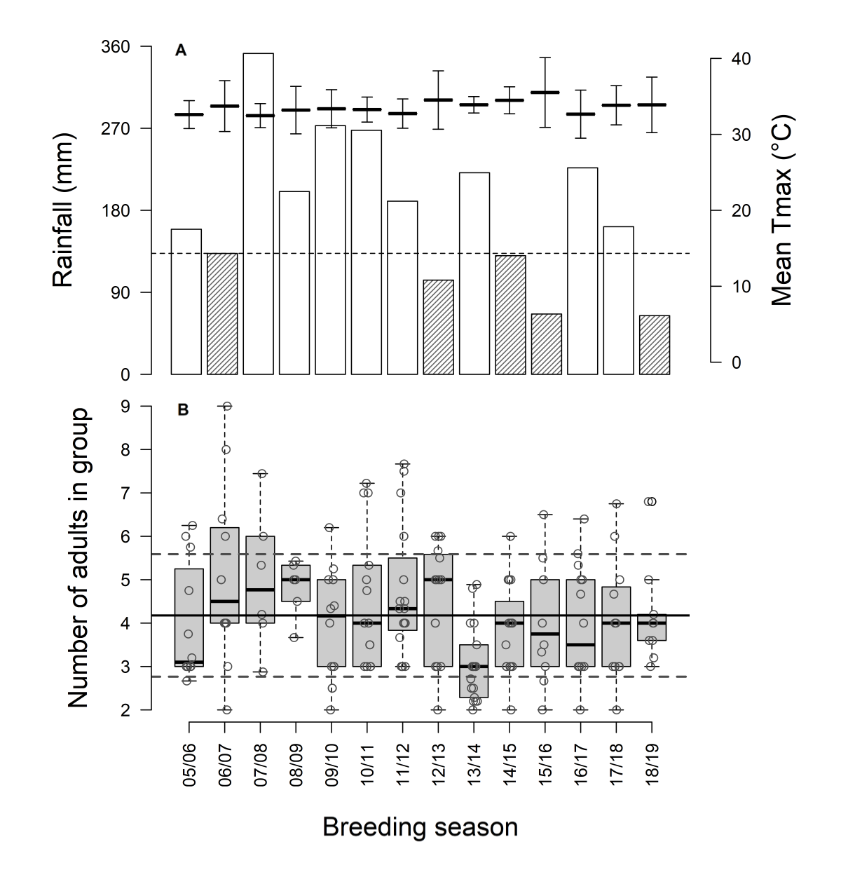

Figure 2
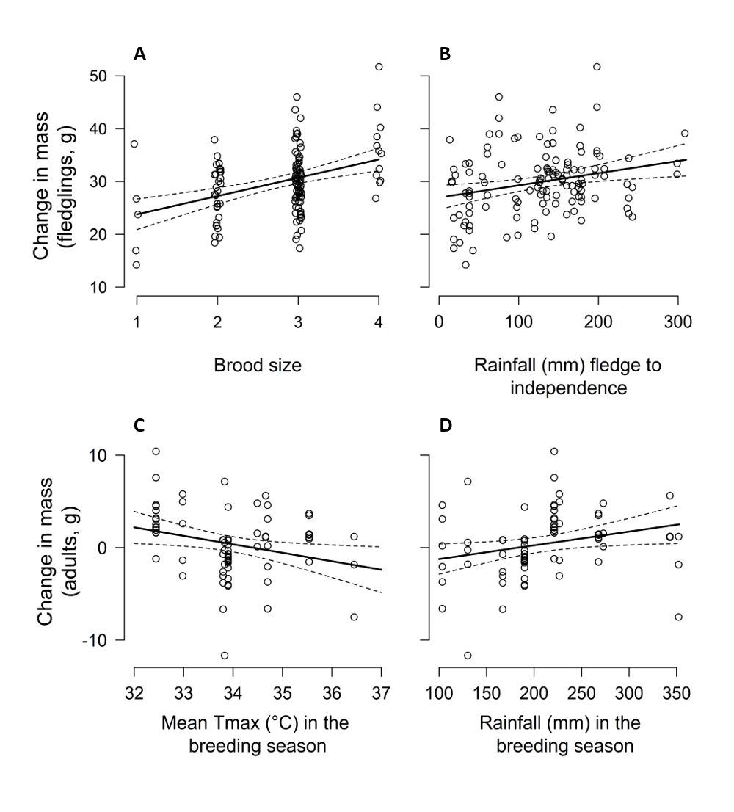

Figure 3
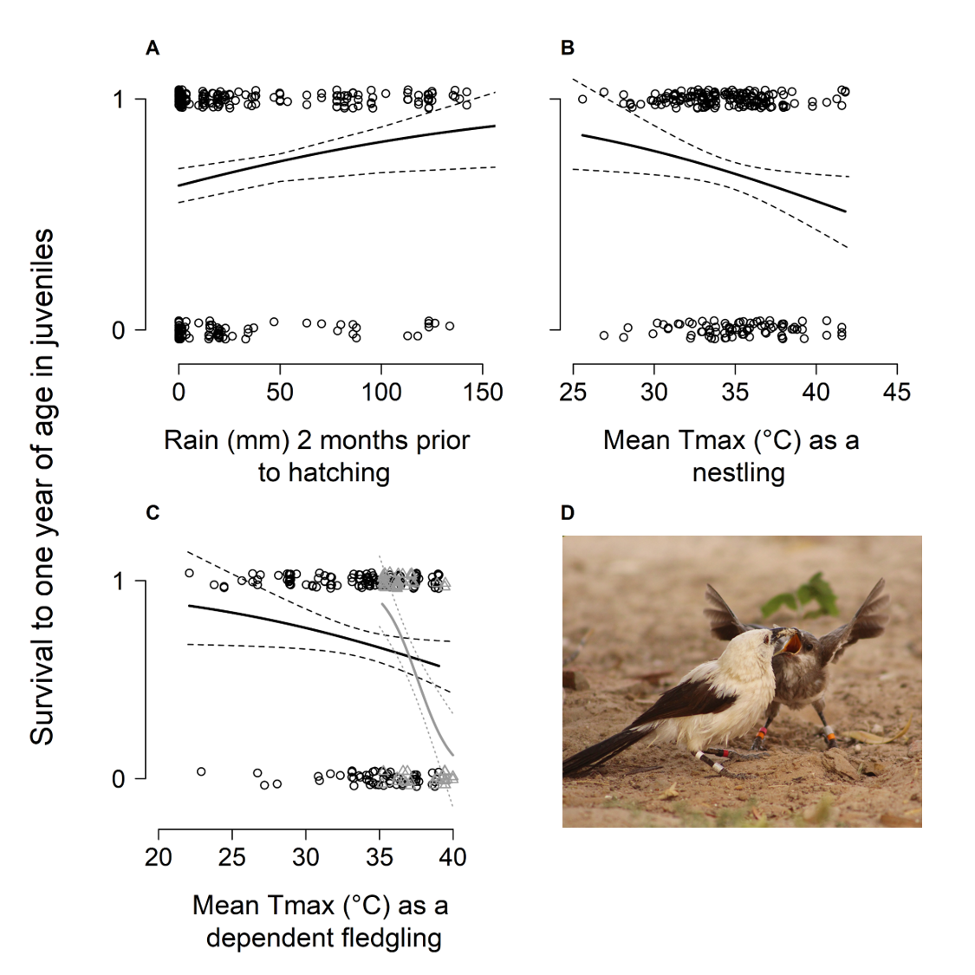

Figure 4
