Correlation between the dynamics and spatial configuration of the circumarctic latitudinal forest-tundra ecotone
Wenkai Guoª*, Gareth Reesª
ª Scott Polar Research Institute, University of Cambridge, Cambridge, United Kingdom
*Corresponding author. Email: wenkai.guo@uit.no

Correlation between the dynamics and spatial configuration of the circumarctic latitudinal forest-tundra ecotone
This study uses the MOderate Resolution Image Spectroradiometer (MODIS) Vegetation Continuous Fields (VCF) data to investigate the relationship between the dynamics of the circumarctic latitudinal forest-tundra ecotones (FTEs) and its spatial configuration. This study also explores the extent to which the Google Earth Engine (GEE) can enable efficient, large-scale and multi-temporal examination of the circumarctic FTE. FTE dynamics is represented by latitudinal interface movement over the 2000 to 2015 period. To represent spatial configuration of the latitudinal FTEs, we propose a continuous measurement of fragmentation derived from window spectral analysis, which builds on the theory of FTE ‘forms’ – a discrete categorisation of altitudinal FTEs primarily based on vegetation fragmentation. Additionally, continentality of the FTEs is calculated to investigate the impact of water variability. Statistical relationship between these variables are analysed in evenly divided longitudinal bands in the circumarctic region containing FTEs. More fragmented latitudinal FTEs are found to be more likely to shift northward in the study period, and FTEs in more continental areas are mostly more fragmented. These empirical results show that similar linkages exist between circumarctic latitudinal FTE fragmentation and dynamics to those found in altitudinal FTEs. This can potentially contribute to the optimisation of future climate modelling as well as modelling of vegetation reactions to climate change. The GEE platform enables the examination of latitudinal FTEs through efficient circumarctic-scale vegetation data assimilation and processing, and the methodological framework allows for future incorporation of additional variables of interest into the analysis.

Keywords:
Forest-Tundra Ecotone (FTE); Google Earth Engine (GEE); window spectral analysis; fragmentation index; Vegetation Continuous Fields (VCF).

1. Introduction
The Forest-Tundra Ecotone (FTE) is a vegetation transition zone of great importance and complexity (Ranson, Montesano and Nelson, 2011; Guo and Rees, 2019), which marks the latitudinal or altitudinal transition from closed canopy forest to treeless tundra. The latitudinal FTE, or the arctic treeline, is the world’s largest vegetation transition zone (Ranson, Montesano and Nelson, 2011). In different regions, both types of FTEs exhibit varying spatial configurations, i.e. different vegetation composition, and also different rates and directions of changes in tree cover and density, tree height and size, and tree growth and reproduction (Sveinbjörnsson, Hofgaard and Lloyd, 2002; Holtmeier, 2010; Ranson, Montesano and Nelson, 2011). FTEs undergo constant movement and structural change, and studies have found different response of FTE position to the changing climate at different locations, the detailed mechanisms behind which are still under study (Rees et al., 2002; Crawford, Jeffree and Rees, 2003; Verbyla, 2008; Rundqvist et al., 2011; Ropars and Boudreau, 2012; Epstein, Myers-Smith and Walker, 2013). For altitudinal FTEs, several globally reoccurring spatial ‘forms’: diffuse, abrupt, island and krummholz, have been recognised and separated based on the spatial patterns of vegetation at the interface (Harsch and Bader, 2011). Global records of altitudinal FTE movement have confirmed a close link between these forms and interface dynamics in terms of interface movement: abrupt altitudinal FTEs respond most frequently to growing-season warming, while those in other forms are relatively unresponsive (Harsch et al., 2009; Harsch and Bader, 2011). This may be caused by the varying dominance of growth limitation, seedling mortality and dieback in FTE formation in FTEs in these different forms. Therefore, accurate characterisation of the spatial configuration of the altitudinal FTEs has great ecological significance, and has potential to help identify the spatial pattern of FTE sensitivity to shift with climate change (Harsch and Bader, 2011; Ranson, Montesano and Nelson, 2011).
This relationship between FTE spatial configuration and dynamics is based on the analysis of altitudinal FTEs studied at the scale of individual trees. To the best of our knowledge, no similar investigation has been reported for latitudinal FTEs. For such a study, the selection of an appropriate proxy for the spatial configuration of the FTE is crucial for two reasons. Firstly, the form-dynamics relationship may not directly apply to latitudinal FTEs where the classification of spatial configurations needs to be conducted at a larger scale, depending on the specific aim of the study and data availability. Secondly, the arbitrary and discrete classification scheme used to define altitudinal FTE forms creates ambiguous cases. FTEs may be classified differently using different interpretations of the classification criteria corresponding to each form (Harsch and Bader, 2011).
The distinction between different altitudinal FTE forms lies essentially in differences in vegetation fragmentation at the interface, from continuous forests bordering low alpine vegetation (abrupt) to patches or strips of vegetation beyond the forest limit (island) to a gradual decrease in tree height and density (diffuse). The level of spatial fragmentation of forests has also been found to be ecologically significant, having profound and lasting impacts on the biodiversity of the ecosystem and its response to environmental fluctuations (Haddad et al., 2015; Camarero et al., 2017). Therefore, the degree of vegetation fragmentation in the FTE will be used as the proxy for its spatial configuration in this study. This study moves beyond the qualitative categorisation of FTE forms, and quantitatively investigates the relationship between FTE movement and a continuum of FTE fragmentation in the circumarctic scale. Specifically, this study uses spectral analysis of satellite image windows containing FTE segments (Renshaw and Ford, 1983), which investigates the structure and scale of vegetation patterns constituting the windows, and thus interprets the degree of fragmentation. Textural analysis has been previously used to successfully distinguish between different altitudinal FTE forms in study areas around the circumarctic region (Guo and Rees, 2019). Several metrics commonly used to characterise landscape fragmentation available in the FRAGSTATS software package (McGarigal, Cushman and Ene, 2012) are also used as additional indicators of FTE fragmentation. They are hereafter referred to as the landscape fragmentation metrics.
The wide span of the circumarctic region and the multi-temporal nature of this study require large amounts of remote sensing data and considerable computational power to process the data within a reasonable timeframe. The Google Earth Engine (GEE) provides petabyte-scale data archive and cloud-based geospatial analysis tools running on supercomputing centres, which together enable easy, interactive retrieval and rapid processing of large amounts of data (Gorelick et al., 2017). Various computed satellite data products relating to vegetation are available in GEE including band-ratio vegetation indices (mostly Enhanced Vegetation Index and Normalised Difference Vegetation Index, or EVI and NDVI), Leaf Area Index (LAI), evapotranspiration, gross primary productivity, global forest change, Vegetation Continuous Fields (VCF), and other land cover classification maps. Studies have used the platform for vegetation mapping and monitoring at various scales (Johansen, Phinn and Taylor, 2015; Lemoine and Léo, 2015; Dong et al., 2016; Farda, 2017; Hird et al., 2017; Wilson et al., 2017; Xiong et al., 2017; Campos-Taberner et al., 2018; Teluguntla et al., 2018), but GEE has not been extensively used in FTE studies. Wei et al. (2018) used NDVI calculated from Landsat imagery from 1984 to 2017 to quantify the movement of altitudinal FTEs in western United States, but to the best of our knowledge no study of large-scale latitudinal FTEs has been conducted based on GEE.
Datasets in GEE potentially suitable for FTE derivation include the VCF products at MODIS and Landsat resolution, the Landsat NDVI product, and Sentinel-2 imagery from which NDVI can be derived. Assessments are made of the suitability of these datasets for this study. The continuous nature of the above-mentioned indicators of FTE fragmentation enables direct statistical comparison with other continuous variables. The trend of FTE latitudinal movement is calculated as the indicator of FTE dynamics. Continentality of the FTEs, represented by Conrad’s index of continentality (Conrad, 1946), is also calculated from the MODIS land surface temperature dataset in GEE. This index provides a synthesised indicator of water availability at the interface (e.g. Crawford, Jeffree and Rees, 2003), which helps to investigate potential factors contributing to the relationship between FTE dynamics and spatial configuration. In summary, this study primarily aims to examine the correlation between circumarctic latitudinal FTE dynamics and spatial configuration, which is quantified by a continuous fragmentation measure. A secondary aim of this study is to investigate the potential of the GEE platform in facilitating such examination of the FTE in a circumarctic scale.

2. Materials and methods
2.1. Study area and data
This study examines latitudinal FTEs over the entire circumarctic region, which is divided into 12 sub-regions based on a scheme adapted from Montesano et al. (2009) while considering the data processing power and time consumption of analysis in GEE. Longitudinal limits of each region are: Eastern Canada (ECA): 55°W–80°W; Central/Western Canada 1 (CWCA1): 105°W–130°W; Central/Western Canada 2 (CWCA2): 80°W–105°W; Alaska 1 (ALA1): 150°W–170°W; Alaska 2 (ALA2): 130°W–150°W; Eastern Eurasia 1 (EEU1): 135°E–110°E; Eastern Eurasia 2 (EEU2): 160°E–135°E; Eastern Eurasia 3 (EEU3): 180°E–160°E; Central Eurasia 1 (CEU1): 85°E–60°E; Central Eurasia 2 (CEU2): 110°E–85°E; Western Eurasia (WEU): 60°E–40°E; Scandinavia (SCA): 40°E–4°E. In each of the sub-regions, latitudinal limits in which the latitudinal FTEs can occur are manually delineated, based on previous studies on FTE positions (e.g. Montesano et al., 2009; Ranson, Montesano and Nelson, 2011) to spatially confine the FTE detection process (Figure 1). The latitudinal limits were specified broadly in order to include any shifting of the interface.
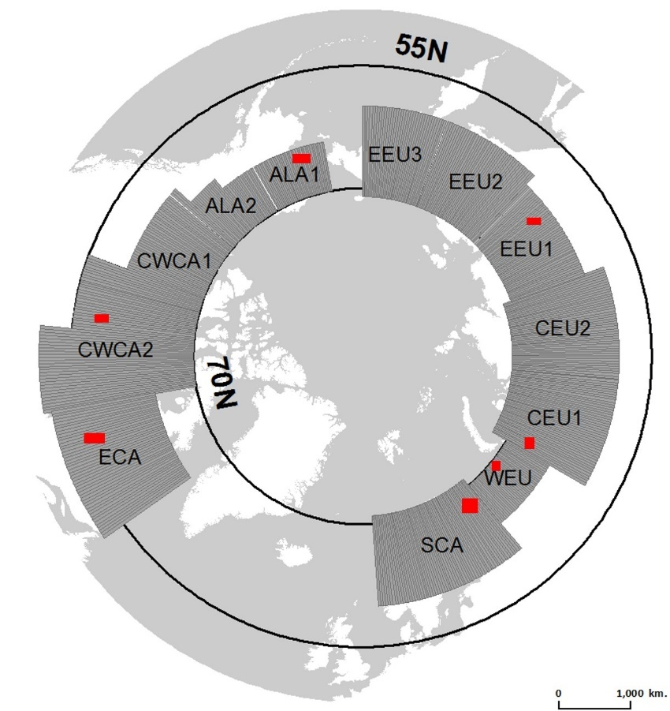
Figure 1. The circumarctic region divided into sub-regions and longitudinal bands. Latitudinal FTEs generated from MODIS VCF and Landsat VCF are compared in sample regions marked with red rectangles.

Several global remote sensing datasets can potentially be used to extract circumarctic FTEs within the GEE platform. VCF pixel values represent the fraction of skylight obstructed by tree canopies of at least 5 m in height (Montesano et al., 2009), and thus provide estimates of the percentage of the pixels covered by tree cover. Therefore, the VCF data is a continuous representation of tree cover which depicts areas with highly heterogeneous vegetation, such as the FTE, better than traditional discrete image classifications (Montesano et al., 2009; DiMiceli et al., 2011; Ranson, Montesano and Nelson, 2011; Townsend et al., 2011).
Two VCF datasets are currently available. The MODIS VCF dataset is derived from 16-day surface reflectance composites from MODIS bands 1 to 7, brightness temperatures from MODIS bands 20, 31, 32, the MODIS Global 250 m Land/Water map, and training data produced from classification of Landsat data (Townsend et al., 2011). It is available at a spatial resolution of 250 m with yearly coverage from 2000 to 2015, making it suitable for large-scale, multi-temporal study of FTE dynamics (Stow et al., 2004; Montesano et al., 2009). This dataset has been used by numerous studies to map tree cover (Cross and Settle, 1991; Zhu and Evans, 1994; Mayaux and Lambin, 1997; Tottrup et al., 2007; Heiskanen and Kivinen, 2008), and has also been used as the data source of an existing circumarctic FTE product (Ranson, Montesano and Nelson, 2011). The Landsat VCF dataset is the MODIS VCF product densified to 30 m resolution using Landsat images, thus having improved discriminatory power for small forest patches. It is currently the highest-resolution multi-temporal global dataset of tree cover, and has been shown to have similar accuracies to MODIS VCF (Sexton et al., 2013). However, the Landsat VCF is not optimal for this study because of its insufficient temporal coverage. The most recent version of the dataset, version 3 (Sexton et al., 2013), covers four nominal epochs: 2000, 2005, 2010 and 2015, derived from MODIS VCF data in the corresponding years, and is thus unable to provide a continuous time series.
NDVI calculated from global satellite products is also potentially useful for FTE derivation. NDVI composite products based on Landsat imagery are available in GEE at a 30 m resolution which provides temporal coverage from 1982 to present. NDVI can also be calculated from Sentinel-2 imagery at 10 m resolution, which is achievable in GEE but less appropriate for this study due to its short temporal coverage, i.e. from 2015 onwards. Also, for a circumarctic FTE study, there is no reliable and consistent NDVI-based technique (e.g. thresholding) to derive FTEs in different regions. The percent canopy cover information that VCF products provide incorporates spectral and phenological information from MODIS spectral bands, NDVI and surface temperature data (Sexton et al., 2013), and is thus a more comprehensive and reliable source of vegetation information for FTE derivation. Therefore, the MODIS VCF product is used as the primary data source for FTE derivation in this study Although its 250 m spatial resolution is relatively coarse compared to alternatives mentioned above, it provides reasonable spatial and temporal coverage that enables a phenomenological investigation of the latitudinal FTE at a circumarctic scale.
The spatial distribution of trees is in part controlled by that of water bodies, which varies both spatially and temporally as a result of weather variations. Spatial variation introduces the possibility of a spatially variable dependence on the spatial resolution of the data used to specify the characteristics of the FTE, while temporal variation points to the desirability of reducing random effects by spatial averaging. We thus choose to average data into longitudinal bands of constant width (250 MODIS pixels, or 62500 m), and also to perform comparisons between FTE generated from MODIS VCF and Landsat VCF in years when both datasets are available in seven sample regions (Figure 1). Google Earth engine is used as the primary data retrieval, assimilation and processing tool, and subsequent statistical analysis is performed in MATLAB and ArcMap 10.4.

2.2. Circumarctic FTE derivation
The FTE is derived for the whole study area following the method of Ranson et al. (2011): image segmentation is applied to the MODIS VCF dataset, and an image segment is considered as part of the FTE if the mean VCF value inside is between 5 and 20, or if it has a mean VCF value of less than 5 but a standard deviation value of larger than 5. The segmentation algorithm used is GEE’s implementation of the Simple Non-Iterative Clustering (SNIC) method (Achanta and Süsstrunk, 2017) which is an improvement upon the previously available Simple Linear Iterative Clustering (SLIC, Achanta et al., 2012) method and achieves fast segmentation on large datasets. The analysis of the relationship between FTE dynamics and spatial configuration is then performed based on the derived latitudinal FTEs, the process of which is summarised in a diagram shown in Figure 2.
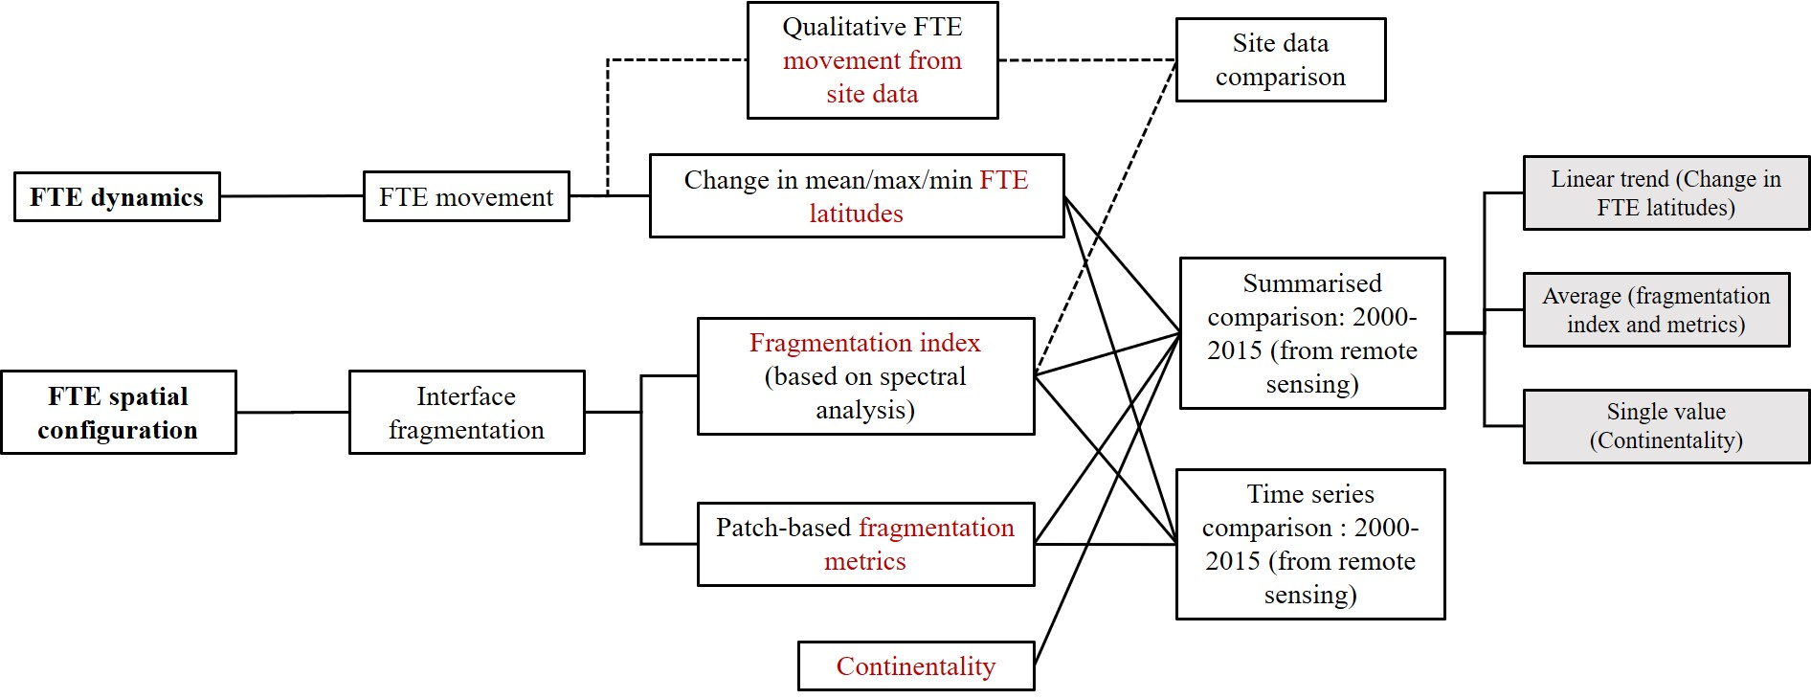
Figure 2. Schematic diagram of the analysis of FTE dynamics and spatial configuration based on remote sensing products and site data (red font indicates variables used in the analysis).

2.3. Latitudinal FTE dynamics, fragmentation and continentality - summarised comparison
Based on the derived FTEs, indicators of FTE fragmentation and dynamics are calculated for each year in the 2000-2015 period. The latitudinal movement in FTE position is summarised over the study period by linear regression (thus examining the temporal trend), and FTE fragmentation by averaging (thus examining the ‘normal’ state).The resulting statistics are compared to reveal their relationships. Continentality in the FTEs is calculated as single value in the study period using the averaged annual temperature range.
Firstly, FTE dynamics is derived by calculating the linear trend of the 16-year time series of mean, minimum and maximum latitudes of FTE pixels (hereafter referred to as mean, minimum and maximum FTE latitudes), i.e. FTE movement, in each longitudinal band.
Secondly, FTE fragmentation is calculated using spectral (spatial frequency) analysis. A windowing process is performed on top of longitudinal zoning whereby each sub-region is divided into grids of 250 by 250 MODIS pixels. VCF data squares within these grids that contain FTE pixels are extracted and exported from GEE for window spectral analysis. Figure 3 is an illustration of FTE derivation based on the segmentation approach and windowing process in the CWCA1 and CWCA2 sub-regions, rendered in GEE. It should be noted that FTE pixels in the figure are those derived using MODIS VCF data resampled to a coarser resolution corresponding to this particular zoom level, as the visualisation of processing results in GEE is tied to the zoom level of the map. The distribution of actual FTE pixels derived from the full resolution VCF product, which is used for analysis in this study, are different and can only be seen when further zoomed in on the map. Therefore, Figure 3 only depicts the general location of the FTE in CWCA1 and CWCA2, and serves only as a qualitative demonstration of the FTE derivation and windowing process.
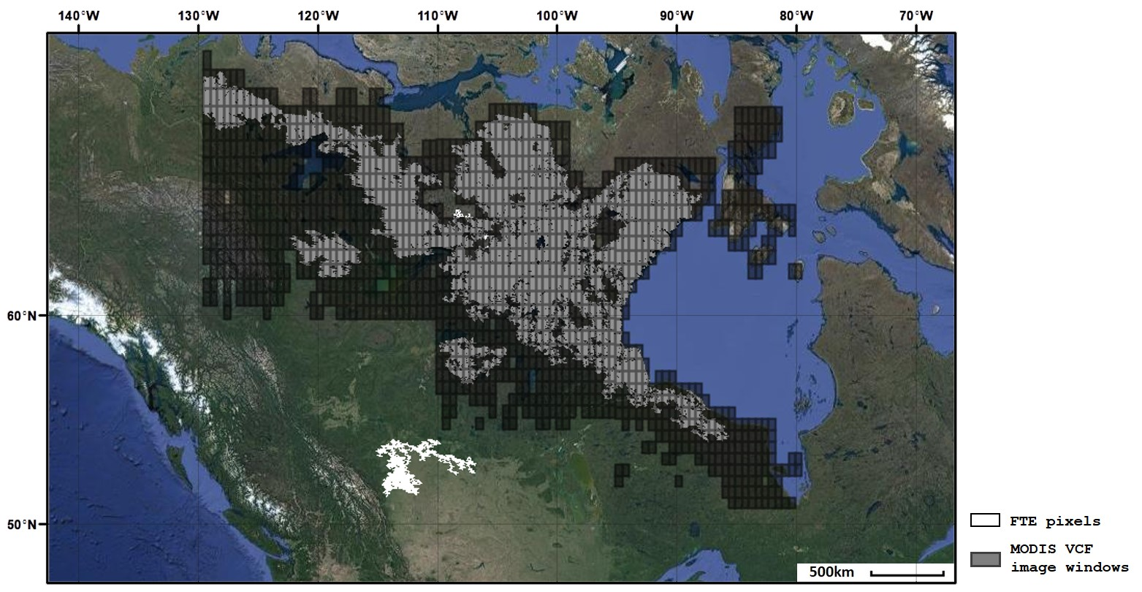
Figure 3. MODIS VCF image windows intersecting with FTE pixels in CWCA1 and CWCA2, 2000 (dark grey).

In order to provide reference to the FTE segments generated from MODIS VCF data, comparisons are made between FTE generated from MODIS VCF data and Landsat VCF data. Firstly, visual comparisons are made between FTE segments generated from both datasets in the 2015 epoch using the above segmentation-based FTE derivation method in seven sample regions in the circumarctic region, each within a sub-region (ECA, CWCA, ALA, EEU, CEU, WEU and SCA), as shown in Figure 4. These sample regions are selected along the northern limit of the boreal forest as classified by the Circumpolar Arctic Vegetation Map (CAVM, Walker et al., 2005), provided that they also fall into the recent circumarctic latitudinal FTE product (Ranson, Montesano and Nelson, 2011). Secondly, a comparison is made between upper and lower FTE latitudinal bounds in every other longitudinal band generated from both datasets in the 2000, 2005, 2010 and 2015 epochs, as shown in Figure 5. These figures show that the latitudinal FTE generated in MODIS and Landsat resolution from the VCF datasets follow each other closely, which provides confidence in the use of MODIS VCF data as the primary data source due to its better temporal coverage.
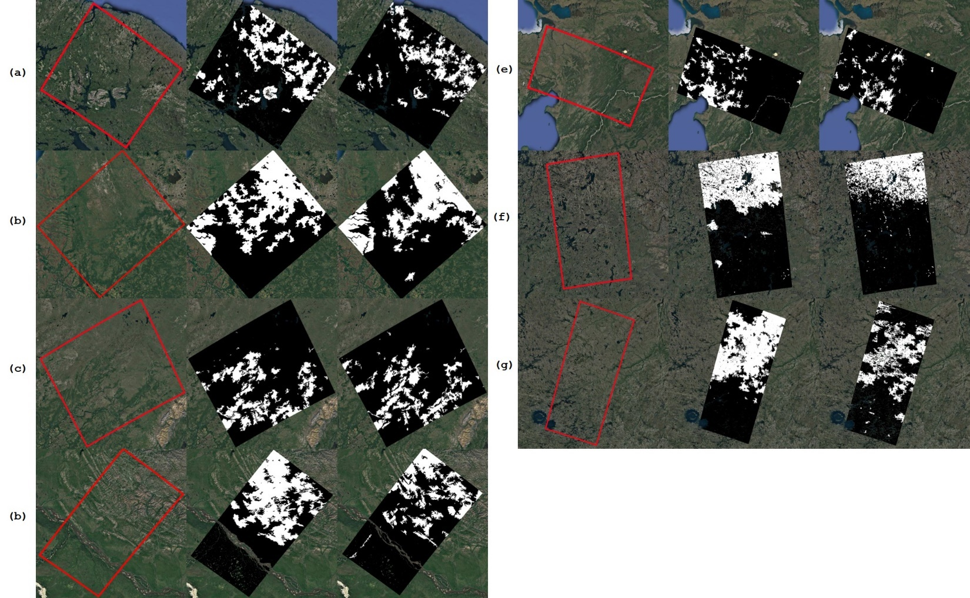
Figure 4. Comparison between Google Earth coverage of seven study areas (left panel) and FTE segments generated from MODIS VCF (centre panel) and from Landsat VCF (right panel) in the 2015 epoch. (a) SCA; (b) WEU; (c) CEU; (d) EEU; (e)ALA; (f) CWCA; (g) ECA.
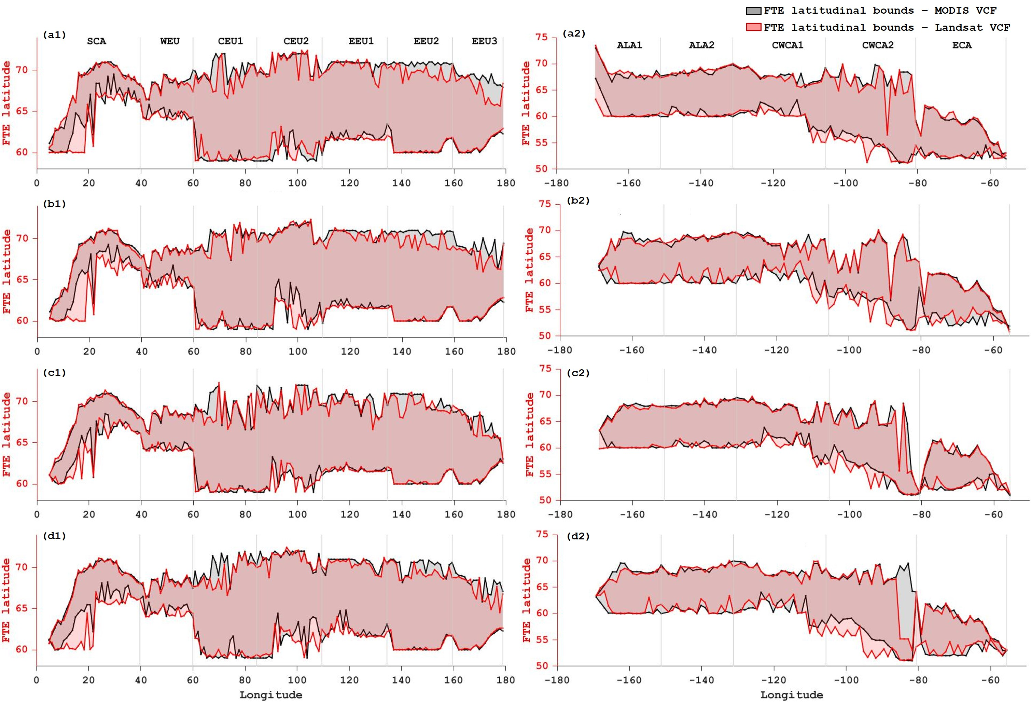
Figure 5. Comparison between the upper and lower latitudinal bounds of FTE segments generated from MODIS VCF and Landsat VCF. (a) 2000; (b) 2005; (c) 2010; (d) 2015. Left: Eurasia; right: North America.
2-dimensional spectral analysis (Renshaw and Ford, 1983) is applied to determine the relative importance of different scales of spatial patterns in the image windows, thus extracting FTE fragmentation. In an image window, this technique calculates the periodograms (Fourier transform of the spatial autocorrelation function) in discrete harmonic wavelengths:
$I_{pq}=n^{-2}\left(a_{pq}^{2}+b_{pq}^{2}\right)$ (1)
where (p,q) is a pair of wavenumbers along the two Cartesian directions of an n by n image window, and $a_{pq}$ and $b_{pq}$ are the Fourier coefficients, or weights of cosine and sine waveforms. The periodogram can also be written in polar coordinates, $I_{rθ}$, which separates the scales of spatial patterns $r=\sqrt{p^{2}+q^{2}}$ and their directions $θ=\tan^{-1}\left(p/q\right)$. These periodograms in all possible directions are averaged, which yields the radial spectrum, or r-spectrum:
$I\left(r\right)={\left(kσ^{2}\right)}^{-1}\sum_{θ}{I_{rθ}}$ (2)
where k represents the number of periodogram values in bin r, and $σ^{2}$ is the image variance (Couteron, Barbier and Gautier, 2006). This statistic is proportional to the relative contribution of spatial patterns in these different scales to the image variance, i.e. a high r-spectrum value at a spatial frequency suggests that a large portion of the image variance can be explained by spatial patterns in this frequency. Thus, the shape of the r-spectra curve (skewness) of an image window indicates the relative importance of coarse vs. fine spatial textures, and is therefore representative of the degree of fragmentation of vegetation inside. The greater the skewness, or equally the more positively skewed the r-spectrum curve is, the more variations in lower frequencies (longer wavelengths) are contributing to the total variance of the window, and thus the less fragmented the FTE is. Window spectral analysis is conducted in each FTE window, and a fragmentation index is defined in this study as 4 minus the r-spectrum skewness so that larger index values correspond to higher degrees of fragmentation. For every longitudinal band, the fragmentation index in all windows are spatially averaged to represent the fragmentation of FTEs in that band. This is repeated for every year between 2000 and 2015. For every longitudinal band, the fragmentation index is further temporally averaged through the time period, resulting in a single fragmentation index for each band representing the ’normal’ state of FTE fragmentation. This index is then compared with other summarised variables to evaluate their relationship with FTE fragmentation.
For the robustness of the study, several other indicators of fragmentation are also calculated for the FTE windows, and the same averaging process as above is applied. These landscape fragmentation metrics in FRAGSTATS include mean patch size (McGarigal, Cushman and Ene, 2012), edge length (EL, Li and Reynolds, 1993), mean nearest neighbour distance (NN, Trani and Giles Jr, 1999), patch cohesion (PC, Schumaker 1996), landscape division (LD, Jaeger 2000), aggregation index (AI, He, DeZonia and Mladenoff, 2000) and contagion index (CI, O’Neill et al., 1988; Li and Reynolds, 1993). These metrics are calculated as equations 3 to 9 in MATLAB, and those which have an inverse relationship with degrees of fragmentation (MPS, PC, AI and CI), i.e. the higher the index, the lower the fragmentation, are inverted to ensure consistency when comparing them to other variables. It should be noted that these metrics are based on the derivation of homogeneous vegetation patches, and are sensitive to the dissection of forests, which limits their viability in characterising the FTE where trees can be sparsely distributed. In contrast, our fragmentation index is based on geostatistical analysis of the pixel-wise distribution of image variation at different spatial frequencies, and assumes spatially continuous vegetation abundance. Therefore, these alternative indicators of fragmentation are incorporated only as a reference to the fragmentation index.
$$MPS=mean a$$ | (3)
$$EL=\sum_{i=1}^{NP}{p_{i}}$$ | (4)
$$NN=meand\left(P_{i}P_{j}\right)$$ | (5)
$$PC=\left[1-\frac{\sum_{i=1}^{NP}{p_{i}}}{\sum_{i=1}^{NP}{p_{i}}∙\sqrt{a_{i}}}\right]∙{\left[1-\frac{1}{\sqrt{N}}\right]}^{-1}$$ | (6)
$$LD=1-\sum_{i=1}^{NP}{{\left[\frac{a_{i}}{A_{T}}\right]}^{2}}$$ | (7)
$$AI=\left[\frac{g_{ii}}{\max{g_{ii}}}\right]$$ | (8)
$$Given G_{i}=\left[\frac{g_{ii}}{\sum_{k=1}^{m}{g_{ik}-min{p_{i}}}}\right], CI=\left\{\begin{aligned}\frac{G_{i}-P_{i}}{P_{i}}, if G_{i}<P_{i} & P_{i}<5. else, \\ \frac{G_{i}-P_{i}}{1-P_{i}}\end{aligned}\right.$$ | (9)

where $P$ is an FTE pixel patch; $a$ is the FTE patch size;$p$ is the perimeter of an FTE patch; $NP$ is the total number of FTE patches in the image window; $N$ is total number of pixels in the image window; $A_{T}$ is the area of the image window; $d\left(P_{i}P_{j}\right)$ is the Euclidean distance between one FTE patch and its nearest neighbouring FTE patch; $g_{ii}$ is the number of adjacencies between FTE pixels, and $g_{ik}$ is the number of adjacencies between FTE pixels and non-FTE pixels; $P_{i}$ is the proportion of the image window occupied by FTE pixels.
Finally, continentality is introduced as an additional parameter and compared with FTE fragmentation and dynamics. Continentality of the FTE windows incorporates multiple environmental factors associated with proximity to the sea manifested in differences in mean annual temperatures. Although lower continentality, or higher oceanicity, is commonly considered advantageous for vegetation to extend their northern limits with increased water availability, it can also harm woody species through the acceleration of carbohydrate depletion leading to root dieback in water-saturated soils. In areas where tree cover is sparse, such as the FTE, higher oceanicity causes accelerated soil leaching which leads to nutrient deficiencies, and paludification further limits vegetation growth and spread (Crawford, 1997; Crawford, Jeffree and Rees, 2003) at large scales. Moreover, current global studies of vegetation response to climate variables indicate that water availability is the dominant controlling factor of vegetation variability (Seddon et al., 2016; Miralles et al., 2017; Quetin and Swann, 2017). Therefore, this study introduces continentality to investigate the impact of water availability on the fragmentation and dynamics of the interface. Conrad’s index of continentality (Conrad, 1946), defined by Equation 10, is calculated as the indicator of continentality based on the 8-day MODIS Terra land surface temperature dataset (1km resolution) for FTE pixels in all FTE windows from 2000 to 2015.
$$k=\frac{1.7A}{sin\left(∅+10°\right)}-14$$ | (10)
where $A$ is the 16-year average annual temperature range (difference between the mean temperature of the warmest and coldest months), and $∅$ is the latitude of the pixel.

2.4. Latitudinal FTE dynamics and fragmentation - time series comparison
A further step is taken to examine the actual time series of the variables rather than summarised statistics of the time series. The representation of FTE fragmentation in the above steps is an indication of its ‘normal’ state in each longitudinal band, and its temporal changes are not considered. Linear fitting of FTE latitudes may also be an oversimplification of 16 years of FTE movement. To compensate for this, the 16-year time series of FTE mean latitudes and fragmentation are directly compared in each longitudinal band, with their correlation and corresponding significance calculated. The statistical relationship between the spatial averages of these variables in both continents is also calculated.

2.5. Latitudinal FTE dynamics and fragmentation - site data comparison
The above steps investigate the relationship between circumarctic FTE fragmentation and dynamics using satellite remote sensing data. In a last step, an examination of this relationship is conducted on FTE site data across the circumarctic region. Two datasets are used for this purpose. The first dataset is a compilation of 161 data points in different vegetation zones (FTE, forest, tundra and forest line) compiled from previous studies achieved from Rees et al. (2020). The second dataset is another compilation of worldwide FTE data points collected by Harsch et al. (2009). Both datasets contain information about the categorisation of FTE forms and movement of the FTEs. Out of these two datasets, 79 are latitudinal FTE sites and are extracted for analysis, the locations of which are shown in Figure 6, with the latitudinal circumarctic FTE derived by Ranson et al. (2011) as a reference of their locations. The average fragmentation index of VCF image windows containing one or more sites are extracted as the indicator of fragmentation of the FTE surrounding these sites. These are then compared with the recorded FTE movement at these site locations.
Figure 6. Latitudinal FTE sites (red dots). The green polygons are the latitudinal FTE product derived by Ranson et al. (2011).

3. Results
3.1. Circumarctic FTE dynamics fragmentation and continentality - summarised comparison
Figures 7 and 8 show the comparison between FTE fragmentation, movement and continentality in longitudinal bands in Eurasia and North America. Mean FTE latitudes in each year are also shown in the lower panels. For illustration purposes, continentality has been normalised to the 0-1 range. Y-axis limits of the three variables are determined so that the curves can be easily separated visually. Table 1 summarises detailed correlation coefficients and corresponding p-values, and Table 2 shows the relationship between these variables in each sub-region. These comparisons are pairwise, as they only examine correlations and all the landscape fragmentation metric serve the same purpose as the fragmentation index.

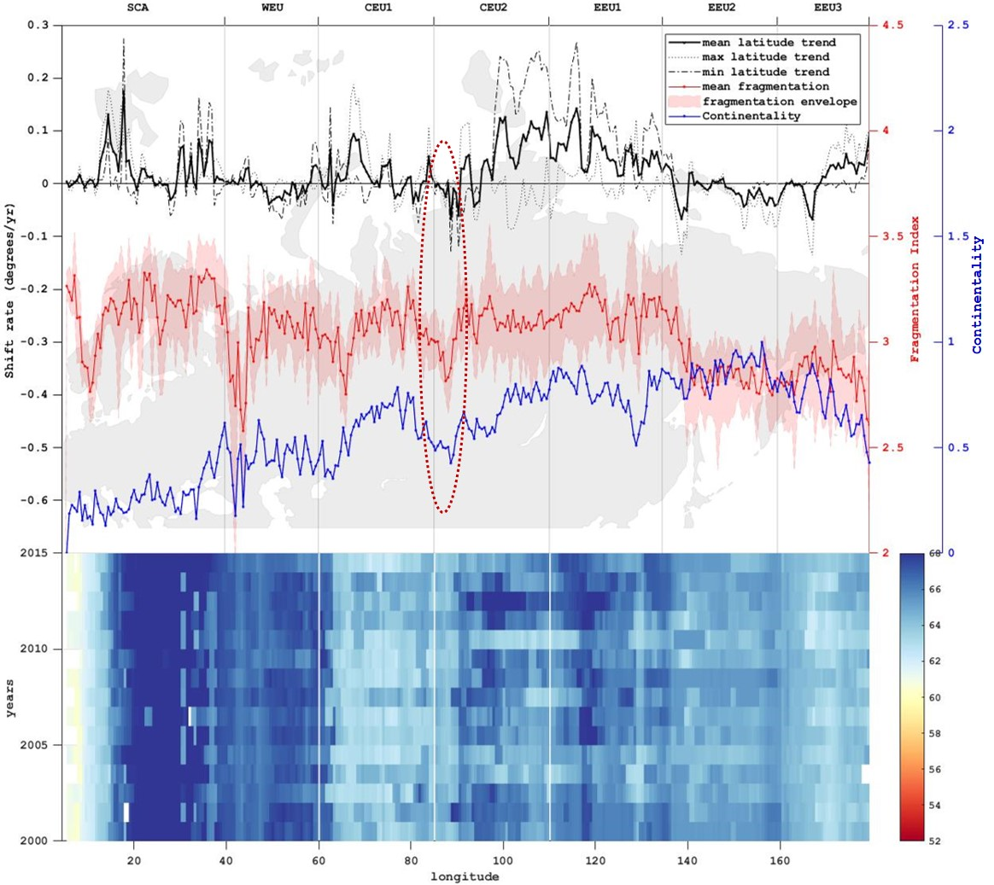
Figure 7. The relationship between 16-year trend of mean/max/min FTE pixel latitudes (black) within each longitudinal band, 16-year average of FTE fragmentation, (red) and continentality (blue) in all windows in the longitudinal bands in Eurasia. The red shade is the envelope of the fragmentation index values in all longitudinal bands. Geographic contour of the study area is displayed in the background. The bottom panel shows mean FTE latitudes in longitudinal bands from 2000 to 2015. The red dotted ellipse include the approximate regions where a depression can be seen in continentality and FTE movement.
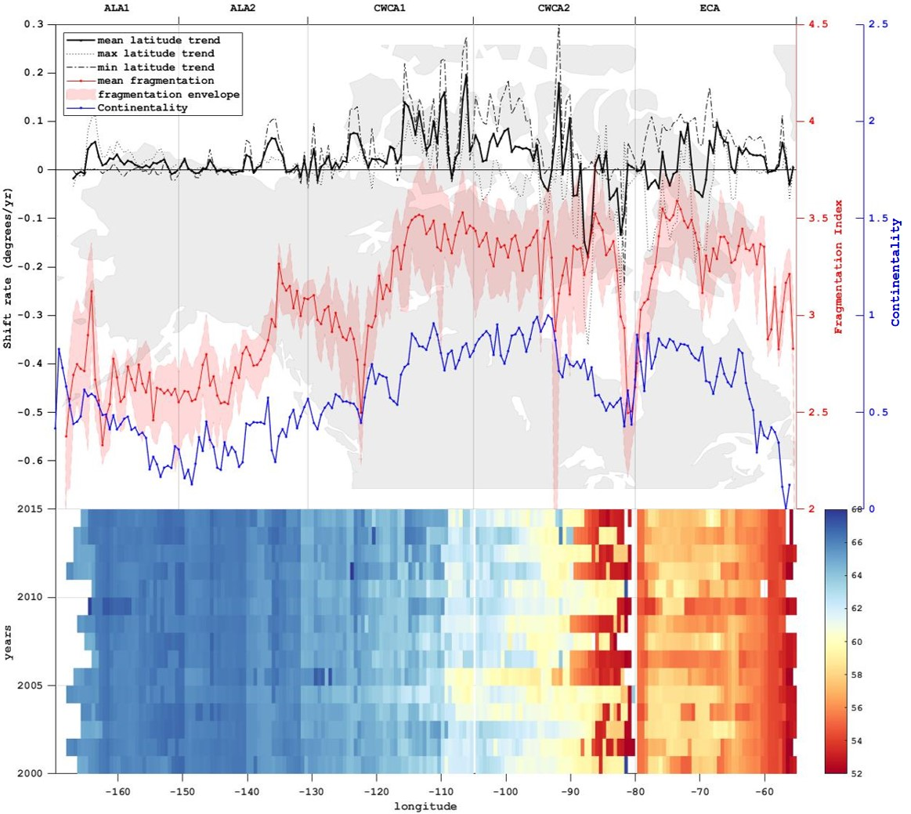
Figure 8. The relationship between 16-year trend of mean/max/min FTE pixel latitudes (black) within each longitudinal band, 16-year average of FTE fragmentation (red), and continentality (blue) in all windows in the longitudinal bands in North America. The red shade is the envelope of the fragmentation index values in all longitudinal bands. Geographic contour of the study area is displayed in the background. The bottom panel shows mean FTE latitudes in longitudinal bands from 2000 to 2015.

Table 1. Upper panel: Linear correlation coefficients (R) and p-values (P) between FTE fragmentation, dynamics and continentality. Mmean, Mmax, Mmin: movement (16-year trend) of mean, maximum and minimum FTE latitudes; F: FTE fragmentation; C: Conrad’s index of continentality. Bottom panel: correlation coefficients (R) and p-values (P) betwen movement of mean FTE latitudes and different indicators of FTE fragmentation. Bold fonts indicate statistical significance (p<0.05).
 | EA |  |  | NA
 | R | P | R |  | P
Mmean – F | 0.339 | $$8.28×{10}^{-10}$$ | 0.213 |  | 0.003
Mmax – F | 0.175 | 0.002 | -0.163 |  | 0.021
Mmin – F | 0.267 | $$1.72×{10}^{-6}$$ | 0.482 |  | $$5.79×{10}^{-13}$$
Mmean – C | 0.014 | 0.808 | 0.210 |  | 0.003
F – C | -0.258 | $$3.95×{10}^{-6}$$ | 0.709 |  | $$7.02×{10}^{-32}$$
Mmean – MPS | 0.234 | $$3.03×{10}^{-5}$$ | -0.058 |  | 0.421
Mmean – EL | 0.129 | 0.023 | 0.325 |  | $$3.05×{10}^{-6}$$
Mmean – NN | 0.137 | 0.016 | 0.109 |  | 0.128
Mmean – PC | -0.031 | 0.588 | 0.155 |  | 0.030
Mmean – LD | 0.365 | $$3.12×{10}^{-11}$$ | -0.125 |  | 0.078
Mmean – AI | 0.309 | $$2.61×{10}^{-8}$$ | 0.302 |  | $$1.54×{10}^{-5}$$
Mmean – CI | 0.155 | 0.006 | 0.277 |  | $$7.97×{10}^{-5}$$

Table 2. Correlation coefficients between FTE fragmentation and dynamics averaged over the 2000-2015 period and continentality in different sub-regions. Bold fonts indicate statistical significance (p<0.05).
 | Mmean – F | Mmean – C | F – C
SCA | 0.247 | -0.055 | 0.331
WEU | -0.375 | -0.129 | 0.421
CEU1 | -0.021 | -0.027 | 0.659
CEU2 | 0.363 | 0.753 | 0.451
EEU1 | 0.291 | 0.141 | 0.174
EEU2 | 0.268 | 0.137 | -0.197
EEU3 | -0.464 | -0.809 | 0.503
ALA1 | 0.335 | 0.361 | 0.194
ALA2 | 0.299 | 0.074 | 0.609
CWCA1 | 0.492 | 0.488 | 0.796
CWCA2 | 0.047 | 0.342 | 0.400
ECA | 0.230 | -0.097 | 0.432

3.1.1. FTE fragmentation and dynamics
In Eurasia, areas of major northward FTE movement concentrate in Central-Eastern Eurasia between roughly 100°E to 140°E, and also in Scandinavia (Figure 7). Part of Central-Western Siberia shows a significant southward movement trend, corresponding to the well-documented influence of high-oceanicity-induced paludification on the FTE (Kremenetski, Sulerzhitsky and Hantemirov, 1998; Crawford, Jeffree and Rees, 2003; Crawford, 2008). This can also be directly seen on Figure 7 where a depression (circled in red) can be found in both the curves of continentality and FTE movement. Southward FTE movement can also be found in Eastern Eurasia. On the other hand, North America shows a general neutrality in FTE movement in Alaska and Western Canada, while Central-Eastern Canada show more areas with significant northward shifts (Figure 8). The most pronounced southward FTE movement exists surrounding the Hudson Bay, which again shows the impact of high oceanicity on FTE placement, as can also be seen on Figure 8. The mean FTE fragmentation curve follows the trend of the FTE movement curve more closely in Central-Eastern Eurasia and Central-Eastern North America.
Table 1 shows significant positive correlations between overall FTE fragmentation and movement of mean FTE latitudes. 9 out of the 12 sub-regions also show positive correlations between them, with significance in CEU2, EEU1, and CWCA1 (Table 2). In both continents, movement of minimum FTE latitudes, i.e. movement of the southern FTE boundaries, have more prominent positive correlations with FTE fragmentation than that of the maximum FTE latitudes, thus contributing significantly more to the positive correlation found between FTE fragmentation and the movement of mean FTE latitudes. Overall, Eurasia shows higher correlations between FTE movement and fragmentation than those in North America. Additional indicators of landscape fragmentation also show a general positive relationship with FTE movement, confirming the positive relationship between FTE movement and fragmentation: 6 out of the 7 landscape fragmentation metrics in Eurasia and 4 out of the 7 metrics in North America show significant positive correlation with FTE movement.

3.1.2. FTE dynamics and continentality
In Eurasia, no significant correlation exists between continentality and FTE movement (Table 1), and only CEU2 shows a significant positive correlation between the two variables, while the EEU3 sub-region shows a significant negative correlation (Table 2). The two variables track each other more closely in North America (Figure 8), showing significant positive overall correlation, and significant positive correlations in 3 of the 5 sub-regions (Table 2).

3.1.3. FTE fragmentation and continentality
In Eurasia, continentality in FTE follows a slightly rising trend from west to east, opposite to that found in the fragmentation index (Figure 7), which is confirmed by the significant negative overall correlation between the two variables (Table 1). However, regional trends of the two variables are similar except for EEU2 (Figure 7), and Table 2 shows that positive correlations indeed exist for these sub-regions, all with statistical significance expect for EEU1. In North America, the fragmentation index and continentality follow a very similar trend both for each sub-region and for the continent overall, which show a slight rising trend from west to east with two major depressions in CWCA1 and the boundary between CWCA2 and ECA (Figure 8). This can also be concluded from the very high positive correlation between the two variables in Table 1 and the presence of positive correlations in Table 2 for all sub-regions which are significant only except for ALA1.

To better illustrate the FTE fragmentation-movement relationship, a map is made showing mean FTE fragmentation and movement trend in the longitudinal bands, both from 2000 to 2015, with the latitudinal FTE derived in 2015 as the background (Figure 9). The 2015 FTE is derived in GEE at a reduced resolution at the zoom level where each sub-region can be fitted into the map viewer, and thus is for illustration purpose only. The colour of each band represents the 16-year fitted trend in mean FTE position within the band, while the size of the circles represents the average fragmentation index of the FTE within the band. Just as presented above, a general trend can be seen where higher degrees of fragmentation tend to coincide with a higher tendency for the FTE to advance northward, which is more pronounced in Central-Eastern Eurasia and Central-Eastern North America.
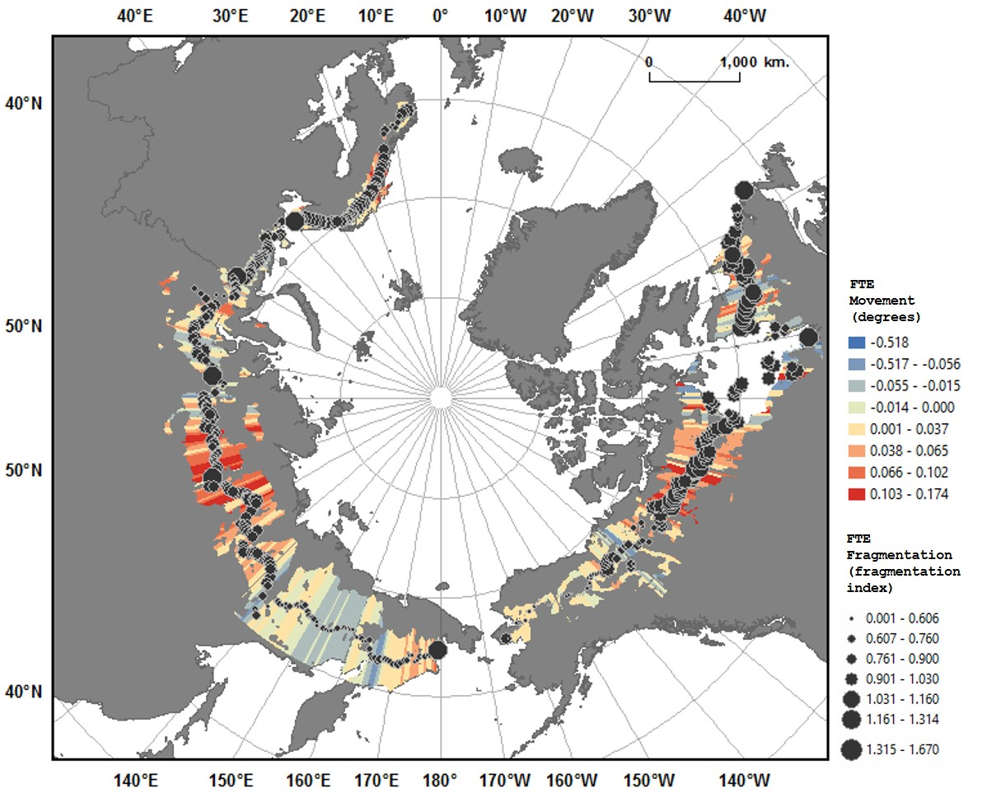
Figure 9. FTE fragmentation vs. movement in mean FTE latitudes.

3.2. Circumarctic FTE dynamics and fragmentation - time series comparison
Figure 10 shows the time series of averaged FTE latitudes (mean, maximum and minimum) and the fragmentation index,over all longitudinal bands in the two continents.
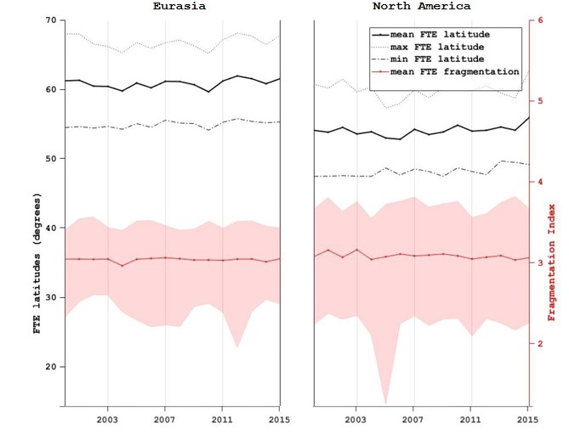
Figure 10. Time series of mean, maximum and minimum FTE latitudes (black), and FTE fragmentation (red), averaged over all the longitudinal bands in Eurasia (left) and North America (right). Shaded areas are envelopes of the corresponding variables in all longitudinal bands.
Correlation coefficients and corresponding p-vales between different variables are listed in Table 3. Most variable pairs are not significantly correlated, but a statistically significant positive relationship can be found between time series of the average FTE fragmentation and average FTE mean latitudes in Eurasia, while no significant correlation is found between the two time series over North America.
Table 3. Correlation coefficients (R) and p-values (P) between time series of mean, maximum and minimum FTE latitudes and fragmentation index, averaged over the two continents. Bold fonts indicate statistical significance (p<0.05).
 | EA |  | NA
 | R | P | R | P
$$mean lat-F$$ | 0.498 | 0.049 | -0.316 | 0.233
$$max lat-F$$ | 0.495 | 0.051 | -0.124 | 0.646
$$min lat-F$$ | 0.360 | 0.171 | -0.393 | 0.133

Apart from comparing time series of variables spatially averaged in each continent, correlations between the time series in each longitudinal band are also calculated and shown in Figure 11. For reference to the summarised comparisons, sub-regions showing significant correlations between the variables temporally averaged over the 2000-2015 period (found in Table 2) are marked with blue triangles. Positive correlations dominate in a major proportion of all longitudinal bands in Eurasia (Figure 11(a1)), with pronounced presence of statistical significance across the continent, showing geographical coherence of the relationship between FTE fragmentation and mean latitudes. This relationship is especially concentrated in CEU1, CEU2, EEU1, and EEU2, out of which CEU2 and EEU1 also show significant positive correlation in the summarised comparison (Table 2). North America shows a more even and spread out distribution with comparable numbers of positive and negative correlations, with significant positive correlations concentrated in ALA1, CWCA1 and CWCA2 (Figure 11(b1)), among which CWCA1 also shows significant positive correlation in the summarised comparison (Table 2).
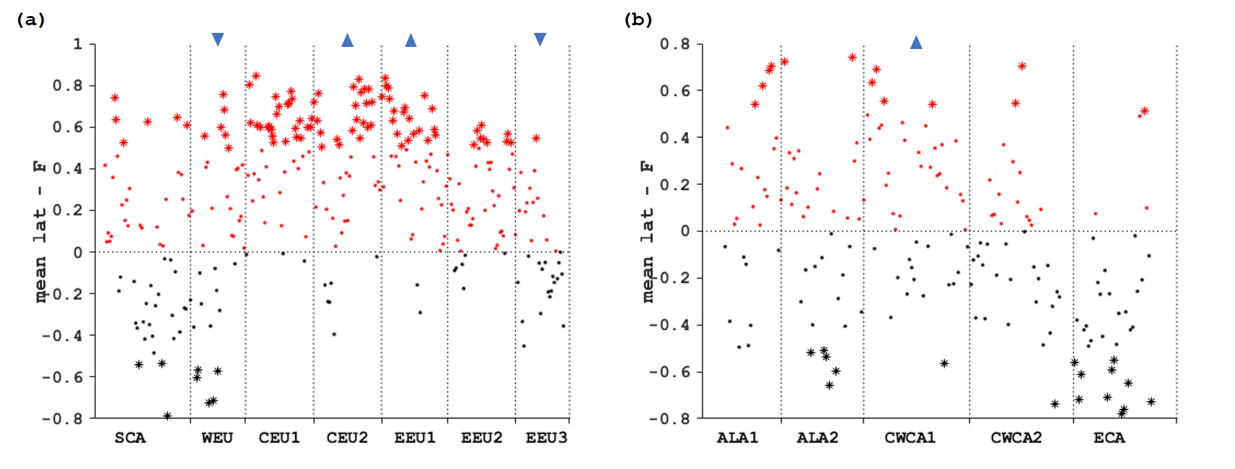
Figure 11. Correlation coefficients between 16-year time series of FTE fragmentation and mean latitude in each longitudinal band (red: positive correlation; black: negative correlation; dots: p-values >= 0.05; asterisks: p-values < 0.05). (a): Eurasia; (b): North America. Blue triangles pointing upwards indicate significant positive correlations found for the two variables in the longitudinal band averaged over the 2000-2015 period (see Table 2); those pointing downwards indicate significant negative correlations. Naming and labelling of variables follow Table 4.

3.3. Latitudinal FTE dynamics and fragmentation - site data comparison
Figure 12 shows boxplots of the fragmentation index calculated for image windows with study sites inside against their movement states. The ‘advance’ category corresponds to latitudinal FTE sites classified as ‘advance,’ ‘advance and filling,’ ‘advance with decreasing abundance,’ and ‘advance with stationary abundance’ in our site dataset. The ‘non-advance’ category corresponds to those classified as ‘infilling,’ ‘stationary,’ ‘not advancing,’ ‘retreat,’ and ‘stationary – retreat.’ A rough pattern can be seen where sites within more fragmented latitudinal FTEs are associated with FTE advance. Further t-tests reveal that the difference in mean fragmentation index for advancing and non-advancing data sites is significant (p = 0.0346).
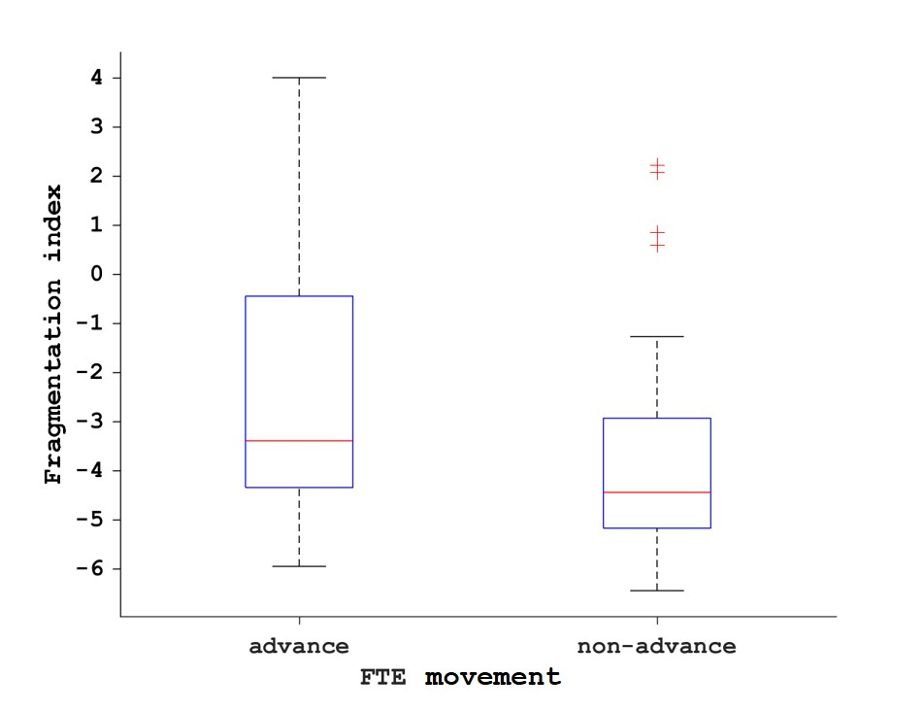
Figure 12. Boxplots: FTE movement and fragmentation in latitudinal FTE sites. The central red marks within the boxes indicate the median; the bottom and top box edges indicate the 25th and 75th percentiles, respectively; the whiskers extend to data extremes without considering outliers; the red plus symbols represent outliers.

4. Discussion
This study applies an expanded version of the FTE ‘form’ concept, i.e. a continuous measure of fragmentation, on the large-scale latitudinal FTE, and examines its relationship with FTE dynamics and continentality. This study uses two approaches of comparing different variables across the circumarctic region from 2000 to 2015. Firstly, we summarise the variables over the 16-year time period (linear fitting and averaging) in each longitudinal band and compare the summarised variables in different spatial scales (between bands, in sub-regions and across the entire continent). Secondly, we directly compare the time series of the variables. Data retrieval and pre-processing in GEE has taken a significantly shorter amount of time (time scale measured in hours) than the traditional approach of data downloading and local processing (typically several days), avoids the need for local storage of large amount of data, and further saves processing time by exporting only the meaningful portions of the landscape, i.e. the FTE windows, for local analysis. The platform also enables fast incorporation of other global datasets at similar spatial resolution, which is also very time consuming if approached traditionally. We note here that these advantages can render feasible some remote sensing tasks that would previously have been too data-intensive to be practical
The comparison between summarised variables shows that FTE movement is positively correlated with FTE fragmentation for the continents as a whole, suggesting that on a continental scale and on the MODIS VCF resolution, more fragmented FTEs have a higher tendency to shift northward. Analysis of latitudinal FTE site data supports this conclusion. The direct comparison between time series of variables produces the same finding over Eurasia, but the time series of these two variables do not significantly correlate over North America. The positive relationship between FTE fragmentation and movement is in line with the current consensus based on altitudinal FTEs, which suggests that among various FTE ‘forms’, diffuse FTEs are more likely to shift positions under the influence of climate change than FTEs that have more abrupt spatial characteristics. This is because growth limitation is dominant only at diffuse FTEs, whereas other forms are more controlled by dieback and seedling mortality (Harsch and Bader, 2011). This study is conducted at a much coarser resolution than studies of altitudinal FTEs, and demonstrates that a similar relationship exists between FTE movement and fragmentation at a circumarctic scale. In comparison to the ‘form’ approach, the continuous fragmentation index avoids arbitrariness in classifying the interface into different categories, and enables quantification of the relationship between FTE spatial characteristics to other continuous variables.
Figures 7 and 8 show values of shift rate during the MODIS VCF data period between around -0.2 to +0.2 degrees per year. These limits are around two orders of magnitude higher than typical 20th century advance rates at the northern boundary of the forest (Rees et al., 2020), but broadly consistent with climate change velocities (Loarie et al., 2009) over the same period. This suggests that variations in forest density propagate more rapidly within the forest than at its boundary.
Continentality is introduced which is representative of water availability and its modulating effect on the annual temperature range. In both continents, it correlates strongly with FTE fragmentation, and more continental areas are mostly found to have higher levels of FTE fragmentation. On the other hand, continentality shows significant positive but weak correlations with FTE movement mostly in North America, which suggests that FTEs in more continental areas are more sensitive to climate variability in terms of interface movement. Several other analyses have been conducted but not presented in full. Firstly, another FTE derivation method is used to provide reference to the segmentation method and test the reliability of the results. This method downscales the MODIS VCF image to 3km resolution (taking into account the computational time of GEE), and thresholds the downscaled image whereby pixels having VCF values between 5 and 20 are deemed to be FTE pixels. Connected FTE pixels are then grouped into objects and those that are isolated (having no neighbouring objects within a 20000 m radius) are eliminated to achieve a large-scale transition. Analyses using FTEs derived in this method yield similar results to those using FTEs derived with the segmentation method. The segmentation approach is used in this study as the primary FTE derivation method as it conforms to existing FTE derivation literatures, does not involve downscaling of the dataset, and is more optimised for the GEE platform.
Secondly, in addition to latitudinal FTE movement, the Vegetation Sensitivity Index (VSI) is calculated as another quantification of FTE dynamics. Changes in the VSI indicate increasing or decreasing vegetation abundance and is thus representative more of the potential response of the FTE. Developed by Seddon et al. (2016), this index evaluates the sensitivity of vegetation productivity to change with climate variability by calculating changes in the enhanced vegetation index (EVI) in response to air temperature, water availability and incoming solar radiation in the 2000-2013 period. The VSI is calculated for the entire land surface at 0.05° resolution using the data and algorithms provided by Seddon et al. Overall, no significant correlation is found between the VSI and FTE fragmentation in either continent. However, a strong correlation has been found between continentality and VSI in the summarised comparison, considerably more prominent than the relationship between continentality and FTE movement. Significant positive correlations also exist between continentality and VSI in eleven out of the twelve sub-regions. This suggests that FTEs in more continental areas are more sensitive, mainly in terms of changes in vegetation productivity but not interface movement, to climate variability.
A possible explanation we propose for this relationship is that FTEs in more continental regions have more restricted water supplies, and are thus more sensitive to outside forcing from climate change, the most influential of which is change in water availability (Miralles et al., 2017). Temperature variations brought by climate change directly affect vegetation growth and thus induce infilling or a reduction in biomass in the interface, and interface movement takes place after these processes where the interface has reached saturation or depletion of vegetation, thus creating a delay in response to climate change. Therefore, FTEs in regions of different continentality levels would be expected to respond differently to climate change as manifested by differences in vegetation productivity, but the difference in interface movement will be secondary and thus less pronounced.

4.1. Future work
This study investigates the relationships between FTE fragmentation, dynamics and continentality, but a thorough investigation into the possible processes behind the relationship found is still needed. Also, further examination of latitudinal FTE fragmentation derived in multiple scales and their relationship with FTE dynamics is needed with future availability of vegetation datasets based on remote sensing products that has better spatial resolution and temporal coverage. For example, Landsat provides a long time series which can be used to extract vegetation information, and in areas of available historical records of LiDAR or active microwave data e.g. RADARSAT-2, sufficient separation between forest and non-forest can be achieved with the help of these datasets, thus enabling Landsat-based application of the methodology in this study. Future improvement in vegetation dataset quality incorporated with the increasing spatial resolution of global Digital Elevation Models (DEMs) could also enable the application of the methodology to investigate altitudinal FTEs worldwide. Also, with future availability of more altitudinal FTE sites, a more thorough statistical analysis of the altitudinal FTE fragmentation-dynamics relationship can be conducted, and different indicators of FTE fragmentation can be further validated. Finally, in this study, a workflow has been established in GEE where other desired variables calculated from datasets available in GEE can be easily incorporated and compared with the existing variables.

5. Conclusions
With the help of the GEE platform, this study provides a circumarctic scale investigation of the relationship between FTE dynamics and its spatial configuration from 2000 to 2015, and shows the meaningfulness of examining the latitudinal FTE in the MODIS spatial resolution. GEE has enabled fast cloud-based data retrieval and processing which vastly expedites the analysis, and the established workflow provides scope for easy incorporation of other variables of interest with future availability of more data products in the platform. The fitted linear trend of FTE latitudes is used as the indicator of vegetation dynamics. Instead of following the FTE form categorisation scheme, this study assesses continuous FTE fragmentation using a fragmentation index developed from window spectral analysis, and several landscape fragmentation metrics are also used as references. To further investigate potential impact factors of vegetation response to climate change, continentality is introduced as an ecological variable carrying information about water availability as influenced by proximity to the sea, and is compared with the rest of the variables. More fragmented FTEs are found more likely to shift northward with climate change, a phenomenon that is more pronounced in Eurasia. FTEs in more continental areas are mostly more fragmented, and also experience more pronounced changes in vegetation productivity with outside forcing. These empirical relationships found between different variables and their future improvements provide the possibility to map the gradient of FTE dynamics in response to climate change inferred by different degrees of interface fragmentation, and can potentially provide constraint for process-based models and thus help with future projections of climatic influences on vegetation, and also help to benchmark representation of vegetation sensitivity in climate models and thus improve model accuracy.

Acknowledgement
W.G. acknowledges financial support by the Cambridge Trust, Trinity and Fitzwilliam colleges, University of Cambridge.

References
Achanta, R. et al. (2012) ‘SLIC superpixels compared to state-of-the-art superpixel methods’, IEEE transactions on pattern analysis and machine intelligence. IEEE, 34(11), pp. 2274–2282.
Achanta, R. and Süsstrunk, S. (2017) ‘Superpixels and polygons using simple non-iterative clustering’, Proceedings - 30th IEEE Conference on Computer Vision and Pattern Recognition, CVPR 2017, 2017-Janua(Ic), pp. 4895–4904. doi: 10.1109/CVPR.2017.520.
Camarero, J. J. et al. (2017) ‘Back to the Future: The Responses of Alpine Treelines to Climate Warming are Constrained by the Current Ecotone Structure’, Ecosystems. doi: 10.1007/s10021-016-0046-3.
Campos-Taberner, M. et al. (2018) ‘Global estimation of biophysical variables from Google Earth Engine platform’, Remote Sensing, 10(8), pp. 1–17. doi: 10.3390/rs10081167.
Conrad, V. (1946) Methods in climatology. Harvard University Press.
Couteron, P., Barbier, N. and Gautier, D. (2006) ‘Textural ordination based on fourier spectral decomposition: A method to analyze and compare landscape patterns’, Landscape Ecology, 21(4), pp. 555–567. doi: 10.1007/s10980-005-2166-6.
Crawford, R. M. M. (1997) ‘Oceanicity and the ecological disadvantages of warm winters’, Botanical Journal of Scotland, 49(2), pp. 205–221. doi: 10.1080/03746609708684867.
Crawford, R. M. M. (2008) Plants at the margin: ecological limits and climate change. Cambridge University Press.
Crawford, R. M. M., Jeffree, C. E. and Rees, W. G. (2003) ‘Paludification and Forest Retreat in Northern Oceanic Environments’, Annals of Botany, 91(2), pp. 213–226. doi: 10.1093/aob/mcf185.
Cross, A. and Settle, J. (1991) ‘Subpixel measurement of tropical forest cover using AVHRR data’, International Journal of Remote Sensing, 12(5), pp. 1119–1129. doi: 10.1080/01431169108929715.
DiMiceli, C. M. et al. (2011) MODIS Vegetation Continuous Fields, Global Land Cover Facility. Available at: http://glcf.umd.edu/data/vcf/description.shtml.
Dong, J. et al. (2016) ‘Mapping paddy rice planting area in northeastern Asia with Landsat 8 images, phenology-based algorithm and Google Earth Engine’, Remote sensing of environment. Elsevier, 185, pp. 142–154.
Epstein, H. E., Myers-Smith, I. and Walker, D. a (2013) ‘Recent dynamics of arctic and sub-arctic vegetation’, Environmental Research Letters, 8(1), p. 015040. doi: 10.1088/1748-9326/8/1/015040.
Farda, N. M. (2017) ‘Multi-temporal land use mapping of coastal wetlands area using machine learning in Google earth engine’, in IOP Conference Series: Earth and Environmental Science. IOP Publishing, p. 12042.
Gorelick, N. et al. (2017) ‘Google Earth Engine: Planetary-scale geospatial analysis for everyone’, Remote Sensing of Environment. The Author(s), 202, pp. 18–27. doi: 10.1016/j.rse.2017.06.031.
Guo, W. and Rees, W. G. (2019) ‘Altitudinal forest-tundra ecotone categorization using texture-based classification’, Remote Sensing of Environment. Elsevier, 232, p. 111312. doi: 10.1016/j.rse.2019.111312.
Haddad, N. M. et al. (2015) ‘Habitat fragmentation and its lasting impact on Earth’s ecosystems’, Science Advances. doi: 10.1126/sciadv.1500052.
Harsch, M. A. et al. (2009) ‘Are treelines advancing? A global meta-analysis of treeline response to climate warming’, Ecology Letters, 12(10), pp. 1040–1049. doi: 10.1111/j.1461-0248.2009.01355.x.
Harsch, M. A. and Bader, M. Y. (2011) ‘Treeline form - a potential key to understanding treeline dynamics’, Global Ecology and Biogeography, 20(4), pp. 582–596. doi: 10.1111/j.1466-8238.2010.00622.x.
He, H. S., DeZonia, B. E. and Mladenoff, D. J. (2000) ‘An aggregation index (AI) to quantify spatial patterns of landscapes’, Landscape Ecology. Springer, 15(7), pp. 591–601.
Heiskanen, J. and Kivinen, S. (2008) ‘Assessment of multispectral, -temporal and -angular MODIS data for tree cover mapping in the tundra-taiga transition zone’, Remote Sensing of Environment, 112(5), pp. 2367–2380. doi: 10.1016/j.rse.2007.11.002.
Hird, J. et al. (2017) ‘Google Earth Engine, open-access satellite data, and machine learning in support of large-area probabilistic wetland mapping’, Remote Sensing. Multidisciplinary Digital Publishing Institute, 9(12), p. 1315.
Holtmeier, K. (2010) ‘Altitudinal and polar treelines in the northern hemisphere Causes and response to climate change’, Polarforschung, 79(September 2009), pp. 139–153.
Jaeger, J. A. G. (2000) ‘Landscape division, splitting index, and effective mesh size: new measures of landscape fragmentation’, Landscape ecology. Springer, 15(2), pp. 115–130.
Johansen, K., Phinn, S. and Taylor, M. (2015) ‘Mapping woody vegetation clearing in Queensland, Australia from Landsat imagery using the Google Earth Engine’, Remote Sensing Applications: Society and Environment. Elsevier, 1, pp. 36–49.
Kremenetski, C. V, Sulerzhitsky, L. D. and Hantemirov, R. (1998) ‘Holocene history of the northern range limits of some trees and shrubs in Russia’, Arctic Alpine Research, 30(4), pp. 317–333.
Lemoine, G. and Léo, O. (2015) ‘Crop mapping applications at scale: Using Google Earth Engine to enable global crop area and status monitoring using free and open data sources’, in 2015 IEEE International Geoscience and Remote Sensing Symposium (IGARSS). IEEE, pp. 1496–1499.
Li, H. and Reynolds, J. F. (1993) ‘A new contagion index to quantify spatial patterns of landscapes’, Landscape Ecology, 8(3), pp. 155–162. doi: 10.1007/BF00125347.
Loarie, S. R. et al. (2009) ‘The velocity of climate change.’, Nature. Nature Publishing Group, 462(7276), pp. 1052–1055. doi: 10.1038/nature08649.
Mayaux, P. and Lambin, E. F. (1997) ‘Tropical forest area measured from global land-cover classifications: Inverse calibration models based on spatial textures’, Remote Sensing of Environment, 59(96), pp. 29–43. doi: 10.1016/S0034-4257(96)00077-6.
McGarigal, K., Cushman, S. and Ene, E. (2012) ‘FRAGSTATS v4: Spatial Pattern Analysis Program for Categorical and Continuous Maps’. Computer software program produced by the authors at the University of Massachusetts, Amherst. Available at: http://www.umass.edu/landeco/research/fragstats/fragstats.html.
Miralles, D. G. et al. (2017) ‘A non-linear data-driven approach to reveal global vegetation sensitivity to climate’, 2017 9th International Workshop on the Analysis of Multitemporal Remote Sensing Images, MultiTemp 2017, pp. 4–6. doi: 10.1109/Multi-Temp.2017.8035198.
Montesano, P. M. et al. (2009) ‘MODIS tree cover validation for the circumpolar taiga–tundra transition zone’, Remote Sensing of Environment, 113(10), pp. 2130–2141. doi: 10.1016/j.rse.2009.05.021.
O’Neill, R. V. et al. (1988) ‘Indices of landscape pattern’, Landscape Ecology, 1(3), pp. 153–162. doi: 10.1007/BF00162741.
Quetin, G. R. and Swann, A. L. S. (2017) ‘Empirically derived sensitivity of vegetation to climate across global gradients of temperature and precipitation’, Journal of Climate, 30(15), pp. 5835–5849. doi: 10.1175/JCLI-D-16-0829.1.
Ranson, K. J., Montesano, P. M. and Nelson, R. (2011) ‘Object-based mapping of the circumpolar taiga–tundra ecotone with MODIS tree cover’, Remote Sensing of Environment. Elsevier B.V., 115(12), pp. 3670–3680. doi: 10.1016/j.rse.2011.09.006.
Rees, G. et al. (2002) ‘How Can the Dynamics of the Tundra-Taiga Boundary Be Remotely Monitored?’, Ambio Special Report. Springer on behalf of Royal Swedish Academy of Sciences, (12), pp. 56–62. doi: 10.2307/25094576.
Rees, W. G. et al. (2020) ‘Is subarctic forest advance able to keep pace with climate change?’, Global Change Biology. Blackwell Publishing Ltd, 26(7), pp. 3965–3977. doi: 10.1111/gcb.15113.
Renshaw, E. and Ford, E. D. (1983) ‘The Interpretation of Process from Pattern Using Two-Dimensional Spectral Analysis : Methods and Problems of Interpretation’, Journal of the Royal Statistical Society. Series C (Applied Statistics), 32(1), pp. 51–63.
Ropars, P. and Boudreau, S. (2012) ‘Shrub expansion at the forest–tundra ecotone: spatial heterogeneity linked to local topography’, Environmental Research Letters, 7(1), p. 015501. doi: 10.1088/1748-9326/7/1/015501.
Rundqvist, S. et al. (2011) ‘Tree and Shrub Expansion Over the Past 34 Years at the Tree-Line Near Abisko, Sweden’, Ambio, 40(6), pp. 683–692. doi: 10.1007/s13280-011-0174-0.
Schumaker, N. H. (1996) ‘Using landscape indices to predict habitat connectivity’, Ecology. Wiley Online Library, 77(4), pp. 1210–1225.
Seddon, A. W. R. et al. (2016) ‘Sensitivity of global terrestrial ecosystems to climate variability’, Nature. Nature Publishing Group, 531(7593), pp. 229–232. doi: 10.1038/nature16986.
Sexton, J. O. et al. (2013) ‘Global, 30-m resolution continuous fields of tree cover: Landsat-based rescaling of MODIS vegetation continuous fields with lidar-based estimates of error’, International Journal of Digital Earth, 6(5), pp. 427–448. doi: 10.1080/17538947.2013.786146.
Stow, D. A. et al. (2004) ‘Remote sensing of vegetation and land-cover change in Arctic Tundra Ecosystems’, Remote Sensing of Environment, 89, pp. 281–308. doi: 10.1016/j.rse.2003.10.018.
Sveinbjörnsson, B., Hofgaard, A. and Lloyd, A. (2002) ‘Natural causes of the tundra-taiga boundary.’, Ambio Special Report, (12), pp. 23–29. doi: 10.2307/25094572.
Teluguntla, P. et al. (2018) ‘A 30-m landsat-derived cropland extent product of Australia and China using random forest machine learning algorithm on Google Earth Engine cloud computing platform’, ISPRS journal of photogrammetry and remote sensing. Elsevier, 144, pp. 325–340.
Tottrup, C. et al. (2007) ‘Mapping fractional forest cover across the highlands of mainland Southeast Asia using MODIS data and regression tree modelling’, International Journal of Remote Sensing. Taylor & Francis, 28(1), pp. 23–46.
Townsend, J. et al. (2011) User Guide for the MODIS Vegetation Continuous Fields product Collection 5 version 1.
Trani, M. K. and Giles Jr, R. H. (1999) ‘An analysis of deforestation: metrics used to describe pattern change’, Forest Ecology and Management. Elsevier, 114(2–3), pp. 459–470.
Verbyla, D. (2008) ‘The greening and browning of Alaska based on 1982–2003 satellite data’, Global Ecology and Biogeography, 17(4), pp. 547–555. doi: 10.1111/j.1466-8238.2008.00396.x.
Walker, D. a et al. (2005) ‘The Circumpolar Arctic vegetation map’, Journal of Vegetation Science, (16), pp. 267–282. doi: 10.1658/1100-9233(2005)016[0267:TCAVM]2.0.CO;2.
Wei, C. and Wilson, A. (2018) ‘Spatio-temporal Detection and Analyses of Shifting Vegetative Boundaries in Alpine Treeline Ecotones in the Western United States’, in AGU Fall Meeting Abstracts.
Wilson, C. H. et al. (2017) ‘Multi-decadal time series of remotely sensed vegetation improves prediction of soil carbon in a subtropical grassland’, Ecological applications : a publication of the Ecological Society of America, 27(5).
Xiong, J. et al. (2017) ‘Automated cropland mapping of continental Africa using Google Earth Engine cloud computing’, ISPRS Journal of Photogrammetry and Remote Sensing. Elsevier, 126, pp. 225–244.
Zhu, Z. and Evans, D. L. (1994) ‘US forest types and predicted percent forest cover from AVHRR data’, Photogrammetric engineering and remote sensing, 60(5).

