Far and Wide: Associations between childhood socio-economic status and brain connectomics
Abstract
Previous studies have identified localized associations between childhood environment – namely their socio-economic status (SES) – and particular neural structures. The primary aim of the current study was to test whether associations between SES and brain structure are widespread or limited to specific neural pathways. We employed advances in whole-brain structural connectomics to address this. Diffusion tensor imaging was used to construct whole-brain connectomes in 113 6-12 year olds. We then applied an adapted multi-block partial-least squares (PLS) regression to explore how connectome organisation is associated with childhood SES (parental income, education levels, and neighbourhood deprivation). The Fractional Anisotropy (FA) connectome was significantly associated with childhood SES and this effect was widespread. We then pursued a secondary aim, and demonstrated that the connectome mediated the relationship between SES and cognitive ability (matrix reasoning and vocabulary). However, the connectome did not significantly mediate SES relationships with academic ability (maths and reading) or internalising and externalising behavior. This multivariate approach is important for advancing our theoretical understanding of how brain development may be shaped by childhood environment, and the role that it plays in predicting key outcomes. We also discuss the limitations with this new methodological approach.

Introduction
Structural brain connectivity changes profoundly from birth to early adulthood (e.g. see Barnea-Goraly et al., 2005; Muftuler et al., 2012; Vértes and Bullmore, 2015). These changes in structural connectivity enhance the efficiency of information exchange across large anatomical distances, something thought crucial for developmental changes in higher order cognitive abilities like fluid reasoning, behavioral regulation (e.g. internalising and externalising behaviors) and educational progress, like learning to read and mathematics (Tau & Peterson, 2010). Fractional Anisotropy (FA) is one way of measuring the integrity of white matter, a key component in changes in structural brain connectivity. FA increases in widespread regions across the brain during childhood and adolescence (Giorgio et al., 2010; Lebel, Treit, & Beaulieu, 2017; Snook, Paulson, Roy, Phillips, & Beaulieu, 2005), with substantial individual variation (Fields, 2008; Johansen-Berg, 2010; Scholz, Tomassini, & Johansen-Berg, 2009), and differences in FA development are associated with a range of developmental markers such as reading (de Moura et al., 2016; Deutsch et al., 2005; Klingberg et al., 2000; Qiu, Tan, Zhou, & Khong, 2008; Vandermosten, Boets, Wouters, & Ghesquière, 2012), maths (Bathelt, Scerif, Nobre, & Astle, 2019; Matejko & Ansari, 2015; Tsang, Dougherty, Deutsch, Wandell, & Ben-Shachar, 2009) and behavioral difficulties (Loe, Lee, & Feldman, 2013; Muetzel et al., 2018; Waller, Dotterer, Murray, Maxwell, & Hyde, 2017).
But what drives these individual differences in FA? The childhood environment is likely to have a profound effect on neural development (Brito and Noble, 2014; Hackman and Farah, 2009; Johnson et al., 2016; Lipina and Evers, 2017; Lipina and Posner, 2012; Ursache and Noble, 2016). There is some evidence that heritability of FA appears to decrease with age, in contrast to white matter volume which tends to have stable high heritability across development (Chiang et al., 2011; Douet, Chang, Cloak, & Ernst, 2014; Richmond, Johnson, Seal, Allen, & Whittle, 2016). In adulthood, socioeconomic status (SES, e.g. income, education or occupation) is significantly associated with FA in multiple regions across the brain (Gianaros, Marsland, Sheu, Erickson, & Verstynen, 2013; Noble, Korgaonkar, Grieve, & Brickman, 2013). These differences emerge in childhood: parental SES is positively associated with FA in a number of tracts across the child brain (Dufford & Kim, 2017; Gullick, Demir-Lira, & Booth, 2016), and in particular within frontal and parietal cortices (Ursache & Noble, 2016). In the study by Gullick et al., 32 7-11 year old children using tract based spatial statistics (TBSS), FA was positively associated with parental SES in clusters across the brain: the left corticospinal tract, right anterior inferior, fronto-occipital fasciculus, left superior longitudinal fasciculus and left temporal inferior longitudinal fasciculus (Gullick et al., 2016). Similar results were found in an another TBSS analysis by Dufford and Kim of 27 8-10 year old children, in which higher FA in the uncinate fasciculus, cingulum bundle, inferior longitudinal fasciculus, superior longitudinal fasciculus, and corticospinal tracts was found to significantly related to parent income (Dufford & Kim, 2017).
However, these studies have primarily focussed on the relationship between the environment and localized FA differences using univariate analyses in which signals from the brain are analysed voxel by voxel, such as comparisons between specific regions of interest (ROIs) or TBSS (for a review and critique of this approach, see Raizada and Kishiyama, 2010). These studies have been vital in demonstrating the associations between individual differences in connectivity and the childhood environment. The focus has been on regions or connections known to play a key functional role in particular behavioral or cognitive processes in adulthood. However, because of this focus on a voxel-wise approach, it remains unclear whether environmental associations are specific or whether there is a more generalized, widespread association between brain structure and the environment. Indeed, given that the brain is organized into highly connected distributed networks (Cao et al., 2014; Fair et al., 2009; Richmond et al., 2016) it is likely that the impact of childhood environment will not be isolated to particular localized brain areas or circuits (Raizada & Kishiyama, 2010; Richmond et al., 2016). For example, Smith et al. demonstrated a widespread association between functional connectivity and 280 environmental, behavioral and demographic (including multiple SES measures, like income) variables in the adult connectome (Smith et al., 2015). And Kim et al. (2019) showed that connectome efficiency across a wide range of regions was significantly associated with income-needs ratio, in girls aged 6-11 years.
This backdrop motivated the conceptual rationale for our study. To complement the localist approach within the field to-date, we adopted a systems neuroscience approach, by creating whole-brain structural connectomes. Voxel-wise methods rely on spatially overlapping associations between FA and other variables across children. This approach is primarily designed to identify focal and consistent differences across individuals, but will likely underestimate the contribution of whole-brain network structure (Bathelt, Gathercole, Butterfield, CALM team, & Astle, 2018). For example, Bathelt et al. contrasted the global organization established using the FA connectome, versus that identified using a voxel-wise FA skeleton (TBSS) in children. They found that TBSS was far less sensitive to academic development (Measured using the Word Reading and Numerical Operations tasks from the Wechsler Individual Achievement Test 2nd edition UK) than the connectome method (Bathelt et al., 2018). This is because FA differences must necessarily overlap across children to yield significant voxel-wise effects, whereas a connectome captures effects that may be spatially variable across children, but which nonetheless have a consistent impact on organisation within different regions or globally.
The current study has two aims. Firstly, to establish whether the relationship between childhood SES and neural connectivity is specifically localized or widespread, using whole-brain structural connectomics (Hagmann et al., 2007; Zalesky, Fornito, & Bullmore, 2010). Next, given that key childhood outcomes such as higher-order cognition, academic ability and behavior rely on efficient communication across distributed brain networks (Pugh et al., 2001; Tau & Peterson, 2010), the FA connectome has the potential to explain why childhood SES is significantly associated with these outcomes (Gullick et al., 2016; Noble et al., 2013). Accordingly, the study’s second aim is to investigate whether the FA connectome provides a mediating pathway between a childhood SES and differences in cognitive ability (matrix reasoning and vocabulary), academic attainment (reading and maths) and behavior (externalising and internalising behaviors). These questions are critical to advancing our theoretical understanding of how and why the environment is important for child development.
Capturing complex associations between aspects of childhood SES, the structural connectome, and child outcomes presents key challenges such as high dimensionality, multicollinearity and bridging multiple different data types. PLS methods (Wold, 1975, 2004), are particularly suited to this context. We applied PLS techniques (McIntosh & Lobaugh, 2004) using the Regularized Generalized Canonical Correlation Analysis (RGCCA) framework (Tenenhaus & Tenenhaus, 2011, 2014) to investigate the associations between childhood SES, the structural connectome and child outcomes, namely general cognitive ability (matrix reasoning and vocabulary), reading and maths, and internalising and externalising behaviors. The following questions were addressed: 1) Is the structural connectome significantly related to a childhood SES (including income, education and neighbourhood deprivation)? 2) Does the structural connectome mediate the relationship between childhood SES, and cognition, academic ability or behavior?

Methods

Participants
Data were collected from 6-12 year olds living in the East of England in the UK. All children took part in academic and cognitive assessments on a one to one basis with a researcher over three hours. Their primary caregiver completed questionnaires about the behavior of their child and their SES. Children took part in a 20 minute structural magnetic resonance imaging (MRI) scan during which Diffusion Tensor Images (DTI) and T1-weighted images were acquired. It was not a requirement for recruitment, but all children were native English speakers.
Given that recruitment of participants often suffers from a bias towards higher SES families (Fry et al., 2017; Henrich, Heine, & Norenzayan, 2010; Sakshaug, Schmucker, Kreuter, Couper, & Singer, 2016; Wolke et al., 2009), particular care was taken to ensure the sample was reflective of the spread of SES in the UK. Participants were primarily recruited through schools that have over 27% of students receiving free school meals (FSM). Flyers and posters were sent to all Sure Start Children’s Centres in Cambridge City and South Cambridgeshire and to houses, GP’s and library’s in areas across Cambridge City that have the highest percentage of children living under the poverty line. Parents could contact the research team by email, phone or by returning an expression of interest form. Each family was reimbursed for their time. Parents provided written informed consent and the study protocol was approved by the Psychology Research Ethics Committee at the University of Cambridge (references: PRE.2015.11 and PRE.2017.102).
We initially recruited and tested 134 children in total. Twenty one DTI scans were excluded due to large movement (maximum displacement above 3mm in the DTI sequence, as calculated by FSL Eddy). The end result was 113 useable datasets for the main analysis. Their mean age was 9.3 years (±1.4 SD years, range: 6.9-12.8 years), 55 were boys and 58 were girls, and 87% of the sample were right-handed. Their mean equivalised income (income adjusted for household size, Anyaegbu, 2010) was £29,277 (±£16,034 SD, range: £3,750 to £75,000). The UK poverty line is defined as 60% of median income, (the median income was £29,060 when most data were collected). Accordingly, we estimate that 32% of the sample were living below the poverty line when tested. Overall, 84% of our sample were White, with 15% of the sample made up of Asian/Asian British and Black/African/Caribbean/Black British. The proportion of ethnic minority families in the sample is slightly higher than would be expected for Cambridgeshire, which is over 90% White (https://cambridgeshireinsight.org.uk/population/).

The Structural Connectome
Magnetic resonance imaging data were acquired at the MRC Cognition and Brain Sciences Unit, Cambridge UK. All scans were obtained on the Siemens 3 T Prisma-fit system (Siemens Healthcare, Erlangen, Germany), using a 32-channel quadrature head coil. T1-weighted volume scans were acquired using a whole brain coverage 3D Magnetization Prepared Rapid Acquisition Gradient Echo (MP-RAGE) sequence acquired using 1 mm isometric image resolution. Echo time was 2.98 ms, and repetition time was 2250 ms. Diffusion scans were acquired using echo-planar diffusion-weighted images with an isotropic set of 68 non-collinear directions, using a weighting factor of b = 1000s*mm-2, inter-leaved with 4 T2-weighted (b = 0) volumes. Whole brain coverage was obtained with 60 contiguous axial slices and isometric image resolution of 2 mm. Echo time was 90 ms and repetition time was 8500 ms. Children watched a film of their choice whilst undergoing the 20-minute MRI scan. The white-matter DTI connectome was constructed by estimating the most probable white matter connections for each participant and then constructing connectivity matrices from the average Fractional Anisotropy (FA) between each pair of brain regions.
An overview of the pre-processing steps is given in Figure 1. Raw MRI scans were first converted from DICOM to compressed NIfTI-1 format using the dcm2niitool (http://www.mccauslandcenter.sc.edu/mricro/mricron/dcm2nii.html). The $b_{0}$-weighted volume of the DTI images was used to create a brain mask and all volumes were corrected for movement and eddy currents using FSL’s eddy tool. Following this, nonlocal means denoising (Coupe et al., 2008) was used to improve the signal-to-noise ratio using the Diffusion Imaging in Python (DiPy) v0.11 package (Garyfallidis et al., 2014). Fractional Anisotropy maps were derived for each participant by fitting the diffusion tensor model using dtifit from the FMRIB Software Library (FSL) v.5.0.6 (Behrens et al., 2003). DiPy was then used to fit a spherical constrained deconvolution (CSD) (Tournier et al., 2008) model to the 60-gradient direction DTI images using a maximum harmonic order of 8. Subsequently, probabilistic whole-brain tractography was applied to this CSD model using 8 seeds in any voxel that had a General FA value greater than 0.2, step size equal to 0.5 and with no more than 2 crossing fibres allowed per voxel.
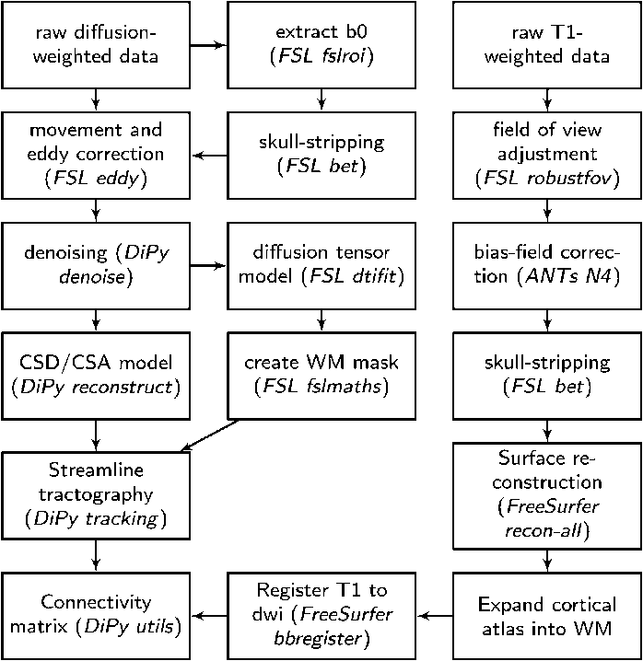
Figure 1: Overview of the pre-processing steps used to derive the DTI connectome. Reprinted with permission from ‘Whole-brain white matter organization, intelligence, and educational attainment’ by Bathelt et al., 2019.
The T1-weighted images were used to define the brain regions. The images were first pre-processed by adjusting the field of view using FSL’s robustfov function and denoised using nonlocal means denoising in DiPy. A robust brain mask was extracted using the brain extraction algorithm of the Advanced Normalization Tools (ANTs) v1.9 package (Avants, Tustison, & Johnson, 2009). The images were then submitted to the recon-all pipeline in FreeSurfer v5.3 (http://surfer.nmr.mgh.harvard.edu). 85 ROI’s were extracted using the Desikan-Killiany parcellation of the MNI template (Desikan et al., 2006). 34 regions were extracted for each hemisphere and 17 subcortical regions (brain stem, and bilateral cerebellum, thalamus, caudate, putamen, pallidum, hippocampus, amygdala, nucleus accumbens). The aparc2aseg tool in FreeSurfer was used to convert the surface parcellation of the cortex to a volume parcellation. The cortical parcellation was then expanded by 2 mm into the subcortical white matter to ensure that the tracts would intersect the ROIs. Finally, the parcellation was transformed into DTI space using a transformation based on the T1-weighted volume and the b0-weighted image of the diffusion sequence calculated using FreeSurfer’s bbregister.
FA-weighted connection matrices were created for each participant using the FA values across the streamlines from the CSD model that connected each pair of ROIs. The corresponding element in the connection matrix for each pair of ROIs was either set to zero if no streamlines intersected both ROIs, or to the average FA of the streamlines intersecting both ROIs. In order to remove spurious connections, a common problem in connectome studies, the matrices were first thresholded using consensus thresholding, ensuring that only connections that are found in over 60% of the sample are retained (de Reus & van den Heuvel, 2013). This resulted in 290 non-zero FA weighted connections between brain ROIs (see Figure 2). Finally, the matrices for each subject were reshaped into a single vector and combined across subjects, resulting in a 290 X 113 dataset in which each column represents the FA between each pair of regions for each of the 113 participants.
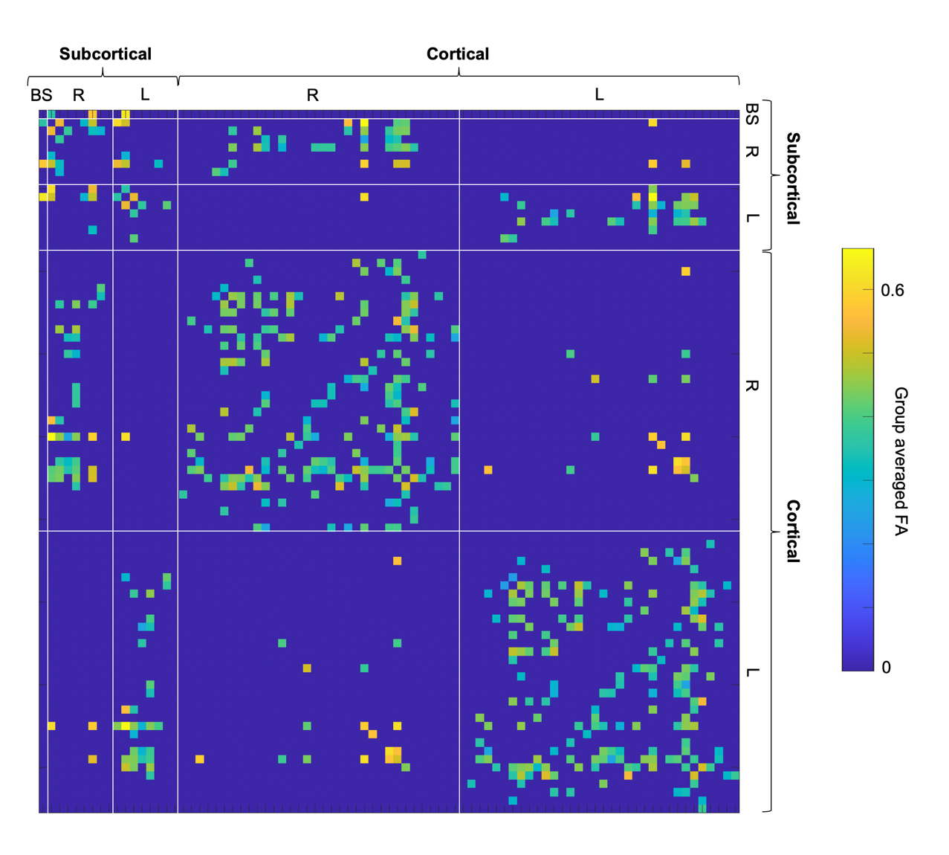
Figure 2: Group-average connectome matrix indicating the ROI-by-ROI FA weighted connections, after 60% consensus thresholding. The ROIs are grouped cortical versus subcortical and hemisphere (L= left hemisphere, R= right hemisphere, BS = brain stem (bilateral)).

Childhood outcomes
Cognitive ability was measured using the Vocabulary and Matrix Reasoning subtests from the Wechsler Abbreviated Scale of Intelligence II (WASI-II) (Wechsler, 2011). We used the raw scores and incorporated age in the PLS analysis.
Academic ability was measured using reading and maths fluency subtests from the Woodcock Johnson III Form B Tests of Achievement (WJ III ACH )(McGrew, Woodcock, & Schrank, 2007; Woodcock, McGrew, & Mather, 2001). Raw scores were used, and age was incorporated in the PLS analysis.
Behavioral problems were measured using the Strengths and Difficulties Questionnaire (SDQ) (Goodman, 1997) completed by the primary caregiver. The SDQ has five subscales relating to externalising and internalising behavior (hyperactivity, emotional symptoms, conduct problems, peer problems and prosocial behavior), which were included in the PLS analysis as individual scales.

Socio-economic Status
We used three validated measures of SES. This included traditional measures of SES: caregiver income (net household equivalised income using the modified OECD equivalence scale, Anyaegbu, 2010), average highest level of education for the caregivers (seven point scale based on the Hollingshead four-factor index of SES, Hollingshead 1975) and a measure of neighbourhood SES (including average income, employment, education, health, crime, barriers to housing and services and living environment across their postcode), assessed using the Income Deprivation Affecting Children Index (IDACI, Office for National Statistics, 2015). This final measure is derived from large-scale national administrative data based upon the family’s postcode (i.e. which street they live on).

Partial Least Squares
PLS was used to identify the set of FA connections that most strongly covaried with childhood SES. PLS is ideally suited to summarising the complex relationships between connectomes and other datasets (e.g. SES measures), owing to the large number of variables in connectomes, which are often multicollinear. PLS is in essence a data reduction technique, not unlike a Principal Components Analysis (PCA). But instead of deriving latent factors within each dataset separately, it finds a set of orthogonal latent variables for each dataset that maximally explain the covariance between the datasets (Wold, 1975, 1982). That is, it establishes whether there is a relationship between two or more datasets and identifies the sets of measures that best model this relationship (e.g. SES measures and edges in an FA connectome). Furthermore, when PLS is applied using a slight adjustment to Wold’s original algorithm ( RGCCA with new Mode A, see Tenenhaus & Tenenhaus, 2011, 2014), the weights identified for each individual measure (known as outer weights) are proportional to the sum covariance between this measure and each of the latent variables for the other datasets (Tenenhaus & Tenenhaus, 2011, 2014). This means that we can use the outer weights to identify the SES measures and structural connections that most strongly relate to each other. There are a growing number of applications of this statistical approach. For example, it has been used to establish the relationship between brain structure across 308 regions and the cortical expression profiles of 20,737 genes (Whitaker et al., 2016).
The ‘PLS’ function from the MixOmics Package (Rohart, Gautier, Singh, & Lê Cao, 2017) and a series of in-house scripts developed for this project in R were used to apply 2-Block Canonical PLS (RGCCA with new Mode A and Horst’s scheme function) to investigate the relationships between the socio-economic measures and the structural connectome (these scripts can be found at https://github.com/ajohnson62). The three SES measures and the connectome data were used as the two data blocks respectively and each variable was standardized (with a mean of zero and standard deviation of one). The significance of each pair of latent variables extracted was tested using permutation (N= 1000), whilst controlling for age and residual head motion, defined as maximum frame-wise displacement. Bootstrapping was used to assess the reliability of each outer weight (N = 1000 with replacement). Procrustes rotation was applied to the imputed outer weights to account for the sign flipping (Bastien, 2008). We then used the bootstrapped weightings to construct 95% confidence intervals. Loadings with bootstrapped confidence intervals not passing zero were considered to load significantly onto the latent variables.
3-block Canonical PLS was implemented using the ‘block.pls’ function from the MixOmics Package and in-house scripts in order to investigate whether the structural connectome partially mediates the association between SES and cognitive, academic and behavioral outcomes in children. The three SES measures, the connectome data and either the cognitive, academic or behavioral datasets were used as the three data blocks respectively and each variable was standardized. The significance of the indirect effect and the reliability of the outer weights and path coefficients were tested using 3000 bootstrap samples with replacement (Taylor & MacKinnon, 2012). 95% confidence intervals were found for the distribution of the indirect effects from the bootstrap samples (Nitzl, Roldan, & Cepeda, 2016). If the upper and lower confidence intervals did not include zero between them, the structural connectome was considered to (partially) mediate the relationship between SES and the outcomes.

Results

Descriptive analysis
Prior to our main analyses we calculated some descriptive statistics for our measures. These can be seen in Table 1.

 |  | Mean | STD | Skewness | Kurtosis
SES
 | Equivalised Income | 29277 | 16034 | 0.77 | 2.61
 | IDACI | 17290 | 8458 | 0.17 | 2.14
 | Parental Education | 4.70 | 1.54 | 0.11 | 1.81
Cognition
 | Vocabulary | 31.37 | 7.94 | -0.76 | 3.84
 | Matrix Reasoning | 18.95 | 6.44 | 1.12 | 6.16
Academic Ability
 | Reading | 47.52 | 16.90 | 0.29 | 2.99
 | Maths | 45.48 | 19.95 | 1.06 | 4.04
Behavior
 | Emotional Problems | 2.50 | 2.51 | 0.80 | 2.59
 | Conduct Problems | 1.63 | 1.83 | 1.53 | 5.57
 | Hyperactivity | 3.76 | 2.78 | 0.46 | 2.41
 | Peer Problems | 1.77 | 1.86 | 1.19 | 3.80
 | Prosocial Behaviors | 8.43 | 2.01 | -1.57 | 5.21

Table 1: Descriptive statistics for the main SES, cognitive (WASI Vocabulary and Matrix Reasoning), Academic Ability (WJ-III Reading and Maths Fluency) and Behavior (SDQ)
We also checked that none of these measures varied significantly with head motion (defined as maximum displacement, using FSL Eddy). For each domain we calculated the mean score (except for the SES measures where we took the first PC from a PCA, because the scales for the individual measures are in different units). None of these correlated with head motion: SES: r=0.01, p=0.89; cognition r=0.09, p=0.35: academic ability r=-0.05, p=0.61: behavior r=7.6452e-04, p=0.99: We also tested that childhood SES was not significantly correlated with age (r=-0.13, p=0.15). Nonetheless, in the subsequent PLS analysis we partialled out age and head motion.

Age effects in the structural connectome
Before we proceeded with addressing our two main questions, we first tested for significant developmental changes within the structural connectome. This was done by simply applying a general linear model, with age as the predictor and edge strength as the response. This was looped over all 290 edges, revealing that 27.28% of the edges were significantly associated with age if an uncorrected (p<0.05) threshold is used. However none of these survive a family-wise error correction for multiple comparisons. Nonetheless, in all subsequent analyses age was controlled for by partialling it out of the latent factors identified in the PLS analyses.

Childhood SES and the structural connectome
The relationship between the three SES measures (equivalised income, IDACI and parental education) and the structural connectome dataset was significant for the first component from the PLS (i.e. the first latent variables for each dataset, that best explain the covariance between datasets). The correlation between the first pair of latent variables from each dataset was r=0.772, p=8.4405e-23, p(permuted)=0.037. This explained 67.15% of the covariance between the datasets. Subsequent components did not survive the permutation testing procedure.
Bootstrapping determined the outer weights for the individual measures that load significantly onto this pair of latent components. Note that the higher the outer weight, the stronger the relationship between this individual measure and the other dataset (for example, the connectome edges with the highest outer weights indicate the connections most strongly associated with SES). The edges from the structural connectome that were reliably non-zero can be seen in Figure 3, in total they are just under 24% of the possible connections in our thresholded connectome, and are all positively associated with the SES latent variable. The outer weights for all the SES measures were non-zero (equivalised income: 1.97, 95% CI [1.89,2.05]; IDACI: 1.92, 95% CI [1.88,2.18]; and parental education: 2.33, 95% CI [2.10,2.49]. It was entirely possible that we would identify multiple PLS components, each explaining unique variance in the structural connectome, and with each SES measure loading onto a different component. But instead we see a single latent component, upon which all three SES measures load significantly. This implies that we are capturing their shared variance.
The brain connections identified by the PLS are widespread across the brain (Figure 3). In general, these were longer-range connections between different lobes rather than within a lobe. Connections radiating from the parietal and temporal lobes were particularly strongly associated with SES, with connections to the frontal, occipital, cingulate cortices and subcortical areas. There are also temporo-parietal connections and connections between the left and right cingulum and left and right subcortical regions that were strongly associated with childhood SES. These data are also plotted as a network diagram in Figure 4, where readers will be able to see the specific regions and connections associated with SES more clearly.
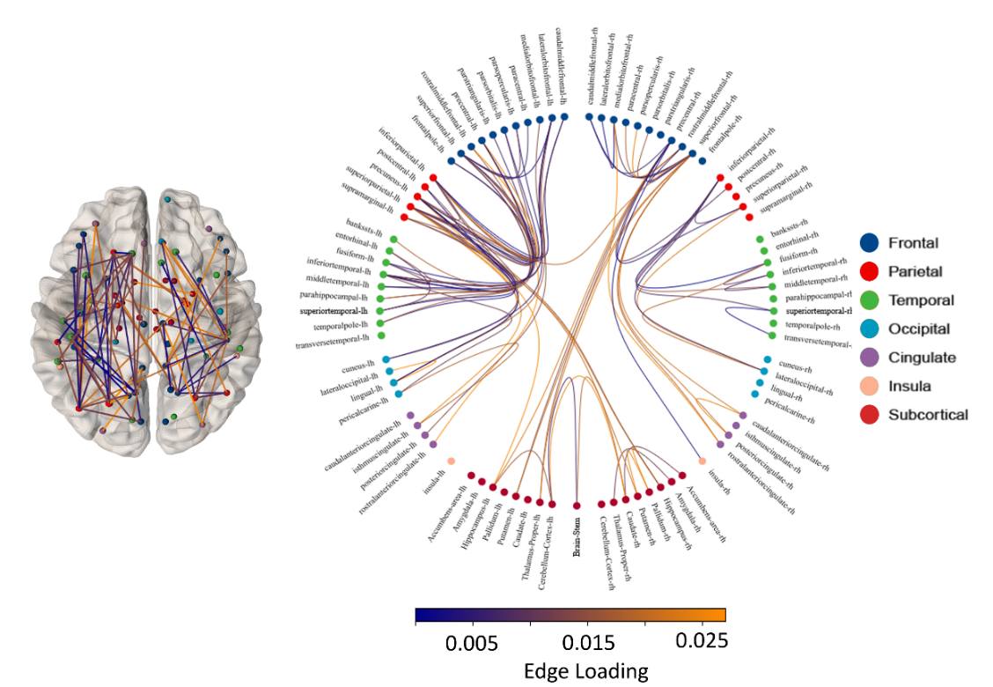
Figure 3: SES and the structural connectome: a topographic and circle plot of the edges that are significantly associated with childhood SES based on the bootstrap of the first PLS component, coloured by the sign of the loading onto the first component (orange, positive; blue, negative). Edges are grouped by brain hemisphere (L/R) and lobe.
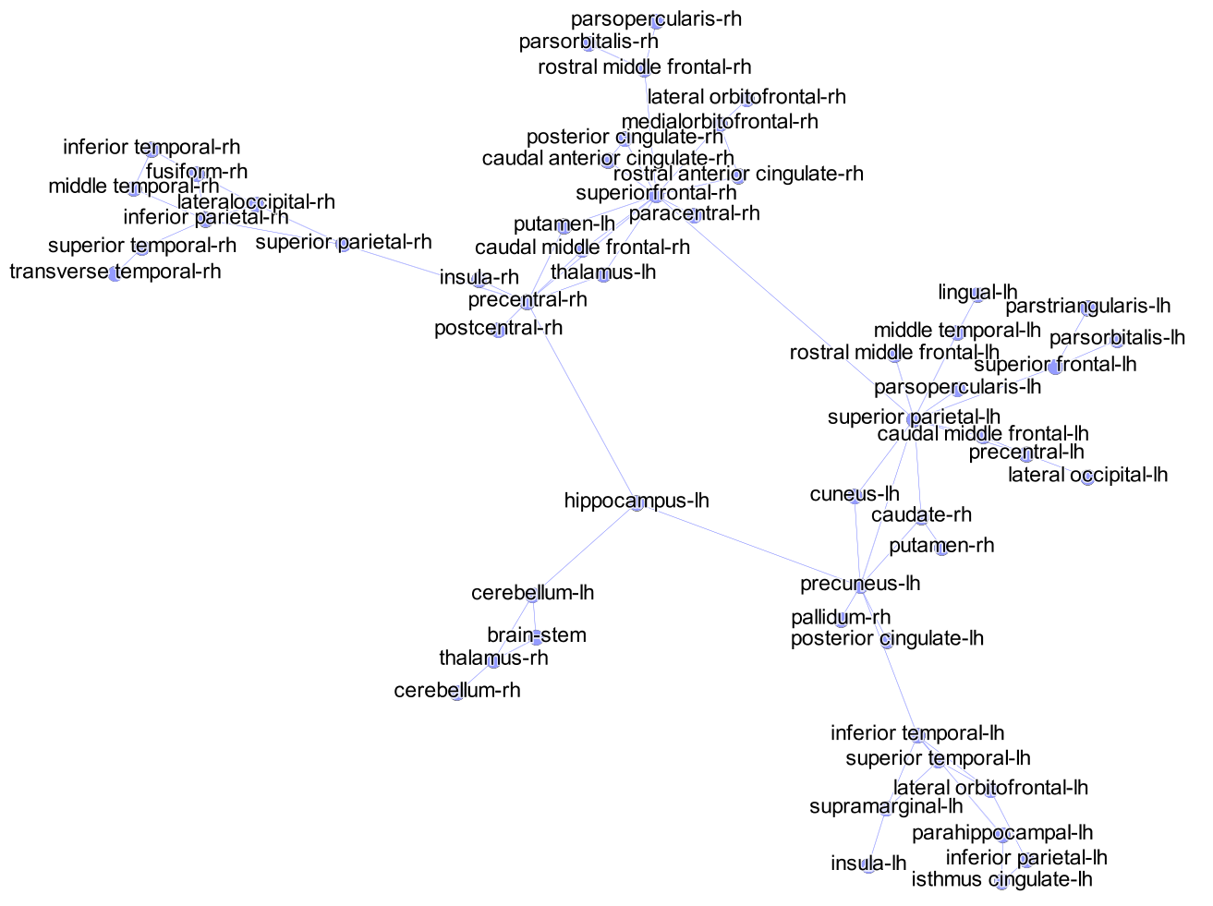
Figure 4: SES and the structural connectome: the same associations displayed in Figure 3, but depicted as a network diagram showing the nodes and connections within the white-matter connectome that are significantly associated with childhood SES, as indexed by non-zero 95% confidence intervals from the bootstrap procedure.

Does the structural connectome mediate the relationship between childhood SES, and cognition, academic ability and behavior?
The structural connectome significantly mediated the relationship between childhood SES (Income, Education, IDACI) and cognitive measures (matrix reasoning and vocabulary) (indirect path coefficient ab=0.14, 95% CI [0.06,0.24]). All of the other paths were significant, the coefficients can be seen in Figure 5. However the structural connectome did not significantly mediate relationships between the SES measures and academic ability (indirect path coefficient ab=0.11, 95% CI [-0.17, 0.19]), and behavior (indirect path coefficient ab=0.09, 95% CI [-0.09, 0.17]). In all cases, there is a significant association between the SES measures and the respective outcomes, and, mirroring the result of the 2-block PLS, between the SES measures and the structural connectome. However, in the case of both academic ability and behavior, the SES-associated connectome is not significantly predictive of the respective outcome. Again, all coefficients can be seen in Figure 6A and 6B, respectively.

Figure 5: PLS mediation analysis between the SES measures, the structural connectome and cognitive ability. The significant weights for each dataset are shown, according to bootstrapped confidence intervals. Note that the topographic structural connectome plot shows only the connections found to be reliably associated with the mediation effect. The coefficients for each path correspond to the 95% confidence intervals from the 3-block bootstrap procedure.
Some caution is required when interpreting the 3-block PLS result, for reasons outlined in the Discussion. In a final analysis, to corroborate the effects in our 3-block PLS, we conducted a general linear model. In this model, the response variable was each outcome type (cognitive, academic and behavioral), and the predictors were a set of control regressors (age in months and SES (the first PC from a PCA analysis of the three SES measures) and the connectome latent factor from the initial 2-block PLS. If the SES-associated elements of the child connectome, established in the permuted 2-block PLS analysis, significantly predict an outcome then this last regressor should explain significant variance in that outcome, despite SES itself being incorporated in the model. By contrast, if SES predicts an outcome, but this is unrelated to the impact SES has on the connectome, then the SES-associated elements of the connectome should not be significant within the GLM. All of the predictors and response variables were scaled to produce standardised beta coefficients.
Cognitive ability (mean of the vocabulary and matrix reasoning measures) was marginally predicted by age (β= 0.15, p= 0.0835), and significantly predicted by their connectome (β= 0.34, p=0.0037), but not by the SES regressor (β=0.09, p= 0.4376). Academic ability (mean of the reading and maths fluency measures) was significantly predicted by age (β= 0.64, p<0.001) and SES (β=0.21, p=0.0274), with no additional variance being explained by the SES-associated elements of their connectome (β=0.08, p=0.3901). Finally, behavior (total problems scale from the SDQ) was only predicted by SES (β=-0.30, p=0.0157), and not by age (β=0.05, p=0.5557) or connectome (β=0.06, p=0.6099). In short, these general linear models mirror the results from the 3-block PLS. The SES-associated elements of the childhood connectome significantly predict cognitive ability, but not academic ability or behavior.
Figure 6: PLS mediation analysis between the SES measures, the structural connectome and A) academic ability, and B) behavior. The significant weights for each dataset are shown, according to bootstrapped confidence intervals (orange indicates negative loading). The coefficients for each path correspond to the 95% confidence intervals from the 3-block bootstrap procedure.

Discussion
Multiple previous studies have identified associations between measures of childhood SES – like parental income – and FA in specific neural tracts, such as localized areas within the Inferior Longitudinal Fasciculus, Superior Longitudinal Fasciculus, Cingulum Bundle, Superior Corticostriatal and Corticospinal tracts (Dufford & Kim, 2017; Gullick et al., 2016; Noble et al., 2013; Ursache et al., 2016). In the current study we constructed white-matter whole-brain connectomes. We used PLS – a multi-block data-reduction method – to test whether these connectomes were significantly associated with childhood SES. We show that when the analytical approach considers wider brain organisation, SES associations are widespread. This suggests that there is a more global relationship between childhood SES and FA that univariate techniques such as ROI analyses and TBSS are likely to underestimate (Bathelt et al., 2018). This SES-connectome association mediated the SES-cognition relationship, but did not mediate SES relationships with academic attainment or behavior.
There are a number of possible reasons for such a global association between brain structure and SES. A generally lower SES may contribute to a systematic reduction in FA, such as an association with fibre density, diameter or myelination at a global scale. For example, exposure to excessive levels of stress hormones can suppress glial cell division which is critical for myelination (Lauder, 1983). In another example, poorer health (increased BMI) was associated with decreased global FA and in regions across the brain (Bettcher et al., 2013; Verstynen et al., 2012). In addition, the developing brain is a highly dynamic and interactive system. Differences in one region or connection between regions are likely to generate further differences in other areas, resulting in cascading effects across the brain (M. H. Johnson, 2011).
Cognitive ability is strongly associated with FA development in childhood, for example, FA is significantly associated with cognitive performance in children who are struggling at school (e.g. Astle et al., 2018; Siugzdaite et al., 2020). Furthermore, in one case FA has been found to fully mediate the association between SES (measured by parental education level) and a wide range of cognitive skills like memory performance and executive functions (Noble et al., 2013). In addition, using an alternative measure of structural brain development, Brito et al. found that cortical surface area mediates the relationship between income and executive function performance (Brito, Piccolo, & Noble, 2017). Within this context, our finding that the FA connectome mediates the relationship between SES variables (income, education and IDACI) and cognitive ability (vocabulary and matrix reasoning) is consistent with the literature.
It is perhaps surprising that we did not observe significant mediation for our academic measures (reading and maths fluency measures). This is surprising firstly because the association between FA and academic outcomes is well established in the literature (Flöel, de Vries, Scholz, Breitenstein, & Johansen-Berg, 2009; Hoeft et al., 2011; Keller & Just, 2009; Matejko & Ansari, 2015; Vandermosten et al., 2012), likely because academic tasks such as reading or maths depend on effective communication across distributed networks of brain regions (Pugh et al., 2001; Tau & Peterson, 2010). Secondly, it is surprising because differences in cognitive ability (like our measures of fluid reasoning and vocabulary), which we show to be significantly linked with the FA connectome, are often strongly associated with differences in academic abilities like reading and maths (Bathelt et al., 2019). Indeed, whilst they use different methods, Gullick et al. found that parent SES moderated the association between FA and reading skills in children (Gullick et al., 2016). Similarly, Hair et al. found that development of grey matter volumes (another marker of structural brain development) in the frontal and temporal lobes and the hippocampus accounted for 15-20% of the income-related academic attainment gap (Hair, Hanson, Wolfe, & Pollak, 2015). And finally, Rosen et al. (2018) show that FA within the superior longitudinal fasiculus, alongside prefrontal activity during a working memory task, significantly mediate the relationship between childhood SES and parental ratings of children’s academic achievement (Rosen, Sheridan, Sambrook, Meltoff & McLaughlin, 2018).
There are a few possible reasons why we failed to identify the mediating role of the structural connectome for SES and academic relationships. Firstly, we only used two particularly quick academic measures (maths and reading fluency) which are likely to be relatively noisy measures of academic ability. With more sensitive and comprehensive set of academic measures (such as the battery of reading and maths subtests from the WJ III ACH) we may have found significant mediation. Secondly, the studies described earlier included older children (8-14, 4-22 and 6-19 years old respectively) and it is possible that an observable relationship between SES, structural connectivity and academic ability takes longer to manifest. Finally, it could be that our environmental measures are too narrow. A wider range of environmental measures capturing more social aspect of the childhood environment (such as the parental attitude to education or the level of reading at home (Gorard, Huat See, & Peter, 2012; The Reading Agency, 2015)) may provide a better characterisation of their environment. An unpublished version of our analysis with a wider academic battery and a broader set of environmental measures did indeed find a significant mediating effect of the FA connectome (A. Johnson, 2019).
The FA connectome did not mediate the relationship between childhood SES and behavioral problems, which is perhaps less surprising. These results are echoed in a recent literature review of white matter and antisocial behavior by Waller et al (Waller et al., 2017), which would mirror some of the behavior scales in our analysis, in particular conduct problems. Results were inconclusive across the 12 studies of white matter in children that met their inclusion criteria. In contrast to the adult studies, which demonstrated a consistent association between reduced FA and antisocial behavior, there were null, positive and negative associations between FA and behavior across the child studies. It is possible that a significant association between FA and behavior takes longer to manifest and is not reliably related during development. It is also possible that associations between FA and behavioral problems might not be strong enough in our sample of typically developing children to identify a significant effect. For example, Loe et al. found significant associations between FA and internalizing behavior in preterm children but not in full-term children, aged 9 to 16 years (Loe et al., 2013). These behaviors would correspond to scales in our own analysis, in particular emotional regulation problems. Ikuta et al. found that poorer executive function behaviors were associated with lower FA in young adults with autism in the cingulum bundle, but not in typical young adults (Ikuta et al., 2014). However, despite identifying large differences in behavior outcomes across a large sample of children, Decety et al. found no association between FA and the number of conduct disorder symptoms across the white matter skeleton in 10 year old children (Decety, Yoder, & Lahey, 2015). As a result, whilst behavior has consistently been associated with the environment (e.g. see Cooper and Stewart, 2013; Dashiff et al., 2009; Qi and Kaiser, 2003; Reiss, 2013), evidence for the role of FA in relation to this association remains inconclusive.
In addition to the limitations already mentioned, namely the range of measures, there are a number of constraints inherent in the methods applied here. Despite its attractive properties for integrating large multivariate datasets, PLS methods remain in their infancy, and as a result it is likely their application will need continued refinement in future. With datasets containing a very large number of variables, like a connectome, it is possible that noise is linearly combined to create apparent correlations with the other dataset. In our own data, the correlation between childhood SES and connectome latent components is almost certainly being inflated by noise. This is why the permutation testing is essential for establishing genuinely significant relationships. It creates a null distribution of the strength of relationships possible by structuring noise. But despite knowing that the relationship between childhood SES and the connectome is significant, this approach is currently limited because it is difficult to ascertain the overall strength of that relationship. In the case of the 3-block PLS it has been shown that the permutation approach has a strong tendency towards type I errors. So instead, as we applied here, significance based on bootstrapping of the indirect path coefficient, ab, is recommended (Taylor & MacKinnon, 2012). In addition, the indirect effect does not typically follow a normal distribution as it is the product of two path coefficients. Therefore, it is recommended to calculate the asymmetric confidence intervals from the distribution of indirect effects from each bootstrap (Nitzl et al., 2016), as we have done here. It is also recommended that non-bias corrected confidence intervals are used as it has been shown that bias correction can also inflate type I error rates (Taylor & MacKinnon, 2012). However, without permuting the PLS components there remains a risk of overfitting. Secondly, recent work has shown that it is difficult to estimate reliably the bootstrapped loadings without large samples (Helmer et al., 2020). Which may mean that to establish reliably which edges in a connectome are most strongly associated with the childhood environment will require larger scale cohorts. And finally, we have controlled for age-related changes in our analyses, but in reality the childhood environment may be differentially associated with the connectome at different points within development. Larger cohorts, with a wider age range, will be needed to explore age interactions, in order to establish how connectome development itself is associated with the childhood environment.

Conclusions
In summary, this study had two aims. Firstly to establish associations between the childhood environment (operationalized as their SES) and whole-brain white-matter connectome. Secondly, to test whether these relationships can account for environment-outcome relationships. The association between childhood SES and their brain architecture is not localized to specific regions. Rather, whole-brain connectomics identified a set of widespread connections between brain regions across which the white matter structural integrity was significantly related to childhood SES. In addition, we have demonstrated that the structural connectome mediates the relationship between childhood SES and cognitive ability (matrix reasoning and vocabulary), suggesting that differences in white matter integrity might provide a mechanism underpinning the relationship between the environment and cognitive ability.

Acknowledgements
This study was made possible with funding from the Templeton World Charity Foundation (TWCF0157) and the Medical Research Council, UK (MC-A0606-5PQ41). We would like to thank Giacomo Bignardi for his assistance with the 3-block PLS analysis, and the RED Team for collecting a portion of the data included in this manuscript, they include Edwin Dalmaijer, Roma Siugzdaite, Alex Anwyl-Irvine, Giacomo Bignardi, Tess Smith, and Stepheni Uh.

References
Anyaegbu, G. (2010). Using the OECD equivalence scale in taxes and benefits analysis. Economic & Labour Market Review, 4(1), 49–54. https://doi.org/10.1057/elmr.2010.9
Astle, D. E., Bathelt, J., CALM team, & Holmes, J. (2018). Remapping the cognitive and neural profiles of children who struggle at school. Developmental Science, e12747. https://doi.org/10.1111/desc.12747
Avants, B. B., Tustison, N. J., & Johnson, H. J. (2009). ANTS: Advanced Open-Source Normalization Tools for Neuroanatomy. Penn Image Computing and Science Laboratory. Penn Image Computing and Science Laboratory. Retrieved from http://www.insight-journal.org/browse/publication/681
Barnea-Goraly, N., Menon, V., Eckert, M., Tamm, L., Bammer, R., Karchemskiy, A., … Reiss, A. L. (2005). White Matter Development During Childhood and Adolescence: A Cross-sectional Diffusion Tensor Imaging Study. Cerebral Cortex, 15(12), 1848–1854. https://doi.org/10.1093/cercor/bhi062
Bastien, P. (2008). R´egression pls et donn´ees censur´ees (Conservatoire National des Arts et M´etiers). Conservatoire National des Arts et M´etiers, Paris. Retrieved from https://tel.archives-ouvertes.fr/file/index/docid/268344/filename/These_CNAM_2008_PBastien_Regression_PLS_et_donnees_censurees.pdf
Bathelt, J., Gathercole, S. E., Butterfield, S., CALM team, & Astle, D. E. (2018). Children’s academic attainment is linked to the global organization of the white matter connectome. Developmental Science. https://doi.org/10.1111/desc.12662
Bathelt, J., Scerif, G., Nobre, K., & Astle, D. (2019). Whole-brain white matter organization, intelligence, and educational attainment. Trends in Neuroscience and Education, 15, 38–47. https://doi.org/10.1016/j.tine.2019.02.004
Behrens, T. E. J., Johansen-Berg, H., Woolrich, M. W., Smith, S. M., Wheeler-Kingshott, C. a. M., Boulby, P. A., … Matthews, P. M. (2003). Non-invasive mapping of connections between human thalamus and cortex using diffusion imaging. Nature Neuroscience, 6(7), 750–757. https://doi.org/10.1038/nn1075
Bettcher, B. M., Walsh, C. M., Watson, C., Miller, J. W., Green, R., Patel, N., … Kramer, J. H. (2013). Body Mass and White Matter Integrity: The Influence of Vascular and Inflammatory Markers. PLOS ONE, 8(10), e77741. https://doi.org/10.1371/journal.pone.0077741
Brito, N. H., & Noble, K. G. (2014). Socioeconomic status and structural brain development. Frontiers in Neuroscience, 8, 276. https://doi.org/10.3389/fnins.2014.00276
Brito, N. H., Piccolo, L. R., & Noble, K. G. (2017). Associations between cortical thickness and neurocognitive skills during childhood vary by family socioeconomic factors. Brain and Cognition, 116, 54–62. https://doi.org/10.1016/j.bandc.2017.03.007
Cao, M., Wang, J.-H., Dai, Z.-J., Cao, X.-Y., Jiang, L.-L., Fan, F.-M., … He, Y. (2014). Topological organization of the human brain functional connectome across the lifespan. Developmental Cognitive Neuroscience, 7, 76–93. https://doi.org/10.1016/j.dcn.2013.11.004
Chiang, M.-C., McMahon, K. L., de Zubicaray, G. I., Martin, N. G., Hickie, I., Toga, A. W., … Thompson, P. M. (2011). Genetics of white matter development: A DTI study of 705 twins and their siblings aged 12 to 29. NeuroImage, 54(3), 2308–2317. https://doi.org/10.1016/j.neuroimage.2010.10.015
Cooper, K., & Stewart, K. (2013). Does money affect children’s outcomes? A systematic review. Joseph Rowntree Foundation.
Coupe, P., Yger, P., Prima, S., Hellier, P., Kervrann, C., & Barillot, C. (2008). An optimized blockwise nonlocal means denoising filter for 3-D magnetic resonance images. IEEE Transactions on Medical Imaging, 27(4), 425–441. https://doi.org/10.1109/TMI.2007.906087
Dashiff, C., DiMicco, W., Myers, B., & Sheppard, K. (2009). Poverty and adolescent mental health. Journal of Child and Adolescent Psychiatric Nursing: Official Publication of the Association of Child and Adolescent Psychiatric Nurses, Inc, 22(1), 23–32. https://doi.org/10.1111/j.1744-6171.2008.00166.x
de Moura, L. M., Cogo-Moreira, H., de Ávila, C. R. B., Pan, P. M., Gadelha, A., Moriyama, T., … Jackowski, A. P. (2016). Children with Poor Reading Skills at the Word Level Show Reduced Fractional Anisotropy in White Matter Tracts of Both Hemispheres. Brain Connectivity, 6(7), 519–523. https://doi.org/10.1089/brain.2016.0430
de Reus, M. A., & van den Heuvel, M. P. (2013). Estimating false positives and negatives in brain networks. NeuroImage, 70, 402–409. https://doi.org/10.1016/j.neuroimage.2012.12.066
Decety, J., Yoder, K. J., & Lahey, B. B. (2015). Sex differences in abnormal white matter development associated with conduct disorder in children. Psychiatry Research, 233(2), 269–277. https://doi.org/10.1016/j.pscychresns.2015.07.009
Desikan, R. S., Ségonne, F., Fischl, B., Quinn, B. T., Dickerson, B. C., Blacker, D., … Killiany, R. J. (2006). An automated labeling system for subdividing the human cerebral cortex on MRI scans into gyral based regions of interest. NeuroImage, 31(3), 968–980. https://doi.org/10.1016/j.neuroimage.2006.01.021
Deutsch, G. K., Dougherty, R. F., Bammer, R., Siok, W. T., Gabrieli, J. D. E., & Wandell, B. (2005). Children’s reading performance is correlated with white matter structure measured by diffusion tensor imaging. Cortex; a Journal Devoted to the Study of the Nervous System and Behavior, 41(3), 354–363.
Douet, V., Chang, L., Cloak, C., & Ernst, T. (2014). Genetic Influences on Brain Developmental Trajectories on Neuroimaging Studies: From Infancy to Young Adulthood. Brain Imaging and Behavior, 8(2), 234–250. https://doi.org/10.1007/s11682-013-9260-1
Dufford, A. J., & Kim, P. (2017). Family Income, Cumulative Risk Exposure, and White Matter Structure in Middle Childhood. Frontiers in Human Neuroscience, 11. https://doi.org/10.3389/fnhum.2017.00547
Fair, D. A., Cohen, A. L., Power, J. D., Dosenbach, N. U. F., Church, J. A., Miezin, F. M., … Petersen, S. E. (2009). Functional Brain Networks Develop from a “Local to Distributed” Organization. PLoS Computational Biology, 5(5). https://doi.org/10.1371/journal.pcbi.1000381
Fields, R. D. (2008). White matter in learning, cognition and psychiatric disorders. Trends in Neurosciences, 31(7), 361–370. https://doi.org/10.1016/j.tins.2008.04.001
Flöel, A., de Vries, M. H., Scholz, J., Breitenstein, C., & Johansen-Berg, H. (2009). White matter integrity in the vicinity of Broca’s area predicts grammar learning success. NeuroImage, 47(4), 1974–1981. https://doi.org/10.1016/j.neuroimage.2009.05.046
Fry, A., Littlejohns, T. J., Sudlow, C., Doherty, N., Adamska, L., Sprosen, T., … Allen, N. E. (2017). Comparison of Sociodemographic and Health-Related Characteristics of UK Biobank Participants With Those of the General Population. American Journal of Epidemiology, 186(9), 1026–1034. https://doi.org/10.1093/aje/kwx246
Garyfallidis, E., Brett, M., Amirbekian, B., Rokem, A., van der Walt, S., Descoteaux, M., … Dipy Contributors. (2014). Dipy, a library for the analysis of diffusion MRI data. Frontiers in Neuroinformatics, 8, 8. https://doi.org/10.3389/fninf.2014.00008
Gianaros, P. J., Marsland, A. L., Sheu, L. K., Erickson, K. I., & Verstynen, T. D. (2013). Inflammatory pathways link socioeconomic inequalities to white matter architecture. Cerebral Cortex (New York, N.Y.: 1991), 23(9), 2058–2071. https://doi.org/10.1093/cercor/bhs191
Giorgio, A., Watkins, K. E., Chadwick, M., James, S., Winmill, L., Douaud, G., … James, A. C. (2010). Longitudinal changes in grey and white matter during adolescence. NeuroImage, 49(1), 94–103. https://doi.org/10.1016/j.neuroimage.2009.08.003
Goodman, R. (1997). The Strengths and Difficulties Questionnaire: A research note. Journal of Child Psychology and Psychiatry, and Allied Disciplines, 38(5), 581–586.
Gorard, S., Huat See, B., & Peter, D. (2012). The impact of attitudes and aspirations on educational attainment and participation. Joseph Rowntree Foundation. Retrieved from Joseph Rowntree Foundation website: https://www.jrf.org.uk/report/impact-attitudes-and-aspirations-educational-attainment-and-participation
Gullick, M. M., Demir-Lira, Ö. E., & Booth, J. R. (2016). Reading skill–fractional anisotropy relationships in visuospatial tracts diverge depending on socioeconomic status. Developmental Science, 19(4), 673–685. https://doi.org/10.1111/desc.12428
Hackman, D. A., & Farah, M. J. (2009). Socioeconomic status and the developing brain. Trends in Cognitive Sciences, 13(2), 65–73. https://doi.org/10.1016/j.tics.2008.11.003
Hagmann, P., Kurant, M., Gigandet, X., Thiran, P., Wedeen, V. J., Meuli, R., & Thiran, J.-P. (2007). Mapping human whole-brain structural networks with diffusion MRI. PloS One, 2(7), e597. https://doi.org/10.1371/journal.pone.0000597
Hair, N. L., Hanson, J. L., Wolfe, B. L., & Pollak, S. D. (2015). Association of Child Poverty, Brain Development, and Academic Achievement. JAMA Pediatrics, 169(9), 822–829. https://doi.org/10.1001/jamapediatrics.2015.1475
Helmer, M., Warrington, S., Mohammadi-Nejad, A.-R., Ji, J. L., Howell, A., Rosand, B., … Murray, J. D. (2020). On stability of Canonical Correlation Analysis and Partial Least Squares with application to brain-behavior associations. BioRxiv, 2020.08.25.265546. https://doi.org/10.1101/2020.08.25.265546
Henrich, J., Heine, S. J., & Norenzayan, A. (2010). Most people are not WEIRD. Nature, 466(7302), 29–29. https://doi.org/10.1038/466029a
Hoeft, F., McCandliss, B. D., Black, J. M., Gantman, A., Zakerani, N., Hulme, C., … Gabrieli, J. D. E. (2011). Neural systems predicting long-term outcome in dyslexia. Proceedings of the National Academy of Sciences of the United States of America, 108(1), 361–366. https://doi.org/10.1073/pnas.1008950108
Hollingshead, A. B. (1975). Four factor index of social status. Unpublished manuscript, Department of Sociology, Yale University, New Haven, CT.
Ikuta, T., Shafritz, K. M., Bregman, J., Peters, B., Gruner, P., Malhotra, A. K., & Szeszko, P. R. (2014). Abnormal Cingulum Bundle Development in Autism: A Probabilistic Tractography Study. Psychiatry Research, 221(1), 63–68. https://doi.org/10.1016/j.pscychresns.2013.08.002
Johansen-Berg, H. (2010). Behavioral relevance of variation in white matter microstructure. Current Opinion in Neurology, 23(4), 351–358. https://doi.org/10.1097/WCO.0b013e32833b7631
Johnson, A. (2019). The Environment and Child Development: A Multivariate Approach (Thesis, University of Cambridge). University of Cambridge. https://doi.org/10.17863/CAM.39216
Johnson, M. H. (2011). Interactive Specialization: A domain-general framework for human functional brain development? Developmental Cognitive Neuroscience, 1(1), 7–21. https://doi.org/10.1016/j.dcn.2010.07.003
Johnson, S. B., Riis, J. L., & Noble, K. G. (2016). State of the Art Review: Poverty and the Developing Brain. Pediatrics, 137(4). https://doi.org/10.1542/peds.2015-3075
Keller, T. A., & Just, M. A. (2009). Altering cortical connectivity: Remediation-induced changes in the white matter of poor readers. Neuron, 64(5), 624–631. https://doi.org/10.1016/j.neuron.2009.10.018
Kim, D.J., Davis, E.P., Sandman, C.A., Glynn, L., Sporns, O., O'Donnell, B.F., Hetrick, W.P. (2019) Childhood poverty and the organization of structural brain connectome. Neuroimage. 184:409-416. doi: 10.1016/j.neuroimage.2018.09.041.
Klingberg, T., Hedehus, M., Temple, E., Salz, T., Gabrieli, J. D., Moseley, M. E., & Poldrack, R. A. (2000). Microstructure of temporo-parietal white matter as a basis for reading ability: Evidence from diffusion tensor magnetic resonance imaging. Neuron, 25(2), 493–500.
Lauder, J. M. (1983). Hormonal and humoral influences on brain development. Psychoneuroendocrinology, 8(2), 121–155.
Lebel, C., Treit, S., & Beaulieu, C. (2017). A review of diffusion MRI of typical white matter development from early childhood to young adulthood. NMR in Biomedicine. https://doi.org/10.1002/nbm.3778
Lipina, Sebastián J., & Evers, K. (2017). Neuroscience of Childhood Poverty: Evidence of Impacts and Mechanisms as Vehicles of Dialog With Ethics. Frontiers in Psychology, 8. https://doi.org/10.3389/fpsyg.2017.00061
Lipina, Sebastian J., & Posner, M. I. (2012). The impact of poverty on the development of brain networks. Frontiers in Human Neuroscience, 6, 238. https://doi.org/10.3389/fnhum.2012.00238
Loe, I. M., Lee, E. S., & Feldman, H. M. (2013). Attention and internalizing behaviors in relation to white matter in children born preterm. Journal of Developmental and Behavioral Pediatrics: JDBP, 34(3), 156–164. https://doi.org/10.1097/DBP.0b013e3182842122
Matejko, A. A., & Ansari, D. (2015). Drawing connections between white matter and numerical and mathematical cognition: A literature review. Neuroscience & Biobehavioral Reviews, 48, 35–52. https://doi.org/10.1016/j.neubiorev.2014.11.006
McGrew, K. S., Woodcock, R. W., & Schrank, K. A. (2007). Woodcock-Johnson III normative update technical manual. Itasca, IL: Riverside Pub.
McIntosh, A. R., & Lobaugh, N. J. (2004). Partial least squares analysis of neuroimaging data: Applications and advances. NeuroImage, 23, S250–S263. https://doi.org/10.1016/j.neuroimage.2004.07.020
Muetzel, R. L., Blanken, L. M. E., van der Ende, J., El Marroun, H., Shaw, P., Sudre, G., … White, T. (2018). Tracking Brain Development and Dimensional Psychiatric Symptoms in Children: A Longitudinal Population-Based Neuroimaging Study. The American Journal of Psychiatry, 175(1), 54–62. https://doi.org/10.1176/appi.ajp.2017.16070813
Muftuler, L. T., Davis, E. P., Buss, C., Solodkin, A., Su, M. Y., Head, K. M., … Sandman, C. A. (2012). Development of white matter pathways in typically developing preadolescent children. Brain Research, 1466, 33–43. https://doi.org/10.1016/j.brainres.2012.05.035
Nitzl, C., Roldan, J. L., & Cepeda, G. (2016). Mediation analysis in partial least squares path modeling: Helping researchers discuss more sophisticated models. Industrial Management & Data Systems, 116(9), 1849–1864. https://doi.org/10.1108/IMDS-07-2015-0302
Noble, K. G., Korgaonkar, M. S., Grieve, S. M., & Brickman, A. M. (2013). Higher Education is an Age-Independent Predictor of White Matter Integrity and Cognitive Control in Late Adolescence. Developmental Science, 16(5), 653–664. https://doi.org/10.1111/desc.12077
Office for National Statistics. (2015). English indices of deprivation 2015. Retrieved 24 September 2018, from GOV.UK website: https://www.gov.uk/government/statistics/english-indices-of-deprivation-2015
Pugh, K. R., Mencl, W. E., Jenner, A. R., Katz, L., Frost, S. J., Lee, J. R., … Shaywitz, B. A. (2001). Neurobiological studies of reading and reading disability. Journal of Communication Disorders, 34(6), 479–492.
Rosen, M. L., Sheridan, M. A., Sambrook, K. A., Meltzoff, A. N., & McLaughlin, K. A. (2018). Socioeconomic disparities in academic achievement: A multi-modal investigation of neural mechanisms in children and adolescents. NeuroImage, 173, 298-310.
Qi, C. H., & Kaiser, A. P. (2003). Behavior Problems of Preschool Children From Low-Income Families: Review of the Literature. Topics in Early Childhood Special Education, 23(4), 188–216. https://doi.org/10.1177/02711214030230040201
Qiu, D., Tan, L.-H., Zhou, K., & Khong, P.-L. (2008). Diffusion tensor imaging of normal white matter maturation from late childhood to young adulthood: Voxel-wise evaluation of mean diffusivity, fractional anisotropy, radial and axial diffusivities, and correlation with reading development. NeuroImage, 41(2), 223–232. https://doi.org/10.1016/j.neuroimage.2008.02.023
Raizada, R. D. S., & Kishiyama, M. M. (2010). Effects of Socioeconomic Status on Brain Development, and How Cognitive Neuroscience May Contribute to Levelling the Playing Field. Frontiers in Human Neuroscience, 4. https://doi.org/10.3389/neuro.09.003.2010
Reiss, F. (2013). Socioeconomic inequalities and mental health problems in children and adolescents: A systematic review. Social Science & Medicine, 90, 24–31. https://doi.org/10.1016/j.socscimed.2013.04.026
Richmond, S., Johnson, K. A., Seal, M. L., Allen, N. B., & Whittle, S. (2016). Development of brain networks and relevance of environmental and genetic factors: A systematic review. Neuroscience & Biobehavioral Reviews, 71, 215–239. https://doi.org/10.1016/j.neubiorev.2016.08.024
Rohart, F., Gautier, B., Singh, A., & Lê Cao, K.-A. (2017). mixOmics: An R package for ’omics feature selection and multiple data integration. PLoS Computational Biology, 13(11), e1005752. https://doi.org/10.1371/journal.pcbi.1005752
Sakshaug, J. W., Schmucker, A., Kreuter, F., Couper, M. P., & Singer, E. (2016). Evaluating Active (Opt-In) and Passive (Opt-Out) Consent Bias in the Transfer of Federal Contact Data to a Third-Party Survey Agency. Journal of Survey Statistics and Methodology, 4(3), 382–416. https://doi.org/10.1093/jssam/smw020
Scholz, J., Tomassini, V., & Johansen-Berg, H. (2009). Individual Differences in White Matter Microstructure in the Healthy Brain. In T. Behrens & H. Johansen-Berg (Eds.), Diffusion MRI: From Quantitative Measurement to In Vivo Neuroanatomy (pp. 237–250). Oxford: Elsevier.
Siugzdaite, R., Bathelt, J., Holmes, J., & Astle, D. E. (2020). Transdiagnostic Brain Mapping in Developmental Disorders. Current Biology, 30(7), 1245-1257.e4. https://doi.org/10.1016/j.cub.2020.01.078
Smith, S. M., Nichols, T. E., Vidaurre, D., Winkler, A. M., Behrens, T. E. J., Glasser, M. F., … Miller, K. L. (2015). A positive-negative mode of population covariation links brain connectivity, demographics and behavior. Nature Neuroscience, 18(11), 1565–1567. https://doi.org/10.1038/nn.4125
Snook, L., Paulson, L.-A., Roy, D., Phillips, L., & Beaulieu, C. (2005). Diffusion tensor imaging of neurodevelopment in children and young adults. NeuroImage, 26(4), 1164–1173. https://doi.org/10.1016/j.neuroimage.2005.03.016
Tau, G. Z., & Peterson, B. S. (2010). Normal Development of Brain Circuits. Neuropsychopharmacology, 35(1), 147–168. https://doi.org/10.1038/npp.2009.115
Taylor, A. B., & MacKinnon, D. P. (2012). Four applications of permutation methods to testing a single-mediator model. Behavior Research Methods, 44(3), 806–844. https://doi.org/10.3758/s13428-011-0181-x
Tenenhaus, A., & Tenenhaus, M. (2011). Regularized Generalized Canonical Correlation Analysis. Psychometrika, 76(2), 257. https://doi.org/10.1007/s11336-011-9206-8
Tenenhaus, A., & Tenenhaus, M. (2014). Regularized generalized canonical correlation analysis for multiblock or multigroup data analysis. European Journal of Operational Research, 238(2), 391–403. https://doi.org/10.1016/j.ejor.2014.01.008
The Reading Agency. (2015). Literature Review: The impact of reading for pleasure and empowerment. BOP Consulting. Retrieved from BOP Consulting website: https://readingagency.org.uk/
Tournier, J.-D., Yeh, C.-H., Calamante, F., Cho, K.-H., Connelly, A., & Lin, C.-P. (2008). Resolving crossing fibres using constrained spherical deconvolution: Validation using diffusion-weighted imaging phantom data. NeuroImage, 42(2), 617–625. https://doi.org/10.1016/j.neuroimage.2008.05.002
Tsang, J. M., Dougherty, R. F., Deutsch, G. K., Wandell, B. A., & Ben-Shachar, M. (2009). Frontoparietal white matter diffusion properties predict mental arithmetic skills in children. Proceedings of the National Academy of Sciences of the United States of America, 106(52), 22546–22551. https://doi.org/10.1073/pnas.0906094106
Ursache, A., & Noble, K. G. (2016). Neurocognitive development in socioeconomic context: Multiple mechanisms and implications for measuring socioeconomic status. Psychophysiology, 53(1), 71–82. https://doi.org/10.1111/psyp.12547
Ursache, A., Noble, K. G., & Pediatric Imaging, Neurocognition and Genetics Study. (2016). Socioeconomic status, white matter, and executive function in children. Brain and Behavior, 6(10), e00531. https://doi.org/10.1002/brb3.531
Vandermosten, M., Boets, B., Wouters, J., & Ghesquière, P. (2012). A qualitative and quantitative review of diffusion tensor imaging studies in reading and dyslexia. Neuroscience and Biobehavioral Reviews, 36(6), 1532–1552. https://doi.org/10.1016/j.neubiorev.2012.04.002
Verstynen, T. D., Weinstein, A. M., Schneider, W. W., Jakicic, J. M., Rofey, D. L., & Erickson, K. I. (2012). Increased Body Mass Index Is Associated With a Global and Distributed Decrease in White Matter Microstructural Integrity. Psychosomatic Medicine, 74(7), 682–690. https://doi.org/10.1097/PSY.0b013e318261909c
Vértes, P. E., & Bullmore, E. T. (2015). Annual Research Review: Growth connectomics – the organization and reorganization of brain networks during normal and abnormal development. Journal of Child Psychology and Psychiatry, and Allied Disciplines, 56(3), 299–320. https://doi.org/10.1111/jcpp.12365
Waller, R., Dotterer, H. L., Murray, L., Maxwell, A. M., & Hyde, L. W. (2017). White-matter tract abnormalities and antisocial behavior: A systematic review of diffusion tensor imaging studies across development. NeuroImage: Clinical, 14, 201–215. https://doi.org/10.1016/j.nicl.2017.01.014
Wechsler, D. (2011). Wechsler abbreviated scale of intelligence- second edition. Bloomington, MN: Pearson.
Whitaker, K. J., Vértes, P. E., Romero-Garcia, R., Váša, F., Moutoussis, M., Prabhu, G., … Villis, L. (2016). Adolescence is associated with genomically patterned consolidation of the hubs of the human brain connectome. Proceedings of the National Academy of Sciences, 113(32), 9105–9110. https://doi.org/10.1073/pnas.1601745113
Wold, H. (1975). Path Models with latent variables: The NIPALS approach. Acad. Press.
Wold, H. (1982). Soft modeling: The basic design and some extensions. Systems under Indirect Observation : Causality, Structure, Prediction, 2.
Wold, H. (2004). Partial Least Squares. In Encyclopedia of Statistical Sciences. John Wiley & Sons, Inc. https://doi.org/10.1002/0471667196.ess1914.pub2
Wolke, D., Waylen, A., Samara, M., Steer, C., Goodman, R., Ford, T., & Lamberts, K. (2009). Selective drop-out in longitudinal studies and non-biased prediction of behavior disorders. The British Journal of Psychiatry, 195(3), 249–256. https://doi.org/10.1192/bjp.bp.108.053751
Woodcock, R. W., McGrew, K. S., & Mather, N. (2001). Woodcock-Johnson III tests of achievement. Itasca, IL: Riverside Publishing.
Zalesky, A., Fornito, A., & Bullmore, E. T. (2010). Network-based statistic: Identifying differences in brain networks. NeuroImage, 53(4), 1197–1207. https://doi.org/10.1016/j.neuroimage.2010.06.041

