Self-Lowering as Power and Trap: Wawa, ‘White’, and Peripheral Embrace of State Formation in Indonesian Papua

Rupert Stasch

University of Cambridge

ABSTRACT
Building on Ferguson’s account of ‘declarations of dependence’ and prior Melanesianist work on ‘humiliation’, I examine how enthusiasm for state-formation among Korowai of Papua has been shaped by their understandings of self-lowering as a politically complex way of influencing kin and equalizing relations. I begin with media firestorms in Australia and urban Papua about the need to save two vulnerable boys. Korowai understandings of these episodes, unknown to faraway media publics, illustrate their idea that self-lowering toward a hoped favorable benefactor is a desirable way of exercising a degree of relational control in a wider situation of being dominated. Building on the Australia-linked Wawa affair, I look further at why sending boys to school in towns is a main strategy by which Korowai try to ameliorate their felt inferiority to city people. Transactions between schoolboys and senior relatives are politically complex, in ways that suggest the schooling strategy is an application of old egalitarian kinship techniques to new geopolitical inequalities. Finally, I look at Korowai responses to the new environment of large money flows into the countryside under government policies of redistricting and community-driven development. Strong Korowai interest in benefactor relations with ‘Regency’ leaders, and the new embrace of divisions between ‘heads’ and ‘community’ within villages, also exemplify a strategy of seeking out a more livable relation of inequality to ease a less livable one.

Keywords: Wawa controversy; dependence; state-society relations; humiliation; whiteness; Indonesian decentralization; egalitarianism; kinship.

In this article, I follow other contributors to this issue in examining articulations between small-scale kinship life and large-scale relations of state and society, with a focus on ‘dependence’ as an ethnographic question. I investigate ideas that people enact, when doing dependence. Such ideas differ sharply, not only across historical contexts, but even between directly interacting persons.
State-society relations have changed dramatically in rural Indonesia over the last twenty years, and nowhere more than in Papua. While policies with names like ‘decentralization’, ‘community driven-development’, and ‘special autonomy’ are recognizable as global trends, the versions implemented in Papua have created conditions quite different from life elsewhere in the Pacific and many other world regions. Their effects have included: steep increase in numbers of government administrative units at all nested territorial scales of ‘Province’, ‘Regency’, ‘District’, and ‘Village’; increase of salaried jobs attached to these units; huge cash grants to Village-level populations; intensification of clientelistic social structures; and increases in inequality and elite gamesmanship among Papuans. These changes have intervened in Papua’s already complex political environment as an Indonesian internal settler colony. The longer-running features of that colonial formation include majority desire of Papuans to be politically independent from Indonesia; forcible repression of Papuan separatism by Indonesian security forces; wide racial stigmatization of Papuans; and residence in Papua of large numbers of migrants from other parts of Indonesia, who are a demographic majority in most towns, and who universally dominate commerce and private-sector formal employment. The recent policy innovations have not lessened Papua’s colonial fractures, but they have distracted attention from those fractures, or complicated their clarity.
I investigate here a relatively invisible side of these changes and their comparative significance, through an ethnographic look at one place. Korowai of Papua’s southern lowlands live on the periphery of the periphery: Papua is Indonesia’s poorest region, and Korowai live at great remove from the region’s cities (Figure 1). Only around 1980 did any of the four thousand Korowai enter regular interaction with state and market processes, and for northern Korowai such interaction dates to the last twenty years. I carried out a year of fieldwork in the southern Korowai area in 1995-1997, and have made shorter visits every five years since. My fieldwork history has been intertwined with the processes of change, and particularly in the 2010s, I have experienced a certain whiplash in following Korowai embrace of state-making activities.

<Figure 1 near here>

The abrupt newness of state presence means my inquiry emphasizes the ‘society’ side of state-society articulations. I focus on the distinctive Korowai understandings that quickly emerge from ethnographic description of how Korowai orient to outside actors and institutions. Yet while Korowai understandings of dependence and other relational principles differ from ideas of outsiders, these understandings harmonize with the new macrostructural processes. My broadest theme is that state formation unknowingly gains energy from value complexes of local kinship life.
What is ‘dependence’ in the first place, when applied to people among whom the European-language category has no prior circulation? I take this category to describe any way someone’s actions or presence are crucial conditions of another’s life, or are felt to be so. Korowai greatly emphasize relations as what matters most in daily affairs, and these relations consist of constant practices of measuring, celebrating, and restructuring dependence. But in English discourse, dependence is perhaps most noticed when asymmetric and contingent, such as when there is suspense about whether someone will actually provide resources another needs, and uncertainty about whether they should.
If I search my own experience of Korowai life for situations closely corresponding to ‘dependence’ in this last sense, a common scene that comes to mind is that of one person seeing, desiring, and ‘asking for’ something another possesses, such as tobacco, food, or a beautiful bag. This ‘asking’ (nεxmo-) is a bold violation of other values of self-restraint, property rights, and deferral to others’ initiative in deciding to offer a gift. Yet ‘asking’ also points toward the valued relational possibility of the possessor giving the object, meeting the asker’s vulnerability with a sacrificial act of care. Even when possessors do not give, they might express compassion for askers’ deprivation, promise future gifts, or position themselves as also lacking possessions or control of them. All of these are also poignant, valued achievements of egalitarian relational alignment. Or an asked person might rebuff or malign an asker’s request, which is part of what makes the asking bold in the first place and what gives the whole scenario its charged sense of drama and importance.
Questioned why they desire specific objects, what Korowai most commonly say is that they want to be like their relatives (e.g. nə-mayox-ülop ‘like my people’). I see this compulsion to likeness as an element in a larger fabric of political sensibilities that can usefully be described as ‘egalitarian’, despite that many anthropologists would shun this term, including out of concern that it glosses over the actual inequalities in all relations and societies. I find the term helpful for naming a distinctive sensitivity to inequality and desire to equalize, somewhat separately from the level of constantly-lived actual inequalities. Lack, asking, and other scenes of dependence were in past Korowai life highly embedded in a wider egalitarian context (consistent with the patterns of ‘demand sharing’ modeled by Peterson 1993; see also Powell Davies this volume). Another prototypic figure of lack and dependence in Korowai life is a child, and more intensely an orphan (Figure 2). Scenes of asking, collective identification with an orphan, and other actions described across this article exemplify a Korowai pattern akin to what Ferguson (2013) calls ‘declaring dependence’. What I find important about Korowai declarations is the understanding that the self-lowering element in dependence can have complex power. I explore here how strategies of self-lowering practiced under local egalitarian understandings have been amplified in new engagement with an inegalitarian geopolitical order. The old political complexity of declaring dependence in kinship drives Korowai participation in state rule.

<Figure 2 near here>

I introduce Korowai ideas of dependence through two events when a vulnerable Korowai boy became the focus of huge media interest among non-Korowai. The first was the 2006 Wawa affair in Australia, and the second was the 2017 Puti affair across urban Papua. Both cases innovated on the existing fame of Korowai as an iconic ‘isolated primitive tribe’, built up since the early 1990s through visits by thousands of tourists, magazine photographers, and television crews. To these visitors and their home audiences, there is a mythic resonance to the idea of Korowai as living beyond market dependence, state control, or state care. But in my account of what happened between outsiders and the boys Wawa and Puti, my ultimate focus is Korowai ideas about the boys that were unknown to outsiders. I use discrepancies between media narratives and local perceptions to throw into relief Korowai ideas about self-lowering as a powerful way of forging favorable terms of dependence with others. In the article’s later sections, I trace how the same ideas have fueled Korowai enthusiasm for new state-building initiatives, in the policy environment sketched above.

WAWA: FOOD OR FUTURE RULER?
The September 2006 firestorm over Wawa centered on the attempt by Australian tabloid news personality Naomi Robson to be filmed rescuing this six-year-old boy from being eaten by adults of his village. The orphan’s peril had been brought to her producers’ attention by travel writer Paul Raffaele, who had visited Korowai a few months earlier and starred in a different TV channel’s fifteen-minute tabloid segment about his trip. When Raffaele could not persuade his earlier collaborators to make a new trip, he pitched the idea of saving the boy to a rival tabloid show. This show sent Raffaele and their own presenter, Robson, on the rescue trip. However, Indonesia deported them for visa violations before they reached the Korowai area. This was when the affair became front-page news across Australia. From an initial focus on Wawa and Korowai, the media coverage quickly shifted attention to the rivalries and possible immorality of the TV personnel. Later stories in the two-week cycle quoted academics saying that Wawa was unlikely to have been in danger (sometimes referencing Stasch 2001).
When I spent four months in Papua starting in March 2007, I sought out everyone involved. Listening to their accounts while recalling the overseas publicity was like watching Kurosawa’s Rashomon, in which the same event is described divergently by its core participants. Nobody in Papua knew about the international furor. With every person I interviewed about Wawa, I raised the idea that sending him to the city had been motivated by danger to his life because of witchcraft accusations, as in the media reports. This was matter-of-factly rejected by virtually everyone in Wawa’s village of Yafufla (Figure 3), and by all other Korowai, including specialist tourism workers from the airstrip village of Yaniruma, who had centrally mediated between Wawa’s kin and the TV crew. They all said the motive for sending Wawa to town with a tour guide was that he could go to school and become literate. Then in adulthood, he would come back as a government head and organize his relatives to attain economic prosperity.

<Figure 3 near here>

How did the tabloid television workers miss this clear local motive for sending Wawa to the city, instead falsely believing his life was in danger? The short answer is that the Australian visitors’ perceptions were limited by their incomprehension of the languages in which Korowai and others around them communicated, and distorted by their own cartoonish stereotypes of New Guinea people.
One indication of how little the media workers understood was that Wawa was not Korowai, as reported. He was from the less famous Kombai ethnolinguistic group. And while media reports described Wawa as parentless, his mother was alive, though residing elsewhere. As for the idea Wawa’s life was in danger, this took initial hold via the Indonesian professional tour guide hired to organize the Australians’ travel, including their relations with Papuans. This Karo Batak man was an immigrant to Papua from the far other end of Indonesia, the highlands of Sumatra. Like other guides, the man speaks English, lived in Jayapura, and had well-established prior relations with specific Korowai and Kombai. The guide’s belief that Wawa might be killed was partly shaped by statements of one specific Kombai man, Wawa’s closest adult male relative. Among the several dozen Korowai and Kombai I spoke with about Wawa, this man was unique in saying that a motive for sending the boy to town had been to protect him, alongside the motive of schooling. Speaking with me retrospectively, this man did not seem able to describe who had been harboring ideas of killing Wawa, or how he knew of their intentions. His views about the boy were colored by his own psychological trauma over the recent murder of a different person, an adult male relative who had been a focus of collective anger about extramarital sexual affairs and practice of a new kind of witchcraft.
Further complicating the epistemological atmosphere, on the same visit that he first met Wawa, the Batak guide additionally learned about an adolescent, mute Korowai orphan also living in Yafufla, who was in fact rumored to be a death-causing witch. (Korowai who later recounted this to me also expected the adolescent could be cured of his witchcraft by urban medical doctors.) There was never any media coverage of this less visually charismatic youth, whose age did not connote vulnerability in the way Wawa did. But his presence fed into the tour guide’s inferences about Wawa, since Korowai mediators readily told the guide the gossip about the older boy, and the anger that villagers felt toward him. Finally, among the tabloid news personnel was the travel writer Paul Raffaele, who is exceptionally salacious in promoting stereotypes of ‘tribal’ people as violent. The media workers together adopted and embellished the ideas they heard from the Batak tour guide, crafting their statements in directions that would play most sensationally to home audiences.
Some weeks after the firestorm, with little overseas publicity, the tour guide returned to Yafufla and brought Wawa and the older boy to Jayapura, three hundred kilometers north, using funds left by the Australians, and the guide over time became Wawa’s adoptive father. By the time of my visit in mid-2007, both boys were settled into school. My impression from meetings with Wawa was that he did not understand much about the stories told about him. When the guide’s tourism business went dormant some years later, he and Wawa moved to Sumatra, joining the guide’s larger family there. The older mute boy had drifted away on his own paths of urban survival.
There was a small postscript in 2019. When Wawa entered university in Sumatra, the same Australian TV channel arranged a return visit of Wawa and his adoptive Batak father to his village back in Papua, with a TV crew filming them for an hour-long tabloid episode. The story would once more center on the villagers’ prior murderous intentions toward Wawa (who was now accurately identified as Kombai). In a discussion staged by the crew as the episode’s climax, Wawa and assembled men were meant to discuss the patterns of violence that had impacted Wawa’s earlier life. Yet the men’s main contribution was to suggest that Wawa should return as ‘mayor’ of their region. Here the show used the English word ‘mayor’ to translate Indonesian Bupati, also often translated as ‘Regent’. In the Indonesian territorial hierarchy, this is the head of a ‘Regency’ (Kabupaten), the next administrative level below ‘Province’. As I discuss below, Korowai today orient intently to the figure of a ‘Regent’, as the paramount embodiment of the idea of a political boss. The Kombai men’s 2019 statements that Wawa should return as their Bupati were a renewed expression of the villagers’ main idea in 2006. In the new television episode, the Australian presenter echoed the ‘mayor’ idea repeatedly in his banter for home audiences, without grasping the core motive for sending Wawa to town that the villagers were again expressing. In 2006, foreign media workers portrayed the villagers as power-holders over Wawa. They were going to kill and eat the boy, an act of extreme subordination. Meanwhile, the villagers were all along hoping Wawa would become their superior.

PUTI: ‘SAVE KOROWAI’ OR ‘BECOME WHITE’ ?
At the time of the Wawa affair, Korowai were unknown within Indonesia, despite the prolific international circulation of images of their amazing treehouses in National Geographic and many television shows (see Steinmetz 1996). Only among tourism workers did they have any domestic visibility. However, in the last ten years, their global fame has percolated back through domestic circuits, thanks to emerging new Indonesian public and commercial attraction to primitivist imagery, itself reflecting broad structural shifts of politics, consumption, and emotion. The explosion of discourse in October 2017 about a boy named Puti Hatil marked a further rise in this domestic prominence.
Puti’s clan land is in the center of the five hundred square mile Korowai region, near a village called Afiümabül that was formed in 2011 (Figure 3). Previously, Korowai lived in single or paired households, spread across hundreds of distinct clan-owned territories. Villages were unknown until about 1980. Creating villages has been the paramount way Korowai engage with new historical institutions of state, market, and Christianity (Stasch 2013).
In September 2017, three-year-old Puti began to suffer from a swollen, painful abscess on his cheek. Abscesses are a common Korowai health affliction, but the one on Puti’s face turned into a noma-like suppurating hole. A highland Dani evangelist has been associated with Afiümabül since the village’s founding, and this non-local Papuan man helped Puti’s parents carry the boy to Danowage, a logistical hub. When Puti’s family reached this larger village, a foreign missionary family was in residence, along with other Dani evangelists, and several newly-arrived Javanese and Papuan schoolteachers from a Christian educational foundation underwritten by tycoon James Riady. The missionaries were nurses in the U.S., and gave Puti interim care while arranging an evacuation flight to Jayapura. The missionaries and schoolteachers regularly broke into tears upon seeing Puti or thinking about him. On Puti’s first night in Danowage, the schoolteachers used a VSAT link to post photos of Puti’s terrible wound to Facebook and WhatsApp, with texts expressing their distress about his suffering. These posts went immediately viral.
One construal of Puti was that he stood for Indonesian state failure and violence toward Papuans. This construal was embodied, for example, in certain Papuan university students’ mobilization to take possession of Puti when he landed at Jayapura’s airport, managing his hospital transfer and many aspects of his family’s accommodation across their two months in town. Here Puti was an instrument of ‘shaming the state’, within a wider pattern of Papuans cannily perceiving that bodily illness and health are pivotal, cloaked channels of Indonesian colonial domination and Papuan indigenous counter-power (Hoesterey 2016, Munro 2020). But across late 2017 there was a wider swirl of news stories, social media posts, online fundraising campaigns, and roadside humanitarian aid-gathering campaigns all focused on Puti, often cutting across lines of Papuan versus Indonesia (Figure 4). These developments were characteristic of a complex new proliferation of humanitarian civic sensibilities in urban Papua and parallel settings across Indonesia. Much of the outpouring around Puti was accompanied by the English tag #SaveKorowai or an Indonesian one translating as ‘Korowai are not alone’ (#KorowaiTakSendiri). ‘Save Korowai’ was also adopted, for example, as the name of one WhatsApp group of about a hundred medical workers, health administrators, politicians, and civil society figures communicating around Puti’s case and practicalities of improving health care delivery in the Korowai area. (It was later retitled Pemberdayaan Korowai or ‘Korowai Empowerment’, and remains active.) Symptomatic of how Puti’s wound positioned Korowai as bellwethers of government failure toward rural Papuans generally, the provincial governor made a flying visit to Danowage three weeks after the boy’s evacuation. This Dani man issued promises of a hospital, school, and other development initiatives. Puti’s story also circulated in national newspapers and television broadcasts, and in social media posts or fundraising contributions of persons on Java and nationwide. Within a few weeks of his case going viral, Jakarta-based staff of the national-level Ministry of Health also visited his home village (see for example Kaimudin and Hidajah 2020). The Papuan provincial government paid Puti’s treatment costs, and the accommodation and flight costs of his family for their stay in Jayapura.

<Figure 4 near here>

I had spent three months in Papua just before the Puti affair, and I returned again in December, at which time I crossed paths with Puti’s family in Danowage. They were making their way back from Jayapura to their home village, which I also visited a few weeks later. Puti’s cheek was healed. Talking to Puti’s parents and other Korowai, I was again struck by discrepancies between Korowai consciousness and town discourse. Puti’s family members and other Korowai had no knowledge of the enormous publicity surrounding the boy. Most Korowai had never even heard of him, since they were not part of his local network. Conversely, many city people who had been moved by Puti’s photo lacked realistic knowledge of concrete conditions of Korowai life, which any medical care provision would need to engage with. Humanitarian campaigns gathered money, clothing, food, or other supplies, and in some cases sent the resources by air to Danowage. But most donors had no idea how dispersed and politically fragmented Korowai are, such that there is no simple method to circulate material aid in ways benefiting collective health (but see Figure 4).
The most jarring incongruity was Puti’s name. Urban Indonesian speakers who discussed Puti’s suffering almost never made notice of his name’s identity with the prominent Indonesian word putih or ‘white’, assuming instead his name was from his own language. The person who had given Puti his name was his grandmother Lajop (Figure 5). All other Korowai who met the boy or heard about him recognized his name as obviously Indonesian, and understood the hopes expressed through its racial reference. Coincidentally, Lajop was more vividly expressive to me about Puti than any other Korowai person. I privilege her ideas here, which even in their idiosyncrasies are indicative of wider Korowai reasoning. While Puti received his name long before he fell sick, this name speaks volumes about the conceptual world in which he existed. There was close continuity in Lajop’s talk between her ideas about his name, and her ideas about the forms of heteronomy or dependence animating his health crisis.
Indonesian is the lingua franca of urban and interethnic life across Papua, and Korowai have been increasingly learning a regional dialect of it, since the early years of village formation. But Puti’s close relatives did not speak connected Indonesian speech in the late 2010s, with the partial exception of his father Daniel. However, even monolingual Korowai like Lajop have sharp knowledge of numerous specific Indonesian words that are iconic of change. Many elements of the new foreign order, such as urban consumer wealth, are intensely desired by Korowai, and Indonesian indexically connotes access to them. Korowai also experience children as figures of desire and hope. A child is someone who might flourish in the future, and relatives imagine themselves flourishing vicariously or tangibly through that child. There is a strong affinity between children and Indonesian, as vessels of desire. Accordingly, giving children Indonesian names is now popular.

<Figure 5 near here>

Lajop told me that naming her grandson Puti expressed a hope that ‘he will become white’ (xalxeyoleloxai, lit. ‘become bright-skinned’). In this Korowai-language statement, she perhaps partly referenced the boy’s skin hue. But a more salient locus of whiteness for Korowai is urban consumer culture. Bodily qualities of ‘bright-skinned people’, as new ethnoracial others, are held to reflect their more fundamental economic condition of consumer prosperity (a pattern with wider regional prominence, best documented by Bashkow 2006). A more specific image she linked with Puti’s name was that ‘He will go to the city and carry a backpack [tasε, from Indonesian tas]’. This foreign technology is associated with white tourists, and with Korowai youths who attend school in towns. Lajop also explained that calling him ‘White’ reflected her subjectivity of wondering ‘whether he will get big’. White tourists are stereotyped as large-bodied, due to their consumer habits. Her implication was that the name might positively influence his growth.
Another foreign word Lajop used in her Korowai discussions with me was iblis, whin in standard Indonesian denotes Satan and demonic spirits. Lajop used this word to talk about a specific type of divinities in Korowai religious thought. By using an Indonesian word rather than more familiar Korowai ones, she was evoking city-dwellers’ perspectives on demonic beings, connected to her desire for me to pass a message on to them. Afiümabül, where we met, was next to a ‘taboo site’ (wotop, in Korowai), which is a major focus of traditional Korowai religious thought. A main attribute of invisible divinities is that when humans disturb the taboo sites where they live, the divinities angrily cause sickness and deaths. On Lajop’s account, divinities in this site were known to have said ‘Don’t have a big village here, don’t cut my eyes and nose with a chainsaw’. In response to the village’s creation, they were now ‘stirring people like coffee’ in order to eat them, and ‘telling people to get in the ground’ (i.e. causing them to die). An attack of these divinities had caused Puti’s wound.
When Lajop and I talked, Puti had been back for a few weeks, and his relatives were thinking about further relations with city people who had helped them, including an expected return trip to Jayapura for follow-up medical care. Lajop’s agenda with me was that I should urge those city people to come live in the village. They would agree because they viewed Lajop’s son Daniel as their ‘relative’, as testified by material aid he had received from them while staying in town. Lajop wanted me to communicate how ‘angry’ and ‘hard’ the nearby divinities are, to underscore the urgency of the city people coming. As Christians, they would be immune to the bad divinities’ power and would cow them into submission. A background principle to all Lajop’s reasoning was that the new spatial form of ‘village’ is strongly understood as a small local version of the faraway ‘city’ (xampung-tale, lit. ‘big village’). Villages by definition point toward a hoped future of becoming cities (Stasch 2016). Lajop envisioned city dwellers’ migration to her village as a sequitur to the imaginative migration to ideals of the city that local Korowai had enacted by making the village.

KOROWAI DECLARATIONS OF DEPENDENCE:

THE POLITICAL COMPLEXITY OF SELF-LOWERING
Telling the Wawa and Puti stories, I have focused on spelling out participants’ wider orienting ideas, mainly Korowai ideas that were unknown to faraway publics. I now retrace that ground less narratively, to state in abstract form some Korowai thought about dependence shaping the events.
What stands out in villagers’ hope that sending Wawa to town would make him their Regent, and in Lajop’s hopes about city people, is a variation on the value framework Ferguson (2013) calls ‘declarations of dependence’. In Ferguson’s account of this southern African pattern, people actively seek subordination to a patron, as a way of furthering their social well-being. However, there are nuances to Korowai practice of this framework, including elaboration of the self-lowering aspect of a declaration. These nuances parallel much that has been described in earlier accounts of Melanesian experience of colonialism, global economic inequality, racial hierarchy, and socioeconomic or kinship crises, such as the model of ‘recessive agency’ put forward by Knauft (2002), the Sahlins-influenced discussions of ‘humiliation’ as a historical process led by Robbins and Wardlow (2005), and the account of Huli women’s modes of ‘negative agency’ given by Wardlow (2006).
The nuances I will explore lend political ambiguity to Korowai gestures of self-lowering, but I should emphasize that these strategies occur in an overall context of profound domination. In early encounters, specific Korowai often rebuffed foreign people, technologies, and institutions in ways implying the superiority of local norms. But the long-term pattern has been for Korowai to see city people as living better lives. Much Korowai activity today is oriented by pain of deprivation. Again paralleling regional patterns, Korowai focus on material objects and their circulation as the paramount site of the problem. As noted above, Korowai bring to this structure of domination strong egalitarian desire to ‘be like’ other people, such as kin.
The first nuance I wish to note about Korowai declarations of dependence relates closely to this overarching domination. In Lajop’s discourse about Puti, subordination is triangular. A gesture of lowering oneself in dependence on another is also a gesture of ranking different powers against each other. Lajop’s idea that city people would be better benefactors than local divinities is echoed across other situations. For example, also during my 2017 fieldwork, my longest-standing hosts convened a meeting to urge me to tell the U.S. and U.K. governments to colonize the Korowai land (ati- lit. ‘hold’), because white tourists had been better transactors than Indonesians. A similar scenario is for a kin network to break away from an existing village to form a new one, changing Regencies in the process. The subdivision processes implemented in 2004 left Korowai people’s land lying across four different Regencies (Figures 1 and 3). Korowai intently judge differences in the performances of the four faraway Regents, in delivering resources to outlying villages. People forming a breakaway village may present themselves to a new Regent by deprecating the one they used to be affiliated to. This was the case, for example, with the founders of a village called Miskin in 2017, who broke away from Waina.
Another nuance of Lajop’s discourse aligns with ideas of Sahlins (2017), and with older anthropological discussions of nature and culture. People’s orientations to dependence in social relations are often linked to experience of heteronomy across a wider range of life contexts. Lajop understood Puti’s bodily wound to be a social wound, resulting from him being eaten by divinities. Whether or not all forces determining people’s lives (including the health of their bodies) are entirely experienced as social, it seems important that a ubiquitous aspect of experience is a polarity of being determined versus exercising control. Seeking out subordination to specific benefactors might on this level too be described as an effort of exercising favorable, qualified control, amidst wider conditions of lacking control.
This pattern of seeking a better benefactor, in an ungiving environment of bad alternatives, also animated the Wawa affair. Local desire to send Wawa to town for school was part of a larger pattern (Stasch 2015:77-85). Like many rural people worldwide, Korowai intensely desire schooling, and make great sacrifices to achieve it (Figure 6; see also Munro 2018 for parallel patterns in relation to longer-distance migration for university-level education). Local provision is limited to fitfully-staffed primary schools in a few villages. The most important way children attend school is by migration to towns. Several hundred kids, mostly boys, now live away from the Korowai area when schools are in session, in a dozen regional administrative centers and distant cities. The motive people universally give for this migration is that by going to school in town the child will become literate and gain salaried work as a teacher, health nurse, minister, soldier, policeman, or civil servant. As exemplified by discourse about Wawa, the most idealized outcome is that a schoolboy would later become a Regent (see also Syndicus, this volume). A common idiom by which people express their goal of a schoolboy gaining a salaried post is ‘become human’, using Korowai yanop-telo in direct translation of Indonesian menjadi manusia, which circulates more widely in southern Papua in this same pattern identifying manusia ‘human’ with pegawai ‘civil servant’. The force is akin to ‘become somebody’. But as speakers readily explain, aligning ‘human’ with ‘salaried worker’ implies sharp deprecation of their heritage world of gardening and hunting. This is an expression of the overarching Korowai experience of their lives today as profoundly inferior to the urban system.

<Figure 6 near here>

Yet two other explanatory statements illustrate how concern with schooling also fits a pattern of Korowai exercising qualified power or control, in dialectical interplay with overarching domination. First, adults regularly explain their enthusiasm for sending away children by saying that they themselves are incapable of learning skills to advance in the market and government order, but children can do so by being removed from their home world and put in the school setting. Second, relatives often describe themselves as regularly sending food and money to support a town-based schoolboy out of expectation that they will later receive money or consumer goods from his earnings (compare again Syndicus, this volume). They refer to those hoped benefits as his ‘yield of hand’ (mel-xalux). This idiom was previously used for a moral convention in which an older relative who routinely gave food and care to a child would later receive meat or garden food from that person when grown.
In other words, seizing so intently on schooling, Korowai follow a logic of trying to solve a problem they do not control and are not good at, their subordinate position relative to the urban market and government order, via the detour of something they do control and are good at, kinship and raising children. The more detailed dialectical play of power within this ‘schooling strategy’ is complex. Relations of adult and child among Korowai are more equal than in many societies, but still asymmetric. Parents or other older persons can sometimes tell children what to do, as in Wawa’s situation of not exerting much control in deciding where he would live. Additionally, adults exploit children’s unformed plasticity of mind. Yet this cuts both ways: plasticity positions children both as controlled subordinates and as superior learners. Adults exercise much of the control through actions of care, which involves subordinating themselves to a dependent’s needs. In former times, when people followed the model of grown children giving game animals or garden produce to prior caregivers, they narrated the oscillating care acts across generational time very sentimentally. Food gifts were accompanied by expressions of love or pity (and in the later phase, nostalgic recollection of the long-ago gifts now prompting the grown person’s reverse care). The emotional poignancy was based on how the acts of care responded to the other’s vulnerability: the small child in the first phase, the aging elder later. Nowadays this poignancy carries over into reciprocities of care envisioned in the schooling strategy. And while parents or other adults often make initial decisions about sending children away, usually the children themselves are even more enthusiastic about schooling migration than their elders. In sum, a characteristic feature of kinship relations, including those of parent and child, is that a plurality of forms of superiority and subordination often run in different directions through them, partly woven around qualities of dependence that are themselves morally and temporally complex. A relation’s layers may include superiority that is exercised in a benevolent mode, understood in effect as self-subordination.
The central political complexity of the schooling strategy is that adults envision a future when the child will be their superior, controlling urban market and government resources, but a superior specially obligated to them. The schooling strategy is again an effort to depend on a better benefactor, within a field of alternative ways of being subordinate.
A useful contrast can be drawn with imagery of dependence embraced by media publics around Wawa and Puti. A prominent element in outsiders’ reasoning was the iconography of child portraiture. Circulating even without any context, images of a child’s face and small body make present in many viewers powerful ideas of innocence, possible flourishing, and dependence of that future on others’ care. Non-white children’s images, marked as economically poor or emotionally distressed, are particularly sharp in calling a viewer to feel pity around the child’s vulnerability. Here Korowai and outsiders are alike in taking a child as a paramount figure of dependence, whose plight provokes compassion and the possibility of care. But in outsiders’ media processes, the dominant message of the iconography was that Wawa and Puti needed saving. Puti often stood for Korowai at large, whose collective need for saving was registered through his suffering. In both affairs, on the immediate periphery of the vulnerable boy were third parties from whom he needed saving: the pathological collective of adult cannibal savages into which Wawa was born, the pathological Australian media workers exploiting him, or the pathological state that failed Puti. These parties’ villainy is also part of the stories’ attention-grabbing force. But an important contrast between Korowai and outsider approaches to dependence is that vulnerable persons’ need for saving in the media representations lacks any hint that a self-lowering declaration of dependence could be an active exercise of power to elicit transactions and remake the relational field. This contrast between perspectives of Korowai and media publics on the situations of these two boys illustrates the interested, perspectival character of ‘ascriptions of dependence’ thematized by Martin (2021). How someone is ‘dependent’, and what it means if they are, shifts according to which interest groups are heard.
For Korowai, the past force of self-lowering as a kind of power move was embedded in a distinctive moral psychology and political economy. Their moral psychology included that people felt strong compulsions to respond to another’s performance of deprivation, by compassionate giving (paralleling also interethnic strategies of ‘submissive extraction’ described by Penfield 2017 in an Amazonian setting). Relatedly, Korowai often feel strong compulsion to avoid standing out as better than others, in favor of declaring oneself worse, or seeking to be the same. A heuristic summary of the contrast I am drawing would be that where outsiders’ psychological response to a deprived person is to feel the subordinate needs saving, the Korowai response was to feel the relation needed equalizing. These psychological patterns existed in an economic environment where people had no ways of accumulating vastly more wealth than others, and a political environment in which nobody emerged as a paramount patron of numerous others, in contrast to situations discussed by Ferguson (2013). Not just in my earlier example of cross-generational aid cycles, but also in more general scenarios of a deprived person getting help from a benefactor, ‘dependence’ of an asymmetric kind in Korowai social processes seems to have often been understood as but one moment in an intrinsically larger process: something to be emphasized, but ideally as a foundation for its transcendence into other moments of felt equivalence, interdependence, or mutual belonging. I cannot elaborate the point ethnographically here, but in the past a dynamic of seeking a better benefactor (as in Lajop’s thought about local divinities versus city people) was most prominent in horizontal kin bonds, including nearly constant flux of people moving toward some relations and away from others.

ANARCHISTS FOR THE STATE: LOCAL PATHS TO DRASTIC CHANGE
Against that background, the current pattern of Korowai and Kombai hoping schoolboys like Wawa will come back as Regents is startling. A generation ago, Korowai were ‘anarchists’ and ‘against the state’, in the senses of Clastres (1977), Graeber (2004), and Scott (2009). They knew no named leadership roles, lived far apart to avoid subjection to each other’s wills, and were quick to rebuke anyone who ordered someone else around. As noted above, village-making has been the foremost way Korowai have engaged since the 1980s with various new extralocal, hierarchical institutions. Until the 2010s, well over half of Korowai either alternated equally between ‘village’ houses and ‘forest’ ones, or lived mainly in the old dispersed way in a forest house, out of ambivalence about the heightened authority structures and social surveillance characteristic of villages. But nowadays ‘village’ is by far dominant. Interwoven with this intensified swing toward village living, Korowai are enthusiastically embracing new relations of overt subordination to political ‘heads’. In this final ethnographic section, I examine two forms of this pattern: client relations with faraway Regents, and adoption of a distinction between ‘heads’ and subordinates among Korowai themselves. Both involve Korowai ideas of the power of self-lowering fueling their participation in new Indonesian state-building initiatives.
The title ‘Regent’ harkens back to 19th century Dutch indirect rule and related structures on Java. In postcolonial times throughout Indonesia, peripheral rural people have given great attention to this figure, as the highest state official who operates in spaces they know directly. In the early 2000s, Regents in Papua were brought closer to their outlying constituents, through division of the existing twelve Regencies into forty-two. Where previously the Regency with authority over Korowai was seated four hundred kilometers away, the four new centers are between fifty and two hundred kilometers distant (Figure 1). Another national policy change bringing Regents socially closer was they started being elected from below, and so are consistently Papuan men. Proliferation of new Regencies was part of a wider nationwide campaign of administrative subdivision (pemekaran), rationalized as bringing government closer to people it served and accelerating development. Subdivision has been an element in a larger ‘decentralization’ adjustment in the wake of the collapse of the Suharto dictatorship. Several policies of fiscal decentralization have compounded subdivision’s force, and further intensified the importance of Regents (see Aspinall and Berenschot 2019:76. These have included regular disbursement of large development block grants directly at the Village level; allocation of Freeport and British Petrolem mineral royalties preponderantly to Papua’s provinces rather than to Jakarta; and governor Lukas Enembe’s parallel increase of Regency budgets at the expense of Province ones, across most government agencies. These changes have not resulted in improved state services, but have widely led Papuan men to mobilize for creation of new government units in order to benefit from associated jobs and funding (see Suryawan 2020).
While some Korowai have directly seen a Regent, the idea of him is universally discussed. Like white ‘tourists’ (tulis), he personifies urban consumer prosperity and possible access to it. For Korowai who have visited a Regency seat, the commerce and infrastructure there is emblematic of what they hope their own villages will become. On Korowai people’s own land, their talk about the Regent commonly centers on an expected encounter with him. During my 2011 and 2017 fieldwork, I was struck by how many kin networks were independently preparing for Regent visits. In 2011, no Regent had ever been to a local village, whereas by 2017 certain Regents occasionally visited the most connected Korowai villages in their jurisdictions. But rumors of an imminent visit were a staple of Korowai life throughout the 2010s. Forest-dwelling persons traveled to villages based on new such rumors, while villagers launched new work of clearing vegetation and digging trenches along the Regent’s expected local arrival promenade.
The focus of most persons’ planning is performance of a stylized dance and chant procession, which will ‘please’ the Regent and induce him to ‘give money’ or ‘give a big village’ (i.e. development). These processions, called xasam, were in the past commonly performed at feasts by guests arriving from far away, matched by a reception performance from the hosts, as part of reciprocal transaction of large food gifts across time. Here the procession carried meanings like ‘we respond to your call to a relation’ or ‘we accept your gift’, while also signifying distance and uncertainty between the encountering networks. Prominent aesthetic features include that men in the processions carry weapons, regularly snapping their bowstrings and clattering their arrows in coordination with chants. Talking about performances for a Regent, individual Korowai sometimes emphasize their intention to take off their clothes and don traditional ornaments, now a highly marked act amidst universal Korowai adoption of clothing in regular life. The self-primitivizing element has been conventionalized also through twenty years of staging clothes-free processions for visiting international tour groups, at special tourist-hosting feasts.
Yet while Regent encounters have a life of their own in Korowai imagination, they are also a real practice, with wider provenance. Indonesian political culture under Suharto in the 1980s and 1990s included nationwide diffusion of the template of local constituents performing tradition and poverty in exchange for government officials’ gifts of economic modernity. Across rural Papua today, popular electoral politics revolves around local rallies in which an incumbent or candidate visits an outlying constituency to exchange his development gifts for the villagers’ tradition-marked aesthetic performances, poverty, and votes (see Aspinall and Berenschot 2019:120 for contemporary Indonesia more widely). Similar procession styles to what Korowai call xasam were historically practiced by different language groups throughout the southern lowlands. Many Korowai persons’ expectations about Regent visits in their area were first formed through a relative participating in such an encounter outside the Korowai region, when visiting a place the Regent also happened to go.
The rise of this encounter model has thus reflected a synergy of endogenous motives and wider structural conventions. On Korowai persons’ side, what I wish to highlight is how their enthusiasm for the script is shaped by the ideas about self-lowering as a politically complex mode of dealing with inequality that I traced in relation to the Wawa and Puti affairs. This model of the power of subordination might even involve taking inequality as something to perform or make visible in highly stylized ways, setting up the unequal person to then be able to work in coordination to transform it. The anticipated script of exchange with Regents specifically is politically bivalent. Procession aesthetics now carry a force of ‘We are from the forest’, ‘we are left behind in the past’, or ‘we have nothing’. A regular part of Regent encounters is that after the procession, Korowai communicate their deprivation through ‘asking’ the visitor for specific resources and administrative decisions (see Stasch 2015 for Korowai spokesman’s oration in this vein while giving a government visitor primitivity-marked objects in hoped exchange for corresponding, superior consumer goods). A parallel example of stylized performance of deprivation was the naming of the earlier-mentioned village of Miskin, founded in 2017. Normally, Korowai villages take their names from a nearby stream, but founders of this village cut to the chase by using the Indonesian word for ‘poor’ or ‘poverty’ (miskin). Their intended audience was the faraway Regent of Asmat, who would thereby understand all the more clearly the deprivation and hope that was their core meaning in making a village (Stasch forthcoming).
Yet mixed in with these acts’ character as gestures of subordination, there is power. I argued earlier that within assumptions of egalitarian moral psychology, performance of deprivation can be understood as almost compelling compassion and largesse in others. Procession aesthetics also carry a force of ‘We are impressive, beautiful, numerous, vital, dangerous, coordinated, and coming forward for you.’ Korowai often directly express an understanding that a Regent is compelled to give resources in return for their votes (lit. ‘voice’ [aup, suara]; see again Aspinall and Berenschot 2019 for national patterns).
Calling a village ‘Poverty’ resembles frequent past naming of children after conditions of lack, such as ‘Famine’, ‘Hungry’, ‘Orphan’, ‘Ugly’, ‘Himself Alone’, or ‘Houseless’. Through these names, older people deprecated their own lives, but also evoked positive emotions of compassion. Another face of children’s status as paradigmatic figures of dependence is idealization of parent figures, as embodying a favorable way of answering to dependence. My impression is that Korowai idealize parental relations as enfolding inequalities of dependence within an egalitarian ethic. There are many contexts of kinship life where people express a distinctive vision of father-child relations as benevolent, non-authoritarian inequality. An ideal father, in this vision, is a man with skills and resources, who gives care and food to deprived others, out of pity and identification. Korowai prolifically speak of Regents and similar government heads as ‘our father’ (noxu ate). The prospect of a relation of paternalistic benevolence with a Regent, in which Korowai move him persuasively through display of their deprivation and enthusiasm, appears as a promising path toward the urban wealth, from which Korowai otherwise feel painfully excluded.
The second role structure I will touch on that has been newly embraced in tandem with intensified ‘village’ living is a divide between ‘heads’ versus ‘community’ among Korowai. This is intertwined with rise of transactions known internationally as ‘community-driven development’, in Indonesian policy as ‘community empowerment’ (pemberdayaan masyarakat), and in concrete administration as the distribution of ‘Village Block Grants’ (Alokasi Dana Desa; see Powell Davies in this volume). Korowai widely speak of the transactions as ‘work’ or ‘wage labor’, borrowing the Indonesian word kerja into Korowai-language frames like ‘take hold of work’ (kelaja ati-) or ‘give wage labor’ (kelaja fedo-). Nationally and globally, the programs’ rationale is that local communities will benefit more from development initiatives they have chosen, designed, and worked on themselves, than from centrally-determined projects. The programs have reached Korowai villages since about 2015 (though lower-budget precursors have reached a few villages since even the 1980s). Village-level funding and monitoring is administered via Regencies, another practical way that Regency personnel have become present across even places they never visit in person.
In ten villages I visited in 2017, which had different local histories and administrative statuses, there was once again a striking uniformity of activity. Korowai were gathering in increased numbers in villages, where they labored collectively at projects like making new lanes, walkways, or permanent-materials houses. Village heads and other local officeholders worked with intermediaries to report completed work to Regency centers, and divided wages to villagers when block grants came through (Figures 7-9). Actual projects were determined in Regency seats or by ‘facilitators’ (pendamping) contracted to mediate between Regencies and outlying villages. To Korowai, the material results are incidental to the more important focus of the labor-for-money exchange itself, and the consumables bought with the pay (see also Powell Davies, this volume; and Sari 2018 on infrastructure as unused ‘monuments’). The extraordinary communicative deliberations needed to coordinate labor, and people’s suspension of gardening to carry out actual projects, are underwritten by a ‘Welfare Rice’ aid scheme, and general dietary shift toward coffee, sugar, tobacco, rice, and instant noodles. Men and women alike are enthusiastic about participating in the schemes. Payouts, when they occur, have meant that some villages have gone from places of cashless profound deprivation, to places of episodic major purchasing power.

<Figure 7 near here>
<Figure 8 near here>
<Figure 9 near here>

What most surprised me was widespread discussion of these activities in terms of an opposition between ‘heads’ and ‘community’ or ‘populace’, adopted from Indonesian. The ‘heads’ are men holding posts in the village administrative apparatus, for which they are paid a regular stipend (onol, honor). They tell the ‘community’ what to do. People speak of ‘heads’ by the Korowai word xabian, which was formerly only used for anatomical heads, but which for the last twenty years has also been used for roles of political authority, in new imitation of the Indonesian word kepala as used in expressions like kepala desa ‘Village Head’. While creating a physical village is different from its state recognition as an administrative unit, Korowai from very early understood a desired goal of making physical villages to be administrative recognition, marked by Regency-mediated appointment of local men as ‘Village Head’, ‘Secretary’, and other such offices. This is one of many ways in which village formation is state formation.
By contrast with this longer-standing discourse of political ‘heads’, explicit reference to a counterpart group of their subordinate subjects is an innovation of the last few years. Speakers refer to the ‘community’ by the newly-borrowed Indonesian word masyarakat (even in monolingual Korowai conversations), and sometimes by the Korowai word mayox ‘people’. In 2017, when I first heard references to villagers in this way as basically ‘commoner’ subordinates of the heads, it struck me as a sharp departure from past patterns of Korowai rejecting the claims of anyone among themselves to be able to tell others what to do.
Villagers without stipends resent exclusion from ‘head’ roles. There is also ill-feeling about past labor that was never paid for. Some heads are artfully deferential and self-lowering toward those whose activities they organize, giving their leadership a kinship-inflected moral tone. Some also artfully manage money in ways that dull inequalities between the two classes. Generally though, when I put to people my surprise at the division of ‘heads’ versus ‘populace’, they agreed that it ran against their past political principles, but explained that the purpose of accepting it was to get money. In this area too, Korowai are embracing one relation of subordination, to ease the larger and more painful one of their collective exclusion from city people’s consumer prosperity.

CONCLUSION: STATE FORMATION FROM OUTSIDE THE STATE
About articulations between local kinship and state rule, one pattern I have charted is Korowai adapting egalitarian sensitivities previously applied between specific relatives to the new relation between two giant imagined collectivities: Korowai versus city people. I have also traced a related pattern of Korowai adapting interactional strategies of self-lowering from everyday kinship interactions to relations with new political patrons, who personify the state as a huge wealth pool.
A tougher articulation to chart would be how Korowai patterns discussed here sit within Papuan political order at large, including as part of Indonesia. There are good reasons why Papuans often use adjectives like kacau ‘mixed up, chaotic’ and halus ‘subtle, indirect’ to describe the region’s political dynamics. I end now with a few generalizations about this complex, opaque field, focused on policy shifts I have already mentioned.
For successive Indonesian presidents and other Jakartan elites, the macro-policies implemented across the 2000s were motivated by their instrumental value in neutralizing Papuan political separatism. First, ‘Special Autonomy’ was a compromise short of independence. Then redistricting (pemekaran), inaugurated by Megawati’s precipitous decree of a new province in 2003, was a maneuver to counteract and cancel parts of the ‘Special Autonomy’ law supporting formation of a pan-Papuan voice. Now the village block grant program is part of Jokowi’s campaign of integrating outlying regions into the nation via infrastructure and market participation, while sidelining any conversations about justice, human rights, or constraining the military (see also Li 2007:230-269 on a community-driven development program preceding Jokowi’s policies). Today’s large financial flows through state offices in Papua are widely remarked as functioning to buy off the independence movement. This pattern of a finance-focused government, funded via natural resource extraction rents, is also an Indonesian variation on global trends often glossed as neoliberalism. What the Indonesian state is pointedly not in rural locations is a weighty, functioning health and education bureaucracy.
The critical label ‘dependence’ (ketergantungan) is not commonly brought into discussions of these programs by government administrators or village-level beneficiaries, despite the highly visible dietary transition they involve from locally-produced foods to store-bought imports (but see Powell Davies, this volume, on local criticism of a ‘Rice Asmat’ mode of life in a research site near Korowai). This is understandable given the programs’ basic purposes. As has been documented by Nerenberg (2018, 2019), the structural result of current policies across Papuan peripheral social landscapes is market and state incorporation by distribution. Heterogeneous social worlds are fragmented in new ways, and integrated into state-funded distribution of consumer goods. National administrators and politicians regularly warn that the expenditures in Papua are not well-used. Government discourse of ‘empowerment’ reflects a notion that the expenditures will ideally create foundations of self-perpetuating local economic enterprise (but see Sari 2018 for divergent construal of the program across different government levels). Yet mainly integration in consumer commodity distribution is the political success of the programs. Participation in distribution networks is the form of development, the state, Indonesia, empowerment, or other valued goals. So a critical label is not appealing. This is one illustration of the comparative point that overarching political structures determine whether and how ‘dependence’ is sensationalized as a problematic moral failing. For state elites wishing to weaken peripheral citizens’ independence-seeking separatism, criticizing them for moral weakness in their economic dependence runs against the goal of keeping them connected to the national body.
Expanding Papuans’ integration in networks of distribution has also involved expansion of the state’s prime social form of clientelism, creating increased dependence also at the level of social structure. It is often noted that alongside general increase in Papuan consumption of store-bought goods, the new policies have led to emergent elites capturing major wealth for themselves and their personal networks (see also Timmer 2007, Suryawan 2020; Chauvel 2021; compare McCormack, this volume). Regents, Village Heads, and other such figures often spend this wealth away from their home post, at higher urban centers. (This spatial absence is one way some Korowai heads partly exit the moral psychology of egalitarian restraint outlined above.) These Papuan elites overtly depend on central state institutions and politicians, for their wealth and power (Suryawan 2020:116). We have seen that the current processes also involve innovating new divides of superior gatekeeper and subordinate client, even within local village populations on the outermost state edge (compare Chauvel 2021:274, 283). Specific Regents or other elites sometimes attract critique or prosecution for ‘corruption’ from higher government levels, when too flagrantly transactional and prodigal around finances. Local constituents also often criticize their Village Heads or higher officials for fiscal greed and deception. But understandings of clientelistic dependence as being good are fundamental to the transactional logics of the Indonesian state and its Papuan branch, foreclosing a negative discourse on dependence as such. Meanwhile also, as Papuans and other observers ruefully remark, the most visible ultimate beneficiaries of the funding are stores, construction companies, and similar economic enterprises owned by non-Papuan immigrant settlers.
This article’s title characterizes Korowai strategies of self-lowering as not just a power move but also a trap, reflecting my impression that these strategies lead them into modes of relation with state and market forces that undermine their well-being. More ethnography would be needed to substantiate that judgment. But a closing claim I do hope to have clearly supported is that regional state formation has been parasitic on values formerly animating local kinship life, values which are mostly not understood by state actors or polices. The pattern I have traced converges with a burgeoning wider recent ethnographic literature on Pacific and other settings, showing how local kin networks proactively produce state forms and embrace state institutions in excess of focused state intervention (e.g. Buitron 2020, Herriman and Winarnita 2016, Oppermann 2015, Tammisto 2016, Street 2012, Schwoerer 2018, to mention just a few contributions). In the Korowai case, their special sensitivity to inequality, and their methods of working with its constant presence in social life, have powerfully driven their entry into large-scale structures of domination. State-building’s parasitic relation to fissures of local kinship is not a central force in the structural processes of Papuan and Papua-Jakarta political order just outlined. Yet such parasitism, in myriad other forms across Papua, has probably had an important role in how widely and rapidly those more central forces have had their effects.

ACKNOWLEDGEMENTS
This article draws on fieldwork in the Korowai area since 1995, but particularly on four months in Papua and two weeks in Jakarta between July 2017 and January 2018, different parts of which were funded by a U.S. Fulbright Faculty Research Fellowship and the ERC grant ‘Situating Free Speech’ (PI Matt Candea). I am deeply indebted to all Korowai who hosted me, and especially to Wayap Dambol. The de Vries and Johnson families, Dian Wasaraka, and Yohana Baransano aided me in many extraordinary ways, and any accuracy I have been able to achieve here owes a lot to them. I deepened a few analytic points by directly adopting wording from Keir Martin and Ingjerd Hoëm’s editorial comments on an earlier draft, and also received very helpful input (and food for future thought) from Jenny Munro. I am grateful to all authors in this issue for our collective discussions.

NOTES

REFERENCES CITED

ASPINALL, E. & BERENSCHOT, W. 2019. Democracy for sale: Elections, clientelism, and the state in Indonesia: Cornell University Press.
BASHKOW, I. 2006. The Meaning of Whitemen: Race and Modernity in the Orokaiva Cultural World. Chicago: University of Chicago Press.
BUITRON, N. 2020. Autonomy, productiveness, and community: the rise of inequality in an Amazonian society. Journal of the Royal Anthropological Institute 26, 48-66.
CHAUVEL, R. 2021. Pemekaran: Fragmentation, Marginalization And Co-Option. In Emansipasi Papua: Tulisan Para Sahabat untuk Mengenang dan Menghormati Muridan S. Widjojo (1967-2014) (eds.) R. Tirtosudarmo & C. Pamungkas, 273-89. Jakarta: IMPARSIAL, the Indonesian Human Rights Monitor.
CLASTRES, P. 1977. Society Against the State. New York: Urizen Books.
FERGUSON, J. 2013. Declarations of dependence: labour, personhood, and welfare in southern Africa. Journal of the Royal Anthropological Institute 19, 223–42.
GRAEBER, D. 2004. Fragments of an anarchist anthropology. Chicago: Prickly Paradigm Press.
HERRIMAN, N. & WINARNITA, M. 2016. Seeking the state: Appropriating bureaucratic symbolism and wealth in the margins of Southeast Asia. Oceania 86, 132-50.
HOESTEREY, J.B. 2016. Vicissitudes of vision: Piety, pornography, and shaming the state in Indonesia. Visual Anthropology Review 32, 133-43.
KAIMUDIN, A. and A. C. HIDAJAH (2020). Epidemiological Investigation of Noma in Papua Province in 2017. Jurnal Berkala Epidemiologi 8, 16-25. http://dx.doi.org/10.20473/jbe.V8I12020.16-25
KNAUFT, B. 2002. Exchanging the Past: A Rainforest World of Before and After. Chicago: University of Chicago Press.
LI, T. 2007. The Will to Improve: Governmentality, Development, and the Practice of Politics. Durham: Duke University Press.
MARTIN, K. 2021. Dependence. In Cambridge Encyclopedia of Anthropology. http://doi.org/10.29164/21dependence
MUNRO, J. 2018. Dreams Made Small: The Education of Papuan Highlanders in Indonesia. Oxford: Berghahn.
MUNRO, J. 2020. ‘Saving our people’: HIV workers, medical citizenship and vernacular sovereignties in West Papua. Journal of the Royal Anthropological Institute 26, 633-651.
NERENBERG, J. 2018. Terminal Economy: Politics of Distribution in Highland Papua, Indonesia, PhD dissertation. Department of Anthropology, University of Toronto.
NERENBERG, J. 2019. Regulating the Terminal Economy: Difference, disruption, and governance in a Papuan commercial hub. Modern Asian Studies 53, 904-42.
OPPERMANN, T.C. 2015. Fake It Until You Make It: Searching for Mimesis in Buka Village Politics. Oceania 85, 199-218.
PENFIELD, A. 2017. Dodged debts and the submissive predator: perspectives on Amazonian relations of dependence. Journal of the Royal Anthropological Institute 23, 320-37.
PETERSON, N. 1993. Demand sharing: reciprocity and the pressure for generosity among foragers. American anthropologist 95, 860-74.
ROBBINS, J. & WARDLOW, H. (eds.) 2005. The Making of Global and Local Modernities in Melanesia: Humiliation, Transformation, and the Nature of Cultural Change Burlington, VT: Ashgate.
SAHLINS, M. 2017. The original political society. HAU: Journal of Ethnographic Theory 7, 91-128.
SARI, Y.I. 2018. The Building of ‘Monuments’: Power, Accountability and Community Driven Development in Papua Province, Indonesia, PhD dissertation, Crawford School of Public Policy, Australian National University.
SCHWOERER, T. 2018. Mipela Makim Gavman: Unofficial Village Courts and Local Perceptions of Order in the Eastern Highlands of Papua New Guinea. Anthropological Forum 28, 342-58.
SCOTT, J.C. 2009. The Art of Not Being Governed: An Anarchist History of Upland Southeast Asia. New Haven: Yale University Press.
STASCH, R. 2001. Giving Up Homicide: Korowai Experience of Witches and Police (West Papua). Oceania 72, 33-55.
STASCH, R. 2013. The Poetics of Village Space When Villages are New: Settlement Form as History-Making in West Papua. American Ethnologist 40, 555-70.
STASCH, R. 2015. From Primitive Other to Papuan Self: Korowai Engagement with Ideologies of Unequal Human Worth in Encounters with Tourists, State Officials, and Education. In From ‘Stone-Age’ to ‘Real-Time’: Exploring Papuan Mobilities, Temporalities, and Religiosities (eds.) M. Slama & J. Munro, 59-94. Canberra: Australian National University Press. http://press.anu.edu.au/titles/from-stone-age-to-real-time/.
STASCH, R. 2016. Singapore, Big Village of the Dead: Cities as Figures of Desire, Domination, and Rupture among Korowai of West Papua. American Anthropologist 118, 258-69.
STASCH, R. forthcoming. Anarchists for the State: From Egalitarian Opacity to Anticipating Thoughts of the Powerful. Ethnos.
STEINMETZ, G. 1996. Irian Jaya's People of the Trees. National Geographic, 189(2), 34-43.
STREET, A. 2012. Seen by the state: Bureaucracy, visibility and governmentality in a Papua New Guinean hospital. The Australian Journal of Anthropology 23, 1-21.
SURYAWAN, I.N. 2020. Siasat Elite Mencuri Kuasa: Dinamika Pemekaran Daerah di Papua Barat [Elite Tactics for Stealing Power: The Dynamics of Territorial Redistricting in West Papua]. Yogyakarta: Basabasi.
TAMMISTO, T. 2016. Enacting the Absent State: State-formation on the oil-palm frontier of Pomio (Papua New Guinea). Paideuma: Mitteilungen zur Kulturkunde 62, 51-68.
TIMMER, J. 2007. Erring Decentralization and Elite Politics in Papua. In Renegotiating Boundaries: Local politics in post-Suharto Indonesia (eds.) H.S. Nordholdt & G. van Klinken, 459-82. Leiden: KITLV.
WARDLOW, H. 2006. Wayward Women: Sexuality and Agency in a New Guinea Society. Berkeley: University of California Press.

Figures:

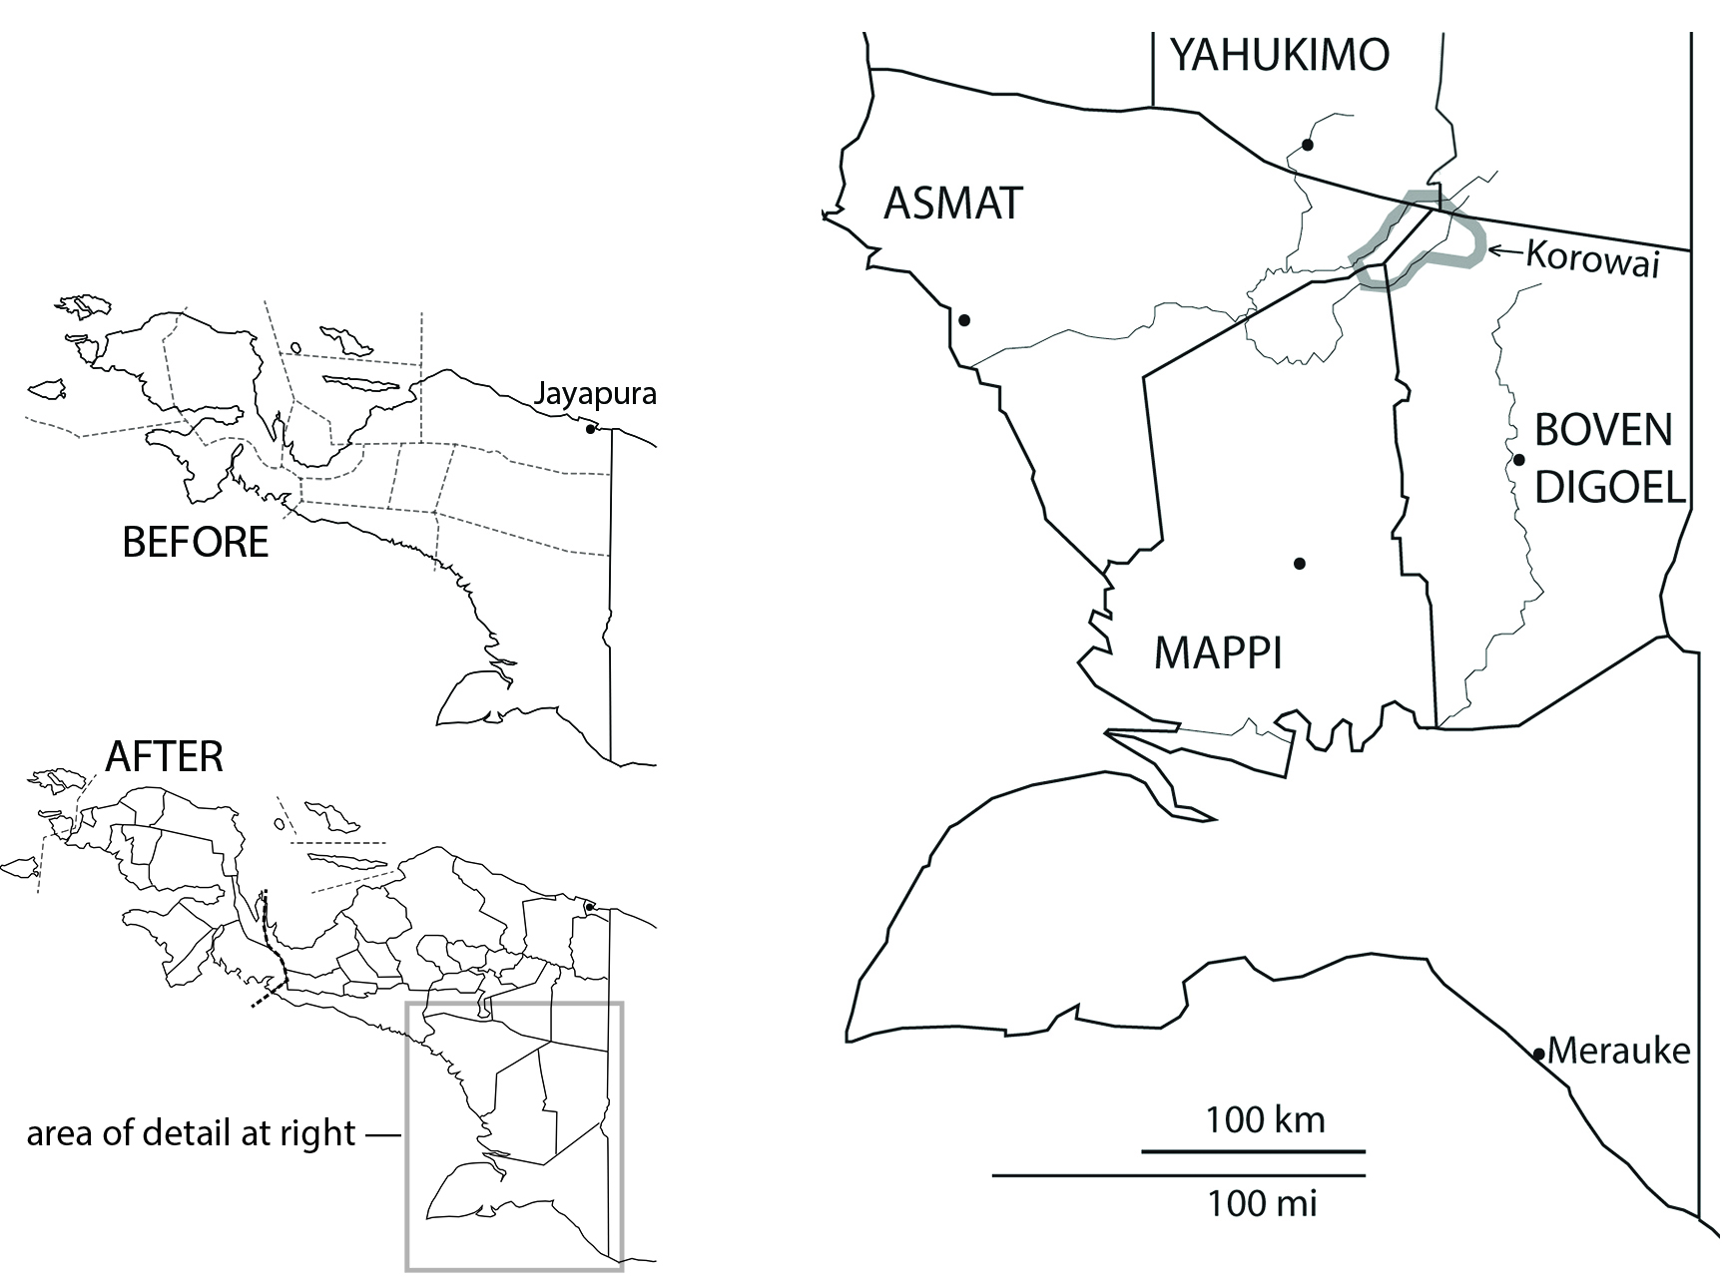
Figure 1: Left, Regency proliferation in Papua in the 2000s. Right, Korowai lands divided across four Regencies. Dots indicate Regency administrative seats.

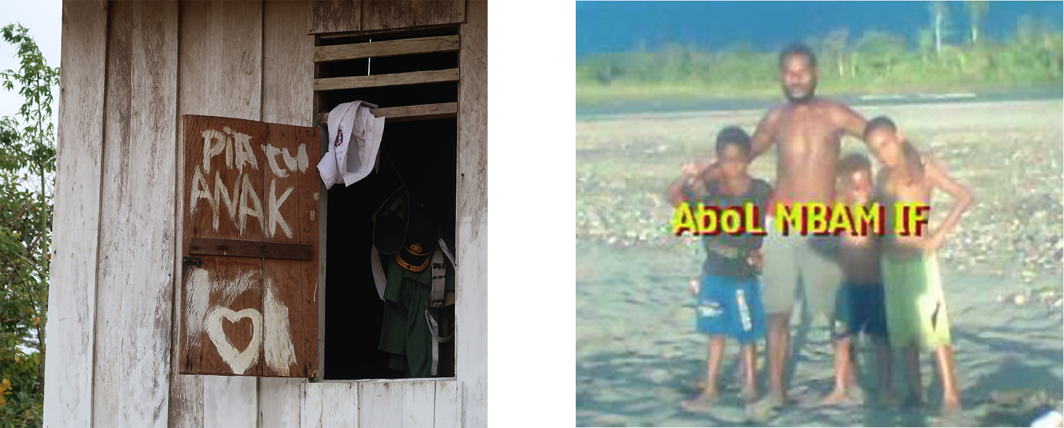

Figure 2: Left, window shutter reading ‘orphan child’ (Indonesian words in Korowai order), Mabül village, 2017. Right, Korowai text ‘this is orphan child’, superimposed over a riverside photo of boys near Yaniruma, posted to Facebook in 2018.
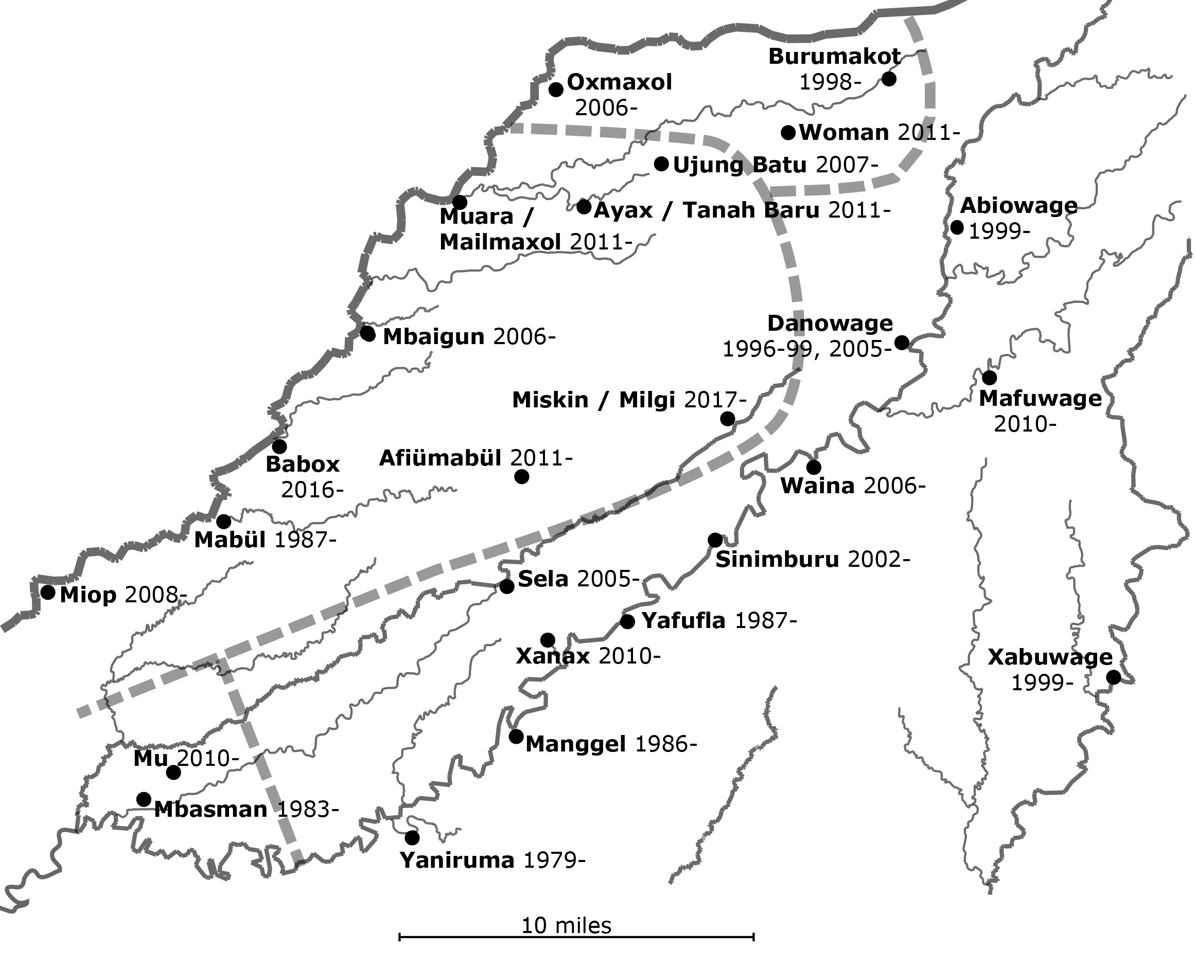

Figure 3: Selected Korowai villages, circa 2017. Dashed lines indicate differences in direction the villagers travel to reach their Regency seat.

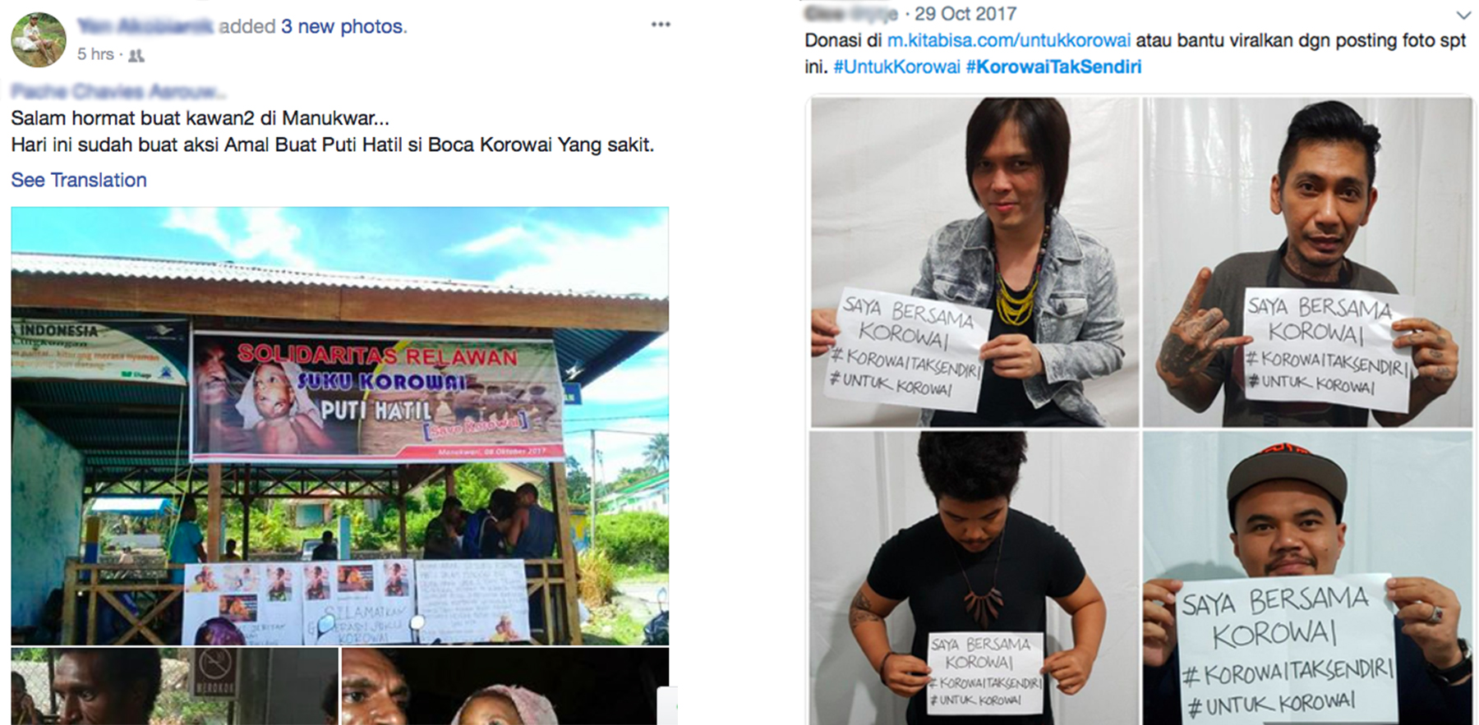
Figure 4: Left, a Papuan activist’s Facebook post about a roadside aid drive in Manokwari. The banner reads ‘VOLUNTEER SOLIDARITY / KOROWAI TRIBE / PUTI HATIL’ over a photo of Puti. Press accounts reported this stall to have raised US $1,000. Right, a Twitter post by a socioeconomically elite woman on Java, promoting another social media post by participants in a Kickstarter-style campaign, who each hold the text ‘I am with Korowai / #Korowai are not alone / #for Korowai’. The US $13,000 raised by this campaign was donated toward costs of a January 2018 mission-organized, helicopter-supported measles vaccination campaign.
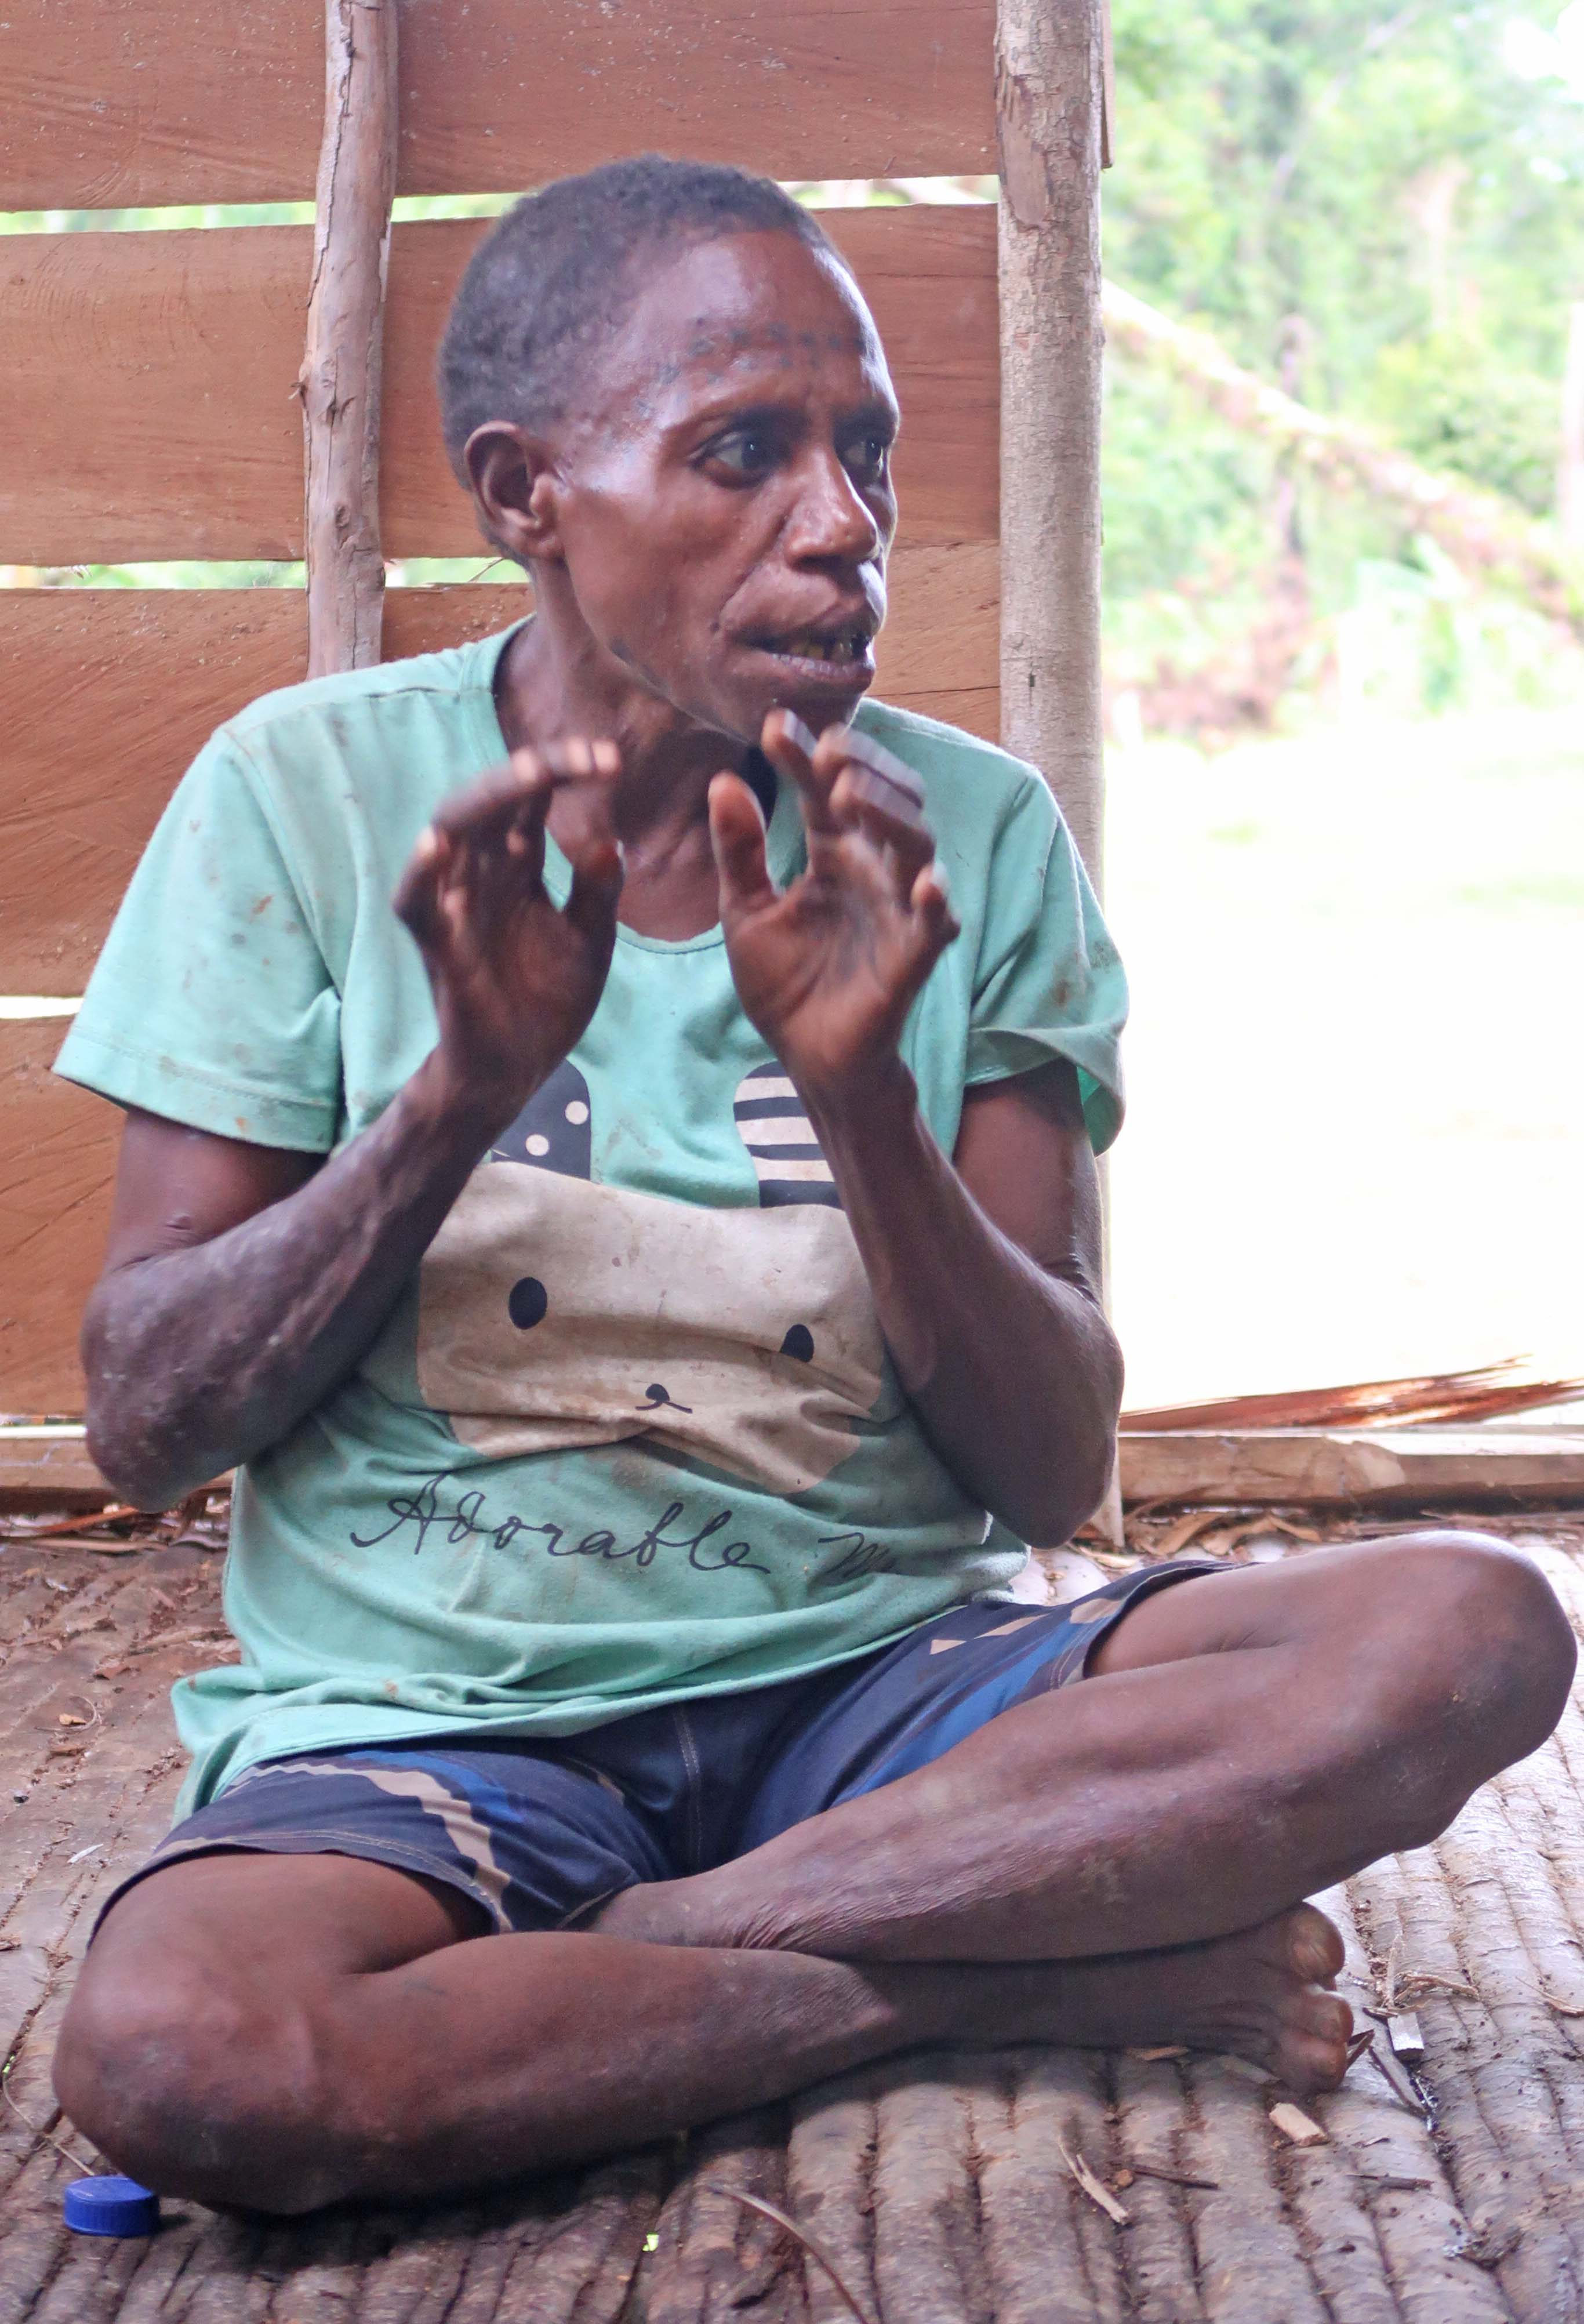
Figure 5: Puti’s grandmother Lajop, early 2018

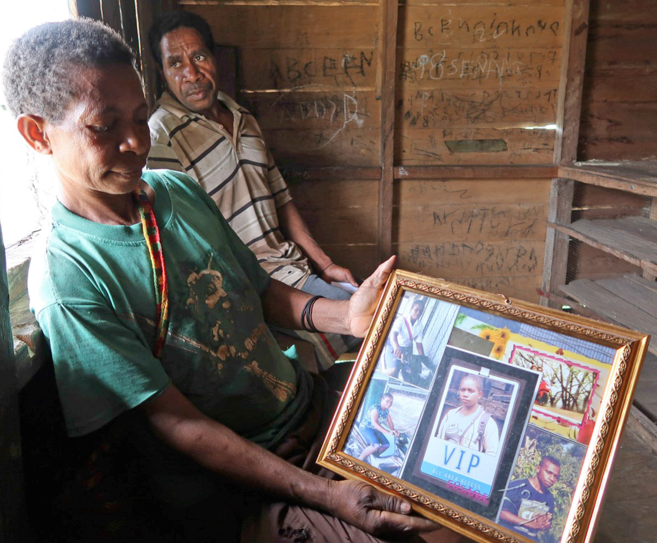

Figure 6: Pisanopeni Ngohoni and her husband, 2017, in Yaniruma village, with photos of their daughter and son who were attending school in towns a hundred kilometers from home (as was a third son, not pictured). The frame and some photos were given by the Indonesian storekeepers with whom the daughter lived.

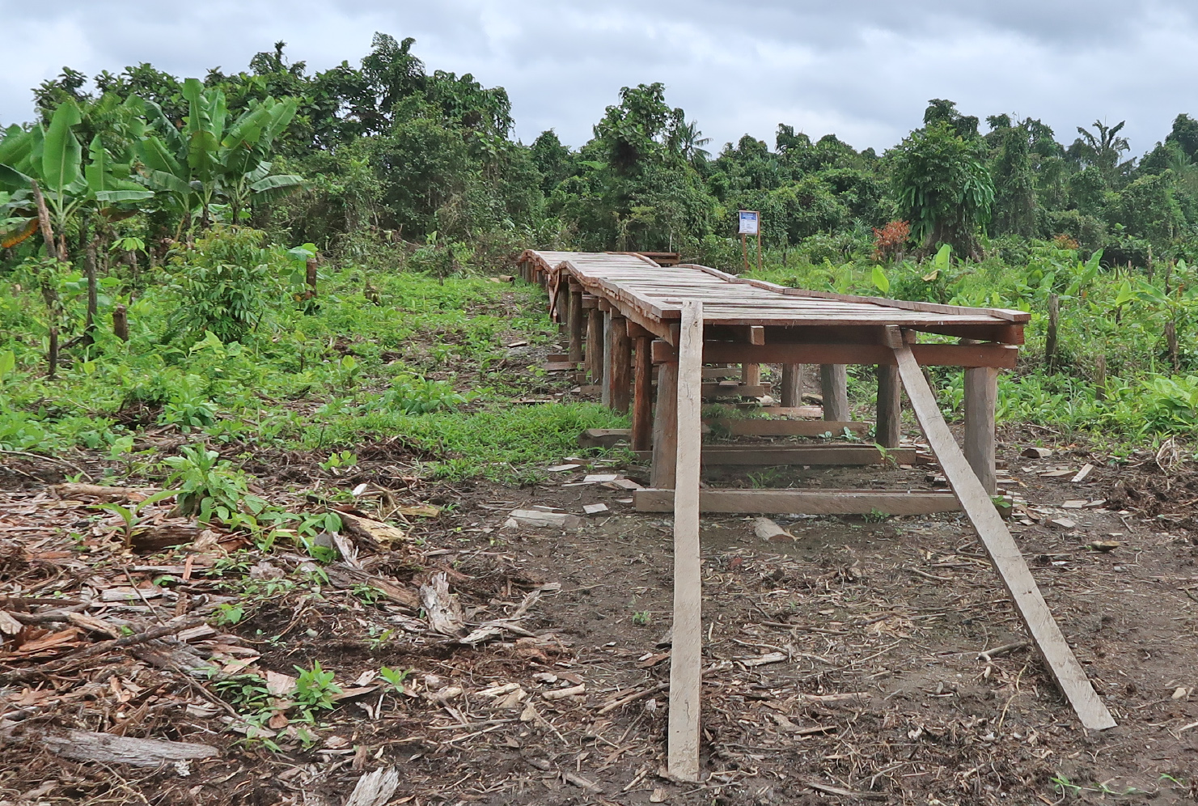

Figure 7: Plank walkway from village lane toward boat landing in Muara, ending short of the riverbank, August 2017.

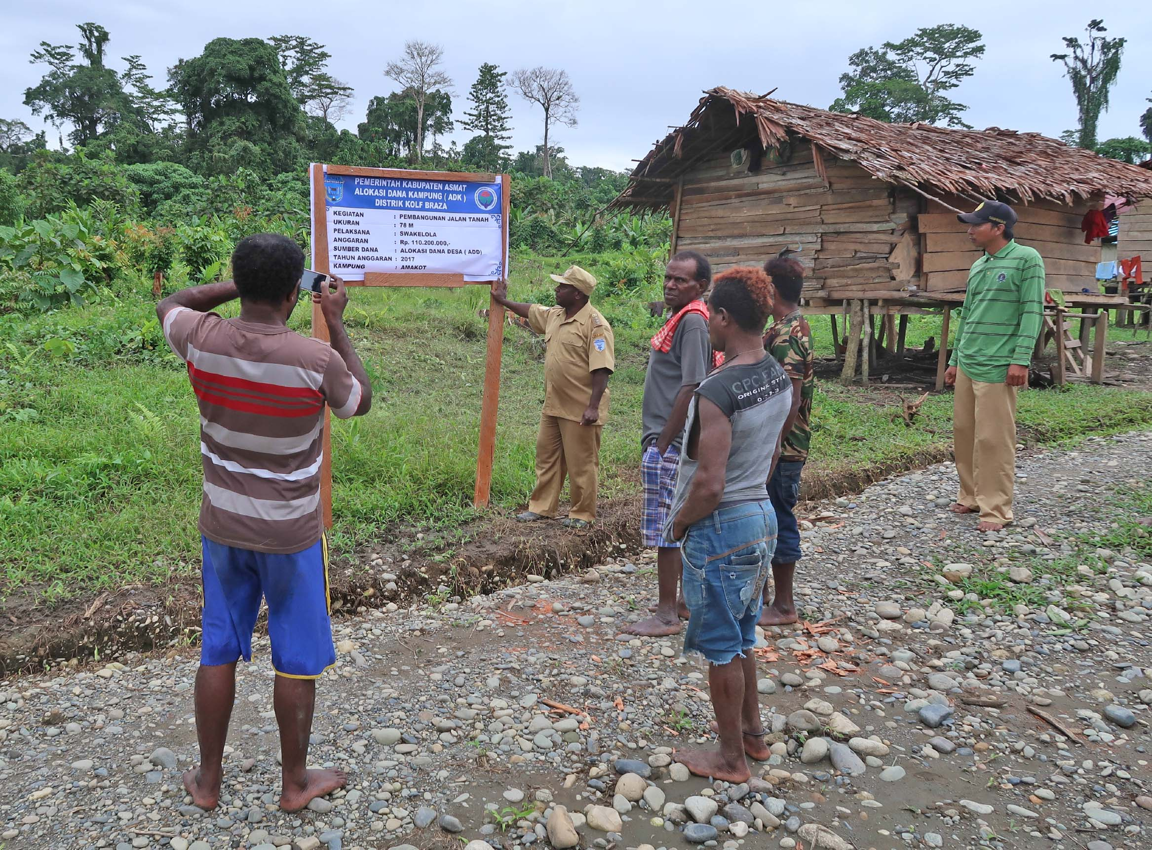

Figure 8: A sign with funding information, sent from a Regency for display next to the project, a new village lane in Muara, August 2017. The District Head from Mabül, a Mandobo Papuan man, is being photographed at the work site, for upward reporting back to the Regency.

Figure 9: Photo on phone of Fenelun Malonggai of US $50,000 brought from the Regency by the Village Head of Yaniruma in early 2017, meant for village development projects and direct distribution to villagers.

‘Last Cannibals’, 60 Minutes, Channel 9, 21 May 2006. See www.youtube.com/watch?v=LTRvcROcWHg, or transcript at www.abc.net.au/mediawatch/transcripts/ep3260m.pdf, both accessed 28 March 2020.
For an overview of the initial affair, see the 18 September 2006 episode of Media Watch (www.youtube.com/watch?v=sABtF-WwDFY and www.abc.net.au/mediawatch/episodes/why-7-ate-9-or-wawas-tv-dinner/9975806, both accessed 28 March 2020).
See for example the Australian press regulator’s censure of the channel that worked with Raffaele on rescuing Wawa, for its later broadcast of his statements about an Amazonian group (www.theguardian.com/media/2014/jun/25/channel-seven-provoked-racism-against-brazilian-tribe-court-rules). In mid-2006, a fact-checker from Smithsonian Magazine was surprised by my claim that the following passage from a draft Korowai-focused travel narrative by Raffaele was racist: ‘Kilikili is the scariest-looking human being I’ve ever seen. His dark eyes are empty of expression, his lips are drawn in a grimace and he walks as soundlessly as a shadow’. The word ‘dark’ was left out of the published story. Raffaele’s numerous publications about Korowai focus on cannibalism above all else. A typical turn of his discourse occurred just after he and Robson had been deported from Indonesia, when a friendly reporter asked him over satellite video link to explain the background to their unsuccessful rescue trip, and he began: ‘In April, I took a 60 Minutes crew into the cannibal area…’ (Today Tonight, Seven Network, 15 September 2006, video file in author’s possessions).
Sunday Night: True Stories, Channel Seven, ‘Jungle Child’, 27 October 2019. See www.youtube.com/watch?v=1nzpS-6IBDk and 7plus.com.au/sunday-night?episode-id=SNIT19-048, both accessed 28 March 2020.
Across this article, I italicize Korowai words while underlining Indonesian ones.
For a color piece on James and Aileen Riady’s philanthropy in Papua, including a 2019 visit to Danowage, see entrepreneur.bisnis.com/read/20190301/52/895093/pedalaman-papua-sisi-lain-james-riady (accessed March 28, 2020).
Small Jayapura-centered networks of Papuan activists of Papuan student activists had already since at least 2016 been drawing attention to needs for improved health and education provision in the Korowai area. For example, at the end of March 2017 (six months before the Puti affair), a network organized a small demonstration at the provincial Department of Health Office, featuring a truck-borne banner that read ‘Korowai Health and Education Emergency: Where are You ???’ beneath portrait photos of President Jokowi, three national cabinet ministers, the governor of Papua province, heads of the provincial health and education departments, and the heads of four Regencies.
For a good sample of some of the humanitarian and social media mobilization around Puti, as well as a narrative of the overall affair, see the account by missionary Trever Johnson titled ‘Going Viral in Papua’ (https://myemail.constantcontact.com/News-from-Indonesia---November--Trevor-and-Teresa-Johnson-.html?soid=1104052160003&aid=nabeNF2imd0, accessed 14 April 2021). For greater detail see also his accounts of ‘three forgotten people’ of the Puti affair (e.g. the installment at https://en.jubi.co.id/baby-kana-three-forgotten-people-in-the-story-of-puti-hatil-and-korowai-part-3/ or the full text at https://papuabarat.kabardaerah.com/2017/12/31/tiga-orang-yang-terlupakan-dalam-kasus-sakitnya-anak-puti-hatil/, both accessed 14 April 2021).
In early 2018, Puti’s story was dwarfed nationally by measles-related deaths of many malnourished Asmat children, which Jakartan politicians more fully understood to threaten state legitimacy.
The expression jadi orang ‘become a person’ is used widely across Indonesia in similar patterns, but does not as pointedly evoke a boundary of human and less-than-human as does jadi manusia ‘become human’.
In the Puti affair, the nation-state also sometimes operated in a more affirmative mode. Non-Papuans often told me that upon seeing Puti’s photo, they had thought of the Indonesian nation as a condition of prosperity they lived in, and it dismayed them to learn there could exist a child so outside the nation’s support as to suffer that way. Collecting aid for Korowai was sometimes a performance of this aspirational script about the nation-state (just as for independence-minded Papuans it was a performance of a condition of disappointment and distress at the hands of that nation-state).
This is a reason why the new idea of humanitarian aid makes sense to Korowai, as testified by many otherwise monolingual Korowai speakers’ use of the Indonesian word bantu ‘aid, help’ in discussing their hopes toward outsiders. A widespread Korowai inference about the motivations of visiting tourists was that they came out of desire to divide out manufactured consumer goods, since they felt love and pity for Korowai as people who lack these articles.
However, see Timmer (2007) on the elite factional politics behind the subdivision campaign’s launch in Papua specifically, through declaration of a new province. See also Chauvel (2021:282-283) for one account of Jakartan politicians’ intentions of using province-creation to stymy Papuan collective mobilization.
Among one sibling set I have known for several decades, when the youngest brother completed high school and became a salaried schoolteacher in a Regency seat, his older siblings switched to addressing him as ‘father’, expressing their hopes of care from him. The teacher’s own dislike of this speech pattern could be read as a germinal experience of the more elaborated critical views about kinship interdependence in a different setting explored by Syndicus (this volume).
Korowai took the word’s usage much further than how kepala is used in Indonesian discourse. By 2000, the Korowai word for ‘head’ was also being prolifically used to refer to external tour guides, as well as to tourism specialists within the Korowai population who worked with those visiting guides as translators. Urban social order in general is imagined to consist entirely of relations between ‘heads’ and subordinates.
For example, in my September 2017 interview with administrators of the provincial governor’s signature ‘Golden Gate’ supplementary funding stream, overseeing a program of sending Papuans overseas for university study, they noted that the funds needed to be used carefully because they were ‘blood money’ (uang darah) for Indonesian military killings of Papuans. The previous day, during an interview with the head of the provincial Village Empowerment Agency overseeing the block grant process, I asked whether it would be a shock in rural communities when funding arrangements of Special Autonomy and related programs hit their sunset dates in 2021, and he suggested that as a matter of political realism the funding would have to continue at high levels because of the independence movement, a sensibility shared in various forms by many other participants in the now-unfolding media and legislative contests around this issue.

