Kastron, Rabaḍ and Arḍūn: the Case of Artanuji
Nicholas Evans
University of Oxford
Introduction
A famous passage in Konstantinos Porphyrogennetos’s De Adminstrando Imperio (DAI) tells the story of a Byzantine manoeuvre that almost went very wrong. In 923, two deaths exacerbated tensions between different branches of the ruling Bagrationi family in Iberia. On the death of Adarnase, his Georgian title of king, mep‘e of K‘art‘li, passed to his eldest son Davit‘. However, it was unclear who would receive his Byzantine court title of kouropalatēs, which was in the gift of the Byzantine emperor. At the same time, the death of the ruler of the kastron of Artanuji had meant that this crucial centre of Bagrationi power had passed into the hands of a certain Ashot ‘Kiskasis’ (‘the Nimble’). DAI tells us that Ashot the Nimble feared the rising power of his son-in-law Gurgen, who had himself been making overtures to the Byzantines. So Ashot decided to offer his kastron to the Byzantines. This appeared to present the Byzantine emperor Romanos Lekapenos with an opportunity to take direct control of a key potential strategic and economic outpost for Byzantine power in Transcaucasia.
However, when Romanos Lekapenos sent the Byzantine droungarios of the fleet, Konstantinos, to take up Ashot’s offer, it became clear that the balance of forces in Iberia had been badly misjudged. The sons of the deceased Adarnase initially suspected that the Byzantines were planning to hand the title of kouropalatēs to Gurgen. When they discovered the Byzantines intended to take over Artanuji directly, though, Gurgen and the sons of Adarnase threatened to “make common cause with the Saracens” in order to retake the city and inflict punitive raids into Byzantine territory. An attempt to exploit divisions between the Bagrationis to gain a stronger foothold in the region nearly had exactly the opposite effect. So the Byzantine forces rapidly withdrew, and the whole incident was blamed on the droungarios Konstantinos. The latter then escorted one of Adarnase’s sons, another Ashot, back with him to Constantinople for him to be invested with the title of kouropalatēs.
There are plenty of reasons to be wary of this account. A recurring theme of DAI is the ineptitude of the previous administration, of Romanos Lekapenos. At the same time, such criticisms are often used as the occasion for lessons in how to turn difficult situations around. For instance, Konstantinos suggests that if, when attempting to negotiate marriage alliances, barbarian rulers point to the precedent set by the marriage of Romanos Lekapenos’s grand-daughter to Tsar Petar I of Bulgaria, then the defence should be that Romanos was “a common, illiterate fellow, and not from among those who have been bred up in the palace, and have followed the Roman customs from the beginning”. The story about Romanos Lekapenos’s blunder over Artanuji provides a similar double function. The future emperor is being taught the tricks of blaming the previous administration and blaming subordinates – notably also shifting blame onto Konstantinos the droungarios – at the same time.
However, the interest of this passage for the purpose of the current paper is in its appraisal of the specific strategic significance of this particular kastron, called Artanuji in Georgian, Ardanoutzi in Greek, and now called Ardanuç in Turkish – its various names tell their own story. Jenkins provides the following translation:
The city (kastron) of Ardanoutzi is very strongly defended, and has moreover a considerable suburban area (rapatin) like a provincial city (chōropolis), and the commerce of Trapezus and of Iberia and of Abasgia and from the whole country of Armenia and Syria comes to it, and it has an enormous customs revenue from this commerce. The country of the city of Ardanoutzin, the ‘Arzyn’, is both extensive and fertile, and it is a key of Iberia and Abasgia and of the Mischians.
This Constantinopolitan appraisal of the significance of the kastron of Artanuji emphasises its excellent defences, its landed wealth, and its location on key commercial and, we might infer, military routes. It is easy to take this at face value. It seems obvious that Artanuji was well placed to be a key node for transportation of goods between Trebizond, the key outpost of Byzantine commerce on the south-east Black Sea coast, and the Transcaucasian interior, Islamic trade from the south, and Abasgian trade, with its links to the long-distance trade from across the Caucasus Mountains to the north.
However, a different impression is produced by photographs of the site of Artanuji. The description of strong defences is easy enough to understand when looking at this rocky outcrop, set in a steep valley. However, the attractions of this valley, and of the mountain valleys to which it connects, for easy travel, let alone extensive agricultural cultivation, seem less self-evident. Indeed, contemporary Georgian sources, which provide descriptions of the region a few decades beforehand, emphasise that the significance of Artanuji and its surrounding regions was by no means geographically predetermined.
So how did this urban development and its associated territories become so politically and economically significant by the mid-tenth century? And exactly what kind of urban development was this kastron? Moreover, what then of its Arabic-sounding rapatis and ‘Arzyn’? To answer these questions it helps to place the problem in three contexts. The first concerns the Iberian Bagrationis; the second concerns Georgian monks. The third context is that of the Islamic political, fiscal and trade systems to which Konstantinos’ text appears to allude with its strange terminology. This terminology may in turn provide a clue to a source of information for chapter forty six of DAI.
The Iberian Bagrationis
In the early-tenth century the Iberian Bagrationis were a rising power in the south-west Caucasus, beginning their ascent to become “rulers of the major power in Eastern Anatolia and the Caucasus at the beginning of thirteenth century”. Having migrated from Armenia in the second half of the eighth century, a branch of the Bagrationi family had established itself as the rulers of south-western Iberia, of which Artanuji became the centre. The eleventh-century Georgian History of Sumbat Davit‘is-dze places particular emphasis on the “rediscovery” of Artanuji by the early-ninth century Ashot the Great:
And this Ashot kouropalatēs discovered in Klarjet‘i, in a forest on a rock, the place where Vaxtang Gorgasali first had erected the fortress named Artanuji; and it had been destroyed by Qru “of Baghdad.” Ashot restored it and built a fortress in front of it. And near its base he built a city. And within the fortress he erected a church [in honour of] the holy apostles Peter and Paul and prepared his sepulchre there, and he settled his residence in that fortress.
The narrative uses the city to link the Iberian Bagrationis with the legendary late-fifth to early-sixth century Georgian king Vaxtang Gorgasali. The narrative device also suggests Ashot foresees the future rise of his dynasty. Ashot prepares a burial place for himself, and a stronghold for his infant sons for after his death. These would allow them to hold out when other lands that he had conquered were taken back into Muslim control in the early-ninth century. It is notable that Konstantinos Porphyrogenitos’s account of the bipartite structure of the city is mirrored here, and the priority of the kastron over the rabaḍ is asserted. However, the development of the latter is projected back to Ashot’s rule, and there is no hint in this source of the influence of Islamic models on the city’s urban development. As we shall see, this may be misleading.
It is clear that Artanuji was a crucial centre of Iberian Bagrationi power, and was perceived as such. However, there was no unitary centre. Power was distributed within and between branches of the Iberian Bagrationi family. The first line was split between Gurgen’s branch and that of his father-in-law of Ashot the Nimble. Gurgen held the title of erist‘avi of erist‘avis (“duke of dukes”), and is described as a particularly prominent military leader in the History of Sumbat Davit‘is-dze. Meanwhile, Ashot the Nimble’s branch of the first line had traditionally held Artanuji itself. At the same time, different members of the second line, to which Adarnase and his sons belonged, could hold the Byzantine court title of kouropalatēs and, from the time of Adarnase, the restored Georgian royal title of mep‘e.
The territorial holdings of the Bagrationi princes, the archontes of Byzantine sources who came into the sphere of interest of the mid-tenth century Byzantine chancellery, have been reconstructed by Bernadette Martin-Hisard. Chapter forty eight of book two of the De Ceremoniis, attributed, like DAI, to Konstantinos VII, includes a list of Iberian archontes in addition to the kouropalatēs. Like the De Administrando, this text makes no mention of the mep‘e, but it does mention archontes of Beriasach, Karanates, Kouel and Atzara. Martin-Hisard identifies these as Upper Tao, Taos-kari, the fortress of Q’veli and Achara, respectively. Upper Tao and Taos-kari lay to the south of Artanuji, while Q’veli and Achara lay to the north. The territories to the south, closer to the emirate of Qālīqalā, Byzantine Theodosioupolis, were in the hands of the second line. Chapter forty five of De Adminstrando reveals that both Romanos Lekapenos and Konstantinos VII pressed the members of this branch of the Iberian Bagrationi family to provide more assistance against Qālīqalā.
The territories to the north were divided between the two branches of the first line. In 923, the fortress of Q’veli was probably already controlled by Gurgen, the son-in-law of Ashot the Nimble. Gurgen would subsequently offer this fortress to Ashot, referred to in the De Administrando as Tyrokastron, in return for Artanuji. Meanwhile, the territory of Achara, which marched with the easternmost districts of the Byzantine theme of Chaldia, was in 923 in the hands of Ashot’s uncle, Davit‘. The refusal of the latter to give his territories to Konstantinos the droungarios in that year would be one of the factors in the collapse of the latter’s attempt to take over Artanuji.
It is important to note that women played a crucial role in these dynastic politics, in which intermarriage helped to create ties and further tensions between different branches of the family. The daughter of Ashot the Nimble and wife of his rival Gurgen is a case in point. She would subsequently emerge as a significant political figure in her own right. After the death of her husband Gurgen in 941, who had in the intervening time taken control of Artanuji as her father had feared, she would attempt to take control of the kastron herself. Although this was unsuccessful, she still had to be placated with grants of other territories.
The distributed system of power and complex dynastic politics were both the cause and product of the fact that the Iberian Bagrationis looked both ways: towards consolidation of local power, and towards creating links with imperial centres. The title of kouropalatēs was a Byzantine court title, and could not technically be inherited from father to son without an official appointment from Constantinople. However, chapter forty six of DAI makes it clear that the Iberian Bagrationis took steps to ensure that they should determine who received the appointment. When Konstantinos the droungarios was on his way to Artanuji, the four sons of the previous kouropalatēs, Adarnase, feared that he was on his way to bestow the title on their rival Gurgen and confronted him. It is unclear exactly whom Romanos Lekapenos did have in mind for this honour, but after the crisis at Artanuji, the Byzantines’ hands were forced, and it was Ashot, son of Adarnase, who went back to Constantinople to receive the title.
Clearly, control of the title of kouropalatēs was important to Iberian Bagrationis. However, this was not the only honour available to members of the Iberian Bagrationi family. Adarnase’s oldest son Davit‘ plays a significant role in Konstantinos Porphyrogenitos’s account. His title is given in DAI as magistros – what is not mentioned in the Byzantine source is that he was also the king, or mep‘e of Georgia (K‘art‘li). An inscription that refers to these brothers from the Georgian cathedral of Ishxani indicates this was considered the senior title. The inscription dates from 954-5, just before Smbat took the title of kouropalatēs, following the death of his brother Ashot, but is describing the consecration of the bishop of Ishxani in around 937. The inscription mentions the four brothers’ father Adarnase, and refers to him by the title of mep‘e. Meanwhile, the order in which it lists the brothers is revealing:
[…] After him by the orders of our glorious [and] worthy kings | – may they be exalted by God – Davit‘, King of the Georgians, | Ashot Kouropalates, Bagrat Magistros <and Sumbat | Antipatrik> dispatched to Trebizond in Greece [Saberdznet‘s Trapezont‘a]| our honourable, worthy Father Stepane […]
The inscription makes a point of mentioning the Byzantine titles – for antipatrik we should read anthypatos, although the Georgian appears to associate the title with the title patrikios – but it accords the local royal title of mep‘e equal or higher status. A few lines later, the inscription also puts a surprising local reading on church hierarchy, with a reference to a Greek “Patriarch Basili” in Trebizond. This is doubly surprising, since no patriarchate in Trebizond existed, and it would seem more normal for an Iberian bishop to have been consecrated by the Iberian katholikos of Mc‘xet‘a. This is not, then, straightforward evidence for either Byzantine dominance or Iberian autonomy. This re-interpretation of the ecclesiastical hierarchy of the imperial church indicates a local negotiation between Iberian Bagrationis and Trapezuntine churchmen that appears to have contradicted the official norms of Iberian and Byzantine churches alike.
The picture of the hierarchy of royal, court and ecclesiastical titles that emerges from the Ishxani inscription can in turn be set beside a list that appears in the Georgian Life of Grigol of Xandzt‘a, written by a monk of the monastery of Xandzt‘a in 951. In the concluding pages of the Life we read:
Our Blessed Father Grigol passed away when the number of his years had reached 102, in the 81st chronicon (861 A.D.). His vita was written 90 years after his death, in 6554 A.M.: when Agathon was Patriarch of Jerusalem, when Mik‘ael was katholikos of Mc‘xet‘a, when kouropalates Ashot, son of Adarnase, the king of the Georgians, ruled over us, the Georgians, when Giorgi, son of King Konstantin, ruled over the Abkhazians, when Sumbat, son of King Adarnase, was erist‘avi of erist‘avis, when Adarnase, son of Bagrat magistros, was magistros, when Sumbat, son of mamp‘ali was erist‘avi.
We therefore learn that Ashot kouropalates had inherited the title of mep‘e from his brother Davit‘ after his death in 937. Sumbat, son of Adarnase, is given his local title of erist‘avi of erist‘avis, rather than his Byzantine court title of anthypatos. There is no mention of the Trapezuntine or Constantinopolitan clergy here: the head of the Georgian church is named, and its link to the church in Jerusalem, which is a recurrent theme in the Life, is alluded to. Unlike the Ishxani inscription, this list includes members of different branches of the Bagrationi family, and not simply the sons of Adarnase: Sumbat, son of Davit‘ the mamp‘ali belonged to the Klarjet‘i branch of the family.
The question of these titles raises an important point about the relationship between the city of Constantinople and other cities such as that of Artanuji. Both personally and politically, there was much to be gained for rulers and aristocrats in frontier regions from titles and offices that enabled them to secure and maintain access to Constantinople, and to privileged treatment when resident. When necessary, the emperor could go further still, offering not only salaries and gifts of movable wealth, but also grants of Constantinopolitan real estate as a tool in tying Transcaucasian princes to the empire –a deliberate strategy “to excite in other princes of the east a similar eagerness for submission to the Romans”. However, the way in which the emperor was able to use such strategies was constrained by local politics and the concrete control of kastra such as Artanuji in the locality. When his control of Artanuji became insecure, Ashot the Nimble may have hoped to exchange his kastron for a comfortable life in Constantinople; but when the Byzantines discovered the real balance of forces, Ashot found himself retiring to the territories of his brother-in-law in Abasgia, rather than to the Byzantine capital.
Georgian Monks
A certain monk called Agapios of Kymina plays a crucial role in the De Administrando’s account of the events surrounding the attempted take-over of Artanuji. The passage reports that Agapios visited Artanuji on his way back to his monastery near Constantinople, returning from a pilgrimage to Jerusalem. It was Agapios who took the news back to the Byzantines that Ashot was keen to surrender his city. Monks such as Agapios created a network of connections between the cities of Byzantium, Transcaucasia and the Near East. Rosemary Morris emphasised the connections between monks and laymen in southern Italy and the Byzantine heartlands further east on the grounds of common language and inclusion within the borders of the empire; the case of the Georgian monks illustrates that relations between monks and laymen in the period permeated both linguistic and administrative frontiers.
The specific itinerary taken by Agapios reflected the close ties between Georgian and Palestinian monasticism. The Life of Grigol of Xandzt‘a indicates that Georgian monks in the period were looking both ways. The naming of Agathon as Patriarch of Jerusalem is one indication. Another appears nearer the opening of the Life. Prior to the founding of the monastery of Xandzt‘a, monks had travelled both to Jerusalem, in order to copy the taktikon of the famous monastery of Mar Saba, and to Constantinople, in order to collect relics, books and vestments for the new monastery. The Life also contains a letter sent from some of Grigol’s pupils, now monks at Mar Saba, delivered to Grigol by a Greek priest called Moisei. The “personal commitment and the administrative support upon which orthodox monasticism was built” did not simply depend on the monks and laymen who lived in the Byzantine heartlands. The connections between monastic communities outside the Byzantine Empire, including those in territories controlled by Muslim rulers, were also crucial.
Nevertheless, Bernadette Martin-Hisard has drawn attention to the fact that monks played a much larger role here than that of mere go-betweens. The Life of Grigol of Xandzt‘a tells the story of the development of a flourishing group of monasteries in the region of Klarjet‘i, of which Artanuji was the capital. Grigol is described as having turned “deserts into cities”. This metaphor, although a topos going back to the Life of St. Antony, has literal meaning. Grigol’s appraisals of the natural resources, the potential for the development of a material base for his monastic communities, are a constant theme of the Vita. On finding the site of the future monastery of Xandzt‘a, he carefully weighs up the benefits: warm sun, but not too hot, a spring, and good quality timber. He emphasises that it is secluded, and that it lacks potential agricultural land or pasture, but it is obviously not completely cut off from access to these kinds of products:
[…] there is no pasture to be mown, nor wheat fields to be ploughed, and therefore food is brought on the backs of donkeys with great difficulty. Yet there is wine, which has been planted by the brethren with utmost toil and hardship, and there are also orchards […]
The series of monasteries Grigol had created was developing a network of marginal lands, turning “deserts into cities”.
The Life is also explicit about the role of private patronage from beyond the immediate Bagrationi family, with the crucial role of the magnate Gabriel Dap‘anchuli in turning over resources in land and people, including a set of master masons, to the direction of the monks. Dap‘anchuli stipulates that his male relatives should receive prayers and be buried there; and provided further material means for the construction of a convent at Gun‘atle, under the supervision of the abbess Febronia, for his female relatives. The concluding pages of the Life, where the list of titles of the Bagrationis is found, also notes the continued involvement of the Iberian nobility, or aznauris, in the monastic network: “in the monasteries built by Our Blessed Father Grigol, the abbots were the sons of the great aznauris”.
The role of private patronage in the development of this monastic network in ninth- to tenth- century Iberia is significant. There are old debates about the extent to which during this period western Europe and Byzantium experienced similar processes of extension of aristocratic control over land, resources and people, in which monastic development in particular played a key role. Some years ago, Alan Harvey argued that the debate about Byzantine agrarian history had been shaped by an excessively “Constantinopolitan perspective”, which obscured similarities with the process of extension of aristocratic control over land, resources and people underway in the west. The evidence of the region around Artanuji suggests that, notwithstanding the distinctive features of the Transcaucasian nobilities, it would be useful to set this in a regional context that looks east as well as west.
Islamic contexts
The History of Sumbat Davit‘is-dze links Artanuji with the rise of the Bagrationi rulers of Iberia, starting with Ashot the Great at the beginning of the ninth century. The Life of Grigol, meanwhile, emphasises the role of monastic colonization in creating the conditions for regional development. However, both the official princely history, and the hagiography, obscure a third and crucial element.
We read in the DAI that the majority of the Iberian Bagrationi princes were prepared to “make common cause with the Saracens” in order to prevent direct Byzantine intervention into their territories, and of the close trade links between Artanuji and Syria. We have also noted the specific vocabulary Konstantinos uses to describe the city, referring to the rapatis and the Arzyn. These, it has been suggested, are Greek transliterations of the Arabic words rabaḍ and arḍūn respectively, the latter being the plural form of the Arabic word for land, arḍ.
In the context of Islamic cities, the rabaḍ is usually taken to refer to a commercial and artisanal sector that lay outside the walled madīna. In the context of the Muslim conquests in the east, Hugh Kennedy has gone so far as to argue for a paradoxical process of “decastellamento”, where the rabaḍ became the functioning centre of urban life. The evolution of towns under Muslim control in the Caucasus had a different trajectory, but commercial and artisanal sectors of the rabaḍ type did develop outside the walls of Tbilisi. It seems likely that the development of such a sector existing on the hillside below the fortress of Artanuji was influenced by Islamic models reflected in its name.
This might be seen as part of a regional development that influenced settlements within the Byzantine Empire, with the growth of centres where large numbers of Muslim merchants gathered. The contemporary geographer, Ibn Ḥawqal, tells us merchants from across the Islamic lands gathered in Trebizond before travelling to or from Constantinople. He also talks about the “immense wealth (māl) and extensive tax-farms (ḍamān)” that the Byzantine emperor’s agent was able to draw from this commerce, and notes that “these are now much more than they were in the past […]”. This passage corroborates the DAI account of Artanuji in indicating why close links with Trebizond would have been a source of wealth specifically in the tenth century. It also indicates the increasing importance of local actors: the implication is that the Byzantine Emperor’s agent was in a position to gain significantly greater personal wealth than earlier. The grand claims made by Trebizond’s churchmen, as implied by the Ishxani inscription, may have its basis in the growing material power of local elites.
What then of the Arabic word arḍūn for the chōra of Artanuji? Here the History of Sumbat Davit‘is-dze gives us a clue despite itself. After the account of the death of Ashot the Great, which it dates to 826 as opposed to other sources claim of 830, it describes the fate of his sons during a period of Muslim re-conquest of all the “exterior lands” which their father had conquered. In the Shavshet‘i, Klarjet‘i, and Nigali valleys, we learn, “everyone paid tribute to the Saracens. Yet on the other side of Artanuji they occupied their ancestral estates of their father: they installed Bagrat as kouropalatēs, and God granted him the authority to rule”.
This eleventh century text then appears to recognise a distinction between “exterior” and “ancestral” lands: between the lands from which revenue was drawn in the form of tribute, including the Shavshet‘i, Klarjet‘i and Nigali valleys, and the personal hereditary holdings of the Bagrationi princes in Tao to the south. The “ancestral” lands in Tao to the south were held by the second line, the descendants of Bagrat the kouropalatēs, while the territories controlled by the first line were concentrated in precisely those regions which are here described as having formerly been subjected to Muslim taxation. Artanuji lay in the centre of these territories.
A narrative of “reconquest” of the exterior territories may mask a less glorious reality. During a general period of fiscal decentralisation and the declining power of the ‘Abbāsid caliphate in the region, in the later-ninth or early-tenth century Bagrationis took over a system of revenue collection that had been established by Arabic-speaking literate administrators, or kuttāb, for their previous Muslim masters. These kuttāb used the Arabic word arḍūn to refer to the “exterior lands” which Konstantinos describes as so extensive. Artanuji, in operating as the central place of this revenue collection, not just from commerce, but also from agricultural production, would have relied upon the assessments made by kuttāb who worked for other masters not so long before. The source of this surprising vocabulary in DAI may originate from this context. In fact, around the time of the events described in chapter forty six of the DAI, did one such kātib, incorrectly sensing a further change in masters from the Bagrationis to the Byzantines, provide the Byzantines with the information on which Konstantinos is drawing here?
We have already seen how Agapios of Kymina could act as emissary, pilgrim and monk at the same time, working for different masters as he moved between Transcaucasia, the Islamic world and the Byzantine Empire. An earlier figure who is described shifting between different roles and different masters appears in the Life of Grigol in the form of the deacon by the name of Ts‘kir. The Life explains that this deacon was “trained in Tiflis by the amīr Sahak, the son of Ismael” (Isḥāq b. Ismā‘īl), before being sent as an ambassador to Ashot the Great. On the death of the bishop of Ancha, in Klarjet‘i, Ts‘kir asked Ashot to appoint him as the new bishop. The Life reports that Ts‘kir’s wish was granted, and that Ts’kir then proceeded to abuse his position, and even attempt to murder Grigol. Through the intervention of the latter, Ashot was persuaded to appeal to the catholicos of Mc‘xet‘a to call a council and strip Ts‘kir of his post, following which the latter was sent back to Isḥāq, who then made Ts‘kir bishop of Ancha once more. This, then, is a mid-tenth century text describing a career which involved training at the court of the Muslim ruler of Tiflis, responsibility as an emissary at the court of the Iberian Bagrationi kouropalatēs, and appointment to ecclesiastical office by both.
Conclusion
This paper has argued that the wealth and significance of the kastron, rabaḍ and arḍūn of Artanuji that so impressed the Byzantines in the mid-tenth century was by no means predetermined. It was the product of three sets of factors.
The first was the increasing political and military significance of the Iberian Bagrationis. These had established a regional base around Artanuji, to the south-west of the traditional heartlands of K‘art‘li in the late-eighth century, but this only took on real significance once they were able to take advantage of the weakening political power of the caliphate in the second half of the following century. They did this by looking both ways, tying themselves in to Byzantine urban networks, but also consolidating local independence. This was both cause and product of their complex and often fractious intra-familial politics.
Secondly, monastic colonisation played a crucial role in developing the core territories around Artanuji. Monks provided links to an urban network from Constantinople to Jerusalem, and at the same time were able to persuade local aristocrats and rulers to turn over land, people and resources to them. Sources such as the Life of Grigol or the History of Sumbat may exaggerate the depredations caused by the Muslims, and hence the under-development or even de-development of the area in the preceding period. However, there can be no doubt that the extensive programme of monastic colonisation undertaken helped to bring more people and territories under the direct control of elite landowners.
Thirdly, while the rise of Artanuji may have been connected to the political weakening of ‘Abbāsid power, the commercial and fiscal infrastructure developed during the ‘Abbāsid period was central to the development of Artanuji subsequently. This appears to have been recognised by Konstantinos VII, but is unsurprisingly underplayed in the Georgian sources. Nonetheless, the same sources provide clues about the way the Iberian Bagrationis might have taken over systems of taxation from the caliphate and the emirs of Tiflis, making use of the expertise of those who may have received their training in the Muslim administration.
There is a wider implication of this story about the City and the Cities and urban development in the tenth century. The weakening of ‘Abbāsid power in the late-ninth and early-tenth centuries left in its wake a vibrant economy and a series of political crises. The offer of Artanuji from Ashot the Nimble had seemed to provide the empire with an opening to take advantage of both the economic and political opportunities resulting from this situation. The significant attractions of the City no doubt weighed heavily in Ashot the Nimble’s mind when he made his offer. Yet it turned out this was a world in which the Byzantines would also be confronted by assertive regional elites. For all the increased influence and military successes the Byzantines would see over the following century, the future in eastern Anatolia and Transcaucasia, would be shaped by monks and laymen with deep local roots and connections with a world by no means mediated by Constantinople alone.

Figure 1: Artanuji exterior, looking northeast. Source: Edwards (1986), Fig. 21.
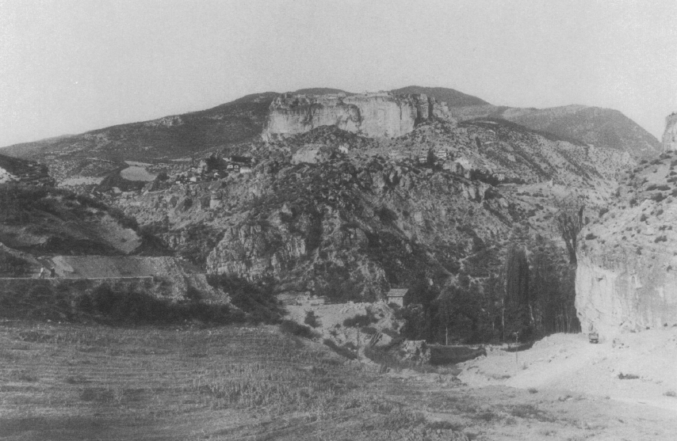
Figure 2: Artanuji exterior, looking northwest. Source: Edwards (1986), Fig. 23.
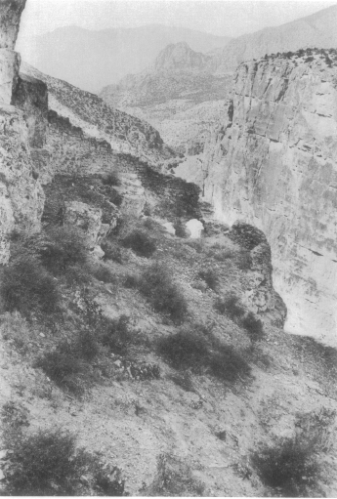
Figure 3: Genealogy of Iberian Bagratids, based on Rapp (2003) and Toumanoff (1976).
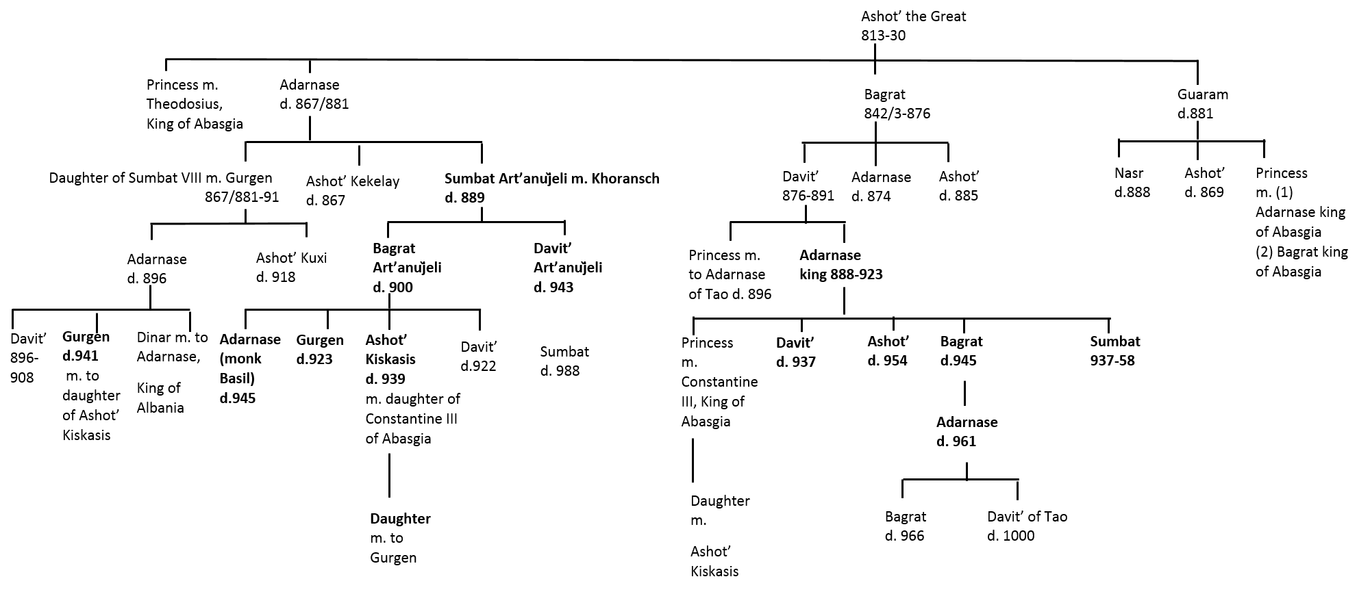
Figure 4: Map of western Caucasia in the tenth century. Source: Martin-Hisard (2000), p. 530.
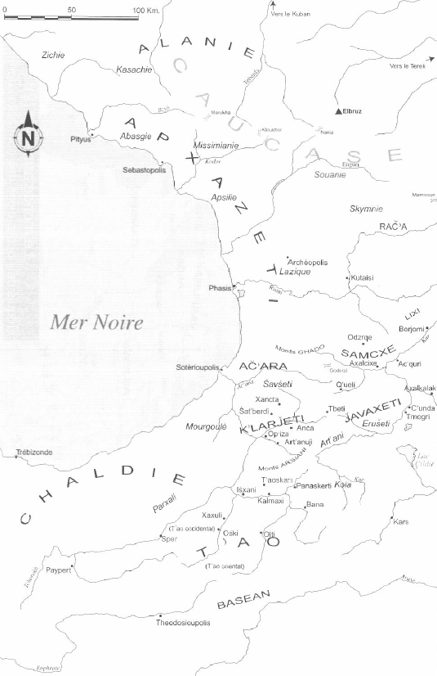
Figure 5. View of Artanuji kastron and rabaḍ. Source: Marr (1911), Fig. 28.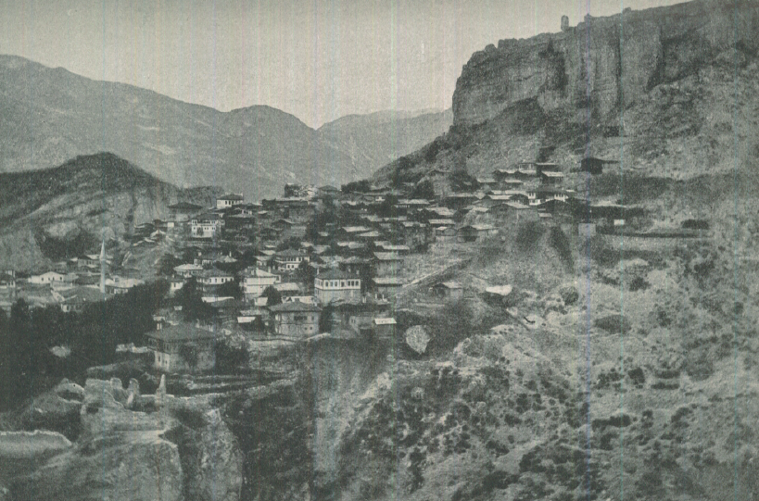

Many thanks to my supervisors Mark Whittow and Jonathan Shepard, as well as to Marek Jankowiak, Nicholas Matheou and Lado Mirianashvili for their comments on this paper, and to the AHRC for funding my research.
Konstantinos Porphyrogennetos, De Adminstrando Imperio, ed. Gyula Moravcsik, and trans. in English Romilly J.H. Jenkins, 2nd ed. (Washington, D.C., 1967), 46.49-165, pp. 216-223; The History of Sumbat Davit‘is-dze, trans. in English Stephen H. Rapp Jr., Studies in Medieval Georgian Historiography: Early Texts and Eurasian Contexts (Louvain, 2003), 38, 39, p. 360.
Konstantinos Porphyrogennetos, De Administrando Imperio: Volume 2, Commentary, ed. Romilly J. H. Jenkins (London, 1962), p.178.
Probably not Konstantinos Lips or Konstantinos Gonygles: Prosopagraphie der mittelbyzantinischen Zeit. Zweite Abteilung (867-1025), 8 vols. (Berlin, 2013), 3:595-6, #23833; cf. DAI, Commentary, p. 179.
Konstantinos Porphyrogennetos, De Ceremoniis Aulae Byzantinae, 2 vols. (Bonn, 1829-1831), vol. 1 ed. with Latin trans. Johann H. Leich and Johann J. Reiske, 1.45, 2.48, pp. 229-31, 687-8; Konstantinos Porphyrogennetos, The Book of Ceremonies, trans. in Engl. Ann Moffatt and Maxeme Tall, 2 vols (Canberra, 2012), 1:229-231; 2:687-8; Theophanes Continuatus, ed. and trans. in Latin Immanuel Bekker, (Bonn, 1838), [De Romano Lacapeno] 6.9, p. 402; Bernadette Martin-Hisard, “Constantinople et les archontes du monde caucasien dans le Livre des Cérémonies, II.48,” Travaux et Mémoires 13 (2000), 428-465.
De Administrando Imperio, 13.149-52, pp. 72-3.
Ibid., 46.42-8, pp. 216-17. The manuscripts give both Ardanoutzi and Adranoutzi forms. Moravcsik takes the former as the preferred reading.
Robert William Edwards, “The Fortifications of Artvin: A Second Preliminary Report on the Marchlands of Northeast Turkey,” Dumbarton Oaks Papers 40 (1986), pp. 171-4, Figures 20-30.
Bernadette Martin-Hisard, “Du T’ao-K’lardzheti à l’Athos: moines géorgiens et réalités sociopolitiques,” Bedi Kartlisa 61 (1984), 34-46.
Antony Eastmond, Royal Imagery in Medieval Georgia (Pennsylvania, 1998), p. 1.
Some Georgian historians have argued that the Bagrationi family originated from “the most ancient Georgian province of Speri”, and that different branches later migrated to Armenia and K‘art‘li. Istoriia Gruzii [History of Georgia], ed. Nikolai Berdzenishvili, 3 vols. (Tbilisi, 1962-1968), 1:129. These claims were rejected by Toumanoff: Cyril Toumanoff, Studies in Christian Caucasian History (Georgetown, 1963), p. 322 (footnote 76), pp. 334-6.
History of Sumbat, 18, pp. 355-356.
Ibid., 21, p. 357.
Ibid., 36, 42, pp. 359, 360. The army (eri) of each province was commanded by an eristavi. The erist‘avi of erist‘avis was the commander of the army as a whole. Ronald Grigor Suny, The Making of the Georgian Nation (London, 1989), p. 320. Ekvtime Takaishvili describes this post as the second most important after the mep‘e, Arkheologicheskaia ekspeditsiia 1917-go goda v iuzhnye provintsii Gruzii [Archaeological Expedition of 1917 in the Southern Provinces of Georgia] (Tbilisi, 1952), p. 32.
Toumanoff, Studies in Christian Caucasian History, pp.496-497; idem, Manuel de généalogie et de chronologie pour l’histoire de la Caucasie Chrétienne (Rome, 1976), pp. 116-119.
Konstantinos Porphyrogennetos, De Ceremoniis, 2.48, pp. 686-688; Martin-Hisard, “Constantinople et les archontes,” pp. 428-465.
De Administrando Imperio, 45.64-175, pp. 208-215.
De Administrando Imperio, 46.13-15, pp. 214-215.
Ibid., 46.117-19, pp. 220-221.
Ibid., 46.24-34, pp. 214-217; Eastmond, Royal Imagery, p. 95 puts the opposite interpretation on this passage.
Martin-Hisard, “Constanintople et les archontes,” pp. 439-450.
De Administrando Imperio, 46.86-93,162-165, pp. 218-219, 222-223.
History of Sumbat, 40, p. 360.
Wachtang Djobadze, Early Medieval Georgian Monasteries in Historic Tao, Klarjeti, and Šavšeti (Stuttgart, 1992), p. 211.
Djobadze, Early Medieval Georgian Monasteries, p. 210; Eastmond, Royal Imagery, pp. 226-227. The Byzantine Empire was called “Greece” (Saberdznet‘i), from berdzeni (“wise [man]”) by the Georgians. Stephen H. Rapp Jr., “Sumbat Davit’is-dze and the Vocabulary of Political Authority in the Era of Georgian Unification,” Journal of the American Oriental Society 120/4 (2000), p. 575 (footnote 44).
Martin-Hisard, “Constantinople et les archontes,” p. 455.
Djobadze, Early Medieval Georgian Monasteries, p. 210-211. Takaishvili suggested that the lost final lines of the inscription indicated that Stepane went to Trebizond rather than Mc‘xet‘a because the katholikos had recently died. Takaishvili attributed the inflation of the title of the prelate from Trebizond either to ignorance or to a desire to increase the importance of the event. Takaishvili, Arkheologicheskaia ekspeditsiia 1917-go goda, pp. 30-2.
Giorgi Merch‘ule, The Life of Grigol of Xandzt‘a, trans. in Russian Nikolai Yakovlevich Marr, Teksty i rayzkaniiia po armiano-gruzinskoi filologii [Texts and Investigations in Armenian and Georgian Philology], 7 (St. Petersburg, 1911), 83, pp. 148-149; trans. in French Bernadette Martin-Hisard, “Moines et monastères géorgiens du 9e siècle: la Vie de saint Grigol de Xancta”, Revue des études byzantines, 59 (2001), 89.
De Administrando Imperio, 43.85-7, pp. 192-193.
Ibid., 46.21-2, pp. 214-215.
ibid., 46.54-64, pp. 216-219.
Cf. Michael McCormick, Origins of the European Economy: Communications and Commerce, A.D. 300-900 (Cambridge, 2001), pp. 240-244 on figures such as the mid-ninth century Basil of Jerusalem (“priest, monk, pilgrim, would-be ambassador, and part-time trader”) and passim.
Rosemary Morris, Monks and Laymen in Byzantium 843-118 (Cambridge, 1995), pp. 5-6. Cf. the eleventh-century Typikon of Grigor Pakourian written in Greek, Georgian and Armenian: “Typikon of Gregory Pakourianos for the Monastery of the Mother of God Petritzonitissa in Bačkovo”, trans. Robert Jordan, in Byzantine Monastic Foundation Documents. A Complete Translation of the Surviving Founders’ Typika and Testaments, ed. John Thomas and Angela Hero, with Giles Constable, 5 vols. (2000), 1:507-63.
Tamara Grzdelidze, “Georgia, Patriarchal Orthodox Church of,” Encyclopedia of Eastern Orthodox Christianity (Oxford, 2011), pp. 264-275; Stephen H. Rapp, Jr., “Georgian Christianity,” The Blackwell Companion to Eastern Christianity (Oxford, 2007), pp. 137-155.
Life of Grigol of Xandzt‘a, 62, trans. Marr, pp. 134-135, trans. Martin-Hisard, pp. 75-76.
Morris, Monks and Laymen, p.6.
Wachtang Djobadze, “A Brief Survey of the Monastery of St. George in Ḥanzt‘a,” Oriens Christianus 78 (1994), 145-176. Djobadze revises the identification of Xanzt‘a made by Nikolai Marr, “Dnevnik poezdki v Shavshetiiu i Klardzhetiiu”, Teksty i rayzkaniiia po armiano-gruzinskoi filologii [“Diary of a Journey to Shavshet‘i and Klarjet‘i”, Texts and Investigations in Armenian and Georgian Philology], 7 (St. Petersburg, 1911) pp. 125-156.
Life of Grigol, 2, trans. Marr, p. 84, trans. Martin-Hisard, p. 23.
Thanks to Rebecca Falcasantos for this point. On St. Antony’s cultivation of marginal lands, see e.g. Athanasius, Life of St. Antony, ed. and trans. in English Archibald Robertson, Select Writings and Letters of Athanasius, Bishop of Alexandria, 50, pp. 209-210.
Life of Grigol, 22, trans. Marr, p.102, trans. Martin-Hisard, pp.43-44.
Ibid., 9, trans. Marr, pp. 92-95, trans. Martin-Hisard, pp. 32-33.
Ibid., 83, trans. Marr, p. 148, trans. Martin-Hisard, p. 89. For aznauris, see Rapp, Studies in Medieval Georgian Historiography, p. 372. On the Sasanian background for the aznauris and their institutions, see Stephen H. Rapp Jr., The Sasanian World through Georgian Eyes. Caucasia and the Iranian Commonwealth in Late Antique Georgian Literature (Farnham, 2014), pp.87-9
Alan Harvey, Economic Expansion in the Byzantine Empire, 900-1200 (Cambridge, 1989), pp. 244-268.
See note 1139 above for aznauris. Cf. the private family holdings of the naxarars of Arsacid Armenia: Robert Thomson, “Armenia (400-600)”, in The Cambridge History of the Byzantine Empire c. 500 -1492, ed. Jonathan Shepard (Cambridge, 2008), p. 159; Toumanoff, Studies in Christian Caucasian History, pp. 139-144. Toumanoff’s own family heritage presumably influenced his view that, “the dynastic aristocracy of Caucasia – and not the Crown, not even the Church, nor the gentry, nor the burgesses, nor the peasants – were the natural and unquestioned leaders of the community, the creative minority that set for it the pattern of behaviour, the style of life.” ibid. p. 144.
De Administrando Imperio, Commentary, p. 178. Edward Lane, An Arabic-English Lexicon (London, 1863-1893), 1, p. 48.
Paul Wheatley, The Places Where Men Pray Together. Cities in Islamic Lands (Chicago, 2001), pp. 305, 307, 311, 318, 322, 336, 513.
Hugh Kennedy, “From Shahristan to Medina,” Studia Islamica 102/3 (2006), 5-34.
Ramin Ramishvili, “Gruziia v epokhu razvitogo srednevekov’ia (X-XIII vv.): Goroda,” Arkheologiia. Krym, Severo-Vostochnoe Prichernomor’e i Zakavkaz’e v epokhu srednevekov’ia, [“Georgia in the High Middle Ages, 10th-13th centuries: Towns”, Archaeology. Crimea, the North-East Black Sea and Transcaucasia in the Middle Ages] ed. Tamara Makarova et Svetlana Pletneva, (Moscow, 2003), p. 298; Mariam Lordkipanidze, “Tibilisskii emirat,” Ocherki Istorii Gruzii [“The Emirate of Tbilisi”, Sketches of the History of Georgia], 8 vols (Tbilisi, 1988), 2:339-353.
Ibn Ḥawqal, Kitāb Ṣūrat al-arḍ, ed. Michael de Goeje (Leiden, 1874); tr. Johannes Kramers and Gaston Weit, Configuration de la terre, 2 vols (Beirut, 1964), 344, 2:337.
History of Sumbat, trans. Rapp, 21, p. 357.
Toumanoff, Studies in Christian Caucasian History, p. 488 (footnote 227); Rapp, Studies in Medieval Georgian Historiography, p. 387.
Life of Grigol, 68-70, pp. 137-139. On Isḥāq ibn Ismā‘īl, see Joseph Laurent, L’Arménie entre Byzance et l’Islam depuis la conquête arabe jusqu’en 886, ed. Marius Canard (Lisbon, 1980), pp. 394-399.

