Triggering participation in smart cities:
Political efficacy, public administration satisfaction and sense of belonging as drivers of citizens’ intention

Norbert LEBRUMENT
Clermont Auvergne University
norbert.lebrument@uca.fr

Cédrine ZUMBO-LEBRUMENT
ESC Clermont Group
cedrine.zumbo-lebrument@esc-clermont.fr

Corinne ROCHETTE
Clermont Auvergne University
corinne.rochette@uca.fr

Thomas J. ROULET
University of Cambridge
tr440@cam.ac.uk

Abstract
Despite citizen participation in smart city projects being a critical topic, we lack quantitative studies exploring such topic. In addition, we know very little about how the human and social attachment of citizens to their smart city drives their involvement in smart cities. This study contributes to this stream of research by exploring the determinants of citizen participation in smart city projects. We develop and quantitatively test a model that identifies three key antecedents on a set of survey data collected from French citizens (N = 604). Our results confirm the importance of political efficacy, the conative dimension of sense of belonging, and the central role public administration satisfaction when it comes to evaluating the intention of citizens to participate in smart city projects. Those three dimensions cover essential elements of the human bond between citizens and their smart city. This study not only informs practically the way we can involve individuals into the design and the construction of smart cities that fulfil their need, but also the bottom-up organizing of broader and larger project.

Keywords: smart city; public administration satisfaction; sense of belonging; citizen participation; political efficacy
- Introduction
While the literature agrees on the aims and objectives of the smart city (Albino, Berardi et Dangelico, 2015 ; Almirall et al., 2016 ; Cocchia, 2014 ; Dameri, 2013 ; Gil-Garcia, Pardo et Nam, 2015 ; Lebrument et Robertie, 2019), recent research insists on the importance of factoring in citizen participation in projects in connection with a “smart city” strategy (Granier et Hiroko Kudo, 2016 ; Mellouli, Luna-Reyes et Zhang, 2014 ; Hu et al., 2015; Nesti et Graziano, 2019). Such approaches require to go beyond examining citizens’ involvement as a sole question of technology acceptance (Sepasgozar et al., 2019). For cities, the objective of citizen participation in a smart city strategy is twofold: on the one hand, to give citizens the resources to (re)appropriate public affairs by becoming the driving agents of the smart city and, on the other hand, to harness the skills and knowledge of citizens to develop a smart city in line with real, i.e. pertinent, needs (Andreani et al., 2019).‬‬ Such approach complements top-bottom perspectives on smart city management (Hu, Wu & Shih, 2015).
Approaching smart city management in a holistic manner (Lee, Hancock & Wu, 2014), requires to avoid excluding citizens from smart city projects (Engelbert et al., 2019) and meet their needs (Trencher, 2019). Participation already assumes that a number of factors have already been met to support the implementation of a participatory approach (Fung, 2015; Vanolo, 2016 ; Vassileva, Dahlquist et Campillo, 2016). However, research on the smart city has not produced any clear indication of what these factors might be or evaluated their influence on the participation of citizens in smart city projects (Marrone et Hammerle, 2018 ; Meijer et Bolívar, 2016). Research on citizen participation in the smart city (SC) has largely consisted of case studies and rarely empirical studies (Desdemoustier et al., 2019) based on a large number of samples.
To fill this gap, this article proposes an original model of determinants for citizen participation in the SC. In looking for determinants of citizens’ intentions, we decided to focus on those related to the attachment of the citizens to their smart city (Belan et al., 2016; Ji et al., 2021). Existing work has often focused on technological acceptance, or technical aspects (Kummitha, 2020), but citizens’ perspectives and human bonds to their smart city are crucial pillars of a bottom-up approach to smart city management (Hu et al., 2015). We thus need to document key dimensions capturing such human bonds, to better assess citizens’ participation, from a bottom-up perspective (Roulet et al., 2019).
We first scanned the entire literature on smart city and progressively came to identify key aspects that could capture citizens’ bonds to their smart city in a comprehensive and complementary way, and inform our understanding of their participation. By analysing the literature, we converged towards three factors in particular that could cover as exhaustively as possible the different aspects of citizens’ attachment, and whose influence it seemed pertinent to test on citizen participation in the SC. The first factor consists of the perception citizens have of their capacity to have an influence on political actions and decisions (Acock, Clarke et Stewart, 1985 ; Craig, Niemi et Silver, 1990 ). This factor refers to the concept of political efficacy (Dyck et Lascher, 2009 ; Oh et Lim, 2017 ; Wong, Liu et Cheng, 2011), meaning the belief citizens have that they can influence their political system. The second factor relates to the level of satisfaction citizens have with their city’s public administration (Martin, Kusow et Wilson, 1997 ; Wong, Liu et Cheng, 2011). The literature on citizen participation has seldom examined the link between the level of citizen satisfaction with local public administration and their participation in projects in their city. The third factor concerns the urban sense of belonging (Frisou, 2012 ; Hernández et al., 2007) expressed by citizens with regard to their city. Urban sense of belonging can be defined as the attitude a citizen has towards their place of residence through their identification with, attachment to and sense of solidarity in their city. If a smart city strategy is first and foremost dependent on the level of participation of its citizens, estimating the influence of these three factors on citizen participation in smart city projects represents a priority for a city’s elected officials.
In these conditions, the objective of this article is to estimate, using a PLS-PM-tested model, if political efficacy, satisfaction with local public administration and urban sense of belonging have a statistically significant influence on citizen participation in smart city projects. To this end, the first part contains an analysis of the concepts of political efficacy, satisfaction with local public administration, urban sense of belonging and citizen participation in a smart city strategy, followed by a presentation of the theoretical model tested and the resulting hypotheses. The second part presents the methodological operationalisation of our model and its empirical testing based on unique dataset of 604 citizens from various French cities. Lastly, we unpack the findings to examine the importance of those triggers of participation in the smart city and the broader contributions of this work for smart city organizing.
- Theoretical Framework

The smart city as a field of research has seen significant growth in terms of volume of publications since 2009-2010 (Appio et al. 2019; Mora, Bolici, & Deakin, 2017). In our research we used the definition by Giffinger et al. (Giffinger et al., 2010) since it defines a smart city both from a technological and human perspective by defining six dimensions with which one can measure what empirically characterises a city as “smart”. A smart city is thereby understood as an effective and efficient city in the six following dimensions: smart economy, smart mobility, smart environment, smart living, smart people, smart governance (participation). The definition by Giffinger et al. incorporates citizen participation as a structural element of a smart city strategy in two ways: on the one hand, with regard to citizen participation in the city’s governance and, on the other hand, citizen participation in public life (participation in municipal elections and participation in volunteer work at the national level). Such perspective enables us to go beyond looking at citizen involvement solely through the lens of technological acceptance (Sepasgozar et al., 2019). While the technological acceptance model (TAM) (Venkatesh, 2000) can offer some keys to understand citizen participation, we focus here on the human element of citizen participation.

Citizen participation in smart city strategies has become central (Hu et al., 2016; Kummitha, 2020), so that smart city fulfil clear needs (Andreani, et al 2019) and capitalise on grass root participation (Noveck, 2015; O’Brien, 2018), or what Hu and colleagues (2016) call a bottom-up approach.‬‬ The importance of participative integration in the development of public services (Clark, Brudney, & Jang, 2013; Jakobsen, 2013 ; O’Brien, Offenhuber, Baldwin-Philippi, Sands, & Gordon, 2017) has accelerated in a number of countries, in particular France where the state subsidies have fallen since 2015. In a context of reduced subsidies combined with a desire to increase the attractiveness of cities, the development of citizen participation in public projects is part of a deeper trend spreading across French society: the citizen’s desire for participatory democracy which allows any constituent to participate, by various ways and means, in promoting the general interest and common good (Tai, Porumbescu et Shon, 2019). From a general perspective, the aim of participatory democracy is to include (Irvin & Stansbury, 2004 ; Ianniello et al., 2019), through various processes (Nabatchi et al., 2017), citizens in the design and decision-making of administrative and political choices that have an influence on their lives Yetano & Royo, 2017). Such approach fundamentally differs from existing top-bottom perspectives (Hu et al., 2015).
While citizen participation is essential to unpack a richer understanding of smart city emergence, we have little knowledge about what determines citizens’ participation, in particular when it comes to the human and social bond that citizens build with their smart city (Belan et al., 2016; Ji et al., 2021). To identify the key aspects that could capture citizens’ bonds, we engaged in a literature review focusing on the relationship between smart cities and their inhabitants. We looked for factors that could cover and capture in a comprehensive and complementary way how attachment triggers participation. We considered a range of factors but progressively converged towards three factors in particular: political efficacy, public administration satisfaction, and sense of belonging.

- Citizen participation in smart city projects: the question of political efficacy

Citizen participation in projects related to a smart city strategy is partly underpinned by their belief that they have an effective role to play in carrying out the proposed projects (Hu et al., 2016). In other words, this raises the question of the influence of the sense of political efficacy (Alan Acock et al., 1985; AlanC. Acock & Clarke, 1990; Clarke & Acock, 1989; Iyengar, 1980) on their participation (Sjoberg et al., 2017) in a smart city strategy. Following on from the research of Bandura (Bandura, 2007) in social cognitive theory, the sense of political efficacy can be defined as: “the feeling that individual political action does have, or can have, an impact upon the political process, …the feeling that political and social change is possible and that the individual citizen can play a part in bringing about this change.” (Campbell et al., 1954).
Political efficacy is composed of two distinct dimensions (Cicatiello et al., 2018; Lane, 1959; Wolak, 2018): internal and external political efficacy. Internal political efficacy refers to an individual’s belief that they feel able to understand political decisions and processes and, in a more general sense, politics in all its forms: individuals with strong internal political efficacy believe they have the capacity to understand political issues, which makes them feel politically enlightened. External political efficacy is where an individual believes that political actors and public institutions are attentive to their needs and take their grievances and needs into consideration: individuals with low external political efficacy feel they are not in a position to understand or take action on the decisions made by politicians and believe that politicians do not take their point of view into consideration. The distinction between the two types of political efficacy has been well established in the literature (Craig et al., 1990; Niemi et al., 1991), even if the positive influence of both types of political efficacy on political participation is not always found to be significant by the research undertaken (Oh and Lim, 2017). However, while research has studied the links between participation in political life (direct democracy) and political efficacy, and even the role of political efficacy on trust in politics, little research has been done to verify the positive effect of political efficacy on the intention to participate in urban projects. Similarly, no research has yet been conducted to empirically test the positive effect of political efficacy on citizens’ intention to participate in their smart city approach. We wish, therefore, to check whether both dimensions of citizens’ political efficacy have a positive influence on their intention to participate in their smart city projects:
- H1: Internal political efficacy has a positive influence on the intention to participate in the smart city
- H2: External political efficacy has a positive influence on the intention to participate in the smart city
- Public administration satisfaction as an antecedent of citizen participation

Inspired by evaluation and oversight practices in the market sphere, the principles and values of New Public Management (NPM) as a model for running public services have been widely discussed. There can be a notable discrepancy between public values and a voluntarist policy to aim for more efficient public services (Hood, 1991), or the professional burnout caused by NPM management practices declared by public agents (Abord de Chatillon and Desmarais, 2012), the fact remains that NPM has opened up serious debate (Osborne, 2006) both on the specifics of managing public services and on improving relations between users and public agents (Scharitzer et Korunka, 2000 ; Vigoda-Gadot, Cohen et Tsfati, 2018). NPM has prompted public administrations to review their management practices and implement reforms based on criticism waged by users on their services (Scharitzer et Korunka, 2000 ; Vigoda-Gadot, Cohen et Tsfati, 2018). It is this observation that prompted Vigoda-Gadot (2016) to talk about the need for reconciliation between public administration and citizens to build strong nations with strong citizen participation. Based on the expectations of users (Ryzin et al., 2004), satisfaction with public services (Jilke and Baekgaard, 2020) is an intangible asset which the public administration can leverage to boost the participation of users in political life and local change (Canel et Luoma-aho, 2018 ; Zumbo-Lebrument and Lebrument, 2020; Okazaki et al., 2020). The main objective of public administration is then maintaining a balance between organisational objectives and the needs expressed by the users, which will always operate in a context in which the objectives and needs will change.
Drawing on the research of Parasuraman et al. in services marketing (Parasuraman, Zeithaml, & Berry, 1985, 1988, 1994; Parasuraman, Berry, & Zeithaml, 1991), the SERVQUAL model evaluates perceived service quality through five dimensions (Ladhari, 2009):
- The tangible components of the service such as the appearance of physical facilities, equipment, personnel and communications materials.
- The reliability of the service offered to customers which aims to measure the capacity to perform the promised service precisely and reliably.
- Responsiveness is the willingness to help customers find what they want and offer a rapid service.
- Assurance relates to employees’ courtesy and knowledge and their capacity to transfer confidence and trust to customers.
- Empathy which aims to gauge the personal attention paid and the degree to which customers’ unique needs are factored in.
However, the SERVQUAL model has attracted criticism with regard (Goudarzi et Guenoun, 2010 ; Orwig, Pearson et Cochran, 1997; Sabadie, 2003) to 1) its relevance in public contexts, 2) the model’s dimensional validity. These limitations have prompted the design of measurement instruments more appropriate to the public services context. Research into the relationship between users and public administrations have brought to light the positive influence of public services quality on political participation and public involvement (Mizrahi, Vigoda-Gadot et Cohen, 2010 ; Vigoda, 2002 ; Vigoda-Gadot, 2006 ; Wong, Liu et Cheng, 2011). In this context, Vigoda has shown that several dimensions related to the personal qualities of the agents and the nature of public administration processes might have an influence on users’ satisfaction with public services (Vigoda, 2002, 2000; Vigoda-Gadot, 2007; Vigoda-Gadot et al., 2008): the professionalism and empathy of civil servants; the city and its personnel’s capacity for innovation and creativity, and the moral integrity and ethics of civil servants. To gauge the influence of these dimensions on user satisfaction with public services, we therefore wish to verify the following hypotheses:
- H3: Professionalism and empathy of civil servants have a positive influence on citizens’ satisfaction with their city’s public administration.
- H4: Capacity for innovation and creativity of a city and its agents has a positive influence on citizens’ satisfaction with their city’s public administration.
- H5: Moral integrity and ethics of civil servants has a positive influence on citizens’ satisfaction with their city’s public administration.
- H6: Satisfaction with public administration has a positive influence on a citizen’s intention to participate in the smart city.
Furthermore, no research has yet gauged the effect of citizen satisfaction with their city’s public administration on their sense of political efficacy within the context of a French smart city approach. In line with the research of Vigoda-Gadot (Vigoda-Gadot, 2007; Vigoda-Gadot et al., 2018), it seems that citizens’ satisfaction with public administration has an effect on their sense of external political efficacy. Indeed, a citizen’s satisfaction with their public administration develops in them the feeling that local political actors and public institutions take their needs into consideration. With this in mind, we formulated the following premise:
- H7: Satisfaction with public administration has a positive influence on a citizen’s external political efficacy.
- Citizens’ sense of belonging and participation in the smart city
While there are cases of smart cities created ex nihilo (Masdar City, Songdo, etc.), the smart city is first and foremost an urban project integrated into an existing urban setting, within a given territory, that determines the initial conditions (Snow et al., 2016). This existing urban setting is often considered from an engineering and technological perspective by smart city strategies, at the detriment to human smart city strategies. In these conditions, the smart city project treats the city’s territory and its citizens as a combination of interconnected resources, flows and functions with fixed objectives at the detriment to a human smart city. In their analysis of the research on smart city governance, Meijer and Bolívar (2016) point out that citizen participation is assessed as a desirable element of a “society of quality” without its relationship with the urban sense of belonging being identified. More importantly, no smart city research thus far has analysed the effect of the sense of belonging, i.e. the emotional attachment between a person and a place (Charton-Vachet and Lombart, 2015; Dion et al., 2010; Frisou, 2012; Hernández et al., 2007), on citizens’ participation in smart city projects. The research has all been conducted as if the smart cities being studied were identityless, disembodied territories where identity characteristics inherent in any territory were quasi non-existent.
Yet any city is a territory with an identity forged by its history. The question of a territory's identity (Braudel, 2009) and that of citizen participation can be examined through the question of urban sense of belonging: public involvement in an SC strategy supposes that the question of citizens’ urban sense of belonging had already been considered. If an SC strategy incorporates citizen participation, it should factor in the citizens’ urban sense of belonging nurtured by the (Sepasgozar et al., 2019) city’s identity (i.e. the existing one) in order to maximise participation in its projects (Belanche et al., 2014). By “sense of belonging” (Jorgensen and Stedman, 2001; Lalli, 1992) we mean the attitude by which an individual expresses their identification with, attachment to and support of a territory, a place (Frisou, 2012). Using this definition, sense of belonging is composed of three dimensions:
  - the cognitive dimension that expresses the individual’s identification with the place;
  - the affective dimension that equates to the individual’s attachment to the place;
  - the conative dimension which reflects the individual’s solidarity with the place.
Zumbo-Lebrument and Lebrument (Zumbo-Lebrument and Lebrument, 2020) showed that sense of belonging has a considerable influence on citizen participation in territorial marketing initiatives. Based on this reasoning, we formulated the following hypotheses applied to the SC:
- H8: Citizens’ identification with their city has a positive influence on their intention to participate in the smart city.
- H9: Citizens’ attachment to their city has a positive influence on their intention to participate in the smart city.
- H10: Citizens’ solidarity with their city has a positive influence on their intention to participate in the smart city.
Moreover, no research has yet verified the existence of a relationship between public administration satisfaction and sense of belonging. However, given previous analyses of public administration satisfaction, it seems that this can only have a positive effect on the different dimensions of citizens’ sense of belonging to a place. Based on this reasoning, we have formulated the following hypotheses:
- H11: Public administration satisfaction has a positive influence on citizens’ identification with their city.
- H12: Public administration satisfaction has a positive influence on citizens’ attachment to their city.
- H13: Public administration satisfaction has a positive influence on citizens’ solidarity towards their city.

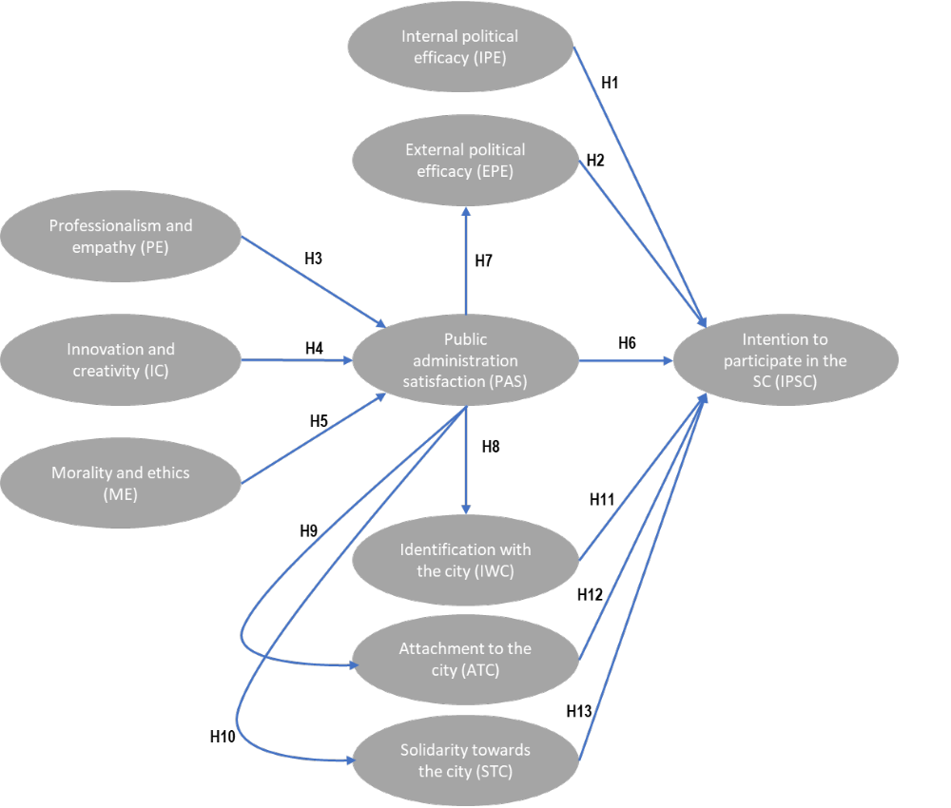
Figure 1: Conceptual determinants model for the intention to participate in the smart city (SC).
- Methodology
- Data collection and cohort
To address our research questions and empirically explore the determinants of citizens’ involvement in smart city project we collected a unique dataset using a survey tool. We collected data from a total of 604 respondents that had the opportunity to be involved in a number of smart city projects across France - meaning that they were in locations where smart city projects could take place. In order to avoid results being influenced by cultural differences, we limited our sample population to French metropolitan citizens. Data was collected between November 2018 and January 2019 using an online platform and survey tool. Participants were selected on the basis of whether they resided in cities with more than 200,000 residents, i.e. cities where smart city projects were potentially in progress or could be launched. We ensured our sampling (See Table 1, below) was as representative as possible from the pool of citizens that could be engaged in a smart city project. We reached out to relevant individuals as we progressed in our data collection, using social media platforms, and directly via email.
In order for our sample to be as representative of citizens being involved in smart cities project, we compared it throughout the data collection with the French metropolitan population. We used the 2019 French national institute for statistical and economic studies databases to establish a correspondence between the different categories of participants in our sample. Our sample closely matches the geographical repartition of inhabitants in France. Our sample is also gender balanced. Finally, we also offer a good balance across age brackets. For most socio professional categories, our sample is representative of the French population. Our sample is under-representing retired individuals because this share of older citizens is not, in its entirety, psychologically and physically able to participate to smart cities projects - in fact, for this reason we did not recruit participants beyond 70. We have also slightly more blue collar workers, which is consistent with expectations of the demographic profiles of engaged citizens in smart cities, as a function of their resources and time (Munoz et al 2019)
The administered questionnaire asked people to respond to a set of proposals presented in the Appendix. To make sure that the respondents understand the subject, a simplified definition of Smart City was given to them at the beginning of the questionnaire and a second time before the question on the intention to participate. Table 1 presents the main characteristics of the cohort of respondents. In building the questionnaire, we used instruments validated in previous studies. The survey was pre-tested two experts, and we consequently made adjustments to the wording. To our knowledge, such survey data on citizens having the opportunity to be involved in smart city project is unique and enables us to quantitatively assess the determinants of their participation.

 | Our Sample
Sex of respondents | 50.3% male, 49.7% female
Age | 18-25 years (11.4%); 26-35 (25.7%); 36-45 (27%); 46-55 (21.5%); 56-70 (14.4%)
Socio-professional category | Farmers: 0.2%  Craftpersons: 0.8%  Shopkeepers: 1.7%  Intermediate professions: 13.1%  Executives and intellectual professionals: 12.6%  CEOs:2%  Accredited professionals: 1.5%  Office workers: 37.3%  Workers: 6.6%  Househusband/housewife: 5.5%  Unemployed: 7.1%  Retired: 6.5%  Students:3.3%  Other: 2%
Location | Ile-de-France : 17.2%  Northeast France : 26.2%  Northwest France : 24.7%  Southeast France : 20.5%  Southwest France : 11.4%
Table 1: Characteristics of the cohort versus French metropolitan population in 2019.
- Measurement instruments
The specification and operationalisation of the measurement instruments were carried out based on recommendations taken from the literature (Anderson et Gerbing, 1988 ; Becker et al., 2012 ; Diamantopoulos et al., 2012 ; Diamantopoulos et Siguaw, 2006 ; MacKenzie, Podsakoff et Podsakoff, 2011 ):
- A summary analysis of the literature was carried out in order to validate the content of each constituent concept of the model.
- The epistemological relationship between each model construct and its items was established based on the decision criteria of Jarvis, MacKenzie and Podsakoff (2003), thereby confirming their reflective nature.
- The measurement instruments taken from the literature were adapted to the French SC.
- The items of the measurement instruments were reformulated after conducting a pre-test with three experts on smart cities
The following measurement instruments identified from earlier research were employed after being adapted and contextualised to our research subject:

Construct | Definition | Number of items | Source and type of measurement instrument
PE | An individual’s perception of the capacity of municipal civil servants to meet citizens’ requests in a pertinent, efficient and understanding manner | 4 | Measurement scale adapted from Vigoda (2000, 2006) and Wong et al. (2011). Items measured on a 5-point Likert scale
IC | An individual’s perception of their city’s capacity to innovate in order to improve the quality of its public services | 4 | Measurement scale adapted from Vigoda (2000, 2006) and Wong et al. (2011). Items measured on a 5-point Likert scale
ME | An individual’s perception of the impartiality and moral integrity demonstrated by municipal civil servants | 4 | Measurement scale adapted from Vigoda (2000, 2006) and Wong et al. (2011). Items measured on a 5-point Likert scale
PAS | Satisfaction expressed by an individual with the municipal public administration’s operations and services | 4 | Measurement scale adapted from Vigoda (2002) and Wong et al. (2011). Items measured on a 5-point Likert scale
IPE | An individual's belief that they have the capacity to understand politics and political issues. | 2 | Measurement scale adapted from Wong et al. (2011) and Oh and Lim (2017). Items measured on a 5-point Likert scale
EPE | An individual’s belief that political actors and political institutions take their grievances into consideration | 2 | Measurement scale adapted from Wong et al. (2011) and Oh and Lim (2017). Items measured on a 5-point Likert scale
IWC | An individual’s stable disposition by which they perceive their place of residence as part of themselves | 3 | Measurement scale adapted from Frisou (2012) and Zumbo-Lebrument and Lebrument (2020). Items measured on a 5-point Likert scale
ATC | An individual’s stable disposition by which they feel attachment to their place of residence | 3 | Measurement scale adapted from Frisou (2012) and Zumbo-Lebrument and Lebrument (2020). Items measured on a 5-point Likert scale
STC | An individual’s stable disposition by which they behave positively towards their place of residence | 4 | Measurement scale adapted from Frisou (2012) and Zumbo-Lebrument and Lebrument (2020). Items measured on a 5-point Likert scale
IPSC | Degree to which an individual expresses their intention to participate in the SC projects proposed by their city | 6 | Measurement scale constructed from smart city characteristics defined by Giffinger et al. (2007; 2010). Items measured on a 5-point Likert scale
Table 2: Nature of constructs and measurement instruments.
- Data analysis methodology
The hypotheses were tested using structural equation modelling. Estimates were computed on the basis of a Partial Least Squares path modelling (PLS-PM) approach (Wold, 1985). This approach is more relevant here than the LISREL approach for one central reason: our model aims to explain the intention to participate in smart city projects through a validation in terms of predictive quality (Fernandes, 2012; Hair and al., 2017). .The model tested is exploratory (we are exploring a new set of variables as determinants) and not confirmatory with a theory-building purpose (Fornell and Bookstein, 1982; Esposito Vinzi et al., 2010; Hair and al., 2016). A LISREL approach would be appropriate if we were retesting and complementing existing models but by testing brand new variables, a PLS-PLM approach is more adapted.

The model was validated by means of three types of estimation based on recommendations in the literature (Bollen, 2011 ; Esposito Vinzi et al., 2010 ; Fernandes, 2012 ; Jarvis, MacKenzie et Podsakoff, 2003 ; Tenenhaus, Amato et Esposito Vinzi, 2004; Wetzels et al., 2009):
- Estimation of the quality of the measurement model: reliability (internal coherence), convergent validity (unidimensionality), discriminant validity;
- Estimation of the quality of the structural model: coefficient of determination (R2) of each dependent latent variable, level of significance of causal relationship coefficients evaluated by a bootstrapping method;
- Estimation of the Goodness of Fit by the geometric mean of the average commonality and average R² value.

- Findings
  - Measurement model testing
The structural equation model estimated by means of the LS method was tested with the estimation parameters set out in table 3. The estimation parameters were selected based on the analyses, recommendations and specifications in the literature on the PLS method (Esposito Vinzi et al., 2010; Lohmöller, 2013; Tenenhaus, 1998; Tenenhaus et al., 2005, 2004).
Estimation of the  measurement model | Reflective variable: Mode A  Treatment of manifest variables: original MV  Initial weighting: values of first eigenvector
Estimation of the  structural model | Estimation of latent variables: Path weighting scheme
Validation of the  model | Bootstrap:  - 5,000 replications  - Confidence interval of 95%
Table 3: Model estimation parameters.
Latent Variable | Items | N | Minimum | Maximum | Mean | Standard deviation
PE | Q1PE | 604 | 1.00 | 5.00 | 3.02 | 0.97
PE | Q2PE | 604 | 1.00 | 5.00 | 3.16 | 1.00
PE | Q3PE | 604 | 1.00 | 5.00 | 2.86 | 0.96
PE | Q4PE | 604 | 1.00 | 5.00 | 3.12 | 0.97
IC | Q1IC | 604 | 1.00 | 5.00 | 2.75 | 1.17
IC | Q2IC | 604 | 1.00 | 5.00 | 3.06 | 1.08
IC | Q3IC | 604 | 1.00 | 5.00 | 3.03 | 0.95
IC | Q4IC | 604 | 1.00 | 5.00 | 3.36 | 1.03
ME | Q1ME | 604 | 1.00 | 5.00 | 3.01 | 0.94
ME | Q2ME | 604 | 1.00 | 5.00 | 3.35 | 1.00
ME | Q3ME | 604 | 1.00 | 5.00 | 3.32 | 0.96
ME | Q4ME | 604 | 1.00 | 5.00 | 3.20 | 0.95
EPE | Q1EPE | 604 | 1.00 | 5.00 | 3.05 | 1.15
EPE | Q2EPE | 604 | 1.00 | 5.00 | 3.03 | 1.08
PAS | Q1PAS | 604 | 1.00 | 5.00 | 3.55 | 0.98
PAS | Q2PAS | 604 | 1.00 | 5.00 | 3.32 | 1.00
PAS | Q3PAS | 604 | 1.00 | 5.00 | 3.58 | 0.99
PAS | Q4PAS | 604 | 1.00 | 5.00 | 3.43 | 0.97
IWC | Q1SIWC | 604 | 1.00 | 5.00 | 3.50 | 1.17
IWC | Q2SIWC | 604 | 1.00 | 5.00 | 2.98 | 1.19
IWC | Q3SIWC | 604 | 1.00 | 5.00 | 2.85 | 1.26
IPSC | Q1IPSC | 604 | 1.00 | 5.00 | 3.71 | 1.12
IPSC | Q2IPSC | 604 | 1.00 | 5.00 | 3.63 | 0.99
IPSC | Q3IPSC | 604 | 1.00 | 5.00 | 3.44 | 1.09
IPSC | Q4IPSC | 604 | 1.00 | 5.00 | 3.61 | 1.09
IPSC | Q5IPSC | 604 | 1.00 | 5.00 | 3.45 | 1.03
IPSC | Q6IPSC | 604 | 1.00 | 5.00 | 3.52 | 1.06
IPE | Q1IPE | 604 | 1.00 | 5.00 | 3.45 | 0.99
IPE | Q2IPE | 604 | 1.00 | 5.00 | 3.54 | 0.99
ATC | Q1ATC | 604 | 1.00 | 5.00 | 3.24 | 1.27
ATC | Q2ATC | 604 | 1.00 | 5.00 | 2.81 | 1.35
ATC | Q3ATC | 604 | 1.00 | 5.00 | 3.34 | 1.17
STC | Q1STC | 604 | 1.00 | 5.00 | 3.05 | 1.14
STC | Q2STC | 604 | 1.00 | 5.00 | 2.88 | 1.15
STC | Q3STC | 604 | 1.00 | 5.00 | 3.32 | 1.08
STC | Q4STC | 604 | 1.00 | 5.00 | 3.05 | 1.30
Table 4: Descriptive statistics.
The results presented in tables 5, 6, 7 and 8 allow us to validate the reliability, discriminant validity and convergent validity of the measurement scales employed while respecting the following decision criteria:
  - Reliability (internal coherence): Cronbach’s alpha and Dillon-Goldstein’s rho > 0.7
  - Convergent validity (unidimensionality):
  - Factorial weighting > 0.5 and statistically significant
  - Intra-communities > 0.5
  - Average variance extracted (AVE) > 0.5
  - Discriminant validity:
  - Cross loadings < loadings
  - Comparison of the square root of the correlation between the latent variables and the average variance extracted
Note that the Cronbach’s alpha for EPE and IPE are relatively low (0.64 and 0.60), which can be explained by the fact that each variable is measured by a small number of items (Cortina, 1993); nonetheless, the Dillon-Goldstein’s rhos for EPE and IPE are satisfactory.
Variable latente | Cronbach’s alpha | DG’s rho
PE | 0.86 | 0.90
IC | 0.84 | 0.89
ME | 0.84 | 0.89
PAS | 0.90 | 0.93
EPE | 0.64 | 0.85
IWC | 0.83 | 0.90
IPE | 0.60 | 0.80
ATC | 0.85 | 0.91
STC | 0.85 | 0.90
IPSC | 0.90 | 0.92
Table 5: Reliability of measurement scales (composite reliability).
Variable latente | Manifest  variable | Correlation | AVE
PE | Q1PE | 0.877 | 0.769
PE | Q2PE | 0.850 | 0.722
PE | Q3PE | 0.785 | 0.616
PE | Q4PE | 0.834 | 0.696
IC | Q1IC | 0.772 | 0.596
IC | Q2IC | 0.855 | 0.731
IC | Q3IC | 0.843 | 0.711
IC | Q4IC | 0.820 | 0.672
ME | Q1ME | 0.780 | 0.609
ME | Q2ME | 0.837 | 0.700
ME | Q3ME | 0.871 | 0.759
ME | Q4ME | 0.793 | 0.629
EPE | Q1EPE | 0.796 | 0.633
EPE | Q2EPE | 0.908 | 0.825
PAS | Q1PAS | 0.873 | 0.762
PAS | Q2PAS | 0.900 | 0.810
PAS | Q3PAS | 0.820 | 0.673
PAS | Q4PAS | 0.913 | 0.834
IWC | Q1IWC | 0.870 | 0.757
IWC | Q2IWC | 0.884 | 0.781
IWC | Q3IWC | 0.845 | 0.714
IPSC | Q1IPSC | 0.726 | 0.527
IPSC | Q2IPSC | 0.841 | 0.707
IPSC | Q3IPSC | 0.790 | 0.623
IPSC | Q4IPSC | 0.826 | 0.682
IPSC | Q5IPSC | 0.847 | 0.717
IPSC | Q6IPSC | 0.865 | 0.748
IPE | Q1IPE | 0.872 | 0.761
IPE | Q2IPE | 0.750 | 0.562
ATC | Q1ATC | 0.905 | 0.818
ATC | Q2ATC | 0.821 | 0.674
ATC | Q3ATC | 0.899 | 0.808
STC | Q1STC | 0.872 | 0.760
STC | Q2STC | 0.849 | 0.721
STC | Q3STC | 0.869 | 0.755
STC | Q4STC | 0.713 | 0.508
Table 6: Correlation and average variance extracted of model construct items.

 | PE | IC | ME | EPE | PAS | IWC | IPSC | IPE | ATC | STC
Q1PE | 0.877 | 0.649 | 0.642 | 0.430 | 0.624 | 0.399 | 0.298 | 0.201 | 0.360 | 0.385
Q2PE | 0.850 | 0.677 | 0.662 | 0.462 | 0.661 | 0.389 | 0.281 | 0.243 | 0.375 | 0.371
Q3PE | 0.785 | 0.510 | 0.534 | 0.397 | 0.501 | 0.296 | 0.242 | 0.149 | 0.268 | 0.282
Q4PE | 0.834 | 0.672 | 0.598 | 0.482 | 0.582 | 0.389 | 0.301 | 0.166 | 0.344 | 0.361
Q1IC | 0.543 | 0.772 | 0.366 | 0.335 | 0.380 | 0.439 | 0.215 | 0.128 | 0.422 | 0.385
Q2IC | 0.686 | 0.855 | 0.506 | 0.436 | 0.556 | 0.393 | 0.267 | 0.161 | 0.379 | 0.388
Q3IC | 0.668 | 0.843 | 0.619 | 0.478 | 0.606 | 0.355 | 0.271 | 0.215 | 0.309 | 0.357
Q4IC | 0.567 | 0.820 | 0.502 | 0.394 | 0.531 | 0.360 | 0.236 | 0.177 | 0.330 | 0.384
Q1ME | 0.580 | 0.461 | 0.780 | 0.381 | 0.500 | 0.297 | 0.235 | 0.151 | 0.254 | 0.319
Q2ME | 0.559 | 0.417 | 0.837 | 0.403 | 0.608 | 0.294 | 0.290 | 0.208 | 0.240 | 0.323
Q3ME | 0.648 | 0.581 | 0.871 | 0.423 | 0.691 | 0.383 | 0.342 | 0.254 | 0.317 | 0.341
Q4ME | 0.616 | 0.570 | 0.793 | 0.439 | 0.562 | 0.357 | 0.302 | 0.245 | 0.308 | 0.317
Q1EPE | 0.355 | 0.325 | 0.322 | 0.796 | 0.292 | 0.302 | 0.295 | 0.314 | 0.288 | 0.329
Q2EPE | 0.527 | 0.513 | 0.507 | 0.908 | 0.479 | 0.304 | 0.356 | 0.269 | 0.252 | 0.335
Q1PAS | 0.592 | 0.509 | 0.637 | 0.377 | 0.873 | 0.335 | 0.268 | 0.208 | 0.291 | 0.327
Q2PAS | 0.687 | 0.637 | 0.674 | 0.454 | 0.900 | 0.420 | 0.298 | 0.213 | 0.363 | 0.378
Q3PAS | 0.541 | 0.493 | 0.541 | 0.358 | 0.820 | 0.283 | 0.273 | 0.125 | 0.270 | 0.287
Q4PAS | 0.665 | 0.602 | 0.683 | 0.439 | 0.913 | 0.423 | 0.313 | 0.223 | 0.369 | 0.376
Q1IWC | 0.380 | 0.384 | 0.399 | 0.293 | 0.413 | 0.870 | 0.339 | 0.210 | 0.776 | 0.615
Q2IWC | 0.399 | 0.421 | 0.352 | 0.311 | 0.364 | 0.884 | 0.346 | 0.174 | 0.711 | 0.590
Q3IWC | 0.374 | 0.397 | 0.296 | 0.313 | 0.310 | 0.845 | 0.289 | 0.182 | 0.765 | 0.676
Q1IPSC | 0.235 | 0.207 | 0.289 | 0.274 | 0.226 | 0.253 | 0.726 | 0.245 | 0.266 | 0.296
Q2IPSC | 0.229 | 0.188 | 0.292 | 0.275 | 0.261 | 0.280 | 0.841 | 0.301 | 0.258 | 0.274
Q3IPSC | 0.276 | 0.233 | 0.290 | 0.328 | 0.252 | 0.272 | 0.790 | 0.301 | 0.238 | 0.299
Q4IPSC | 0.321 | 0.294 | 0.322 | 0.354 | 0.329 | 0.328 | 0.826 | 0.268 | 0.314 | 0.315
Q5IPSC | 0.297 | 0.288 | 0.286 | 0.338 | 0.270 | 0.364 | 0.847 | 0.279 | 0.336 | 0.371
Q6IPSC | 0.280 | 0.261 | 0.285 | 0.305 | 0.268 | 0.337 | 0.865 | 0.284 | 0.295 | 0.357
Q1IPE | 0.305 | 0.249 | 0.322 | 0.336 | 0.259 | 0.269 | 0.316 | 0.872 | 0.234 | 0.258
Q2IPE | 0.032 | 0.072 | 0.074 | 0.189 | 0.079 | 0.057 | 0.233 | 0.750 | 0.030 | 0.068
Q1ATC | 0.384 | 0.414 | 0.326 | 0.259 | 0.353 | 0.833 | 0.303 | 0.165 | 0.905 | 0.695
Q2ATC | 0.294 | 0.293 | 0.189 | 0.202 | 0.197 | 0.705 | 0.225 | 0.084 | 0.821 | 0.596
Q3ATC | 0.373 | 0.394 | 0.345 | 0.326 | 0.383 | 0.736 | 0.362 | 0.195 | 0.899 | 0.681
Q1STC | 0.408 | 0.442 | 0.362 | 0.345 | 0.390 | 0.696 | 0.321 | 0.169 | 0.729 | 0.872
Q2STC | 0.351 | 0.364 | 0.336 | 0.341 | 0.304 | 0.606 | 0.288 | 0.176 | 0.624 | 0.849
Q3STC | 0.354 | 0.388 | 0.348 | 0.343 | 0.346 | 0.607 | 0.412 | 0.255 | 0.637 | 0.869
Q4STC | 0.266 | 0.302 | 0.251 | 0.234 | 0.241 | 0.447 | 0.253 | 0.088 | 0.485 | 0.713
Table 7: Convergent validity of measurement scales.

 | PE | IC | ME | PAS | EPE | IWC | IPE | ATC | STC | IPSC
PE | 0.837* | 0.569 | 0.535 | 0.507 | 0.280 | 0.197 | 0.053 | 0.165 | 0.177 | 0.113
IC | 0.569 | 0.823* | 0.384 | 0.413 | 0.256 | 0.213 | 0.045 | 0.183 | 0.208 | 0.092
ME | 0.535 | 0.384 | 0.821* | 0.527 | 0.250 | 0.166 | 0.070 | 0.117 | 0.156 | 0.129
PAS | 0.507 | 0.413 | 0.527 | 0.877* | 0.218 | 0.178 | 0.049 | 0.139 | 0.154 | 0.108
EPE | 0.280 | 0.256 | 0.250 | 0.218 | 0.854* | 0.124 | 0.111 | 0.096 | 0.149 | 0.147
IWC | 0.197 | 0.213 | 0.166 | 0.178 | 0.124 | 0.866* | 0.048 | 0.748 | 0.518 | 0.142
IPE | 0.053 | 0.045 | 0.070 | 0.049 | 0.111 | 0.048 | 0.813* | 0.032 | 0.047 | 0.117
ATC | 0.165 | 0.183 | 0.117 | 0.139 | 0.096 | 0.748 | 0.032 | 0.876* | 0.569 | 0.122
STC | 0.177 | 0.208 | 0.156 | 0.154 | 0.149 | 0.518 | 0.047 | 0.569 | 0.828* | 0.153
IPSC | 0.113 | 0.092 | 0.129 | 0.108 | 0.147 | 0.142 | 0.117 | 0.122 | 0.153 | 0.817*
AVE | 0.700 | 0.678 | 0.674 | 0.770 | 0.729 | 0.750 | 0.662 | 0.767 | 0.686 | 0.667
Table 8: Discriminant validity of model constructs.
*Square root of the AVE on the diagonal.

  - Structural model test
After estimating the reliability and convergent and discriminant validities of the measurement scales, the results of the structural model test were analysed (cf. Table 9). Eleven out of the 13 hypotheses tested were validated. These results indicate the satisfactory validity of the structural model tested in our research.
Hs | Path relationship | R²  (Contribution to R² (%)) | Path coefficient | Significance  (Value of t) | Pr > |t| | f² | Q² | Conclusion of hypothesis
 |  | 0.612 |  |  |  |  | 0,408
H3 | PE → PAS | (31.8%) | 0.273 | 6.04*** | 0.000 | 0.061 |  | Validated
H4 | IC → PAS | (18.9%) | 0.180 | 4.60*** | 0.000 | 0.035 |  | Validated
H5 | ME → PAS | (49.3%) | 0.415 | 10.99*** | 0.000 | 0.201 |  | Validated
H7 | PAS → EPE | 0.218 | 0.467 | 12.96*** | 0.000 | 0.279 | 0,123 | Validated
H8 | PAS → IWC | 0.178 | 0.422 | 11.43*** | 0.000 | 0.217 | 0,100 | Validated
H9 | PAS → ATC | 0.139 | 0.372 | 9.85*** | 0.000 | 0.161 | 0,054 | Validated
H10 | PAS → STC | 0.154 | 0.393 | 10.48*** | 0.000 | 0.182 | 0,070 | Validated
 |  | 0.273 |  |  |  |  | 0,148
H1 | IPE →IPSC | (25.8%) | 0.205 | 5.50*** | 0.000 | 0.051 |  | Validated
H2 | EPE →IPSC | (23.9%) | 0.170 | 4.04*** | 0.000 | 0.027 |  | Validated
H6 | PAS →IPSC | (11.0%) | 0.091 | 2.19* | 0.029 | 0.008 |  | Validated
H11 | IWC →IPSC | (14.9%) | 0.108 | 1.49 | 0.137 | 0.004 |  | Not validated
H12 | ATC →IPSC | (1.8%) | 0.014 | 0.19 | 0.851 | 0.000 |  | Not validated
H13 | STC →IPSC | (22.6%) | 0.158 | 2.83** | 0.005 | 0.013 |  | Validated
Table 9: Results on the determinants of the intention to participate in the smart city.
*p < .05; **p < .01; ***p < .001
In PLS-PM approach, one would like to explains as much variation in a dependent variable as possible to measure the ‘performance’ of our model. The R² is thus a natural measure of fit in our case (Tenenhaus et al., 2004; 2006). To judge the predictive relevance of our model, we also computed Stone-Geisser’s Q² values (cf. Table 9) for all endogenous constructs and found them to be above zero (Hair and al., 2016), which confirms the predictive relevance of the model. Based on these indices, the structural model is validated.
The Goodness of Fit of the model is measured using an indicator which evaluates the quality of the measurement models and structures of the structural equation modelling based on the geometric mean of the average commonality and average R² value (Tenenhaus et al., 2004 ; 2005). The results obtained for the GoF indices indicates that the Goodness of Fit of our model is correct (Wetzels et al., 2009) with an Absolute GoF of around 0.43 (cf. Table 10). Similarly, the stability of the mode’s Goodness of Fit is satisfactory given the small difference between the GoF indices scores before and after Bootstrap.
 | GoF | GoF (Bootstrap) | Standard error
Absolute | 0.430 | 0.434 | 0.022
Relative | 0.933 | 0.917 | 0.021
External model | 0.998 | 0.997 | 0.014
Internal model | 0.935 | 0.920 | 0.015
Table 10: Goodness of Fit of the model of determinants for the intention to participate in the smart city.
The results of the test of the structural model of determinants for the intention of citizens to participate in the smart city are represented by figure 2.
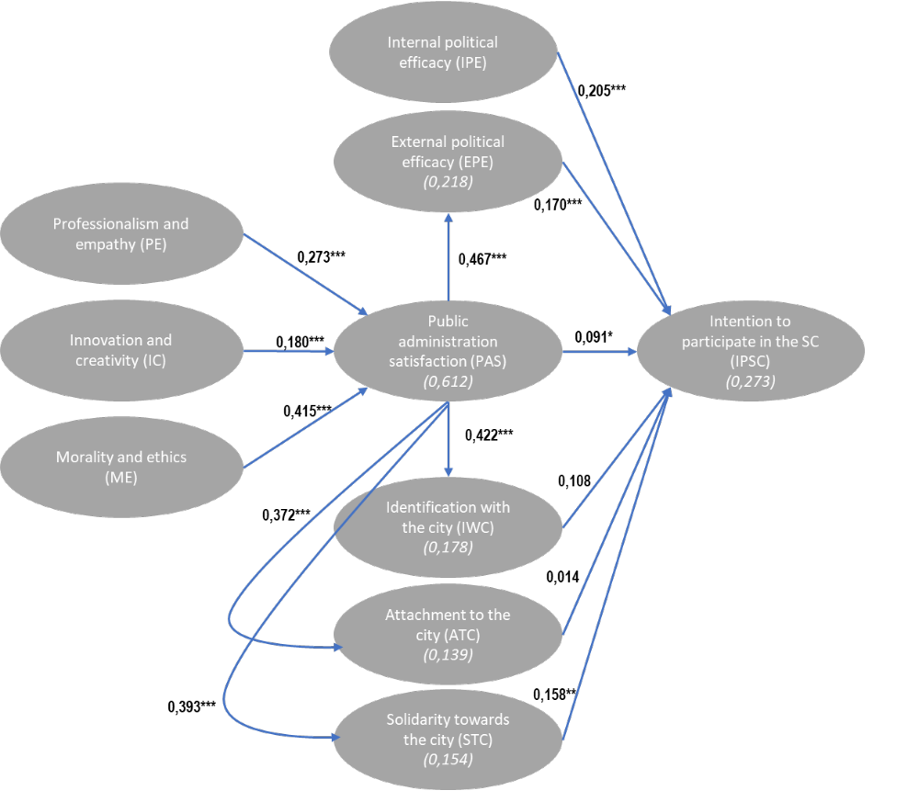
Figure 2: Results of the structural model of determinants for the intention of citizens to participate in the smart city (SC)
(*p < .05; **p < .01; ***p < .001. (R2)).
  - Findings analysis and discussion
From an analysis of the results of the model test, the following key conclusions were drawn:
- The results indicate that the professionalism and empathy of local civil servants (PE) positively influences citizens’ satisfaction with their city’s public administration (PAS) (H3: β =,273, p<0.001). Innovation and creativity (IC) of municipal public services has a significant impact on citizens’ satisfaction with their city’s public administration (PAS) (H4: β =,180, p<0.001). Similarly, moral integrity and ethics (ME) of municipal public services has a significant influence on citizens’ satisfaction with their city’s public administration (PAS) (H5: β =,415, p<0.001). This means that the higher the level of PE, IC and ME for an individual, the higher the level of satisfaction with their city’s public administration. These results confirm in part the results obtained by Vigoda (2002) and Wong et al. (2011) on the determinants of citizens’ satisfaction with their public administration.
- Citizens’ satisfaction with their city’s public administration has a positive influence on their level of external political efficacy (EPE) (H7: β =,467, p<0.001). In other words, the higher a citizen's satisfaction with their city’s public administration, the higher their level of external political efficacy. This finding supports the results obtained by Wong et al. (2011) by showing that external political efficacy is positively influenced by citizens’ satisfaction with public administration. It completes the results obtained by Oh and Lim (2017).
- Citizens’ satisfaction with their city’s public administration positively influences their identification with their city (IWC) (H8: β =,422, p<0.001), attachment to their city (ATC) (H9: β =,372, p<0.001) and solidarity with their city (STC) (H10: β =,393, p<0.001). This shows that the higher a citizen’s level of satisfaction with their city’s public administration, the higher their urban sense of belonging, regardless of the dimension of the sense of belonging analysed. These results indicate that an individual’s sense of belonging to a city is positively influenced by their level of satisfaction with their city’s public administration. These results complete the study of Belanche et al. (2014) by indicating that public administration satisfaction is a predictor of identification with their city.
- The results show that internal political efficacy (IPE) and external political efficacy (EPE) have a significant positive influence on intention to participate in the smart city (IPSC) (H1: β =,205, p<0.001; H2: β =,170, p<0.001). In this respect, the higher an individual's sense of political efficacy, the higher their level of participation in smart city projects will be. These results indicate that an individual’s belief that they can understand political issues and are listened to by politicians positively determines their intention to participate in projects related to a smart city strategy. The results complete and extend the recent research of Nesti and Graziano (2019) and of Trencher (2019) on the mechanisms effectively promoting the participation and expression of citizens.
- An individual’s satisfaction with their city’s public administration (PAS) has a positive influence on their intention to participate in the smart city (IPSC) (H6: β =,091, p<0.05). This means that the higher an individual’s satisfaction with their city’s public administration, the greater their intention to participate in the smart city projects proposed by their city. This finding expands on the results obtained by Vigoda et al. (Vigoda-Gadot et al., 2008) by showing the positive influence public administration satisfaction has on citizens’ intention to participate in the smart city. This finding corroborates the results of the study by Ianniello et al. (2019), precisely on the impact of the attitude of civil servants towards citizen participation.
- Identification with the city (IWC) and attachment to the city (ATC) have no significant effect on the intention to participate in the SC (H11: β =,108; H12: β =,014). However, solidarity towards the city (STC) does have a positive effect on the intention to participate in the SC (H13: β =,170, p<0,01). It is, therefore, fair to say that the higher an individual’s level of solidarity with their city, the greater their intention to participate in their city’s smart city projects. These results mean that only the conative dimension of an individual’s sense of belonging (reflecting their solidarity towards their city) positively influences their intention to participate in projects proposed within the context of a smart city strategy. These results corroborate the findings of Zumbo-Lebrument and Lebrument (2020) specifying the dimension of the sense of belonging that has a significant effect on participation. They complete and extend the research of Belanche et al. (2014) on the effect of identification with the city on adopting innovative services.
  - Importance-Performance Matrix Analysis
To evaluate the importance and performance of latent variables, we performed an Importance-Performance Matrix Analysis (IPMA) with IPSC as the target latent variable. The IPMA is used to visualise the importance and performance of latent variables on a target variable thereby identifying areas for potential improvement of a target variable. We, therefore, in a first instance, carried out an IPMA of IPSC (cf. Figure 3), then simulated an increase of 5, 10 and 20% of the mean score of these explicative variables to measure the predicted impact on its average score (cf. Figure 4).

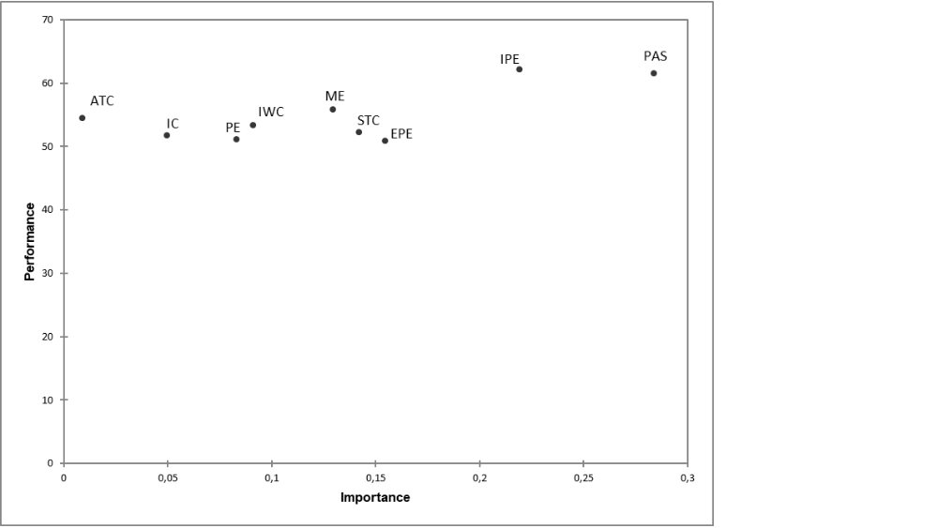
Figure 3: Importance performance matrix analysis (IPMA): latent variable IPSC.

The IPMA on IPSC showed that EPE, IPE and PAS are the most interesting variables in terms of potential impact on IPSC owing to the scope for improvement of their performance and importance. Figure 5 represents the simulation of the impact of a 5, 10 and 20% increase of the average score of manifest variables on the IPSC average. It corroborates that EPE, IPE and PAS are the variables that have the most significant effect on the average IPSC score. Increasing the average score of EPE, IPE and PAS by 20% increases the average IPSC score by 6.8%, 9.6% and 12.5% respectively. Compared to other latent variables, PAS is the first area for improvement of IPSC: this indicates that improving PAS will have the greatest effect on the development of IPSC.

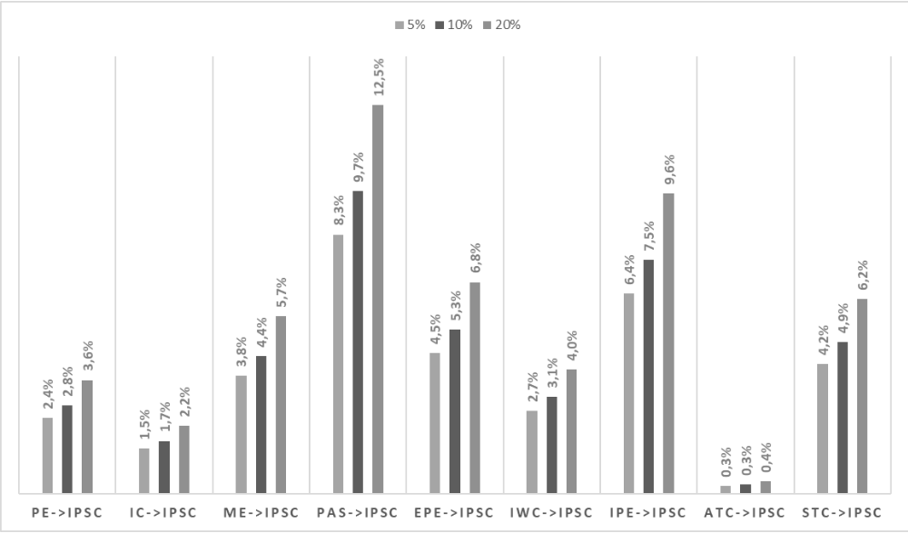
Figure 4: Simulation of the effect of a 5, 10 and 20% increase of the average score of manifest variables on the IPSC average.

- Discussion
Applied to the context of French cities, the aim of our article was to present the results of the empirical test of an original model of determinants of the citizens’ intention to participate in smart city projects. Estimation of the structural equation modelling by means of the partial least squares method (PLS-PM) based on 604 respondents indicates that political efficacy, public administration satisfaction and the conative dimension of sense of belonging have a positive influence on citizens’ intention to participate in smart city projects. Estimation of the model of determinants for the intention of citizens to participate in the smart city validated the predictive nature of the proposed model. These results bring to light a number of issues and implications.
Whether in France or in other countries, citizen participation in smart city projects are the corner stone of a bottom-up strategy to democratically build the smart city (Hu et al., 2016; Appio et al. 2019; Mora, Bolici, & Deakin, 2017). Our study highlights how citizens' involvement in smart city projects is rooted in social and human dimensions (sense of belonging, political efficacy and public administration satisfaction), capturing the attachment of citizens to their smart city. Establishing those three dimensions as key trigger of citizens’ participation offers novel contribution to the literature on smart cities. We have integrated three complementary concepts (political efficacy, public administration satisfaction and sense of belonging) to explain the mechanisms by which citizens wish to get involved in smart city projects. We expand a bottom-up perspective on the smart city (Hu et al., 2016), where the service to residents is critical (Noveck, 2015; O'Brien, 2018; Andreani, et al 2019). It provides some answers to the modalities of citizen involvement in a participatory strategy as a structuring element of the smart city (Giffinger et al., 2010). More generally, it shows how the smart city can be a catalyst for the citizen's desire for a participatory democracy that allows every constituent to promote the general interest (Yetano & Royo, 2017) and the common good (Ianniello et al., 2019).

For practitioners, these results are elements urging them to try and systemically understand the conditions of citizen participation in the smart city: the factors influencing participation in the smart city must be designed at the same time as the factors improving citizens’ satisfaction with public administration, political efficacy and sense of belonging. Furthermore, the findings highlight the cardinal role of citizens’ satisfaction with their city’s public administration: indeed, this has a significant positive influence on external political efficacy, every dimension of the sense of belonging, and the intention to participate in the smart city.

In this sense, our findings bring to light two types of managerial implications aimed at public managers: an operational one and a strategic one. On the operational side, a first implication consists of the fact that the tested model allows public managers to identify which factors (political efficacy, public administration satisfaction and urban sense of belonging) they should take into consideration to understand and maximise citizen participation in smart city projects. A second implication is based on the fact that the model offers public managers the possibility to plan desired results according to the resources deployed to one of the factors influencing citizen participation. The model, therefore, represents for public mangers a tool for planning and maximising resources allocated to predictors of citizen participation in smart city projects in an effort to increase such participation. In light of our results, public administration satisfaction is the predictor of citizen participation upon which public managers should concentrate their efforts if they wish to implement a sustainable participative approach.
Concerning the strategic implications of this research, three recommendations can be envisaged. The first concerns the residents' sense of belonging (Roulet, 2020). Our results suggest that smart city projects should take into account the identity of the city and its values, which are in themselves discursively and collectively constructed (Roulet & Pichler, 2020). The sense of belonging of the residents is indeed primarily based on such identity and values. A place marketing approach to the city or territory (Rodner et al., 2020) will put forward projects to the residents that correspond to the city or territory's values. To take advantage of the influence of the political efficacy of residents, smart city projects must involve them by putting forward projects that are close to their daily reality. In doing so, it will allow them to be involved in smart city projects by soliciting their sense of efficacy in being able to change their urban environment. The third recommendation concerns public administration satisfaction. Following our results, it seems essential get residents to participate in projects designed to improve their public administration satisfaction: for example, involving them in projects aiming at improving the quality of public service by using information and communication technologies. In 2012, the city of Luxembourg, despite initially suffering from a satisfaction deficit with its administration, capitalized on groups of residents to operate a digital transformation of its administrative relationship with inhabitants. This transformation resulted in the implementation of an intelligent administration approach focused on resident satisfaction.

This research has its limits which, while they do not diminish the value of the results obtained, they do call us to relativise the generalisation of the results. The first limit is in our sample, which was designed according to a random sampling technique which cannot guarantee its representativeness. A second limit of our research is that we estimate our model with a unique sample at a single point in time. In order to strengthen the validity of our findings, it would be necessary to replicate our results at several points in time, in order to identify possible changes in the attitudes of citizens regarding their intention to participate in smart city projects. We would be able to assess the impact of the three key factors in a more dynamic way. Another limit relates to the fact that our research was carried out in a French context, which does not guarantee that the results obtained with the same model in another context will have the same significance as those obtained in this study. We could have finally explored the combination of other determinants of citizens’ participation such as technological acceptance (Venkatesh, 2000), and how it may condition the human and social bond that may develop between citizens and their smartcities.

This paper allows us to identify many avenues of future research. One research avenue could explore how smart city technological acceptance (Kummitha, 2020 can impact resident smart city participation. We could also expand the study by capturing the determinants of citizens’ intention to participate at several points in time, and examine how such intention unfolds as citizens’ attachment to their city grows. We could also take a confirmatory approach using the LISREL approach on other datasets in order to estimate, not the predictive value of our model, but its goodness of fit to the data. .

- Conclusion
By validating the role of political efficacy as a determinant of citizen participation in the smart city, our results enrich the understanding of this concept (Craig et al., 1990; Niemi et al., 1991). We prove the importance of this concept in explaining urban participation. Fleshing out political efficacy, we offer a modality to put citizens at the heart of smart city projects (Engelbert et al., 2019; Trencher, 2019). By showing the role played by the sense of belonging, our research provides some answers to the question asked by Desdemoustier et al. (2019) about the impact of territorial characteristics on understanding of the smart city phenomenon. A smart city strategy should factor in the citizens’ sense of belonging (Sepasgozar et al., 2019) based on a city’s identity to enhance participation in its projects (Belanche et al., 2014). Expanding Vigoda-Gadot's research (Vigoda-Gadot, 2007; Vigoda-Gadot et al., 2018), this study complements previous findings on public administration satisfaction and highlights its central role in citizens' intention to get involved in the life of the smart city. The smart city can play a role in reconciling public administration and citizens.
Our results suggest that proposing high-quality participative projects to citizens is not sufficient to influence their intention to participate. In other words, if a city wants to initiate a participative approach to its smart city strategy, it is not enough to consider only the participatory measures to implement: it is also necessary to analyse and evaluate beforehand the predictors of citizen participation, namely political efficacy, public administration satisfaction and the conative dimension of the sense of belonging.

References

Appendix
Survey presentation :
“Hello,
We are researchers currently conducting research on citizen participation in smart city projects. In response to the technological and climatic changes of the 21st century, we are increasingly talking about "smart cities". The smart city can be defined as a city that relies on information and communication technologies to guarantee a favorable and sustainable context for its development (economic, social, etc.) and its environment (quality of life, health, safety, tourism, etc.). To do this, it requires the participation of its residents to best meet their needs.”
Survey items :
Constructs | Items
Professionalism and empathy (PE) | - Public servants are professional and highly qualified  - Public servants show understanding, care, and willingness to serve the citizens  - This city employs only high quality individuals  - Public leadership and senior management in this city are well qualified
Innovation and creativity (IC) | - Compared with other cities, this city (or town) has a dominant position in developing innovation projects for the public  - I think this city is run with creativity for improving public service quality  - The city government encourages public servants to take initiative and suggest good ideas to improve service quality  - Advanced technology is involved in improving service quality in this city
Moral integrity and ethics (ME) | - Most public servants are neutral  - Most public servants are honest  - I receive equal and fair treatment from public servants  - In this city, exceptions from good moral norms are rare
Public administration satisfaction (PAS) | - You’re satisfied with public servant courtesy and kindness  - You’re satisfied with the efficiency of public servants  - You’re satisfied with the physical conditions in city hall  - You’re satisfied with the services you received from public servants
External political efficacy (EPE) | - Citizens have considerable influence on politics  - My local government is generally responsive to public opinion
Internal political efficacy (IPE) | - I feel that I have a pretty good understanding of significant political issues  - I feel that I could do as good a job in public agency as public servants
Identification with the city (IWC) | - I really feel at my home in my city  - I identify a little with my city  - I feel my city as a part of myself
Attachment to the city (ATC) | - I am very attached to my city  - I would feel uprooted if I had to leave my city  - When I'm away from my city, I'm happy to come back
Solidarity towards the city (STC) | - I feel very solidarity with my city  - In my choices, I give priority first to the interests of my city  - It's important for me to help my city grow  - I avoid buying elsewhere what I can find in my city
Intention to participate in the smart city (IPSC) | If you were offered to participate to a smart city project by your city, would you be willing to be involved in projects related to:  - The fight against pollution, the management of energy and the economy of resources, the production of renewable energies  - The quality of public service (accessibility, simplification, quality of service level, efficiency), the quality of public space  - Mobility management, parking, infrastructure, ticketing, new decarbonized propulsion modes (electric, hydrogen, CNG (Compressed Natural Gas)  - Education, social cohesion, solidarity, commitment and empowerment of citizens  - Citizen participation in public action, the administration's relationship with citizens  - Collaborative innovation, the circular economy, local food systems.

We did not formulate a premise regarding the effect of public administration satisfaction on internal political efficacy as positing such a relationship does not seem pertinent.
School teachers, Hospital personnel, Public administration personnel.
Lawyers, engineers, architects, accountants and pharmacists

