Association of collagen, elastin, glycosaminoglycans and macrophages with tissue ultimate material strength and stretch in human thoracic aortic aneurysms: a uniaxial tension study

Aziz Tokgoz PhD^{1†}, Shuo Wang PhD^{2,3,4†}, Priya Sastry MD, PhD⁵, Chang Sun BSc², Nichola L. Figg³, Yuan Huang PhD^{2,6}, Martin R. Bennett MD PhD⁵, Sanjay Sinha PhD⁵, Jonathan H. Gillard MD², Michael P. F. Sutcliffe PhD¹*, Zhongzhao Teng PhD^{2,1,7}*

- Department of Engineering, University of Cambridge
- Department of Radiology, University of Cambridge
- Digital Medical Research Center, School of Basic Medical Sciences, Fudan University, Shanghai, China
- Shanghai Key Laboratory of MICCAI, Shanghai, China
- Division of Cardiovascular Medicine, Department of Medicine, University of Cambridge
- Centre for Mathematical and Statistical Analysis of Multimodal Clinical Imaging, University of Cambridge
- Beijing Advanced Innovation Center for Biomedical Engineering, Beihang University, Beijing, 100083, China

† Equal authorship

Running title: Fibres, GAG, inflammation & aortic strength

* Corresponding authors

Dr Zhongzhao Teng
Department of Radiology, University of Cambridge
Level 5, Box 218, Addenbrooke's Hospital, Hills Rd.,
Cambridge, CB2 0QQ, UK
Tel: 44 (0)1223 746447
Fax: 44 (0)1223 330915
Email: zt215@cam.ac.uk

Prof Michael P. F. Sutcliffe
Department of Engineering, University of Cambridge
Trumpington Street,
Cambridge, CB2 1PZ, UK
Tel: 44 (0)1223 332996
Fax: 44 (0)1223 332662
Email: mpfs@eng.cam.ac.uk

Total word count: 3,999 (Including abstract, main text, and legends)
Abstract
Objective: Fibre structures and pathological features, e.g., inflammation and glycosaminoglycan (GAG) deposition, are the primary determinants of aortic mechanical properties which are associated with the development of aneurysm. This study is designed to quantify the association of tissue ultimate strength and extensibility with the structural percentage of different components, in particular, GAG, and local fibre orientation.

Materials and Methods: Thoracic aortic aneurysm (TAA) tissues from 8 patients were collected. Ninety-six tissue strips of thickened intima, media and adventitia were prepared for uni-extension tests and histopathological examination. Area ratios of collagen, elastin, macrophage and GAG and collagen fibre dispersion were quantified.

Results: Collagen, elastin and GAG were layer-dependent and the inflammatory burden in all layers was low. The local GAG ratio was negatively associated with the collagen ratio (r²=0.173, p<0.05), but positively with elastin (r²=0.037, p<0.05). Higher GAG deposition resulted in larger local collagen fibre dispersion in the media and adventitia, but not in the intima. The ultimate stretch in both axial and circumferential directions was exclusively associated with elastin ratio (Axial: r²=0.186, p=0.04; Circumferential: r²=0.175, p=0.04). Multivariate analysis showed that collagen and GAG contents were both associated with ultimate strength in the circumferential direction, but not with the axial direction (Collagen: slope=27.3, GAG: slope=-18.4, r²=0.438, p=0.002).

Conclusions: GAG may play important roles in TAA material strength. Their deposition was found to be associated positively with the local collagen fibre dispersion and negatively with ultimate strength in the circumferential direction.

Keywords: Thoracic aortic aneurysm; fibre; glycosaminoglycan; inflammation; strength

Abbreviations

CD68  CI | Cluster of differentiation 68  Confidence interval
CT | Computed tomography
ECM | Extracellular matrix
EVG | Elastin Van Gieson
GAG | Glycosaminoglycan
H&E | Hematoxylin and Eosin
MRI | Magnetic resonance imaging
TAA | Thoracic aortic aneurysm

- Introduction
Thoracic aortic aneurysms (TAAs) are significant contributors of deaths¹. TAAs are mostly asymptomatic during diagnosis as lesions are commonly identified unexpectedly during an echocardiography or computed tomography (CT), or when taking an X-ray image of the chest. Thoracic aneurysms have a mean growth rate of 0.1 cm/year, where this value is location- and patient-dependent². Moreover, rupture rate of lesions ≥6.0 cm was found to be at least 7%, which is more than 25 times higher than that of the lesions with diameters between 4.0 cm and 4.9 cm². However, lesions with less than 6 cm diameter were also found to show tendency to rupture or to develop into a dissection³. These findings strongly suggest that close radiological monitoring is critical for identifying the lesions that show a rapid growth despite being under the surgical repair threshold.

The main pathological feature of TAAs is cystic medial degeneration, which is commonly accelerated with other clinical conditions such as hypertension, bicuspid aortic valve aortopathy and genetic mutations. Degeneration of the media layer and the deposition of proteoglycans and thereafter glycosaminoglycans (GAG) often take place simultaneously in the aorta wall, which is also accompanied by fragmentation of the elastic lamellae⁴. GAG are long unbranched polysaccharides that consist of a repeating disaccharide unit. Despite the fact that GAG make up a small portion of the artery wall (2%-5% by dry weight), they play key roles in both physiological and the pathological processes that are undergone by a vessel^{5,6} and also contribute to the mechanical behaviour of the tissue⁷. In its healthy state, the arterial wall undergoes mechanical loading as a result of the dynamic blood pressure and flow. Undergoing such continuous mechanical loading is likely to modulate and have adverse effects on the biological and biochemical physiology of the endothelium⁸ and smooth muscle cells⁹ of the arterial wall. In addition, following degeneration, the vessel wall may become more likely to rupture or dissect as a result of the dynamic mechanical loading. These factors point towards a clear need for obtaining better understanding of the material properties and mechanical strength of TAA and any association between its mechanics and structural composition as well as microstructural features.

The major load bearing components of the arterial extracellular matrix (ECM) are elastin and collagen fibres¹⁰. Their orientations and structural organisations are associated with strength of arteries in both health and disease¹¹. Existing literature on the mechanical behaviour of arterial ECM has so far commonly targeted collagen and elastin, where the role of GAG has often been neglected. Despite being a minor constituent of the ECM, GAG could play a significant role in the development of dissections¹² as excessive accumulation and aggregation of GAG could lead to high levels of local stress concentrations that can cause delamination of the artery wall¹³. Moreover, a reduced GAG content is known to lead to earlier collagen and elastin fibre recruitment in porcine thoracic aortas, giving the aortas a stiffer mechanical behaviour¹⁴.

In this study, TAA tissue strips were tensile tested to quantify the ultimate stretch and material strength of the tissues, histopathological investigations were performed to quantify the structural area occupied by distinct microstructural components, and statistical analyses were performed to explore the correlations between the mechanical properties of the tissue and its detailed composition, which also includes GAG.

- Materials and methods
  - Collection of tissues
Eight TAA tissue pieces were collected from 8 patients (one female; ages were 61.4±12.2 years 3 from ascending aorta, 4 from aortic arch and 1 from descending aorta; 3 were chronic dissections and 5 fusiform aneurysms), who underwent open aortic repair in Royal Papworth Hospital, NHS Foundation Trust, Cambridge, UK. None of the lumens showed thrombus presence that has been confirmed by the histologic examination. The local ethics committee approved this study and written patient consents were obtained.

  - Mechanical testing
Tissue pieces were cut into rings (circumferential sections) (Fig.1A) or axial sections shortly after the tissue collection. The thickened intima, media and adventitia of each arterial piece were separated (Fig.1B). Tissue strips from each layer, with ~1.5 mm width and ~15 mm length, along both axial and circumferential directions to the blood flow were prepared and the width, thickness and length of each tissue strip were documented (Fig.1C-E) as detailed in the Supplementary Materials. Two water-proof markers were placed on the tissue surface to trace the local displacement (Fig.1F). Each tissue strip was mounted on an in-house designed micro tester to perform a uniaxial tensile test. The loadcell reading was set to zero when the tissue strip was loose, and then a pre-load of 0.001 N was applied to achieve the starting state. Prior to testing, pre-conditioning with ~5% stretch at a speed of 0.05 mm·s⁻¹ was repeated five times and the strip was then stretched until failure at a speed of 0.01 mm·s⁻¹ in a 37 °C phosphate buffered saline bath. New tissue strips would be prepared and tested again when strips failed near one of the clamps.

During stretching, the force and tissue images were recorded by a sensor and a camera, respectively, and the displacement of the clamp was also recorded (Fig.1G). The micro tester comprises a uniaxial stepper motor (Miniature Steel Motorised Linear Stage, Newport Corporation, Irvine, California, USA), a custom-made linear load cell, a camera (PixeLink PL-B776U 3.1 MP USB2 Colour Camera, PixeLink, Ottawa, Canada) and a custom control interface developed in LabVIEW (National Instruments, Austin, Texas, USA). The position resolution of the stepper motor was 0.1 µm and the precision of the load cell was 0.0005 N. The size of each image frame was 2048×1536 pixels, with an 80×60 mm² field of view. The marker was in dark blue and it had a strong contrast with white tissue strips and their red background. A dark blue colour threshold and standard morphological image operations available in MATLAB (imclearborder, imerode, imfill and imclose functions of MATLAB) were utilised to generate marker spot binary masks from the acquired Red-Green-Blue (RGB) colour space images. The described mechanical testing protocol has been developed, optimised and used in previous studies¹⁵.

  - Calculation of stress-stretch
A semi-automatic MATLAB platform was developed to compute the local displacement of each arterial tissue from images acquired at the end of each stepper motor displacement increment. The markers on the tissue surface were recognised automatically to determine their centroid coordinates (Fig.1F). The distance between the centroids of the two markers were used to compute the local stretch, λ_{i}=l_{i}/l₀, in which l_{i} is the distance between the centroid of the two markers at the i^{th} increment and l₀ is the distance at rest. Cauchy stress was computed using, σ_{i}=(F_{i}·λ_{i})/A₀, where F_{i} was the measured force at each displacement increment, A₀ was the initial cross-sectional area of the arterial tissue strip. The stress-stretch of each tissue strip was
shown in Figure S2 in the Supplementary Materials. The tissue ultimate stretch and material strength were defined respectively as the stretch ratio and the stress prior to failure as indicated by the sudden drop in the force-displacement curve (Fig.1G).

Compared with the ultimate stretch and material strength, the stress-stretch curve at a low stress level reflects the tissue physiologic mechanical behaviour better. In this study, the Young’s modulus (E₅₀) defined by the slope of a straight line approximated the stress-stretch curve at a stress level of [0, 50] kPa was calculated. This stress range was chosen as the curve in this range could be well approximated linearly.

  - Histology and image processing
Tissue strips adjacent to those used for mechanical testing were collected for immunohistochemical examination. Following standard processing, each tissue strip was embedded in paraffin wax, cut into 4 μm thick slices, and stained with Hematoxylin and Eosin (H&E), Sirius Red, Elastin Van Gieson (EVG), Alcian Blue and Cluster of Differentiation 68 (CD68) to visualise collagen, elastin, GAG, calcium and macrophages respectively (Fig.2). Each immunohistochemically stained slice was digitised using NanoZoomer (Hamamatsu, Hamamatsu City, Japan) at a magnification rate of 40x. Collagen appears red in Sirius Red, elastin dark purple in EVG, GAGs blue in Alcian Blue and macrophages appear brown in CD68. A semi-automatic platform developed in MATLAB was used to compute the area percentage of each microstructural component for each histopathological slide.
$$Area Percentage= \frac{Number of Microstructural Component Pixels}{Total Number of Pixels in the region of interest}×100\%$$
Collagen fibre is a mechanically important tissue constituent, which bears loading at higher strains and determines the strength of the tissue¹⁶. Along with the overall area percentages, the local distribution of collagen fibre orientations were computed with the developed MATLAB platform. Fibre dispersion was used to describe the spread of fibre orientations, where smaller dispersion implies stronger alignment. In this study, the standard deviation of fibre orientation in a region was used to characterise the local fibre dispersion. Considering the heterogenous distribution of the microstructural components, two hundred ROI squares with 200×200 pixels were randomly placed in each histology image to quantify the local association between fibre dispersion and GAG content. Details of image processing can be found in the reference¹⁷ and the Supplementary Materials.

  - Statistical analysis
Since multiple observations of GAG ratio and fibre dispersion were taken from each strip, linear mixed-effects models were used to account for the data hierarchy. In addition, to better reflect the heterogeneity between strips, the models assumed both random intercepts and random slopes. The non-simultaneous marginal predictions and their 95% confidence intervals (CIs) were then plotted to illustrate the population trend.

Correlations between percentages of microstructural constituents (collagen, elastin, GAG and macrophages) and the mechanical properties were evaluated using a linear model with the consideration of random effect using least-squares fit. For each estimated coefficient, the coefficient of determination (r²) and the corresponding p-value for t-statistic were reported.

Differences in microstructural constituent percentages and mechanical properties between different tissue types were evaluated using the Wilcoxon signed rank test. Statistical analysis was performed in MATLAB (MathWorks, Inc.). A significant difference was assumed if p<0.05.

- Results
Data from 96 tissue strips of 8 aneurysm samples were prepared for testing and analyses: 48 strips for material testing and 48 matched strips for the histopathological examination. Each 48-group is composed of one strip from each of thickened intima, media and adventitia in the axial direction and one in the circumferential direction from each sample, that is, 12 tissues from each aneurysm sample and 6 for the material testing and 6 for the histopathological examination.

  - Layer-specific component contents
Collagen and elastin were found to be the two main constituents of the aortic wall, followed by GAG and macrophages (Fig.3). Among the three layers, the thickened intima was found to have the lowest collagen content, and the adventitia was found to have the highest collagen content; in contrast, the intima was found to have more elastin than the adventitia and the elastin area ratios of intima and media were found to be comparable. Both intima and media were found to have higher GAG contents than adventitia (p<0.001). Compared with collagen, elastin and GAG, the macrophage area ratio in the arterial wall was significantly less (p<0.001). Correlation analysis showed that GAG area ratio was negatively associated with the collagen area ratio (r²=0.173, p<0.001) but positively with elastin (r²=0.037, p=0.038).

  - Layer-specific collagen fibre architectures and their association with GAG deposition
The association between local fibre dispersion and GAG deposition was explored. Collagen fibre dispersion in the intima was 43.5° [40.8°, 44.4°] (median [interquartile range]) in the circumferential and 42.3° [40.2°, 44.6°] in the axial direction, with no significant difference between these two directions (p=0.677). Fibre dispersion in the media was smaller in the circumferential than in the axial direction (39.4° [36.2°, 40.7°] vs 44.2° [42.5°, 46.2°], p=0.001).

Across layers, fibre dispersion of the media in the circumferential direction was smaller than in the intima (p=0.003). Local GAG content was positively associated with fibre dispersion in the media and adventitia in both circumferential and axial directions, but not in the intima in either direction (Fig.4).

  - Layer-specific mechanical properties
Failure tests showed that the adventitia in the circumferential direction had the highest ultimate material strength (Fig.5A). The material strength of intima in the axial direction was similar to that of media in the same direction (395.9 [202.3, 567.2] vs 236.4 [213.3, 341.4], p=0.31; unit: kPa), where the intima and media strengths were also similar in the circumferential direction (518.4 [249.5, 750.3] vs 606.5 [358.8, 708.2], p=0.84; unit: kPa). Across layers, the intima had similar material strengths in both directions (p=0.46), while the media and adventitia were stronger in the circumferential than the axial direction (both with p=0.02). In general, the ultimate stretch of all layers in both directions was similar, except for the adventitia in the circumferential direction, which was more extendable than media in the same direction (1.33 [1.21, 1.54] vs 1.16 [1.14, 1.33], p=0.02) (Fig.5B).

  - Relationship between component contents and tissue mechanical properties
Correlation analyses showed that the ultimate stretches in both axial and circumferential directions were associated only with elastin area ratio (Axial: r²=0.186, p=0.04; Circumferential: r²=0.175, p=0.04). The ultimate material strength in the circumferential direction associated with collagen positively, while with GAG negatively (Collagen: slope=32.7, r²=0.328, p=0.003; GAG: slope=-25.5, r²=0.227, p=0.019), but not with strength in the axial direction. Further multivariate analysis confirmed the association between the material strength in the circumferential direction with collagen and GAG contents (Collagen: slope=27.3, GAG: slope=-18.4, r²=0.438, p=0.002); and this association remained when data from both axial and circumferential directions were pooled (Collagen: slope=17.0, GAG: slope=-12.6, r²=0.249, p=0.002).

Univariable analyses shown that E₅₀ was associated with different area ratio of different component in the axial and circumferential direction differently (Table S1 in Supplementary Materials). When data from different direction were pooled, no significant association was found. When data from three layers in the two directions were pooled, a significantly negative correlation between E₅₀ and the elastin area ratio was found (r=-0.29, p=0.047), but such significant association was not found when the multivariable regression analysis was performed.

- Discussion
This study showed that distributions of collagen, elastin, GAGs, and macrophages were layer-dependent and GAG deposition was associated with local fibre dispersion. Mechanical tests demonstrated that collagen and GAG contents were associated with tissue ultimate stretch and material strength.

In addition to fibre type and other material contents, fibre orientation is an important determinant for the tissue extensibility and strength. However, the fibre orientation is best characterised in the 3D setting, such as via use of multiphoton microscopy¹⁸. The 2D histological slides as used in this study would provide the information of projected fibre orientations on a certain slide plane. Due to the limitation of 2D projection, the fibre dispersion rather than the concrete spatial orientations was used when the relationship between GAGs and the fibre microstructure was accessed.

The negative relationship between GAG content and ultimate strength and the positive relationship between GAG content and the ultimate stretch in the circumferential direction implies that GAGs are a weaker material than collagen. This is in agreement with their molecular structures that consist of linear chains of repeating disaccharide units¹⁹. GAG are highly negatively charged and thus sequester water and contribute directly to the compressive, rather than tensile stiffness of the artery^{12,19}. The negatively charged GAG could alter the regional distribution of interstitial water causing a swelling pressure, which has been speculated to be similar in magnitude to blood pressure¹². Such swelling might damage the arterial wall by separating the fibre lamellae^{20,21} as evidenced by greater separation distances between elastic lamellae where accumulation of GAG was found²², which might lead to the development of aortic dissection.

Apart from the inherent material characteristics of GAG, which can modify the local structure and strength, the deposition of GAG pools in the arterial wall also alters the local mechanical environment. Due to the lower tensile stiffness, pooled GAG deposition could elevate the local stress concentration by 3-5 times as compared with the far-field stresses, which are not affected by the local pooling of GAGs¹³. This GAG pooling induced stress concentration and swelling pressure might cause local delamination in the aortic wall and therefore contribute to the development of aortic dissection. GAG deposition may also play an important role in atherosclerotic plaque erosion in the coronary circulation. Plaque erosion involves the formation of thrombus in an area of endothelial denudation adjacent to an atherosclerotic plaque without disruption of the fibrous cap^{23,24}, and is responsible for ~25% of deaths due to acute myocardial infarction²⁴. Histopathological analyses have demonstrated the superficial accumulation of specific GAGs and hyaluronan at the sites of plaque erosion (Fig.6)²³. As shown in this study, the GAG accumulation weakens the local material, implying that the superficial accumulation of GAGs can elevate the local stretch (Fig.6B&C). The elevated stretch level might promote local endothelium cell apoptosis⁸ leading to endothelial denudation. It also induces specific changes in the synthesis and organisation of GAG by vascular smooth muscle cells²⁵, e.g., large stretch increases versican, biglycan and perlecan core proteins, and this generates a positive feedback loop further promoting the accumulation of GAG. Moreover, given the large stretch together with weaker material, the GAG accumulation might damage the local tissue integrity by forming micro-fissures. The endothelial denudation and micro-fissures alone or in combination might lead to the local development of thrombosis and fatal events^{26,27}. The mechanical analysis shown in Fig.6B&C has followed previous reports²⁸ and mechanical properties of each component were adopted from previous direct measurements¹⁵. Detailed numerical processes that were used to produce Fig.6 can be found in the Supplementary Materials.

Tissues from TAA seem to be less extensible and stiffer than those from abdominal aortic aneurysm (AAA), for which quantitative comparisons are provided in the table in Supplementary Materials. This study also showed a heterogeneous transmural distribution of GAG. Both intima (area percentage, 19.7% [13.6%, 24.7%]) and media (17.4% [10.8%, 25.7%]) had a significantly higher GAG content than adventitia (4.1% [1.6%, 7.8%]) where similar distribution patterns have also been reported in the healthy arterial wall²⁹. However, in healthy arterial wall GAG occupy a small percentage of the total extracellular matrix (4%), but increase dramatically in the early lesion phase, e.g., ∼50% in atherosclerotic lesion, and as lesions become more advanced, collagen predominates with decreased GAG content (∼20%)³⁰. The heterogeneous transmural distribution may be a source of residual stress²⁹ which can present itself as a radial cut on an arterial ring³¹ or as a radial cut on an atherosclerotic lesion³². The interactions between GAGs and other extracellular components also play an important role in the mechanics of the arterial wall. Although removal of GAGs results in an earlier transition point of the nonlinear stress-strain curves during extension mechanical testing, the stiffness was not significantly different after GAG removal¹⁴. Microscopic examination showed that when GAGs were removed, the adventitial collagen fibres were straighter, and both elastin and collagen fibres recruited at lower levels of strain, in agreement with the mechanical change¹⁴.

Sodium magnetic resonance imaging (MRI), delayed gadolinium-enhanced MRI of cartilage and T₁-rho mapping have been developed to permit the visualisation of the charged GAG distribution in cartilage³³. These imaging techniques might be modified for the detection of GAG accumulation in the aortic wall, and particularly in the thoracic aorta where most dissections are located. Successful development of this aspect would be beneficial for prediction of dissection development.

Despite obtaining interesting findings, limitations exist in this study: (1) samples were obtained from the arch region where diseased tissues were mostly located. However, tissue structure and properties vary across the thoracic aorta. Studies with a bigger sample size are, therefore, needed to confirm findings reported in this study; (2) although uniaxial tension tests were performed in both circumferential and axial directions, the anisotropic material behaviour of aneurysmal tissues cannot be assessed comprehensively; (3) no controls were provided for comparison since it is unethical to obtain healthy human aortic tissues; (4) although tissues used for mechanical tests and histopathological examination were from a narrow adjacent region, the heterogeneity of aneurysmal tissues means that measurements from adjacent tissue strips might not represent the inherent mechanical and histopathological features; (5) the fibre dispersion was used to characterise the fibre architecture instead of the absolute fibre orientation as the local curvature and orientation of each tissue strip would not affect the dispersion. However, the nonuniform distortion induced by the processing procedure for histopathological stains could affect the fibre dispersion analysis. The effect of this have been reduced by the utilised small square patch dimension (0.18×0.18 mm²; please see the Supplementary Materials for more details). Moreover, the fiber dispersion was quantified in 2D, not 3D; (6) the type of collagen fibres was not differentiated and considered, and the possible effect of fibre waviness on the calculation of its dispersion was not assessed; and (7) further studies with a bigger sample size are needed to explore the association of GAG contents with patient clinical characteristics.

Acknowledgement
This research is supported by EPSRC (EP/P021654/1), BHF (PG/18/14/33562), NSERC (6799-427538-2012) and the NIHR Cambridge Biomedical Research Centre (BRC-1215-20014). Dr Tokgoz is supported by an EPSRC Doctoral Training Award at the University of Cambridge and Dr Wang by the China Scholarship Council.

Contributions
AT and SW performed the testing and analysed the data; PS collected the samples and interpreted their physiologic and pathologic features; CS and YH analysed the data; NLF performed the histopathological examinations and interpreted the pathological features; MRB, SS and JHG provided facilities and supports for the mechanical testing and histopathological examinations and interpreted the pathologic findings; MPFS designed the study and revised the manuscript significantly; ZT designed and supervised the whole study and drafted the manuscript.

Disclosures
Dr Teng is the chief scientist of Tenoke Ltd., Cambridge, UK and Jingsan (Nanjing) Medical Science and Technology, Ltd., China. Other authors do not have any conflict of interest related to this study to declare.

References
1. L.H. S JAE. Epidemiology and natural history of thoraco-abdominal aortic aneurysms. Milano: Springer;. 2011.
2. Davies RR, Goldstein LJ, Coady MA, et al. Yearly rupture or dissection rates for thoracic aortic aneurysms: simple prediction based on size. Ann Thorac Surg. 2002;73(1):17-18. doi:10.1016/s0003-4975(01)03236-2
3. Elefteriades JA, Farkas EA. Thoracic aortic aneurysm clinically pertinent controversies and uncertainties. J Am Coll Cardiol. 2010;55(9):841-857. doi:10.1016/j.jacc.2009.08.084
4. Sariola H, Viljanen T, Luosto R. Histological pattern and changes in extracellular matrix in aortic dissections. J Clin Pathol. 1986;39(10):1074-1081. doi:10.1136/jcp.39.10.1074
5. Karangelis DE, Kanakis I, Asimakopoulou AP, et al. Glycosaminoglycans as key molecules in atherosclerosis: the role of versican and hyaluronan. Curr Med Chem. 2010;17(33):4018-4026. doi:10.2174/092986710793205354
6. Camejo G. The interaction of lipids and lipoproteins with the intercellular matrix of arterial tissue: its possible role in atherogenesis. Adv Lipid Res. 1982;19:1-53. doi:10.1016/b978-0-12-024919-0.50007-2
7. Mattson JM, Wang Y, Zhang Y. Contributions of Glycosaminoglycans to Collagen Fiber Recruitment in Constitutive Modeling of Arterial Mechanics. J Biomech. 2019;82:211-219. doi:10.1016/j.jbiomech.2018.10.031
8. Jufri NF, Mohamedali A, Avolio A, Baker MS. Mechanical stretch: physiological and pathological implications for human vascular endothelial cells. Vasc Cell. 2015;7:8. doi:10.1186/s13221-015-0033-z
9. Sotoudeh M, Li YS, Yajima N, et al. Induction of apoptosis in vascular smooth muscle cells by mechanical stretch. Am J Physiol Hear Circ Physiol. 2002;282(5):H1709-16. doi:10.1152/ajpheart.00744.2001
10. Schriefl AJ, Zeindlinger G, Pierce DM, Regitnig P, Holzapfel GA. Determination of the layer-specific distributed collagen fibre orientations in human thoracic and abdominal aortas and common iliac arteries. J R Soc Interface. 2012;9(71):1275-1286. doi:10.1098/rsif.2011.0727
11. O’Rourke M. Mechanical principles in arterial disease. Hypertension. 1995;26(1):2-9. doi:10.1161/01.hyp.26.1.2
12. Humphrey JD. Possible mechanical roles of glycosaminoglycans in thoracic aortic dissection and associations with dysregulated transforming growth factor-β. J Vasc Res. 2013;50(1):1-10. doi:10.1159/000342436
13. Roccabianca S, Ateshian GA, Humphrey JD. Biomechanical roles of medial pooling of glycosaminoglycans in thoracic aortic dissection. Biomech Model Mechanobiol. 2014;13(1):13-25. doi:10.1007/s10237-013-0482-3
14. Mattson JM, Turcotte R, Zhang Y. Glycosaminoglycans contribute to extracellular matrix fiber recruitment and arterial wall mechanics. Biomech Model Mechanobiol. 2017;16(1):213-225. doi:10.1007/s10237-016-0811-4
15. Teng Z, Zhang Y, Huang Y, et al. Material properties of components in human carotid atherosclerotic plaques: A uniaxial extension study. Acta Biomater. 2014;10(12):5055-5063. doi:10.1016/j.actbio.2014.09.001
16. Ottani V, Raspanti M, Ruggeri A. Collagen structure and functional implications. Micron. 2001;32(3):251-260. doi:10.1016/s0968-4328(00)00042-1
17. Wang S, Tokgoz A, Huang Y, et al. Bayesian Inference-Based Estimation of Normal Aortic, Aneurysmal and Atherosclerotic Tissue Mechanical Properties: From Material Testing, Modeling and Histology. IEEE Trans Biomed Eng. 2019;66(8):2269-2278. doi:10.1109/TBME.2018.2886681
18. Sugita S, Matsumoto T. Multiphoton microscopy observations of 3D elastin and collagen fiber microstructure changes during pressurization in aortic media. Biomechanics and modeling in mechanobiology. 2017;16(3):763-73. doi: 10.1007/s10237-016-0851-9
19. Alberts B Lewis J, Raff M, Roberts K, Walter P. JA. Molecular biology of the cell. New York, USA Garl Sci. 2002.
20. Evanko SP, Johnson PY, Braun KR, Underhill CB, Dudhia J, Wight TN. Platelet-derived growth factor stimulates the formation of versican-hyaluronan aggregates and pericellular matrix expansion in arterial smooth muscle cells. Arch Biochem Biophys. 2001;394(1):29-38. doi:10.1006/abbi.2001.2507
21. Hosoda Y, Iri H. Angiolathyrism. 1. A histological and histochemical study on successive changes of the lathyritic rat aorta. Acta Pathol Jpn. 1966;16(3):239-252. doi:10.1111/j.1440-1827.1966.tb01957.x
22. Guo DC, Regalado ES, Minn C, et al. Familial thoracic aortic aneurysms and dissections: identification of a novel locus for stable aneurysms with a low risk for progression to aortic dissection. Circ Cardiovasc Genet. 2011;4(1):36-42. doi:10.1161/circgenetics.110.958066
23. Farb A, Burke AP, Tang AL, et al. Coronary plaque erosion without rupture into a lipid core. A frequent cause of coronary thrombosis in sudden coronary death. Circulation. 1996;93(7):1354-1363. doi:10.1161/01.cir.93.7.1354
24. Arbustini E, Dal Bello B, Morbini P, et al. Plaque erosion is a major substrate for coronary thrombosis in acute myocardial infarction. Heart. 1999;82(3):269-272. doi:10.1136/hrt.82.3.269
25. Lee RT, Yamamoto C, Feng Y, et al. Mechanical strain induces specific changes in the synthesis and organization of proteoglycans by vascular smooth muscle cells. J Biol Chem. 2001;276(17):13847-13851. doi:10.1074/jbc.M010556200
26. Kolodgie FD, Burke AP, Farb A, et al. Differential accumulation of proteoglycans and hyaluronan in culprit lesions: insights into plaque erosion. Arter Thromb Vasc Biol. 2002;22(10):1642-1648. doi:10.1161/01.atv.0000034021.92658.4c
27. Partida RA, Libby P, Crea F, Jang IK. Plaque erosion: a new in vivo diagnosis and a potential major shift in the management of patients with acute coronary syndromes. Eur Hear J. 2018;39(22):2070-2076. doi:10.1093/eurheartj/ehx786
28. Teng Z, Brown AJ, Calvert PA, et al. Coronary plaque structural stress is associated with plaque composition and subtype and higher in acute coronary syndrome: The BEACON i (Biomechanical Evaluation of Atheromatous Coronary Arteries) study. Circ Cardiovasc Imaging. 2014;7(3):461-470. doi:10.1161/CIRCIMAGING.113.001526
29. Azeloglu EU, Albro MB, Thimmappa VA, Ateshian GA, Costa KD. Heterogeneous transmural proteoglycan distribution provides a mechanism for regulating residual stresses in the aorta. Am J Physiol Hear Circ Physiol. 2008;294(3):H1197-205. doi:10.1152/ajpheart.01027.2007
30. Wight TN. A role for proteoglycans in vascular disease. Matrix Biology. 2018;71:396-420. doi: 10.1016/j.matbio.2018.02.019
31. Chuong CJ, Fung YC. On residual stresses in arteries. J Biomech Eng. 1986;108(2):189-192. doi:10.1115/1.3138600
32. Teng Z, Feng J, Zhang Y, et al. A uni-extension study on the ultimate material strength and extreme extensibility of atherosclerotic tissue in human carotid plaques. J Biomech. 2015;48(14):3859-3867. doi:10.1016/j.jbiomech.2015.09.037
33. Gray ML, Burstein D, Kim YJ, Maroudas A. 2007 Elizabeth Winston Lanier Award Winner. Magnetic resonance imaging of cartilage glycosaminoglycan: basic principles, imaging technique, and clinical applications. J Orthop Res. 2008;26(3):281-291. doi:10.1002/jor.20482

Figure 1. Representative aneurysmal ring (A) and isolated tissue strips (C-E) for mechanical testing and a tissue strip under stretching (F; blue markers were placed on the surface to trace the local displacement to compute the local stretch ratio; markers were identified as enclosed by the red lines automatically; G: a representative displacement-force curve; the gap between adjacent lines in A-E is 0.5 mm).

Figure 2. Histopathological sections showing tissue local fibre structure and pathological features. (A: Hematoxylin and Eosin stain (H&E) for an overall assessment; B: Sirius Red stain showing collagen fibres; C: Elastin Van Gieson (EVG) stain showing elastin; D: Cluster of Differentiation 68 (CD68) stain for macrophages; and E: Alcian blue stain for GAG). Area ratios of the corresponding microstructural components are also provided at the bottom left of each histopathological slide image.

Figure 3. Area ratio of collagen, elastin, GAG and macrophages in different layers.

Figure 4. Correlation analysis using linear mixed-effects models showing the local correlation between dispersion of collagen fibre orientations and GAG area ratio in different layers in both axial and circumferential directions. The non-simultaneous marginal predictions and their confidence intervals are plotted to illustrate population-wise association.

Figure 5. Ultimate material strength and stretch of tissue strips.

Figure 6. A 2D finite element analysis showed that superficial GAG deposition increased local stretch levels (A: The finite element model was reconstructed based on the Movat staining of a coronary atherosclerotic lesion from a 38-year-old woman in Figure 5 from Farb, A., et al., Circulation, 93: 1354-63, 1996; B: Mechanical analysis demonstrated that the superficial GAG deposition induced increased local tissue stretch particularly around the lumen region; C: When no GAG deposition was assumed, the stretch level reduced by over 10%; details about the analysis can be found in the Supplementary Materials).

Figure 1

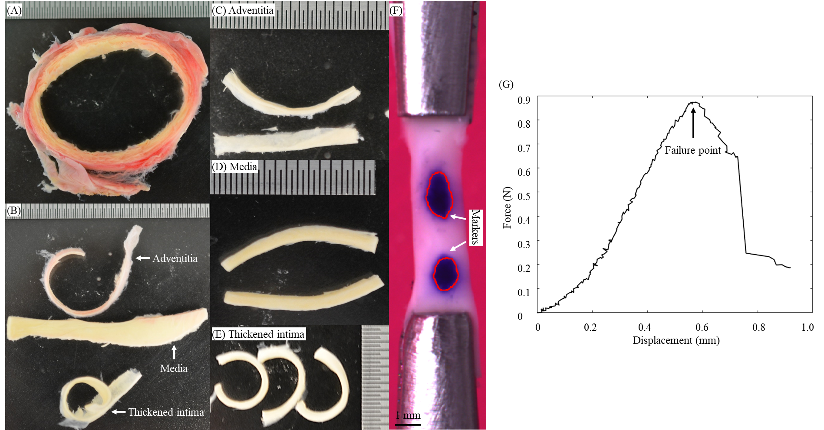

Figure 2
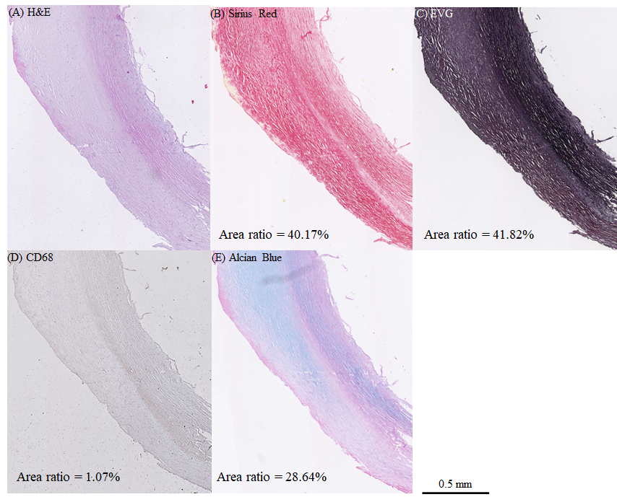
Figure 3
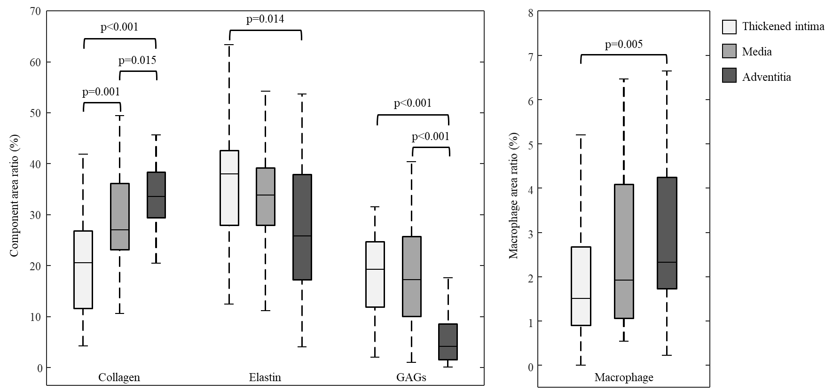

Figure 4
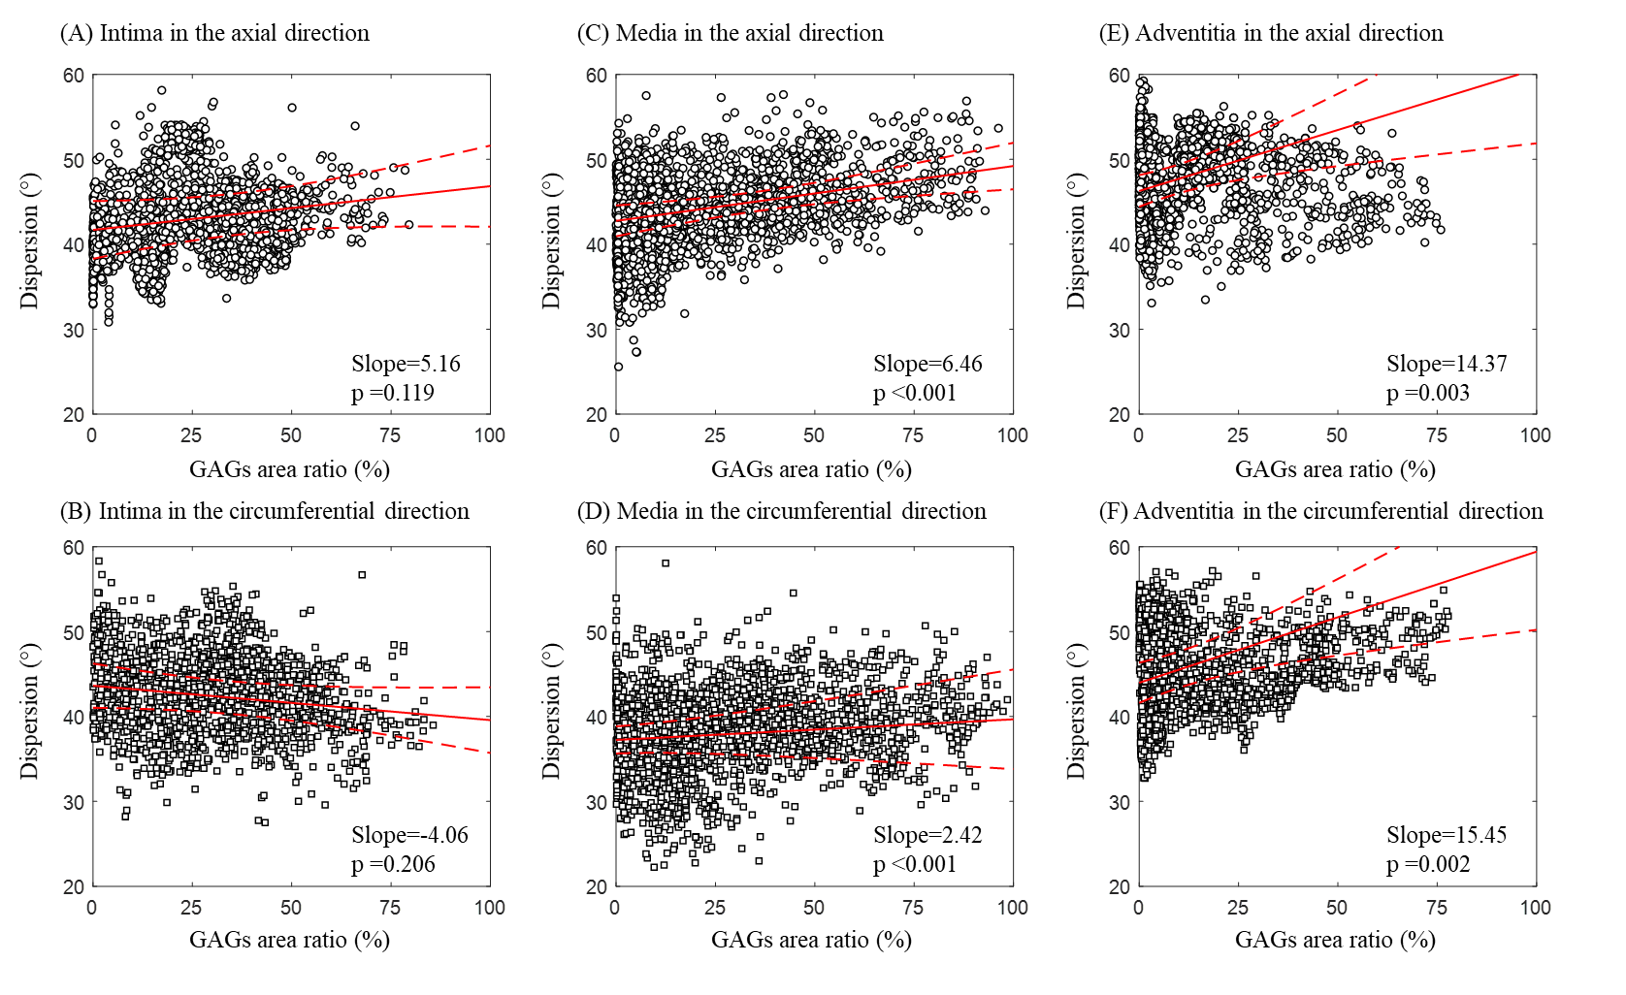

Figure 5

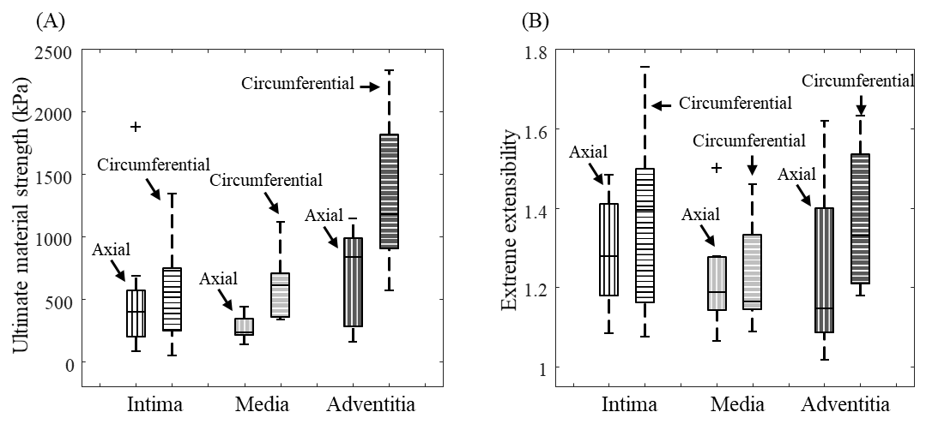

Figure 6

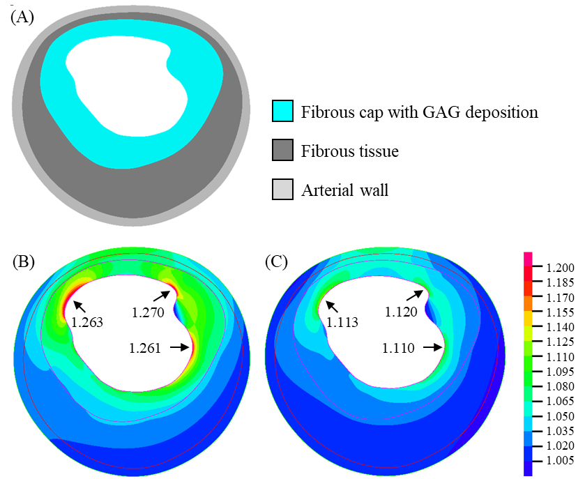

Supplementary Materials to

Tokgoz A., Wang S., et al., Association of collagen, elastin, glycosaminoglycans and macrophages with tissue ultimate material strength and stretch in human thoracic aortic aneurysms: a uniaxial tension study

- Tissue collection and strip preparation
Upon resection from the patient, each arterial tissue piece was immediately stored in liquid nitrogen, where cryoprotectant (20% dimethylsulfoxide in 5% human albumin) solution added to a final concentration of 10% dimethylsulfoxide was utilised to minimise potential damage caused by freezing. Diseased aortic tissue pieces were transferred to Addenbrooke’s Hospital, NHS Foundation Trust, Cambridge, UK for mechanical testing. The thickened intima, media and adventitia layers of each tissue piece were separated and cut into rectangular mechanical testing strips. Prior to separation into the three distinct arterial tissue layers, each tissue piece was immersed in phosphate buffered saline and defrosted in a 37°C tissue bath. The intact arterial rings were first cut open, flattened, and then cut further into smaller sections with a scalpel, along with the other relatively large noncircular pieces, to allow easier separation of the three layers. The thickened intima, media and adventitia of each tissue section were then separated with tweezers and cut into rectangular tissue strips of ~1.5 mm width and ~15 mm length according to the mechanical testing setting, along both the axial and the circumferential directions to the blood flow, as shown in Figure S1. The thickness of intima, media and adventitia were 0.99±0.49 mm, 1.67±0.40 mm, and 0.85±0.34 mm, respectively. The total time that elapsed between resection and mechanical testing was approximately 1 week for all samples.

Images were taken for each strip from the front and lateral sides. Edge detections were performed in MATLAB to identify the tissue strip edges on the photos. The thickness and width of each tissue strip was determined as the average value of the distances between 100 pairs of closest points that were distributed evenly along each edge. The same procedure has been reported in detail in previous studies¹.

- Histological image analysis
A semi-automatic MATLAB-based (Version 2017b, The Mathworks, Inc., MA, USA) platform was developed to segment collagen, elastin, GAGs and macrophages on Sirius Red, EVG, Alcian Blue and CD68 stained histological slice images, respectively. Each histology slice was scanned using NanoZoomer (Hamamatsu Photonics, Japan) and digitized to RGB images for segmentation. First, a region of interest (ROI) was manually drawn and the pixels outside the ROI were removed. The whole Alcian Blue slide was co-registered to the Sirius Red slide using affine transformation according to manually annotated anchor points. These anchor points were distributed on the boundary of the tissue and enclosed ROI for analysis, as indicated by the black circles in Figure S3(A). Then the cropped image was transformed into L-a-b colour space. A threshold was automatically selected to remove the white background by applying the Otsu’s method on the lightness channel (L-channel) ^{2,3}. Next, the threshold for segmenting collagen from Sirius Red stained images was chosen by applying the Otsu’s method on the green–red channel (a-channel). The segmentations of GAGs from Alcian Blue
and macrophages from CD68 were performed according to the blue and brown colour intensity,
respectively. The threshold for segmenting elastin from EVG stained images was also chosen
by applying the Otsu’s method on the green channel. These semi-automatic segmentations were
reviewed by Ms Nichola Figg, who has more than 15 years of experience in histopathological
analysis of diseased arterial tissues. Two hundred square patches were then independently and
randomly sampled from the ROI. Each square patch was 0.18 mm (200 pixels) in length. Representative patches were demonstrated as black boxes on the Figure S3(A). This provided
200 paired collagen patches and GAG patches, as well as their segmentations for correlation analysis.

The component area ratio of each patch was calculated as the ratio between the number of pixels belonging to a component and the total number of pixels within the patch. Segmentation masks of collagen were skeletonised to quantify the dispersion of fibres Figure S3(B). The fibre orientation of each patch could vary from site to site. Each patch was first cropped with a disk-like mask and rotated to align with the primary fibre orientation in the vertical direction. This was realised by choosing the rotation angle that maximised the texture feature ‘homogeneity’. Considering the segmentation artifacts (e.g., small islands), morphological erosion and dilation were applied to smooth the mask. Then the pre-processed segmentation mask was skeletonised and further transformed to a graphical representation of fibres. This was realised using the open-source toolbox ‘skel2graph3d’ originally developed for the fibre analysis in the bone tissue⁴ and linear fitting was employed to determine relative orientations. Based on the recognised fibres, the dispersion of collagen fibres (𝜅) of each patch was defined as the standard deviation of fibre orientations:
$$κ= \sqrt{\sum_{i=1}^{N}{\frac{{(θ_{i}-\overline{θ})}^{2}}{N}}}$$
where N is the number of fibres, $θ_{i}$ is the angle of the i-th fibre and $\overline{θ}$ is the mean orientation angle in the patch.

- Finite element analysis
Plaque components were segmented manually according the Figure 5 in the reference ⁵. All components were assumed to be incompressible, piecewise homogeneous, non-linear isotropic and hyper-elastic described by the modified Mooney-Rivlin strain energy density function:
$$W=c_{1}\left(I_{1}-3\right)+D_{1}\left[exp\left(D_{2}\left(I_{1}-3\right)\right)-1\right]$$
where $I_{1}$ is the first invariant of deformation tensor and $c_{1}$, $D_{1}$ and $D_{2}$ are material parameters derived from previous experimental work ^{6,7}, arterial vessel wall, c₁=0.138 kPa, D₁=3.833 kPa, D₂=18.803; fibrous tissue, c₁=0.186 kPa, D₁=5.769 kPa, D₂=18.219. The material constants for the tissue with GAG deposition were assumed to be the same as necrotic lipid core: c₁=0.046 kPa, D₁=4.885 kPa, D₂=5.426.

The motion of each plaque component was governed by kinetic equations as:
$$ρv_{i,tt}=σ_{ij,j} (i, j=1, 2)$$
where $[v_{i}]$ and $[σ_{ij}]$ are the displacement vector and stress tensor, respectively, $ρ$ = density of each component, and $t$ = time. The entire plaque model was then meshed using 9-node quadrilaterals, generating 4,233 2D elements. Both displacement and strain were assumed to be large. The dynamic blood pressure was applied on the element edge along the lumen. There was no relative movement at the interface of atherosclerotic components and relative energy tolerance was set to 0.005. Two adjacent points were fixed to prevent rigid body displacement.

Table S1. Pearson correlation analysis between the initial stiffness (secant modulus at 50 kPa) and the area ratio of different component.
Component | Axial |  |  |  | Circumferential
 | Intima | Media | Adventitia | All layers | Intima | Media | Adventitia | All layers
Elastin | r=-0.86,  p=0.011 | r=-0.64,  p=0.096 | r=-0.86,  p=0.024 | r=-0.39,  p=0.069 | r=0.04,  p=0.963 | r=-0.43,  p=0.299 | r=-0.19,  p=0.665 | r=-0.16,  p=0.460
Collagen | r=0.75,  p=0.066 | r=0.25,  p=0.595 | r=0.31,  p=0.564 | r=0.40,  p=0.062 | r=-0.46,  p=0.302 | r=-0.83,  p=0.015 | r=0.12,  p=0.793 | r=-0.14,  p=0.511
GAG | r=-0.62,  p=0.115 | r=-0.90,  p=0.005 | r=-0.43,  p=0.354 | r=-0.35,  p=0.096 | r=-0.61,  p=0.167 | r=-0.62,  p=0.115 | r=-0.02,  p=0.977 | r=0.10,  p=0.662

Table S2. Comparison of ultimate stretch and material strength of tissues from TAA from this study and AAA from a previous report
 | TAA tissues from this study |  |  | AAA tissue from reference⁶
 | Axial | Circumferential |  | Axial | Circumferential
Media | 1.19 [1.14, 1.28] | 1.16 [1.14, 1.33] |  | 1.30 [1.23, 1.37] | 1.331 [1.24, 1.50]
 | 1.15 [1.09, 1.40] | 1.33 [1.21, 1.54] |  | 1.44 [1.30, 1.57] | 1.336 [1.26, 1.44]
Adventitia | 236.4 [213.3, 341.4] | 606.5 [358.8, 708.2] |  | 432.8 [135.3, 548.0] | 341.61 [181.9, 718.6]
 | 833.2 [280.1, 990.5] | 1181.9 [904.7, 1812.5] |  | 520.5 [341.4, 766.0] | 452.19 [232.8, 593.7]

References
- Wang S, Tokgoz A, Huang Y, Zhang Y, Feng J, Sastry P, Sun C, Figg N, Lu Q, Sutcliffe MPF, Teng Z, Gillard JH. Bayesian Inference-Based Estimation of Normal Aortic, Aneurysmal and Atherosclerotic Tissue Mechanical Properties: From Material Testing, Modeling and Histology. IEEE Trans Biomed Eng. 2019;66(8):2269-2278.
- Otsu, N. A Threshold Selection Method from Gray-Level Histograms. IEEE Trans. Syst. Man. Cybern. 9, 62–66 (1979).
- MathWorks, U. multithresh - Matlab R2017b Documentation. (2017). at https://uk.mathworks.com/help/images/ref/multithresh.html
- Kerschnitzki M, Kollmannsberger P, Burghammer M, Duda GN, Weinkamer R, Wagermaier W, Fratzl P. Architecture of the osteocyte network correlates with bone material quality. Journal of Bone and Mineral Research. 2013, 28(8): 1837-1845.
- Farb A, Burke AP, Tang AL, Liang TY, Mannan P, Smialek J and Virmani R. Coronary plaque erosion without rupture into a lipid core. A frequent cause of coronary thrombosis in sudden coronary death. Circulation. 1996;93:1354-63.
- Teng Z, Zhang Y, Huang Y, Feng J, Yuan J, Lu Q, Sutcliffe MP, Brown AJ, Jing Z and Gillard JH. Material properties of components in human carotid atherosclerotic plaques: A uniaxial extension study. Acta biomaterialia. 2014;10:5055-63.
- Teng Z, Feng J, Zhang Y, Huang Y, Sutcliffe MP, Brown AJ, Jing Z, Gillard JH, Lu Q, Layer- and Direction-Specific Material Properties, Extreme Extensibility and Ultimate Material Strength of Human Abdominal Aorta and Aneurysm: A Uniaxial Extension Study. Ann Biomed Eng. 2015; 43:2745-2759.

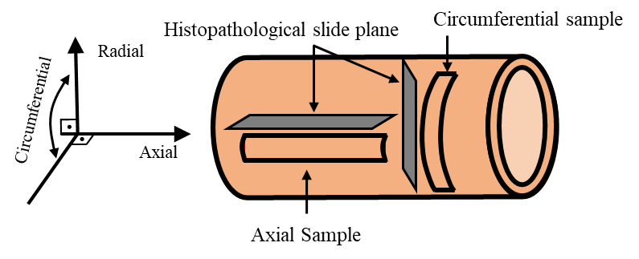
Figure S1. Illustration of the orientations of samples for mechanical testing and histopathological examination.
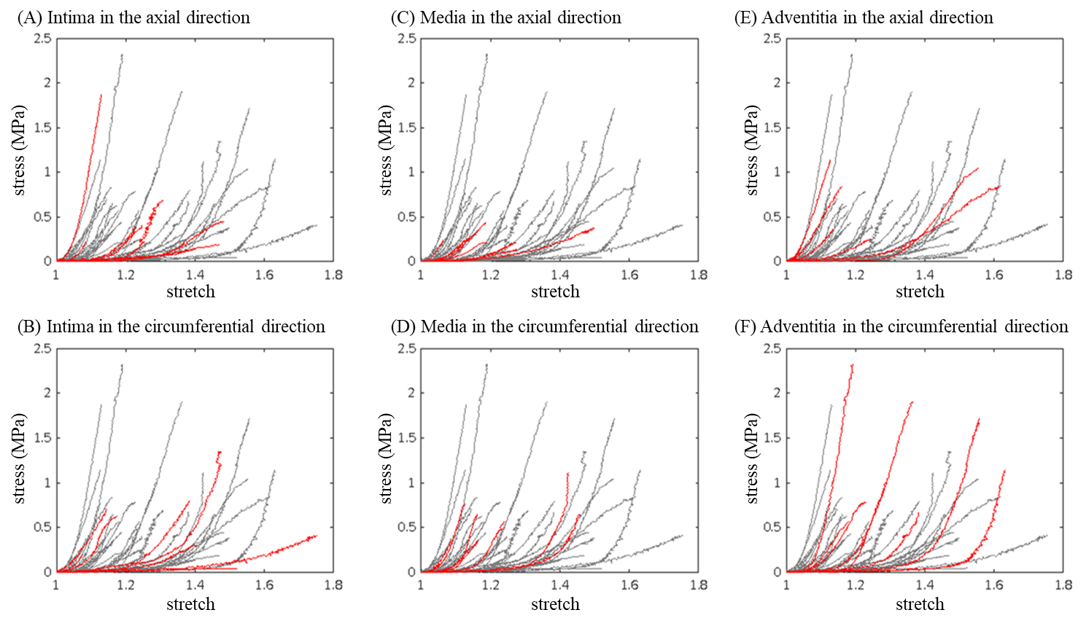
Figure S2. Visualisation of the stress-strain curves of subgroups. All 48 stress-strain curves from mechanical testing are plotted in grey as background in all graphs (A)-(F). The results of each subgroup are plotted in (A)-(F) and highlighted in red accordingly.

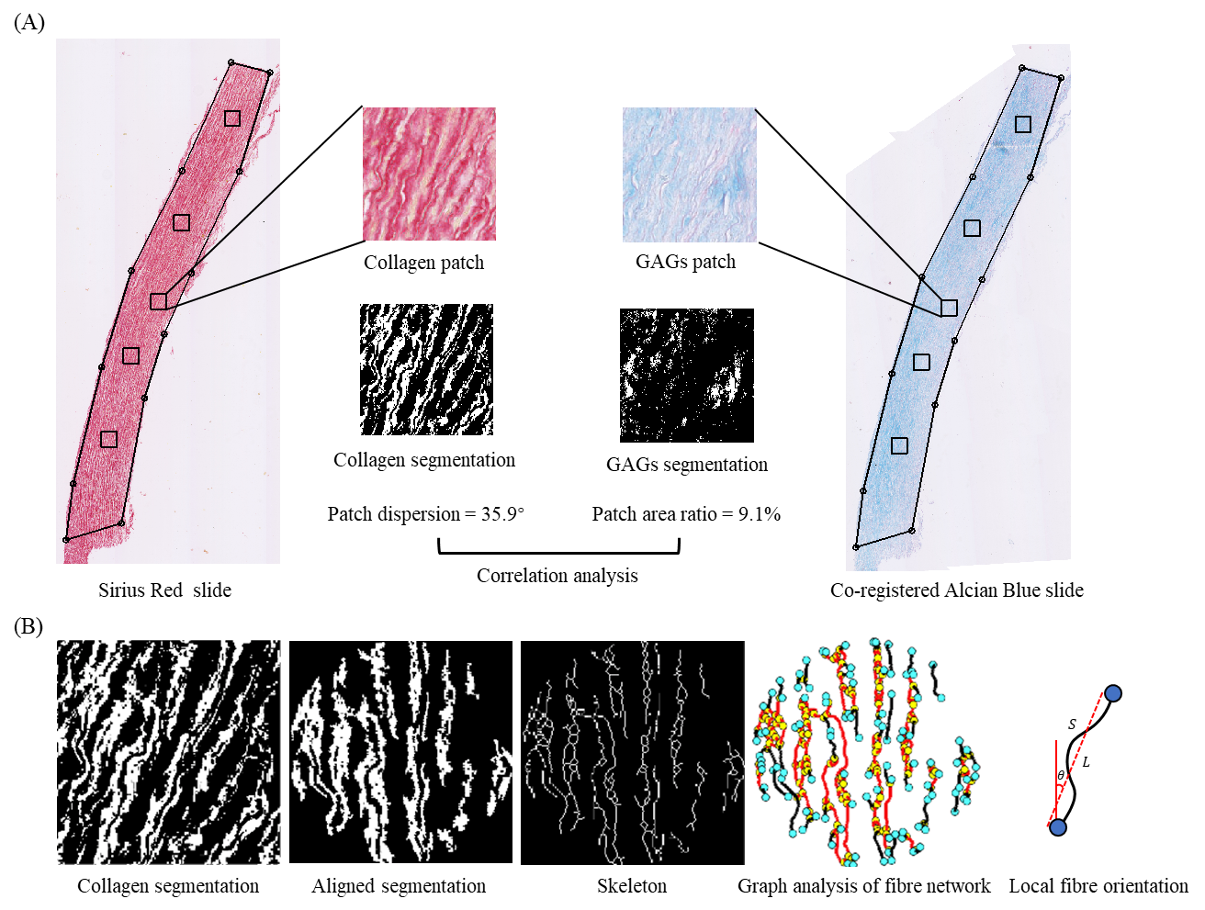
Figure S3. Steps showing image processing (A: co-registered adjacent histological slices for
collagen and GAGs; B: intermediate processing results for fibre skeletons and quantification
of relative orientations)

