Appendix 3: Charting

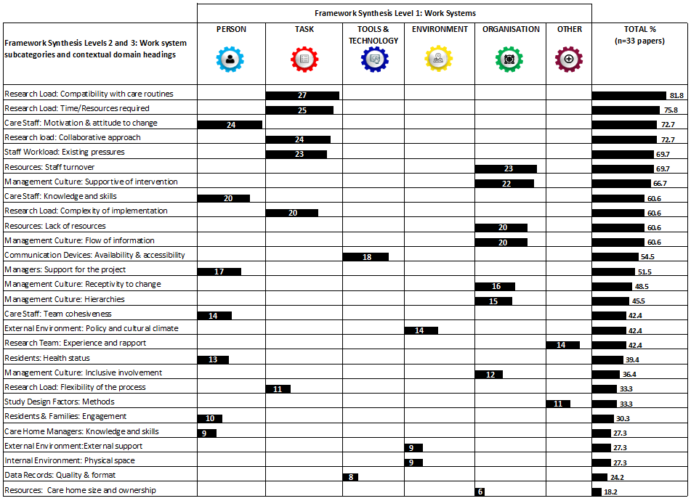
Figure A3.1 Context domains presented according to care home work system and ranked according to reporting frequency across the 33 included papers.

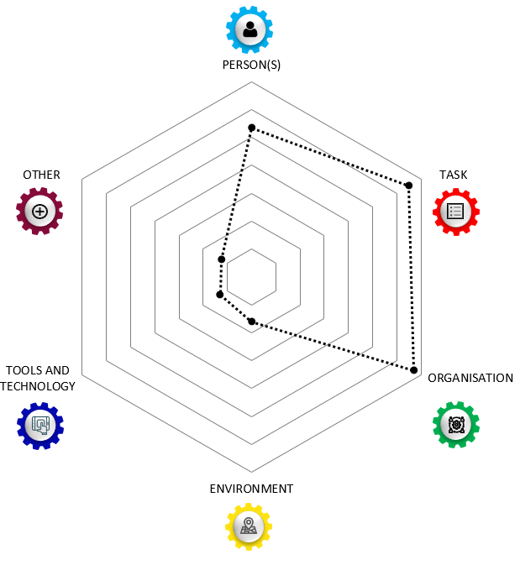

Figure A3.2. Radar plot displaying the weighting of reported contextual factors influencing trial implementation processes in CHs across work systems.

Descriptive Summary of the Work-System Sub-categories

Organisation
Sub-categories of the organisation work system included resources, and management culture. Contextual factors indexed within the organisational work system were the most prevalent across all 28 contextual domains. The data demonstrated that CH organisational factors have a strong mediating effect on research implementation. “Care homes are recognized to be highly variable in terms of their organizational structure and this has been identified as a challenge to research.” (p.979)[1] Not only did attributes of the organisation lend themselves to their state of readiness to host a research study but they also determined whether the organisation was poised to accept and adopt changes to habitual routines. The effects of staffing stability, the management culture, adequate allocation of resources, the influence of internal hierarchies, and the quality of communication within and across teams were all influential factors on successful research implementation. There was a need for, “vertically and horizontally linked teams (involving professional and nonregulated staff from various departments) to identify, instigate, own, and monitor a change process. This precipitated two change mechanisms: managerial support and a disruptive innovation.” (p.365)[2]
“Organizational aspects influenced the ease with which the care program was embraced in.. [Dementia Special Care Units]. Staff turnover, high workload, concurrent projects, cancelled meetings and organizational changes were described as barriers for implementing the care program.” (p.9)[3]
Task
The task work system was the second highest in terms of prevalence of contextual factors in the included literature. Sub-categories of the task work system were research load, and staff workload. They represented four out of the top six context domains: congruence of research activities with routine care, the roll of collaboration in supporting research tasks, perceived complexity of the implementation process, and the time and resources the intervention required. Novel research activities were not prioritized in many situations because, “the new routines were seldom accompanied by suggestions as to what routines should be replaced.” (p.90)[4] The additional ‘load’ that staff experienced required extra effort for which their appeared few rewards, unless the benefit to residents’ was clear over the short term. One internal facilitator reported, “…after the residential, I was exhausted. For five days I just sat there, demolished, and like ‘where do I start’.” (p.6)[5]
Person(s)
The person work system was the third most prevalent across the indexed data. Sub-categories within the person work system were care staff, managerial team, and residents and family. The perceived benefit of the intervention, confidence levels of staff, the amount of support from the CH management, and the health status of residents all had significant influences on protocol compliance and implementation success. These factors contributed to dwindling engagement and a loss of momentum of research focussed activities over time. “Mappers were also required to use skills they had not previously had to employ, such as engaging colleagues in discussion of practice development issues and accurate written recording of outcomes” (p.6).[6] When staff perceived negative elements of the intervention, it tended to spread throughout the organisation. “There was a lot of negative feedback from the staff; they thought it was a stupid project.” (p.364)[2]

Environment
The environment work system had two sub-categories, internal and external. The internal physical environment was highly variable between CHs. Externally, economic constraints at a societal level affected retention of experienced staff and residents’ health status when initially transferring to a CH. “...the care is subject to huge cutbacks, so really good staff members leave because the quality becomes unacceptable. You then have to deal with less professional personnel, making it even more difﬁcult to apply new methods like this one.” (nurse assistant, p.542)[7] These details introduced further heterogeneity between sites and influenced intervention feasibility, fidelity, and staff appraisals of appropriateness across individual CH settings. “… the care home population is older and frailer than anticipated when the OPERA trial was planned, perhaps as a result of a prevailing ethical and financial imperative to maintain frail older people in their own homes with support for as long as possible.” (p.10)[8]
Tools and Technology
This work-system had sub-categories of data records, and communication devices. Approaches to record keeping and archiving were heterogeneous across CHs. These details were also influenced by the varying degrees of digital literacy among staff as well as the degree computers and wireless connections were available to staff. “The relatively low response to some of the questionnaires is also an important limitation. One of the reasons for this is probably that the nursing home staff did not regularly use the e-mail account at work (p.13).[9] Due to many staff having English as a second language remote teleconferences enabled inclusion but were also reported to inhibit understanding in some studies. Research teams experienced technological and communication challenges with CHs. “Communication with the care home managers and mappers could be challenging and difficult to maintain for experts. A reliance on telephone and e-mail, meant experts had to call when the appropriate person was on shift and available, or e-mail. This latter method was often ineffective if mappers did not have work e-mail addresses or checked and answered them irregularly.” (p.8)[10]

Other
An additional work system was assigned to the synthesis framework that included research team and trial factors as sub-categories. Reasons for procedural drift were also attributed to aspects of the research process, “the most commonly cited obstacle to coherence did not relate to care home characteristics, but to the procedures required for the cRCT [cluster randomised controlled trial] itself within the care homes: the lengthy gaps between ﬁrst contacts, data collection, intervention activities and adjustments to the intervention all undermining coherence (p.9).[11] In addition relational qualities of the research team were important. For example,” When the relationship with the detailer was strong (Intervention Source), homes reported that the intervention had a high perceived value, exceeding their expectations. In contrast, the two homes who reported a negative perception of the detailer noted a lack of perceived value in the overall [Academic Detailing] intervention (p9).”[12]

Appendix 3 References

1. Walker GM, Armstrong S, Gordon AL, Gladman J, Robertson K, Ward M, et al. The Falls In Care Home study: a feasibility randomized controlled trial of the use of a risk assessment and decision support tool to prevent falls in care homes. Clin Rehabil. 2016;30(10):972-83.
2. Edwards NC, Smith Higuchi K. Process Evaluation of a Participatory, Multimodal Intervention to Improve Evidence‐Based Care in Long‐Term Care Settings. Worldviews on Evidence-Based Nursing. 2018;15(5):361-7.
3. Eldh AC, Olai L, Jönsson B, Wallin L, Denti L, Elf M. Supporting first-line managers in implementing oral care guidelines in nursing homes. Nordic Journal of Nursing Research. 2018;38(2):87-95.
4. Rycroft-Malone J, Seers K, Eldh AC, Cox K, Crichton N, Harvey G, et al. A realist process evaluation within the Facilitating Implementation of Research Evidence (FIRE) cluster randomised controlled international trial: an exemplar. Implementation Science. 2018;13(1):138.
5. Surr CA, Griffiths AW, Kelley R, Holloway I, Walwyn REA, Martin A, et al. The Implementation of Dementia Care Mapping in a Randomized Controlled Trial in Long-Term Care: Results of a Process Evaluation. American Journal of Alzheimer's Disease and other Dementias. 2019;34(6):390-8.
6. van Haeften-van Dijk AM, van Weert JCM, Dröes R-M. Implementing living room theatre activities for people with dementia on nursing home wards: a process evaluation study. Aging & Mental Health. 2015;19(6):536-47.
7. Ellard DR, Thorogood M, Underwood M, Seale C, Taylor SJ. Whole home exercise intervention for depression in older care home residents (the OPERA study): a process evaluation. BMC Medicine. 2014;12:1.
8. Lichtwarck B, Myhre J, Selbaek G, Kirkevold Ø, Rokstad AMM, Benth JŠ, et al. TIME to reduce agitation in persons with dementia in nursing homes. A process evaluation of a complex intervention. BMC Health Services Research. 2019;19(1):N.PAG-N.PAG.
9. Surr CA, Shoesmith E, Griffiths AW, Kelley R, McDermid J, Fossey J. Exploring the role of external experts in supporting staff to implement psychosocial interventions in care home settings: results from the process evaluation of a randomized controlled trial. BMC health services research. 2019;19(1):790.
10. Keenan J, Poland F, Manthorpe J, Hart C, Moniz-Cook E. Implementing e-learning and e-tools for care home staff supporting residents with dementia and challenging behaviour: A process evaluation of the ResCare study using normalisation process theory. Dementia. 2018:1471301218803195.
11. Desveaux L, Saragosa M, Rogers J, Bevan L, Loshak H, Moser A, et al. Improving the appropriateness of antipsychotic prescribing in nursing homes: a mixed-methods process evaluation of an academic detailing intervention. Implementation Science. 2017;12(1):71

1. Walker GM, Armstrong S, Gordon AL, et al.; The Falls In Care Home study: a feasibility randomized controlled trial of the use of a risk assessment and decision support tool to prevent falls in care homes. Clin Rehabil 2016;30(10):972-983. doi: 10.1177/0269215515604672.
2. Edwards NC, Smith Higuchi K; Process Evaluation of a Participatory, Multimodal Intervention to Improve Evidence‐Based Care in Long‐Term Care Settings. Worldviews on Evidence-Based Nursing 2018;15(5):361-367. doi: 10.1111/wvn.12313.
3. Zwijsen SA, Smalbrugge M, Eefsting JA, et al.; Grip on challenging behavior: Process evaluation of the implementation of a care program. Trials 2014;15(1).
4. Eldh AC, Olai L, Jönsson B, et al.; Supporting first-line managers in implementing oral care guidelines in nursing homes. Nordic Journal of Nursing Research 2018;38(2):87-95. doi: 10.1177/2057158517713379.
5. Rycroft-Malone J, Seers K, Eldh AC, et al.; A realist process evaluation within the Facilitating Implementation of Research Evidence (FIRE) cluster randomised controlled international trial: an exemplar. Implementation Science 2018;13(1):138.
6. Surr CA, Griffiths AW, Kelley R, et al.; The Implementation of Dementia Care Mapping in a Randomized Controlled Trial in Long-Term Care: Results of a Process Evaluation. American Journal of Alzheimer's Disease and other Dementias 2019;34(6):390-398.
7. van Haeften-van Dijk AM, van Weert JCM, Dröes R-M; Implementing living room theatre activities for people with dementia on nursing home wards: a process evaluation study. Aging & Mental Health 2015;19(6):536-547. doi: 10.1080/13607863.2014.955459.
8. Ellard DR, Thorogood M, Underwood M, et al.; Whole home exercise intervention for depression in older care home residents (the OPERA study): a process evaluation. BMC Medicine 2014;12:1.
9. Lichtwarck B, Myhre J, Selbaek G, et al.; TIME to reduce agitation in persons with dementia in nursing homes. A process evaluation of a complex intervention. BMC Health Services Research 2019;19(1):N.PAG-N.PAG. doi: 10.1186/s12913-019-4168-0.
10. Surr CA, Shoesmith E, Griffiths AW, et al.; Exploring the role of external experts in supporting staff to implement psychosocial interventions in care home settings: results from the process evaluation of a randomized controlled trial. BMC health services research 2019;19(1):790.
11. Keenan J, Poland F, Manthorpe J, et al.; Implementing e-learning and e-tools for care home staff supporting residents with dementia and challenging behaviour: A process evaluation of the ResCare study using normalisation process theory. Dementia 2018:1471301218803195. doi: 10.1177/1471301218803195.
12. Desveaux L, Saragosa M, Rogers J, et al.; Improving the appropriateness of antipsychotic prescribing in nursing homes: a mixed-methods process evaluation of an academic detailing intervention. Implementation Science 2017;12(1):71.

