Supplementary information:
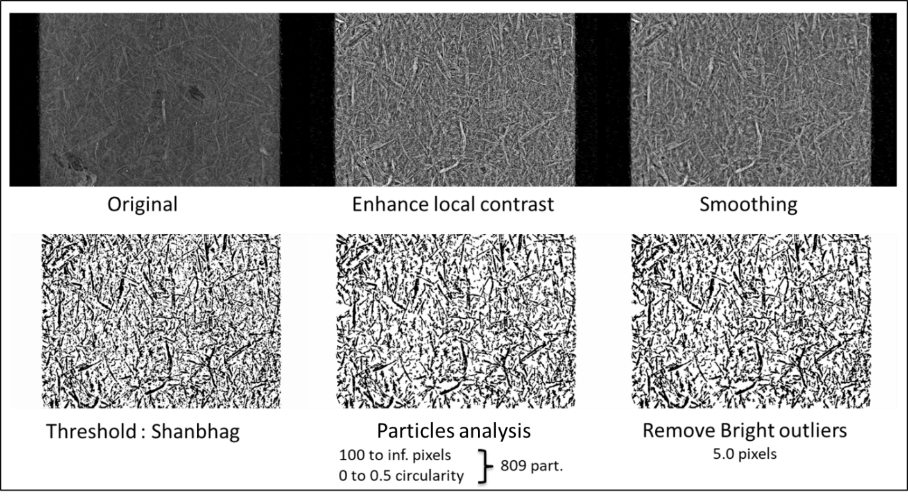
S.I. Figure 1: Pre-treatment process done on 2D images before orientation analysis.
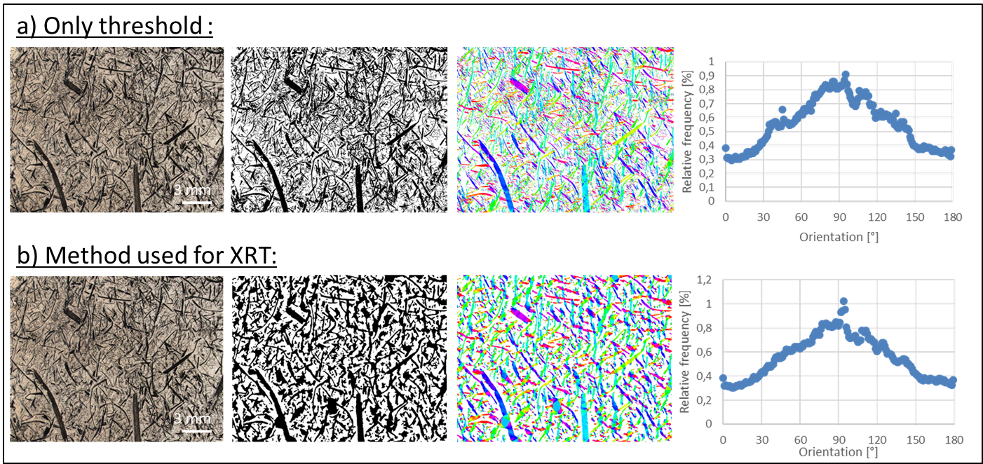S.I.Figure 2: Validation of the pre-treatment process by comparing the orientation analysis with (a) and without (b) pre-treatment. These analyses were done on the same optical microscope picture.

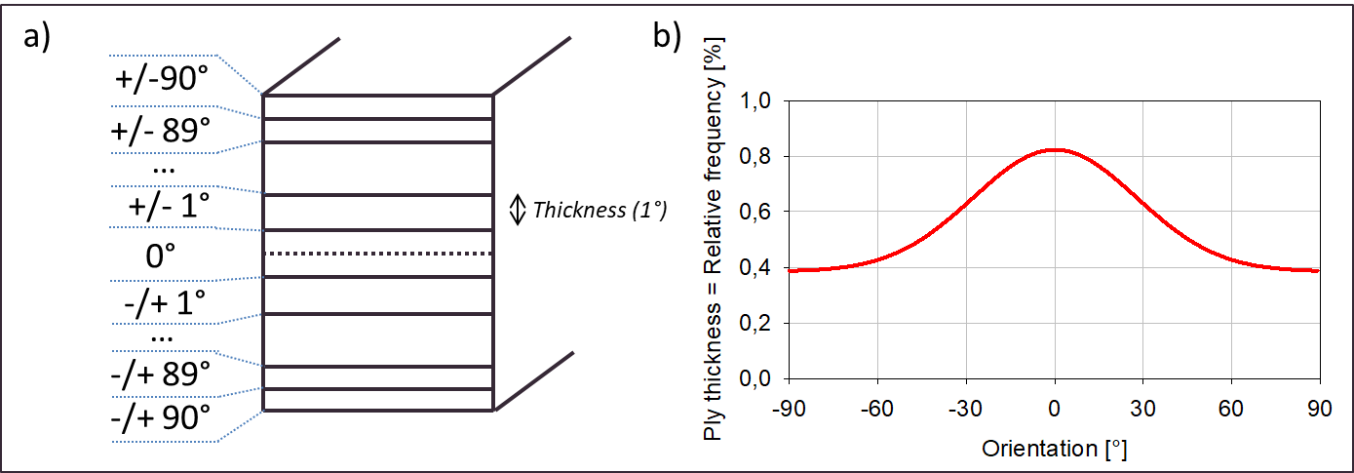
S.I. Figure 3: Explanation of the laminate building, a) schema of the symmetric laminate with thickness repartition, b) ply thickness used regarding the Gaussian fit of the orientation relative frequency.

