Article
Lipid Profiles from Dried Blood Spots reveal Lipidomic Signatures of Newborns undergoing Mild Therapeutic Hypothermia after Hypoxic-Ischemic Encephalopathy
Rebekah Nixon^{1,2}, Ting Hin Richard Ip^{1,2}, Benjamin Jenkins³, Ping Yip², Paul Clarke^{4,5}, Vennila Ponnusamy⁶, Adina T. Michael-Titus², Albert Koulman* ³ and Divyen K Shah* ^{1,2}
Citation: Nixon, R.; Ip, T.H.R.; Jenkins, B.; Yip, P.; Clarke, P.; Ponnusamy, V.; Michael-Titus, A.T.; Koulman, A.; Shah, D.K. Lipid Profiles from Dried Blood Spots reveal Lipidomic Signatures of Newborns undergoing Mild Therapeutic Hypothermia after Hypoxic-Ischemic Encephalopathy. Nutrients 2021, 13, x. https://doi.org/10.3390/xxxxx
Academic Editor(s):
Received: date
Accepted: date
Published: date
Publisher’s Note: MDPI stays neutral with regard to jurisdictional claims in published maps and institutional affiliations.
Copyright: © 2021 by the authors. Submitted for possible open access publication under the terms and conditions of the Creative Commons Attribution (CC BY) license (http://creativecommons.org/licenses/by/4.0/).
¹ The Royal London Hospital, Barts Health NHS Trust, UK.
² Centre for Neuroscience, Surgery and Trauma, Blizard Institute, Barts and The London School of Medicine and Dentistry, Queen Mary University of London, UK.
³ NIHR BRC Core Metabolomics and Lipidomics Laboratory, MRC Human Nutrition Research, Wellcome Trust, Cambridge, UK.
⁴ Neonatal Unit, Norfolk and Norwich University Hospitals NHS Foundation Trust, Norwich, UK.
⁵Norwich Medical School, University of East Anglia, Norwich, UK.
⁶ Ashford and St. Peter’s Hospitals NHS Foundation Trust, Chertsey, UK.
*Joint Senior Authors – Dr Albert Koulman and Dr Divyen K Shah
* Correspondence: ak675@medschl.cam.ac.uk; d.shah@qmul.ac.uk; Tel: +44 20 3594 0524; Fax: +44 20 7882 2180 (D.K.S.)
Abstract: Hypoxic-ischemic encephalopathy (HIE) is associated with perinatal brain injury, which may lead to disability or death. As the brain is a lipid-rich organ, various lipid species can be significantly impacted by HIE and these correlate with specific changes in the lipidomic profile in the circulation. Objective: to investigate the peripheral blood lipidomic signature in dried blood spots (DBS) from newborns with HIE. Using univariate analysis, multivariate analysis and sPLS-DA modelling, we show that newborns with moderate-severe HIE (n = 46) who underwent therapeutic hypothermia (TH) displayed a robust peripheral blood lipidomic signature comprising 29 lipid species in 4 lipid classes; namely phosphatidylcholine (PC), lysophosphatidylcholine (LPC), triglyceride (TG) and sphingomyelin (SM) when compared with newborns with mild HIE (n = 18). On sPLS-DA modelling, the three most discriminant lipid species were TG 50:3, TG 54:5, and PC 36:5. We report a reduction in plasma TG and SM and an increase in plasma PC and LPC species during the course of TH in newborns with moderate-severe HIE, compared to a single specimen from newborns with mild HIE. These findings may guide the research in nutrition-based intervention strategies after HIE in synergy with TH to enhance neuroprotection.
Keywords: Hypoxic-ischemic encephalopathy; Therapeutic hypothermia; Newborn; Brain; Dried blood spot; Lipids; Lipidome; Nutrition

1. Introduction
Hypoxic-ischemic encephalopathy (HIE) remains an important cause of death and disability in newborns globally (1). Mild therapeutic hypothermia (TH) has been shown to be effective in reducing death and disability, with numbers needed to treat of seven (2) and is now considered a standard of care (3, 4).
Lipids play multiple, key roles, both in the structure, function and homeostasis of the brain (5, 6). The brain contains the largest quantities and the widest diversity of lipid classes and species (Supplementary Table 1) of all the organs in the body (5). Their functions include lipid-protein and lipid-lipid interactions, lipid trafficking, signal transduction, membrane organisation, and energy storage (7). The neurolipidome, a representation of the lipid content of the brain, is distinct in the newborn compared to that of the adult and evolves through development (8, 9). It undergoes the greatest change during infancy (8), utilising lipids from the circulation.
Lipidomic studies have provided pathophysiologic insights and biomarker signatures for neurologic disease processes such as motor neurone disease, stroke and dementia (10-13). In experimental models of neonatal brain injury, changes in individual lipid species have been noted in both hypoxic brain tissue and umbilical cord blood (14, 15). e.g. O-phosphocholine, measured by H-NMR is known to become dysregulated in lipotoxic conditions, such as in ischemia. As such O-phosphocholine levels in umbilical cord blood have been shown to be predictive of HIE severity (15).
Dried blood spots (DBS) are routinely used in the first week after birth as part of national new-born screening programmes for detection of multiple diseases including cystic fibrosis, congenital hypothyroidism and inborn errors of metabolism (16). DBS have been shown to be a suitable medium for the study of blood biomarkers, as they are relatively non-invasive, easy to transport and easy to store for substantial periods of time (17).
Since lipids constitute a sizeable proportion of the brain, are rapidly changing during early life and are integral for its structure and function, we hypothesised that moderate-severe HIE in newborns will lead to the cleavage and the release of membrane lipids, which will be associated with changes in the concentration of lipids in the circulation. In this study, we aimed to: 1) show that it is feasible to use DBS stored at room temperature to study the lipid profiles of newborns with HIE undergoing TH, 2) assess the changes in lipids between newborns with mild HIE and those with moderate-severe HIE treated with TH, and 3) assess the evolution of lipid profiles during the course of TH.

2. Materials and Methods
Between Jan 2014 to Dec 2015, newborns of > 36 weeks gestation were recruited as part of the Brain Injury Biomarkers in Newborn Study (BIBiNS) from five neonatal units: The Royal London Hospital (Barts Health NHS Trust), Homerton University Hospital NHS Foundation Trust, Ashford and St Peter’s NHS Foundation Trust, University Hospital Southampton NHS Foundation Trust, and Norfolk and Norwich University Hospitals NHS Foundation Trust. The study was approved by a UK research ethics committee (REC ref:13/LO/1738). Newborns were recruited with written consent from parents.

2.1. Participants
Samples were studied from two groups of newborns from this cohort: group 1) newborns admitted to the neonatal intensive care unit with mild acidosis and/or mild HIE (mild HIE group) who did not fulfil standard criteria for TH and were managed conservatively, and group 2) newborns with moderate-severe HIE who fulfilled standard criteria and were treated with TH (18, 19). TH was commenced within six hours after birth using a servo-controlled total body cooling device maintaining the core temperature as measured by a rectal probe at 33.5 ⁰C for 72 hours, after which rewarming was carried out over a period of 12 hours.

2.2. Blood sampling and Dried Blood Spots
Group 1 newborns with mild HIE who did not receive TH had a single blood sample taken within 48 hours after birth. Group 2 newborns with moderate-severe HIE had blood samples taken at three time points throughout the course of TH: (i) after the newborn had reached target temperature (S1), (ii) prior to commencing rewarming (S2), and (iii) after completing rewarming (S3). A drop of blood was collected at each sample point on an absorbent filter paper (Whatman 903 Protein Saver Card) to form a DBS, and the paper was stored in a polythene bag with a desiccant packet, at room temperature.

2.3. Lipid Extraction
The method used for lipid extraction and analysis has been described in detail previously (20). Briefly, using an automated method lipids were extracted from a single 6 mm chad of each DBS using an Anachem automated liquid handler. Vortexing was carried out, adding 250 μl of internal standard (methanol (MeOH) containing six internal standards: 0.6 μM 1,2-di-o-octadecyl-sn-glycero-3-phosphocHoline, 1.2 μM 1,2-di-O-phytanyl-sn-glycero-3-phosphoethanolamine, 0.6 μM C8-ceramide, 0.6 μM N-heptadecanoyl-D-erythro-sphingosylphosporylcholine, 6.2 μM undecanoic acid, 0.6 μM trilaurin) and then adding 750 μl of methyl tert-butyl ether (MtBE). Once the solvent extraction was completed, the samples were centrifuged, resulting in two layers, with an aqueous layer at the bottom and an organic layer on top. The extracted lipids from the organic layer were placed in glass coated 2.4 ml deep 384 well plates, along with wells for quality controls (100 μl of H₂O and 15 μl of plasma) and blanks (200 μl of H₂O), and stored at -20 °C until further processed.
The extracted lipid profile was determined using a combined direct infusion high-resolution DIHRMS assay. The advantages of DIHRMS were the rapid analysis time, the small amount of sample needed, and the high reproducibility (21). The limitation of DIHRMS is that it can only separate analytes by mass to charge ratio (m/z) and this limits the identification. Additional LC-MS on DBS samples enable further identification, based on accurate mass and accurate mass MS² spectra and retention time from a database. Upon lipid extraction and analysis, the raw data was converted to .mzXML files and sent for data analysis.
Eighty-four lipid species were analysed. The lipid specie levels were all normalised according to internal standard for their lipid class, so all triglyceride (TG) lipid species were normalised to the TG internal standard. The lipid specie levels were expressed as the relative intensity and log2 transformed.
Then the fold change difference, which was a ratio of the lipid quantity between two groups studied, was calculated. Therefore, the fold change difference aids in the understanding of upregulation or downregulation of lipid specie levels relative to different outcome groups and different time points (S1, S2 or S3).

2.4. Statistical Analysis
In comparing the perinatal characteristics of the two groups of newborns, the Mann-Whitney U test was used for continuous data and the χ² Test (22) or the Fishers Exact Test for categorical data, using SPSS V27.0 (IBM Corp, Armonk, New York). The Fishers Exact Test was used when there was a small sample size with a small number of variables (23).
The raw data from the .mzXML files consisted of all of the DBS lipid profiles. Each lipid specie in the lipid profile was relatively expressed as a percentage of all of the lipid species analysed. With each of the 84 lipid species being measured, the intensity of each lipid specie was expressed as a percentage of the intensity of the total lipid profile of all 84 lipid species for each newborn; termed the relative intensity of the lipid specie.
The distributions of the majority of lipid species were skewed, hence the relative intensities were log2 transformed. K-nearest neighbours imputation (k = 10) was used to impute missing data (package “impute”). All analysis was performed in R 3.6.1 (24). Principal Component Analysis was then used to identify outliers.
First, univariate analysis was performed by either the Wilcoxon Signed Rank/Rank Sum Test or the Mann-Whitney U test to identify significant differences in relative intensity in each lipid specie (i.e. Mol%).
The Wilcoxon Signed Rank test was used to compare two sets of data that come from the same participants in the study, so it can be used to observe any change in the data from one time point to another (25). The Mann-Whitney U test was used to compare the differences between two independent samples when they were not normally distributed and the sample sizes were small (26). Wilcoxon Signed Rank test was used when samples were paired, Mann-Whitney U test was used when samples were not paired. Bonferroni multiple testing correction was applied to all significance thresholds. The Bonferroni corrected significance threshold was used to reduce Type I error when making multiple comparisons within the data by taking the significance threshold (e.g. p value < 0.05 or FDR) and dividing it by the number of comparisons (27). Then, if the multiple univariate analysis showed a significant difference (e.g. p value < 0.05 or FDR), multivariate analysis was performed.
Using the “mixOmics” package (28), sparse partial least squares discriminant analysis (sPLS-DA), a supervised statistical test, was utilised here to identify individual lipid species that separate the outcome groups (moderate-severe HIE and mild HIE) and provide a predictive value of the lipid species individually or combined. sPLS-DA selects the most predictive or discriminative features in the data that help classify the samples and allows for variable selection (29). Area Under the Receiver Operating Characteristics (AUROC) was used to determine the model performance at using the lipid species to predict outcome groups. When AUROC was 0.7, it means there was 70% chance that model will be able to distinguish between the outcome groups (30). The lower the error rate (range 0-1), the more accurate the model.
As an extension of the univariate analysis, sPLS-DA was used on the cohort with mild cases and moderate-severe cases at S2 and S3, due to the multiple lipid species identified.
Considering that nutritional supplementation or the method of feeding of the newborn may be a confounding factor, an additional analysis was performed. Mann-Whitney U test with adjusted p-value threshold of 0.05 was used. Those in the nil-by-mouth (intravenous dextrose) group were compared to breast fed, formula fed, mixed feeds groups, at each time point. As a final step, those who had parenteral nutrition were compared to those who did not.

3. Results

3.1. Patients and Samples
Lipid extraction was successful from DBS for samples from 64 (82%) newborns of a total of 78 (21 – mild HIE group, 57 – moderate-severe HIE group) processed. The perinatal characteristics of the 64 newborns are shown in Table 1. Newborns in the moderate-severe HIE group were more likely to have a lower Apgar score at 10 minutes age, a worse base deficit in the first hour, meconium aspiration and seizures. Of the moderate-severe HIE group, 8 (17%) newborns had cerebral MRI predictive of an unfavourable outcome (31). The rating of the MR images has been described previously in this cohort (32) using a validated system (31).
Table 1. Baseline characteristics of the studied population.
Perinatal characteristics | Mild HIE | Moderate- Severe HIE | p-value
 | No TH | TH
n | 18 | 46
Male | 5 (28%) | 25 (54%) | 0.06
Birth Weight (g) | 3520 (3080 , 3900) | 3450 (3105 , 3860) | 0.81
10-minute Apgar score | 9 (8, 10) | 6 (5 , 7) | <0.001*
Chest compressions | 2 (11%) | 9 (20%) | 0.48
Inotropes used | 0 (0%) | 16 (35%) | 0.003*
Worst pH in first hour | 6.95 (6.93 , 7.00) | 6.92 (6.84 , 7.00) | 0.24
Worst base deficit in first hour | -13.2 (-14.0 , -10.9) | -16.2 (-18.0 , -14.9) | <0.001*
Sentinel event | 6 (33%) | 11 (24%) | 0.54
Meconium aspiration | 0 (0%) | 9 (20%) | 0.05*
Seizures | 0 (0%) | 25 (54%) | <0.001*
Unfavourable MRI | - | 8 (17%) | -
* - denotes significance where p < 0.05. Values stated as median (interquartile range).

3.2. Significant lipid species changes between the single sample from the mild HIE group and the moderate-severe HIE group at S1, S2 and S3
The age of the newborn at the time of the sampling in hours (median age in hours (IQR)) were 23 (15, 29) for the mild HIE group. For the moderate-severe HIE group the times of the sampling in hours after birth (median age in hours (IQR), the S1 (when newborn had reached target temperature) was 22 (17, 27), the S2 (prior to commencing rewarming) was 59 (50, 65), and for S3 (after completing rewarming) was 98 (90, 108). Prior to lipid extraction, the DBS were stored at room temperature for up to four years.
At S1, concentrations of one lipid specie, TG (54:5), were higher in mild HIE newborns compared to newborns with moderate-severe HIE (2.031 times higher; 95% CI:1.435 , 2.768), FDR: 0.018, (Table 2, Figure 1). At S2, 7 lipid species, 2 phosphatidyl choline (PC) species and 5 TG species, showed significant changes in relative intensity between the two outcome groups (Table 2, Figure 1) and at S3, 29 lipid species exhibited a significant difference between the two groups (Table 3).
Table 2. Mann Whitney U test statistics for significant lipid species when comparing Mild vs. Moderate-Severe HIE at S1 and S2.
Moderate-Severe HIE at S1 vs. Mild
Lipid Species | Moderate-Severe HIE Lipid Median | Mild HIE Lipid Median | Change in relative intensity as a multiple (95% Confidence Interval) | P value | Adjusted P Value  (FDR)
TG (54:5) | 0.66 | 1.432 | 2.031 (1.4345 , 2.768) | <0.001 | 0.018
Moderate-Severe HIE at S2 vs. Mild
Lipid Species | Moderate-Severe HIE Lipid Median | Mild HIE Lipid Median | Change in relative intensity as a multiple (95% Confidence Interval) | P value | Adjusted P Value  (FDR)
PC (34:2)/PE (37:2)/PA (39:3) | 1.247 | 0.726 | 0.616 (0.487 , 0.829) | 0.002 | 0.026
PC (36:5)/PE (39:5)/PA (41:6) | 1.31 | 0.589 | 0.494 (0.327 , 0.736) | 0.001 | 0.024
TG (48:1) | 1.087 | 1.678 | 1.542 (1.183 , 2.061) | 0.002 | 0.031
TG (48:2) | 1.049 | 1.642 | 1.605 (1.236 , 2.214) | 0.001 | 0.026
TG (50:3) | 0.92 | 1.628 | 1.708 (1.267 , 2.493) | 0.001 | 0.023
TG (52:4) | 0.741 | 1.394 | 1.691 (1.219 , 2.253) | 0.003 | 0.032
TG (54:5) | 0.695 | 1.432 | 2.018 (1.447 , 2.836) | <0.001 | 0.021
Abbreviations: FDR – false discovery rate

Figure 1. Lipid species from TG and PC classes which show significant differences between Mild HIE Cases and Moderate-Severe HIE Cases at different time points (S1, 2 and 3).
Table 3. Mann Whitney U test statistics for the significant lipid species when comparing Moderate-Severe HIE at S3 vs. Mild HIE.
Lipid Species | Moderate-Severe HIE Lipid Median | Mild HIE  Lipid Median | Change in relative intensity as a multiple (95% Confidence Interval) | P value | Adjusted P Value  (FDR)
PC (34:2)/PE (37:2)/PA (39:3) | 1.291 | 0.726 | 0.631 (0.479 , 0.825) | 0.001 | 0.012
PC (35:2)/PE (38:2)/PA (40:3) | 0.761 | 1.119 | 1.509 (1.171 , 1.947) | 0.004 | 0.017
PC (36:2)/PE (39:2)/PA (41:3) | 1.125 | 0.838 | 0.725 (0.5910 , 0.872) | 0.003 | 0.015
PC (36:5)/PE (39:5)/PA (41:6) | 1.186 | 0.589 | 0.495 (0.351 , 0.692) | 0 | 0.006
PC-O (16:0)/LPE (19:0) | 1.209 | 0.595 | 0.552 (0.3784 , 0.862) | 0.014 | 0.045
PC-O (18:0)/LPE (21:0) | 1.238 | 0.533 | 0.505 (0.361 , 0.717) | 0.001 | 0.011
PC-2O (32:0) | 1.275 | 1.518 | 1.182 (1.094 , 1.303) | 0.001 | 0.011
PC-O (34:2)/PE-O (37:2) | 0.837 | 1.498 | 1.770 (1.294 , 2.445) | 0.002 | 0.015
PC-O (34:1)/PE-O (37:1) | 1.283 | 1.52 | 1.175 (1.053 , 1.318) | 0.008 | 0.032
PC (37:4)/PE (40:4)/PA (42:5) | 0.692 | 1.525 | 2.073 (1.430 , 2.990) | 0 | 0.006
LPC-O (18:1) | 1.094 | 0.677 | 0.619 (0.493 , 0.855) | 0.002 | 0.015
LPC-P (18:1) | 0.976 | 0.726 | 0.7195 (0.553 , 0.932) | 0.017 | 0.05
SM (34:1) | 1.266 | 1.429 | 1.235 (1.029 , 1.471) | 0.017 | 0.05
SM (35:1) | 1.118 | 1.765 | 1.403 (1.122 , 2.015) | 0.004 | 0.019
SM (36:2) | 1.185 | 1.38 | 1.219 (1.061 , 1.433) | 0.01 | 0.035
SM (40:1) | 1.225 | 1.624 | 1.361 (1.127 , 1.778) | 0.003 | 0.015
SM (42:1) | 1.221 | 1.741 | 1.405 (1.188 , 1.724) | 0 | 0.006
DG (36:1) | 0.794 | 1.652 | 1.968 (1.368 , 2.866) | 0.002 | 0.013
TG (48:1) | 0.939 | 1.678 | 1.727 (1.306 , 2.512) | 0 | 0.006
TG (48:2) | 0.909 | 1.642 | 1.646 (1.180 , 2.667) | 0.002 | 0.015
TG (48:3) | 0.81 | 1.662 | 1.735 (1.152 , 2.476) | 0.011 | 0.038
TG (50:1) | 0.841 | 1.775 | 1.929 (1.341 , 2.821) | 0.003 | 0.015
TG (50:2) | 0.847 | 1.459 | 1.693 (1.100 , 2.365) | 0.011 | 0.038
TG (50:3) | 0.91 | 1.628 | 1.631 (1.163 , 2.450) | 0.004 | 0.017
TG (50:4) | 0.92 | 1.828 | 1.722 (1.319 , 2.294) | 0.001 | 0.009
TG (51:2) | 0.74 | 1.149 | 1.613 (1.116 , 2.110) | 0.009 | 0.034
TG (52:4) | 0.744 | 1.394 | 1.535 (1.068 , 2.224) | 0.016 | 0.049
TG (54:5) | 0.804 | 1.432 | 1.739 (1.232 , 2.462) | 0.003 | 0.015
Abbreviations: FDR – false discovery rate.

3.3. Significant lipid species changes over the course of therapeutic hypothermia for newborns with moderate-severe HIE
When comparing lipid levels between S1 and S3, 8 lipid species demonstrated significant differences, namely lysophosphatidylcholine (LPC) 15:0, LPC-P (18:1), sphingomyelin (SM) (34:1), SM (36:2), SM (42:3), SM (42:1) and PC (40:5) (Table 4, Figure 1 and 2). When comparing lipid levels between S2 and S3, 2 lipid species have a significant increase in levels: LPC-2O (16:0) and LPC-O (18:1) (Table 4 and Table 6, Figure 2). Furthermore, LPC (15:0), PC (36:2) and PC (36:5) had all increased significantly between S1 and S3, while PC-2O (32:0) had decreased significantly by S3 (Table 4 and Table 6).
Table 4. Wilcoxon Signed Rank test Statistics of the moderate-severe HIE newborns when comparing different time points during therapeutic hypothermia (S1, S2 and S3).
S1 vs. S3 for Moderate-Severe HIE
Lipid Species | Median Level at Birth | Median Level at Re-warming | Change in relative intensity as a multiple (95% Confidence Interval) | P value | Adjusted P Value  (FDR)
PC (36:2)/PE (39:2)/PA (41:3) | 0.865 | 1.222 | 0.711 (0.599, 0.832) | <0.001 | 0.004
PC (40:5) | 0.932 | 1.409 | 0.576 (0.459, 0.832) | 0.002 | 0.025
LPC (15:0)/LPE (18:0) | 1.42 | 0.717 | 1.935 (1.456, 2.442) | <0.001 | 0.001
LPC-P (18:1) | 0.818 | 0.964 | 0.811 (0.713 , 0.932) | 0.002 | 0.025
SM (34:1) | 1.437 | 1.163 | 1.443 (1.174 , 1.729) | 0.001 | 0.023
SM (36:2) | 1.407 | 1.171 | 1.382 (1.22 , 1.580) | <0.001 | 0.001
SM (42:1) | 1.496 | 1.197 | 1.402 (1.126 , 1.667) | 0.002 | 0.025
SM (42:3) | 1.405 | 1.067 | 1.535 (1.193 , 1.956) | 0.001 | 0.018
S2 vs. S3 for Moderate-Severe outcome HIE
Lipid Species | Median level at Cooling | Median Level at Re-warming | Change in relative intensity as a multiple (95% Confidence Interval) | P value | Adjusted P Value  (FDR)
LPC-2O (16:0) | 0.837 | 1.308 | 0.693 (0.554 , 0.847) | <0.001 | 0.027
LPC-O (18:1) | 0.704 | 1.073 | 0.647 (0.519 , 0.826) | 0.001 | 0.043
Abbreviations: FDR – false discovery rate.
Figure 2. Lipid species from LPC and SM classes which show differences between mild HIE cases and moderate-severe HIE cases at different time points (S1, S2 and S3).

3.4. The predictive value of the significant changes in lipid species in differentiating mild HIE cases from moderate-severe HIE cases using sparse partial least squares discriminant analysis (sPLS-DA).
As multiple lipid species were identified univariately in groups between mild HIE cases and moderate-severe HIE cases at S2 and at S3, an sPLS-DA model was fitted to investigate the association when considering these lipid species together. The loading scores generated by the sPLS-DA model indicated the degree of confidence in the differential expression of each of the lipid species.
The dataset with mild HIE cases and with moderate-severe HIE cases at S2 was compared in the first sPLS-DA model (Figure 3). The final tuned model gives an AUC-ROC of 0.96 (p < 0.001, Components 1 and 2) with 5 of the 7 lipid species that were found to be univariately significant, namely TG (50:3), TG (52:4), TG (54:5), PC (34:2) and PC (36:5), to be the only selected features in the first component (Table 5). In particular, TG (54:5), TG (50:3), and PC (36:5) had moderate to high loading scores of 0.745, 0.400, and -0.466 respectively (Table 5), which indicates their significant predictive value within this model.
Figure 3. Scatter plot showing the sPLS-DA model and its prediction for mild cases and moderate-severe cases at S2. The x axis represents Component 1 and the y axis represents Component 2.
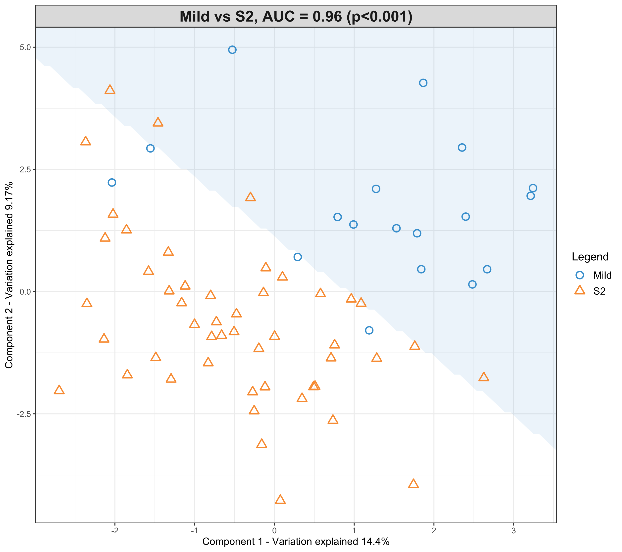
Table 5. sPLS-DA loading values for mild HIE newborns vs. moderate-severe HIE newborns at S2.
Lipid Species | Component 1 | Component 2 | Component 3
PC (34:2)/PE (37:2)/PA (39:3) | -0.13725 | 0 | 0
PC (36:5)/PE (39:5)/PA (41:6) | -0.46582 | -5.03E-04 | 0
TG (48:1) | 0 | 0 | 0
TG (48:2) | 0 | 0 | -0.12742
TG (50:3) | 0.400286 | 0 | 0
TG (52:4) | 0.221072 | 0 | 0
TG (54:5) | 0.745032 | 0 | 0
A second model was fitted using the dataset with mild HIE cases and moderate-severe HIE cases at S3 (Figure 5). The final tuned model gave an AUC-ROC of 0.98 (p < 0.001, Component 1 and 2) with 28 of the 29 lipid species, that were identified to be univariately significant, to be selected in the first component (Table 6). The remaining lipid species were selected in the second component. The 28 lipid species represent the majority of the moderate to high loading within the first component, again, indicating their significance in the predictive performance (Figure 4).
Figure 4. sPLS-DA model of mild HIE cases vs. moderate-severe HIE cases at S3, loadings plot of Component 1.
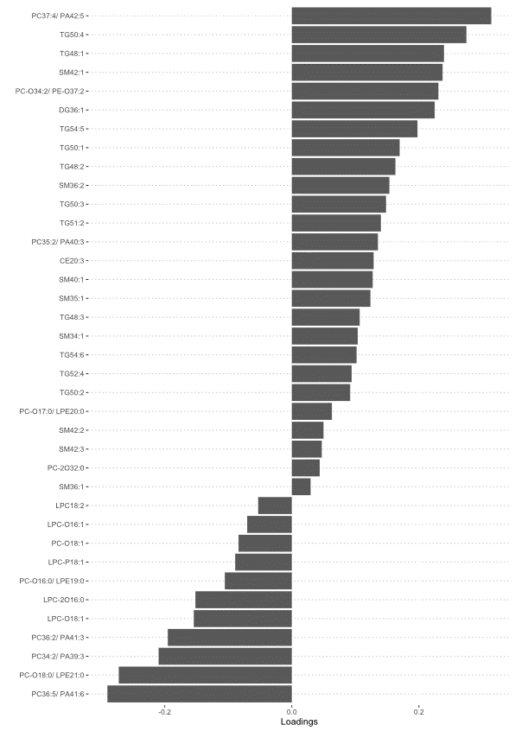

Figure 5. Scatter plot showing the sPLS-DA model and its prediction for mild cases and moderate-severe at S3. The x axis represents Component 1 and the y axis represents Component 2.
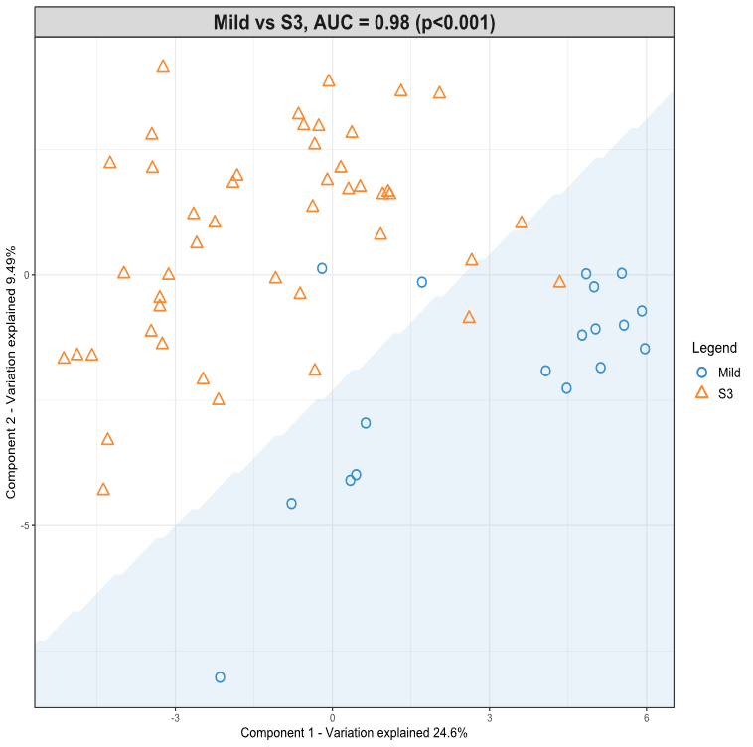
Table 6. - sPLS-DA loading values for mild HIE cases vs. moderate-severe HIE Cases at S3.
Lipid Species | Component 1 | Component 2 | Component 3
PC (34:2)/PE (37:2)/PA (39:3) | -0.20961 | 0.127569 | 0
PC (35:2)/PE (38:2)/PA (40:3) | 0.135575 | 0 | 0
PC (36:5)/PE (39:5)/PA (41:6) | -0.29015 | 0.141899 | 0
PC (36:2)/PE (39:2)/PA (41:3) | -0.19513 | 0.168625 | 0
PC (37:4)/PE (40:4)/PA (42:5) | 0.313908 | 0 | 0
PC-O (16:0)/LPE (19:0) | -0.10542 | -0.11515 | 0
PC-O (18:0)/LPE (21:0) | -0.27236 | 0 | 0
PC-O (34:2)/PE-O (37:2) | 0.230711 | 0 | 0
PC-O (34:1)/PE-O (37:1) | 0 | 0.069747 | 0
PC-2O (32:0) | 0.043895 | 0 | 0
LPC-O (18:1) | -0.15428 | 0 | 0
LPC-2O (16:0) | -0.15171 | 0 | 0
LPC-P (18:1) | -0.08909 | 0.067468 | 0
SM (34:1) | 0.103771 | 0 | 0.484361
SM (35:1) | 0.123691 | 0.015681 | 0
SM (36:2) | 0.153531 | -0.06324 | 0
SM (40:1) | 0.127328 | 0 | 0
SM (42:1) | 0.237286 | 0 | 0
DG (36:1) | 0.224861 | 0 | 0
TG (48:1) | 0.239505 | 0 | 0
TG (48:2) | 0.16305 | 0 | 0
TG (48:3) | 0.106817 | 0.044888 | 0
TG (50:1) | 0.169699 | 0 | 0
TG (50:2) | 0.091848 | 0 | 0
TG (50:3) | 0.14831 | 0 | 0
TG (50:4) | 0.274731 | 0 | 0
TG (51:2) | 0.14014 | 0 | 0
TG (52:4) | 0.094162 | 0.01366 | 0
TG (54:5) | 0.197721 | 0 | 0

Using this methodology, on comparison of the mild HIE cases to moderate-severe HIE cases one significant species was identified at S1. A further 6 significant species as well as the one identified at S1 were noted to be significant at S2 (Table 5) and a further 22 species plus the previous 7 identified at S2 were noted to be significant at S3 (Table 6, Figure 4).

3.5. Nutrition
The nutrition groups of the newborns at S1, S2 and S3 are summarised in Supplementary Table 2.
When comparing the NBM group to those newborns who were breast fed (exclusively), formula fed (exclusively) or mixed at any time point (S1, S2, S3), none of the lipid species relative intensity was found to be significantly different (adjusted p value threshold < 0.05). Furthermore, when comparing the NBM group to different combinations of nutrition supplement (i.e. breast fed and mixed, formula and mixed, and all three) at any time point, none of the lipid species was found to be significantly different. Finally, when comparing those who had parenteral nutrition and those who had not at any time point, again, none of the lipid species was found to be significantly different.

4. Discussion
We demonstrate that it is feasible to extract lipid species in sufficient quantity and quality from a single 6-mm-diameter DBS stored at room temperature. DBS is cheap, technically easy to obtain in newborns, and simpler for transportation and storage. Lipids within DBS have been shown to be stable for up to a year when stored at -20 °C (17). In this study we show the feasibility of lipid extraction and analysis from DBS stored at room temperature for up to 4 years. The method used has already been validated in newborns (20) and has also been used to validate biomarkers of metabolic efficacy in infant nutrition (33).
We demonstrate that in newborns with moderate-severe HIE treated with TH, there is an overall reduction in TG and SM classes and an increase in the PC and LPC classes of lipids in comparison to the mild HIE group, in the peripheral circulation, detected using DBS. We also demonstrated that several lipid species differentiate between newborns with mild HIE and those with moderate-severe HIE undergoing TH. This starts with one significant lipid specie at S1, then progresses to seven lipid species (six more) at S2, to 29 lipid species (22 more) at S3. The most discriminant lipid species are TG (50:3), TG (54:5), and PC (36:5). To our knowledge, this is the first study investigating the lipidome in newborns with HIE through the course of TH.

4.1. The impact of nutrition
Based on previous data we expected that nutrition and the type of feed might have confounded some or all of the changes seen in the significant lipid species identified, as infant feeding can alter the lipid profile in DBS (34, 35). In addition, breast milk and each type of formula milk have their own distinctive lipid profiles (36). All nutrition groups were compared and nutrition was found to have no significant effect on the changes seen in specific lipid species. However these samples were taken in the first days after birth and the impact of nutrition on the circulating metabolism might not yet affect the circulating lipids. In this cohort we showed that the nutrition given to the newborn did not bring about any of the observed significant lipid species changes and therefore it can be excluded as a confounding factor.

4.2. The lipid classes in the context of what is already known (Supplementary Table 3)

4.2.1. Triglyceride
TG is an integral energy store in the body, with the liver being an important storage organ. TG (48:1) and (48:2) specifically are the result of de novo lipogenesis (37). We observed a decrease in the levels of TG species in the moderate-severe HIE at each time point compared to mild HIE. Secondary energy failure is an important mechanism of injury after hypoxia-ischemia (HI) (38), including in newborn HIE (39, 40) and in adult stroke (41). HIE often co-exists with multisystem HI including hepatic impairment, as reflected by abnormal liver function tests which also show differences in concentrations between clinical grades of HIE severity(42). The lower TG levels may be a result of the multisystem HI or of attenuation by TH. If the decreased levels are just a result of temporary attenuation of the increased metabolic demand in ischemia by TH, then the TG levels would be expected to rise at S3 (after rewarming). However, in this study the reduced TG levels persist after rewarming.

4.2.2. Phosphatidylcholine
We observed increased levels of PC species in the infants with moderate-severe HIE undergoing TH compared with in those with mild HIE. In an animal model of adult stroke, PC (16:0/18:1) increased in ischemic brain tissue within 2 hours of HI and continued to accumulate over 5 days post-stroke (43). In the cord blood after HI, there are increased levels of PC (34:1), PC (36:4), PC (38:4), and PC (38:5) compared to in controls (44, 45). Also during TH, MR-spectroscopy demonstrates decreased levels of PC in the basal ganglia and the white matter in severe HIE compared to in moderate-severe HIE, which may reflect apoptosis in these regions (46). In experimental models of HI, increased degradation of the glycerophospholipid species, such as PC and PE, have been demonstrated in the affected brain tissue at 18-48 hours (47, 48).
We also noted increased levels of PC species at S3 (after rewarming). In an MR-spectroscopy study of newborns with HIE, an increase in PC was shown in the white matter at day 5-6 post TH (46). We speculate that the increase in PC species on rewarming (S3) may be associated with the release of PC from damaged cell membranes in the brain.
We noted that one PC species levels differed from how the other PC species behaved. PC-2O (32:0) levels were decreased in moderate-severe HIE compared to mild HIE. PC-2O (32:0) is specifically used in the production of fatty acids in the liver, so its decrease in moderate-severe HIE may be related to secondary energy failure and may also reflect the effect of cooling.
Phospholipases hydrolyse key groups from phospholipids. Phospholipases are activated in HI through the intracellular Ca²⁺ influx. Activated phospholipases have been shown to cause inflammation in HI by releasing arachidonic acid (AA) and prostaglandins from membrane phospholipids, such as PC. In particular, phospholipase A₂ (PLA₂) and phospholipase C are significantly activated in HIE, which leads to the production of reactive oxidative species (49, 50).

4.2.3. Lysophosphatidylcholine
We observed that LPC levels were increased in the peripheral blood of the moderate-severe HIE compared to the mild HIE. We speculate that this might reflect a compensatory mechanism to attenuate injury from HI. It is possible that an LPC rich diet to increase peripheral levels might prove to be neuroprotective.
We speculate that the lower levels of LPC at S2 compared to S3 (rewarming) over the course of TH might be due to the effect of TH, reducing metabolic rate, followed by an increase in LPC after rewarming which may reflect the wearing off of the effect of TH.
The interpretation of the LPCs analysed from DBS is challenging as lipases may remain active during the drying process (51) and some hydrolysis can occur even during storage. These processes are unlikely to influence the results here as for each newborn the samples were taken within days after birth and the total storage time was relatively long (up to 4 years).

4.2.4. Sphingomyelin
SM species, especially SM (36:1) and SM (36:2) are important constituents of the myelin sheath (5, 52). Some SM species are in the outer layer of the lipid bilayer of cell membranes. After cerebral ischemia, there is compromise of the blood-brain barrier, so neurolipids may be found in the peripheral blood (53).
In our study SM (36:2) was found to be one of the better discriminant lipid species for the severity of HIE. We observed decreased levels of all significant circulating SM species, including SM (36:2), in the moderate-severe HIE group compared to the mild HIE group. To our knowledge this is the first study of SM levels in newborn HIE. Our findings are contrary to evidence from animal stroke models. In animal neonatal HIE and adult stroke models, there were decreased SM levels, specifically SM (18:0), in ischemic brain tissue associated with apoptosis and demyelination of the ischemic tissue (43, 54, 55). In alignment with this, in an animal stroke model an increase in plasma SM (37:1) and SM (38:3) levels was noted (56).
Acid sphingomyelinase (ASM) hydrolyses SM into ceramide (Cer), which is overactivated in ischemia (57). It has been suggested that in ischemia there is a breakdown of SM into Cer, causing an accumulation of Cer, which is a potent inducer of apoptosis (58, 59). Interestingly, despite including Cer in our extraction and analysis, we did not find any significant difference in the levels of the Cer species between mild and moderate-severe HIE at any time point. With the decrease in SM, one would expect a downstream increase in Cer.

4.3. Strengths
In this study, a validated and reliable method to extract lipid species from DBS was used (20). Several statistical approaches, including univariate analysis, multivariate analysis and sPLS-DA models were combined in order to provide confirmation of the lipid species which show significant changes. In comparison with the mild HIE group, additional significant lipid species were identified through the course of hypothermia and rewarming, but the lipid species identified at the previous sampling time point were still retained at later time points. Our study identified predictive trends in the entire class of lipids during TH. Any potential confounding effect of the nutritional status of the newborn on the lipid profiles was also adjusted for.

4.4. Limitations
The sample timing of the DBS collection was variable and samples were obtained when convenient in the clinical setting to minimise painful venesection. We were able to extract lipids successfully from 82% of samples. Eight (17%) of the 46 newborns with moderate-severe HIE who underwent TH had substantial brain injury on MRI predictive of adverse outcome. As such, the study was not powered to compare the neurolipidome between newborns with and without substantial brain injury on MRI.
A study such as ours can only determine differences and associations and not causation. It is important to consider throughout in interpretation of the data is that the changes we show in moderate-severe HIE cases managed with TH are likely to be a summation of the pathophysiology and of the therapeutic intervention; and discerning the exact contribution of each of these factors remains a significant challenge.

5. Conclusions
Using DBS, this study demonstrates a reduction in TG and SM and an increase in PC and LPC classes of circulating lipids during the course of TH in newborns with moderate-severe HIE compared to a single specimen from newborns with mild HIE. Larger studies are required to study the neurolipidome changes in newborns with substantial brain injury. These methods and findings may guide the research in nutrition-based intervention strategies after HIE in synergy with TH to enhance neuroprotection.
Supplementary Materials: The following are available online at www.mdpi.com/xxx/s1.
Author Contributions: Conceptualisation – A.K., A.M-T, P.Y and D.K.S; Funding acquisition – D.K.S; Investigation - R.N., R.I., P.Y., B.J., A.K., and D.K.S.; Methodology – R.N., R.I., P.Y., B.J., A.K., and D.K.S.; Resources – D.K.S. and A.K.; Data curation – R.N., R.I., P.Y., B.J., A.K., V.P., P.C., and D.K.S.; Writing – original draft preparation – R.N., D.K.S., and R.I.; Writing – review and editing – R.N., R.I., P.Y., B.J., A.K., V.P., P.C., A.M-T. and D.K.S.; Supervision – P.Y., A.K., and D.K.S.; All authors have read and agreed to the published version of the manuscript.
Funding: We are grateful to the Barts Charity, London, UK. We are also grateful to The Neonatal Society, UK for a Student Research bursary for RN. The funders had no other role in any aspect of this study or its publication. NIHR Cambridge Biomedical Research Centre (146281) & Biotechnology and Biological Sciences Research Council (BB/P028195/1).
Institutional Review Board Statement: The study was approved by a UK research ethics committee (REC ref:13/LO/1738).
Informed Consent Statement: Informed consent was obtained from all parents of the subjects involved in the study.
Data Availability Statement: The data presented in this study are available on request from the corresponding author.
Acknowledgments: The authors are grateful to all of the families who agreed to participate in this study. We would also like to thank Nicola Openshaw-Lawrence, Dr Olga Kapellou, Dr Philippa Chisholm, Dr Neelam Gupta and Ms Karen Few for collecting informed consent, dried blood spots, data on perinatal characteristics and nutritional status data from the following neonatal units The Royal London Hospital (Barts Health NHS Trust), Homerton University Hospital NHS Foundation Trust (Barts Health NHS Trust), Ashford and St Peter’s NHS Foundation Trust, University Hospital Southampton NHS Foundation Trust, and Norfolk and Norwich University Hospitals NHS Foundation Trust. Moreover, we thank Dr Jane Evanson and Dr Olga Kapellou for rating the cerebral MR images. To conclude, we thank the NIHR BRC Core Metabolomics and Lipidomics Laboratory for extracting and identifying the lipid species from the dried blood spots sent to them.
Conflicts of Interest All remaining authors declare no conflict of interest.
List of Abbreviations
AA – arachidonic acid
ASM – acid sphingomyelinase
BM – breastmilk
Cer – ceramide
DBS – dried blood spots
DG – diglyceride
DHA - docosahexaenoic acid
FDR – false discovery rate
HI – hypoxia-ischemia
HIE – hypoxic-ischemic encephalopathy
LPC – lysophosphatidylcholine
MCAO – middle cerebral artery occlusion
MeOH - methanol
NBM – nil-by-mouth
PA – phosphatidic acid
PC - phosphatidylcholine
PE – phosphatidylethanolamine
PN – parenteral nutrition
PUFA - polyunsaturated fatty acids
SM – sphingomyelin
sPLS-DA – sparse partial least square discriminant analysis
TG – triglyceride
TH – therapeutic hypothermia
W – Wilcoxon signed rank test

References
1. Lawn J, Shibuya K, Stein C. No cry at birth: global estimates of intrapartum stillbirths and intrapartum-related neonatal deaths. Bull World Health Organ. 2005;83(6):409-17.
2. Jacobs SE, Berg M, Hunt R, Tarnow-Mordi WO, Inder TE, Davis PG. Cooling for newborns with hypoxic ischaemic encephalopathy. Cochrane Database Syst Rev. 2013(1):CD003311.
3. Excellence NIoCaH. Therapeutic hypothermia with intracorporeal temperature monitoring for hypoxic perinatal brain injury, Interventional procedures guidance [IPG347]. In: NICE, editor. 2 ed. Machester: NICE; 2010.
4. NEWBORN COFA. Hypothermia and Neonatal Encephalopathy. American Academy of Pediatrics; 2014. p. 1146-50.
5. Sastry PS. Lipids of nervous tissue: composition and metabolism. Prog Lipid Res. 1985;24(2):69-176.
6. Rouser G, Yamamoto A. Curvilinear regression course of human brain lipid composition changes with age. Lipids. 1968;3(3):284-7.
7. Fantini JY, N. Brain Lipids in Synaptic Function and Neurological Disease. 1st ed: Academic Press; 2015.
8. Li Q, Bozek K, Xu C, Guo Y, Sun J, Pääbo S, et al. Changes in Lipidome Composition during Brain Development in Humans, Chimpanzees, and Macaque Monkeys. Mol Biol Evol. 2017;34(5):1155-66.
9. Yu Q, He Z, Zubkov D, Huang S, Kurochkin I, Yang X, et al. Lipidome alterations in human prefrontal cortex during development, aging, and cognitive disorders. Mol Psychiatry. 2018.
10. Blasco H, Veyrat-Durebex C, Bocca C, Patin F, Vourc'h P, Kouassi Nzoughet J, et al. Lipidomics Reveals Cerebrospinal-Fluid Signatures of ALS. Sci Rep. 2017;7(1):17652.
11. Kloska A, Malinowska M, Gabig-Cimińska M, Jakóbkiewicz-Banecka J. Lipids and Lipid Mediators Associated with the Risk and Pathology of Ischemic Stroke. Int J Mol Sci. 2020;21(10).
12. Kao YC, Ho PC, Tu YK, Jou IM, Tsai KJ. Lipids and Alzheimer's Disease. Int J Mol Sci. 2020;21(4).
13. Mulder IOP, N. Broos , Prop, A. Wermer, M. Heeren, R & van den Maagdenberg, A. Distinguishing core from penumbra by lipid profiles using Mass Spectrometry Imaging in a transgenic mouse model of ischemic stroke. Scientific Reports, Nature; 2019. p. 1090.
14. Blaise BJ, Schwendimann L, Chhor V, Degos V, Hodson MP, Dallmann G, et al. Persistently Altered Metabolic Phenotype following Perinatal Excitotoxic Brain Injury. Dev Neurosci. 2017;39(1-4):182-91.
15. Reinke SN, Walsh BH, Boylan GB, Sykes BD, Kenny LC, Murray DM, et al. 1H NMR derived metabolomic profile of neonatal asphyxia in umbilical cord serum: implications for hypoxic ischemic encephalopathy. J Proteome Res. 2013;12(9):4230-9.
16. England PH. Newborn blood spot screening programme: supporting publications. HM Government; 2012.
17. Palmer EA, Cooper HJ, Dunn WB. Investigation of the 12-Month Stability of Dried Blood and Urine Spots Applying Untargeted UHPLC-MS Metabolomic Assays. Anal Chem. 2019;91(22):14306-13.
18. National Perinatal Epidemiology Unit. UK TOBY Cooling Register Protocol. 2007.
19. Azzopardi D, Brocklehurst P, Edwards D, Halliday H, Levene M, Thoresen M, et al. The TOBY Study. Whole body hypothermia for the treatment of perinatal asphyxial encephalopathy: a randomised controlled trial. BMC Pediatr. 2008;8:17.
20. Koulman A, Prentice P, Wong MC, Matthews L, Bond NJ, Eiden M, et al. The development and validation of a fast and robust dried blood spot based lipid profiling method to study infant metabolism. Metabolomics. 2014;10(5):1018-25.
21. Kirwan JA, Weber RJ, Broadhurst DI, Viant MR. Direct infusion mass spectrometry metabolomics dataset: a benchmark for data processing and quality control. Sci Data. 2014;1:140012.
22. Geert van den Berg R. Chi-Square Independence Test – What and Why? : SPSS Tutorials; 2021.
23. Tutorials ES. How To Do Fisher Exact Test in SPSS. 2021.
24. Team RC. R: A language and environment for statistical computing. Version 3.6.1 ed. Vienna, Austria.: R Foundation for Statistical Computing; 2021.
25. Statistics L. Wilcoxon Signed-Rank Test using SPSS Statistics: Lund Research Ltd; 2018 [Available from: https://statistics.laerd.com/spss-tutorials/wilcoxon-signed-rank-test-using-spss-statistics.php.
26. Admin. Mann-Whitney U Test: Statology; 2018 [Available from: https://www.statology.org/mann-whitney-u-test/.
27. Bradburn S. The Bonferroni Correction Method Explained: Top Tip Bio; [Available from: https://toptipbio.com/bonferroni-correction-method/.
28. mixOmics. PLS-DA 2017 [Available from: http://mixomics.org/methods/pls-da/.
29. Lê Cao KA, Boitard S, Besse P. Sparse PLS discriminant analysis: biologically relevant feature selection and graphical displays for multiclass problems. BMC Bioinformatics. 2011;12:253.
30. Narkhede S. Understanding AUC - ROC Curve: Towards Data Science; 2018 [Available from: https://towardsdatascience.com/understanding-auc-roc-curve-68b2303cc9c5.
31. Rutherford M, Ramenghi LA, Edwards AD, Brocklehurst P, Halliday H, Levene M, et al. Assessment of brain tissue injury after moderate hypothermia in neonates with hypoxic–ischaemic encephalopathy: a nested substudy of a randomised controlled trial. Lancet Neurol. 2010;9(1):39-45.
32. Tharmapoopathy P, Chisholm P, Barlas A, Varsami M, Gupta N, Ekitzidou G, et al. In clinical practice, cerebral MRI in newborns is highly predictive of neurodevelopmental outcome after therapeutic hypothermia. Eur J Paediatr Neurol. 2020;25:127-33.
33. Furse S, Richardson L, Koulman A. The validation of biomarkers of metabolic efficacy in infant nutrition. Nutr Bull. 2018;43(3):296-300.
34. Acharjee A, Prentice P, Acerini C, Smith J, Hughes IA, Ong K, et al. The translation of lipid profiles to nutritional biomarkers in the study of infant metabolism. Metabolomics. 2017;13(3):25.
35. Suganuma H, Ikeda N, Ohkawa N, Shoji H, Shimizu T. Influence of i.v. lipid emulsion on lipoprotein subclass in preterm infants. Pediatr Int. 2018;60(9):839-43.
36. Mendonça MA, Araújo WMC, Borgo LA, Alencar ER. Lipid profile of different infant formulas for infants. PLoS One. 2017;12(6):e0177812.
37. Bayés García R, Quiles Guardia P, Neira Antonio B, Molina Font J. [Effect of perinatal hypoxia on blood triglycerides and total cholesterol including high density lipoproteins]. An Esp Pediatr. 1988;29(1):15-22.
38. Gibson GE, Blass JP. Impaired synthesis of acetylcholine in brain accompanying mild hypoxia and hypoglycemia. J Neurochem. 1976;27(1):37-42.
39. Hamilton PA, Hope PL, Cady EB, Delpy DT, Wyatt JS, Reynolds EO. Impaired energy metabolism in brains of newborn infants with increased cerebral echodensities. Lancet. 1986;1(8492):1242-6.
40. Hope PL, Costello AM, Cady EB, Delpy DT, Tofts PS, Chu A, et al. Cerebral energy metabolism studied with phosphorus NMR spectroscopy in normal and birth-asphyxiated infants. Lancet. 1984;2(8399):366-70.
41. Pathak D, Berthet A, Nakamura K. Energy failure: does it contribute to neurodegeneration? Ann Neurol. 2013;74(4):506-16.
42. Muniraman H, Gardner D, Skinner J, Paweletz A, Vayalakkad A, Chee YH, et al. Biomarkers of hepatic injury and function in neonatal hypoxic ischemic encephalopathy and with therapeutic hypothermia. Eur J Pediatr. 2017;176(10):1295-303.
43. Nielsen MM, Lambertsen KL, Clausen BH, Meyer M, Bhandari DR, Larsen ST, et al. Mass spectrometry imaging of biomarker lipids for phagocytosis and signalling during focal cerebral ischaemia. Sci Rep. 2016;6:39571.
44. Walsh BH, Broadhurst DI, Mandal R, Wishart DS, Boylan GB, Kenny LC, et al. The Metabolomic Profile of Umbilical Cord Blood in Neonatal Hypoxic Ischaemic Encephalopathy. PLoS One. 2012;7(12).
45. Fattuoni C, Palmas F, Noto A, Fanos V, Barberini L. Perinatal asphyxia: a review from a metabolomics perspective. Molecules. 2015;20(4):7000-16.
46. Lucke AM, Shetty AN, Hagan JL, Walton A, Stafford TD, Chu ZD, et al. Early proton magnetic resonance spectroscopy during and after therapeutic hypothermia in perinatal hypoxic-ischemic encephalopathy. Pediatr Radiol. 2019;49(7):941-50.
47. Drgová A, Likavcanová K, Dobrota D. Changes of phospholipid composition and superoxide dismutase activity during global brain ischemia and reperfusion in rats. Gen Physiol Biophys. 2004;23(3):337-46.
48. Luptakova D, Baciak L, Pluhacek T, Skriba A, Sediva B, Havlicek V, et al. Membrane depolarization and aberrant lipid distributions in the neonatal rat brain following hypoxic-ischaemic insult. Sci Rep. 2018;8(1):6952.
49. Nishida A, Emoto K, Shimizu M, Uozumi T, Yamawaki S. Brain ischemia decreases phosphatidylcholine-phospholipase D but not phosphatidylinositol-phospholipase C in rats. Stroke. 1994;25(6):1247-51.
50. Hassell KJ, Ezzati M, Alonso-Alconada D, Hausenloy DJ, Robertson NJ. New horizons for newborn brain protection: enhancing endogenous neuroprotection. Arch Dis Child Fetal Neonatal Ed. 2015;100(6):F541-52.
51. Adam BW, Orsini JJ, Martin M, Hall EM, Zobel SD, Caggana M, et al. The preparation and storage of dried-blood spot quality control materials for lysosomal storage disease screening tests. Clin Biochem. 2011;44(8-9):704-10.
52. Jain M, Ngoy S, Sheth SA, Swanson RA, Rhee EP, Liao R, et al. A systematic survey of lipids across mouse tissues. Am J Physiol Endocrinol Metab. 2014;306(8):E854-68.
53. Yang Y, Rosenberg GA. Blood-brain barrier breakdown in acute and chronic cerebrovascular disease. Stroke. 2011;42(11):3323-8.
54. Wang HY, Liu CB, Wu HW, Kuo JS. Direct profiling of phospholipids and lysophospholipids in rat brain sections after ischemic stroke. Rapid Commun Mass Spectrom. 2010;24(14):2057-64.
55. Sheth SA, Iavarone AT, Liebeskind DS, Won SJ, Swanson RA. Targeted Lipid Profiling Discovers Plasma Biomarkers of Acute Brain Injury. PLoS One. 2015;10(6).
56. Sheth SA, Iavarone AT, Liebeskind DS, Won SJ, Swanson RA. Targeted Lipid Profiling Discovers Plasma Biomarkers of Acute Brain Injury. PLoS One. 2015;10(6):e0129735.
57. Ong WY, Herr DR, Farooqui T, Ling EA, Farooqui AA. Role of sphingomyelinases in neurological disorders. Expert Opin Ther Targets. 2015;19(12):1725-42.
58. Adibhatla RH, J. Dempsey, R. Lipid metabolism in ischemic neuronal death. Recent Research Developments in Neurochemistry. 1999;2:533-49.
59. Jones ZB, Ren Y. Sphingolipids in spinal cord injury. Int J Physiol Pathophysiol Pharmacol. 2016;8(2):52-69.
60. MAPS L. Recommendations and tools: classification, nomenclature and structure drawing 2018 [Available from: http://www.lipidmaps.org/data/classification/lipid_cns.html.
61. Jia Z, Tie C, Wang C, Wu C, Zhang J. Perturbed Lipidomic Profiles in Rats With Chronic Cerebral Ischemia Are Regulated by Xiao-Xu-Ming Decoction. Front Pharmacol. 2019;10:264.
62. Liu J, Sheldon RA, Segal MR, Kelly MJ, Pelton JG, Ferriero DM, et al. 1H nuclear magnetic resonance brain metabolomics in neonatal mice after hypoxia-ischemia distinguished normothermic recovery from mild hypothermia recoveries. Pediatr Res. 2013;74(2):170-9.
63. Yang L, Lv P, Ai W, Li L, Shen S, Nie H, et al. Lipidomic analysis of plasma in patients with lacunar infarction using normal-phase/reversed-phase two-dimensional liquid chromatography-quadrupole time-of-flight mass spectrometry. Anal Bioanal Chem. 2017;409(12):3211-22.
64. Koizumi S, Yamamoto S, Hayasaka T, Konishi Y, Yamaguchi-Okada M, Goto-Inoue N, et al. Imaging mass spectrometry revealed the production of lyso-phosphatidylcholine in the injured ischemic rat brain. Neuroscience. 2010;168(1):219-25.
65. Irie M, Fujimura Y, Yamato M, Miura D, Wariishi H. Integrated MALDI-MS imaging and LC-MS techniques for visualizing spatiotemporal metabolomic dynamics in a rat stroke model. Metabolomics. 2014;10(3):473-83.
66. Lind L, Salihovic S, Ganna A, Sundström J, Broeckling CD, Magnusson PK, et al. A Multi-Cohort Metabolomics Analysis Discloses Sphingomyelin (32:1) Levels to be Inversely Related to Incident Ischemic Stroke. J Stroke Cerebrovasc Dis. 2020;29(2):104476.

