New magnetic resonance and computational methods to study crossover reactions in Li-air and redox-flow batteries using TEMPO
Evelyna Wang, Evan Wenbo Zhao#, Clare P. Grey*
AUTHOR ADDRESS
Department of Chemistry, University of Cambridge, Lensfield Road, Cambridge CB2 1EW, UK
KEYWORDS
Lithium-air batteries, Redox-flow batteries, Redox molecules, Redox mediators

ABSTRACT
Redox-active molecules or ions are important in a variety of electrochemical energy storage systems. In lithium-air batteries (LABs), redox active mediators are added as soluble catalysts that mitigate (dis)charge overpotentials as well as promote solution-phase reactions that improve the capacity and cycle life of a cell. Redox flow batteries (RFBs) are dependent on the dissolved species to carry and store charge. In both of these systems, crossover phenomena, whereby the redox-active species in solution diffuse from one side of the cell to the other, result in capacity loss. Here, we report a technique to monitor crossover reactions in lithium-air batteries and redox-flow batteries, exploiting methodology previously developed to monitor radical formation in redox flow batteries. In this technique, radical concentrations are directly quantified operando by flowing an electrolyte solution containing 2,2,6,6-tetramethylpiperidinyloxyl (TEMPO) through nuclear magnetic resonance (NMR) and electron paramagnetic resonance (EPR) spectrometers. We apply this to Li-TEMPO flow batteries and find the coulombic efficiency is only 50%; 50% of the oxidized TEMPO radical, TEMPO⁺, formed at the cathode, crosses over to the anode where it is reduced, regenerating TEMPO. Numerical modelling simulations of static systems cannot capture the extent of redox shuttling seen experimentally unless extremely fast diffusion of TEMPO and TEMPO⁺ is assumed in 1D models or convection is included in 2D models, confirming that redox shuttling is enhanced significantly by flow. Finally, we tested Nafion membranes in both flow cells and static LABs and found that the membrane limited crossover of TEMPO and TEMPO⁺ by factors of ~15x and ~7x respectively.

INTRODUCTION
Next-generation battery chemistries are an extremely active area of research, the work being motivated by growing demand for high performance energy storage devices, which are cheaper, use more sustainable materials, have higher energy densities, and can be scaled to sizes relevant for grid scale storage.^{1–3} Each of these technologies comes with its own challenges, which need to be overcome to realize a practical device. In this work, we develop a new in situ metrology to explore crossover effects and redox shuttles, challenges relevant to two next-generation technologies, lithium-air batteries and non-aqueous redox flow batteries.
The lithium-air battery (LAB) is the only battery system that promises energy densities comparable to fossil fuels, yet there are many challenges to be overcome.^{2,3} In a typical LAB during discharge, lithium metal is oxidized at the anode, forming Li⁺ ions that diffuse to the porous cathode and react with oxygen gas, where the O₂ is (reversibly) reduced to form solid lithium peroxide, Li₂O₂. However, the electronically insulating Li₂O₂ phase that forms and deposits on the cathode prevents electron transport, inhibiting further reduction of O₂, and eventually limiting the discharge capacity of a LAB. During charge, the insulating Li₂O₂ causes an increase in the potential during galvanostatic oxidation, driving side reactions, such as electrode degradation.^{2,3}
One promising method for removing the solid lithium peroxide deposits at lower potentials on charge is to employ solution phase redox mediators (RMs), also termed soluble catalysts.⁴ These catalysts undergo electron transfer at the electrode, then diffuse to, and chemically oxidize the Li₂O₂ deposits, pinning the charge voltage at the redox potential of the mediator.⁵ 2,2,6,6-tetramethylpiperidinyloxyl (TEMPO) is commonly used as a mediator in organic synthesis during the oxidation of alcohols into ketones, and therefore a suitable candidate as a charge redox mediator in LABs.^{6,7} TEMPO was first demonstrated as an oxidation mediator in LABs by Bergner et al.⁵
A second next-generation technology, and one that is inherently scalable, is an organic redox flow battery (RFB). These batteries are widely studied for grid-level energy storage, in order to address the intermittency of renewable energy sources, such as solar and wind. However, they face challenges with degradation of solution species, self-discharge, and low energy densities.^{8–10} Hybrid-semi flow designs have also been studied, which enable higher voltages by using a Li metal anode and flowing non-aqueous catholyte.^{9,11} Of relevance to this work, the hybrid flow design has been applied to LABs,¹² and many of the molecules (or ions) and their derivatives proposed as RMs in LABs have also been considered as redox active molecules (catholytes or anolytes) in RFBs.¹³ For example, TEMPO can be employed as the catholyte charge carrying species in aqueous and non-aqueous RFBs and hybrid flow batteries.^{8,11,14}
In both RFBs and LABs, mass transport of redox active species is crucial to rate capabilities and overall performance, as shown experimentally and computationally.^{12,15–18} One problem in these systems, however, is that the mobility of the redox active species also leads to crossover from anode to cathode or vice versa, and the effect of mass transport on this crossover is rarely explicitly discussed. Crossover creates major challenges by limiting the capacity per cycle and promoting self-discharge via redox shuttle mechanisms.^{19,20} The Li metal solid electrolyte interphase (SEI) can also be significantly altered when Li metal is used as an anode.^{21,22} Development of selective membranes to prevent crossover in non-aqueous systems remains a major area of research:^{10,23–26} critically, the absence of effective and commercially available membranes for non-aqueous systems necessitates new methodologies that allow detailed studies into crossover rates and reactions.
Previous reports on crossover reactions in RFBs and their membranes utilized diffusion experiments, capacity fade during cycling, as well as diffusion and permeability modeling.^{19,23,26,27} In LABs, crossover studies have focused on the effects of atmospheric gases and RMs on the Li anode by studying electrochemical performance and ex-situ characterization of the SEI.^{21,22} In this work, we introduce a new methodology to observe redox behavior and crossover reactions in a Li-air flow battery connected to electron paramagnetic resonance (EPR) and nuclear magnetic resonance (NMR) spectrometers. TEMPO is directly detectable via EPR,²⁸ while also affecting the NMR spectra by inducing bulk magnetic susceptibility (BMS) shifts,²⁹ which arise from the magnetic fields caused by partial alignment of the paramagnetic species in a static magnetic field.²⁹ Both of these spectroscopic techniques have been used to study radical concentrations in solution,^{30–33} during electrochemical cycling.
We study the extent of TEMPO redox shuttling by comparing the total charge passed during electrochemical oxidation/reduction and the change in radical concentrations measured via in-situ magnetic resonance. We first show the radical concentration changes measured by EPR and NMR clearly deviate from that expected from the electrochemistry (and total charge passed). We ascribe this mismatch to redox shuttling, where oxidized TEMPO migrates to the counter electrode and is reduced back to TEMPO. Both 1 and 2-dimensional (1D and 2D) diffusion models are then used to investigate the mass transport effects on the extent of redox shuttling. Both the experimental and modeling results indicate that capacity is lost via self-reduction of redox active species that have migrated from the cathode to the anode. Finally, we tested the efficacy of a lithiated Nafion (Li-Nafion) membrane in mitigating the crossover of TEMPO and TEMPO⁺ species using the flow set-up with in-situ magnetic resonance measurements as well as assembling LABs with these membranes. We found that at short time scales the Li-Nafion mitigated, but did not completely prevent, crossover of both TEMPO and its cation.
EXPERIMENTAL METHODS
Materials. Lithium bis (trifluoromethyl) sulfonylimide (LiTFSI) was sourced from Sigma Aldrich. Prior to use, LiTFSI was dried under vacuum at 120° C for 12 hours. Diethylgylcolmethyl ether (diglyme) was purchased from Acros Organic. Diglyme was refluxed under Ar with sodium metal, then distilled, and finally stored in an Ar-filled glovebox over molecular sieves. Carbon electrodes, Sigracet 39BC, comprising of carbon fiber paper coated with microporous carbon were purchased from FuelCellStore. Electrodes were cut into 0.5 cm² discs or 1 cm² squares, rinsed in EtOH, and dried under vacuum at 120° C for 12 h. Borosilicate glass fiber (GF) separators from Whatman, were used. Lithium metal, 99.5%, was purchased from LTS Research, and stored in an Ar-filled glovebox. 2,2,6,6-tetramethylpiperidinyloxyl (TEMPO) radical, 98% purity, was purchased from Alfa Aesar and used as is. Lithium iron phosphate (LFP) was purchased from MTI corporation.
The membranes used were either Celgard 3501, or Li-Nafion. Celgard membranes were rinsed in EtOH and dried in a 60° C oven prior to use. Nafion 212 membranes, were purchased from Sigma Aldrich. Lithiated membranes were prepared following procedures outlined in literature:³⁴ the Nafion was heated in 1M LiOH aqueous solution for 8 h at 80° C in a water bath, followed by rinsing for 30 min in distilled water, then drying under vacuum at 80° C overnight before storing in the glovebox. Prior to use in cells, the Li-Nafion was soaked in electrolyte for 12 h.
Battery assembly. Electrolyte solutions were prepared in an Ar-filled glove box. The electrolytes used were 0.25 M LiTFSI in diglyme with or without 25 mM TEMPO. In Swagelok cells, 75 μL was used for cells with one separator and 100 μL was used for cells with 2 separators. In flow cells, 25 mL of electrolyte was used. All cells were assembled in an Ar-filled glovebox.
Swagelok cells were assembled using carbon cathodes, borosilicate glass fiber separators, Li metal, or LFP in order to minimize parasitic reactions caused by Li metal. De-lithiated LFP was first obtained by electrochemical oxidation of LFP assembled into a Swagelok cell (Li anode). After cell assembly in the glovebox, the cells were connected to a O₂ gas filling station via Swagelok connections. The gas volume in each cell was measured by a mass flow controller. Operando pressure measurements were performed using a pressure transducer connected to the Swagelok cells. Pressure changes were measured during electrochemical cycling, then converted to moles of gas consumed/evolved using the known volumes and the ideal gas law:
- $∆PV=∆nRT$
where V is the volume of gas the cell body, 8.024 cm³, R is the universal gas constant, and T is the temperature.
For flow cells, stainless steel and graphite current collectors were used for the delithiated LFP anode and carbon cathode, respectively. The graphite current collector was etched with interdigitated flow fields to allow electrolyte flow. Polytetrafluoroethylene (PTFE) seals were used to prevent electrolyte leakage (see SI). A Suba-Seal rubber stopper was used to seal the electrolyte reservoir (see SI). The cell was assembled and bolted to 2N-m force using a torque wrench. Perfluoroalkoxy (PFA) tubing, 1/16-inch outer diameter, was used to connect the cell to spectrometers and electrolyte reservoir. MasterFlex tubing 77202-60 #14 Chem Bio was used with the peristaltic pump. The tubing used may be permeable to water and other gases, however the experiments were run for less than two days and the amount of contamination due to permeation through the tubing should be low. A non-aqueous redox flow cell design was reproduced following specifications from Milshtein et al.³⁵ For a hybrid-flow, instead of flowing both anolyte and catholyte, only the catholyte was flowed and a PTFE seal was placed on the Li anode side.
Online NMR and EPR set-up. The online flow-through design is discussed in detail in previous reports.^{32,33} NMR measurements were performed using a Bruker 300 MHz Advance III Spectrometer, with MRI probe and a custom flow-through NMR sampling tube. EPR measurements were performed using Magnettech 5000 benchtop EPR, with a flow-through quartz tube. Electrolyte was pumped from a glass reservoir into the cell, then from the cell to the EPR, then to the NMR, and finally back into the reservoir (figure 1). A peristaltic pump, MasterFlex L/S 0755020, was set to 20 rpm, resulting in a flow rate of ~ 0.06 cm³ s⁻¹. The flow rates used in the experiment give a Reynolds number of ~3, indicating that we are in the laminar flow regime (Re < 2000). All measurements were performed under inert atmosphere.
Pseudo 2D-NMR experiments were performed with single 4.5° pulse excitations. The pulse length was 1μs. Such a small tip angle was used to avoid the saturation of the NMR receiver since a non-deuterated solvent was used. The signals from the solvent molecules were being tracked so as to determine their ¹H chemical shifts, and a small tip angle is sufficient for their excitation. The acquisition time and recycle delays were 0.165 s and 5 s, respectively. Number of scans was 16, giving the total acquisition time per spectrum as 82.6 s (16 × 5.165 s).
The X-band EPR measurements were performed using a microwave power of 0.1 mW microwave power, 9.47 GHz microwave frequency, 0.01 mT modulation, the field was swept from 330 to 345 mT, and the sweep time was 60 s.
Battery cycling. Electrochemical cycling was performed using either a portable Biologic SP 150 potentiostat and EC-lab software or Ivium potentiostat and software. For potentiostatic cycling, voltages of 3.8 V, 4.0 V, or 4.2 V versus Li/Li⁺ was applied to oxidize TEMPO radicals and 3.0 V was applied to reduce the TEMPO⁺ cation back to TEMPO radical. For galvanostatic Swagelok static cell experiments, currents of 50 μA cm⁻² were applied.
Radical concentration calculations. The double integral of the EPR spectra is directly proportional to the concentration of spins. The conversion equation is as follows:³⁶
- $DI= \frac{C_{ns}\sqrt{P}B_{n}Qk_{B}S(S+1)V}{f(B_{1},B_{m})}C_{spins}$
where DI is the double integral of the EPR spectra, C_{ns} is a constant including the normalized spectrometer settings, P is the microwave power, B_{m} is the modulation amplitude, Q is the resonator quality factor, k_{B} is the Boltzmann constant, S is the electron spin, V is the sample volume, and f(B₁,B_{m}) is the spatial distribution of microwave magnetic field and modulation amplitude. By measuring EPR spectra for samples of known concentrations, the linear relation between DI and C_{ns} can be established (SI). Substituting in the constants and the C_{ns} value from calibration, the spin concentrations can be calculated from the EPR double integrals in experiment.
Using Evans' method, shifts in the in the proton peak positions caused by paramagnetic species in solution can be accurately related to concentration of the species.³⁰ The change in solvent chemical shift can be related to the magnetic susceptibility, which is calculated by the molar paramagnetic susceptibility and molar volume of radicals. The molar paramagnetic susceptibility can be calculated by:
- $C_{rad}=\frac{9k_{B}T}{16πN_{A}β^{2}S(S+1)}∆δ_{s}$
where C_{rad} is the concentration of radicals, k_{B} is the Boltzmann constant, T is temperature, N_{A} is Avogadro’s number, β is the Bohr magnetron, S is the total spin quantum number (1/2 for an unpaired electron), and Δδ_{s} is the change in chemical shift. Combining equations and simplifying all the constants yields a simple scaling factor that converts the change in chemical shift, in ppm, to radical concentration, in mM, by a factor of 183.33.³²
Computational Modeling. All 1D diffusion modeling was performed on Matlab R2019b. Schematics of the computational domains and governing mass transport equation for the 1D models can be found in the SI. The electrode and separator domains were discretized into 200-300 points, with the exception of the model with low mass transport (which required 800 mesh points in the separator). At each timestep, the TEMPO redox reactions were calculated either under galvanostatic or potentiostatic conditions. TEMPO redox reactions were assumed to be the sole contributor to current for galvanostatic models. For potentiostatic models, the rate of TEMPO oxidation reactions at the cathode and self-reduction reactions at the anode were calculated using equations 4 and 5:
- $rate= \frac{d}{dx}\left(k_{ox/red}C_{{TEMPO/TEMPO}^{+}}\right)$
- $k_{ox/red}= k_{0}exp⁡(-\frac{(E_{app}-E^{0})F}{RT})$
where k₀ is the heterogeneous electron transfer coefficient, E_{app} is the applied potential, and E⁰ is the standard potential.³⁷
Concentration gradients were then calculated for each mesh point in the electrode and separator domains. Subsequently, diffusive flux was calculated using Fickian diffusion for solution species in the dilute limit and assuming a geometric effect of the tortuosity and porosity on effective diffusion (captured via the Bruggeman relation)³⁸. The concentrations were updated at each point, where each mesh point corresponds to a volume of 1×10⁻⁴ cm³.
Open-circuit voltage models were performed following similar methods to the potentiostatic models. The potential was then calculated from the concentrations via the Nernst equation:
- $E= E^{0}-\frac{RT}{nF}\ln\left(\frac{[red]}{[ox]}\right)$
where E is the potential, E⁰ is the equilibrium potential of TEMPO/TEMPO⁺ (3.76 V vs Li/Li⁺),⁵ R is the universal gas constant, T is temperature, n is the number of moles of electrons involved in the redox reaction, F is Faraday’s constant, [red] is the concentration of the reduced species, and [ox] is the concentration of oxidized species.
For the 2D model, a 2D flow field across the cathode and separator cross sectional areas is first calculated based on the flow rate being simulated. TEMPO and TEMPO⁺ concentrations are then calculated for each mesh point. Equations used to calculate the reaction rates are the same as those used in the 1D model, while the mass transport is modeled according to the convection-diffusion equation:
- $\frac{∂C}{∂t}=u∇C(x,y,t)-{∇(D}_{eff}∇C(x,y,t))$
where u is a 2D vector, $[\begin{matrix}u_{x} \\ u_{y}\end{matrix}]$ describing the flow at each mesh point. Further details are included in the SI.
Initial parameter values input into the 1D and 2D models can be found in the SI (Table S2, figure S9).
RESULTS
Online NMR and EPR measurement during potentiostatic cycling of TEMPO
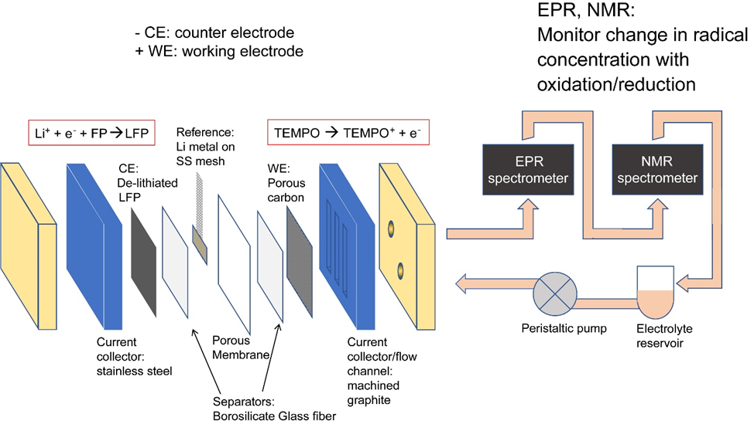
Figure 1. Schematic of the Li-TEMPO battery and electrolyte flow pathway. The electrolyte (0.25 M LiTFSI in diglyme with 25 mM TEMPO) is pumped from the reservoir into the cell then out from the cell consecutively to the EPR and NMR spectrometers.
A Li-TEMPO battery was assembled (figure 1) and cycled under potentiostatic conditions. De-lithiated lithium iron phosphate, FePO₄, was used as the counter electrode in order to limit the effect of SEI reactions (and TEMPO decomposition at low potentials) on the experimental results. Lithium metal was used as the reference electrode and a porous carbon gas diffusion layer was used as the cathode. The electrolyte was flowed from the cell through the NMR and EPR spectrometers, enabling online measurements during electrochemical cycling (figure 1). The cells were cycled in an Ar environment so as to investigate TEMPO redox reactions without the influence of O₂. The theoretical redox potential for TEMPO is 3.76 V vs Li/Li⁺ (0.31 V vs LiFePO₄/ FePO₄).⁵ During TEMPO oxidation, a constant voltage of 3.8 V vs Li/Li+ (0.35 V vs LFP/FP) was applied at the cathode for 10 h and TEMPO is oxidized to the TEMPO⁺ cation at the cathode (figure 2a), while Li⁺ ions are intercalated into the FePO₄ anode and forming LiFePO₄ (LFP). During TEMPO⁺ reduction, a voltage of 3.0 V vs. Li/Li⁺ was applied to reduce TEMPO⁺ back into TEMPO radical at the cathode, and the LFP anode is delithiated. This 3.0 V voltage hold ensures a higher overpotential for reduction (0.76 V overpotential is applied on reduction as opposed to a 0.04 V overpotential applied on oxidation), with the aim to drive the reduction to completion (i.e., to ensure all the TEMPO⁺ species are reduced back into TEMPO and the TEMPO concentration reaches its initial value before the next cycle).
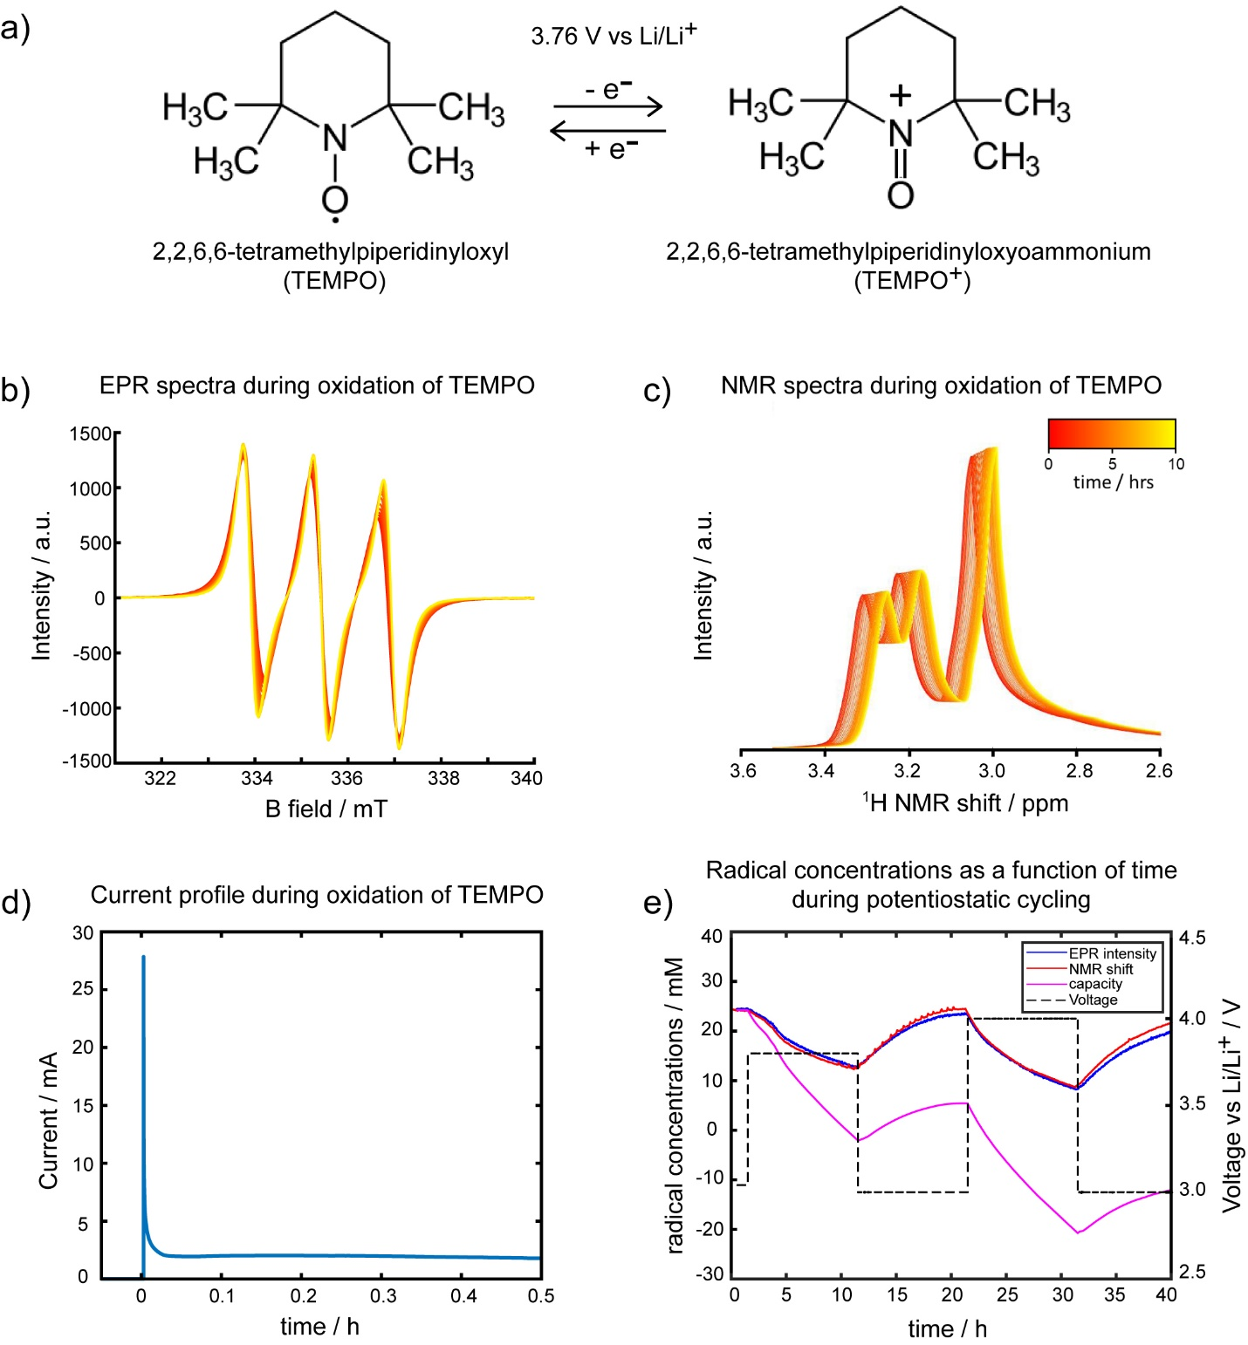Figure 2. a) Molecular structure of TEMPO radical and the corresponding oxidized species, the oxoammonium cation, TEMPO⁺. b) EPR and c) NMR spectra evolution over time and d) current profile during the 3.8 V vs Li/Li⁺ voltage hold. e) Radical concentrations calculated from the EPR absorption (blue), NMR BMS shift (red), and capacity (pink), plotted alongside the applied voltages vs Li/Li⁺ (black).
Figure 2b shows the EPR spectra collected during constant voltage (at 3.8 V vs Li/Li⁺) oxidation of TEMPO. The unpaired electron resides mainly on the nitrogen and oxygen atoms, and is protected by methyl groups from chemical reduction and decomposition into nitrone, making it a stable radical (figure 2a).²⁸ The three observed peaks are characteristic of the hyperfine splitting caused by the nitrogen (spin = 1) nuclei in nitroxyl radicals.²⁸ The peak width decreases with time, which is ascribed to a decrease in both spin exchange as well as dipolar interactions between cations and radicals,³¹ as the TEMPO concentration decreases. Integrating the EPR spectra gives the absorption signal, which is clearly seen to decrease over time (figure S1). The integral of the absorption spectra is directly proportional to the TEMPO concentration, as fitted by using a calibration curve (see figure S2 for details).
Three ¹H peaks are seen in the NMR spectra (figure 2c), which are assigned to the diglyme solvent peaks as non-deuterated diglyme was used. The TEMPO radical is not directly observed under the conditions used here. Nonetheless, the TEMPO concentration can be inferred indirectly by monitoring the peak shifts caused by changes in the BMS as the radical concentrations evolve during the electrochemistry, using the Evans’ method (see experimental methods).³⁰ The line broadening of the NMR solvent peaks also decreases with decreasing radical concentration, as expected with changing concentrations of paramagnetic species in solution (figure S3).
Thus, from both the EPR spectra integrals and BMS shifts, the radical calculations can be monitored during cell operation and compared to the total charge passed, where the total charge, in mAh, was calculated by integrating the current profile (figure 2d) over time. Charge was then converted into TEMPO radical concentration (figure 2e), assuming TEMPO redox reactions were the only contributors to current (i.e., 100% coulombic efficiency) and using a stoichiometric conversion of one mole e⁻ per mole of TEMPO (figure 2a). This calculation is useful as it allows us to compare the theoretical concentrations of TEMPO in the solution based on the current flow with those obtained via the EPR and NMR quantification methods.
The changes in radical concentration measured via EPR and NMR are consistent with the expected redox reactions, where at potentials above the redox potential of TEMPO, the radical concentration decreases as the TEMPO is oxidized to TEMPO⁺, and at potentials below that of TEMPO redox potential, the radical concentration increases as TEMPO⁺ is reduced and TEMPO radicals are regenerated, (figure 2e). There is, however, an apparent mismatch between the amount of charge passed and the measured radical concentrations from EPR and NMR spectroscopy. Due to the reversibility of the TEMPO redox reaction, as shown by the recovery of TEMPO after the reduction steps (figure 2e, table S1), and the lack of detectable amounts of impurities or degradation products in the electrolyte (figure S4), we propose that the mismatch between total charge and measured radical concentrations can be explained by rapid redox shuttling of the TEMPO⁺ and a large self-reduction rate at the counter electrode, which regenerates the TEMPO radicals.
The changes in the current when a constant voltage is applied (chronoamperometry) also provides information on concentration and mass transport.³⁹ The application of overpotential causes a current spike due to initial redox reactions that occur quickly on the electrode surface. The surface species are then rapidly consumed when sufficient overpotentials are applied and the current decays toward zero, indicative of a diffusion limit, where the diffusion rate of reactants from the bulk electrolyte cannot keep up with the electron transfer at the electrode surface.³⁹ Interestingly, after the initial current peak, the current plateaus (figure 2d) rather than decaying as expected in static chronoamperometry experiments (figure S5). This indicates that a diffusion limit is not reached; instead, it suggests that a constant supply of reactants is reaching the electrode at rates comparable to the oxidation reaction rate. In part this is due to the flow set-up, where ‘fresh’ electrolyte containing TEMPO is continually transported to the electrode for oxidation, enhancing the mass transport and preventing the current from quickly decaying to zero, as seen in figure 2d. However, once all the TEMPO in the tubing and reservoir has been oxidized into TEMPO⁺, the oxidation current is again expected to approach zero. This decrease in current is not observed even after long voltage holds (figure S6), and further supports the radical quantification data (figure 2e) which showed that the TEMPO was not being continuously depleted on oxidation but was being regenerated elsewhere in the cell. In other words, increasing mass transport in LABs/RFBs, as achieved here by using a flow cell, also results in increased crossover of redox active species in solution.
Modelling crossover (i) during constant voltage oxidation
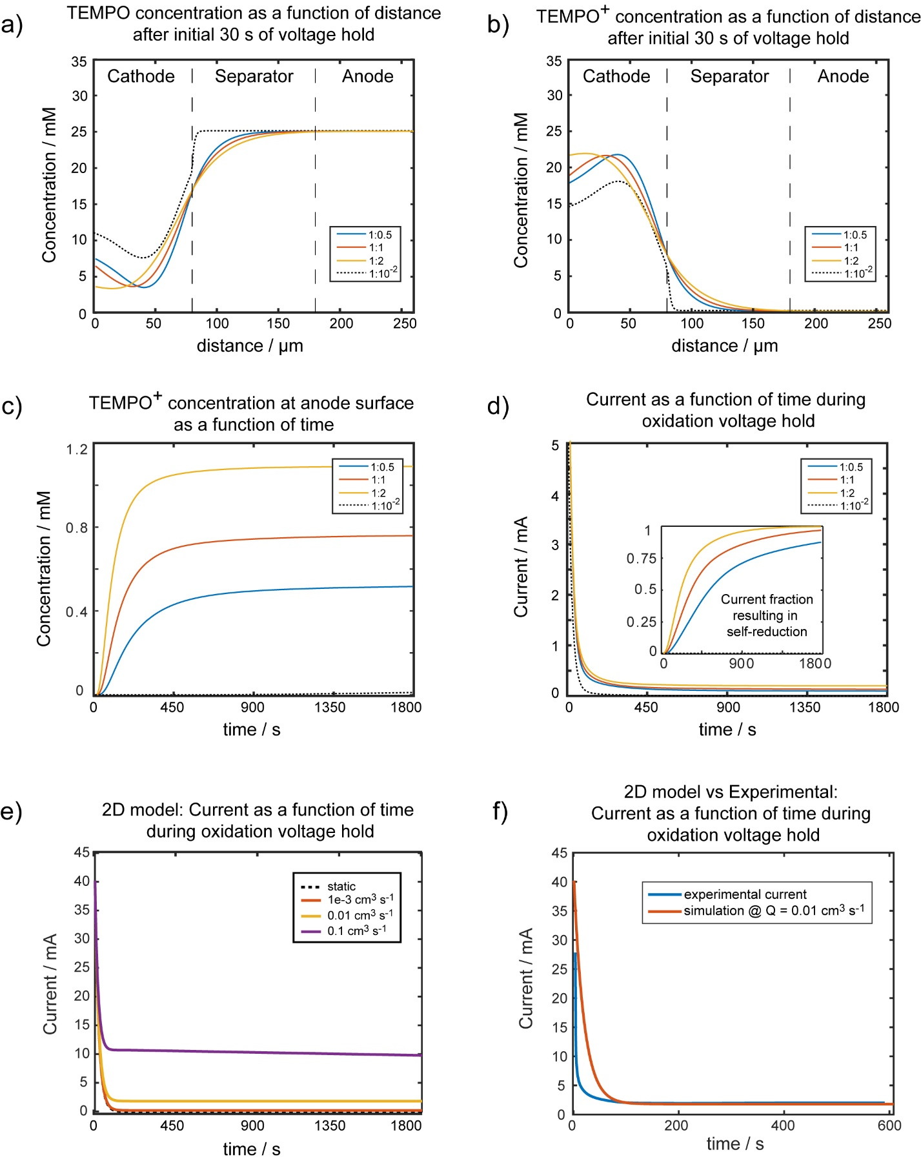Figure 3. a) Simulated TEMPO and b) TEMPO⁺ concentrations as a function of distance across the cathode, separator, and anode domains shown after the first 30 s of a constant voltage hold at 3.8 V vs Li/Li⁺ (0.35 V vs LFP/FP), c) TEMPO⁺ concentration at the anode surface as a function of time during constant voltage oxidation, d) simulated current profiles during constant voltage oxidation, and (inset) fraction of the current resulting in self-reduction at the anode. Reaction rate constant:diffusion coefficient ratios of 1:0.5, 1:1, and 1:2, were used, where a 1:0.5 ratio (blue trace) corresponds to a diffusion coefficient value that is half that of the redox reaction rate constant. The black dotted trace corresponds to a simulation with diffusion rates that are orders of magnitude smaller than the reaction rate, representing a cell with low mass transport. e) Simulated current profiles using the 2D model at various flow rates, from static to 0.1 cm³ s⁻¹, and f) Comparison of experimental current profile with the simulation at a 0.01 cm³ s⁻¹ flow rate.

A 1D computational model was developed and applied to investigate the diffusion of TEMPO/TEMPO⁺ during oxidation reactions. The governing equations and model domains are given in the SI. The model is used to calculate the concentrations of solution species in the electrodes and bulk electrolyte and explore the effect of diffusion rates on the extent of redox shuttling. For modeling simplicity, a static cell without flowing electrolyte was used. (No convective terms were added to the governing equations due to the complexities of accurately describing the flow field for the cell shown in figure 1). The 1D models were then tested for different ratios of the redox rate to effective diffusivity. Ratios were used to simplify the model, as the diffusion rate changes at each time point and position point, due to its dependence on local concentration gradients (equation S9.3). Similarly, the reaction rate is dependent on the local concentration, (equation 4) and will also vary with time and position. A 3.8 V potential vs Li/Li⁺ (0.35V vs LFP/FP) was applied for 1800 s at the cathode to oxidize TEMPO to TEMPO⁺ for all simulations.
An electron-transfer rate constant of ~1$×$10⁻³ cm∙s⁻¹ was measured experimentally using chronoamperometry in a static cells (figure S5), which is comparable with literature values, ~3 $×$10⁻³ cm s⁻¹,⁴⁰ while a typical literature value for the diffusion coefficient of TEMPO is D_{TEMPO} ~ 1x10⁻⁵ cm² s⁻¹.⁵ Thus simulations were initially performed with a reaction rate constant:diffusion coefficient of 1:10⁻² (figure 3a, b, black dotted trace). Figure 3a and b, respectively, show the TEMPO and TEMPO⁺ concentrations after 30 s of constant voltage oxidation. Under these simulations conditions almost no transport of TEMPO from the bulk into the cathode or TEMPO⁺ from the cathode into the electrolyte is observed. Furthermore, very little TEMPO⁺ reaches the anode surface throughout the simulation, as shown in figure 3c, black dotted trace. Figure 3d plots the current as a function of time as calculated from the diffusion model, assuming TEMPO redox is the sole contributor to current. Currents were calculated by integrating the number of electrons passed per timestep across the electrode region. Initially, the rapid oxidation of TEMPO species at the cathode results in high currents (figure 3d). In contrast to the experimental data of Figure 2d, but as expected for a diffusion-limited regime, the calculated current profile exhibits a rapid decay to zero, indicating a depletion of TEMPO species at the cathode.
Since these simulations were unable to reproduce the experimentally observed current behaviors and redox shuttling (figure 2d, e), simulations with faster mass transport were explored. Reaction:diffusion coefficient ratios of 1:0.5, 1:1, and 1:2, were used, corresponding to diffusion constant equal to half, equal and double the reaction rate constant, respectively (figure 3a, b). As expected, relatively lower diffusion leads to faster depletion of TEMPO in the cathode region (figure 3a, blue trace), while at increased diffusion ratios (figure 3a, yellow trace), TEMPO from the bulk (separator region) easily replenishes the supply. The TEMPO⁺ formed at the cathode also diffuses into the bulk separator region much more efficiently at the higher rate of diffusion (figure 3b, yellow trace).
Again, increasing the diffusion ratio increases the amount of TEMPO⁺ that diffused to the anode as a function of time (figure 3c). After more than 450 s, ~1 mM of TEMPO⁺ is present at the anode surface for a 1:2 redox to diffusion rate ratio (figure 3c, yellow). In the model, all TEMPO⁺ species that have diffused to the anode are subject to self-reduction, due to the overpotential at the anode.
Initially Li metal anode was first used in the modelling due to its relevance in Li-air batteries. Since the metal has a large reductive potential, the self-reduction rate of TEMPO⁺ at the anode (in the absence of a passivating layer such as the SEI) is very fast. Furthermore, as the reaction rate constant is proportional to the exponential term (equation 5), the overpotential at the anode results in a reduction rate constant that is several orders of magnitude larger than the oxidation rate constant at the cathode. We note that the overpotential of both Li metal ($η_{{TEMPO/TEMPO}^{+}}=3.76 V$) and LFP ($η_{{TEMPO/TEMPO}^{+}}=0.31 V$) at the anode results in a sufficiently large reaction rate constant (equation 5), leading to fast reduction of TEMPO⁺ back to TEMPO. For the timescales and time steps used, varying the choice of anode resulted in essentially no difference to the simulated results of figure 3, as shown in Figure S7.
In the fast mass transport regime used in the model, the current subsequently plateaus (figure 3d) rather than decaying to zero,³⁹ now consistent with the experimental current profile (figure 2d). Larger diffusion ratios resulted in larger current values at the plateau. The current plateau occurs at lower values in the simulated data (figure 3d) compared to the experimental (figure 2d) due to modeling constraints; the model contains a smaller volume of electrolyte and therefore a smaller number of redox species. Only electrolyte in the cell is accounted for in the model as opposed to an external electrolyte reservoir, which limits the amount of current that can be sustained in the model. The inset in figure 3d shows the fraction of the current at the anode stemming from the self-reduction of TEMPO⁺. At these fast mass transport regimes, redox shuttling contributes to nearly all of the current at the anode by 1800 s. Again, this is comparable to the radical quantification experiment with in-situ EPR and NMR, where the net oxidation of TEMPO to TEMPO⁺ is limited by significant reduction of TEMPO⁺ at the anode.
A 2D computational model was also developed for this system. First, a flow field was set up over the computational domain, where electrolyte flows in via an inlet, flows through the cell, and then out via an outlet (figure S9).⁴¹ The mass transport of TEMPO and TEMPO⁺ is then determined using a convection-diffusion equation (Equation 7), which includes both flow and diffusion.⁴² Details for the model description can be found in the SI. The concentration profiles and simulated current vs time calculated using the 2D model show the same trends to the 1D model: at higher flow rates, TEMPO from the bulk electrolyte reaches the cathode more readily, enabling higher concentrations of TEMPO⁺ to form (figures S10-S13). In the simulated current profiles, increasing the mass transport also led to current plateaus at larger values (figure 3e) as well as higher crossover and larger currents that resulted from TEMPO⁺ reduction at the anode (figure S14). The simulated current using a flow rate of 0.01 cm³ s⁻¹ is close to the measured experimental current, particularly when the current plateaus (figure 3f), although further work improving the accuracy of the 2D model is still needed, particularly to capture the experimental exponential current decay by using more accurate reaction rates.
The 1D crossover model (ii) during constant voltage holds
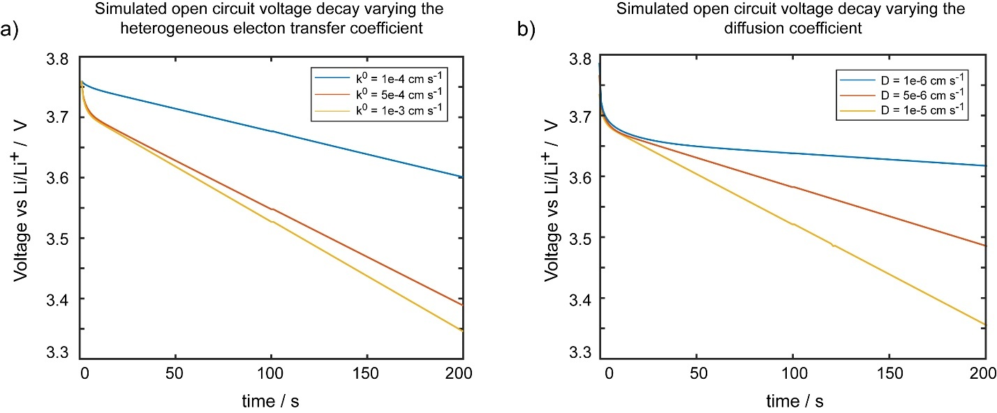
Figure 4. OCV decay profile varying a) heterogeneous electron transfer coefficients and b) diffusion coefficients.
Applying the 1D diffusion model to open-circuit-voltage (OCV) behavior also indicates that both the diffusion rate and self-reduction rate affects the voltage decay. The Nernst equation (equation 6) relates the concentration of oxidized and reduced species to deviations from standard potential. As the concentration of TEMPO slowly increases at OCV due to the crossover and self-reduction of TEMPO⁺, the equilibrium potential decreases. Increasing the electron transfer rate leads to faster decrease in voltage decay, as expected since TEMPO concentrations will increase more rapidly with faster self-reduction (figure 4a). Slower diffusion rates led to a gentle sloping OCV decay, while faster diffusion rates lead to a steeper decay (figure 4b). These general trends and shape of the initial drop and slower decay in the simulated OCV can help explain the experimental OCV (figure S15, figure 4), where the initial volage drop is related to the fast reaction kinetics, and the subsequent sloping voltage decay is more closely related to diffusion rates. Due to the fast diffusion and the comparatively small volume of electrolyte used in the simulation, however, the OCV decays much faster than in experiments (figure S8). These results are in agreement with OCV models for vanadium redox flow batteries, which demonstrate that crossover rates of redox-active species play an important role in self-discharge extent and rate.¹⁹
Effect of Li-Nafion on TEMPO crossover using online NMR and EPR experiments
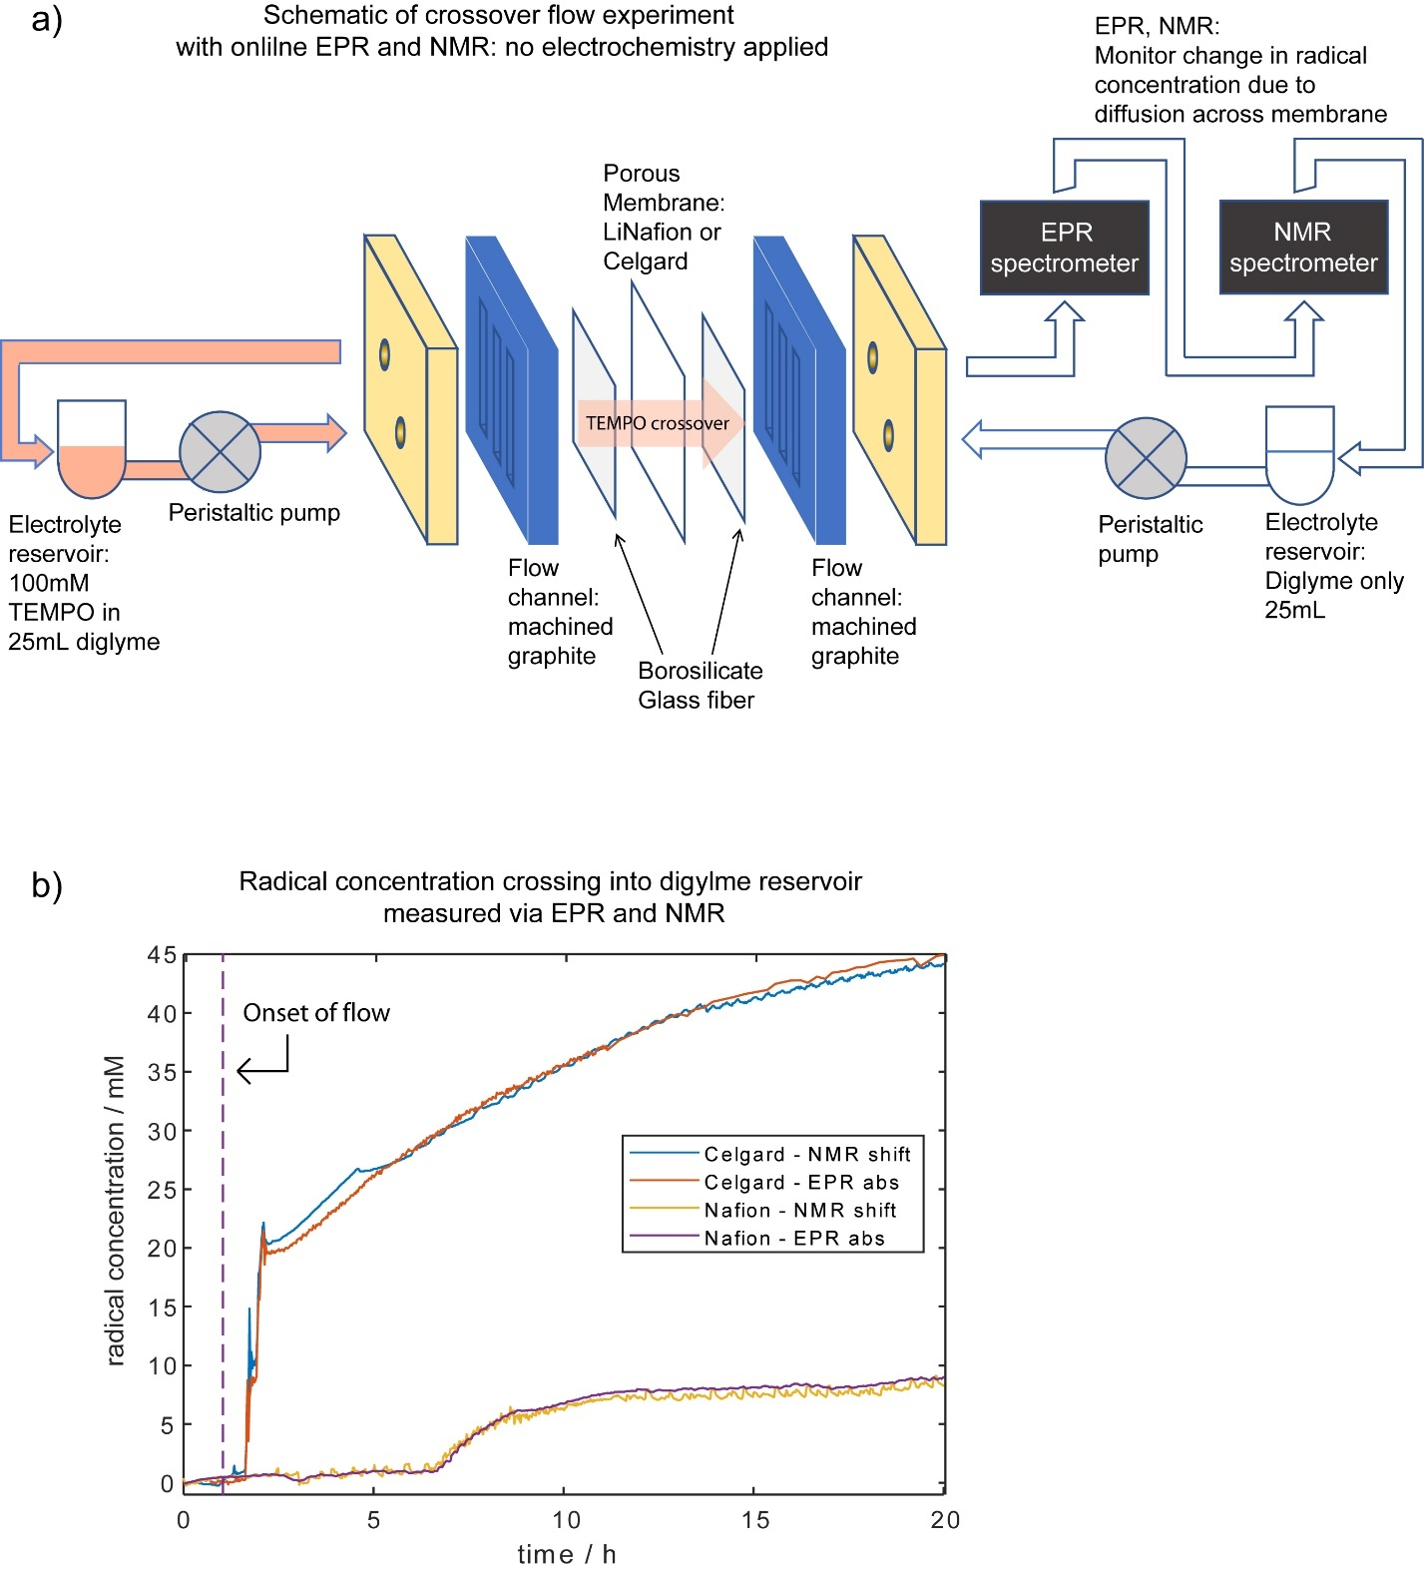Figure 5. a) Schematic of flow cell designed to measure TEMPO crossover in the absence of electrochemical reactions, with electrolyte reservoirs containing TEMPO in diglyme on one side and diglyme reservoir on the other. The crossover species were measured via online EPR and NMR by monitoring the change in the radical concentrations in the solvent-only reservoir as a function of time as shown in (b) for two different membranes, Celgard and Nafion. The radical concentration was measured by EPR absorption and NMR via the BMS shift.
It is clear from both experiments and the simulations that crossover rates are significantly enhanced in flow experiments, motivating simpler experiments, performed in the absence of an electrochemical reaction, to compare the efficacies of Li-Nafion and Celgard in mitigating crossover (figure 5a schematic). In this set-up, a reservoir of TEMPO in diglyme solvent was flowed on one side of the cell, while a reservoir of pure diglyme was flowed on the other side and through the EPR and NMR spectrometers. The concentration of radical species in the pure reservoir was monitored via online EPR and NMR measurements, to track crossover of TEMPO species. Either Celgard or Li-Nafion membranes were used to separate the two sides of the cell. Flow rates used were the same as the electrochemical cell (~ 0.06 cm³ s⁻¹, see experimental).
When Celgard is used, a sharp increase in radical concentration is detected in the pure solvent side, due to a fast crossover of radical species through the porous Celgard membrane. This is followed by a more gradual increase in concentration (figure 5b, blue and orange trace), caused by a dilution effect, where initially, TEMPO species that cross over the membrane are detected in the EPR and NMR in high concentrations before being diluted when the solution is then pumped into the solvent reservoir (figure 5a schematic). When a Li-Nafion membrane is used, crossover concentrations were much lower than when Celgard is used (figure 5b, yellow and purple trace). The longer delay before the detection of TEMPO via EPR and NMR (time = 0-7 h) when using Li-Nafion may be related to slower solvent uptake within the Li-Nafion membrane compared to Celgard, despite having soaked the Li-Nafion in solvent prior to assembly. The membrane wettability and degree of swelling in various non-aqueous solvents strongly affect the effective diffusivity of solution species,²³ and therefore crossover rates. These experimental results suggest that while Li-Nafion can better prevent crossover of radical species compared to Celgard, it is not a wholly effective membrane at stopping crossover and longer duration experiments or aged membranes may see even more species cross over.
Simple 1D diffusion across a membrane was then simulated in order to compare to the experimental results (figure S16). The initial conditions for the model mimic that of the experiment: on one side of the membrane, there is an initial concentration of TEMPO species, while on the other side of the membrane, there is initially only pure solvent. Varying membrane porosity and thicknesses had clear effects on the rates of crossover and therefore the concentrations of crossover species over time as well (figure S16). Effective diffusivities can be affected by porosity and tortuosity via a geometric relation, where increased porosity increases the effective diffusivity.³⁸ The modeling results are consistent with the experimental results where the effective diffusivity of TEMPO is likely lower in Li-Nafion compared to Celgard due to the smaller and ion-selective nature of the pores in Li-Nafion.²³ Thicker membranes also led to slower crossover rates and slower increase in crossover concentrations, which again corroborates experimental results as the Li-Nafion has a thickness of 51 μm and Celgard membrane is 25 μm thick.
Effect of Li-Nafion on TEMPO⁺ diffusion in LABs using operando pressure measurements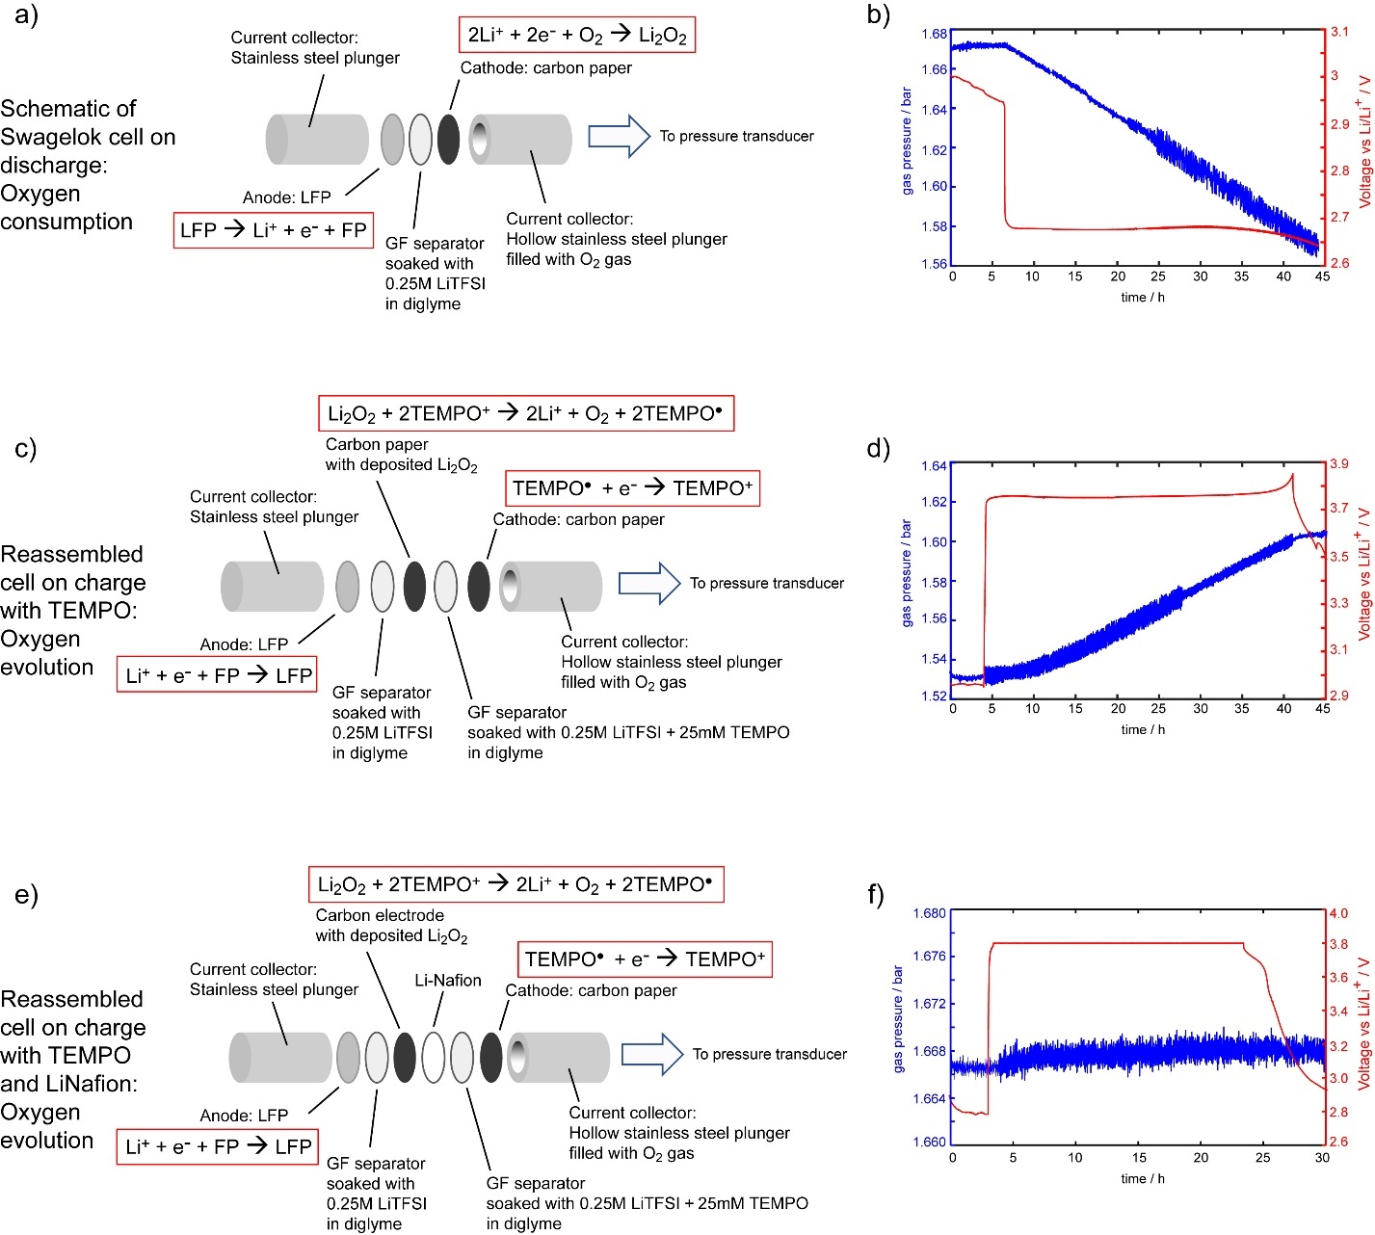
Figure 6. a, e, c) Schematic of LAB Swagelok cells connected to pressure transducers (expanded view) and b, d, f) corresponding voltage profiles during galvanostatic discharge/charge with operando pressure measurements. In a, b) the LAB cell comprising of stainless-steel current collectors, Li metal anode, GF separator with 0.25 M LiTFSI in diglyme electrolyte, and carbon electrode undergoes discharge to form Li₂O₂ at the carbon cathode and consume O₂ gas. In c, d) the cell is then reassembled where the carbon electrode containing Li₂O₂ discharge products is electrically isolated from the current collectors. An electrolyte with 25 mM TEMPO added is used so that upon charging, TEMPO is electrochemically oxidized to TEMPO⁺ at the carbon cathode. The TEMPO⁺ then diffuses to and chemically oxidises the Li₂O₂, which evolves O₂ gas. Similarly, in e, f) the electrically isolated Li₂O₂ and TEMPO/TEMPO⁺ are used, however a Li-Nafion membrane is added between the TEMPO⁺ species and the Li₂O₂ order to evaluate the extent of TEMPO⁺ diffusion through the Li-Nafion.
Operando pressure experiments with Li-O₂ batteries were then designed to characterize TEMPO⁺ transport across Li-Nafion membranes further, and to determine whether these membranes can prevent diffusion of the oxidized TEMPO radical, TEMPO⁺. Since TEMPO⁺ is difficult to detect directly via online NMR and EPR measurements with the flow cell shown in figure 5a, an electrochemical method was used where Swagelok cells were set up such that the chemical oxidation of Li₂O₂ into O₂ gas can only occur via TEMPO⁺ diffusion. The O₂ gas evolution is therefore indicative of TEMPO⁺ diffusion and can be easily monitored in operando using a pressure transducer.
First a Li-O₂ Swagelok cell is assembled without TEMPO redox mediator (figure 6a) and the galvanostatic discharge behavior is recorded (figure 6b). A Li metal anode and carbon paper cathode are used (figure 6a). During discharge, O₂ is reduced at the carbon cathode, and reacts with Li⁺ to form Li₂O₂, which precipitates and deposits on the cathode. The reduction of O₂ gas results in a linear decrease in the pressure during discharge (figure 6b, blue), as monitored by the pressure transducer. The voltage profile (figure 6b, red) shows a clear plateau at 2.65 V vs Li/Li⁺. Using the ideal gas law, the number of moles of gas consumed during discharge can be calculated, while the number of electrons passed can be calculated by integrating the current over time. The experimental data for gas consumption closely follows the 2 mole e⁻/mole of O₂ (2 Li⁺ + 2 e⁻ + O₂ Li₂O₂) indicative of Li₂O₂ formation on discharge (see SI for detailed calculations, Table S3).
The noise seen in the data from the pressure measurement is due to electrical interference at the pressure transducer. The transducer is electrically insulated from the rest of the cell body, however a small electrical connection to the cell (e.g., due to ineffective grounding) can interfere with the electrical signal recorded. As seen in the data, the noise in the pressure measurement is only observed during electrochemical cycling of the battery and not during OCV, demonstrating that the noise is related to electrical interference.
Following the first discharge, the cell was disassembled and reassembled as shown in figure 6c. In this arrangement, the Li₂O₂ is now electrically isolated and can only be chemically oxidized via a redox mediator, such as TEMPO. During galvanostatic charge, TEMPO is oxidized to TEMPO⁺ at the carbon electrode (depicted in figure 6c). The voltage plateau (figure 6d, red) is pinned at the TEMPO/TEMPO⁺ redox potential of 3.76 V vs Li/Li⁺. The TEMPO⁺ then diffuses to the Li₂O₂ and chemically oxidizes the Li₂O₂ to form O₂, which can be observed via the change in pressure (figure 6d, blue). The onset of gas evolution is slightly delayed compared to the application of constant current due to the delay in diffusion of TEMPO⁺ from the cathode to the Li₂O₂ as well as the diffusion of O₂ gas from further inside the cell. The charge reaction, as measured via the oxygen evolution, deviates from the ideal 2 mole e⁻/mole O₂ (see SI, Table S11) due to parasitic reactions. However, some parasitic reactions and the subsequent deviation of mole e⁻/mole gas evolved is observed even in cells where the Li₂O₂ in electrical contact with the current collector (figure S17, Table S3).
In contrast, when a Li-Nafion membrane is placed between the electrically isolated Li₂O₂ and the TEMPO/TEMPO⁺ (figure 6e), the amount of gas that is evolved relative to current passed decreases significantly (figure 6f). A ratio of more than 7 mol e⁻/mole O₂ evolved was observed (Table S11). This suggests that TEMPO⁺ does not diffuse as easily across the Li-Nafion membrane and only a small amount of Li₂O₂ was oxidized to O₂. As a side note, due to overpotentials caused by the Li-Nafion ionic resistivity during galvanostatic oxidation,²³ the 3.8 V vs Li/Li+ cutoff voltage was quickly reached. This limited the total capacity passed.
Combined, the flow crossover experiment (figure 5) and the operando pressure cell on charge (figure 6e, f) indicate that, if implemented in a TEMPO-mediated LAB, the Li-Nafion can mitigate both TEMPO and TEMPO⁺ crossover: a reduction by a factor of ~15x and ~7x is achieved for TEMPO and TEMPO⁺ respectively when Li-Nafion is used (see SI for calculations).
DISCUSSION
Although TEMPO⁺ is a diamagnetic ion, it was not easily detected in the ¹H NMR spectra in these experiments (figure S4). Fast intermolecular electron transfer between diamagnetic TEMPO⁺ and paramagnetic TEMPO has been studied previously characterized to explain the challenges in NMR detection:^{31,32,43} exchange between TEMPO and its oxidized form, on a timescale approaching the hyperfine interactions in TEMPO, results in severe line-broadening of the ¹H signals of TEMPO⁺ making direct NMR detection difficult if even small concentrations of TEMPO are present in the solution.⁴³ The paramagnetic properties, however enables detection of radical species in solution based on the BMS shift in ¹H NMR spectra of the solvent, diglyme, as well as direct quantification through EPR.
The changes in radical concentration measured by EPR and NMR during constant voltage oxidation and reduction of TEMPO is suggestive of significant crossover reactions. The radicals oxidized are recovered during reduction (table S1), indicating the reversibility of the TEMPO redox reaction and that the parasitic electric current cannot be solely related to TEMPO degradation reactions. Although a solution phase chemical self-reduction or degradation may occur and has been briefly mentioned in literature,^{9,20} this was not observed in our experiments and solution-phase decomposition products were not seen in the ¹H NMR spectra (figure S4). Impurities which may result in parasitic side reactions consuming electrons are also not observed in the pristine electrolyte, nor are their decomposition products observed (figure S4). Thus, it is not reasonable to ascribe any of these potential parasitic pathways to all the parasitic current observed, where for every mole of electron passed, in net, only half a mole of radicals is oxidized (figure 2e). It is, however, reasonable to conclude a fast redox shuttling of TEMPO⁺.
From the modeling results, mass transport plays a large role in determining the extent of crossover, concentration gradients across the cell, and current profiles during potentiostatic cycling. Previous models studying mass transport effects in LABs focus on the impact of O₂ mass transport on concentration gradients within the cells, with and without a flowing design.^{12,15,16} Our models expand on previous work, now studying transport phenomena in soluble RMs and examining the effect of mass transport on not only the cathode reactions, but also at the anode, i.e., redox shuttling. Typically, diffusion is much slower than electron transfer rates, however this is not the case for the Li-air flow battery or RFBs. Convective flux from flowing the electrolyte occurs in addition to diffusive flux. When comparing the 1D model to experimental conditions, the effective diffusion rates can then be considered as total flux rates, which includes both diffusive flux and convective flux arising from the flow field. Choosing diffusion coefficients that are on the same order of magnitude as the reaction rate constant, much larger than the literature values,^{40,44} results in average mass flux values of ~7 ×10⁻⁷ mol s⁻¹ cm⁻², which approaches the flux in experimental cells with flowing electrolyte, ~1 ×10⁻⁶ mol s⁻¹ cm⁻². In this way, the model can provide an appropriate comparison to experiment as both are in the fast mass transport regime, where supply of reactants at the electrode does not limit reaction rate. We found that the simulations with fast mass transport, such as that achieved with flowing electrolytes, show considerably higher concentrations of TEMPO⁺ diffusing to the anode (figure 3c) and increased redox shuttle contributions to total current passed (figure 3d) compared to simulations of static cells using realistic diffusion coefficients. Furthermore, a preliminary multidimensional (2D) model with simplified flow field corroborates the trends observed in experiment and in the 1D simulations (figure 3e, 3f, S10-13).
Direct detection and quantification of the crossover phenomena in RFBs and flow LABs is of importance to RFBs and flow LABs, where the extent of crossover is greatly increased at high mass transport regimes. In RFBs species crossover from one electrode/electrolyte tank to the other causes losses in round-trip efficiency and overall capacity loss over time.¹⁹ In LABs, crossover and redox shuttling also result in capacity loss and interfacial reactions. Due to redox shuttling, a greater amount of current needed to remove Li₂O₂ discharge product in LABs. Since chemical oxidation of Li₂O₂ via redox mediators is slower than the fast heterogeneous electron transfer of redox mediators at the electrode,⁴⁰ mediators can easily diffuse into bulk electrolyte without oxidizing Li₂O₂, and crossover to the Li anode.
While redox shutting is a well-known issue, for example, the widely studied polysulfide shuttling in Li-Sulphur batteries,⁴⁵ it is not well-studied in LABs. Characterization of cathode reactions during charge and discharge is prioritized in LABs, and redox shuttling and crossover reactions to the anode have not been thoroughly considered.³ Having now shown, experimentally and computationally, the significant concentration of species that have crossed over to the anode, particularly when fast mass transport occurs, we now consider the impact of crossover on the anode reactions.
The specific effects of TEMPO⁺ on the Li metal SEI were not characterized in this work as de-lithiated LFP was used for the in-situ studies and no SEI was likely to form. In addition, no SEI components were included in the computational models. However, it is well known that the stability of the SEI greatly affects the lifetime and cyclability of the Li anode.⁴⁶ An ideal SEI would be electronically insulating, preventing redox shuttling of crossover species and further oxidation of Li metal. The SEI must itself also be chemically stable toward oxidation. For instance, the theoretical oxidation potential of Li₂CO₃, a common inorganic SEI component, is above the TEMPO redox potential and will not be oxidized by TEMPO⁺ that has crossed over to the anode.^{21,47–49} However, the specific composition of Li metal is dependent on the electrolyte used and the atmospheric environment it is exposed to.²¹ Therefore SEI stability toward oxidation is strongly dependent on composition: SEI components with lower redox potentials than TEMPO such as lithium oxides or hydroxides may be chemically oxidized and removed by TEMPO⁺. Ha et al. demonstrated this phenomenon by using a thiazine-based redox mediator.²² The oxidation of SEI via redox shuttling of the mediator caused de-stabilization of the Li metal anode and further parasitic electron and electrolyte consumption,²² motivating further work.
Despite increasing redox shuttling, enabling high mass transport through a flowing design is advantageous: flowing the electrolyte improves rate capabilities, increases uniformity of Li₂O₂ deposition at the cathode, and increases longevity of the LAB.¹⁵ In order to capitalize on the improvements granted by increasing mass transport while also mitigating crossover, engineering a stable SEI or providing protective layers to inhibit crossover is necessary. Selective membranes are widely used in the aqueous RFB community and may be employed to protect the anode and limit parasitic redox shuttling.
Adapting conventional membranes used in aqueous conditions for non-aqueous batteries has proven challenging. We performed several experiments studying the effects of a Li-Nafion membrane on crossover rates of TEMPO/TEMPO⁺. Li-Nafion appears to prevent severe crossover of TEMPO radical species as compared to a Celgard membrane (figure 5) as well as limiting TEMPO⁺ diffusion shown in the operando pressure measurements with LAB cells (figure 6). In the OCV decay experiments, Li-Nafion also slowed the voltage decay at rest after charging, corresponding to less self-discharge (figure S8). Challenges remain however, to ensure good ionic conductivity and compatibility of the membrane with electrolytes used in LABs and non-aqueous RFBs. In our static cells, Li-Nafion increased the ionic resistivity and limited the total charge capacity (figure 6f). This result is consistent with literature,⁵⁰ and is particularly problematic in LABs, where high overpotentials can lead to additional electrode and electrolyte breakdown.² Furthermore, since Nafion is typically used in aqueous electrolytes, its long-term stability in non-aqueous electrolytes and long-term efficacy at preventing crossover also require further study.^{23,45} As seen in our crossover flow experiment, within less than a day, on the order of 10mM TEMPO species had diffused across the Li-Nafion membrane (figure 5b). Improvements in short term crossover we observed with Li-Nafion may in part be a result of slower non-aqueous solvent uptake in these, which decreases the membrane porosity and diffusivity of species through the membrane.²³
Further work is required in order to develop next-generation battery technologies such as RFBs and LABs. While high mass transport has many advantages when used in flow-LABs and are integral to RFBs, the combination of employing solution phase redox active species and flow systems where fast mass transport is enabled requires detailed consideration of crossover rates.
CONCLUSION
In summary, we have utilized in-situ measurements and supporting computational modeling to study crossover and redox shuttling in batteries using TEMPO as the redox-active species. Online EPR and NMR measurements reveal a mismatch between the changes in TEMPO concentrations and the capacities measured from electrochemistry. A significant amount of charge passed on oxidation, nearly half, does not result in net TEMPO oxidation into TEMPO⁺. The discrepancy is a result of self-reduction of TEMPO⁺ species that have crossed over to the anode. Modeling the diffusion and redox behavior of TEMPO/TEMPO⁺ supports the hypothesis of extensive redox shuttling at high mass transport regimes – i.e., during flow, resulting in effective mass fluxes across the membrane that are two orders of magnitude higher than for a static system. Crossover and self-reduction continue while the cells are at rest, leading to self-discharge and capacity loss.
Since in high mass transport regimes, TEMPO⁺ (and indeed other soluble RMs) can easily crossover to the anode surface, this can result in further reactions at the Li metal surface used in LABs and hybrid RFBs, which will affect the SEI forming reactions. The continuous crossover reactions necessitate the use of membranes for non-aqueous RFBs and LABs. Lithiated-Nafion reduces the rate of species crossover in simple crossover, operando pressure, and OCV experiments. However, this membrane also resulted in increased overpotentials, and we have yet to demonstrate its efficacy over long periods of time. Development of effective, stable, and highly conductive ion-selective membranes, particular in non-aqueous solvent, to combat crossover reactions is critical for LABs and RFBs.
The study of crossover and redox shuttling is relevant to RFBs and LABs, resulting in loss of efficiency during operation and significant self-discharge, as well as SEI reactions in the latter. We used TEMPO a model species to characterize redox shuttling since it is used in both RFBs and LABs and is also quantifiable via EPR and NMR. The online EPR and NMR methodology presented in this work is an effective and general method of studying species crossover which can be applied to monitor redox and crossover behavior with other radical species in solution, including intermediates or side reaction products. The concentrations of radical species can be quantified and compared throughout various stages of electrochemical cycling. The approach demonstrated here using TEMPO molecules can easily be applied to studying degradation reactions and redox reactions. Oxidation reactions with Li₂O₂ or SEI species can also be investigated by reaction with TEMPO/TEMPO⁺ via monitoring the changes in radical concentrations in solution.
ASSOCIATED CONTENT
The following files are available free of charge:
Supporting Information: Additional EPR and NMR spectra, calculations, and computational method (file type, PDF)
AUTHOR INFORMATION
Corresponding Author
cpg27@cam.ac.uk
Fax: (+44)1223336362
Tel: (+44)1223336509
Notes
The authors declare no competing financial interest.
ACKNOWLEDGMENT
The authors thank EPSRC-EP/M009521/1 and the Cambridge Trust (E.W.) for research funding. C.P.G. acknowledge support from Centre of Advanced Materials for Integrated Energy Systems (CAM-IES), via EPSRC grant no. EP/P007767/1. The authors thank Fikile R. Brushett (MIT) for sharing the design of the flow battery that is compatible with non-aqueous solvents.
ABBREVIATIONS
LAB, lithium-air battery; RFB, redox-flow battery; TEMPO, 2,2,6,6-tetramethylpiperidinyloxyl; NMR, nuclear magnetic resonance; EPR, electron paramagnetic resonance; SEI, solid electrolyte interphase; BMS, bulk magnetic susceptibility; LiTFSI, lithium bis (trifluoromethyl) sulfonylimide; GF, glass fiber; LFP, lithium iron phosphate; OCV, open circuit voltage.
PRESENT ADDRESSES:
#E.W.Z: Magnetic Resonance Research Center, Institute for Molecules and Materials, Radboud University Nijmegen, Nijmegen 6500 GL, Netherlands
REFERENCES
(1) Li, Y.; Lu, J. Metal-Air Batteries: Will They Be the Future Electrochemical Energy Storage Device of Choice? ACS Energy Lett. 2017, 2 (6), 1370–1377.
(2) Liu, T.; Vivek, J. P.; Zhao, E. W.; Lei, J.; Garcia-Araez, N.; Grey, C. P. Current Challenges and Routes Forward for Nonaqueous Lithium-Air Batteries. Chem. Rev. 2020, 120 (14), 6558–6625. https://doi.org/10.1021/acs.chemrev.9b00545.
(3) Aurbach, D.; McCloskey, B. D.; Nazar, L. F.; Bruce, P. G. Advances in Understanding Mechanisms Underpinning Lithium-Air Batteries. Nat. Energy 2016, 1, 16128.
(4) Park, J. B.; Lee, S. H.; Jung, H. G.; Aurbach, D.; Sun, Y. K. Redox Mediators for Li–O2 Batteries: Status and Perspectives. Adv. Mater. 2018, 30 (1), 1–13. https://doi.org/10.1002/adma.201704162.
(5) Bergner, B. J.; Schürmann, A.; Peppler, K.; Garsuch, A.; Janek, J. TEMPO: A Mobile Catalyst for Rechargeable Li-O2 Batteries. J. Am. Chem. Soc. 2014, 136 (42), 15054–15064. https://doi.org/10.1021/ja508400m.
(6) de Nooy, A. E. J.; Besemer, A. C.; van Bekkum, H. Highly Selective Tempo Mediated Oxidation of Primary Alcohol Groups in Polysaccharides. Recl. des Trav. Chim. des Pays‐Bas 1994, 113 (3), 165–166. https://doi.org/10.1002/recl.19941130307.
(7) Nutting, J. E.; Rafiee, M.; Stahl, S. S. Tetramethylpiperidine N-Oxyl (TEMPO), Phthalimide N-Oxyl (PINO), and Related N-Oxyl Species: Electrochemical Properties and Their Use in Electrocatalytic Reactions. Chem. Rev. 2018, 118 (9), 4834–4885. https://doi.org/10.1021/acs.chemrev.7b00763.
(8) Li, Z.; Li, S.; Liu, S.; Huang, K.; Fang, D.; Wang, F.; Peng, S. Electrochemical Properties of an All-Organic Redox Flow Battery Using 2,2,6,6-Tetramethyl-1-Piperidinyloxy and N-Methylphthalimide. Electrochem. Solid-State Lett. 2011, 14 (12), 171–174. https://doi.org/10.1149/2.012112esl.
(9) Wei, X.; Xu, W.; Vijayakumar, M.; Cosimbescu, L.; Liu, T.; Sprenkle, V.; Wang, W. TEMPO-Based Catholyte for High-Energy Density Nonaqueous Redox Flow Batteries. Adv. Mater. 2014, 26 (45), 7649–7653. https://doi.org/10.1002/adma.201403746.
(10) Shin, S. H.; Yun, S. H.; Moon, S. H. A Review of Current Developments in Non-Aqueous Redox Flow Batteries: Characterization of Their Membranes for Design Perspective. RSC Adv. 2013, 3 (24), 9095–9116. https://doi.org/10.1039/c3ra00115f.
(11) Ok, B.; Na, W.; Kwon, T. H.; Kwon, Y. W.; Cho, S.; Hong, S. M.; Lee, A. S.; Lee, J. H.; Koo, C. M. Understanding the Enhanced Electrochemical Performance of TEMPO Derivatives in Non-Aqueous Lithium Ion Redox Flow Batteries. J. Ind. Eng. Chem. 2019, 80, 545–550. https://doi.org/10.1016/j.jiec.2019.08.027.
(12) Huang, J.; Faghri, A. Capacity Enhancement of a Lithium Oxygen Flow Battery. Electrochim. Acta 2015, 174, 908–918. https://doi.org/10.1016/j.electacta.2015.06.071.
(13) Zhu, Y. G.; Wang, X.; Jia, C.; Yang, J.; Wang, Q. Redox-Mediated ORR and OER Reactions: Redox Flow Lithium Oxygen Batteres Enabled with a Pair of Soluble Redox Catalysts. ACS Catal. 2016, 6, 6191–6197.
(14) Liu, Y.; Goulet, M. A.; Tong, L.; Liu, Y.; Ji, Y.; Wu, L.; Gordon, R. G.; Aziz, M. J.; Yang, Z.; Xu, T. A Long-Lifetime All-Organic Aqueous Flow Battery Utilizing TMAP-TEMPO Radical. Chem 2019, 5 (7), 1861–1870. https://doi.org/10.1016/j.chempr.2019.04.021.
(15) Li, X.; Huang, J.; Faghri, A. Modeling Study of a Li-O2 Battery with an Active Cathode. Energy 2015, 81, 489–500. https://doi.org/10.1016/j.energy.2014.12.062.
(16) Read, J.; Mutolo, K.; Ervin, M.; Behl, W.; Wolfenstine, J.; Driedger, A.; Foster, D. Oxygen Transport Properties of Organic Electrolytes and Performance of Lithium/Oxygen Battery. J. Electrochem. Soc. 2003, 150 (10), A1351. https://doi.org/10.1149/1.1606454.
(17) Schurmann, A.; Haas, R.; Murat, M.; Kuritz, N.; Balaish, M.; Ein-Eli, Y.; Janek, J.; Natan, A.; Schroder, D. Diffusivity and Solubility of Oxygen in Solvents for Metal/Oxygen Batteries: A Combined Theoretical and Experimental Study. J. Electrochem. Soc. 2018, 165 (13), A3095–A3099.
(18) Gittleson, F. S.; Jones, R. E.; Ward, D. K.; Foster, M. E. Oxygen Solubility and Transport in Li-Air Battery Electrolytes: Establishing Criteria and Strategies for Electrolyte Design. Energy Environ. Sci. 2017, 10, 1167–1179.
(19) Kleinsteinberg, B.; Klick, S.; Sauer, D. U. Empirical Approach to Determine Open-Circuit Voltage of a Vanadium-Redox-Flow Battery for Models, Based on Published Data for Anion-Exchange and Cation-Exchange Membranes and Temperature Dependency. J. Energy Storage 2020, 28 (February), 101109. https://doi.org/10.1016/j.est.2019.101109.
(20) Kwak, W.-J.; Kim, H.; Jung, H.-G.; Aurbach, D.; Sun, Y.-K. Review—A Comparative Evaluation of Redox Mediators for Li-O 2 Batteries: A Critical Review . J. Electrochem. Soc. 2018, 165 (10), A2274–A2293. https://doi.org/10.1149/2.0901810jes.
(21) Wang, E.; Dey, S.; Liu, T.; Menkin, S.; Grey, C. P. Effects of Atmospheric Gases on Li Metal Cyclability and Solid-Electrolyte Interphase Formation. ACS Energy Lett. 2020, 5 (4), 1088–1094. https://doi.org/10.1021/acsenergylett.0c00257.
(22) Ha, S.; Kim, Y.; Koo, D.; Ha, K. H.; Park, Y.; Kim, D. M.; Son, S.; Yim, T.; Lee, K. T. Investigation into the Stability of Li Metal Anodes in Li-O2 Batteries with a Redox Mediator. J. Mater. Chem. A 2017, 5 (21), 10609–10621. https://doi.org/10.1039/c7ta02210g.
(23) Su, L.; Darling, R. M.; Gallagher, K. G.; Xie, W.; Thelen, J. L.; Badel, A. F.; Barton, J. L.; Cheng, K. J.; Balsara, N. P.; Moore, J. S.; et al. An Investigation of the Ionic Conductivity and Species Crossover of Lithiated Nafion 117 in Nonaqueous Electrolytes. J. Electrochem. Soc. 2016, 163 (1), A5253–A5262. https://doi.org/10.1149/2.03211601jes.
(24) Farooqui, U. R.; Ahmad, A. L.; Hamid, N. A. Challenges and Potential Advantages of Membranes in Lithium Air Batteries: A Review. Renew. Sustain. Energy Rev. 2017, 77, 1114–1129.
(25) Tan, R.; Wang, A.; Malpass-Evans, R.; Williams, R.; Zhao, E. W.; Liu, T.; Ye, C.; Zhou, X.; Darwich, B. P.; Fan, Z.; et al. Hydrophilic Microporous Membranes for Selective Ion Separation and Flow-Battery Energy Storage. Nat. Mater. 2020, 19 (2), 195–202. https://doi.org/10.1038/s41563-019-0536-8.
(26) Liang, Z.; Attanayake, N. H.; Greco, K. V.; Neyhouse, B. J.; Barton, J. L.; Kaur, A. P.; Eubanks, W. L.; Brushett, F. R.; Landon, J.; Odom, S. A. Comparison of Separators vs Membranes in Nonaqueous Redox Flow Battery Electrolytes Containing Small Molecule Active Materials. ACS Appl. Energy Mater. 2021, 4 (6), 5443–5451. https://doi.org/10.1021/acsaem.1c00017.
(27) Small, L. J.; Pratt, H. D.; Anderson, T. M. Crossover in Membranes for Aqueous Soluble Organic Redox Flow Batteries. J. Electrochem. Soc. 2019, 166 (12), A2536–A2542. https://doi.org/10.1149/2.0681912jes.
(28) Haugland, M. M.; Anderson, E. A.; Lovett, J. E. Tuning the Properties of Nitroxide Spin Labels for Use in Electron Paramagnetic Resonance Spectroscopy through Chemical Modification of the Nitroxide Framework. Electron Paramagnetic Resonance: Volume 25, edited by Chechik, V and Murphey, D.M., Royal Society of Chemistry 2017, 1-34. https://doi.org/10.1039/9781782629436-00001.
(29) Chu, K. ‐. C.; Xu, Y.; Balschi, J. A.; Springer, C. S. Bulk Magnetic Susceptibility Shifts in Nmr Studies of Compartmentalized Samples: Use of Paramagnetic Reagents. Magn. Reson. Med. 1990, 13 (2), 239–262. https://doi.org/10.1002/mrm.1910130207.
(30) Evans, D. F. Determination of the Pararnagnetic Susceptibility of Substances in Solution by Nuclear Magnetic Resonance. J. Chem. Soc. 1959, 2003–2005.
(31) Bales, B. L.; Michelle, M.; Smith, S.; Peric, M. EPR Line Shifts and Line Shape Changes Due to Spin Exchange Between Nitroxide Free Radicals in Liquids: 6. Separating Line Broadening Due to Spin Exchange and Dipolar Interactions. J. Phys. Chem. A 2009, 113, 4930–4940. https://doi.org/10.1007/s00723-016-0854-9.
(32) Zhao, E. W.; Liu, T.; Jónsson, E.; Lee, J.; Temprano, I.; Jethwa, R. B.; Wang, A.; Smith, H.; Carretero-González, J.; Song, Q.; et al. In Situ NMR Metrology Reveals Reaction Mechanisms in Redox Flow Batteries. Nature 2020, 579 (7798), 224–228. https://doi.org/10.1038/s41586-020-2081-7.
(33) Zhao, E. W.; Jónsson, E.; Jethwa, R. B.; Hey, D.; Lyu, D.; Brookfield, A.; Klusener, P. A. A.; Collison, D.; Grey, C. P. Coupled in Situ NMR and EPR Studies Reveal the Electron Transfer Rate and Electrolyte Decomposition in Redox Flow Batteries. J. Am. Chem. Soc. 2021, 143 (4), 1885–1895. https://doi.org/10.1021/jacs.0c10650.
(34) Gao, J.; Sun, C.; Xu, L.; Chen, J.; Wang, C.; Guo, D.; Chen, H. Lithiated Nafion as Polymer Electrolyte for Solid-State Lithium Sulfur Batteries Using Carbon-Sulfur Composite Cathode. J. Power Sources 2018, 382 (October 2017), 179–189. https://doi.org/10.1016/j.jpowsour.2018.01.063.
(35) Milshtein, J. D.; Kaur, A. P.; Casselman, M. D.; Kowalski, J. A.; Modekrutti, S.; Zhang, P. L.; Harsha Attanayake, N.; Elliott, C. F.; Parkin, S. R.; Risko, C.; et al. High Current Density, Long Duration Cycling of Soluble Organic Active Species for Non-Aqueous Redox Flow Batteries. Energy Environ. Sci. 2016, 9 (11), 3531–3543. https://doi.org/10.1039/c6ee02027e.
(36) Magnettech GmbH. Manual and Documentation of Magnettech MiniScope MS 5000 and MS 5000X; Berlin, Germany.
(37) Rieger, P. H. Electron-Transfer Kinetics. In Electrochemistry; Springer: Dordrecht, 1994; pp 315–370. https://doi.org/https://doi.org/10.1007/978-94-011-0691-7_6.
(38) Tjaden, B.; Cooper, S. J.; Brett, D. J.; Kramer, D.; Shearing, P. R. On the Origin and Application of the Bruggeman Correlation for Analysing Transport Phenomena in Electrochemical Systems. Curr. Opin. Chem. Eng. 2016, 12, 44–51. https://doi.org/10.1016/j.coche.2016.02.006.
(39) Bard, A. J.; Faulkner, L. R. Electrochemical Methods: Fundamentals and Applications, 2nd ed.; John Wiley & Sons, Inc: New York, 2001.
(40) Chen, Y.; Gao, X.; Johnson, L. R.; Bruce, P. G. Kinetics of Lithium Peroxide Oxidation by Redox Mediators and Consequences for the Lithium-Oxygen Cell. Nat. Commun. 2018, 9 (1), 767. https://doi.org/10.1038/s41467-018-03204-0.
(41) Kazim, A.; Liu, H. T.; Forges, P. Modelling of Performance of PEM Fuel Cells with Conventional and Interdigitated Flow Fields. J. Appl. Electrochem. 1999, 29 (12), 1409–1416. https://doi.org/10.1023/A:1003867012551.
(42) Knehr, K. W.; Agar, E.; Dennison, C. R.; Kalidindi, A. R.; Kumbur, E. C. A Transient Vanadium Flow Battery Model Incorporating Vanadium Crossover and Water Transport through the Membrane. J. Electrochem. Soc. 2012, 159 (9), A1446–A1459. https://doi.org/10.1149/2.017209jes.
(43) Bobbitt, J. M.; Eddy, N. A.; Cady, C. X.; Jin, J.; Gascon, J. A.; Gelpí-Dominguez, S.; Zakrzewski, J.; Morton, M. D. Preparation of Some Homologous TEMPO Nitroxides and Oxoammonium Salts; Notes on the NMR Spectroscopy of Nitroxide Free Radicals; Observed Radical Nature of Oxoammonium Salt Solutions Containing Trace Amounts of Corresponding Nitroxides in an Equilibrium R. J. Org. Chem. 2017, 82 (18), 9279–9290. https://doi.org/10.1021/acs.joc.7b00846.
(44) Lacey, M. J.; Frith, J. T.; Owen, J. R. A Redox Shuttle to Facilitate Oxygen Reduction in the Lithium Air Battery. Electrochem. commun. 2013, 26 (1), 74–76. https://doi.org/10.1016/j.elecom.2012.10.009.
(45) Bauer, I.; Thieme, S.; Brückner, J.; Althues, H.; Kaskel, S. Reduced Polysulfide Shuttle in Lithium-Sulfur Batteries Using Nafion-Based Separators. J. Power Sources 2014, 251, 417–422. https://doi.org/10.1016/j.jpowsour.2013.11.090.
(46) Peled, E.; Menkin, S. Review - SEI: Past, Present and Future. J. Electrochem. Soc. 2017, 164 (7), A1703–A1719. https://doi.org/10.1149/2.1441707jes.
(47) Mahne, N.; Renfrew, S. E.; McCloskey, B. D.; Freunberger, S. A. Electrochemical Oxidation of Lithium Carbonate Generates Singlet Oxygen. Angew. Chemie - Int. Ed. 2018, 57 (19), 5529–5533. https://doi.org/10.1002/anie.201802277.
(48) Lim, H. K.; Lim, H. D.; Park, K. Y.; Seo, D. H.; Gwon, H.; Hong, J.; Goddard, W. A.; Kim, H.; Kang, K. Toward a Lithium-"Air" Battery: The Effect of CO2 on the Chemistry of a Lithium-Oxygen Cell. J. Am. Chem. Soc. 2013, 135 (26), 9733–9742. https://doi.org/10.1021/ja4016765.
(49) Asadi, M.; Sayahpour, B.; Abbasi, P.; Ngo, A. T.; Karis, K.; Jokisaari, J. R.; Liu, C.; Narayanan, B.; Gerard, M.; Yasaei, P.; et al. A Lithium-Oxygen Battery with a Long Cycle Life in an Air-like Atmosphere. Nature 2018, 555 (7697), 502–506. https://doi.org/10.1038/nature25984.
(50) Cheng, H.; Scott, K. Improving Performance of Rechargeable Li-Air Batteries from Using Li-Nafion® Binder. Electrochim. Acta 2014, 116, 51–58. https://doi.org/10.1016/j.electacta.2013.11.018.

TOC graphic
