Table of Contents
Supplementary Methods 3
Participating Cohorts 3
Age, Gene/Environment Susceptibility Study (Reykjavik) (1) 3
Cardiovascular Health Study (2) 3
Chin-Shan Community Cardiovascular Cohort Study (CCCC) (3) 4
The European Prospective Investigation into Cancer (Norfolk) (4) 4
The European Prospective Investigation into Cancer (Potsdam) (6) 4
Framingham Heart Study (Offspring Cohort) (7) 5
Health Professional’s Follow-up Study 5
Melbourne Collaborative Cohort Study (9) 5
Multi-Ethnic Study of Atherosclerosis 6
Nurses' Health Study 6
Physicians' Health Study 7
Women's Health Initiative Memory Study 7
Ascertainment of Type 2 Diabetes in Ten Prospective Cohort Studies 8
Supplementary Results 10
Supplemental Table S1. Summary statistics of baseline individual trans fatty acids levels in ten prospective cohorts 10
Supplemental Table S2. Intercorrelations between baseline trans fatty acid levels in participating prospective cohorts 12
Supplemental Table S3. Baseline continuous covariates among participants with measured trans fatty acid biomarkers in ten prospective cohorts 14
Supplemental Table S4. Baseline categorical covariates among participants with measured trans fatty acid biomarkers in ten prospective cohorts 15
Supplemental Figure S1. Pooled relative risks of type 2 diabetes by inter-quintile range (difference between the midpoint of the 1st and 5th quintile) of trans-16:1n9. 17
Supplemental Figure S2. Pooled relative risks of type 2 diabetes by inter-quintile range (difference between the midpoint of the 1st and 5th quintile) of total trans-18:1. 18
Supplemental Figure S3. Pooled relative risks of type 2 diabetes by inter-quintile range (difference between the midpoint of the 1st and 5th quintile) of trans/trans-18:2. 19
Supplemental Figure S4. Pooled relative risks of type 2 diabetes by inter-quintile range (difference between the midpoint of the 1st and 5th quintile) of cis/trans-18:2. 20
Supplemental Figure S5. Pooled relative risks of type 2 diabetes by inter-quintile range (difference between the midpoint of the 1st and 5th quintile) of trans/cis-18:2. 21
Supplemental Figure S6. Pooled relative risks of type 2 diabetes by inter-quintile range (difference between the midpoint of the 1st and 5th quintile) of total trans-18:2. 22
Supplemental Figure S7. Multivariable-adjusted relationship between levels of trans-16:1n-9 in plasma phospholipid and type 2 diabetes, evaluated using 3-knot restricted cubic splines. 23
Supplemental Figure S8. Multivariable-adjusted relationship between levels of total trans-18:1 in (A) plasma phospholipid (B) red blood cells, and (C) total plasma compartments and type 2 diabetes, evaluated using 3-knot restricted cubic splines. 24
Supplemental Figure S9. Multivariable-adjusted relationship between levels of trans/trans-18:2 in (A) plasma phospholipid, (B) red blood cell-membrane phospholipid, and (C) total plasma compartments and type 2 diabetes, evaluated using 3-knot restricted cubic splines. 25
Supplemental Figure S10. Multivariable-adjusted relationship between levels of cis/trans-18:2 in (A) plasma phospholipid, (B) red blood cell-membrane phospholipid, and (C) total plasma compartments and type 2 diabetes, evaluated using 3-knot restricted cubic splines. 26
Supplemental Figure S11. Multivariable-adjusted relationship between levels of cis/trans-18:2 in (A) plasma phospholipid, (B) red blood cell-membrane phospholipid, and (C) total plasma compartments and type 2 diabetes, evaluated using 3-knot restricted cubic splines. 27
Supplemental Figure S 12. Multivariable-adjusted relationship between levels of total trans-18:2 in (A) plasma phospholipid, (B) red blood cell-membrane phospholipid, and (C) total plasma compartments and type 2 diabetes, evaluated using 3-knot restricted cubic splines. 28
Supplemental Table S5. Relative risks (RR) and 95% confidence intervals (CI) for t-16:1n9, total t-18:1, and total t-18:2 and the risk of incident diabetes: analysis of potential interaction and stratified analyses by sex, race, triglyceride levels and body mass index* 29
Supplemental Table S6. Relative risks (RR) and 95% confidence intervals (CI) for t/c-18:2, c/t-18:2, and total t/t-18:2 and the risk of incident diabetes: analysis of potential interaction and stratified analyses by sex, race, triglyceride levels and body mass index* 30
Conflict of Interest and Author Funding 31
Acknowledgement and Funding 32
References 35

Supplementary Methods

Participating Cohorts
Twelve prospective cohort studies provided data for the current investigation, including: the Age, Gene/Environment Susceptibility Study (Reykjavik) (AGES-R); Cardiovascular Health Study (CHS); Chin-Shan Community Cardiovascular Cohort Study (CCCC); European Prospective Investigation into Cancer (Norfolk) (EPIC-Norfolk); European Prospective Investigation into Cancer (Potsdam) (EPIC-Potsdam); Framingham Heart Study (FHS); Health Professionals Follow-up Study (HPFS); Melbourne Collaborative Cohort Study (MCCS); Multi-Ethnic Study of Atherosclerosis (MESA); Nurses' Health Study (NHS); Physician's Health Study (PHS); and the Women’s Health Initiative Memory Study (WHIMS).

Age, Gene/Environment Susceptibility Study (Reykjavik) (1)
The AGES-Reykjavik Study is a random sample of 5,764 men and women who were drawn from an established single center population based cohort; the Reykjavik Study, begun in 1967 to study heart disease. AGES-Reykjavik Study was designed to examine risk factors, including genetic susceptibility and gene/environment interaction, in relation to disease and disability in old age. At study baseline (2002–06), participants were aged 66–96 years. A total of 753 adults with available data on circulating fatty acids and diabetes were eligible for the current analysis.
Plasma phospholipid fatty acid measurement
Blood samples were collected at the AGES-Reykjavik baseline after an overnight fast and stored at -80 ºC. Fatty acids were measured in plasma phospholipids at the Biomarker Laboratory, Fred Hutchinson Cancer Research Center. Plasma lipids were extracted by using the method of Folch. Phospholipids were separated from other lipids by using one-dimensional thin-layer chromatography. Fatty acid methyl esters were prepared by direct transesterification and separated by using gas chromatography (Agilent Technologies 7890 Gas Chromatograph flame ionization detector detector; Supelco fusedsilica 100-m capillary column SP-2560; initially at 1608ºC for 16 min, ramped up at 3.08 ºC/min to 2408ºC, and held for 15 min). The identification, precision, and accuracy were continuously evaluated by using both model mixtures of known fatty acid methyl esters and established in-house control pools.

Cardiovascular Health Study (2)
The CHS Study is a prospective population-based cohort study of people ≥ 65 years old at baseline initiated to evaluate risk factors for the development and progression of cardiovascular disease. Participants were recruited at four field centers (Forsyth County, NC; Sacramento County, CA; Washington County, MD; Pittsburgh, PA) from random samples of Medicare eligibility lists. The cohort consists of 5201 non-institutionalized men and women, recruited in 1989-90, plus an additional 687 black participants recruited in 1992-93. A total of 3,007 adults with available data on circulating fatty acids and diabetes were eligible for the current analysis.
Plasma phospholipid fatty acid measurement
Plasma phospholipid fatty acids were measured at the Fred Hutchinson Cancer Research Center (Seattle, WA) using stored blood samples from 1992-1993. Total lipids were extracted from plasma using the methods of Folch. A one dimensional thin-layer chromatography was used to separate phospholipids from neutral lipids. Phospholipids fraction was directly trans-esterified using the Lepage and Roy method to prepare fatty acid methyl esters, and individual fatty acid methyl esters were separated using gas chromatography (Agilent 5890 Gas Chromatograph flame ionization detector, Agilent Technologies, Palo Alto, CA; fused silica capillary column SP-2560 [100m x 0.25mm, 0.2μm], Supelco Belefonte, PA; initial 160 degrees Celsius for 16 min, ramp 3 degrees Celsius/min to 240 degrees Celsius, hold 15 minutes). All fatty acids were processed at the Biomarker Laboratory of the Fred Hutchinson Cancer Research Center (Seattle, WA).

Chin-Shan Community Cardiovascular Cohort Study (3)
The CCCC Study is a prospective population-based cohort study of people more than or equal to 35 years old at baseline to evaluate the cardiovascular disease occurrence and related risk factors. Participants were recruited at one center during 1990 and 1991 in the Chin-Shan community, New Taipei City in Taiwan, from the samples of community household lists. The cohort consisted of 3602 non-institutional men and women. A total of 1443 adults with available data on circulating fatty acids and free from diabetes in baseline and follow-up data were eligible for the current analysis.
Total plasma fatty acid measurement
A 10-ml tube of EDTA-anticoagulated blood was collected, refrigerated at the site centers, then the blood was centrifuged at 800 x g for 10 min. The resulting plasma was separated and dispensed into several aliquots and frozen at -70°C for analysis for fatty acid content by the same technician. After thawing, 0.5 mL of plasma was extracted with 0.5 mL methanol, followed by 1.0 mL chloroform under a nitrogen atmosphere for lipid extraction. A 5890 gas chromatograph (Hewlett Packard, Avondale, PA, USA) equipped with a 30m-FFAT WCOT glass capillary column (J & W Scientific, Folsom, CA, USA) and a flame-ionization detector was performed in separated methyl esters, and the 29 individual fatty acid peaks were ascertained by comparing the retention time of each peak relative to the retention times of FAs of synthetic standards of known FA components. The relative amount of each FA (% of total FAs) was quantified by integrating the area under the peak, and dividing the result by the total area for all FAs.

The European Prospective Investigation into Cancer (Norfolk) (4)
The EPIC-Norfolk study is a population-based cohort study with 25,639 participants, aged 60-79 years at baseline (1993-97), who resided in and around Norwich, England. There were 892 incident diabetes cases that occurred until 31 July 2006. A set of randomly selected non-cases (n = 1025) was compiled from the entire EPIC-Norfolk cohort at baseline. From this set of cases (n = 892) and non-cases (n = 1025), a subsample of 397 diabetes cases and non-cases were selected for whom measured plasma phospholipid fatty acid concentrations were available. After excluding 14 prevalent cases with diabetes, 383 participants became available for this analysis.
Non-fasting venous blood samples were collected from each participant in citrated tubes at the baseline health check. The samples were stored in a dark container overnight at 4–7 ºC and then centrifuged at 2100 g for 15 min at 4 ºC, transported, and subsequently stored in liquid nitrogen at 196 ºC. The average time interval from blood draw to storage in freezers was 2 d. Plasma samples were stored for an average of 10 y, and erythrocyte samples were stored for 12 y before fatty acid analysis.
Plasma phospholipid fatty acid measurement
Plasma fatty acid analysis was performed in the Nutrition and Hormones Laboratory at the International Agency for Research on Cancer (IARC) in Lyon, France. Relative concentrations as % of total phospholipid fatty acids were assayed after trans-methylation with a HP-5980 gas chromatograph (Agilent, Palo Alto, CA) equipped with a flame ionization detector. The details are reported elsewhere (5). Quality control was conducted by using a daily in-house standard plasma sample (n = 137).
Red blood cell-membrane fatty acid measurement
Erythrocyte-membrane phospholipid fatty acid analysis was conducted on stored baseline samples at the Rijksinstituut voor Volksgezondheid en Milieu (RIVM) Laboratory at the National Institute for Public Health and the Environment in Bilthoven, Netherlands. Relative concentrations as % of total phospholipid fatty acids were assayed after trans-methylation with a GC-3900 gas chromatograph (Varian Associates, Palo Alto, CA) equipped with a flame ionization detector. Quality control was assured by between-run samples, which were analyzed with every 100 samples.

The European Prospective Investigation into Cancer (Potsdam) (6)
The European Prospective Investigation into Cancer and Nutrition (EPIC)-Potsdam Study is part of the multi-centre prospective cohort study EPIC. In Potsdam, Germany, 27,548 subjects (16,644 women aged mainly 35-65 years and 10,904 men aged mainly 40-65 years) from the general population were recruited between 1994 and 1998. A case-cohort study within the prospective EPIC-Potsdam study was designed. We randomly selected 2,500 individuals from all participants of the EPIC-Potsdam study population who provided blood samples (n=26,444) for a subcohort. The subcohort and the incident cases of T2D form the case-cohort study population. We have excluded participants with prevalent diabetes, unclear disease status as well as participants with implausible fatty acid values resulting in a final study population of n=2,165 (1,724 participants in the subcohort, 488 cases of incident T2D with 47 incident cases being subcohort members).
Red blood cell-membrane fatty acid measurement
Thirty milliliters of blood were taken from each participant during baseline examination and were centrifuged at 1000 g for 10 min at 4°C. Plasma, serum, red blood cells, and buffy coat were removed and stored at –80°C. The erythrocyte membrane FAs were analyzed at the Laboratory of the Dutch National Institute for Public Health and Environment between February and June 2008. Briefly, FA methyl esters (FAME) were separated on a GC-3900 gas chromatograph (Varian Inc., Middelburg, Netherlands) equipped with a 100 m x 0.25mm ID WCOT-fused silica capillary column and flame ionization detector with separation of FAME peaks based on mixed FAME standards (Sigma Aldrich, St Louis, USA). The Galaxie software version 1.9.3.2 (Varian Inc.) was used for quantification and identification of peaks. The FAs were expressed as the percentage of total FAs present in the chromatogram. The intraassay CV for the sum of of trans-18:1-n9 and trans-18:1n7 was 7.8%.

Framingham Heart Study (Offspring Cohort) (7)
The Framingham Heart Study (FHS) Offspring sample is a population based longitudinal study of families living in Framingham, Massachusetts.14 The offspring study was initiated in 1971 and consisted of a sample of 5,124 individuals, offspring of the original cohort and their spouses. Blood samples for fatty acid measurement and covariate data were collected during wave 8 of the study (2005-2008), and participants were followed till 2015.
Red blood cell-membrane fatty acid measurement
The fatty acid composition of RBC samples were analyzed by gas chromatography equipped with a SP 2560 capillary column after direct transesterification for 10 minutes in boron trifluoride/ methanol and hexane at 100 C as previously described (8). This technique generates fatty acids primarily from RBC glycerophospholipids. RBCs were isolated from blood drawn after a 10–12 h fast and frozen at −80 °C immediately after collection. All fatty acids present at >1% abundance had CVs of ≤7%.

Health Professional’s Follow-up Study
The Health Professionals Follow-up Study (HPFS) started in 1986, when 51,529 male health professionals, who were 40 – 75 years of age at recruitment in 1986. Blood samples were collected in 1994. For this study we utilized previously measured fatty acid concentrations in stored blood used for nested case-control studies of incident CVD. Subjects were free of CVD, cancer and diabetes at the time of blood sampling.
Plasma phospholipid and red blood cell-membrane fatty acid measurement
Blood samples were sent back with an ice pack via overnight courier and the majority of the samples arrived within 24 hours. Upon arrival, samples were centrifuged and divided into aliquots for plasma, white blood cell, and red blood cells, and stored in liquid nitrogen freezers at ≤-130°C. In both cohorts, fatty acid concentrations were measured in stored total plasma and erythrocyte samples in the same laboratory using gas-liquid chromatography. Concentrations of individual circulating fatty acids were expressed as a percentage of total fatty acids either in plasma or erythrocyte membranes. The average intra-assay coefficient of variation for 18:1 trans isomers were <8% for plasma and erythrocytes. For 18:2 trans isomers, the values were <10.0% for erythrocytes and <7% for plasma.

Melbourne Collaborative Cohort Study (9)
The Melbourne Collaborative Cohort Study (MCCS) is a prospective cohort study of 41,513 women and men aged 27 to 75 years (99% were between 40-69 years) when recruited between 1990 and 1994. Italian and Greek migrants were over-sampled to extend the range of lifestyle exposures. Participants were recruited via the electoral rolls (registration to vote is compulsory for adults in Australia), advertisements, and community announcements in local media (e.g. television, radio, and newspapers). Comprehensive lists of Italian and Greek surnames in the phone book and Electoral Rolls were also used to target southern European migrants. The Cancer Council Victoria’s Human Research Ethics Committee approved the study protocol. Participants gave written consent to participate and for the investigators to obtain access to their medical records. Vital status and cause of death information were obtained via linkage to the National Death Index of Australia. A case-cohort design was used to measure plasma fatty acids using baseline blood samples. The case-cohort study included all participants diagnosed with diabetes between baseline and 30 June 2002 (n = 402) and a random sample (subcohort) of all MCCS participants (n = 4659, which included 58 diabetes cases). After exclusions, 3996 participants (which includes 333 incident diabetes cases) were available with available data on circulating fatty acids and diabetes were eligible for the current analysis.
Plasma phospholipid fatty acid measurement
Total lipids were extracted from plasma with chloroform/methanol (2:1, by volume). Lipid extracts were separated by thin-layer chromatography (TLC) into PL, triglyceride and CE classes on silica gel plates (Silica gel 60H Merck Darmstadt Germany). The TLC solvent system was petroleum spirit:diethyl ether:glacial acetic acid (180:30:2, by volume). Lipid classes were visualized with Fluorescein 5-Isothiocyanate against TLC standard 18-5 (NuChek Prep Inc: Elysian, MN). All solvents contained the anti-oxidant butylated hydroxy anisole at 0.005% (wt/vol).
Phospholipid fractions were transesterified by methanolysis (1% H2SO4 in methanol) for three hours at 70 ºC. After cooling, the resulting fatty acid methyl esters (FAME) were extracted with n-heptane and transferred into gas chromatography vials containing anhydrous Na2SO4. FAME were separated and quantified with a Hewlett-Packard 5880 gas-liquid chromatograph using a capillary column equipped with flame ionization detection and Hewlett-Packard Chem-Station data system. Separation was achieved on a 50m x 0.33mm ID. BPX-70 column (SGE, Melbourne, Australia). Helium was the carrier gas at a column flow rate of 35 cm per second. The inlet split ratio was set at 30 to 1. The oven temperature at injection was set at 140 ºC and programmed to rise to 220 ºC at 5 ºC per minute. The injector and detector temperatures were set at 250 ºC and 300 ºC, respectively. FAME were identified by comparison of retention times to authentic lipid standards (NuChek Prep Inc: Elysian, MN).

Multi-Ethnic Study of Atherosclerosis
The Multi-Ethnic Study of Atherosclerosis (MESA) is a study of the characteristics of subclinical cardiovascular disease (disease detected non-invasively before it has produced clinical signs and symptoms) and the risk factors that predict progression to clinically overt cardiovascular disease or progression of the subclinical disease. MESA researchers study a diverse, population-based sample of 6,814 asymptomatic individuals of European- African- Hisapnic- and Chinese American ancestry ascertained across six field centers across the United States. Baseline data for the current analyses were taken from the first clinic exam conducted in 2000-2002. In addition to yearly phone calls, follow-up clinic exams are conducted approximately every two years, and at the time the current analyses were conducted incident diabetes was available until the fifth clinic exam conducted in 2010-2012.
Plasma phospholipid fatty acid measurement
Fatty acids were measured in EDTA plasma frozen at -70˚C using samples collected after a 12-hour fast. Plasma phospholipids were isolated by thin layer chromatography, with fatty acids being subsequently separated by gas chromatography. The Collaborative Studies Clinical Laboratory at Fairview-University Medical Center (Minneapolis, MN) performed the fatty acid assays. Individual fatty acids were expressed as a percentage of total fatty acids.

Nurses' Health Study
The Nurses Health Study (NHS) was established in 1976 by recruiting 121,700 female nurses aged 30 to 55 who responded to a questionnaire with information related to their health, lifestyle practices and occurrence of chronic diseases. Blood samples were collected from NHS participants in 1989-1990. For this study we utilized previously measured fatty acid concentrations in stored blood used for nested case-control studies of incident CVD. Subjects were free of CVD, cancer and diabetes at the time of blood sampling.
Plasma phospholipid and red blood cell-membrane fatty acid measurement
Blood samples were sent back with an ice pack via overnight courier and the majority of the samples arrived within 24 hours. Upon arrival, samples were centrifuged and divided into aliquots for plasma, white blood cell, and red blood cells, and stored in liquid nitrogen freezers at ≤-130°C. In both cohorts, fatty acid concentrations were measured in stored total plasma and erythrocyte samples in the same laboratory using gas-liquid chromatography. Concentrations of individual circulating fatty acids were expressed as a percentage of total fatty acids either in plasma or erythrocyte membranes. The average intra-assay coefficient of variation for 18:1 trans isomers were <9% for plasma and erythrocytes. For 18:2 trans isomers, the values were <11.0% for erythrocytes and <9% for plasma.

Physicians' Health Study
PHS I is a completed randomized trial in 22,071 male physicians to assess the effects of aspirin, beta-carotene and vitamins on cancer and cardiovascular disease. PHS II is a completed randomized trial of 14,641 male physicians designed to study the effects and risk of vitamins on chronic diseases. We measure red blood cell fatty acids in an ancillary study of PHS consisting of 2,000 participants who provided blood samples between 1995 and 2001 were free of coronary artery disease. We used data on 1000 controls (nested case-control design) for current analyses.
Red blood cell-membrane fatty acid measurement
In PHS, RBC fatty acids were quantified using gas chromatography method previously described. Interassay CVs:<4.5% for fatty acids present at level >1 mol% and <7.1% for fatty acids present at levels <1 mol%.

Women's Health Initiative Memory Study
WHIMS randomized trials which examined the effects of postmenopausal hormone therapy on cognitive function in women aged 65-80 years. Recruitment began in 1995.
Red blood cell-membrane fatty acid measurement
The fatty acid composition of RBC samples were analyzed by gas chromatography equipped with a SP 2560 capillary column after direct transesterification for 10 minutes in boron trifluoride/ methanol and hexane at 100 C as previously described. This technique generates fatty acids primarily from RBC glycerophospholipids. During the aliquoting phase, the RBC samples were stored improperly at -20°C for a period of approximately 2 weeks, causing oxidative degeneration of the PUFAs before measurement. The original FA levels were estimated with multiple imputations using independent data on fatty acid degradation and length of time the samples were exposed to -20°C [Pottala et al. 2012]. All fatty acids present at >1% abundance had CVs of ≤6.5%. Pottala JV, Espeland MA, Polreis J, Robinson J, Harris WS (2012) “Correcting the effects of -20°C storage and aliquot size on erythrocyte fatty acid content in the Women’s Health Initiative” Lipids. 47(9):835-46.

Ascertainment of Type 2 Diabetes in Ten Prospective Cohort Studies
Cohort | Ascertainment/definition of type 2 diabetes
Age, Gene/Environment Susceptibility Study (Reykjavik) | Incident and prevalent diabetes were determined from self-reported diabetes, diabetes medication use or fasting plasma glucose >=7 mmol/L based on American Diabetes Association diagnosis recommendations. Incident diabetes that occurred between baseline and follow-up assigned to half of the time between baseline and follow-up.
Cardiovascular Health Study | Incident and prevalent diabetes were primarily defined by glucose ≥126 mg/dL when participants reported fasting ≥8 h before venipuncture, glucose ≥200 mg/dL when fasting was <8 h, 2-hour post-challenge glucose ≥200 mg/dL (oral glucose tolerance test) or use of insulin or oral hypoglycemic medication.
Chin-Shan Community Cardiovascular Cohort | Incident and prevalent diabetes were diagnosed by fasting glucose more than or equal to 126 mg/dL or use of insulin or oral hypoglycemic medications.
The European Prospective Investigation into Cancer (Norfolk) | New cases of diabetes that occurred until 31 July 2006 were ascertained by using multiple sources. Record linkage was used to trace each participant for diabetes diagnosis, including linkage with general practice diabetes registers, hospital outpatient diabetes registers, and hospital admissions information for diabetes. In addition, diabetes-related deaths were flagged by linkage to the National Death Registry (The Office for National Statistics, Newport, United Kingdom).
The European Prospective Investigation into Cancer (Potsdam) | Incident cases of diabetes were identified during follow-up (every 2-3 years) via self-reports of a diabetes diagnosis, diabetes-relevant medication, or dietary treatment due to diabetes. All incident cases were verified by questionnaires mailed to the diagnosing physician asking about the date and type of diagnosis, diagnostic tests, and treatment of diabetes. Only cases with a physician diagnosis of type 2 diabetes (ICD10: E11) and a diagnosis date after the baseline examination were considered as confirmed incident cases of type 2 diabetes.
Framingham Heart Study (Offspring Cohort) | Incident diabetes was defined as fasting glucose concentration ≥126 mg/dL, HBA1C≥6.5 or new use of insulin or oral hypoglycemic medication at wave 9 after excluding all individuals with a type 2 diabetes diagnosis during at least one earlier wave.
Health Professional’s Follow-up Study | Incident cases of T2D are identified by self-reports on the mail questionnaires and confirmed by supplementary information collected about the diagnosis using the following criteria from the National Diabetes Data Group (NDDG) up until 1998: (1) manifestation of classic symptoms such as excessive thirst, polyuria, weight loss and hunger, in conjunction with elevated fasting glucose ≥140 mg/dL (7.77 mmol/L) or non-fasting glucose levels ≥200 mg/dL (11.1 mmol/L) (2) asymptomatic but elevated plasma glucose in two separate occasions or abnormal glucose tolerance test results and (3) receiving any hypoglycemic treatment for diabetes. After 1998 a fasting glucose concentration ≥126 mg/dL (6.99 mmol/L) was adopted per the new diagnostic criteria of the American Diabetes Association (ADA). Medical records were obtained for a subset of the subjects diagnosed with diabetes to validate the information obtained by the supplemental questionnaire. This supplemental questionnaire has been validated as a confirmation tool for diabetes diagnosis with high reliability (>98% of cases confirmed for women who provided records) in previous studies.
Melbourne Collaborative Cohort Study | Incident diabetes cases were those participants who had not been diagnosed with diabetes at baseline but had a self-reported diabetes diagnosis 4 years later (at follow-up). These diabetes diagnoses were confirmed by the participants’ Doctor in 76% of cases. If the diagnosis could not be confirmed by a Doctor, we still assumed that they had diabetes.
Multi-Ethnic Study of Atherosclerosis | Incident and prevalent T2D were primarily defined by glucose ≥126 mg/dL when in fasted participants, or use of insulin or oral hypoglycemic medication.
Nurses' Health Study | Incident cases of T2D are identified by self-reports on the mail questionnaires and confirmed by supplementary information collected about the diagnosis using the following criteria from the National Diabetes Data Group (NDDG) up until 1998: (1) manifestation of classic symptoms such as excessive thirst, polyuria, weight loss and hunger, in conjunction with elevated fasting glucose ≥140 mg/dL (7.77 mmol/L) or non-fasting glucose levels ≥200 mg/dL (11.1 mmol/L) (2) asymptomatic but elevated plasma glucose in two separate occasions or abnormal glucose tolerance test results and (3) receiving any hypoglycemic treatment for diabetes. After 1998 a fasting glucose concentration ≥126 mg/dL (6.99 mmol/L) was adopted per the new diagnostic criteria of the American Diabetes Association (ADA). Medical records were obtained for a subset of the subjects diagnosed with diabetes to validate the information obtained by the supplemental questionnaire. This supplemental questionnaire has been validated as a confirmation tool for diabetes diagnosis with high reliability (>98% of cases confirmed for women who provided records) in previous studies.
Physicians' Health Study | Diabetes was ascertained by self-reports on annual follow up questionnaires.
Women's Health Initiative Memory Study | Baseline diabetes was defined as treated diabetes at baseline or a fasting glucose level of 126 or higher.

Supplementary Results

Supplemental Table S1. Summary statistics of baseline individual trans fatty acids levels in twelve prospective cohorts
Cohort (Country) | Year of measurement | Total no. of fatty acids assessed | Biomarker compartment | Fatty acid | n | Mean (SD) | Median | Min | Max
AGES-R (Iceland) | 2002-06 | 41 | Plasma phospholipid | t-16:1n9 | 753 | 0.05 (0.016) | 0.05 | 0.02 | 0.14
 |  |  |  | total t-18:1 | 753 | 0.85 (0.27) | 0.80 | 0.32 | 2.12
 |  |  |  | t/t-18:2 | 753 | 0.04 (0.01) | 0.04 | 0.017 | 0.09
 |  |  |  | c/t-18:2 | 753 | 0.05 (0.01) | 0.05 | 0.02 | 0.10
 |  |  |  | t/c-18:2 | 753 | 0.06 (0.02) | 0.06 | 0.03 | 0.25
 |  |  |  | total t-18:2 | 753 | 0.16 (0.03) | 0.16 | 0.10 | 0.40
CHS (USA) | 1992-93 | 46 | Plasma phospholipid | t-16:1n9 | 3007 | 0.07 (0.03) | 0.07 | 0.04 | 0.12
 |  |  |  | total t-18:1 | 3007 | 2.01 (0.73) | 1.94 | 0.97 | 3.27
 |  |  |  | t/t-18:2 | 3007 | 0.05 (0.03) | 0.04 | 0.03 | 0.09
 |  |  |  | c/t-18:2 | 3007 | 0.08 (0.02) | 0.08 | 0.04 | 0.12
 |  |  |  | t/c-18:2 | 3007 | 0.13 (0.06) | 0.12 | 0.07 | 0.23
 |  |  |  | total t-18:2 | 3007 | 0.26 (0.08) | 0.25 | 0.16 | 0.40
CCCC (Taiwan) | 1992-95 | 29 | Total plasma | t-16:1n9 | 1443 | 1.36 (0.41) | 1.36 | 0.50 | 5.80
 |  |  |  | total t-18:1 | 1443 | 2.56 (0.69) | 2.50 | 1.02 | 9.30
 |  |  |  | total t-18:2 | 1442 | 4.96 (1.31) | 4.83 | 1.88 | 14.8
EPIC-Norfolk (UK) | 1993-98 | 27 | Plasma phospholipid | t-16:1n9 | 383 | 0.06 (0.03) | 0.06 | 0.01 | 0.23
 |  |  |  | total t-18:1 | 383 | 0.10 (0.07) | 0.09 | 0.00 | 0.37
 |  | 33 | Red blood cell-membrane phospholipid | t-16:1n9 | 383 | 0.19 (0.04) | 0.18 | 0.10 | 0.41
 |  |  |  | total t-18:1 | 383 | 0.88 (0.21) | 0.86 | 0.43 | 1.54
EPIC-Potsdam (Germany) | 1994-98 | 32 | Red blood cell-membrane phospholipid | total t-18:1 | 2165 | 0.53 (0.14) | 0.51 | 0.20 | 2.14
FHS (USA) | 2005-08 | 22 | Red blood cell-membrane phospholipid | total t-18:1 | 2166 | 1.61 (0.52) | 1.54 | 0.34 | 4.79
 |  |  |  | total t-18:2 | 2166 | 0.28 (0.10) | 0.27 | 0.07 | 1.07
HPFS (USA) | 1994 | 42 | Total plasma | total t-18:1 | 1471 | 1.76 (0.96) | 1.56 | 0.18 | 9.02
 |  |  |  | t/t-18:2 | 1471 | 0.04 (0.03) | 0.03 | 0.00 | 0.47
 |  |  |  | c/t-18:2 | 1471 | 0.26 (0.13) | 0.24 | 0.01 | 2.20
 |  |  |  | t/c-18:2 | 1471 | 0.17 (0.10) | 0.16 | 0.00 | 1.55
 |  |  |  | total t-18:2 | 1471 | 0.47 (0.22) | 0.43 | 0.02 | 2.55
 |  |  | Red blood cell-membrane phospholipid | total t-18:1 | 1519 | 1.58 (0.67) | 1.44 | 0.33 | 5.86
 |  |  |  | t/t-18:2 | 1519 | 0.02 (0.02) | 0.01 | 0.00 | 0.23
 |  |  |  | c/t-18:2 | 1519 | 0.12 (0.05) | 0.11 | 0.04 | 0.57
 |  |  |  | t/c-18:2 | 1519 | 0.09 (0.04) | 0.08 | 0.02 | 0.51
 |  |  |  | total t-18:2 | 1519 | 0.22 (0.09) | 0.21 | 0.06 | 1.08
MCCS (Australia) | 1990-94 | 55 | Plasma phospholipid | t-16:1n9 | 3711 | 0.11 (0.04) | 0.11 | 0.00 | 0.53
 |  |  |  | total t-18:1 | 3711 | 0.82 (0.32) | 0.78 | 0.14 | 3.71
 |  |  |  | total t-18:2 | 3711 | 0.10 (0.04) | 0.10 | 0.00 | 0.34
MESA (USA) | 2000-2002 | 27 | Plasma phospholipid | t-16:1n9 | 2234 | 0.06 (0.03) | 0.05 | 0.00 | 0.24
 |  |  |  | total t-18:1 | 2234 | 1.28 (0.66) | 1.19 | 0.10 | 5.13
 |  |  |  | t/t-18:2 | 2234 | 0.04 (0.06) | 0.03 | 0.00 | 0.18
 |  |  |  | c/t-18:2 | 2234 | 0.06 (0.02) | 0.05 | 0.01 | 0.18
 |  |  |  | t/c-18:2 | 2234 | 0.11 (0.05) | 0.10 | 0.02 | 0.42
 |  |  |  | total t-18:2 | 2234 | 0.20 (0.08) | 0.19 | 0.05 | 0.61
NHS (USA) | 1990 | 42 | Total plasma | total t-18:1 | 1570 | 2.18 (1.21) | 1.91 | 0.41 | 11.30
 |  |  |  | t/t-18:2 | 1570 | 0.10 (0.09) | 0.07 | 0.00 | 0.79
 |  |  |  | c/t-18:2 | 1570 | 0.52 (0.80) | 0.37 | 0.05 | 12.28
 |  |  |  | t/c-18:2 | 1570 | 0.35 (0.27) | 0.29 | 0.01 | 4.74
 |  |  |  | total t-18:2 | 1570 | 0.96 (0.95) | 0.74 | 0.16 | 12.81
 |  |  | Red blood cell-membrane phospholipid | total t-18:1 | 1482 | 2.09 (0.75) | 2.03 | 0.51 | 7.49
 |  |  |  | t/t-18:2 | 1482 | 0.05 (0.04) | 0.04 | 0.00 | 0.30
 |  |  |  | c/t-18:2 | 1482 | 0.18 (0.07) | 0.17 | 0.00 | 1.41
 |  |  |  | t/c-18:2 | 1482 | 0.14 (0.05) | 0.14 | 0.04 | 0.37
 |  |  |  | total t-18:2 | 1482 | 0.38 (0.13) | 0.36 | 0.14 | 1.65
PHS (USA) | 1995-2001 |  | Red blood cell-membrane phospholipid | t-16:1n9 | 938 | 0.06 (0.03) | 0.06 | 0.01 | 0.19
 |  |  |  | total t-18:1 | 941 | 1.19 (0.39) | 1.16 | 0.35 | 2.55
 |  |  |  | total t-18:2 | 941 | 0.19 (0.13) | 0.15 | 0.00 | 1.15
WHIMS (USA) | 1995 | 22 | Red blood cell-membrane phospholipid | total t-18:1 | 6349 | 2.11 (0.65) | 2.05 | 0.37 | 6.89
 |  |  |  | total t-18:2 | 6349 | 0.49 (0.19) | 0.46 | 0.12 | 4.05

Supplemental Table S2. Intercorrelations between baseline trans fatty acid levels in participating prospective cohorts
Cohort | Lipid compartment |  | Trans fatty acid biomarkers
 |  |  | t-16:1n9 | total t-18:1 | t/t-18:2 | c/t-18:2 | t/c-18:2 | total t-18:2
AGES-R | Plasma phospholipids | t-16:1n9 | 1.00
 |  | total t-18:1 | 0.73 | 1.00
 |  | t/t-18:2 | 0.09 | 0.05 | 1.00
 |  | c/t-18:2 | 0.12 | 0.32 | -0.14 | 1.00
 |  | t/c-18:2 | 0.19 | 0.43 | -0.12 | 0.61 | 1.00
 |  | total t-18:2 | 0.21 | 0.44 | 0.19 | 0.79 | 0.89 | 1.00
CHS | Plasma phospholipids | t-16:1n9 | 1.00
 |  | total t-18:1 | 0.76 | 1.00
 |  | t/t-18:2 | 0.16 | 0.10 | 1.00
 |  | c/t-18:2 | 0.48 | 0.65 | -0.07 | 1.00
 |  | t/c-18:2 | 0.36 | 0.53 | 0.09 | 0.77 | 1.00
 |  | total t-18:2 | 0.44 | 0.59 | 0.36 | 0.80 | 0.94 | 1.00
CCCC | Total plasma | t-16:1n9 | 1.00
 |  | total t-18:1 | 0.36 | 1.00
 |  | total t-18:2 | 0.62 | 0.50 | 1.00
EPIC-Norfolk | Plasma phospholipids | t-16:1n9 | 1.00 |  | - | - | - | -
 |  | total t-18:1 | 0.32 | 1.00 | - | - | - | -
FHS | Red blood cell-membrane phospholipid | total t-18:1 | - | 1.00 | - | - | - | -
 |  | total t-18:2 | - | 0.49 | 1.00 | - | - | -
HPFS | Total plasma | total t-18:1 | - | 1.00 | - | - | - | -
 |  | t/t-18:2 | - | 0.43 | 1.00 | - | - | -
 |  | c/t-18:2 | - | 0.64 | 0.42 | 1.00 | - | -
 |  | t/c-18:2 | - | 0.58 | 0.43 | 0.58 | 1.00 | -
 |  | total t-18:2 | - | 0.65 | 0.54 | 0.90 | 0.58 | 1.00
 | Red blood cell-membrane phospholipid | total t-18:1 | - | 1.00 | - | - | - | -
 |  | t/t-18:2 | - | 0.25 | 1.00 | - | - | -
 |  | c/t-18:2 | - | 0.53 | 0.20 | 1.00 | - | -
 |  | t/c-18:2 | - | 0.36 | 0.18 | 0.80 | 1.00 | -
 |  | total t-18:2 | - | 0.52 | 0.44 | 0.91 | 0.88 | 1.00
MCCS | Plasma phospholipids | t-16:1n9 | 1.00 | - | - | - | - | -
 |  | total t-18:1 | 0.41 | 1.00 | - | - | - | -
 |  | total t-18:2 | 0.37 | 0.57 | - | - | - | 1.00
MESA | Plasma phospholipid | t-16:1n9 | 1.00
 |  | total t-18:1 | 0.65 | 1.00
 |  | t/t-18:2 | 0.24 | 0.44 | 1.00
 |  | c/t-18:2 | 0.31 | 0.50 | 0.28 | 1.00
 |  | t/c-18:2 | 0.35 | 0.56 | 0.31 | 0.62 | 1.00
 |  | total t-18:2 | 0.39 | 0.64 | 0.58 | 0.75 | 0.93 | 1.00
NHS | Total plasma | total t-18:1 | - | 1.00 | - | - | - | -
 |  | t/t-18:2 | - | 0.31 | 1.00 | - | - | -
 |  | c/t-18:2 | - | 0.75 | 0.45 | 1.00 | - | -
 |  | t/c-18:2 | - | 0.72 | 0.44 | 0.91 | 1.00 | -
 |  | total t-18:2 | - | 0.69 | 0.65 | 0.94 | 0.91 | 1.00
 | Red blood cell-membrane phospholipid | total t-18:1 | - | 1.00 | - | - | - | -
 |  | t/t-18:2 | - | -0.08 | 1.00 |  |  | -
 |  | c/t-18:2 | - | 0.40 | 0.11 | 1.00 |  | -
 |  | t/c-18:2 | - | 0.34 | 0.06 | 0.91 | 1.00 | -
 |  | total t-18:2 | - | 0.29 | 0.38 | 0.93 | 0.90 | 1.00
PHS | Red blood cell-membrane phospholipid | t-16:1n9 | 1.00 | - | - | - | - | -
 |  | total t-18:1 | 0.61 | 1.00 | - | - | - | -
 |  | total t-18:2 | 0.43 | 0.24 | - | - | - | 1.00
WHIMS | Red blood cell-membrane phospholipid | total t-18:1 | - | 1.00 | - | - | - | -
 |  | total t-18:2 | - | 0.31 | - | - | - | 1.00

Supplemental Table S3. Baseline continuous covariates among participants with measured trans fatty acid biomarkers in twelve prospective cohorts
Cohort | Age (years); Mean (SD) | BMI (kg/m²); Mean (SD) | Waist circumference (cm); Mean (SD) | Alcohol intake; Mean (SD) | Triglycerides (mg/dL); Mean (SD)
AGES-R | 75.5 (5.2) | 27.0 (4.0) | 99.5 (11.6) | 0.2 (0.4) (servings/day) | 101 (50)
CHS | 75.1 (5.3) | 26.3 (4.5) | 95.7 (12.8) | 2.8 (6.5) (servings/week) | 137 (77)
CCCC | 60.1 (10.7) | 23.1 (3.3) | - | - | 119 (82)
EPIC-Norfolk | 64.0 (7.7) | 26.4 (3.6) | 89.2 (12.3) | 0.2 (0.3) (servings/day) | -
EPIC-Potsdam | 49.4 (8.9) | 26.0 (4.2) | 85.5 (12.7) | 14.2 (19.8) (g/day) | 112 (79)
FHS | 64.5 (8.3) | 27.7 (5.0) | 99.5 (13.8) | 0.7 (1.0) (servings/day) | 112 (61)
HPFS-Total Plasma | 64.5 (8.6) | 25.8 (3.3) | - | 1.0 (1.3) | -
HPFS-RBC | 64.6 (8.6) | 25.8 (3.3) | - | 1.0 (1.3) | -
MCCS | 55.0 (8.6) | 26.7 (4.3) | 85.2 (12.6) | 11.7 (18.6)  (g ethanol/day) | 110 (64)
MESA | 60.9 (10.1) | 27.5 (5.4) | 95.5 (14.0) | 4.3 (10.2)  (g/day) | 131 (81)
NHS-Total Plasma | 60.4 (6.4) | 25.3 (4.4) | - | 0.44 (0.8) | -
NHS-RBC | 60.4 (6.4) | 25.3 (4.4) | - | 0.44 (0.8) | -
PHS | 68.6 (8.8) | 25.7 (3.3) | - | 0.43 (0.4) (servings/day) | -
WHIMS | 70.1 (3.8) | 28.1 (5.5) | 87.4 (12.8) | 0.52 (0.9) | 139 (74)

Supplemental Table S4. Baseline categorical covariates among participants with measured trans fatty acid biomarkers in twelve prospective cohorts
Cohort | Sex (female), % | Race/Ethnicity, % | Occupation, % | Education | Smoking | Prevalent Hypertension, % | Prevalent Dyslipidemia, % | Prevalent CHD, %
AGES-R | 59.5 | 100 (Caucasian) | 64.3 (Clerical)  35.7 (Others) | 21.8 (<High school)  50.2 (High school graduate)  28.0 (College or higher) | 44.5 (Never)  43.5 (Former)  12.0 (Current) | 78.4 (Self-report and treated) | 21.0 (Treated) | 23.9 (Self-report and treated)
CHS | 60.0 | 88.3 (Caucasian)  11.7 (Non-Caucasian) | 37.3 (Professional)  15.1 (Clerical)  13.6 (Laborer)  1.7 (Farming)  22.6 (Housewife)  9.7 (Other) | 25.3 (<High school)  27.6 (High school)  23.4 (Some college)  23.7 (College graduate) | 47.0 (Never)  41.8 (Former)  11.3 (Current) | 40.1 (Treated) | 4.5 (Treated) | 20.7 (Treated)
CCCC | 43.2 | 100 (Taiwanese) | 10.5 (Clerical)  34.4 (Labour)  55.1 (Housewife/ Unemployed) | 95.6 (<High school)  4.4 (High school graduate) | 55.7 (Never)  6.3 (Former)  38.0 (Current) | 33.8 (Self-report and treated) | - | 2.0 (Self-reported)
EPIC-Norfolk | 51.6 | 100 (Caucasian) | - | 19.7 (<High school)  40.4 (High school graduate)  9.8 (College or higher) | 38.3 (Never)  50.1 (Former)  11.6 (Current) | 17.4 (Self-reported medication use) | 1.6 (Self-reported medication use) | 6.5 (Self-reported physician’s diagnosis)
EPIC-Potsdam | 62.4 | 100 (Caucasian) | - | 3.5 (in or no training)  34.0 (Vocational training)  24.7 (Technical school)  37.8 (Technical college or university degree) | 41.7 (Never)  32.1 (Former)  20.8 (Current) | 15.8 (Treated) | 4.4 (Treated) | 7.2 (Self-reported)
FHS | 57.5 | 100 (Caucasian) | 3.9 (Clerical)  94.7 (Others) | 2.6 (<High school)  45.2 (High school graduate)  51.7 (College or higher) | 90.6 (Never)  9.1 (Current) | 40.4 (Treated) | 37.0 (Treated) | 8.0 (Adjudicated)
HPFS  (Total plasma) | 0 | 93.7 (Caucasian)  6.3 (Non-Caucasian) | 100 (Others) | 100 (College or higher) | 42.6 (Never)  49.3 (Former)  8.1 (Current) | 24.1 (Treated) | 7.0 (Treated) | 2.5 (Self-reported)
HPFS (RBC) | 0 | 93.9 (Caucasian)  6.1 (Non-Caucasian) | 100 (Others) | 100 (College or higher) | 43.1 (Never)  48.4 (Former)  8.5 (Current) | 24.1 (Treated) | 7.0 (Treated) | 2.4 (Self-reported)
MCCS | 55.4 | 79.3 (Australian)  11.6 (Italian)  9.1 (Greek) | - | 53.6 (<High school)  21.9 (High school graduate)  24.6 (College or higher) | 57.5 (Never)  31.4 (Former)  11.2 (Current) | 21.5 (Self-reported) | 22.9 (Measured) | 5.0 (Self-reported)
MESA | 53.9 | 28.4 (Caucasian)  25.6 (Chinese American)  22.2 (African American)  23.9 (Hispanic American) | 12.2 (Homemaker)  42.9 (Employed FT)  9.12 (Employed PT)  0.45 (On Leave-Health)  0.36 (On Leave-Not Health)  1.12 (Unemployed <6 mths)  0.85 (Unemployed >6 mths)  22.4 (Retired not working)  5.07 (Retired working)  5.57 (Retired volunteering) | 1.03 (No schooling)  10.5 (Grades 1-8)  7.23 (Grade 9-11)  18.3 (High School/GED)  15.0 (Some college)  7.32 (Technical School Certificate)  5.52 (Associate Degree)  18.4 (Bachelor’s Degree)  16.7 (Graduate/Professional Degree) | 55.1 (Never)  31.6 (Former)  13.3 (Current) | 39.3 (Mixture of self-report and treated) | 35.8 (Mixture of self-report and treated) | 7.8 (Mixture of self-report and treated)
NHS (Total plasma) | 100 | 99.2 (Caucasian)  0.8 (Non-Caucasian) | - | 100 (College or higher) | 39.7 (Never)  38.5 (Former)  22.8 (Current) | 28.1 (Treated) | 3.7 (Treated) | 1.0 (Self-reported)
NHS (RBC) | 100 | 99.2 (Caucasian)  0.8 (Non-Caucasian) | - | 100 (College or higher) | 42.0 (Never)  39.5 (Former)  18.5 (Current) | 28.0 (Treated) | 3.9 (Treated) | 1.1 (Self-reported)
PHS (RBC) | 0 | 98.0 (Caucasian)  2.0 (Non-Caucasian) | 93.8 (Caucasian)  3.7 (Asian)  1.1 (African-American)  0.9 (Hispanic)  0.5 (Other) | 100 (College or higher) | 52.0 (Never)  46.0 (Former)  1.9 (Current) | 37.7 (Self-reported) | 0.06 (Self-reported) | 2.5 (Adjudicated by PHS endpoint committee)
WHIMS | 100 | 88.4 (Caucasian)  6.1 (African American)  2.1 (Hispanic)  1.7 (Asian) | 34.8 (Manager)  12.2 (Homemaker)  29.8 (Technician)  8.8 (Service/Laborer)  14.5 (Missing/Other) | 7.0 (<High school)  22.4 (High school)  40.1 (Some college)  30.6 (College graduate) | 54.2 (Never)  38.6 (Former)  7.2 (Current) | 28.5 (Treated) | 17.0 (Self-report) | 16.1 (Self-report)

Supplemental Figure S1. Pooled relative risks of type 2 diabetes by inter-quintile range (difference between the midpoint of the 1st and 5th quintile) of trans-16:1n9. The association between trans-16:1n-9 and type 2 diabetes was assessed in multivariable models adjusting for age, sex, race, field site (if applicable), education, occupation, physical activity, smoking, alcohol use, prevalent hypertension, prevalent dyslipidemia, prevalent coronary heart disease, body mass index, waist circumference, circulating palmitic acid, circulating stearic acid, circulating linoleic acid, and triglycerides. Results were pooled using inverse-variance weighted fixed effects meta-analysis. Abbreviations: AGES-R, Age, Gene/Environment Susceptibility Study (Reykjavik); CHS, Cardiovascular Health Study; CCCC, Chin-Shan Community Cardiovascular Cohort Study; EPIC-Norfolk, European Prospective Investigation into Cancer (Norfolk); MCCS, Melbourne Collaborative Cohort Study; MESA, Multi-Ethnic Study of Atherosclerosis; PHS, Physicians' Health Study.
Supplemental Figure S2. Pooled relative risks of type 2 diabetes by inter-quintile range (difference between the midpoint of the 1st and 5th quintile) of total trans-18:1. The association between total trans-18:1 and type 2 diabetes was assessed in multivariable models adjusting for age, sex, race, field site (if applicable), education, occupation, physical activity, smoking, alcohol use, prevalent hypertension, prevalent dyslipidemia, prevalent coronary heart disease, body mass index, waist circumference, circulating palmitic acid, circulating stearic acid, circulating linoleic acid, and triglycerides. Results were pooled using inverse-variance weighted fixed effects meta-analysis. If multiple biomarkers are available in the study, one was chosen for the overall analysis based on its ability to reflect long-term dietary intake (in the order of preference): red blood cell-membrane phospholipids (RBC), plasma phospholipids (PL), and total plasma (TP). Abbreviations: AGES-R, Age, Gene/Environment Susceptibility Study (Reykjavik); CHS, Cardiovascular Health Study; CCCC, Chin-Shan Community Cardiovascular Cohort Study; EPIC-Norfolk, European Prospective Investigation into Cancer (Norfolk); EPIC-Potsdam, European Prospective Investigation into Cancer (Potsdam); FHS, Framingham Heart Study; HPFS, Health Professionals Follow-up Study; MCCS, Melbourne Collaborative Cohort Study; MESA, Multi-Ethnic Study of Atherosclerosis; NHS, Nurses' Health Study; PHS, Physicians' Health Study; WHIMS, Women’s Health Initiative Memory Study.
Supplemental Figure S3. Pooled relative risks of type 2 diabetes by inter-quintile range (difference between the midpoint of the 1st and 5th quintile) of trans/trans-18:2. The association between trans/trans-18:2 and type 2 diabetes was assessed in multivariable models adjusting for age, sex, race, field site (if applicable), education, occupation, physical activity, smoking, alcohol use, prevalent hypertension, prevalent dyslipidemia, prevalent coronary heart disease, body mass index, waist circumference, circulating palmitic acid, circulating stearic acid, circulating linoleic acid, and triglycerides. Results were pooled using inverse-variance weighted fixed effects meta-analysis. If multiple biomarkers are available in the study, one was chosen for the overall analysis based on its ability to reflect long-term dietary intake (in the order of preference): red blood cell-membrane phospholipids (RBC), plasma phospholipids (PL), and total plasma (TP). Abbreviations: AGES-R, Age, Gene/Environment Susceptibility Study (Reykjavik); CHS, Cardiovascular Health Study; HPFS, Health Professionals Follow-up Study; MESA, Multi-Ethnic Study of Atherosclerosis; NHS, Nurses' Health Study.
Supplemental Figure S4. Pooled relative risks of type 2 diabetes by inter-quintile range (difference between the midpoint of the 1st and 5th quintile) of cis/trans-18:2. The association between cis/trans-18:2 and type 2 diabetes was assessed in multivariable models adjusting for age, sex, race, field site (if applicable), education, occupation, physical activity, smoking, alcohol use, prevalent hypertension, prevalent dyslipidemia, prevalent coronary heart disease, body mass index, waist circumference, circulating palmitic acid, circulating stearic acid, circulating linoleic acid, and triglycerides. Results were pooled using inverse-variance weighted fixed effects meta-analysis. If multiple biomarkers are available in the study, one was chosen for the overall analysis based on its ability to reflect long-term dietary intake (in the order of preference): red blood cell-membrane phospholipids (RBC), plasma phospholipids (PL), and total plasma (TP). Abbreviations: AGES-R, Age, Gene/Environment Susceptibility Study (Reykjavik); CHS, Cardiovascular Health Study; HPFS, Health Professionals Follow-up Study; MESA, Multi-Ethnic Study of Atherosclerosis; NHS, Nurses' Health Study.
Supplemental Figure S5. Pooled relative risks of type 2 diabetes by inter-quintile range (difference between the midpoint of the 1st and 5th quintile) of trans/cis-18:2. The association between trans/cis-18:2 and type 2 diabetes was assessed in multivariable models adjusting for age, sex, race, field site (if applicable), education, occupation, physical activity, smoking, alcohol use, prevalent hypertension, prevalent dyslipidemia, prevalent coronary heart disease, body mass index, waist circumference, circulating palmitic acid, circulating stearic acid, circulating linoleic acid, and triglycerides. Results were pooled using inverse-variance weighted fixed effects meta-analysis. If multiple biomarkers are available in the study, one was chosen for the overall analysis based on its ability to reflect long-term dietary intake (in the order of preference): red blood cell-membrane phospholipids (RBC), plasma phospholipids (PL), and total plasma (TP). Abbreviations: AGES-R, Age, Gene/Environment Susceptibility Study (Reykjavik); CHS, Cardiovascular Health Study; HPFS, Health Professionals Follow-up Study; MESA, Multi-Ethnic Study of Atherosclerosis; NHS, Nurses' Health Study.
Supplemental Figure S6. Pooled relative risks of type 2 diabetes by inter-quintile range (difference between the midpoint of the 1st and 5th quintile) of total trans-18:2. The association between total trans-18:2 and type 2 diabetes was assessed in multivariable models adjusting for age, sex, race, field site (if applicable), education, occupation, physical activity, smoking, alcohol use, prevalent hypertension, prevalent dyslipidemia, prevalent coronary heart disease, body mass index, waist circumference, circulating palmitic acid, circulating stearic acid, circulating linoleic acid, and triglycerides. Results were pooled using inverse-variance weighted fixed effects meta-analysis. If multiple biomarkers are available in the study, one was chosen for the overall analysis based on its ability to reflect long-term dietary intake (in the order of preference): red blood cell-membrane phospholipids (RBC), plasma phospholipids (PL), and total plasma (TP). Abbreviations: AGES-R, Age, Gene/Environment Susceptibility Study (Reykjavik); CHS, Cardiovascular Health Study; CCCC, Chin-Shan Community Cardiovascular Cohort Study; HPFS, Health Professionals Follow-up Study; FHS, Framingham Heart Study; MCCS, Melbourne Collaborative Cohort Study; MESA, Multi-Ethnic Study of Atherosclerosis; NHS, Nurses' Health Study; PHS, Physicians' Health Study; WHIMS, Women’s Health Initiative Memory Study.

No. of cohorts = 5
P for non-linearity = 0.531
P for linearity = 0.042

Supplemental Figure S7. Multivariable-adjusted relationship between levels of trans-16:1n-9 in plasma phospholipid and type 2 diabetes, evaluated using 3-knot restricted cubic splines. The reference value was set at the 10th percentile. The solid lines and dashed lines represent the central risk estimate and 95% confidence interval, respectively. Evidence for non-linearity was determined by a likelihood ratio test that compared models pooling all study-specific spline estimates using a multivariate meta-analysis with fixed effects with pooling the study-specific linear spline variable only, while linearity was determined by pooling the study-specific linear spline variable only. Model adjustments include age, sex, race, field site (if applicable), education, occupation, physical activity, smoking, alcohol use, prevalent hypertension, prevalent dyslipidemia, prevalent coronary heart disease, body mass index, and waist circumference, circulating palmitic acid, circulating stearic acid, circulating linoleic acid, and triglycerides. Findings for red blood cell-membrane and total plasma were not presented as there was only one cohort in each compartment.
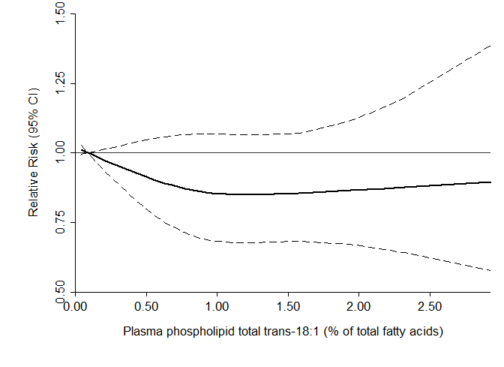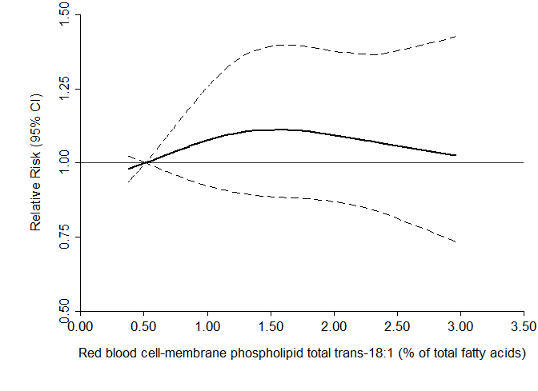

(A) Plasma phospholipid total trans-18:1
No. of cohorts = 5
P for non-linearity = 0.322
P for linearity = 0.271
(B) Red blood cell-membrane phospholipid total trans-18:1
No. of cohorts = 7
P for non-linearity = 0.372
P for linearity = 0.698

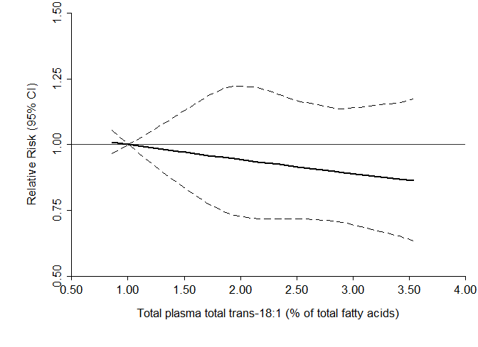
(C) Total plasma total trans-18:1
No. of cohorts = 3
P for non-linearity = 0.994
P for linearity = 0.318

Supplemental Figure S8. Multivariable-adjusted relationship between levels of total trans-18:1 in (A) plasma phospholipid (B) red blood cells, and (C) total plasma compartments and type 2 diabetes, evaluated using 3-knot restricted cubic splines. The reference value was set at the 10th percentile. The solid lines and dashed lines represent the central risk estimate and 95% confidence interval, respectively. Evidence for non-linearity was determined by a likelihood ratio test that compared models pooling all study-specific spline estimates using a multivariate meta-analysis with fixed effects with pooling the study-specific linear spline variable only, while linearity was determined by pooling the study-specific linear spline variable only. Model adjustments include age, sex, race, field site (if applicable), education, occupation, physical activity, smoking, alcohol use, prevalent hypertension, prevalent dyslipidemia, prevalent coronary heart disease, body mass index, and waist circumference, circulating palmitic acid, circulating stearic acid, circulating linoleic acid, and triglycerides.

(A) Plasma phospholipid trans/trans-18:2
No. of cohorts = 3
P for non-linearity = 0.319
P for linearity = 0.512
(B) Red blood cell-membrane phospholipid trans/trans-18:2
No. of cohorts = 2
P for non-linearity < 0.001
P for linearity = 0.019

(C) Total plasma trans/trans-18:2
No. of cohorts = 2
P for non-linearity = 0.098
P for linearity = 0.863
Supplemental Figure S9. Multivariable-adjusted relationship between levels of trans/trans-18:2 in (A) plasma phospholipid, (B) red blood cell-membrane phospholipid, and (C) total plasma compartments and type 2 diabetes, evaluated using 3-knot restricted cubic splines. The reference value was set at the 10th percentile. The solid lines and dashed lines represent the central risk estimate and 95% confidence interval, respectively. Evidence for non-linearity was determined by a likelihood ratio test that compared models pooling all study-specific spline estimates using a multivariate meta-analysis with fixed effects with pooling the study-specific linear spline variable only, while linearity was determined by pooling the study-specific linear spline variable only. Model adjustments include age, sex, race, field site (if applicable), education, occupation, physical activity, smoking, alcohol use, prevalent hypertension, prevalent dyslipidemia, prevalent coronary heart disease, body mass index, and waist circumference, circulating palmitic acid, circulating stearic acid, circulating linoleic acid, and triglycerides.
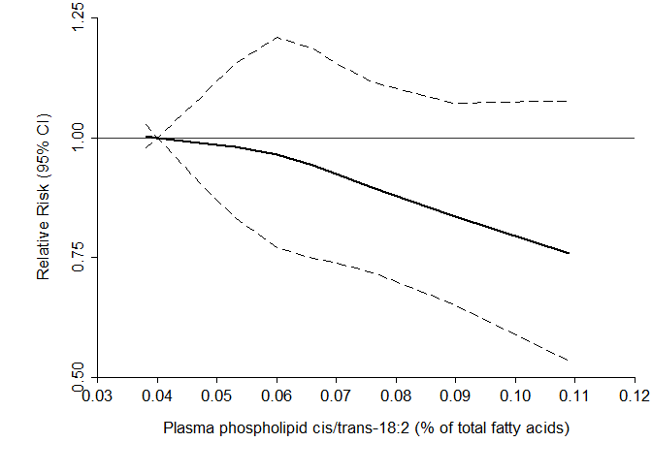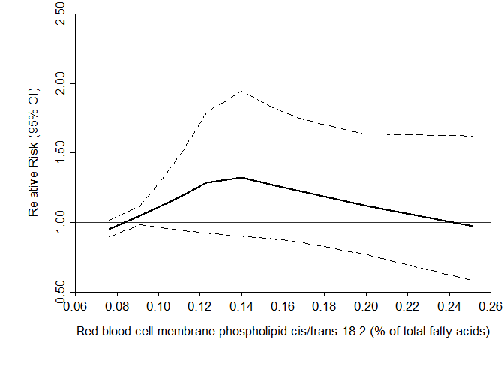

(A) Plasma phospholipid cis/trans-18:2
No. of cohorts = 3
P for non-linearity = 0.685
P for linearity = 0.120
(B) Red blood cell-membrane phospholipid cis/trans-18:2
No. of cohorts = 2
P for non-linearity = 0.103
P for linearity = 0.962
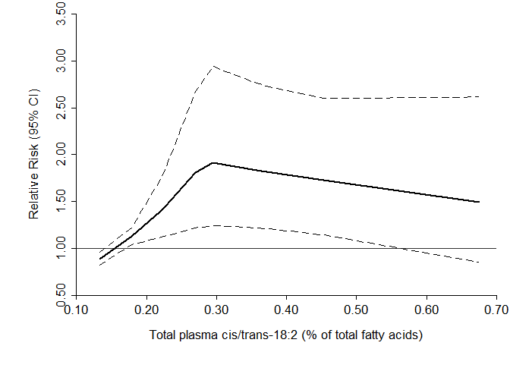
(C) Total plasma cis/trans-18:2
No. of cohorts = 2
P for non-linearity = 0.005
P for linearity = 0.229
Supplemental Figure S10. Multivariable-adjusted relationship between levels of cis/trans-18:2 in (A) plasma phospholipid, (B) red blood cell-membrane phospholipid, and (C) total plasma compartments and type 2 diabetes, evaluated using 3-knot restricted cubic splines. The reference value was set at the 10th percentile. The solid lines and dashed lines represent the central risk estimate and 95% confidence interval, respectively. Evidence for non-linearity was determined by a likelihood ratio test that compared models pooling all study-specific spline estimates using a multivariate meta-analysis with fixed effects with pooling the study-specific linear spline variable only, while linearity was determined by pooling the study-specific linear spline variable only. Model adjustments include age, sex, race, field site (if applicable), education, occupation, physical activity, smoking, alcohol use, prevalent hypertension, prevalent dyslipidemia, prevalent coronary heart disease, body mass index, and waist circumference, circulating palmitic acid, circulating stearic acid, circulating linoleic acid, and triglycerides.
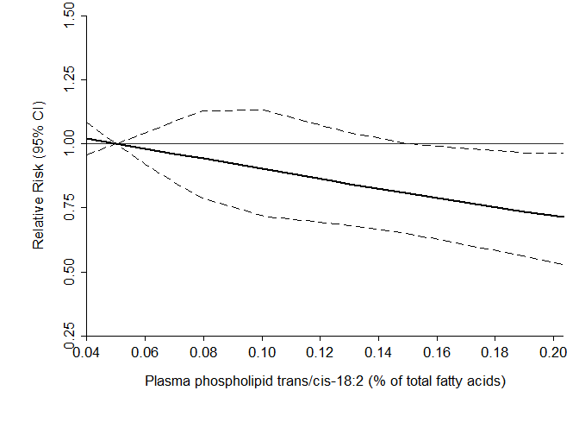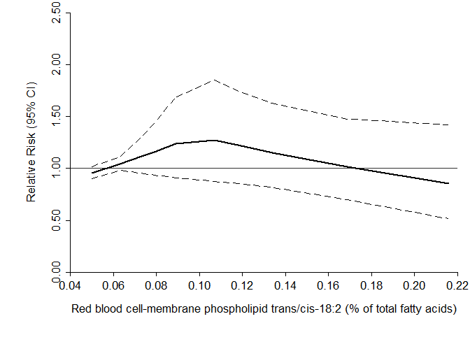

(A) Plasma phospholipid trans/cis-18:2
No. of cohorts = 3
P for non-linearity = 0.943
P for linearity = 0.021
(B) Red blood cell-membrane phospholipid trans/cis-18:2
No. of cohorts = 2
P for non-linearity = 0.095
P for linearity = 0.640
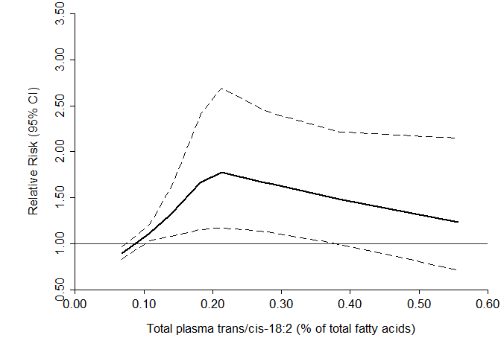
(B) Total plasma trans/cis-18:2
No. of cohorts = 2
P for non-linearity = 0.006
P for linearity = 0.453

Supplemental Figure S11. Multivariable-adjusted relationship between levels of cis/trans-18:2 in (A) plasma phospholipid, (B) red blood cell-membrane phospholipid, and (C) total plasma compartments and type 2 diabetes, evaluated using 3-knot restricted cubic splines. The reference value was set at the 10th percentile. The solid lines and dashed lines represent the central risk estimate and 95% confidence interval, respectively. Evidence for non-linearity was determined by a likelihood ratio test that compared models pooling all study-specific spline estimates using a multivariate meta-analysis with fixed effects with pooling the study-specific linear spline variable only, while linearity was determined by pooling the study-specific linear spline variable only. Model adjustments include age, sex, race, field site (if applicable), education, occupation, physical activity, smoking, alcohol use, prevalent hypertension, prevalent dyslipidemia, prevalent coronary heart disease, body mass index, and waist circumference, circulating palmitic acid, circulating stearic acid, circulating linoleic acid, and triglycerides.
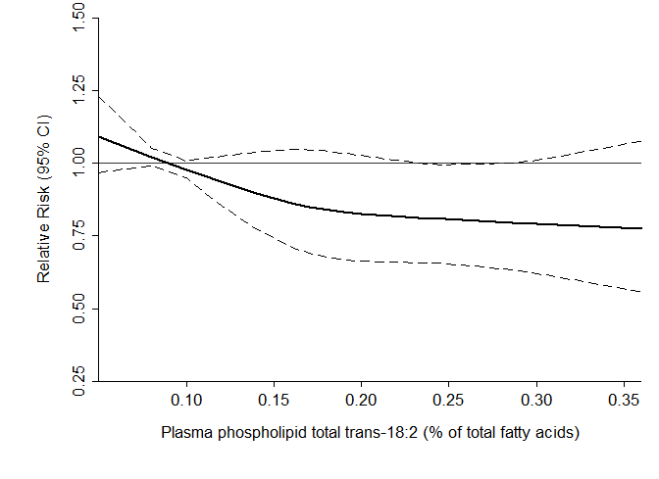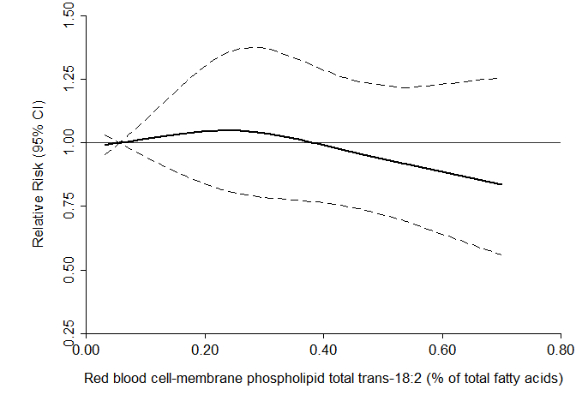

(A) Plasma phospholipid total trans-18:2
No. of cohorts = 4
P for non-linearity = 0.417
P for linearity = 0.053
(B) Red blood cell-membrane phospholipid total trans-18:2
No. of cohorts = 5
P for non-linearity = 0.473
P for linearity = 0.501
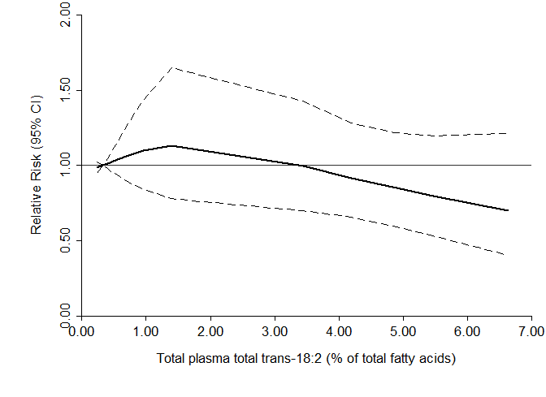
(B) Total plasma total trans-18:2
No. of cohorts = 3
P for non-linearity = 0.352
P for linearity = 0.312

Supplemental Figure S 12. Multivariable-adjusted relationship between levels of total trans-18:2 in (A) plasma phospholipid, (B) red blood cell-membrane phospholipid, and (C) total plasma compartments and type 2 diabetes, evaluated using 3-knot restricted cubic splines. The reference value was set at the 10th percentile. The solid lines and dashed lines represent the central risk estimate and 95% confidence interval, respectively. Evidence for non-linearity was determined by a likelihood ratio test that compared models pooling all study-specific spline estimates using a multivariate meta-analysis with fixed effects with pooling the study-specific linear spline variable only, while linearity was determined by pooling the study-specific linear spline variable only. Model adjustments include age, sex, race, field site (if applicable), education, occupation, physical activity, smoking, alcohol use, prevalent hypertension, prevalent dyslipidemia, prevalent coronary heart disease, body mass index, and waist circumference, circulating palmitic acid, circulating stearic acid, circulating linoleic acid, and triglycerides.

Supplemental Table S5. Relative risks (RR) and 95% confidence intervals (CI) for trans-16:1n9, total trans-18:1, and total trans-18:2 and the risk of incident diabetes: analysis of potential interaction and stratified analyses by sex, race, triglyceride levels and body mass index*
 | No. of studies† | trans-16:1n9 |  | No. of studies† | Total trans-18:1 |  | No. of studies† | Total trans-18:2
 |  | RR (95% CI)‡ | P§ |  | RR (95% CI)‡ | P§ |  | RR (95% CI)‡ | P§
Sex
Male (ref) | 6 | 0.83 (0.68, 1.01) | 1.00 | 8 | 0.67 (0.55, 0.82) | 0.66 | 6 | 0.77 (0.63, 0.93) | 0.70
Female | 6 | 0.88 (0.71, 1.09) |  | 8 | 0.77 (0.61, 0.97) |  | 6 | 0.79 (0.64, 0.98)
Race
White (ref) | 3 | 0.61 (0.47, 0.78) | 0.75 | 6 | 0.82 (0.70, 0.97) | 0.40 | 6 | 0.92 (0.79, 1.08) | 0.30
Non-White | 3 | 0.66 (0.39, 1.11) |  | 6 | 0.60 (0.40, 0.88) |  | 6 | 0.63 (0.40, 0.98)
Body mass index
Normal (ref) | 7 | 0.85 (0.65, 1.11) | 0.67 | 12 | 0.77 (0.63, 0.95) | 0.35 | 10 | 0.94 (0.79, 1.12) | 0.54
Overweight | 7 | 0.86 (0.72, 1.02) |  | 12 | 0.92 (0.79, 1.07) |  | 9 | 0.88 (0.76, 1.03)
Obese | 7 | 1.24 (0.88, 1.75) |  | 12 | 1.37 (1.01, 1.85) |  | 10 | 1.22 (0.90, 1.65)
Triglycerides
<150 mg/dL (ref) | 5 | 0.85 (0.70, 1.02) | 0.75 | 7 | 0.81 (0.68, 0.97) | 0.78 | 6 | 0.76 (0.63, 0.92) | 0.39
≥150 mg/dL | 5 | 0.95 (0.79, 1.15) |  | 7 | 0.94 (0.78, 1.13) |  | 6 | 0.94 (0.78, 1.12)
*Pre-specified interaction analyses included age, sex, race, body mass index, and triglycerides. Pooled relative risks and 95% CI of the multiplicative interaction term did not reveal statistically significant results for age, which was modelled linearly, and thus not presented here.
†Study count (maximum 12) varied by the availability of fatty acid data.
‡Relative risk and 95% CI were obtained through calculations previously published (10).
§P-value to assess heterogeneity obtained by pooling the relative risks and 95% CI of all strata, then performing the Wald test.

Supplemental Table S6. Relative risks (RR) and 95% confidence intervals (CI) for trans/cis-18:2, cis/trans-18:2, and total trans/trans-18:2 and the risk of incident diabetes: analysis of potential interaction and stratified analyses by sex, race, triglyceride levels and body mass index*
 | No. of studies† | trans/cis-18:2 |  | No. of studies† | cis/trans-18:2 |  | No. of studies† | trans/trans-18:2
 |  | RR (95% CI)‡ | P§ |  | RR (95% CI)‡ | P§ |  | RR (95% CI)‡ | P§
Sex
Male (ref) | 3 | 0.84 (0.62, 1.14) | 0.48 | 3 | 0.77 (0.53, 1.12) | 0.93 | 3 | 0.81 (0.59, 1.12) | 0.90
Female | 3 | 0.71 (0.53, 0.95) |  | 3 | 0.76 (0.57, 1.01) |  | 3 | 0.86 (0.67, 1.10)
Race
White (ref) | 4 | 0.97 (0.82, 1.15) | 0.26 | 4 | 1.00 (0.84, 1.18) | 0.49 | 4 | 1.14 (0.95, 1.36) | 0.52
Non-White | 4 | 0.63 (0.34, 1.16) |  | 4 | 0.79 (0.45, 1.37) |  | 4 | 0.90 (0.59, 1.37)
Body mass index
Normal (ref) | 5 | 0.86 (0.67, 1.10) | 0.48 | 5 | 0.92 (0.72, 1.18) | 0.89 | 5 | 0.94 (0.70, 1.26) | 0.81
Overweight | 5 | 0.88 (0.71, 1.08) |  | 5 | 0.90 (0.73, 1.12) |  | 5 | 0.95 (0.78, 1.16)
Obese | 5 | 1.44 (0.83, 2.51) |  | 5 | 1.20 (0.72, 1.99) |  | 5 | 1.32 (0.82, 2.12)
Triglycerides
<150 mg/dL (ref) | 3 | 0.64 (0.49, 0.83) | 0.17 | 3 | 0.68 (0.51, 0.91) | 0.51 | 3 | 0.71 (0.56, 0.90) | 0.08
≥150 mg/dL | 3 | 0.88 (0.68, 1.15) |  | 3 | 0.82 (0.62, 1.09) |  | 3 | 1.03 (0.86, 1.24)
*Pre-specified interaction analyses included age, sex, race, body mass index, and triglycerides. Pooled relative risks and 95% CI of the multiplicative interaction term did not reveal statistically significant results for age, which was modelled linearly, and thus not presented here.
†Study count (maximum 12) varied by the availability of fatty acid data.
‡Relative risk and 95% CI were obtained through calculations previously published (10).
§P-value to assess heterogeneity obtained by pooling the relative risks and 95% CI of all strata, then performing the Wald test.

Conflict of Interest and Author Funding

Dr. Murphy has consulted and received compensation from Pharmavite LLC.
Dr. Ardisson Korat is supported by NIH training grants (3T32DK007703
and T32CA009001).

Acknowledgement and Funding

Cohort | Funding Source | Acknowledgements
Age, Gene/Environment Susceptibility Study (Reykjavik) | Supported by The Office of Dietary Supplements, NIH contract N01-AG012100, the NIA Intramural Research Program, Hjartavernd (the Icelandic Heart Association), the Althingi (the Icelandic Parliament) | We thank Pho Diep for technical assistance with fatty acid analyses.
Cardiovascular Health Study | This research was supported by grant 2R01HL08571006A1  from the National Heart, Lung, and Blood Institute (NHLBI). The Cardiovascular Health Study was supported by contracts HHSN268201200036C, HHSN268200800007C, HHSN268201800001C, N01HC55222, N01HC85079, N01HC85080, N01HC85081, N01HC85082, N01HC85083, N01HC85086, 75N92021D00006, and grants U01HL080295 and U01HL130114 from the National Heart, Lung, and Blood Institute (NHLBI), with additional contribution from the National Institute of Neurological Disorders and Stroke (NINDS). Additional support was provided by R01AG023629 from the National Institute on Aging (NIA). A full list of principal CHS investigators and institutions can be found at CHS-NHLBI.org. The content is solely the responsibility of the authors and does not necessarily represent the official views of the National Institutes of Health. | The authors express their gratitude to the CHS participants.
Chin-Shan Community Cardiovascular Cohort | This CCCC Study research was supported by the grants of the National Science Council and the Minstry of Science and Technology, Taiwan (MOST 106-2314-B-002 -158 -MY3, NSC 102-2314-B-002 -080 -MY2, NSC 100-2314-B-002 -113 -MY3, NSC 97-2314-B-002 -130 -MY3 ), National Taiwan University Hospital (NTUH 106-S3453) and National Taiwan University (NTU--101R7622-3). The content is solely the responsibility of the authors and does not necessarily represent the official views of the funding offices. | The authors express their gratitude to the CCCC participants.
The European Prospective Investigation into Cancer (Norfolk) | The EPIC-Norfolk study (doi: 10.22025/2019.10.105.00004) is supported by programme grants from the Medical Research Council UK (MR/N003284/1) and Cancer Research UK (C864/A14136). NJW, NGF, and FI are supported by the core Medical Research Council Epidemiology Unit Programmes (MC_UU_00006/1 and MC_UU_00006/3); NGF, NJW: National Institute for Health Research (NIHR) Cambridge Biomedical Research Centre Nutrition, Diet, and Lifestyle Research Theme (IS-BRC-1215-20014). NGF is an NIHR Senior Investigator.
The European Prospective Investigation into Cancer (Potsdam) | Supported by the German Federal Ministry of Science (01 EA 9401) and the European Union (SOC 95201408 05F02) for the recruitment phase of the EPIC-Potsdam Study. The follow-up of the EPIC-Potsdam Study was supported by the German Cancer Aid (70-2488-Ha I) and the European Community (SOC 98200769 05F02). The present analysis was also supported by a grant from the German Research Foundation (DFG, SCHU 1516/5-1), a grant from the German Ministry of Education and Research (BMBF), and the State of Brandenburg (DZD grant 82DZD00302).
Framingham Heart Study (Offspring Cohort) | The Framingham Heart Study is conducted and supported by the National Heart, Lung and Blood Institute (NHLBI) and in collaboration with Boston University (Contract No. N01-HC-25195). This manuscript has been reviewed by the Framingham Heart Study for scientific content and consistency of data interpretation with previous Framingham Heart Study publications. | The authors express their gratitude to the FHS participants.
Health Professional’s Follow-up Study | CA186107, CA87969, CA49449, HL34594, HL35464, U01 CA167552, HL60712, and HL088521 from the National Institutes of Health. | The authors express their gratitude to the HPFS participants.
Melbourne Collaborative Cohort Study (MCCS) | Cohort recruitment was funded by Cancer Council Victoria [http://www.cancervic.org.au/] and VicHealth [https://www.vichealth.vic. gov.au/]. The MCCS was further supported by grants 209057, 251553 and 504711 from the Australian National Health and Medical Research Council (NHMRC) [http://www.nhmrc.gov.au/] and ongoing follow-up and data management has been funded by Cancer Council Victoria since 1995. | The MCCS was made possible by the contribution of many people, including the original investigators, the teams that recruited the participants and continue working on follow-up, and the many thousands of Melbourne residents who continue to participate in the study.
Multi-Ethnic Study of Atherosclerosis (MESA) | MESA and the MESA SHARe project are conducted and supported by the National Heart, Lung, and Blood Institute (NHLBI) in collaboration with MESA investigators. Support for MESA is provided by contracts 75N92020D00001, HHSN268201500003I, N01-HC-95159, 75N92020D00005, N01-HC-95160, 75N92020D00002, N01-HC-95161, 75N92020D00003, N01-HC-95162, 75N92020D00006, N01-HC-95163, 75N92020D00004, N01-HC-95164, 75N92020D00007, N01-HC-95165, N01-HC-95166, N01-HC-95167, N01-HC-95168, N01-HC-95169, UL1-TR-000040, UL1-TR-001079, UL1-TR-001420. Also supported in part by the National Center for Advancing Translational Sciences, CTSI grant UL1TR001881, and the National Institute of Diabetes and Digestive and Kidney Disease Diabetes Research Center (DRC) grant DK063491 to the Southern California Diabetes Endocrinology Research Center. | The authors thank the other investigators, the staff, and the participants of the MESA study for their valuable contributions. A full list of participating MESA investigators and institutions can be found at http://www.mesa-nhlbi.org.
Nurses' Health Study | UM1 CA186107, P01 CA87969, R01 CA49449, R01 HL034594, HL35464, CA167552, HL60712, and R01 HL088521 from the National Institutes of Health. | The authors express their gratitude to the NHS participants.
Physicians' Health Study | These ancillary studies were funded by grants R21 HL088081 (Dr Djoussé) from the National Heart, Lung, and Blood Institute and the Office of Dietary Supplement, Bethesda, MD. The Physicians' Health Study was supported by grants CA-34944, CA-40360, and CA-097193 from the National Cancer Institute and grants HL-26490 and HL-34595 from the National Heart, Lung, and Blood Institute, Bethesda, MD.
Women's Health Initiative Memory Study | The WHI program is funded by the National Heart, Lung, and Blood Institute, National Institutes of Health, U.S. Department of Health and Human Services through contracts HHSN268201600018C, HHSN268201600001C, HHSN268201600002C, HHSN268201600003C, and HHSN268201600004C | The WHI program is supported by contracts from the National Heart, Lung and Blood Institute, NIH. The authors thank the WHI investigators and staff for their dedication, and the study participants for making the program possible. A listing of WHI investigators can be found at http://www.whi.org/researchers/Documents%20%20Write%20a%20Paper/WHI%20Investigator %20Short%20List.pdf.

References
1. Harris TB, Song X, Reinders I, Lang TF, Garcia ME, Siggeirsdottir K, Sigurdsson S, Gudnason V, Eiriksdottir G, Sigurdsson G, Steingrimsdottir L, Aspelund T, Brouwer IA, Murphy RA. Plasma phospholipid fatty acids and fish-oil consumption in relation to osteoporotic fracture risk in older adults: the Age, Gene/Environment Susceptibility Study. The American Journal of Clinical Nutrition 2015;101:947-955
2. Fried LP, Borhani NO, Enright P, Furberg CD, Gardin JM, Kronmal RA, Kuller LH, Manolio TA, Mittelmark MB, Newman A, et al. The Cardiovascular Health Study: design and rationale. Ann Epidemiol 1991;1:263-276
3. Lee Y, Lin RS, Sung FC, Yang C, Chien K, Chen W, Su T, Hsu H, Huang Y. Chin-Shan Community Cardiovascular Cohort in Taiwan-baseline data and five-year follow-up morbidity and mortality. J Clin Epidemiol 2000;53:838-846
4. Patel PS, Sharp SJ, Jansen E, Luben RN, Khaw KT, Wareham NJ, Forouhi NG. Fatty acids measured in plasma and erythrocyte-membrane phospholipids and derived by food-frequency questionnaire and the risk of new-onset type 2 diabetes: a pilot study in the European Prospective Investigation into Cancer and Nutrition (EPIC)-Norfolk cohort. Am J Clin Nutr 2010;92:1214-1222
5. Saadatian-Elahi M, Slimani N, Chajès V, Jenab M, Goudable J, Biessy C, Ferrari P, Byrnes G, Autier P, Peeters PHM, Ocké M, Bueno de Mesquita B, Johansson I, Hallmans G, Manjer J, Wirfält E, González CA, Navarro C, Martinez C, Amiano P, Suárez LR, Ardanaz E, Tjønneland A, Halkjaer J, Overvad K, Jakobsen MU, Berrino F, Pala V, Palli D, Tumino R, Vineis P, Santucci de Magistris M, Spencer EA, Crowe FL, Bingham S, Khaw K-T, Linseisen J, Rohrmann S, Boeing H, Noethlings U, Olsen KS, Skeie G, Lund E, Trichopoulou A, Oustoglou E, Clavel-Chapelon F, Riboli E. Plasma phospholipid fatty acid profiles and their association with food intakes: results from a cross-sectional study within the European Prospective Investigation into Cancer and Nutrition. The American Journal of Clinical Nutrition 2009;89:331-346
6. Boeing H, Korfmann A, Bergmann MM. Recruitment procedures of EPIC-Germany. European Investigation into Cancer and Nutrition. Ann Nutr Metab 1999;43:205-215
7. Kannel WB, Feinleib M, McNamara PM, Garrison RJ, Castelli WP. An investigation of coronary heart disease in families. The Framingham offspring study. Am J Epidemiol 1979;110:281-290
8. Harris WS, Pottala JV, Vasan RS, Larson MG, Robins SJ. Changes in erythrocyte membrane trans and marine fatty acids between 1999 and 2006 in older Americans. J Nutr 2012;142:1297-1303
9. Milne RL, Fletcher AS, MacInnis RJ, Hodge AM, Hopkins AH, Bassett JK, Bruinsma FJ, Lynch BM, Dugue PA, Jayasekara H, Brinkman MT, Popowski LV, Baglietto L, Severi G, O'Dea K, Hopper JL, Southey MC, English DR, Giles GG. Cohort Profile: The Melbourne Collaborative Cohort Study (Health 2020). Int J Epidemiol 2017;46:1757-1757i
10. Del Gobbo LC, Imamura F, Aslibekyan S, Marklund M, Virtanen JK, Wennberg M, Yakoob MY, Chiuve SE, Dela Cruz L, Frazier-Wood AC, Fretts AM, Guallar E, Matsumoto C, Prem K, Tanaka T, Wu JH, Zhou X, Helmer C, Ingelsson E, Yuan JM, Barberger-Gateau P, Campos H, Chaves PH, Djousse L, Giles GG, Gomez-Aracena J, Hodge AM, Hu FB, Jansson JH, Johansson I, Khaw KT, Koh WP, Lemaitre RN, Lind L, Luben RN, Rimm EB, Riserus U, Samieri C, Franks PW, Siscovick DS, Stampfer M, Steffen LM, Steffen BT, Tsai MY, van Dam RM, Voutilainen S, Willett WC, Woodward M, Mozaffarian D, Cohorts for H, Aging Research in Genomic Epidemiology Fatty A, Outcomes Research C. Omega-3 Polyunsaturated Fatty Acid Biomarkers and Coronary Heart Disease: Pooling Project of 19 Cohort Studies. JAMA Internal Medicine 2016;176:1155-1166

