Perceptions across scales of governance and the Indonesian peatland fires

Rachel Carmenta^{a,b}*, Aiora Zabala^{c}, Willy Daeli^{a,d}, Jacob Phelps^{e,a}
ª* Forests and Governance, Center for International Forestry Research (CIFOR), Jalan CIFOR, Situ Gede, Sindang Barang, Bogor (Barat) 16115, Indonesia. Email: rachelcarmenta@gmail.com
^{b} Cambridge Conservation Initiative, David Attenborough Building, University of Cambridge, Pembroke Street, Cambridge, CB2 3QZ, UK.
^{c} Department of Land Economy, University of Cambridge, Department of Land Economy, 19 Silver Street, Cambridge, CB3 9EP, UK. Email: aiora.zabala@gmail.com
^{d} School of Forest Resources and Conservation, University of Florida, 136 Newins-Ziegler Hall, Gainesville, Florida, 32611, USA. Email: willydaeli@gmail.com
^{e} Lancaster Environment Centre, Library Avenue, Lancaster University, Lancaster, LA1 4YQ, UK. Email: jacop.phelps@gmail.com

Key words: policy, Q method, haze, deforestation, conservation, transboundary governance

Acknowledgements
This work was funded by the Department for International Development of the UK Government (DFID). Project name: Political Economy of Fire and Haze in Indonesia; Project No. 203034.

Abstract
Across leading environmental challenges—fire management, climate change, deforestation - there is growing awareness of the need to better account for diverse stakeholder perceptions across complex, multi-level governance arrangements. Perceptions often condition behavior, compliance and engagement in ways that impact environmental outcomes. We illustrate the importance of, and approaches to, examining perceptions across scales of governance (e.g. international, national, local) and sectors (e.g. civil society, government, corporate) through the example of Indonesian peatland fires. Peatlands are crucial global carbon stocks threatened by land use change and fire and subject to a range of policy interventions that affect many different stakeholder groups. Peatland drainage and conversion to plantation agriculture has been associated with severe, uncontrolled peat fires that present significant climate, public health and economic risks. Peatland fire management has become a domestic and international priority, spurring intensely contentious debates, policies and legal proceedings. Previous fire management interventions (FMI) are numerous yet have suffered widespread implementation failures. Against this backdrop, our manuscript provides a thematically and methodologically novel analysis of how diverse stakeholders, from local farmers to international policy makers, perceive peatland fires in terms of, i) how they prioritize the associated benefits and burdens, and ii) the perceived effectiveness of FMI. We adopt an innovative application of Q method to provide needed insights that serve to quantify the areas of contention and consensus that exist among the stakeholders and their multi-dimensional perspectives. We show that many of the contemporary FMI were perceived as among the most effective interventions overall, but were also the most controversial between groups. Clear consensus areas were related to the shared concerns for the local health impacts and the potential of government support for fire-free alternatives as a solution pathway. Improved understanding of stakeholder perceptions has potential to: give voice to marginalized communities; enable transparent mediation of diverse priorities; inform public education campaigns, and shape future policy and governance arrangements.

- Introduction
Globally, the carbon stored in peatlands exceeds that stored in vegetation, and peatlands are one of the most vulnerable terrestrial carbon pools, presently threatened by agriculture and fire (Turetsky et al., 2015). While peat fires have recently affected the global north, they are particularly severe in Indonesia (Page and Hooijer, 2016). In 2015 alone the resulting daily emissions from Indonesian fires were inordinate, surpassing the average daily emissions from the entire USA (Huijnen et al., 2016, Van Der Werf, 2015). The magnitude of the event reflects the severity of tropical peatland fires, which now represent a significant global climate risk and a national and regional humanitarian and economic threat (Page and Hooijer, 2016, Marlier et al., 2013, World Bank, 2016, Shannon et al., 2016, Kátia et al., 2017).

Since the late 1990s, recurrent large-scale peatland fires have affected Indonesia’s Sumatra, Borneo and Papua islands (Miettinen et al., 2016). Once considered marginal agricultural land, peatlands are increasingly exploited for oil palm and pulp wood cultivation (McCarthy et al., 2012, Miettinen et al., 2016, Persoon and Simarmata, 2014), necessitating land drainage and vegetation clearing - often through burning. South East Asia’s peatlands have transitioned from carbon sinks to carbon sources through the release of significant carbon emissions during combustion and subsequent oxidation (Hooijer et al., 2012, Huijnen et al., 2016, Gaveau et al., 2014). Fires have positive feedbacks and, once burned, areas are likely to re-burn (Hoscilo et al., 2011) and wildfires are likely to increase in a context of extended fire weather seasons (Jolly et al., 2015, Kátia et al., 2017).

Severe peat fire events have spurred a range of Fire Management Interventions (FMI), forming a polycentric governance arrangement of interventions across scales, sectors and stakeholders. These FMI include new regulations (e.g. a moratorium on new oil palm concessions on peatland), technical innovations (e.g. cloud seeding to produce rain), developments in fire monitoring (e.g. ‘real-time’ civil society satellite-based monitoring, community fire brigades), and provision of incentives for improved land management (e.g. payments to communities to reward fire-free practices) (Tacconi, 2016). However, many FMI have suffered chronic implementation failures (Page and Hooijer, 2016). Like other global environmental change governance efforts, FMI epitomize the policy-practice gap and “wicked” governance challenges, in which management involves diverse actors with divergent interests operating across scales (Game et al., 2014, McCarthy et al., 2012, Cash et al., 2006).

Stakeholder perceptions of governance arrangements, including FMI, are critical to improving their design and on-the-ground implementation (Adgar et al., 2005, Game et al., 2014, Reed, 2016, Tschakert et al., 2016). Articulating stakeholder perceptions is fundamental to ensuring legitimacy and buy-in, enabling transparent boundary management, incorporating knowledge and interests across scales (Adgar et al., 2005, Bennett, 2016, Biggs et al., 2011, Game et al., 2014, Law et al., 2016, Achyar et al., 2015). Clearly defining the diverse stakeholder subjectivities solicits information valuable to knowledge brokers (e.g., where to target actions, baseline information on positions) and can serve as a boundary object available to boundary organizations that aim to mediate and navigate conflicting perceptions (Cash et al., 2006). Transparent dialogue allows points of consensus and controversy to be identified, building trust to facilitate negotiation when addressing inevitable trade-offs (Adgar et al., 2005, Game et al., 2014, Reed, 2016). Social acceptance and perceptions are not the only determinants of policy performance, yet this type of clarity is particularly critical in decentralized governance systems such as in Indonesia. Fire management interventions in peatlands constitute national, regional and local priorities that are widely debated and involve contested accounts of blame for fire-setting, instances of conflict, legal proceedings, asymmetric interest pathways and little consensus or productive negotiation among actors (Forsyth, 2014, Harwell, 2000). While national and provincial level government articulate laws and regulations, sound, practical FMI design and implementation will also need to address the perceptions and preferences of the diverse groups they engage if they are to generate behavioral change and policy uptake (Game et al., 2014, Gaveau et al., 2016, McCarthy et al., 2012, Goldstein, 2016, Biggs et al., 2011).

Through an innovative application of Q method, we illustrate the diverse stakeholders' perceptions of peat fires and FMI across sectors (private, government, civil society, individual) and scales of governance (international ASEAN level, national, provincial, local). We focus on peatlands in Riau Province, Sumatra, since Riau exemplifies the region’s rapid land-use change, has extensive fires, and landscapes in which multiple stakeholders intersect (Gaveau et al., 2016, Miettinen et al., 2016, Gaveau et al., 2014). We define perceptions on two key aspects of peatland management: (1) how stakeholders prioritize the benefits and burdens associated with peatland fires (and the resulting haze), and (2) which FMI are perceived as most effective. We show significant distinctions among groups of perceptions, clear areas of agreement and controversy, and discuss the implications for future FMI design and the polycentric governance challenges of global environmental change.

- Methods
Q is a semi-qualitative methodology used to identify a detailed view of the subjective perceptions held across a diverse group of people on a given topic (Watts and Stenner, 2012). It aims to balance the qualitative depth of interviews with the advantages of quantitative enquiry, allowing for systematic comparison of perceptions.

In Q, respondents provide a relative ranking of pre-formed statements (a Q-set). These statements are a representative selection of all possible opinions about the topic (the concourse). This approach reduces compliance bias and is appropriate for sensitive topics because respondents are not obliged to orally articulate their opinion (McKeown and Thomas, 2013). Responses are summarized through factor analysis into a number of perceptions (Q-factors), each of which is the average perception of respondents with similar views. Each respondent is related to a given perception through a coefficient (the Q-factor loading; with value 1 for high positive relations, 0 for no relation). Q does not solicit results which are generalizable to the entire population (applies purposive sampling frames), but rather gives an indication of the diversity of perceptions held by a particular population of policy relevance, regardless of their predominance.

Respondent and site selection
Respondents in this study were selected using purposive sampling and identified through actor mapping informed by field scoping in Dumai, Riau over 6 weeks in early 2015, expert consultation (with donor, NGO, scientist representatives), and literature review (including journal publications and grey literature in Indonesian and English). Twelve stakeholder groups were defined (Figure 1). We sampled respondents from multiple spatial and governance scales, including policy communities based in Pekanbaru (Riau), Jakarta and Singapore. Policy communities were broadly defined, and included civil servants, researchers (e.g. from universities and think tanks), CSOs and government representatives with an interest and a role in the policy arena of peatland fires. Within the stakeholder group categories, the respondents selected represented different viewpoints and backgrounds to ensure maximum representation of possible perspectives. The large majority of respondents were at the farm-level (small-scale farmers, landless residents, agro-industry) and included both men and women.

Site selection at the local level was done using spatial analysis of MODIS derived hotspots, Landsat imagery of land cover and available maps of land tenure types, to identify three sites with a diversity of land uses (rubber, acacia, oil palm and idle land), fire dynamics, land tenure arrangements and actors (Figure 1.a.) (Gaveau et al., 2016).

Sample sizes for the policymakers were as follows: i) Singapore- (8 respondents); ii) Jakarta- (9) and iii) Riau-based policy communities (11) and iv) local public figures (15). Respondents with connection to land use included; v) large scale land holders (15); vi) medium absentee investors (15); vii) industrial agriculture (30); viii) small scale farmers (42); ix) medium land holders (34); x) laborers/share croppers (15) and xi) landless (15) and vii) non-governmental organizations (NGO, 10) (Figure 1.b.).

2.2. Statement selection
Perceptions on peatland management were explored with two separate Q-sets in which respondents ranked the benefits and burdens (BB) associated with peatland fires in Riau and the effectiveness of FMI. The statements of each Q-set were formulated iteratively based on the same methods as the actor mapping - literature review, expert consultations, and field scoping (section 2.1). We selected 30 statements on benefits and burdens of fire and 40 statements reflecting FMI options. The statements were kept short to avoid redundancies, ensure clarity and comprehension by all participants (from policymakers to landless farmers), and avoid double-loading (i.e. ensure each response related to only one item). Statements and scales were translated from English into Indonesian and extensively piloted in the field. Images were printed on each card to “flag” the statement card in the respondent's memory and in cases where the respondent struggled with the text, statements were read by the enumerator, following Dasgupta and Vira, 2005.

Figure 1. (COLOUR) Stakeholders across scales of peatland governance. a) Map of Riau province and three local sampling sites in Dumai District. Inset shows the Indonesian islands of Java and Sumatra, Malaysia, Singapore. b) The respondents in the study, including their stakeholder group and associated definitions.
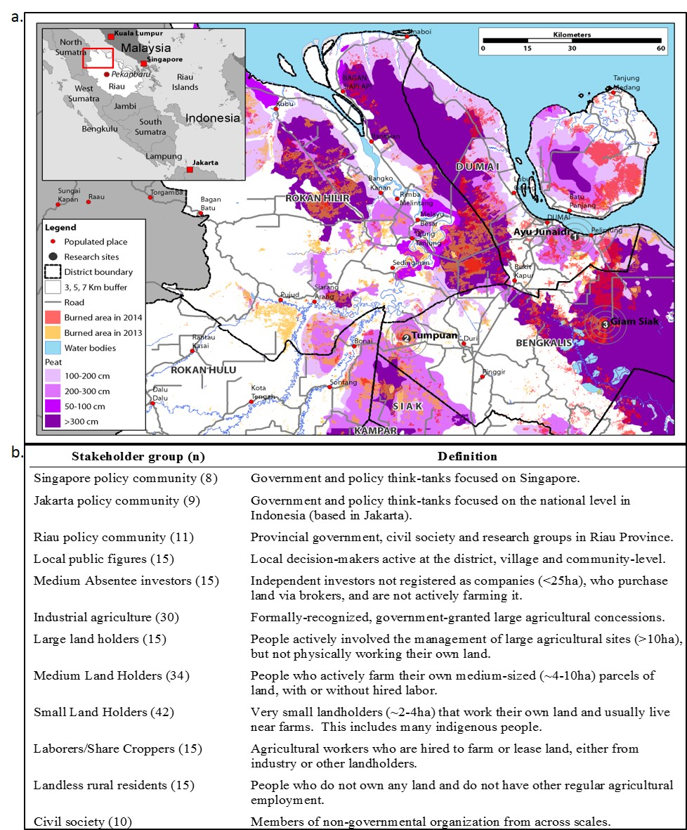

2.3. Administration
Between July-September 2015, 221 respondents sorted the two Q-sets. This is an exceptionally high number for a Q study (typically 30-60 respondents). Respondents first sorted benefit/burdens statements on a scale of importance over a grid representing a normal distribution, in a scale of least important (-3) to most important (3) (Supplementary Figure 1). Respondents then sorted the FMI statements on a scale of perceived effectiveness (from least effective, -3 to most effective, 3) over a similar grid. A relatively flat distribution characterized the pyramid grid because we had many statements with which people agreed (Watts and Stenner, 2012). We asked follow-up questions that solicited the respondent’s justification of their rankings for the six most extreme positions (three statements sorted at each end of the scale). These justifications aided interpretation of the Q-factors.

2.4. Data analysis
Each Q-set was analyzed in parallel, using the R package 'qmethod' (R Development Core Team, 2016, Zabala, 2014). Responses were statistically summarized into Q-factors using principal components analysis and varimax rotation. To determine the number of Q-factors to extract from the data we used a set of standard criteria, namely: higher total variability explained, screeplot, low correlation between Q-factors (to obtain dissimilar perceptions), and parsimony and explanatory power (Watts and Stenner, 2012).

Every respondent relates to each rotated Q-factor via a Q-factor loading, which is interpreted similarly to a correlation coefficient. Automatic pre-flagging, based on significant differences in factor loadings across Q-factors indicated which responses were most representative of each perception. The pre-flagging was then manually inspected (Van Exel et al., 2011, Brown, 1980) to eliminate responses that may be confounding due to high relation with more than one factor. In this process, we eliminated 8 flags from burdens/benefits factors and 5 from FMI Q-factors.

Four Q-factors were extracted for the benefits and burdens Q-set, and five for the FMI solutions Q-set. The variance explained by the factors was 47% for benefits and burdens and 39% for solutions, similar to other Q studies on perceptions of fire management (Ray, 2011) yet slightly lower than usual in Q studies (typically 50-60%). This may be due to the fact that Q studies tend to be of a much smaller sample (e.g. 40 respondents), and therefore it is more likely that all responses can be explained by fewer Q-factors (e.g. if four Q-factors were selected with n = 40, there would be 10 respondents per Q-factor, whereas in our study there are ~50 respondents per Q-factor). In addition, the variance explained by the FMI Q-factors was lower than that explained by benefits and burdens, even though we retained more Q-factors for the former. This indicates higher heterogeneity in the responses on FMI solutions, which may be due to the hypothetical nature of discussing FMI that have not been implemented or for which effectiveness has not been tested.

The resulting Q-factors from the two Q-sets were defined by a ranking of the statements. This ranking is based on the rankings of flagged respondents for each factor (who had significantly different factor loadings). The responses of flagged Q-sorts were used to calculate a weighted mean response, which reflects the response that best represents the given factor. For each statement, the weighted mean score is called the z-score. We compared the z-scores for a statement across Q-factors in order to assess whether the Q-factors demonstrate different perceptions regarding the given statement. If this comparison did not yield significant differences across factors, we considered it a consensus statement. If a statement z-score for a Q-factor was significantly different from that of other factors, then the statement was distinguishing for the given Q-factor.

In addition, the membership of stakeholder groups for each Q-factor was explored by calculating the percentage from each group that was flagged for each Q-factor (Table 2, 3). Significant differences between male and female perspectives were not evident. The relation between the perceptions concerning benefits and burdens and about FMI solutions was also explored but yielded only secondary insights (Supplementary Table 1).

- Results
  - Stakeholders across scales
The results highlight peatland fire management as a complex, multi-level policy arena. We identified 12 key stakeholder groups across the 4 scales of governance (local, regional, national and international; see Methods) as relevant to management of peatland fires in Riau (Figure 1.b.).

  - Stakeholders demonstrated a wide range of ways of thinking about fires
Q method involves an iterative process, in which researchers first conduct preliminary interviews, field scoping and literature review to generate a set of statements (Table 1), which respondents are then asked to rank. The elaboration of the benefits and burdens (BB) Q-statement set (30 statements) highlighted a diverse range of burdens associated with fire, including direct (e.g. fire damage to crops), and indirect impacts (e.g. downstream economic impact of haze pollution) (Supplementary Table 2). Direct benefits were also identified and included increased profit margins for large and small scale farmers using fire for land clearing, and fires’ role in expediting grievances over contested land claims (Table 1).

Similarly, the Q-statements about the perceived (not actual) FMI effectiveness revealed a suite of existing and prospective interventions (40 statements) (Supplementary Table 3). Notably, these included FMI focused on improved firefighting, such as through technological innovations, as well as a range of FMI targeting fire prevention by focusing on underlying drivers, such as those related to governance reforms, changes to enforcement regimes and provision of incentives to promote changes in land-use management (Table 1).

Table 1. Example Q-statements. Example statements used in the Q-statement set, referring to the possible benefits and burdens and to the potential solutions to peat fires in Riau, Sumatra. (See Supplementary Tables 2 and 3).
Example Q-statements about the benefits and burdens that result from peatland fires in Riau
Direct benefits | "Fire reduces weeds and pests that damage crops"
 | "Plantation companies increase their profits when they use fire to clear land"
Indirect benefits | "Fire has enabled rapid agricultural development in Riau responsible for improved hospitals, roads and schools"
 | "Central government gives money to stakeholders in Riau to fight fires"
Direct burdens | "Fire reduces biodiversity"
 | "Small-holders lose income when fires destroy their farms"
Indirect burdens | "Fire weakens the reputation of Indonesia's oil palm industry"
 | "Fire increases the risk that others will invade your land since burnt land looks vacant"
Example statements about the effectiveness of FMI options to peatland fires in Riau
Enforcement | "Increase enforcement against small-holder farmers that use fire"
 | "Government cancel the licenses of companies that illegally use fire"
Fire fighting | "Improve fire prediction tools"
 | "Strengthen government-led firefighting"
Governance reforms | "Increase clarity on land tenure boundaries to avoid people using fire to claim land"
 | "Allow for the regulated, careful use of fire, such as avoiding fire use during very dry and windy periods"
Incentives | "Give incentives, such as rewards of money, seedlings, health and school services, for individual land holders to encourage them to prevent fire"
 | "Give incentives, such as rewards of money and technical support, to local Riau government to encourage them to prevent fire"

Perceptions about the benefits and burdens of fire
Based on how individual respondents ranked statements about the benefits and burdens associated with fires, the analysis revealed four Q-factors (clusters of perceptions or views) that best characterized the distinct perceptions held in our sample (see Methods) (Table 2). Q-factor clusters representing benefits and burdens are denoted “BB”, while “FMI” denotes those related to perceptions of solutions. Q-factors varied most distinctly in terms of concern for particular stakeholder groups impacted by fire (e.g. impacts on companies versus small-scale farmers); the geographic scale at which burdens were experienced (e.g. domestic versus international), and the type of impact emphasized (e.g. economic versus quality of life) (Supplementary Table 4). Notably, only one factor, associated with landholders, was distinguished by its recognition that fire has associated benefits.

Table 2. Benefits and burdens Q-Factors. Key characteristics of the four Q-factor clusters (distinct perceptions) concerning the benefits and burdens (BB) associated with Indonesian peatland fires in Riau, Sumatra. (See Supplementary Table 4).
Q-Factor | Prioritizes as important | Does not prioritize (unimportant) | Q-Factor Membership (%)*
BB1  Fires burden companies | • Negative impacts on companies, both economic and reputational.  • Concern for negative local impacts on health, economy and transport. | • Utility of fire as a tool for land-clearing by large or small-scale farmers.  • Difficulty of defining responsibility for setting fires, or conflicts arising from allegations of who is responsible for fire setting. | Industrial agriculture (26)  Absentee Investors (13)  Landless (13)  Laborers/Share croppers (11)  Medium landholders (11)
BB2  Fires burden small-scale farmers | • Concerned with negative impacts on small-scale farmers including lost income and unfair allegations.  • Only Q-factor concerned with the risk of fire dis-incentivizing agriculture. | • Does not value the utility of fire for small-scale farmers or traditional practices. | Small-landholders (21)  Local Public Figure (19)  Medium landholders (17)  Laborers/Share croppers (11)
BB3  Fires both burden and benefit small-scale farmers | • Values the utility of fire for small-scale farmer practices and agriculture.  • Concerned with negative impacts of fire for small-scale farmers including through lost income and unfair allegations. | • Least concern for diplomatic tension and negative impacts abroad and to agribusiness. | Small landholders (53)  Medium landholders (28)
BB4  Fires yield local conflict and impacts abroad | • Concerned with negative impacts of fire abroad and globally.  • Concerned with the utility of fire in land clearing by diverse actors and the role of fire in conflicts. | • Unconcerned with the negative impacts of fire for local and diverse landholders. | Industrial Agriculture (29)  Jakarta Policy Community (18)  NGOs (18)  Singapore Policy Community (18)  Riau Policy Community (12)
*Percentage of stakeholder type who were most representative for this factor (>10% membership). See Figure 1.

Analysis of the benefits and burdens ranked most important by respondents overall (Figure 2) indicated two statements that generated greatest consensus; the burdens of fire on public health and on biodiversity in Riau. Importantly, however, some of the statements that ranked as most important overall, generated considerable controversy between Q-factors, with some Q-factors giving little, and others high importance. These included small-scale farmers losing income from fire, fires resulting in unfair blame on smallholders for setting fires, and fires generating greenhouse-gas emissions (Figure 2). (Supplementary Figure 2).

Figure 2. Q-statements about the benefits and burdens (BB) caused by peat fires. Statements about the benefits and burdens of peat fires that respondents ranked overall as “most important” (upper half), and “least important” (lower half). The graph shows the weighted mean responses to each statement given by the 4 BB Q-factor clusters (Perspectives, icons). The relative space between the icons indicates the level of consensus between Q-factor BB clusters, and is emphasized by the “traffic light” markers (from red for high disagreement, to green, for relative consensus). Filled icons denote distinguishing statements (see Data Analysis).

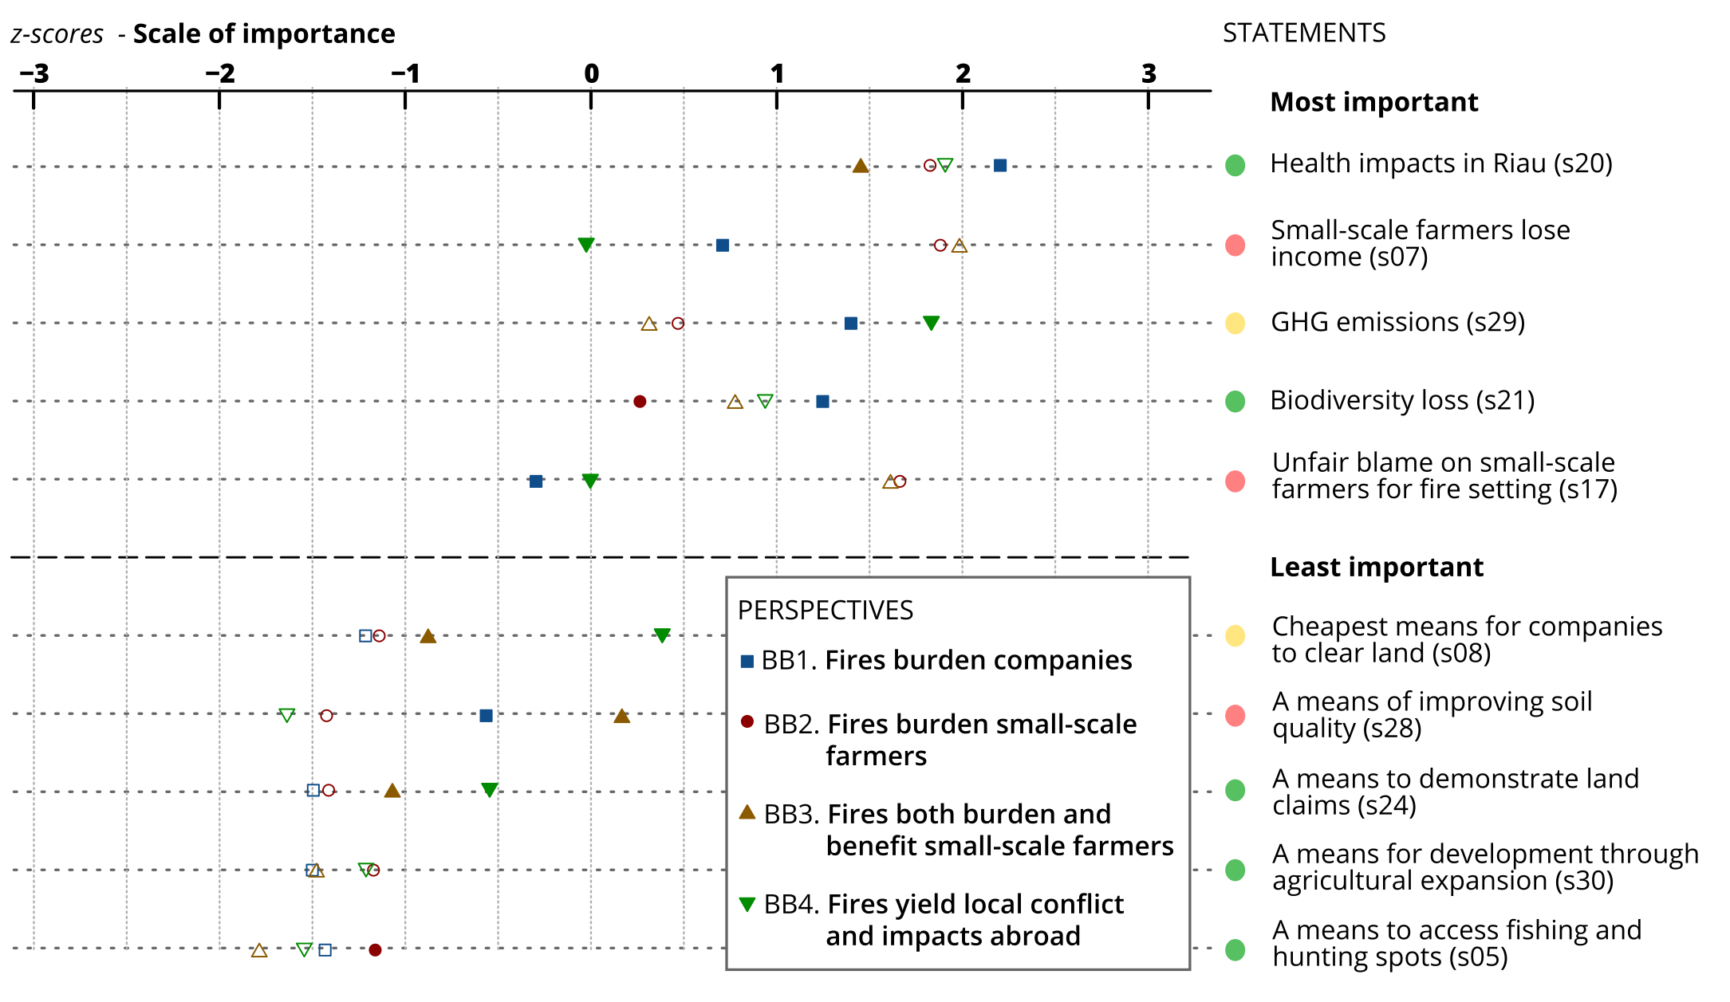

  - Perceptions about the effectiveness of Fire Management Interventions (FMI)
Perceptions about the relative effectiveness of different FMI were best described by five Q-factors (Table 3). These were most distinct in terms of: the type of intervention approach perceived as most effective (e.g. enforcement versus incentives); the stakeholder group perceived most effective in an implementation role (e.g. government versus private sector), and the stakeholder group targeted for behavioral change (e.g. small-scale farmers versus agribusiness) (Supplementary Table 5).

Table 3. Fire Management Intervention Q-Factors. Key characteristics of the five Q-factor clusters (distinct perceptions) concerning the effectiveness of various Fire Management Interventions (FMI) (See Supplementary Table 5).

Q-Factors | Effective FMI solutions | Not effective FMI solutions | Q-Factor Membership (%)*
FMI1  Strengthen firefighting | • Preference for technical firefighting solution. | • Adverse to agricultural restrictions, prefers extension services, particularly for small-scale farmers.  • Dislikes enforcement, unless directed at large-scale actors. |  | Small-scale farmer (30)  Medium landholders (21) Laborer/Share cropper (13)  Landless (13)
FMI2  Employ hard measures against large actors | • Diverse FMI solutions preferred, including sanctions, enforcement and standards directed at large-scale actors.  • Preference for transforming the agricultural sector and conservation of peatlands. | • Enforcement directed at small-scale users not preferred.  • Awareness raising is ineffective.  • Legalizing fire is ineffective. |  | Riau policy Community (23)  NGO (23)  Industrial Agriculture (20)  Jakarta Policy Community (20)
FMI3  Raise awareness to prevent fires | • Preference for awareness raising.  • Preference of short-term immediate FMI solutions such as enforcement when directed at companies and increased canal use. | • Adverse to long-term FMI solutions directed at underlying drivers. |  | Industrial Agriculture (26)  Medium Absentee Investors (22)  Small-scale farmers (19)  Medium landholders (15)  Local Public Figure (11)
FMI4  Employ hard measures against all actors | • Blanket enforcement measures preferred.  • Underlying drivers must be addressed.  • Mobilizing institutions, CSOs and Governments to prevent fire. | • Adverse position for transforming the agricultural sector and the role of improved technology. |  | Small-scale farmers (25)  Laborer/Share Cropper (19)  Medium landholders (19)  Large landholder (12)
FMI5  Employ soft measures to improve small-scale agricultural practices | • Preference for incentive-based FMI solutions for improved agriculture and support for small-scale farmers.  • Supports legalizing fire. | • Firefighting measures disregarded. |  | Medium landholders (25)  Small-scale farmers (25)  Industrial Agriculture (17)
*Percentage of stakeholder type that was most representative for this Q-factor (>10% membership). See Figure 1.

There was little consensus across the FMI Q-factors concerning individual FMI (Supplementary Figure 3). For example, of the five FMI ranked overall as the most effective, four were also among the most controversial FMI, generating high disagreement between Q-factors (Figure 3). Importantly, among those perceived as most effective, only one FMI was received with consensus: increasing technical support to small-scale farmers to clear land without fire (e.g. through provision of machinery). The most controversial FMI in the data related to criminalising further agricultural expansion on peatlands.

Stakeholder membership within and across Q-factors
Most Q-factors were associated with particular stakeholder groups (Tables 2 and 3). Importantly, there were significant differences in the benefits and burdens that landholders (from small to large-scale) prioritized, when compared with policymakers (from provincial to international scales). Local public figures were the only policy-engaged stakeholder group (i.e. between International and national policy makers) that shared perceptions with landholders, regarding both benefits and burdens of fire and FMI. Meanwhile, industrial agriculture was the only landholder group that shared the perceptions held by the policy communities.

Figure 3. Q-statements about the fire management intervention options (FMI) caused by peat fires. Fire management intervention statements ranked overall as “most effective” (upper half) and “least effective” (lower half). The graph shows the weighted mean responses to each statement given by the 5 FMI Q-factor clusters (Perspectives, icons). The relative space between the icons indicates the level of consensus between Q-factor FMI clusters, and is emphasized by the “traffic light” markers (from red for high disagreement, to green, for relative consensus). Filled icons denote distinguishing statements (see Data Analysis).

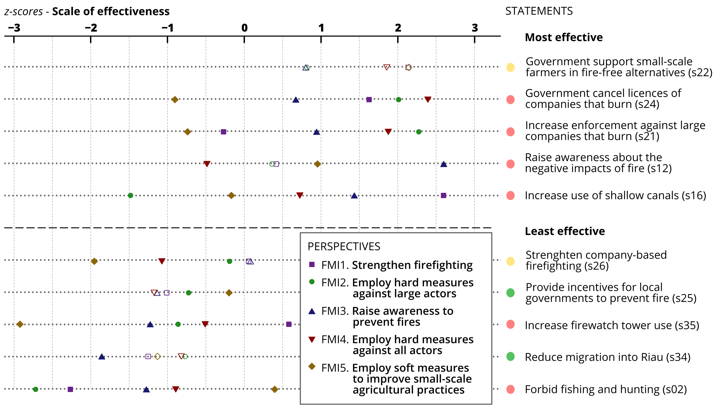
4. Discussion
4.1 Simple narratives of fire attribution misrepresent considerable diversity
The results challenge popular, simplistic framings in media and policy debates (Min, 2016) about peatland fires and resulting emissions and toxic transboundary haze. These often present fires as the activities of either small-scale or industrial-scale farmers, seeking quick and cheap land clearing strategies. However, we identified 12 stakeholder groups, many of which maintained distinct perceptions about peatland fire (Tables 2, 3). These included sub-categories of landholders, notably absentee investors, who are often overlooked in related debates and FMI solutions (Jelmsa and Schoneveld, 2016). Further, despite the prevailing dichotomy of small versus industrial, the data suggest that no single stakeholder group is primarily responsible for fire-setting. Instead the actor mapping indicated that numerous types of stakeholders (e.g. from local elites to absentee investors) have a role in peat fire contagion and that stakeholder perceptions reflect the same multiplicity of agents.

Similarly, we identified a number of comparatively nuanced motivations for fire-setting, with benefits of burning accruing at multiple scales, from local to international (Roos et al., 2016). Some motivations are associated with inexpensive land-clearing (e.g. to increase profit margins) and have been the focus of much public debate (e.g. exemplified in the new Moratorium on further oil palm expansion on peatland). However, motivations may also be associated with the lack of alternative land-clearing technologies (e.g. where mechanical land-clearing is not viable), land conflicts, and land claims (e.g. where formal titles are lacking). The resulting benefits and burdens are not always experienced as direct impacts (e.g. economic gains, health losses), but also indirectly, often following complex causal pathways (Roos et al., 2016). For example, the contemporary fire crisis has increased enforcement of environmental regulations, and in some cases has resulted in potentially unrepresentative blame of particular stakeholder groups and increased bureaucratic burdens for agro-industry (Table 4) (Gaveau et al., 2016).

Stakeholders prioritize the benefits and burdens of peat fires in different ways; some Q-factors prioritize the utility of fire, whilst others focus exclusively on its burdens (Table 2). How burdens are distributed and experienced among stakeholders will likely contribute to determining their preference for FMI solution measures and not perceived effectiveness alone (Newton et al., 2012). For example, small-scale landholders, with limited access to alternative forms of land clearance, and high risk of losing homes to wild fire, prefer fire-fighting measures above fire prevention, while policy makers prefer enforcement measures. Interventions that overlook the actual motivations for fire use are ill-equipped to manage the inevitable trade-offs that "fire-free" peatland agriculture entails. There is a need to integrate these grounded realities and the greater complexity surrounding fire prevalence into popular conceptions of what and who is causing fires. For example, through outreach, dedicated dialogue, dissemination and identification of national and local “champions” (Kenward et al., 2011).

4.2 Challenges of polycentric climate and environmental governance
The results highlight the lack of single, simple solutions to peatland fires (cf. (Ostrom et al., 2007)). As in other complex global environmental change policy arenas, results reveal a highly polycentric governance regime (Jordan et al., 2015). This involves diverse stakeholders, multiple scales, creative and often uncoordinated FMI responses (Ostrom, 2012), including from across levels of government (e.g. Table 4), civil society and the private sector. This diversity is important to the innovation and agency that may contribute to defining sustainable pathways for future resource management (Achyar et al., 2015, Viana et al., 2016).

However, polycentric regimes also present distinct challenges for harmonization, scaling, and for gaining common understanding and consensus amid diverse perspectives (Ostrom, 2010). This is critical in the context of peatland fires, where key distinctions between the perceptions held by the policy communities (Jakarta, Singapore, NGOs) and the industrial agriculture sector contrasted with those of the smaller landholder respondent groups. These patterns are visible in the specific membership portfolio of the FMI Q-factors and reflect key disconnects in how different parts of society perceive this issue.

Profound distinctions in ways of thinking about fire within this polycentric regime extend beyond disagreement about individual FMI, and potentially reflect differences in underlying ideologies, worldviews and values, themselves determinants of whether individuals believe in a need for behavioral change (Biggs et al., 2011, Hornsey et al., 2016, Clayton et al., 2015, Devine-Wright et al., 2015). For example, we identify differences related to perceptions about the:
- Relative effectiveness of FMI based on firefighting versus those orientated towards fire prevention;
- FMI premised on transformational changes in the agricultural sector (e.g. halt to agro-expansion on peat; re-flooding drained peat) versus those that seek to address fire risk within a context of continued business-as-usual agricultural practices (e.g. improved firefighting, expanded use of shallow canals);
- FMI that involve "hard" interventions, notably enforcement of laws against illegal burning and restrictions on the agricultural sector, versus "soft" FMI such as awareness raising, and use of incentives to reduce fire setting; and
- FMI that target behavioral change among large-scale and industrial actors versus FMI that target small-scale farmers.

Such core differences are potentially responsible for the widely observable policy-practice gaps (Anderson et al., 2016). Articulating and reconciling these positions is particularly important in the context of the highly contested FMI (Achyar et al., 2015, Sayer et al., 2013, Biggs et al., 2011). Moreover, successful interventions likely require a balance of carrots and sticks (Börner et al., 2014), suggesting that, while stakeholders may hold polarizing views, real solutions lie in their ability to accept hybrid interventions (e.g. a combination of economic incentive and direct regulation, mixed public-private initiatives) (Lambin et al., 2014).

Implications for contemporary FMI
Tensions are pressing, and particularly in relation to the leading contemporary FMI, including policies designed in response to the 2015 fires (Table 4). When evaluated for their perceived effectiveness, Q-statements associated with these high-profile FMI ranked among the most effective overall, but also generated greatest controversy.

Technically-sound interventions that involve deployment of FMI that conflict with stakeholder priorities and understandings of the problem are likely to need higher inputs (i.e. in policy design, implementation, enforcement) to avoid performance challenges (Carmenta et al., 2013). Therefore, we contend that greater understanding of the different aspirations, preferences and burdens experienced by distinct stakeholder groups is essential to designing appropriate interventions to secure improved FMI performance (Bennett, 2016, Biggs et al., 2011, Ray, 2011).

Table 4. Contemporary and controversial FMI. The FMI Q-statements that generated most controversy among stakeholders are also high-profile contemporary FMI.

Contemporary FMI solution | Description of the FMI | Corresponding Q-statement
Presidential Decree 1/2016 on peatland restoration agency | Establishment of a new Peatland Restoration Agency mandated to rewet 2 million hectares of drained peatland within 5 years (by 2020). | Increase use of shallow canals (to ensure access to water, provide fire breaks, and also maintain higher water tables)
New moratorium (announced 2016) on expansion of oil palm and mining operations | The proposed moratorium would prevent further expansion on peatlands related to oil palm cultivation and mining activities. | Forbid new agricultural expansion into forested areas on peatland
Presidential Decree 8/2015 on moratorium on new permits on peatlands and primary forests | Ministry of Environment and Forests should extend the moratorium (first started in 2011) on allocation of concession permits on peatland and forests, removing exemptions allowed under previous versions of the moratorium. | Forbid new agricultural expansion into forested areas on peatland
Ministry of Agriculture Regulation no. 11/Permentan/OT.140/3/2015 on Indonesian Sustainable Palm Oil Certification System | Requirement for companies to comply with zero burning, through mandatory ISPO certification. Transgression results in license revocation. | Increase enforcement against companies that allow fire
Ministry of Environment Circular Letter no. S.494/MENLHK-PHPL/2015 on the Prohibition to Open Peatlands | Prohibits the granting of permits on peatland, helping to operationalize the peatland moratorium, including by clarifying land use plans, requiring companies to review their Annual Work Plans to ensure these are in line with latest regulations, and pressuring companies to ensure future plans reduce impacts on forests and peatland fires. | Forbid new agricultural expansion into forested areas on peatland
Government Regulation 71/2014 on protection and management of peatland (PP71), Article 23 Clause 3(a) | Maintain water table depth of 40cm within peatland areas. | Increase use of shallow canals (to ensure access to water, provide fire breaks, and also maintain higher water tables)
ASEAN Agreement on Transboundary Haze Pollution 2002 (ratified by the Government of Indonesia through Law 26/2014) | Targets companies, not countries, responsible for criminal conduct of generating, or contributing to haze through their land management practices. | Increase enforcement against companies that allow fire

Leveraging consensus across Q-factors
The heterogeneity of FMI responses, diversity of stakeholder perceptions, and challenges inherent to complex environmental problems, highlight the need for consensus-building (Kenward et al., 2011). Multi-stakeholder negotiation and dialogue to define acceptable compromises, are important enablers of policy performance (Game et al., 2014, Reed, 2016, Sayer et al., 2013). Consensus points held between diverse stakeholders can provide productive entry points for a broader dialogue; generate agreement on the need for change, and inform communications to lever behavioral change (Achyar et al., 2015), as well as begin to learn from and up-scale lessons from previous experience of past FMI. A number of new institutions have emerged that may help facilitate these processes. For example, the newly-inaugurated Peatland Restoration Agency is looking to systematize canal blocking activities in fire-prone landscapes and calls for research that identifies what local priorities are on the ground. The Fire Free Alliance (FFA) provides a platform to share knowledge and to scale-up and coordinate efforts across the private sector. These initiatives will likely be challenged not only in the implementation of FMI, but in engaging the support of a diverse range of stakeholders with contested perspectives.

Across benefits and burdens Q-factors two negative impacts of fire were agreed by all to be important: environmental damage (for biodiversity and climate) and local public health (Figure 2). These areas of agreement may be key to initiate consultations, negotiations and public communication about behavioral change. Using this common ground would be a considerable development in contemporary public discussion about fires, shifting from narrow focuses on illegality and blame for fire-setting, to engagement with consensus around impacts of fire in everyday life, including environment, economy and – notably – health. Whilst public health impacts have yet to be extensively quantified, new research offers empirical evidence of the magnitude of the health impacts (Shannon et al., 2016, Crippa et al., 2016). Our results suggest that robust data quantifying health impacts could be used as a cornerstone for communication to convene actors that otherwise have few shared interests, and bring legitimacy to FMI that are framed to alleviate such burdens.

Similarly, FMI that generate consensus between Q-factors represent important points for multi-stakeholder policy engagement. Broadest consensus emerged over the effectiveness of government (and not private sector) support to small-scale farmers, allowing them to pursue fire-free agriculture (e.g. through use of mechanical land clearing or paludiculture (i.e. cultivation on wet peat soil)) (Figure 2). This consensus may reflect a perception that these actors are primarily responsible for fires, alongside a call for the State to internalize some of the costs of behavioral change, rather than simply demanding burdensome transitions by small-scale resource users. However, the possibility of long-term sustainable agriculture on peatland is unclear due to oxidation, subsidence and fire risk (Evers et al., 2016, Wijedasa et al., 2016).

Future research and way forward
Across efforts to mitigate global environmental change there is a growing awareness of the need to better account for complex governance arrangements and diverse stakeholder perceptions (DeFries et al., 2012, Galaz et al., 2012, Hornsey et al., 2016, Saunders and Myers, 2003, Hudson and Leftwich, 2014, Clayton et al., 2015). This is exemplified by peatland fire management, where there is a need to move away from over simplifications of actors and fire phenomena (Gaveau et al., 2016, Jelsma and Schoneveld, 2016, Varkkey, 2013). Q methodology distills an important component of this complexity, and opens questions of theoretical and policy interest related to cost-shifting behaviors in FMI, the potential of polycentric governance to resolve complex environmental problems, how perceptions shape implementation and performance, and what interventions and arrangements are most effective. Finally, our results call for a mix of targeted policy measures, and suggest that stakeholder engagement and platforms for dialogue between diverse groups will be essential in designing and implementing a sound, high performing, FMI approach.

Recurrent, large-scale peatland fires represent a major climate risk and a broad threat to the environment, economy and society (The World Bank, 2016, Gaveau et al., 2014, Huijnen et al., 2016, Marlier et al., 2013, Shannon et al., 2016, Tacconi, 2016). However, like many other areas of global environmental change, the management of peatland fires presents unique challenges for environmental governance. FMI success demands not only technically sound interventions but, importantly, the willingness and engagement of stakeholders (Marshall et al., 2017). This is particularly true where interventions involve multi-scale governance, complex trade-offs, vested interests and the livelihoods of vulnerable communities (Achyar et al., 2015). Understanding stakeholder perceptions and identifying ways for these to shape interventions to overcome the policy-practice gap, is now the leading challenge to peatland fire management and, arguably, to the governance of global environmental change.

- References
Achyar, E., Schmidt-Vogt, D. & Shivakoti, G. P. 2015. Dynamics of the multi-stakeholder forum and its effectiveness in promoting sustainable forest fire management practices in South Sumatra, Indonesia. Environmental Development, 13, 4-17.
Adgar, W. N., Brown, K. & Tomkins, E. L. 2005. The Political Economy of Cross-Scale Networks in Resource Co-Management. Ecology and Society, 10.
Anderson, Z. R., Kusters, K., Mccarthy, J. & Obidzinski, K. 2016. Green growth rhetoric versus reality: Insights from Indonesia. Global Environmental Change, 38, 30-40.
Bennett, N. J. 2016. Using perceptions as evidence to improve conservation and environmental management. Conservation Biology.
Biggs, D., Abel, N., Knight, A. T., Leitch, A., Langston, A. & Ban, N. C. 2011. The implementation crisis in conservation planning: could “mental models” help? Conservation Letters, 4, 169-183.
Börner, J., Wunder, S., Wertz-Kanounnikoff, S., Hyman, G. & Nascimento, N. 2014. Forest law enforcement in the Brazilian Amazon: Costs and income effects. Global Environmental Change, 29, 294-305.
Brown, S. R. 1980. Political subjectivity: Applications of Q methodology in political science., Yale University Press, New Haven and London., Yale University Press.
Carmenta, R., Vermeylen, S., Parry, L. & Barlow, J. 2013. Shifting cultivation and fire policy: insights from the Brazilian Amazon. Human Ecology, 41, 603-614.
Cash, D. W., Adger, N., Berkes, F., Garden, P., Lebel, L., Olsson, P., Pritchard, L. & Young, O. 2006. Scale and Cross-Scale Dynamics: Governance and Information in a Multilevel World. Ecology and Society, 11.
Clayton, S., Devine-Wright, P., Stern, P. C., Whitmarsh, L., Carrico, A., Steg, L., Swim, J. & Bonnes, M. 2015. Psychological research and global climate change. Nature Clim. Change, 5, 640-646.
Crippa, P., Castruccio, S., Archer-Nicholls, S., Lebron, G. B., Kuwata, M., Thota, A., Sumin, S., Butt, E., Wiedinmyer, C. & Spracklen, D. V. 2016. Population exposure to hazardous air quality due to the 2015 fires in Equatorial Asia. Scientific Reports, 6, 37074.
Dasgupta, P. & Vira, B. 2005. “Q Methodology ” for Mapping Stakeholder Perceptions In Participatory Forest Management. London, UK: Univeristy of Cambridge.
Defries, R. S., Ellis, E. C., Chapin, F. S., Matson, P. A., Turner, B. L., Agrawal, A., Crutzen, P. J., Field, C., Gleick, P., Kareiva, P. M., Lambin, E., Liverman, D., Ostrom, E., Sanchez, P. A. & Syvitski, J. 2012. Planetary Opportunities: A Social Contract for Global Change Science to Contribute to a Sustainable Future. BioScience, 62, 603-606.
Devine-Wright, P., Price, J. & Leviston, Z. 2015. My country or my planet? Exploring the influence of multiple place attachments and ideological beliefs upon climate change attitudes and opinions. Global Environmental Change, 30, 68-79.
Evers, S., Yule, C. M., Padfield, R., O'reilly, P. & Varkkey, H. 2016. Keep wetlands wet: the myth of sustainable development of tropical peatlands – implications for policies and management. Global Change Biology.
Forsyth, T. 2014. Public concerns about transboundary haze: a comparison of Indonesia, Singapore, and Malaysia. Global Environmental Change, 25, 76-86.
Galaz, V., Crona, B., Österblom, H., Olsson, P. & Folke, C. 2012. Polycentric systems and interacting planetary boundaries — Emerging governance of climate change–ocean acidification–marine biodiversity. Ecological Economics, 81, 21-32.
Game, E. T., Meijaard, E., Sheil, D. & Mcdonald-Madden, E. 2014. Conservation in a Wicked Complex World; Challenges and Solutions. Conservation Letters, 7, 271-277.
Gaveau, D. L. A., Pirard, R., Salim, M. A., Tonoto, P., Husnayaen, Parks, S. A. & Carmenta, R. 2016. Overlapping land claims limit the use of satellites to monitor No-Deforestation commitments and No-Burning compliance. Conservation Letters, 1-15.
Gaveau, D. L. A., Salim, M. A., Hergoualc'h, K., Locatelli, B., Sloan, S., Wooster, M., Marlier, M. E., Molidena, E., Yaen, H., Defries, R., Verchot, L., Murdiyarso, D., Nasi, R., Holmgren, P. & Sheil, D. 2014. Major atmospheric emissions from peat fires in Southeast Asia during non-drought years: evidence from the 2013 Sumatran fires. Scientific Reports, 4, 6112.
Goldstein, J. E. 2016. Knowing the subterranean: Land grabbing, oil palm, and divergent expertise in Indonesia’s peat soil. Environment and Planning A, 48, 754-770.
Harwell, E. 2000. Remote Sensibilities: Discourses of Technology and the Making of Indonesia’s Natural Disaster. Development and Change, 31, 307-340.
Hooijer, A., Page, S., Jauhiainen, J., Lee, W. A., Lu, X. X., Idris, A. & Anshari, G. 2012. Subsidence and carbon loss in drained tropical peatlands. Biogeosciences, 9, 1053-1071.
Hornsey, M. J., Harris, E. A., Bain, P. G. & Fielding, K. S. 2016. Meta-analyses of the determinants and outcomes of belief in climate change. Nature Clim. Change, 6, 622-626.
Hoscilo, A., Page Susan E., Tansey Kevin J. & O., R. J. 2011. Effect of repeated fires on land-cover change on peatland in southern Central Kalimantan, Indonesia, from 1973 to 2005. International Journal of Wildland Fire, 20, 578-588.
Hudson, D. & Leftwich, A. 2014. From political economy to political analysis. . DLP Research Paper. DLP.
Huijnen, V., Wooster, M. J., Kaiser, J. W., Gaveau, D. L. A., Flemming, J., Parrington, M., Inness, A., Murdiyarso, D., Main, B. & Van Weele, M. 2016. Fire carbon emissions over maritime southeast Asia in 2015 largest since 1997. Scientific Reports, 6, 26886.
Jelmsa, I. & Schoneveld, G., C 2016. Towards more sustainable and productive independent oil palm smallholders in Indonesia: Insights from the development of a smallholder typology. Working Paper. Bogor, Indonesia: CIFOR.
Jelsma, I. & Schoneveld, G. C. 2016. Towards more sustainable and productive independent oil palm smallholders in Indonesia: Insights from the development of a smallholder typology. CIFOR Working Paper. Bogor, Indonesia: Center for International Forestry Research (CIFOR).
Jolly, W. M., Cochrane, M. A., Freeborn, P. H., Holden, Z. A., Brown, T. J., Williamson, G. J. & Bowman, D. M. J. S. 2015. Climate-induced variations in global wildfire danger from 1979 to 2013. Nat Commun, 6.
Jordan, A. J., Huitema, D., Hilden, M., Van Asselt, H., Rayner, T. J., Schoenefeld, J. J., Tosun, J., Forster, J. & Boasson, E. L. 2015. Emergence of polycentric climate governance and its future prospects. Nature Clim. Change, 5, 977-982.
Kátia, F., Louis, V., Walter, B., Victor, G.-V., Miguel, P.-V. & Christopher, M. 2017. Heightened fire probability in Indonesia in non-drought conditions: the effect of increasing temperatures. Environmental Research Letters, 12, 054002.
Kenward, R. E., Whittingham, M. J., Arampatzis, S., Manos, B. D., Hahn, T., Terry, A., Simoncini, R., Alcorn, J., Bastian, O., Donlan, M., Elowe, K., Franzén, F., Karacsonyi, Z., Larsson, M., Manou, D., Navodaru, I., Papadopoulou, O., Papathanasiou, J., Von Raggamby, A., Sharp, R. J. A., Söderqvist, T., Soutukorva, Å., Vavrova, L., Aebischer, N. J., Leader-Williams, N. & Rutz, C. 2011. Identifying governance strategies that effectively support ecosystem services, resource sustainability, and biodiversity. Proceedings of the National Academy of Sciences, 108, 5308-5312.
Lambin, E. F., Meyfroidt, P., Rueda, X., Blackman, A., Börner, J., Cerutti, P. O., Dietsch, T., Jungmann, L., Lamarque, P., Lister, J., Walker, N. F. & Wunder, S. 2014. Effectiveness and synergies of policy instruments for land use governance in tropical regions. Global Environmental Change, 28, 129-140.
Law, E. A., Bryan, B. A., Meijaard, E., Mallawaarachchi, T., Struebig, M. J., Watts, M. E. & Wilson, K. A. 2016. Mixed policies give more options in multifunctional tropical forest landscapes. Journal of Applied Ecology.
Marlier, M. E., Defries, R. S., Voulgarakis, A., Kinney, P. L., Randerson, J. T., Shindell, D. T., Chen, Y. & Faluvegi, G. 2013. El Nino and health risks from landscape fire emissions in southeast Asia. Nature Clim. Change, 3, 131-136.
Marshall, N., Adger, N., Attwood, S., Brown, K., Crissman, C., Cvitanovic, C., De Young, C., Gooch, M., James, C., Jessen, S., Johnson, D., Marshall, P., Park, S., Wachenfeld, D. & Wrigley, D. 2017. Empirically derived guidance for social scientists to influence environmental policy. PLOS ONE, 12, e0171950.
Mccarthy, J. F., A.C. Vel, J. & Afiff, S. 2012. Trajectories of land acquisition and enclosure: development schemes, virtual land grabs, and green acquisitions in Indonesia's Outer Islands. The Journal of Peasant Studies, 39, 521-549.
Mckeown, B. & Thomas, D. 2013. Q-Methodology, Sage Publications, London., Sage Publications.
Miettinen, J., Shi, C. & Liew, S. C. 2016. Land cover distribution in the peatlands of Peninsular Malaysia, Sumatra and Borneo in 2015 with changes since 1990. Global Ecology and Conservation, 6, 67-78.
Min, C. H. 2016. Singapore offers help to Indonesia to fight fires and haze as dry season starts. Straits Times.
Newton, P., Nichols, E. S., Endo, W. & Peres, C. A. 2012. Consequences of actor level livelihood heterogeneity for additionality in a tropical forest payment for environmental services programme with an undifferentiated reward structure. Global Environmental Change, 22, 127-136.
Ostrom, E. 2010. Beyond Markets and States: Polycentric Governance of Complex Economic Systems. American Economic Review, 100, 641-72.
Ostrom, E. 2012. Nested externalities and polycentric institutions: must we wait for global solutions to climate change before taking actions at other scales? Economic Theory, 49, 353-369.
Ostrom, E., Janssen, M. A. & Anderies, J. M. 2007. Going beyond panaceas. Proceedings of the National Academy of Sciences, 104, 15176-15178.
Page, S. E. & Hooijer, A. 2016. In the line of fire: the peatlands of Southeast Asia. Philosophical Transactions of the Royal Society B: Biological Sciences, 371.
Persoon, G. A. & Simarmata, R. 2014. Undoing ‘marginality’: The islands of the Mahakam Delta, East Kalimantan (Indonesia). Journal of Marine and Island Cultures, 3, 43-53.
R Development Core Team. 2016. R: A language and environment for statistical computing. R Foundation for Statistical Computing, Vienna, Austria.: R Foundation for Statistical Computing.
Ray, L. 2011. Using Q-methodology to identify local perspectives on wildfires in two Koyukon Athabascan communities in rural Alaska. Sustainability: Science, Practice, & Policy, 7, 18-29.
Reed, J., Van Vianen, J., Deakin, E. L., Barlow, J., Sunderland, T 2016. Integrated landscape approaches to managing social and environmental issues in the tropics: learning from the past to guide the future. Glob Change Biol, 22, 2540–2554.
Roos, C. I., Scott, A. C., Belcher, C. M., Chaloner, W. G., Aylen, J., Bird, R. B., Coughlan, M. R., Johnson, B. R., Johnston, F. H., Mcmorrow, J. & Steelman, T. 2016. Living on a flammable planet: interdisciplinary, cross-scalar and varied cultural lessons, prospects and challenges. Philosophical Transactions of the Royal Society B: Biological Sciences, 371.
Saunders, C. & Myers, J., E.O. 2003. The emerging field of conservation psychology. Human Ecology Forum, 10, 137-149.
Sayer, J., Sunderland, T., Ghazoul, J., Pfund, J.-L., Sheil, D., Meijaard, E., Venter, M., Boedhihartono, A. K., Day, M., Garcia, C., Van Oosten, C. & Buck, L. E. 2013. Ten principles for a landscape approach to reconciling agriculture, conservation, and other competing land uses. Proceedings of the National Academy of Sciences, 110, 8349-8356.
Shannon, N. K., Loretta, J. M., Miriam, E. M., Jonathan, J. B., Patrick, S. K., Tianjia, L., Melissa, P. S., Ruth, S. D., Daniel, J. J., Joel, S., Montira, P. & Samuel, S. M. 2016. Public health impacts of the severe haze in Equatorial Asia in September–October 2015: demonstration of a new framework for informing fire management strategies to reduce downwind smoke exposure. Environmental Research Letters, 11, 094023.
Tacconi, L. 2016. Preventing fires and haze in Southeast Asia. Nature Clim. Change, 6, 640-643.
Tschakert, P., Das, P. J., Shrestha Pradhan, N., Machado, M., Lamadrid, A., Buragohain, M. & Hazarika, M. A. 2016. Micropolitics in collective learning spaces for adaptive decision making. Global Environmental Change, 40, 182-194.
Turetsky, M. R., Benscoter, B., Page, S., Rein, G., Van Der Werf, G. R. & Watts, A. 2015. Global vulnerability of peatlands to fire and carbon loss. Nature Geosci, 8, 11-14.
Van Der Werf, G. October 25 2015 2015. Indonesian fire season progression. Global Fire Data updates [Online]. Available from: http://www.globalfiredata.org/updates.html [Accessed October 25 2015 2015].
Van Exel, J., De Graaf, G. & Rietveld, P. 2011. ‘I can do perfectly well without a car!'. Transportation, 38, 383–407.
Varkkey, H. 2013. Patronage politics, plantation fires and transboundary haze. Environmental Hazards, 12, 200-217.
Viana, C., Coudel, E., Barlow, J., Ferreira, J., Gardner, T. & Parry, L. 2016. How Does Hybrid Governance Emerge? Role of the elite in building a Green Municipality in the Eastern Brazilian Amazon. Environmental Policy and Governance, n/a-n/a.
Watts, S. & Stenner, P. 2012. Doing Q Methodological Research: Theory, Method & Interpretation, London, UK, Sage.
Wijedasa, L. S., Jauhiainen, J., Könönen, M., Lampela, M., Vasander, H., Leblanc, M.-C., Evers, S., Smith, T. E. L., Yule, C. M., Varkkey, H., Lupascu, M., Parish, F., Singleton, I., Clements, G. R., Aziz, S. A., Harrison, M. E., Cheyne, S., Anshari, G. Z., Meijaard, E., Goldstein, J. E., Waldron, S., Hergoualc'h, K., Dommain, R., Frolking, S., Evans, C. D., Posa, M. R. C., Glaser, P. H., Suryadiputra, N., Lubis, R., Santika, T., Padfield, R., Kurnianto, S., Hadisiswoyo, P., Lim, T. W., Page, S. E., Gauci, V., Van Der Meer, P. J., Buckland, H., Garnier, F., Samuel, M. K., Choo, L. N. L. K., O'reilly, P., Warren, M., Suksuwan, S., Sumarga, E., Jain, A., Laurance, W. F., Couwenberg, J., Joosten, H., Vernimmen, R., Hooijer, A., Malins, C., Cochrane, M. A., Perumal, B., Siegert, F., Peh, K. S. H., Comeau, L.-P., Verchot, L., Harvey, C. F., Cobb, A., Jaafar, Z., Wösten, H., Manuri, S., Müller, M., Giesen, W., Phelps, J., Yong, D. L., Silvius, M., Wedeux, B. M. M., Hoyt, A., Osaki, M., Takashi, H., Takahashi, H., Kohyama, T. S., Haraguchi, A., Nugroho, N. P., Coomes, D. A., Quoi, L. P., Dohong, A., Gunawan, H., Gaveau, D. L. A., Langner, A., Lim, F. K. S., Edwards, D. P., Giam, X., Van Der Werf, G., Carmenta, R., Verwer, C. C., Gibson, L., Grandois, L., Graham, L. L. B., Regalino, J., Wich, S. A., Rieley, J., Kettridge, N., Brown, C., Pirard, R., Moore, S., Ripoll Capilla, B., Ballhorn, U., et al. 2016. Denial of long-term issues with agriculture on tropical peatlands will have devastating consequences. Global Change Biology.
World Bank. 2016. The cost of fire: an economic analysis of Indonesia’s 2015 fire crisis. Indonesia Sustainable Landscapes Knowledge Note. Jakarta, Indonesia: World Bank.
Zabala, A. 2014. qmethod: A package to explore human perspectives using Q methodology. R Journal, 6, 163:173.

Supplementary Information
Tables.
Supplementary Table 1. Comparison between the factors on benefits and burdens and those on FMI. Spearman correlation coefficients between respondent factor loadings.
 | FMI1 |  | FMI2 |  | FMI3 |  | FMI4 |  | FMI5
BB1 | -0.13 | * | 0.01 |  | 0.13 | * | 0.06 |  | -0.20 | ***
BB2 | 0.12 | * | -0.14 | ** | 0.18 | *** | 0.11 | * | -0.07
BB3 | 0.27 | *** | 0.00 |  | 0.16 | ** | 0.05 |  | 0.23 | ***
BB4 | -0.30 | *** | 0.43 | *** | -0.14 | ** | -0.02 |  | -0.04
Significance values: * p < 0.1 ** p< 0.05 *** p< 0.01

Supplementary Table 2. Complete set of Q-statements concerning the benefits and burdens of peatland fires in Riau. Factor scores (BB1-BB4) indicate the importance given to each item by the four Q-factors.
No. | Statement | BB1 | BB2 | BB3 | BB4
1 | Fire reduces weeds and pests that damage crops | -1 | -2 | 0 | -1
2 | Fire weakens the reputation of Indonesia's oil palm industry | 0 | 0 | -1 | 0
3 | Fire increases the risk that others will invade your land since burnt land looks vacant | -2 | 0 | 0 | -2
4 | Fire causes haze that makes transportation more dangerous | 3 | 0 | 2 | 0
5 | Fire is used to clear spaces to increase access to fishing and hunting spots | -3 | -1 | -3 | -3
6 | Fire reduces harvest of household subsistence food production | 0 | 1 | 0 | -1
7 | Small-holders lose income when fires destroy their farms | 1 | 3 | 3 | 0
8 | Plantation companies increase their profits when they use fire to clear land | -2 | -1 | -2 | 0
9 | Central government gives money to stakeholders in Riau to fight fires | 0 | 0 | -2 | 0
10 | Fire in Indonesia generates haze that travels to Singapore and Malaysia and causes health problems there | 1 | 0 | 0 | 2
11 | Fire in Indonesia causes haze that travels to Singapore and Malaysia and causes economic losses in those countries | 0 | 0 | -1 | 1
12 | Fire is the traditional way in which people clear land | -1 | -3 | 2 | 0
13 | Small holders can participate in agriculture because they can clear land cheaply by using fire | -1 | -2 | 3 | 0
14 | Fire makes it difficult to know who is responsible when land is illegally cleared | 0 | 1 | 1 | 1
15 | Fire causes haze that makes people stay in doors | 1 | 0 | 1 | 1
16 | Fire causes conflicts among different groups of people about who is responsible for burning | 0 | 2 | 0 | 3
17 | Fire leads to unfair blame and policy enforcement against small farmers | 0 | 3 | 3 | 0
18 | Haze from fire reaches Singapore and Malaysia and causes diplomatic tensions | 0 | 0 | -1 | 0
19 | Fire causes losses to Riau's entire economy | 2 | 2 | 0 | 1
20 | Fire generates haze which causes health problems in Riau | 3 | 3 | 2 | 3
21 | Fire reduces biodiversity | 2 | 0 | 1 | 2
22 | Fire makes agricultural business more difficult because of increased bureaucracy, rules and enforcement. | 0 | 1 | 0 | -2
23 | Conflicts lead people to set fire to other people or companies' land | -2 | -1 | -1 | 2
24 | Fire helps people to demonstrate their claim to land | -3 | -3 | -2 | -1
25 | Fire creates the risk of destroying your crops which discourages people from planting on their land | 0 | 2 | 1 | -3
26 | Fire reduces recreational enjoyment | 1 | 0 | 0 | 0
27 | Large-scale land holders lose income when fires destroy their plantations | 2 | -1 | -3 | -1
28 | Fire makes peatland soil less acidic and better for farming | -1 | -3 | 0 | -3
29 | Fire causes greenhouse gas emissions that affect the global climate | 3 | 1 | 0 | 3
30 | Fire has enabled rapid agricultural development responsible for improved hospitals, roads and schools | -3 | -2 | -3 | -2

Supplementary Table 3. Complete set of Q-statements concerning the solutions to peatland fires in Riau. Factor scores (FMI1-FMI5) indicate the effectiveness score for each item given by the five Q-factors.
No. | Statement | FMI1 | FMI2 | FMI3 | FMI4 | FMI5
1 | Improve the transparency and public participation in local planning processes | 0 | 2 | -1 | 0 | 1
2 | Forbid fishing and hunting | -3 | -3 | -2 | -1 | 0
3 | Support communities to create their own local-level rules and sanctions about fire | 0 | 1 | 0 | 0 | 0
4 | Increase enforcement against local elite who allow use of fire | 0 | 0 | 0 | 3 | 0
5 | Give incentives, such as rewards of money, seedlings, health and school services, for individual land holders to encourage them to prevent fire | 0 | 0 | 0 | -1 | 3
6 | Allow for the regulated, careful use of fire, such avoiding fire use during very dry and windy periods | -1 | -3 | 0 | 0 | 1
7 | Strengthen political agreements with neighboring countries related to reducing fire and haze | 0 | -1 | -1 | -1 | 0
8 | Conduct more research to improve knowledge about peatland and fire management | 0 | 0 | 0 | 0 | 0
9 | Increase enforcement against independent investors (not companies) from outside Riau who allow fire on their land | -1 | 2 | 0 | 1 | -2
10 | Strengthen companies' environmental standards to ensure they do not use, promote or facilitate fire | 0 | 1 | 0 | 0 | -1
11 | Strengthen government-led firefighting | 2 | 0 | 0 | 0 | -3
12 | Build awareness about the various negative impacts of fire | 1 | 0 | 3 | 0 | 2
13 | RSPO (Roundtable on Sustainable Palm Oil) sanction members that use fire | -1 | 0 | 0 | 0 | 0
14 | Strengthen anti-corruption efforts against people that use corruption to illegally gain land in Riau | 0 | 1 | -1 | 0 | 1
15 | Plant land soon after it is cleared, instead of leaving it idle, because that will make it less vulnerable to fire | 0 | 0 | 2 | 0 | 1
16 | Increase use of shallow canals as fire breaks | 3 | -3 | 3 | 1 | 0
17 | National government should facilitate the process for transferring forest land into land for development (APL), so that people don't have to use fire as an excuse to gain this permission | -1 | -2 | 0 | 0 | 0
18 | Increase central government control over land use and fire issues within Riau | 1 | 0 | 0 | 0 | -1
19 | Large companies provide support to out-grower groups (plasma) to clear land without using fire | 0 | 0 | 1 | 0 | 2
20 | Mobilize civil society / NGOs to take actions to address fire | 1 | 0 | 1 | 1 | -1
21 | Increase enforcement against large companies that allow fire | 0 | 3 | 2 | 3 | -1
22 | Government provide support to small-holders to clear land without using fire | 3 | 2 | 1 | 2 | 3
23 | Increase enforcement against small-holder farmers that use fire | -1 | -1 | 0 | 1 | -2
24 | Government cancel the licenses of companies that illegally use fire | 2 | 3 | 1 | 3 | -2
25 | Give incentives, such as rewards of money and technical support, to local Riau government to encourage them to prevent fire | -2 | -1 | -2 | -2 | 0
26 | Strengthen company-based firefighting | 0 | 0 | 0 | -2 | -3
27 | Increase enforcement against paid laborers that use fire to clear land for other people | -3 | -2 | 0 | 2 | 0
28 | Build awareness that burning to clear land is illegal | 1 | 0 | 3 | 0 | 0
29 | Re-flood drained peatlands | 2 | 2 | -3 | -2 | 2
30 | Increase use of traditional farming techniques and crops such as sago and coconut that are less vulnerable to fire than oil palm farming | -2 | 1 | -2 | -3 | 2
31 | Strengthen banks' standards to ensure they do not provide services or loans to people or companies who use fire | -2 | 1 | -1 | -3 | 0
32 | Improve use of drone, plane and satellite-based technologies for fire detection | 0 | 0 | 0 | -1 | 0
33 | Improve fire prediction tools | 3 | -1 | 1 | -2 | 0
34 | Reduce migration into Riau from other provinces | -2 | -1 | -3 | -1 | -2
35 | Build and staff more firewatch towers | 1 | -2 | -2 | 0 | -3
36 | Improve peat land map quality to improve its management and fire prevention | 0 | 0 | -1 | 0 | 0
37 | Build awareness to stop accidental fires from cooking or cigarettes butts | 0 | -2 | 2 | 2 | 1
38 | Strengthen local-level (e.g., MPA community-level) firefighting | 2 | 0 | 2 | 1 | -1
39 | Forbid new agricultural expansion into forested areas on peatland | -3 | 3 | 0 | -3 | 0
40 | Increase clarity on land tenure boundaries to avoid people using fire to grab land | 0 | 0 | -3 | 2 | 3

Supplementary Table 4. Four factors describing perspectives on the benefits and burdens associated with peat fire in Riau Province, Indonesia. Statement numbers given in parenthesis and statements that significantly distinguish the factor against other factors are marked with *. Stakeholder groups most represented by the factor are listed where proportion of respondents in the factor >10% - proportion given in parenthesis.
Factor name | Description | Stakeholder factor membership (%)
BB1: Fires burden companies | The perspective is the only one concerned with the economic losses (S27*) and reputational damage (S02*) companies experience as a result of fire. However, the perspective does not consider fire important as a cheap tool for land clearing, either by companies (S08) or small-scale farmers (S13*). Nor does the perspective consider important the uncertainties of defining parties responsible for fire (S14*) or conflicts among actors that result from disagreements about fire source/attribution (S16*). It does not prioritize the importance of fire as the result of disputes among actors (e.g., over land rights, S23*). The perspective is also concerned with negative local impacts of fire on wellbeing, including on transportation safety (S04*), recreation (S26*) and the Riau economy (S19*). | Industrial agriculture (26)  Absentee Investors (13)  Landless (13)  Laborers/Share croppers (11)  Medium landholders (11)
BB2: Fires burden small-scale farmers | This perspective is concerned about the negative direct and indirect impacts of fire on small-scale farmers, including to lost income (S07) and unfair blame for fire setting (S17). The perspective also places greatest importance on how fire risks disincentivize agriculture, through increased bureaucracy (S22*) and by discouraging planting (due to recurrent losses, S25*). However, it is unconcerned with the utility of fire in small-scale farmer agriculture. It places least importance on the role of fire as a cheap (S13*) and traditional (S12*) way to clear land, as a tool for pest management tool (S01*) and is relatively unconcerned with fire as a way to improve soil (S28*). | Small-landholders (21)  Local Public Figure (19)  Medium landholders (17)  Laborers/Share croppers (11)
BB3: Fires both benefit and burden small-scale farmers | This perspective is distinguished by the importance it places on the utility of fire as a cheap (S13*) and traditional (S12*) small-scale farmer practice that improves soils (S28*) and pest management (S01*). However, it is also concerned with the negative impacts of fire on small-scale farmers, including lost income (S07) and unfair blame for fire (S17). It also places concern on how fire generates conflict amongst actors over responsibility (S16*). The perspective is least concerned with impacts of fire abroad, including on health (S10*), economy (S11*) and bilateral relations (S18*). It is also least concerned with impacts on large-holders, including reputational risks (S02*), economic loss (S27*). It places relatively low importance on the use of fire as a cheap land-clearing tool by companies (S08*). Similarly, the perspectives is least concerned with government receipt of money for firefighting (S09*). | Small landholders (53)  Medium landholders (28)
BB4: Fires yield local conflict and impacts abroad | This perspective places greatest concern on the negative impacts of fire abroad, including economic losses (S11*) and health (S10*). It also gives greatest importance to greenhouse gases (S29*). In contrast, it does not prioritize the risks that fire entails for different types of landholder. For example, it is relatively unconcerned with direct losses fire has on company income (S27), subsistence food production (S06*) and small-scale farmer income (S07*). It places least importance on how fire risks disincentivize agriculture, through increased bureaucracy (S22*) and by discouraging planting (due to recurrent losses, S25*). The perspective does, however, place importance on the use of fire as a cheap land clearing tool, especially by large-holders (S08*), and also by small-scale farmers (S13*). It is also concerned with how fire use links to conflicts amongst these actors, including as part of pre-existing conflicts (e.g., over land rights, S23*) and as a source of new conflicts (over who is responsible, S16*). | Industrial Agriculture (29)  Jakarta Policy Community (18)  NGOs (18)  Singapore Policy Community (18)  Riau Policy Community (12)

Supplementary Table 5. Five factors describing perspectives on Fire Management Intervention (FMI) solutions to Riau’s peatland fires. Statement numbers given in parenthesis and those that distinguish the factor against other factors are marked with *. Stakeholder groups most represented by the factor are listed where proportion of respondents in the factor >10% - proportion given in parenthesis.
Factor Name | Description | Stakeholder factor membership (%)
FMI1: Strengthen firefighting | This factor is strongly focused on improved firefighting by government agencies (S11*) and at the local level (S38*). In this line, it strongly highlights the effectiveness of expanded use of fire watch towers (S35*), improved fire prediction technology (S33*) and increased use of shallow canals (S16*). It considers efforts to limit agricultural expansion ineffective, particularly where they affect small-scale farmer livelihoods. For example, it does not consider effective the efforts to restrict agricultural expansion on peatlands (S39) or to restrict fishing and hunting (S02*), while it highlights the effectiveness of government support for small-scale farmers to pursue agriculture without fire (S22). It considers all enforcement-based FMI solutions moderately ineffective, including enforcement against investors (S09*), laborers (S27), small-scale farmers (S23) and companies (S21*). However, it suggests that efforts to suspend the licenses of companies that use fire (S24*) would be effective. | Small-scale farmer (30)  Medium landholders (21)  Laborer/Share cropper (13)  Landless (13)
FMI2: Employ hard measures against large actors | This perspective is characterized by its highest emphasis on hard measures directed at large-scale actors, including enforcement against companies (S21*) and external investors (S09), and of the suspension of licences for companies that use fire (S24*). It also highlights the effectiveness of company environmental standards (S10) and bank restrictions on lending to companies that allow burning (S31*). The perspective also views notably the need to stop agricultural expansion on peatlands (S39*). The following are strongly ineffective efforts to promote careful legal fire use (S06*), facilitate the legal conversion of forest-designated land into agricultural land (S17*), or expand the use of shallow canals to enable agriculture while mitigating fire risk (S16*). In contrast, it views enforcement against laborers (S27) and small-scale farmers (S23) as ineffective. Similarly, efforts to restrict fishing and hunting (that might result in fire) (S02*) or to raise awareness about related accidental fire risks (S37*) are considered very ineffective. | NGO (23)  Riau policy Community (23)  Industrial Agriculture (20)  Jakarta Policy Community (20)
FMI3: Raise awareness to prevent fires | This perspective is distinguished by its focus on awareness-raising FMI solutions as the most effective. These include awareness on the potential negative impacts of fire (S12*), the illegality of fire setting (S28*), and preventing accidental fire spread (S37). It strongly highlights the ineffectiveness of interventions that target the underlying issues widely regarded as driving fire, such as those addressing land tenure (S40*), corruption (S14*), peatland drainage (i.e. re-flooding peatlands) (S29*), and migration (often associated with fire use) (S24*). The perspective moderately prefers FMI solutions which are more immediate, including increased use of shallow canals (16*) and enforcement against companies (S21*). | Industrial Agriculture (26)  Medium Absentee Investors (22)  Small-scale farmers (19)  Medium landholders (15)  Local Public Figure (11)
FMI4: Employ hard measures against all actors | This perspective is very strongly characterized by a focus on enforcement against all actors that use fire, including companies (S21*), local elite (S04*), laborers (S27*), small-scale farmers (S23*) and investors (S09) and also includes the effectiveness of suspending the licenses of companies that use fire (S24*). It considers efforts to clarify land tenure boundaries very effective (40*). This perspective highlights the effectiveness of FMI solutions that mobilize civil society (S20*) and provide incentives for local government to prevent fires (S25*). Efforts that challenge business as usual agricultural models are not effective, including efforts to restrict agricultural expansion on peatland (S39), interventions to re-flood peatlands (S29*), or to promote traditional framing techniques over oil palm (S30*). Fire management intervention Solution measures relying on technological advances are strongly considered ineffective, including improving fire prediction (S33*) and fire detection by aerial and satellite observation (S32*). | Small-scale farmers (25)  Laborer/Share Cropper (19)  Medium landholders (19)  Large landholder (12)
FMI5: Employ soft measures to improve small-scale agriculture | This perspective is characterized by the effectiveness of incentive-based FMI solutions for reducing fires through a change in their farming practices (S05*). Both government (S22) and company (S19) support for small-scale farmers, and the need for a transition towards traditional farming techniques (S30*) are regarded as effective. It considers very effective the introduction of measures to legalize careful fire use (S06*). The perspective perceives many firefighting efforts as ineffective, notably increased fire watch tower use (S35*), company (S26), local (S38*) and government led (S11) efforts. | Medium landholders (25)  Small-scale farmers (25)  Industrial Agriculture (17)

Figures
Supplementary Figure 1. Distribution of the Q sorting grids. a. benefits and burdens, and b. fire management intervention options.
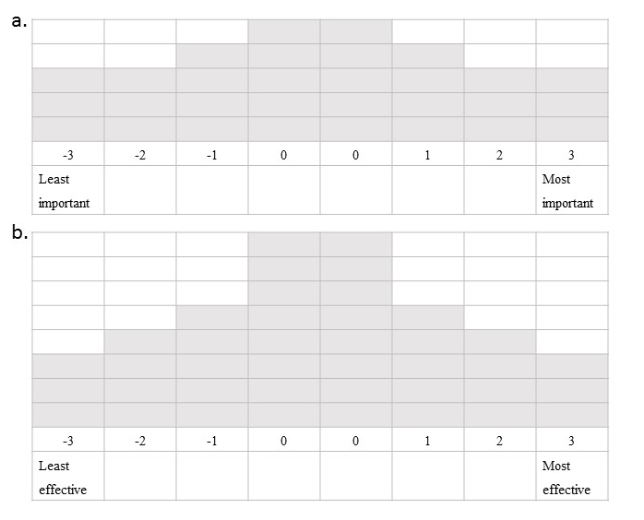

Supplementary Figure 2. Statement z-scores for benefits and burdens of fire and haze. Filled symbols indicate distinguishing statements and full text of statements is shown in Supplementary Table 1.
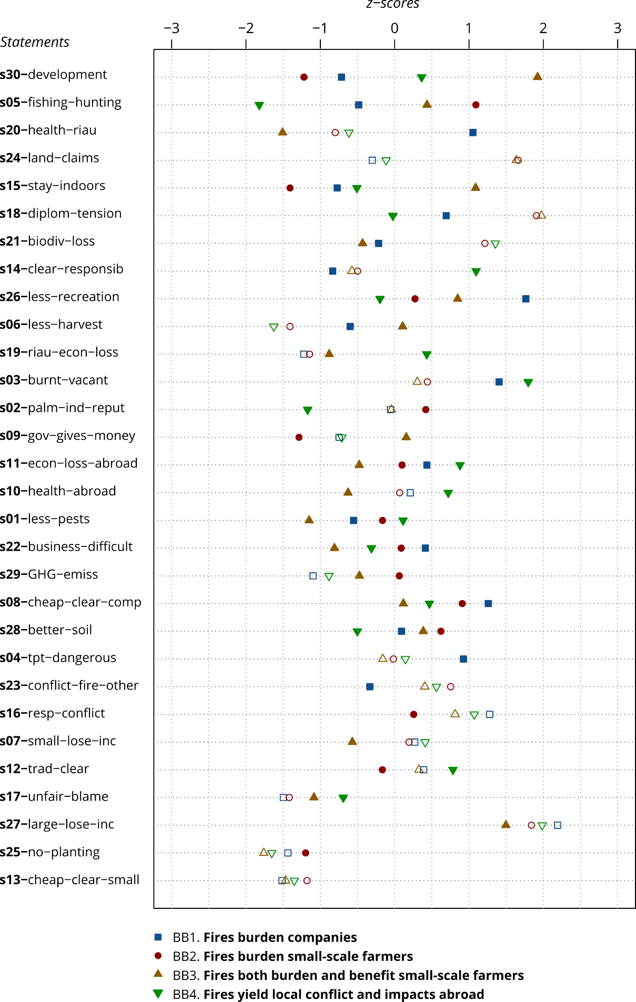

Supplementary Figure 3. Statement z-scores for FMI solutions. Filled symbols indicate distinguishing statements and full text of statements is shown in Supplement Table 4.