A global horizon scan of issues impacting marine and coastal biodiversity conservation

James E. Herbert-Read^{1*+}, Ann Thornton^{2*+}, Diva J. Amon^{3,4}, Silvana N.R. Birchenough⁵, Isabelle M. Côté⁶, Maria P. Dias^{7,8}, Brendan J. Godley⁹, Sally A. Keith¹⁰, Emma McKinley¹¹, Lloyd S. Peck¹², Ricardo Calado¹³, Omar Defeo¹⁴, Steven Degraer¹⁵, Emma L. Johnston¹⁶, Hermanni Kaartokallio¹⁷, Peter I. Macreadie¹⁸, Anna Metaxas¹⁹, Agnes W.N. Muthumbi²⁰, David O. Obura^{21,22}, David M. Paterson²³, Alberto R. Piola^{24,25}, Anthony J. Richardson^{26,27}, Irene R. Schloss^{28,29,30}, Paul V.R. Snelgrove³¹, Bryce D. Stewart³², Paul M. Thompson³³, Gordon J. Watson³⁴, Thomas A. Worthington², Moriaki Yasuhara³⁵ and William J. Sutherland^{2,36}.

*corresponding authors: J.E. Herbert-Read jh2223@cam.ac.uk, A. Thornton at915@cam.ac.uk
⁺These authors contributed equally to the manuscript.

¹Department of Zoology, Cambridge University, Downing St, CB2 3EJ, UK
²Conservation Science Group, Department of Zoology, Cambridge University, The David Attenborough Building, Pembroke Street, Cambridge, CB2 3QZ, UK
³SpeSeas, D’Abadie, Trinidad and Tobago
⁴Marine Science Institute, University of California, Santa Barbara, Santa Barbara, CA, USA
⁵The Centre for Environment, Fisheries and Aquaculture Science (Cefas), Pakefield Road, Lowestoft, Suffolk, NR33 0HT, UK
⁶Department of Biological Sciences, Simon Fraser University, Burnaby, BC V5A 1S6, Canada
⁷Centre for Ecology, Evolution and Environmental Changes (cE3c), Department of Animal Biology, Faculdade de Ciências da Universidade de Lisboa, Portugal
⁸BirdLife International, The David Attenborough Building, Pembroke Street, Cambridge, CB2 3QZ, UK
⁹Centre for Ecology and Conservation, University of Exeter, Penryn, TR10 9EZ
¹⁰Lancaster Environment Centre, Lancaster University, Lancaster, LA1 4YQ, UK
¹¹School of Earth and Environmental Sciences, Cardiff University, Park Place, Cardiff, CF10 3AT, UK
¹²British Antarctic Survey, Natural Environment Research Council, High Cross, Madingley Road, Cambridge, CB3 OET, UK
¹³ECOMARE, CESAM - Centre for Environmental and Marine Studies, Department of Biology, University of Aveiro, Santiago University Campus, 3810-193 Aveiro, Portugal
¹⁴Laboratory of Marine Sciences (UNDECIMAR), Faculty of Sciences, University of the Republic, 11400 Montevideo, Uruguay
¹⁵Royal Belgian Institute of Natural Sciences, Operational Directorate Natural Environment, Marine Ecology and Management, Vautierstraat 29, 1000 Brussels, Belgium
¹⁶School of Biological, Earth, and Environmental Sciences, University of New South Wales, NSW 2052, Australia
¹⁷Finnish Environment Institute, Agnes Sjöbergin katu 2, 00790 Helsinki, Finland
¹⁸Centre for Integrative Ecology, School of Life and Environmental Sciences, Deakin University, Burwood Campus, Burwood VIC, Australia
¹⁹Department of Oceanography, Dalhousie University, Halifax, Nova Scotia, Canada, B3H4R2
²⁰Department of Biology, University of Nairobi, P.O. Box 30197-00100 Nairobi, Kenya
²¹Coastal Oceans Research and Development in the Indian Ocean, Box 10135 Mombasa 80101, Kenya
²²University of Queensland, St. Lucia, Brisbane QLD 4072, Australia
²³Scottish Oceans Institute, School of Biology, University of St Andrews, UK
²⁴Servício de Hidrografía Naval, Buenos Aires, Argentina
²⁵Instituto Franco-Argentino sobre Estudios de Clima y sus Impactos, CONICET/CNRS, Universidad de Buenos Aires, Buenos Aires, Argentina
²⁶School of Mathematics and Physics, The University of Queensland, St Lucia, Queensland, Australia,
²⁷Commonwealth Scientific and Industrial Research Organisation (CSIRO) Oceans and Atmosphere, Queensland Biosciences Precinct, St Lucia, Brisbane, Queensland, Australia
²⁸Instituto Antártico Argentino, Buenos Aires, Argentina
²⁹Centro Austral de Investigaciones Científicas (CADIC-CONICET), Bernardo Houssay 200, Ushuaia, Tierra del Fuego, CP V9410CAB, Argentina
³⁰Universidad Nacional de Tierra del Fuego, Antártida e Islas del Atlántico Sur, Ushuaia, Argentina
³¹Department of Ocean Sciences and Biology Department, Memorial University, St. John’s, NL Canada A1C 5S7
³²Department of Environment and Geography, University of York, York, YO10 5NG, UK
³³Lighthouse Field Station, School of Biological Sciences, University of Aberdeen, Cromarty, IV11 8YL, UK
³⁴Institute of Marine Sciences, School of Biological Sciences, University of Portsmouth, Ferry Road, Portsmouth, UK
³⁵School of Biological Sciences, Area of Ecology and Biodiversity, Swire Institute of Marine Science, Institute for Climate and Carbon Neutrality, Musketeers Foundation Institute of Data Science, and State Key Laboratory of Marine Pollution, The University of Hong Kong, Kadoorie Biological Sciences Building, Pokfulam Road, Hong Kong SAR, China
³⁶Biosecurity Research Initiative at St Catharine's (BioRISC), St Catharine's College, University of Cambridge, Cambridge, UK

Abstract
The biodiversity of marine and coastal habitats is experiencing unprecedented change. While there are well-known drivers of these changes, such as overexploitation, climate change, and pollution, there are also relatively unknown emerging issues that are poorly understood or recognised that have potentially positive or negative impacts on marine and coastal ecosystems. In this inaugural Marine and Coastal Horizon Scan, we brought together 30 scientists, policymakers, and practitioners with trans-disciplinary expertise in marine and coastal systems to identify novel issues that are likely to have a significant impact on the functioning and conservation of marine and coastal biodiversity over the next 5-10 years. Based on a modified Delphi voting process, the final 15 issues presented were distilled from a list of 75 submitted by participants at the start of the process. These issues are grouped into three categories: ecosystem impacts, for example the impact of wildfires and the effect of poleward migration on equatorial biodiversity; resource exploitation, including an increase in the trade of fish swim bladders and increased exploitation of marine collagens; and novel technologies, such as soft robotics and new bio-degradable products. Our early identification of these issues and their potential impacts on marine and coastal biodiversity will support scientists, conservationists, resource managers, and policymakers to address the challenges facing marine ecosystems.

Introduction
The fifteenth Conference of the Parties (COP) to the United Nations Convention on Biological Diversity will conclude negotiations on a global biodiversity framework in late-2022 that will aim to slow and reverse the loss of biodiversity and establish goals for positive outcomes by 2050¹. Currently recognised drivers of declines in marine and coastal ecosystems include overexploitation of resources (e.g., fishes, oil and gas), expansion of anthropogenic activities leading to cumulative impacts on the marine and coastal environment (e.g., habitat loss, introduction of contaminants, and pollution), and effects of climate change (e.g., ocean warming, freshening, and acidification). Within these broad categories, marine and coastal ecosystems face a wide range of emerging issues that are poorly recognised or understood, each having the potential to impact biodiversity. Researchers, conservation practitioners, and marine resource managers must identify, understand, and raise awareness of these relatively ‘unknown’ issues to catalyse further research into their underlying processes and impacts. Moreover, informing the public and policymakers of these issues can mitigate potentially negative impacts through precautionary principles before those effects become realised: horizon scans provide a platform to do this.

Horizon scans bring together experts from diverse disciplines to discuss issues that are i) likely to have a positive or negative impact on biodiversity and conservation within the coming years, and ii) not well known to the public or wider scientific community or face a significant ‘step-change’ in their importance or application². Horizon scans are an effective approach for pre-emptively identifying issues facing global conservation³. Indeed, marine issues previously identified through this approach include microplastics⁴, invasive lionfish⁴, and electric pulse trawling⁵. To date, however, no horizon scan of this type has focused solely on issues related to marine and coastal biodiversity, although a scan on coastal shorebirds in 2012 identified potential threats to coastal ecosystems⁶. This horizon scan aims to benefit our ocean and human society by stimulating research and policy development that will underpin appropriate scientific advice on prevention, mitigation, management, and conservation approaches in marine and coastal ecosystems.

Results
We present the final 15 issues below in thematic groups identified post-scoring, rather than rank order (Fig. 1).
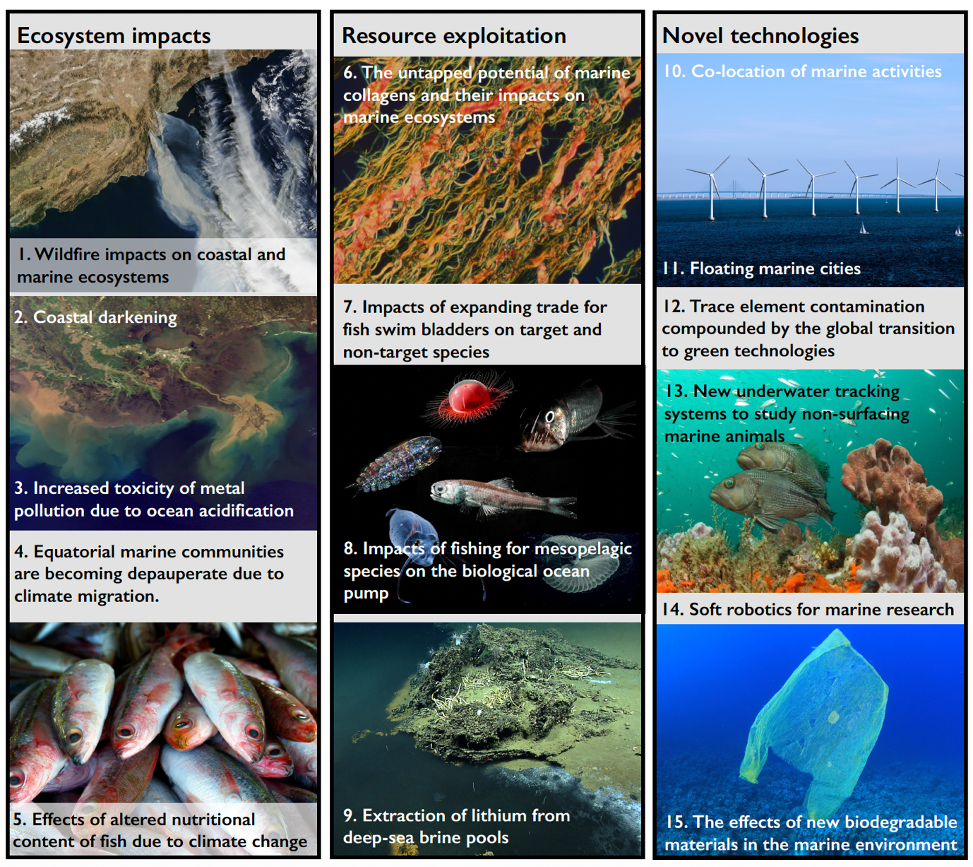
Figure 1: The 15 horizon issues presented in thematic groups: Ecosystem impacts, Resource exploitation and Novel technologies. Numbers refer to the order presented in this article, rather than final ranking. Image of brine pool courtesy of the NOAA Office of Ocean Exploration and Research, Gulf of Mexico 2014.
Ecosystem impacts
Wildfire impacts on coastal and marine ecosystems
The frequency and severity of wildfires are increasing with climate change⁷. Since 2017, there have been fires of unprecedented scale and duration in Australia, Brazil, Portugal, Russia, and along the Pacific coast of North America. In addition to threatening human life and releasing stored carbon, wildfires release aerosols, particles, and large volumes of materials containing soluble forms of nutrients including nitrogen, phosphorus, and trace metals such as copper, lead, and iron. Winds and rains can transport these materials over long distances to reach coastal and marine ecosystems. Australian wildfires, for example, triggered widespread phytoplankton blooms in the Southern Ocean⁸ along with fish and invertebrate kills in estuaries⁹. Predicting the magnitude and effects of these acute inputs is difficult because they vary with the size and duration of wildfires, the burning vegetation type, rainfall patterns, riparian vegetation buffers, dispersal by aerosols and currents, seasonal timing, and nutrient limitation in the recipient ecosystem. Wildfires might therefore lead to beneficial, albeit temporary, increases in primary productivity, produce no effect, or have deleterious consequences, such as the mortality of benthic invertebrates, including corals, from sedimentation, coastal darkening (see below), eutrophication, or algal blooms¹⁰.

Coastal darkening
Coastal ecosystems depend on the penetration of light for primary production by planktonic and attached algae and seagrass. However, climate change and human activities increase light attenuation through changes in dissolved materials modifying water colour and suspended particles. Increased precipitation, storms, permafrost thawing, and coastal erosion have led to the ‘browning’ of freshwater ecosystems by elevated organic carbon, iron, and particles, all of which are eventually discharged into the ocean¹¹. Coastal eutrophication leading to algal blooms compounds this darkening by further blocking light penetration. Additionally, land-use change, dredging, and bottom fishing can increase seafloor disturbance, re-suspending sediments, and increasing turbidity. Such changes could affect ocean chemistry, including photochemical degradation of dissolved organic carbon and generation of toxic chemicals. At moderate intensities, limited spatial scales, and during heatwaves, coastal darkening may have some positive impacts such as limiting coral bleaching on shallow reefs¹², but at high intensities and prolonged spatial and temporal extents, lower light-regimes can contribute to cumulative stressor effects thereby profoundly altering ecosystems. This darkening may result in shifts in species composition, distribution, behaviour, and phenology, as well as declines in coastal habitats and their functions (e.g., carbon sequestration)¹³.

Increased toxicity of metal pollution due to ocean acidification
Concerns about metal toxicity in the marine environment are increasing as we learn more about the complex interactions between metals and global climate change¹⁴. Despite tight regulation of polluters and remediation efforts in some countries, the high persistence of metals in contaminated sediments results in the ongoing remobilisation of existing metal pollutants by storms, trawling, and coastal development, augmented by continuing release of additional contaminants into coastal waters, particularly in urban and industrial areas across the globe¹⁴. Ocean acidification increases the bioavailability, uptake, and toxicity of metals in seawater and sediments, with direct toxicity effects on some marine organisms¹⁵. Not all biogeochemical changes will result in increased toxicity; in pelagic and deep-sea ecosystems, where trace metals are often deficient, increasing acidity may increase bioavailability and, in shallow waters, stimulate productivity for non-calcifying phytoplankton¹⁶. However, increased uptake of metals in wild-caught and farmed bivalves linked to ocean acidification could also affect human health, especially given that these species provide 25% of the world’s seafood. The combined effects of ocean acidification and metals could not only increase the levels of contamination in these organisms but could also impact their populations in the future¹⁴.

Equatorial marine communities are becoming depauperate due to climate migration
Climate change is causing ocean warming, resulting in a poleward shift of existing thermal zones. In response, species are tracking the changing ocean environmental conditions globally, with range shifts moving five times faster than on land¹⁷. In mid- and higher latitudes as some species move away from current distribution ranges, other species from warmer regions can replace them¹⁸. However, the hottest climatic zones already host the most thermally-tolerant species, which cannot be replaced due to their geographical position. Thus, climate change reduces equatorial species richness and has caused the formerly unimodal latitudinal diversity gradient in many communities to now become bimodal. This bimodality (i.e., dip in equatorial diversity) is projected to increase within the next 100 years if carbon dioxide emissions are not reduced¹⁹. The ecological consequences of this decline in equatorial zones are unclear, especially when combined with impacts of increasing human extraction and pollution²⁰. Nevertheless, emerging ecological communities in equatorial systems are likely to have reduced resilience and capacity to support ecosystem services and human livelihoods.

Effects of altered nutritional content of fish due to climate change
Essential fatty acids (EFAs) are critical to maintaining human and animal health, and fish consumption provides the primary source of EFAs for billions of people. In aquatic ecosystems, phytoplankton synthesise EFAs, such as docosahexaenoic acid (DHA)²¹, with pelagic fishes then consuming phytoplankton. However, concentrations of EFAs in fishes vary, with generally higher concentrations of omega-3 fatty acids in slower-growing species from colder waters²². Ongoing effects of climate change are impacting the production of EFAs by phytoplankton, with warming waters predicted to reduce the availability of DHA by about 10–58% by 2100²³; a 27.8% reduction in available DHA is associated with a 2.5ºC rise in water temperature²¹. Combined with geographical range shifts in response to environmental change affecting the abundance and distribution of fishes, this could lead to a reduction in sufficient quantities of EFAs for fishes, particularly in the tropics²⁴. Changes to EFA production by phytoplankton in response to climate change, as shown for Antarctic waters²⁵, could have cascading effects on the nutrient content of species further up the food web, with consequences for marine predators and human health²⁶.

Resource exploitation
The untapped potential of marine collagens and their impacts on marine ecosystems
Collagens are structural proteins increasingly used in cosmetics, pharmaceuticals, nutraceuticals, and biomedical applications. Growing demand for collagen has fuelled recent efforts to find new sources that avoid religious constraints, and alleviate risks associated with disease transmission from conventional bovine and porcine sources²⁷. The search for alternative sources has revealed an untapped opportunity in marine organisms, such as from fisheries bycatch²⁸. However, this new source may discourage efforts to reduce the capture of non-target species. Sponges and jellyfish offer a premium source of marine collagens. While the commercial-scale harvesting of sponges is unlikely to be widely sustainable, there may be some opportunity in sponge aquaculture and jellyfish harvesting, especially in areas where nuisance jellyfish species bloom regularly (e.g., Mediterranean and Japan Seas). The use of sharks and other cartilaginous fish to supply marine collagens is of concern given the unprecedented pressure on these species. However, the use of co-products derived from the fish-processing industry (e.g., skin, bones, and trims) offers a more sustainable approach to marine collagen production and could actively contribute to the blue bio-economy agenda and foster circularity²⁹.

Impacts of expanding trade for fish swim bladders on target and non-target species
In addition to better-known luxury dried seafoods, such as shark fins, abalone, and sea cucumbers, there is an increasing demand for fish swim bladders, also known as fish maw³⁰. This demand may trigger an expansion of unsustainable harvests of target fish populations, with additional impacts on marine biodiversity through bycatch^{30,31}. The fish swim-bladder trade has gained a high profile because the over-exploitation of totoaba (Totoaba macdonaldi) has driven both the target population and the vaquita (Phocoena sinus) (which is by-caught in the Gulf of Mexico fishery) to near extinction³². By 2018, totoaba swim bladders were being sold for $46,000 USD per kg. This extremely lucrative trade disrupts efforts to encourage sustainable fisheries. However, increased demand on the totoaba was itself caused by over-exploitation over the last century of the closely-related traditional species of choice, the Chinese bahaba (Bahaba taipingensis). We now risk both repeating this pattern and increasing its scale of impact, where depletion of a target species causes markets to switch to species across broader taxonomic and biogeographical ranges³¹. Not only does this cascading effect threaten other croakers and target species, such as catfish and pufferfish, but maw nets set in more diverse marine habitats are likely to create bycatch of sharks, rays, turtles, and other species of conservation concern.

Impacts of fishing for mesopelagic species on the biological ocean carbon pump
Growing concerns about food security have generated interest in harvesting largely unexploited mesopelagic fishes that live at depths of 200-1000 m³³. Small lanternfishes (Myctophidae) dominate this potentially 10-billion-ton community, exceeding the mass of all other marine fishes combined³⁴, and spanning millions of square kilometres of the open ocean. Mesopelagic fish are generally unsuitable for human consumption but could potentially provide fishmeal for aquaculture³⁴ or be used for fertilisers. Although we know little of their biology, their diel vertical migration transfers carbon, obtained by feeding in surface waters at night, to deeper waters during the day across many hundreds and even thousands of metres depth where it is released by excretion, egestion, and death. This globally important carbon transport pathway contributes to the biological pump³⁵ and sequesters carbon to the deep sea³⁶. Recent estimates put the contribution of all fishes to the biological ocean pump at 16.1% (± s.d. 13%)³⁷. The potential large-scale removal of mesopelagic fishes could disrupt a major pathway of carbon transport into the ocean depths.

Extraction of lithium from deep-sea brine pools
Global groups, such as the Deep-Ocean Stewardship Initiative, emphasise increasing concern about the ecosystem impacts from deep-sea resource extraction³⁸. The demand for batteries, including for electric vehicles, will likely lead to a demand for lithium that is more than five times its current level by 2030³⁹. While concentrations are relatively low in seawater, some deep-sea brines and cold seeps offer higher concentrations of lithium. Furthermore, new technologies, such as solid-state electrolyte membranes, can enrich the concentration of lithium from seawater sources by 43,000 times, increasing the energy efficiency and profitability of lithium extraction from the sea³⁹. These factors could divert extraction of lithium resources away from terrestrial to marine mining, with the potential for significant impacts to localised deep-sea brine ecosystems. These brine pools likely host many endemic and genetically distinct species that are largely undiscovered or awaiting formal description. Moreover, the extremophilic species in these environments offer potential sources of novel marine genetic resources that could be used in new biomedical applications including pharmaceuticals, industrial agents, and biomaterials⁴⁰. These concerns point to the need to better quantify and monitor biodiversity in these extreme environments to establish baselines and aid management.

Novel technologies
Co-location of marine activities
Climate change, energy needs, and food security have moved to the top of global policy agendas⁴¹. Increasing energy needs, alongside the demands of fisheries and transport infrastructure, have led to the proposal of co-located and multi-functional structures to deliver economic benefits, optimise spatial planning, and minimise the environmental impacts of marine activities⁴². These designs often bring technical, social, economic, and environmental challenges. Some studies have begun to explore these multipurpose projects (e.g., offshore windfarms co-located with aquaculture developments and/or Marine Protected Areas) and how to adapt these novel concepts to ensure they are ‘fit for purpose’, economically viable, and reliable. However, environmental and ecosystem assessment, management, and regulatory frameworks for co-located and multi-use structures need to be established to prevent these activities from compounding rather than mitigating the environmental impacts from climate change⁴³.

Floating marine cities
In April 2019, the UN-HABITAT programme convened a meeting of scientists, architects, designers, and entrepreneurs to discuss how floating cities might be a solution to urban challenges such as climate change and lack of housing associated with a rising human population (https://unhabitat.org/roundtable-on-floating-cities-at-unhq-calls-for-innovation-to-benefit-all). The concept of floating marine cities – hubs of floating structures placed at sea – was born in the middle of the 20th century, and updated designs now aim to translate this vision into reality⁴⁴. Oceanic locations provide benefits from wave and tidal renewable energy and food production supported by hydroponic agriculture⁴⁵. Modular designs also offer greater flexibility than traditional static terrestrial cities, whereby accommodation and facilities could be incorporated or removed in response to changes in population or specific events. The cost of construction in harsh offshore environments, rather than technology, currently limits the development of marine cities, and potential designs will need to consider the consequences of more frequent and extreme climate events. Although the artificial hard substrates created for these floating cities could act as stepping-stones, facilitating species movement in response to climate change⁴⁶, this could also increase the spread of invasive species. Finally, the development of offshore living will raise issues in relation to governance and land ownership that must be addressed for marine cities to be viable⁴⁷.

Trace element contamination compounded by the global transition to green technologies
The persistent environmental impacts of metal and metalloid trace element contamination in coastal sediments are now increasing after a long decline⁴⁸. However, the complex sources of contamination challenge their management. The acceleration of the global transition to green technologies, including electric vehicles, will increase demand for batteries by over 10% annually in the coming years⁴⁹. Electric vehicle batteries currently depend almost exclusively on lithium-ion chemistries, with potential trace element emissions across their life cycle from raw material extraction to recycling or end-of-life disposal. Few jurisdictions treat lithium-ion batteries as harmful waste, enabling landfill disposal with minimal recycling⁴⁹. Cobalt and nickel are the primary ecotoxic elements in next-generation lithium-ion batteries⁵⁰, although there is a drive to develop a cobalt-free alternative likely to contain higher nickel content⁵⁰. Some battery binder and electrolyte chemicals are toxic to aquatic life or form persistent organic pollutants during incomplete burning. Increasing pollution from battery production, recycling, and disposal in the next decade could substantially increase the potentially toxic trace element contamination in marine and coastal systems worldwide.

New underwater tracking systems to study non-surfacing marine animals
The use of tracking data in science and conservation has grown exponentially in recent decades. Most trajectory data collected on marine species to date, however, has been restricted to large and near-surface species, limited by the size of the devices and reliance on radio signals that do not propagate well underwater. New battery-free technology based on acoustic telemetry, named ‘Underwater Backscatter Localization’ (UBL), may allow high-accuracy (< 1 m) tracking of animals travelling at any depth and over large distances⁵¹. Still in the early stages of development, UBL technology has significant potential to help fill knowledge gaps in the distribution and spatial ecology of small, non-surfacing marine species, as well as the early life-history stages of many species⁵², over the next decades. However, the potential negative impacts of this methodology on the behaviour of animals are still to be determined. Ultimately, UBL may inform spatial management both in coastal and offshore regions, as well as in the high seas and address a currently biased perspective of how marine animals use ocean space, which is largely based on near-surface or aerial marine megafauna (see e.g. [⁵⁵]).

Soft robotics for marine research
The application and utility of soft robotics in marine environments is expected to accelerate in the next decade. Soft robotics, using compliant materials inspired by living organisms, could eventually offer increased flexibility at depth because they do not face the same constraints as rigid robots that need pressurised systems to function⁵⁴. This technology could increase our ability to monitor and map the deep sea, with both positive and negative consequences for deep-sea fauna. Soft-grab robots could facilitate collection of delicate samples for biodiversity monitoring but, without careful management, could also add pollutants and waste to these previously unexplored and poorly understood environments⁵⁵. With advancing technology, potential deployment of swarms of small robots could collect basic environmental data to facilitate mapping of the seabed. Currently limited by power supply, energy-harvesting modules are in development that enable soft robots to ‘swallow’ organic material and convert it into power⁵⁶, although this could result in inadvertently harvesting rare deep-sea organisms. Soft robots themselves may also be ingested by predatory species mistaking them for prey. Deployment of soft robotics will require careful monitoring of both its benefits and risks to marine biodiversity.

The effects of new biodegradable materials in the marine environment
Mounting public pressure to address marine plastic pollution has prompted the replacement of some fossil fuel-based plastics with bio-based biodegradable polymers. This consumer pressure is creating an economic incentive to adopt such products rapidly, and some companies are promoting their environmental benefits without rigorous toxicity testing and/or life-cycle assessments. Materials such as polybutylene succinate (PBS), polylactic acid (PLA), or cellulose and starch-based materials may become marine litter and cause harmful effects akin to conventional plastics⁵⁷. The long-term and large-scale effect of the use of biodegradable polymers in products (e.g., clothing) and the unintended release of by-products, such as microfibres, into the environment remain unknown. However, some natural microfibres have greater toxicity than plastic microfibres when consumed by aquatic invertebrates⁵⁸. Jurisdictions should enact and enforce suitable regulations to require the individual assessment of all new materials intended to biodegrade in a full range of marine environmental conditions. In addition, testing should include studies on the toxicity of major transition chemicals created during the breakdown process⁵⁹, ideally considering the different trophic levels of marine food webs.

Discussion
This scan identified three categories of horizon issues: impacts on, and alterations to, ecosystems; changes to resource use and extraction; and the emergence of novel technologies. While some of the issues discussed, such as improved monitoring of species (underwater tracking and soft robotics) and more sustainable resource use (marine collagens), may have some positive outcomes for marine and coastal biodiversity, most identified issues are expected to have substantial negative impacts if not managed or mitigated appropriately. This imbalance highlights the considerable emerging pressures facing marine ecosystems that are often a by-product of human activities.

Four issues identified in this scan related to ongoing large-scale (hundreds to many thousands of km²) alterations to marine ecosystems (wildfires, coastal darkening, depauperate equatorial communities, and altered nutritional fish content), either through the impacts of global climate change or other human activities. There are already clear impacts of climate change, for example, on stores of blue carbon (e.g. [⁶⁰]) and small-scale fisheries (e.g. [⁶¹]), but the identification of these novel issues highlights the need for global action that reverses such trends. The United Nations Decade of Ocean Science for Sustainable Development (2021-2030) is now underway, aligning with other decadal policy priorities, including the Sustainable Development Goals (https://sdgs.un.org/), the 2030 targets for biodiversity to be agreed in 2022, the conclusion of the ongoing negotiations on biodiversity beyond national jurisdictions (BBNJ) ( https://www.un.org/bbnj/), the UN Conference on Biodiversity (COP15) (https://www.unep.org/events/conference/un-biodiversity-conference-cop-15), and the UN Climate Change Conference 2021 (COP26) (https://ukcop26.org/). While some campaigns to allocate 30% of the ocean to Marine Protected Areas by 2030 are prominently aired⁶², the unintended future consequences of such protection, and how to monitor and manage these areas, remain unclear^{63,64,65}.

Another set of issues related to anticipated increases in marine resource use and extraction (swim bladders, marine collagens, lithium extraction, and mesopelagic fisheries). The complex issue of mitigating the impacts on marine conservation and biodiversity of exploiting and using newly discovered resources must consider public perceptions of the ocean^{66,67}, market forces, and the sustainable blue economy^{68,69}.

The final set of issues related to new technological advancements, with many offering more sustainable opportunities, albeit some having potentially unintended negative consequences on marine and coastal biodiversity. For example, trace-element contamination from green technologies and harmful effects of biodegradable products highlights the need to assess the step-changes in impacts from their increased use and avoid the paradox of technologies designed to mitigate the damaging effects of climate change on biodiversity themselves damaging biodiversity. Indeed, the impacts on marine and coastal biodiversity from emerging technologies currently in development (such as underwater tracking or soft robotics) need to be assessed before deployment at scale.

There are limitations to any horizon scanning process that aims to identify global issues and a different group of experts may have identified a different set of issues. By inviting participants from a range of subject backgrounds and global regions, and asking them to canvass their network of colleagues and collaborators, we aimed to identify as broad a set of issues as possible. We acknowledge, however, that only approximately one quarter of the participants were from non-academic organisations, which may have skewed the submitted issues, and how they were voted on. However, Sutherland et al.³ reported no significant correlation between participants’ areas of research expertise and the top issues selected in the horizon scan conducted in 2009. Therefore, horizon scans do not necessarily simply represent issues that reflect the expertise of participants. We also sought to achieve diversity by inviting participants from 22 countries and actively seeking representatives from the global south. However, the final panel of 30 participants spanned only 11 countries, the majority in the global north. We were forced by the COVID-19 pandemic to hold the scan online, and while we hoped this would enable participants to engage from around the world alleviating broader global inequalities in science⁶³, digital inequality was in fact enhanced during the pandemic⁷⁰. Our experience highlights the need for other mechanisms that can promote global representation in these scans.

This Marine and Coastal Horizon Scan seeks to raise awareness of issues that may impact marine and coastal biodiversity conservation in the next 5-10 years. Our aim is to bring these issues to the attention of scientists, policymakers, practitioners, and the wider community, either directly, through social networks, or the mainstream media. Whilst it is almost impossible to determine whether issues gained prominence as a direct result of a horizon scan, some issues featured in previous scans have seen growth in reporting and awareness. Sutherland et al.³ found that 71% of topics identified in the Horizon Scan in 2009 had seen an increase in their importance over the next ten years. Issues such as microplastics and invasive lionfish had received increased research and investment from scientists, funders, managers, and policymakers to understand their impacts, and the horizon scans may have helped motivate this increase. Horizon scans, therefore, should primarily act as signposts, putting focus onto particular issues, and providing support for researchers and practitioners to seek investment in these areas.

Whilst recognising that marine and coastal environments are complex social-ecological systems, the role of governance, policy, and litigation on all areas of marine science needs to be developed, as it is yet to be established to the same extent as in terrestrial ecosystems⁷¹. Indeed, tackling many of the issues presented in this scan will require an understanding of the human dimensions relating to these issues, through fields of research including but not limited to ocean literacy^{72,73}, social justice, equity⁷⁴, and human health⁷⁵. Importantly, however, horizon scanning has proved an efficient tool in identifying issues that have subsequently come to the forefront of public knowledge and policy decisions, while also helping to focus future research. The scale of the issues facing marine and coastal areas emphasises the need to identify and prioritise, at an early stage, those issues specifically facing marine ecosystems, especially within this UN Decade of Ocean Science for Sustainable Development.

Methods
Identification of issues
In March 2021, we brought together a Core Team of 11 participants from a broad range of marine and coastal disciplines. The Core Team suggested names of individuals outside their subject area who were also invited to participate in the horizon scan. To ensure we included as many different subject areas as possible within marine and coastal conservation, we selected one individual from each discipline. Our panel of experts comprised 30 (37% female) marine and coastal scientists, policymakers, and practitioners (27% from non-academic institutions), with cross-disciplinary expertise in ecology (including tropical, temperate, polar, and deep-sea ecosystems), paleoecology, conservation, oceanography, climate change, ecotoxicology, technology, engineering, and marine social sciences (including governance, blue economy, and ocean literacy). Participants were invited from 22 countries across six continents, resulting in a final panel of 30 experts from 11 countries (Europe n = 17 (including the three organisers); North America and Caribbean n = 4; South America n = 3; Australasia n = 3; Asia n = 1; Africa n = 2). All experts co-author this paper.

To reduce the potential for bias in the identification of suitable issues, each participant was invited to consult their own network and required to submit two to five issues that they considered novel and likely to have a positive or negative impact on marine and coastal biodiversity conservation in the next 5–10 years (see Supplementary Note SN1 for instructions given to participants). Each issue was described in paragraphs of approximately 200 words (plus references). Due to the COVID-19 pandemic, participants relied mainly on virtual meetings and online communication using email, social-media platforms, online conferences, and networking events. Through these channels approximately 680 people were canvassed by the participants, counting all direct in-person or online discussions as individual contacts, but treating social media posts or generic emails as a single contact. This process resulted in a long-list of 75 issues that were considered in the first round of scoring (see Supplementary Note SN2 for the full list of initially submitted issues).

Round 1 scoring
The initial list of proposed issues was then shortened through a scoring process. We used a modified Delphi-style⁷⁶ voting process, which has been consistently applied in horizon scans since 2009 (see^{4,77}) (see Fig. 2 for the stepwise process). This process ensured that consideration and selection of issues remained repeatable, transparent, and inclusive. Panel members were asked to confidentially and independently score the long list of 75 issues from 1 (low) to 1000 (high) based on the following criteria:
- Whether the issue is novel (with “new” issues scoring higher) or is a well-known issue likely to exhibit a significant step-change in impact.
- Whether the issue is likely to be important and impactful over the next 5-10 years.
- Whether the issue specifically impacts marine and coastal biodiversity.
Participants were also asked whether they had heard of the issue or not.
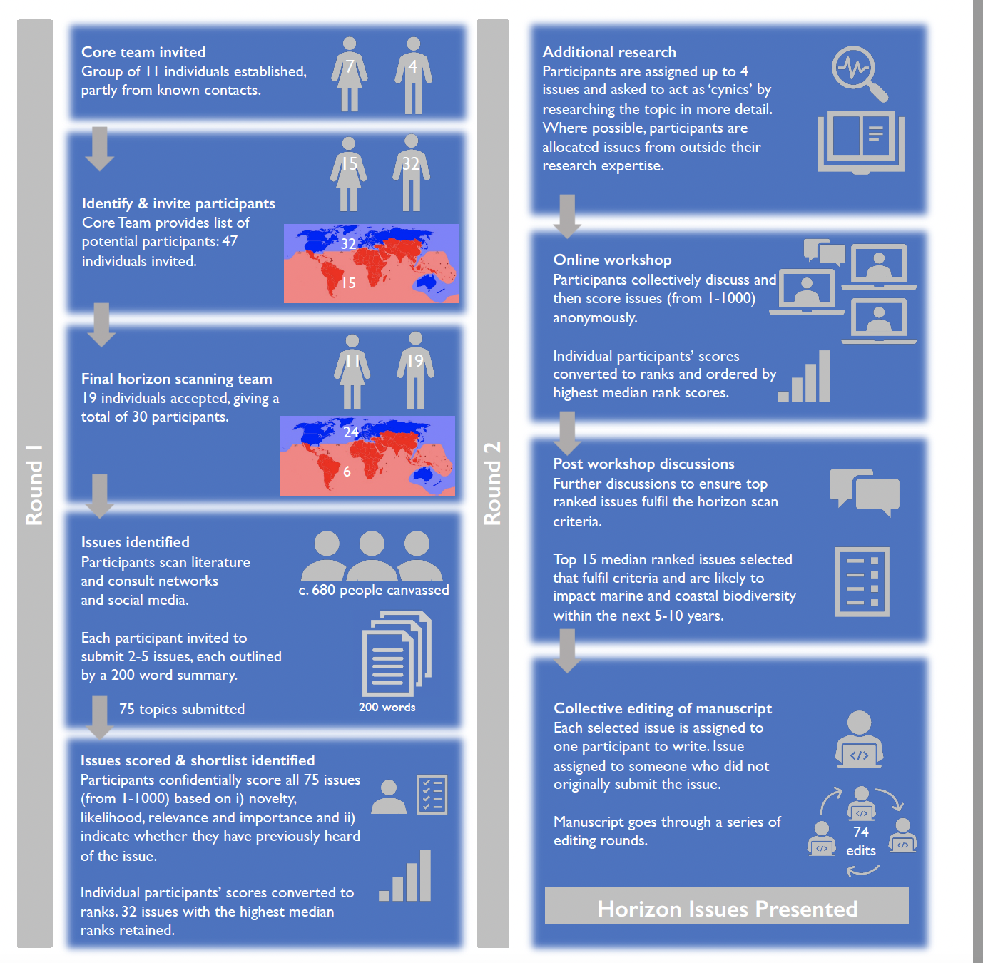
Figure 2: Stepwise process used to identify, score, and present the 15 horizon issues likely to impact marine and coastal biodiversity conservation in the next 5-10 years. Left and right columns show the process for the first and second rounds of scoring, respectively.

‘Voter fatigue’ can result in issues at the end of a lengthy list not receiving the same consideration as those at the beginning⁷⁶. We counteracted this potential bias by randomly assigning participants to one of three differently ordered long-lists of issues. Participants’ scores were converted to ranks (1-75). We had aimed to retain the top 30 issues with the highest median ranks for the second round of assessment at the workshop but kept 31 issues because two issues achieved equal median ranks. In addition, we identified one issue that had been incorrectly grouped with three others and presented this as a separate issue. The subsequent online workshop to discuss this shortlist, therefore, considered the top-ranked 32 issues (Fig. 3a) (see Supplementary Note SN3 for the full list).

Workshop and Round 2 scoring
Prior to the workshop, each participant was assigned up to four of the 32 issues to research in more detail and contribute further information to the discussion. We convened the one-day workshop online in September 2021. The geographic spread of participants meant that time zones spanned 17 hours. Despite these constraints, discussions remained detailed, focused, varied, and lively. In addition, participants made use of the chat function on the platform to add notes, links to articles, and comments to the discussion. After discussing each issue, participants re-scored the topic (1-1000, low to high) based on novelty, and the issue’s importance for, and likely impact on, marine and coastal biodiversity (three participants out of 30 did not score all issues and therefore their scores were discounted). At the end of the selection process, scores were again converted to ranks and collated. Highest-ranked issues were then discussed by correspondence focusing on the same three criteria as outlined above, after which the top 15 horizon issues were selected (Fig. 3b).
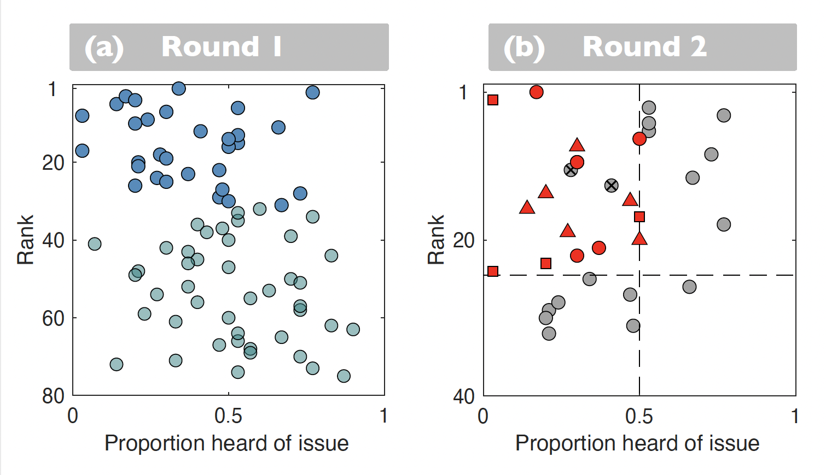
Figure 3: Median rank of each issue versus proportion of issues participants had previously heard of. (a) Round 1. Each point represents an individual issue (for all issue titles, see SN2). Issues in dark blue were retained for the second round. Issues that were ranked higher were generally those that participants had not heard of (Spearman rank correlation = 0.38, p < 0.001). (b) Round 2 (scores as in Round 1; for titles of the second round of 32 issues see SN3). The 15 final issues (marked in red) achieved the top ranks (horizontal dashed line) and had only been heard of by 50% of participants (vertical dashed line). Red circles, squares and triangles denote issues relating to ecosystem impacts, resource exploitation, and novel technologies, respectively. The two grey issues marked with crosses were discounted during final discussions because participants could not identify the horizon component of these issues.

Data Availability
The datasets generated during and/or analysed during the current study are available from Figshare https://doi.org/10.6084/m9.figshare.19703485.v1.

Acknowledgements
This Marine and Coastal Horizon Scan was funded by Oceankind. SNRB is supported by EcoStar (DM048) and Cefas (My time). RC acknowledges FCT/MCTES for the financial support to CESAM (UIDP/50017/2020, UIDB/50017/2020, LA/P/0094/2020) through national funds. OD is supported by CSIC Uruguay and Inter-American Institute for Global Change Research. JH-R is supported by the Whitten Lectureship in Marine Biology. SAK is supported by a Natural Environment Research Council grant (NE/S00050X/1). PIM is supported by an Australian Research Council Discovery Grant (DP200100575). DMP is supported by the Marine Alliance for Science and Technology for Scotland (MASTS). ARP is supported by the Inter-American Institute for Global Change Research. WJS is funded by Arcadia. AT is supported by Oceankind. MY is supported by the Deep Ocean Stewardship Initiative and bioDISCOVERY. We are grateful to everyone who submitted ideas to the exercise and the following who are not authors but who suggested a topic that made the final list: Rachel Brown (co-location of marine activities), Nick Graham and Christina Hicks (altered nutritional content of fish), Andrew Thornton (soft robotics), Amanda Vincent (fish swim bladders), Tom Webb (mesopelagic fisheries).

Author Contributions Statement
J. Herbert-Read and A. Thornton contributed equally to the manuscript.
JH-R, AT and WJS devised, organised, and led the Marine and Coastal Horizon Scan.
DJA, SNRB, IMC, MPD, BJG, SAK, EM, LSP formed the Core Team and are listed alphabetically in the author list. All other authors are listed alphabetically.
All authors contributed to and participated in the process, and all were involved in writing and editing the manuscript.

Competing Interests Statement
The authors declare no competing interests.

Supplementary Information
Supplementary Notes are available for this paper.
SN1: Instructions for participants
SN2: List of 75 issues submitted.
SN3: List of 32 issues taken to Round 2.
Additional Information
Correspondence and requests for materials should be addressed to J. Herbert-Read jh2223@cam.ac.uk, or A. Thornton at915@cam.ac.uk

Reprints and permissions information is available at www.nature.com/reprints.

References
1 Díaz, S. et al. Set ambitious goals for biodiversity and sustainability. Science 370, 411–413 (2020).
2 Sutherland, W.J. & Woodroof, H.J. The need for environmental horizon scanning. Trends Ecol. Evol. 24, 523–527 (2009).
3 Sutherland, W.J. et al. Ten years on: a review of the first global conservation horizon scan. Trends Ecol. Evol. 34, 139-153 (2019).
4 Sutherland, W.J. et al. A horizon scan of global conservation issues for 2010. Trends Ecol. Evol. 25, 1-7 (2010).
5 Sutherland, W.J. et al. A horizon scan of global conservation issues for 2016. Trends Ecol. Evol. 31, 44-53 (2016).
6 Sutherland, W.J. et al. A horizon scanning assessment of current and potential future threats facing migratory shorebirds. Ibis 154, 663–679 (2012).
7 Bowman, D.M.J.S. et al. Vegetation fires in the Anthropocene. Nat. Rev. Earth Environ. 1, 500–515 (2020).
8 Tang, W. et al. Widespread phytoplankton blooms triggered by 2019–2020 Australian wildfires. Nature 597, 370–375 (2021).
9 Silva, L.G.M. et al. Mortality events resulting from Australia's catastrophic fires threaten aquatic biota. Glob. Change Biol. 26, 5345- 5350 (2020).
10 Abram, N.J., Gagan, M.K., McCulloch, M.T., Chappell, J. & Hantoro, W.S. Coral reef death during the 1997 Indian Ocean Dipole linked to Indonesian wildfires. Science 301, 952-955 (2003).
11 Solomon, C.T. et al. Ecosystem consequences of changing inputs of terrestrial dissolved organic matter to lakes: current knowledge and future challenges. Ecosystems 18, 376–389 (2015).
12 Sully, S. & van Woesik, R. Turbid reefs moderate coral bleaching under climate related temperature stress. Glob. Change Biol. 26, 1367-1373 (2021).
13 Blain, C.O., Hansen, S.C. & Shears, N.T. Coastal darkening substantially limits the contribution of kelp to coastal carbon cycles. Glob. Change Biol. 27, 5547-5563 (2021).
14 Stewart, B.D. et al. Metal pollution as a potential threat to shell strength and survival in marine bivalves. Sci. Total Environ. 755, 143019 (2021).
15 Roberts, D.A. et al. Ocean acidification increases the toxicity of contaminated sediments. Glob. Change Biol. 19, 340-351 (2013).
16 Hauton, C. et al. Identifying Toxic Impact of metals Potentially Released during Dep-Sea Mining – A Synthesis of the Challenges to Quantifying Risk. Front. Mar. Sci., 4, (2017).
17 Chaudhary, C. et al. Global warming is causing a more pronounced dip in marine species richness around the equator. PNAS, 118, e2015094118 (2021).
18 Burrows, M.T. et al. Geographical limits to species-range shifts are suggested by climate velocity. Nature 507, 492-495 (2014).
19 Yasuhara, M. et al. Past and future decline of tropical pelagic biodiversity. PNAS 117, 12891-12896 (2020).
20 Pandolfi, J.M. et al. Are U.S. coral reefs on the slippery slope to slime? Science 307, 1725–1726 (2005).
21 Hixson, S.M. & Arts, M.T. Climate warming is predicted to reduce omega-3, long-chain, polyunsaturated fatty acid production in phytoplankton. Glob Chang Biol. 22, 2744-2755 (2016).
22 Hicks, C.C. et al. Harnessing global fisheries to tackle micronutrient deficiencies. Nature 574, 95–98 (2019).
23 Colombo, S.M. et al. Projected declines in global DHA availability for human consumption as a result of global warming. Ambio 49, 865–880 (2020).
24 Lam, V.W. et al. Climate change, tropical fisheries and prospects for sustainable development. Nat. Rev. Earth Environ. 1, 440-454 (2020).
25 Antacli, J.C. et al. Increase in unsaturated fatty acids in Antarctic phytoplankton under ocean warming and glacial melting scenarios. Sci. Total Environ. 790, 147879 (2021).
26 Maire, E. et al. Micronutrient supply from global marine fisheries under climate change and overfishing. Curr. Biol. 18, 4132-4138 (2021).
27 Lim, Y.S., Ok, Y.J., Hwang, S.Y., Kwak, J.Y. & Yoon, S. Marine collagen as a promising biomaterial for biomedical applications. Mar. Drugs 17, 467 (2019).
28 Xu, N. et al. Marine-derived collagen as biomaterials for human health. Front. Nutr. 8, 702108 (2021).
29 Vieira, H., Leal, M.C. & Calado, R. Fifty shades of blue: How blue biotechnology is shaping the bioeconomy. Trends Biotechnol. 38, 940-943 (2020).
30 Ben-Hasan, A. et al. 2021. China’s fish maw demand and its implications for fisheries in source countries. Mar. Policy 132, 104696 (2021).
31 Sadovy de Mitcheson, Y., To, A.W.l., Wong, N.W., Kwan, H.Y. & Bud, W.S. Emerging from the murk: threats, challenges and opportunities for the global swim bladder trade. Rev. Fish Biol. Fish. 29, 809–835 (2019).
32 Brownell Jr, R.L. et al. Bycatch in gillnet fisheries threatens Critically Endangered small cetaceans and other aquatic megafauna. Endanger. Species Res. 40, 285-296 (2019).
33 Webb, T.J., Vanden Berghe, E. & O'Dor, R.K. Biodiversity's big wet secret: The global distribution of marine biological records reveals chronic under-exploration of the deep pelagic ocean. PLoS ONE 5, e10223 (2010).
34 St. John, M.A. et al. A dark hole in our understanding of marine ecosystems and their services: perspectives from the mesopelagic community. Front. Mar. Sci. 3, 31 (2016).
35 Thomsen, L. et al. The Oceanic Biological Pump: Rapid carbon transfer to depth at continental margins during winter. Sci. Rep. 7, 10763 (2017).
36 Roberts, C.M., Hawkins, J.P., Hindle, K., Wilson, R.W. & O’Leary, B.C. Entering the Twilight Zone: The ecological role and importance of mesopelagic fishes. https://www.bluemarinefoundation.com/wp-content/uploads/2020/12/Entering-the-Twilight-Zone-Final.pdf. Blue Marine Foundation, London (2020).
37 Cavan, E.L., Laurenceau-Cornec, E.C., Bressac, M. & Boyd, P.W. Exploring the ecology of the mesopelagic biological pump. Prog. Oceanogr. 176, 102125 (2019).
38 Levin, L.A. et al. Climate change considerations are fundamental to management of deep‐sea resource extraction. Glob. Change Biol. 26, 4664–4678 (2020).
39 Li, Z. et al. Continuous electrical pumping membrane process for seawater lithium mining. Energy Environ. Sci. 14, 3152-3159 (2021).
40 Jin, M., Gai, Y., Guo, X., Hou, Y. & Zeng, R. Properties and applications of extremozymes from deep-sea extremophilic microorganisms: a mini review. Mar. Drugs 17, 656 (2019).
41 Mbow, C. et al. Ch. 5 Food Security. In: Climate Change and Land: an IPCC special report on climate change, desertification, land degradation, sustainable land management, food security, and greenhouse gas fluxes in terrestrial ecosystems (eds. Shukla, P.R. et al.) 437-550 (IPCC, 2019).
42 Christie, N., Smyth, K., Barnes, R. & Elliott, M. Co-location of activities and designations: A means of solving or creating problems in marine spatial planning? Mar. Pol. 43, 254-261 (2014).
43 Mayer-Pinto, M., Dafforn, K.A. & Johnston E.L. A decision framework for coastal infrastructure to optimize biotic resistance and resilience in a changing climate. BioScience 69, 833-843 (2019).
44 Wang, C.M. & Wang, B.T. Floating solutions for challenges facing humanity. In: ICSCEA 2019 (eds. Reddy, J.N. Wang, C.M., Luong, V.H. & Le, A.T.) 3–29 (Springer, Singapore, 2020).
45 Ross, C.T.F. & McCullough, R.R. Conceptual design of a floating island city. J. Ocean Technol. 5, 120–121 (2010).
46 Dong, Y.-w., Huang, X.-w., Wang, W., Li, Y. & Wang, J. The marine ‘great wall’ of China: local- and broad-scale ecological impacts of coastal infrastructure on intertidal macrobenthic communities. Diver. Distrib. 22, 731-744 (2016).
47 Flikkema, M.M.B., Lin, F.-Y., van der Plank, P.P.J., Koning, J. & Waals, O. Legal issues for artificial floating islands. Front. Mar. Sci. 8, 619462 (2021).
48 Richir, J., Bray, S., McAleese, T. & Watson, G.J. Three decades of trace element sediment contamination: the mining of governmental databases and the need to address hidden sources for clean and healthy seas. Environ. Int. 149, 106362 (2021).
49 Zhao, Y. et al. A Review on Battery Market Trends, Second-Life Reuse, and Recycling. Sustain. Chem. 2, 167-205 (2021).
50 Li, W., Lee, S., & Manthiram, A. High‐Nickel NMA: A Cobalt‐Free Alternative to NMC and NCA Cathodes for Lithium‐Ion Batteries. Adv. Mater. 32, 2002718 (2020).
51 Ghaffarivardavagh, R., Afzal, S.S., Rodriguez, O. & Adib, F. Underwater Backscatter Localization: Toward a Battery-Free Underwater GPS. In: Proceedings of the 19th ACM Workshop on Hot Topics in Networks (HotNets '20) (Association for Computing Machinery New York, 2020) 125–131.
52 Hazen, E.L. et al. Ontogeny in marine tagging and tracking science: technologies and data gaps. Mar. Ecol. Prog. Ser. 457, 221–240 (2012).
53 Davies, T.E. et al. Tracking data and the conservation of the high seas: Opportunities and challenges. J. Appl. Ecol. in press (2021).
54 Li, G. et al. Self-powered soft robot in the Mariana Trench. Nature 591, 66–71 (2021).
55 Aracri, S. et al. Soft robots for ocean exploration and offshore operations: A perspective. Soft Robotics. Available online ahead of print https://doi.org/10.1089/soro.2020.0011 (2021).
56 Philamore, H., Ieropoulos, I., Stinchcombe, A. & Rossiter, J. Toward energetically autonomous foraging soft robots. Soft Robotics, 3, 186-197 (2016).
57 Manfra, L. et al. Biodegradable polymers: A real opportunity to solve marine plastic pollution? J. Hazard. Mater. 416, 125763 (2021).
58 Kim, D., Kim, H. & An, Y.J. Effects of synthetic and natural microfibers on Daphnia magna: Are they dependent on microfiber type? Aquat. Toxicol. 240, 105968 (2021).
59 Degli-Innocenti, F., Bellia, G., Tosin, M., Kapanen, A. & Itävaara, M. Detection of toxicity released by biodegradable plastics after composting in activated vermiculite. Polym. Degrad. Stab. 73, 101-106 (2001).
60 Macreadie, P.I. et al. The future of Blue Carbon science. Nat. Commun. 10, 1–13 (2019).
61 Short, R.E. et al. Harnessing the diversity of small-scale actors is key to the future of aquatic food systems. Nat. Food 2, 733-741 (2021).
62 Watson J.E.M. et al. Set a global target for ecosystems. Nature 578, 360–362 (2020).
63 Obura D.O. et al. Integrate biodiversity targets from local to global levels. Science 373, 746 (2021).
64 Barnes M.D., Glew L., Wyborn C. & Craigie I.D. Prevent perverse outcomes from global protected area policy. Nat. Ecol. Evol. 2, 759–762 (2018).
65 Grorud-Colvert, K. et al. The MPA Guide: A framework to achieve global goals for the ocean. Science 373, eabf0861 (2021).
66 Jefferson, R.L., McKinley, E., Griffin, H., Nimmo, A. & Fletcher, S. Public perceptions of the ocean: lessons for marine conservation from a global research review. Front. Mar. Sci. 8, (2021).
67 Potts, T., Pita, C., O’Higgins, T. & Mee, L. 2016. Who cares? European attitudes towards marine and coastal environments. Mar. Pol. 72, 59-66 (2016).
68 Bennett, N.J. et al. Towards a sustainable and equitable blue economy. Nat. Sustain. 2, 991-993 (2019).
69 Jouffray, J.-B., Blasiak, R., Norström, A.V., Österblom, H. & Nyström, M. The Blue Acceleration: The Trajectory of Human Expansion into the Ocean. One Earth 2, 43-54 (2020).
70 Zheng, Y. & Walsham, G. Inequality of what? An intersectional approach to digital inequality under Covid-19. Inf. Organ. 31, 100341. https://doi.org/10.1016/j.infoandorg.2021.100341 (2021).
71 Blythe, J.L., Armitage, D., Bennett, N.J., Silver, J.J. & Song, A.M. The politics of ocean governance transformations. Front. Mar. Sci. 8, 634718 (2021).
72 Brennan, C., Ashley, M. & Molloy, O. A System Dynamics Approach to Increasing Ocean Literacy. Front. Mar. Sci. 6, 360 (2019).
73 Stoll-Kleemann, S. Feasible Options for Behavior Change Toward More Effective Ocean Literacy: A Systematic Review. Front. Mar. Sci. 6, 273 (2019).
74 Bennett N.J. et al. Advancing social equity in and through marine conservation. Front. Mar. Sci. 8, 711538 (2021).
75 Short, R.E. et al. Review of the evidence for oceans and human health relationships in Europe: A systematic map. Environ. Int. 146, 106275 (2021).
76 Mukherjee, N. et al. The Delphi technique in ecology and biological conservation: applications and guidelines. Methods Ecol. Evol. 6, 1097–1109 (2015).
77 Sutherland, W.J. et al. A 2021 Horizon Scan of Emerging Global Biological Conservation Issues. Trends Ecol. Evol. 36, 87-97 (2021).

