Supporting Online Material

Behavioural thermoregulation and climatic range restriction in the globally threatened Ethiopian Bush-crow Zavattariornis stresemanni

ANDREW J. BLADON, PAUL F. DONALD, SAMUEL E.I. JONES,^{4,5} NIGEL J. COLLAR, JARSO DENG, GALGALO DADACHA, YILMA D. ABEBE & RHYS E. GREEN

Methods used to model geographical distribution in relation to bioclimate variables
We related the geographical distribution of each of the three species to geographical variation in 1950–2000 mean values of the five bioclimate variables by fitting SDMs to the presence and absence data using the biomod2 package (Thuiller et al. 2009) in R version 3.2.4 (R Core Team, 2016). We used six model algorithms available in biomod2 (Thuiller et al. 2009): Generalised Linear Models (GLMs), Generalised Additive Models (GAMs), Flexible Discriminant Analysis (FDA), Multiple Adaptive Regression Splines (MARS), Boosted Regression Trees (BRT), and Random Forests (RF).
Generating robust assessments of SDM prediction success requires that a test comparing observations of presence/absence in a grid cell with predicted probability of occurrence from an SDM uses predictions from SDMs fitted to independent data (Fielding & Bell, 1997). Because we only had one set of distribution data for each species, we used k-fold partitioning, a cross-validation procedure in which the data are divided into k subsets. Partitioning is sometimes done by assigning individual sample points to subsets at random, but this method does not account for spatial autocorrelation, and therefore inflates estimates of model performance (Pearce-Higgins & Green 2014). Instead, we followed Huntley et al. (2007) in partitioning our data into geographically coherent subsets.
We partitioned the sampled points into eight subsets (k = 8) by dividing the map box around each species’ range into sectors, each of which was bounded by the margin of the map box and by two of eight lines radiating like spokes of a wheel from a point within the species’ range (Fig. 1). For the Bush-crow, the spokes originated from the geodesic centroid of all the 0.05-degree map cells with presence records. We chose the angles between the spokes so as to make the number of presence records approximately equal across the eight sectors. For each of the two starling species, we chose a point within the species’ range and drew four lines from that point to each of the corners of the map box and four more lines from the point north, south, east and west to the edges of the map box. We then varied the location of the point within the species’ range and chose a final location for it which gave an approximately equal number of sampled presence points in the eight sectors (Fig. 1).
For each species, we fitted SDMs using a given modelling algorithm to data from a set of seven segments, omitting the eighth sector. We repeated this eight times, with a different sector’s data being omitted each time. Model performance was assessed by linking the observed status (presence or absence) at each sampled point with its predicted probability of occurrence calculated using the model version that did not include observations from the sector in which it occurred in its fitting. These observations and predictions were used to calculate the area under the curve (AUC) of the receiver-operating characteristic plot (Hanley & McNeil 1982, Pearce-Higgins & Green 2014). We used AUC as the measure of model performance because it does not require that a single threshold value of expected probability of occurrence is chosen to convert continuous probabilities into binary expected presence-absence scores. AUC scores greater than 0.9 are considered high, with those greater than 0.7 considered useful (Swets 1988). The AUC scores were compared to assess the ability of each modelling technique to predict each species’ range.
To assess variable importance, the model algorithms which gave k-fold AUC scores greater than 0.8 were fitted again using k-fold partitioning, but with each of the five bioclimate variables left out in turn. We subtracted the k-fold AUC of the model with a given variable missing from the k-fold AUC of the model with all variables, and termed this the ΔAUC score for the missing variable. The higher the value of ΔAUC, the more important the variable is to the performance of the full model.
Finally, we re-fitted each model algorithm to the full dataset for each species, without k-fold partitioning (Fielding & Bell 1997), to obtain the relationship of probability of occurrence to each predictor variable when all other variables were held constant.

Table S1. Pairwise correlation coefficients for the five bioclimatic variables chosen for distribution modelling.
 | Maximum temperature | Temperature seasonality | Annual temperature range | Precipitation of the wettest quarter | Precipitation of the driest quarter
Maximum temperature |  | 0.24 | 0.36 | 0.67 | 0.69
Temperature seasonality |  |  | 0.37 | 0.075 | 0.29
Annual temperature range |  |  |  | 0.097 | 0.55
Precipitation (wettest quarter) |  |  |  |  | 0.72
Precipitation (driest quarter)

Table S2. Comparison of Underhill-Zucchini models of the panting behaviour of Ethiopian Bush-crows, White-crowned Starlings and Superb Starlings. Each row represents a model formulation, with models relating the proportion of time spent panting to temperature in the upper part of the table and those describing its relationship to the quadratic transform v of time of day in the lower part. The model specification identifies which of the parameters of the model were assumed to be common (same value) for all three species (C) or species-specific (S). ΔAIC_{c} values were calculated across the entire set of models of both types. The model with the lowest AIC_{c} is shown in bold type.
Temperature models
Model | Mean temperature at panting start |  |  | Difference in temperature | SD of temperature | Number of fitted parameters | AIC_{c} | ΔAIC_{c}
1 | C |  |  | C | C | 3 | 620.96 | 6.86
2 | S |  |  | C | C | 5 | 614.58 | 0.47
3 | C |  |  | S | C | 5 | 623.55 | 9.44
4 | C |  |  | C | S | 5 | 622.18 | 8.08
5 | C |  |  | S | S | 7 | 624.84 | 10.73
6 | S |  |  | C | S | 7 | 614.11 | 0.00
7 | S |  |  | S | C | 7 | 616.89 | 2.78
8 | S |  |  | S | S | 9 | 617.46 | 3.35
Time of day models
Model | Mean v at panting start | Quadratic coefficient q |  | Difference in v | SD of v | Number of fitted parameters | AIC_{c} | ΔAIC_{c}
9 | C | C |  | C | C | 4 | 643.47 | 29.36
10 | C | S |  | C | C | 6 | 634.25 | 20.14
11 | S | C |  | C | C | 6 | 633.20 | 19.09
12 | C | C |  | S | C | 6 | 646.75 | 32.64
13 | C | C |  | C | S | 6 | 640.88 | 26.77
14 | S | S |  | C | C | 8 | 636.99 | 22.88
15 | C | S |  | S | C | 8 | 637.33 | 23.22
16 | C | S |  | C | S | 8 | 636.02 | 21.91
17 | S | C |  | S | C | 8 | 636.19 | 22.08
18 | S | C |  | C | S | 8 | 635.70 | 21.59
19 | C | C |  | S | S | 8 | 637.58 | 23.47
20 | S | C |  | S | S | 10 | 639.02 | 24.91
21 | C | S |  | S | S | 10 | 638.13 | 24.02
22 | S | S |  | C | S | 10 | 639.32 | 25.21
23 | S | S |  | S | C | 10 | 640.20 | 26.09
24 | S | S |  | S | S | 12 | 641.83 | 27.72

Table S3. Maximum-likelihood estimates of parameters of the Underhill-Zucchini model of panting behaviour with asymptotic standard errors. Results are for the model with the lowest AIC_{c} value (Model 6 in Table S2).
 | Mean temperature at panting start (°C) |  | Standard deviation of panting start distribution (°C) |  | Difference in mean temperatures: panting continuously minus start panting (°C)
Species | Estimate | se | Estimate | se | Estimate | se
Ethiopian Bush-crow | 38.6 | 1.2 | 8.6 | 4.0 | 13.2 | 3.1
White-crowned Starling | 56.7 | 14.0 | 21.0 | 14.8 | As above
Superb Starling | 47.8 | 4.2 | 10.3 | 5.8 | As above

Table S4. Analysis of variance tables for models of the proportion of time spent in the shade by the Ethiopian Bush-crow, White-crowned Starling and Superb Starling.
Term | χ² | DF | P
Temperature in full sunlight | - | - | -
Species | - | - | -
Time of day | 4.51 | 1 | 0.034
Group type | 0.09 | 1 | 0.763
(Temperature in full sunlight)² | 0.05 | 2 | 0.826
(Time of day)² | 4.95 | 2 | 0.084
Temperature by species | 6.44 | 2 | 0.040
Temperature by group type | 0.09 | 1 | 0.762
Temperature by time of day | 1.69 | 1 | 0.194
Time of day by species | 0.87 | 2 | 0.647
Time of day by group type | 0.12 | 1 | 0.731

Table S5. Analysis of variance tables for models of the food intake rate of the Ethiopian Bush-crow, White-crowned Starling and Superb Starling.
Term | χ² | DF | P
Temperature in full sunlight | - | - | -
Species | - | - | -
Time of day | 1.49 | 1 | 0.222
(Temperature in full sunlight)² | 0.504 | 2 | 0.478
(Time of day)² | 4.49 | 2 | 0.106
Temperature by species | 10.64 | 2 | 0.005
Temperature by time of day | 1.59 | 1 | 0.207
Time of day by species | 2.50 | 3 | 0.475

Figure S1. Bush-crow nests positioned at the top of tall acacia trees (one in the top photo, two in the bottom), demonstrating their detectability from a slow-moving vehicle.
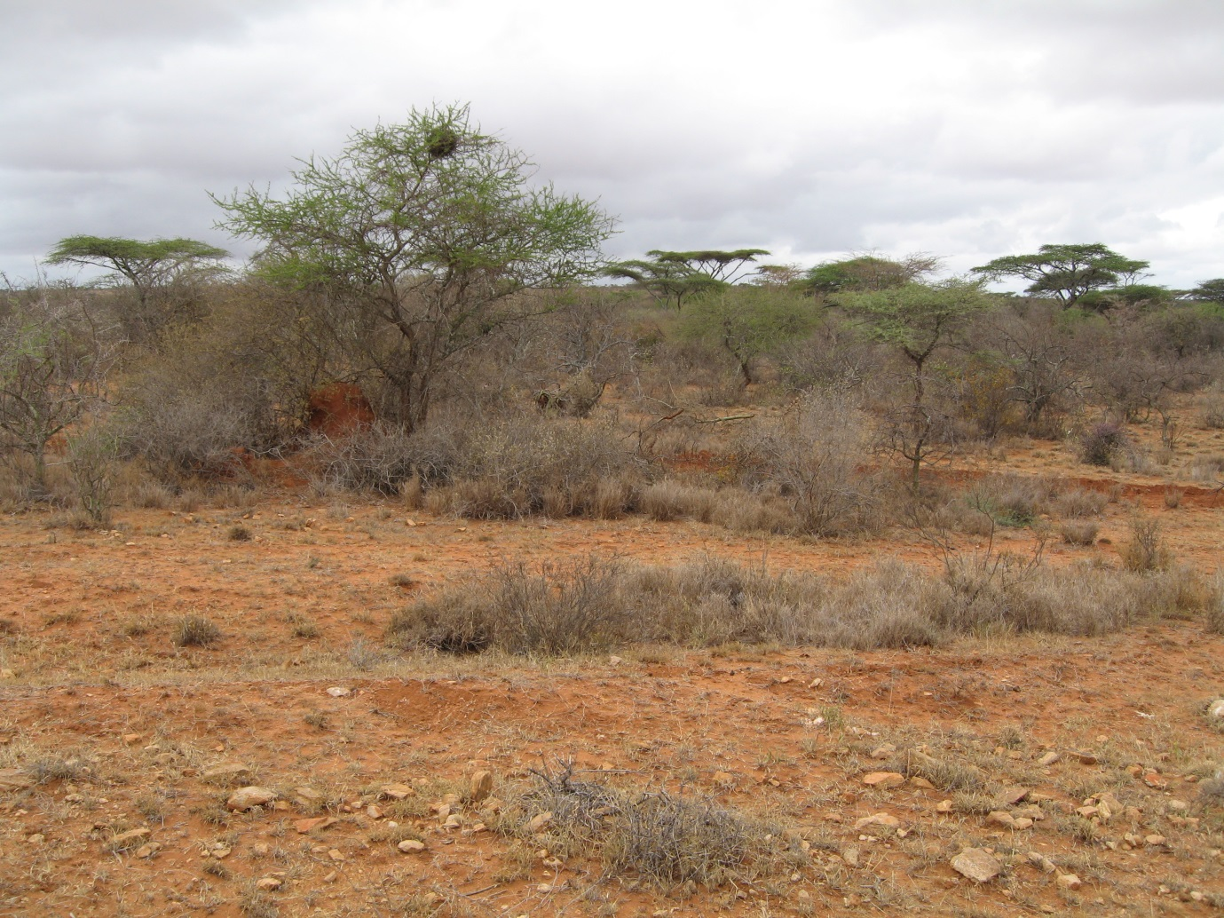
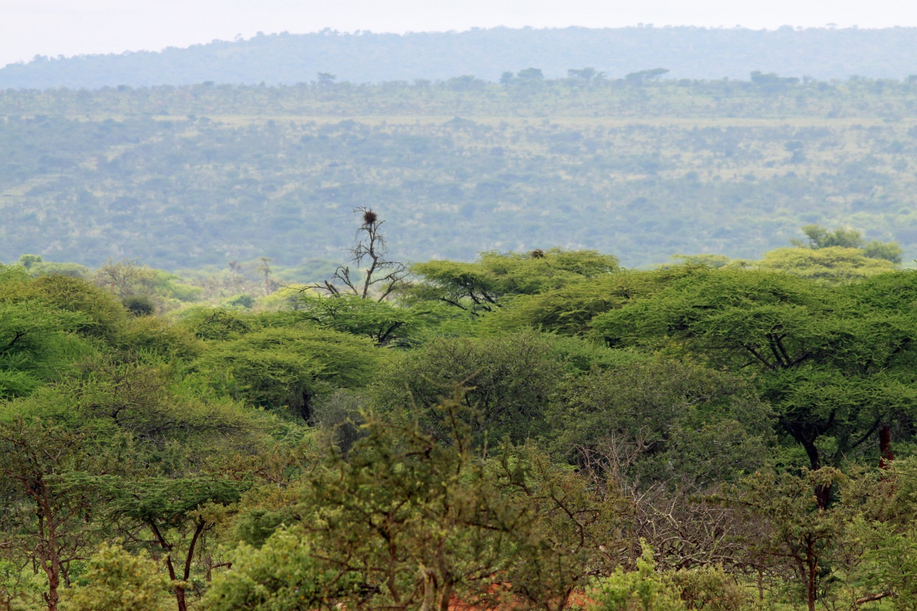

Figure S2. Bush-crow presence and absence locations used in Species Distribution Modelling (SDM).
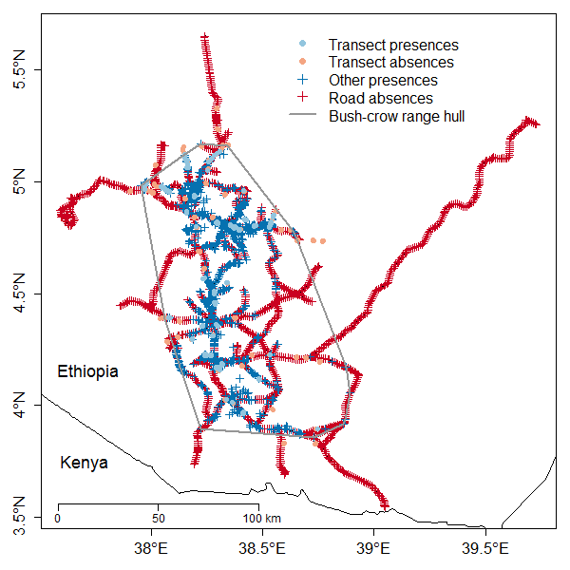

Figure S3. The location of study sites (blue) used to record Ethiopian Bush-crow, White-crowned Starling and Superb Starling behaviour. Site locations are overlaid on a map of the simulated, climatically suitable range for the Ethiopia Bush-crow (green) based on our best-fitting Species Distribution Model (SDM). The previously used convex hull around the outermost Bush-crow records (Donald et al. 2012, Bladon et al. 2016) is shown in red.
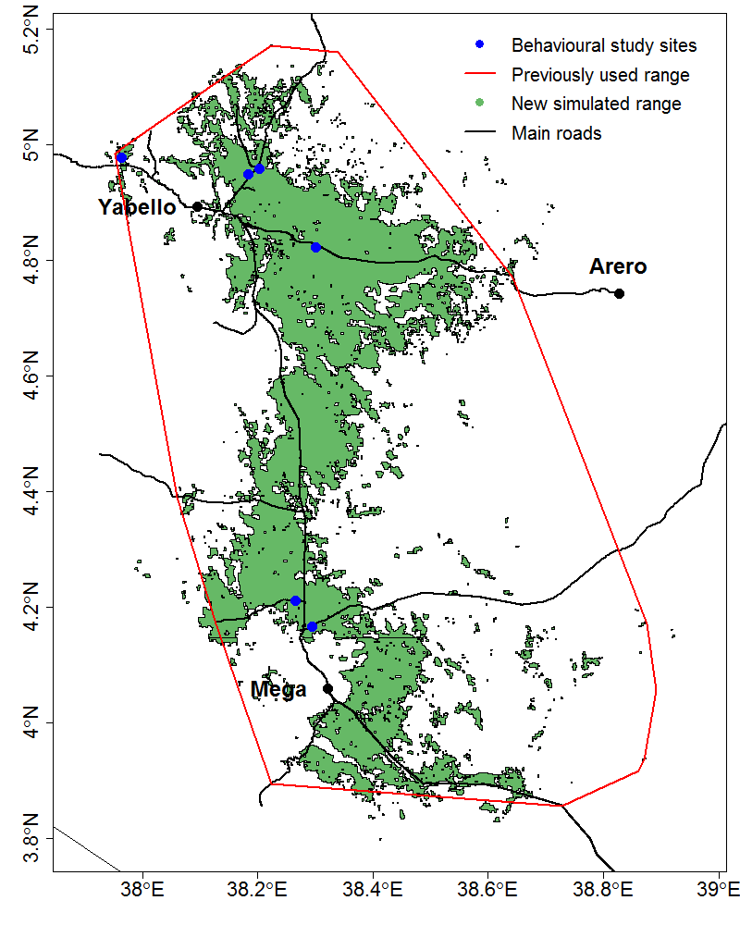
Figure S4. Relationship of the proportion of time spent panting to temperature in full sunlight for the Ethiopian Bush-crow, White-crowned Starling and Superb Starling. Points show data from individual follows.
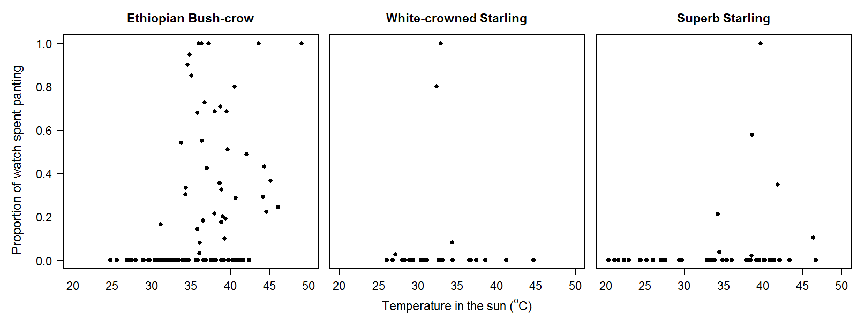

Figure S5. The response of partial probability of Ethiopian Bush-crow occurrence to each bioclimatic variable. Lines show the predicted response to each variable according to each model algorithm, with all other variables held constant.
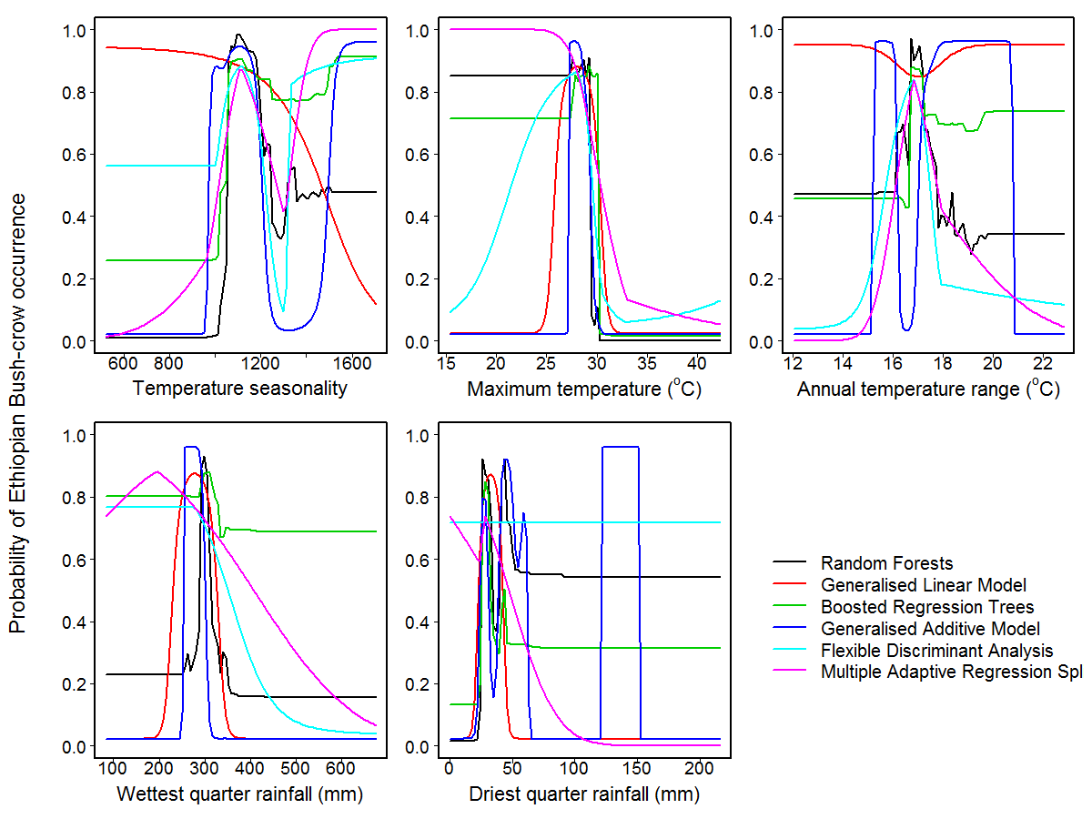

Figure S6. The predicted response of partial probability of occurrence to each bioclimatic variable for A) White-crowned Starling and B) Superb Starling. Lines show the predicted response to each variable according to each model algorithm, with all other variables held constant.
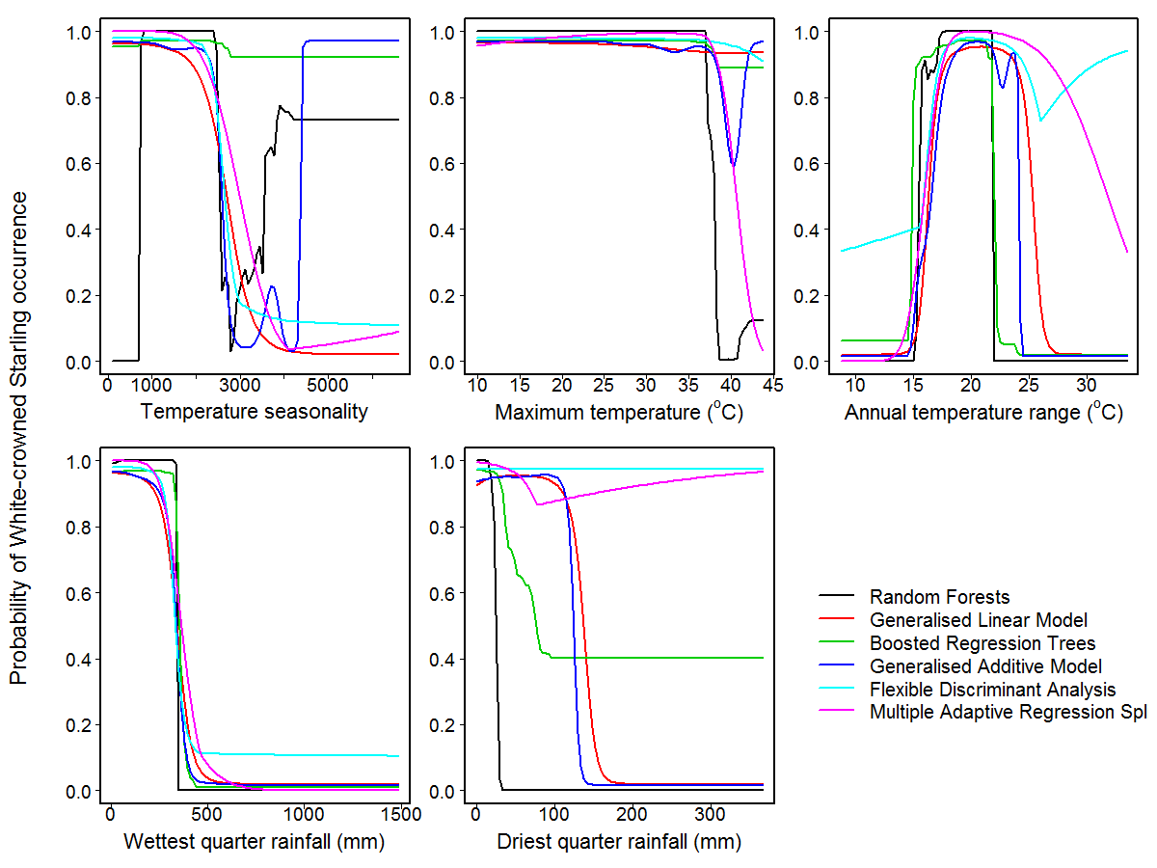
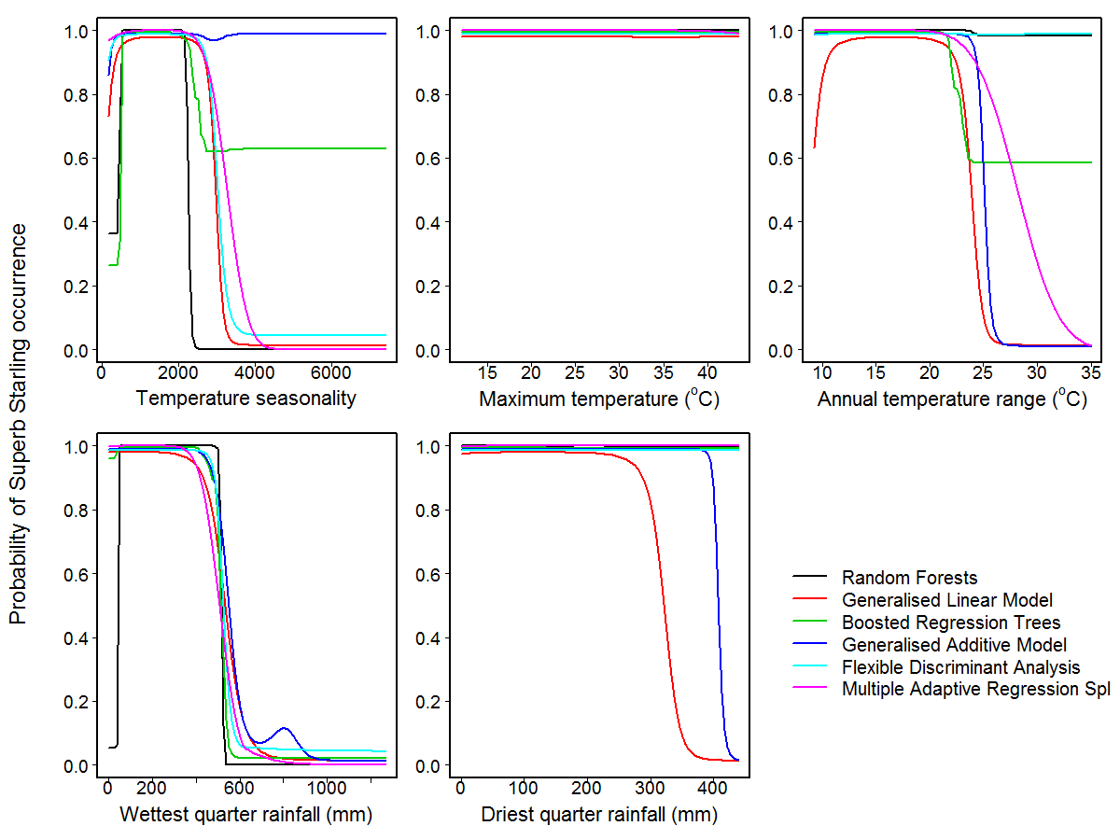

REFERENCES
Bladon, A. J., Jones, S. E. I., Collar, N. J., Dellelegn, Y., Donald, P. F., Gedeon, K., … Wondafrash, M. (2016). Further notes on the natural history of the Ethiopian Bush-crow Zavattariornis stresemanni. Bulletin of the African Bird Club 23: 27–45.
Donald, P. F., Gedeon, K., Collar, N. J., Spottiswoode, C. N., Wondafrash, M., & Buchanan, G. M. (2012). The restricted range of the Ethiopian Bush-crow Zavattariornis stresemanni is a consequence of high reliance on modified habitats within narrow climatic limits. Journal of Ornithology 153: 1031–1044. doi:10.1007/s10336-012-0832-4
Fielding, A. H., & Bell, J. F. (1997). A review of methods for the assessment of prediction errors in conservation presence/absence models. Environmental Conservation 24: 38–49.
Hanley, J. A., & McNeil, B. J. (1982). The meaning and use of the area under a receiver operating characteristic (ROC) curve. Radiology 143: 29–36. doi:10.1148/radiology.143.1.7063747
Huntley, B., Green, R. E., Collingham, Y. C., & Willis, S. G. (2007). A Climatic Atlas of European Breeding Birds. Lynx Edicions, Barcelona, Spain.
Pearce-Higgins, J. W., & Green, R. E. (2014). Birds and Climate Change: Impacts and Conservation Responses. Ecology, Biodiversity and Conservation. Cambridge University Press, UK.
R Core Team (2016). R: A Language and Environment for Statistical Computing. R Foundation for Statistical Computing, Vienna, Austria.
Swets, J. A. (1988). Measuring the accuracy of diagnostic systems. Science 240: 1285–1293.
Thuiller, W., Lafourcade, B., Engler, R., & Araújo, M. B. (2009). BIOMOD – a platform for ensemble forecasting of species distributions. Ecography 32: 369–373. doi:10.1111/j.1600-0587.2008.05742.x

