Chemically Characterising the Cortical Cell Nano-Structure of Human Hair using Atomic Force Microscopy integrated with Infrared Spectroscopy (AFM-IR)

A. P. Fellows*, M. T. L. Casford and P. B. Davies

Department of Chemistry
University of Cambridge
Lensfield Road
Cambridge
CB2 1EW
UK
*Corresponding Author: apf36@cam.ac.uk; +44 (0)1223 334663
Keywords: Atomic Force Microscopy, Infrared Nanospectroscopy (AFM-IR), Hair, Cortical Cells, Amide Deconvolution, Protein Secondary Structures
Abstract
OBJECTIVE: The use of conventional microscopy and vibrational spectroscopy in the optical region to investigate the chemical nature of hair fibres on a nanometre scale is frustrated by the diffraction limit of light, prohibiting the spectral elucidation of nanoscale sub-structures that contribute to the bulk properties of hair. The aim of this work is to overcome this limitation and gain unprecedented chemical resolution of cortical cell nanostructure of hair.
METHODS: The hybrid technique of AFM-IR, combining atomic force microscopy with an IR laser, circumvents the diffraction limit of light and achieves nanoscale chemical resolution down to the AFM tip radius. In this work, AFM-IR was employed on ultra-thin microtomed cross-sections of human hair fibres to spectrally distinguish and characterise the specific protein structures and environments within the nanoscale components of cortical cells.
RESULTS: At first, a topographical and chemical distinction between the macrofibrils and the surrounding intermacrofibillar matrix was achieved based on 2.5x2.5μm maps of cortical cell cross-sections. It was found that the intermacrofibrillar matrix has a large protein content and specific cysteine-related residues, whereas the macrofibrils showed bigger contributions from aliphatic amino acid residues and acidic-/ester-containing species (e.g. lipids). Localised spectra recorded at a spatial resolution of the order of the AFM tip radius enabled the chemical composition of each region to be determined following deconvolution of the Amide-I and Amide-II bands. This provided specific evidence for a greater proportion of α-helices in the macrofibrils and correspondingly larger contributions of β-sheet secondary structures in the intermacrofibrillar matrix, as inferred in earlier studies. Analysis of the parallel and antiparallel β-sheet structures, and of selected dominant amino acid residues, yielded further novel composition and conformation results for both regions.
CONCLUSION: In this work, we overcome the diffraction limit of light using atomic force microscopy integrated with IR laser spectroscopy (AFM-IR) to characterise sub-micron features of the hair cortex at ultra-high spatial resolution. The resulting spectral analysis shows clear distinctions in the Amide bands in the macrofibrils and surrounding intermacrofibrillar matrix, yielding novel insight into the molecular structure and intermolecular stabilisation interactions of the constituent proteins within each cortical component.

Introduction
The structure of hair fibres has been the focus of much research over the last century with several techniques used to investigate their structure.^{1–4} Hair fibres consist of three main regions (from innermost to outermost respectively): the medulla, the cortex and the cuticles, shown schematically in Figure 1.^{1,5–9} The medulla makes up the centre of the hair and consists of highly disordered fibrillar cells interspersed with vacuoles, therefore having a low density.^{1,5,10} It can exist continuously or discontinuously and may even be completely absent (a phenomenon often related to the overall fibre thickness).^{1,5,7,10} The outermost region of a hair fibre comprises the cuticle which is formed from between 5 and 10 layers of overlapping cuticle cells, each approximately 0.5-1.0 μm thick. It has been extensively investigated.^{1,5,9}
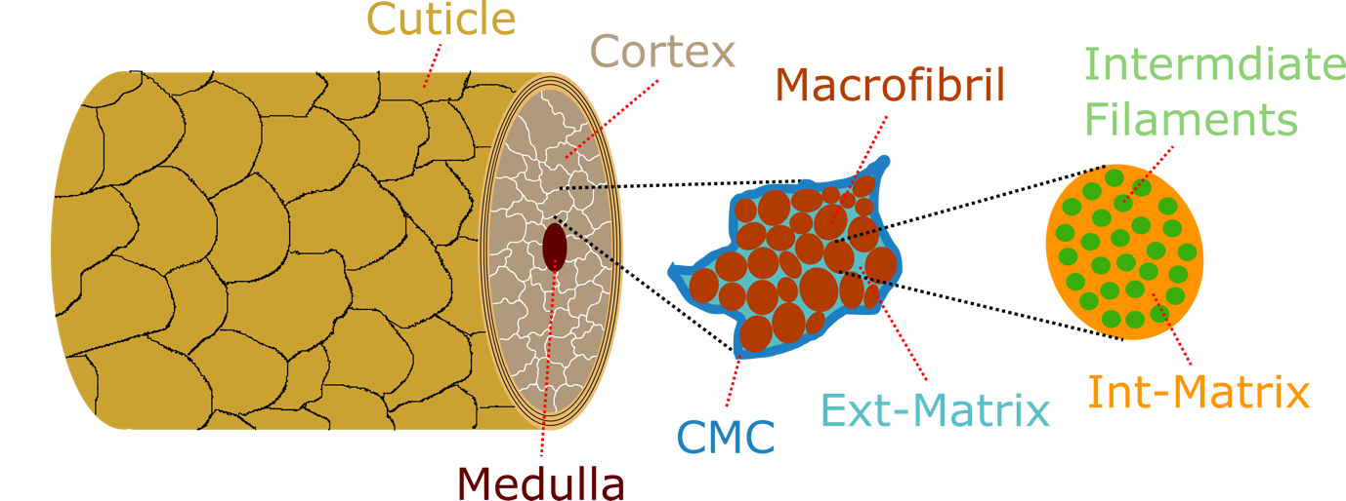
Figure 1: Schematic representation of the fundamental structure of a hair fibre showing the three main structural regions: the medulla, the cortex and the cuticle. The first inset shows an enlargement of a cortical cell with its structural regions: the cell membrane complex (CMC), macrofibrils, and surrounding intermacrofibrillar matrix material. The second inset shows a further enlargement of an individual macrofibril showing its sub-structure: intermediate filaments interspersed within intramacrofibrillar matrix material.
The main constituent of hair fibres of relevance to their mass, volume and associated mechanical properties, however, is the cortex,^{1,6,11} which is the subject of the present study. As with the two other macroscopic regions, the physical structure of the cortex has been widely studied and consists of long, spindle-shaped and tightly-packed cortical cells embedded in a cell membrane complex (CMC).^{1,5,9,12} Individual cortical cells are made up of packed macrofibrils within an amorphous protein matrix, the intermacrofibrillar matrix (referred to subsequently as the Ext-matrix for brevity, Ext indicating it is external to the macrofibrils, inset to Figure 1). The macrofibrils, aligned parallel to each other like the cortical cell itself, show a similar rod-like geometry and give rise to the fibrous nature of bulk hair.^{1,5,12} Macrofibrils are comprised of smaller microfibrils (also referred to as intermediate filaments) and subsequently into even smaller sub-units until ultimately reaching the fundamental coiled protein chain dimers which exist predominantly as α-helix secondary structures.^{5,12,13} There is a significant proportion of these coiled α-helix protein structures within macrofibrils and consequently also a significant propensity for tensile deformation with associated alpha-beta secondary structure transitions, which were characterised by Cao in 2002 and later by Kreplak et al. in 2004.^{14,15} The α-helices of the macrofibril sub-units are held within the intramacrofibrillar matrix (referred to subsequently as the Int-matrix, Int indicating it is internal within the macrofibrils, further inset in Figure 1) with its high protein content and significant proportion of cystine, formed from two cysteine residues linked with a disulphide bond.^{5,6,16–18} Like the Int-matrix, the Ext-matrix also constitutes high levels of Cys residues. However, the Ext-matrix is gel-like and known to swell in high humidity environments. This is, therefore, attributed to a fairly low proportion of intra-matrix cross-linking.^{6,16–18}

As the major constituent, and responsible for a significant proportion of the structural and mechanical properties of hair, quantitative characterisation of the chemical and physical sub-structure of the cortex is clearly important. AFM-IR combines the localised scanning features of Atomic Force Microscopy with the chemical characterisation of IR-spectroscopy in a surface selective method, providing nanoscale resolution of both IR vibrational transitions and topography. An intrinsic feature of AFM-IR is that the drawback imposed by the diffraction limit of conventional IR microscopies is eliminated, resulting in previously unachievable resolution for IR based chemical mapping.¹⁹ Because of this, AFM-IR has proved to be a powerful analytical tool across a large variety of substrates, including many of significant relevance to biological substrates, such as red blood cells^{20–23}, amyloid fibrils²⁴, hydrogels²⁵, bacteria²⁶, and lipid monolayers²⁷. Furthermore, AFM-IR was first applied to human hair cross sections by Marcott et al. who showed the localisation of structural lipids to the medulla and the CMC separating the cuticle layers.²⁸ More recently, AFM-IR has also been employed to analyse the layered structure of the cuticles by probing the external hair surface.²⁹ The current study extends this work, focussing on chemical characterisation of the internal sub-structures of hair cortical cells in order to gain insight into the differential constitution of the individual components.
Experimental
Sample Preparation
Human hairs (European brown) from multiple individuals were first washed several times with Millipore water and rinsed with methanol. Bundles of 5 to 10 hairs were sectioned into samples 100, 200 or 300 nm thick with a diamond tipped microtome. This provided samples where the different regions of individual hairs could be investigated as well as any hair to hair variation. Several methods of microtoming were investigated namely sectioning free unsupported fibres, fibres loosely supported in plastic pipette tips and fibres held in a resin support. A cryo-ultramicrotome to freeze the fibres during microtoming was also investigated. Resin embedding of fibres for microtoming was found to be the best method for producing reliable and reproducible samples for AFM-IR. The samples were subsequently mounted without adhesive on glass coverslips for AFM-IR analysis. Spectral contributions from the resin diminished throughout the cuticle with minimal presence in the cortex so that changes to spectroscopic and physical properties of the samples were only detectable in the 3-7 µm regions of the section perimeters. The results presented here were recorded close to the centre of the cross section between 20 and 30 µm from the perimeter.

The predominant contribution to the AFM-IR signal at the three selected thicknesses comes from the surface layer with diminishing but finite contributions from deeper into the sample. It was established there were no contributions to the signals from the cover slips by comparing spectra from the different thicknesses as well as from the cover slips themselves. In fact, contributions from the surface of the cover slip are insignificant in comparison with spectral variations between the different components within the cortical cells. Furthermore, these spectral variations suggest that the contributions from deeper in the sample also maintain significant differentiation, suggesting only limited axial variability through the sample depth. This can be attributed to the fibrillar nature of the components which, because of their size in terms of both their area and depth in the sample, means they make a significant contribution to the AFM-IR spectra and represent the major component of the material axially beneath the tip. The choice of sample thickness is a compromise between maximising the IR absorption that generates measurable cantilever deflections and maintaining a thin enough sample to resolve individual components. The IR signal to noise ratios at the selected thicknesses were more than sufficient to discriminate between the two structural components of interest here.

AFM-IR Analysis
Spectra and maps were recorded in contact mode using an Anasys NanoIR2 instrument equipped with a MIRcat Laser system (Daylight Solutions) containing four quantum cascade lasers (QCLs) covering the 1125-2298 cm⁻¹ spectral range with transition boundaries at ~1460, 1710 and 2000 cm⁻¹. The AFM cantilever-tip assemblies used (ATEC-ContAu, Apex Probes) were gold-coated with 30 nm tip radius, approximate cone angle of ~12° (aspect ratio >4:1 over the last 1.5µm), spring constant 0.02-0.75 Nm⁻¹ and resonant frequency 7-25 kHz. An SEM image of the tip showing the approximate radius and cone geometry is given in Supplementary Information, Figure S1. Mapping was achieved with a 0.5 Hz scan rate at resolutions of at least 200 x 200 pixels. IR analysis was undertaken in resonant-enhanced mode using the second resonance frequency at ~200kHz (3% duty cycle) with tracking the contact resonance for mapping with a phase-lock loop (PLL). IR maps are presented here as recorded, with no background intensity correction. The laser power was varied between 3 and 11%, depending on the cross-section thickness, with the objective of optimising the signal-to-noise ratio whilst avoiding saturating the detector. Spectra were recorded at 1 cm⁻¹ per point to enable optimum subtraction of the sharp water vapour bands and hence aid accurate spectral deconvolution.

Spectral Analysis
AFM-IR spectra were recorded under reduced-humidity (dry N₂) to minimise water vapour bands that appear in the Amide-I region. The spectra were automatically background-corrected to account for environmental absorptions and variations of the laser power spectrum. Two of the QCL chip transitions occur within the regions of interest at ~1460 and 1710 cm⁻¹. The 1710 cm⁻¹ transition coincides with a carbonyl absorption band and could therefore be corrected with confidence. The lower transition at 1460 cm⁻¹ presented with a step-like function, probably due to the very low laser power of both chips at this frequency. Significant uncertainty must therefore arise from spectral analysis of this feature as well as when comparing intensities at frequencies either side of the transition frequency. However, as the main analysis of the different hair structures was undertaken using the Amide-I and Amide-II bands, this transition falls outside the required spectral range, thus eliminating these concerns.
Further background subtraction was then applied to remove underlying broad spectral variations using a spline curve followed by smoothing using a 7pt low-pass FFT-filter. This removed high frequency noise contributions and had a minimum effect on any broader underlying spectral features.³⁰ The FFT treatment was carefully applied by comparing smoothed spectra to their raw counterparts to minimise any effect on the underlying spectral features. The same spectral procedure has been used previously on AFM-IR spectra of hair fibres where a comparison of the as-recorded and processed spectra was made and no significant alteration to the underlying spectral intensities was found.²⁹ The smoothing steps then enable derivative analysis to be applied in order to identify band-centres and hence accurate spectral deconvolution into the contributing bands. Confidence in the deconvolution procedure arises firstly from the minimising of the underlying spectral deviations from the FFT smoothing, and secondly because the derivative analysis identifies bands at well-known band frequencies reported in the literature.

Spectra were recorded and averaged (3-5 co-averages per point) over 10 different surface locations on a given cross-section corresponding to the macrofibrils and intermacrofibrillar matrix, showing good reproducibility both across different locations on the same cross-section as well as for different cross-sections corresponding to the same hair fibre. It was found that further averaging over more surface locations on a given sample made minimal changes to the average spectra due to the high reproducibility achieved. Some variability in the absolute spectral contributions from average spectra between cross-sections of different fibres was observed, which is to be expected for complex biological samples. However, the relative comparisons of average spectra between the macrofibrils and surrounding matrix were qualitatively consistent, leading to the same conclusions reported later. Due to the variability between fibres, the ‘global average’ relative intensities are not presented here as they contain disproportionately high uncertainties and are not representative of the qualitative differences observed for a given sample. Furthermore, as there is significant variability between different fibres, the analysis and conclusions presented here are based on qualitative comparisons of relative spectral intensities rather than on quantitative specific intensity data. Instead, the spectra and analysis presented here are from a representative fibre, with spectra averaged across multiple locations within a section and across several sections.

Results
Figure 2 shows AFM-IR analysis of the cortical cell, displaying averaged individual point spectra corresponding either to the Ext-matrix regions or to macrofibrils, as well as AFM topography maps alongside maps at specific IR bands observed in the spectra from a representative cross-section. Band assignments from the literature are given in Table 1. The survey recordings of the AFM-IR spectral maps and point spectra show significant variation in the relative band intensities between the Ext-matrix and macrofibril regions on the surface. The maps at 1330, 1465 and 1736 cm⁻¹ all show increased intensity for the macrofibrils and smaller contributions from the Ext-matrix whereas all other mapped frequencies show the reverse i.e., enhanced IR signal for the Ext-matrix and less for the macrofibrils. Although the spectral intensity is small, these variations are nevertheless confirmed in the spectra themselves which, although they haven’t been normalised, show larger relative contributions from the 1330, 1465 and 1736 cm⁻¹ bands in the macrofibril averaged spectrum. The structural interpretation of the nine bands identified in Table 1 is presented below.

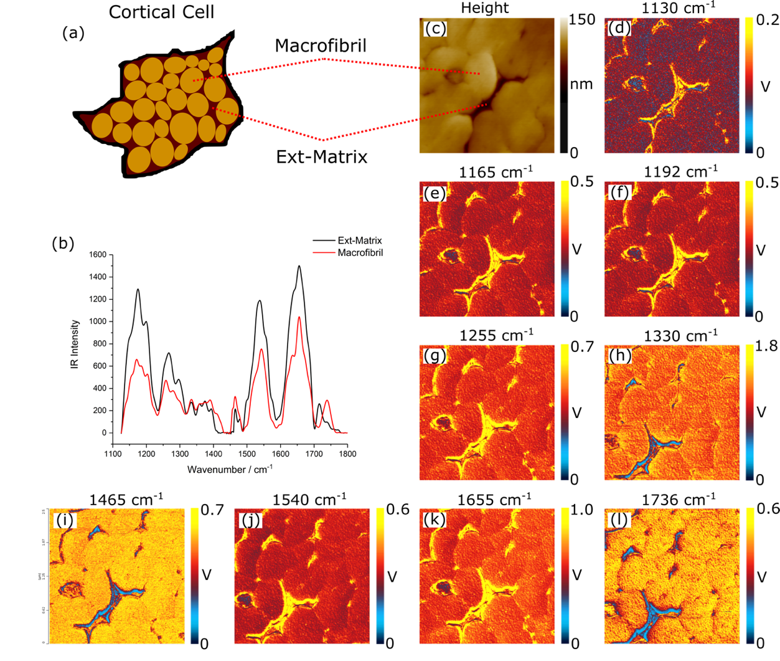
Figure 2: AFM-IR data obtained from a human hair cross-section (approx. 300 nm thick) showing (a) a schematic structural representation of the cortical cell (b) average spectra corresponding to each observed region (macrofibril and Ext-matrix) (c) AFM height map and (d)-(l) IR-intensity maps recorded in contact mode across a 2.5 × 2.5 μm region of the surface at a number of different infrared frequencies corresponding to contributions observed in the spectra (each shown above the corresponding image) for a representative fibre section.

Table 1: Assignments of the bands observed in Figure 3 based on data reported in the literature.^{31–38}
Band / cm⁻¹ | Assignment
1130 | SO₂ Stretch (Cysteine-Related Products)
1165 | Asymmetric Cysteic Acid Stretch
1192 | SO₂ Sulfonyl Chloride Stretch
1255 | Amide-III
1330 | C-H Twist / Wag
1465 | CH₂ Scissor or CH₃ Asymmetric Bend
1540 | Amide-II
1655 | Amide-I
1736 | Carbonyl C=O stretch

The assignments of the bands at 1330, 1465 and 1736 cm⁻¹ given in Table 1 and the observed intensities in the AFM-IR spectra and maps in Figure 2 indicate that the macrofibril regions show greater contributions from C-H and carbonyl C=O carriers. Given their long hydrocarbon chain groups and their ester functionalities, lipid and triglyceride species would be expected to make significant contributions to both the C-H and C=O spectral regions. However, it is well known that, in the human hair cortex, lipids and triglycerides are only present in significant quantities within the β-layers and the δ-layer, respectively, of the CMC, with most regions predominantly occupied by an abundance of proteinaceous material.^{39–43} Because of this, even though proteins have relatively low hydrocarbon content (cf. lipids and triglycerides), it is reasonable to assume that the main contributor to the C-H backbone peaks at 1330 and 1465 cm⁻¹ is proteinaceous in nature. More specifically, aliphatic amino acid residues such as leucine which are known to be highly prevalent in the hair cortex,^{44,45} are likely to be significant sources of these bands.

Unlike the C-H contributions, however, most amino acids do not present with a carbonyl group above 1700 cm⁻¹. Only those with acidic side chains will give rise to higher carbonyl stretching frequencies >1700 cm⁻¹ e.g. Glutamic acid (Glu) and Aspartic acid (Asp) which are known to be the most prevalent and have carbonyl bands coinciding with observation.^{44,45} Hence, the relative lipid and triglyceride contributions to this spectral region are expected to be significantly greater despite the low levels of lipids and triglycerides within the cortex. Additionally, the position of carbonyl bands above 1700 cm⁻¹ is expected to vary due to the wide range of chemical environments and association states that can exist due to hydrogen bonding. This accounts for the broad carbonyl band above 1700 cm⁻¹ appearing in the spectra in Figure 3 and which, interestingly, shows a different structure in the two areas investigated. To summarise, in the AFM-IR maps, all three bands assigned to C-H and C=O functional groups appear with greater intensity for the macrofibrillar regions i.e., there are greater concentrations of the carriers of these bands in these regions. However, the significant overlap of the bands means that IR mapping by analysing individual contributions is unreliable.

The bands at 1655, 1540 and 1255 cm⁻¹ all source from predominantly protein-related species, being assigned to three amide bands. Although significant in both regions, their relative intensity is greater in the Ext-matrix. Similarly, the bands related to cysteine (Cys) derivatives at 1130, 1165 and 1192 cm⁻¹ also have an increased intensity in the Ext-matrix cf. the macrofibrils. (Although the Cys bands can overlap with those from lipid and triglyceride C-O moieties, these modes should be significantly weaker due to their relative abundances i.e. significant Cys in matrix material and lower lipids contributions within the matrix as mentioned earlier.)

The small band at ~1710 cm⁻¹ in Figure 2, is present in the Ext-matrix and virtually absent in the macrofibril regions. That this is just a shift in the band centred at 1736 cm⁻¹ in the macrofibril spectrum can be discounted since this feature is also present in the Ext-matrix spectra but with much lower intensity. As already mentioned, C=O bands above 1700 cm⁻¹ are expected to show significant variation in their positions due to large environmental shifts for the carbonyl carrying moieties. Therefore, the region >1700 cm⁻¹ is expected to house several contributions from different carbonyl environments. It is reasonable to assign the band at 1710 cm⁻¹ to contributions from acidic amino acid side chains with significant intermolecular H-bonding, well known to weaken the carbonyl bond and hence reduce the stretching frequency. The broader band centred at 1736 cm⁻¹, however, must arise from stronger carbonyl moieties e.g. esters sourcing from lipids or triglycerides as well as acidic side chain amino acids with less intermolecular association i.e. stronger carbonyl bonds. From this analysis of the AFM-IR spectra for the two different regions, it is clear that there is a large variation in the carbonyl group environments and their states of association within the cortex region, with each component region exhibiting different relative contributions from each carbonyl environment. A more detailed discussion of these contributions follows below.

It is important to note that the IR mapping presented in Figure 2 does not lead to conclusive chemical analysis of the structures of interest owing to potential measurement artefacts that can arise due to tip-sample coupling and imperfect tracking across the surface. (In this case the imperfect tracking effects appear to be minimal, as demonstrated by the low intensity deflection map in Supplementary Information, Figure S2.) Additionally, there are intensity contributions that arise from resonances at nearby frequencies in the spectra. The latter point is particularly worthy of consideration given the highly convoluted nature of the Amide bands from proteinaceous material. It is, therefore, crucially important to analyse the observed structures using point spectra, where the highly convoluted bands can be deconvoluted, in order to characterise their chemical structure and constituents.

Since a significant proportion of the composition of hair is composed of protein, the contribution that they make to the macroscopic properties of hair fibres is of central importance. Hence characterisation of the protein structure in different regions has been of particular interest in much of the large amount of work reported to date.^{5,44–48} Therefore our attention was focussed on deconvoluting the Amide-I and Amide-II spectral region (1470-1780 cm⁻¹) with spectra smoothed with a 7-point FFT-filter to reduce noise and allow for second-derivative peak-finding. The resulting spectra within this region, along with their second derivatives, are shown in Figure 3.
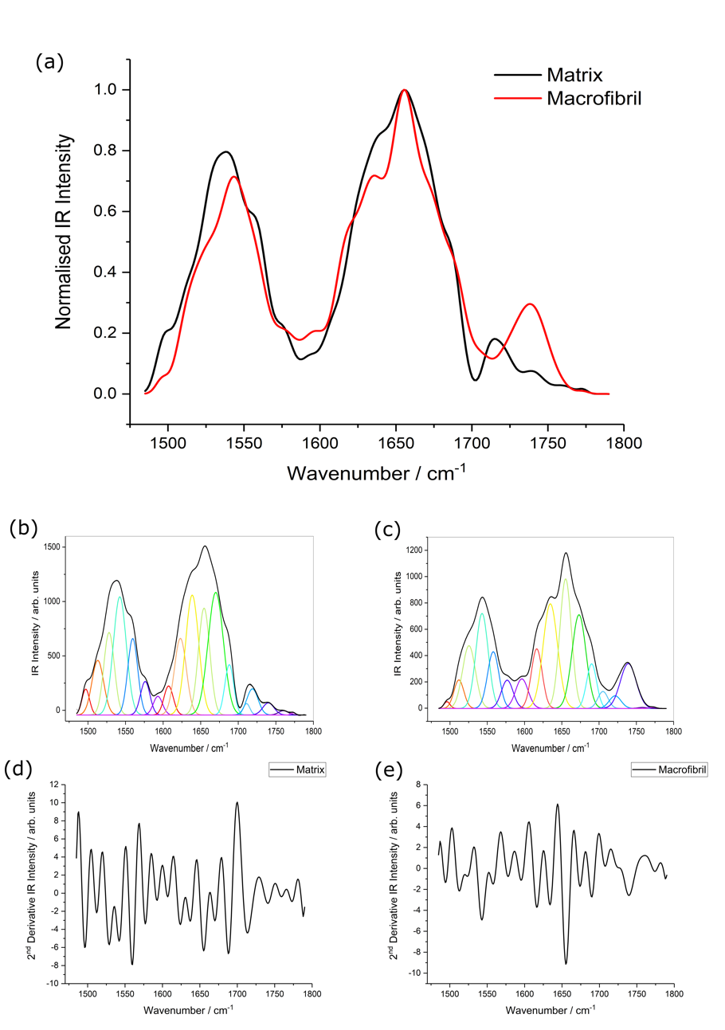
Figure 3: AFM-IR spectral analysis of the Ext-matrix and macrofibrils showing (a) overlapping spectra from 1470 to 1780 cm⁻¹, containing the Amide-I and Amide-II regions of the spectra shown in Figure 2, as well as individual deconvoluted spectra in this region for (c) the matrix and (d) the macrofibrils. The smoothed spectra were fitted using the contributing bands that were identified in the second-derivative spectra shown in (d) and (e) as described in the text.
From the fitted spectra, it is clear that there is a difference in the number of contributing bands in the two regions. The second-derivative plots show similar band centres for all contributing bands except the band at approximately 1616 cm⁻¹ which is missing in the Ext-matrix spectrum but replaced with two bands at 1607 and 1623 cm⁻¹ which are not present in the macrofibril spectrum. Since the separation of these bands lies outside the cut-off frequency of the FFT smoothing filter (7 cm⁻¹), either of these contributions in the macrofibril spectrum cannot source from the same species as those which give rise to the identified band in the matrix spectrum without cause for a significant band-centre shift. Furthermore, this also suggests a change in the number of clearly identifiable constituent protein structures. The observed bands for macrofibril and Ext-matrix are given in Table 2 where the observed differences between them are ≤ 4 cm⁻¹, i.e., within the uncertainty margin associated with the spectral resolution and subsequent 7pt FFT algorithm. Also given are the assignments of the deconvoluted bands based on well-established data from the literature.^{31,32,49–52}

Table 2: Contributions in the Amide-I and Amide-II spectral regions obtained by second-derivative peak fitting for each of the spectra shown in Figure 3.
 | Matrix | Macrofibril | Assignment
Band 1 | 1497 | 1496 | His / Trp (C-N Str. in ring)
Band 2 | 1513 | 1512 | β-Sheet (Antiparallel)
Band 3 | 1528 | 1525 | β-Sheet (Parallel)
Band 4 | 1542 | 1543 | α-Helix / Random Coil
Band 5 | 1560 | 1558 | Trp (Indole ring vibration)
Band 6 | 1576 | 1577 | Asp / Glu COO⁻ (Antisym Str.)
Band 7 | 1593 | 1596 | His / Tyr / Trp (C-C Str. in ring)
Band 8 | 1607 | - | β-Sheet (Antiparallel)
Band 9 | - | 1616 | β-Sheet (Antiparallel)
Band 10 | 1623 | - | β-Sheet (Antiparallel)
Band 11 | 1639 | 1635 | β-Sheet (Parallel)
Band 12 | 1654 | 1655 | α-Helix
Band 13 | 1670 | 1673 | β-Turn
Band 14 | 1688 | 1690 | Asn / Gln (Amide Str.) / higher β-Sheet
Band 15 | 1711 | 1705 | C=O (Acidic Residues)
Band 16 | 1719 | 1721 | C=O (Acidic Residues)
Band 17 | 1740 | 1739 | C=O (Lipid / Triglyceride Esters)
Band 18 | 1760 | 1758 | C=O (monomeric acid residues)
Band 19 | 1773 | 1773 | C=O (monomeric acid residues)

Figure 4 shows the constituent bands from the Ext-matrix and macrofibril spectra shown in Figure 3 presented in block format, i.e., representing the integrated band intensities. This demonstrates the clear spectral difference between the two regions, with 3 of the assigned bands only being present in 1 of the 2 spectra and the others showing relative intensity shifts. Because of the overlap of bands from different constituents, changes in local concentrations can generally only be deduced after deconvolution (an exception is the relatively well resolved Cys-related band between 1125 and 1225 cm⁻¹). Bands in the Amide-I and Amide-II regions, identified by deconvolution using an FFT-filter and second derivative peak fitting, are given in Table 3 based on previously reported assignments in the literature.³⁰ This table identifies the substantial residues and secondary structures revealed spectroscopically and consequently the regions showing the greater proportions of each.

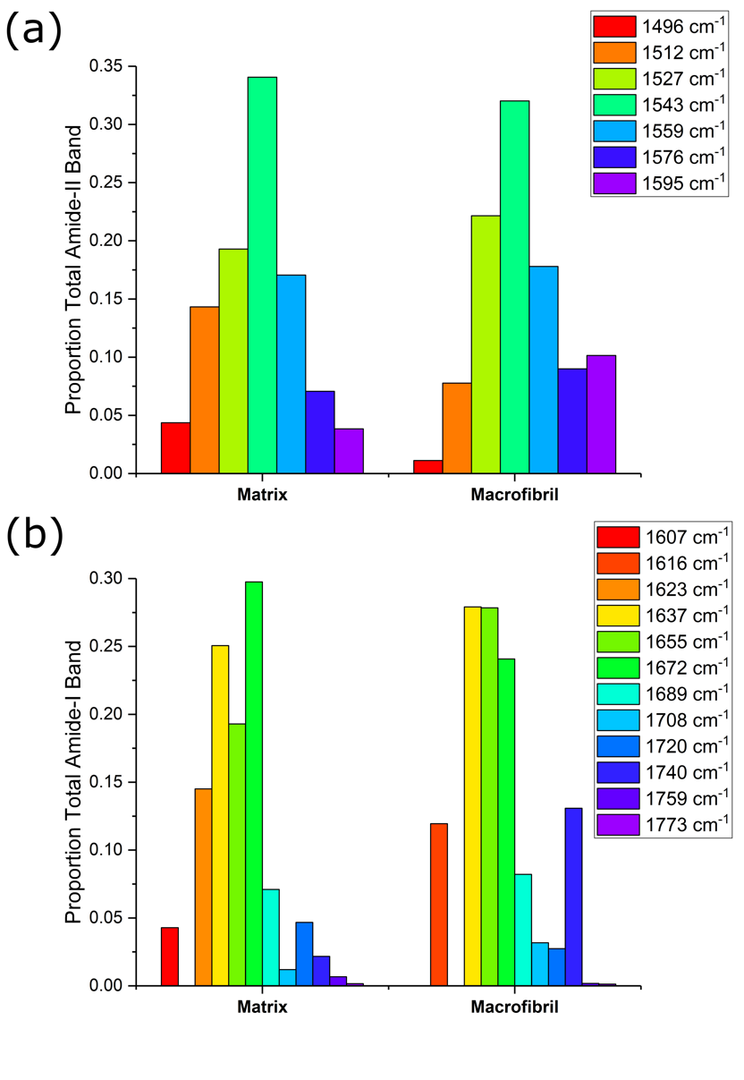
Figure 4: Deconvolution profiles calculated from the contributing band integrations shown in Figure 3; (a) Amide-II and (b) Amide-I.

Table 3: Summary of the contributing residues and secondary structures present in the hair cortex indicating the regions of greater band contributions. The abbreviations used are: Mtx – Ext-matrix, MF – macrofibril (combined intermediate filament and Int-matrix).
Species | Contributing Bands | Greatest Contribution In
Cys | 1130, 1165 and 1192 cm⁻¹ | Mtx
His | 1, 7 | Mtx
Trp | 1, 5, 7 | Approx. Equal
Tyr | 7 | MF (within I-Matrix)
Deprotonated Asp / Glu | 6 | Approx. Equal
Amide side chain Asn / Gln | 14 | MF
H-bonded Acidic Asp / Glu | 15 | MF
‘Free’ Acidic Asp / Glu | 16 | Mtx
Monomeric Asp / Glu | 18-19 | Mtx
Asp / Glu (total) | 6, 14-16, 18-19 | MF
β-Sheet (AP) | 2, 8, 9 | Mtx
β-Sheet (P) | 3, 10, 11 | MF
β-Sheet (total) | 2-3, 8-11 | Mtx
α-Helix | 4, 12 | MF
Random Coil | 4 | Mtx
β-Turn | 13 | Mtx
Lipid / Triglyceride | 17 | MF

Discussion

To begin we consider the information that can be deduced from the AFM-IR maps and average spectra presented in Figure 2. The spectra, averaged over several points on the surface in the regions of the macrofibrils and the Ext-matrix, and across different sections of the same fibre, show significant differences in the relative intensities for the various bands. The macrofibril regions show higher intensity for the bands corresponding to C-H moieties (1330 cm⁻¹ C-H twist / wag and the 1465 cm⁻¹ combination of CH₂ scissoring and CH₃ asymmetric bending). The major contributions to the C-H band intensity are from the aliphatic amino acid residues in the proteinaceous material and from the lipid tail groups, due to a higher proportion of CH₂ groups compared to non-aliphatic protein species. The 1736 cm⁻¹ band also shows a much-increased profile for the macrofibrils, but this is a result of overlapping bands from numerous species and environments making spectral deconvolution necessary for quantitative analysis. Similarly, those bands associated with Cys-related molecules that have S-O related stretches in the 1100-1200 cm⁻¹ spectral region (cystine, cystine monoxide / dioxide, cysteic acid / sulfonyl chloride), as well as the generic protein-associated bands (Amide-I, -II and –III) which originate from all amino acid residues, all show an increased profile in the Ext-matrix compared to the macrofibrils regions. The spectral results are consistent with the known structure and composition of the Ext-matrix as being a highly proteinaceous region with considerable Cys content (high-sulphur keratin-associated proteins, KAPs) and minimal lipid presence.

At first it might be assumed that the amorphous material constituting the Ext-matrix might have a lower protein density than the macrofibrils, which contain well-ordered intermediate filaments. However, the macrofibrils contain both intermediate filaments and Int-matrix and hence the protein content in them will be averaged over both species. The intermediate filaments are stabilised through significant H-bonding of the intramacrofibrillar material and it is reasonable to assume that this results in an increased intermolecular spacing and a decreased density compared to the Ext-matrix. This follows with the observed increases in the IR maps corresponding to the Amide bands in the Ext-matrix regions. The lipid component of the macrofibrils, however, is found to be significantly greater than in the Ext-matrix, contrary to some previous suggestions that lipid can be pushed into intermacrofibrillar material during the growth and hardening of the hair fibres.²⁸

Any structural lipids that are bound within protein networks are more likely to remain within the Int-matrix where greater stabilisation of the intermediate filament proteins can result, in agreement with the difference in lipid content between the two structures found here (although it should be mentioned that both have relatively low lipid contributions c.f. proteinaceous material). Leucine has been previously found to be a dominant amino acid in the hair cortex and to be in greater proportions in the intermediate filament proteins of the macrofibrils compared to the surrounding Ext-matrix, hence the enhanced C-H 1330 and 1465 cm⁻¹ bands for the macrofibrils.
We next consider the structural results derived from examining the spectra comprising the Amide-I and II regions. In the Amide-I region, whereas the Ext-matrix shows bands at 1607 cm⁻¹ (band 8) and 1623 cm⁻¹ (band 10), there is only one band in this region in the macrofibril spectra at 1616 cm⁻¹ (band 9). All three are assigned to anti-parallel β-sheet structures and therefore must arise from a different arrangement of these secondary structures as noted previously by Litvinov et al.⁵³. The band at 1616 cm⁻¹ strongly suggests that the macrofibrils have different β-sheet structures with more intermolecularly H-bonded, aggregated protein. Given that the hair fibres are generally not under tension, the intermediate filaments will majoritively consist of α-helix protein structures, hence the β-sheet contributions most likely arise from the Int-matrix within the macrofibrils. The observed variation shows that the Int-matrix presents more intermolecularly H-bonded β-structures whereas the Ext-matrix exists with both intramolecular β-sheet structures and some intermolecular H-bonding, but with significantly different aggregation structures. Band 11 (1635-9 cm⁻¹), associated with the parallel β-sheet secondary structure, shows a greater proportion from the macrofibril (Int-matrix) despite higher concentrations of overall β-sheet structures in the Ext-matrix. This illustrates the differences in the two types of matrix material: the Int-matrix is dominated by the less stable parallel β-sheets and β-sheets involved in intermolecular H-bonding interactions. Conversely, the Ext-matrix exhibits both strong intermolecular H-bonding and intramolecular interactions within its β-sheet structures which exist mostly in the antiparallel arrangement, consistent with a greater conformational and structural freedom within the Ext-matrix. In contrast, the network of proteins in the Int-matrix is more restricted and is believed to be due to the significant cross-linking from Cys-related species and stabilising interactions between the Int-matrix and intermediate filaments. The Ext-matrix consists of homogeneous matrix material unlike the macrofibrils which are a combination of the Int-matrix and intermediate filaments. It is, therefore, expected that both types of matrix species will present high Cys-related proportions. The gel-like Ext-matrix is highly susceptible to water uptake and, despite having a high Cys content, is not expected to present significant cross-linking in contrast to the macrofibrils where cross-linking is thought the be more significant. This conclusion is compatible with the more restricted protein network observed within the macrofibrils as well as the greater intensity from the Cys-oxidation products which indicates Cys residues that are not undergoing cross-linking. The complementary α-helix secondary structures in these regions (band 12 at 1654-5 cm⁻¹) shows that there is a greater contribution in the macrofibrils, as expected and consistent with their observed lower β-sheet contributions.
The final 3 bands below 1750 cm⁻¹ (bands 15, 16 and 17) at 1705-11, 1719-21 and 1739-40 cm⁻¹ all arise from higher carbonyl stretching modes, the first two believed to be Asp and Glu residues. The band at 1739-40 cm⁻¹ is due to ester moieties contributed by lipids and triglycerides that are relatively low in concentration in both species, consistent with the known structure of the cortex, but showing a greater relative concentration in the macrofibrils cf. the Ext-matrix. The higher frequency of the acid carbonyl group is due to ‘free’ -COOH groups and the lower to -COOH groups involved in significant intermolecular H-bonding. The higher frequency carries a greater contribution from the Ext-matrix whereas the lower is more prevalent within macrofibrils. The α-helical structure of the intermediate filaments within the macrofibrils is known to be stabilised by H-bonding.^{54,55} The amorphous Ext-matrix, on the other hand, has considerably less α-helical structured protein, for which band 12 is a marker, and hence will also have less propensity for these stabilising H-bonds. The two bands above 1750 cm⁻¹, at 1758-60 and 1773 cm⁻¹, likely arise from monomeric acid side-chains (i.e. Asp and Glu), as opposed to ‘dimer-like’ side-chains, and are greater in the Ext-matrix than the macrofibrils. Both bands show small contributions in both regions compared to the ‘dimer’ counterparts, as would be expected in species where H-bonding in fairly unimpeded.

Next, turning to the Amide-II band, the lowest frequency feature at 1496-7 cm⁻¹ corresponds to aromatic ring stretching modes of the indole or imidazole groups, dominated by tryptophan or histidine, with a greater intensity in the Ext-matrix.^{44,49,50} The band at 1512-3 cm⁻¹ arises from the antiparallel β-sheet secondary structure, also with higher intensity in the Ext-matrix, and is consistent with the antiparallel β-sheet bands found in the Amide-I regions. In contrast, the third contributing band at 1525-8 cm⁻¹ arises from parallel β-sheet secondary structure and shows a greater intensity for the macrofibrils (also in agreement with the Amide-I band deconvolution). The gel-like Ext-matrix facilitates easier rearrangement of molecules via hydrogen bonding, optimising intermolecular interactions in comparison to the more restricted, cross-linked Int-matrix material that supports the intermediate filaments.^{6,16–18} This difference in structural environments is compatible with the anti-parallel β-sheet structures being more favoured in the Ext-matrix and the parallel form in the macrofibrils as previously suggested. Band 4 at 1542-3 cm⁻¹ is believed to have contributions from both the α-helix and random coil secondary structures. To determine the relative contributions of each, we compared it with band 12 in the Amide-I region where it was found that, although the α-helix contribution to band 4 should mean an increased intensity for the macrofibril, the random coil contribution must be dominating and be greater in the Ext-matrix. This is consistent with the known structure since the intermediate filaments within the macrofibrils are known to be of high α-helix content when not under significant tension.^{5,12–15} Band 5 at 1558-60 cm⁻¹ has been found to be associated with tryptophan and there is no significant difference in intensity between macrofibril and Ext-matrix, indicating a uniform contribution throughout. The band at 1576-7 cm⁻¹ is an additional combination of Asp and Glu contributions (deprotonated) with greater intensity in the macrofibrils. This chimes with the other Asp and Glu contributions (bands 15 and 16) at higher frequencies and indicates no preference for the deprotonated form in either region. The observed relative proportions are just due to an overall concentration in the Asp and Glu residues, not a shift in the deprotonation equilibrium. Finally, the band at 1593-6 cm⁻¹ arises from the C-C ring stretching modes of the dominant His, Try and Trp residues, again with a higher intensity in the macrofibril region, and the unknown relative contribution of each residue to the whole feature frustrates further analysis.
Conclusions
Survey spectrochemical mapping of cross-sections within the hair cortex using AFM-IR revealed significant regional differences in the contributing protein structures and amino acid residues, suggesting fundamental constituent differences between the intramacrofibrilar and intermacrofibrilar matrix materials. The macrofibrils exhibit greater proportions of aliphatic and acidic proteins as well as lipids and triglycerides while the surrounding matrix material shows much greater contributions from cysteine oxidation products and an overall greater protein concentration. Consistent with the presence of their constituent intermediate filaments, the macrofibrils showed greater relative proportions of α-helix protein than the surrounding intermacrofibrilar matrix, which conversely had greater proportions of β-structures. The β-sheet environments, since only in significant concentrations within matrix material (cf. intermediate filaments), provide a direct means for comparing the inter- and intra-macrofibrillar matrix. The former showed significantly greater relative proportions of β-sheets in the more thermodynamically stable antiparallel configuration, whereas the parallel form was more prominent in the latter. It was concluded that the β-sheet structures exist in a more restrictive environment in the macrofibrils, inhibiting the thermodynamically favourable rearrangement, that could arise from crosslinking e.g., due to H-bonding or disulphide linkages. This conclusion was supported by comparing the carbonyl stretching bands of the amide- or acid-containing sidechains from the Asparagine / Glutamine and Aspartic / Glutamic acid amino acids, respectively, which showed greater overall relative proportions within the macrofibrils. Additionally, many spectral contributions are present from acid residues in the macrofibrils, arising from different association states of the -COOH group, indicating more significant H-bonding. Furthermore, the lipid contribution within the carbonyl region was also more significant (but still in relatively small amounts) within the macrofibrils, pointing to the presence of stabilising structural lipids supporting the intermediate protein framework. Overall, the ability of AFM-IR to spectrally characterise these sub-diffraction limit components of the hair cortex has shed new light into their chemical distinction, showing fundamental differences between the inter- and intra-macrofibrilar matrix materials.
Acknowledgements
We are grateful to Dr Paul Pudney and Dr Ken Lee at Unilever R&D for providing support and guidance through the project. Additionally, we are thankful for Unilever R&D and the EPSRC for providing the iCASE studentship for A. P. F. on Grant EP/R511870/1.
References
1. R. Dawber. “Hair: Its structure and response to cosmetic preparations”. Clin. Dermatol. 1996. 14(1): 105–112. 10.1016/0738-081X(95)00117-X.
2. B. Bhushan, N. Chen. “AFM studies of environmental effects on nanomechanical properties and cellular structure of human hair”. Ultramicroscopy. 2006. 106(8–9): 755–764. 10.1016/j.ultramic.2005.12.010.
3. L.N. Jones, D.E. Rivett. “The role of 18-methyleicosanoic acid in the structure and formation of mammalian hair fibres”. Micron. 1997. 28(6): 469–485. 10.1016/S0968-4328(97)00039-5.
4. P.D.A. Pudney, E.Y.M. Bonnist, K.J. Mutch, R. Nicholls, H. Rieley, S. Stanfield. “Confocal raman spectroscopy of whole hairs”. Appl. Spectrosc. 2013. 67(12): 1408–1416. 10.1366/13-07086.
5. C.R. Robbins. Chemical and physical behavior of human hair. 5th ed. Springer-Verlag, Berlin, Heidelberg, 2012. 10.1007/9783642256110.
6. Y. Yu, W. Yang, B. Wang, M.A. Meyers. “Structure and mechanical behavior of human hair”. Mater. Sci. Eng. C. 2017. 73: 152–163. 10.1016/j.msec.2016.12.008.
7. K. Hashimoto. “The structure of human hair”. Clin. Dermatol. 1988. 6(4): 7–21. 10.1016/0738-081X(88)90060-0.
8. M.R. Harkey. “Anatomy and physiology of hair”. Forensic Sci. Int. 1993. 63(1–3): 9–18. 10.1016/0379-0738(93)90255-9.
9. J.W.S. Hearle. “A critical review of the structural mechanics of wool and hair fibres”. Int. J. Biol. Macromol. 2000. 27(2): 123–138. 10.1016/S0141-8130(00)00116-1.
10. R. De Cássia Comis Wagner, P.K. Kiyohara, M. Silveira, I. Joekes. “Electron microscopic observations of human hair medulla”. J. Microsc. 2007. 226(1): 54–63. 10.1111/j.1365-2818.2007.01747.x.
11. A. Samanta, M. Bhattacharya, S. Dalui, M. Acharya, P.S. Das, D.K. Chanda, et al. “Nanomechanical responses of human hair”. J. Mech. Behav. Biomed. Mater. 2016. 56: 229–248. 10.1016/j.jmbbm.2015.10.010.
12. D.P. Harland, R.J. Walls, J.A. Vernon, J.M. Dyer, J.L. Woods, F. Bell. “Three-dimensional architecture of macrofibrils in the human scalp hair cortex”. J. Struct. Biol. 2014. 185(3): 397–404. 10.1016/j.jsb.2014.01.010.
13. K.E. Wilk, V.J. James, Y. Amemiya. “The intermediate filament structure of human hair”. BBA - Gen. Subj. 1995. 1245(3): 392–396. 10.1016/0304-4165(95)00111-5.
14. J. Cao. “Is the α-β transition of keratin a transition of α-helices to β-pleated sheets. II. Synchrotron investigation for stretched single specimens”. J. Mol. Struct. 2002. 607(1): 69–75. 10.1016/S0022-2860(01)00901-2.
15. L. Kreplak, J. Doucet, P. Dumas, F. Briki. “New aspects of the α-helix to β-sheet transition in stretched hard α-keratin fibers”. Biophys. J. 2004. 87(1): 640–647. 10.1529/biophysj.103.036749.
16. C. Popescu, H. Höcker. “Hair—the most sophisticated biological composite material”. Chem. Soc. Rev. 2007. 36(8): 1282–1291. 10.1039/b604537p.
17. Y. Shimomura, M. Ito. “Human hair keratin-associated proteins.” J. Investig. dermatology. Symp. Proc. 2005. 10(3): 230–233. 10.1111/j.1087-0024.2005.10112.x.
18. R.L.C. Akkermans, P.B. Warren. “Multiscale modelling of human hair”. Philos. Trans. R. Soc. A Math. Phys. Eng. Sci. 2004. 362(1821): 1783–1793. 10.1098/rsta.2004.1395.
19. A. Dazzi, C.B. Prater. “AFM-IR: Technology and applications in nanoscale infrared spectroscopy and chemical imaging”. Chem. Rev. 2017. 117(7): 5146–5173. 10.1021/acs.chemrev.6b00448.
20. D. Perez-Guaita, K. Kochan, M. Batty, C. Doerig, J. Garcia-Bustos, S. Espinoza, et al. “Multispectral Atomic Force Microscopy-Infrared Nano-Imaging of Malaria Infected Red Blood Cells”. Anal. Chem. 2018. 90(5): 3140–3148. 10.1021/acs.analchem.7b04318.
21. F.S. Ruggeri, C. Marcott, S. Dinarelli, G. Longo, M. Girasole, G. Dietler, et al. “Identification of oxidative stress in red blood cells with nanoscale chemical resolution by infrared nanospectroscopy”. Int. J. Mol. Sci. 2018. 19(9): 1–14. 10.3390/ijms19092582.
22. A.P. Fellows, M.T.L. Casford, P.B. Davies, J.S. Gibson, J.N. Brewin, D.C. Rees. “Nanoscale adhesion profiling and membrane characterisation in sickle cell disease using hybrid atomic force microscopy-IR spectroscopy”. Colloids Surfaces B Biointerfaces. 2021. 197: 111383. 10.1016/j.colsurfb.2020.111383.
23. A.P. Fellows, M.T.L. Casford, P.B. Davies. “Infrared Nanospectroscopy of Air-Sensitive Biological Substrates Protected by Thin Hydrogel Films”. Biophys. J. 2020. 119(8): 1474–1480. 10.1016/j.bpj.2020.09.007.
24. F.S. Ruggeri, T. Šneideris, S. Chia, M. Vendruscolo, T.P.J. Knowles. “Characterizing individual protein aggregates by infrared nanospectroscopy and atomic force microscopy”. J. Vis. Exp. 2019. 2019(151): e60108. 10.3791/60108.
25. A.P. Fellows, D. Puhan, M.T.L. Casford, P.B. Davies. “Understanding the Lubrication Mechanism of Poly(vinyl alcohol) Hydrogels using Infrared Nanospectroscopy”. J. Phys. Chem. C. 2020. 124(33): 18091–18101. 10.1021/acs.jpcc.0c04782.
26. P. Vitry, R. Rebois, E. Bourillot, A. Deniset-Besseau, M.J. Virolle, E. Lesniewska, et al. “Combining infrared and mode synthesizing atomic force microscopy: Application to the study of lipid vesicles inside Streptomyces bacteria”. Nano Res. 2016. 9(6): 1674–1681. 10.1007/s12274-016-1061-6.
27. S.A. Goussous, A.P. Fellows, M.T.L. Casford, P.B. Davies. “A time domain study of surfactin penetrating a phospholipid monolayer at the air-water interface investigated using sum frequency generation spectroscopy, infrared reflection absorption spectroscopy, and AFM-nano infrared microscopy”. Biochim. Biophys. Acta - Biomembr. 2019. 1861(9): 1568–1578. 10.1016/j.bbamem.2019.06.004.
28. C. Marcott, M. Lo, K. Kjoller, F. Fiat, N. Baghdadli, G. Balooch, et al. “Localization of human hair structural lipids using nanoscale infrared spectroscopy and imaging”. Appl. Spectrosc. 2014. 68(5): 564–569. 10.1366/13-07328.
29. A.P. Fellows, M.T.L. Casford, P.B. Davies. “Nanoscale Molecular Characterization of Hair Cuticle Cells Using Integrated Atomic Force Microscopy–Infrared Laser Spectroscopy”. Appl. Spectrosc. 2020. 74(12): 1540–1550. 10.1177/0003702820933942.
30. A.P. Fellows, M.T.L. Casford, P.B. Davies. “Spectral Analysis and Deconvolution of the Amide I Band of Proteins Presenting with High-Frequency Noise and Baseline Shifts”. Appl. Spectrosc. 2020. 74(5): 597–615. 10.1177/0003702819898536.
31. P.M.J. Barton. A Forensic Investigation of Single Human Hair Fibres using FTIR-ATR Spectroscopy and Chemometrics. Queensland University of Technology, Brisbane, 2011.
32. H. Panayiotuo. Vibrational spectroscopy of keratin fibers, A forensic approach. School of physical and chemical sciences. Queensland University of Technology, 2004.
33. F. Kogelheide, K. Kartaschew, M. Strack, S. Baldus, N. Metzler-Nolte, M. Havenith, et al. “FTIR spectroscopy of cysteine as a ready-to-use method for the investigation of plasma-induced chemical modifications of macromolecules”. J. Phys. D. Appl. Phys. 2016. 49(8). 10.1088/0022-3727/49/8/084004.
34. A.H.B. Dourado, A.P. De Lima Batista, A.G.S. Oliveira-Filho, P.T.A. Sumodjo, S.I. Cordoba De Torresi. “l-Cysteine electrooxidation in alkaline and acidic media: a combined spectroelectrochemical and computational study”. RSC Adv. 2017. 7(13): 7492–7501. 10.1039/c6ra26576f.
35. B.R. Singh, D.B. DeOliveira, F.-N. Fu, M.P. Fuller. “Fourier transform infrared analysis of amide III bands of proteins for the secondary structure estimation”. Biomol. Spectrosc. III. 1993. 1890: 47–55. 10.1117/12.145242.
36. V. Stanic, F.C.B. Maia, R. de O. Freitas, F.E. Montoro, K. Evans-Lutterodt. “The chemical fingerprint of hair melanosomes by infrared nano-spectroscopy”. Nanoscale. 2018. 10(29): 14245–14253. 10.1039/c8nr03146k.
37. R. Nyquist. “Sulfoxides, Sulfones, Sulfates, Monothiosulfates, Sulfonyl Halides, Sulfites, Sulfonamides, Sulfonates, and N-Sulfinyl Anilines”. In: R. Nyquist, editor. Interpreting Infrared, Raman, and Nuclear Magnetic Resonance Spectra. Elsevier Inc., 2001. Pp. 85–117. 10.1016/b978-012523475-7/50185-6.
38. K. Bito, M. Okuno, H. Kano, S. Tokuhara, S. Naito, Y. Masukawa, et al. “Protein secondary structure imaging with ultrabroadband multiplex coherent anti-Stokes Raman scattering (CARS) microspectroscopy”. J. Phys. Chem. B. 2012. 116(4): 1452–1457. 10.1021/jp210914x.
39. D.J. Lyman, S.G. Fay. “The effect of breast cancer on the Fourier transform infrared attenuated total reflection spectra of human hair”. Ecancermedicalscience. 2014. 8: 405. 10.3332/ecancer.2014.405.
40. C. Robbins. “The cell membrane complex: Three related but different cellular cohesion components of mammalian hair fibers”. J. Cosmet. Sci. 2009. 60(4): 437–465. 10.1111/j.1468-2494.2010.00577_6.x.
41. L.J. Wolfram. “Human hair: A unique physicochemical composite”. J. Am. Acad. Dermatol. 2003. 48(6 SUPPL.): S106–S114. 10.1067/mjd.2003.276.
42. B. Nogués, M.L. Coderch, P. Erra. “Isolation and Partial Characterization of Glycolipids from Wool Fibers”. Text. Res. J. 1986. 56(9): 588–590. 10.1177/004051758605600913.
43. S. Hilterhaus‐Bong, H. Zahn. “Contributions to the chemistry of human hair: II. Lipid chemical aspects of permanently waved hair”. Int. J. Cosmet. Sci. 1989. 11(4): 167–174. 10.1111/j.1467-2494.1989.tb00506.x.
44. C.R. Robbins. “Chemical Composition of Different Hair Types”. In: C.R. Robbins, editor. Chemical and Physical Behavior of Human Hair. 5th ed. Springer-Verlag, Berlin, Heidelberg, 2012. Pp. 105–176. 10.1007/978-3-642-25611-0_2.
45. C.R. Robbins, C.H. Kelly. “Amino Acid Composition of Human Hair”. Text. Res. J. 1970. 40(10): 891–896. 10.1177/004051757004001005.
46. X. Hu, P. Cebe, A.S. Weiss, F. Omenetto, D.L. Kaplan. “Protein-based composite materials”. Mater. Today. 2012. 15(5): 208–215. 10.1016/S1369-7021(12)70091-3.
47. Y. Zhou, R. Rigoletto, D. Koelmel, G. Zhang, T.W. Gillece, L. Foltis, et al. “The effect of various cosmetic pretreatments on protecting hair from thermal damage by hot flat ironing”. J. Cosmet. Sci. 2011. 62(2): 265–282.
48. D.J. Lyman, J. Murray-Wijelath, M. Feughelman. “Effect of temperature on the conformation of extended α-keratin”. Appl. Spectrosc. 2001. 55(5): 552–554. 10.1366/0003702011952343.
49. L. V. Epishina, V.I. Slovetskii, V.G. Osipov, O. V. Lebedev, L.I. Khmel’nitskii, V. V. Sevost’yanova, et al. “Infrared spectra and the structure of salts of imidazoles”. Chem. Heterocycl. Compd. 1969. 3(4): 570–575. 10.1007/BF00481609.
50. C.N.R. Rao, R. Venkataraghavan. “Contribution To the Infrared Spectra of Five-Membered N- and N,S-Heterocyclic Compounds”. Can. J. Chem. 1964. 42(1): 43–49. 10.1139/v64-007.
51. J. Kong, S. Yu. “Fourier transform infrared spectroscopic analysis of protein secondary structures”. Acta Biochim. Biophys. Sin. (Shanghai). 2007. 39(8): 549–559. 10.1111/j.1745-7270.2007.00320.x.
52. A. Barth. “Infrared spectroscopy of proteins”. Biochim. Biophys. Acta - Bioenerg. 2007. 1767(9): 1073–1101. 10.1016/j.bbabio.2007.06.004.
53. R.I. Litvinov, D.A. Faizullin, Y.F. Zuev, J.W. Weisel. “The α-helix to β-sheet transition in stretched and compressed hydrated fibrin clots”. Biophys. J. 2012. 103(5): 1020–1027. 10.1016/j.bpj.2012.07.046.
54. A.L. Lehninger. “Proteins: Three-dimensional Conformation”. In: A.L. Lehninger, editor. Biochemistry. 2nd ed. Worth Publishers Inc., New York, 1977. Pp. 125–155.
55. C.F. Cruz, C. Costa, A.C. Gomes, T. Matamá, A. Cavaco-Paulo. “Human hair and the impact of cosmetic procedures: A review on cleansing and shape-modulating cosmetics”. Cosmetics. 2016. 3(3): 26. 10.3390/cosmetics3030026.

