Neither Roman metal nor modern drill core – the Thwing Cylindrical Artefact

Th Rehren, C Farci, T Schadla-Hall, and M Millett

Introduction
In September 2003 one of us was asked to examine a possible Roman site at Thwing, east Yorkshire. The site area was freshly ploughed and a walkover demonstrated that it was indeed a Roman site. A number of prehistoric pot sherds (late Iron Age) and a small quantity of worked flints were noted, but predominantly the surface material was of Roman date, with local greyware pot sherds in abundance, as well as quantities of ceramic building material. Having confirmed a Roman date for the site (all material was left in situ), one amphora fragment was removed for dating purposes together with what was thought to be an unusual piece of metal waste or casting fragment, not something normally encountered on a rural Romano-British site. The amphora was duly assigned a probably 3rd century AD date by Dr Andrew Gardner (UCL). The possible metal waste fragment was transferred to the Wolfson Archaeological Science Laboratories at the UCL Institute of Archaeology for analysis and identification; the outcomes of this investigation are reported here.

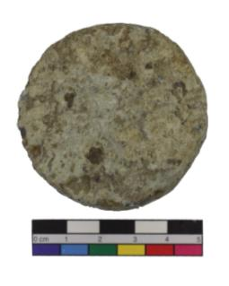
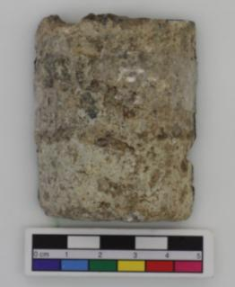

Fig. 1a, b: The Thwing Cylindrical Artefact: Bottom view (left), side view (right). Photos C Farci and U Veronese.

Initial assessment – developing hypotheses
The object is dirty off-white, 6 cm long cylindrical with flat ends and just under 5 cm in diameter (Fig. 1a, b), and with a total weight of around 200 g relatively light. It very clearly is an artefact and not a piece of local geology, and given its find spot should be of Roman origin. The field identification as metal or casting waste served as the starting point of the assessment, and a discussion ensued between the third and the first author of this report regarding the nature of the find. The off-white corrosion colour excluded gold, copper and its alloys as well as iron, leaving only silver, lead, tin or zinc as potential metals known in Roman times (Craddock 1995; for Roman zinc see in particular Rehren 1996 and 1999). The colour most closely resembled corroded lead metal, a frequent find in many Roman contexts, and the shape could – somehow – indicate that it had flowed through a pipe or something. However, it felt far too light to be lead metal. Lead has a specific gravity of around 11 g/cm3; the object had a volume of just over 100 cm3 and only weights just over 200 g. Were it made from lead metal it would have weighed more than 1 kg. The same argument excluded the other metals showing whitish corrosion – even the lighter ones, such as zinc and tin, would have given the object a weight of at least 700 grams.
So perhaps it was in fact stone or common building material such as concrete or plaster? Limestone has a specific gravity of around 2 to 2.5 g/cm3, and the colour would fit. But even if it were a stone, the shape clearly marked it as man-made – or at least man-shaped. Maybe it is a drill core, as they are produced as waste in huge quantities in many building sites when wire or pipe runs need to be run through walls or floors (Fig. 2)? Such drill cores require specific tools to produce, which were unknown in Roman times; a Romano-British age of the Thwing Cylindrical Artefact (TCA) was therefore unlikely. This emerged as the preferred working hypothesis of the first author; to test it, it was decided to cut the core lengthwise in half and expose its assumed concrete nature.

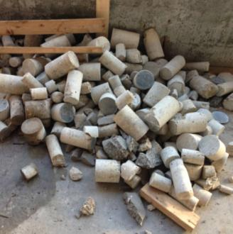
Fig. 2: A heap of discarded drill cores at an unidentified building site.

The evidence
It took not long to set up the water-cooled circular blade saw in the labs of the Institute, and to cut through the object. In fact, it cut easier than expected for concrete – maybe due to some porosity? However, once cut in half the inside revealed a rather different nature than expected (Fig. 3): clearly, the object was metallic after all, and consisted even of different metals in a rather complex but deliberate arrangement.

Reassessment
So much for visual identification of concrete by an established material scientist, in a sizeable hand specimen. The metallic nature of the TCA was indisputable now, but what metals did it consist of, and what function did it have? Close visual inspection of the cut identified five to six different metals or alloys: Firstly the outer case, comprising about half of the total artefact and consisting of two parts, namely an upper outer case, linked to a lower outer case by what looks like a fine thread; the upper part of the elongated cylindrical core in a brass colour; a small piece of copper-coloured metal within it; a series of wires that looked like a spring cut multiple times; a nail with a sharp blade pointing upright into the brass part; and a base plate underneath the spring, of similar white metallic colour to the outer case, but slightly different hue.

Instrumental analysis: pXRF and SEM-EDS
More detailed analyses of the artefact were done at the Archaeological Materials Science Laboratories at UCL Qatar, first using a portable X-ray Fluorescence Analysis instrument (Olympus Delta; using Alloys Plus 3 mm UCL calibration, with beams: 40kV, 13kV, and 8kV, respectively). This identified both parts of the outer case as a magnesium alloy with 5 to 6 wt% aluminium and 2 to 3 wt% zinc, as well as small amounts of manganese and silicon in the order of between half of one percent and one percent.
The yellow-looking metal was identified as brass, with just under 40 wt% zinc and 2 to 3 wt% lead; the copper-coloured metal was found to be technically pure copper. The spring and central nail were found to be pure iron (presumably a carbon steel, but carbon cannot be detected by the methods used), while the thin plate beneath the spring was identified as mostly aluminium with around 18 wt% magnesium and 3 wt% iron; however, due to the small size of the aluminium plate the latter two elements are most likely representing the surrounding materials caught by the excitation beam of the pXRF.
Handheld or pXRF analyses, however, are known to be really only indicative of the real composition of an artefact, unless the calibration of the instrument has been tuned specifically for the material in question. Thus, we undertook further analyses of the object, inserting it into a JEOL Scanning Electron Microscope with Energy-Dispersive Spectrometer, and analysing all parts again. Thanks to the metallic nature of the object this was possible without carbon coating. Using the AZtec software provided by the manufacturer of the EDS system yielded the results presented in Table 1.

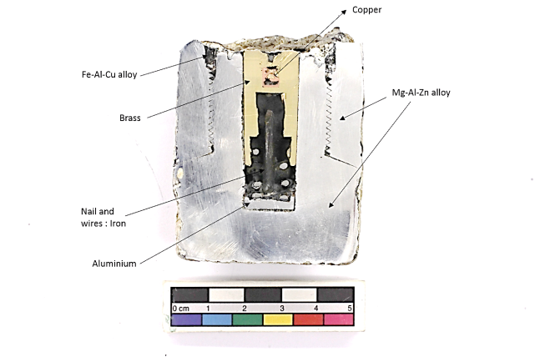
Fig. 3: Thwing Cylindrical Artefact cut open, exposing its complex metallic nature.

Table 1. EDS results on the different metal parts of the artefact. Data are given as elements in wt%, balance to 100 wt% is predominantly oxygen.
Areas | Mg | Al | Si | Mn | Fe | Cu | Zn | Sn | Pb
Main Body (3) | 95.9 | 2.2 |  | 0.2 |  |  | 0.9
Brass (4) |  |  |  |  | 0.2 | 57.9 | 39.0 | 0.3 | 1.9
Copper (3) | 0.2 |  |  |  |  | 99.2
Aluminium (3) |  | 95.0 | 1.2 |  | 0.2
Fe-Al-Cu (3) | 0.4 | 30.6 | 0.6 | 0.3 | 66.3 | 1.1

For most parts, the SEM-EDS data appear consistent with the results obtained using the portable XRF. This is true not only for the main elements, but also for minor elements, such as Mn in the main body and Pb in the brass part. However, the small metal plate at the bottom of the spring-cum-nail part is composed mostly of aluminium, with Si and Fe as main impurities but no Mg above the detection limit of the instrument.
The imaging capability of the SEM showed that the lead in the brass part, measured with the portable XRF at around 2-3 %, is present in small inclusions. They have a composition of almost pure lead, as one would expect from the insoluble nature of lead in copper and its alloys. It also showed how corrosion is progressing along the threaded surfaces of the two main parts (Fig. 4), but really only on a very limited scale when considering the chemical reactivity of pure magnesium metal.

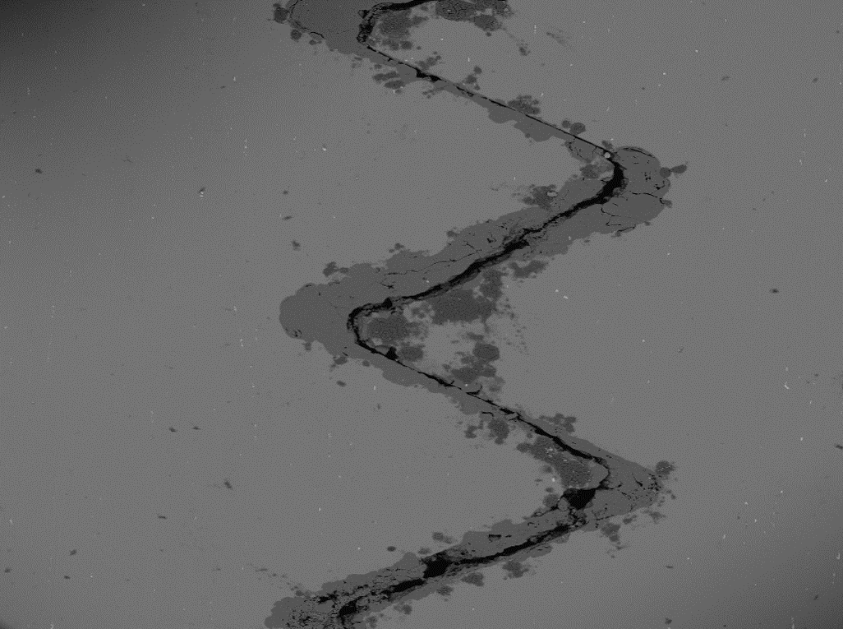
Fig. 4: Close-up of the thread between the two parts of the main body, showing some limited corrosion from the thread surface. Width of image c 0.05 mm.

Thus, the TCA consists predominantly of a two-part body made from magnesium alloyed with small amounts of aluminium and zinc, and a trace of manganese. In the centre of this is set a smaller and more elongated composite cylindrical part, consisting primarily of a high-zinc brass tube and an iron spring-cum-nail part, the latter supported at the bottom by a thin aluminium plate and pointing with the blade of the nail to a pure copper piece embedded in the heart of the brass tube. The upper/outer part of the main body is linked to an iron-aluminium-copper alloy; however, only a very small part of this remained and no full compositional analysis of it was possible.
The composition of the main magnesium alloy part is very typical of commercial 20th century material, as is the high zinc content of the brass, and the relatively clean nature of the aluminium plate. A Roman age of the find can therefore be safely ruled out, but the question remains: what was the function of this artefact, and how did it end up in a Roman-British site in east Yorkshire?

Interpretation
Magnesium and its alloys are much more expensive than the much more common light construction metal, aluminium, and are therefore preferred only where weight is a particular concern. Already in the 1920s and 30s engine-makers were testing magnesium alloys for their weight reduction for major parts, even leading to “all-magnesium” engines being made, particular for use in aircraft and racing cars (Hanson 1930). Lightweight magnesium has the lowest density (1.74 g/cm3) of all commercial metals, significantly less than aluminium alloys (around 2.8 g/cm3), titanium (around 4.5 g/cm3) and iron (nearly 8 g/cm3). The earliest commercially used alloying elements for magnesium were aluminium and zinc to improve its hardness and other working properties (Polmear 1994, 1996). Corrosion issues have always been a major concern in magnesium alloy production. In 1925, it was discovered that adding small amounts of manganese helps to improve the corrosion resistance of magnesium alloys, and “about 0.3 wt% is generally added” (Hanson 1930: 310). We therefore consider our manganese reading at 0.2 wt % (SEM data) reliable, as well as indicating a production date of the alloy of later than the mid-1920s.
On balance, the artefact is therefore most likely part of an aircraft engine. The fact that it is composed of a variety of metals and alloys, including a spring, suggests that it was probably a part meant to react to variable stress or pressure, such as a pressure switch or some kind of sensor. The choice of the main alloy speaks for a necessity to reduce weight in its construction. Still unclear is the specific function of the central elongated cylindrical part of brass etc., which appears to have been moveable relative to the main body and the spring-cum-nail (Fig. 5). Whether the sharp blade of the nail was pointing at the soft copper to connect with it upon compression of the spring, or whether the copper is a post-depositional corrosion product forming as a result of electrolytic corrosion between the brass and iron metal is at present unknown.

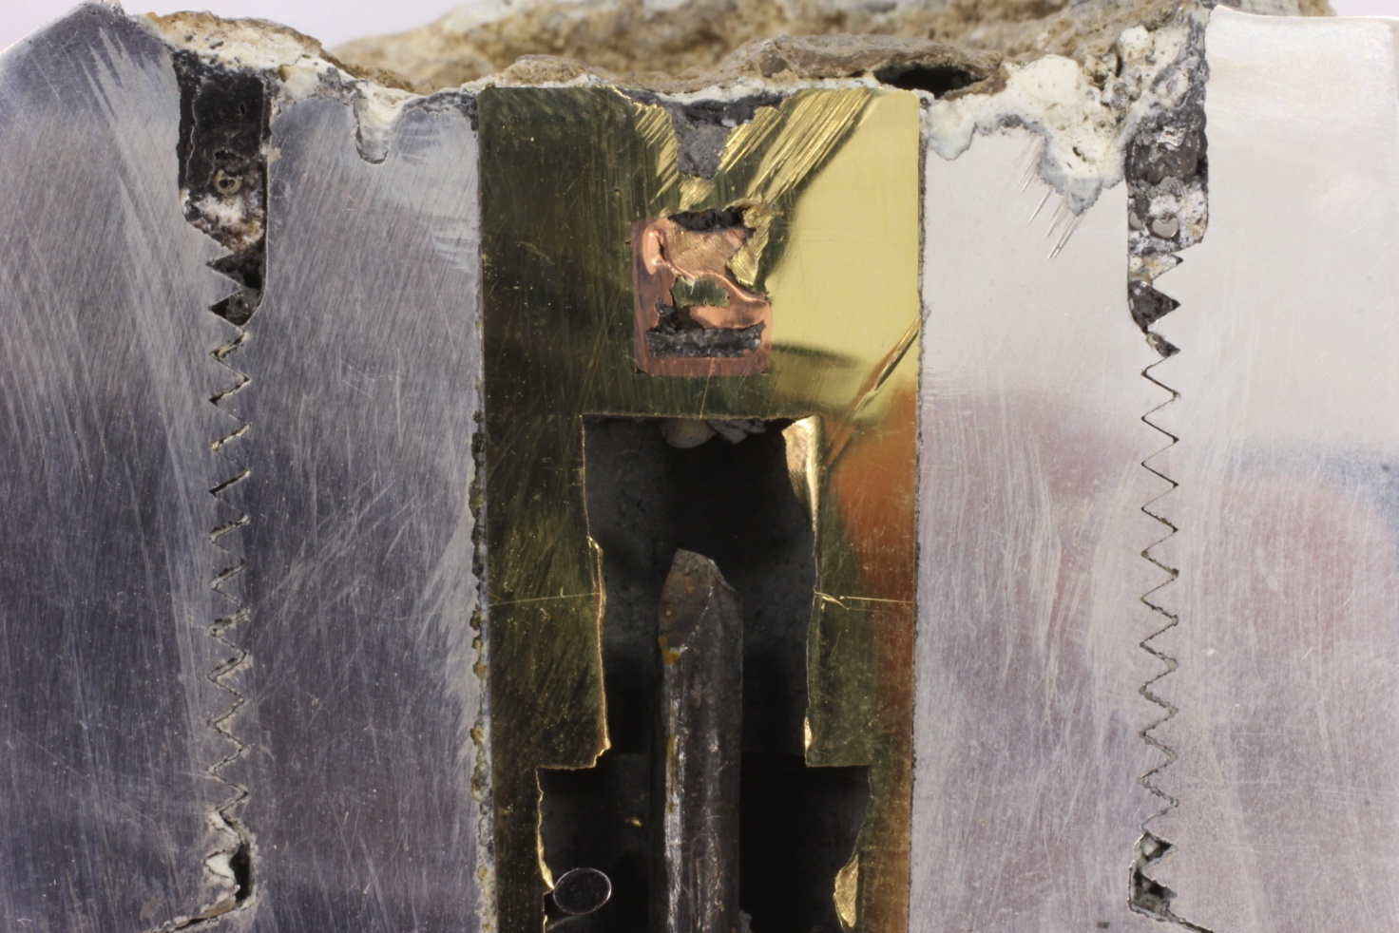
Fig. 5: Close-up of the upper part of the TCA, showing the bladed tip of the central nail pointing to a copper-lined part within the brass tube.

Subsequent information
After the identification of the nature of the material further research in Thwing revealed that the field had seen an aircraft crash on it in 1942. Further enquiries and web-based research showed that it was a Halifax bomber. In the night of 12/13th April 1942 the 76 Squadron, based at Middleton St George, Co Durham (about 5 miles east of Darlington) took of for operations over Essen at the heart of the German heavy industry in the Ruhr area. However, on take-off one of the bombers, code MP-L, serial number R9452, struck a set of ground maintenance steps which broke off part of the undercarriage. Therefore the bomb load had to be jettisoned at sea and the crew subsequently brought the plane back over land before they bailed out over the Hunmanby area at around 3 am, injuring one crew member. The aircraft, powered by a 1,390 hp (1,040 kW) Merlin engine rich in magnesium parts, then crashed in a field near Thwing village, providing a brief disturbance of the Romano-British site while adding its own debris to the archaeological record.

Conclusion
The Thwing Cylindrical Artefact most likely represents a part of the Merlin engine of the Halifax bomber that in April 1942 crashed into the field near Thwing. Its precise function is unknown, but its presence among the survey material serves to underline that even ‘secure’ mono-period sites can contain material of quite unexpected origin.

Acknowledgements
Mr S Thomas initiated the survey of the field at Thwing which yielded the artefact presented here. Several local members of the public provided helpful information on the aircraft crash in the early 1940s, Benjamin Regel (Imperial College) offered assistance with background research into the Halifax bomber, and Kimble D. McCutcheon of the Aircraft Engine Historical Society provided most valuable information and guidance in the interpretation of the object, and its composition. Their help is much appreciated, while the responsibility for any shortcomings in presentation and interpretation remains of course the authors’. The research and analyses were funded by the employers of the authors, with no known ethical or commercial conflicts of interest. Funding by Qatar Foundation for Education, Science and Community Engagement to support UCL Qatar and its Archaeological Materials Science Laboratories is greatly appreciated.

References
Craddock, P.T. (1995): Early Metal Mining and Production. Edinburgh Press.
Hanson, D. (1930) Non-ferrous Metals for Aircraft. Aircraft Engineering and Aerospace Technology Vol. 2, Iss 11, 290-291. http://dx.doi.org/10.1108/eb029340
Polmear, I.J. (1994) Magnesium Alloys and Applications. Materials Science and Technology. 10 (1), 1-16.
Polmear, I.J. (1996) Recent Developments in Light Alloys. Materials Transactions, JIM. 37 (1), 12-31.
Rehren, Th. (1996): A Roman zinc tablet from Bern, Switzerland - Reconstruction of the manufacture. In: S. Demirci, A. Özer & G. Summers (Eds.), Archaeometry '94, Ankara, 35-45.
Rehren, Th. (1999): 7. Archäometallurgische Untersuchung des Zinktäfelchens, 160-169, und 8. Quellen und Funde zum frühen Zink in Europa, 169-172, in: R. Fellmann, Das Zink-Täfelchen vom Thormebodewald auf der Engehalbinsel bei Bern und seine keltische Inschrift, Archaeologie im Kanton Bern. Fundberichte und Aufsaetze 4A, 133-175.

